Marketing plan written for Chez Panisse Restaurant
  - Student name: Eremia Alex Avram
  - Student ID number: 2130850
  - The module title: Marketing Essentials BMGM 5001
  - Lecturer’s name – Ruth Taylor-Davies

Contents
Introduction 2
Situation Analysis 2
Company 2
Customers 2
Segmentation 2
Targeting 3
Competitors 3
Collaborators 3
Climate 3
Objectives 4
Strategy 5
Value Proposition 5
Communication and Delivery 5
Customer Segments 5
Ansoff’s Matrix and Market Strategy 5
Tactics/ Marketing Mix 7
Product 7
Place 7
Price 9
Promotion 9
Action and Control 10
Gantt Chart 10
Marketing Channels Schedule Justification: 11
Measurement of Success: 11
Conclusion 11
References 12

Introduction
This marketing strategy seeks to improve the brand visibility and customer satisfaction of Chez Panisse Restaurant. The management team is ready to coordinate plans for achieving sustainable development. The plan uses the SOSTAC structure, focusing on Situation Analysis, Objectives, Strategy, Tactics, Action, and Control. Chez Panisse is a restaurant in Berkeley, California founded in 1971 by Alice Waters and Paul Aratow. It is named after a character from Marcel Pagnol's Marseille Trilogy. Chez Panisse is the first farm-to-table restaurant in the United States. The restaurant is based on Alice Waters' belief that the most delicious food is organic, locally sourced, and farmed in environmentally friendly methods by those who are managing the land for future sustainability. (Banas, 2023)

Situation Analysis
Company: Chez Panisse has a distinct brand image and is dedicated to using organic, locally-sourced foods. The SWOT analysis identifies strengths such as a strong culinary reputation and drawbacks like a restricted seating capacity.
Strengths  Culinary Reputation  Sustainable Sourcing  Brand Loyalty  Creative Menu  Founder’s Legacy | Weaknesses  High Prices  Limited Accessibility  Seasonal Menu Constraints  Reliance on Founder’s Influence  Capacity Constraints
Opportunities  Expansion  Online Presence  Partnerships  Culinary Education  Menu Diversification | Threats  Competition  Economic Downturns  Changing Consumer Preferences  Supply Chain Disruptions  Regulatory Challenges
(MBA, 2024)
Customers: Customers are segmented into food connoisseurs, health-conscious eaters, and rich folks looking for luxury dining experiences.
Segmentation:
Geographic Segmentation: Chez Panisse primarily serves customers located in Berkeley, California and surrounding areas.
Demographic Segmentation: Professionals, academics and idividuals interested in gourmet dining experiences.
Psychographic Segmentation: Food enthusiasts who value organic, sustainable and locally sourced ingredients.
Behavioural Segmentation: Customers who are willing to pay premium prices for high-quality, artisanal food. (Pesci, 2021)
Targeting:
Gourmet Enthusiasts: Individuals who appreciate fine dining experiences and are willing to spend on high-quality food and ambiance.
Health-Conscious Customers: Customers who prioritize health and sustainability in their food choices.
Special Occasion Celebrators: Couples, families and groups who visit Chez Panisse to celebrate milestones or special occasions.
Culinary Tourists: Tourists visiting Berkeley who are attracted to the city’s reputation as a culinary destination. (Addison, 2021)
Competitors: Upscale eateries and neighbourhood bistros. Perceptual positioning maps illustrate Chez Panisse's distinctive combination of high-end dining with sustainability. Chez Panisse is renowned for its inventive food and dedication to using fresh, locally procured products, positioning it in competition with several other fine dining establishments in the culinary industry. Competitors of the restaurant include The French Laundry, Per Se, Blue Hill at Stone Barns, Eleven Madison Park, Gramercy Tavern, Boulevard, and Zuni Café. (Zippia, 2024)
Collaborators: Over the years, Chez Panisse Restaurant has partnered with a variety of people, organisations, and suppliers to further its goal of promoting sustainable, locally produced food and building relationships within the culinary community. Notable contributors include local farmers and producers, food advocacy groups, guest chefs and culinary experts, artists and designers, as well as environmental and community organisations. (Tom, 2017)
Climate: A PESTLE study reveals positive trends in the increasing desire for organic and sustainable eating experiences.
Political | Political stability and global connections may impact the accessibility and price of imported ingredients, particularly those obtained from areas vulnerable to climate-related disturbances.
Economic | Fluctuations in commodity prices, such as agricultural items and energy, may impact ingredient costs and total operating expenditures for the restaurant.
Social | Shifts in demography and consumer behaviours may impact eating habits and tastes, resulting in changes in demand for certain kinds of food or dining experiences.
Technological | Agricultural technological advancements like precision farming and indoor vertical farming might enhance the resilience and sustainability of Chez Panisse's ingredient supply chain in response to climate-related concerns.
Legal | Labour laws and regulations, such as those concerning pay, working conditions, and immigration rules, might affect the restaurant's workforce and operating expenses.
Environmental | Climate change-related disasters like harsh weather, droughts, or wildfires may interrupt agricultural supply chains and impact the availability and quality of seasonal foods utilised by Chez Panisse.

Chez Panisse may get insight into the possibilities and difficulties presented by the climate by analysing these elements. This will help them design strategies to adjust to changing environmental circumstances while maintaining their dedication to sustainability and culinary quality. (Berkeley, 2024)

Objectives
The goal of Chez Panisse Restaurant is to achieve a fifteen percent increase in revenue during the upcoming fiscal year. This will be accomplished by implementing targeted marketing initiatives to attract new customers, enhancing the dining experience by introducing innovative menu offerings that showcase locally sourced, sustainable, and seasonal ingredients, optimising operational efficiency to streamline processes and reduce costs, investing in staff training and development to ensure exceptional service standards, and fostering community engagement through partnerships with local farmers, producers, and environmental organisations. All of these goals will be accomplished while maintaining the restaurant's commitment to achieving a high level of culinary excellence, sustainability, and social responsibility. (Freedman, 2023)

Strategy

Value Proposition
The value proposition of Chez Panisse Restaurant focuses on delivering a unique dining experience based on culinary mastery, sustainability, and community involvement. Chez Panisse stands out due to its steadfast dedication to procuring ingredients locally, responsibly, and seasonally. This ensures that each meal not only delights the palate but also benefits local farmers, producers, and the environment. The restaurant is known for its unique meals that highlight California's abundant resources, including fresh ingredients in imaginative and delectable dishes made with precision and care. Chez Panisse stands itself for creating a welcoming setting where diners can enjoy more than simply a meal, but an experience that celebrates cuisine, culture, and community. (Chesbrough et al., 2014)

Communication and Delivery
Chez Panisse conveys its value proposition via several channels such as its website, social media platforms, email newsletters, and face-to-face contact with visitors. The restaurant uses these platforms to emphasise its dedication to sustainability, display its seasonal menus and partnerships with local craftsmen, and communicate tales that connect with its audience. Chez Panisse upholds its value proposition by paying careful attention to detail in all aspects of the dining experience, including the quality and presentation of food, the environment, and the service offered by well-informed and enthusiastic personnel. (Short, 2021)

Customer Segments
Chez Panisse mainly caters to gourmet foodies, health-conscious customers, special occasion celebrators, and culinary travellers who appreciate great dining experiences and support the restaurant's commitment to sustainability and quality. Chez Panisse's targeting and positioning tactics are influenced by focusing on particular client categories, enabling the restaurant to customise its offers and message to align with the interests and values of its target audience.

Ansoff’s Matrix and Market Strategy
Chez Panisse implements a specialised marketing approach by providing distinctive and high-quality eating experiences tailored to the individual interests of its target customers. The restaurant emphasises market penetration and product growth by constantly improving its services and growing its client base via focused marketing strategies and menu innovation. Chez Panisse establishes itself as a top player in the fine dining business by retaining a unique identity and providing outstanding value to its target groups. This strategy helps the restaurant build a loyal customer base that values its dedication to culinary quality and sustainability. (Chesbrough et al., 2014)

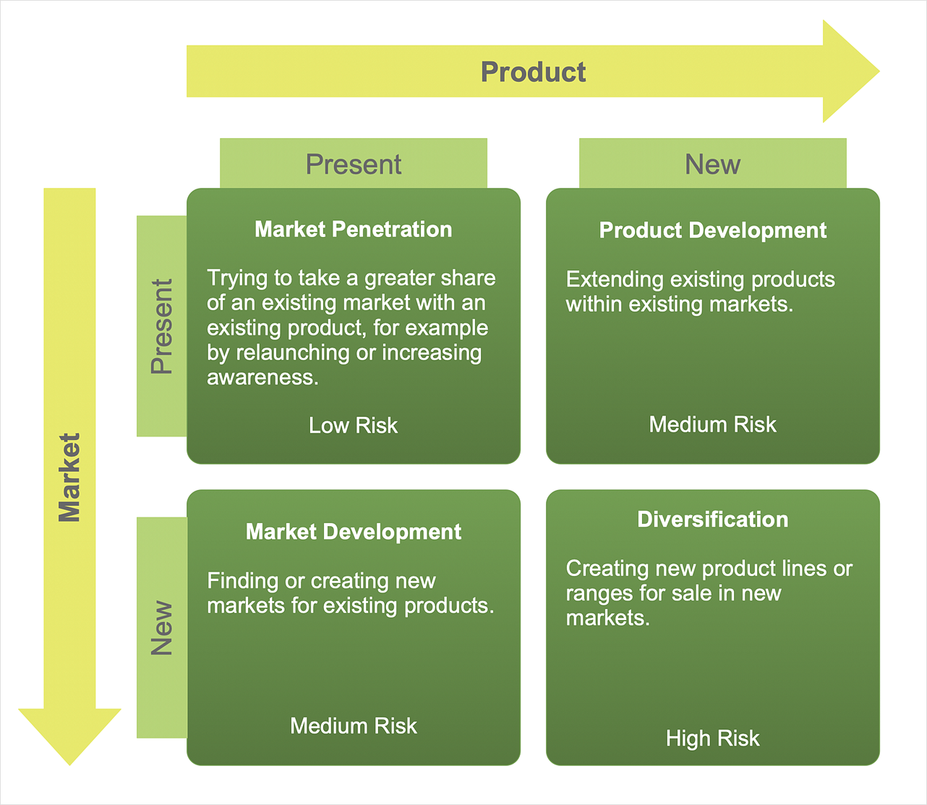

Tactics/ Marketing Mix
Product | Seasonally inspired, locally sourced meals at Chez Panisse Restaurant provide a unique eating experience. The restaurant is noted for its quality, sustainability, and celebration of California's vibrant food culture. What Chez Panisse gives guests:  - sources from local farmers, ranchers, and craftspeople who practise sustainable and ethical practices.  - Chez Panisse's chefs are known for their creativity and ability in showcasing California's diverse cuisine.  - Cosy lighting, rustic décor, and attentive service make the restaurant a nice place to dine.  Customers may enjoy great meals, support local farmers, and learn about California's culinary heritage at Chez Panisse, known for its welcoming hospitality. (Inamine, 2021)
Place | Customers may find Chez Panisse Restaurant via several channels, both online and offline, to ensure accessibility and exposure for customers looking for a distinctive culinary experience. Customers may locate the restaurant by following these directions: website, Internet-based cartography and listings, Social Media, Regional periodicals and reference materials, Signage and Geographical Position and Concierge Services and Hotel Recommendations.  Chez Panisse uses both online and offline means to help guests find the restaurant and learn about its distinctive offerings, catering to local residents, visitors, and culinary aficionados looking for a memorable dining experience. (Emba, 2020)
Price | Berkeley's Chez Panisse charges more to demonstrate its culinary ability, high-quality ingredients, and excellent dining experience. Chez Panisse's pricing strategy matches the perceived value of the food, setting, and service, making it a popular option for discerning visitors willing to pay extra for a wonderful meal. The pricing strategy:  Marketing environment study and research  Value and pricing approach  Variety of pricing  Providing Pricing Information  Chez Panisse's price reflects its commitment to quality, sustainability, and cuisine. It offers many pricing alternatives for different events and customer preferences. By properly conveying and aligning with its value proposition, Chez Panisse ensures that customers see its price as fair and justified, improving their dining experience. (Chesbrough et al., 2014)
Promotion | Chez Panisse Restaurant employs a comprehensive promotional strategy, integrating various elements of the RACE (Research, Action, Communication, and Evaluation) communications mix to effectively reach and engage its target audience. Here's how the restaurant advertises and promotes its offerings:  Research:  Market Analysis  Customer Feedback  Media Consumption Habits  Action:  Menu Development  Collaborations  Community Engagement  Communication:  Digital Marketing  Public Relations  Content Creation  Advertising  Evaluation:  Performance Metrics  Customer Surveys  ROI Analysis  By leveraging the RACE communications mix, Chez Panisse Restaurant ensures that its advertising and promotional efforts are strategic, targeted, and aligned with its brand values and objectives. This integrated approach helps the restaurant reach and resonate with its target audience while continually refining its messaging and tactics based on real-time feedback and performance data. (Guide, 2024)

Action and Control

Gantt Chart
DATE/  ACTION | CONTROL/  MEASUREMENT | Jan | Feb | Mar | Apr | May | Jun
Preparation | 2 weeks ( Feb 1, 2024 – Feb 14, 2024)
Market Research | 3 weeks ( Feb 15, 2024- Mar 6, 2024)
Marketing Channels | 4 weeks (Mar 7, 2024 – Apr 3, 2024)
Gathering Feedback | 2 weeks (Apr 4, 2024 – Apr 17, 2024)

Marketing Channels Schedule Justification:
Preparation period: February 1 - February 14, 2024 - This phase include internal planning, objective establishment, and resource distribution for the marketing effort. It establishes the groundwork for future actions.
During the period from February 15 to March 6, 2024, thorough market research will be carried out to analyse client preferences, rival tactics, and industry trends.
Marketing Channels (Mar 7 - Apr 3, 2024): A detailed marketing channels strategy will be created and put into action using information obtained from market research.
Collecting input (Apr 4 - Apr 17, 2024): After executing marketing initiatives, this stage includes gathering input from consumers via surveys, reviews, and other communication methods.

Measurement of Success:
New Customers: Success may be determined by comparing the number of new clients obtained during the campaign to previous statistics. New customers reflect marketing success in growing the client base.
Positive Brand Attitudes: Positive reviews, social media activity, and consumer feedback show that the marketing effort built brand image and loyalty.
Profit Growth: The restaurant's bottom line will determine the marketing campaign's success. Higher revenue and profitability throughout the campaign show that marketing efforts drive corporate development and financial success.
Other Metrics: Internet traffic, social media interaction, reservation reservations, and consumer satisfaction will also be tracked to assess marketing campaign success and ROI.

Conclusion
This marketing strategy for Chez Panisse Restaurant intends to strengthen its position as a culinary industry leader by emphasising sustainability and culinary quality. The plan outlines a strategy for sustained expansion and improved customer experience by capitalising on the brand's strengths and addressing shortcomings like insufficient seating capacity.
It is recommended to constantly innovate menu items to stay relevant in a changing market and to strengthen partnerships with local suppliers to improve the restaurant's farm-to-table concept. The plan emphasises the need of maintaining a premium pricing approach to mirror the quality and exclusivity linked with the Chez Panisse experience.

References
Addison, B. (2021) Chez Panisse reimagined the way we eat. after 50 years, is that enough?, Los Angeles Times. Available at: https://www.latimes.com/food/story/2021-08-19/chez-panisse-50th-anniversary-alice-waters-bill-addison (Accessed: 27 February 2024).
Banas, A. (2023) Alice Waters: Food revolutionary, BBC News. Available at: https://www.bbc.com/travel/article/20230214-alice-waters-food-revolutionary (Accessed: 27 February 2024).
Berkeley (2024) Best lab UC Berkeley. Available at: https://best.berkeley.edu/best-research/culinary-experience-design-in-open-innovation-ecosystems-chez-panisse-case/ (Accessed: 27 February 2024).
Chesbrough, H., Kim, S. and Agogino, A. (2014) ‘Chez Panisse: Building an open innovation ecosystem’, California Management Review, 56(4), pp. 144–171. doi:10.1525/cmr.2014.56.4.144.
Emba (2020) Marketing 4P : Chez Panisse: Building an open innovation ecosystem marketing 4P mix analysis, EMBA Pro for Executive MBA Professionals. Available at: https://embapro.com/frontpage/marketing4pcase/4825-panisse-chez (Accessed: 27 February 2024).
Freedman, P. (2023) Happy 50th birthday to Chez Panisse, The Berkeley Restaurant that launched farm-to-fork eating, The Conversation. Available at: https://theconversation.com/happy-50th-birthday-to-chez-panisse-the-berkeley-restaurant-that-launched-farm-to-fork-eating-162588 (Accessed: 27 February 2024).
Guide, M. (2024) Chez Panisse – Berkeley - a Michelin Guide Restaurant, MICHELIN Guide. Available at: https://guide.michelin.com/us/en/california/berkeley/restaurant/chez-panisse (Accessed: 27 February 2024).
Inamine, E. (2021) What Chez Panisse taught us, Bon Appétit. Available at: https://www.bonappetit.com/story/chez-panisse-best-lessons (Accessed: 27 February 2024).
MBA (2024) Chez Panisse: Building an open innovation ecosystem SWOT analysis, SWOT matrix, weighted SWOT analysis - strengths, weaknesses, opportunities, and threats, MBA Case Pro. Available at: https://mbacasepro.com/wp/swot2analysis/5039-chez-panisse (Accessed: 27 February 2024).
Pesci, S. (2021) Can a Farm-to-Table restaurant bring about change in the food system?: A case study of Chez Panisse, Taylor and Francis Online . Available at: https://www.tandfonline.com/doi/full/10.1080/15528014.2021.1948754 (Accessed: 27 February 2024).
Short, A. (2021) How do we assess the legacy of legendary restaurant Chez Panisse?, Los Angeles Times. Available at: https://www.latimes.com/food/newsletter/2021-08-21/how-do-we-assess-the-legacy-of-legendary-restaurant-chez-panisse-tasting-notes (Accessed: 27 February 2024).
Tom, P. (2017) Open innovation found to be basic ingredient of Chez Panisse’s success: Haas News: Berkeley Haas, Haas News | Berkeley Haas. Available at: https://newsroom.haas.berkeley.edu/open-innovation-found-be-basic-ingredient-chez-panisse%E2%80%99s-success/ (Accessed: 27 February 2024).
Zippia (2024) Chez Panisse competitors, Zippia. Available at: https://www.zippia.com/chez-panisse-careers-201164/competitors/ (Accessed: 27 February 2024).

