Group Project – 2023

William Taylor Durban – 2218327

Reflective Analysis of Project – Developing a Process/Jig for Reducing the Risk of RSI Injury When Assembling Fibre Optic Cable Ferrules

Contents
Introduction 3
Objectives of Report 3
The Project Background 3
Gantt Chart 5
Analysis of Methods Used to Meet Objectives 10
Design Brief/Specification 10
Research 11
Brainstorming 14
Prototyping 18
Effectiveness 22
Project Analysis 24
Time Management 26
Budget 27
Minimise Health and Safety Risk 28
Recommendations 29
Conclusion 30

Introduction

Objectives of Report

This report analyses the process of a recent project involving the creation and implementation of a solution to a RSI (repetitive strain injury) risk to an operator in the assembly area of the camera department. This project was completed in September of 2022 by Taylor Durban from the Equipment Engineering department of Sony UK Technology centre, although Taylor has completed most of the tasks the whole project has involved the input, influence and support from colleagues within the department.
The tools and techniques used throughout the project will be assessed and conclusions made as to whether the project was an overall success. To support this conclusion the strengths of the project will be identified as well as recommendations made for improvements in the tools and techniques that could have been utilised.

The Project Background

The RSI risk was reported by the operator, who stated that when assembling the fibre optic leads that are used within the camera assembly, they are required to use a handheld crimping tool. This tool is appropriate for the job; is not heavy, easy to handle, doesn’t require too much force to crimp the lead and works consistently. However, the operator makes batches of 300, therefore 300 crimps in around one full day’s work (8 hours of working time), in total 600 leads are required per week. The operator notified his direct manager to inform them that this task was beginning to cause a strain injury in their hand towards the end of the day, they suggested that an alternative method, or some assistance to take the strain out of using the jig would be beneficial.

Projects like these are relatively common in the organisation as there is a large focus on health and safety as well as Kaizen activities. Kaizen is a Japanese methodology meaning continuous improvement, for example never assuming or deciding that a process or procedure is 100% correct or efficient and keeping the attitude that there is always room for improvement (Hargrave, 2022). Whether that be increased production, decreased costs, or in this instance reduced risk of injury for the operator.

My manager approached me to lead this task and gave me a two-week window to find, manufacture and implement a solution. There was a short time frame for this as the issue was health and safety related no time was to be wasted in producing a solution to the problem.

The objective of this project was to find and implement a solution to the risk as soon as possible. The solution needed to be cost effective, especially considering the low frequency of use of the solution. It was also vital to consider any other implications of introducing the solution, for example a new health and safety hazard, the need for specialist training, maintenance etc.

Gantt Chart

First used in the 1860s a Gantt chart is a visual representation of a project schedule, set out using different sized bars to represent timescale of tasks. They have become the most widely used chart for project management situations due to their simplicity to create and effectiveness in quickly giving representation to whether a project is ahead, on or behind schedule (Mitchell, 2022).

At the start of the project a task list and Gantt chart was created using Microsoft Project. This project software allows you to list the tasks that are required for the project, assign a start date, order them in a logical way – adding predecessors to show that certain tasks cannot be started before others, and add the amount of time each task should take. By setting up the correct working hours, taking out time for break times, factory shutdowns and even for time that must be spend completing other tasks this allows the program to correctly predict a finish date and build a Gantt chart.

This is an excellent method for setting out project timelines and scheduling goals to ensure that projects stay on track, and that if they fall behind it can be easily noticed, and changes can be made to catch back up or adjust the schedule accordingly.
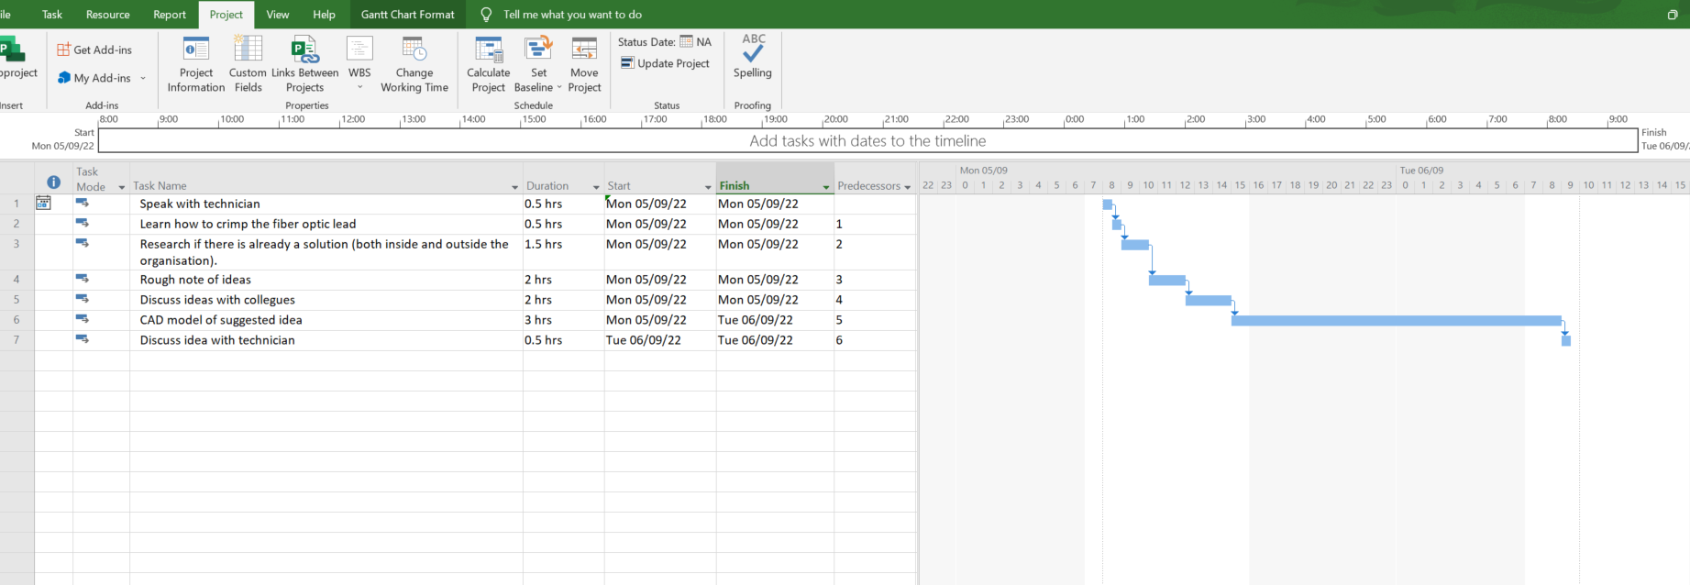Figure 1
Figure 2
As can be seen in figure 1 above, the task list, when filled out correctly, including information such as predecessors, creates the Gantt chart as seen in figure 2. In the chart the hours between 16:00 and 6:00 are greyed out to show that this is not working time, the bar still carried through this as the project is still ongoing. As can be seen from this first list of tasks the brainstorming and discussion phase should only take just over a day to complete, this creates the goal to complete the work quickly and get the project underway efficiently.

After discussing the idea with the technician who will be using the solution it was decided that the proposed idea had potential and solved the problem. From this point the next list of tasks were written so that the project kept flowing efficiently, the task list can be seen below in figure 3 and the new, updated Gantt chart can be seen in figure 4.
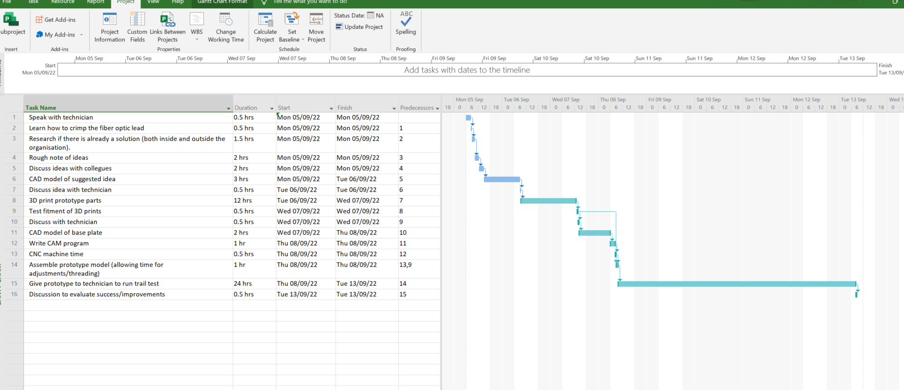 Figure 3
Figure 4
The task lists were created in stages purposefully, this was to minimise wasted time in redoing and modifying the tasks frequently. As with many projects it is very difficult to identify what obstacles will be found, that is why all the small task lists only focus on completing one main goal. In phase one this was to find and solution and bring the idea to the technician who reported the risk. In phase two this moved on to discussing the prototype after a trial run.

After these steps were completed, the task list for phase three was written, these tasks are shown below in figure 5, with figure 6 showing the corresponding Gantt chart.
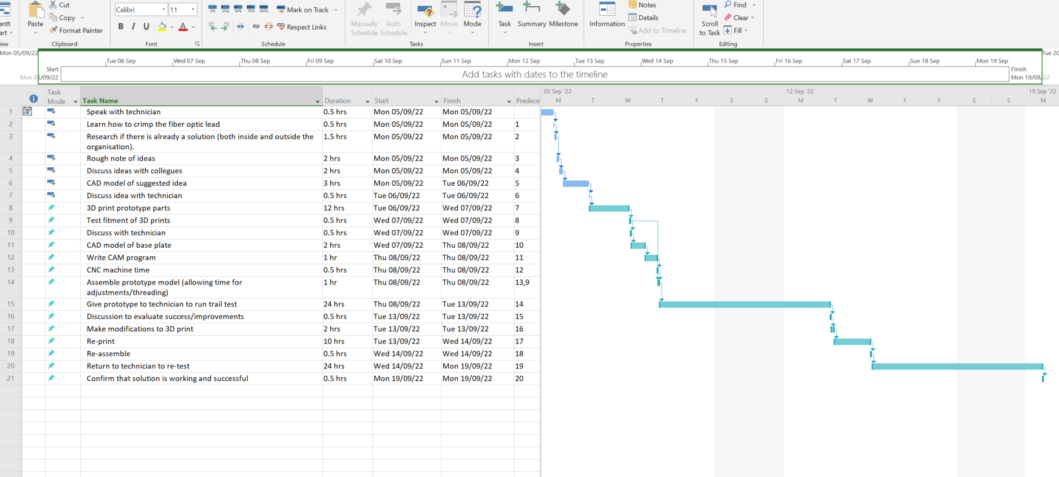 Figure 5
Figure 6
These tasks included making the modifications that were suggested in the discussion with the technician after the initial trail. Once the modifications were complete and the modified files were printed the jig was sent back up to the technician for use.

After this date a review meeting was set up in order to evaluate the success of the solution, due to ongoing work projects this meeting has since been delayed, however no further recommendations or issues have been reported. If any improvements are suggested this simply puts the project back into the phase 3 stage, where modifications are made, and the next revision solution is produced. Within Sony UK Tec there is a factory wide culture surrounding the principle of Kaizen, this is the mindset of never finding a ‘perfect’ solution, there is always room to further develop, whether that be to improve efficiency, reduce cost, reduce carbon footprint, or even just for aesthetics (SonyPencoed, 2023).

Analysis of Methods Used to Meet Objectives

This section focuses on the analysis of the project, identifying and reflecting on what tools and techniques were used to complete the project. As suggested by Caldwell and Grobbel (2013) refection is a skill that should be practiced and used as frequently as possible, through the analysis of decisions conclusions be drawn to decide upon what correct and incorrect choices were made and help to identify better practices in the future.
Alongside writing the initial task list, and as a part of some of the tasks the following project planning, organisational and tracking techniques were used.

Design Brief/Specification

This was written as a neat copy up of the notes taken during the very first discussion with the technician. A design brief, as explained by Heaton (2020) is a planning tool that is used to clearly outline the need for the project. It gives the team completing the project a clear guide as to what the goal is and gives a means of measuring the success of the project once it is complete.

For this project the following design brief was written;
The solution to this problem must be cost effective as there are only a certain number of fibre optic crimps made each week. The department is also very small and so a large piece of equipment is likely to get in the way. It is well recognised that if something is over complicated and difficult to use then someone is less likely to use it, therefore it is vital that the solution is easy to use to encourage its use. As the solution is used in batches it needs to be able to effectively complete one batch without variation in quality and without any difficulties in terms of breakdowns/maintenance.

To help simplify this short design brief a specification list was created.
- The solution must reduce the risk of repetitive strain injury for the user.
- The solution must achieve <98% repeatability to ensure that all the fibre optic crimps that are made are the same and do not suffer from poor crimping.
- The solution should be cost effective in relation to the quantity of use.
- The solution must be simple and not add a great deal to the maintenance requirements on the production floor.
- The solution should be small enough to be put away/not take up much space as the department area is very small.
Although very simple, design brief and specifications are vital tools for ensuring that the project is heading towards a goal. It is very easy for projects to drift away from their main aim and when this happens it is often very difficult to identify it happening. Having easy access to tools such as these mean that frequent check backs can help to ensure that key information has not been missed out and that all the project goals are within sight.

Research
As can be seen in the task list and Gantt chart, after the discussions were complete and the information collected in the form of design specifications the project moved into a research phase. This involved both researching the method of crimping the fibre optic cables (learning to complete the task in question) as well as learning about the specialist crimps themselves.

It was found that the method of crimping the cable was more technical than first thought, not only did the connector need to be crimped firmly, the wire also needed to be stripped back first, the outer sheath neat and tidy with the protective fibres free to be slip into the connector without interfering with the connection. To complete this job, hold the fibre optic cable still and then crimp the connector was quite tricky. This led to the idea that there needed to be a better way to hold the wire steady.

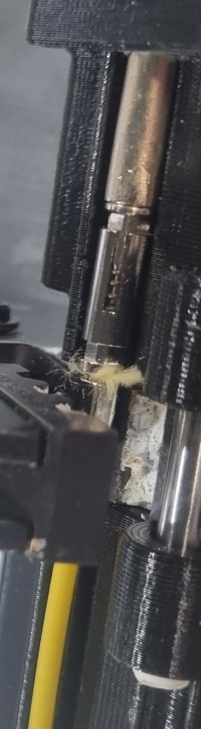
Figure 7 – Image showing the set up of the fibre optic wire and the connector that needs to be crimped.
The research also involved checking how other organisations are completing this task and considering other possible solutions, research of how others solve similar problems is an excellent way to identify how others in the industry address similar problems and can give huge insights into the benefits and drawbacks of particular ideas (Zarah, 2023).

It was found that if the process is high quantity, then a semi-automated pneumatic crimping tools are used, such as seen in figure 8 below. However, for low batch, low budget circumstances the cables are assembled and crimped by hand, usually with a crimp similar to as seen in figure 9. Through more research it was found that the pneumatic crimping tool (as seen in figure 8) are very expensive. This led to the understanding that modifying, or making a set of assisted hand crimps may be a good option – especially considering the design specifications regarding simplicity and cost.
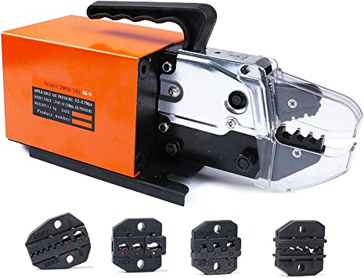

Figure 8 – pneumatic crimping tool.
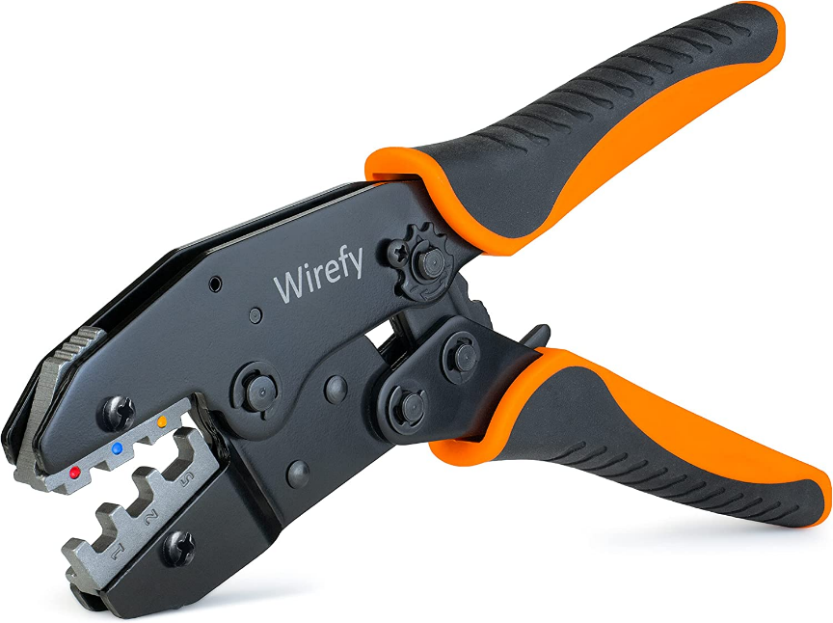

Figure 9 – Hand powered crimping tool.

To double check the research and ensure that all ideas were considered the implications of using a machine/pneumatic press was considered. This includes things such as technician training, routine maintenance and breakdown support. Other considerations such as understanding the difficulties of setting up an air supply or creating the space for the machine to go supports the research, and suggests, that a machine/pneumatic press is likely to be too expensive and unnecessary considering the number of units being made per week.

To consider all possible options it was also discussed what the potential costs would be to have this task completed externally, this was quickly answered as cost was not the only factor in this decision – the main reason the fibre optic leads are built on side is to ensure an exceptionally high-quality standard.

Brainstorming
After completing some initial sketch ideas using the research and design brief/specification as a guide the project progressed onto the group discussion phase. These sketches can be seen in figures 10, 11 and 12 below.
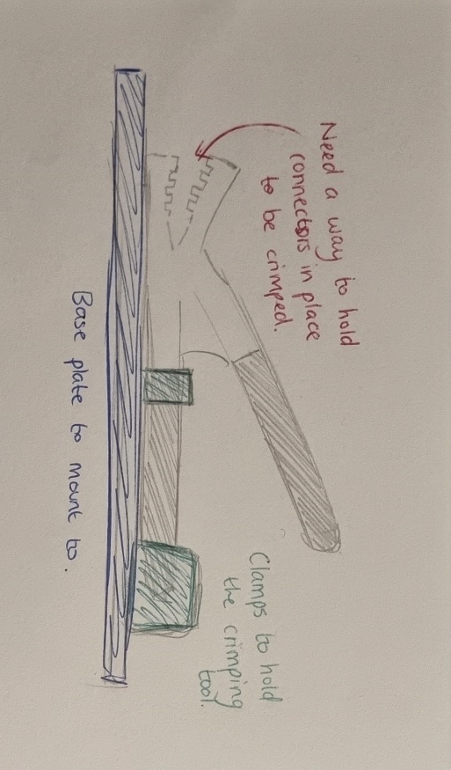 Figure 10 – Idea one.
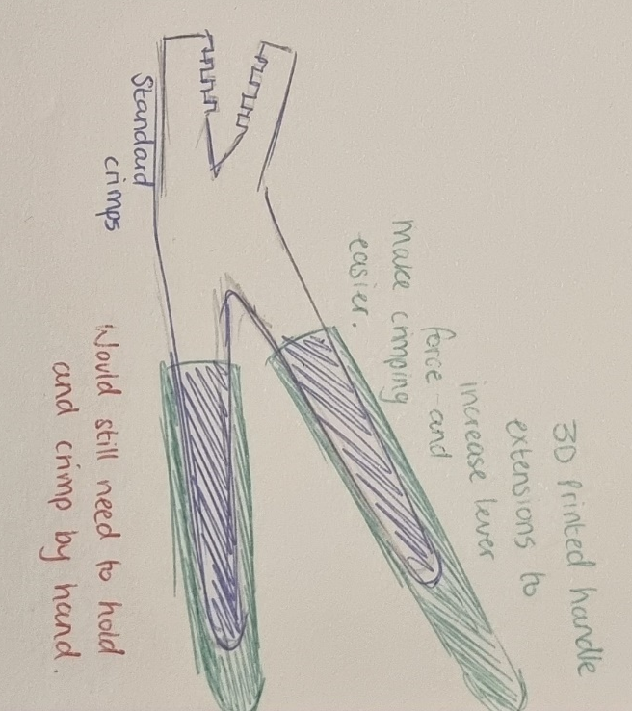 Figure 11 – Idea two.
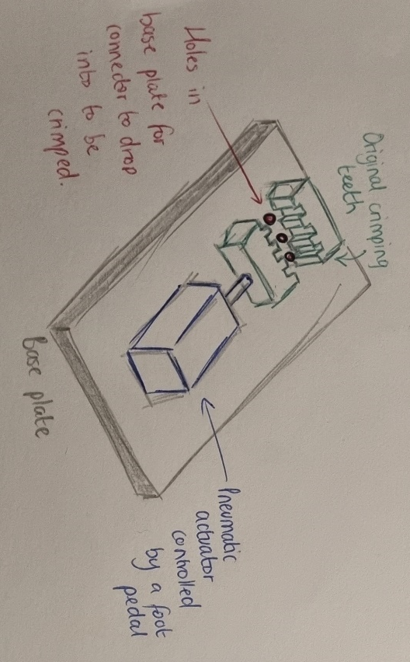 Figure 12 – Idea 3.
For this is a small team involving 4 people, the technician, who will be using the solution, a design engineer, the principal engineer (the person who typically has the largest amount of machine and jig design experience), a production maintenance technician and an automation engineer. These individuals were decided to keep the project small and efficient, not have too many opinions clashing and causing delays whilst also ensuring that there is enough knowledge, experience, and skills to make good quality comments and suggestions about the ideas.

These ideas were recorded using an online brainstorming software called Coggle. A brainstorming page was created for each idea as a quick and easy way to make note of people’s suggestions and opinions, these can be seen in figures 13, 14 and 15 below. As suggested by Banister (2018) the use of brainstorming is an excellent and simple method of collecting opinions without breaking down anyone’s ideas as most points are just a single line and then the discussion moves onto the next one – this can often encourage people to share more as there is less risk of negative feedback, resulting in a more honest data collection.
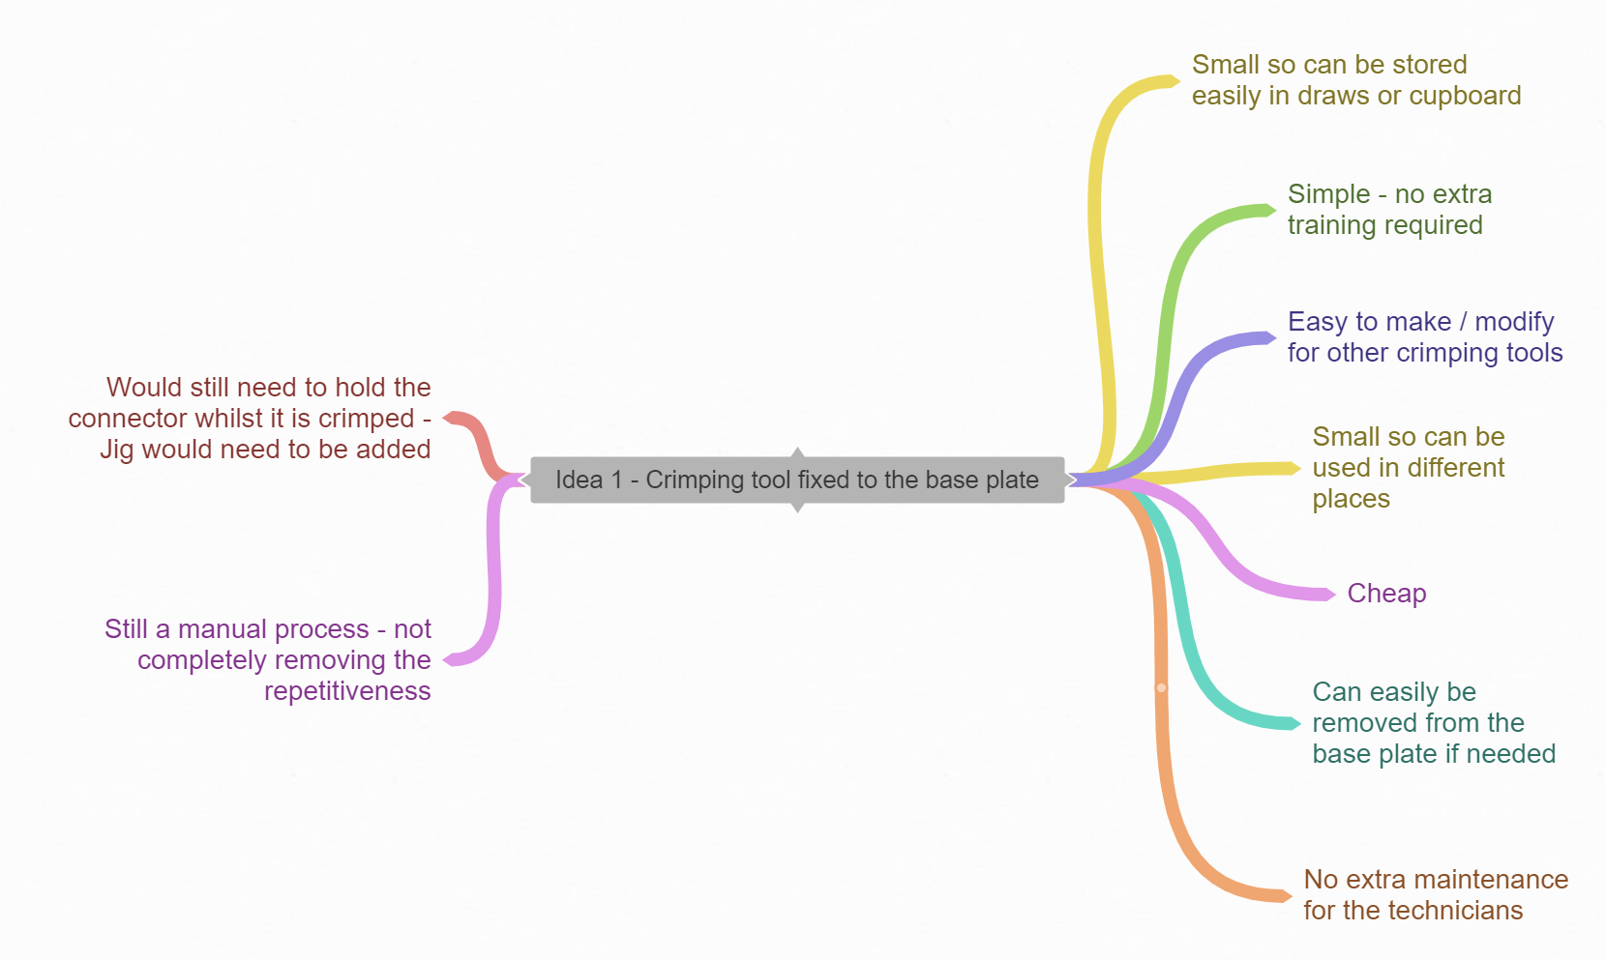
Figure 13 – Coggle showing the opinion on idea one.
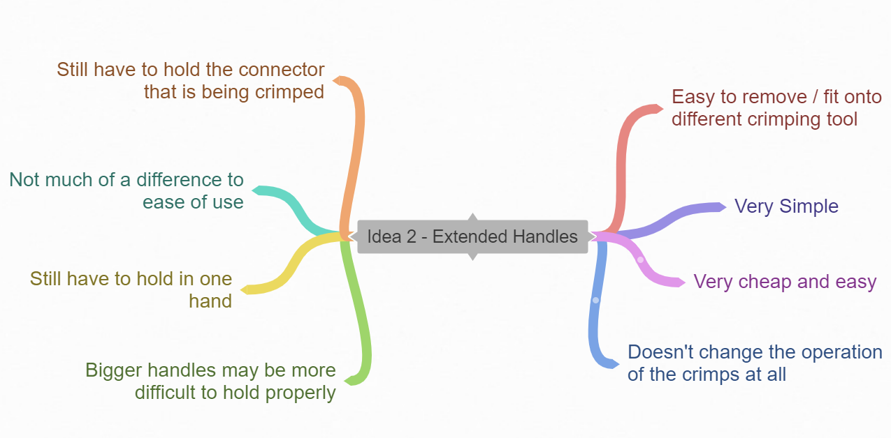
Figure 14 – Coggle showing the opinion on idea two.
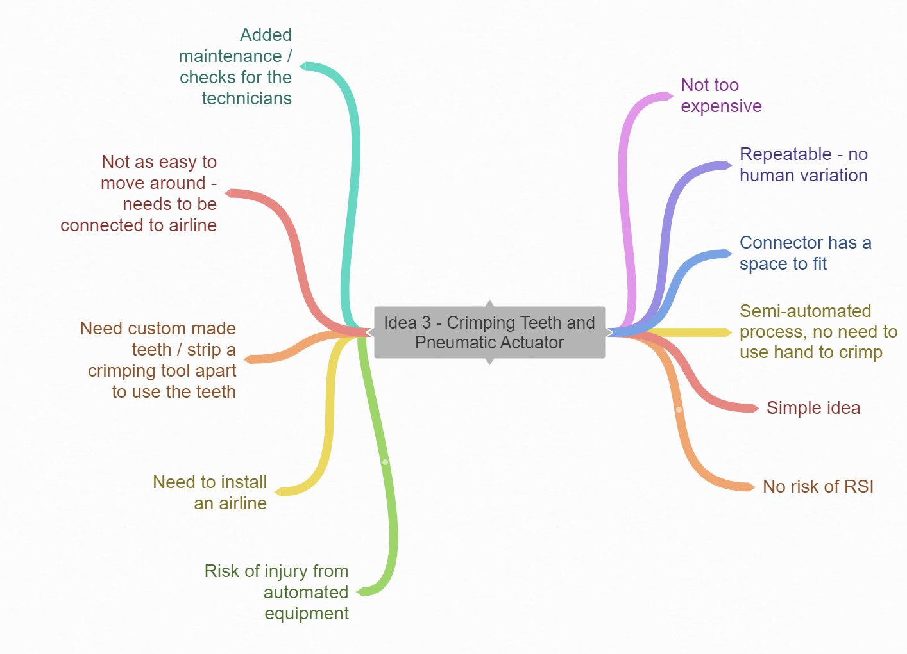
Figure 15 – Coggle showing the opinion on idea three.

To make the final decision a decision matrix method was adopted, this analysis tool is used heavily throughout Sony as a clear and less bias method for making decisions. Described by Peek (2023) as being an excellent tool for selecting the best path of action and prioritizing asks from a logical viewpoint the design brief is used throughout the world and considered one of the most versatile decision-making tools. Figure 16 shows the decision matrix that was created and used in this circumstance.

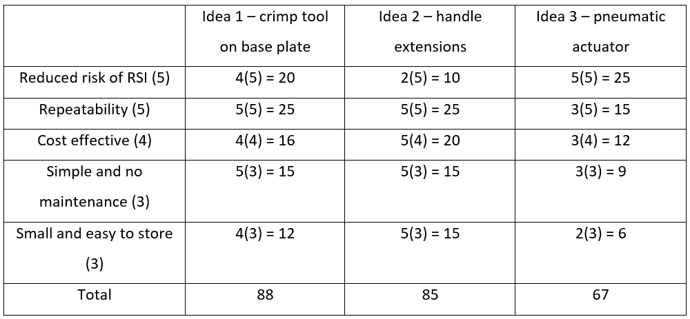Figure 16 – Decision matrix to help decide the best idea.

As can be seen in the decision matrix the criteria that was written as ‘must’ in the design specification have been given a weight of 5 and anything that was a ‘should’ has been weighted according. This highlights that although idea three does reduce the risk of RSI the best it does not score the highest overall as it adds too much maintenance, cost and is less repeatable (due to more moving parts/set up variations etc).

Prototyping
Once all the teams’ comments and the decision matric considered the progressed version of the model (as can be seen in figure 17 below) was created using Solidworks CAD (computer aided design) software. This idea was mainly based off idea 1, with a newly designed jig attached for holding the connector whilst being crimped. As seen in figure 18, a handle extension was also created to extract some of the benefit of idea two – the extra leverage benefit for very little difficultly.
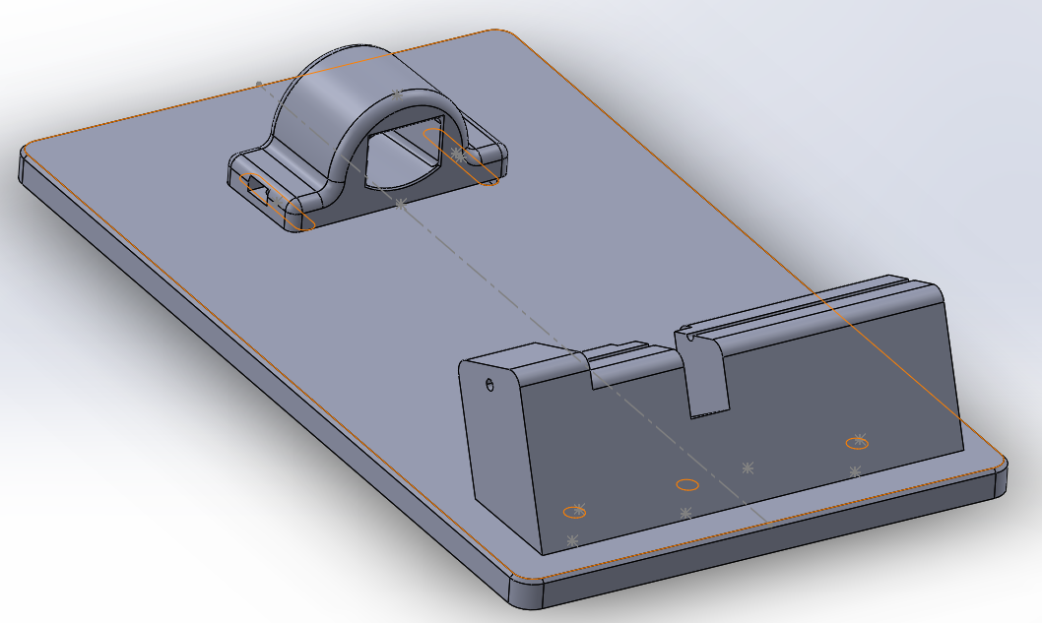
Figure 17 – Assembly of the parts for the prototype, assembled for L/H use. Based on idea 1.
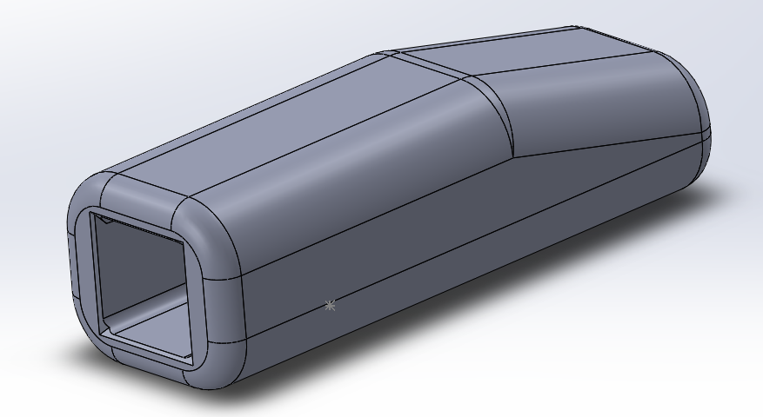

Figure 18 – The handle extension for the crimping tool. Based upon idea two.

As suggested by D’Aveni (2015) 3D printing is becoming the normal method for prototyping and small batch manufacturing for many mainstream companies – this was 8 years ago, considering the growth of the market since then, it is now commonplace. D’Aveni continues to explain about the savings in both financial and time terms when prototyping and the opportunities that are present when additive manufacturing compared to reduction methods. These are the reasons for using 3D printing for this project, for both the prototype and final components.
As the first prints are only prototypes the material choice and print settings weren’t important, the main objective was for the print to be quick and cheap. As can be seen in the photos below (figures 19 and 20) the print had large layers, for minimal print time and a very low density, this makes the print less strong but is still suitable for test fitting and to ensure that the sizes were correct. For the prototype the Ultimaker S5 printer and a standard PLA material was used, this is a cheap polylactic acid thermoplastic that is cheap, easy to print with and recyclable (Ultimaker.com, 2023).

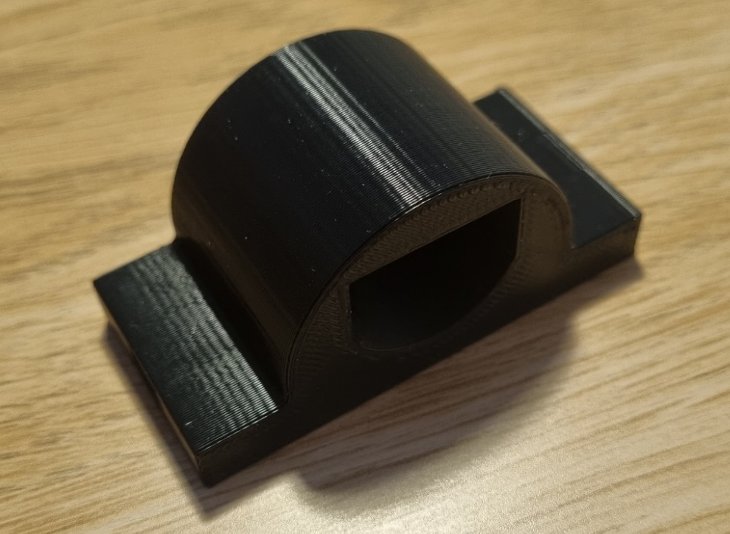

Figure 19 – Clamp to hold the back of the crimping tool to the base plate.
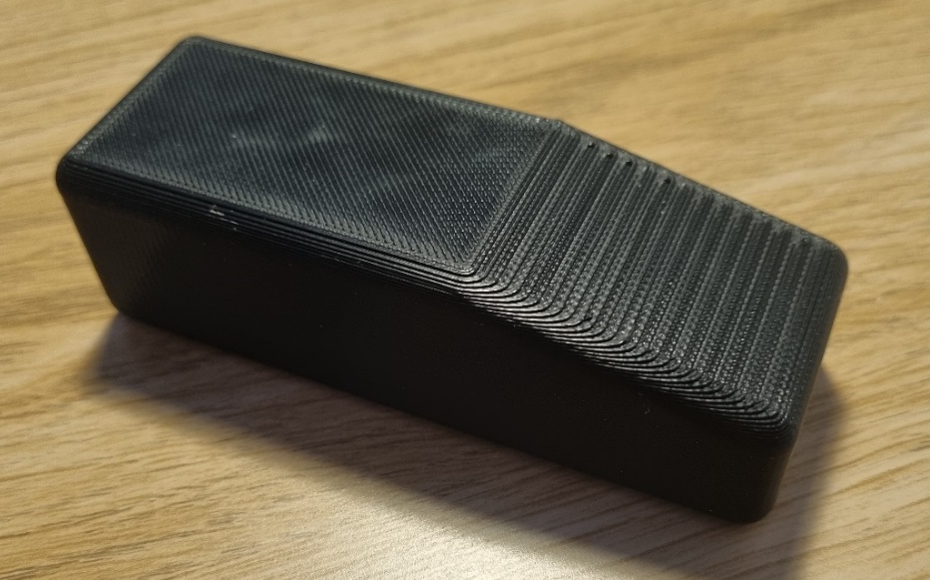

Figure 20 – Handle extender for crimping tool.

After successfully test fitting the prototype prints and then making some quick adjustments for some of the hole positions the CAD models were printed again, this time on the more expensive and accurate printer – Stratasys F170. The material choice was different this time as the priority of material properties had changed, the parts needed to be strong, not flex under force and have good fatigue properties to ensure that the print wouldn’t break after a couple of months of use, this is why ASA (acrylonitrile styrene acrylate) was used. This material is very similar to ABS but has been designed to be better for 3D printing, having better aesthetics, strength properties and being UV resistant (Stratasys.com, 2023). The finished first set of useable prints can be seen in figures 21 and 22 below.
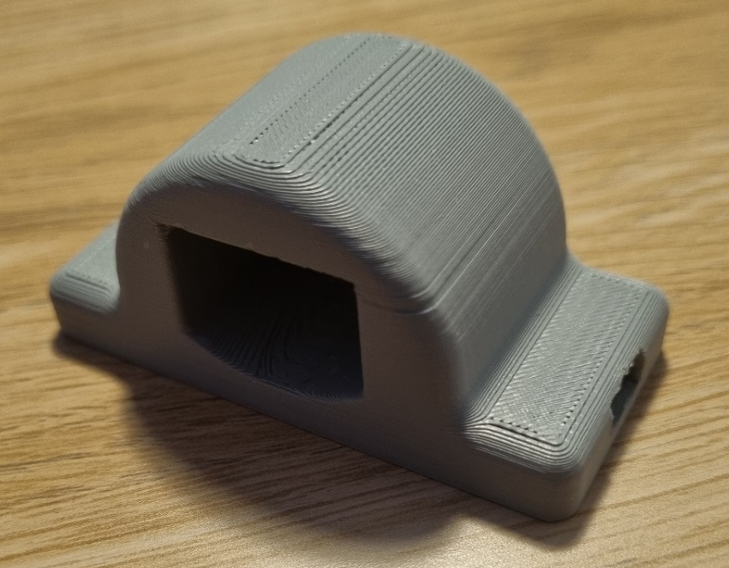

Figure 21 – Re-print of handle clamp.

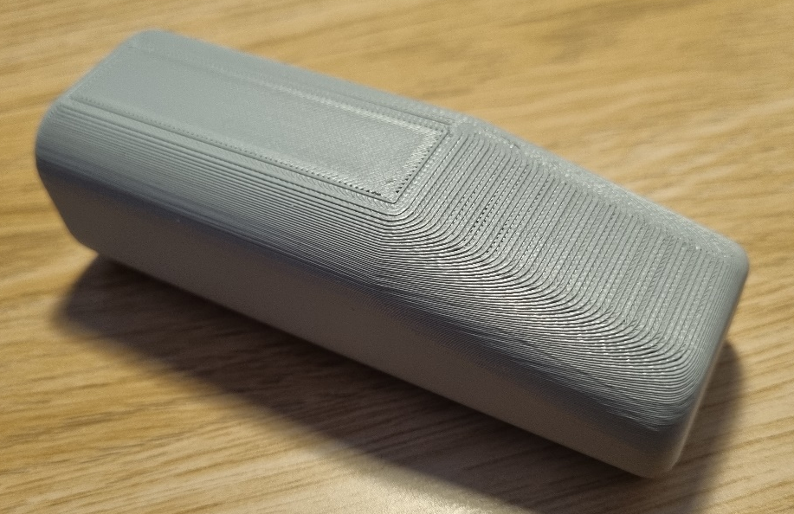

Figure 22 – Re-print of handle extender.

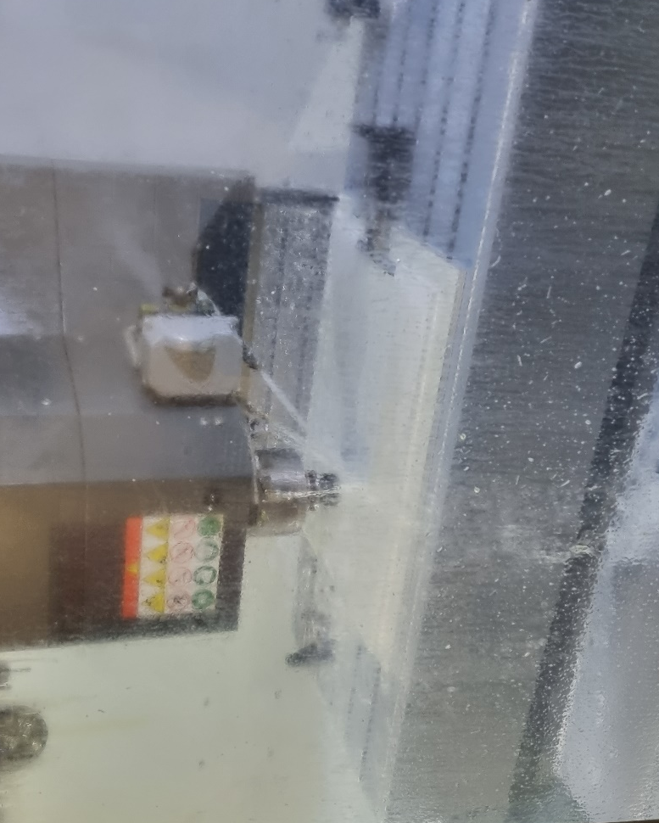
The next stage after successfully printing the parts was to focus on the main base plate. For ease of machining, availability, and lack of requirement for any specific properties (strength to weight etc) the material choice was aluminium. There is often a lot of off cuts/waste from other jobs and to help keep the costs low on this project a waste piece was used for the main base plate. Firstly, the CAD model was loaded into the OneCNC CAM (computer aided manufacture) system, and the tool path program written for the CNC machine. Then the stock material loaded into the machine, the tool list checked, and the machine set to run the program, as can be seen in figure 23.

Figure 23 – CNC machine running the base plate.

All the components were then assembled, and the jig tested for functional use. Due to the cost of the fibre optic leads, only 5 fibre optic leads and connects were signed off for testing, however, as the solution uses the original crimping tool completely unmodified there was no variation in the crimping quality and so 5 tests were enough to be confident in handing the job to the technician for an online test. Figure 24 below shows the finished jig.

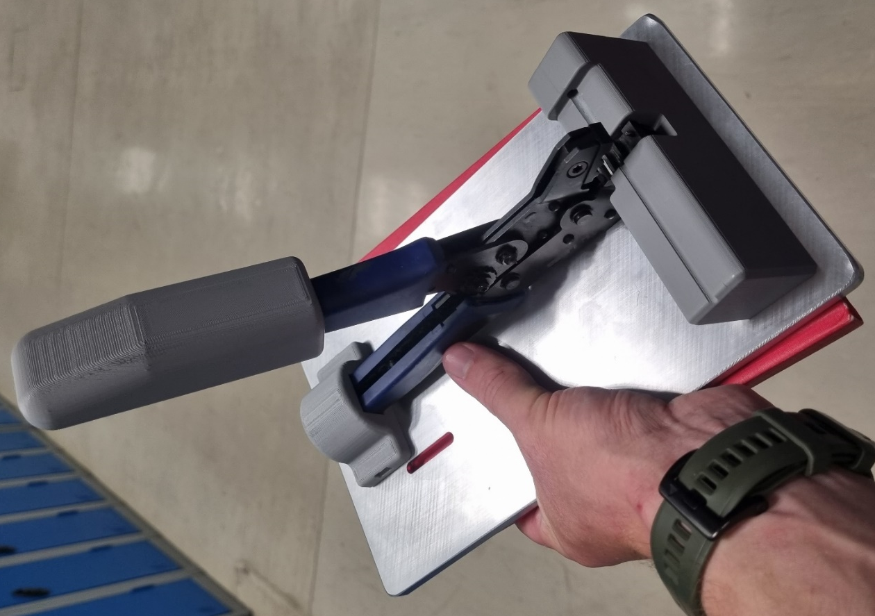

Figure 24 – V2 of the printed parts and V1 of the base plate fully assembled. V1 base plate has unnecessary slots, these will not be on V2.

Note: the connector holding jig was flipped and printed for R/H use.

Effectiveness
As seen in the Gantt chart task list (figure 5) after the technician had used the crimping jig for a while a meeting was organised to analyse the solution and pick away at any of the issues that had arisen.
Overall, the technician was pleased with the jig with the only difficulty being that the crimping tool had too much free movement at the crimp end. The issue was discussed and tested to demonstrate the issue; it was decided quickly that as only ever one size of connector was being crimped that one of the other empty crimping edges could be used as a place to hold the crimp in place.
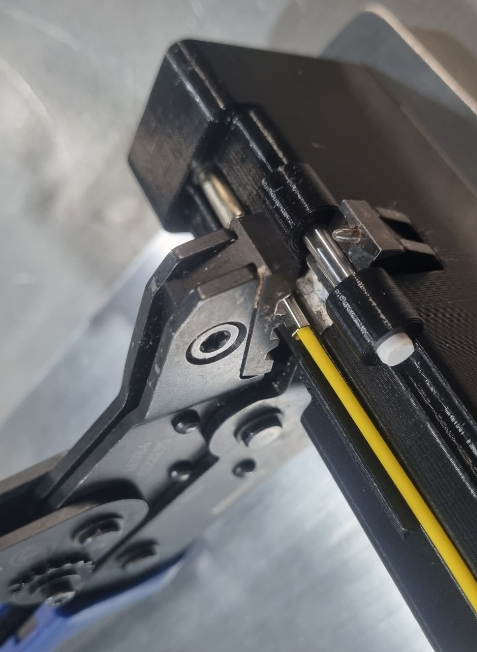
During the modification phase it was remembered that the reason for keeping the end of the crimping tool free to move was to ensure that there could never be a damaging amount of force put onto the connector if it was inserted poorly. With the crimping edges being fixed into place if everything didn’t line up then there could be extra forces on one side compared to the other. Figure 25 below, shows the modified cable holding jig and how it now locks the crimping tool into a semi-free position. At this stage V2 of the base plate was also used.

Figure 25 – the new locking bar that helps to keep the crimping edges in position.

After a re-trial another meeting determined that this had fixed the small issue and the technician was happy to agree that the project had reduced the risks of a repetitive strain injury whilst crimping the connectors.

Project Analysis

Reflection of a project is a vital step that helps to outline the successes and failures in a project, giving weight to the decision on whether the project has been a success overall. This is also the opportunity that gives realisation to the potential opportunities that the project has uncovered as well as identifying the weaknesses that are within the organization/team. This may be regarding resources, budgets, training, or anything else that has held the project back or created a threat to the success of the project.

SWOT on Project
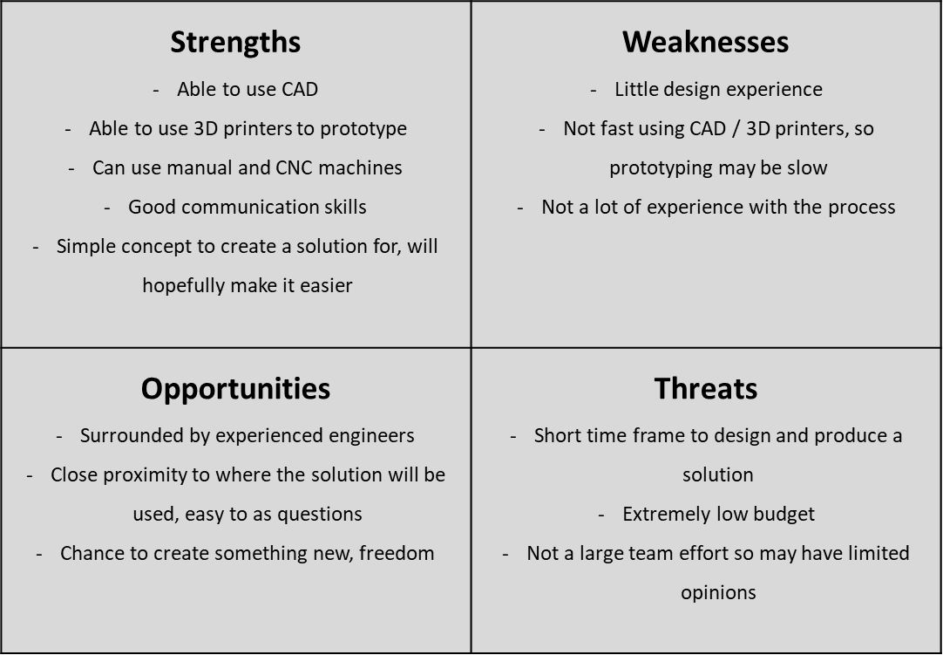
As described by (Kenton, 2023) a SWOT analysis is a simple, yet effective tool for analysing a person or situation for their strengths, weaknesses, the opportunities, and the threats. For this project a SWOT analysis was completed at the beginning and another at the end, the first SWOT (as seen in figure 27) was aimed at looking at the project from an opportunity point of view.

Figure 26 - initial SWOT analysis.
This SWOT analysis was completed at the very start of the project along side creating the Gantt chart, the reason behind this was to identify what things needed to be included in the Gantt chart, for example – allowing extra time for CAD, speaking with the engineers in group discussions and making the most of the ability to prototype. These were all key things, both positive and negative, that were identified in the initial SWOT and then either exploited (positives) or neutralised (negatives) by adding the tasks to the task list/Gantt chart.
The second SWOT was completed at the end of the project, as a reflective analysis to see how things could have been completed differently, this can be seen below in figure 27.
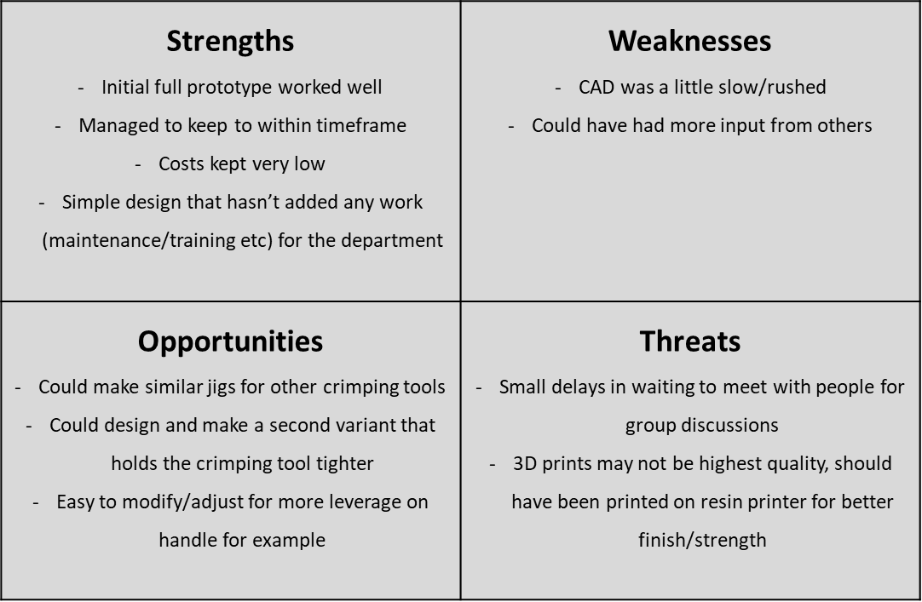
Figure 27 -SWOT analysis completed at the end of the project.
As can be seen by some of the points made in the final SWOT analysis the project has had a lot of good points, although there is room for improvement regarding having more opinions on the designs and potentially using better 3D print methods to minimise the risk of the parts breaking through fatigue.

Changes to Quality
Quality is one of the main focuses at almost every organisation and the implementation of this crimping jig should not have had any negative effect on this. As there is only a couple of batches being made per week, and all by the same person it is mainly the responsibility of the technician to use their experience and expertise to test and monitor failures. For this project this was discussed in the final review with the technician and no quality issues have been raised and no differences in the quality of the crimping has been reported compared to the old method.

Time Management

Projects are well known for usually running over the estimated time, often this can be because of various external delays. However, in this project everything was completed internal, no material needed to be order in and none of the team that had input had sickness/holidays.
Comparing the Gantt chart and the task list that was created at the very beginning of this project it can quickly be said that the project ran according to schedule and only ran late by a day. This was only due to the secondary modification that needed to be made to the cable holding part of the jig to help secure the crimping jaws in a more accurate position. This delay could not have been predicted as the modification was not planned to be needed, although even with this extra day the project still fell within the three-week window that was given by the manager who delegated the project – being completed in two weeks and two days.
Time management is not only about the start and finish of a project, but also about planning resources, defining activities and monitoring progress as explained by Strelca (2022). To compare the actual times compared to the schedules times a timesheet should have been kept – this would have been an ideal way to monitor the accuracy of the Gantt chart and task list. However, for this project it was not completed and so there is little to acknowledge the accuracy. As Taylor Durban was the project leader and completed most of the work personally it can be said that the task list/Gantt chart was mainly accurate, however, more time should have been considered for the CAD models as they were more awkward to create and modify than first thought.

Budget

As stated at the beginning of the task, with no real budget and simply with the goal to complete this task as cheaply as possible it is difficult to have a quantitative measure to determine if the project came in under budget.
The bill for the overall project – excluding labour and fixed overheads – estimated to be around the £25 mark. This is exceptionally cheap and only possible due to the availability of 3D printing and waste aluminium plate that could be recycled. The only other cost for the project was for consumables such as nuts, bolts and washers and a dowel that was added in the final modification – again all of these were available from the assembly room stocks and the low quantities mean that the consumables cost is negligible.
As the project came in within the given timeframe and most of the work was completed by one person – excluding the small amount of time used for brainstorming meetings and evaluation meetings with the technician – there are no hidden additional labour costs to consider.
Another great saving was that the crimping tool was used directly in the final jig, without modification or purchasing any additional parts. These crimps cost near £500 (information found out from the camera area manager) so not needing to purchase another set/make a set of crimping teeth was a great way to minimise the costs.
For these reasons it can certainly be stated that from a budget perspective the project has been successful.

Minimise Health and Safety Risk

The aim of this project was to produce a solution to the reported issue of an RSI risk when crimping the connectors onto a fibre optic cable, this risk has certainly been lowered a great deal as the operation of the crimp is now completely different.
As can be seen in the operation procedure below;
- Assemble the fibre optic lead and the connector
- Slide the open end of the connector into the support sheath
- Insert into the holding jig, carefully lining up the crimping area of the connector into the jaws of the crimp tool
- Hold the cable still and with the other hand use the extra leverage of the crimp handle to close the jaws and crimp the connector
- Release and remove carefully
This change in operation has completely removed the need for manually holding and squeezing the handle of the crimping tool, now it is simply a push downwards. The longer length and more ergonomic grip of the 3D printed handle extender also makes this task much easier and requires less force due to the added mechanical advantage.
There may still be some risks involved due to the large quantities of cables that are crimped at one time, however, with the new jig at least this can be divided between both arms as the small size of the jig means it can be moved around easily, and the need to only push down the handle means that it can be operated by each hand – allowing the user to alternate and remove some of the repetitive strain and further reduce the risk of an injury.

Recommendations

Even considering all the research and techniques used throughout the project there are always opportunities for improvement, as mentioned, a tracker to monitor the progress alongside the Gantt chart would have been an excellent way to see how the project is really progressing – as well as giving the information required to improve future Gantt charts on other projects.
Involving more people, from all aspects of the process would also be an ideal way to ensure that the best possible suggestions get made and that potential opportunities as well as threats are noticed and delt with. Although most of the work in-between discussions has been completed independently - and it could be suggested that this is why the delivery time has been so quick – having more minds to consider the options may have meant that the modification that was made at the very end was noticed earlier on. This could have saved time, money on the re-print as well as any wasted product from poorly crimped connectors.

Conclusion

In conclusion and reviewing the skills and techniques used it can be stated that the project has been a success, the solution that was created to reduce the risk of RSI has been successful and in reference to the initial design brief/specification has been low cost, completed within 3 weeks and not added to the maintenance schedule. The solution is simple to use, has no increased risks compared to the standard method and completes the job to exactly the same quality standard, importantly the crimping tool can also be easily removed and replaced/used manually if needing to do so and is easy to store away.
Feedback from colleagues and the main technician has also been positive, with small improvements recommended; these have taken place and the parts updated accordingly. The simplicity of the design allows for these changes to be quick and easy and means that in the future if other crimping jigs are required then any design changes are easy to complete, and another jig can be created for a different set of crimps.
To reach this outcome well recognised project management and planning techniques have been utilised and specific activities have taken place to gain important information and feedback – such as meetings and brainstorming gatherings. Various analysis methods have also been used, such as SWOT and decision matrix to ensure than non-bias points can be found and relevant software such as CAD as well as additive and reductive manufacturing methods have also been used to ensure that key goals such as cost and time have been achievable.

References
Banister, C. (2018), ‘The 5 Benefits of Brainstorming’, [online]. Available: https://raybourn.com/the-5-benefits-of-brainstorming/ [Accessed – 2023, May, 23].
Caldwell, L and Grobbel, C. (2013), ‘International Journal of Caring Sciences’, The Importance of Reflective Practice in Nursing, 6:3, p319.
D’Aveni, R. (2015), ‘The 3-D Printing Revolution’, [online]. Available: https://hbr.org/2015/05/the-3-d-printing-revolution [Accessed - 2023, May, 23].
Hargrave, M. (2022), ‘Kaizen: Understanding the Japanese Business Philosophy’, [online]. Available: https://www.investopedia.com/terms/k/kaizen.asp [Accessed - 2023, May, 20].
Heaton, S. (2020), ‘ What is a Design Brief and How to Write One’, [online]. Available: https://www.shopify.com/uk/partners/blog/100022086-how-to-write-a-design-brief-to-keep-your-web-design-projects-on-track [Accessed - 2023, May, 14].
Kenton, W. (2023), ‘SWOT Analysis: How To With Table and Example’, [online]. Available: https://www.investopedia.com/terms/s/swot.asp [Accessed - 2023, May, 24].
Mitchell, G. (2022), ‘Gantt Charting: Definition, Benefits, and How They're Used’, [online]. Available: https://www.investopedia.com/terms/g/gantt-chart.asp [Accessed - 2023, May, 08].
Peek, S. (2023), ‘What Is a Decision Matrix? Definition and Examples’, [online]. Available: https://www.businessnewsdaily.com/6146-decision-matrix.html [Accessed - 2023, May, 23].
SonyPencoed. (2023), ‘Sony UK Technology Centre’, [online]. Available: https://www.sonypencoed.co.uk/ [Accessed – 2023, May, 12].
Stratasys.com. (2023), ‘ASA’, [online]. Available: https://www.stratasys.com/uk/materials/materials-catalog/fdm-materials/asa/ [Accessed – 2023, May, 24].
Strelca, A. (2022), ‘Why is project time management important + ways to improve it’, [online]. Available: https://desktime.com/blog/project-time-management [Accessed - 2023, May, 25].
Ultimaker.com. (2023), ‘PLA for S series’, [online]. Available: https://ultimaker.com/materials/s-series-pla/ [Accessed – 2023, May, 24].
Zarah, L. (2023), ‘7 Reasons Why Research Is Important’, [online]. Available: https://owlcation.com/academia/Why-Research-is-Important-Within-and-Beyond-the-Academe [Accessed - 2023, May, 14].

Image References
Figure 8 – pneumatic crimping tool. https://www.amazon.co.uk/Holmesis-Pneumatic-Crimping-Machine-Terminals/dp/B07SQ1LKCQ [Accessed - 2023, May, 14].
Figure 9 – Hand powered crimping tool. https://www.amazon.co.uk/Crimping-Tool-Heat-Shrink-Connectors/dp/B07GFXHH91 [Accessed - 2023, May, 14].

