Sandra Ghinescu
2118454
Proposed Research Title:
The Impact of Hybrid Working on Employee Motivation, with Special Reference to Zurich Insurance
Name of the University:
University of Wales Trinity Saint David (London Campus)
Submission Date:
21.08.2024

Table Of Contents
Introduction 3
Contextual Background 3
Problem Statement 3
Proposed Aim, Objectives, and Research Questions 3
Literature Review 5
Definition and Characteristics of Hybrid Working 5
Theoretical Framework 5
Positive Impacts on Employee Motivation 5
Negative Impacts on Employee Motivation 6
Existing Research Gaps 6
Research Methodology and Methods 8
Research Onion Framework 8
Research Philosophy 8
Research Approach 9
Research Design 9
Data Collection 9
Sampling 9
Data Analysis 10
Ethical Consideration 11
Time Horizon 11
References 12

Introduction

Contextual Background
Another emerging model that has become popular in the present day working environment is the hybrid model where employees work from the office and other locations such as from home (Diab-Bahman and Al-Enzi, 2020). This model is relatively flexible and attempts at enhancing the work-life balance and this has advantages as well as disadvantages in enhancing the motivation of the employees. A study conducted by Microsoft in 2021 showed that a majority of the workers, that is 71% of them, wish to have flexible working arrangements after the pandemic, and 66% of employers are adapting their workplaces to support hybrid working (Microsoft, 2021). However, the transition is not without certain challenges, for example, the decrease of productivity and the increase of loneliness (Lim, Eres and Vasan, 2020). Zurich Insurance is one of the organisations that has embraced the hybrid working model with the view of improving the levels of employee engagement and productivity. The purpose of this research is to investigate the impact of hybrid working on motivation in the employees of Zurich Insurance Company as well as examine the advantages and disadvantages of the hybrid work model and how to improve motivation.

Problem Statement
Prior studies on hybrid working have predominantly focused on the positive effects of the model, for instance, enhanced flexibility and work-life balance (Grzegorczyk et al., 2021; Gorjifard and Crawford, 2021). However, there appears to be a lack of clear understanding of the effect of culture on employee motivation in the insurance industry, especially in Zurich Insurance Company. Though Oppong Peprah (2024) pointed out some possible drawbacks including loss of efficiency and enhanced loneliness, author did not elaborate on how these impacts influence the motivation level of the employees. This research seeks to address this gap by examining the implications of hybrid work arrangements on the motivation of employees at Zurich Insurance. Thus, the research will contribute to the understanding of an underexplored area and offer practical recommendations to improve hybrid work policies to increase employees’ engagement and productivity.

Proposed Aim, Objectives, and Research Questions
Aim:
To examine the impact of hybrid working on employee motivation, with a specific focus on Zurich Insurance.
Objectives:
- To review the literature on how hybrid working impacts employee motivation.
- To investigate the positive impacts of hybrid working on employee productivity at Zurich Insurance.
- To investigate the negative impacts of hybrid working on employee productivity at Zurich Insurance.
- To provide recommendations for Zurich Insurance to improve employee motivation in a hybrid work setting.

Literature Review

Definition and Characteristics of Hybrid Working
The current trend in the workplace is the increased use of hybrid work, which entails the split between remote and on-site work, and has been greatly influenced by the COVID-19 pandemic (Wontorczyk and Rożnowski, 2022). As depicted by Davidescu et al. (2020) hybrid work is flexible in nature and allows employees to select their working environment depending on the task and their preference. This is quite a shift from conventional work models that are based on office settings and has led to a lot of research with an aim to understanding the effects of such flexibility on different aspects of work life, including motivation.

Theoretical Framework
The theory that this study shall build on is the Herzberg’s Two Factor Theory. This theory is based on two factors; the motivators which make the employee satisfied in his or her job, and the hygiene factors which if not met make the employee dissatisfied (Herzberg, 1968). Thus, utilising Herzberg’s Two-Factor Theory in the context of hybrid working at Zurich Insurance Company, one can gain a better understanding of how altering the work environment and conditions affects motivation. Incentives including achievement, recognition and the work itself can also be affected by hybrid work since employees are likely to be more independent and flexible. On the other hand, hygiene factors such as company policies, supervision and working conditions are equally crucial. Further, it has been noted that when the management is engaging in an effective communication, implementing supportive policies, and providing adequate supervision, the employees working in a hybrid model will be satisfied with their job while the absence of these factors will lead to dissatisfaction. With these factors in mind, this study seeks to offer findings and suggestions for enhancing employee motivation in the context of Zurich Insurance’s hybrid work model.

Positive Impacts on Employee Motivation
Based on the 2021 Microsoft Work Trend Index, more than 70% of the employees surveyed indicated that they would like to continue working from home after the pandemic, which supports the hybrid model of work (Microsoft, 2021). This preference is due to several reasons. First of all, as it was mentioned by Grzegorczyk et al. (2021), hybrid working reduces the time people spend on commuting and opens the opportunity for employees to organise their time and conflicts between work and personal life. This can mean higher job satisfaction and motivation since everyone is more or less on the same level.
Furthermore, it is possible to argue that hybrid working enhances the subject’s feelings of control over their work environment, which, as Bloom, Han and Liang (2022) pointed out, is one of the key factors that inspire intrinsic motivation. Workers who are allowed to select their working location and hours feel more encouraged and involved in their work than those who do not have such options. Mujtaba and Lawrence (2024) found that remote working boosted performance by 13% and turnover by a massive 50%, meaning that there are potential benefits to both productivity and retention from a hybrid model of working.

Negative Impacts on Employee Motivation
Although, hybrid working has some advantages, it also has some disadvantages that may demotivate employees in the workplace. There is a potential for loss of social contact and consequently, feelings of loneliness and isolation in which people can easily become isolated from the rest of the society. According to Ozcelik and Barsade (2018), workers are likely to miss the opportunity of interacting directly with other people in the workplace, which may cause feelings of isolation. This isolation often reduces the morale and motivation of the employees especially for the social butterflies.
In addition, while hybrid working is supposed to help establish a proper boundary between work and personal life, the opposite is often the case and leads to work-life imbalance and burnout (Stasiła-Sieradzka et al., 2023). The disadvantages of hybrid working include longer working hours or the feeling of being available all the time, which is detrimental to employees’ health and morale. Moreover, the management of a hybrid workforce can be difficult for the supervisors as they may have difficulties in maintaining equal support and resources for the remote and the on-site workers (Wontorczyk and Rożnowski, 2022).

Existing Research Gaps
Although there is a considerable body of research on the subject of hybrid work (Winkelbach and Walter, 2015; Diab-Bahman and Al-Enzi, 2015), these studies lack an analysis of the particular consequences of this mode of work on motivation in insurance companies like Zurich Insurance. Prior research has been conducted mainly on technology companies or general offices, which means there is a lack of industry-specific knowledge (Winkelbach and Walter, 2015). Furthermore, research such Abomeh and Peace (2015) and Diab-Bahman and Al-Enzi (2015) offer useful information on productivity and social interaction but fail to thoroughly assess how they affect motivation specifically in the insurance industry.

Research Methodology and Methods

Research Onion Framework
In this research study, the research methodology will be based on Saunders’ Research Onion which is a framework that outlines various layers of research (Melnikovas, 2018). The first layer encompasses the research philosophies, while the second layer focuses on the research approaches. The next layer contains methods that define the ways in which the research can be carried out based on the selected area of interest (Saunders, Lewis and Thornhill, 2009). The choice of methods layer involves deciding whether to use mono-method, mixed-methods or multi-methods approaches. The next layer is time horizon that asks if the study is going to be cross-sectional or longitudinal. The core layer is centred on methods and methods of data gathering and data analysis to guarantee that the research questions have been tackled comprehensively and methodically.
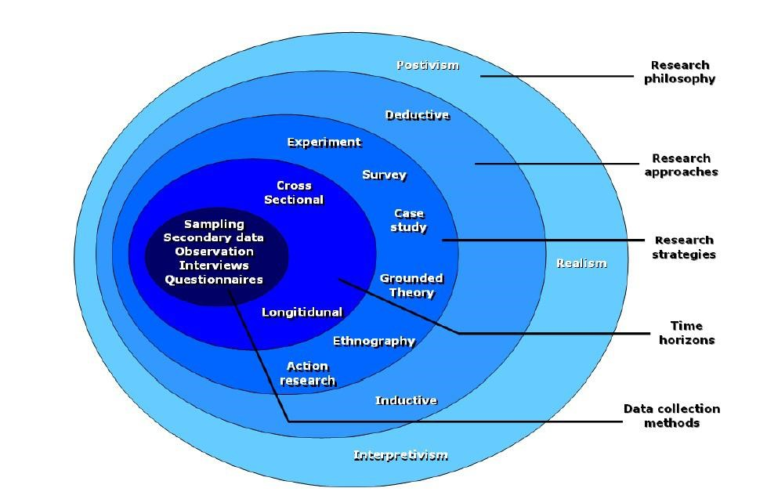
Figure 1 - Research Onion (Source: Melnikovas, 2018)

Research Philosophy
To accomplish the objectives of this study, the research philosophy that will be used is positivism because the data collected will be factual and the outcomes will be quantifiable (Alharahsheh and Pius, 2020). This method is most appropriate for the study because it shall help in the establishment of the impact of hybrid working on the motivation of Zurich Insurance employees through quantifiable variables and statistical analysis. Thus, the positivism approach will assist in the identification of data and analysis of the motivational effects in the insurance industry. This will ensure that the study will be able to come up with measurable and specific factors that will define the motivation of employees in both the physical and the remote working environments.

Research Approach
This research will use a deductive approach and thus data will be collected through the testing of the hypotheses developed from theories. It is appropriate to use the deductive approach as it will facilitate the testing of theories and hypotheses by analysing quantitative data, which is crucial for assessing the impact of hybrid working on employees’ motivation at Zurich Insurance (Pellegrino and Glaser, 2021). A theory generation through an inductive approach is not suitable for this study since it aims at testing theories in a well-defined field of research.

Research Design
The research questions will be answered most effectively through the use of quantitative research design. Quantitative research is the scientific study of variables with numerical data by collecting and analysing numerical information (Mohajan, 2018). This approach is especially useful in the context of the current research as it enables the researcher to measure the motivational levels of employees and analyse the obtained data for patterns and relationships so that the impact of hybrid working on motivation at Zurich Insurance could be better comprehended.

Data Collection
The type of data collection techniques that will be used in this research study will be of primary data collection only. The primary data collection method will be an online questionnaire with closed-ended questions. Ultimately, each participant is expected to spend about 15- 20 minutes in answering the questions of the survey. This method will help to achieve the stated objectives and research questions by quantifying the impact of hybrid working on the motivation of the workers at Zurich Insurance. The online survey will assist the researcher in getting efficient and standardised answers from the target population of employees as well as cast the net wider than in the case of a traditional survey.

Sampling
This study will employ convenience sampling, and 100 participants will be chosen based on their willingness to participate in the study. Convenience sampling is a type of non-probability sampling technique in which subjects are selected based on the easiness of their accessibility to the investigators (Winton and Sabol, 2022). This approach is preferred as it enables the collection of a large number of opinions on the impact of hybrid working on the motivation of the employees of Zurich Insurance within the time duration of the study.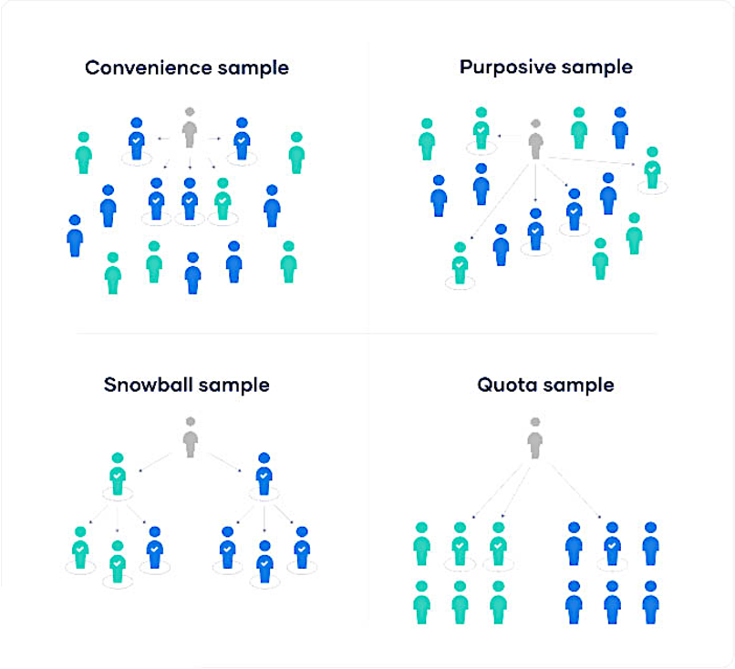
Figure 2 - Convenience Sampling in Comparison to All Other Non-Probability Sampling Techniques (Source - Baidya, 2023)

Data Analysis
The primary data gathered will be analysed employing SPSS software applying frequency, correlation, and regression analysis out of the collected data. Descriptive statistics such as frequency analysis will be utilised to present the pattern of the responses obtained from the given data set. Correlation analysis will establish the existence and the degree of the relationship between variables. Through regression analysis, it will be possible to establish the effect of hybrid working on employee motivation by outlining predictors and evaluating their effects on the dependent variable. This approach will be used because it will enable the researcher to quantify and statistically test the relationships and effects and thereby present a sound analysis of the impacts of hybrid working on employee motivation at Zurich Insurance.

Ethical Consideration
The ethical issues that will be addressed in this research study will include informing the participants of the study and obtaining their consent to participate in the study. All the participants will be anonymised, and to respect participants’ anonymity, any sensitive data will be protected. The research objectives and participants’ rights, including the right to withdraw from the study at any time, will be described to all participants. Ethical considerations will be observed at all stages for the duration of the study.

Time Horizon

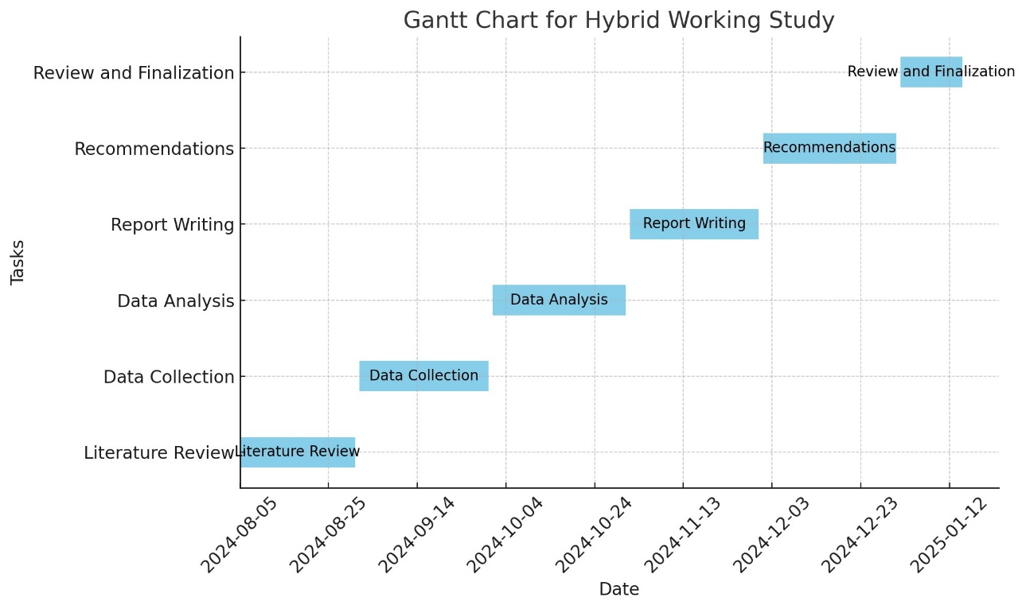
Figure 3 - Timeline

References
Abomeh, O.S. and Peace, N.N. (2015) 'Effects of training on employees’ productivity in Nigeria insurance industry', British Journal of Economics, Management & Trade, 7(3), pp. 227-235.
Ajayi, V.O. (2017) ‘Primary sources of data and secondary sources of data’, Benue State University, 1(1), pp.1-6.
Alharahsheh, H.H. and Pius, A. (2020) ‘A review of key paradigms: Positivism VS interpretivism’, Global Academic Journal of Humanities and Social Sciences, 2(3), pp.39-43.
Baidya, T.K. (2023) AGILE PROJECT MANAGEMENT AND ITS EFFICACY: A CASE STUDY ON BANGLADESHI SMALL AND MEDIUM SIZED ENTERPRISE. Available at: https://www.researchgate.net/profile/Tushar-Baidya/publication/371006859_AGILE_PROJECT_MANAGEMENT_AND_ITS_EFFICACY_A_CASE_STUDY_ON_BANGLADESHI_SMALL_AND_MEDIUM_SIZED_ENTERPRISE_A_dissertation_submitted_for_the_degree_of_Master_of_Science_in_Project_Management/links/646ea0de8bf29018ccbd0a4f/AGILE-PROJECT-MANAGEMENT-AND-ITS-EFFICACY-A-CASE-STUDY-ON-BANGLADESHI-SMALL-AND-MEDIUM-SIZED-ENTERPRISE-A-dissertation-submitted-for-the-degree-of-Master-of-Science-in-Project-Management.pdf (Accessed: June 26, 2024).
Bloom, N., Han, R. and Liang, J. (2022) 'How hybrid working from home works out' (No. w30292). National Bureau of Economic Research.
Davidescu, A.A., Apostu, S.A., Paul, A. and Casuneanu, I. (2020) 'Work flexibility, job satisfaction, and job performance among Romanian employees—Implications for sustainable human resource management', Sustainability, 12(15), p. 6086.
Diab-Bahman, R. and Al-Enzi, A. (2020) 'The impact of COVID-19 pandemic on conventional work settings', International Journal of Sociology and Social Policy, 40(9/10), pp. 909-927.
Gorjifard, R. and Crawford, J. (2021) 'Working from home: Impact on wellbeing and work-life balance', New Zealand Journal of Employment Relations, 46(2), pp. 64-78.
Grzegorczyk, M., Mariniello, M., Nurski, L. and Schraepen, T. (2021) 'Blending the physical and virtual: a hybrid model for the future of work' (No. 14/2021). Bruegel Policy Contribution.
Lim, M.H., Eres, R. and Vasan, S. (2020) 'Understanding loneliness in the twenty-first century: an update on correlates, risk factors, and potential solutions', Social Psychiatry and Psychiatric Epidemiology, 55, pp. 793-810.
Melnikovas, A. (2018) ‘Towards an Explicit Research Methodology: Adapting Research Onion Model for Futures Studies’, Journal of futures Studies, 23(2).
Microsoft. (2021) 'The Next Great Disruption Is Hybrid Work – Are We Ready?', Microsoft Work Trend Index. Available at: https://www.microsoft.com/en-us/worklab/work-trend-index/hybrid-work (Accessed: 02 August 2024).
Mohajan, H.K. (2018) ‘Qualitative research methodology in social sciences and related subjects’, Journal of economic development, environment and people, 7(1), pp.23-48.
Mujtaba, B.G. and Lawrence, E.T. (2024) 'Workplaces of Today and Tomorrow to Attract and Retain Top Talent: Challenges and Opportunities with Remote/Hybrid Practices', SocioEconomic Challenges (SEC), 8(2).
Nundulall, R. (2017) ‘Online Research Output Submission System as a mechanism to influence publication citations: A pilot study’, South African Journal of Information Management, 19(1), pp.1-12.
Oppong Peprah, E. (2024) 'Hybrid workplace: current status, positives, negatives, challenges, and team learning', The Learning Organization, 31(1), pp. 88-103.
Ozcelik, H. and Barsade, S.G. (2018) 'No employee an island: Workplace loneliness and job performance', Academy of Management Journal, 61(6), pp. 2343-2366.
Pellegrino, J.W. and Glaser, R. (2021) ‘Components of inductive reasoning’, In Aptitude, learning, and instruction (pp. 177-218). Routledge.
Saunders, M., Lewis, P. and Thornhill, A. (2009) ‘Research methods for business students’, Pearson education.
Sileyew, K.J. (2019) Research design and methodology (Vol. 7). Cyberspace.
Stasiła-Sieradzka, M., Sanecka, E. and Turska, E. (2023) 'Not so good hybrid work model? Resource losses and gains since the outbreak of the COVID-19 pandemic and job burnout among non-remote, hybrid, and remote employees', International Journal of Occupational Medicine and Environmental Health, 36(2), p. 229.
Terry, G., Hayfield, N., Clarke, V. and Braun, V. (2017) ‘Thematic analysis’, The SAGE handbook of qualitative research in psychology, 2(17-37), p.25.
Walliman, N. (2017) ‘Collecting Primary Data’, In Research Methods: The Basics (pp. 105-130). Routledge.
Winkelbach, A. and Walter, A. (2015) 'Complex technological knowledge and value creation in science-to-industry technology transfer projects: The moderating effect of absorptive capacity', Industrial Marketing Management, 47, pp. 98-108.
Wontorczyk, A. and Rożnowski, B. (2022) 'Remote, hybrid, and on-site work during the SARS-CoV-2 pandemic and the consequences for stress and work engagement', International Journal of Environmental Research and Public Health, 19(4), p. 2400.
Wontorczyk, A. and Rożnowski, B. (2022) 'Remote, hybrid, and on-site work during the SARS-CoV-2 pandemic and the consequences for stress and work engagement', International Journal of Environmental Research and Public Health, 19(4), p. 2400.

