05/11/2022

Improving Organisational Performance; An Analysis.

Robert Yeo (2000752)

Introduction
How do you improve an organisations performance? With every organisation being different, what “levers” can managers pull to help improve their organisation’s performance? What are the best choices to be made given that every organisation is different? This analysis describes how organisational structure, culture and cooperation with stakeholders are the key drivers of organisational performance and how managers can optimise each aspect for certain situations.
Organisations are a collective of individuals that have a common goal in mind (Maduenyi, Oluremi Oke, Fadeyi 2015). These individuals have separate tasks that will help organisations obtain this goal. Although through this sub goals will emerge when smaller units emerge within the organisation due to its growing size. With every organisation being different due to size, age, legal form, economic environment and goals. How should managers influence and help improve organisational behaviour, organisational structure and cooperation with stakeholders, so performance is optimised for the specific situation?
Organisational structure is the formal lines of communication and responsibility in an organisation, and it sets the foundation of how an organisation works. This will allow employees to have a clear view of the organisation and where they sit.
Organisational culture is the personality of the organisation it is a combination of its beliefs, values and attitudes. It is what drives and motivates employees within the organisation to work well. It also influences the external stakeholders’ attitude towards the organisation in how they think about and treat the organisation.
Cooperation with stakeholders is the interaction with individuals affiliated with the organisation, both within and outside. It is about how well an organisation can best communicate and work with these individuals depending on the circumstance.
Optimisation always requires careful tuning between organisational structure, culture and cooperation with stakeholders. They all work together to produce a good work environment for an organisation. They need to be holistically tuned so they work together to create the perfect performance scenario.
An organisation is never static, it is always developing and changing even within a short time span of say three years. Over the past three years, as an example, organisations have drastically changed becoming more dependent on technology due to the emergence of Covid 19. When the environment around the organisation changes, managers need to adjust the performance “levers”.
Stability too is important requirement for organisational performance since without it an organisation’s changes to organisational structure, culture and cooperation with stakeholders does not have time to settle and reap the benefits. Employees will find it difficult to adapt to these potentially drastic changes to their work environment as not everybody is open to change. There for, time is required for these changes to be implemented and to take effect.
Communication is greatly required for an organisation. Organisational structure, culture and stakeholder cooperation all look at in some aspect. Employees will need to learn how to best communicate with their boss and pears or else there will be no direction to their work.

Main Points

Organisational Structure
An organisation’s structure has a strong impact on its performance. It provides the organisations circuit diagram for information flow and processing. According to (Mullins 2016 pg 395) “the effective management of people is the requirement for a clear understanding of the nature of the business in which the organisation is engaged”. It is strong because it will help employees understand their place in the organisation, where they can get support and motivate them to move up this hierarchy that’s given to them.
Over the course of the 19th and 20th centuries many different organisational structures have emerged to meet the different organisational requirements involving business processes, functional expertise requirements and scales of centralisation or decentralisation. Different structures include centralised hierarchies, decentralised hierarchies, matrix structures and network organisations. Each organisation’s structure should match the objectives of the organisation itself. In the case of the construction company, matrix or network organisation could benefit it.
A hierarchical organisation is a pyramid where everyone has a boss above them. They are typically found in “command and control” organisations such as the military and some older based companies where orders come from the top and are expected to be executed quickly. Hierarchical organisations can be built from many smaller hierarchies.
Matrix organisations combine a group of people who are all focused on delivering a common business objective where the members come from different specialisms. These different specialisms have their own structure to encourage depth of expertise and career opportunities. Matrix organisations combine the best of both worlds but can add extra costs to the organisation.
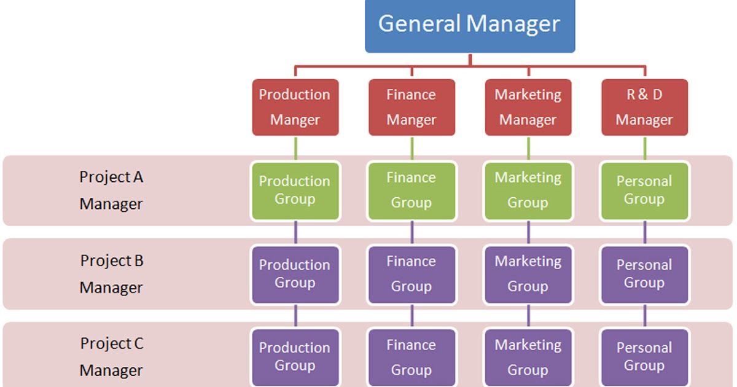
(Brooks 2018 pg 222) says matrix organisations “can help to push forward progress on a number of fronts simultaneously and allow staff to reap the benefits of working together in a functional areas”. Matrix structures are particularly useful when an organisation is presented with multiple projects across multiple functions.
Management Studies: Matrix Organization Structure | Usefulness of Matrix Organization Structure (analysisproject.blogspot.com)
A network organisation is temporary group of people with the necessary skills and capabilities to deliver a specific business objective within a certain time frame. The people are taken from functional specialisms full time or part time for the duration of the project. One of the members can be the leader for accountability. This type of organisation is typically found in project orientated industries like consulting or construction.
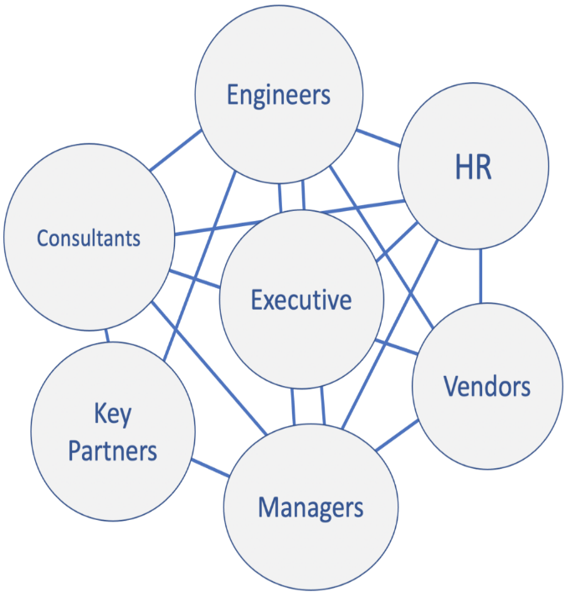
(Brooks 2018 pg 226) states for network organisations “a small core organisation coordinates an ever-changing set of legally and geographically separate organisation in pursuit of clear goals”. This means that a network structure can allow flexibility, better stakeholder communications and process alignment for an organisation with few extra costs.
https://pingboard.com/blog/types-business-organizational-structures
For the construction organisation in the Organization Development Journal article from Rick Goldstein & Greg Behm, the network organisation structure could be a suitable solution for the business. It would address issues mentioned such as “many managers had a limited understanding of what other functions did and how they did it.” and “What became clear in these discussions was that better cross-functional process execution in their core operations was the key to increasing customer satisfaction, quality, and profitability”.

Organisational Culture
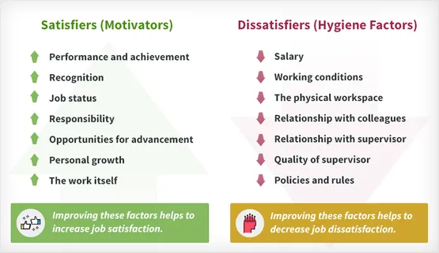
“Organization culture is an amalgam and summary of what is done within an organization, how it is done and why it is done” (Pettinger 2010 pg 313). It is the least tangible but can be the most important aspect of an organisation’s performance. It is the personality of the organisation and defines how an organisation behaves and reacts to environmental stimuli. Without it, employees would lack job satisfaction (McLean & Mullins 2019) this will affect the organisation with its performance, its reputation and its future success. To change an organisational culture will take a lot of time due to it being slow to change, requiring a change to the mindset of the employees of the organisation. There are many theories and models regarding the motivation of employees within an organization such as Herzberg’s two- factor theory.
https://www.simplypsychology.org/herzbergs-two-factor-theory.html
This theory recognizes that amongst having to show positive motivators when creating a work culture, you also have to reduce negatives in that culture with good “hygiene” which is the direct environment surrounding the employees. With a lack of hygiene employees will eventually become demotivated even with many satisfiers, in which a focus on reducing dissatisfiers takes priority.
Another key feature of organisation culture is management behaviour. Good managers lead by example and employees will absorb their behaviours and beliefs. This is supported by (Brunet-Thornton & Stanislav 2017) managers are meant to support and encourage employees to make their mission clear so then a positive change will emerge in organisational culture. With this he is saying that in order for an organisation to make changes in an organisations culture, they must be effective with being a leader amongst their team.
When employee’s values align with the organisation it can strongly benefit culture. (Judge 2017) say that to have an effective team you must hire individuals with similar values to the company so then they have the right drive to work with them. With aligning values, the employees will remain satisfied and committed to the organisation.

Cooperation with Stakeholders
Amongst organisational structure and organisational culture, stakeholder cooperation is key to a successfully led organisation. According to Elizabeth Harrin (2020) stakeholder management is identifying the right individuals to engage with and how to engage with them. It is about the formal and informal lines of communication amongst people involved with the organisation.
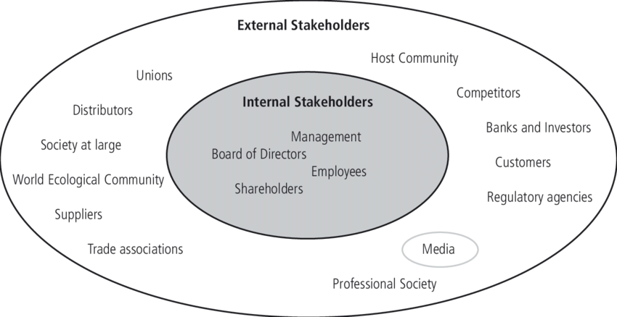
Organisations have internal and external stakeholders. Internal stakeholders are the individuals directly associated with the organisation such as employees, shareholders and managers. External stakeholders are people involved on the outside of the company including suppliers, competitors and customers.
Cecilia Mark-Herbert Carolina von Schantz, (2007)
Internal stakeholders are some of the most important parts to focus on as they run the organisation. Communication with internal stakeholders will “help employees make sense of the organisation, its strategies, and policies” (Bowen & Linjaun Men 2017 pg1). With employees and managers learning their stakeholders and the relationships that they have with them; it will improve communication throughout the company. With this in mind, it will develop trust between employees and teams in organisations (Polat et al 2018). If internal communication is done successfully an organisation will run smoothly.

Not all stakeholders are the same, they have different roles and require different communication methods. The RACI model is a useful framework for stakeholder management and communications. RACI stands for: responsible, accountable, consulted and informed. It helps stakeholders understand their roles and how they should be communicated with in a project.
- Responsible – Does the work
- Accountable – Approves the work
- Consulted – Expertise needed for the work
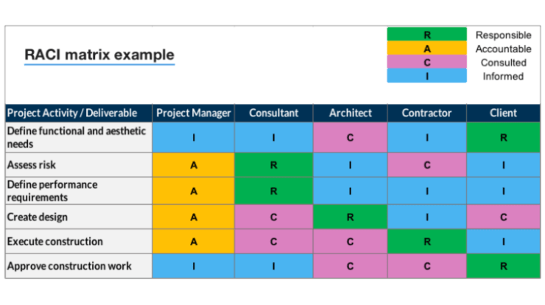
- Informed – Kept up to date with the relevant information
https://pmtips.xyz/2020/06/21/stakeholder-analysis-using-raci-charts/
The RACI model will help communication between all the various stakeholders participating in the work. The model also shows clearly how stakeholders should be communicated with and at what stage of the project. From this it will benefit organisations internal and stakeholder communication therefore making cooperation greater.
Drawing from all the points, communication will boost cooperation with stakeholders. Identifying and understanding communication methods with the stakeholders will improve motivation, trust and the effectiveness of the teamwork. Management will have an easier time controlling and managing teams. External stakeholders will get improved relationships with the organisation.

3.0 Conclusion
Overall, it is clear that organisational structure contributes to the formal communication and improves teamwork. Organisational culture improves motivation from employees within the organisation. Cooperation with stakeholders improves the informal communication lines both within and outside of the organisation. All define a key part in organisational performance. By thinking that one is more important than the rest is untrue since the mixture is what improves the performance of an organisation. Understanding the formal structure of the company will improve efficiency and communication within the company. Having a well-managed culture with good hygiene will keep employees motivated and will stop them being discouraged in the long term. Good stakeholder cooperation will improve efficiency and stakeholders’ willingness to cooperate with the organisation, both internal and external. This amalgam will improve the efficiency, communication and work ethic of an organisation.
A key focus for the organisation is to make sure that it adapts to changing situations. To adjust and to tune the key elements so then it can reap the benefits of good performance.
Even so, there are certain limitations to this report. The majority of the references are very much looking at western companies and are sources and may include “western bias” in terms of the ideal workplaces. Another limitation may include the use of a single library and the lack of viewpoints from sources. Also, the due to recent events such as the rise of Covid 19 forming the increase of use of technology with communication such as Zoom and Teams. May have changed the relevancy of the sources that are pre-covid.

4.0 References
- Sylvia Maduenyi, Adunola Oluremi Oke, Olatunji Fadeyi, Akintude M. Ajagbe (1 January 2015) Impact of Organisational Structure on Organisational Performance, Covenant University Repository, CU-ICADI PROCEEDING.pdf (core.ac.uk) (Last visited 13/11/2022)
- Mullins, L.J. (2016) Management & organisational behaviour. Eleventh edition. Harlow, England ;: Pearson.
- Brooks, I. (2018) Organisational behaviour individuals, groups and organisation. 5th ed. Harlow: Pearson.
- Management Studies: Matrix Organization Structure | Usefulness of Matrix Organization Structure (analysisproject.blogspot.com) (Last visited 05/11/2022)
- 2021 Pingboard Inc., (2021) https://pingboard.com/blog/types-business-organizational-structures (Last visited 05/11/2022)
- Pettinger, R. (2010) Organizational behaviour : performance management in practice. 1st ed. Abingdon, Oxon: Routledge. Available at: https://doi.org/10.4324/9780203857595
- Mullins, L.J. and McLean, J.E. (2019) Organisational behaviour in the workplace. Twelfth edition. Harlow, England ;: Pearson.
- Charlotte Nickerson, (16/11/2021 https://www.simplypsychology.org/herzbergs-two-factor-theory.html (Last visited 06/11/2022)
- Hása, S. and Brunet-Thornton, R. (2017) Impact of organizational trauma on workplace behavior and performance. Hershey, Pennsylvania: IGI Global.
- Robbins, S.P. and Judge, T. (2017) Organizational behavior / Stephen P. Robbins, Timothy A. Judge. 17 edition, Global edition. Harlow: Pearson
- Harrin, E. (2020) Engaging stakeholders on projects : how to harness people power. Princes Risborough, Buckinghamshire: Association for Project Management
- Men, R.L. and Bowen, S.A. (2017) Excellence in internal communication management. First edition. New York, New York (222 East 46th Street, New York, NY 10017): Business Expert Press.
- Polat, V. et al. (2018) ‘Formal and Informal Communication in New Product Development Teams: The Mediation Effect of Team Trust’, International Journal of Innovation (São Paulo), 6(2), pp. 97–111. Available at: https://doi.org/10.5585/iji.v6i2.245
- Cecilia Mark-Herbert Carolina von Schantz, (2007), Communicating Corporate Social Responsibility – Brand management, EJBO - Electronic Journal of Business Ethics and Organization Studies, Vol. 12 (2) http://ejbo.jyu.fi
- Anuj Seth, (2022), Stakeholder analysis using RACI charts | Project Mangement Tips (pmtips.xyz) (Last visited 10/11/2022)

5.0 Contents
1.0 Introduction 1
2.0 Main Points 2
2.1 Organisational Structure 2
2.2 Organisational Culture 4
2.3 Cooperation with Stakeholders 5
3.0 Conclusion 7
4.0 References 8
5.0 Contents 9

