Cover Page:


University of Wales Trinity Saint David

Certificate or high education – skills for the workplace

Module
Digital skills and research methods
(BMSW4003-CARD)
Website designing report for final Assignments
Lecturer: Christin Felices
Student: Mohamed Babeker Osman Ahmed
Student ID: 2112126
November2022

Table of Contents:
Contents
1.0 Cover Page: 1
1.0 Table of Contents: 2
2.0 Introduction: 3
3.0 Findings: 3
3.1 Why primary research is important for businesses? 3
3.2 Analysis of the questionnaire data and impacts: 4
3.3 Webpages and website design: 7
7.0 References: 12

Introduction:
Login details:
2112126@student.uwtsd.ac.uk
Password: dob.22.02.82

Within this introduction, in this report we will talk about three main highlights which are finding. A questionnaire has been conducted for a business idea and the responses ware variety. we will be analyzing the primary questionnaire data to identify trends and pertinent information and the responses from that questionnaire.
The information obtained from the questionnaire has helped us to believe that the websites are often the first interaction a customer has with the business in modern commerce.

Findings:

Why primary research is important for businesses?

The most important thing to focus on when it comes to search optimization is the "true user experience," says (Haley, 2022). Research we conducted suggests that brands play meaningfully different roles in setting and startup our business. settings due to various market and tasks that influence the process of management in decision making (JONES, and MITCHENER, 2016). Identifies key differences between business and customer as well as concludes that these differences generally offer a reduced role for the business brands, when comparing to other businesses and companies. Because of understanding when the brands are more or less, its likely to influence buyer decision-making. It is critical for us to achieve performance from business’s brand-building, to bay efforts and it’s also strategically important for next step in the development of the business branding. However, customers are essential part of the business, so our questionnaire has designed and published to help us knowing their needs.

Analysis of the questionnaire data and impacts:

The responses we have got from the customers who completed the questionnaire was magnificent key, assisted us to identify out market targeting, positioning, and the segmentation. The screenshots and charts below explain the impacts that effects our idea.
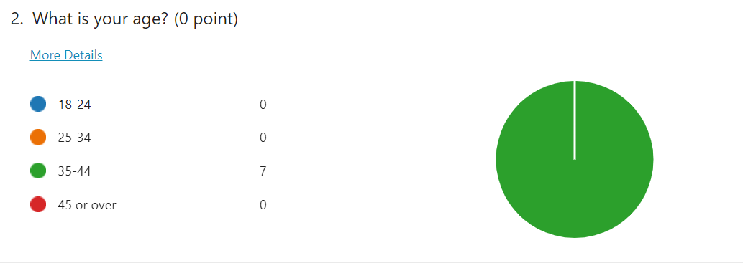
Our ideal customers are between the ages of 35 and 44 who are interested in our service.

When we look at the pivot chart below, the most of our expected customers are meles, they prefer to send items that do not wight mor than 5Kg, including the percentage of the females. This data will allow us focusing on business sustainability as the desired outcome for responses, and how there can be numerous conditions and factors associated with this. A considerable number of responses have shown these issues, and as such we have devised an analytical framework for examining these sustainability conditions by integrating the main points etc.
The main point that we have considered are four elements
- The continent that our customers want to send their parcels to.
- The way that customers prefer to send items.
- The preferred seasons.
- The price that they consider paying according to the wight.

- The continent that our customers want to send their parcels to.
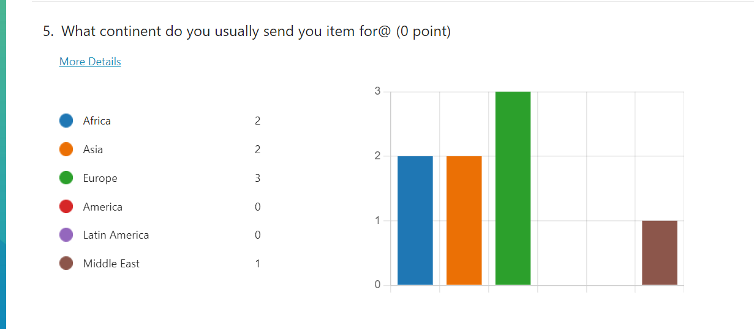

We can clearly see from the chart above customers has chosen Europe with majority and the second choice was equally between Asia and Africa. After we analyzed this information as FAST-IMOPRTATION business and made the matrix to take a decision we decided to choose Africa, because of our knowledge, understanding the culture and language, and its much easer for us to have trusted partners who can help us achieve our missions.

- The way that customers prefer to send their items.
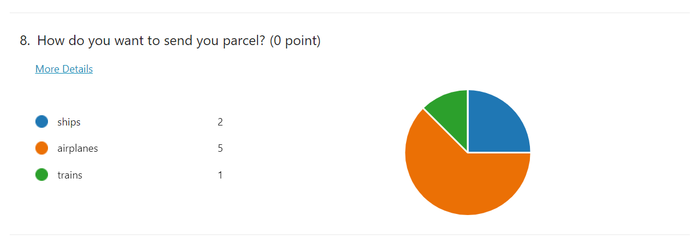
The pie above showing most of our customers want to send their item via airplanes, which is Ideal of saving time and safety for them, and this fact has a major impact on our business idea. Therefore, analyzing external environments and competitors, and many other things related especially the contracts that we aim to do with airplanes to send these items through, the government procedures; things like Tax, Customs and Permits Department, and the communications we make between different partners to identify what is best deal to consider and adopt.
- The preferred seasons.
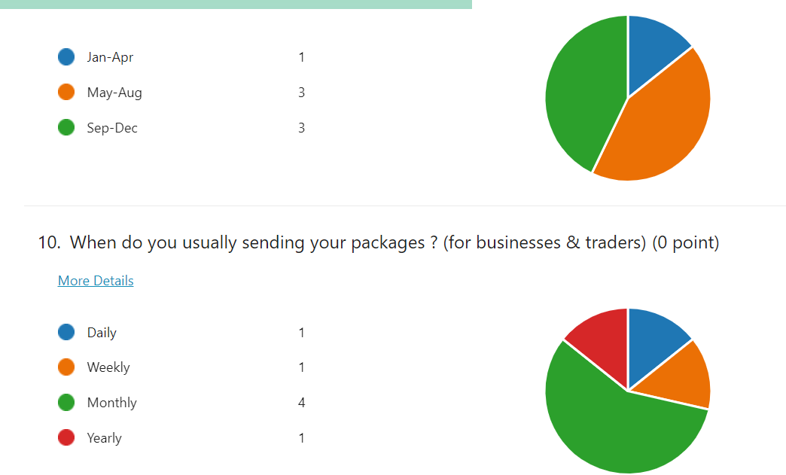
Based on our review on this aspect, we intend to separate the customers in two sectors, who exactly are our potential customers? Are they individuals and or entrepreneur traders? Then the appropriate time for each to send their packages. The responses upon the individual’s sector have shown that customers choices are similar in the second half of the year! This fact identifies our busiest time duration so, we can prepper and gather the information about deporting on this time because of the events and festivals happening, like Christmas and New year. Again, from the trader’s pie we can see clear majority of traders are welling to send items regularly every month, this fact has an impact of our business which could be our consistent work in the future across contracts that can be signed with several entrepreneurs.
- The price that they consider paying according to the wight.

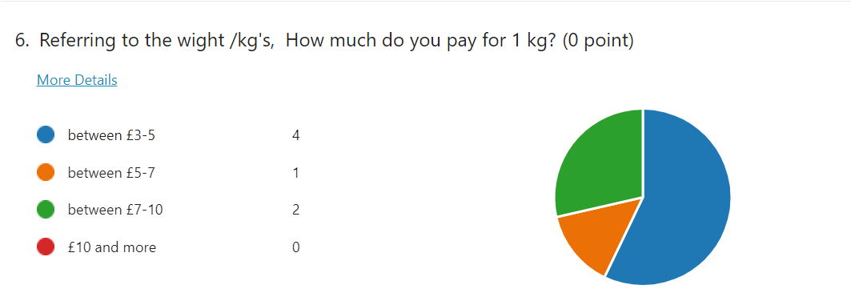

The scope of our analysis into management and internal aspects that may influence the business sustainability is the prices that we provide to the customers. The impact that price made directly to our business idea is to establish and admit a ‘’Cost leader strategy’’, to allow us positioning in the minds of the consumers as a company that provides products and services the consumers want at a price that is lower than competing products available in the marketplace. In other words, customers just expect to have service to meet their needs and nothing more.

Webpages and website design:

The information obtained from the questionnaire has helped us to believe that the websites are often the first interaction a customer has with the business in modern commerce (Lowry, and Haig, 2014). In addition, to reach the potential customers we must analyze the data we gather and understand the CRISP-DM cycle. However, in this section we will include some screenshots from our website and explain each one under four elements:
- Layout and design.
- colors and images.
- Messages and language.
- SEOs and the keywords.

- Layout and design:

Home page 1.0
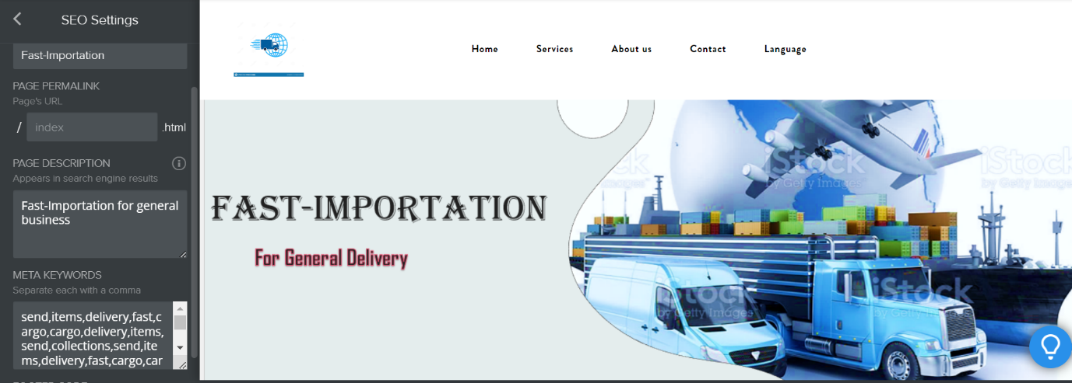
We believe that website’s layouts have a significant impact on consumer’s behavior. (Kincl and Štrach, 2012) indicated that the retailing atmosphere is one of the key success factors about online stores. However, the layout and design on the ‘’home page 1.0’’, formed by both the content and structure of the information provided by websites affect the willingness of consumers to make purchases. Further, figure 1.0 contains the logo in the cyan color, the name of the business and an image we believe that instills in the customer’s mind what the company’s work is, in addition to the keywords related to search engine operations SEOs.

- Colors and images:

Figure 1.1
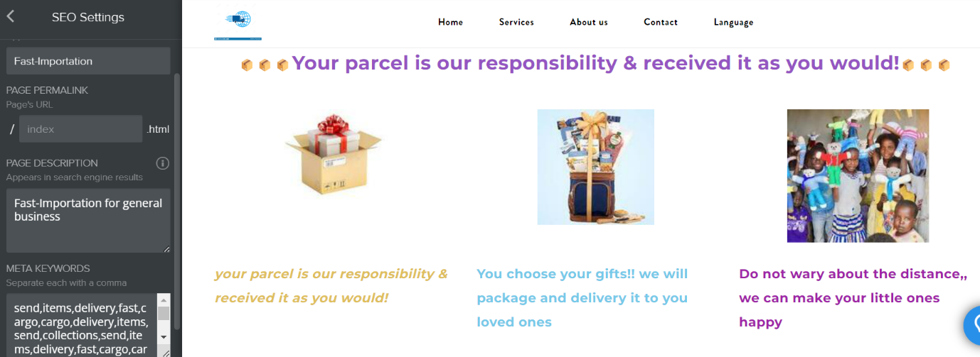

Colors play particularly important roles in both designing and accessing Web pages. Color information such as hue, brightness, and saturation have the potential to affect users and the website visitors (WU and HAN, 2018, P77). The customer’s perceptions of the colors and images on an online website may elicit positive or negative emotions that will impact their subsequent attitude towards, purchase intention, and behaviors. In addition, the quality of these aspects plays a significant role on the customer’s satisfactions. When we look at the figure 1.1 above, we can see the professional work has been carried out by applying the skills, knowledge, and understanding of the module studied.
- Messages and language.
Figure 1.2
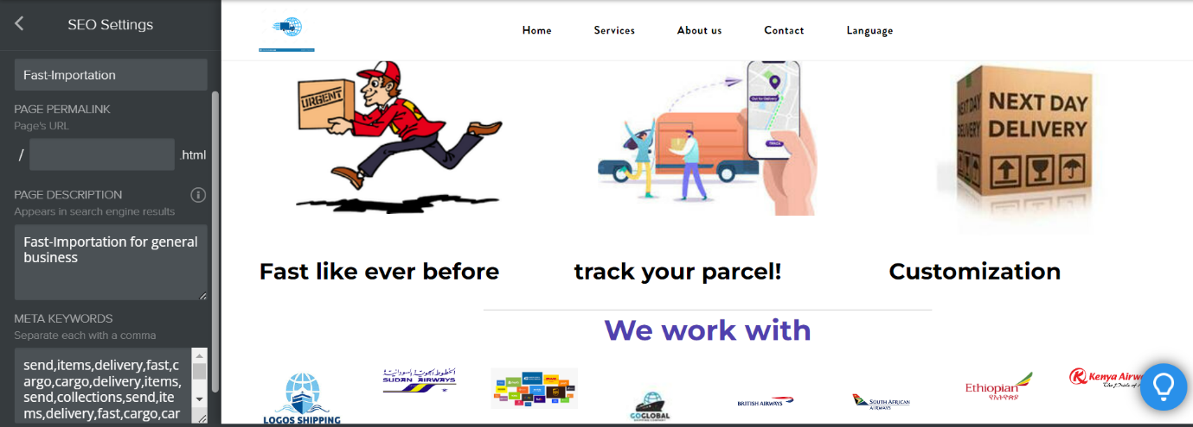

As we can see, there are many factors to consider in the figure 1.2. This has taken a lot of time and researching to have effective SEO approach to allow us to manage these factors. Our marketing management team focused on the marketing message, language, and culture putting all these things with the overarching plan (Wilson, and Haig, 2014).
To expand our business internationally, we localized and translate the website so that international customers can easy understand what the brand is offering. Investing in a multilingual SEO plan is another approach to ensure that clients reach the website on their search engine. It entails raising brand recognition, making it easier for potential customers to find our products and services, and translating the website to improve optimization and localization services for our website’s users.
- SEOs and the keywords.

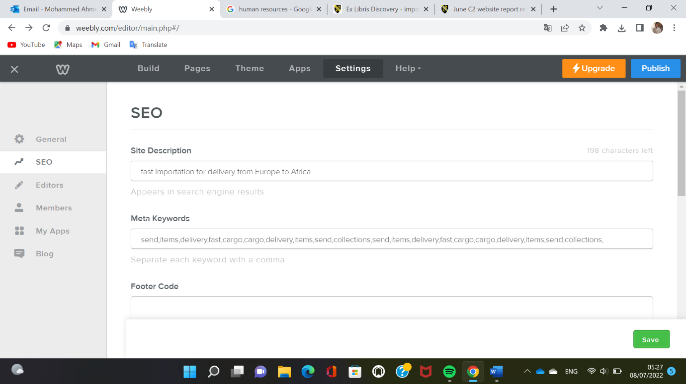
Figure 1.3
We know that quality content and smart SEOs are essential to achieve our marketing goals, but that does not mean success is easy to come (Purdy, 2016). Both SEO and content are in it for the long haul. The content needs to be long living to maximize its SEO value and make significant results. Plus, with frequent algorithm changes to search engines, what might have been a poor performer in the past could be your top piece of content in the future. SEO requires that you include the keywords of a subject in your content according to The Importance of SEO in Online Marketing (Chatham, 2019). This will increase our chance of appearing on the first page of the search results when any of those keywords are mentioned in the search. We have also included relevant photos associated with the content. This will attract search engine sites and boost the search engine ranking.

7.0 References:

EVANS, J.D., JONES, T. and MITCHENER, G., 2016. AN OWNERSHIP FRAMEWORK FOR MANAGERS' ACCELERATED SEO DECISIONS: THE IMPORTANCE OF CONNECTED INSTITUTIONAL INVESTORS IN THE REIT INDUSTRY. Journal of Real Estate Portfolio Management, 22(2), pp. 159-178.
Kincl, T. and Štrach, P. (2012) ‘Measuring website quality: asymmetric effect of user satisfaction’, Behaviour & information technology, 31(7), pp. 647–657. doi:10.1080/0144929X.2010.526150.
KRASONIKOLAKIS, I., VRECHOPOULOS, A., POULOUDI, A. and DIMITRIADIS, S., 2018. Store layout effects on consumer behavior in 3D online stores. European Journal of Marketing, 52(5), pp. 1223-1256.
Lowry, P.B., Wilson, D.W. and Haig, W.L. (2014) ‘A Picture is Worth a Thousand Words: Source Credibility Theory Applied to Logo and Website Design for Heightened Credibility and Consumer Trust’, International journal of human-computer interaction, 30(1), pp. 63–93. doi:10.1080/10447318.2013.839899.
PURDY, R., 2016. Shrinking Google Real Estate and the Importance of SEO. The Business Journal - Central New York, 30(1), pp. 10.
The 60 Second Marketer: The Importance of SEO in Online Marketing. 2019. Chatham: Newstex.
VALUEWALK, 2022. Phil's Stock World: Website translation and the importance of SEO. Chatham: Newstex.
WU, O. and HAN, M., 2018. Screenshot-based color compatibility assessment and transfer for Web pages. Multimedia Tools and Applications, 77(6), pp. 6671-6698.
WU, W., CHIA-LING, L., CHEN-SU, F. and HONG-CHUN, W., 2014. How can online store layout design and atmosphere influence consumer shopping intention on a website? International Journal of Retail & Distribution Management, 42(1), pp. 4-24.
Yang, B. et al. (2019) ‘A Color‐Pair Based Approach for Accurate Color Harmony Estimation’, Computer graphics forum, 38(7), pp. 481–490. doi:10.1111/cgf.13854.

