BMMB7000
CHANGE & STABILITY MANAGEMENT

Table of Contents
1. Introduction 3
2. Background of the company and the reason for the change 3
3. Key change management modules 4
4. Utilization of change management modules 7
5. Driver factors of change 9
6. Dealing with and Identifying the resistance factors for the change 11
7. Impact of change on the company 12
8. Recommendation 13
9. Conclusion 14
References 16

Executive Summary
The whole report is focused on change management and its stability. It has been founded in this report that for the adaptation of a perfect change in the company, there is a requirement of many things. Firstly, a company has been chosen on which the whole research is focused. After that all the change model that has been implemented under the company is being evaluated in this report. Moreover, these modules are discussed in this report. There are many drivers of the change which is also discussed in the report. Finally, all the impacts that a change has on this company is also discussed in this report.

1. Introduction
Several factors have forced multinational companies all around the world to implement change in their management. For example, the Covid-19 pandemic and Brexit are one of the primary reasons behind this. However, there are many change management theories and practical strategies for managing this change. Therefore, this report will be focused on analyzing those theories and strategies for implementing a successful change in the chosen organization. Moreover, there will also be a focus on analyzing the impacts of these changes on the selected organization. There will be a use of theoretical ideas, modules, and concepts for focusing on organizational development (Cameron and Green, 2019). There are several factors like culture, power, digitization, competition, and power which play an important role in driving the change.

2. Background of the company and the reason for the change
The company that has been chosen for this report is Tesco. This is a multinational general merchandise and groceries retailer company in Britain. In the year 2011, this was the third largest retailing company in terms of revenues all over the world. This company is operating on a very large scale all around the world. For example, the total number of locations that are being used for a business by this company is 4,673. The revenue of this organization that has been calculated recently is around £61.344 billion. This revenue as well as success for this company has been made successful with the help of around 354,744 employees. However, like many other multinational companies, this company has been affected by the pandemic of Covid-19 and Brexit as well. For example, during the pandemic, none was allowed to go outside their homes which forced this company to make a change in their business by providing online delivery facilities to their customers. On the other hand, Brexit has affected the price module of this company. Because of Brexit, the trade between the UK and the EU has been hampered which resulted in a change in their food price. Brexit has also resulted has led the country to a decline in home-grown products and crops on the shelves of the supermarket in Britain (Briand et al. 2019).
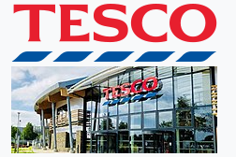
Figure: Tesco Logo
(Source: Tesco.com, 2023)

3. Key change management modules
During the pandemic of Covid-19, there were many restrictions on every citizen as well as companies all around the world. Due to the lockdown ordered by the government worldwide, many companies were closed during this period and many were forced to implement changes in their management. One of the major and most common changes that are being enforced by the government all around the world is work-from-home and online marketing. Online marketing is something that has found major growth during this period (Hayes,2022).
The "key change management module" that has been implemented by this company is "Lewin's change module". This model has developed a planned change in this company which has successfully explained how to manage, initiate, and stabilize the process of change (Toanoglou et al. 2022). There are three steps in this process which are defined in this change module.
Unfreezing: This is the step that involves the organization unfreezing existing behavior and attitudes. With the help of this process, the company has successfully made their employees go through a process for unlearning all the old habits of offline stores, old ideas, and all the old perceptions as well as adopting the new change of being online.
Change: - This is the second step which involves behavioral changes. Under this step, the employees of this company have successfully modified their old ways and have taken all the new ways of thinking. For establishing online delivery in their process, there was a requirement for this company to go through a systematic process that was successfully implemented by them (Whysall et al. 2019). The employees of this company have played a very vital role in establishing an online delivery system and have made this change very positive for the company.
Refreezing: This is the last and final step of this module which involves the process of maintaining the change momentum through locking the change, stabilizing the situation, system consolidation, support, building relationships, and evaluation (By, 2021). This last process of the module has helped this company in maintaining its online delivery services and has also helped them in boosting their new ways of extracting positive results from the new change.
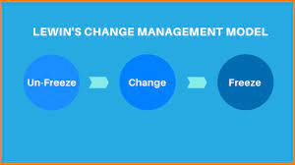
Figure: Lewin’s Change management model
(Source: Startuptalky.com, 2023)
The second change module that has been implemented by this company after Brexit is the "Beckhard and Harries model". According to this model organizational change occurs in three stages. For example, transition state, present state, and future state.
Present state: This stage is referred to the current situation of any organization which generally contains the organization's structure, people, processes, and internal and external environment of the company.
The transition state is the stage that consists of the process, structure, environment, and people of the organization as it changes. This is the stage where Tesco looked at all their previous processes and management and then decided what next to do (Pokhrel et al. 2021). Because of Brexit, the trade between the UK and the EU has been completely hampered. That is why this company is looking forward to adopting a change in its management.
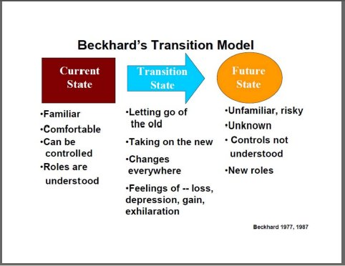
Figure: Beckhard’s Transition Model
(Source: Stratigiesforchange.com, 2023)
The future state is the last and final destination of all these change processes. This is the stage where this company will finally achieve its desired future in its state.

4. Utilization of change management modules
The models that have been chosen by the company in their worst situations are " John Kotter’s 8-step change model" and "ADKAR change management model". Therefore, considering the pandemic of Covid-19 as the situation for this company, these models have played a very vital role in implementing the change in their company and have also successfully fought the situation strongly.
Linking the module with the situation.
John Kotter’s 8-step change model
John Kotter’s 8-step change model is a widely used and accepted framework for managing organisational change. Tesco, one of the largest retail companies in the world, can benefit from Kotter’s change management model to improve its management structure.
- The first step in Kotter’s 8-step change model is to create a sense of urgency. In Tesco, this could be achieved by communicating the need to change and the potential advantages of doing so to the management team (Olsen, 2021). This will help to establish an effective management style in the company to fight the challenges from Covid and Brexit.
- The second step is to form a powerful coalition. The coalition should be made up of the most influential people in the organisation who are able to drive the change process. This could include the CEO, senior managers, and other key stakeholders.
- The third step is to create a vision for change. This should be a clear and compelling vision that outlines the desired future state of the organisation. It should be aligned with the organisation’s overall goals and objectives and should be shared with the entire organisation.
- The fourth step is to communicate the vision. Tesco can use a variety of communication channels, such as presentations, newsletters, and social media, to ensure that the message is heard by all stakeholders (Toanoglou et al. 2022).
- The fifth step is to empower employees to act on the vision. Tesco should provide employees with the necessary resources and support to help them implement the changes. This could include training, job redesigns, and new technology.
- The sixth step is to create short-term wins. Tesco should set achievable milestones and celebrate successes along the way. This will help to keep morale high and ensure that the change process is seen as a success (Hayes,2022).
- The seventh step is to consolidate gains and produce more change. Tesco should continue to review and refine the change process to ensure that it is meeting its objectives.
- The final step is to institutionalise the new processes. Tesco should embed the new processes into its culture and ensure that they become part of the organisation’s day-to-day operations.
By following Kotter’s 8-step change model, Tesco can create a successful and sustainable change in its management structure and mitigate the challenges of Brexit and the global pandemic.
ADKAR change management model
ADKAR change management model is an effective approach for Tesco to implement changes. The model suggests that all successful changes depend on the individual and their ability to accept, embrace and implement the change.
- The first step of ADKAR's change management model is creating awareness. This step involves informing employees about the changes and the reasons why they are necessary (Cameron et al. 2021). Tesco should ensure that all staff members understand the goals and purpose of the changes.
- The second step of the ADKAR model is knowledge. This is a vital step as it ensures that employees are educated and trained on the changes. Tesco should provide the necessary resources and training materials to help staff understand what is required of them.
- The third step of the ADKAR model is desire. This step involves motivating employees to adopt the changes. Tesco should create a positive and encouraging environment where employees can feel valued and motivated to make the changes.
- The fourth step of the ADKAR model is ability. This step involves providing employees with the skills and resources they need to successfully implement the changes (Rahmanov, 2021). Tesco should ensure that employees have access to the right tools and training to be able to effectively make the changes.
- The fifth step of the ADKAR model is reinforcement. This step involves monitoring the progress of the changes and providing feedback to employees.
Tesco should provide recognition and rewards to employees who successfully implement the changes. By following these steps, Tesco can ensure that the changes are successfully implemented and that employees are motivated and equipped to embrace the changes.

5. Driver factors of change
Several factors are considered driving factors for the change. These factors are as follows;
Culture: The corporate culture of Tesco is also focused on building healthy interpersonal relationships as well as fostering a sense of community among all its staff. The culture of Tesco has played a very vital role in driving the change under their management. For example, the culture of this company is not only benefiting the success of their business but it is also showing how the employees of this company are enjoying their work while coming to the office and also finding joy while working together in the company (Ratana et al. 2020). The culture of any company is very important and also plays a vital role in adopting any change quickly.
Leadership: Leadership is one of the most important factors that play a very vital role in bringing positive change to the organization. The leaders of this company are helping all the employees by providing the proper direction that they desire and also stopping them from adopting any negative change. Moreover, all the leaders are motivating their employees in such a manner that they are not getting frustrated or panicking about any situation and continuously adopt positive change in their company.
Power: The corporation tax is the only power that is in the hands of the government. This is a policy of the government which could be changed over the government anytime. The rise in the corporation tax has impacted this company negatively (Celone et al. 2021). For example, the government of most countries has increased the corporation tax for this company which is resulting in an increased price of the products for the company. Therefore, the increased tax is forcing this company to manage all their budgets and implement some changes in their manufacturing process so that they could have less manufacturing cost.
Digitalization: Digital transformation which is also known as digitalization directly impacts the operations of the company. Digitalisation has also brought many challenges for this company to adopt. Digitalisation has forced this company to adopt many changes. However, all these changes have left a very positive result for this company (Cameron et al. 2021). For example, Tesco is now using very big data, cloud, and artificial intelligence among many other disruptive technologies for digitally transforming their operations. With the help of this change, the annual ICT spending of this company has been estimated at $2.2 billion for the year 2022.
Competition: Tesco is one of the largest U.K. grocery retailers and firms who are having some major competitors like Sainsbury's, Morrison's, and ASDA. Competitors also brought a lot of competition for Tesco which is why they are forced to implement some major changes so that they could have a competitive advantage over all their competitors (Fountaine et al. 2021). For earning a good competitive advantage, this company is providing better quality products to their customers at a very cheap rate. For providing the same they have brought many changes in their operations. For example, they have made some changes in their manufacturing process by using cheaper and more valuable products so that they could have less manufacturing cost.

6. Dealing with and Identifying the resistance factors for the change
Some of the major challenges as well as resistance factors used by Tesco while becoming online during the pandemic of Covid-19 are;

Barriers | Resistance factors
The lack of proper measures for ensuring privacy and data security over the online platform is one of the major barriers to becoming online. Nowadays, many cases are related to data insecurity. | For resisting the data of their company, Tesco could invest more in hiring cyber professionals who can conduct regular audits related to cybersecurity (Olsen, 2021). Moreover, companies must have a proper backup of their data on the daily basis.
Currency challenges are another challenge, especially concerning all the cross-border transactions and the volatile nature of the exchange rates. Every country has its rates for exchanging currency. | For fighting this challenge, this company can buy an S&P 500 index fund (Hamilton et al. 2021). Moreover, they can also make them diversify globally. Furthermore, they can also invest in currency-hedged funds.
“Unpredictable consumer behavior” is also another major issue. For example, every country has a different culture and hence the customers of every country are very different. That is why it is very difficult to predict the behavior of customers worldwide on the online platform. | For predicting the behavior of customers all around the world the company is needed to hire employees for that particular reason only where they are going to trade. In this way, they could easily predict the behavior of customers from different regions.
Delay in delivery is also one of the major issues that are being faced by the company while being online. | For providing faster delivery this company could open their delivery office in as many regions as they can (Hashim et al. 2021). Moreover, they could hire any e-commerce company which could help them in providing faster deliveries to their customers.
Table 1: Barriers and Resistance factors
(Source: Self-Developed)

7. Impact of change on the company
The online marketing strategy that has been implemented as the major change in the company has brought many benefits for the company. For example, it is playing an important role in retaining and attracting the attention of its viewers. Nowadays, Tesco is using the online platform for advertising their products and their price they are also convincing their customers to take beneficial actions after viewing their website to them (Rahmanov, 2021). They are building trust among their customers by providing them with quality products. Implementation of online shopping websites in their company has made many loyal customers for this company. After adopting this change, the company has successfully become the second most visited website all over the world in terms of groceries. They are receiving a total of around 25 million visits every month. Among this much highest number, around 28% of their visitors are purchasing from this company (Oana, 2020). This is the reason they are now achieving the highest rate of conversation of all the groceries websites in the UK.
During the pandemic of covid 19, government restrictions have come up with many challenges and resulted in a loss of around £6.4 billion for the company. That is why they established online shopping facilities in their company (Burnes, 2017). This change brought many opportunities for the company and resulted very positively for the company. For example, nowadays this company is operating a total of around 1 million customers daily and is also earning 10% more than earlier profits. The net profit earned by this company in the year 2022 is around $2.2 billion.
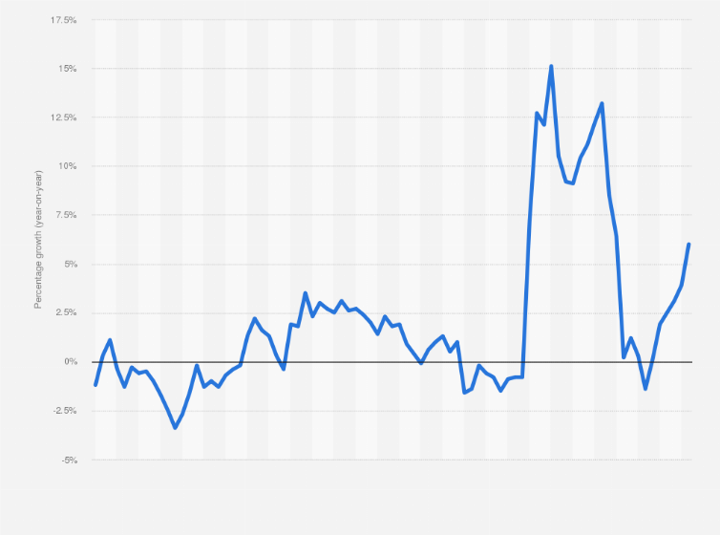
Figure: Tesco sales figure
(Source: Statista.com, 2023)

8. Recommendation
Tesco has already established a very good change management program in their company. With the help of this, they have earned a total net profit of around $2.2 billion. However, there are still some areas that can be focused on by this company for earning more profit and for operating on a larger scale.
- All the employees of the company need to adopt the changes as soon as possible. For the same, this company can create a "sense of urgency" around the need for their change.
- For removing all the obstacles in the implementation of the change, Tesco could also create a clear vision for the change that they are going to establish. Having a clear vision will help all their employees to easily adopt the change.
- “Creating short-term wins” is another way by which they can keep their employees motivated. For example, they can set up rewards for all those employees who are doing well and adopting the change very quickly. This will add more motivation among the team and hence the motivated employees will work more actively and will earn more profit for the company.

9. Conclusion
This report was focused on the change management module. Firstly, Tesco was chosen as a company in the UK in this report. After that, all the change management module that has been adopted by Tesco is analyzed properly in this report. For example, it has been found that "Lewin's change module" and "Beckhard and Harries's module" are the models that are adopted in this company. During the pandemic covid-19, there was a need for the company to implement some changes in its management. Therefore, with the help of Lewin's module, this company successfully implemented online shopping in their company. Moreover, Brexit also brought many challenges for the company. Therefore, fighting this situation also this company adopted a change in their manufacturing costs with the help of Beckhard and Harries's change module. Moreover, many drivers are forcing this company to implement the change. For example, culture, leadership, competition, and power. All these drivers were also discussed critically in this report. Finally, all the impacts of this change implemented in the company were analyzed in this report. It has been founded that the change has brought many benefits to the company.

References
Cameron, E. and Green, M., 2019. Making sense of change management: A complete guide to the models, tools and techniques of organizational change. Kogan Page Publishers.
Hayes, J., 2022. The theory and practice of change management. Bloomsbury Publishing.
Toanoglou, M., Chemli, S. and Valeri, M., 2022. The organizational impact of COVID-19 crisis on travel perceived risk across four continents. Journal of Organizational Change Management, 35(2), pp.293-307.
Whysall, Z., Owtram, M. and Brittain, S., 2019. The new talent management challenges of Industry 4.0. Journal of management development.
By, R.T., 2021. Leadership: In pursuit of purpose. Journal of Change Management, 21(1), pp.30-44.
Pokhrel, Y., Felfelani, F., Satoh, Y., Boulange, J., Burek, P., Gädeke, A., Gerten, D., Gosling, S.N., Grillakis, M., Gudmundsson, L. and Hanasaki, N., 2021. Global terrestrial water storage and drought severity under climate change. Nature Climate Change, 11(3), pp.226-233.
Deszca, G., Ingols, C. and Cawsey, T.F., 2019. Organizational change: An action-oriented toolkit. Sage Publications.
Abd El-Shafy, I., Zapke, J., Sargeant, D., Prince, J.M. and Christopherson, N.A., 2019. Decreased pediatric trauma length of stay and improved disposition with implementation of Lewin's change model. Journal of Trauma Nursing| JTN, 26(2), pp.84-88.
Burnes, B., 2020. The origins of Lewin’s three-step model of change. The Journal of Applied Behavioral Science, 56(1), pp.32-59.
Cone, C. and Unni, E., 2020. Achieving consensus using a modified Delphi Technique embedded in Lewin's change management model designed to improve faculty satisfaction in a pharmacy school. Research in Social and Administrative Pharmacy, 16(12), pp.1711-1717.
Ratana, S., Raksmey, C. and Danut, D., 2020. CONCEPTUALIZING A FRAMEWORK: A CRITICAL REVIEW OF THE DEVELOPMENT OF CHANGE MANAGEMENT THEORIES. Studies in Business & Economics, 15(2).
Celone, A., Cammarano, A., Caputo, M. and Michelino, F., 2022. Is it possible to improve the international business action towards the sustainable development goals?. Critical Perspectives on International Business, 18(4), pp.488-517.
Cameron, E. and Green, M., 2019. Making sense of change management: A complete guide to the models, tools and techniques of organizational change. Kogan Page Publishers.
Fountaine, T., McCarthy, B. and Saleh, T., 2019. Building the AI-powered organization. Harvard Business Review, 97(4), pp.62-73.
Hamilton, R.W., Mittal, C., Shah, A., Thompson, D.V. and Griskevicius, V., 2019. How financial constraints influence consumer behavior: An integrative framework. Journal of Consumer Psychology, 29(2), pp.285-305.
Hashim, M., Nazam, M., Abrar, M., Hussain, Z., Nazim, M. and Shabbir, R., 2021. Unlocking the sustainable production indicators: a novel tesco based fuzzy AHP approach. Cogent Business & Management, 8(1), p.1870807.
Rahmanov, F., 2021. Consumer behavior in digital era: impact of COVID 19. Marketing i menedžment innovacij.
Oana, D., 2020. The impact of the current crisis generated by the COVID-19 pandemic on consumer behavior. Studies in Business and Economics, 15(2), pp.85-99.
Burnes, B. (2017), Managing Change, 7th edition, Harlow: Pearson
Briand, L.C., Labiche, Y. and O'Sullivan, L., 2003, September. Impact analysis and change management of UML models. In International Conference on Software Maintenance, 2003. ICSM 2003. Proceedings. (pp. 256-265). IEEE.
Olsen, T.L. and Tomlin, B., 2020. Industry 4.0: Opportunities and challenges for operations management. Manufacturing & Service Operations Management, 22(1), pp.113-122.

