Seren Cherry – 2501571 – Games Design and History
Game Review Document – Fallout Shelter
In this essay I will be analysing the video game ‘Fallout Shelter.’ Developed by ‘Bethesda Games Studios,’ Fallout Shelter was released in 2015 for mobile devices and Microsoft Windows and later on in 2016 and 2017 for console releases. Fallout Shelter is a free to play simulation game set in a post-apocalyptic world with resource management and base building mechanics. You build, manage and expand a vault while caring for it’s habitants and exploring a post-apocalyptic wasteland for resources.
Fallout Shelter is primarily a resource management and base builder game at it’s core. There are 3 resources you need to produce and manage as you progress in the game. Food, water and power. You produce these resources by building 3 specific rooms: a diner, water treatment and power generator. Along with building these rooms, they require dwellers to run them. In Fallout Shelter, ‘dwellers’ are the people in your vault and another resource required for you to manage. You add more dwellers to your vault by either having 2 dwellers of the opposite gender in the barracks together or having the radio studio room which will have a chance to attract new dwellers toward your vault.
Each dweller has their own skill points structured in Fallout’s mechanic of ‘S.P.E.C.I.A.L.’
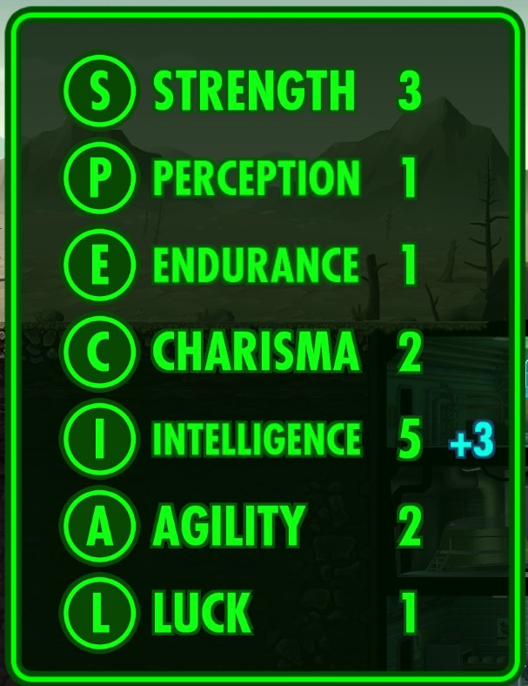
Fig 1. Special stats.
Almost all rooms that can be built for the vault have a certain S.P.E.C.I.A.L skill required by the assigned dwellers for it to run. The dwellers also have their own happiness levels that contributes to the total vault happiness, which affects all of the dwellers efficiency when working. The player can help raise and maintain their dwellers happiness by doing a number of things. For example, building a radio studio room and assigning a charisma based dweller can help maintain the happiness of all dwellers in the vault. The universal currency for all instalments of the Fallout series is called ‘Bottle caps,’ or ‘caps’ for short, and is another resource the player has to earn and manage in Fallout Shelter. Caps are primarily used in the build mode to buy elevators, new rooms and to upgrade rooms. When dwellers are out on a quest or exploring the wasteland caps can also be spent to revive them.
The dwellers having their own skill points, happiness levels and each room having a required skill adds an overall, and constant, challenge to the game. This keeps players engaged by encouraging them to think strategically and make decisions depending on their situation. Giving the player a sense of satisfaction when they finally make their vault self sufficient, where hands on resource management isn’t needed as much anymore and the player can comfortably leave their vault and dwellers to run by itself. For example, if a player were to expand their vault too quickly power would become an issue as the vault would be using up more power than it can produce, which means rooms will slowly stop producing resources for the player. The same issue can arise if there are too many dwellers and not enough diner rooms to produce food, and dwellers will slowly start to die from starvation3.
Unlike some other free-to-play mobile games, like ‘Hogwarts Mystery,’ Fallout Shelter does not use an energy system to determine how long your play sessions are.
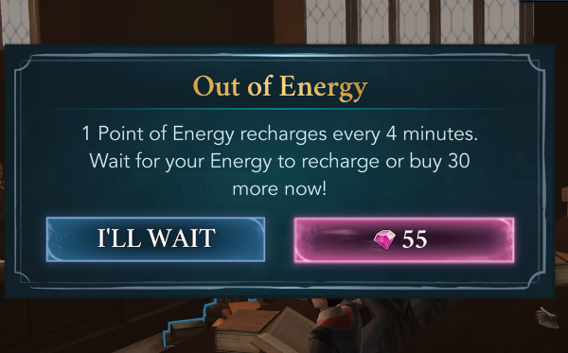
Fig 2. Hogwarts Legacy energy system.
Fallout Shelter offers the player a flexible session each time they open the game. When the player opens the game, they are met with a variety of resources and completed quests. After collecting daily rewards, resources and quest rewards the game slowly eases up on things to do, giving the player an option to leave the session rather than being told to by the game itself 9. Fallout Shelter also constantly gives the player the incentive to return to the game with it’s quest and exploration system. In game, the player can kit up a chosen dweller with armour, weapons and an animal companion and send them out into the wasteland to explore and gather experience and helpful items3, creating an engaging gameplay loop where the player is encouraged to keep returning to the game to do daily tasks and receive rewards.
Satisfying gameplay loops can be linked to Adam Crowe’s theory on compulsion loops. A behaviour that humans will repeat to have a neurochemical reward, such as a feeling of pleasure. This compulsion loop theory can be applied to the gameplay loop of games like Fallout Shelter, where a player will receive enjoyment from playing the game on the regular to complete tasks and earn rewards and caps. This theory can also be applied the Fallout Shelter’s lunchbox system. In the game, you can earn an item called a lunchbox. Opening one can give you a number of random items such as resources, weapons, pets and dwellers. The compulsion loop theory applies to this, as dopamine release promotes novelty seeking behaviour0, making players want to constantly earn these lunch boxes.
However, the core gameplay loop for Fallout Shelter that keeps making you come back and play can be it’s downfall. A game like ‘Stardew Valley,’ developed and produced by ‘Concerned Ape’ has a gameplay loop similar to that of Fallout Shelter of completing daily tasks and having a routine. But, the catch is time goes by faster in Stardew Valley, rather than going by a real time clock. This gives the player more control over their time spent in game and actions taken. A person playing Stardew Valley can experience a satisfying gameplay loop of an in game day and it’s rewards multiple times in one real life day, whereas a player playing Fallout Shelter can only experience most rewards by waiting up to one real life day for one quest to be complete as the game time matches up with real world time3.
In addition to this, although Fallout Shelter does not strictly have a pay to win structure, it can come under a pay to progress quicker structure as the events in game can take hours in real time. This is where the pay to progress quicker structure comes into play, as the game has a currency called ‘Nuka-Cola Quantum.’ Nuka-Cola quantum is an item used to speed up production times, quest times and the time it takes for a dweller to return from exploration3. Although, like lunchboxes, the item can be earned in game there is still an option to purchase them in bulk in the in-game store and earning the Nuka-Cola quantum is a much slower method than just purchasing a bundle.
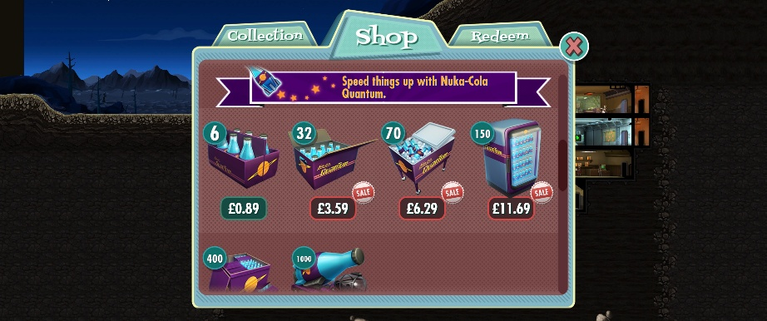
Fig 3. Quantum Nuka-Cola Store page.
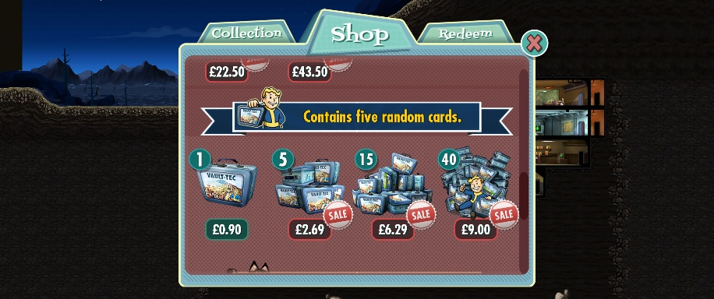
Fig 4. Lunchbox Store page.
The store promotes the purchasable items as being able to get ahead of the game and skip some of the more boring waiting aspects. This also links back to the compulsion loop, with the player receiving dopamine when receiving new items from lunchboxes and being able to receive rewards faster using the Quantum Nuka-Cola to get rewards and the itch scratched quicker.
On the contrary, Fallout Shelter is a great game for introducing someone to the Fallout series or video games as a whole. This is because, along with resource management, a core gameplay of Fallout Shelter is it’s simple point and click gameplay. Coming from the game’s origin as a mobile game.
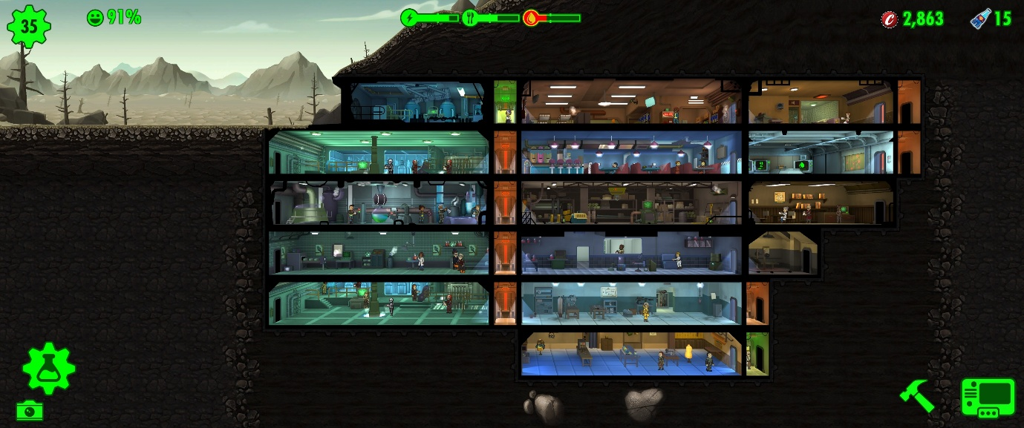
Fig 5. Overview of the Vault.
As seen in the image above, and previously explained in this essay, the vault is where the player spends most of their time. The simple graphics and simple control system are what make it so accessible to new players. To reference a quote from Scott Roger’s game design book ‘Level Up!’ “always remember that humans are playing these games.” Which is what makes Fallout Shelter so accessible, as it is a point and click game, there are no actions that are hidden by certain key binds. All the icons you need to play the game are easily visible on the HUD, and available at all times to the player. Which makes the game accessible to both old and new gamers alike. It introduces basic video game controls to newer gamers, while being easy to pick up and familiar to the more experienced gamers. When the player sends dwellers on a quest, the control mechanics slightly differ but the basis on point and click remains the same. During combat on a quest, the player can assign each of their dwellers to an enemy, by either dragging the dweller toward the desired enemy or clicking on their dweller and then an enemy. This is good for newer players as engaging in combat does not completely change the game controls, it remains a simple point and click, just using that mechanic in a new but familiar way. This is good as it helps to keep less experienced people engaged and free from confusion or frustration.
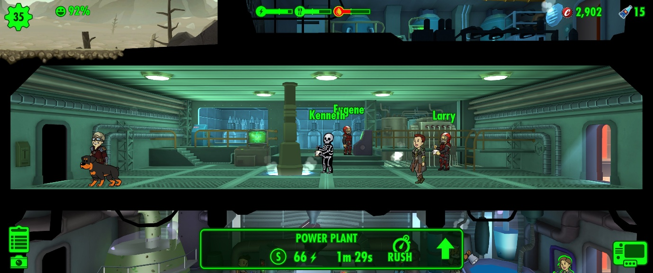
Fig 6. Game Visuals.
The character designs as seen in figure 1 take reference to the cartoon mascots of ‘Vault Tech,’ Fallout’s in game corporation, Vault Boy and Vault Girl . Though the in-game dwellers have their own unique features like skin tone and hairstyle. The dwellers maintain their cartoony looks by remaining 2 dimensional in the seemingly 3 dimensional world. This contrast creates interesting visuals and adds a sense of visual depth to this seemingly simple game. The game camera is seen to be a ‘scrollable camera,’ as explained by Scott Rogers in his book. The game is viewed at a side view, but apart from the characters, the vault and environment is 3 dimensional, as mentioned before. As it is a scrollable camera, the player can click and drag to move the camera around the environment to look at their vault or quest location. Rather than a static camera, where you cannot interact with it, this scrollable camera is another way Fallout Shelter keeps the audience’s attention. Making the player interact with the world to look around helps players to become immersed within the game.
Using audio cues, Fallout Shelter encourages players to interact with a character called ‘The Mysterious Stranger.’ Depicted as Vault Boy wearing a trench coat and hat.
Fig 7. Mysterious Stranger.
After playing the game for some time, the player will hear an ominous piano riff. This tells the player that the Mysterious Stranger has spawned somewhere in their vault. If the player is fast enough to find and click the character, they will be rewarded with some caps3. This game mechanic is quite interesting as it rewards the player with a slight boost in caps for being attentive. This promotes engagement through the game audio, even when nothing seems to be happening in the vault at a given time. In addition to audio cues, the games background noise consists of mechanical whirring and machines running. This ambient noise helps immerse the player in the post apocalyptic world of Fallout, helping them feel like they’re in the vault with the dwellers. This keeps the player interested in the game and it’s world and, in turn, wanting to play more often.
The audience for Fallout Shelter will be those who enjoy management games and planning out and building a base. Anyone who is a fan of the Fallout games will also enjoy this game too, as it maintains the campy humour and cartoony side of Fallout, along with the familiar lore, characters and items that can be collected and used3. The game also opened itself up to a new audience with the release of the ‘Fallout’ TV show on Amazon Prime Video, as Fallout Shelter added the TV characters into the game and are available to unlock.
In conclusion, Fallout Shelter is a game based around managing your resources effectively, exploration and base building. All of which are key for the player’s progression. As explained, base building is heavily linked to your resource management, where you build specific rooms to produce said resources while managing your growing population and resource consumption. Exploration and quests allow the player to find and collect new and helpful items. The game’s playstyle is heavily based around gameplay loops, where the player logs on to do the same tasks each day. The art style of the dwellers is familiar and nostalgic for returning fallout fans and charming and simple for people discovering Fallout for the first time. Overall, Fallout Shelter remains to be an engaging and fun management game, with simple visuals until the player starts to progress further into the game where the fun gameplay loop starts to become more of a chore. With rarer and more powerful items taking longer to get and highly rewarding quests taking up to a whole day to finish. This is where idea of pay to progress faster becomes more obvious.

Bibliography
[1] HandWiki, “Software:Fallout Shelter (video game) - HandWiki,” HandWiki, Jul. 26, 2022. https://handwiki.org/wiki/Software:Fallout_Shelter_(video_game) (accessed Jan. 08, 2026).
[2] Bethesda Softworks, “Fallout Shelter on Steam,” Steampowered.com, 2017. https://store.steampowered.com/app/588430/Fallout_Shelter/ (accessed Jan. 08, 2026).
[3] Bethesda Games Studios, Fallout Shelter, Mar. 29, 2017.
[4] S. Cherry, S.P.E.C.I.A.L Stats. 2026.
[5] C. to, “Happiness (Fallout Shelter),” Fallout Wiki, 2024. https://fallout.fandom.com/wiki/Happiness_(Fallout_Shelter) (accessed Jan. 09, 2026).
[6] Contributors , “Bottle cap,” Fallout Wiki. https://fallout.fandom.com/wiki/Bottle_cap (accessed Jan. 09, 2026).
[7] “Resource Management,” Meegle.com, Dec. 15, 2024. https://www.meegle.com/en_us/topics/game-design/resource-management#technical-overview (accessed Jan. 09, 2026).
[8] J. Jordan, Hogwarts Mystery energy system. 2018. Accessed: Jan. 09, 2026. [Online Image]. Available: https://www.pocketgamer.com/harry-potter-hogwarts-mystery/making-the-case-for-harry-potter-hogwarts-mysterys-energy-system/
[9] A. Telfer, “Deconstructing Fallout Shelter,” Mobile Free to Play. https://mobilefreetoplay.com/a-deep-dive-into-fallout-shelter/ (accessed Jan. 09, 2026).
[10] A. Crowe, “Compulsion Loops,” Slideshare, 2023. https://www.slideshare.net/slideshow/compulsion-loops/13171832#5 (accessed Jan. 09, 2026).
[11] “Stardew Valley,” Stardew Valley. https://www.stardewvalley.net (accessed Jan. 10, 2026).
[12] Marigold Longplays, “Stardew Valley Year 1 Week 1 (Spring) - Relaxing Gameplay | Longplay | No Commentary,” YouTube, Apr. 20, 2022. https://www.youtube.com/watch?v=i9vsA89pHmU&list=PLjO3knpev7XRG97YtD3RbSid4VqR0bVmt (accessed Jan. 10, 2026).
[13] Contributors, “Nuka-Cola Quantum,” Fallout Wiki. https://fallout.fandom.com/wiki/Nuka-Cola_Quantum_(Fallout_Shelter) (accessed Jan. 09, 2026).
[14] S. Cherry, Quantum Nuka-Cola Store page. 2026.
[15] S. Cherry, Lunchbox Store Page. 2026.
[16] S. Cherry, Overview of the Vault. 2026.
[17] S. Rogers, Level Up!, First. Chris Webb, 2010. Accessed: Jan. 09, 2026. [Online]. Available: https://eclass.uoa.gr/modules/document/file.php/DI413/%CE%94%CE%B9%CE%AC%CF%86%CE%BF%CF%81%CE%B1/Rogers_LevelUp_2010videogame-design.pdf
[18] Bethesda Support, “Bethesda Support,” Bethesda.net. https://help.bethesda.net/#en/answer/34936 (accessed Jan. 09, 2026).
[19] S. Cherry, Game Visuals . 2026.
[20] Contributors, “Vault Boy,” Fallout Wiki. https://fallout.fandom.com/wiki/Vault_Boy (accessed Jan. 09, 2026).
[21] Contributors , Mysterious Stranger . Accessed: Jan. 09, 2026. [Online Image]. Available: https://fallout.wiki/wiki/Mysterious_Stranger_%28Fallout_Shelter%29
[22] All Sorts of Things, “Fallout Shelter - Ambience | Atmosphere (Water Filtration Station),” YouTube, Sep. 28, 2021. https://www.youtube.com/watch?v=td65-xWSRy0&list=PLierHCG32cV0XdGwbP9NeH5UwqD1dy8gH&index=17 (accessed Jan. 10, 2026).
[23] GizmozGamer, “Characters From The Fallout TV Show Arrived in Fallout Shelter and Come With Their Own S.P.E.C.I.A.L Stats,” FextraLife, Apr. 22, 2024. https://fextralife.com/characters-from-the-fallout-tv-show-arrived-in-fallout-shelter-and-come-with-their-own-s-p-e-c-i-a-l-stats/ (accessed Jan. 09, 2026).

[1] HandWiki, “Software:Fallout Shelter (video game) - HandWiki,” HandWiki, Jul. 26, 2022. https://handwiki.org/wiki/Software:Fallout_Shelter_(video_game) (accessed Jan. 08, 2026).
[2] Bethesda Softworks, “Fallout Shelter on Steam,” Steampowered.com, 2017. https://store.steampowered.com/app/588430/Fallout_Shelter/ (accessed Jan. 08, 2026).
[3] Bethesda Games Studios, Fallout Shelter, Mar. 29, 2017. (accessed Jan. 08, 2026).
[4] S. Cherry, S.P.E.C.I.A.L Stats. 2026. (accessed Jan. 09, 2026).
[5] C. to, “Happiness (Fallout Shelter),” Fallout Wiki, 2024. https://fallout.fandom.com/wiki/Happiness_(Fallout_Shelter) (accessed Jan. 09, 2026).
[6]Contributors , “Bottle cap,” Fallout Wiki. https://fallout.fandom.com/wiki/Bottle_cap (accessed Jan. 09, 2026).
[7] “Resource Management,” Meegle.com, Dec. 15, 2024. https://www.meegle.com/en_us/topics/game-design/resource-management#technical-overview (accessed Jan. 09, 2026).
[8] J. Jordan, Hogwarts Mystery energy system. 2018. Accessed: Jan. 09, 2026. [Online Image]. Available: https://www.pocketgamer.com/harry-potter-hogwarts-mystery/making-the-case-for-harry-potter-hogwarts-mysterys-energy-system/(accessed Jan. 09, 2026).
[9] A. Telfer, “Deconstructing Fallout Shelter,” Mobile Free to Play. https://mobilefreetoplay.com/a-deep-dive-into-fallout-shelter/ (accessed Jan. 09, 2026).
[10] A. Crowe, “Compulsion Loops,” Slideshare, 2023. https://www.slideshare.net/slideshow/compulsion-loops/13171832#5 (accessed Jan. 09, 2026).
[11] “Stardew Valley,” Stardew Valley. https://www.stardewvalley.net (accessed Jan. 9, 2026).
[12] Marigold Longplays, “Stardew Valley Year 1 Week 1 (Spring) - Relaxing Gameplay | Longplay | No Commentary,” YouTube, Apr. 20, 2022. https://www.youtube.com/watch?v=i9vsA89pHmU&list=PLjO3knpev7XRG97YtD3RbSid4VqR0bVmt (accessed Jan. 9, 2026).
[13] Contributors, “Nuka-Cola Quantum,” Fallout Wiki. https://fallout.fandom.com/wiki/Nuka-Cola_Quantum_(Fallout_Shelter) (accessed Jan. 09, 2026).
[14] S. Cherry, Quantum Nuka-Cola Store page. 2026. (accessed Jan. 09, 2026).
[15] S. Cherry, Lunchbox Store Page. 2026.
[16] S. Cherry, Overview of the Vault. 2026. (accessed Jan. 09, 2026).
[17] S. Rogers, Level Up!, First. Chris Webb, 2010. Accessed: Jan. 09, 2026. [Online]. Available: https://eclass.uoa.gr/modules/document/file.php/DI413/%CE%94%CE%B9%CE%AC%CF%86%CE%BF%CF%81%CE%B1/Rogers_LevelUp_2010videogame-design.pdf
[18] Bethesda Support, “Bethesda Support,” Bethesda.net. https://help.bethesda.net/#en/answer/34936 (accessed Jan. 09, 2026).
[19] S. Cherry, Game Visuals . 2026. (accessed Jan. 09, 2026).
[20] Contributors, “Vault Boy,” Fallout Wiki. https://fallout.fandom.com/wiki/Vault_Boy (accessed Jan. 9, 2026).
[21] Contributors , Mysterious Stranger . Accessed: Jan. 9, 2026. [Online Image]. Available: https://fallout.wiki/wiki/Mysterious_Stranger_%28Fallout_Shelter%29
[22] All Sorts of Things, “Fallout Shelter - Ambience | Atmosphere (Water Filtration Station),” YouTube, Sep. 28, 2021. https://www.youtube.com/watch?v=td65-xWSRy0&list=PLierHCG32cV0XdGwbP9NeH5UwqD1dy8gH&index=17 (accessed Jan. 9, 2026).
[23] GizmozGamer, “Characters From The Fallout TV Show Arrived in Fallout Shelter and Come With Their Own S.P.E.C.I.A.L Stats,” FextraLife, Apr. 22, 2024. https://fextralife.com/characters-from-the-fallout-tv-show-arrived-in-fallout-shelter-and-come-with-their-own-s-p-e-c-i-a-l-stats/ (accessed Jan. 09, 2026).

