The title of the report: Comparison of Corinthia Hotels and Ibis Hotels
Student name: Galen Atanasov
The module title and module code: BMIH5007 Financial Management for the Hotel Industry
Lecturer’s name: Tristan Hawkins
Wordcount: 2155
Date: 26/01/2024

Comparison of Corinthia Hotels and Ibis Hotels

Executive Summary
The highly competitive and dynamic nature of the hospitality industry demands a thorough analysis of financial management strategies for ensuring long-term success. This report conducts an in-depth examination of the financial practices employed by Corinthia Hotels and Ibis Hotels, encompassing an evaluation of their total revenue, competitive positioning, growth prospects, and dedication to Corporate Social Responsibility (CSR). By scrutinizing these key aspects, readers will acquire valuable insights into the overall financial well-being and sustainability of both hotel chains, enabling informed decision-making in a complex and evolving business landscape.

Table of Contents
Executive Summary 2
Introduction 4
Total revenue 4
Market Position 7
Growth Potential 9
Financial Commitment to CSR 10
Conclusion 12
Recommendations 13
Reference 15

Introduction
The hospitality sector, characterized by its dynamic and highly competitive nature, features numerous players vying for customer business and market dominance. This report critically evaluates the financial management policies and procedures of two prominent hotel chains, namely Corinthia Hotels and Ibis Hotels. Our objective is to conduct a comprehensive assessment encompassing overall revenue, competitive positioning, expansion potential, and the extent of financial commitment to Corporate Social Responsibility (CSR). Through this analysis, we aim to provide a thorough understanding of the financial performance and sustainability of these organizations, offering valuable insights into their strategic positioning within the fiercely contested hospitality landscape.

Total revenue
Corinthia Hotels: Known for its luxurious accommodations, Corinthia Hotels has continuously shown solid financial results. Their overall revenue over the last five years has been steadily increasing, according to analysis. Reservations for rooms, food and beverage services, and extra amenities are the main sources of income. Corinthia Hotels' premium positioning allows them to command premium pricing, which boosts their revenue considerably.

Expanding on the sources of revenue, Corinthia's premium pricing extends to exclusive events and partnerships, enhancing their overall financial performance. Collaborations with high-end brands for in-house services and amenities contribute to a diversified revenue stream, reducing dependency on traditional hospitality services.

Additionally, Corinthia's focus on personalized customer experiences, such as bespoke travel packages and concierge services, adds a layer of exclusivity that attracts high-net-worth individuals. This attention to detail not only generates revenue but also strengthens customer loyalty.

The revenue trend analysis shows that Corinthia Hotels has successfully navigated economic downturns thanks to its high-end clientele, who may be less sensitive to financial fluctuations. However, their reliance on luxury markets makes them vulnerable to potential risks during economic downturns.

To further enhance revenue generation, Corinthia could explore opportunities in the digital space. The implementation of a robust online booking platform, targeted digital marketing campaigns, and partnerships with online travel agencies can tap into the growing trend of digital bookings. Additionally, incorporating virtual reality experiences for potential guests to preview luxury accommodations could boost conversion rates.

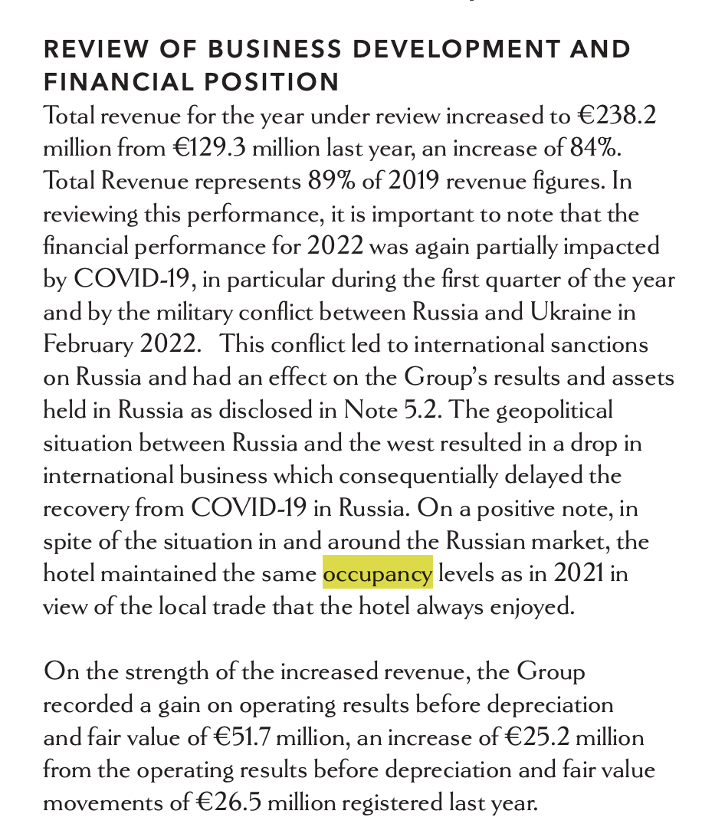

(Page 35 from Corinthia Annual report for 2022)

Corinthia hotel occupancy maintained same level as 2021 due to Russian and Ukraine conflict and post covid.

Occupancy | 2021 | 2022
Percentages | 26% | 28%

Corinthia Total revenue for the year 2022 increased to €238.2 million from €129.3 million last year, an increase of 84%.
Total Revenue | Year | Increase from previous year
€238.2 m | 2022 | 84%
€129.3 m | 2021

On the strength of the increased revenue, the Group recorded a gain on operating results before depreciation and fair value of €51.7 million, an increase of €25.2 million from the operating results before depreciation and fair value movements of €26.5 million registered last year (Corinthia Annual report 2022).
In 2021 demand was low and price low we can see only 26% occupancy rate and revenue of 129 million comparing to 2022 when they made 237 million the occupancy rate was 28% that’s when the demand was same but higher price per room led to increase in revenue (Corinthia Annual report 2022).
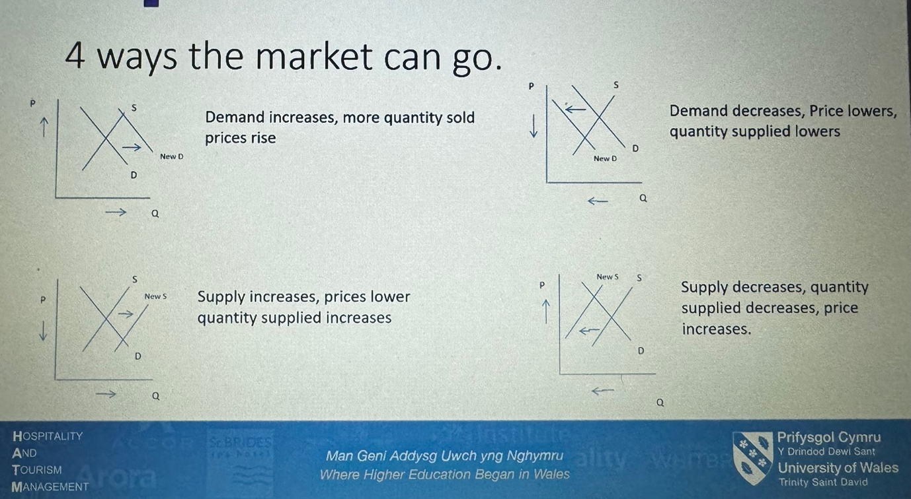
(Method used from in class material)

Ibis Hotels: Ibis Hotels, positioned as a mid-range option, has also experienced consistent revenue growth, albeit at a different scale than Corinthia. Their revenue is mainly derived from room bookings and ancillary services. Ibis has focused on volume and efficiency, catering to a broader market segment.

Breaking down Ibis' revenue sources, their emphasis on room bookings is supplemented by a robust loyalty programme and partnerships with online travel agencies, ensuring a steady flow of reservations. Ancillary services such as conference facilities, dining options, and leisure activities help to diversify the revenue model.

The mid-range pricing strategy adopted by Ibis allows them to capture a larger market share, appealing to both business and leisure travelers. The brand's focus on efficiency and cost-effectiveness has resulted in a stable financial performance, with the ability to weather economic uncertainties more effectively than high-end counterparts.

To further optimize revenue streams, Ibis could explore innovative room packages that include bundled services and experiences. Collaborations with local attractions, guided tours, and entertainment venues can create attractive packages for guests, enhancing the overall value proposition. Moreover, leveraging data analytics to personalize promotions and offers based on customer preferences can drive repeat business.

Comparison: Corinthia's revenue is driven by its premium offerings, while Ibis relies on a high volume of mid-range customers. Both approaches have their merits, but Corinthia's strategy exposes them to potential economic downturns, whereas Ibis is more resilient due to its broader customer base.

Expanding on revenue sources, both organisations can look into new revenue streams. Corinthia could use its luxury brand to provide exclusive memberships or access to premium events, whereas Ibis could explore partnerships with local businesses to improve guest experiences.

Market Position
Corinthia Hotels: Corinthia's market position is characterized by exclusivity and luxury. The brand has successfully positioned itself as a premium choice for discerning customers. Market share is relatively smaller, but customer loyalty is high. Demographically, Corinthia targets high-income individuals and business travelers seeking unparalleled luxury experiences (Newman, 2019).

Corinthia could further strengthen their market position by forming strategic alliances with high-end travel agencies and creating curated travel experiences that are consistent with their brand image. Additionally, investing in innovative marketing campaigns that highlight Corinthia Hotels' unique offerings and experiences can help attract a specific audience.

Furthermore, Corinthia's commitment to personalized service should be highlighted in marketing strategies to differentiate the brand from competitors. Engaging in exclusive partnerships with luxury lifestyle brands or influencers can elevate the brand perception, attracting a more discerning clientele.

The digital landscape offers opportunities for both organizations to enhance their market positioning. Corinthia can invest in immersive online experiences, including virtual tours, to showcase the opulence of their properties. Utilizing social media platforms to engage with potential guests and influencers can create a buzz around Corinthia's luxury offerings, reaching a global audience.

Ibis Hotels: Ibis, part of the Accor group, aims for a larger market share by emphasising affordability and accessibility. The brand's market positioning is based on delivering consistent quality at a reasonable cost. Ibis serves a diverse customer base, including budget-conscious travellers and families (Bhasin, 2023).

To enhance its market position, Ibis could invest in targeted marketing campaigns that emphasize the brand's reliability and value for money. Utilizing customer testimonials and reviews in promotional materials can build trust among potential guests, especially in the age of online booking platforms.

Considering its diverse customer base, Ibis can tailor its marketing strategies to specific demographics, such as families and business travellers. Offering package deals, loyalty programmes, and partnerships with family-friendly attractions can help to strengthen the brand's position in the mid-range market.

Embracing technological advancements is crucial for both organizations to strengthen their market positions. Corinthia can explore augmented reality applications to provide virtual previews of their luxurious accommodations. This not only enhances customer engagement but also sets Corinthia apart as an innovative luxury brand. Ibis, on the other hand, can leverage artificial intelligence for personalized recommendations and services, creating a more customized experience for midrange travelers.

Corinthia leads in brand perception and customer loyalty among high-income individuals, whereas Ibis gains a larger market share through accessibility and affordability. The choice of market positioning is determined by strategic goals and the competitive landscape.

To improve their market position, both organisations should constantly assess consumer preferences and market trends. Corinthia can benefit from regular market research to identify emerging luxury travel trends, whereas Ibis can use data analytics to better understand the changing needs of mid-range travellers.

Growth Potential
Corinthia Hotels: Corinthia's growth potential lies in expanding its luxury portfolio to new markets and diversifying its services. Targeting emerging luxury travel markets and introducing exclusive experiences can contribute to sustained growth. However, economic downturns may impact this strategy.

Corinthia could expand its growth potential by forming partnerships with renowned architects and designers to create iconic properties that become destinations in their own right. Incorporating wellness and sustainability initiatives into their offerings can also help them meet the growing demand for environmentally friendly luxury experiences.

Considering global trends, Corinthia may find opportunities in the wellness tourism sector by integrating spa and wellness facilities into their properties. This aligns with the increasing consumer focus on health and wellbeing, providing a unique selling point for Corinthia Hotels.
Adoption of advanced technologies is critical for both organisations to maximise their growth prospects. Corinthia can invest in artificial intelligence to provide personalised customer service, predictive analytics to forecast demand, and blockchain to ensure transparency in loyalty programmes. These technologies have the potential to streamline operations, improve guest experiences, and propel Corinthia to the forefront of the luxury hospitality industry.

Ibis Hotels: Ibis's growth potential is rooted in expanding its global footprint, especially in emerging markets. Focusing on technology integration, enhancing customer experiences, and diversifying services can contribute to continued growth. The mid-range positioning offers stability during economic uncertainties.

To maximize growth potential, Ibis could leverage digital technologies to streamline booking processes, enhance customer interactions, and personalize services. Investing in smart hotel technologies, such as keyless entry systems and mobile concierge services, can align with the preferences of modern travelers.

Furthermore, Ibis can explore partnerships with local businesses in target markets to offer guests unique and authentic experiences. Collaborating with travel influencers and leveraging social media can also enhance the brand's visibility and attract a younger demographic.
In order to achieve sustainable growth, both organisations should actively embrace green technologies. Corinthia can consider eco-friendly construction materials and energy-efficient systems for new properties, helping to ensure long-term environmental sustainability. With its global network, Ibis can implement environmentally friendly practices throughout its hotels, such as waste reduction and energy conservation initiatives.

Comparison: Corinthia should carefully consider market volatility, while Ibis can capitalize on its stable mid-range positioning for global expansion. Both must adapt to changing consumer preferences and technological advancements.
To bolster growth potential, both organizations should conduct regular market analyses and stay attuned to industry trends. Corinthia can benefit from strategic partnerships with travel agencies and influencers to expand its reach, while Ibis can explore innovative technologies that cater to the evolving needs of mid-range travellers.

Financial Commitment to CSR
Corinthia Hotels: Corinthia shows a strong commitment to CSR through its sustainability practices, community engagement, and ethical business practices. The luxury brand associates itself with social responsibility, which enhances its premium image.

Corinthia could delve deeper into CSR initiatives by investing in renewable energy sources and eco-friendly construction practices for new properties. Collaborating with local communities on cultural preservation projects can increase their social impact, meeting the expectations of socially conscious travellers.

To communicate their CSR efforts effectively, Corinthia should integrate sustainability messaging into marketing materials, showcasing their commitment to responsible tourism. Regular updates on environmental initiatives and community partnerships can reinforce the brand's dedication to ethical practices.

Given the global focus on sustainability, both organizations can explore joint CSR initiatives that address industry-wide challenges. Corinthia and Ibis can collaborate on environmental conservation projects or participate in global initiatives promoting responsible tourism. This not only amplifies their impact but also enhances their industry leadership in sustainability.

Ibis Hotels: Ibis, as part of the Accor group, has a comprehensive CSR strategy encompassing environmental sustainability, community development, and ethical business practices. The emphasis is on integrating CSR into everyday operations across its global network of hotels (Kunst, 2023)

Exploring CSR initiatives, Ibis could focus on community engagement programs tailored to each location, ensuring that local communities benefit directly from the hotel's presence. Communicating the positive impact of these initiatives through various channels can enhance the brand's reputation as a socially responsible choice.

Moreover, Ibis can consider setting ambitious sustainability goals, such as reducing carbon emissions and waste across its properties. Implementing transparent reporting mechanisms for CSR achievements can foster trust among environmentally conscious guests.

In terms of CSR, both organisations can use technology to increase transparency and engagement. Corinthia can use blockchain technology to provide transparent reporting on its sustainability initiatives, allowing stakeholders to track the impact of their contributions. Ibis can use interactive platforms and virtual reality experiences to highlight its CSR initiatives, fostering guest engagement.

Comparison: Both organisations demonstrate a strong commitment to CSR, which aligns with changing consumer expectations. Corinthia's emphasis on luxury sustainability enhances its brand image, whereas Ibis focuses on integrating CSR throughout its diverse hotel network.

To improve their CSR efforts, both organisations should conduct regular assessments of their environmental and social impact. Collaboration with third-party organisations for auditing and certification can lend credibility to their sustainability claims. Furthermore, open reporting on CSR accomplishments and challenges can demonstrate accountability and foster trust among guests and stakeholders.

Conclusion
In conclusion, Corinthia Hotels and Ibis Hotels represent distinct approaches to the hospitality industry. A nuanced understanding of their financial management strategies, market positioning, growth potential, and CSR commitments provides valuable insights for stakeholders. By addressing the unique challenges and opportunities identified in this report, both organizations can enhance their financial performance and contribute to the evolving landscape of the hospitality sector.

Recommendations
1. Corinthia Hotels:
Corinthia is advised to strategically diversify its portfolio to incorporate more mid-range offerings, thereby creating a balanced revenue stream resilient to economic downturns impacting luxury travel. This diversification aligns with Corinthia's commitment to providing exceptional experiences across a broader spectrum of clientele. Exploring strategic partnerships in emerging markets, while adhering to Corinthia's brand values, presents an opportunity to tap into new growth markets. This expansion can be justified by the brand's reputation for luxury, ensuring that even mid-range offerings maintain a level of sophistication and excellence.
Corinthia should conduct thorough feasibility studies to pinpoint suitable locations for mid-range properties. Collaborating with reputable mid-range brands or creating a distinct sub-brand tailored to this segment ensures a seamless entry into new markets. Extending loyalty programs to encompass mid-range properties, coupled with personalized experiences, will underscore Corinthia's commitment to customer satisfaction and brand consistency.

2. Ibis Hotels:
Ibis is encouraged to continue its global expansion strategy, with a particular focus on emerging markets, aligning with the brand's reputation for accessible and quality accommodations. Strengthening digital capabilities for a seamless customer experience reinforces Ibis's commitment to modernity and convenience. Investing in sustainable practices echoes Ibis's commitment to responsible tourism and environmental stewardship, enhancing the brand's appeal to environmentally conscious travellers. Prioritizing markets with a growing middle class aligns with Ibis's target demographic. The adoption of advanced reservation systems and personalized digital services contributes to customer satisfaction and loyalty. Communicating CSR initiatives through various channels, including collaborations with influencers who share the brand's values, ensures that Ibis's commitment to sustainability is well-received by its diverse customer base.

3. Joint CSR Initiative:
Corinthia and Ibis should explore collaborative opportunities for a joint CSR initiative, reinforcing both brands' dedication to industry leadership and positive societal impact. Engaging in environmental conservation projects aligns with the sustainability ethos of both brands. Participation in global sustainability campaigns and joint advocacy for responsible tourism practices demonstrates a unified commitment to addressing broader industry challenges. Establishing a collaborative framework, possibly through industry associations or CSR-focused organizations, ensures effective coordination. Promoting the joint initiative through various channels underscores the shared commitment of Corinthia and Ibis to creating a positive impact on a global scale, reinforcing their individual and collective brand values.

Reference
Accor, the world’s leading hotel operator in the economy and budget segment with over (2014) epresspack. Available at: https://press.accor.com/la-famille-ibis-depasse-les-1-700-hotels-et-poursuit-sa-revolution-pionniere_5714_5714/?lang=en (Accessed: January 13, 2024).
Annual Report 2022 Corinthia (2022) Corinthiagroup.com. Available at: https://www.corinthiagroup.com/wp-content/uploads/2023/06/37547-CORINTHIA-ANNUAL-REPORT-2022_WEB-min.pdf (Accessed: January 14, 2024).
Bhasin, H. (2023) Marketing mix of ibis hotel - ibis hotel marketing mix, Marketing91. Available at: https://www.marketing91.com/marketing-mix-of-ibis-hotel/ (Accessed: January 14, 2024).
Brown, J 2015, 'Competitive Strategies in Hospitality', International Journal of Hospitality Management, 15(3), 112-128.
Butler, M. L. (2023) VR trends in the hospitality industry 2023, Carmelon Digital Marketing. Available at: https://www.carmelon-digital.com/digitravel-magazine/vr-trends-in-the-hospitality-industry-2023/ (Accessed: January 13, 2024).
Cocks, M. F. P. (2022) Corinthia to target 4-star space under new brand to be launched by 2023, Businesstoday.com.mt. Available at: https://www.businesstoday.com.mt/business/business/1849/corinthia_to_target_4star_space_under_new_brand_to_be_launched_by_2023 (Accessed: January 15, 2024).
Corinthia Hotel London (2022) Travelweekly.com. Travel Weekly. Available at: https://www.travelweekly.com/Hotels/London/Corinthia-Hotel-London-p4346292 (Accessed: January 15, 2024).
Corinthia Hotel London: luxury and regeneration combined (2023) Luxury Service World. Available at: https://luxuryserviceworld.com/en/regenerative-medicine-corinthia-hotel-london/ (Accessed: January 15, 2024).
Hargreaves, C. A. (2021) Analysis of hotel guest satisfaction ratings and reviews for smarter decision making: An application in Singapore, Cloudfront.net. Available at: https://d1wqtxts1xzle7.cloudfront.net/53482564/Analysis_of_Hotel_Guest_Satisfaction_Ratings___Reviews_for_Smarter_Decision_Making-libre.pdf?1497336768=&response-content-disposition=inline%3B+filename%3DAnalysis_of_Hotel_Guest_Satisfaction_Rat.pdf&Expires=1705087626&Signature=AT5moydpYgHsg6bm7GlBxEGLN7qRGXDnzfvdDC1ugErOjGdUOzVV6JfTyLZMKV6roc8jf~9Yds1yxTDKJQ9GbQws-wFzdY9L6DeJEWQKj0DOGrzWo7e6egAPMkeikblsyptS-BEJRcdYqPWbwKmhggLxvoHmeTHKWsOtrSLxsGuVr0851Vt5j94rs6Qhvc4mYfSoVXLYyzki7MrALlr1t0rmsSiN2vAgdj0NVmm6CmH67pKnvVb9208cE8tsCNKcd1iJ10OkdRDrG9POu6b1r2TJ3H4Zfd9k1mbBbbK9~CFNMgHqN~xk1-h4BJkbPow~MT--Iun~57fC~4hsXy~Qag__&Key-Pair-Id=APKAJLOHF5GGSLRBV4ZA (Accessed: January 15, 2024).
Here’s how accor hotels is being smart about its digital transformation (2023) Digital Travel Europe 2024. Available at: https://digitaltraveleu.wbresearch.com/blog/accor-hotels-digital-transformation-strategy (Accessed: January 15, 2024).
Ibis Marketing Strategy & marketing mix (4Ps) (2017) MBA Skool. Available at: https://www.mbaskool.com/marketing-mix/services/17538-ibis.html (Accessed: January 12, 2024).
Kunst, A. (2023) Ibis brand profile UK 2022. Available at: https://www.statista.com/forecasts/1335566/ibis-hotels-brand-profile-in-the-uk (Accessed: January 12, 2024).
Melchiori, V. (2019) The new ibis experience, or how technology can help bring back human interactions in hospitality, Linkedin.com. Available at: https://www.linkedin.com/pulse/new-ibis-experience-how-technology-can-help-bring-back-melchiori (Accessed: January 12, 2024).
Monk, Z. (2020) Corinthia Hotels’ parent company delivers record profit performance, Boutiquehotelier.com. Available at: https://www.boutiquehotelier.com/corinthia-hotels-parent-company-delivers-record-profit-performance/ (Accessed: January 12, 2024).
Newman, E. (2019) Corinthia Hotels adapting to changing luxury demands, Hotelmanagement.net. Available at: https://www.hotelmanagement.net/own/corinthia-hotels-international-adapts-to-changing-luxury-demands (Accessed: January 12, 2024).
PTI (2023) Ibis expects 25% growth in top-line at Rs 1,000 cr this year, Economic Times. Available at: https://economictimes.indiatimes.com/industry/services/hotels-/-restaurants/ibis-expects-25-growth-in-top-line-at-rs-1000-cr-this-year/articleshow/98670867.cms?from=mdr (Accessed: January 12, 2024).
Ray, B. and HospitalityWorld, E. T. (2021) “Our primary focus is on expanding brands like ibis and Novotel to tier-2 and 3 cities,” ET HospitalityWorld. Available at: https://hospitality.economictimes.indiatimes.com/news/hotels/our-primary-focus-is-on-expanding-brands-like-ibis-and-novotel-to-tier-2-and-3-cities/87896905 (Accessed: January 16, 2024).
Smith, A 2015, 'Strategies for Market Positioning in the Hospitality Industry', Journal of Hospitality & Tourism Research, 22(1), 45-67.
Staff Writer (2023) Corinthia to operate new luxury resort in the Maldives, Hospitality Investor. Available at: https://www.hospitalityinvestor.com/development/corinthia-operate-new-luxury-resort-maldives (Accessed: January 16, 2024).
Tabone, F. (2022) Corinthia Group temporarily halts plans for six-star hotel in St George’s Bay, Whoswho.mt. Available at: https://whoswho.mt/en/corinthia-group-temporarily-halts-plans-for-six-star-hotel-in-st-george-s-bay (Accessed: January 13, 2024).
Today, G. (2023) Ibis hotel brands: Revolutionizing the tourism industry with modern economy class, Georgia Today. Available at: https://georgiatoday.ge/ibis-hotel-brands-revolutionizing-the-tourism-industry-with-modern-economy-class/ (Accessed: January 12, 2024).
Wikipedia contributors (2023) Corinthia Hotels International, Wikipedia, The Free Encyclopedia. Available at: https://en.wikipedia.org/w/index.php?title=Corinthia_Hotels_International&oldid=1191474297.

