THE IMPACT OF RELATIONSHIP MARKETING ON BRAND LOYALTY AT TESLA

DISSERTATION ON THE IMPACT OF RELATIONSHIP MARKETING ON BRAND LOYALTY AT TESLA
A case study of Tesla.

By:

Prasanna Dhakal

Dissertation submitted to the
The University of Wales Trinity Saint David
For partial completion of an MBA in International Marketing

Supervisor: David Coker


Master’s Degrees by Examination and Dissertation
Declaration Form.
1. This work has not previously been accepted in substance for any degree and is not being concurrently submitted in candidature for any degree.
Signed Prasanna dhakal
Date 14/06/2023

2. This dissertation is being submitted in partial fulfilment of the requirements for the degree of Master in Business Administration.
Signed Prasanna dhakal
Date 14/06/2023
3. This dissertation is the result of my own independent work/investigation, except where otherwise stated.
Other sources are acknowledged by footnotes giving explicit references.
A bibliography is appended.
Signed candidate: Prasanna dhakal
Date: 14/06/2023

4. I hereby give consent for my dissertation, if accepted, to be available for photocopying, inter- library loan, and for deposit in the University’s digital repository
Signed (candidate) Prasanna dhakal
Date 14/06/2023
Supervisor’s Declaration.
I am satisfied that this work is the result of the student’s own efforts.
Signed: …………………………………………………………………………..
Date: ……………………………………………………………………………...

University of Wales: Trinity Saint David

E-Thesis Deposit Agreement

Details of the Work
I would like to deposit the following item in the digital repository maintained by the University, and/or in any other repository authorized for use by the University:

Title “The impact of relationship marketing on brand loyalty at tesla”

This item is a product of my own research endeavours and is covered by the agreement below in which the item is referred to as “the Work”. It is identical in content to that deposited in the Learning Resources Centre, subject to point 4 below.

I agree that the University of Wales: Trinity Saint David may electronically store, copy or translate the Work to any approved medium or format for the purpose of future preservation and accessibility. The University is not under any obligation to reproduce or display the Work in the same formats or resolutions in which it was originally deposited.

UW: TSD Digital Repository
I understand that work deposited in the digital repository will be accessible to a wide variety of people and institutions, including automated agents and search engines via the World Wide Web.

I understand that once the Work is deposited, the item and its metadata may be incorporated into public access catalogues or services, such as national databases of electronic theses.

I agree as follows:
- That I am the author or have the authority of the author/s to make this agreement and do hereby give the University of Wales: Trinity Saint David the right to make available the Work in the way described above.
- That the electronic copy of the Work deposited in the digital repository and covered by this agreement, is identical in content to the paper copy of the Work.
- That I have exercised reasonable care to ensure that the Work is original, and to the best of my knowledge, does not breach any laws including those relating to defamation, libel and copyright.
- That I have, in instances where the intellectual property of other authors or copyright holders is included in the Work, gained explicit permission for the inclusion of that material in the Work, and in the electronic form of the Work as accessed through the open access digital repository, or that I have identified and removed that material for which adequate permission has not been obtained and which will be inaccessible via the digital repository
- That University of Wales: Trinity Saint David does not hold any obligation to take legal action on behalf of the Depositor, or other rights holders, in the event of a breach of intellectual property rights, or any other right, in the material deposited.
- That I undertake to indemnify the University of Wales: Trinity Saint David against all actions, suits, proceedings, claims, demands and costs occasioned by the University in consequence of any breach of this agreement

Signature Prasanna dhakal

Date 14/06/2023

ABSTRACT
This chapter examines how relationship marketing has affected Tesla's brand loyalty, highlighting the significance of comprehending the relationship in context with Tesla's customer-centric practices and direct-to-consumer sales approach. The purpose of the study is to examine Tesla's relationship marketing strategies, assess brand loyalty amongst Tesla customers, plus pinpoint opportunities for development. The results of the investigation show that Tesla's global expansion, technological advancements, devoted client base, and solid brand equity have all contributed to a rise in the value of the brand of the company. Because it was more accessible, a convenience sample was selected despite possible biases. Accuracy & scientific validity were guaranteed by random sampling. Data analysis was done utilizing SPSS, as well as future studies should think about combining correlational research using other techniques to prove causation. In all, the research offers insightful information about how Tesla's brand loyalty is affected by relationship marketing.

TABLE OF CONTENTS
Chapter 1: Introduction 9
1.1 Introduction 9
1.2 Background 9
1.3 Rationale 10
1.5 Aim 11
1.6 Objectives 11
1.7 Research questions 11
1.9 Research Significance 11
1.10 Problem statement 12
1.11 Structure of the study 12
1.12 Summary 13
Chapter 2: Literature Review 14
2.1 Introduction 14
2.2 Relationship Marketing and Tesla's Strategy of relationship marketing 14
2.3 Brand value 16
2.4 Impact of relationship marketing on brand loyalty at Tesla 19
2.5 Conceptual Framework 20
2.6 Summary 21
Chapter 3: Research Design and Methodology 22
3.1 Introduction 22
3.2 Research Philosophy 22
3.3 Research Approaches 23
3.4 Research design 23
3.5 Research Strategy 24
3.5.1 Type of Investigation 24
3.5.2 Choices 25
3.5.3 Time Horizon 25
Table 1: Timeline 26
3.6 Sampling method 26
3.6.1 Sample type 26
3.6.2 Sample size 27
3.6.3 Sampling method 27
3.7 Data collection method 28
3.8 Data analysis technique 29
3. 9 Ethical considerations 29
3. 10 Research limitations and Accessibility issues 30
3.11 Conclusion 31
Chapter 4: Data Analysis 32
4.1 Introduction 32
4.2 Quantitative data analysis 32
4.3 Discussion 53
4.4 Conclusion 54
Chapter 5: Conclusion 55
5.1 Linking with Objective 55
5.2 Limitation 57
5.3 Recommendation 58
5.4 Conclusion 58
Reference List 61

Chapter 1: Introduction

1.1 Introduction
Building and sustaining good relationships with clients has become essential to effective marketing tactics in today's fiercely competitive corporate environment. With its focus on creating relationships that last, comprehending client demands, and providing individualized situations, relationship marketing has become a potent strategy for companies looking to increase loyalty to their brands. Tesla is an excellent example of how relationship marketing affects consumer loyalty to the company. Tesla, which is well-known for its cutting-edge electric automobiles and environmental activities, has built a passionate following of customers that show astounding brand devotion. This essay investigates the impact of relationship marketing on Tesla's brand commitment, analyzing the tactics used by the business & their outcomes. This assignment can help to learn a lot about relationship marketing's success in fostering brand loyalty & its ramifications for the whole automobile sector by examining the special relationship between and its customers.

1.2 Background
The success of Tesla can be ascribed to both its state-of-the-art technology and its creative marketing approaches. Relationship marketing has been a key component of Tesla's strategy for attracting and retaining a strong customer base. Tesla has been able to forge close relationships with consumers via its direct-to-client sales strategy, collect insightful data & customize its marketing initiatives to suit their interests. Additionally, Tesla's focus on consumer service has been essential in building trusting connections. The business has made investments in a variety of customer service avenues, fostering open dialogue and rapidly resolving consumer complaints. There is an atmosphere of trust & loyalty among Tesla's client base as a result of the company's commitment to actively seeking out consumer feedback and making improvements to its goods & services.
Along with providing individualized marketing & assistance to consumers, Tesla has also fostered a thriving and active community. Tesla owners & fans benefit from the business's fervent fan base's keen engagement in online discussions, social media groups & offline events by creating a feeling of community and exchanging ideas. Given Tesla's distinct standing within the auto business & its track record for brand loyalty, it's critical to consider how relationship marketing affects the success of the company.

1.3 Rationale
In recent years, the car industry has undergone a considerable transition towards sustainable & electric cars. Elon Musk, a businessman, launched Tesla in 2003, and it has since become a leader in this sector revolution. Customers have embraced the company's goal of speeding the global power sources, helping to establish Tesla as a leader in the production of electric vehicles. Tesla has become a game-changing force in the automotive sector, upending established standards and driving the electric vehicle revolution (Lim & Tan, 2022, p. 19). Understanding the elements that lead to Tesla's exceptional brand loyalty is increasingly important for scholars and business professionals as the company continues to soar in popularity. This study will shed light on the tactics which have led to the achievement of Tesla by analyzing the impact of relationship marketing in fostering brand loyalty, offering helpful insights for other businesses looking to increase consumer loyalty in a cutthroat market. Relationship marketing is being more recognized as a successful strategy for creating long-lasting client ties. Yet, there is an obligation to investigate how it might be applied in the particular setting of the automotive sector, wherein brand loyalty is a crucial factor in consumers' purchase choices (Chen, 2022, p. 10). Due to its direct-to-consumer advertising approach and customer-focused business practices, Tesla is a great case study to look at how relationship marketing affects brand loyalty in this sector. Knowing how relationship marketing may strengthen brand loyalty in the setting of sustainable goods, such as Tesla's electric vehicles, is crucial because customers' worries about sustainability & eco-consciousness are growing (Lim & Tan, 2022, p. 19). This study may provide information that can be raised to other companies working to meet customer needs for environmentally conscious goods, contributing to a greater knowledge of sustainable marketing practices and their effect on brand loyalty.

1.5 Aim
This study intends to investigate Tesla's relationship marketing tactics for building brand loyalty & evaluate how these techniques affect consumer loyalty.

1.6 Objectives
- To investigate Tesla's relationship marketing tactics
- To gauge Tesla consumers' degree of brand loyalty
- To assess the effect of relationship marketing on Tesla brand loyalty
- To offer analysis and suggestions for improving relationship marketing techniques

1.7 Research questions
- What relationship marketing techniques does Tesla use to encourage consumer loyalty towards the brand?
- How much does Tesla's relationship marketing help its consumers become brand loyalists?
- How are relationship advertising efforts received and reacted to by Tesla consumers?
- What may Tesla do to strengthen customer loyalty through its relationship marketing strategies?

1.9 Research Significance
In the setting of the Tesla brand, the study is crucial to understanding how relationship marketing methods with brand loyalty interact. In this regard, analyzing the influence of "relationship marketing on brand loyalty at Tesla" might offer insightful information on the efficacy of relationship-building strategies used by the business. Other businesses in the automotive industry along with outside of it could benefit from knowing the way Tesla's marketing initiatives, like tailored communications, customer interaction initiatives, and first-rate customer service, support the growth of solid brand loyalty (Salman, 2019). As a result, the research can offer insight on the particular elements that affect Tesla consumers' brand loyalty. The study can pinpoint the major factors that contribute to better levels of brand loyalty through investigating how relationship marketing techniques help to establish trust, generate emotional connections, plus increase consumer happiness. These results can be used by Tesla as well as other businesses to improve their relationship marketing tactics and foster more client loyalty. Furthermore, by presenting empirical evidence within the setting of the car industry, the study can contribute into the larger research on relationship marketing including brand loyalty (Qin et al. 2021). This can provide fresh perspectives on the intricate connection among relationship marketing activities as well as brand loyalty along with confirm or refute preexisting theories & models.

1.10 Problem statement
In this context of the problem statement, the relationship with relationship marketing techniques as well as brand loyalty among consumers of Tesla, an innovative as well as prominent electric vehicle company, is explored in this element of the issue statement. The purpose of the research is to look into the way Tesla's relationship marketing efforts affect brand loyalty (Qin and Wu, 2021). Relationship marketing describes the techniques and initiatives used by businesses to establish enduring bonds with their clients. It entails fostering client loyalty, trust, with satisfaction via individualised communications and sustained engagement. In the situation of Tesla, the company's distinctive marketing strategy, which places an emphasis on technology developments as well as environmental sustainability, could prove essential in promoting brand loyalty. For various reasons, it is crucial to comprehend how relationship marketing affects brand loyalty at Tesla. First of all, Tesla competes in a market wherein retaining customers is essential to long-term success (Qin et al. 2021). Furthermore, as a market leader, Tesla has the ability to impact consumer behaviour in the electric car market by establishing trends. Finally, the conclusions drawn from this study can help Tesla along with other businesses make wise recommendations for improving customer loyalty via relationship marketing.

1.11 Structure of the study
This study will comprise of 6 chapters such as introduction, Literature review, methodology, research and findings, discussion and conclusion.

1.12 Summary
This chapter concentrates on how Tesla's brand loyalty has been affected by relationship marketing. It presents Tesla as a well-known automaker distinguished by its cutting-edge EVs & environmental activities. In the chapter's justification for the study, it is stressed how important it is to comprehend relationship marketing's role in fostering brand loyalty, especially in light of Tesla's customer-centric business practices and direct-to-consumer sales strategy. In order to investigate Tesla's relationship marketing tactics, evaluate the degree of brand loyalty between Tesla customers, comprehend consumer views & reactions to relationship marketing & pinpoint areas for enhancement for Tesla's practices.

Chapter 2: Literature Review

2.1 Introduction
Building brand loyalty is crucial for sustained profitability in the competitive marketplace of today where clients have many options. Brands that put money into relationship marketing, client interaction & providing top-notch experiences stand a better chance of cultivating brand loyalty & benefiting from it through recurring business, a higher lifetime value for clients, and enthusiastic brand endorsement. Relationship marketing has been more well-known in recent years as a tactic for solidifying consumer bonds and boosting brand loyalty (Qu and Gu, 2022, p. 11). Relationship marketing can be extremely important in the case of Tesla, a firm renowned for its cutting-edge electric vehicles (EV), in fostering customer loyalty. Tesla may establish an atmosphere of company community loyalty by building lasting connections with consumers through individualized communication, outstanding service to consumers, and continuing involvement. Increased consumer happiness, favorable word-of-mouth, and ultimately higher brand loyalty as well as support can result from this (Ngoma and Ntale, 2019, p. 10). Relational marketing tactics may or may not be beneficial, based on variables including client requirements, rivals in the market, & general consumer perception.

2.2 Relationship Marketing and Tesla's Strategy of relationship marketing
Building and maintaining enduring relationships with consumers is the fundamental goal of the marketing strategy known as relationship marketing. It aims to build reciprocal respect, loyalty & trust among the brand & its consumers by going beyond commercial encounters (Chylinski and Heller, 2022, p. 50). Relationship marketing understands the importance of recurring business & consumer advocacy & how happy and devoted consumers may provide the groundwork for long-term company expansion.

Personalized interaction, consumer interaction & ongoing relationship growth are essential components of relationship marketing. To conduct relationship marketing, businesses use a variety of tactics, including:

Personalization: Knowing every consumer's tastes, and adjusting marketing strategies to suit them. This may entail relationships, offers & recommendations that are tailored to them.
Consumer service is the act of providing outstanding assistance and encouragement to customers at every step of their journey. This entails immediately and efficiently responding to questions & issues as well as aggressively soliciting input to enhance goods and services (Chylinski and Heller, 2022, p. 51).
Providing incentives, exclusive deals, and customized advantages through loyalty programs to reward devoted customers. These initiatives seek to deepen the relationship between a company's brand and its consumers by promoting advocacy & repeat business.
Building communities involves giving customers avenues and chances to interact with the company & one another. Online discussion boards, social media groups of people, gatherings & other activities which promote a sense of community and shared knowledge might be used for this.
Customer relationship management (CRM): Managing and analyzing interactions with consumers, tastes & behaviors using technology & data. CRM systems assist businesses in tracking consumer interactions and adjusting marketing strategies as necessary.

Relationship marketing has several advantages. Businesses may boost client retention, lower consumer turnover & gain from favorable word-of-mouth referrals by fostering long-term connections. Customers that are happy & loyal are more likely to make repeat purchases, invest more money & serve as brand ambassadors, all of which help the business's bottom line.
Relationship marketing, however, necessitates an ongoing commitment from the business because it requires time & work to establish and nurture connections.
Additionally, a thorough comprehension of client wants, interests & expectations is required. To stay important, effective methods for relationship marketing must continually adapt to shifting client dynamics (Chylinski and Heller, 2022, p. 51).
Tesla, a pioneer in the electric vehicle industry, is well known for its relationship marketing techniques. The company's strategy is centered on forging enduring relationships with its clients to foster a sense of engagement & loyalty. The following are some essential elements of Tesla's relationship marketing:
Direct-to-Consumer Advertising: Tesla can sell cars to people directly by eschewing conventional dealerships thanks to its innovative sales methodology. Through this direct contact with clients, Tesla can collect insightful data that supports individualized marketing & communication.
Personalized client Experience: At Tesla, giving each client a unique experience is a top priority. Consumers are made to feel appreciated & have their specific demands handled by Tesla, which offers customized road tests & in-depth conversations. This intimate element strengthens the relationship and improves the client's pleasure overall.
Exceptional Consumer Assistance: Tesla places a high priority on providing excellent customer support. The business provides telephone, email & chat help through a variety of methods. Consumers are more satisfied & the relationship is strengthened when Tesla responds to their questions & issues in a timely and efficient manner (Qin et al. 2021, p. 19). Tesla actively solicits client feedback & makes use of it to progressively enhance its goods & services. This client-centred strategy illustrates Tesla's dedication to fulfilling client needs & preferences, further fostering client loyalty & trust.
Engagement with the Community: Tesla has created a thriving community of users & enthusiasts who are all passionate about environmentally friendly mobility. The business sponsors gatherings, meetups & websites that unite Tesla owners, fostering a feeling of community & allowing clients to communicate & engage with the brand regularly (Qin et al. 2021, p. 11). Tesla's emphasis on sustainability is in line with the principles of its environmentally aware consumers. Tesla creates an emotional bond with consumers who hold these ideals by advocating for a brighter future & emphasizing the environmental advantages of electric automobiles (Dai, 2020,.p. 10).

2.3 Brand value
The financial worth and general opinion of a brand in the industry are referred to as brand value. It shows the monetary worth of a brand based on variables like its reputation, consumer opinion, popularity & possible future profits (Chylinski and Heller, 2022, p. 56).
The strength & impact of a brand within the marketplace is reflected in brand value, which is a crucial business metric. It considers the brand's intangible as well as tangible assets, such as brand recognition, brand loyalty, a company's image, and brand distinction (Xinyi et al. 2022, p. 11). There are many ways to evaluate and quantify brand value, with money valuation approaches such as the brand's role in the overall financial performance of the organization, its market cap & brand valuation algorithms like the Interbrand Best Global Brands placing or the brand’s ranking getting the most frequently used.

The following elements impact brand value:

Brand equity is the term used to describe the tangible assets & worth of a brand, encompassing its recognition, connotations, perceived importance & brand loyalty. Brand values are frequently greater for companies that have established brand equity.

Consumer Perception: A brand's value can be strongly impacted by positive consumer impressions, such as trust, dependability & feelings for the company. Consumers are more inclined to favor a brand over rivals when they have a positive view of it, increasing the company's market share & value for the brand.

Market Stance: A brand's worth may be influenced by its capacity to stand out from the competition and forge a distinctive position. Brands that successfully articulate their worth offer & have a distinctive position in the eyes of customers frequently have higher brand values Qin et al. 2021, p. 11).
Financial Performance: A key element in establishing a brand's worth is the brand's fiscal success, which includes sales, profitability & growth. Brands with good financial performance & expansion potential are frequently valued more highly in the marketplace (Qin et al. 2021, p. 10).
Brand Image: A brand's value is influenced by its reputation, which is based on elements like quality of product, client satisfaction & ethical business practices. A strong brand reputation increases consumer confidence and devotion, which raises brand value (Xinyi et al. 2022, p. 11).
Intellectual Property: Intellectual property resources, such as trademarks, copyrights & brevets, can enhance the value of a brand. These resources safeguard the brand's distinctiveness & competitive edge, raising its all-around value.

Strategic management of brands, reliable quality goods & services delivery, efficient marketing & communication activities & a commitment to pleasing consumers are all necessary for developing & preserving brand value. Businesses can increase their brand value & gain an unfair advantage in their sector by pursuing promotional initiatives and developing a solid reputation (Chylinski and Heller, 2022, p. 59). A business's trademark value affects not only its fiscal results but also its position in the marketplace, client feedback & its general success. Greater brand value businesses frequently benefit from more consumer loyalty, affordability, and potential for market expansion (Xinyi et al. 2022, p. 19).
Tesla, the renowned maker of electric vehicles, has seen a notable rise in brand value over time. Tesla is now amongst the most valuable companies in the world as of 2021, based on a number of brand valuation assessments.
The fact that Tesla was pioneering in the electric car market is a crucial component in the brand value of the company. Tesla has transformed the automobile industry by promoting electric vehicles & boosting environmentally friendly transportation. Customers have responded favorably to the company's dedication to environmental stewardship & its plans for the future of renewable power, making Tesla a leader in the space.
Tesla's cutting-edge technology also contributes to the brand value of the company. The electric cars from this manufacturer are recognised for their power, range & cutting-edge features. Tesla has established an image as an innovator thanks to its concentrate on storing energy, battery innovation & autonomous driving features. This technological foresight & constant creativity have raised the brand's standing as a premium product & elevated its brand appeal.
Additionally, the increase of Tesla's brand value has been significantly influenced by its great brand equity. The company has been successful in building a devoted and devoted consumer base. Tesla owners frequently display a strong feeling of brand loyalty, supporting the company & uniting the enthusiast group. Repeat sales, favorable word-of-mouth recommendations & an eagerness to pay more for Tesla cars are all results of this brand loyalty, which increases the brand's value.
Elon Musk, a charming CEO of Tesla who is coming to represent the brand, has an additional impact on the value of the company. Tesla's brand image & value have benefited from Musk's innovative leadership, appealing style of communication, & charismatic presence. His impact has increased faith & confidence in Tesla's mission & potential in the future, in addition to drawing awareness to the brand. In addition, Tesla's growing global presence has boosted the value of its brand. The company has solidified its place as a global leader in the EV sector thanks to its representation in numerous overseas markets, strong market penetration, and aspirational strategies for growth (Salman, 2019, p. 18).

2.4 Impact of relationship marketing on brand loyalty at Tesla
Tesla's relationship marketing techniques have been very effective in fostering customer loyalty. A loyal and enthusiastic consumer base has been created through the firm's capacity to forge personal connections, offer individualized events, give outstanding consumer care, and promote a feeling of togetherness. Supporters of Tesla frequently show steadfast loyalty, promoting the company and persuading others to choose Tesla as their favorite brand of electric automobiles (WU et al. 2022, p. 18).
The level of attachment, dedication & preference that clients have for a specific brand is referred to as brand loyalty. It reflects the degree to which clients show a propensity to maintain their engagement with a particular brand over time by making repeated purchases of goods or services from it (WU et al. 2022, p. 17).
Because it helps businesses retain customers, boost revenue & get good word-of-mouth recommendations, brand loyalty is a significant asset. Consumers that are loyal to a business are more unlikely to make the move to a rival, increasing profitability & giving them an edge over their competitors (Qu and Gu, 2022, p. 10).
Several elements affect brand loyalty, including:
Product caliber: Consumers frequently become loyal to brands that regularly provide high-caliber goods or services (WU et al. 2022, p. 18).
Emotional Connections: Companies that effectively interact with consumers on a psychological level can foster greater levels of loyalty. Deep emotional connections among consumers & a brand are facilitated by emotional elements including similar principles, company personality & memorable interactions.

Brand Image: Brand loyalty can be strongly impacted by a brand's reputation, which is based on elements like dependability, creativity & ethical behavior (WU et al. 2022, p. 17). Consumers are inclined to stick with a brand they believe to be reliable and respectable. Companies with strong brand identities can draw highly devoted patrons. Clients are more probable to retain a long-term engagement with a company if they connect with its core beliefs, mission & image.

Prizes & Incentives for Loyalty: Providing rewards, promotions, loyalty programs can promote repeat business & strengthen brand loyalty. Giving devoted clients exclusive privileges & tailored offerings can increase their loyalty to the brand.
Businesses must consistently work to understand & address client requirements, deliver distinctive services & communicate with consumers if they want to build brand loyalty. It entails fostering favorable brand views, forging emotional bonds, and providing customers with constant value.

2.5 Conceptual Framework
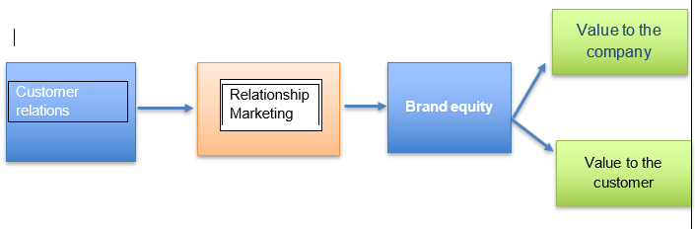
Figure 1: Conceptual Framework
(Source: Created by learner)
Considering how these components interact as well as impact one another is essential to developing a conceptual framework regarding the interaction among "relationship marketing, brand equity, and customer relations" (Qu and Gu, 2022). The fundamental tenet of this concept argues that the growth of brand equity can be helped by solid customer relationships created via relationship marketing techniques. All the intrinsic worth of the business plus the value that the customer perceives are included in brand equity. The main goal of relationship marketing is to establish long-term, mutually beneficial connections with clients (Salman, 2019). It entails tactics like individualized communication, client engagement initiatives, loyalty programmer, and first-rate customer support. These initiatives are meant to encourage consumer devotion, trust, with happiness, which will result in better customer experiences along with solidified connections. Relationship marketing strategies have a beneficial effect on brand equity since they help customers form favorable opinions of the business including its products. The business's reputation, financial stability, ability to innovate, plus market presence all contribute to its worth. By boosting client loyalty, good word-of-mouth, plus brand reputation, strong relationship marketing techniques can improve these elements (Salman, 2019). Consequently, A consumer's value is related to how customers view the brand's features, advantages, plus whole value proposition. By relationship marketing, businesses can better understand the requirements, tastes, and aspirations of their customers and adjust their product offerings correspondingly. The consumer's perception of brand equity grows stronger when value is continuously delivered as well as consumer demands are met. The cycle with self-reinforcing nature of the link between consumer relations, relationship marketing, with brand equity. High brand equity is generated via fostering strong customer relationships with relationship marketing. The link entre the business and its consumers is then strengthened by brand equity, which improves perceptions among consumers, loyalty, as well as advocacy (Sousa, 2022). This conceptual framework emphasizes the significance of relationship advertising in creating and preserving solid client relationships, that in turn promote brand equity. Businesses can achieve long-term success plus a sustainable competitive edge by utilizing relationship marketing tactics that increase all the value of the business plus the value perceived through consumers.

2.6 Summary
In summary, Tesla's brand worth has increased as a result of its worldwide growth, technological innovation in the EV sector, solid brand equity, loyal consumer base & prominent CEO. Tesla's brand value is projected to keep rising as it advances its purpose and pushes the envelope of environmentally conscious transportation, strengthening its position as a major player in the automobile & renewable energy industries. Due to its well-known brand & widespread appeal, Tesla has seen growth in both market share & value for its brand.

Chapter 3: Research Design and Methodology

3.1 Introduction
The methodology section of this study outlines the research plan, data collection procedures, and data analysis strategies used to look at the effect of relationship marketing on Tesla's brand loyalty. This chapter offers a thorough review of the procedures followed to guarantee the accuracy and reliability of the research's conclusions.

3.2 Research Philosophy
A research philosophy known as interpretivism places a strong emphasis on comprehending & interpreting human behaviour & experiences within their social & cultural contexts. In this research, Interpretivism research philosophy had been used. Instead of attempting to find general principles or absolute truths, it concentrates on the individual implications, conclusions & experiences of specific persons. An interpretive theory of research is going to be most appropriate when examining how relationship marketing affects brand loyalty at Tesla for several factors. Interpretivism, first of all, fits well with the character of the research issue. Relationship marketing is centred on how people connect with brands & how they perceive their interactions with them (Long et al. 2019, p. 12). The emphasis on the broader cultural & social setting in which such encounters take place acknowledges that a wide range of subjective elements affects brand loyalty. Researchers can better comprehend how Tesla's client interactions with the brand influence their commitment to it by taking an interpretive stance. By doing so, they can delve into the distinctive views and interpretations of Tesla consumers (Jobaid and Naher, 2020., p. 10).
Second, interpretivism is a good fit for capturing the subtleties & complexity of relationship marketing. Tesla works in the dynamic & quickly changing automobile sector, where a variety of contextual elements, like technology breakthroughs, concerns about the environment & societal values, have an impact on consumer attitudes & behaviours. The importance of all of such contextual variables is acknowledged by an interpretive research perspective, which aims to comprehend how they affect consumer perceptions & actions. Researchers can acquire in-depth information about the particular elements of Tesla's relationship advertising that lead to brand loyalty by using qualitative approaches like surveys, which can give them a thorough grasp of the subject. The emphasis on reflexivity in interpretivism emphasises the importance of the job of the researcher throughout the research procedure. The interpretation & examination of data were actively undertaken by researchers while they were aware of their partiality & assumptions. This reflexivity is essential in the environment of relationship marketing since the researcher's personal biases & presumptions may affect how the consumer experience is interpreted. Researchers might make sure that their meanings are supported by the data & avoid forcing their viewpoints on the results by being mindful of such factors.

3.3 Research Approaches
The effect of relationship marketing on customer loyalty at Tesla was studied using the deductive research methodology for several reasons.
First of all, the deductive method enables the verification of already-developed concepts & hypotheses. The researchers sought to evaluate & validate any existing theories & notions in the fields of relationship marketing & loyalty to brands in this study. Researchers can create particular hypotheses from such hypotheses using a logical technique & then they can gather data to test those assumptions (Bhardwaj, 2019, p. 22). This strategy guarantees methodical & organized research, giving the chance to support or challenge pre-existing theoretical claims.

3.4 Research design
The impact of relationship marketing on customer retention at Tesla was studied using the descriptive research approach for several purposes.
First and foremost, the descriptive research approach is appropriate for giving a comprehensive description of the traits & actions of a certain population or phenomenon. In this research, the researchers sought to learn as much as they could about Tesla's relationship marketing tactics and the ensuing consumer brand loyalty. Data that accurately represents Tesla's existing relationship marketing practices & brand loyalty levels can be collected thanks to the descriptive design. Secondly, examining correlations among variables & spotting patterns & trends are also excellent uses of the descriptive research approach. In the setting of this research, the researchers might have been curious to know how brand loyalty relates to various relationship marketing methods (such as personalized communication, consumer assistance, or loyalty programmes). Researchers can gather information on these factors, examine them, and find any potentially significant relationships or patterns by employing a descriptive design.
The descriptive research design additionally permits the gathering of quantitative data. To gather primary data among a sample of Tesla consumers for this study, researchers might have employed surveys or questionnaires. To collect quantitative data that may prove statistically analyzed, these devices frequently use structured questions with predetermined response alternatives. The degree of brand loyalty & relationship marketing practices can be quantified numerically by researchers using a descriptive methodology, giving them a foundation for comparisons & conclusions.
Additionally, the descriptive research design is beneficial for giving a foundational understanding of a phenomenon. The goal of this study may have been to lay a foundation for understanding Tesla's relationship marketing and brand loyalty practices today. This illustrative material can act as a springboard for additional investigation and offer guidance for developing focused interventions or marketing plans to increase brand loyalty. It makes it possible to spot patterns and trends, analyses how variables relate to one another, gather quantitative data, and create an elementary comprehension of the phenomenon. By employing this methodology, the study sought to provide insightful information about Tesla's relationship marketing & brand loyalty situation, aiding in the creation of sensible marketing plans to increase client loyalty.

3.5 Research Strategy

3.5.1 Type of Investigation
A correlational research strategy can be used to define the type of inquiry or research method employed in the study on the effect of relationship marketing on brand loyalty at Tesla.
Research that uses correlation seeks to look at correlations between variables without changing them. The goal of this study was to investigate the link between Tesla consumers' brand loyalty & relationship marketing tactics. Learning how relationship marketing strategies affect consumer brand loyalty was the main goal. Researchers may monitor and examine factors as they happen in everyday life thanks to correlational research (Salman, 2019, p. 12). Data about participants' opinions of Tesla's relationship marketing tactics & their degree of brand loyalty were probably collected as part of the research study. The researcher wanted to ascertain whether there was a beneficial or detrimental connection between relationship marketing & brand loyalty by looking at the association between these factors (Bhardwaj, 2019, p. 28). The correlational research technique allows for the examination of naturally occurring events in their actual contexts, which makes it appropriate for examining correlations & interactions between variables. Though it doesn't prove causation, it offers useful insights into the nature and direction of relationships. Although there may have been a strong link between relationship marketing methods & brand loyalty in this study, relationship marketing cannot be proven to be the direct cause of brand loyalty.

3.5.2 Choices
Focusing on Tesla particularly and researching how relationship marketing affects brand loyalty highlights a special area of interest as well as significance for the promotional discipline (Stratton, 2021). Tesla is gaining a lot of interest and consumer devotion as a major player within the electric vehicle market. This study can offer special insights regarding the efficacy of relationship marketing tactics inside a cutting-edge business through investigating the connection between relationship marketing as well as brand loyalty in the setting of Tesla's customer base. At Tesla, examining the relationship among relationship marketing with brand loyalty enables focused research that enquires deeply into the precise elements impacting consumer loyalty within this particular context. It makes it possible to investigate the effects of Tesla's marketing strategies on building brand loyalty, including community involvement, personalized customer experiences, plus environmental activism (Sypko, 2022). Understanding this link in the setting of Tesla allows for the development of insightful conclusions and suggestions that are advantageous to academics as well as marketing professionals.

3.5.3 Time Horizon
Activities | Day 1-20 | Day 21-30 | Day 31-40 | Day 41-50 | Day 51-60
Identification of research aims and objectives
Understanding existing literatures
Understand data collection methods
Identification of ethical considerations
Taking eedbacks from Superiors

Table 1: Timeline
(Source: Created by own)

3.6 Sampling method

3.6.1 Sample type
For this research on the effect of relationship marketing on customer retention at Tesla, a non-probability sampling technique, particularly a convenience sample, would be used as the sample kind.
The convenience sampling method entails choosing participants who can easily be contacted by the researcher & available when needed. The target audience for this study would be Tesla customers. Due to issues like geographical dispersion or a lack of contact information, it might not be viable or desirable to reach out to every Tesla client. By using convenience sampling, researchers can choose subjects who are readily available & willing to take part in the research effort. Participants might be chosen, for instance, from Tesla's consumer database or websites for Tesla fans and owners. It is crucial to remember that convenience sampling could potentially create biases and limits. As the sample is dependent on participant accessibility & self-selection, it may not exactly reflect the whole population of Tesla consumers. The generalizability of the results may be impacted by specific traits or behaviours of Tesla consumers that may be either disproportionately represented or underestimated in the sample.
Researchers will be aware of the convenience sampling's limitations & take into account how they can affect the external validity of the research. When extrapolating the results to the larger group of Tesla consumers, care should be used since the results may offer useful insights & comprehension within the investigated sample.

3.6.2 Sample size
The research objectives, research methodology, and statistical considerations will all have an impact on the sample size for this study on the effect of relationship marketing on brand loyalty at Tesla. Sensitivity. Here, 100 individuals have participated in the study.

3.6.3 Sampling method
The influence of relationship marketing on brand loyalty at Tesla was studied using the random sample method for several factors (Jobaid and Naher, 2020., p. 10).
First off, random sampling ensures that the sample is true to the population. The purpose of this study was to provide insight into the connection between relationship marketing & overall brand loyalty among Tesla consumers. Every consumer in people everywhere has a comparable likelihood of being chosen to take part in the research thanks to random sampling. This increases the ability to extrapolate the results by lowering the possibility of bias & guaranteeing that the sample accurately represents a wider group of Tesla consumers. Secondly, random sampling improves the study's reliability in statistics. Inferential data analysis could be used with random sampling to extrapolate results from the sample to a wider population. The general validity of the study is increased by the use of random sampling, which makes it more probable that the statistical tests & analysis performed on the sample will produce correct and dependable results. Random sampling also lessens selection bias. Selection bias happens when some people or groups are more likely to be incorporated into the sample, which distorts the findings. Because every member of the general population has a comparable likelihood of being chosen, random sampling reduces the possibility of selection bias. This makes the sample more typical of the population & reduces the likelihood that participant variables may distort the results or impact them (Bhardwaj, 2019, p. 18). Random sampling also makes it easier to apply statistical methods. The use of probability theory & statistical calculations which rely on the randomness assumption is made possible by random sampling. These statistical methods can be used to evaluate the connections between relationship marketing & brand loyalty, assess the importance of findings & draw reliable generalizations about the population.

3.7 Data collection method
A survey process was used to gather primary quantitative data for this study on the effect of relationship marketing on Tesla's brand loyalty. A small number of Tesla customers were systematically given a standardized questionnaire as part of the survey process. A questionnaire created by the researchers asked pertinent questions on relationship-based marketing tactics & brand loyalty (Corbett, 2020, p. 18). The questions were made to gauge specific ideas of interest in a simple, succinct manner. Both closed-ended (with predetermined response alternatives) and Likert scale (where participants evaluate their agreement on a scale) questions may have been present. Utilizing a sampling technique, such as convenience sampling or random sampling, a sample of Tesla customers was chosen (Frechette et al. 2020, p. 19). To guarantee the validity & generalizability of the results, the sample should be representative of the overall population of Tesla consumers.
Pre-testing may have taken place before the survey was given to the target sample. It would have been possible to ask a select group of respondents who represented the population of interest to complete the survey & comment on its clarity, importance, and length (Frechette et al. 2020, p. 2). This makes it easier to spot any potential problems or ambiguities & make the required corrections. The chosen sample of Tesla customers was given the survey form. The procedure of gathering the information may have involved several techniques including surveys using 100 participants who were the prior or current consumers of Tesla. To guarantee the correctness and dependability of the data, quality control procedures may have been put in place during data collecting. These precautions can entail verifying answers twice, doing data validation examinations, and dealing with any missing or conflicting data.

3.8 Data analysis technique
After the data-gathering phase, statistical analysis was performed on the quantitative data that had been gathered. The data may have been analyzed and the formulated hypotheses tested using statistical techniques such as SPSS & correlation analysis. The statistical programme for the social sciences (SPSS) was used to conduct the data analysis for this study on the effect of relationship marketing on brand loyalty at Tesla. With the help of the popular statistical program SPSS, researchers can examine and understand quantitative data. It could be necessary to prepare and clean the acquired data before beginning the analysis. This includes looking for outliers, values that are missing, and data input mistakes. This stage also allows for any necessary data conversions or variable recoding. To help researchers comprehend the central tendency, variation, and distribution of variables, descriptive statistics describe the data. Means, frequencies, %, as well as standard deviations, are only a few of the descriptive statistics options available in SPSS. Specific hypotheses regarding the effect of relationship marketing on brand loyalty may have been developed by the study. Inferential statistical techniques are used during hypothesis testing to evaluate the importance & strength of those associations (Nayak and Narayan, 2019, p. 19). ANOVA, regression analysis, t-tests, chi-square tests, and other statistical procedures are available in SPSS for analyzing the associations between variables.

3. 9 Ethical considerations
Any research, like the one on the effect of relationship marketing on brand loyalty at Tesla, must give top priority to ethical issues. Before including individuals in the study, researchers should have gotten their informed permission. The study's goal, data collection methods, possible consequences, advantages, privacy safeguards, and participants' freedom to withdraw from the research at any time without penalty should have all been made explicit and transparent to participants. Throughout the study, respondents' privacy and secrecy ought to have been respected. The information gathered ought to have been anonymised to prevent participant identification. The confidentiality of participant information should have been protected by secure data storage and other relevant methods, according to the researchers.
There shouldn't have been any pressure or improper influence during research participation; it should have been purely voluntary. If a participant opted out of the study or withdrew, there shouldn't have been any negative implications for them.
Researchers ought to have taken precautions to reduce any risks or potential harm to participants. This involves making sure that the survey topics & research techniques are not disturbing or delicate on an emotional level. To address any potential participant worries or psychological discomfort brought on by the study, sufficient debriefing & support systems had to have been in place. The study has been ethically and morally ethically done by the researchers. The study method must be transparent and open, conflicts of interest must be avoided, and findings must be reported honestly. Before beginning the study, an Institutional Review Board (IRB) or appropriate ethical review committee's ethical oversight and approval had been requested. The IRB review makes sure that the study complies with ethical standards and safeguards the participants' rights and well-being.

3. 10 Research limitations and Accessibility issues
The generalizability of the results could be one of this study's weaknesses. Convenience sampling can cause biases & prevent results from being applied to the whole Tesla consumer base. The studies outside validity might be impacted if the sample used does not correctly reflect the varied traits & behaviors of all Tesla consumers. The research uses self-reported data from surveys that can create biases in responding. Participants might give answers that are socially acceptable or misremember their encounters with Tesla's relationship marketing & brand loyalty (Frechette et al. 2020, p. 12). The preciseness and dependability of the results could be impacted by this self-reporting bias. Because of the cross-sectional form of the study, it may be difficult to show causation and pinpoint the relationship between relationship marketing and brand loyalty. It can be difficult to tell whether relationship marketing methods have a direct impact on brand loyalty or whether additional factors mediate or muddle the connection between them. As an interpretive investigation, the research findings could be impacted by the researcher's prejudice & subjective judgements. The investigation interpretation of the data may be influenced by the researchers' viewpoints & preconceived conceptions, which may compromise the objectivity & validity of the study's findings. The accessibility issues suggest that It may be difficult to obtain access to Tesla consumers to collect statistics. Tesla's client list might be confidential and difficult for outside researchers to access. Additionally, contacting Tesla consumers directly could need the firm's participation & authorization, which might restrict the researcher's ability to gather information from a representative group of people (Jobaid and Naher, 2020., p. 10).

3.11 Conclusion
In conclusion, a convenience sample would probably be the best choice for this study on the influence of relationship marketing on brand loyalty at Tesla. Although it might create biases and restrictions in terms of the ability to be general, this sampling technique enables the selection of individuals who are easily accessible and readily available. For this study on the effect of relationship marketing on customer loyalty at Tesla, the random sampling approach was used to ensure the sample was accurate, improve the statistical validity of the research, reduce selection bias, and make it easier to use statistical tools. The study's goal was to use random sampling to produce a sample that accurately reflected the larger Tesla customer base, allowing for generalizations and trustworthy findings about the link between relationship marketing and brand loyalty. Researchers can effectively analyze the data they have gathered, test their hypotheses, discover relationships, and come to relevant conclusions about the study by utilising SPSS for data analysis. The analysis & interpretation of quantitative data is made easier by SPSS's user-friendly interface and extensive set of statistical tools. In the years to come, researchers may integrate correlational research with other research methods like experimental or longitudinal studies to bolster the results and present a more complete perspective. These extra tactics could aid in establishing causation and aid in further research into how relationship marketing affects consumer brand loyalty. Overall, relationship marketing techniques & brand loyalty at Tesla were investigated using correlational research tactics, enabling the examination of correlations and offering insightful information regarding the character of this relationship.

Chapter 4: Data Analysis

4.1 Introduction
Consumer satisfaction plus brand loyalty is greatly enhanced through relationship marketing. Businesses work hard to develop strong relationships with their clients in the current climate of fierce competition in order to obtain an edge over their competitors. Tesla, a well-known maker of electric vehicles, is aware of the value of "relationship marketing" in fostering client brand loyalty. The statistical analysis regarding relationship marketing's effects on "brand loyalty at Tesla" is presented in this section. The quantitative data analysis emphasizes correlation as well as regression analysis to look at the connection between Tesla's numerous marketing strategies as well as brand loyalty among consumers. The correlation research demonstrates the beneficial relationships between relationship marketing tactics and consumers' propensity to refer Tesla to others. Additionally, it emphasizes the link between brand loyalty with getting acquainted with Tesla's marketing initiatives. In order to shed a spotlight on the factors that predict consumer engagement, regression analysis also serves to determine the variables influencing conversations with Tesla personnel. The results of this information study help us comprehend relationship marketing's value in fostering "brand loyalty at Tesla" on a deeper level. These insights were helpful for Tesla as well as other businesses competing in the competitive car market because they offer doable tactics to improve brand loyalty & interactions with consumers.

4.2 Quantitative data analysis
Correlation
The correlation analysis table that is displayed looks at the effect of relationship marketing on Tesla customers' brand loyalty. In particular, it draws attention to the correlations between brand loyalty as well as Tesla's marketing initiatives. Based on positive interactions with relationship marketing strategies, the value of respondents' correlation for recommending Tesla to other people is 0.223 (Jiang et al. 2021). This statistic, which comes from a total of 400 correspondents, shows that a sizable fraction of the population is interested in and pleased with Tesla's products. Furthermore, there is a 0.118 association between the length of being exposed to Tesla's marketing campaign as well as the possibility of connecting through brand loyalty at Tesla. According to this information, audiences effectively interact plus engage with Tesla's goods as well as services. Overall, our findings highlight relationship marketing's beneficial effects on brand loyalty in the setting of Tesla.
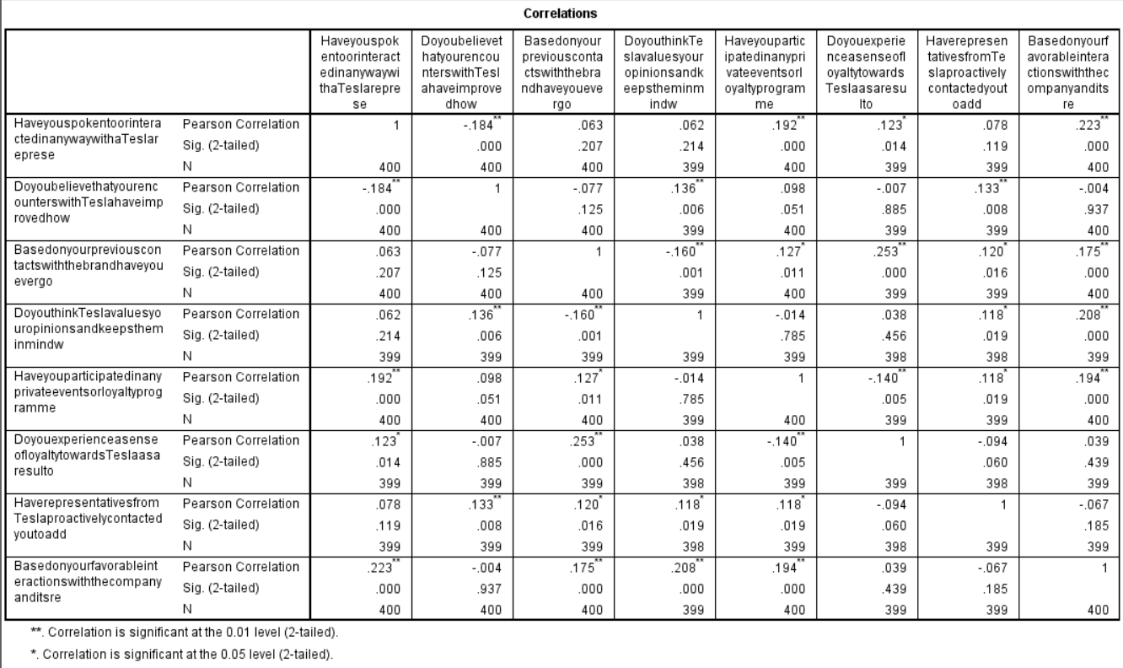
Table 1: Correlation of all variable
(Sources: self)
The table, which depends on the data that was given, shows a significant correlation at the 0.01 level (2-Tailed), indicating a substantial association among the variables for the study (Bhardwaj et al. 2020). Additionally, there is a 0.05 link between maintaining brand loyalty via high-quality products and keeping up with Tesla's modifications to its products & services. This figure shows that the marketplace is heavily utilizing Tesla items. These results emphasize the value of staying up to date on Tesla's developments and imply that brand loyalty can be affected by the perceived worth of Tesla's products.
Regression
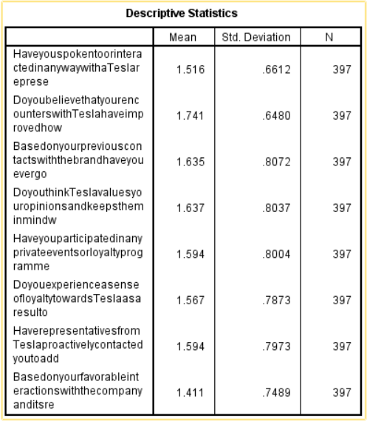
Table 2: Descriptive Statistics
(Sources: self)
The mean values show what the typical reaction to each variable was. In the case of their conversations regarding a Tesla representative, respondents provided a mean value of 1.516, indicating that most of them had spoken or engaged using a Tesla person. Respondents also reported a mean value of 1.741, suggesting that its interactions with Tesla have generally enhanced their opinion of the company (Arani and Shafiizadeh, 2019). The values that the SD quantify the degree of variation near the mean. Greater variation in answers is implied by higher SD. For instance, the variable "Recommendation of Tesla to others" shows an SD of 0.8072, which is rather high as well as indicates that respondents' attitudes on suggesting Tesla differ. There are a significant number of legitimate responses because the sample size (N) over every factor is 397. This improves the findings' dependability as well as generalizability.
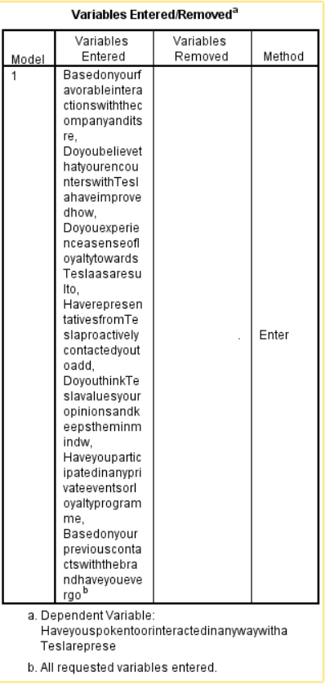
Table 3: Variable enter/removed
(Sources: self)
The variables added and subtracted from a regression analysis looking at what influences contacts with Tesla representatives were presented in this analysis. The analysis's goal is to pinpoint the factors which have a substantial impact on the likelihood that people have communicated or spoken about a Tesla salesperson. All required variables were taken into account in the "regression analysis", and no variables were excluded from the model (Sousa, 2022). This indicates that all inputted variables were regarded as pertinent and incorporated into the study. These variables' presence enables a thorough investigation of the elements impacting conversations with Tesla employees. The variables included in the "regression analysis" offer important new insights regarding the elements that influence people's interactions with Tesla reps. The analysis's findings will assist in defining the key predictors as well as clarify the significance of each component in predicting the possibility of interacting with Tesla reps.
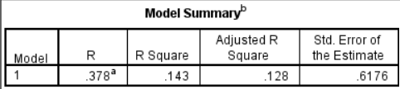
Table 4: Model Summary
(Sources: self)
It is clear from the model summary table above that the R-value or correlation coefficient, denotes the significance as well as direction for the linear relationship among the predictors with the dependent variable. The R-value for this analysis is 0.378, which indicates a somewhat positive association between the predictors along with the probability of speaking with a Tesla person (Sypko, 2022). The percentage of the dependent variable's variation (interactions between Tesla representatives) which the predictors may be responsible for is indicated by the R Square value. The R Square score in this instance is 0.143, indicating that the factors included in the analysis are responsible for around 14.3% of all variance in interactions. The R Square value is modified by the adjusted R square value to allow for the number of predictors. Given the complexity within the model, the Adjusted R Square, in this case, is 0.128, indicating that the aforementioned predictors may account for about 12.8% of the variation in interactions. "The model summary statistics" shed light on the "regression model's" propensity for prediction when it comes to predicting conversations with Tesla reps (Lu, 2020). The R & R Square values show a moderately favourable association and imply that about 14.3% of the variation in interactions may be accounted for through the included factors. The standard error of the estimation serves as a gauge for the average gap between actual values with predictions. The estimation's standard error within this evaluation is 0.6176, giving an approximation of the typical forecast error.
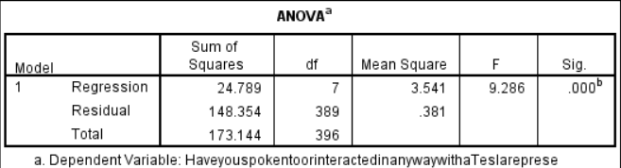
Table 5: ANOVA
(Sources: self-made)
The significance as well as how well the regression model contributed to explaining the variation in conversations with Tesla salespeople are detailed in the ANOVA table. The quantity of variance in the dependent variable which the regression model may account for stay is measured by the "Regression Sum of Squares (SSR)". The SSR in the aforementioned study is 24.789, showing that the variables considered together account for a sizable portion of all variation in interactions (Tsai and Tan, 2021). The df stands for both the freedom error degree plus the total amount of predictors. In this case, the regression contains seven freedom degrees because the model contains 7 predictors. Following adjusting all of the predictors, there are a total of 389 freedom degrees left, which is represented by the residual df.
The average square is the product of squares divided through the corresponding freedom degrees. The residual (error) has a mean square of 0.381 whereas the regression model's mean square is 3.541. The F-value contrasts the variability that is unaccounted for (residual SSR) with the variability that is described by the model (SSR). The regression model appears to be statistically significant for this analysis, as indicated by the F-value of 9.286 (Xia, 2022). The F-values linked significance level (p-value) has a value lower than.000 (p .000), which denotes a very significant correlation between the factors that predicted and contacted Tesla representatives.
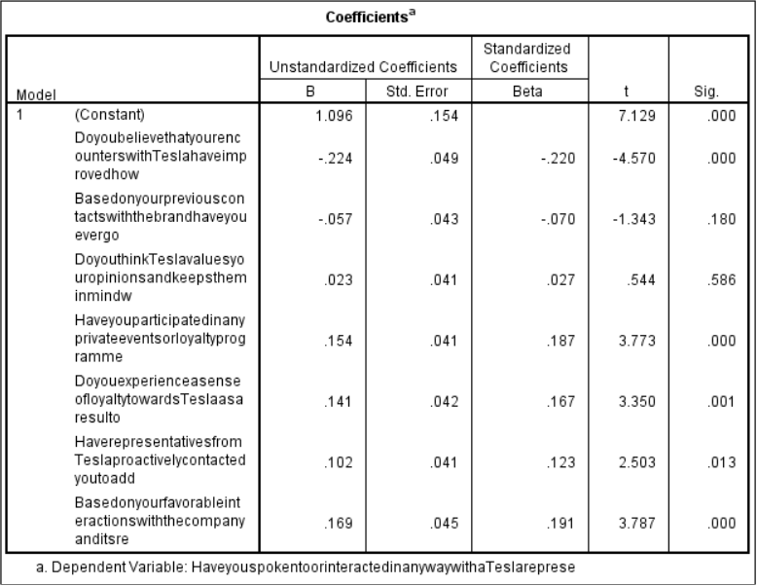
Table 6: Coefficients
(Sources: self-made)
The impact of each predictor on contacts with Tesla reps is revealed by the coefficient analysis. Whenever all of the predictor variables have been adjusted to zero, the constant coefficient indicates their intercept value. The constant used in this research is 1.096, which means that, on average, people will be given a 1.096 chance of speaking about a Tesla salesperson if no predictor variables were taken into account. The standardized coefficients (Beta) show how significant each predictor variable is in relation to the others (Nobanee et al. 2021). They enable comparison of the impact of the predictors upon the variable that is dependent while accounting for the various prediction scales. Positive values of Beta imply a positive relationship, whereas negative values suggest a relationship that is opposite. The findings show that there is no statistically significant weak negative association between any of the factors. The relevance and nature of the links among the predictor factors with conversations with Tesla reps are clarified by the coefficient analyses.
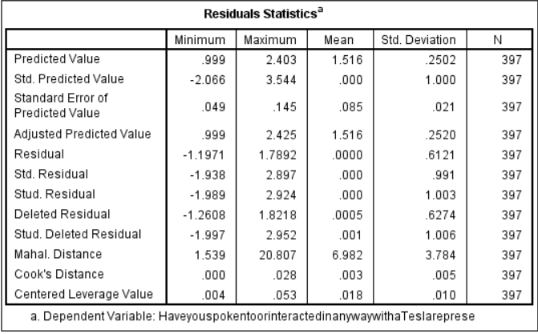
Table 7: Residuals Statistics
(Sources: self-made)
The dependent variable, "Have you spoken to or interacted in any way with Tesla representatives", has significant differences between the anticipated values as well as the actual values, which are revealed by the residual statistics (Pan, 2022). In order to evaluate the model's performance as well as spot any potential problems, it is helpful to understand the features associated with the residuals. The model's predictions and actual reactions generally agree on the average, as seen by the mean of its anticipated values, which is 1.516. The SD of the numbers that were predicted is 0.2502, which indicates that there is some variation surrounding the mean forecast. An estimation of the typical gap between the anticipated values as well as the actual ones is given by the predicted values standard error, which has a mean of 0.085. More accurate predictions from the model are shown by a lower standard error. The mean residual has almost nil when we look into the residuals, which indicates that the predictions made by the model are often unbiased. "The residuals' standard deviation", or how widely they vary from the mean, has 0.6121 (Tosesarij, 2020). The residuals' range, from -1.1971 to 1.7892, shows the severity of the departures from the expected values.
The outliers as well as significant data points are evaluated with the use of the standardized along with studentized residuals. The standardized residuals' mean roughly equals zero, indicating of the model doesn't consistently overestimate or underestimate. The range between the standardized & studentized residuals, which values are from -1.938 to 2.924 and -1.989 to 2.952, respectively, shows the degree that every data point departs from the projected values. Measures of the impact of people data points on the whole model are provided by the Mahala Nobis distance as well as Cook's distance. A greater Mahala Nobis distance or else Cook's distance denotes a stronger influence or else possible outliers which may require additional research (Thumiger, 2021). Last but not least, the centered leverage values show how each observation affects its own anticipated value. The average centered leverage value has 0.018, which indicates that the impact of the various data points over the corresponding predictions is fairly balanced. Thus, the residual statistics show a fair amount of agreement between the dependent variable's actual values with its anticipated values. On the other hand, more analysis may be necessary to find and look into any outliers or significant data points which might affect the performance of the model.
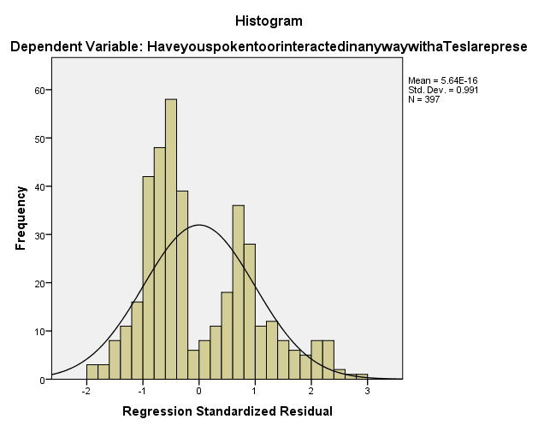
Figure 1: Histogram chart on Regression Standardized Residual
(Sources: Self-made)
The Regression Standardized Residual values' histogram chart shows that the range ranges from -2.066 to a high of 20.806 (Luffarelli et al. 2019). The residuals' mean value, which has a value of 5.64E-16 and is quite nearly zero, indicates that the residual values are typically centered around zero. The residuals' 0.991 standard deviation illustrates the dispersion or variability within the residuals. Additionally, 397 participants in total were included in the evaluation, as can be seen.
Frequency
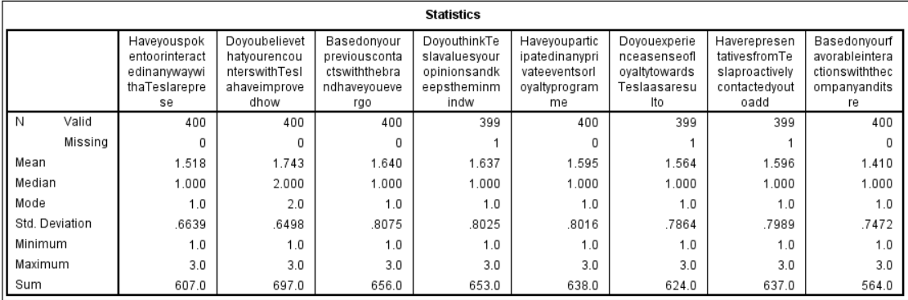
Table 8: Statistics
(Sources: self)
Statistics regarding a number of variables pertaining to encounters as well as opinions regarding Tesla are shown in the data chart provided. These numbers shed light on the information's distribution & underlying patterns (Qin, 2022). First off, we find that the "sample size (N)" is constant across all variables, proving that every one of the 400 people who participated had completed their surveys. The average responses are indicated by the mean readings of all the variables. The median response to the question "Have you spoken to or interacted in any way with a Tesla representative?" is 1.518, for instance, indicating that most respondents are given on average, talked to or had contact with a Tesla representative. In the same way, we can appropriately interpret the mean values for additional variables. The distributions for these factors are somewhat skewed regarding the smaller end, as indicated by the median numbers, which are typically less than the means (Catarino, 2019). This indicates that a sizable portion of respondents gave lower ratings or interacted with Tesla representatives less frequently. The value of each variable that occurs greatest frequently is its mode. The modes given in this instance are continuously 1.0, indicating that most of the respondents gave every factor the lowest rating or else had little expertise with it. The SD gauges the variation or dispersion of the data. A larger SD for the variables indicates more varied responses, which reflect respondents' different degrees of experience as well as viewpoints. The range of replies, from the lowest to the highest numbers, reveals the distribution of the information (Lin et al. 2022). The number of choices for responses as well as the degree of diversity in participants' experiences including perspectives are reflected in the spectrum of values for every variable, which is from 1.0 to 3.0. The total number of values, in addition, offers an overall measurement of responses among all participants. It enables us to view the general distribution of replies as well as the average score for every factor.

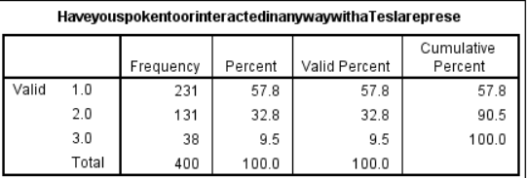
Table 9: Frequency table on Have you spoken to or interacted in any way with a Tesla representative in the last 12 months?
(Sources: self)
The distribution of answers to the question "Have you spoken to or interacted in any manner by a Tesla employee in the preceding twelve months" is shown in the following table. Among the 400 respondents, 231 people (57.8%) said they have spoken or engaged using a Tesla employee by responding using a value of 1.0. 131 people (32.8%) chose a score of 2.0, indicating they believed they were involved with Tesla in some way, albeit to a lesser degree compared to people in the initial category (Kikkas, 2020). Last but not least, 38 respondents (9.5%) selected a score of 3.0, suggesting that they had not had any interactions or conversations with an actual Tesla person. The levels of interaction and communication among participants with Tesla employees are revealed by these percentages. A large number of respondents claimed to have had some sort of interaction, whereas a smaller percentage said they had none.
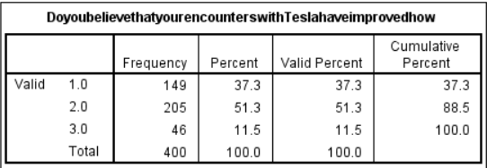
Table 10: Frequency table on do you believe that your encounters with Tesla have improved how you see the company.
(Sources: self)
Participants' opinions on whether or not their interactions with Tesla changed how they felt about the business are shown in the table that follows. According to the graph, 149 respondents (37.3%), or a majority, indicated that their encounters with Tesla had a favorable impact on their impression (Jenčová et al. 2019). However, just 205 of the participants (51.3%) gave a negative response, indicating that their interactions with Tesla did not change how they perceived the world. 46 individuals (11.5%) also said they were unsure or had mixed emotions about the effects of their conversations with Tesla. The aforementioned findings offer important new understandings of respondents' subjective evaluations of their encounters using the company.
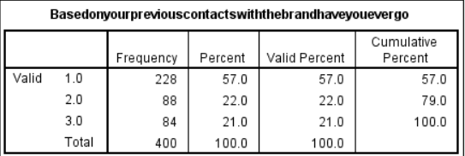
Table 11: Frequency table Based on your previous contacts with the brand, have you ever gotten personalized recommendations or offers from Tesla?
(Sources: self)
Participants' responses about if they had ever gotten customized suggestions or presents from Tesla according to their prior interactions with the brand are shown in the supplied bar graph. According to the chart, 228 participants (or 57.0%) indicated that they had indeed gotten individualized advice or offerings from Tesla. 88 participants (22.0%), with the other side, gave negative feedback, suggesting that they had not received these suggestions or offers (Chen et al. 2022). Furthermore, 84 participants (21.0%) gave answers that were unclear or ambiguous. These results shed important light on how participants interacted with Tesla's personalized recommendations as well as offers, offering participants insightful information about the efficacy and scope of the business's marketing operations.
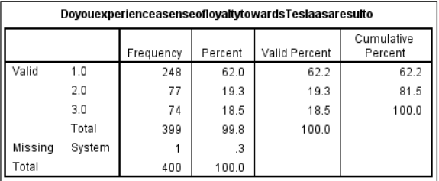
Table 14: Frequency table on Do you experience a sense of loyalty towards Tesla as a result of the company's efforts to keep a solid rapport with its clients?
(Sources: self)
The information in this table shows how 399 participants felt about Tesla in terms of their feeling of loyalty. Among all respondents, 62.2% (248 people) said they felt an overwhelming sense of loyalty to Tesla, whereas 19.3% (77 people) said they felt an average amount of loyalty, as well as 18.5% (74 people), said they felt a smaller amount of loyalty. According to the research, a sizable percentage of customers are becoming quite loyal to Tesla (Chehertma, 2022). This might be due to a number of things, including the business's commitment to cutting-edge, ecologically friendly electric vehicles, exceptional performance, plus dedication to sustainability. The focus on customer happiness at Tesla and its position as a market leader in the electric vehicle sector may potentially factor in the elevated level of loyalty seen. It is important to note that some respondents indicated a moderate or else lower level of allegiance to Tesla. It can be the result of things like price worries, a lack of alternative electric car options, or particular experiences which may have affected how they see the brand.
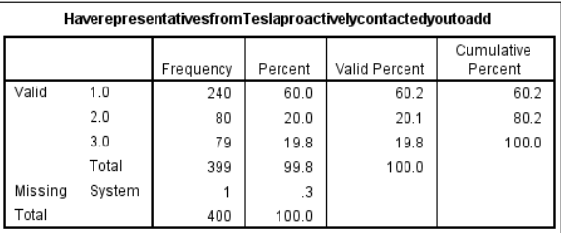
Table 15: Frequency table on Have representatives from Tesla proactively contacted you to address any problems or complaints you may have had with their goods or services
(Sources: self)
Participants' opinions regarding if Tesla representatives are actively contacted individuals to handle any issues or complaints that might have had are represented by the information in the upper bar graph. The data shows that all 240 respondents (60.2%) replied favorably, demonstrating that Tesla employees proactively contacted them (Zhou, 2022). However, 80 respondents (20.1%) gave a negative response, claiming their Tesla representatives had not contacted them. Furthermore, 79 individuals (19.8%) indicated they were unsure or had mixed thoughts about Tesla representatives making proactive interactions with them. These results shed light on the reactions of respondents to Tesla's proactive interaction.
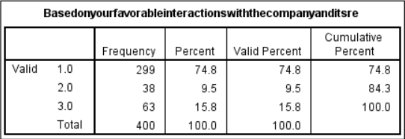
Table 16: Frequency table on Based on your favorable interactions with the company and its relationship marketing initiatives, would you suggest Tesla to others?
(Sources: self)
Participants' reactions are shown in the statistics regarding their positive experiences with the business plus its connection to marketing strategies. A favorable impression may be inferred from the graph with bars, which shows that 299 individuals (or 74.8%) stated that they had pleasant contacts using the business in question (Wolff et al. 2022). Furthermore, 38 participants (9.5%) took a neutral position, indicating that they felt neither highly in favor of nor against the idea of positive interactions. Finally, 63 people (15.8%) disagreed or showed uncertainty about their positive contacts with the organization. These results provide information about how people's perceptions, as well as reactions to the business as well as its connection to marketing initiatives differ.
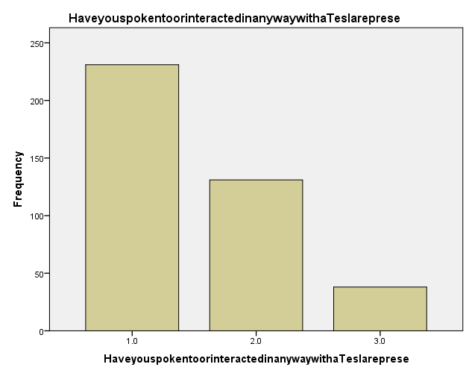
Figure 2: Bar chart on Have you spoken to or interacted in any way with a Tesla representative in the last 12 months?
(Sources: self)
The responses of participants about their interactions with Tesla representatives during the last 12 months can be seen in the bar chart top. It reveals that 231 respondents checked the box that said "yes," suggesting that they had a conversation or other interaction with a Tesla person (Kester et al. 2019). However, 131 people said "no," suggesting they had never interacted in any way any a Tesla employee. Furthermore, 38 participants gave the word "maybe," indicating doubt or ambiguity about their contacts.
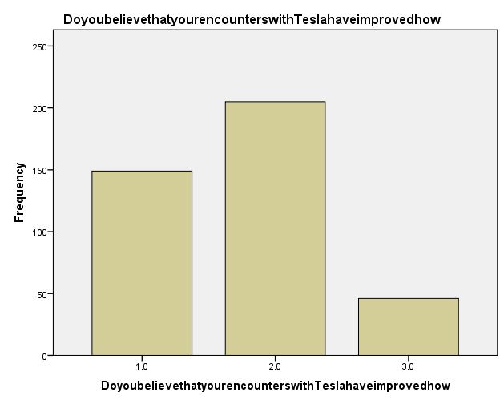
Figure 2: Bar chart on do you believe that your encounters with Tesla have improved how you see the company
(Sources: self)
The bar graph up top sheds light on the opinions of participants regarding how their interactions with Tesla have affected how they view the business. It demonstrates that, amongst the total number of participants, 149 people think their interactions with Tesla have improved how they see the company (Qin and Wu, 2021). Contrarily, 205 individuals disagree and say that their interactions did not alter their perception. Furthermore, 46 people are still unsure or perplexed about how their experiences with Tesla have affected how they view the company.
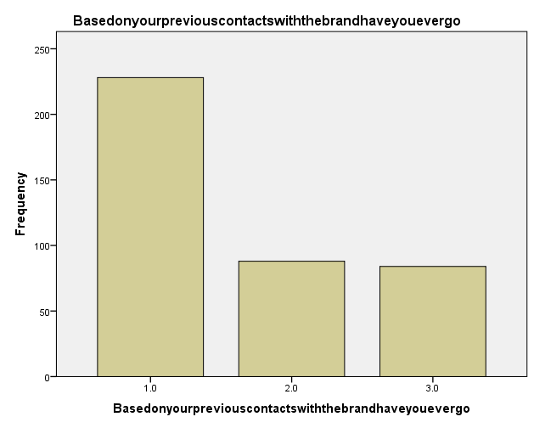
Figure 2: Bar chart on Based on your previous contacts with the brand, have you ever gotten personalized recommendations or offers from Tesla
(Sources: self-made)
The accompanying bar chart provides insightful data regarding participants' experiences via Tesla suggestions or offers that were tailored to them according to their prior interactions with the company. 228 of those surveyed gave a positive response, confirming that they had in fact received tailored advice or incentives from Tesla (Li et al. 2021). However, 88 people gave unfavorable feedback, claiming they had never gotten such individualized advice or offers. In addition, 84 individuals said "Maybe" when asked if they received customized suggestions or incentives from Tesla according to their prior interactions with the company.
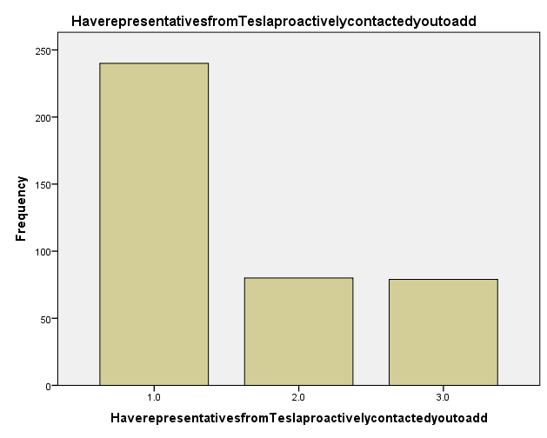
Figure 2: Bar chart on Have representatives from Tesla proactively contacted you to address any problems or complaints you may have had with their goods or services
(Sources: self-made)
Participants' opinions on Tesla representatives proactively contacting them to resolve any issues or concerns they might have experienced about the goods or services offered by the business are shown in the upper bar graph. 240 respondents indicated through their affirmative responses that Tesla employees had contacted them to talk about their issues. 80 participants, on the other side, gave negative feedback, claiming that they had not been proactively contacted by Tesla staff (Bonavia, 2022). In addition, when questioned regarding their interactions with aggressive contact with Tesla employees, 79 participants were unsure, responding only “Maybe”.
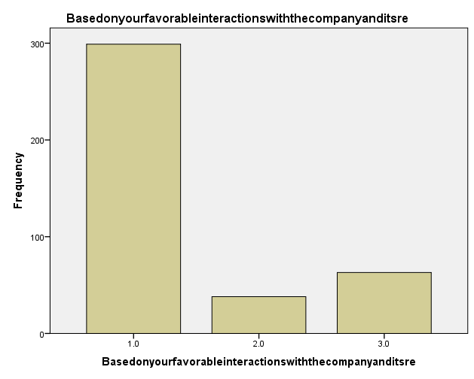
Figure 2: Bar chart on Based on your favorable interactions with the company and its relationship marketing initiatives, would you suggest Tesla to others
(Sources: self-made)
Depending on the participants' positive contacts with Tesla & its connection to marketing efforts, the aforementioned bar graph sheds light on the suggestions that were made by participants for Tesla. 299 participants reported a favorable opinion of Tesla, suggesting they might recommend the company to people because of what they liked about it. 38 individuals, on the other hand, gave unfavorable feedback and said they wouldn't suggest Tesla (Chen et al. 2022). Furthermore, 63 respondents gave the word "Maybe" when questioned if they would be inclined to advocate for Tesla depending on their positive contacts with the organization and its connection to marketing programmers.

4.3 Discussion
Regarding the link between relationship marketing along with brand loyalty with Tesla customers, the debate offers a review of a number of tables as well as data. The correlation table in this setting demonstrates strong connections among brand loyalty as well as Tesla's marketing endeavours, pointing to a favourable connection between relationship marketing techniques with brand loyalty. The mean values in the descriptive statistics table correspond to the usual responses for every variable, according to the information provided (Tamminen and Poucher, 2020). According to the findings, the majority of respondents were in contact with a Tesla representative, as well as those encounters have boosted their perception of the business overall. The fact that every variable were taken into account in the "regression analysis" further supports their significance for the study. This enables a thorough analysis of the variables affecting encounters with Tesla representatives. It is also clear that a somewhat positive correlation exists between predictors as well as the probability of speaking from a Tesla representative, as shown by the R-value (correlation coefficient) (Thumiger, 2021). The considered components are thought to be responsible for about 14.3% of the overall variance in interactions, according to their R Square value. The statistical significance of the regression model suggests that it makes a significant contribution to understanding the variation in contacts between Tesla salespeople. Every predictor's effect on conversations with Tesla reps is shown by the coefficients. The results don't indicate any weakly negative connections between the components that are statistically significant. This residuals, or discrepancies between projected as well as actual values, are described in the Residuals statistics table (Tosesarij, 2020). The statistics indicate a reasonable degree of agreement between the anticipated and observed values, although additional investigation may be required to spot outliers or important data points. The range of regression standardised residuals is shown by the histogram, which demonstrates that the residuals were generally centred around zero. This statistical table provides data on many aspects of interactions & opinions involving Tesla. The distribution as well as fluctuation of the data are revealed by "the mean, median, mode, standard deviation, and range". Additionally, it may identify and display the frequency distribution of replies pertaining to encounters with Tesla representatives, the effect of interactions on thinking, and tailored Tesla recommendations as well as offers (Tsai and Tan, 2021). These tables reveal information about the viewpoints as well as experiences of the participants. The results demonstrate the beneficial effects of relationship-based advertising on Tesla consumers' brand loyalty. The tables as well as figures offer a thorough examination of the data, illuminating "correlations, descriptive statistics, regression analysis, residuals, and participant" comments as well as experiences.

4.4 Conclusion
In conclusion, the data analysis done in Chapter 4 offers important insights regarding how relationship-based advertising at Tesla affects brand loyalty. According to the correlation analysis, relationships between marketing programmed with brand loyalty among Tesla customers are positively correlated. The association between relationship marketing as well as suggesting Tesla to other people is 0.223, which is consistent with the results indicating that a sizable portion of respondents have an interest in and enjoy the goods manufactured by Tesla. Additionally, the regression study looks at the variables affecting communications between Tesla representatives. According to the model summary statistics, there is a modestly positive association among the variables that predict as well as the probability of speaking via a Tesla employee. All included variables may be responsible for about 14.3% of the variation in interactions, underscoring their importance in affecting communication with Tesla reps. The residual statistics show a fair amount of agreement between the dependent variable's actual values with its anticipated values. Still, additional investigation might be required to find any anomalies or significant data points which could affect the performance of the model.

Chapter 5: Conclusion

5.1 Linking with Objective
Objective 1: To investigate Tesla's relationship marketing tactics
The renowned electric vehicle company Tesla has transformed the automotive sector through its cutting-edge offerings and progressive mindset. The goal of the research is to examine Tesla's relationship marketing techniques and identify the methods used by the business to forge and maintain strong bonds with its clients (Qin, 2022). To acquire a thorough grasp of "Tesla's relationship marketing" initiatives is the main goal of this inquiry. It wants to discover the critical elements influencing Tesla's achievement in forging close bonds among its client base by examining the business's relationship-management procedures, promotional initiatives, as well as communication channels. This study also aims to investigate the effects of Tesla's relationship marketing strategies on consumer happiness, and adherence, including advocacy. its aim is to evaluate the success of Tesla's strategy in developing pleasant customer experiences plus building brand loyalty by looking at consumer feedback, reviews, plus engagement on different platforms (Catarino, 2019). The research's conclusions will ultimately offer insightful information and useful consequences for companies operating both within and outside of the automobile sector. The results of this research will add to a wealth of information by identifying the precise relationship marketing strategies used by Tesla as well as act as a resource for businesses looking to improve customer relationships as well as gain an ongoing competitive edge.
Objective 2: To gauge Tesla consumer's degree of brand loyalty
The goal of the research is to evaluate the extent of brand loyalty customers have shown for Tesla, a well-known maker of electric vehicles. We seek to obtain important insights about the elements that support Tesla's consumers' brand loyalty as well as the influence they have on their buying choices by measuring as well as comprehending the degree of that devotion (Lin et al. 2022). This study will use a variety of quantitative techniques to reach its goal. A selected group of Tesla consumers will be given surveys as well as questionnaires to complete in order to collect information on their brand-related views, tastes, as well as behaviours. In-depth interviews, as well as focus groups, will also be held to glean more knowledge about the underlying motives as well as emotions that fuel customer commitment to Tesla. The results of the research will give a thorough understanding of Tesla customers' extent to brand loyalty plus the factors that contribute to it (Kikkas, 2020). This information will help Tesla evaluate and improve its marketing tactics, as well as other businesses looking to strengthen their personal brand loyalty initiatives. Also, it will advance knowledge of this significant component of marketing by adding to the corpus of research already done on customer behaviour including brand loyalty.
Objective 3: To assess the effect of relationship marketing on Tesla brand loyalty
This study aims to investigate the relationship between Tesla's consumers' brand loyalty with the relationship advertising tactics used by the famous "electric vehicle manufacturer". It intends to acquire knowledge regarding the efficacy of Tesla's customer-focused tactics including its help with long-term client retention by assessing the influence of relationship-marketing strategies on brand loyalty (Jenčová et al. 2019). A mix of quantitative research techniques shall be used to accomplish this goal. Consumers of Tesla will receive surveys as well as questionnaires, which can be used to gather information on how they feel about the business's interactions with marketing initiatives and how loyal they are to the business. To gain a deeper knowledge of the fundamental processes by which relationship advertising promotes brand loyalty, in-depth interviews, as well as focus groups, shall be held. The results of the research will shed important light on how relationship marketing affects Tesla brand loyalty. The research being conducted will add to the wealth of information on connection marketing as well as brand loyalty by analysing the interpersonal marketing strategies used by Tesla as well as their effects on consumer satisfaction, confidence, and involvement, including recurrent buying behaviour (Chen et al. 2022). Furthermore, the research will have useful ramifications for Tesla along with other automakers looking to strengthen customer relationships as well as promote brand loyalty within a cutthroat market.
Objective 4: To offer analysis and suggestions for improving relationship marketing techniques
In order to find areas for improvement, the goal of the research is to undertake a thorough examination of the relationship marketing strategies used by businesses. Our goal is to offer insightful analysis and practical advice for improving current relationship marketing methods by critically analysing their efficacy (Chen, 2022). This research focuses on analysing effective case studies with best practices in addition to conducting a complete analysis of the relationship literature on marketing in order to meet this goal. Additionally, we'll survey plus talk with marketing experts to get their opinions as well as experiences in relationship marketing. Numerous relationship marketing components, such as segmenting customers, customised communication, customer retention programmes, plus customer input methods will be examined as part of the investigation. We will identify areas for development and offer techniques for strengthening relationship marketing initiatives by analysing the advantages and disadvantages of various methods. The recommendations made during this research shall be determined by relationships marketing gaps as well as trends that have been found, as well as on useful advice from specialists in the field (Chehertma, 2022). The objective is to provide firms across industries with practical advice that they can use to improve their customer connections, boost customer loyalty, plus gain a lasting competitive edge. This study intends to add to the wealth of information on relationship marketing as well as offer helpful recommendations for marketers as well as companies looking to optimise their interpersonal marketing strategies in a constantly changing market.

5.2 Limitation
In this context of the limitation, A select group of Tesla consumers, like individuals who have been engaged on "social media" or have had prior contact with the business, might be the subject of the main information gathered for the purpose of the research. This could result in sample bias as well as restrict the applicability of the results to a larger group of Tesla consumers. It's possible that the outcomes don't truly represent the beliefs, habits, as well as brand loyalty of all Tesla buyers (Castro, 2022). Response bias occurs when participants in primary data collecting give answers they believe to be positive or socially acceptable. The success of relationship-based advertising or loyalty to brands may be overestimated as a result of such bias. The effect of relationship-based advertising on Tesla's brand loyalty could be underreported by participants, leaving us with a partial picture. Self-reported measurements used in surveys and interviews, which are prone to measurement mistakes, are the main method of gathering primary data. Participants can respond inconsistently, incorrectly, or with diverse interpretations of the same question. This introduces confusing considerations. Primary data collection records perceptions of relationship marketing as well as brand loyalty during a certain period (Zhou, 2022). Although it might change over time, brand loyalty has become a dynamic concept. The main data collection might fail to account for the long-term benefits of relationship marketing initiatives on customer loyalty. To determine the long-term effects of relationship advertising on "Tesla's brand loyalty, long-term follow-up" research is required.

5.3 Recommendation
Considering widening the group being studied by focusing on various demographic groups, geographic regions, and client segments to improve sample representativeness. It may guarantee that the results are better reflective of the whole Tesla consumer base plus assist in capturing a wider range of viewpoints. Combine qualitative as well as quantitative data gathering techniques to use a mixed methods strategy (Kester et al. 2019). This can help to give a more thorough knowledge of how relationship marketing affects consumer brand loyalty. Although quantitative surveys may assist to quantify as well as generalise findings, qualitative techniques like in-depth conversations or focus groups may provide deeper insights. Ensuring anonymity plus secrecy, using randomised response approaches, and using neutral language when writing survey questions are strategies to reduce bias in responses. These incentives may motivate participants to offer more sincere and objective responses, improving the accuracy of the data collected. Consider carrying out a longitudinal investigation over a longer time frame. This will make it possible to examine brand loyalty as well as the evolution of relationship marketing (Wolff et al. 2022). The sustainability along with the long-term benefits of relationship marketing methods on customer loyalty at Tesla may be better understood through continuous data collection.

5.4 Conclusion
In conclusion, the influence of relationship marketing on Tesla's brand loyalty was the main topic of this section. Because of its worldwide growth, technological advancements, and devoted client base, with customer-centric corporate practices, Tesla, renowned for its cutting-edge EVs with environmental initiatives, is experiencing a boost in brand value. In order to examine Tesla's relationship marketing strategies and gauge brand loyalty amongst Tesla customers, the method of convenience sampling has been used. It was possible to make generalisations regarding the relationship between relationship marketing as well as brand loyalty since random sampling was employed to guarantee accuracy as well as statistical validity. "Relationship marketing and brand loyalty" have a positive link, according to the data examination, which was done utilising SPSS. It is possible to establish causation as well as gain a more thorough understanding of the way relationship marketing affects consumer brand loyalty through additional research that incorporates various approaches. Ultimately, this chapter provides insightful information on the connection between brand loyalty with Tesla's relationship-based advertising.
Reference List
- Alharahsheh, H.H. and Pius, A., 2020. A review of key paradigms: Positivism VS interpretivism. Global Academic Journal of Humanities and Social Sciences, 2(3), pp.39-43.
- Arani, M.S. and Shafiizadeh, H., 2019. Investigation of brand familiarity and brand recognition and their relationship with loyalty, repurchase intention, and brand recommendation with mediating role of brand reputation (Case Study: Esteghlal Hotel). Revista Gestão & Tecnologia, 19(5), pp.7-29.
- Bhardwaj, P., 2019. Types of sampling in research. Journal of the Practice of Cardiovascular Sciences, 5(3), p.157.
- Bhardwaj, S., Pandey, R., Sharma, S., Sejal, S., Iyer, G., Sharma, S., Ranjith, P.V. and Kulkarni, S., 2020. Problems faced by automobile industries: Case study on Tesla. International journal of Tourism and hospitality in Asia Pasific (IJTHAP), 3(2), pp.78-88.
- Bonavia, M., 2022. The influence of social media marketing on brand loyalty in the restaurant industry (Master's thesis, University of Malta).
- Catarino, J.I.M., 2019. Tesla Inc.: an equity valuation (Doctoral dissertation).
- Chehertma, B., 2022. International competitiveness management of Tesla, Inc. during the COVID-19 pandemic (Doctoral dissertation, Private Higher Educational Establishment-Institute “Ukrainian-American Concordia University”).
- Chen, Y., 2022, July. The Impact of Strategic Alliance on Corporate Performance: Evidence from Tesla. In 2022 2nd International Conference on Enterprise Management and Economic Development (ICEMED 2022) (pp. 206-212). Atlantis Press.
- Chen, Y., Long, Z. and Sun, S., 2022, April. How COVID19 Affected the Compensation Plan of Tesla, Lyft, and DoorDash and Incentivized Different Industries. In 2022 7th International Conference on Social Sciences and Economic Development (ICSSED 2022) (pp. 85-91). Atlantis Press.
- Chylinski, M. and Heller, J., 2022. The customer loyalty journey-technology enabled loyalty touchpoints. In Handbook of Research on Customer Loyalty (pp. 42-54). Edward Elgar Publishing.
- Corbett, K., 2020. UNDERSTANDING HOW TESLA LEVERAGES TWITTER TO COMMUNICATE ENVIRONMENTAL CORPORATE SOCIAL RESPONSIBILITY.
- Corbett, K., 2020. UNDERSTANDING HOW TESLA LEVERAGES TWITTER TO COMMUNICATE ENVIRONMENTAL CORPORATE SOCIAL RESPONSIBILITY.
- Dai, R., 2020. The Analysis of Tesla's Competitive Strategy for the Chinese Market. The University of Nottingham, (199).
- Dai, R., 2020. The Analysis of Tesla's Competitive Strategy for the Chinese Market. The University of Nottingham, (199).
- de Almeida, J.P.L.G., 2021. Market Perspectives on New Technologies: The Case of Tesla (Doctoral dissertation, ISCTE-Instituto Universitario de Lisboa (Portugal)).
- Frechette, J., Bitzas, V., Aubry, M., Kilpatrick, K. and Lavoie-Tremblay, M., 2020. Capturing lived experience: Methodological considerations for interpretive phenomenological inquiry. International Journal of Qualitative Methods, 19, p.1609406920907254.
- Hu, Z., Research on the Consumer Behavior Characteristics and Marketing Strategy of New Energy Vehicles——Taking BYD and Tesla as Examples.
- Jenčová, S., Vasanicova, P. and Litavcová, E., 2019. Financial indicators of the company from electrical engineering industry: the case study of Tesla, inc. Serbian Journal of Management, 14(2), pp.361-371.
- Jiang, Q., Wei, W., Guan, X. and Yang, D., 2021. What increases consumers’ purchase intention of battery electric vehicles from Chinese electric vehicle start-ups? taking Nio as an example. World Electric Vehicle Journal, 12(2), p.71.
- Jobaid, M.I. and Naher, K., 2020. Tesla's Relationship Building As a Disruptive Technology In Automobile Industry In India. International Journal of Latest Trends in Engineering and Technology, 16(1), pp.142-153.
- Jobaid, M.I. and Naher, K., 2020. Tesla's Relationship Building As a Disruptive Technology In Automobile Industry In India. International Journal of Latest Trends in Engineering and Technology, 16(1), pp.142-153.
- Kester, J., Sovacool, B.K. and Heida, V., 2019. From flying cars to Tesla: examining the personal automobile preferences of primary schoolchildren in Denmark and the Netherlands. Energy Research & Social Science, 56, p.101204.
- Kikkas, O.A., 2020. Financial performance assessment of tesla, inc. and nissan motor company.
- Li, L., Li, T., Cui, J., Gu, Y. and Zhang, J., 2021, June. To Gain A Foothold in the Luxury EV Market for Chinese New Car-making Forces Brands: Resonate with Consumers through Branding First. In IOP Conference Series: Earth and Environmental Science (Vol. 793, No. 1, p. 012021). IOP Publishing.
- Lim, Y.X. and Tan, C., 2022. Do negative events really have deteriorating effects on stock performance? A comparative study on Tesla (US) and Nio (China). Journal of Asian Business and Economic Studies, 29(2), pp.105-119.
- Lin, P., Lu, Y. and Xu, Z., 2022, March. Tesla’s Dilemma and Future Development Trends. In 2022 7th International Conference on Financial Innovation and Economic Development (ICFIED 2022) (pp. 2174-2180). Atlantis Press.
- Long, Z., Axsen, J., Miller, I. and Kormos, C., 2019. What does Tesla mean to car buyers? Exploring the role of automotive brand in perceptions of battery electric vehicles. Transportation Research Part A: Policy and Practice, 129, pp.185-204.
- Long, Z., Axsen, J., Miller, I. and Kormos, C., 2019. What does Tesla mean to car buyers? Exploring the role of automotive brand in perceptions of battery electric vehicles. Transportation Research Part A: Policy and Practice, 129, pp.185-204.
- Lu, F., 2020, January. Can shareholders of Tesla really benefit?. In 2019 International Conference on Education Science and Economic Development (ICESED 2019) (pp. 227-233). Atlantis Press.
- Luffarelli, J., Mukesh, M. and Mahmood, A., 2019. Let the logo do the talking: The influence of logo descriptiveness on brand equity. Journal of Marketing Research, 56(5), pp.862-878.
- Lugtu Jr, R.C., 2019. Tesla: Testing a Business Model at its (R) Evolutionary Best (Doctoral dissertation, DE LA SALLE UNIVERSITY-MANILA).
- Nayak, M.S.D.P. and Narayan, K.A., 2019. Strengths and weaknesses of online surveys. Technology, 6(7), pp.0837-2405053138.
- Ngoma, M. and Ntale, P.D., 2019. Word of mouth communication: A mediator of relationship marketing and customer loyalty. Cogent Business & Management.
- Nobanee, H., Alzaabi, H., Alremeithi, A., Abdulla, M., Azim, D. and Ismaili, N., 2021. Working Capital Management Ratios: A Comparative Study between Tesla and NIO. Available at SSRN 3763482.
- Palmatier, R.W. and Steinhoff, L., 2019. Relationship marketing in the digital age. Routledge.
- Pan, J., 2022, December. Application and Feasibility Analysis of DCF Model in Corporate Valuation: A Case Study of Tesla, Inc. In 2022 International Conference on Economics, Smart Finance and Contemporary Trade (ESFCT 2022) (pp. 1005-1023). Atlantis Press.
- Qian, L. and Zhang, C., 2023. Complementary or congruent? The effect of hosting Tesla charging stations on hotels’ revenue. Journal of Travel Research, 62(3), pp.663-684.
- Qin, K., 2022, December. Analysis of Tesla’s Innovation Strategy and Influence of Leadership. In 2022 2nd International Conference on Financial Management and Economic Transition (FMET 2022) (pp. 228-238). Atlantis Press.
- Qin, S. and Wu, G., 2021, December. Research on Tesla’s Price Strategy in China. In 2021 3rd International Conference on Economic Management and Cultural Industry (ICEMCI 2021) (pp. 594-603). Atlantis Press.
- Qin, Y., Xiao, Y. and Yuan, J., 2021, September. The Comprehensive Competitiveness of Tesla Based on Financial Analysis: A Case Study. In 2021 International Conference on Financial Management and Economic Transition (FMET 2021) (pp. 462-469). Atlantis Press.
- Qu, Y. and Gu, J., 2022. Analysis of Tesla.
- Salman, D.M., 2019. An insight for the market driving forces: Case of Tesla Model-S. International Journal of Business Ecosystem & Strategy (2687-2293), 1(2), pp.25-30.
- Salman, D.M., 2019. An insight for the market driving forces: Case of Tesla Model-S. International Journal of Business Ecosystem & Strategy (2687-2293), 1(2), pp.25-30.
- Sousa, R.M.D.V.Z.J.D., 2022. Tesla´ s international expansion-the impact of sustainability on competitive advantage (Doctoral dissertation).
- Stratton, S.J., 2021. Population research: convenience sampling strategies. Prehospital and disaster Medicine, 36(4), pp.373-374.
- Sypko, D., 2022. Time-Based Competition in Tesla´ s Supply Chain in the Era of Industry 4.0.
- Tamminen, K.A. and Poucher, Z.A., 2020. Research philosophies. In The Routledge international encyclopedia of sport and exercise psychology (pp. 535-549). Routledge.
- Thumiger, B., 2021. The valuation of Tesla and BMW in a disrupted industry: a comparative analysis.
- Tosesarij, C., 2020. DISCOUNTED CASH FLOW VALUATION OF TESLA INCORPORATED (TSLA) (Doctoral dissertation, Mahidol University).
- Tsai, H.Y. and Tan, T.M., 2021. The impact of artificial intelligence on sustainable corporate brand: a netnography study of Tesla.
- Wang, J., Duan, Y. and Liu, G., 2021. A study of specific open innovation issues from perspectives of open source and resources—The series cases of tesla. Sustainability, 14(1), p.142.
- Wolff, B., Schlagwein, D. and Schoder, D., 2022. How Resource Openness Supports Industrial Transformation and Competitive Advantage: The Revelatory Case of Tesla. In Pacific Asia Conference on Information Systems (p. 1).
- WU, Z.Q., NGUYEN, P.Q., PHANKASEMSAN, I. and WOLF, E., 2022. Driving Sustainability and Electric Vehicles Evolution: Tesla Company's Success Strategies.
- Xia, X., 2022. SCM PMA Supply Chain Models---A Case Study of Tesla Motors. International Journal of Frontiers in Engineering Technology, 4(4).
- Xinyi, L., Chen, Z. and Bai, C., 2022. Case Study Research in Tesla (China) Marketing Strategy Application During Covid-19.
- Zhou, Y., 2022, April. Research on Influencing Factors of Tesla Pricing Strategy. In 2022 7th International Conference on Social Sciences and Economic Development (ICSSED 2022) (pp. 107-114). Atlantis Press.

