Student Number: 2106584
BA course title: Graphic Design
Word count: 2545

Question: Can Graphic Design really save your life? Explore the association of wellbeing and personal growth in Design in your discussion.

Contents list

Introduction
The background of graphic design and the importance of graphic design.
Chapter one
Graphic design can call on more people to pay attention to human rights issues.
Chapter two
Graphic design can also apply in the prevention and control of infectious diseases, it improves social wellbeing.
Chapter three
Graphic design can help vulnerable groups.
Chapter four
Graphic design can contribute to environmental protection
Conclusion
Summarize how graphic design can save our lives, and discuss the relationship between personal growth and wellbeing that I have found in design.

Introduction

The following essay is about how graphic design could possibly can save your life, and can improve your wellbeing and personal growth.

Graphic design is commonly defined as being able to solve problems on a two-dimensional surface (Arntson, 2011); it involves transforming text information into images to improve the efficiency of conveying messages to the public: “This is the Age of Information, not the Industrial Age” (Arntson, 2011, p. 4). Information penetrates into our daily life. In particular, “Images are 'everywhere'. They permeate our academic work and everyday lives. They inhabit and inspire our imaginations, technologies, texts and conversations” (Pink, 2013, p. 1). The growing importance of graphic design has been attributed to the information age, due to its importance in message transmission. Graphic design is a potent tool as it influences others through enlightening, motivating, and entertaining them (Roberts, 2006).

Graphic design can address different areas problem in society. It benefits people in numerous ways. In this essay, I intend to examine different ways that graphic design can be used to affect people and to galvanise, mobilise individuals and populations.

The first chapter is about how graphic design can encourage people to pay attention to human rights issues. The second chapter discusses how graphic design can be extremely helpful in the diagnosis and management of infectious diseases and by doing so, help with health and general wellbeing of the public. The third chapter considers that humanized fonts created by graphic designers can benefit vulnerable groups and increase their happiness; The final chapter shows how graphic designers incorporate the design principles of environmentally friendly and sustainable development, which can protect the environment and conserve resources, ultimately saving humanity. It can also realize the designer's personal value. To conclude this discussion, I will discuss my own experiences in relation to my research into wellbeing and personal development in design.

Chapter One:
The connection between Graphic design and human rights issues.

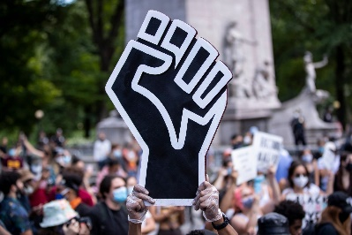
Graphic design can contribute to global equality, for example, Black Lives Matter Movement. Black Lives Matter supporters urge action to address the oppression and unfair treatment that date back to the time of slavery but still exist now. (BBC News, 2021). A black fist is depicted in Figure 1 in Black Lives Matter this symbol is frequently used. The clinched fist, commonly known as the "black fist," became associated with the Black Lives Matter (BLM) movement in 2020 as a symbol of strength, pride, and tenacity, George Floyd, a black man, passed away in May 2020 as a result of a white police officer continuously pressing him in the neck for more than nine minutes. The closed fist is once more popular among Black Lives Matter activists. This is how Freud is being remembered all throughout the world. (Helligar, 2012).
Figure 1. A protester holds up a large black power raised fist gathered at Columbus Circle in New York City for a Black Lives Matter protest spurred by the death of George Floyd. Helligar,2021

The colour black denotes that this symbol refers to the black community as a whole. The reason for the closed fist is that every finger by itself has no force, but close together they will be strong (Stout, 2020). One protester said that “as a young black girl … this signifies resiliency and power through every triumph and struggle” (Stout, 2020). The goal of BLM activists is to raise awareness of the numerous ways that black people in society are treated unfairly, as well as the ways that institutions, laws, and policies contribute to this injustice (Britannica, 2022). People now instantly associate Black Lives Matter with the clenched fist because it has evolved into a symbolic language. “That symbolic fist really opened my eyes to the injustices within our country," as a protester said (Stout, 2020). Without a doubt, the effectiveness of information transmission is increased by this graphic symbol. The audience can understand the symbol's meaning even without any written instructions. With the use of powerful visual symbols that make the symbol simpler for the public to recognize and remember, the message of the clenched fist may be communicated more successfully and bring greater attention to the problem of Black Lives Matter.

Chapter Two:
Graphic Design can also apply in the prevention and control of infectious diseases, it improves social wellbeing.

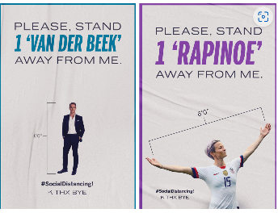
Graphic design can make a significant contribution to human health protection. Graphic designers have their own special methods for dealing with sudden catastrophic human disasters in the medical profession, such as the coronavirus, which is one of the worst threats confronting humanity. Additionally, graphic designers have made an effort to uphold their obligations to positively communicate messages like "stay at home" and "keep the distance" to everyone around the globe and to contribute to the solution by coming up with innovative solutions to fit the needs and expectations of the modern world (Atasoy, 2021).
Figure 2. These clever posters are part of a series of 12, all using celebrities to encourage social distancing. Ostrower

Rosenberg’ s (2020) 12 posters Figure 2 includes celebrities employed by the artists to encourage social distance among the audience. Because audiences love, trust, and even imitate celebrities, this is could be transferred to the trust, and imitation of the action, the artists take advantage of the celebrity effect (Rosenberg, 2020).

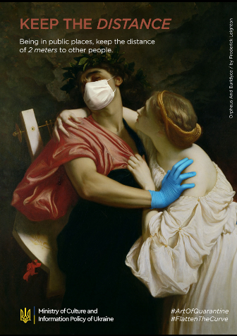
We may claim that maintaining the quarantine is a form of art. This is a campaign called the “Art of quarantine” (2020), launched in collaboration with the Ukrainian Ministry of Culture and Information Security. Because many people continue to flout the fundamental guidelines of quarantine and personal safety during the ongoing coronavirus outbreak, old-fashioned artworks were given the fresh style by artists and provided safety and COVID-19 prevention lessons. The goal of this campaign was to limit the disease's spread and reach as many people as possible throughout the world (Art of quarantine, 2020). In the poster, the beautiful woman tries to get close to the man, but the man turns his head away, closes his eyes, wears a mask and pushes her away with a hand using medical gloves. The headline of the poster is, “keep your distance”, and it says below, “keep two meters” apart in public areas to call on people not to get too close.
Figure 3. Art of quarantine, 2020

The designers use their observational skills to transform the current negative situation into a positive one, and they may even add a little humour to this situation. They like to give people happiness in this way. Designers use images to represent the messages, guidelines, and policies they feel are necessary to express in order to provide correct information. The importance of the information's transmission and the impact it will have, along with the importance of the information's accuracy should not be ignored. By adding visual components to the information, people may direct their attention to a certain topic (Atasoy, 2021).
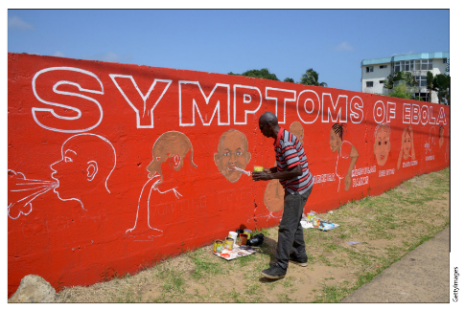
Furthermore, another example of graphic design applied to contagion is one found in West Africa during the 2014 Ebola outbreak. Liberian designer Stephen Doe, painted walls red to indicate danger and used straightforward iconography to explain the illness symptoms to a populace that spoke more than 30 different languages and had limited literacy (Lange, 2017). Effective graphics are exceptional in their capacity to instantly communicate across language and literacy limitations (Plinth, 2017). A similar motif can be seen in UNICEF's posters. It is an engaging show that is logically set out, well-organized, and continually educational (Burki, 2017).
Figure 4. Hand-painted Ebola mural, Doe, 2014

Through different forms of creation, graphic design significantly contributes to the prevention, control, and reaction of most diseases.

Chapter Three:
Graphic Design can help vulnerable groups

The graphic designer will be concerned with more societal groupings in the hope that more individuals can live in happiness. Good designers are able to make their audience feel comfortable and provide them with convenience. Graphic designers for instance, employ colour with colour blindness in mind, while Typeface designers, create Braille libraries to aid the blind.

This is the first Braille font of Ali font in China. The font name is Ali Health Font. First of all, the main use of this font is designed for the drugs of Ali Health Pharmacy. From the shape of the font, we see that Figure 5 the overall appearance of the font presents a rounded feeling, more with a kind of affinity, giving people a close and warm feeling. It is an emotional design. Secondly, the stroke-turning part of the font is designed in the form of a round outside and a square inside, and the middle part is loose so that it does not look so tight. The font outline is clear, presenting simple and generous modeling, greatly improving recognition. This provides convenience for elderly users and visually impaired people.
Figure 5. AliHealthFont, Tencent News, 2022

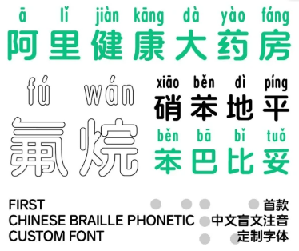
In addition, the designer found that patients often encounter unfamiliar words when buying medicine. In order to make it more convenient for patients to buy medicine, Ali Health Font added phonetic notes to the rare words of medicine as seen in Figure 6, so as to solve the purchasers' difficulty in recognizing the rare words of medicine. It “certainly shows how graphic design can enhance the user experience by making information clear and accessible” (Walker, 2017, p. 296).
Figure 6．Tencent News，2022

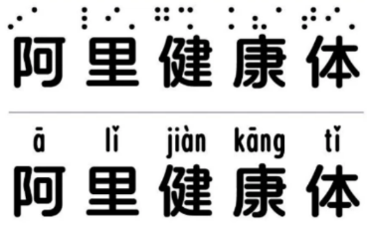
Ali Health Font also introduced a blind style Figure 7. Chinese characters based on following the national standards of Chinese Braille, so as to achieve a more legible effect. Especially this can be helpful for visually impaired people to buy medicine. The design of Braille makes it more convenient for them to take care of themselves in daily life.
Figure 7. The top dot is in Braille, and the top of the second line Ali Health Font is marked with pinyin. Tencent News，2022


With its simple and friendly design, Ali Health Font is used in the outer packaging of drugs, it adopted green as the main design, and its simple typesetting and text design make it easier for the public to select and identify when buying.


It can be seen that the brand customized fonts launched by Ali Health are designed around the keyword of "simple and convenient." It adopted green as the main design, simple style, and comfort people. Both the simple and legible Chinese font and the Braille design for the visually impaired are of great social significance and strengthen the development
direction of the brand (Tencent News, 2022).

Chapter four
Figure 8. Tencent News, 2022
Graphic design can contribute to environmental protection

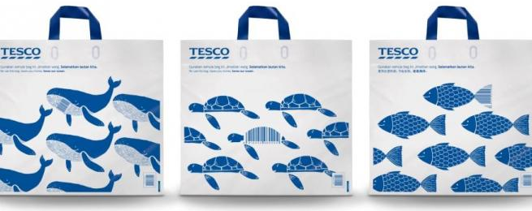
Graphic design also has a very important part to play in protecting the environment. Graphic designers use their ways to draw attention to some problems in society so that we can work better together on the tasks that challenged our daily life（Pink, 2013).
Figure 9. Tesco stores are rolling out reusable shopping called unforgettable bag, Greenmatters, 2019

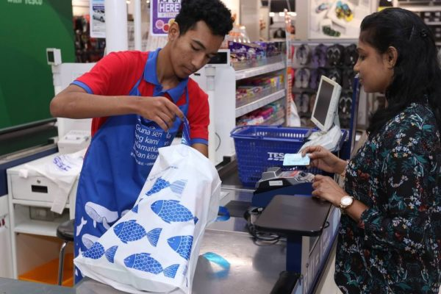
An example of one challenge which can be seen in how we tackle plastic pollution. Each year, more than 1 trillion plastic bags are produced and distributed worldwide; the majority of them are single-use which is non-productive and also pollutes oceans. The Tesco conglomerate shopping outlet has developed a creative initiative to lessen plastic waste. This chain unveiled new recyclable material-made bags. Each of them has a barcode that will give clients a discount when they purchase at Tesco. So far, the outcomes have been rather amazing. Tesco projects this year's use of plastic bags in its stores will be cut by 5 million pieces, thanks to the Unforgettable Bag (Brandactivation,2018).
Figure 10. Reusable shopping bags with barcodes that provide customer discounts, 2019

In terms of graphic language, graphic designers use the most straightforward graphics, Figure 10. Here you can see the repeated arrangement of marine creatures as the main graphic theme. The design is directly related to the conservation of marine animals. In terms of colour, only blue is used, which not only echoes the ocean theme, but also reduces the use of other colours in order to save resources and protect the environment. The bag is made of recycled materials, which carries out the theme of protecting the environment.

Kim and Geissbühler (2018) state that environmentally friendly design is good design. Design contributes significantly to the protection of the environment. Throughout the lifecycle of the product, this minimises physical and visible pollution, whilst conserving resources.

Designers typically apply design thinking to their work. They are each aware that their creations must empower people and help to progress societal issues. They advocate for a better way of life, convey beauty to the audience, and educate people about sustainable development concepts. This procedure can demonstrate the importance of graphic designers - they contribute to environmental conservation, and they can also enhance social human wellbeing. Additionally, the designer also gaining more knowledge and personal growth throughout this time.

Conclusion

To sum up, I have identified how graphic design has the potential to save human life, both immediately and for future generations to come. By accurately transforming the world into visuals, graphic designers assist the public to grasp important information, which can provoke understanding and worldwide engagement. Designers should provide contemporary information using modern technologies, whilst maintaining a focus on current trends and problems (Arntson, 2011).

Graphic design has been employed to inform, persuade, and empower ( Wallersteiner, 2017).
Consequently, societal wellbeing may be served better through a deeper understanding of the utility of graphic design. Graphic design can call on more people to solve and pay attention to the inequality of human rights and help disadvantaged people. Additionally, it played an important part in the control of infectious diseases. It can also design more suitable fonts for vulnerable groups to facilitate their lives. If we look towards productive ways in which graphic designers can also comply with sustainable development principles when using environmentally friendly and sustainable materials. This can be seen as a crucial contribution towards the future of our health and wellbeing, whilst protecting the environment of our planet. Graphic design could be considered important towards the sustainability and longevity of human life.

I have learned more about graphic design as I have gathered materials and written this article. My understanding towards the utilization of graphic design is more significant than I previously thought. Graphic design undoubtedly has tangible impacts for our daily life. This research has increased my enthusiasm and desire for graphic design overall.

Dougher (2015) stated that as designers, we are frequently expected to solve a wide range of issues, yet our experiences are often insufficient to give us the knowledge or comprehension necessary to complete these tasks successfully. Therefore, I will continue to expand my skills as a learner, designer and educator.

Going forward, I will look towards ways of improving my design capabilities, whilst also integrating the development of my interpersonal morals and ethics. By doing this, I hope that my future designs can be empathetic, productive and practical. Upon reflection, gaining more knowledge and experience within the process of design can assist in the realization of my personal wellbeing. My personal growth and life experience can help promote the development of society through my designs, so to help others improve their life efficiency and social wellbeing.

Bibliography

Arntson, A. E. (2011). Graphic design basics. 5thedn. Boston: Clark Baxter

Atasoy, S. N. (2021) ‘The role of graphic design in the COVID-19 global outbreak’, New Trends and Issues Proceedings on Humanities and Social Sciences, 8(1), pp. 52–69. DOI: 10.18844/prosoc.v7i4.5791.

Bayley, S. (2017) ‘Design: Can Graphic Design Save Your Life?’, The Spectator. 277(8774), pp.1-3. Available at: Design: Can Graphic Design Save Your Life? - ProQuest (Accessed: 20 October 2022).

BBC News（2021）What is Black Lives Matter and what are the aims. Available at: What is Black Lives Matter and what are the aims? - BBC News (Accessed: 20 November 2022).

Brandactivation (2018) Tesco – The Unforgettable Bag. Available at: Tesco – The Unforgettable Bag (brandactivation.com) (Accessed: 2 November 2022).

Britannica, T. （2022）Black Lives Matter. Available at: Black Lives Matter | Definition, Founders, Goals, History, & Influence | Britannica (Accessed: 20 November 2022).

Burki, T.K.（2017） ‘Can graphic design save your life’， The Lancet Respiratory Medicine, 5(11), pp.854-855. DOI: https://doi.org/10.1016/S2213-2600(17)30375-2

Costes, E.et al. (2009) October. ‘Graphic design for blind users: an industrial case study’. In International Association of Societies of Design Research Conference, pp. 1099-1108.

DeRosa, A. and Scherling, L. (2020) ‘Ethics in design and communication: critical perspectives’, in L. Scherling and A. DeRosa (eds). London [England: Bloomsbury Visual Arts. Available at: https://doi.org/10.5040/9781350077027. (Accessed: 23 October 2022).

Dougher, S. (2005) 100 habits of successful graphic designers: insider secrets on working smart and staying creative. Gloucester: Rockport.

Helligar, J. (2012) How the Clenched Fist Became a Black Power Symbol. Available at: The Black Power Fist: How the Clenched Fist Became the Symbol for Black Power | Reader's Digest (rd.com) (Accessed: 20 November 2022).

Jedlicka, W. (2010) Sustainable Graphic Design: Tools, Systems and Strategies for Innovative Print Design. Canada: John Wiley & Sons.

Kim, H.H. and Geissbühler, S. (2018) Graphic design discourse: evolving theories, ideologies, and processes of visual communication. 1stedn. New York: Princeton Architectural Press.

Lange, C. D. (2017) Graphic design can save your life – here’s how. Available at: Graphic design can save your life – here’s how | New Scientist (Accessed: October 25 2022).

Liu, C., Liu, S. and Ren, Z. (2021) ‘Using Design and Graphic Design with Color Research in AI Visual Media to Convey’. Sensors, 2021, pp.1-11. Available at: https://doi.org/10.1155/2021/8153783 (Accessed: 2 November 2022).

Lupton, E. and Lipps, A. (2018) The senses: design beyond vision. 1stedn. New York: Cooper Hewitt, Smithsonian Design Museum.

Pinion, S. (2017) ‘Design for life’, The Lancet (British edition), 390(10102), pp. 1578–1578. Available at: https://doi.org/10.1016/S0140-6736(17)32487-X. (Accessed: 1 November 2022).

Pink, S. (2013) Doing visual ethnography. 3rdedn. California: SAGE.

Plinth (2017) Can graphic design save your life? Available at: Can Graphic Design Save Your Life? (plinth.uk.com) (Accessed: 20 October 2022).

Prahara, G. A. (2022). Embracing the Future: Creative Industries for Environment and Advanced Society 5.0 in a Post-Pandemic Era. 1stedn. London: Routledge.

Rigden, C. (1999). 'The Eye of the Beholder'-Designing for Colour-Blind Users’. British Telecommunications Engineering, 17(1999), pp.291-295. Available at: rigden (gatech.edu) (Accessed: 3 November 2022).

Roberts, L. (2006) Good: an introduction to ethics in graphic design. Lausanne: AVA Academia.

Spean, B. (2019) Malaysia looks to Improve its recycling rate with new incentives. Available at: Malaysia Looks To Improve Its Recycling Rate With New Incentives (greenmatters.com) (Accessed :1 November 2022).

Stout, J. (2020) The history of the raised fist, a global symbol of fighting oppression. Available at: The history of the raised fist, a global symbol of fighting oppression | National Geographic
(Accessed: 20 November 2022).

Walker, S. (2017) ‘Can graphic design save your life？’, Design for health, 1(2), pp. 296-304. DOI: 10.1080/24735132.2017.1386506

Wallersteiner, R. (2017) Can graphic design save your life? Available at: Can graphic design save your life? - The Hippocratic Post (Accessed :1 November 2022).

List of Figures

Figure 1: Helligar, J. (2012) How the Clenched Fist Became a Black Power Symbol. Available at: The Black Power Fist: How the Clenched Fist Became the Symbol for Black Power | Reader's Digest (rd.com) (Accessed: 20 November 2022).

Figure 2: These Excellent Covid-19 Posters Are Both Beautiful and Beneficial Available at: These Excellent Covid-19 Posters Are Both Beautiful and Beneficial - Washingtonian (Accessed: November 3 2022).

Figure 3: Art of Quarantine Available at: Art of Quarantine on Behance(Accessed: November 3 2022).

Figure 4: Can graphic design save your life? Available at: Can graphic design save your life? - The Hippocratic Post (Accessed: 1 November 2022).

Figure 5: AliHealth releases its first accessible font, designed for everyone! Available at: 阿里健康发布首款无障碍字体，为所有人设计！_腾讯新闻 (qq.com) (Accessed: 6 November 2022).

Figure 6: AliHealth releases its first accessible font, designed for everyone! Available at: 阿里健康发布首款无障碍字体，为所有人设计！_腾讯新闻 (qq.com) (Accessed: 6 November 2022).

Figure 7: AliHealth releases its first accessible font, designed for everyone! Available at: 阿里健康发布首款无障碍字体，为所有人设计！_腾讯新闻 (qq.com) (Accessed: 6 November 2022).

Figure 8: AliHealth releases its first accessible font, designed for everyone! Available at: 阿里健康发布首款无障碍字体，为所有人设计！_腾讯新闻 (qq.com) (Accessed: 6 November 2022).

Figure 9: Malaysia looks to Improve its recycling rate with new incentives. Available at: Malaysia Looks To Improve Its Recycling Rate With New Incentives (greenmatters.com) (Accessed: 5 November 2022)

Figure 10: Nákupní taška od Tesco obsahuje skrytou slevu pro zákazníky Available at: Nákupní taška od Tesco obsahuje skrytou slevu pro zákazníky – Za každým úspěchem stojí dobrý insight (Accessed :5 November 2022)

