A marketing plan written for Travelodge Hotel Company

Student Name: Nasima Akter

Student ID number: 2212068

Marketing Essentials BMIH4005

Lecture: Christopher Wilkin

Word Count: 1360

Contents
Introduction 3
Situation Analysis 3
Company 3
Customers 3
Competitors 4
Collaborators 4
Climate 4
Objectives 4
SMART target 4
Strategy 4
Tactics 5
Marketing mix 5
Action 6
Control 6
Conclusion 6
References 7

Introduction
An important factor for a company’s success is powerful marketing. This marketing plan is based on the Travelodge Hotel Company which has hotels based across the UK, Ireland, and Spain.
The purpose of this plan is to promote the advancement and use of Digital Marketing for this Hotel to attract new customers specially the use of Search Engine Optimisation (SEO) and Pay Per Click (PPC) advertising.
Travelodge have solely categorised their target market as business and leisure travellers. This plan will also include to target the younger generation also known as ‘Generation Z’ a group who are becoming more common hotel guests but are more likely to seek budget friendly deals (Darios, 2020). The discussions and focus of this plan will be based on SOSTAC marketing model, Porter’s 5 Forces and McCarthy’s 4 P’s.

Situation Analysis

Company
Strengths | Weaknesses
- Most of the hotel locations are tourist attraction site’s which will generate both local and international customers.  - Travelodge has a strong brand image as a budget hotel with valuable services.  - Diversity staff and strong leadership representation present with the brand where overall the workforce is ‘73% female’ (Thame and London Limited, 2022) | - Creating a strong presence and reputation on the internet can be a challenge amongst competitors who have a strong online presence.  - Tourism and seasons can be impactful on the hotel industry. During COVID 19 pandemic travel industry was hugely affected and thus tourism (Seyitoğlu & Ivanov, 2020).
Opportunities | Threats
- Data driven and digital marketing techniques will help the company future planning decision on supply and demand and to factor in any coming downturns such as further conflict in Ukraine or pandemic outbreaks (Korjuhina & Sorokin, 2017) | - Potential recession and cost of living crisis within the UK can prevent bookings and in turn profit. The surge in costs will prevent the Travelodge from positioning their brand as a budget hotel if inflation increases (Rojas, 2022).

Customers
The Travelodge Hotels are positioned as a low-cost operator and can offer their services at an affordable price and rate to both business and leisure customers who seek short term travel accommodation. As the younger generation and incorporated in these categories, it will allow the Travelodge Hotel to incorporate them within their target market and offer a great balance of price, location, and quality. (Thame and London Limited, 2022).

Competitors
Threat of New Entrants | Negative reviews highly impact on a company’s online presence, when customers utilise sites such as TripAdvisor and Trustpilot to share their experiences it further prevents forming new and good customer relationships.
Supplier Bargaining Power | External partners and investors support the capabilities of maintaining the products and services. Strong relationships are also dependent of revenue and brand image (Porter, 2008).
Internal Competition | As Bowman’s strategy clock demonstrates ‘focused differentiation’ compared to low prices is more valuable to customers this create intense competition amongst hotels (Radut, 2015).
Threat of Substitutes | There are cheaper alternatives to hotels, Airbnb are a low-cost and affordable form of hospitality which is seeing a rise in market and thus are a threat to budget hotels (Sampson & Fagan, 2022).
Customer Bargaining Power | Online customers can utilise technical tools to compare prices of hotels to seek out the most value product for its price.

Collaborators
The Travelodge work alongside several partners to support bring a good brand image. Most recently they partnered with ‘Purpose Coalition on a levelling Up Impact Report’ to deliver positive impact on communities (Travelodge, 2022).

Climate
Political | Travelodge must ensure to carry out their operations in line with Government legislation. All forms of trade and affiliated partnerships must be protected to ensure performance can still be maintained.
Economical | A potential recession for 2023 has been predicted and a ‘-0.4%’ economic growth is suggested. As the Travelodge Hotel has a stable customer base it will most likely outperform smaller rival businesses (Forbes, 2022).
Social | Global population is currently approximately 8 billion.
Technological | Travelodge have an easy and effective online booking system which is also mobile friendly. Their website also advertises other services available for example their Bar Cafes and Location based promotions.

Objectives
SMART target
The aim of this plan is to implement the use of SEO and PPC advertising as part of the digitalisation marketing strategy for the Travelodge Hotel. Though the use of these technological tools it should over time support with online bookings through the paid adverts and website as well as create a strong online presence and thus overall digital communication strategy (Ryan, 2014) . Data results can be extracted from both system’s which can allow the company to measure success.

Strategy
The Travelodge have a clear and distinctive value proposition, the company seeks to entice customers with affordable prices but simultaneously deliver moderate to supreme products which differentiate it from its rivals. Their market segment is board with geographic and demographic crossover which can potentially widen the company’s value proposition (Dibb & Simkin, 2007). Bowman’s Strategy Clock suggests the Travelodge to be a ‘hybrid model’ but by adopting a different pricing strategy it could enable high profit margins.

Tactics

Marketing mix
Product
The Travelodge Hotel offers affordable rates for both business and leisure needs within a busy city. Tourism within majority of the brands location’s supports the hospitality industry however, since COVID 19 many customers seek ‘staycation’s’ therefore, it provides a great alternative for local customers who can still seek exploration of the area.
Place (Distribution)
The UK, Ireland and Spain have well-known tourist attraction site’s and through SEO and PPC advertising when customers seek hotels for any location, they can be directed to the Travelodge website. Within the website there is details on the hotel and its location and what products are on offer by the Hotel.
Price
The Travelodge continues to offer budget friendly prices for customers at this location. Many of the hotel’s are strategically placed within the central area of the city where customers can access other facilities that offer different products within a variety of prices. Information on this can be seen through the Hotel website, their social media pages and through paid advertising.
Promotion
Most customers utilise a search engine to find and locate the best prices and promotion. Search Engine Optimisation (SEO) aims to direct more traffic to your website using keywords and phrases from your target audience. Examples of keywords are ‘budget hotels’ or ‘low-cost hotels’, this will enable targeting the correct audience and increase the rank of the hotel website (Hall, 2022).
Similarly, PPC advertising will generate further traffic towards your brand. This is ‘auction-based system’ which relies on bids on keywords (Hall, 2022). This will direct the customers to company’s paid advertising and thus should lead to a fast return on investment when customers buy the product or service in the ad (SEO Monitor, 2022).
This should lead to an increase in sales and overall brand awareness amongst customers. In 2021 approximately 90% of bookings were made through the ‘direct channels’ this includes the website (Thame and London Limited, 2022).

Action
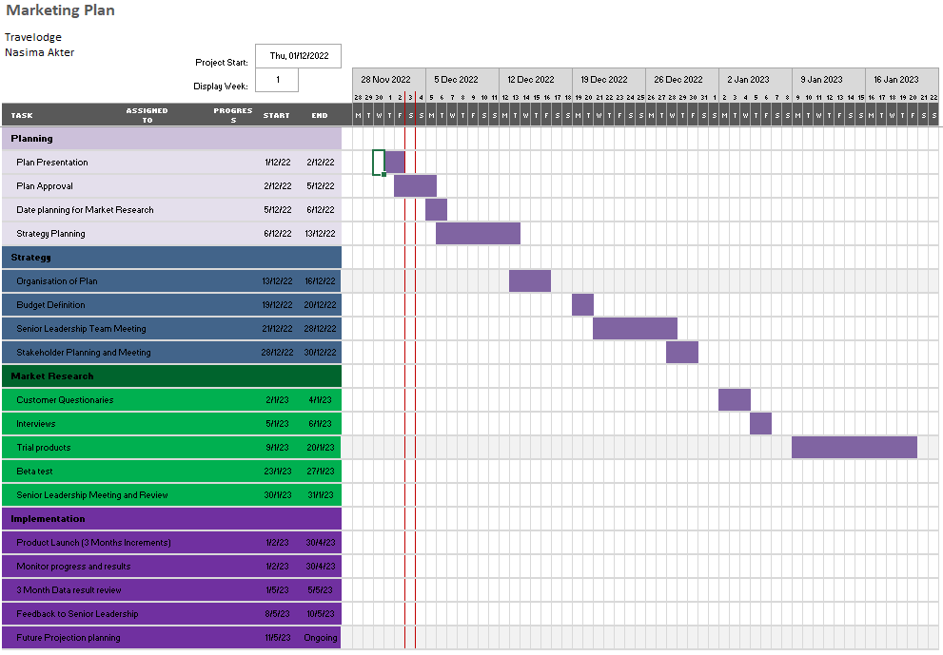

The schedule will begin with implementing a planning stage to ensure to leadership consensually of budgets and tasks set to reach the aim of the marketing plan. This will ensure that the Travelodge Hotel management are able organise, trial, and deliver desired products with the aim to review data results and generate a plan. To execute the plan the following factors supports the implementation; ‘relevant advertisement, sales received, discounts/deals and future booking availability (Narval, et al., 2019)’.

Control

The targeted customers are the younger generation who are more familiar with purchasing products and services through ads by using SEO and PPC advertising it will reach the new target customers at a faster rate. Sales through these ads on the website can be monitored to analysis the success and if there has been profitable gain.

Conclusion
To conclude, the Travelodge is a popular hospitality company within the UK, Ireland, and Spain, however as there is a possibility for a recession to take place in 2023 investing in digital tools such and SEO and PPC can pose as a challenge if return of investment is not met. To overcome a potential challenge market research and trials would be beneficial.

References
Darios, I., 2020. 10 Types of Hotel Guests: Examples for Building your Guest Personas. [Online]
Available at: https://www.cloudbeds.com/articles/types-hotel-guests/
[Accessed 30 November 2022].
Dibb, S. & Simkin, L., 2007. Targeting, Segments and Positioning. International Journal of Retail and Distribution Management, 19(3), pp. 4-10.
Forbes, 2022. 2023 Recession Predictions: Is One Coming And How Will It Impact You?. [Online]
Available at: https://www.forbes.com/sites/forbesfinancecouncil/2022/12/02/four-trends-in-green-technology-and-venture-investment/?sh=547fad3e4f63
[Accessed 30 November 2022].
Hall, S., 2022. Innovative B2B Marketing New Models. Processes and Theory. 2 ed. Great Britian: Kogan Page.
Korjuhina, J. & Sorokin, O., 2017. Developing marketing strategy for Ramada Encore Kiev. Information Technologies, Management and Society, 10(1), pp. 13-17.
Narval, A., Rosario, J. D. & Baraero-Era, J. S., 2019. Lessons Learned from Organsing an International Event. Asia Pacific International Events Management Journal, 1(1), pp. 25-28.
Porter, M., 2008. The Five Competitive. Harvard Business Review, pp. 24-40.
Radut, C., 2015. Strategies of Change for the Hotel Industry. Porter, Kotler, Bowman Positions. Knowledge Horizons - Economics, 7(4), pp. 79-84.
Rojas, J.-P. F., 2022. Cost of living: Restaurant and hotel prices set to rise as hospitality firms grapple with surge in costs. [Online]
Available at: https://news.sky.com/story/cost-of-living-hospitality-firms-plan-to-put-up-prices-by-11-12532850
[Accessed 30 November 2022].
Ryan, D., 2014. Understanding Digital Marketing. 3 ed. Great Britian: KoganPage.
Sampson, H. & Fagan, E., 2022. Airbnb is more successful than ever. Why is everyone so mad at it?. [Online]
Available at: https://www.washingtonpost.com/travel/2022/11/14/airbnb-airbnbust-hosts-fees-chores/
[Accessed 30 November 2022].
SEO Monitor, 2022. How To Combine SEO & PPC Keyword Strategies For More Effective ROI. [Online]
Available at: https://www.searchenginejournal.com/seo-ppc-keyword-strategies-seomonitor-spcs/470714/
[Accessed 03 December 2022].
Seyitoğlu, F. & Ivanov, S., 2020. A conceptual framework of the service delivery system design for hospitality firms in the (post-)viral world: The role of service robots. International Journal of Hospitality Management, Volume 91.
Thame and London Limited, 2022. Annual Report and Financial Satements for the Year Ending 31 December 2021, London: Thame and London Limited.
Travelodge, 2022. Travelodge partners with the Purpose Coalition on a Levelling Up Impact Report. [Online]
Available at: https://www.travelodge.co.uk/press-centre/press-releases/Travelodge-partners-Purpose-Coalition-Levelling-Impact-Report
[Accessed 30 November 2022].

POWERPOINT PRESENTATION SLIDES
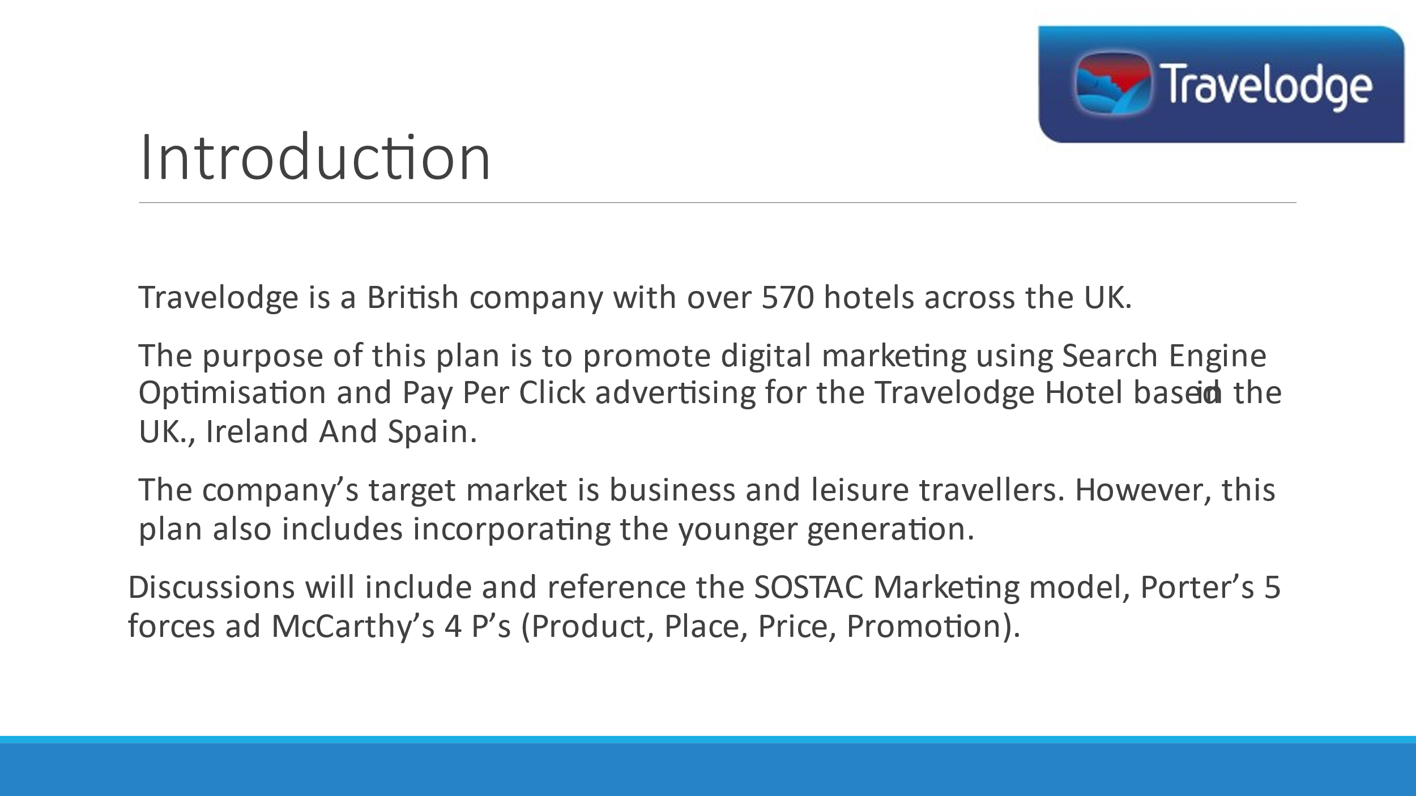
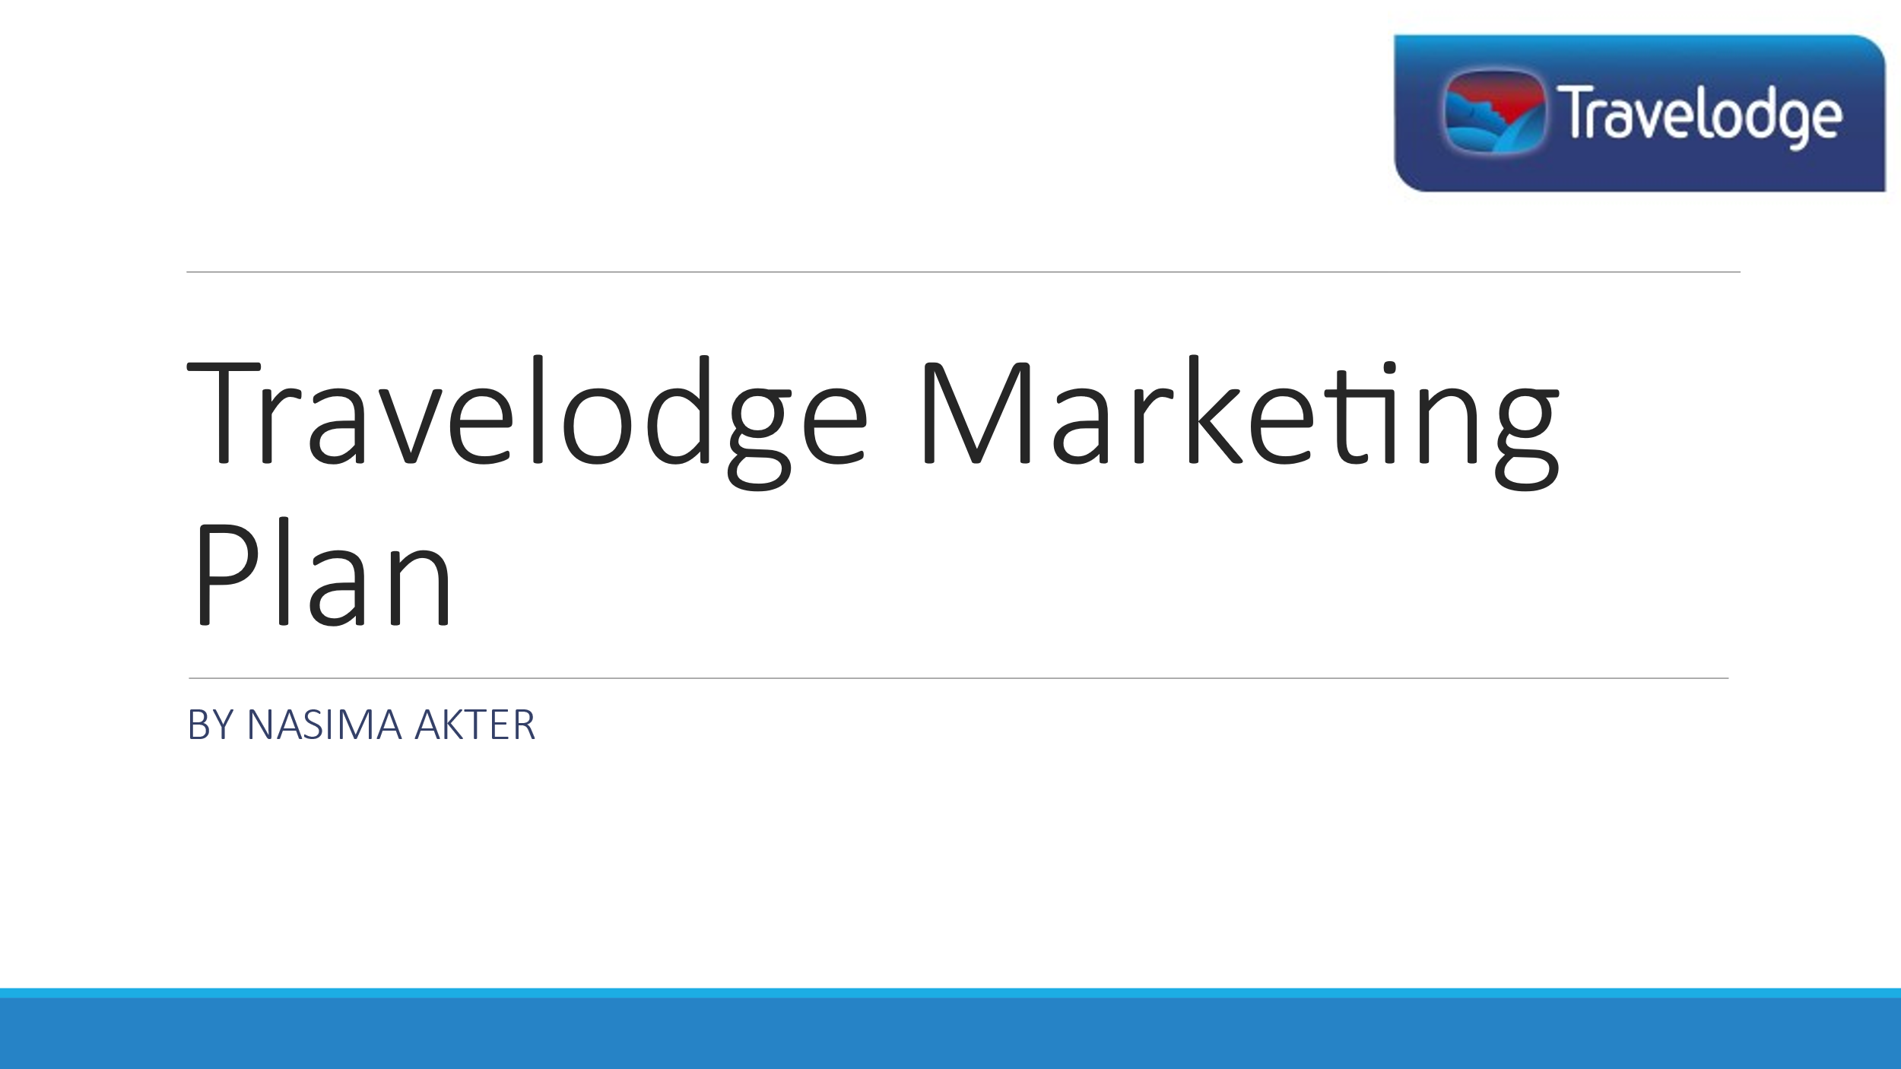

Along with the notes for slide 2:
An important factor for a company’s success is powerful marketing. This marketing plan is based on the Travelodge Hotel.
The purpose of this plan is to promote the advancement and use of Digital Marketing for this Hotel to attract new customers specially the use of Search Engine Optimisation (SEO) and Pay Per Click (PPC) advertising.
Travelodge have solely categorised their target market as business and leisure travellers. This plan will also include to target the younger generation also known as ‘Generation Z’ a group who are becoming more common hotel guests but are more likely to seek budget friendly deals (Darios, 2020). The discussions and focus of this plan will be based on SOSTAC marketing model, Porter’s 5 Forces and McCarthy’s 4 P’s.
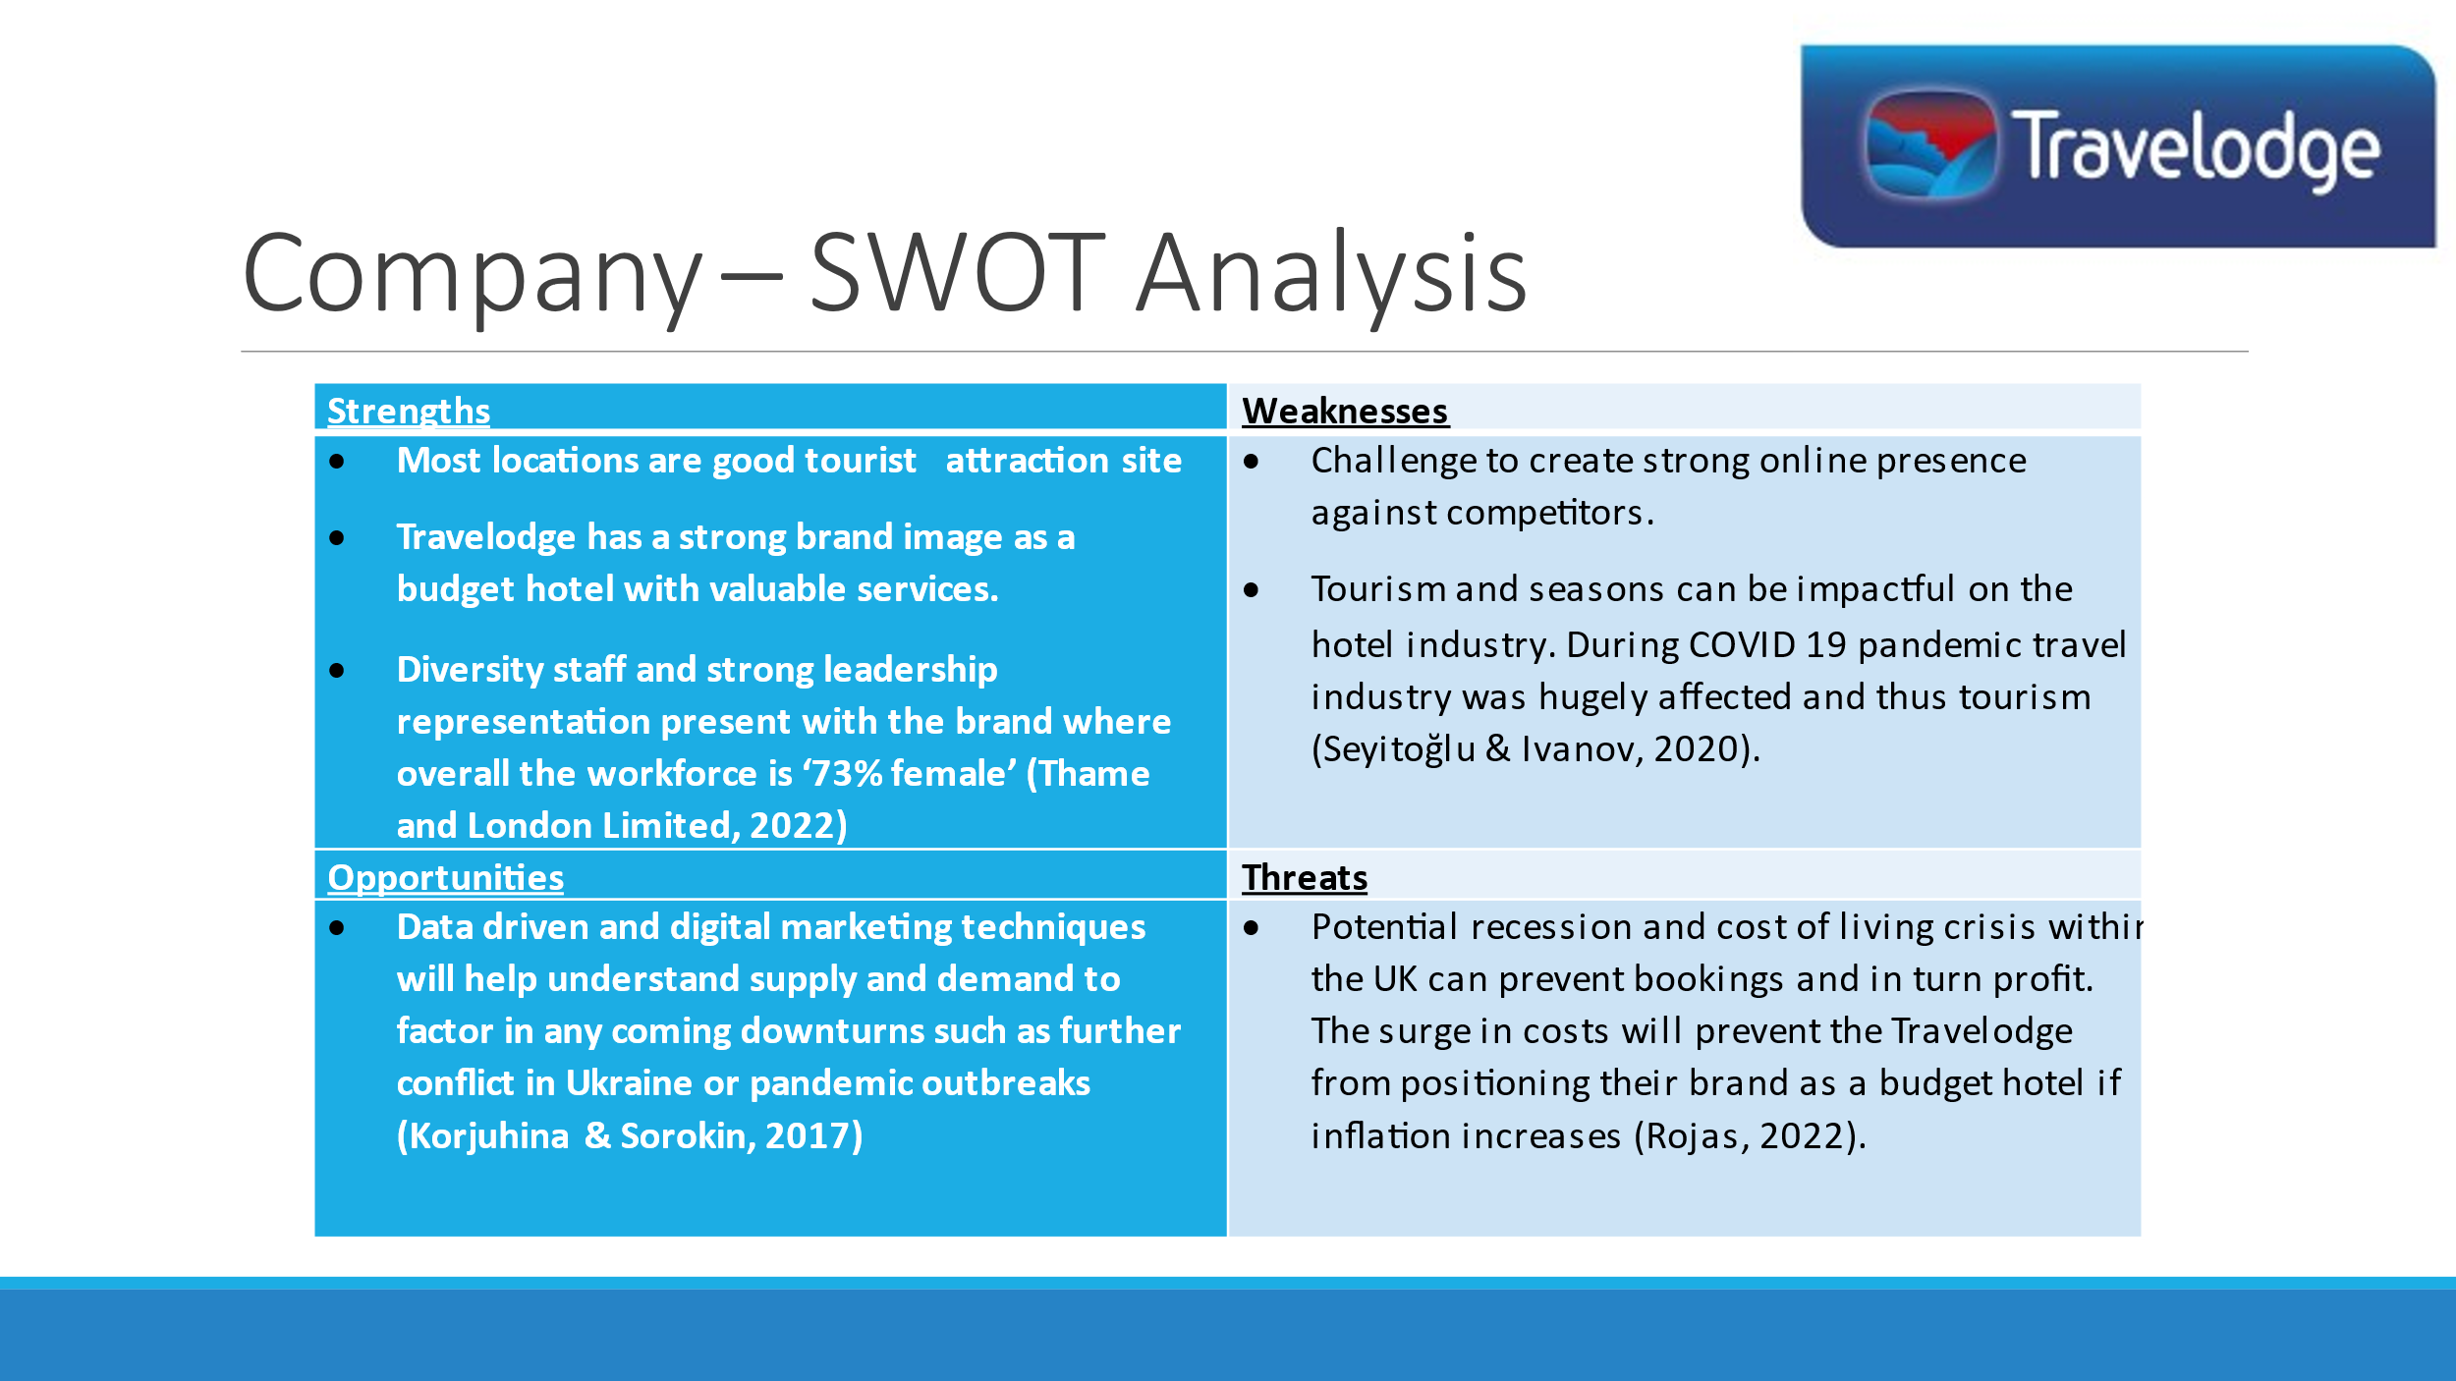

Notes for Slides 3:
Strengths
- UK, Ireland and Spain have great tourist attraction site which will generates both local and international customers.
- Travelodge has a strong brand image as a budget hotel with valuable services.
- Diversity staff and strong leadership representation present with the brand where overall the workforce is ‘73% female’ (Thame and London Limited, 2022)
Weaknesses
- Creating a strong presence and reputation on the internet can be a challenge amongst competitors who have a strong online presence.
- Tourism and seasons can be impactful on the hotel industry. During COVID 19 pandemic travel industry was hugely affected and thus tourism (Seyitoğlu & Ivanov, 2020).
Opportunities
- Data driven and digital marketing techniques will help the company future planning decision on supply and demand and to factor in any coming downturns such as further conflict in Ukraine or pandemic outbreaks (Korjuhina & Sorokin, 2017)
Threats
- Potential recession and cost of living crisis within the UK can prevent bookings and in turn profit. The surge in costs will prevent the Travelodge from positioning their brand as a budget hotel if inflation increases (Rojas, 2022).

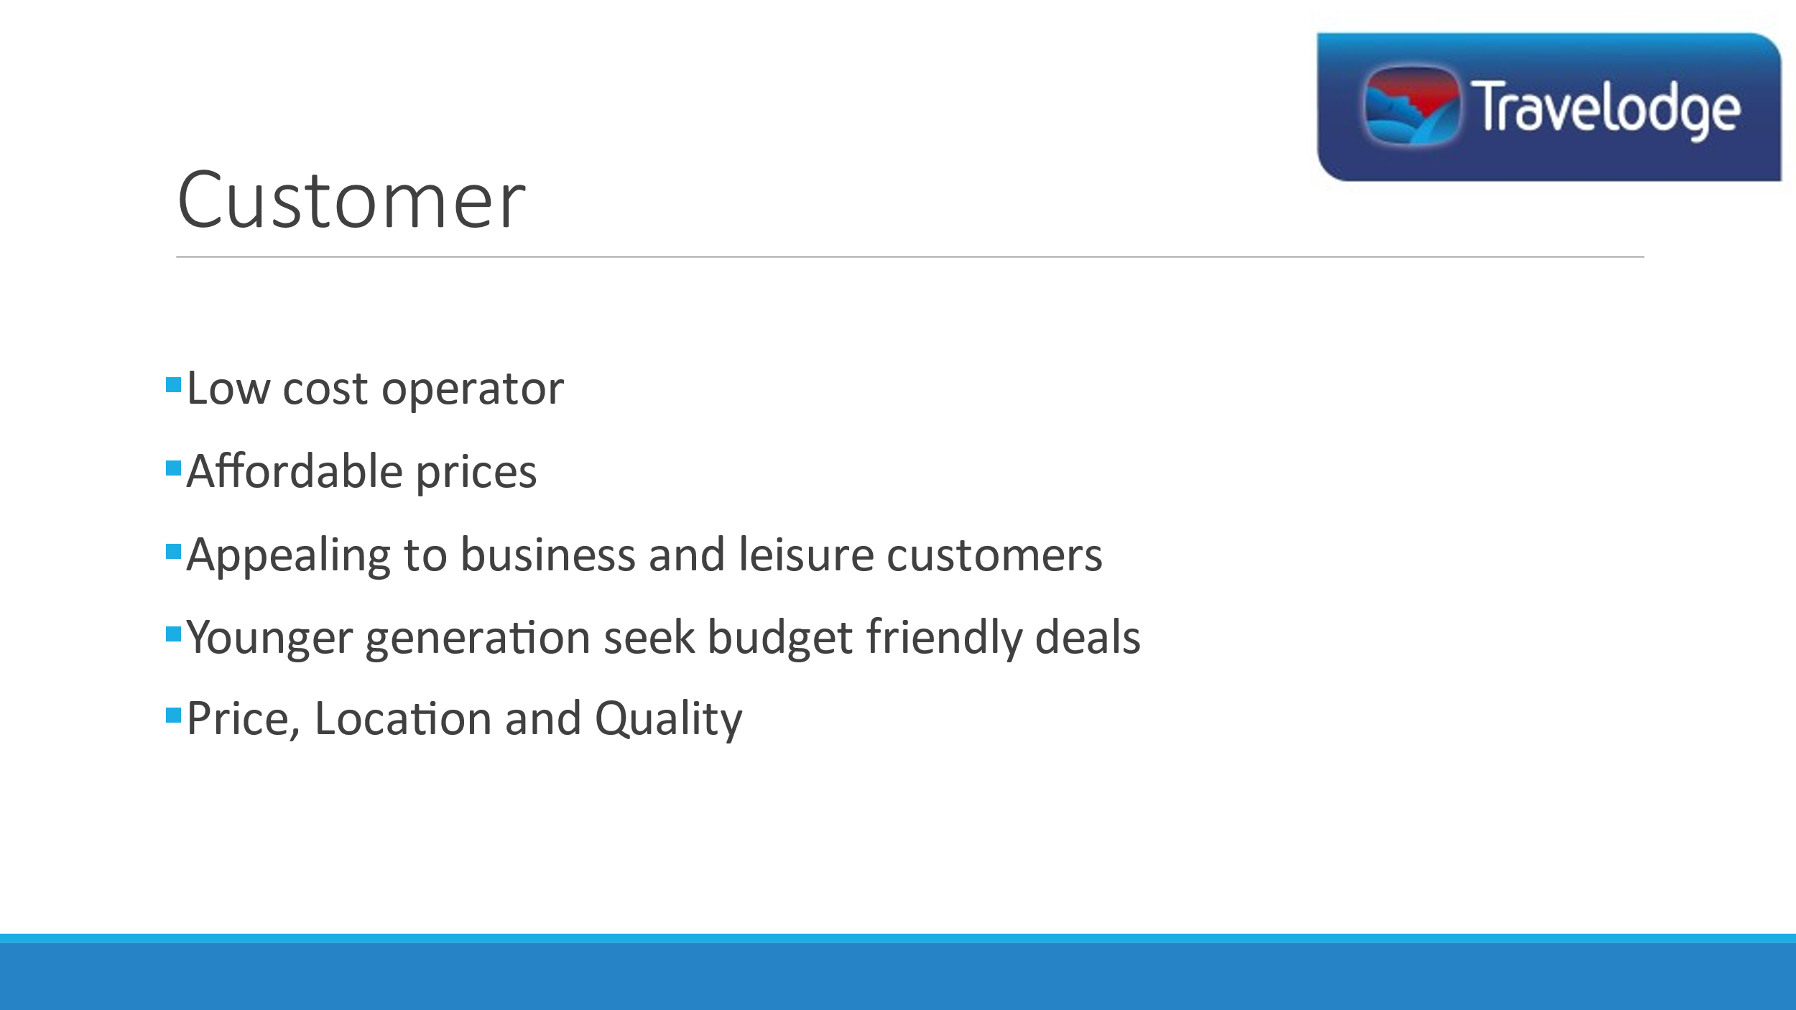
Notes For Slide 4:
The Travelodge Hotels are positioned as a low-cost operator and can offer their services at an affordable price and rate to both business and leisure customers who seek short term travel accommodation. As the younger generation and incorporated in these categories, it will allow the Travelodge Hotel to incorporate them within their target market and offer a great balance of price, location, and quality. (Thame and London Limited, 2022).
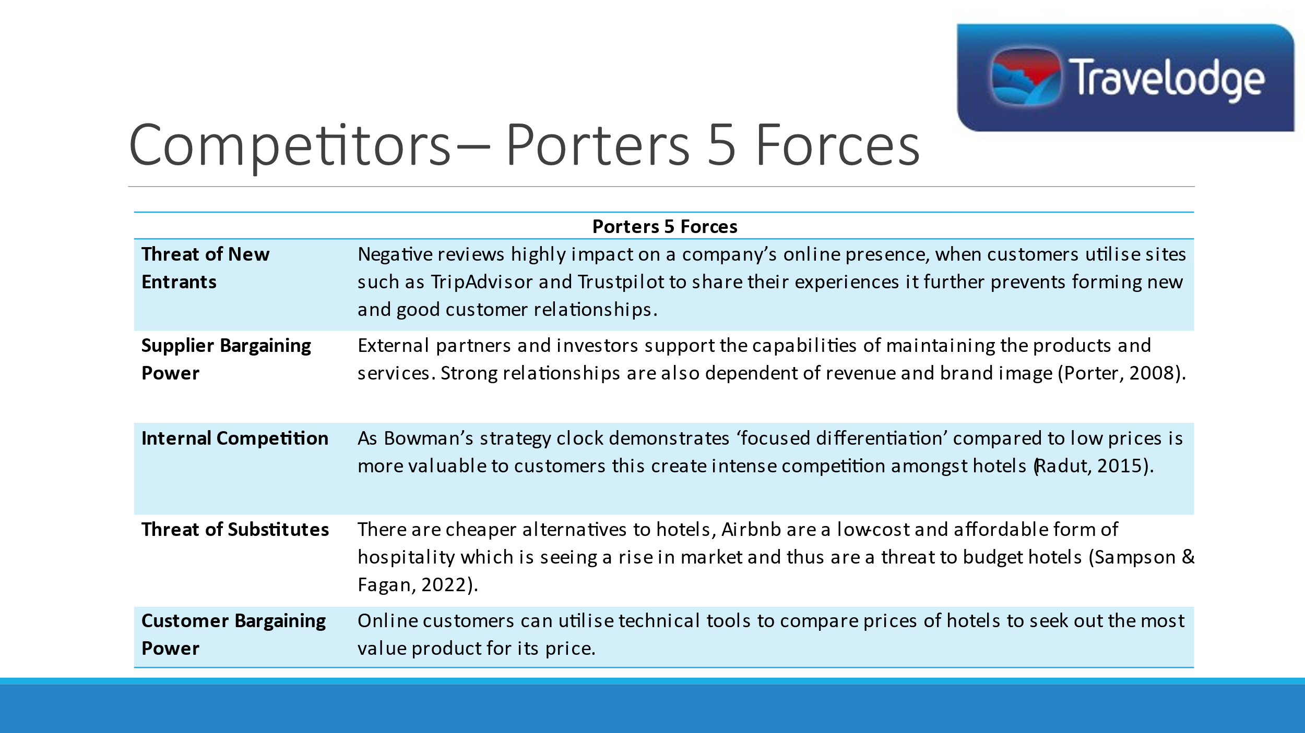
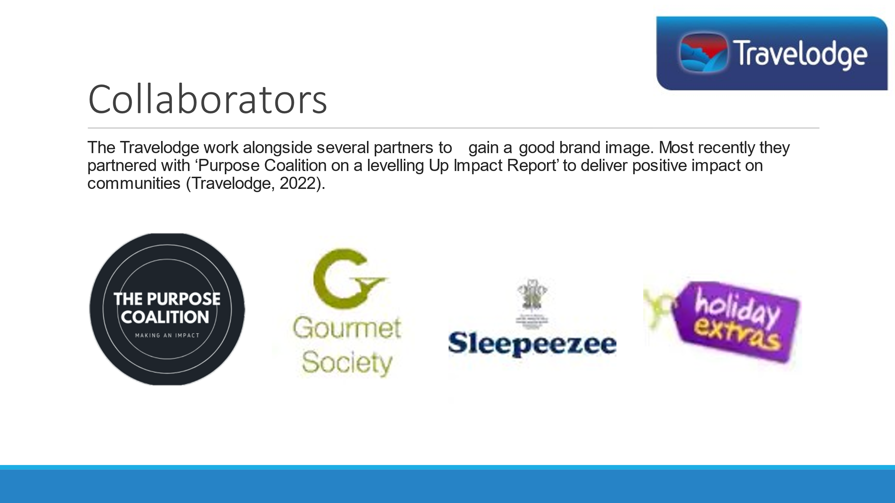
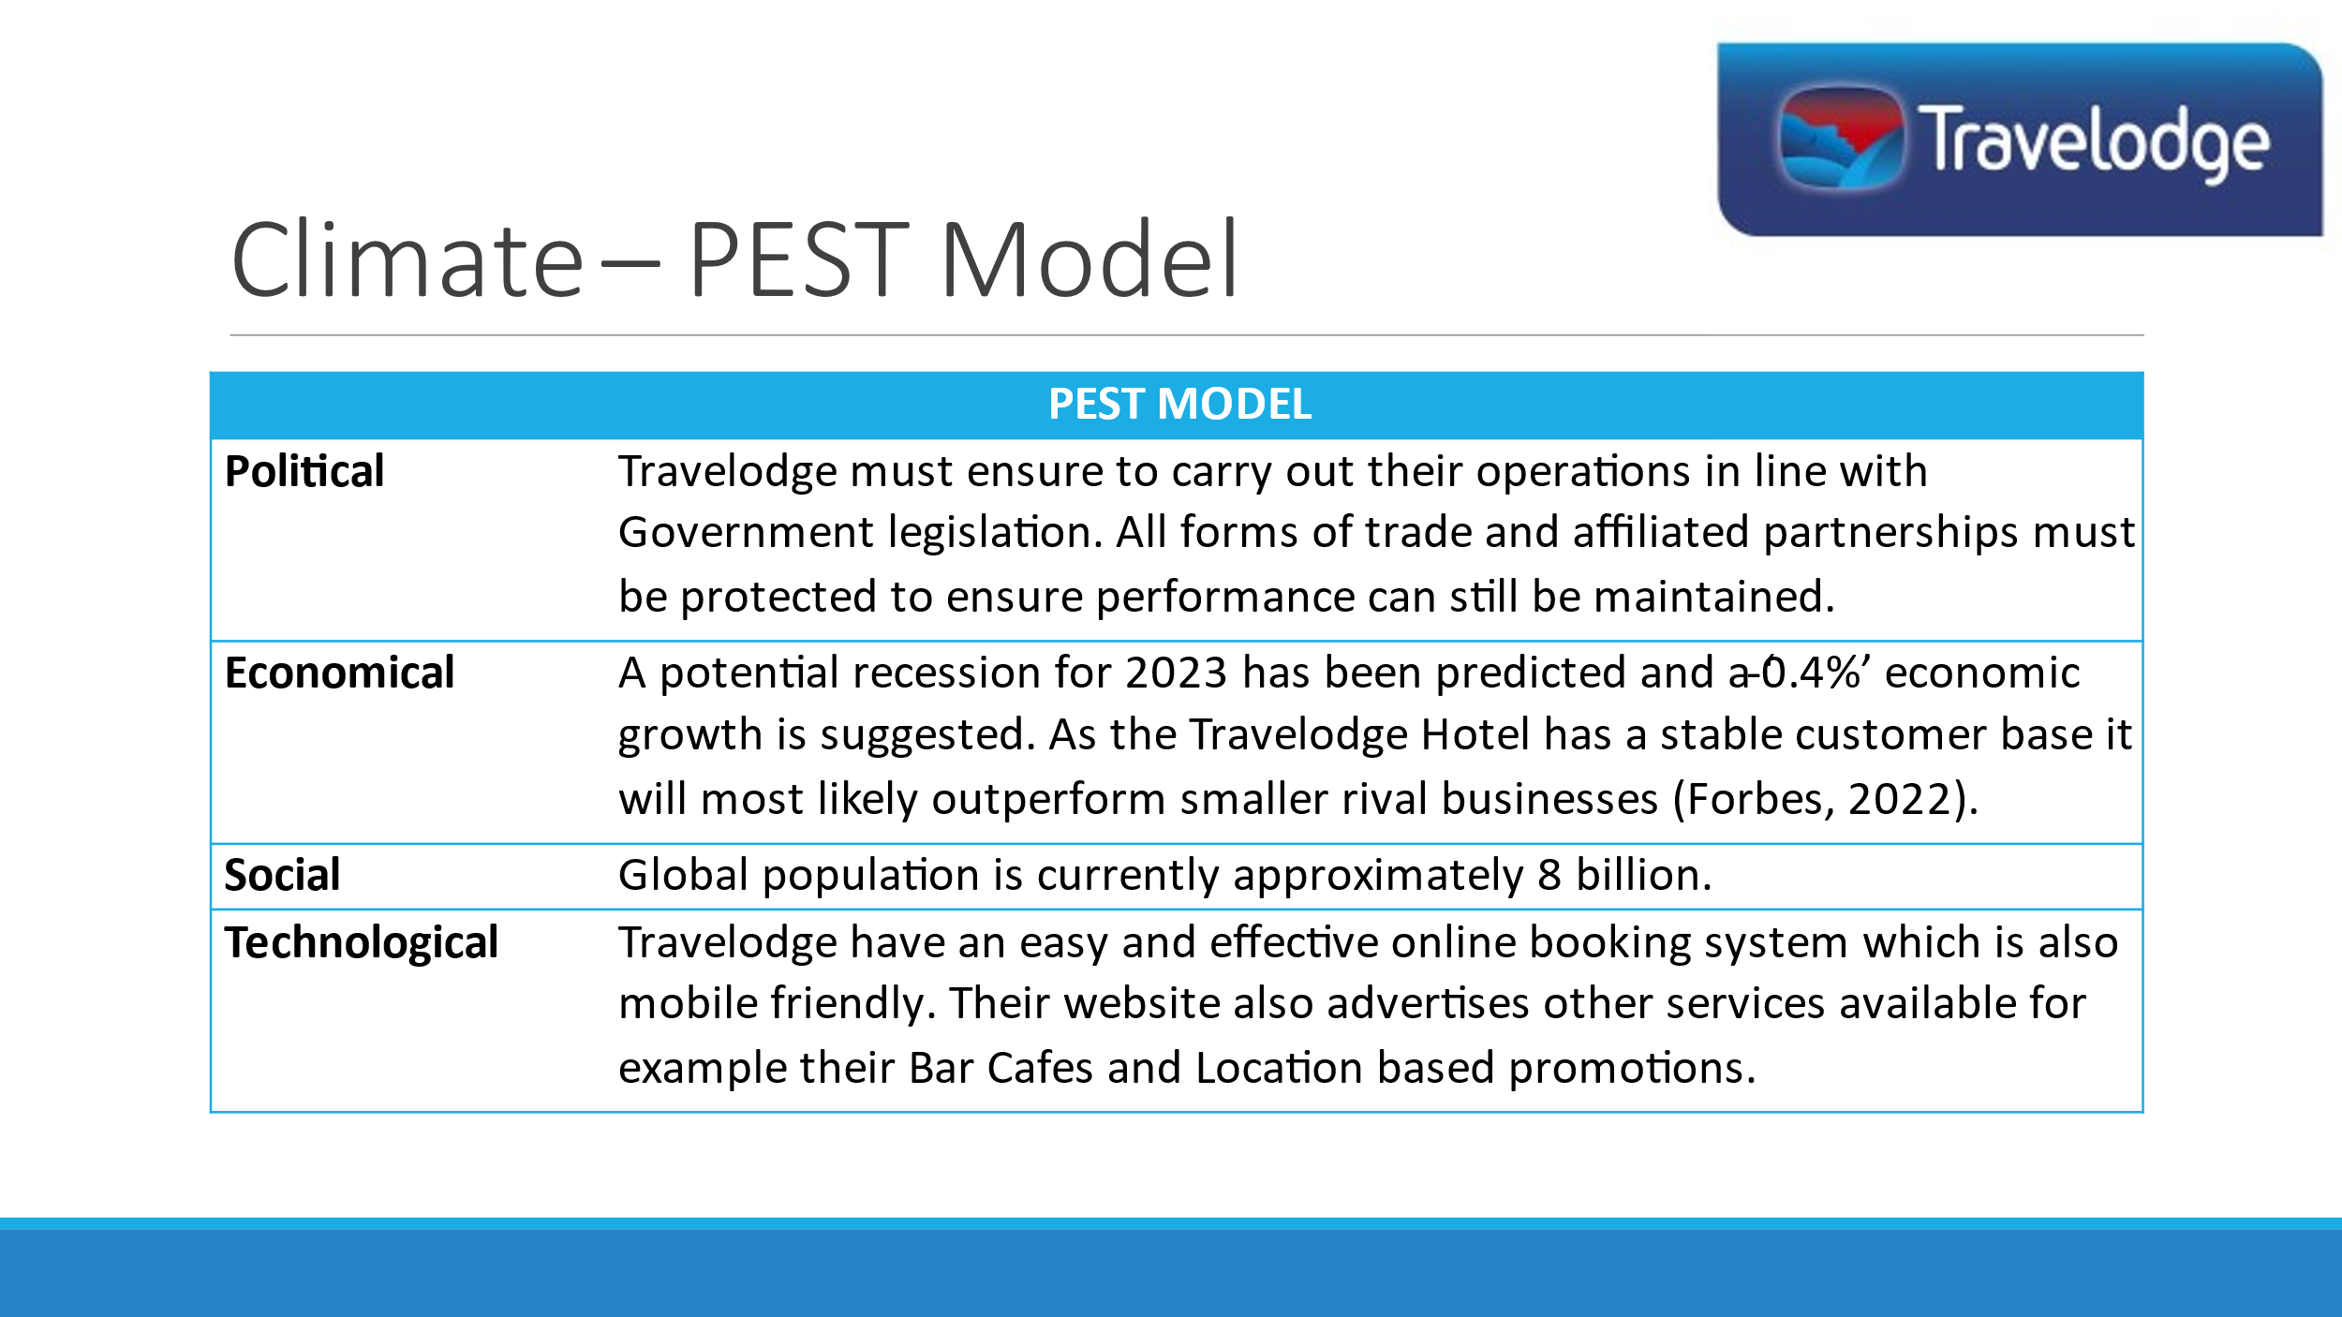
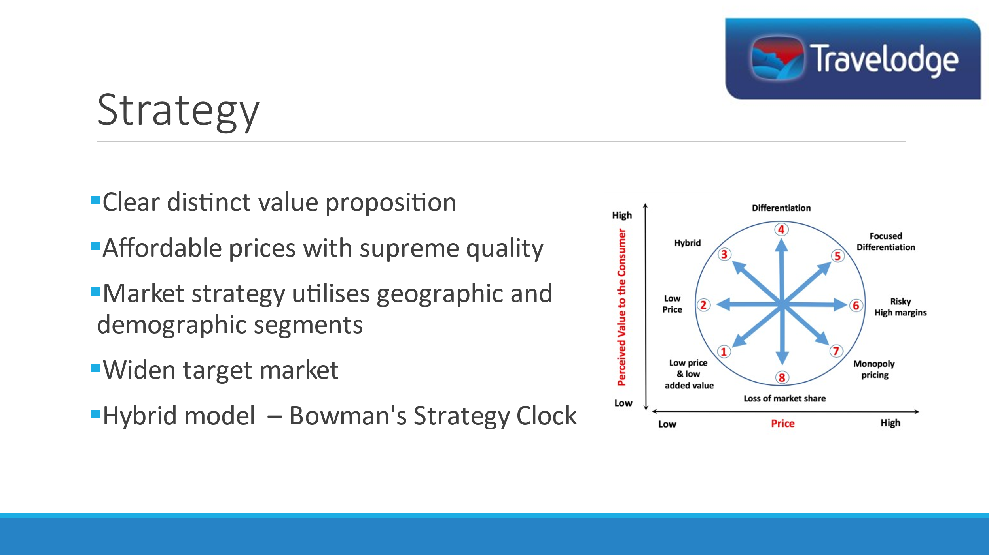
Notes for Slide 8:
The Travelodge have a clear and distinctive value proposition, the company seeks to entice customers with affordable prices but simultaneously deliver moderate to supreme products which differentiate it from its rivals. Their market segment is broad with a geographic and demographic crossover which can potentially widen the company’s value proposition (Dibb & Simkin, 2007). Bowman’s Strategy Clock suggests the Travelodge to be a ‘hybrid model’ but by adopting a different pricing strategy it could enable high-profit margins.

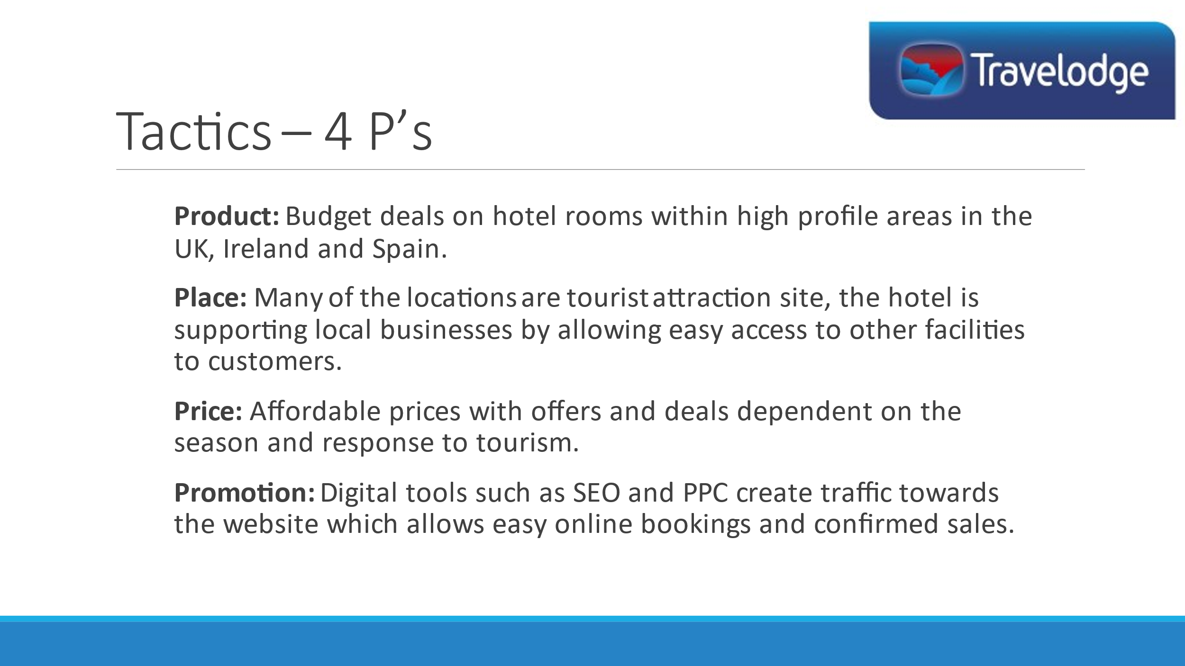
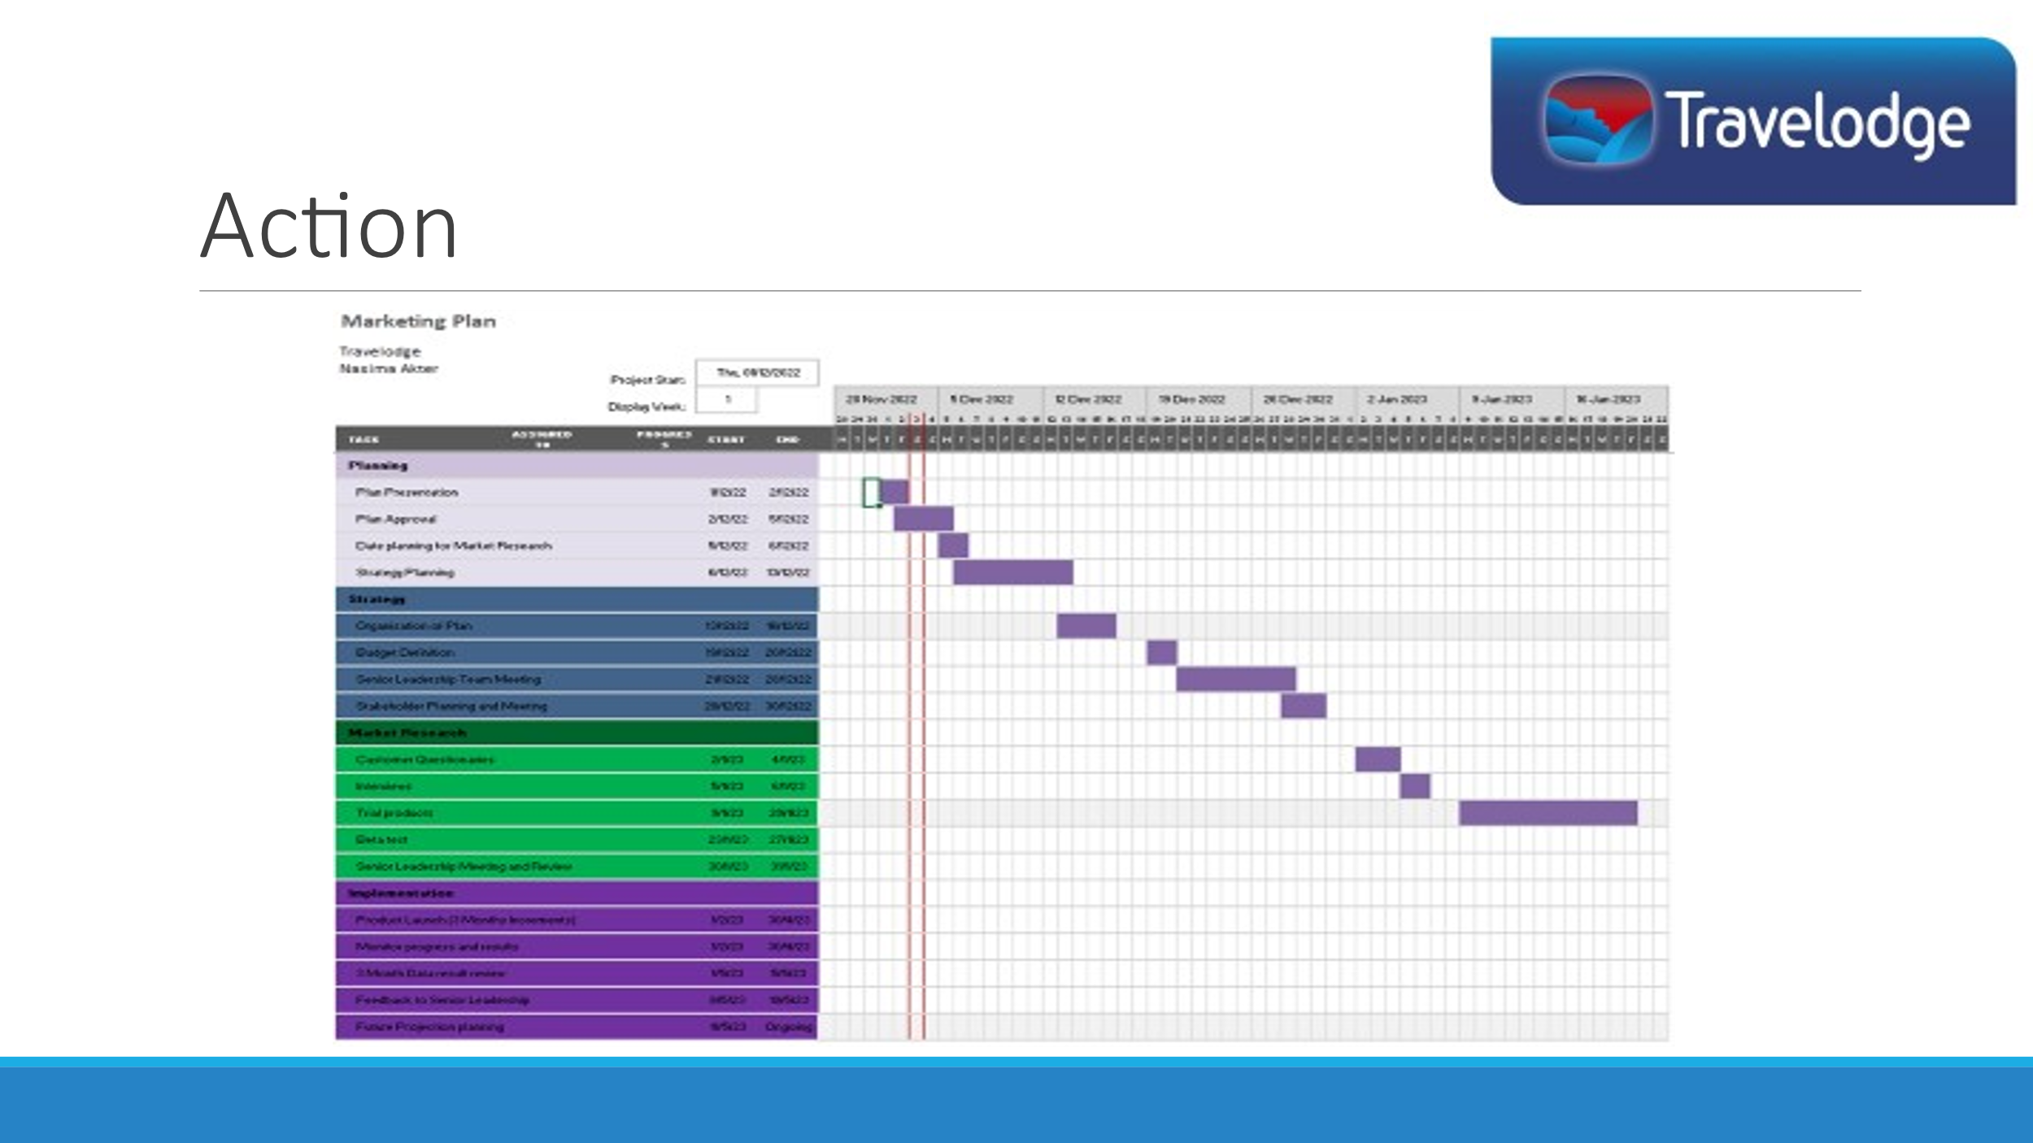
Notes For Slide 10:
The schedule will begin with implementing a planning stage to ensure to leadership consensually of budgets and tasks set to reach the aim of the marketing plan. This will ensure that the Travelodge Hotel management are able organise, trial, and deliver desired products with the aim to review data results and generate a plan. To execute the plan the following factors supports the implementation; ‘relevant advertisement, sales received, discounts/deals and future booking availability (Narval, et al., 2019)’.
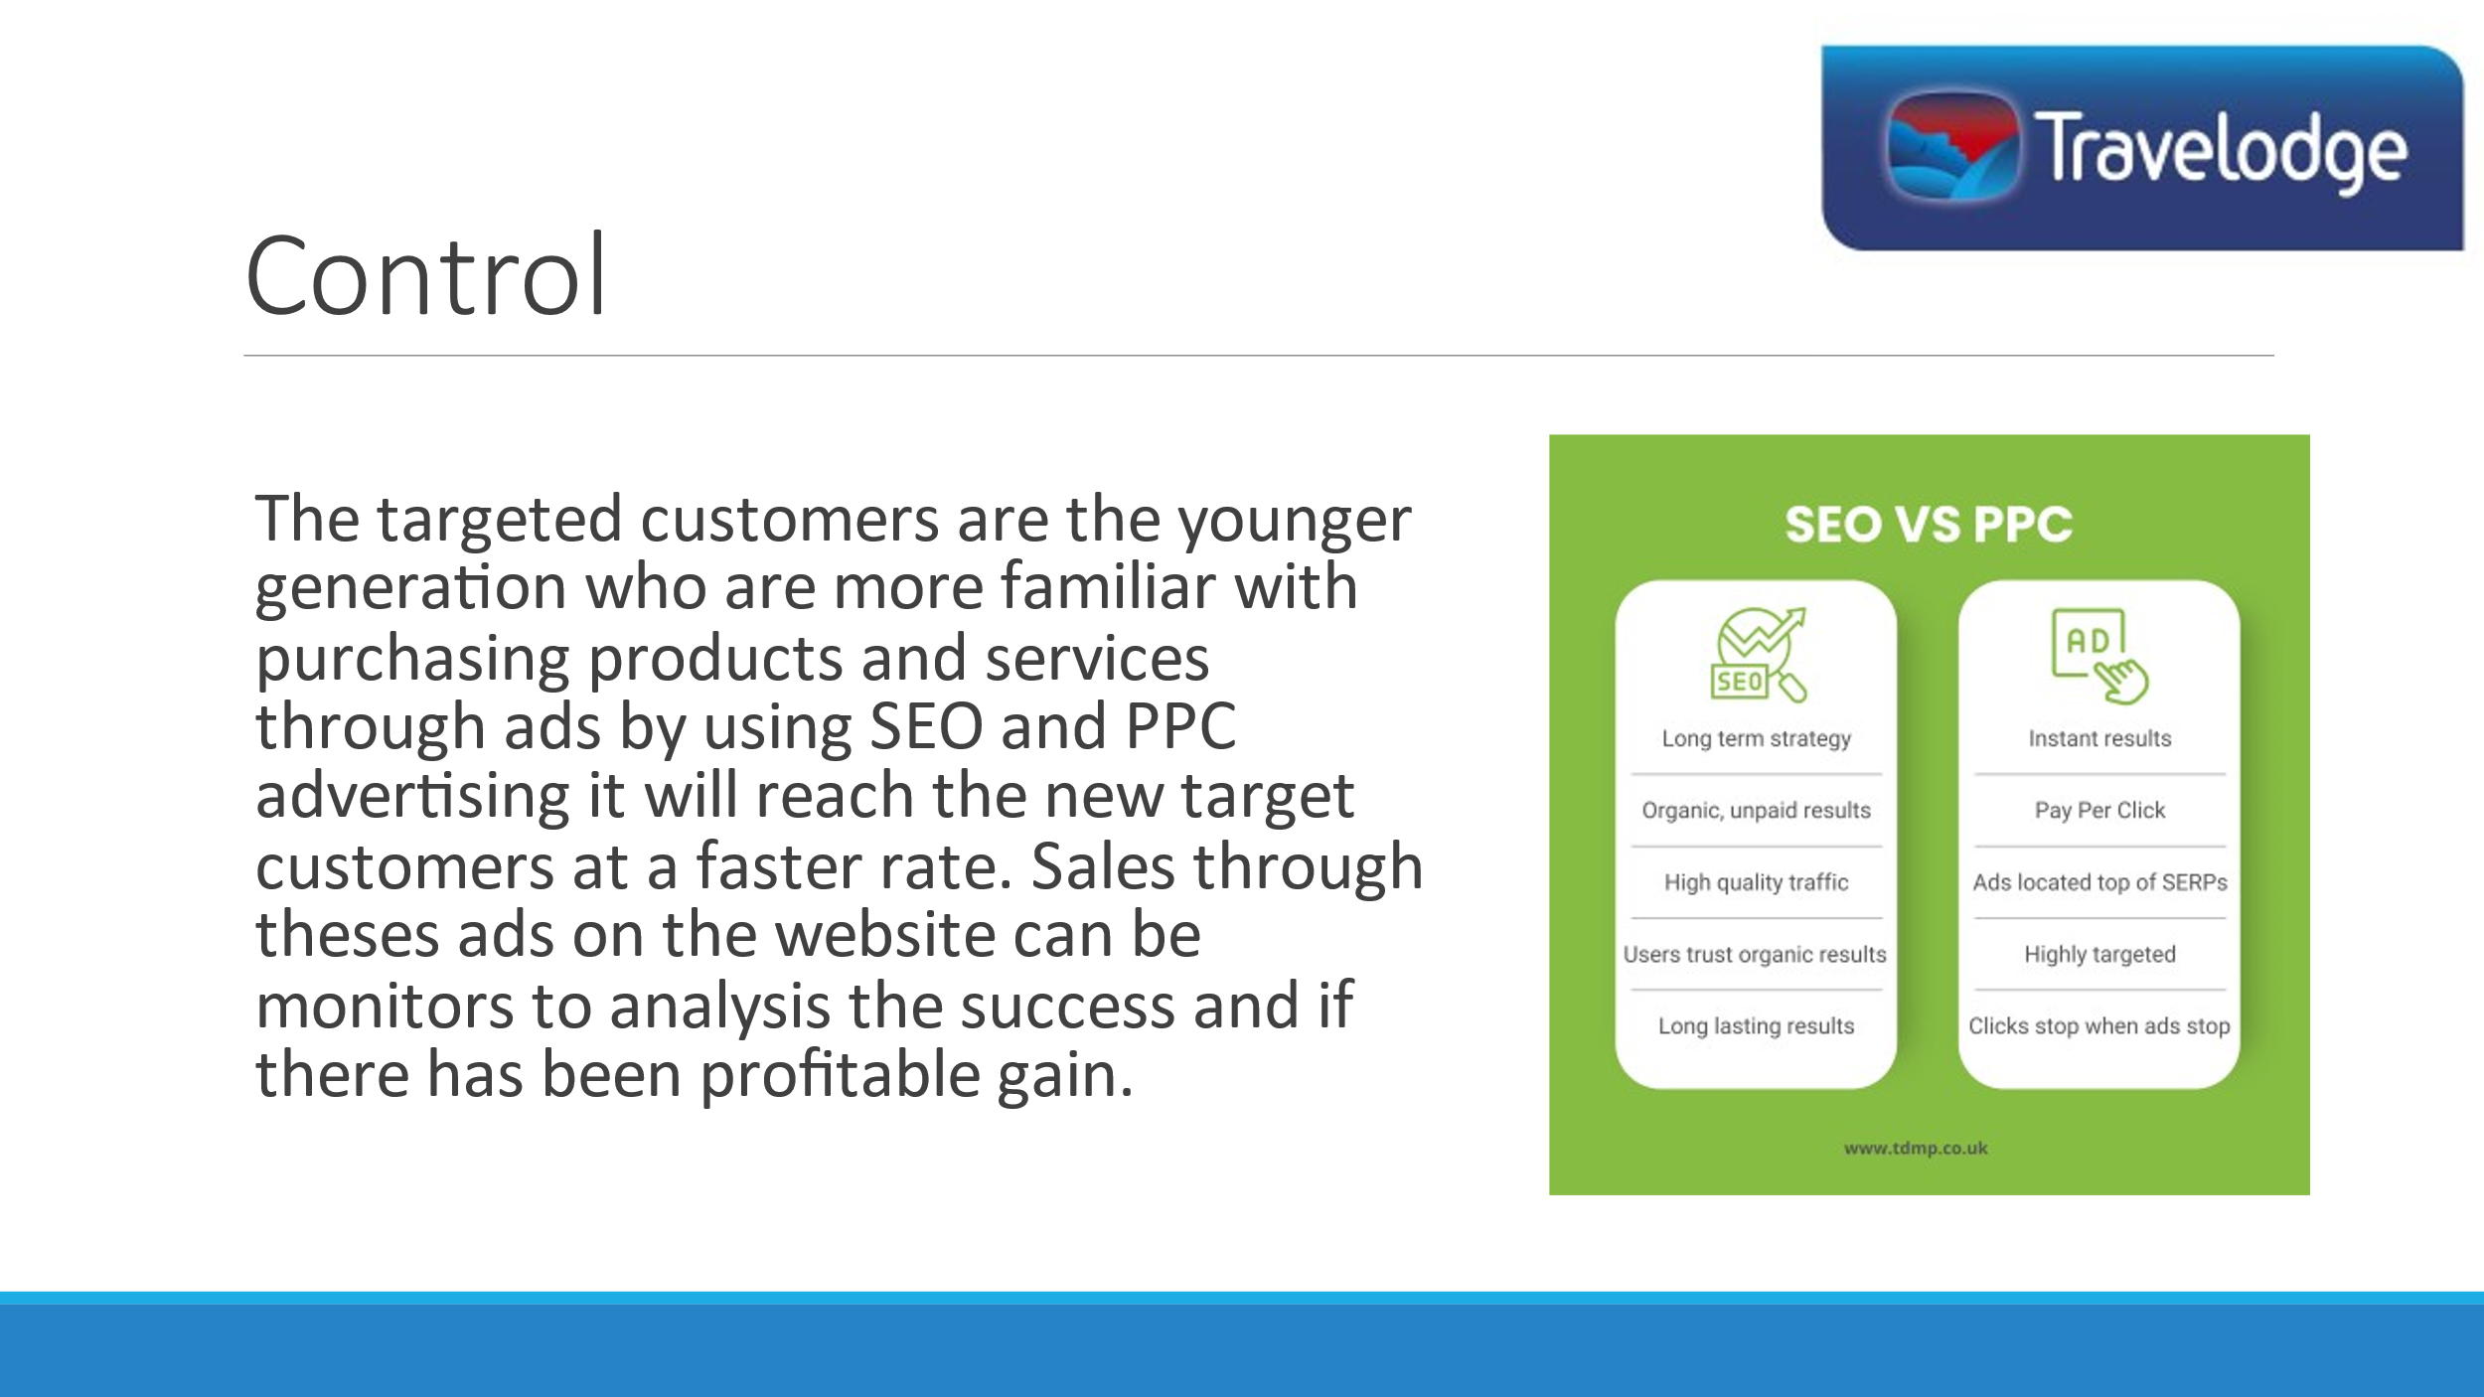

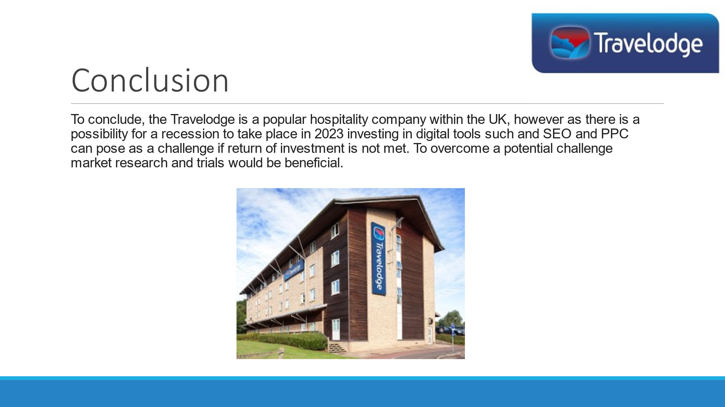
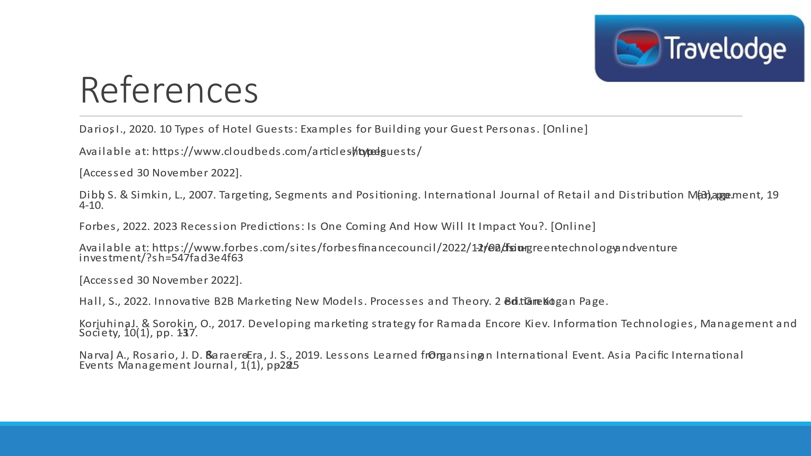
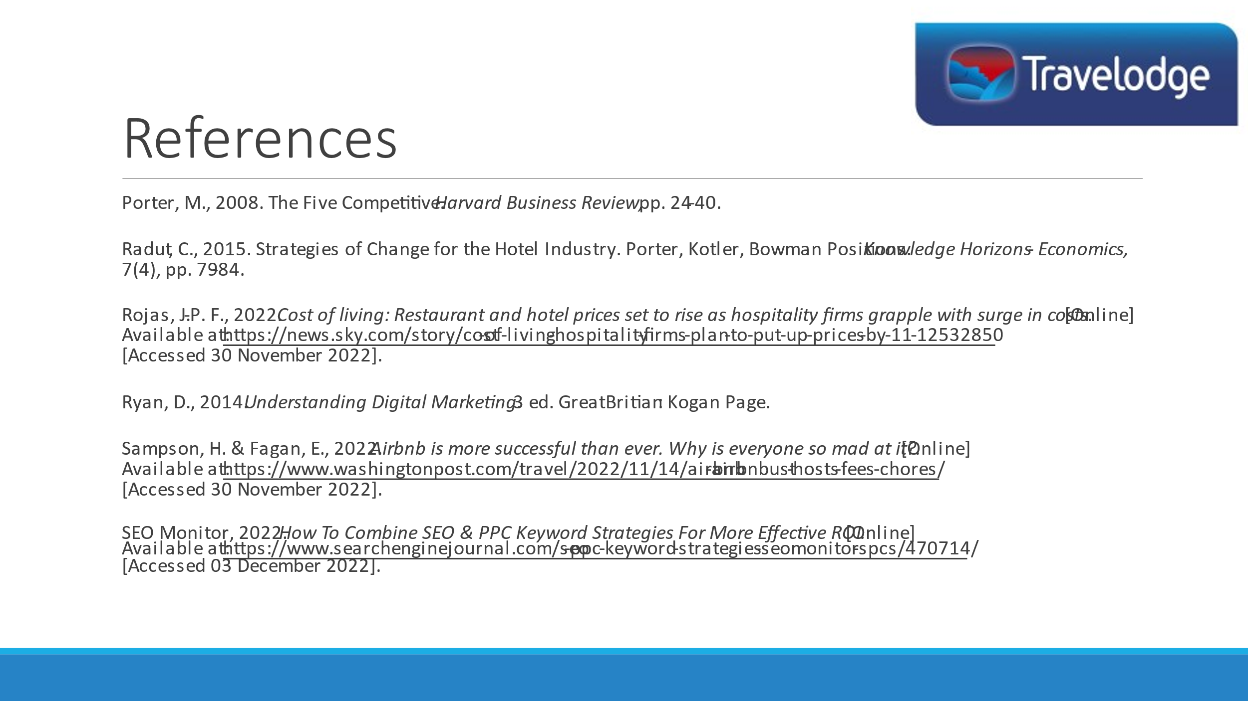
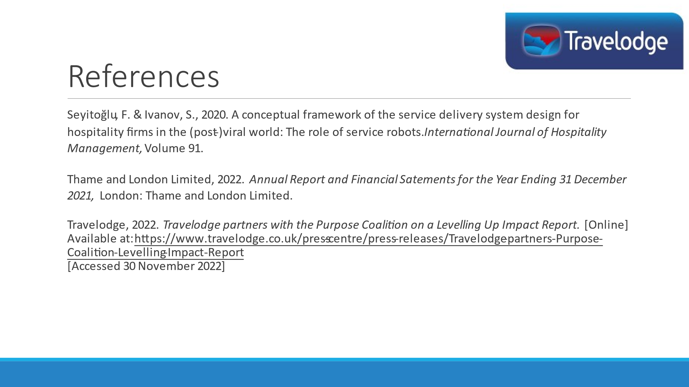
Please note: Most of the notes are the script for when I displayed my slides and spoke about them.
Thank You.

