
UNIVERSITY OF WALES TRINITY SAINT DAVID, LONDON
NAME: RUHUL ISLAM RUBEL

STUDENT ID:2533221

LECRURER:ANUM PRACHA

Course code:ACCA4022

COURSE NAME:COMPUTER ARCHITECTURE AND OPERATING SYSTEM
Term :2

TASK 1: Important Features of General Operating Systems Table of Contents Section Page
1. Management of Processes
2. Memory Control
3. File System Administration
4. Device and Input/Output (I/O) Control
5. Safety and Defense
6. Managing the User Interface
TASK 2: Using Windows OS CLI Commands
1. Process Control with Windows CLI
2. File and Directory Administration
3. Network Monitoring and Testing
4. Management of Users

TASK 2: Linux OS CLI Commands
1. Commands for Process Monitoring
2. Commands for File and Directory Management
3. Commands for Network Monitoring
4. Commands for User Management
TASK4: Windows OS Scripts:
The first batch script: Script Features Explained.
1 Variables
2 User Input
3 Mathematical Operations
4 Loop
5 Conditional Statement
TASK 5:
Automated File Backup System Batch Script
1 Variables
2 User Input
3 Mathematical Operations
4 Loop
5 Conditional Statement
Use of Linux OS Scripts
Script 1: Calculator of Student Grades
Script 2: Calculator for Number Sum
Folder Structure
Conclusion
References

Important Features of General Operating System
general-purpose operating system (OS) serve as fundamental software that regulates computer hardware and software resources while providing essential services for application programs. By acting as a mediator between users and the hardware, it guarantees that the system operates efficiently, securely, and reliably. Popular general-purpose operating systems include UNIX-based systems, Linux distributions (such as Fedora and Ubuntu), Apple macOS, and Microsoft Windows. These operating systems all perform a number of crucial functions that enable users to interact with computing devices in an efficient manner, despite variations in implementation and design [1], [2].
Process Management:
One of a general-purpose operating system's main duties is process management. Process creation, execution, scheduling, synchronization, and termination are all under its control. Scheduling algorithms are used by modern operating systems to effectively divide CPU time among several active applications, allowing multitasking and enhancing system performance. Additionally, efficient process management guarantees that system resources are distributed equitably among users and applications and avoids conflicts between processes [1], [2].
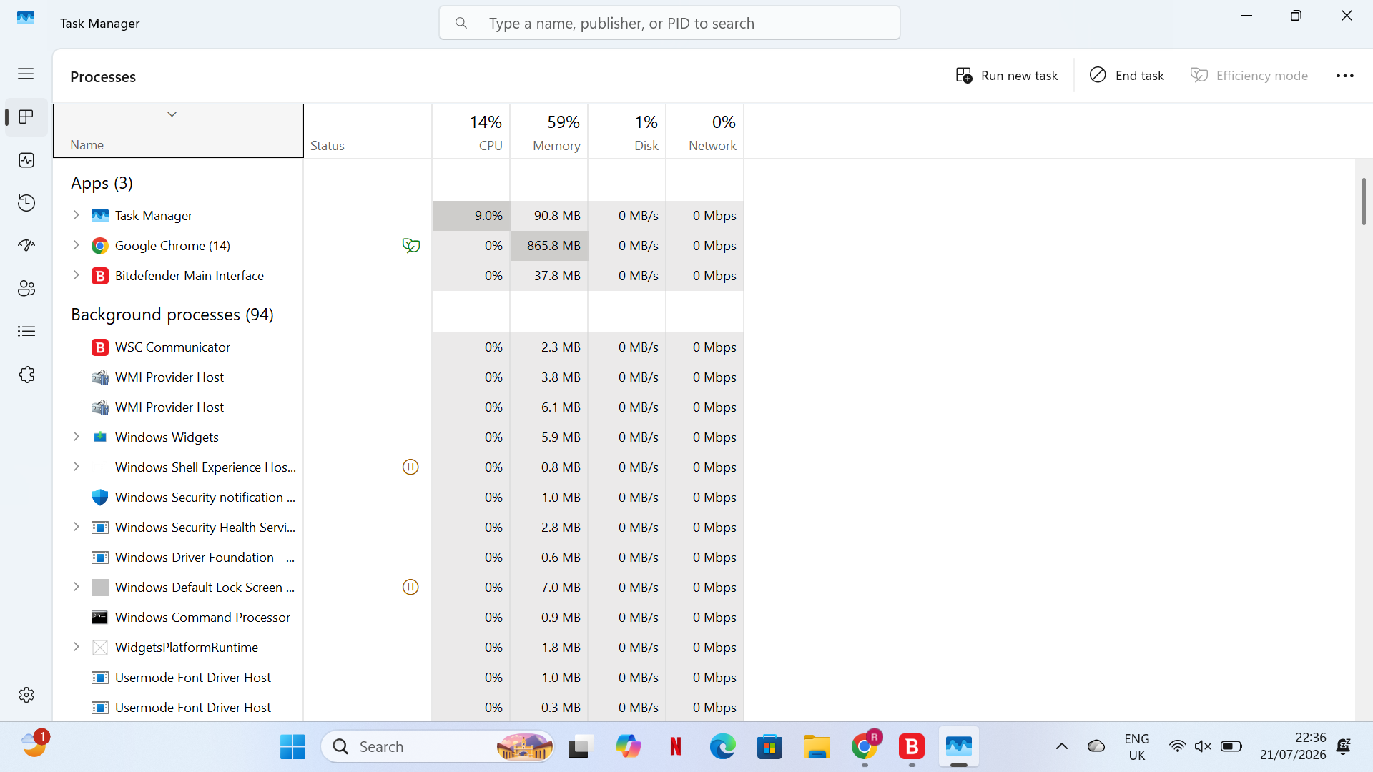
Memory management
Memory management protects each process from unauthorized access to the memory space of another process while allowing the operating system to allocate and deallocate memory to applications. By using secondary storage, virtual memory techniques enable systems to run applications that are larger than the physical memory that is available.[2],[3]
In order to increase application reliability, decrease memory corruption, and improve system security, modern operating systems also incorporate sophisticated memory protection techniques [2], [3].
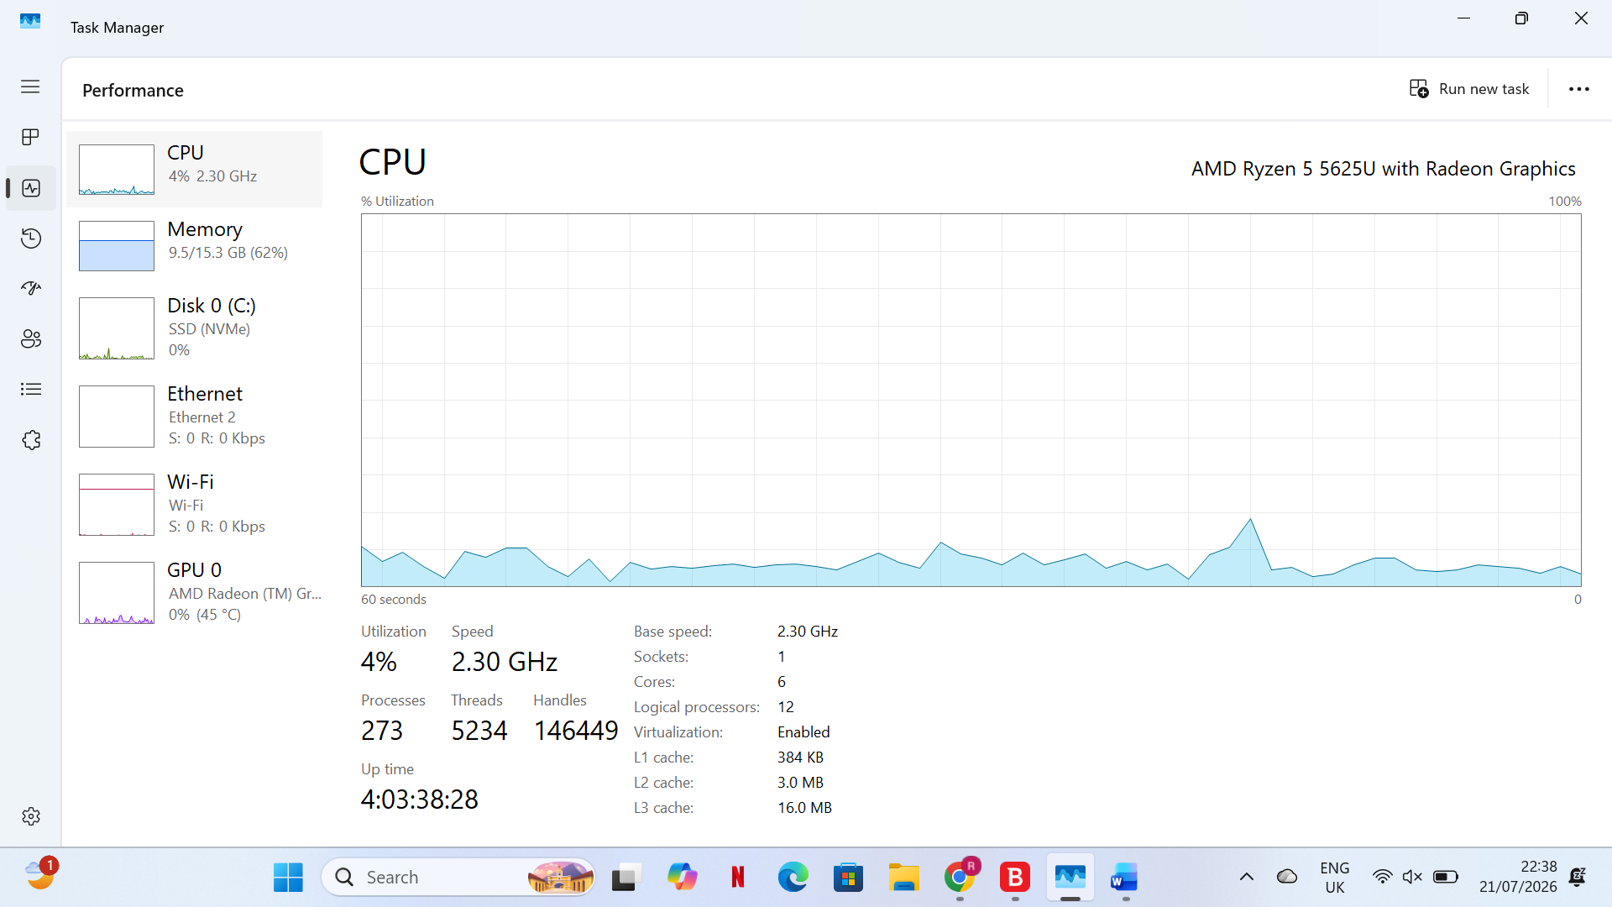
File System Management:
The operating system effectively organizes, stores, retrieves, updates, and deletes data in order to manage files and directories. To guarantee that only authorized users or applications can access sensitive data, it regulates file permissions and access rights. File systems that support data integrity, backup, and recovery features, like NTFS in Windows and ext4 in Linux, offer dependable storage management [1].
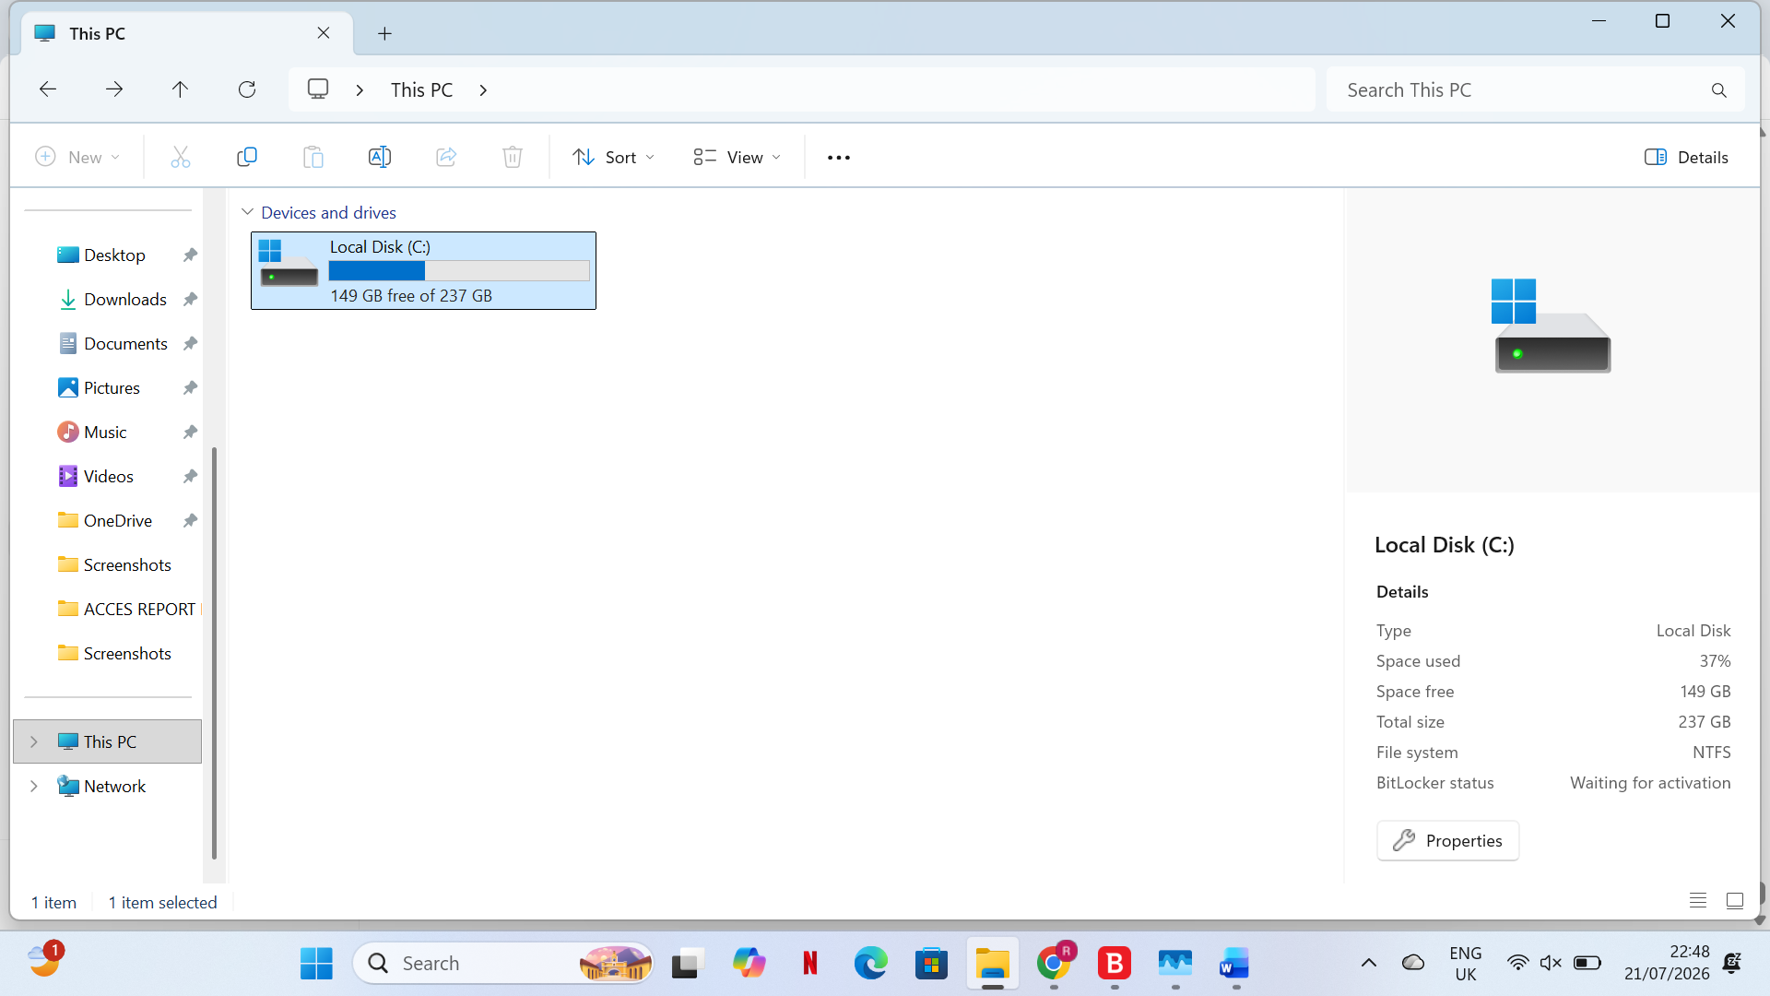
Device and Input/Output (I/O) Management:
Device drivers are used by general-purpose operating systems to facilitate communication between software programs and hardware devices. For hardware components like keyboards, printers, storage devices, displays, and network adapters, the operating system controls input and output operations, interrupt handling, buffering, and resource allocation. Effective device management guarantees compatibility between various hardware components and software programs and enhances hardware utilization [3].
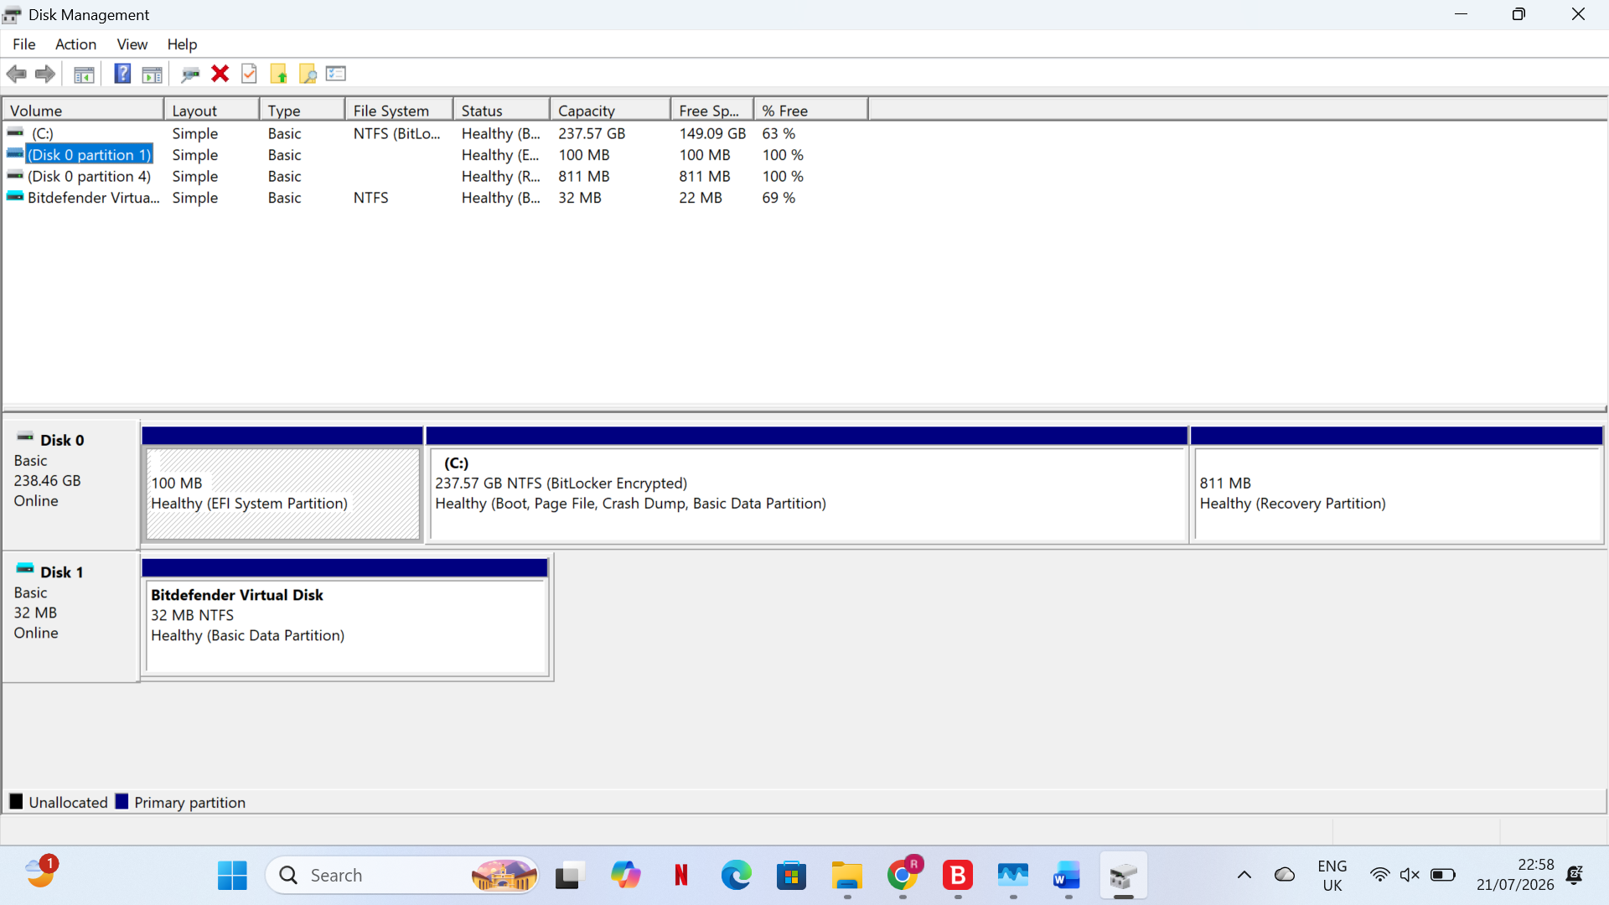
Security and Protection:
To shield users, apps, and hardware resources from illegal access and online threats, operating systems include a number of security measures. User authentication, access control, encryption, secure boot, kernel protection, and memory isolation are some of these mechanisms. According to recent studies, contemporary operating systems keep bolstering memory protection and kernel-level security to fend off malware, privilege escalation attacks, and system vulnerabilities [1], [4].
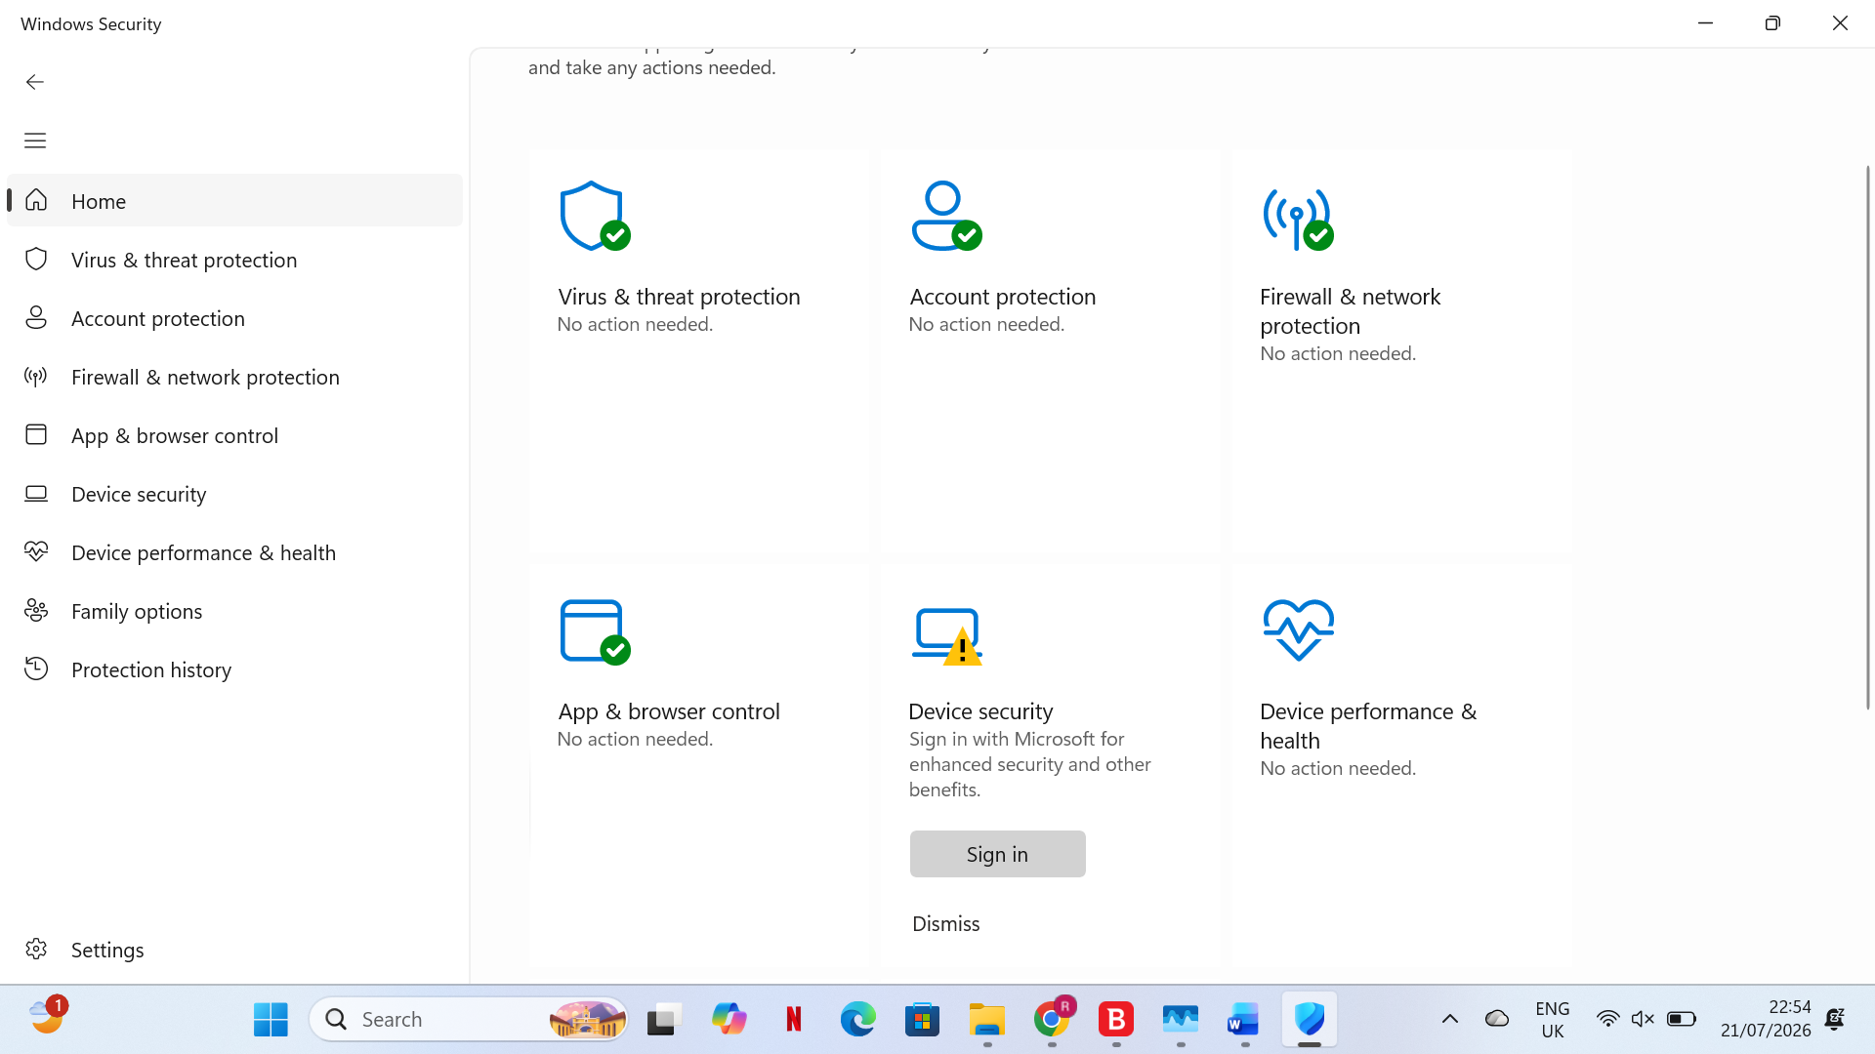
User Interface Management:
Users can interact with computer hardware and software through interfaces provided by the operating system. Graphical user interfaces (GUI), which offer windows, icons, menus, and pointers for convenience, are supported by most contemporary operating systems. Additionally, they offer command-line interfaces (CLI), which let developers and administrators run sophisticated system commands, automate processes, and better manage system resources. While accommodating various user needs and technical skill levels, both interfaces enhance usability [2].
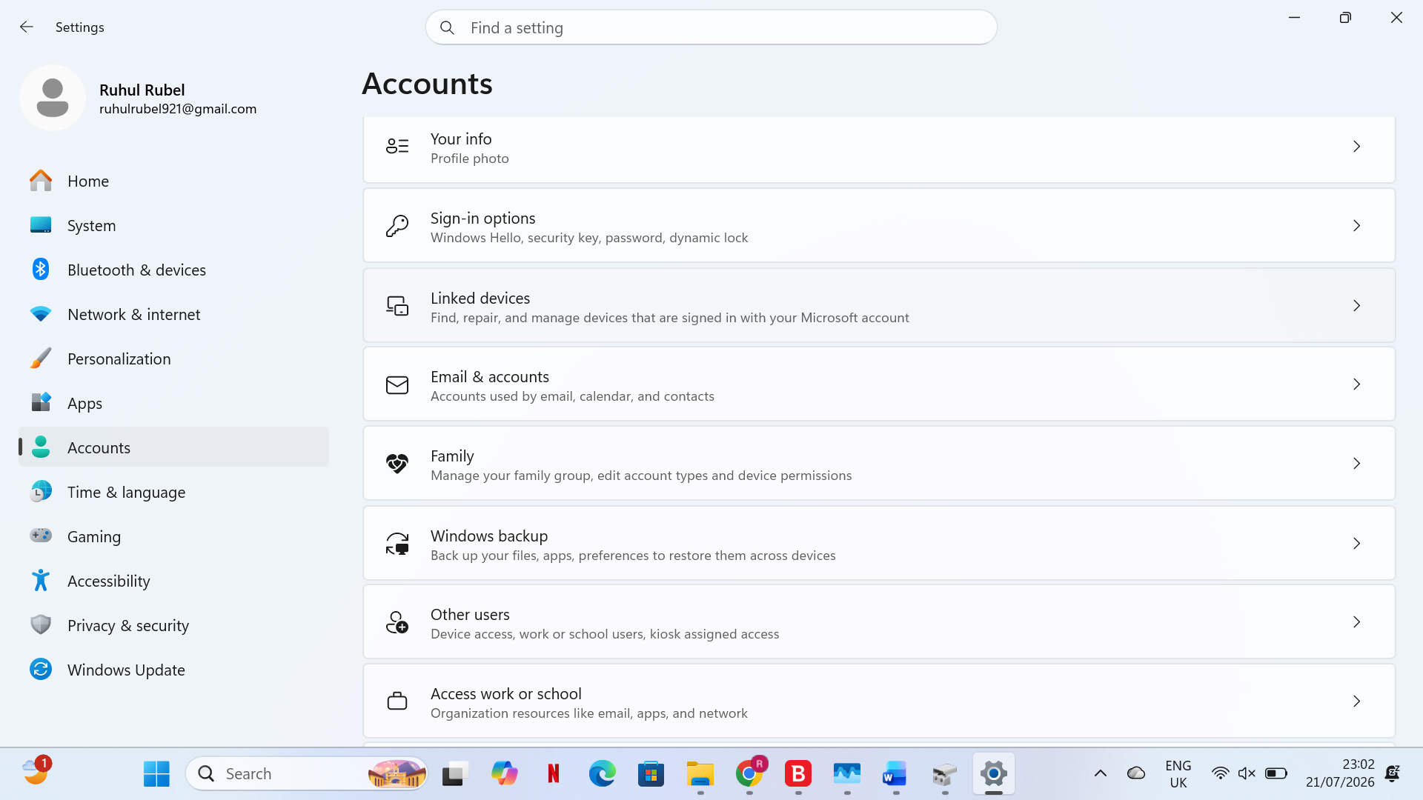

Using Windows OS CLI Commands
Process Management
Windows offers command-line tools for monitoring and managing active processes. The Tasklist command shows the details of the processes that are currently running.[5] For instance: tasklist /v
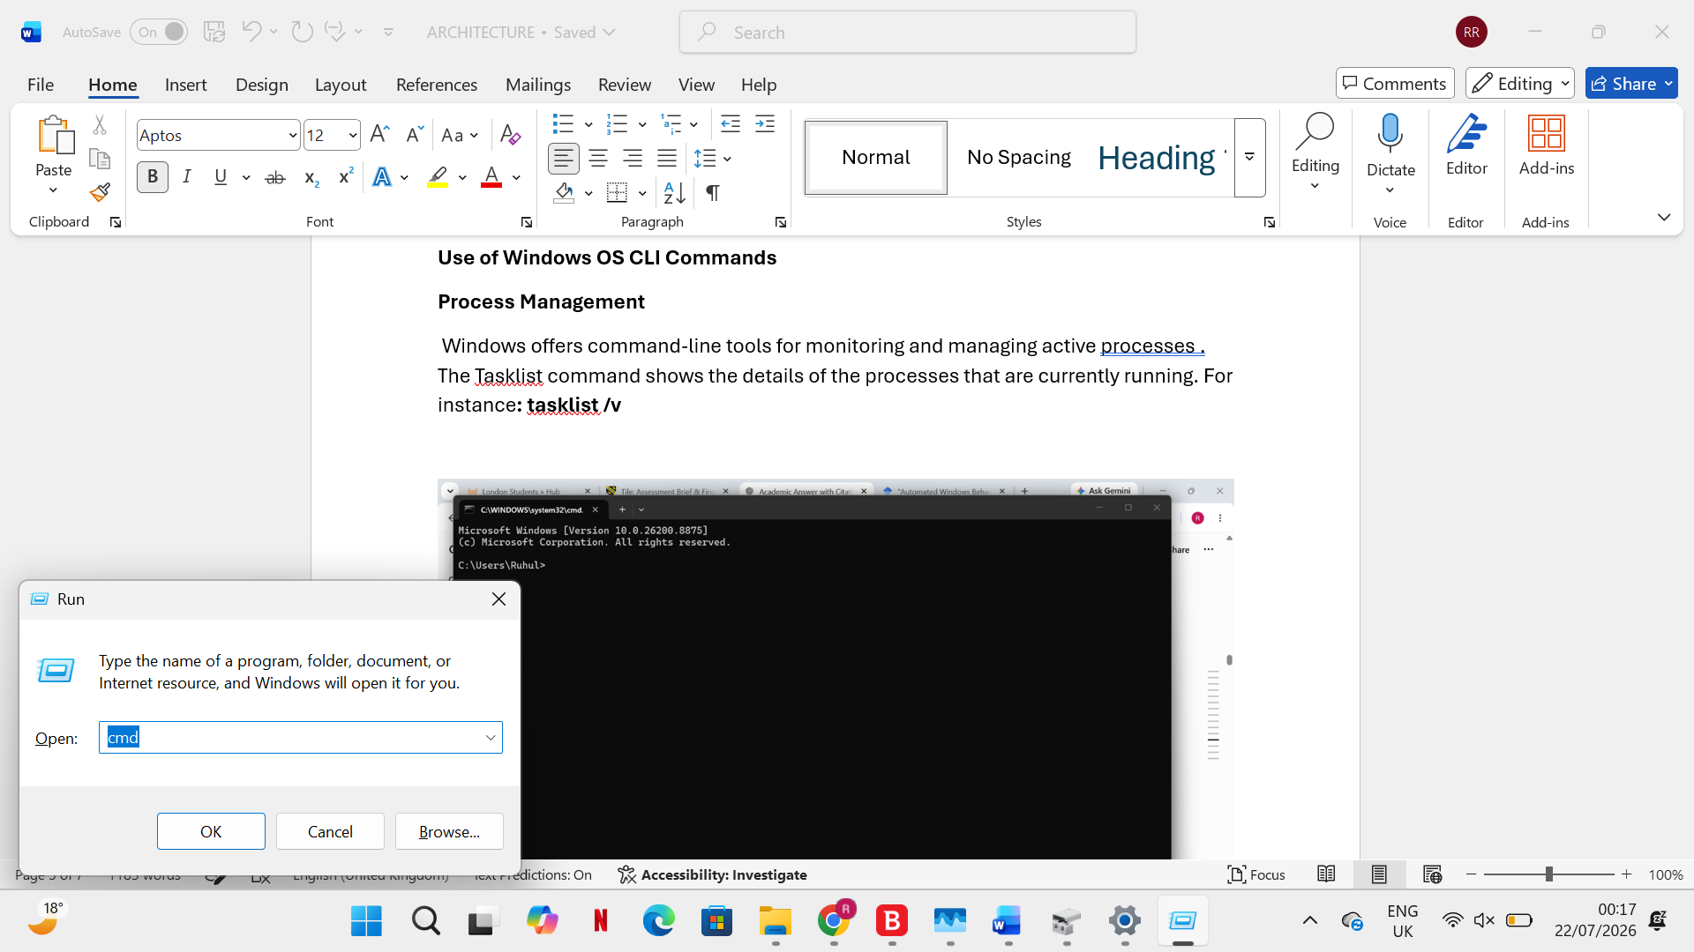

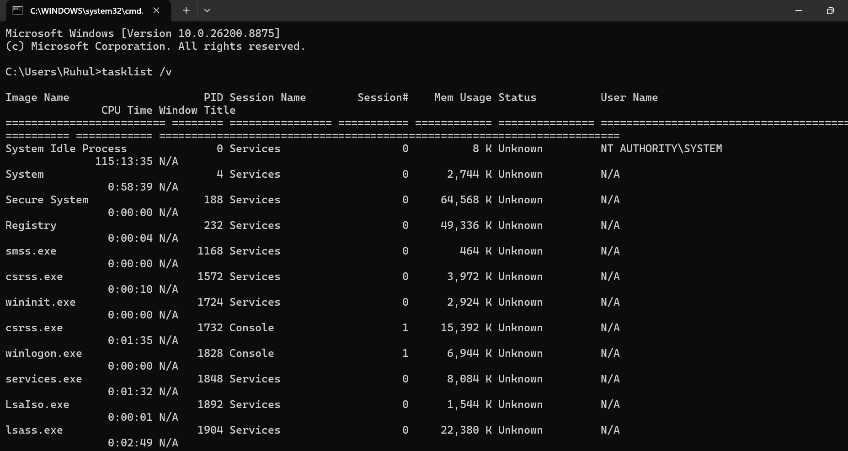
The /v switch offers comprehensive information, such as user and process status. Taskkill /PID 1234 /F is a command that administrators can use to end unwanted applications.[5]

The /F option compels termination, while the /PID option identifies the process ID. The following PowerShell commands support system monitoring and troubleshooting by enabling administrators to identify and manage active processes: Get-Process [5]
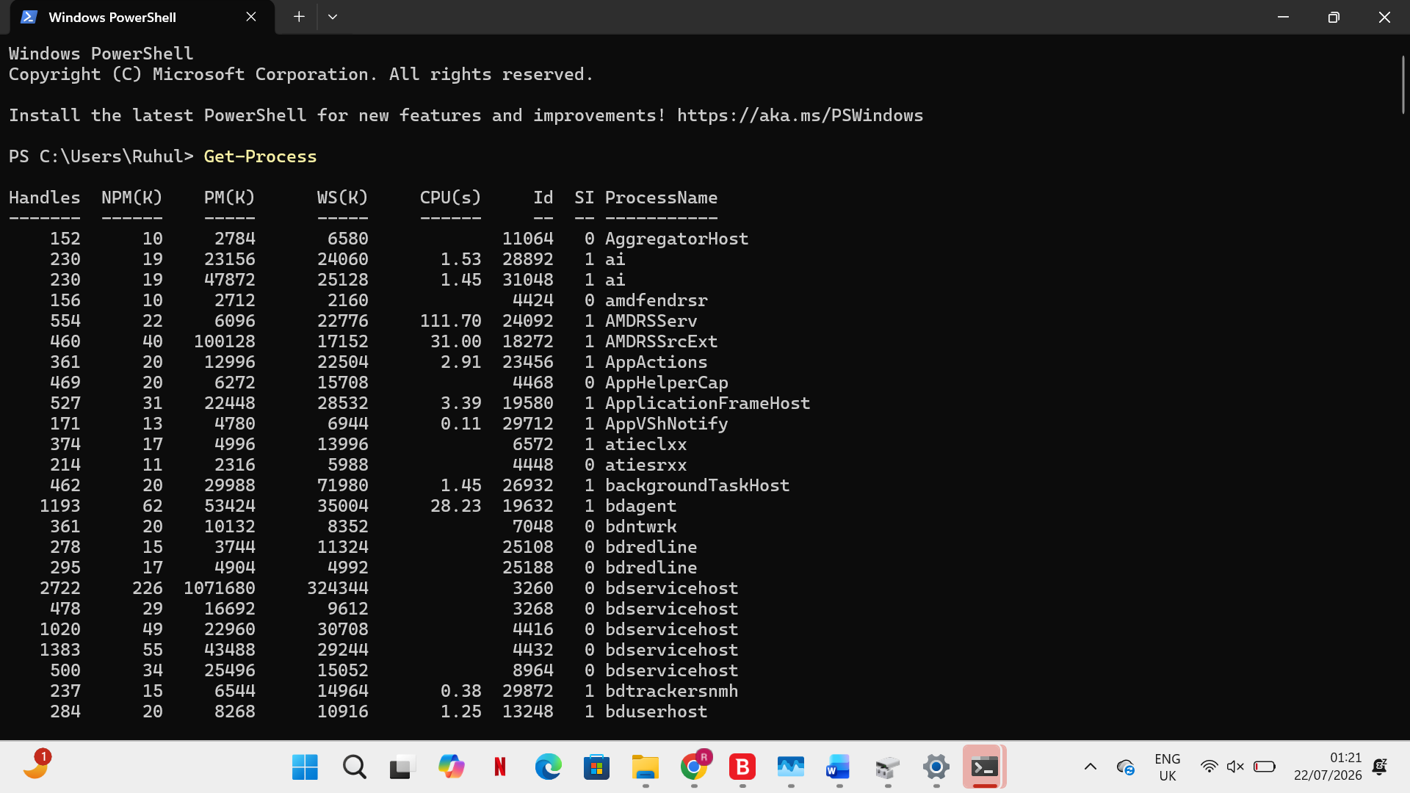

Stop-Process -Name chrome -Force.[5]
File and Directory Management
The Windows Command Prompt offers a number of commands for handling files and directories. Recursively displaying files and subdirectories is possible with the command dir , dir /s. [7]
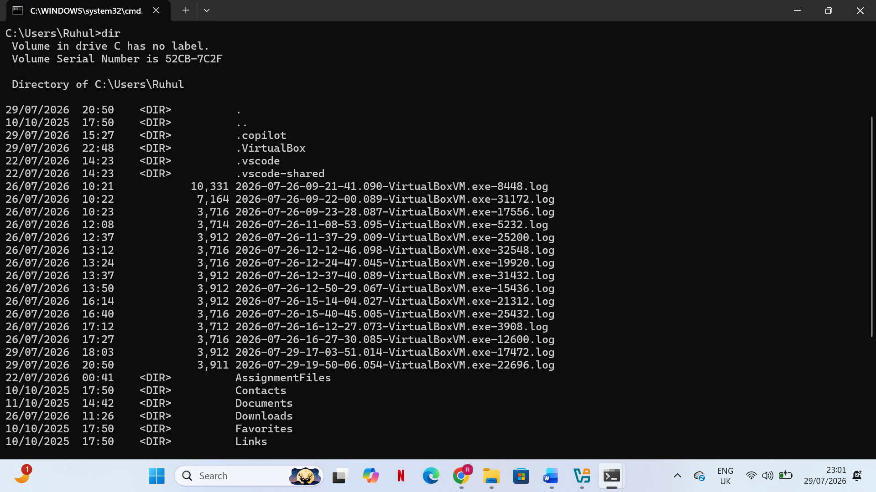
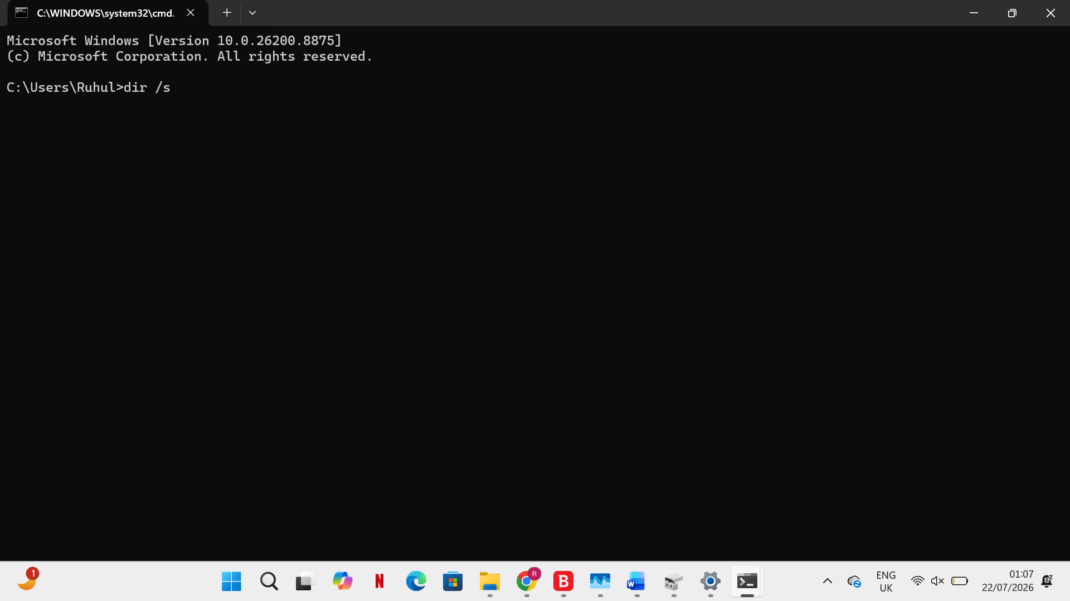
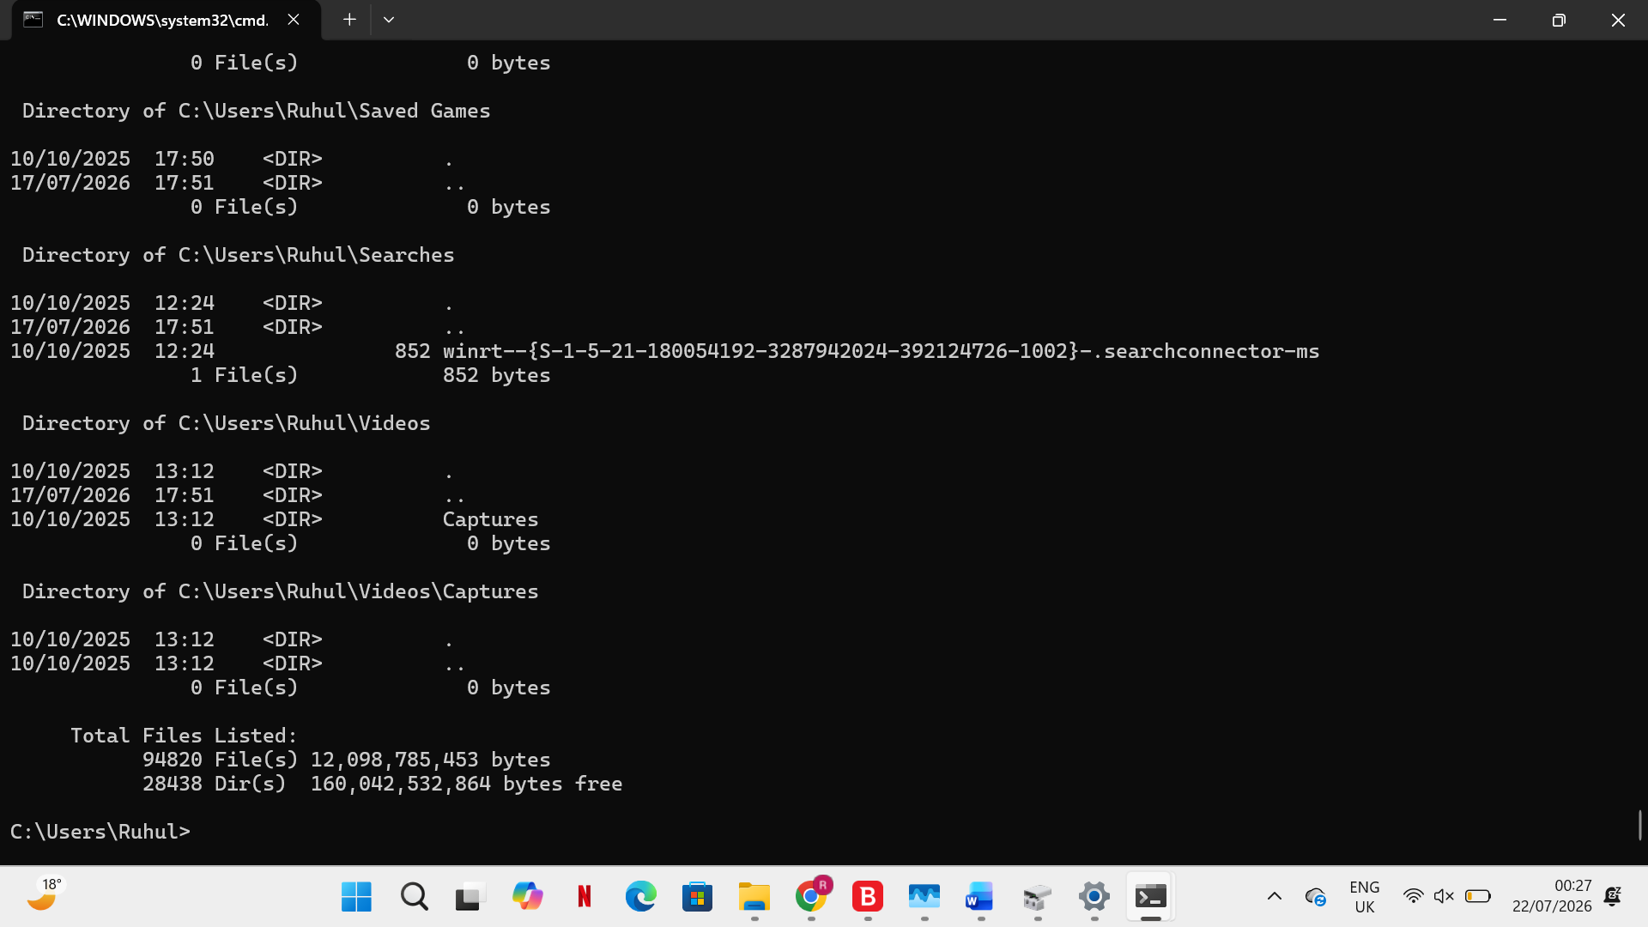
Users can view the contents of all subfolders in a directory by using the /s option.The command "copy file.txt D:\Backup" can be used to copy files, and the command "mkdir assignmentFiles" can be used to create directories.[7]

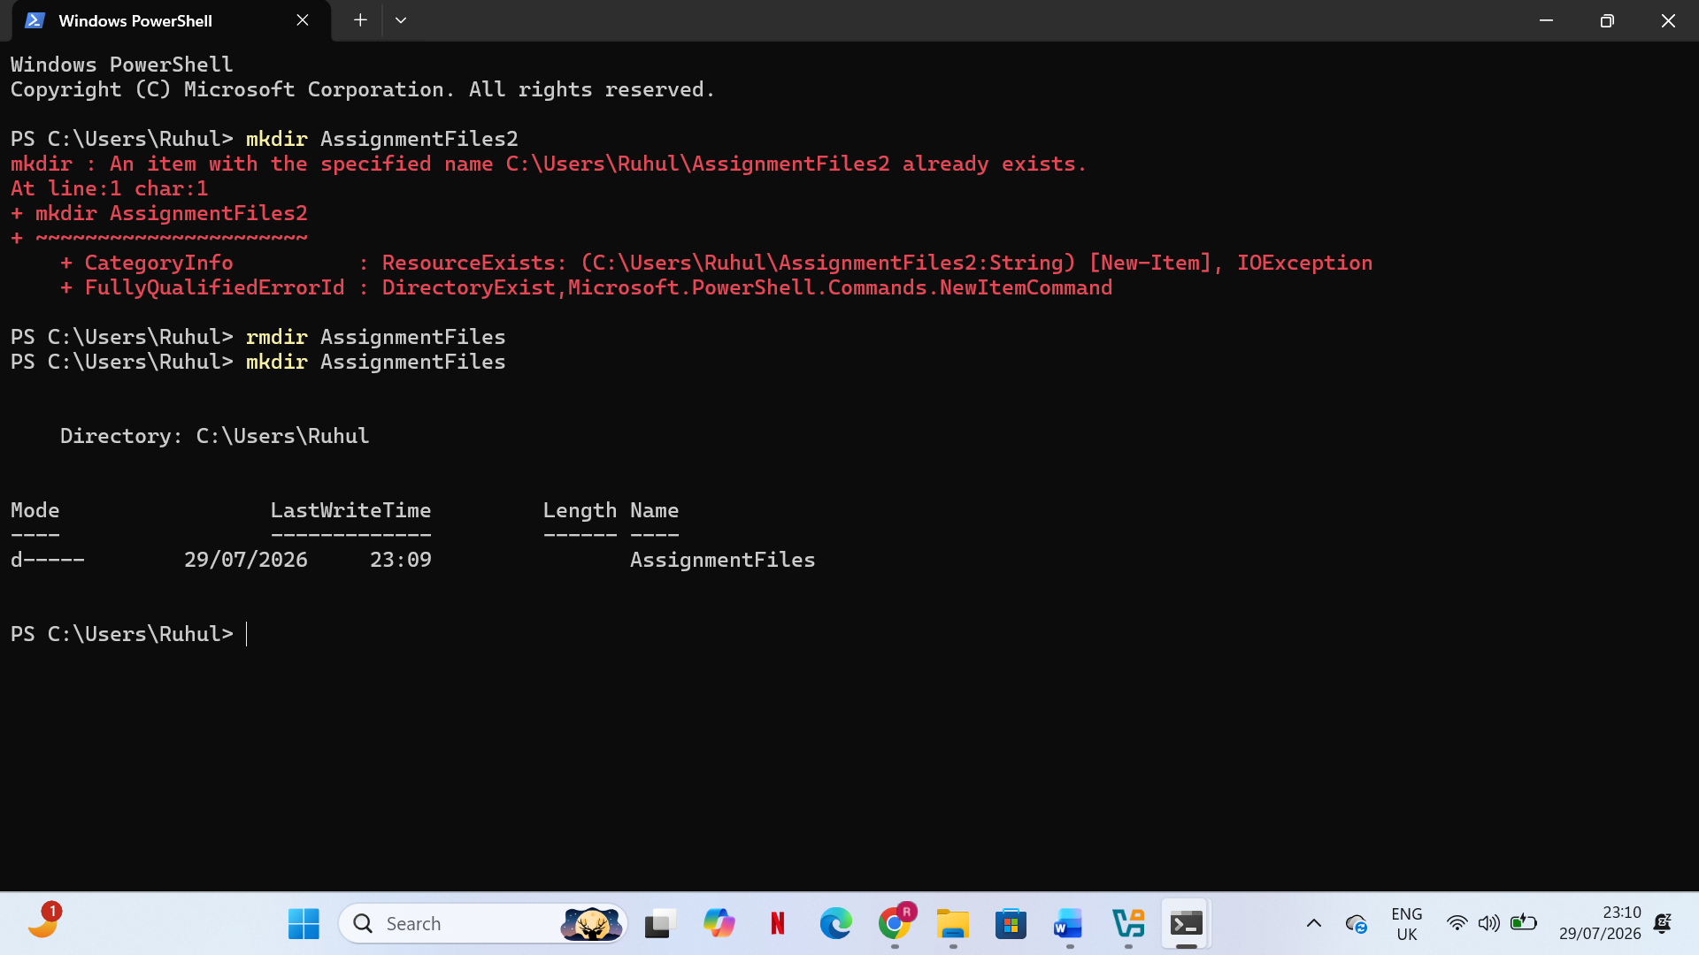
PowerShell offers sophisticated file management features, such as "Get-ChildItem -Path C:\Users -Recurse," which searches all subdirectories. These commands assist administrators in effectively organizing, finding, and maintaining system files [7].
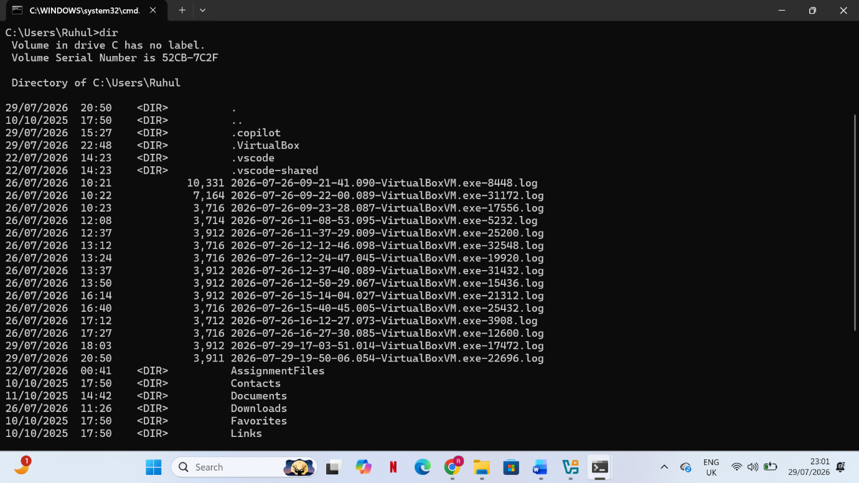
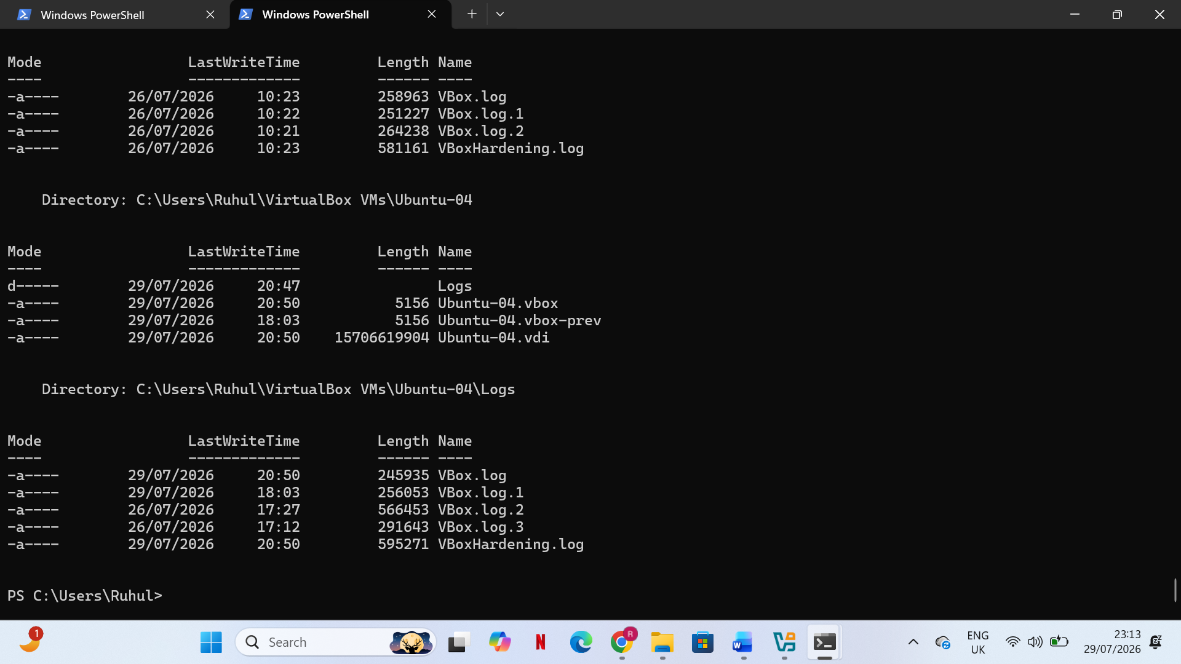
network testing and monitoring.
Windows has a number of network diagnostic commands for network testing and monitoring. IP addresses, DNS servers, and configuration information about network adapters are all displayed by the command ipconfig /all.Ping 8.8.8.8 -n 5, where -n 5 sends five test packets to measure connectivity, can be used to test network connectivity.[5],[6]

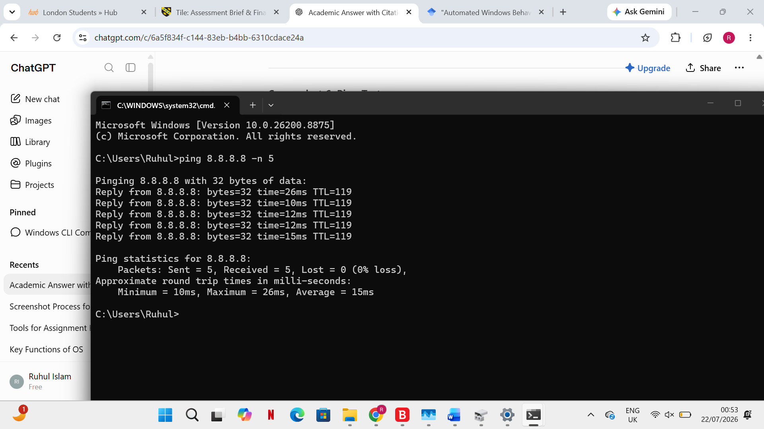
Netstat -ano allows administrators to keep an eye on active connections.

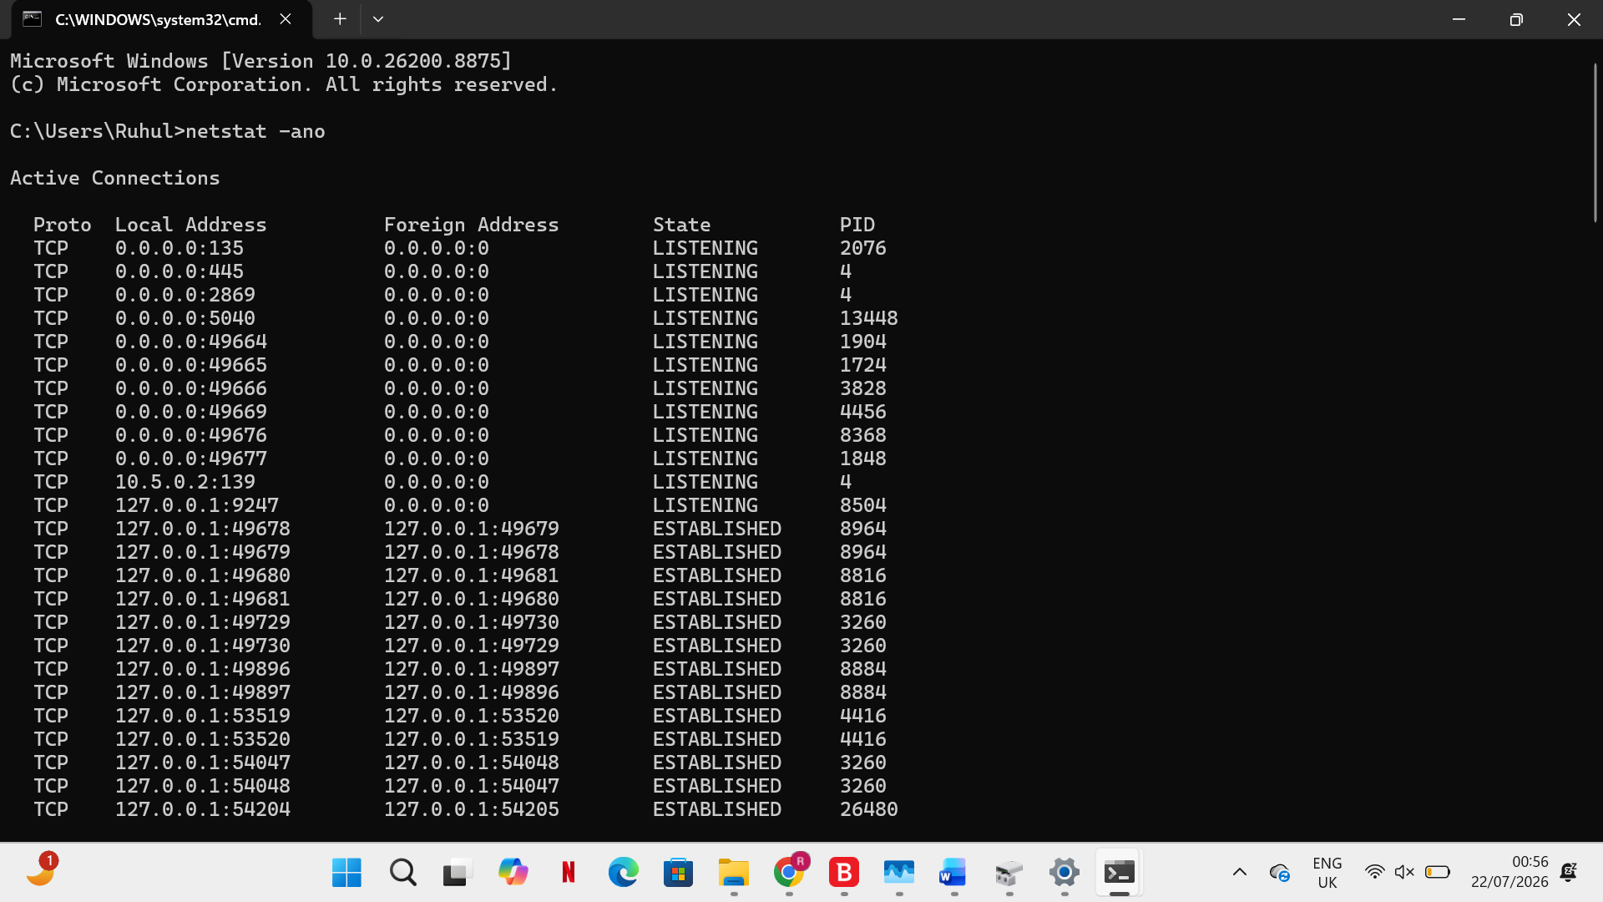 The -a switch shows all connections, the -n switch shows numerical addresses, and the -o switch displays process IDs linked to connections. These commands are helpful for spotting suspicious activity and network issues [5], [6].
User Management
Command-line tools are available for managing Windows user accounts. The existing user accounts are shown by the command net user.[8]

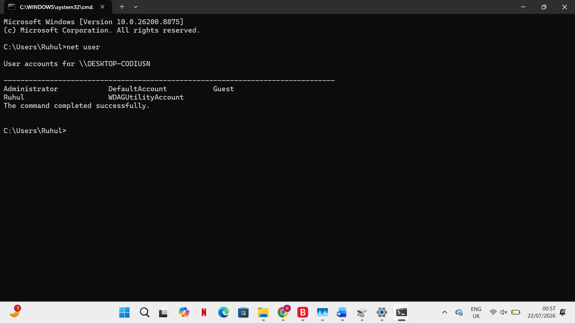
Net user Student Password123 /add is one way to create a new user.[8]
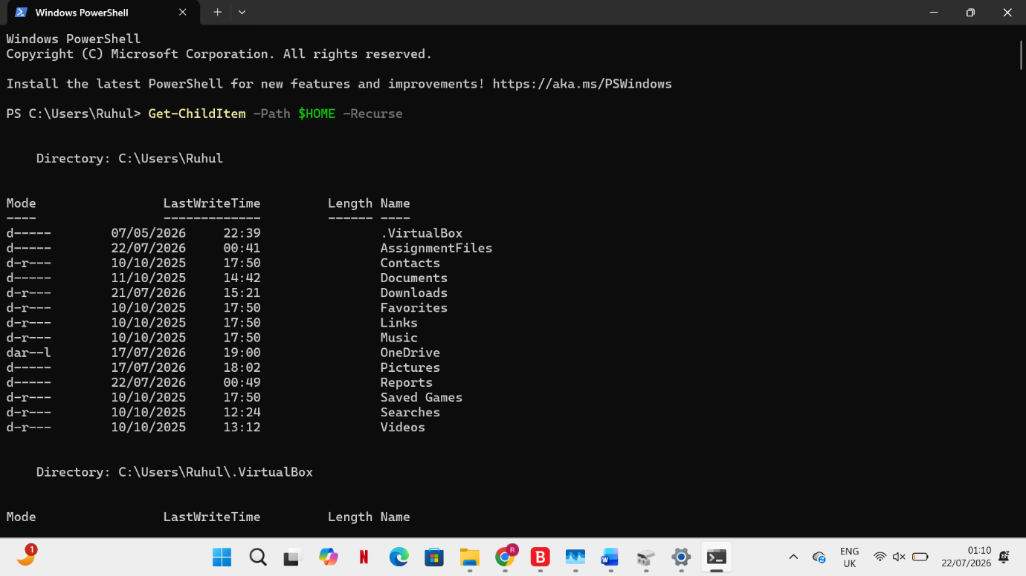 The /add switch generates a new account. Similar management features are offered by PowerShell, such as Get-LocalUser, which shows local user data. These tools help administrators securely manage user accounts and regulate access permissions [8].
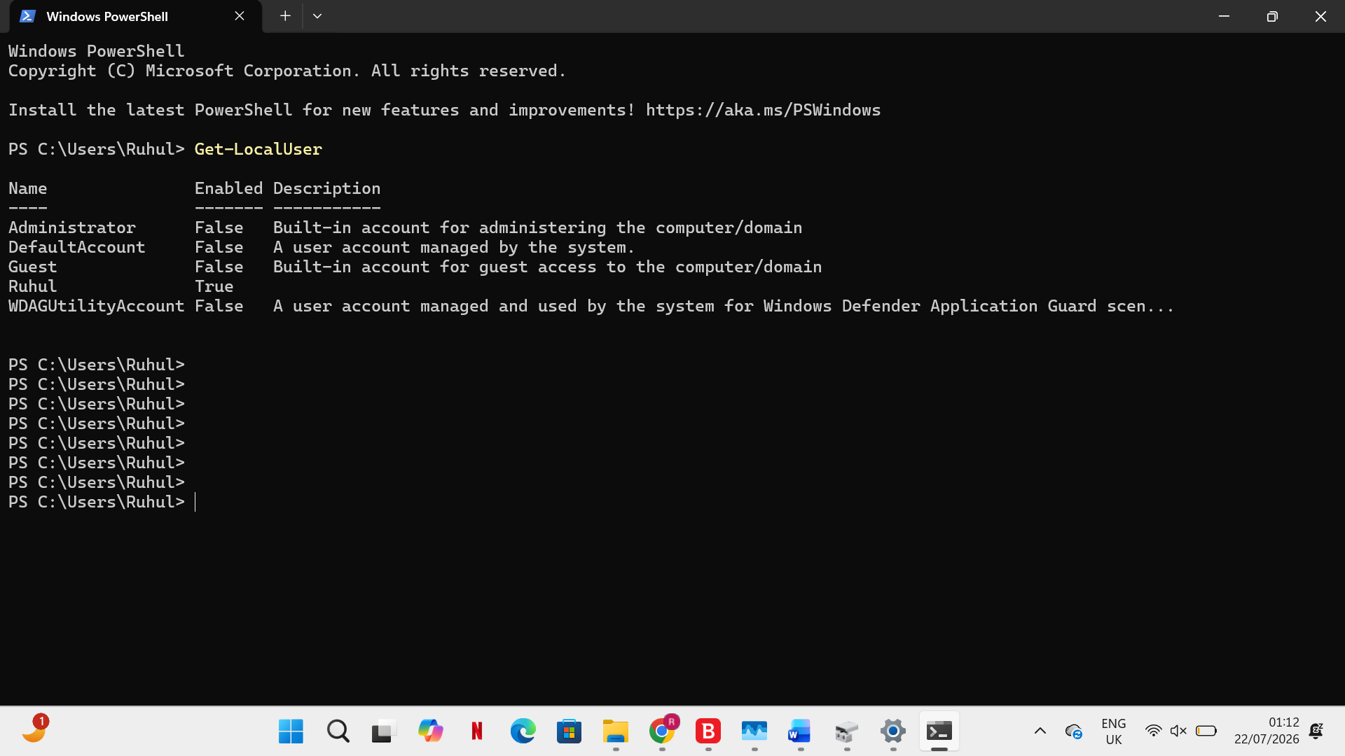
Task Scheduling Windows,
Task Scheduler can be operated via the command line with the following command: schtasks /query
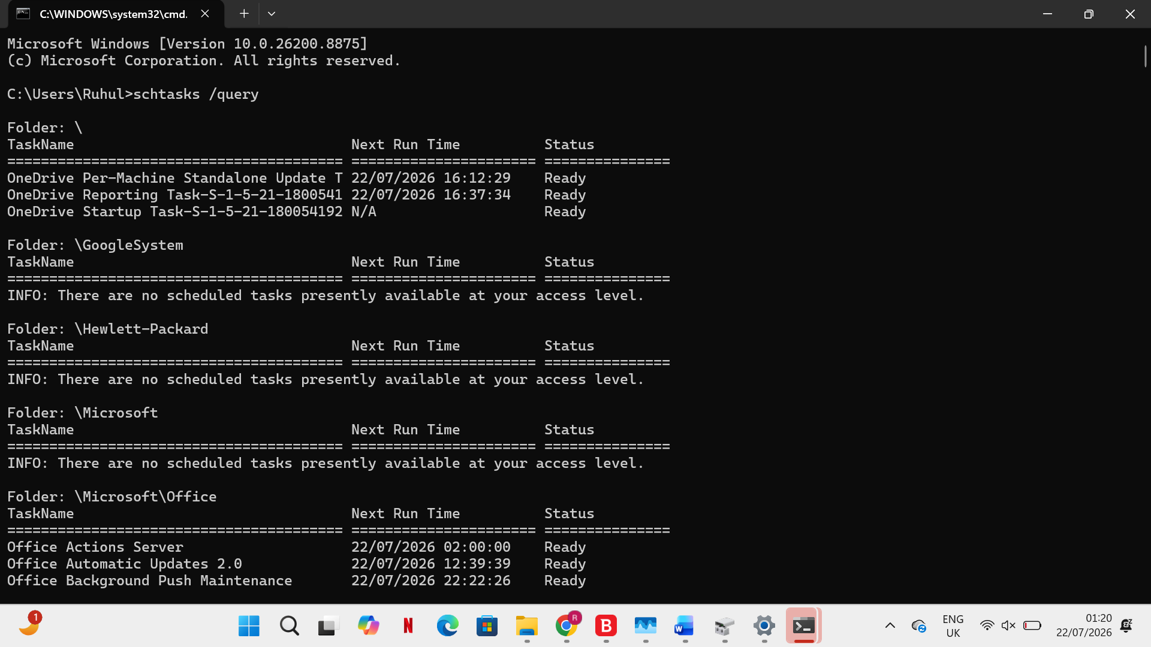
This shows the scheduled tasks that are currently set up on the system.
Schtasks /create /tn BackupTask /tr backup.bat /sc daily can be established a recurring process. The /tn option oexact the task name, /tr defines the program to run, and /sc daily schedules the task to execute every day. dministrators can automate maintenance tasks like backups, updates, and system monitoring by using task scheduling [6].

Use of Linux OS CLI Commands:
The ps -aux command shows all active processes along with comprehensive user data. Administrators can monitor system activity and identify resource-intensive tasks by using the options -a (all users), -u (user-oriented format), and -x (processes without terminals) [9].
ps -aux
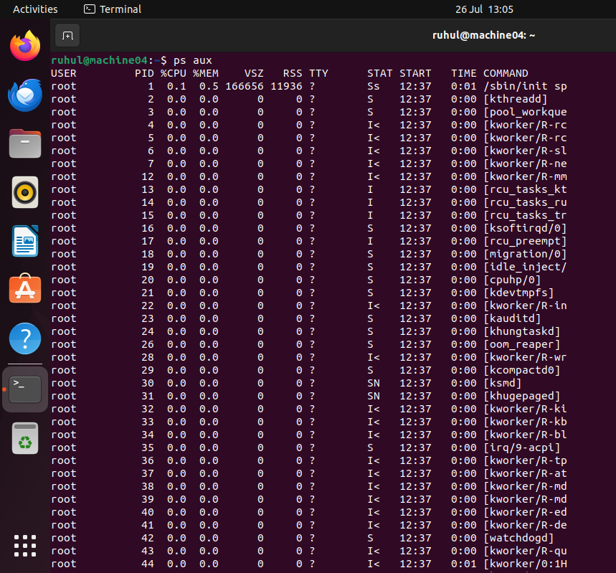

The top command is helpful for performance monitoring because it a live look at cpu activity, memory consumption, active tasks, and overall system strain[9].
top,
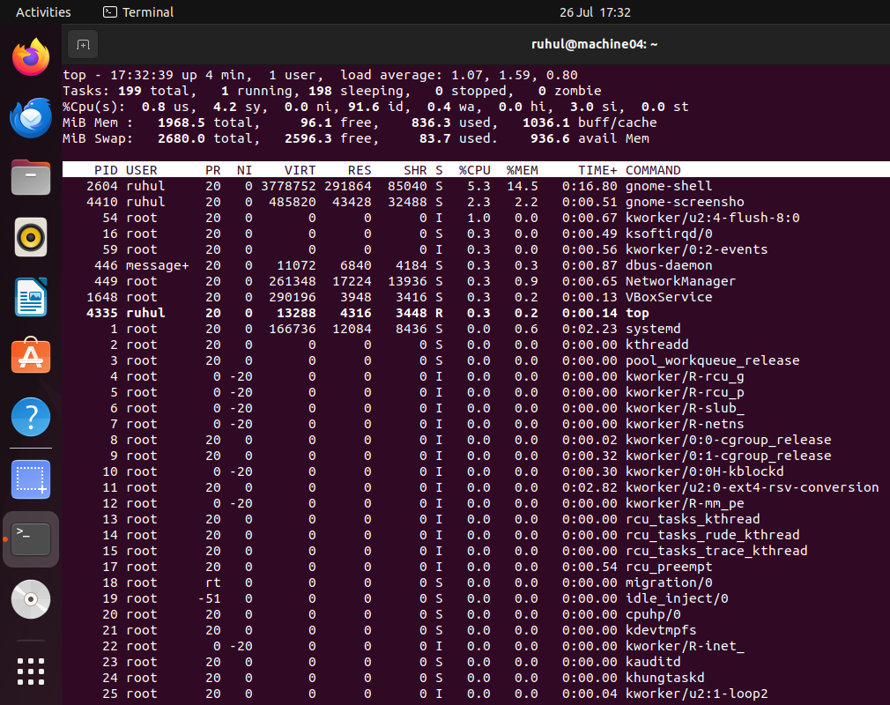
The ls -lah command displays files and directories with human-readable sizes (-h), hidden files (-a), and detailed permissions (-l) [10].
ls -lah
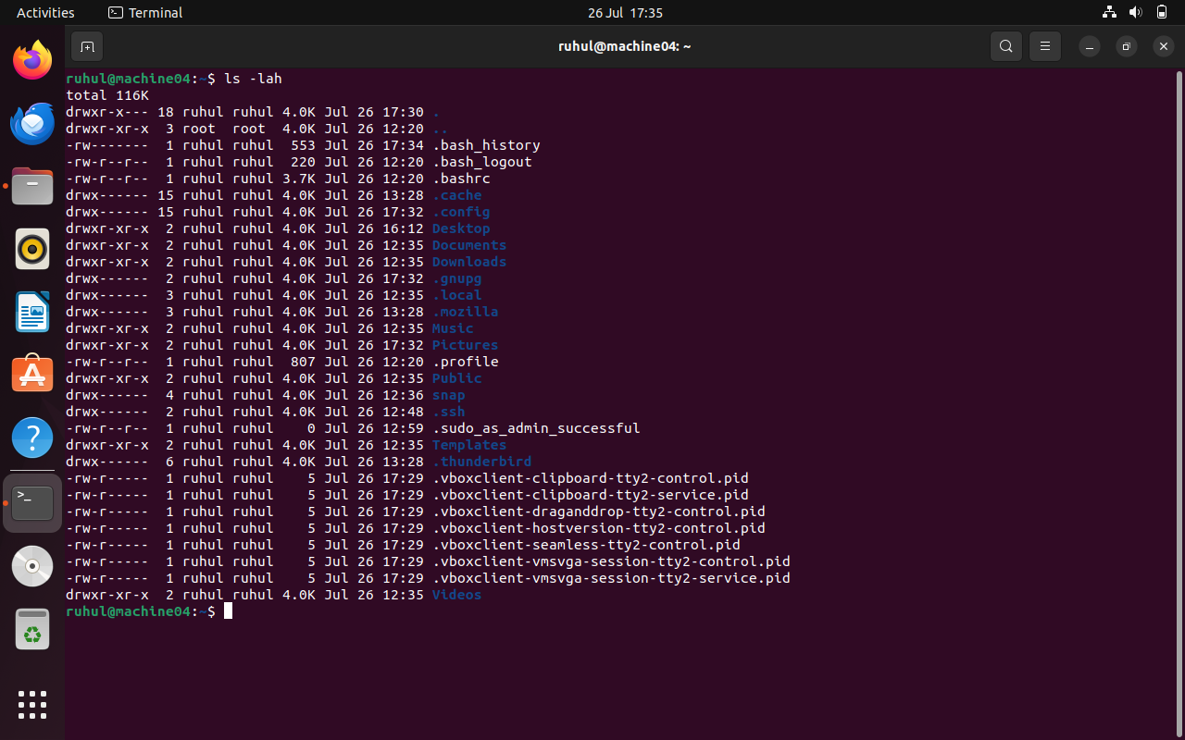
The cp -r Documents Backup/ command, which is frequently used for backups, recursively copies a directory and all of its contents using the -r option [10].
cp -r Documents Backup/
The find . -name "*.txt" command looks for all text files that match the given filename pattern in the current directory and its subdirectories [10].
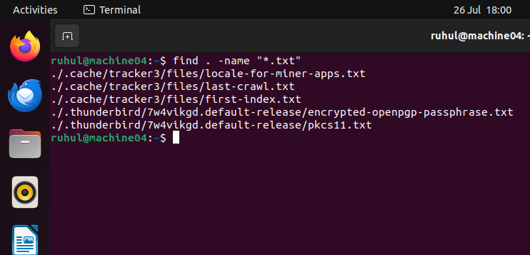
locate "*.txt"To check network connectivity and gauge response time, the ping -c 4 google.com command sends four ICMP echo requests (-c 4) [11].
ping -c 4 google.com For network monitoring, the ss -tulpn command shows listening ports, active TCP/UDP sockets, and related process IDs [11].
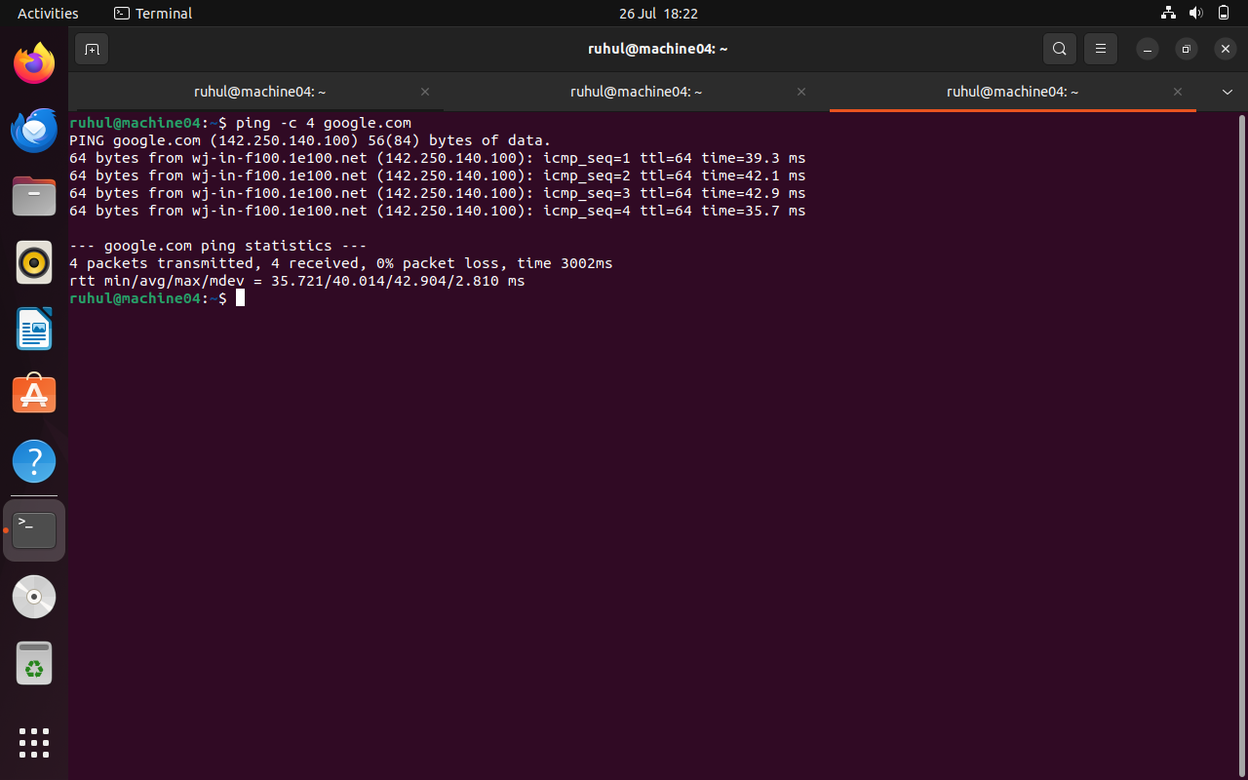
The ss -tulpn command displays active TCP/UDP sockets, listening ports, and associated process IDs for network monitoring [3].
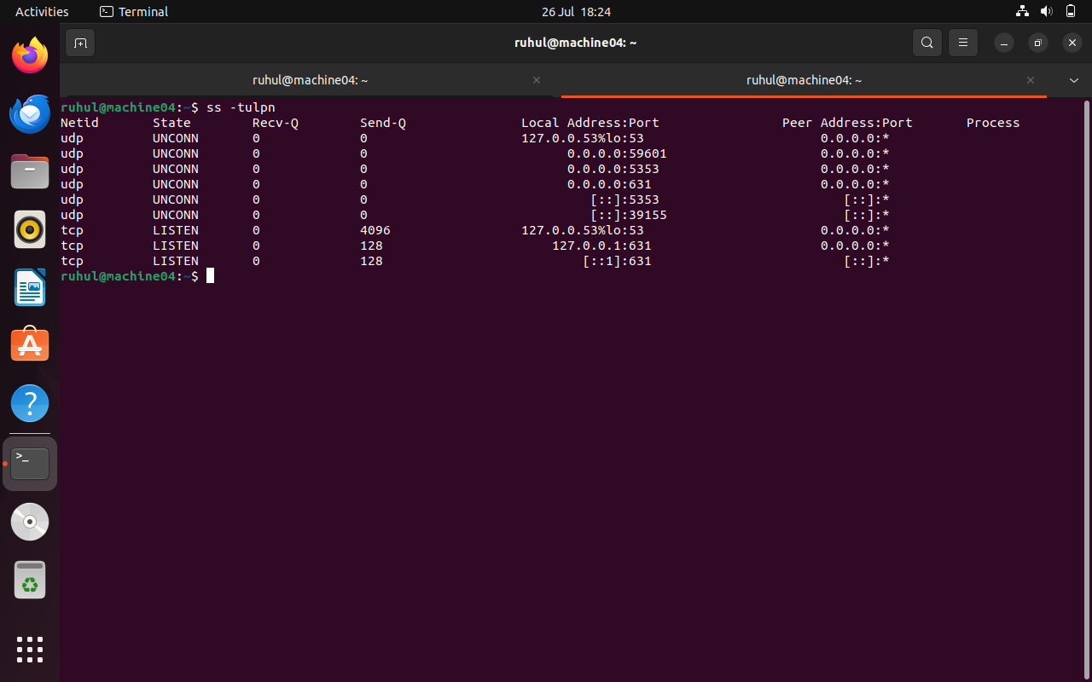

sudo useradd -m student1 The sudo passwd student1 command improves account security by assigning or changing the password of the designated user [9].
Sudo passwd student1
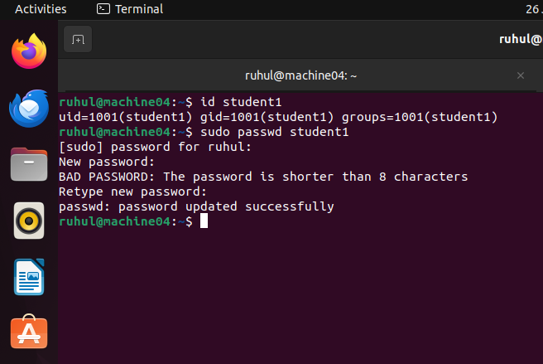
By assigning or changing the password of the designated user, the sudo passwd student1 command enhances account security [9].
The crontab -e command modifies scheduled cron jobs, enabling repetitive tasks like backups to be executed automatically [10].
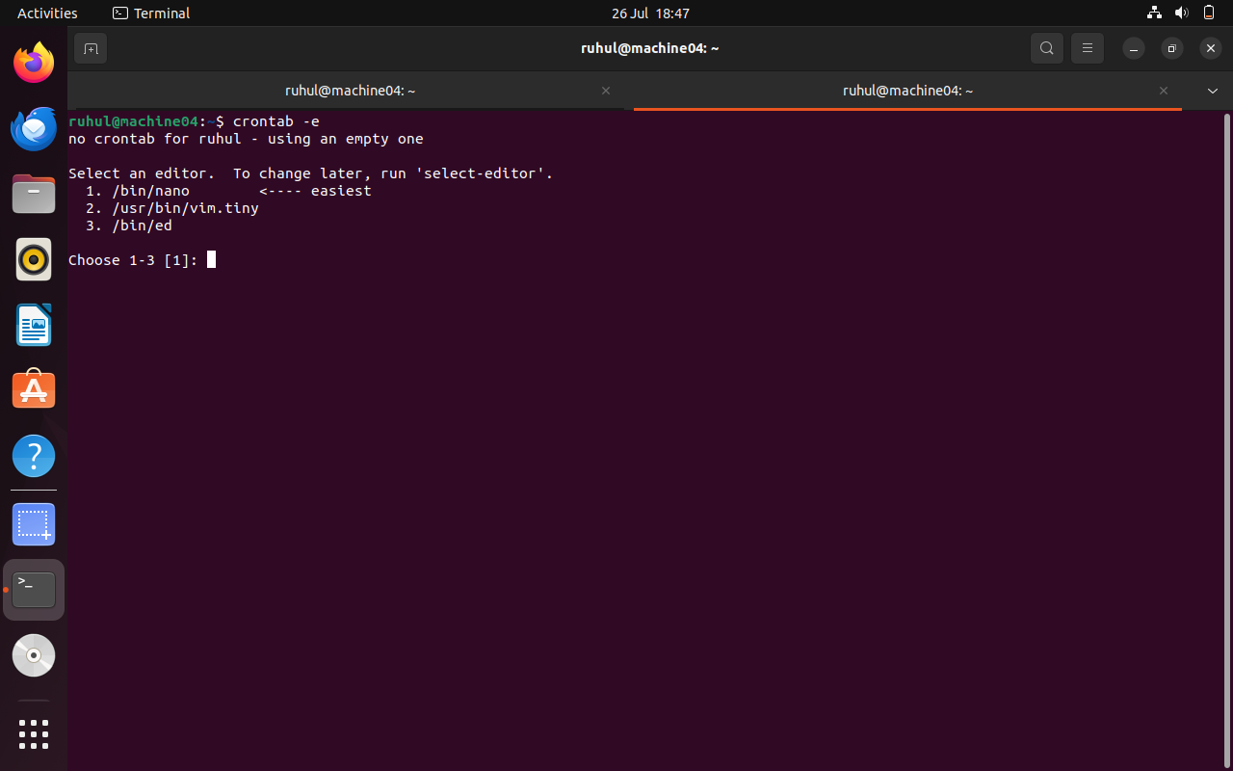
The echo "shutdown -h now" | at 23:30 command uses the at utility to schedule a one-time task to run at the designated time [11].
echo "shutdown -h now" |
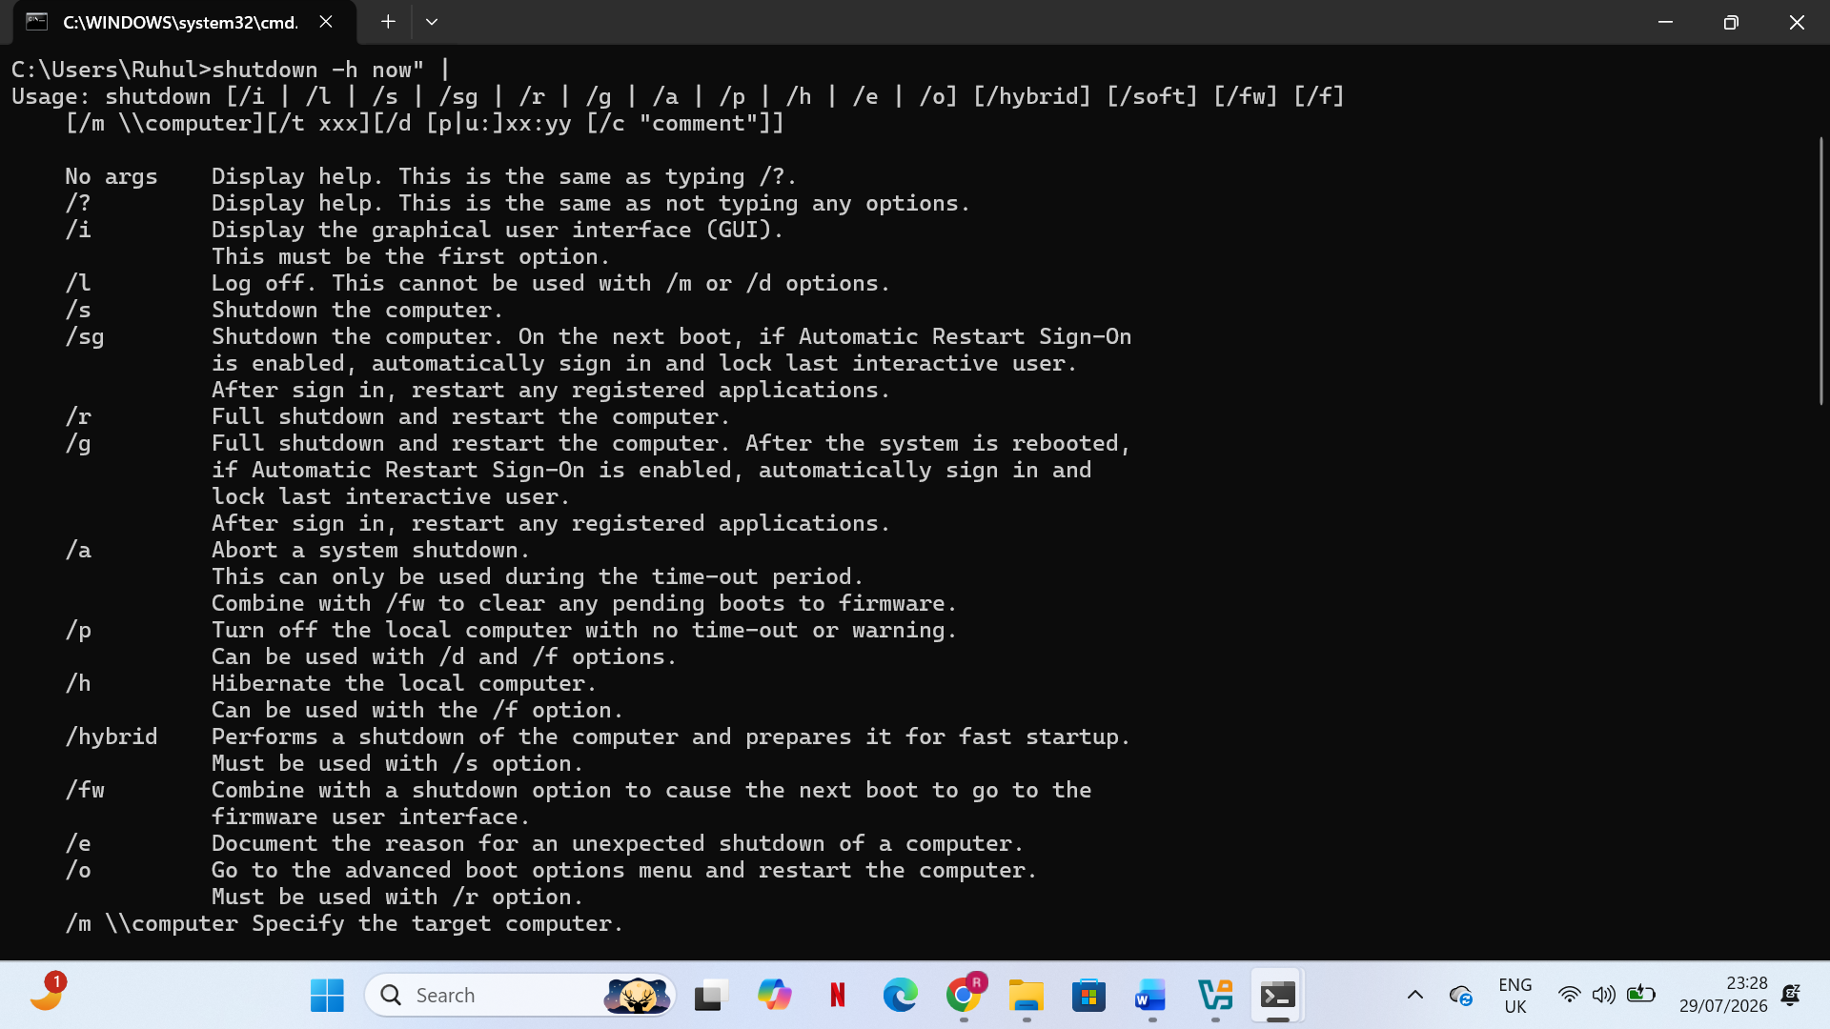
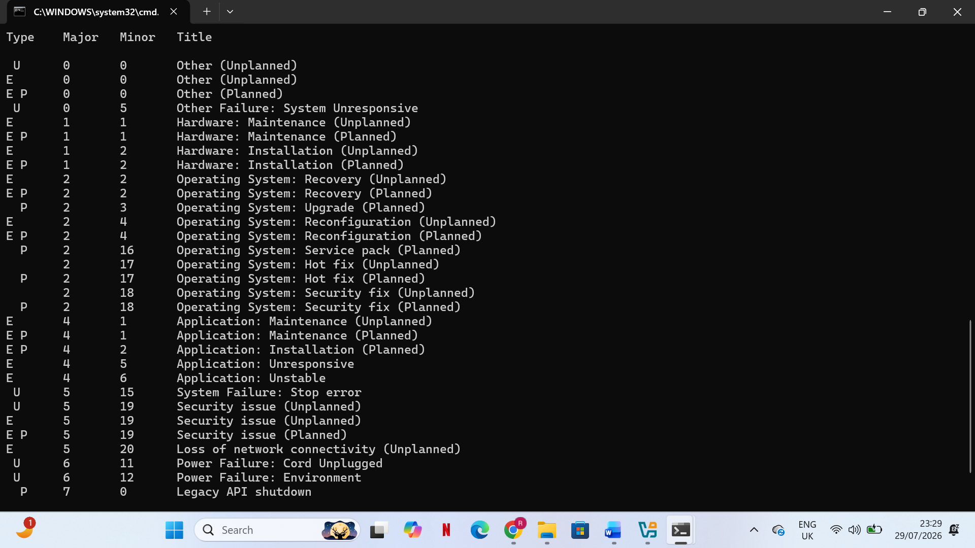

Use of Windows OS scripts

Batch Script 1: Automated System Information Checker
This script copies files from a chosen source folder to a backup location in order to automate file backup tasks. [12] Modern operating systems depend on file management and storage operations, where automated backup processes enhance data availability and dependability [13].
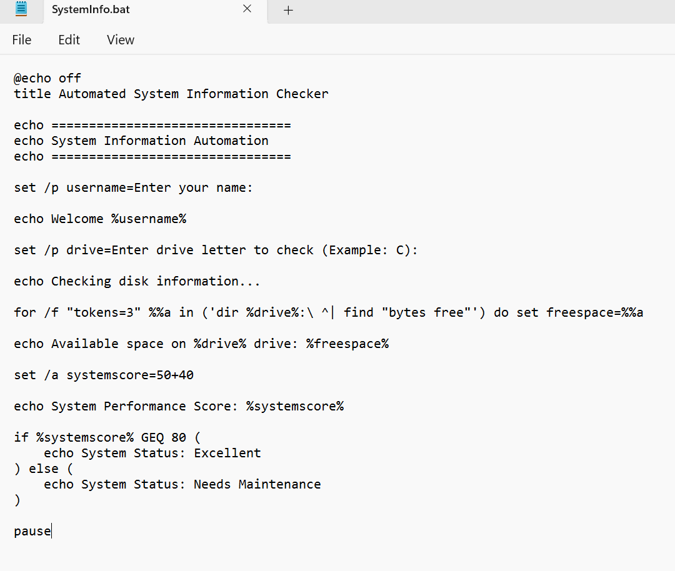
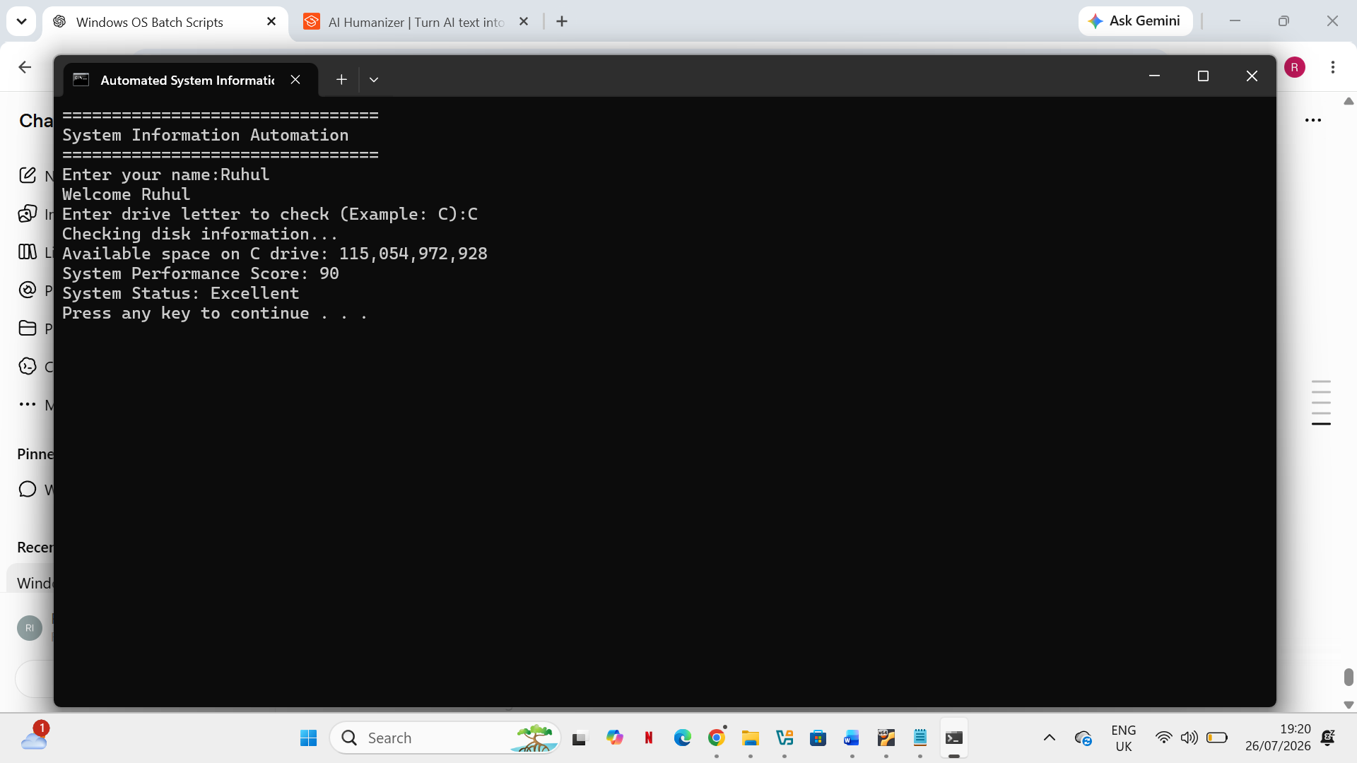

Explanation of Script Features Variables:
Variables are used to temporarily store data values, including calculated results, drive locations, and usernames. Because the same program can handle various inputs without altring the code structure, the use of variables increases script flexibility [15].

User Input
By accepting values during execution, the set /p command enables communication between the user and the batch script. Because they offer direct control over operating system functions, command-line interfaces are frequently utilized in system administration [12].

Mathematical Operations
In the Batch environment, arithmetic computations are carried out by the set /a command. Because of this feature, scripts can automatically process numerical data without the need for external programs [15].
Loop
The for /f loop automatically repeats operations while processing command output. Because they decrease repetitive instructions and increase automation efficiency, loop structures are crucial programming concepts [15].

Conditional Statement
Making decisions based on particular conditions is made possible by the if statement. Automation scripts frequently employ conditional execution to react differently based on user input or system conditions [16].

Batch Script 2: Automated File Backup System Goal:
By transferring files from a chosen source folder to a backup location, this batch script automates file backup operations.[12] Modern operating systems depend on file management and storage operations, where automated backup processes enhance data availability and dependability [14].

Code for Batch Scripts
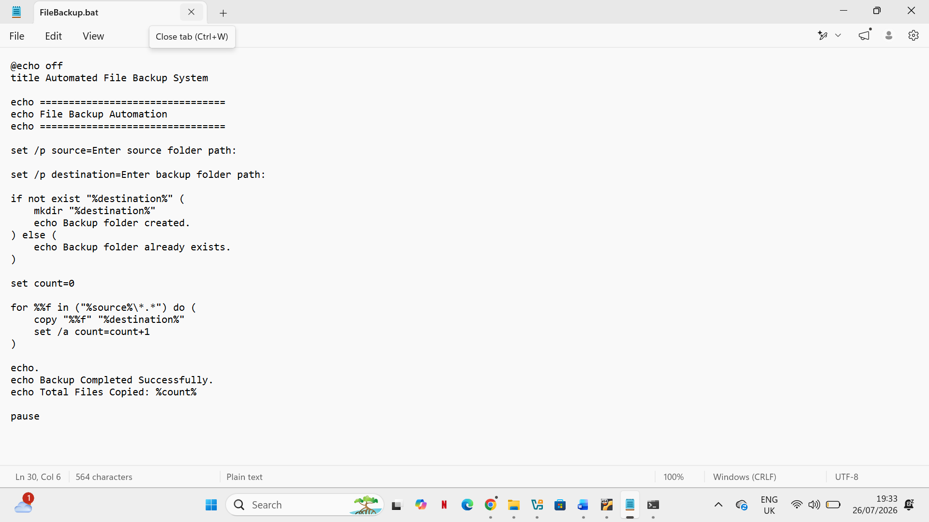
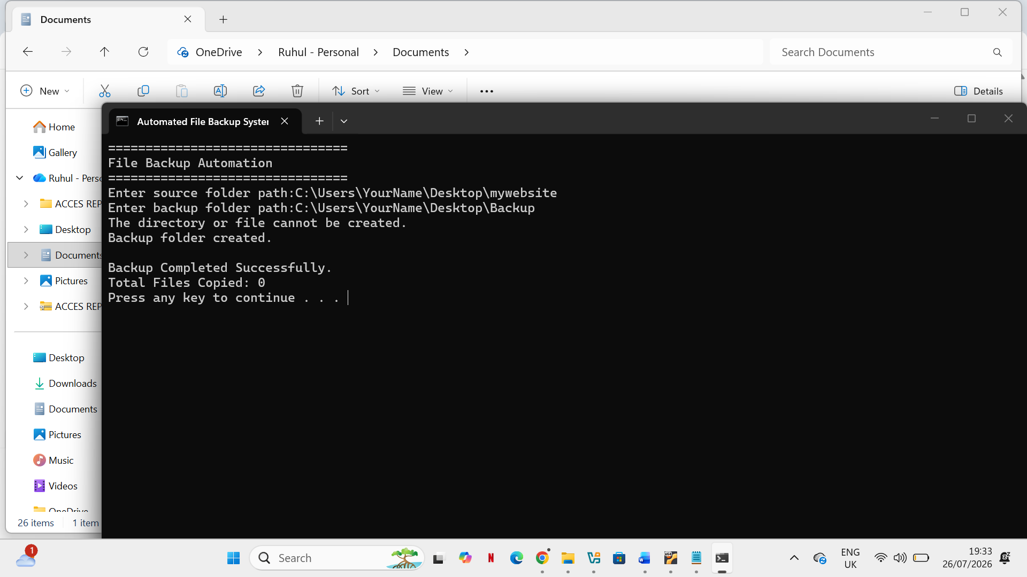

Description of Script
Features Variables The script stores file counters, source paths, and destination paths using variables. Scripts can adjust to various environments and user needs thanks to variable-based programming [15].

User Input
The backup tool is reusable for various directories because users supply folder locations during execution. Administrators frequently use interactive command-line tools to perform system maintenance [12].

Mathematical Operations
After each successful arithmetic calculation copy operation, the file counter rises. Users can monitor automated tasks and receive feedback by counting processed files [15].
Loop
Multiple files are automatically processed by the for loop, which eliminates the need for separate copy commands for each file. In system administration scripts, automated iteration is a basic programming technique [16].

Conditional Statement
Before generating a new directory, the if not exist condition verifies that the backup folder is accessible. By doing this, mistakes are avoided and necessary resources are guaranteed before operations are carried out [12].

Script 1: Student Grade Calculator
The Student Grade Calculator is a Bash shell script that uses user-entered marks to automatically assign a letter grade. The script employs conditional statements (if, elif, and else) to determine the proper grade, variables to store input, the read command to gather user data, and arithmetic comparison operators. In Linux, bash scripting is frequently used to automate tedious administrative tasks and boost productivity [17]. In shell scripting, conditional statements are essential control structures that allow decision-making based on user input [18].
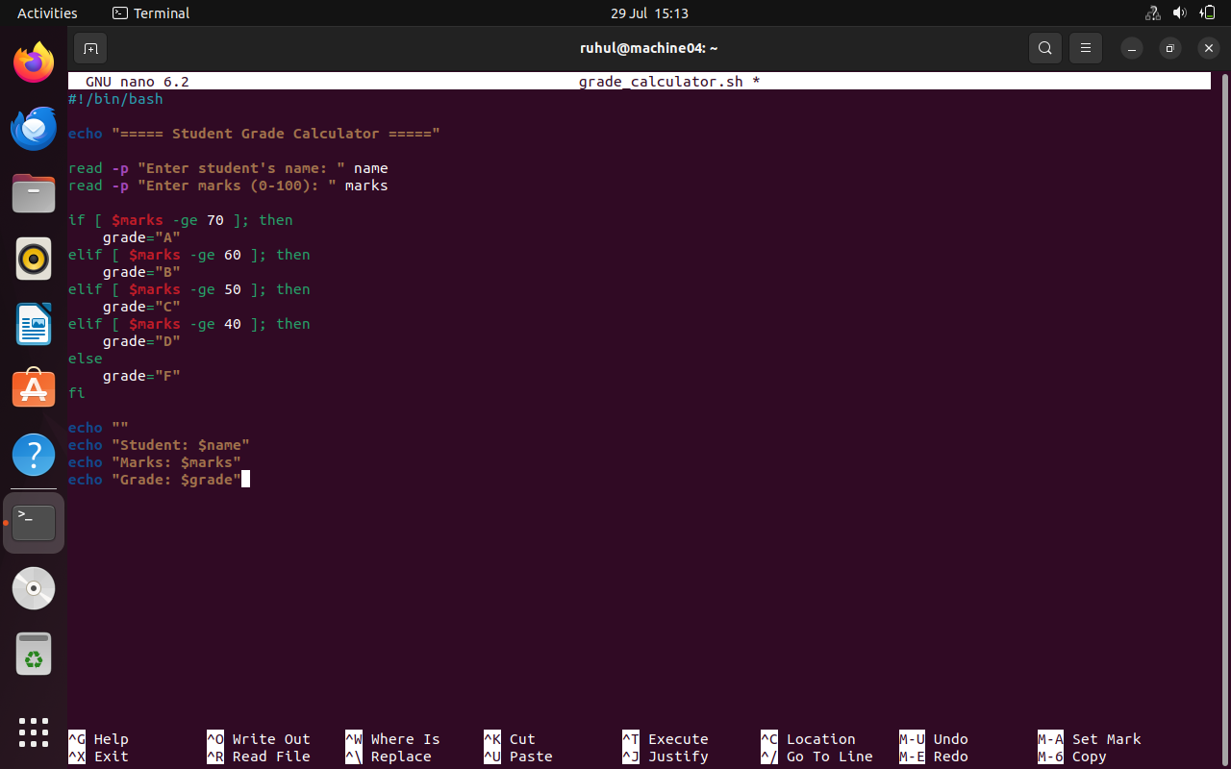

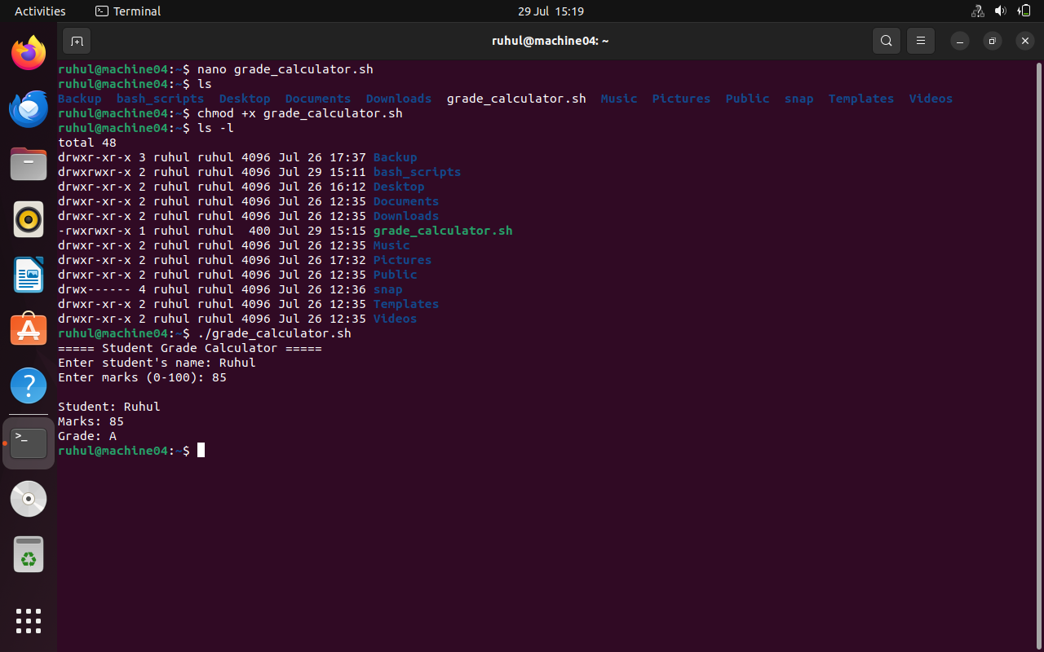

Script 2: The Number Sum
Calculator shows how to compute the sum of numbers from 1 to a user-defined value using variables, arithmetic operations, and a for loop. Because they automate repetitive tasks without requiring human intervention, loop structures are a crucial component of shell scripting [19]. In Linux system administration, shell scripting is frequently used to increase efficiency and decrease human error [17].
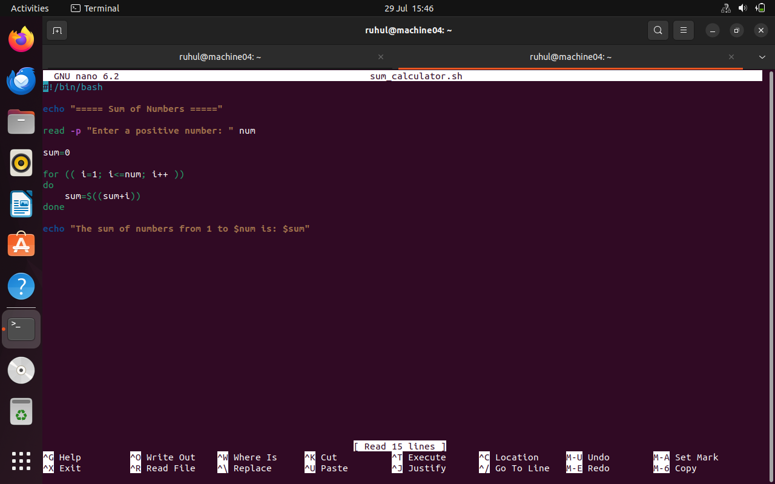

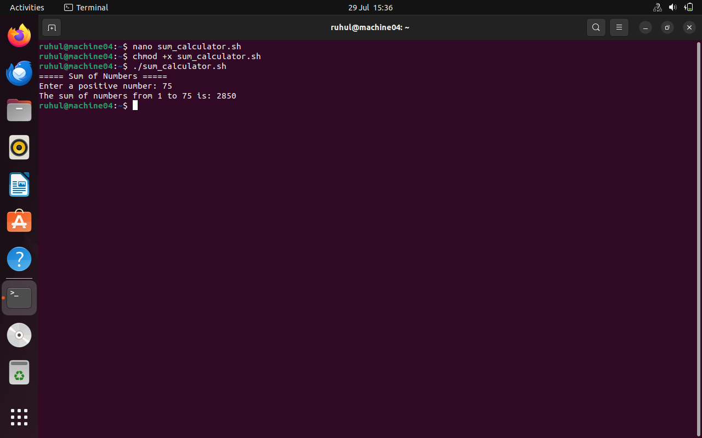

Folder Structure

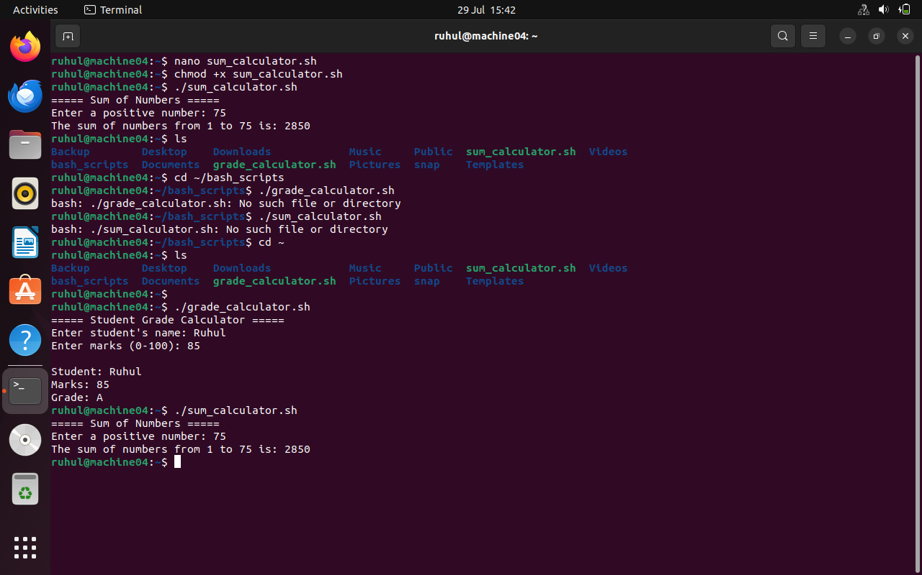

Conclusion
The report provided examples of the key characteristics of general operating systems and the practical use of Windows and Linux command-line tools for system administration. It also showed how Batch and Bash scripts use variables, loops, conditional statements, and user input to automate repetitive tasks, improving efficiency, accuracy, and overall system management.

References
[1] Z. Ali et al, "A Systematic Review of Kernel-Level Security Mechanisms, Vulnerability Detection and Mitigation in Modern Operating Systems," Sensors, vol. 26, (8), 2026. .
[2] C. Li et al, "MProtect: Operating System Memory Management without Access," 2022. .
[3] H. Kuzuno and T. Yamauchi, "Prevention of Kernel Memory Corruption Using Kernel Page Restriction Mechanism," Journal of Information Processing, vol. 30, pp. 563–576, 2022. .
[4] T. Geppert et al, "Trusted Execution Environments: Applications and Organizational Challenges," Frontiers in Computer Science, vol. 4, 2022. .
[5] C. Smiliotopoulos, K. Barmpatsalou and G. Kambourakis, "Revisiting the Detection of Lateral Movement through Sysmon," Applied Sciences, vol. 12, (15), 2022. .
[6] S. Rana, N. Kumar and A. Handa, "Automated Windows Behavioral Tracing for Malware Analysis," Security and Privacy, vol. 5, (6), 2022. .
[7] A. Bhardwaj et al, "Alternate Data Stream Attack Framework to Perform Stealth Attacks on Active Directory Hosts," Sustainability, vol. 14, (19), 2022. .
[8] F. Yang et al, "A Flexible Approach for Cyber Threat Hunting Based on Kernel Audit Records," Cybersecurity, vol. 5, (11), 2022. .
[9] E. Nemeth et al, "untitled," 2021. .
[10] W. E. Shotts, "The Linux Command Line," 2019. .
[11] M. G. Sobell, "A Practical Guide to Linux Commands, Editors, and Shell Programming," 2020. .
[12] A. Silberschatz, P. B. Galvin and G. Gagne, "Operating System Concepts," vol. 10, 2021. .
[13] D. A. Patterson and J. L. Hennessy, "Computer Organization and Design: The Hardware/Software Interface, 6th ed," 2021. .
[14] M. Bishop, "Computer security: Art and science," IEEE Security &Amp; Privacy, vol. 1, (1), pp. 73–75, 2003. .
[15] R. W. Sebesta, "Concepts of Programming Languages," 2019. .
[16] S. Mcconnell, "Code Complete: A Practical Handbook of Software Construction, 2nd ed," 2004. .
[17] S. Nanz and C. A. Furia, "Proc. 37th Int. Conf. Software Engineering (ICSE)," pp. 778–788, 2015. .
[18] D. Spinellis, "Tools and techniques for code quality and software maintenance," IEEE Software, vol. 23, (4), pp. 15–18, 2006. .
[19] A. S. Tanenbaum and H. Bos, "Modern Operating Systems, 4th ed. Upper Saddle River," 2015. .

Apendices
Appendix A – Tutorial Activity: Operating System Types
The system software that controls computer hardware and software resources and offers services for application programs is called an operating system. It serves as the user's interface with the hardware of the computer.
Aim
The purpose of this tutorial was to understand the different types of operating systems, their characteristics, and their applications in modern computer systems.
Operating System Types
Operating System Type | Description | Example
Batch Operating System | Processes groups of similar jobs together without requiring user interaction. | IBM OS/360
Time-Sharing Operating System | Allows multiple users to access the computer system simultaneously by sharing CPU time. | UNIX
Distributed Operating System | Connects multiple computers and allows them to function as a single system. | Amoeba
Network Operating System | Manages network resources and allows communication between computers on a network. | Windows Server, Linux Server
Real-Time Operating System (RTOS) | Processes data immediately with minimal delay, commonly used in critical systems. | VxWorks, QNX
Mobile Operating System | Designed specifically for smartphones and tablets. | Android, iOS
Embedded Operating System | Used in dedicated devices with limited hardware resources. | Embedded Linux, FreeRTOS

Comparison of Operating System Types

Type | Multi-user | Fast Response | Network Support | Typical Use
Batch OS | No | No | No | Payroll processing
Time-Sharing OS | Yes | Yes | Limited | Universities and shared computer systems
Network OS | Yes | Yes | Yes | File and printer servers
Distributed OS | Yes | Yes | Yes | Large distributed computing environments
Real-Time OS | Limited | Very High | Optional | Medical equipment, industrial control
Mobile OS | Yes | High | Yes | Smartphones and tablets
Embedded OS | No | Very High | Limited | Smart devices and appliances

APPENDIX B – Lecture Activities
Overview
The Moodle page for the Computer Architecture and Operating Systems module is displayed in the following figure. It shows that I participated in the lecture materials and weekly learning activities that were offered throughout the semester.

Lecture Activities Completed
Week | Lecture Topic | Learning Outcome
Week 2 | Computer Components | Learned the basic hardware components of a computer system and their functions.
Week 3 | CPU & Computer Buses | Studied CPU architecture, registers, system buses, and the fetch-decode-execute cycle.
Week 4 | Number Systems | Practised binary, decimal, hexadecimal, and binary arithmetic conversions.
Week 5 | Logic Gates | Learned AND, OR, NOT, NAND, NOR, XOR, and XNOR gates and created truth tables.
Week 6 | RAID and NAS | Understood RAID levels, data redundancy, and network-attached storage concepts.
Week 7 | Introduction to Operating Systems | Learned the functions of operating systems, kernel, process management, memory management, and file systems.
Week 8 | Windows Operating System | Explored Windows architecture, file management, and administrative tools.
Week 9 | Linux Operating System | Learned Linux commands, file permissions, directory structure, and shell operations.

Reflection
I used the Moodle learning platform frequently during the semester to finish lecture assignments and go over weekly readings. My knowledge of operating systems and computer architecture has increased as a result of these exercises. Specifically, the subjects of operating systems, Windows, Linux, and logic gates improved my theoretical understanding and practical abilities. I was also better prepared for my coursework and lab exercises thanks to the lecture materials.
Appendix C – Evidence of Online Certified Course (LabEx)
Course Details
Course Title: Linux for Beginners: Basics in 10 Quick Labs
Platform: LabEx.io
Course Type: Online Practical Linux Training
Status: Completed







