Ryan Morris – 1550957
1550957@student.uwtsd.ac.uk
Introduction to Web and Database Concepts (Web)
(ACCA4023)
11/05/2023

Table of Contents
Introduction 4
Requirements 4
Implementation 4
Evaluation 10
Works Cited 15
Appendices 16

Introduction

This report is to summarise the decision making and learning materials used in making my travel agent website, Morris Travel.

Requirements
My website needs to be simple with an eye-catching design, it needs to contain lots of high-quality images of the destinations on offer and have good descriptions of destinations available. It also needs to be easy to navigate, anybody who wants to be able to browse holidays and ask a query should be able to do so with ease.
Both public and private sector websites need to accommodate people with disabilities on their websites, so I need to ensure I include necessary accessibility features, such as alt tags for photos for text to speech among other features.
The website needs to contain many common SEO phrases relating to holidays which are likely to be searched upon by potential clients to ensure my website will appear higher up search engine results.

Implementation

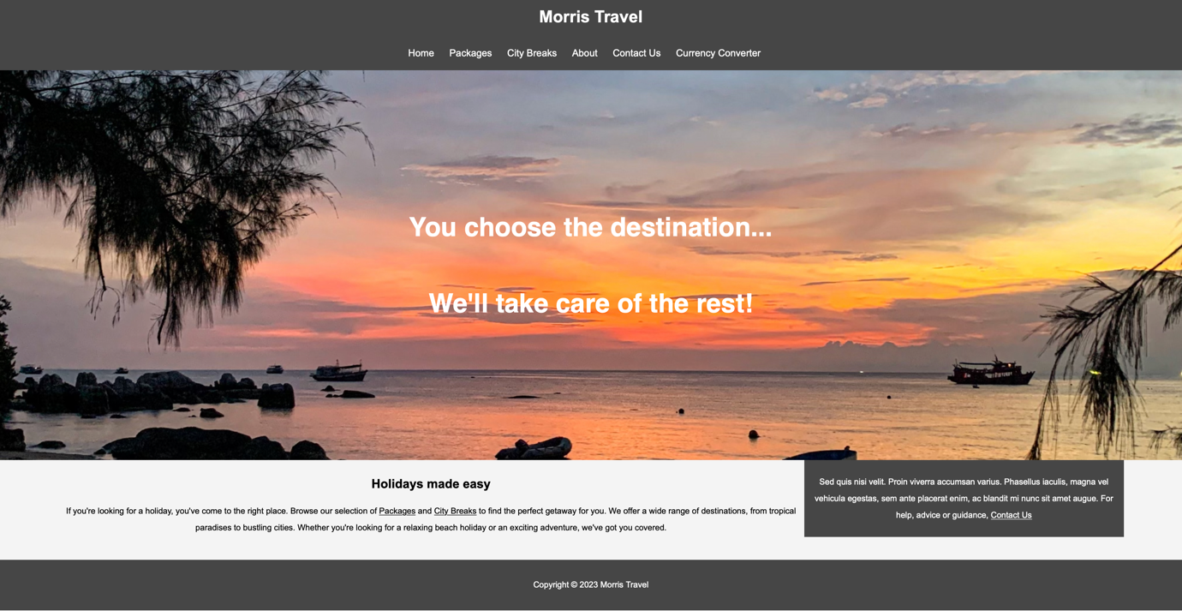

Index/Landing page – I have attempted to make the landing page eye catching by using a photo I took of a sunset in Koh Tao, Thailand. I have chosen the Montserrat font centred on the image with a catch phrase to capture the users attention. I have added a navigation bar which is constant throughout the site for ease of navigation. Below that I have added a brief description including hrefs/hyperlinks linking to important pages through the site.
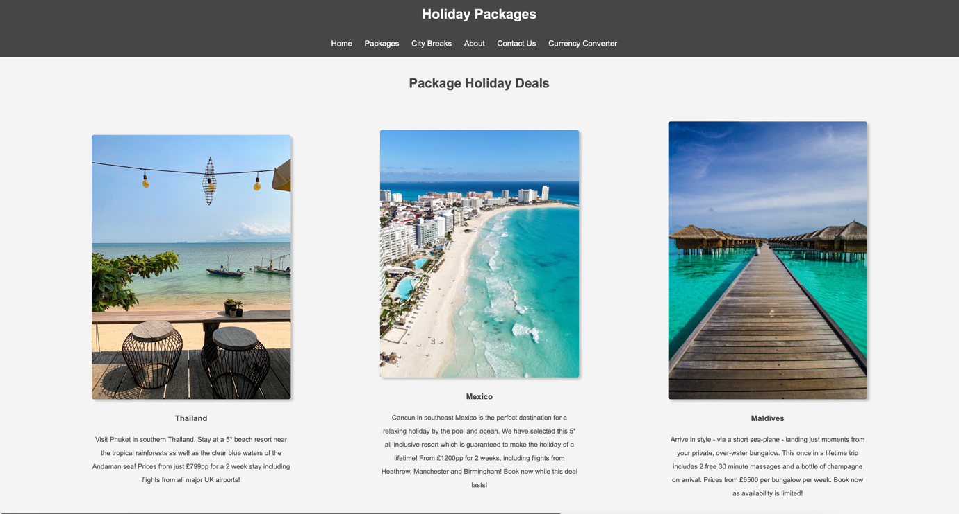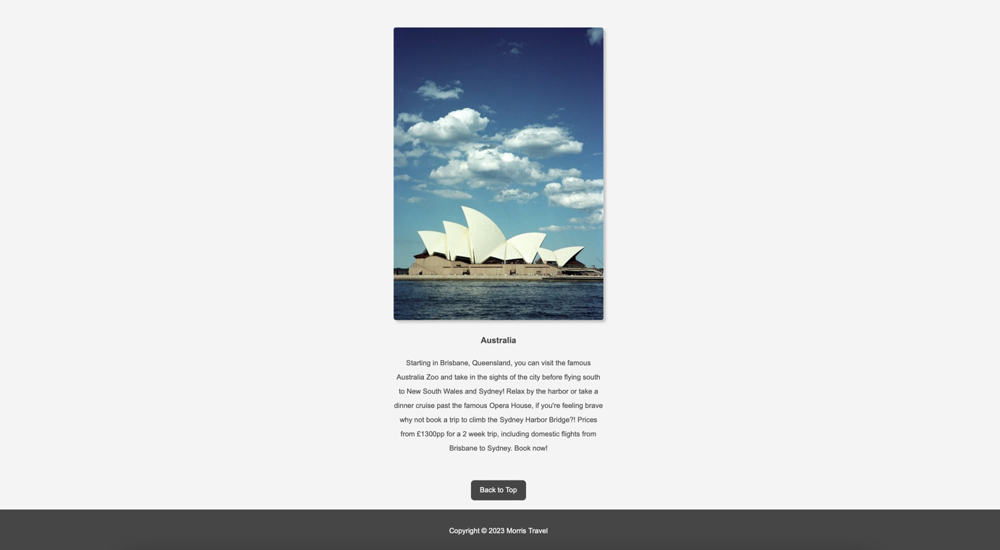The two screen shots above show the Holiday Package Deals webpage, which is accessed by the navigation bar or hyperlinks on the index page. The page features holiday destinations with a brief description and image. Both the image and the header are image are hyperlinks leading to their corresponding pages. I have added a “Back to top” button at the bottom of the page for ease of navigation, which would be especially useful upon expansion of the webpage. The image for Thailand was taken by me in Koh Samui. Mexico [1], Maldives [2], Australia [3].
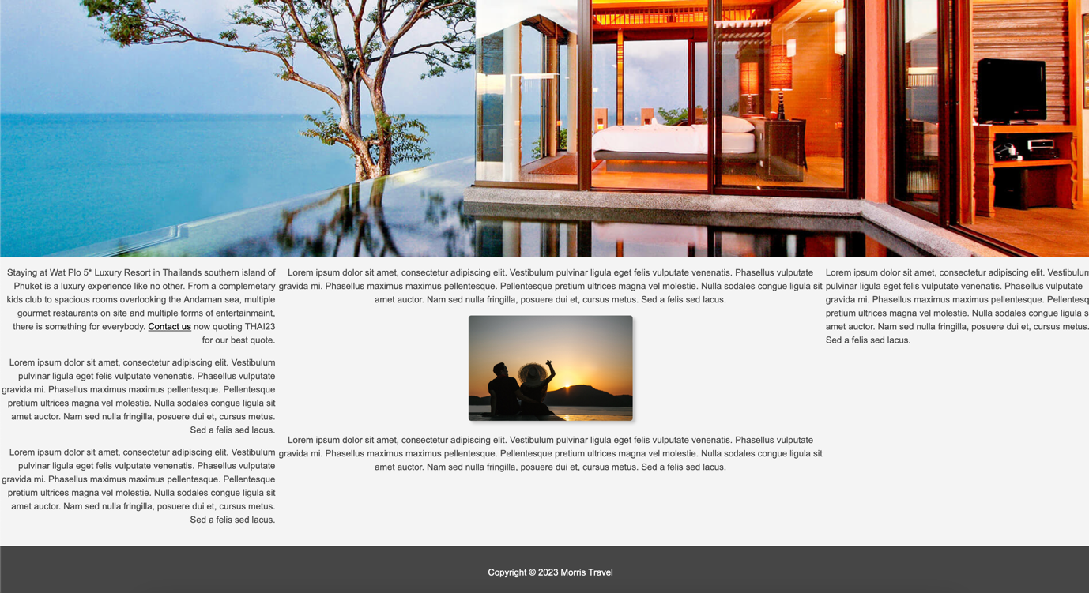

This is the webpage for the Thailand package holiday. I have selected an image to draw the user in. I have also attempted to lay the text of the webpage out in an ‘F’ shape as this has been proven to catch users attention. Both images [4].ß

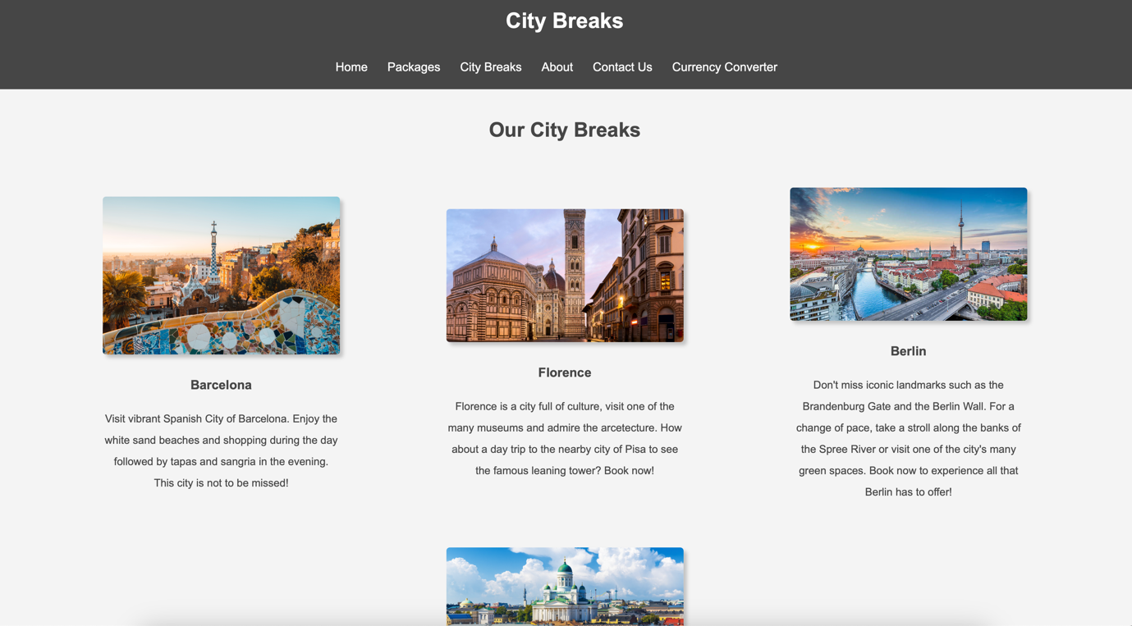

This webpage is similar to the Package Deals webpage but is to showcase the City Breaks on offer. Barcelona image [5], Florence image [6], Berlin image [7], Helsinki image [8].

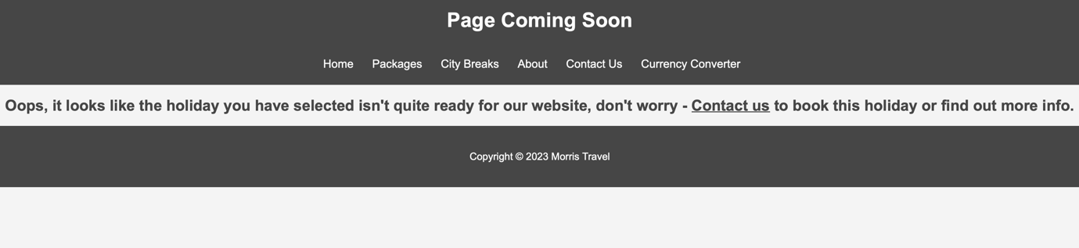

I have not completed a new webpage for each destination, if a user selects a webpage which does not yet exist, they will be presented with this webpage which offers the potential client a contact option.
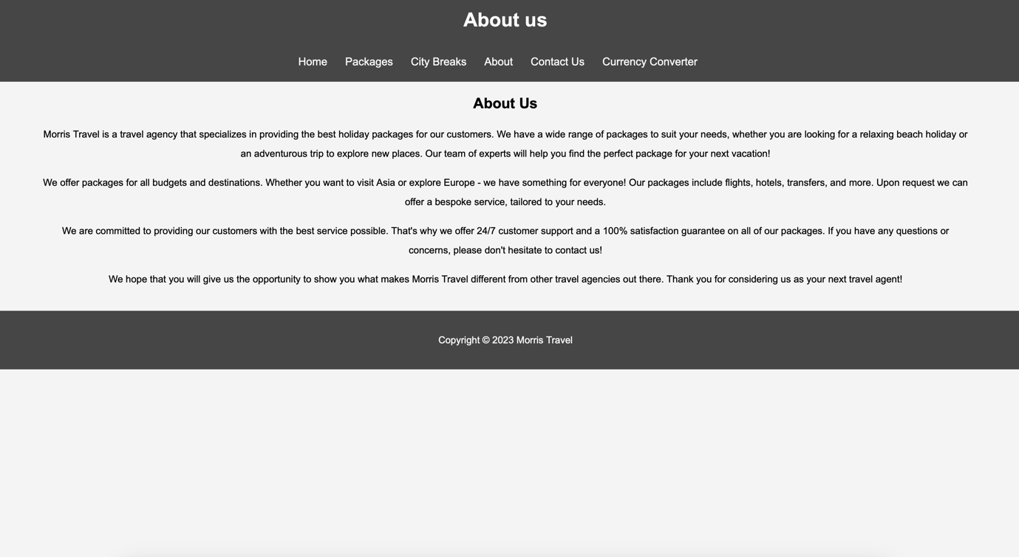

This webpage is an introduction to the company and serves to relax the customer as well as to mention some commonly searched upon SEO terms.

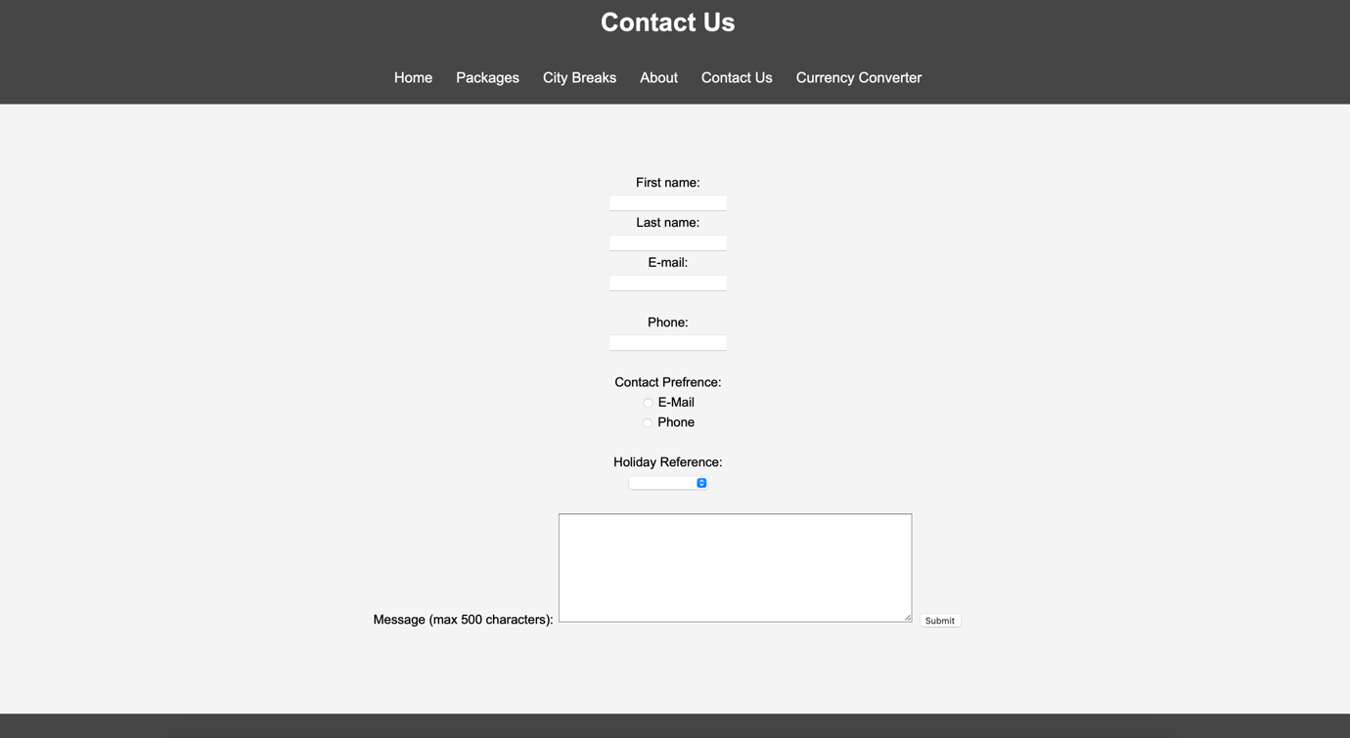
This is the contact form. I have made it so that the first and surname are required fields, the email uses HTMLs email verification which checks for the correct format of email addresses and is also required. The phone number checks for an 11 digit number (UK format), also required. The user can utilise radio buttons to select their preferred contact method. There is also holiday reference drop down which is optional. I have put a 500 character limit on the message body so the company admin staff do not get overwhelmed and allocate queries to the relevant parties.

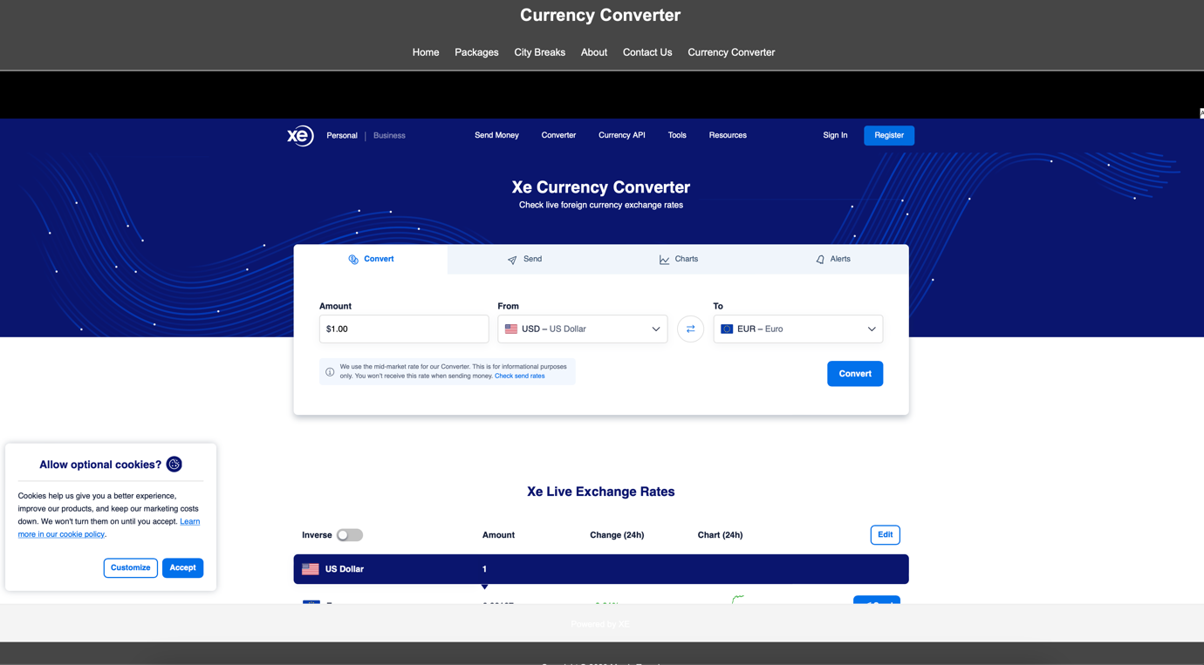

I have added this currency converter tool as it goes hand in hand with the travel aspect of my website. I have added this via iframe and I think it’s a useful addition to the website.

Validation Checks

Below are the results of the validation checks of the HTML of my website home page. I have used the validation checker found at https://validator.w3.org.

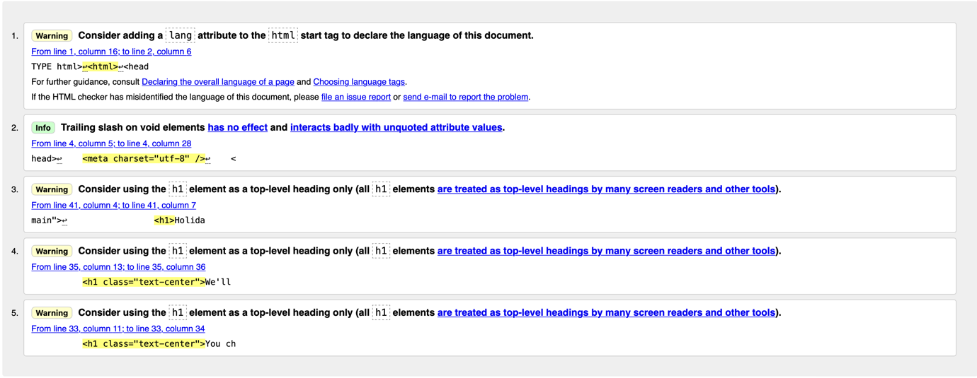

I have addressed all of the points made by the validation checker, I have added inline CSS on the (now h2) headings to increase their size to the default size of h1 headers. The new results can be seen below.
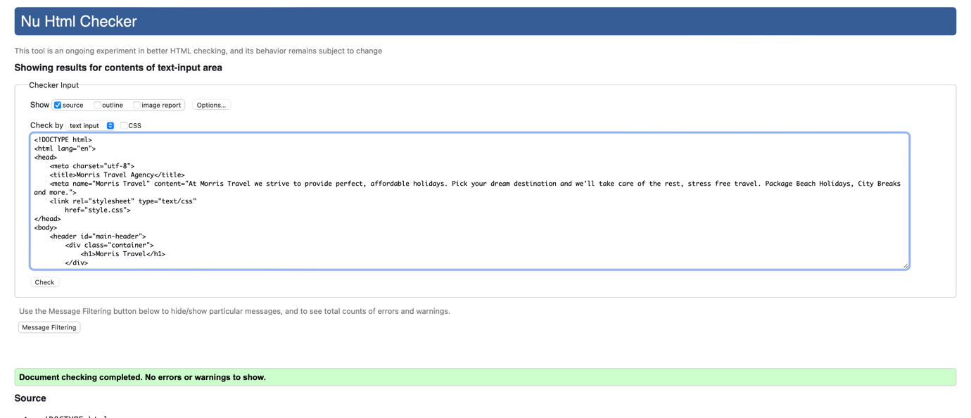

I have used the CSS validator at http://jigsaw.w3.org/css-validator/ to check my CSS for errors, the results are below.

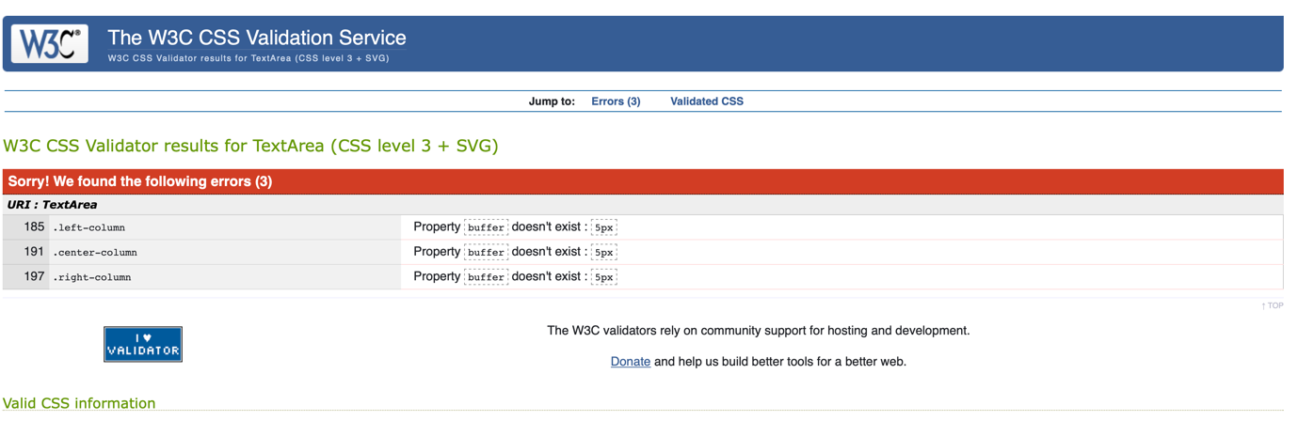

I didn’t realise that buffer was the incorrect property name until I used the validation checker, I have checked my site and it I like it how it is so have removed buffer from the 3 instances.

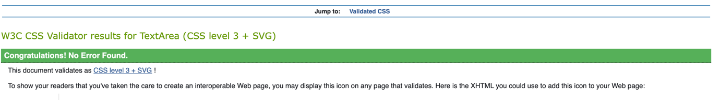

Evaluation
a)
Website Usability

Website usability ensures that a site is designed in such a way that the user can navigate and use the tools on a webpage with ease, without having any prior experience on the website without struggling to find the information they are looking for. It also ensures the information contained on the website is clear and concise.

There are 5 principles website usability can be broken down to, they are;
- Availability
- Clarity
- Recognition
- Credibility
- Relevance
[1]

Availability refers to how accessible your website is on different devices, for instance your website should be adaptable so it is usable on mobile phones, tablets as well as computer monitors.

The clarity of your website is essential to retain the user, if a user enters your webpage and can’t easily find the information they’re looking for, they may leave your website in search of a website with better clarity. Usability Geek suggest that after having a quality product, the next most important step in ensuring users return to your site is to keep your site “neat, clean, clutter free and easy to use”. [1]

Recognition refers to common website layouts found on many webpages, for example, users with even basic computer skills know to look toward the top of a webpage to find navigation tools, if your website strays from this some users might not have an easy experience navigating your webpage.

Website credibility is important to ensure the users stay on your webpage. If your website doesn’t look trustworthy, people will hesitate to use your website, this could damage sales if you are facilitating payments on your site. To ensure credibility your website should look professional and consistent throughout, and in my opinion shouldn’t have too many adds and certainly no pop-up ads.

Relevance ensures the information presented to the customer is relevant and engaging, a lot of thought must go into the wording and other content on your website.

Website Accessibility

Adhering to website accessibility is important as it ensures that everybody can use your website. Some users such as people with blindness or low vision, deafness and physical disabilities may not be able to use your site in the same way able bodied people can. It is therefore website creators responsibility to ensure that thorough accessibility features are in place throughout webpages.

Some key ways in how to make your website fully accessible include, but are not limited to:

Text alternatives – all images, video and sound clips should have a descriptive ‘alt’ description which can be utilised by text to speech software. This is an easy way to ensure your website is inclusive.

Transcripts – any video or sound clips utilised on a webpage should have full transcripts, again for speech to text software.

Contrast – people with low vision may need a webpage with high contrast to interpret the content on a webpage, some websites utilise a toggle button to toggle high contrast on and off. Alternatively, you can design your webpage using contrasting colours for this purpose.

Colour blindness – Take care not to use colours which could make it hard or impossible for users with colour blindness to read the content on the webpage. [3]

Search Engine Optimisation (SEO)

Search engine optimisation is the act of optimising a website so that it appears higher up the search results of search engines such as Google, Bing etc. Getting SEO right is key for any business/website as it is the primary way in which users find your website. Research by backlinko shows that only 0.63% of Google searchers click on a link from the second page of Google results [4], therefore it is important to make sure a sites SEO is the best it can be.

There are many SEO techniques, it isn’t an exact science and will require tweaking to ensure you are maximising your results. Some of the techniques used in SEO include:
- Keyword research
- Content Marking
- Link Building
- On-page optimisation
[5]

Keyword research involves researching which keywords your site and competitors sites are ranking for. By identifying what terms search engines associate with your site as well as keywords you think potential customers may search for gives you a starting point to create content containing these keywords.

Content Marking – this follows on from keyword research, once you know what your site ranks for and know what search terms potential users are searching, you can begin incorporating these keywords into the content on your site. For example, if you are a travel agent, you would want to include keywords and phrases in the content of your website such as, ‘affordable luxury holidays’ etc. It is important to create quality content which is more likely to be shared on social media to give your site a further boost.

Link Building – if other websites create a link to your website on their website, it is known as backlinks. Backlinks play a large role in a sites SEO ranking as it indicates to the search engine that your site contains reliable and valuable information. A good way to increase backlinks is to create content that users want to share, such as blog posts, viral videos, competitions etc.
Website developers can utilise SEO tools to help with their SEO, such as Google Search Console which is a free tool to see rankings and traffic reports as well as other useful information. [6]

b)

Evaluation of my website
Usefulness (usability and utility)

I have designed my website to be simple to navigate and not too cluttered. I would describe it as a basic website, which I think is good as everything works as it should.
The theme and navigation is constant throughout and I believe the navigation is natural and will be easily used by all potential customers.
To me the website looks good, albeit basic. If I were to create this website for real world application, I would first look to using bootstrap as I had some issues with alignment. I would secondly look to learn some JavaScript to make my website more interactive. I also have not fully finished the site, a lot of the holidays link to a ‘page unavailable’ webpage, which would need to be addressed.

SEO

I have tried to incorporate key words and phrases throughout my site which I think would be searched upon by potential customers to assist with SEO. 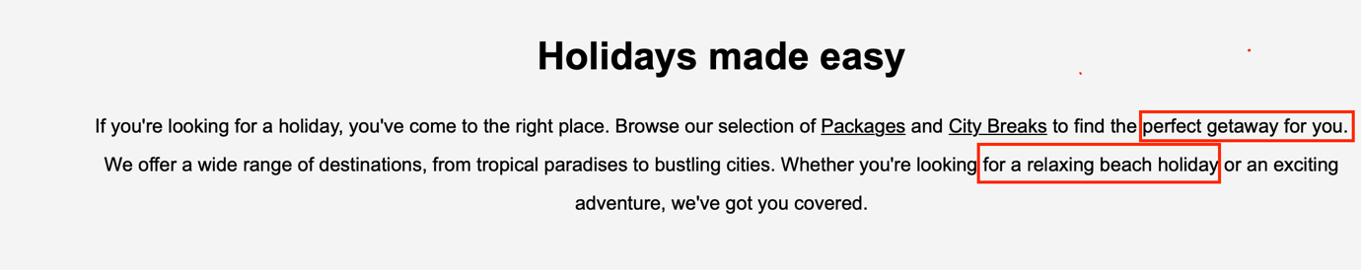

I have also added alt tags to all the images used on the website which will also improve SEO as I have tagged them with what I believe are commonly searched phrases.
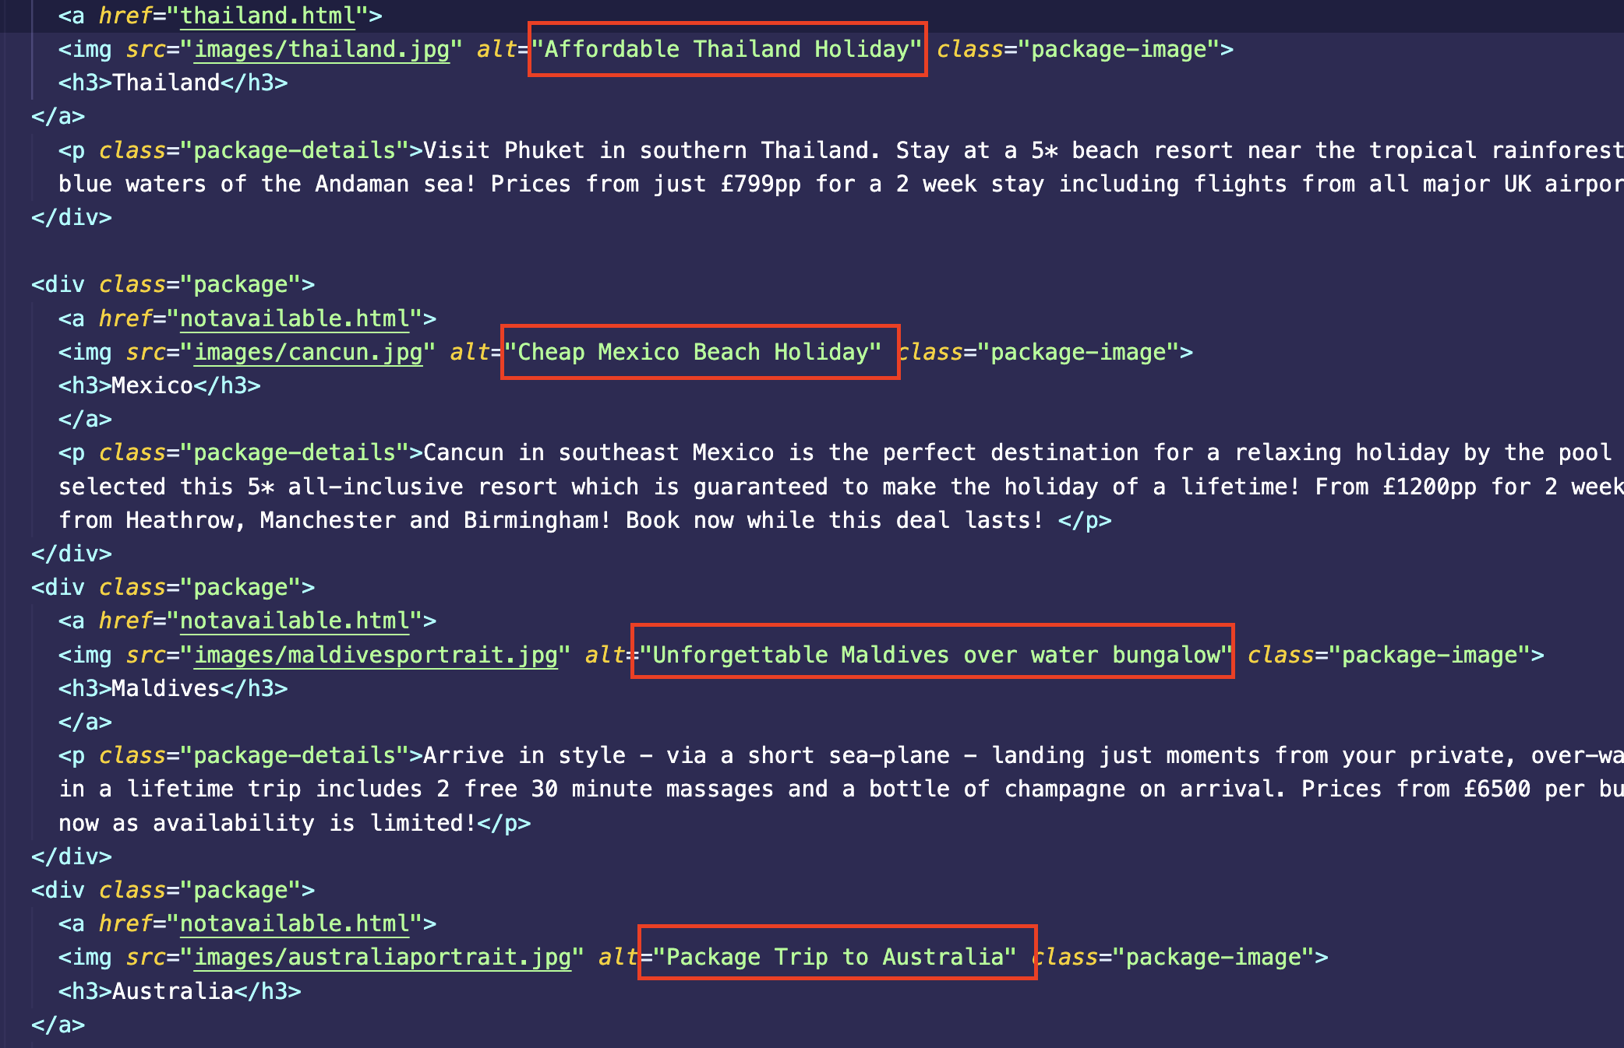

I have also utilised meta tags which although don’t directly contribute to SEO improvement, they appear on search results so will increase click rates.

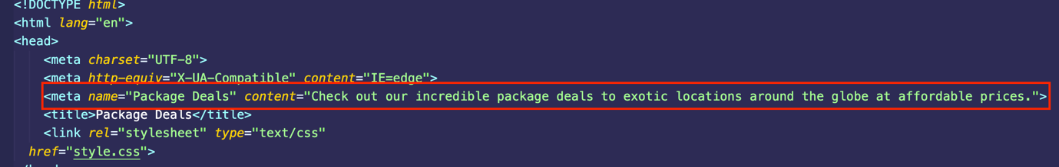

Accessibility

Perceivable

I have utilised https://contrastchecker.com to ensure the contrast and text sizes are perceivable inline with WCAG 2.1. The results show that text size and contrast are acceptable on my site.
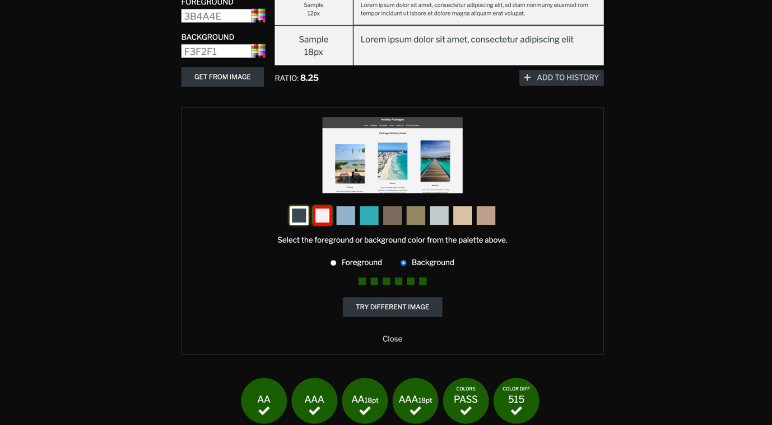

Operable

As previously stated my website is simple in design with not many buttons, a user could in theory use only a keyboard using the tab and enter keys to navigate my website.

Understandable

I have tried to ensure my website uses clear and concise language so that it is understandable by all target users.

Robust

I have used alt tags wherever possible to assist with text to speech software. Other than photos, all of the information on my site is text based so it will be easily converted to text to speech.

Works Cited

[1] | Mexico, "Cancun," [Online]. Available: https://www.mexicancaribbean.travel/cancun/. [Accessed 20 04 2023].
[2] | CNBC, "Maldives," CNBC, [Online]. Available: https://www.cnbc.com/2020/07/16/is-it-safe-to-visit-the-maldives-heres-what-hotels-are-doing.html. [Accessed 22 04 2023].
[3] | Sean, "Sydney Opera House, Australia," sean.co.uk, [Online]. Available: https://www.sean.co.uk/photography/travelphotography/sydney.shtm. [Accessed 25 04 2023].
[4] | Sri Panwa, "Booking.com," Booking.com, [Online]. Available: https://www.booking.com/hotel/th/sri-panwa-phuket.en-gb.html?aid=304142&label=gen173nr-1BCAEoggI46AdIM1gEaFCIAQGYAQm4AQfIAQ3YAQHoAQGIAgGoAgO4Aru4zqIGwAIB0gIkM2JmYjVlODAtN2JiMS00OGEyLTk4ZTYtMTg1OWRlYjg2MTU32AIF4AIB&sid=17b9a8edb30e35a60b34e31fbd11dd6f&all_. [Accessed 26 04 2023].
[5] | CN Traveller, "Barcelona," [Online]. Available: https://media.cntraveller.com/photos/62d14e029bbb08746e6fd952/3:2/w_6000,h_4000,c_limit/barcelonaGettyImages-1386922276.jpeg. [Accessed 22 04 2023].
[6] | CN Traveller, "Florence," CN Traveller, [Online]. Available: https://media.cntraveler.com/photos/5e7503f4a32d290008f50909/16:9/w_2580,c_limit/GiottosBellTower-GettyImages-1173218936.jpg. [Accessed 02 05 2023].
[7] | Timeout, "Berlin," Timeout, [Online]. Available: https://media.timeout.com/images/105303515/750/422/image.jpg. [Accessed 20 04 2023].
[8] | Architectural Digest, "Helsinki," Architectural Digest, [Online]. Available: https://media.architecturaldigest.com/photos/5c9e699c1aeb991ed9e6da2b/16:9/w_2560%2Cc_limit/GettyImages-183996236.jpg. [Accessed 01 05 2023].
[9] | 99designs Team, "The principles of website usability," 99designs, 01 01 2021. [Online]. Available: https://99designs.com/blog/web-digital/website-usability-principles/#2. [Accessed 05 05 2023].
[10] | T. Vides, "Reimaging Your Website As A Tool For Customer Retention," Usability Geek, [Online]. Available: https://usabilitygeek.com/reimagining-website-tool-customer-retention/. [Accessed 10 05 2023].
[11] | HubSpot, "Web Accessibility: The Ultimate Guide," HubSpot, 21 02 2023. [Online]. Available: https://blog.hubspot.com/website/web-accessibility. [Accessed 06 05 2023].
[12] | B. Dean, "We Analyzed 4 Million Google Search Results," BackLinko, 14 10 2022. [Online]. Available: https://backlinko.com/google-ctr-stats. [Accessed 29 04 2023].
[13] | Optimizely, "Search engine optimization," Optimizely, [Online]. Available: https://www.optimizely.com/optimization-glossary/search-engine-optimization/. [Accessed 01 05 2023].
[14] | A. Frost, "The Ultimate Guide to Google Search Console in 2023," HubSpot, 25 02 2021. [Online]. Available: https://blog.hubspot.com/marketing/google-search-console. [Accessed 20 04 2023].

Appendices

HTML:
Index.html:
<!DOCTYPE html>
<html lang="en">
<head>
<meta charset="utf-8">
<title>Morris Travel Agency</title>
<meta name="Morris Travel" content="At Morris Travel we strive to provide perfect, affordable holidays. Pick your dream destination and we'll take care of the rest, stress free travel. Package Beach Holidays, City Breaks and more.">
<link rel="stylesheet" type="text/css"
href="style.css">
</head>
<body>
<header id="main-header">
<div class="container">
<h1>Morris Travel</h1>
</div>
</header>

<nav id="navbar">
<div class="container">
<ul>
<li><a href="index.html">Home</a></li>
<li><a href="packages.html">Packages</a></li>
<li><a href="citybreaks.html">City Breaks</a></li>
<li><a href="about.html">About</a></li>
<li><a href="contact.html">Contact Us</a></li>
<li><a href="currency.html">Currency Converter</a></li>
</ul>
</div>
</nav>

<section id="showcase">
<div class="container">
<h2 class="text-center" style="font-size:2em">You choose the destination...</h2>
<br>
<h2 class="text-center" style="font-size:2em">We'll take care of the rest!</h2>
</div>
</section>

<div class="container">
<section id="main">

<h2 style="font-size:2em">Holidays made easy</h2>
<p> If you're looking for a holiday, you've come to the right place. Browse our selection of <a href="packages.html">Packages</a> and <a href="citybreaks.html">City Breaks</a> to find the perfect getaway for you. We offer a wide range of destinations, from tropical paradises to bustling cities. Whether you're looking for a relaxing beach holiday or an exciting adventure, we've got you covered. </p>
</section>
<aside id="sidebar">
<p>Sed quis nisi velit. Proin viverra accumsan varius. Phasellus iaculis, magna vel vehicula egestas, sem ante placerat enim, ac blandit mi nunc sit amet augue. For help, advice or guidance, <a href="contact.html">Contact Us</a></p>
</aside>
</div>

<footer id="main-footer">
<p> Copyright &copy; 2023 Morris Travel</p>
</footer>
</body>
</html>

Packages.html:
<!DOCTYPE html>
<html lang="en">
<head>
<meta charset="UTF-8">
<meta http-equiv="X-UA-Compatible" content="IE=edge">
<meta name="Package Deals" content="Check out our incredible package deals to exotic locations around the globe at affordable prices.">
<title>Package Deals</title>
<link rel="stylesheet" type="text/css"
href="style.css">
</head>
<header id="main-header">
<div class="container">
<h1>Holiday Packages</h1>
</div>
</header>
<nav id="navbar">
<div class="container">
<ul>
<li><a href="index.html">Home</a></li>
<li><a href="packages.html">Packages</a></li>
<li><a href="citybreaks.html">City Breaks</a></li>
<li><a href="about.html">About</a></li>
<li><a href="contact.html">Contact Us</a></li>
<li><a href="currency.html">Currency Converter</a></li>
</ul>
</div>
</nav>

<body>
<section id="packages">
<div class="container">
<h2 class="text-center">Package Holiday Deals</h2>
<div class="package-container">
<div class="package">
<a href="thailand.html">
<img src="images/thailand.jpg" alt="Affordable Thailand Holiday" class="package-image">
<h3>Thailand</h3>
</a>
<p class="package-details">Visit Phuket in southern Thailand. Stay at a 5* beach resort near the tropical rainforests as well as the clear blue waters of the Andaman sea! Prices from just £799pp for a 2 week stay including flights from all major UK airports! </p>
</div>

<div class="package">
<a href="notavailable.html">
<img src="images/cancun.jpg" alt="Cheap Mexico Beach Holiday" class="package-image">
<h3>Mexico</h3>
</a>
<p class="package-details">Cancun in southeast Mexico is the perfect destination for a relaxing holiday by the pool and ocean. We have selected this 5* all-inclusive resort which is guaranteed to make the holiday of a lifetime! From £1200pp for 2 weeks, including flights from Heathrow, Manchester and Birmingham! Book now while this deal lasts! </p>
</div>
<div class="package">
<a href="notavailable.html">
<img src="images/maldivesportrait.jpg" alt="Unforgettable Maldives over water bungalow" class="package-image">
<h3>Maldives</h3>
</a>
<p class="package-details">Arrive in style - via a short sea-plane - landing just moments from your private, over-water bungalow. This once in a lifetime trip includes 2 free 30 minute massages and a bottle of champagne on arrival. Prices from £6500 per bungalow per week. Book now as availability is limited!</p>
</div>
<div class="package">
<a href="notavailable.html">
<img src="images/australiaportrait.jpg" alt="Package Trip to Australia" class="package-image">
<h3>Australia</h3>
</a>
<p class="package-details">Starting in Brisbane, Queensland, you can visit the famous Australia Zoo and take in the sights of the city before flying south to New South Wales and Sydney! Relax by the harbor or take a dinner cruise past the famous Opera House, if you're feeling brave why not book a trip to climb the Sydney Harbor Bridge?! Prices from £1300pp for a 2 week trip, including domestic flights from Brisbane to Sydney. Book now!</p>
</div>
</div>
</div>
</section>

<div class="button">
<a href="#" title="Back to Top">Back to Top</a>
</div>
</body>
<footer id="main-footer">
<p> Copyright &copy; 2023 Morris Travel</p>
</footer>
</html>

Thailand.html
<!DOCTYPE html>
<html lang="en">
<head>
<meta charset="UTF-8">
<meta http-equiv="X-UA-Compatible" content="IE=edge">
<meta name="Thailand" content="Visit amazing Thailand, the land of smiles. Best hotel in Phuket at an even better price.">
<title>Thailand</title>
<link rel="stylesheet" type="text/css"
href="style.css">
</head>
<header id="main-header">
<div class="container">
<h1>Thailand - Phuket</h1>
</div>
</header>
</header>
<nav id="navbar">
<div class="container">
<ul>
<li><a href="index.html">Home</a></li>
<li><a href="packages.html">Packages</a></li>
<li><a href="citybreaks.html">City Breaks</a></li>
<li><a href="about.html">About</a></li>
<li><a href="contact.html">Contact Us</a></li>
<li><a href="currency.html">Currency Converter</a></li>
</ul>
</div>
</nav>

<section id="thailandshowcase">
</section>
<body>
<div class="containerf">
<div class="left-column">
<p> Staying at Wat Plo 5* Luxury Resort in Thailands southern island of Phuket is a luxury experience like no other. From a complemetary kids club to spacious rooms overlooking the Andaman sea, multiple gourmet restaurants on site and multiple forms of entertainmaint, there is something for everybody. <a href="contact.html">Contact us</a> now quoting THAI23 for our best quote.</p>
<p>Lorem ipsum dolor sit amet, consectetur adipiscing elit. Vestibulum pulvinar ligula eget felis vulputate venenatis. Phasellus vulputate gravida mi. Phasellus maximus maximus pellentesque. Pellentesque pretium ultrices magna vel molestie. Nulla sodales congue ligula sit amet auctor. Nam sed nulla fringilla, posuere dui et, cursus metus. Sed a felis sed lacus.</p>
<p>Lorem ipsum dolor sit amet, consectetur adipiscing elit. Vestibulum pulvinar ligula eget felis vulputate venenatis. Phasellus vulputate gravida mi. Phasellus maximus maximus pellentesque. Pellentesque pretium ultrices magna vel molestie. Nulla sodales congue ligula sit amet auctor. Nam sed nulla fringilla, posuere dui et, cursus metus. Sed a felis sed lacus.</p>
</div>
<div class="center-column">
<p>Lorem ipsum dolor sit amet, consectetur adipiscing elit. Vestibulum pulvinar ligula eget felis vulputate venenatis. Phasellus vulputate gravida mi. Phasellus maximus maximus pellentesque. Pellentesque pretium ultrices magna vel molestie. Nulla sodales congue ligula sit amet auctor. Nam sed nulla fringilla, posuere dui et, cursus metus. Sed a felis sed lacus.</p>
<p>
<img src="images/sunsetwat.jpg" alt="Thailand 5* Hotel Phuket" width="300" height="auto">
</p>
<p>Lorem ipsum dolor sit amet, consectetur adipiscing elit. Vestibulum pulvinar ligula eget felis vulputate venenatis. Phasellus vulputate gravida mi. Phasellus maximus maximus pellentesque. Pellentesque pretium ultrices magna vel molestie. Nulla sodales congue ligula sit amet auctor. Nam sed nulla fringilla, posuere dui et, cursus metus. Sed a felis sed lacus.</p>

</div>
<div class="right-column">
<p>Lorem ipsum dolor sit amet, consectetur adipiscing elit. Vestibulum pulvinar ligula eget felis vulputate venenatis. Phasellus vulputate gravida mi. Phasellus maximus maximus pellentesque. Pellentesque pretium ultrices magna vel molestie. Nulla sodales congue ligula sit amet auctor. Nam sed nulla fringilla, posuere dui et, cursus metus. Sed a felis sed lacus.</p>

</div>
</div>
</body>

<footer id="main-footer">
<p> Copyright &copy; 2023 Morris Travel</p>
</footer>
</html>
Citybreaks.html
<!DOCTYPE html>
<html lang="en">
<head>
<meta charset="UTF-8">
<meta http-equiv="X-UA-Compatible" content="IE=edge">
<meta name="City Breaks" content="Find your exclusive City Breaks in Europe and beyond.">
<title>City Breaks</title>
<link rel="stylesheet" type="text/css"
href="style.css">
</head>
<header id="main-header">
<div class="container">
<h1>City Breaks</h1>
</div>
</header>
</header>
<nav id="navbar">
<div class="container">
<ul>
<li><a href="index.html">Home</a></li>
<li><a href="packages.html">Packages</a></li>
<li><a href="citybreaks.html">City Breaks</a></li>
<li><a href="about.html">About</a></li>
<li><a href="contact.html">Contact Us</a></li>
<li><a href="currency.html">Currency Converter</a></li>
</ul>
</div>
</nav>

<body>
<section id="packages">
<div class="container">
<h2 class="text-center">Our City Breaks</h2>
<div class="package-container">
<div class="package">
<a href="notavailable.html">
<img src="images/barcelona.jpg" alt="Barcelona city break" class="package-image">
<h3>Barcelona</h3>
</a>
<p class="package-details">Visit vibrant Spanish City of Barcelona. Enjoy the white sand beaches and shopping during the day followed by tapas and sangria in the evening. This city is not to be missed!</p>
</div>
<div class="package">
<a href="notavailable.html">
<img src="images/florence.jpg" alt="Florence Romantic getaway" class="package-image">
<h3>Florence</h3>
</a>
<p class="package-details">Florence is a city full of culture, visit one of the many museums and admire the arcetecture. How about a day trip to the nearby city of Pisa to see the famous leaning tower? Book now!</p>
</div>
<div class="package">
<a href="notavailable.html">
<img src="images/berlin.jpg" alt="Visit Berlin" class="package-image">
<h3>Berlin</h3>
</a>
<p class="package-details"> Don't miss iconic landmarks such as the Brandenburg Gate and the Berlin Wall. For a change of pace, take a stroll along the banks of the Spree River or visit one of the city's many green spaces. Book now to experience all that Berlin has to offer!</p>
</div>
<div class="package">
<a href="notavailable.html">
<img src="images/helsinki.jpg" alt="Helsinki getaway" class="package-image">
<h3>Helsinki</h3>
</a>
<p class="package-details">Helsinki is a vibrant city that offers a unique blend of modern and traditional culture. Stroll through the charming streets of the city center and discover the beautiful architecture, trendy cafes, and bustling markets. </p>
</div>
</div>
</div>
</section>

</body>
<footer id="main-footer">
<p> Copyright &copy; 2023 Morris Travel</p>
</footer>
</html>

Notavailable.html

<!DOCTYPE html>
<html lang="en">
<head>
<meta charset="UTF-8">
<meta http-equiv="X-UA-Compatible" content="IE=edge">
<meta name="Webpage Unavailable" content="This webpage is under construction, please see our package deals and city breaks for amazing holidays available now.">
<title>Webpage unavailable</title>
<link rel="stylesheet" type="text/css"
href="style.css">
</head>
<header id="main-header">
<div class="container">
<h1>Page Coming Soon</h1>
</div>
</header>
</header>
<nav id="navbar">
<div class="container">
<ul>
<li><a href="index.html">Home</a></li>
<li><a href="packages.html">Packages</a></li>
<li><a href="citybreaks.html">City Breaks</a></li>
<li><a href="about.html">About</a></li>
<li><a href="contact.html">Contact Us</a></li>
<li><a href="currency.html">Currency Converter</a></li>
</ul>
</div>
</nav>

<body id="message">
<div class="unavailable">
<h2>Oops, it looks like the holiday you have selected isn't quite ready for our website, don't worry - <a href="contact.html">Contact us</a> to book this holiday or find out more info.</h2>
</div>
</body>
<footer id="main-footer">
<p> Copyright &copy; 2023 Morris Travel</p>
</footer>
</html>

About.html

<!DOCTYPE html>
<html lang="en">
<head>
<meta charset="UTF-8">
<meta http-equiv="X-UA-Compatible" content="IE=edge">
<meta name="about" content="About our company, Morris Travel. Best affordable holidays.">
<title>Package Deals</title>
<link rel="stylesheet" type="text/css"
href="style.css">
</head>
<header id="main-header">
<div class="container">
<h1>About us</h1>
</div>
</header>
</header>
<nav id="navbar">
<div class="container">
<ul>
<li><a href="index.html">Home</a></li>
<li><a href="packages.html">Packages</a></li>
<li><a href="citybreaks.html">City Breaks</a></li>
<li><a href="about.html">About</a></li>
<li><a href="contact.html">Contact Us</a></li>
<li><a href="currency.html">Currency Converter</a></li>
</ul>
</div>
</nav>

<body>
<section id="about">
<div class="container">
<h2 class="text-center">About Us</h2>
<p class="text-center">Morris Travel is a travel agency that specializes in providing the best holiday packages for our customers. We have a wide range of packages to suit your needs, whether you are looking for a relaxing beach holiday or an adventurous trip to explore new places. Our team of experts will help you find the perfect package for your next vacation!</p>
<p class="text-center">We offer packages for all budgets and destinations. Whether you want to visit Asia or explore Europe - we have something for everyone! Our packages include flights, hotels, transfers, and more. Upon request we can offer a bespoke service, tailored to your needs.</p>
<p class="text-center">We are committed to providing our customers with the best service possible. That's why we offer 24/7 customer support and a 100% satisfaction guarantee on all of our packages. If you have any questions or concerns, please don't hesitate to contact us!</p>
<p class="text-center">We hope that you will give us the opportunity to show you what makes Morris Travel different from other travel agencies out there. Thank you for considering us as your next travel agent!</p>
</div>

</section>
</body>
<footer id="main-footer">
<p> Copyright &copy; 2023 Morris Travel</p>
</footer>
</html>

Contact.html

<!DOCTYPE html>
<html lang="en">
<head>
<meta charset="UTF-8">
<meta http-equiv="X-UA-Compatible" content="IE=edge">
<meta name="Contact" content="Contact us now to arrange affordable holidays to exotic locations.">
<title>Contact Us</title>
<link rel="stylesheet" type="text/css"
href="style.css">
</head>
<header id="main-header">
<div class="container">
<h1>Contact Us</h1>
</div>
</header>
</header>
<nav id="navbar">
<div class="container">
<ul>
<li><a href="index.html">Home</a></li>
<li><a href="packages.html">Packages</a></li>
<li><a href="citybreaks.html">City Breaks</a></li>
<li><a href="about.html">About</a></li>
<li><a href="contact.html">Contact Us</a></li>
<li><a href="currency.html">Currency Converter</a></li>
</ul>
</div>
</nav>

<body>
<section id="contactform">
<form action="">
<label for="fname">First name:</label><br>
<input type="text" id="fname" name="fname" value=""><br>
<label for="lname">Last name:</label><br>
<input type="text" id="lname" name="lname" required><br>

<label for="email">E-mail:</label><br>
<input type="email" id="email" name="email" required><br><br>
<label for="phone">Phone:</label><br>
<input type="tel" id="phone" name="phone" pattern="[0-9]{11}" required><br><br>

<label for="email">Contact Prefrence:</label><br>
<input type="radio" id="email" name="contact_pref" value="E-mail">
<label for="email">E-Mail</label><br>
<input type="radio" id="phone" name="contact_pref" value="Phone">
<label for="phone">Phone</label><br>
<br>
<label for="reference">Holiday Reference:</label><br>
<select id="reference" name="reference">
<option value="blank"></option>
<option value="Thailand">THAI23</option>
<option value="Maldives">MALDIVES23</option>
<option value="Mexico">MEXICO24</option>
<option value="Australia">AUS23</option>
<option value="other">Other</option>
</select><br><br>
<label for="message">Message (max 500 characters):</label>
<textarea id="message" name="message" rows="10" cols="60" maxlength="500"></textarea>
<input type="submit" value="Submit">
</form>

</section>

</body>
<footer id="main-footer">
<p> Copyright &copy; 2023 Morris Travel</p>
</footer>
</html>

Currency.html

<!DOCTYPE html>
<html lang="en">
<head>
<meta charset="UTF-8">
<meta http-equiv="X-UA-Compatible" content="IE=edge">
<meta name="Currency" content="Check the current market rates on currency for your trip.">
<title>Currency Converter</title>
<link rel="stylesheet" type="text/css"
href="style.css">
</head>
<header id="main-header">
<div class="container">
<h1>Currency Converter</h1>
</div>
</header>
</header>
<nav id="navbar">
<div class="container">
<ul>
<li><a href="index.html">Home</a></li>
<li><a href="packages.html">Packages</a></li>
<li><a href="citybreaks.html">City Breaks</a></li>
<li><a href="about.html">About</a></li>
<li><a href="contact.html">Contact Us</a></li>
<li><a href="currency.html">Currency Converter</a></li>
</ul>
</div>
</nav>
<body>

<iframe src="https://www.xe.com/currencyconverter/"></iframe>

<p>Powered by <a href="https://www.xe.com/" target="_blank">XE</a></p>
</body>
<footer id="main-footer">
<p> Copyright &copy; 2023 Morris Travel</p>
</footer>
</html>

Style.css

body{
background-color:#f4f4f4;
color:#ffffff;
font-family: 'Montserrat', Arial, Helvetica, san-serif;
font-size:16px;
line-height:1.6em;
margin:0;
text-align:center;
}

#main a{
color:rgb(0, 0, 0);
text-decoration: underline;
}

.container{
width:90%;
margin:auto;
overflow:hidden;
line-height: 2em;
}

#main-header{
background-color:rgb(70, 70, 70);
color:#fff;
}

#navbar{
background-color:rgb(70, 70, 70);
color:#fff;
}

#navbar ul{
padding:0;
list-style:none;
}

#navbar li{
display:inline;
}

#navbar a{
font-size:18px;
padding-right:25px;
}

a:hover{
color:rgb(0, 179, 223);
}

a{
color:white;
text-decoration: none;
}

#showcase {
background-image: url('images/sunset.jpg');
background-size: cover;
background-position: center center;
height: 750px;
display: flex;
justify-content: center;
align-items: center;

}

#showcase h1 {
color: #fff;
font-family: 'Montserrat', sans-serif;
font-size: 50px;
text-align: center;
}

#main-footer {
background-color:rgb(70, 70, 70);
color:#fff;
text-align: center;
padding: 20px;
margin-top: 20px;
}

#main{
float:left;
width:70%;
padding:10px;
box-sizing: border-box;
color: black;
}

#sidebar{
float:right;
width:30%;
background:rgb(70, 70, 70);
color:#fff;
padding:10px;
box-sizing: border-box;
}

#sidebar a{
text-decoration: underline;
}

#packages h2{
color:rgb(70, 70, 70);
font-size: 30px;
text-align: center;
padding: 20px;
}

#packages img{
width: 100%;
height: auto;
border-radius: 5px;
box-shadow: 5px 5px 5px rgba(0, 0, 0, 0.2);
}

.package-container {
display: flex;
flex-direction: row;
flex-wrap: wrap;
justify-content: space-around;
align-items: center;
}

.package {
width: 23%;
margin: 1%;
padding: 10px;
color:rgb(70, 70, 70);
}

#about p{
color: black;
}

#about h2{
color: black ;
}

#contactform{
color: black;
}

form {
padding-top:5%;
padding-bottom:5%;
padding-left: 25%;
padding-right: 25%;
}

.button{
display: inline-block;
background-color:rgb(70, 70, 70);
color: white;
padding: 10px 20px;
border-radius: 8px;
border: none;
cursor: pointer;
margin-top: 10px;
}

h3{
color:rgb(70, 70, 70);
}

#thailandshowcase {
background-image: url('images/thailandimage.jpg');
background-size: cover;
background-position: center center;
height: 750px;
display: flex;
justify-content: center;
align-items: center;
}

.containerf {
display: flex;
color: rgb(70, 70, 70);
}

.left-column {
flex: 1;
text-align: right;
}

.center-column {
flex: 2;
text-align: center;
}

.right-column {
flex: 1;
text-align: left;
}

.containerf img{
border-radius: 5px;
box-shadow: 5px 5px 5px rgba(0, 0, 0, 0.2);
}

.left-column a{
color: black;
text-decoration: underline;
}

iframe {
height: 1000px;
width: 100%;
}

.unavailable h2{
color:rgb(70, 70, 70);
}

.unavailable a{
color:rgb(70, 70, 70);
text-decoration: underline;
}

