A Zero Trust Security Framework for Vigilant Trust & Asset Management

Student Name: Christian Prida
Student Number: 2425771
Module: Networks and Cyber Security Essentials
Date: December 18, 2025.
Abstract
Cyber security threats targeting financial services organizations continue to increase in scale, sophistication, and impact. Financial intuitions remain high- value targets due to the sensitivity of financial data, strict regulatory obligations, and a heavy reliance on digital infrastructure. This report presents a comprehensive Zero Trust-based security framework for Vigilant Trust & Asset Management (VTAM), a medium sized financial services organization operating in a highly regulated environment. VTAM has recently experienced a sophisticated phishing campaign that bypassed traditional email security controls and an attempted ransomware infection, highlighting the limitations of perimeter-based security models. Grounded in internationally recognized standards such as the NIST Cybersecurity Framework (CSF), ISO/IEC 27001, and guidance from the Cybersecurity and infrastructure Security Agency (CISA), this report identifies modern internal and external cyber threats develops aligned security policies, proposes feasible technical and administrative mitigation measures, and outlines a proactive monitoring, incident response, and continuous security awareness programmed. The objective of the proposed framework is to enhance organizational resilience, reduce cyber risk exposure, ad support secure, compliant, and sustainable business.

Introduction
The financial services sector is one of the most frequently targeted industries for cybercrime due to the monetary value of financial assets, the availability of sensitive personal and transactional data, and the potential for regulatory penalties and reputational damage following security incidents. In recent years, the rapid adoption of cloud computing, Software-as-a-Service (SaaS) platforms, and hybrid working models has significantly expanded organizational attack surfaces. As a result, traditional security architectures that rely heavily on network perimeter defenses are increasingly ineffective against modern cyber threats that exploit compromised credentials, trusted third parties, and human behavior.
Vigilant Trust & Asset Management (VTAM), a medium-sized financial services organization, has recently experienced a sophisticated phishing campaign that bypassed existing email filtering technologies, as well as an attempted ransomware infection. These incidents demonstrate critical weaknesses in traditional security controls and highlight the need for a strategic shift towards a modern, identity-centric security architecture. In response, the board of directors has mandated the development of a comprehensive security framework based on the Zero Trust security model. tThis report synthesizes credible academic, governmental, and industry research to design a practical, scalable, and standards-aligned security solution tailored to VTAM’s operational, regulatory, and risk context.
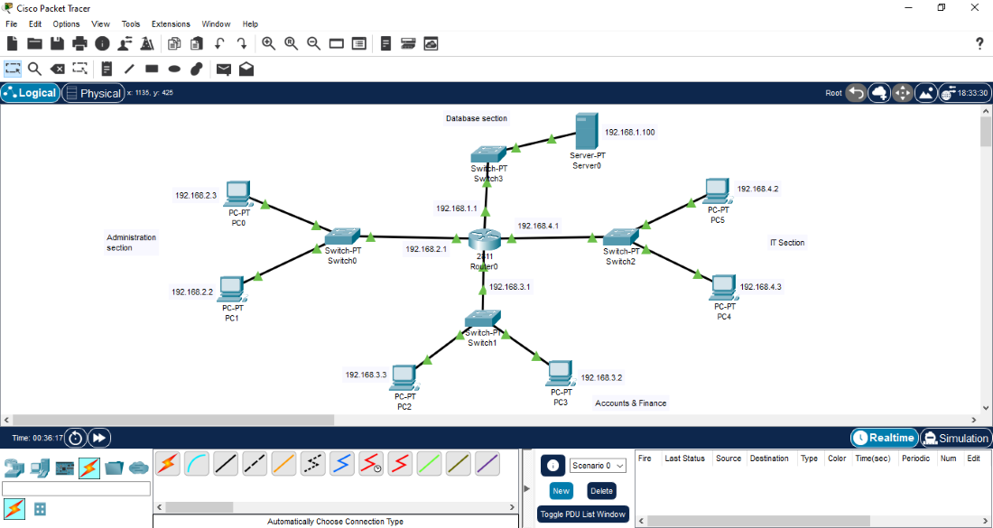

Identification of Modern Threats
VTAM f aces a wide range of contemporary cyber threats originating from both external and internal sources. One of the most significant external threats is Ransomware-as-a-Service (RaaS), which enables cybercriminal groups to deploy ransomware campaigns without requiring advanced technical expertise. RaaS operators provide malware, infrastructure, and payment mechanisms in exchange for a share of ransom payments. These attacks commonly begin with phishing emails, exploitation of unpatched vulnerabilities, or compromised remote access services such as virtual private networks. Once initial access is achieved, attackers may move laterally across the network, exfiltrate sensitive data, and encrypt critical systems to extort ransom payments.
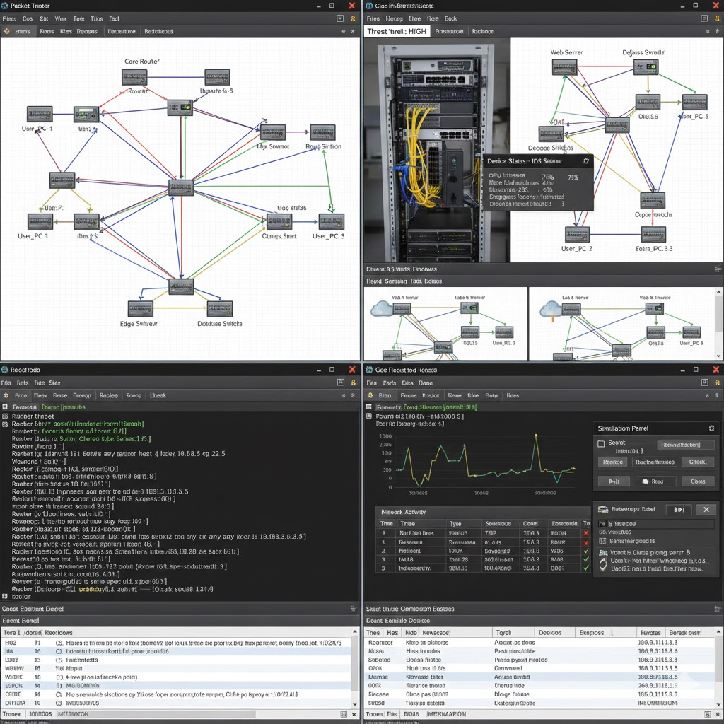
Financial services organizations are particularly attractive targets for ransomware attacks due to their perceived ability to pay ransoms quickly in order to restore services and avoid reputational damage. In addition to financial loss, ransomware incidents can result in prolonged operational disruption, regulatory scrutiny, and loss of customer trust. Another critical external threat is artificial intelligence–powered social engineering. Modern phishing and vishing attacks increasingly leverage machine learning techniques to generate highly convincing messages that closely mimic legitimate communications. Deepfake voice technology has been used to impersonate senior executives and deceive employees into authorising fraudulent transactions or disclosing confidential information, particularly within finance departments.
Supply chain compromises also represent a major threat to VTAM. Attackers increasingly target trusted third-party software providers and managed service providers to gain indirect access to multiple organizations simultaneously. High-profile incidents such as the MOVE it breach demonstrate how a single vulnerability in a widely used platform can have cascading effects across the financial sector. Furthermore, the widespread adoption of cloud services introduces additional risks related to misconfigured storage resources, excessive identity and access permissions, and limited visibility across complex multi-cloud environments.
Internal threats must also be considered within VTAM’s threat landscape. These include negligent insiders who inadvertently expose systems to attack through poor security practices, malicious insiders motivated by financial gain, and privilege misuse resulting from over-provisioned access rights. The increasing prevalence of shadow IT, where employees adopt unauthorized applications and cloud services to improve productivity, further increases the risk of data leakage and regulatory non-compliance. Collectively, these threats undermine the confidentiality, integrity, and availability of VTAM’s information assets.
Regulary and Business Alignment
In addition to imp roving technical security, the proposed Zero Trust framework supports VTAM’s regulatory and business objectives. Financial services organizations operating in the United Kingdom are subject to strict regulatory requirements related to data protection, operational resilience, and risk management. Regulations and guidance from bodies such as the Financial Conduct Authority and the Information Commissioner’s Office emphasize the need for robust controls to protect customer data and ensure continuity of critical services. By enforcing least privilege access, continuous verification, and strong monitoring, Zero Trust principles directly support compliance with these regulatory expectations.
From a business perspective, effective cyber security is increasingly recognized as a key enabler of trust and competitive advantage. Clients expect financial institutions to safeguard their assets and personal information, and security incidents can quickly erode confidence and damage brand reputation. The implementation of a structured, standards-aligned security framework demonstrates due diligence and proactive risk management to clients, regulators, and stakeholders.
Furthermore, improved visibility and control over users, devices, and data supports more informed decision-making and incident response. Rather than reacting to breaches after damage has occurred, VTAM is better positioned to detect threats early, contain incidents rapidly, and minimize business impact. Aligning cyber security initiatives with business and regulatory priorities ensures that security investments are sustainable, defensible, and strategically justified.

Modern Security Policies Aligned wit Zero Trust
The Zero Trus t security model is founded on the principle that no user, device, or system should be trusted by default, regardless of whether it resides inside or outside the organizational network. Instead, all access requests are continuously verified based on identity, context, and risk. To operationalize this model, VTAM must establish a comprehensive set of modern security policies aligned with Zero Trust principles and recognized frameworks such as the NIST Cybersecurity Framework and ISO/IEC 27001.
An Identity and Access Management (IAM) policy should mandate the use of multi-factor authentication for all users, including privileged accounts, and enforce the principle of least privilege through role-based access control. Conditional access decisions should consider factors such as user identity, device health, geographic location, and behavioral indicators. A device security policy should ensure that only managed and compliant devices are permitted to access corporate systems, supported by mobile device management and endpoint management solutions. Network security policies should focus on micro-segmentation to restrict lateral movement and limit the potential impact of a security breach.
Cloud security policies must clearly define responsibilities under the shared responsibility model and require continuous monitoring of cloud configurations and access permissions. Third-party risk management policies should mandate security due diligence, contractual security controls, and ongoing monitoring of suppliers and service providers. Together, these policies provide a governance framework that supports Zero Trust implementation while aligning with regulatory and industry expectations.
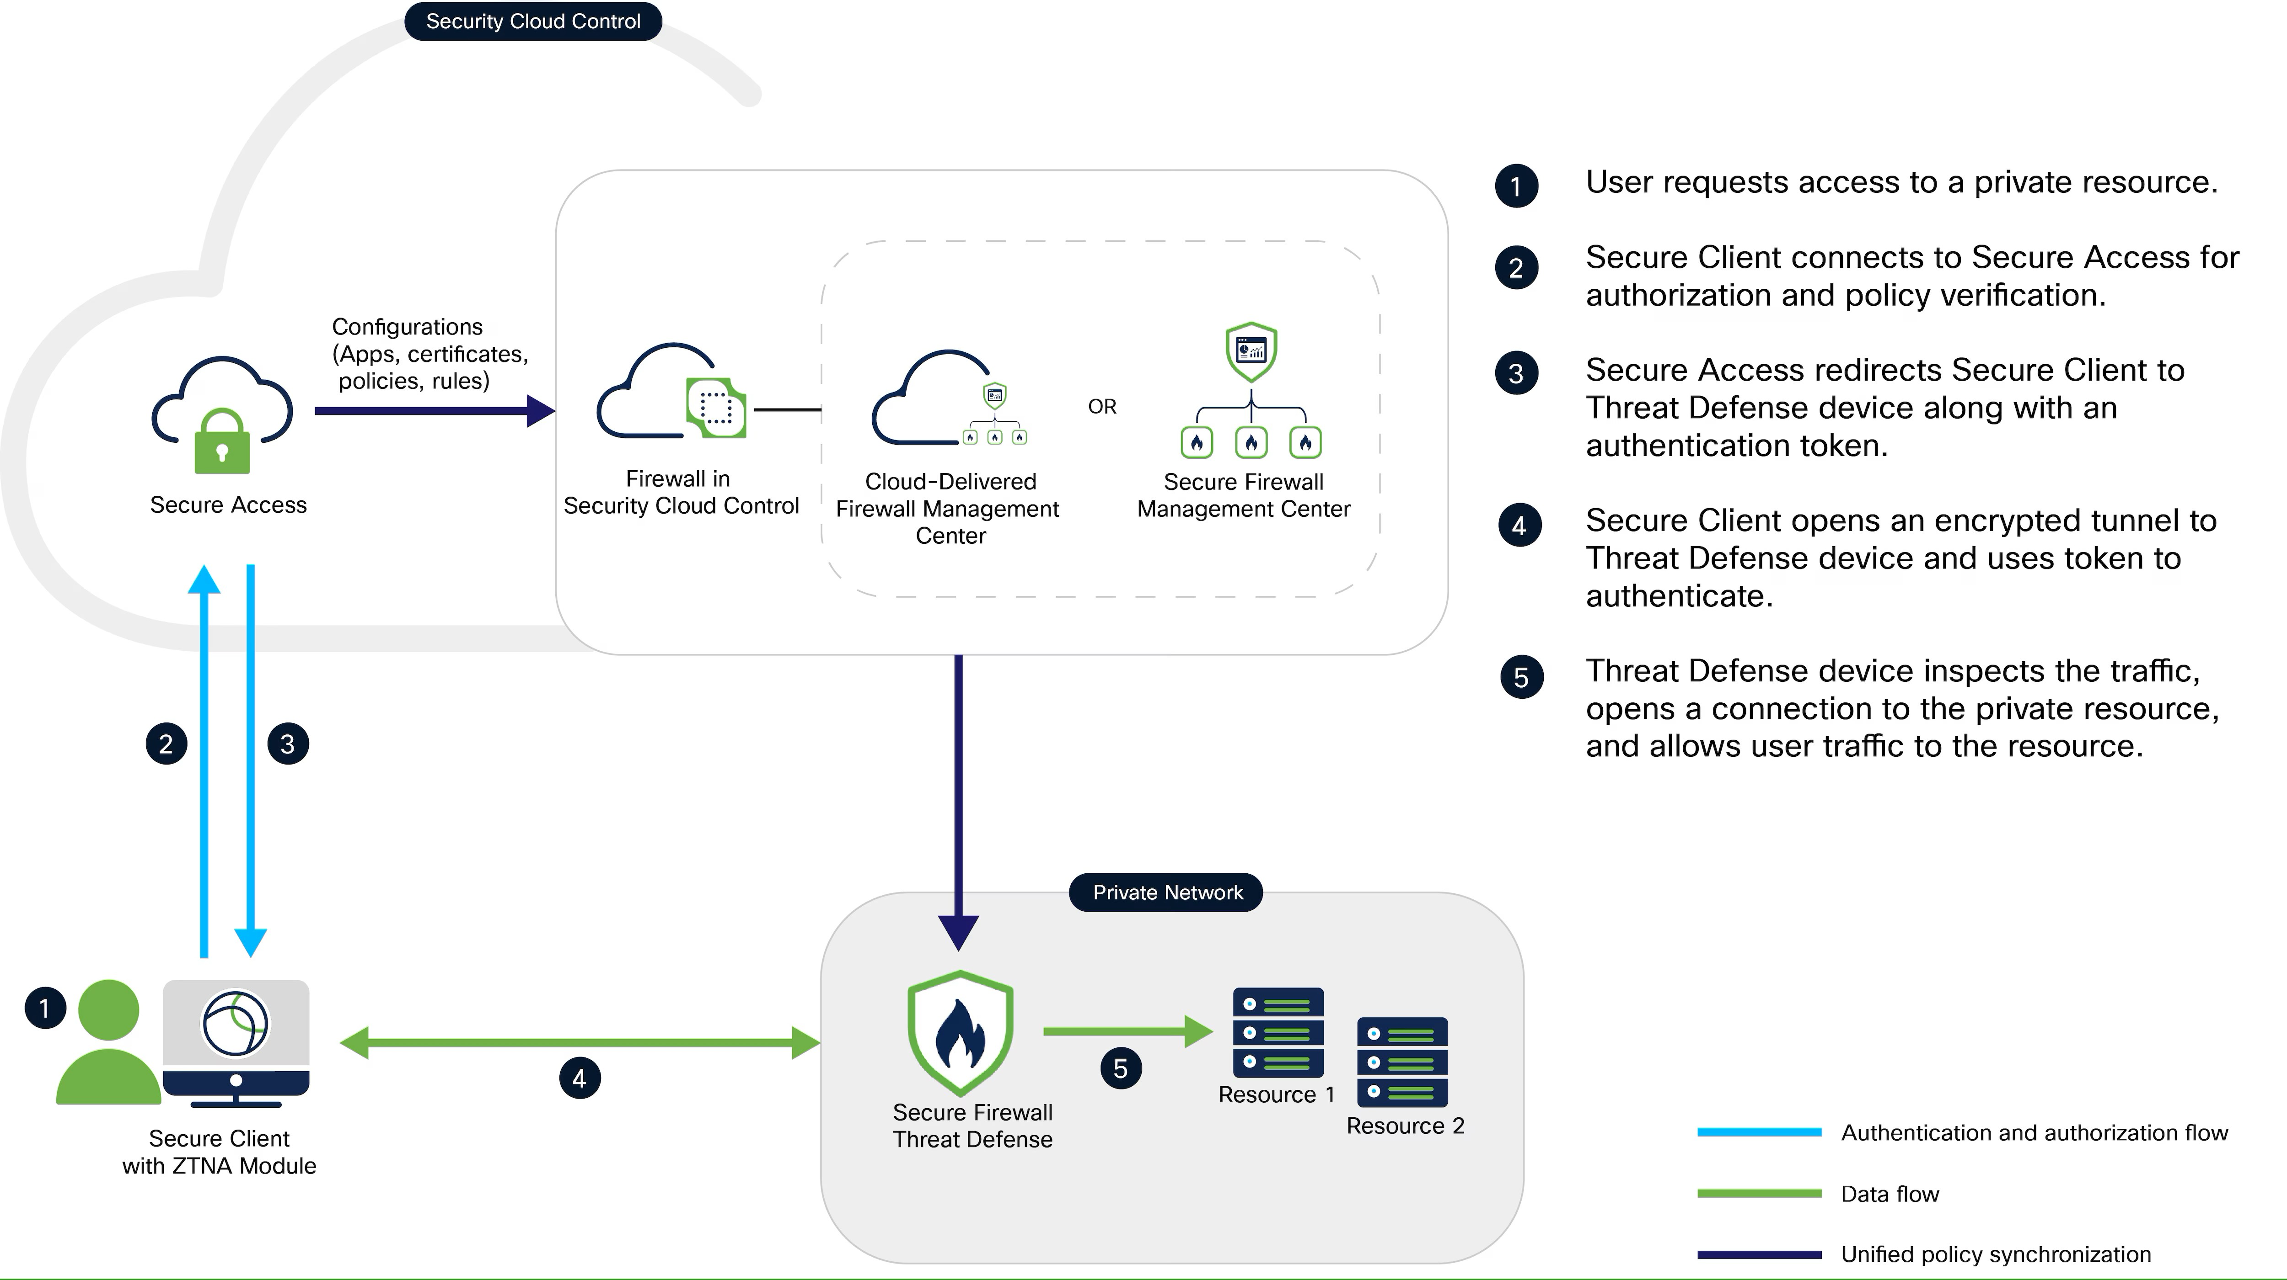
Implementation Challenges and Risk Trade-Offs
While the adoption of a Zero Trust security framework provides significant security benefits, its implementation within a medium-sized financial services organization such as VTAM also introduces a number of practical challenges and trade-offs that must be carefully managed. One of the primary challenges relates to cost and resource constraints. Implementing advanced identity controls, endpoint detection technologies, and continuous monitoring solutions requires financial investment as well as skilled personnel to configure, maintain, and operate these systems effectively. For a medium-sized organization, prioritization of controls based on risk is therefore essential to ensure that security investments deliver measurable value.
Another challenge involves organizational change and user experience. Zero Trust models often introduce additional authentication steps, access restrictions, and monitoring mechanisms that may initially be perceived by employees as barriers to productivity. If not communicated and implemented effectively, these changes can lead to user frustration, workarounds, or resistance to security controls. To mitigate this risk, VTAM must ensure that security initiatives are accompanied by clear communication, executive sponsorship, and alignment with business processes. From an operational perspective, balancing strong security controls with usability is critical to long-term success.
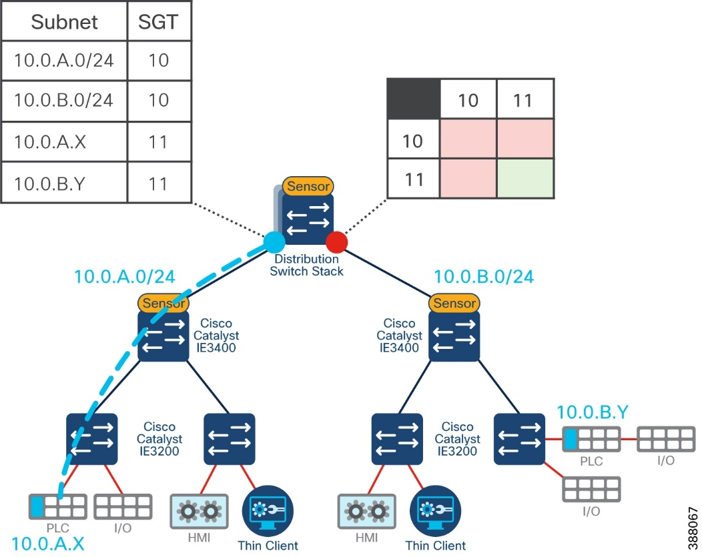

Technical and Administrativee Mitigation Measures
To enforrce these policie and mitigate identified threats, VTAM should deploy a combination of technical and administrative controls that are realistic and achievable within a medium-sized organization. Identity-focused controls are central to the Zero Trust model and include multi-factor authentication, privileged access management, and strong authentication policies to reduce the risk of credential compromise. Endpoint Detection and Response (EDR) solutions should be deployed across all endpoints to provide real-time visibility, behavioral analysis, and rapid containment of malware and ransomware threats.
Network security controls should include micro-segmentation and Zero Trust Network Access solutions to restrict access based on verified identity rather than network location. Ransomware resilience should be enhanced through the implementation of immutable backups stored offline or using write-once-read-many technology, combined with regular backup and recovery testing. Patch management processes should priorities vulnerabilities listed in the CISA Known Exploited Vulnerabilities catalogue to reduce exposure to actively exploited flaws.
In cloud environments, Cloud Security Posture Management tools should be used to continuously assess configurations and detect misconfigurations, while Cloud Access Security Brokers provide visibility and control over Software-as-a-Service usage. Encryption of data at rest and in transit further protects sensitive information and supports compliance with data protection regulations. These mitigation measures align primarily with the Protect and Detect functions of the NIST Cybersecurity Framework.
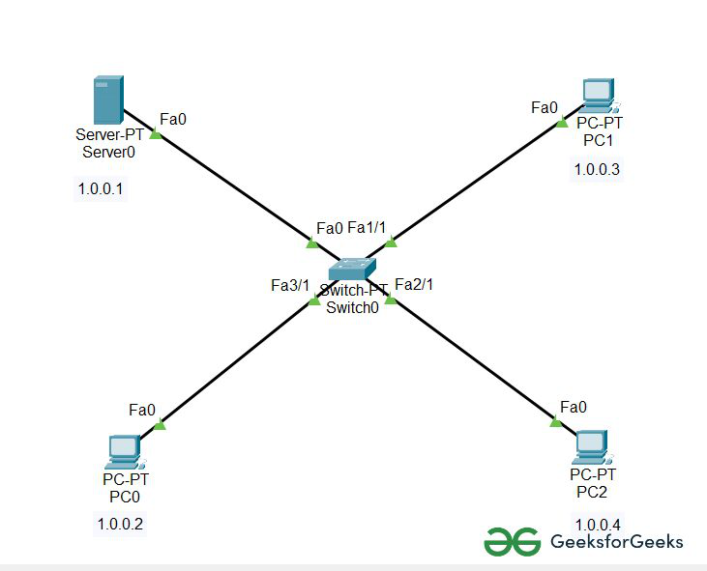

Proactive Monitoring and Incident Response
Given the Speed and impact of modern cyber attacks, proactive monitoring and effective incident response capabilities are essential. VTAM should establish a twenty-four-hour security monitoring capability supported by a centralized Security Information and Event Management platform. The SIEM should aggregate and correlate logs from endpoints, network devices, identity systems, and cloud services to detect anomalous behavior and potential security incidents in near real time. To improve response times and reduce reliance on manual processes, Security Orchestration, Automation and Response should be integrated with the SIEM to automate containment actions.
The incident response process should follow a structured lifecycle consisting of detection, analysis, containment, eradication, recovery, and lessons learned. For example, in the event of a ransomware incident, automated response actions may include isolating affected systems, disabling compromised user accounts, blocking malicious network traffic, and initiating recovery from immutable backups. Regular incident response exercises, clearly defined roles and responsibilities, and effective communication procedures are critical to ensuring organizational preparedness.
Continous Training and Security Awareness
Despite signicant advances insecurity technology, human behavior remains one of the most frequently exploited attack vectors. Continuous security awareness and training are therefore critical components of VTAM’s overall security strategy. The organization should move beyond annual compliance-focused training and implement an ongoing, engaging programmed that reflects real-world attack scenarios.
This programme should include regular phishing and vishing simulations designed to mirror current attacker tactics, techniques, and procedures. Training should be role-based, with tailored content for executives, finance teams, and technical staff. Clear and accessible reporting mechanisms should be promoted across the organization to encourage early reporting of suspected incidents. Effectiveness should be measured using metrics such as phishing click rates, reporting rates, and time-to-report. By fostering a culture of shared responsibility for security, VTAM can significantly reduce the likelihood and impact of successful cyber attacks.

Conclusion
This report has presented a comprehensive Zero Trust-Based security framework designed to address the evolving cyber threat landscape facing Vigilant Trust & Asset Management. By systematically identifying modern threats, aligning security policies with recognized standards, implementing feasible technical and administrative controls, and stablishing robust monitoring, incident response, and training programmers, VTAM can substantially enhance its cyber resilience. Importantly, the proposed framework supports not only technical security objectives but also broader business goals, including regulatory compliance, operational continuity, and reputational protection. As cyber threats continue to evolve, adopting a Zero Trust approach positions VTAM to proactively manage risk and maintain trust with clients and stakeholders.

Link to the Power Point Presentation: presented.pptx

References
NIST (2020). Zero Trust Architecture. NIST Special Publication 800-2007.
CISA (2023). Zero Trust Maturity Moderl Version 2.0. Cybersecurity and Infrastructure Security Agency.
Dhiman, P., et al. (2024). Zero Trust And Micro-Segmentation.
Akinsuli, O. (2021). The Rise of Al-Enhanced Rasonware-as-a-Service (RaaS).

