Business Report -
Ibis and Corinthia
Catalina Gabriela Dumitru
2209716
Financial Management for the Hotel Industry (BMIH5007, BMIH5002)
Lecturer : Tristan Hawkins
2038 words

Executive Summary

In the competitive landscape of the hospitality industry, financial management strategies, decisions and corporate social responsibility (CSR) practices play crucial roles in shaping the success and reputation of hotel chains. This comparative analysis delves into the financial management strategies and CSR initiatives of two distinct hotel chains: Ibis, a part of the globally recognized Accor Hotels group, and Corinthia Hotels, a luxury hotel brand known for its opulent accommodations and personalized service. While Ibis focuses on budget-friendly accommodations catering to a broad market segment, Corinthia Hotels targets the high-end market with luxury offerings. This comparison will highlight how each chain manages its financial resources, implements CSR practices, and navigates the dynamic challenges of the hospitality industry in last years, research based on financial data published for these corporations.

Content table

Introduction 4
IBIS 4
CORINTHIA 5
Growth 6
Financial Data, strategies and position on market 8
Comparison 10
Sustainability 10
Conclusion 10
Recommendation 12
Reference list 14

Introduction
The purpose of this report is to check financial data which will help to analyse and assess management of two hotel brands considering gross numbers as revenues, to appreciate their growth, and to judge decisions of costs, pricing, with a final look on sustainability practices and CSR implications of each company. Ibis, part of Accor Hotels, is a well-established budget hotel brand targeting cost-conscious travellers. It operates primarily within the economy class, typically offering 2 to 3-star accommodations. Known for its affordability, Ibis provides essential amenities with consistent quality across its locations, appealing to business travellers and tourists seeking value for money.
In contrast, Corinthia Hotels is a luxury hotel chain catering to high-end clientele. Positioned in the upscale market, Corinthia offers 4 to 5-star properties renowned for their elegance, personalized service, and premium facilities. Its target market includes affluent travellers and business executives seeking exceptional quality and exclusivity.
IBIS
Accor boasts a diverse range of hotels, with 20% of its total rooms under the Ibis brand. Ibis hotels, typically rated three stars, fall into the economy and business class categories. Ibis has carved out a significant niche in the hotel industry by emphasizing simplicity, comfort, and affordability (Accor, 2021). Their distinct advantage lies in offering budget-friendly yet comfortable accommodations, focusing on the Bed and Breakfast (B&B) model.
This strategy is reflected in their room amenities, which include essentials like 24-hour hot water, clean bathrooms, and comfortable furniture, while limiting entertainment options to keep costs low. The chain comprises 1,269 hotels, as per the latest financial report, with over half located in Europe. Many of these were rebranded in 2011, transitioning from Ibis Styles (formerly All Seasons) and Ibis Budget (formerly Etap Hôtel).
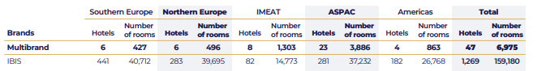
(Ibis, 2024)
To analyse Accor Group in the economic segment, particularly focusing on their Ibis brand, it is crucial to evaluate several key areas impacting their financial performance.
Revenue Management: Accor employs dynamic pricing strategies to optimize room rates based on demand fluctuations (Accor, 2022). For instance, during peak seasons or events, room rates are adjusted upwards to maximize revenue.
Cost Control: Efficient cost management is pivotal. Ibis hotels maintain a lean operational model by limiting non-essential amenities, which helps reduce operational costs. This model includes automated check-in processes and minimalistic room designs, leading to lower maintenance costs.
Occupancy Rates: High occupancy rates are indicative of successful financial strategies. Ibis consistently achieves robust occupancy levels, often exceeding 70% annually, as reported in Accor's financial statements (Accor, 2023). This is driven by competitive pricing and strategic locations.
Market Expansion and Investment: Accor's investment in expanding the Ibis brand has been significant. The rebranding of Ibis Styles and Ibis Budget in 2011 is a testament to their aggressive market strategy. The latest financial reports highlight a portfolio of over 1,269 Ibis hotels globally, with continuous investments in new markets.
Sustainability and CSR: Accor's Planet 21 program focuses on sustainable practices, which positively influence financial performance by reducing energy costs and enhancing brand reputation (Accor, 2020). For example, Ibis hotels have implemented energy-efficient systems and water-saving initiatives, contributing to cost savings and appealing to environmentally conscious consumers.

CORINTHIA
On contrary, Corinthia Hotels is a luxury hotel brand with a unique history and presence in the hospitality industry. Founded in the 1960s by the Pisani family of Malta. The brand started with the opening of a fine-dining restaurant, which eventually led to the establishment of their first hotel, the Corinthia Palace Hotel and Spa in Malta.
To evaluate Corinthia Hotels Group in the luxury segment, it is essential to consider several critical areas impacting their financial performance:
Revenue Management: Corinthia Hotels leverage sophisticated revenue management systems to optimize room pricing based on market demand, special events, and seasonality. This dynamic pricing approach maximizes Average Daily Rate (ADR) and Revenue Per Available Room (RevPAR). For instance, Corinthia's annual reports often highlight higher ADRs during peak tourism periods and exclusive events (Corinthia, 2020).
Cost Control and Efficiency: Although luxury hotels generally have higher operating costs due to premium services and amenities, Corinthia focuses on efficiency without compromising quality. Investments in energy-efficient technologies and staff training programs ensure cost-effective operations. Their financial reports detail substantial investments in green technologies, resulting in long-term savings.
Guest Experience and Satisfaction: Exceptional guest experiences are crucial for repeat business and positive reviews. Corinthia Hotels invest heavily in staff training and high-end facilities to maintain superior service levels. Financial performance data often show a correlation between high guest satisfaction scores and increased occupancy rates.
Market Expansion and Investment: Strategic investments in prime locations and continuous property enhancements are central to Corinthia's growth. For example, their financial statements reflect significant capital expenditure on refurbishments and new developments, such as the recent expansion in the Middle East and North Africa (MENA) region.
Brand Differentiation and CSR: Corinthia's commitment to corporate social responsibility and sustainability practices enhances its brand appeal. Initiatives like local community support and environmental conservation programs are highlighted in their sustainability reports (Capocchi, 2019). These practices not only build brand loyalty but also attract high-net-worth individuals who value responsible luxury.
Growth
Over the years, Corinthia has grown into various locales, celebrated for its opulence and high-end appeal. The hotels blend local charm with the group's ethos of delivering exceptional service and lavish experiences. For example, the Corinthia Hotel in London, housed in a Victorian edifice, is acclaimed for its sophistication, historical importance, and premium facilities, including a prestigious spa and several gourmet restaurants.
What distinguishes Corinthia Hotels is their dedication to maintaining the historical and cultural essence of their properties while providing luxurious and contemporary amenities. They are often situated in iconic buildings steeped in history, meticulously restored to merge luxury with heritage, offering guests a distinctive mix of historical allure and modern comfort (Corinthia, 2021).
While for many years the company owned just nine major hotels, the past decade has seen significant investments, with notable acquisitions in key locations., until 2020 owning 16 hotels, for next years intend to open several more, all in top of the world.
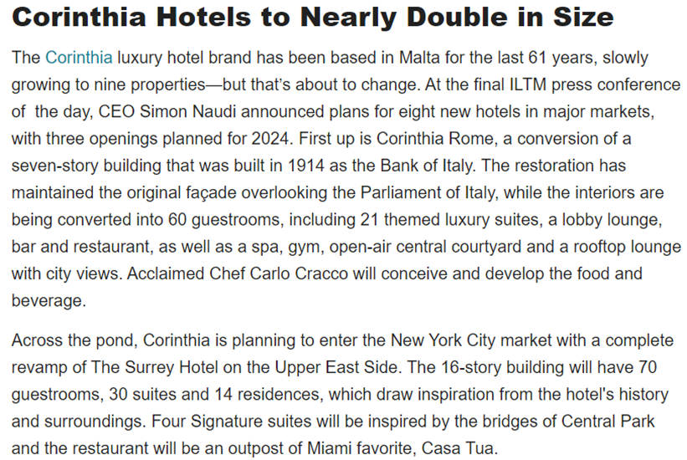
(Goldfisher, 2023)
This significant decision followed years of careful study and consideration. Corinthia Group announced its intentions for New York 4-5 years in advance, showcasing once again a mature approach to management. Investing capital in hospitality requires substantial resources and a long-term commitment, as these properties are often designed for specific purposes and are difficult to repurpose. This approach involves inherent risks, making it crucial for management to anticipate market trends and minimize potential challenges. (Atrill, 2021, p. 287).
Financial Data, strategies and position on market
or financial analysis, data were gathered from the past five years, including annual reports for 2019-2022 and a partial report for 2023. This period is particularly notable due to the historical events of 2020.
Examining the 2019-2022 timeframe, with a focus on the COVID-19 pandemic's impact on the hotel industry, most hotels worldwide saw a drop in demand because of travel restrictions, lockdowns, and decreased tourism. Some hotels temporarily closed or scaled down operations, reducing the overall supply of rooms. Amid decreased demand and heightened competition for fewer travellers, hotels, including those under the Accor brand like Ibis, likely adjusted their pricing strategies, employing discounts, promotions, and special offers to attract customers and boost demand.
In the case studied, Ibis was less affected by the crisis compared to Corinthia. Ibis hotels remained operational, except during mandatory quarantines, continuing to host business travellers, local tourists, and workers (as shown in the next picture from an Ibis internal report). In contrast, Corinthia faced significant impacts from the cancellation of international flights and holiday plans.
For Ibis, financial data are reflective of the Accor group as a whole. However, analysing the Premium, Mid-scale, and Economic segments suggests that Ibis experienced fewer losses in 2020 compared to other Accor divisions. This underscores the advantage of business versatility in crisis situations: when luxury segments falter, economic brands like Ibis continue to generate revenue, enhancing the overall company image in financial reports. This scenario supports Drury’s (2021, p.223) theory of constraints and decision-making under pressure.
Financial reports integrate various data types, including achievements, budgets, capital amortizations, collaborative metrics, and divisional performance evaluations, aligning with strategic marketing accounting principles (Seal, 2019, p.695-696). The results are promising, indicating significant growth and potential in the hospitality sector.
In the third quarter of 2023, Accor Group reported a revenue of €1,286 million, a 13% like-for-like increase compared to the same quarter in 2022 (Accor, 2023). This growth was consistent across the Premium, Midscale, and Economy divisions, including the Ibis brand. The Group's strong performance signals a robust business phase across all markets, especially in Asia, and highlights ongoing network expansion efforts.
For Corinthia Group (2019), financial results indicate raise, as in picture:
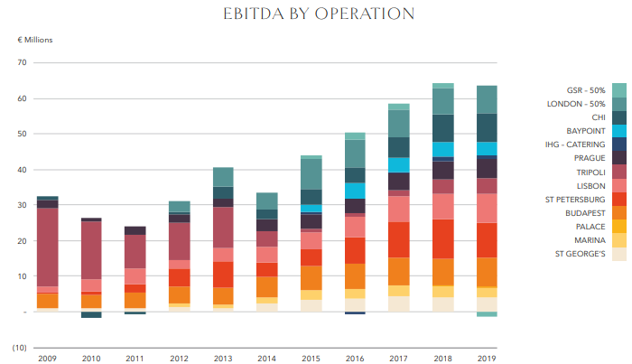
(Corinthia, 2020)
After 2020, deeply affected by pandemic, negative results; in 2021, start to come back in profit; 2022 year shows a better trend, double revenue and two times more profit as 2021, suggesting business is successfully revived (Corinthia, 2022).
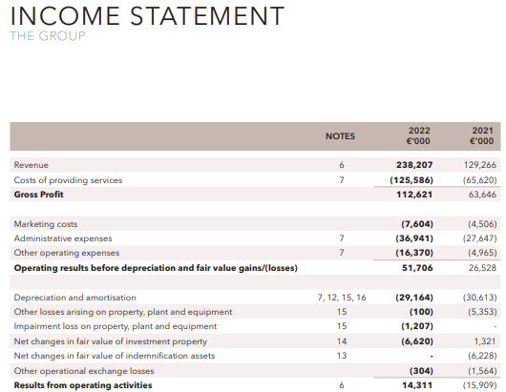
(Corinthia 2023)

Comparison
A net comparison will not be relevant, as numbers, more relevant could be appreciation of potentiality, how much is possible to evolve in next years, this potential is reflected in position on market and targeted segment, on Bowman Clock for each brand:
Ibis, positioned at "Recovery" on the Bowman Clock, focuses on cost efficiency and value delivery. Through competitive pricing and strategic location choices, Ibis emphasizes maintaining high occupancy rates and managing operational costs, ensuring resilience in the budget hotel segment.
Corinthia Hotels are at "Differentiation" on the Bowman Clock, emphasizing unique luxury experiences and exceptional service. Their strategy involves maintaining high-quality standards, leveraging historical and cultural assets, and investing in prime locations, distinguishing themselves in the competitive luxury hotel market.
Sustainability
Accor CEO Denis Hennequin emphasized the company's strategic focus: "We will revolutionize our economy brand portfolio around the Ibis brand, which benefits from unrivalled worldwide recognition" (Hospitality Site, 2022). This strategy includes a strong commitment to social responsibility.
Corinthia has taken a significant step forward. While financial reports prior to 2020 primarily highlighted income and revenue figures, recent reports prioritize metrics related to fuel economy, energy efficiency, and CO2 emissions reductions (Lugar, 2006). These reports also detail decreases in energy and water consumption per room, as well as waste reduction efforts. This modern approach reflects the view that "sustainable event tourism not only provides environmental advantages but also financial returns" (Walker, 2021, p.333). Sustainability initiatives reduce costs and educate consumers on best practices for minimizing waste and pollution, which can be financially beneficial. Moreover, these efforts enhance the brand's public image, showcasing a commitment to ethical values.
In a 2024 article dedicated to Corinthia, Hospitality Site highlighted Alfred Pisani, the founder of the hotel chain, during a Lifetime Award Ceremony. Pisani reflected on their journey: "Our mission began on a small island with no natural resources, which, in the 1960s, was virtually unknown. This made our mission doubly difficult."
The main four directions of Corinthia’s sustainability are presented on their site:
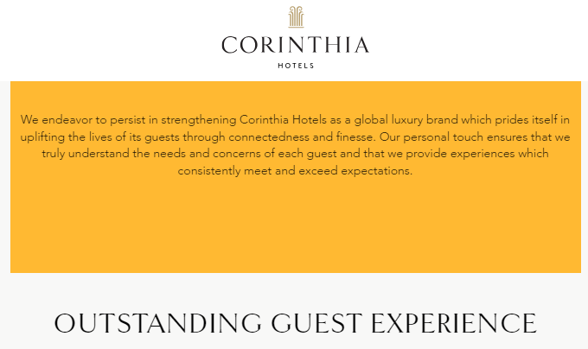
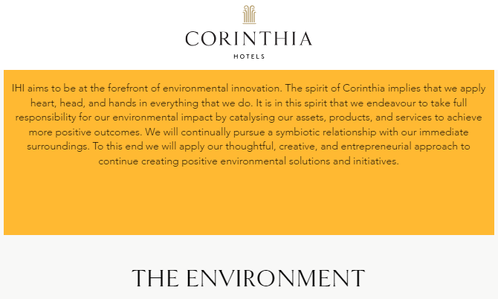
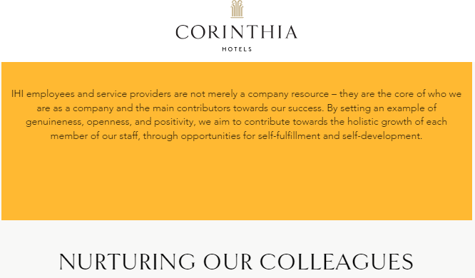
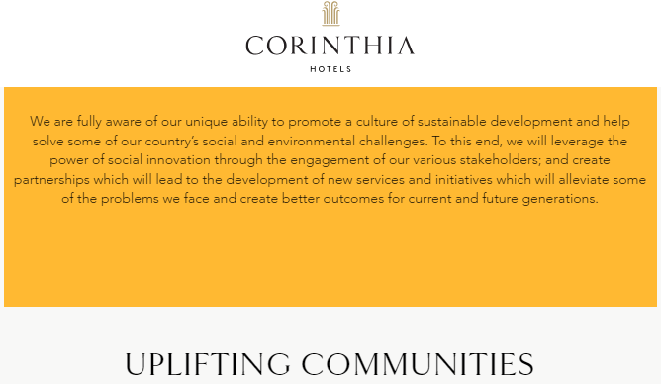
(Corinthia Group, 2024)

Conclusion
The two companies under consideration are leaders in their respective sectors: one is the largest player in Europe's economic class, and the other is a top contender in the luxury class. It is fascinating to observe their growth trajectories, adaptation to the challenging conditions of the pandemic, and continued success in a competitive market. Ibis has pursued an intensive strategy, perfecting its services and image within a fixed market space, thereby capturing a larger share of the economy segment. In contrast, Corinthia has focused on expansion, reinvesting capital to acquire spectacular hotels in prime global locations. This strategy extends their market reach while maintaining the distinctiveness and elegance that have established their reputation.
Recommendations
Ibis
Ibis has discovered a successful formula and should consider expansion. Reinvesting to acquire more properties and increase their room inventory is key. Ideally, every major city worldwide should boast at least one Ibis hotel.
As part of the Accor Group, Ibis Hotels has been actively involved in initiatives to enhance guest experiences and promote sustainability. Areas where Ibis could further excel include:
Guest Experience and Technology: Ibis has innovated by incorporating mobile technology to enhance guest experiences. Further advancements, such as more personalized interactions through technology and sophisticated room automation systems, could elevate the guest experience even further (Demirçiftçi, 2016).
Interior Design and Local Cultural Integration: With design concepts like Agora, Plaza, and Square, Ibis Hotels have embraced expressiveness and a homely atmosphere (Ishraq, 2023). Enhancing this by incorporating local cultural elements into hotel designs can provide guests with a unique, immersive experience that reflects the local environment and culture.
Operational Efficiency: Continuously improving operational efficiency, particularly in energy management, waste reduction, and sustainable sourcing, can reduce environmental impact and lead to cost savings (Juhász-Dóra, 2015). These savings can be reinvested into enhancing guest services and facilities.
By focusing on these areas, Ibis Hotels can continue to enhance their offerings, ensuring they remain competitive and appealing to environmentally conscious and tech-savvy guests.
Corinthia
Corinthia Hotels, renowned for its dedication to luxury and exceptional service, has several opportunities for further improvement and innovation (Cavendish, 2013). Here are some suggestions based on current industry trends and the hotel's existing strategies:
Sustainability Initiatives: Corinthia has made significant progress in sustainability, exemplified by its Corinthia Oasis project focusing on eco-friendly practices such as eco-gardens, natural climate solutions, and green roofs. To deepen this commitment, Corinthia could explore advanced energy-efficient technologies, expand the use of renewable energy sources, and integrate sustainable practices more extensively across their supply chain and operations.
Expanding Wellness Offerings: With the global emphasis on well-being, Corinthia could enhance its wellness programs. This could include expanding spa and health services, incorporating wellness into the overall guest experience, and offering personalized health and wellness packages to meet diverse guest needs.
Employee Development and Satisfaction: Investing in employee training and development, especially in sustainability and guest service, can further elevate service quality and staff satisfaction (Wohlfart, 2016). This, in turn, positively impacts guest experiences, reinforcing Corinthia’s reputation for outstanding service.
By centring on these areas, Corinthia Hotels can continue to enhance their luxury offerings, ensuring they remain competitive in the fast-evolving hospitality industry. These improvements and innovations will help Corinthia maintain its status as a top choice for luxury travellers seeking unique, authentic, and high-quality experiences.

References List
Accor (2023), Third-quarter 2023 revenue of €1,286 million up 13% like-for-like available at: https://press.accor.com/third-quarter-2023-revenue-ofe1286-millionup-13-like-for-like/
Accor Group (2023), Financial report available at: https://group.accor.com/en/finance/results-and-publications/ financial-result
Accor, Société Anonyme, (2023), Interim_Financial_Report_2023_Accor available at: https://group.accor.com/-/media/Corporate/Investors/Documents-financiers/2023/07-27-H1/Interim_Financial_Report_2023_Accor_vDef.pdf
Accor, Société Anonyme, (2023), ACCOR_DEU_2022 available at: https://group.accor.com/-/media/Corporate/Investors/Documents-de-reference/ACCOR_DEU_2022_US_PDF_UA.pdf (last accessed 25/01/2024)
Accor, Société Anonyme, (2022), OPT_ACCOR_DEU_2021_MEL_US_300322 available at: https://group.accor.com/-/media/Corporate/Investors/Documents-de-reference/ OPT_ACCOR_DEU_2021_MEL_US_300322.pdf
Accor, Société Anonyme, (2021), 2020_ACCOR_URD available at: https://group.accor.com/-/media/Corporate/Investors/Documents-de-reference/2020_ACCOR_URD_VeDef.pdf
Accor, Société Anonyme, (2020), 2019_ACCOR_URD_DEF available at: https://group.accor.com/-/media/Corporate/Investors/Documents-de-reference/2019_ACCOR_URD_DEF.pdf
Accor, (2024) Financial Reports available at: https://group.accor.com/en/finance/results-and-publications/financial-result
Atrill, P. and McLaney, E.J. (2021) Management accounting for decision makers. Tenth edition. Harlow, England: Pearson.
Bhimani, A. (ed.) (2006) Contemporary issues in management accounting. Oxford ; Oxford University Press.
Capocchi, A., & Capocchi, A. (2019). Economic Value and Revenue Management Systems: Case Studies. Economic Value and Revenue Management Systems: An Integrated Business Management Model, 191-206.
Cavendish, D. (2013). Above and Beyond, Corinthia Hotel, London, Review. The Telegraph, 22.
Corinthia (2020) 2019 Annual Report available at: https://www.corinthiagroup.com/wp-content/uploads/2020/08/Corinthia-Annual-Report-2019-web.pdf
Corinthia (2021) 2020 Annual Report available at: https://www.corinthiagroup.com/wp-content/uploads/2021/04/Corinthia-Annual-Report-2020.pdf
Corinthia (2022) 2021 Annual Report available at: https://www.corinthiagroup.com/wp-content/uploads/2022/05/Corinthia-Annual-Report-2021.pdf
Corinthia (2023) 2022 Annual Report available at: https://www.corinthiagroup.com/wp-content/uploads/2023/06/37547-CORINTHIA-ANNUAL-REPORT-2022_WEB-min.pdf
Corinthia (2023) 2023 Interim Report available at: https://www.corinthiagroup.com/wp-content/uploads/2023/08/IHI-Interim-Financial-Statements-30-June-2023.pdf
Corinthia Group, (2024) Sustainability 4 pillars available at: https://www.corinthia.com/en-gb/sustainability/
Demirçiftçi, T., & Kızılırmak, I. (2016). Strategic branding in hospitality: Case of Accor Hotels. Journal of Tourismology, 2(1), 50-64.
Drury, C. (2021) Management and cost accounting. Eleventh edition. Australia: Cengage.
Goldfisher, Emily, (2023), ILTM Day 2: Booking Pattern Trends and Sustainability Initiatives available at: https://www.luxurytraveladvisor.com/your-business/iltm-day2-booking-pattern-trends-and-sustainability-report last accessed 28/02/2024
Hospitality site, 2022, Accor unveils new marketing strategy for its Ibis brand , article available at: https://hospitality-on.com/en/marketing/accor-unveils-new-marketing-strategy-its-ibis-brand last accessed 27/01/2024
Hospitality site ( 2024) The Corinthia Spirit, a tale of a lifetime achievement by founder Alfred Pisani article available at: https://hospitality-on.com/en/development/corinthia-spirit-tale-lifetime-achievement-founder-alfred-pisani last accessed 29/01/2024
Ibis (2024) official site available at: https://group.accor.com/en/finance/results-and-publications/ financial-result last accessed 02/02/2024
Ishraq, S., & Zakaria, A. K. M. (2023). IBIS Hotel's Cultural Pragmatics, Marketing Strategies and Critical Discourse Analysis.
Juhász-Dóra, K. (2015). Hotel competitiveness measurement methods. Knowledge Horizons. Economics, 7(3), 94.
Lugar, R. G. (2006). The New Energy Realists. The National Interest, (84), 30-33.
Seal, W.B. et al. (2019) Management accounting. Sixth edition. London: McGraw-Hill Education.
The Business Research Company, (2024), Hospitality Buildings Market Trends, Growth Analysis, Scope to 2033 available at: https://www.thebusinessresearchcompany.com/ report/hospitality-global-market-report
Walker, J.R. (2021) Introduction to hospitality. Eight, Global edition. Harlow, England: Pearson.
Wohlfart, L., et all, (2016). Corporate and grassroot frugal innovation: a comparison of top-down and bottom-up strategies. Technology Innovation Management Review, 6(4), 5-17.
Worldwide Hospitality Awards, (2023) Ibis reinventing guest experience article available at: https://hospitality-on.com/en/worldwide-hospitality-awards/ibis/ibis-reinventing-guest-experience last accessed 01/02/2024

