MODULE NAME & CODE: PROBLEM SOLVING AND DECISION MAKING BMSW4004

Lectures Name : Chijiobe Uba
Student Name : Geanina Elena Tronaru
Student Number : 2118801

Table of Contents
THE INTRODUCTION 3
Background & Impact of the problem 4
Application of PESTLE upon the problem 4
A complex look into the cause and effect of the problem 6
Potential solutions to be applied on the problem 6
Planification of the most efficient solution to apply 7
The bottom line 8
List of References 9
Appendix 11
Appendix 2 – 12

THE INTRODUCTION
The following report is going to be focusing on key elements that have been studied as part of the Problem Solving and Decision-Making module for which a presentation has been generated based on a given scenario which focuses on one current issue in the National Health Service industry. V b g f r t h t r e s d f g v c x s V b g f r t h t r e s d f g v c x s V b g f r t h t r e s d f g v c x s V b g f r t h t r e s d f g v c x s
That said, it is consistent with the realization that the importance of these skills can be an important factor in the longevity of specific problems to be addressed and supported (Actual, 2022). Additionally, the record includes a report-style business design to support great clarity and a good and consistent structure for introducing and discovering data (Williams, 2021). Given the given situation and staffing problems with respect to adequate care in the UK, the materialization of the report will be scrutinized and informed as it is prepared as to the complex nature of the subject matter and the impact on representatives. will have a configuration based on and their association is to examine large-scale ecological variables that contribute to interesting problems. In addition, research reported along with reason and impact assessments to better illustrate critical thinking and critical thinking abilities using fishbone diagrams is also a joke. In addition, within the framework of this work, an assessment of answers to complex questions related to staff shortages and a plan to select the most valuable will also be made available. Ultimately, all sections of the paper require agreement to implement decisions aimed at solving problems in conversation and evaluation of progress indicators to assess the feasibility of the decisions. is. V b g f r t h t r e s d f g v c x s V b g f r t h t r e s d f g v c x s

Background & Impact of the problem

Basically the nature of the problem is very simple. Because many fields suffer from

the exact same problem. The lack of human resources is not only hurting the profits

of the company, but also the profits of the people due to the loss of employees. You will lose your job and lose an important source of funding (Asrar-ul Haq, Cheema, 2017). V b g f r t h t r e s d f g v c x s V b g f r t h t r e s d f g v c x s V b g f r t h t r e s d f g v c x s
However, given the situation in which staff shortages affect his NHS sector, the complexity of the situation and issues is greatly increased due to all the negative effects this entails. A major reason for staff shortages in the medical field is that there are not enough specialists to care for all patients on a daily basis. Taking this idea further, it is fair to say that these staffing issues negatively impact the quality and level of care provided to individuals in uncomfortable situations such as: Being sick or in good health (NHS Providers, 2022). When people are understaffed and the care they need isn't delivered, the health situation can become even more prevalent and hopeless. (NHS Funding, 2022).

Application of PESTLE upon the problem
External factors have a very large influence and an important task that puts them in a very specific space. What justifies this is the unknown number of people who have come to the UK to test medicines, and to be honest almost 10% of the experts are from her EU countries, but the number of medical personnel 6% of him deal with similar beginnings. In addition, 22% of health professionals and 14% of health care supervisors come from non-EU countries, mostly corresponding to Asia, more specifically India (Statista, 2022). Despite the importance of external issues, London, the heart of the UK, has the highest proportion of her NHS staff of non-British ethnicity at 27% (British Parliament, 2022).
To add an external variable and tie this to the above allegation, I agree with the findings that political factors had the greatest impact on his NHS staff shortages, and the rationale is that Brexit will reduce the ton. that it helped to promote The unknown number of workers who have left the UK as recent arrangements and conditions have come into force has left many organisations, including the main clinical organisation, without staff (Hacker, 2021).
On the other hand, the economy deals with another important variable, which is worth mentioning here. Because understaffing leads to holes in financial problems, because organizations have to make up for staffing shortages - in any case, this current situation is just the opposite. Because specialists are also neglected, out of the functional space, fired or kicked out. This is due to reasons such as the recent unfamiliar post-Brexit decisions (Economics Observatory, 2020).

Another important factor is social issues, which indicate the local environment. Individuals have the power to give appropriate perspectives, think, and act or change ideas. Forces due to impact travel through them (GSE, 2022). Therefore, full-time employees are influenced by the words of former specialists and leave the field, leading to a shortage of personnel both inside and outside the clinical site, which may be another reason for the labor shortage.
Innovation is the expectation the clinical space needs. Proper use of the latest innovations and all electronic gadgets and the potential consequences they have had for the world can alleviate the NHS staffing shortages. There are various occupations that can be conducted online, such as meetings and examinations (depending on the case and patient's condition). In addition, innovation can be used to improve individual conditions, diagnose faster and increase patient confidence in the clinical setting (NHS, 2022).
There is also a legitimate portion of external aspects to consider. Failure to comply with current rules, ordinances and policies may, in some cases, result in breach of contract or violation of law. For example, if a representative is dismissed without good cause, the NHS will be held liable as the law may be broken. On the other hand, arrangements may have been shared if delegates missed schedules and programs (HSE, 2022).

A complex look into the cause and effect of the problem
Another important factor is social issues, which indicate the local environment. Individuals have the power to give appropriate perspectives, think, and act or change ideas. Forces due to impact travel through them (GSE, 2022). Therefore, full-time employees are influenced by the words of former specialists and leave the field, leading to a shortage of personnel both inside and outside the clinical site, which may be another reason for the labor shortage.
Innovation is the expectation the clinical space needs. Proper use of the latest innovations and all electronic gadgets and the potential consequences they have had for the world can alleviate the NHS staffing shortages. There are various occupations that can be conducted online, such as meetings and examinations (depending on the case and patient's condition). In addition, innovation can be used to improve individual conditions, diagnose faster and increase patient confidence in the clinical setting (NHS, 2022).
There is also a legitimate portion of external aspects to consider. Failure to comply with current rules, ordinances and policies may, in some cases, result in breach of contract or violation of law. For example, if a representative is dismissed without good cause, the NHS will be held liable as the law may be broken. On the other hand, arrangements may have been shared if delegates missed schedules and programs (HSE, 2022).

Potential solutions to be applied on the problem
Each problem, including staff shortages in the clinical field, may have an answer if conclusively debated. The cause of the problem is being investigated, so the psyche may be tuned to deal with it.
That being said, there are specific responses to this issue, including the coordination of various missions that expect to explore all the benefits of being a manual laborer in such an important area. On the other hand, to give seriousness and credibility, you can introduce the shortcomings as well as how to turn the shortcomings into advantages.As an evaluation, this placement is useful because the individual is more educated about the space. However, there should be a little more rationale in dealing with the problem of scarcity.
Therefore, another rule that can be used to strengthen it and achieve positive results for complex problems is the excellent way the compensation framework, including the possibility of wage rate increases, is possible. There is a nature. Clearly, a salary increase is probably the number one need for delegates, and the clinical field is no exception. That said, honor and reward are generally good ingredients for inspiration, and as a result, workers' inspiration is surprisingly magnified (Cherry, 2020). As a result, the power and influence of individuals can be channeled here, resulting in an increase in the number of individuals who will need to work in the field, thereby potentially alleviating the ongoing and complex labor shortage problem. There is a nature.
For supervisors who get it, the tedious research can be traced in the Appendix 2 section of the report.

Planification of the most efficient solution to apply
Considering the issues outlined in the above explanation - it is a reasonable and valid intention to make the choice to teach individuals about the subject, as well as present useful and new compensation plans that can can be accomplished by carefully examining the data that will be made available to the world to educate them about drugs. This includes all individuals should have the opportunity to participate in the mission, so for those who need it in person, a large venue must be selected. What's more, in order to give each of the great circumstances to individuals, the whole should even be shown to those who can't really make it to the end, but need to be a part of it.

Additionally, despite the fact that the schedule of honors and bounties could be a little more chaotic, the election's conduct shows positive results in terms of reducing staff shortages with the support of funders and patrons. As such, at this point a combination of arrangements for both educational camps and comprehensive compensation plans that support agent inspiration and future worker inspiration are considered. Elections will lead to fewer people leaving the scene, and as a result, the staff shortage problem will gradually disappear. In addition, another measure of success is patient satisfaction with the level of care received. Especially given the difficult times in which
shortages are a problem, the level of care will be much higher, and care will be reduced if there are not enough people. of this. No chance.

The bottom line
In summary, the problem is very complex and can have fatal consequences if the necessary approach is not taken. However, if the company strictly follows the given solutions and therefore maintains an appropriate level of analysis and constant control to keep the situation under control at all times, improvements in employee behavior and work performance are observed. increase. In addition, since the medical field is advanced, the labor shortage has been resolved compared to the number of people requiring nursing care and the degree of care, and good effects can be seen even when looking at the number of people requiring nursing care. It was the worst.

Appendix 1
FISHBOURNE DIAGRAM

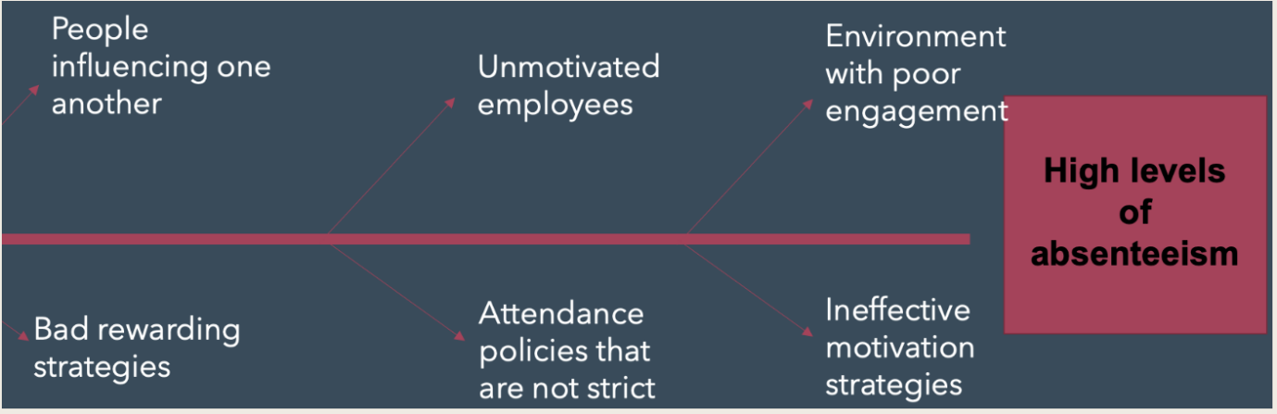

Appendix 2 –
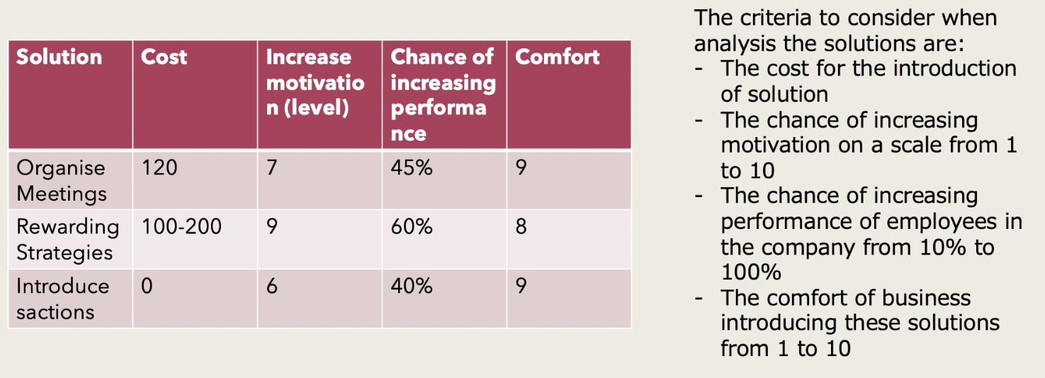
Grind analysis

List of References
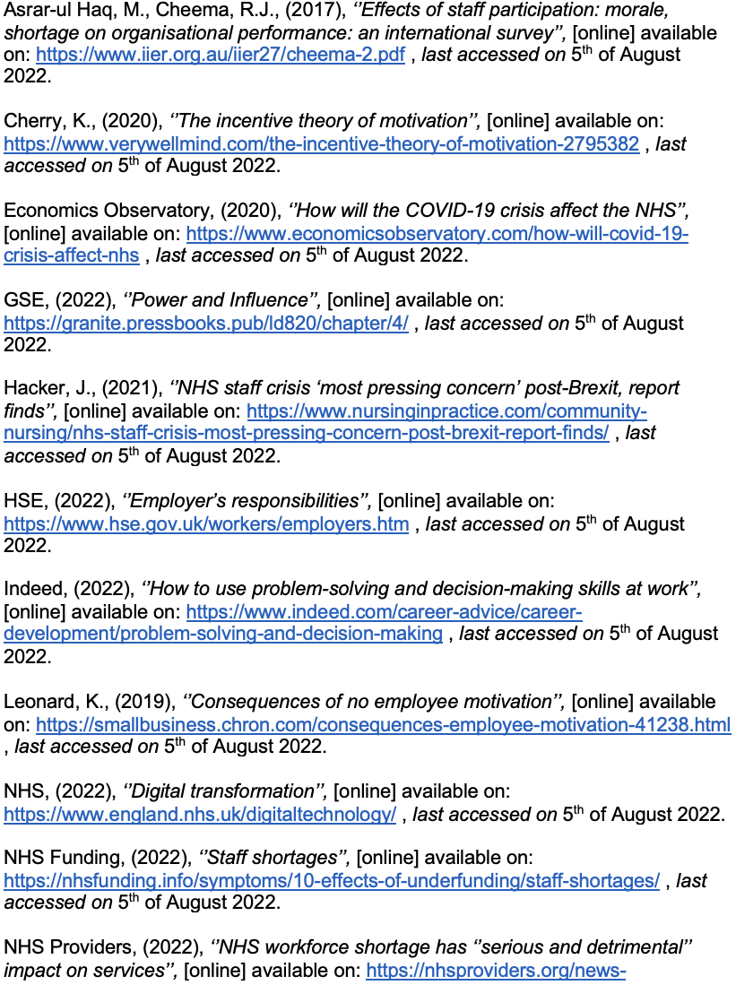 , last accessed on 5th of August 2022.



