Module Title: INTRODUSING THE MODERN WORKPLACE
ASSESSMENT 2
Module code: LCBB4003

Lecturer: HOANG NGUYEN

Student Name: Marian Busca

Student no: 2125297

Relationship between the organization structure and its performance
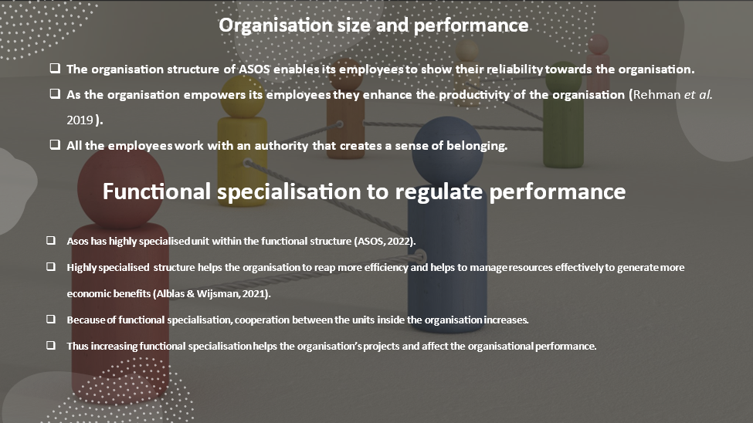
Organisation size and performance
Asos’s size has an interactive impact on the business's performance. The size of Asos determines and regulates other structural issues (Alblas & Wijsman, 2021). Asos also has a well-structured organisational platform to resolve conflicts and disputes, so the company can manage its size. By offering a wide range of specialization, an organisation like Asos gains more benefits and opportunities. Easy coordination and communication among different units gives the company high access to information and the ability to make decisions accordingly (Alblas & Wijsman, 2021).
Functional specialisation to regulate performance
Within the functional structure of Asos, there is a highly specialised unit (ASOS, 2022). A highly specialised structure helps the organisation reap more efficiency and manage resources effectively to generate more economic benefits. Because of functional specialisation, cooperation between the units inside the organisation increases (Alblas & Wijsman, 2021). Thus, increasing functional specialisation helps the organisation’s projects and affects the organization's performance. Systematic procedures help Asos to provide a smooth working environment for the employee, which motivates them to be innovative and progressive.

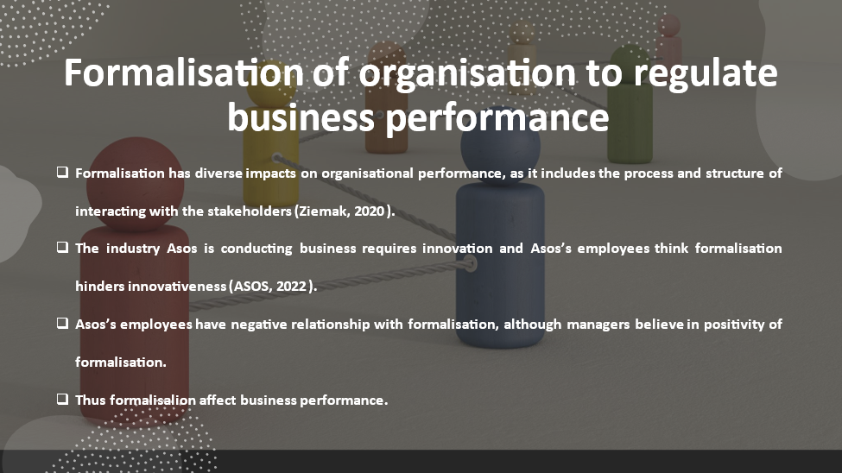
Formalisation of organisation to regulate business performance
Formalisation has diverse impacts on organisational performance, as it includes the process and structure of interacting with stakeholders (Ziemak, 2020). Asos is very careful about the communication channel through which stakeholders are passing information (ASOS, 2022). The industry in which Asos is conducting business requires innovation, and Asos’s employees think formalisation hinders innovativeness. Asos’s employees have a negative relationship with formalisation, although their managers believe in its positivity. Thus, formalities affect business performance.
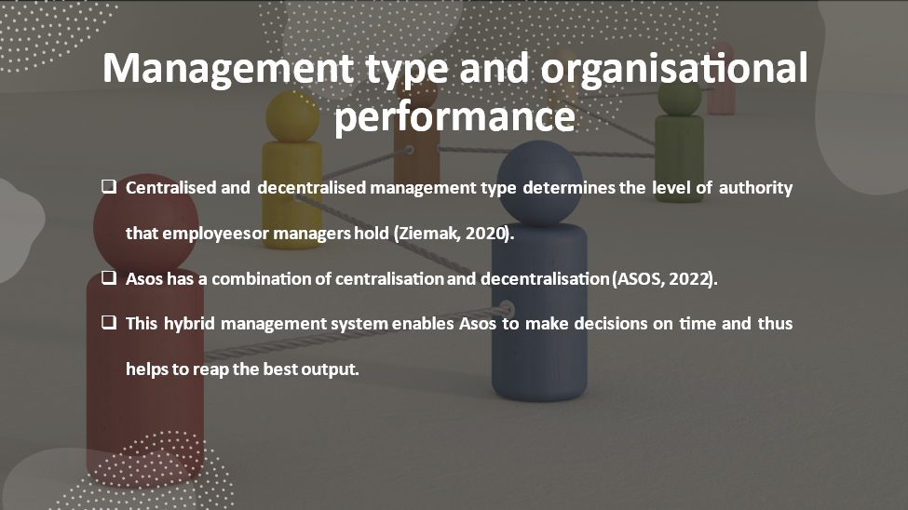
Management type and organisational performance
Centralised and decentralised management types determine the level of authority that employees or managers hold (Ziemak, 2020). Asos has a combination of centralisation and decentralisation. Asos encourages its employees to be team-oriented and supportive of their coworkers. Supervisors monitor the employees and try to maintain mutual coordination to protect a healthy working environment (ASOS, 2022). This hybrid management system enables Asos to make decisions on time and thus helps to reap the best output.
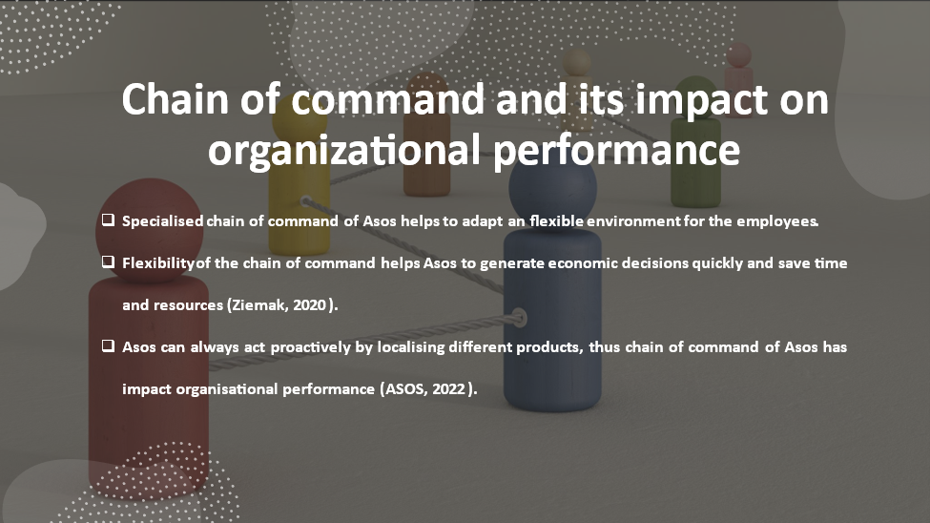
Chain of command and its impact on organizational performance
At Asos, the specialised chain of command aids in the adaptation of a flexible environment for the employees. Asos’s chain of command supports and encourages a progressive working environment for its employees, where every employee has the opportunity to learn new things and to generate innovative ideas (ASOS, 2022). The flexibility of the chain of command helps Asos generate economic decisions quickly and save time and resources. Asos can always act proactively by localising different products; thus, the chain of command at Asos has an impact on organisational performance.
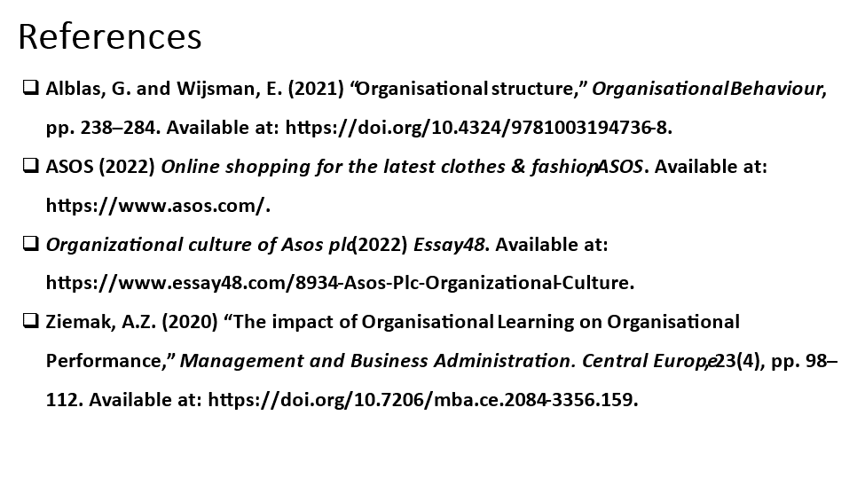
References
Alblas, G. and Wijsman, E. (2021) “Organisational structure,” Organisational Behaviour, pp. 238–284. Available at: https://doi.org/10.4324/9781003194736-8.
ASOS (2022) Online shopping for the latest clothes & fashion, ASOS. Available at: https://www.asos.com/.
Organizational culture of Asos plc (2022) Essay48. Available at: https://www.essay48.com/8934-Asos-Plc-Organizational-Culture.
Ziemak, A.Z. (2020) “The impact of Organisational Learning on Organisational Performance,” Management and Business Administration. Central Europe, 23(4), pp. 98–112. Available at: https://doi.org/10.7206/mba.ce.2084-3356.159.

