Programme: BSc Health and Social Care
Module: Living with Care: The Older Person
Module code: BMHP6009
Lecturer: Laila Surani
Student Name: Sevzhihan Hasanova
Student Number: 2020999

Assessment 1 Written assignment (Report)
The impact of loneliness and social isolation on the elderly population on the UK and USA.

Table of content
1- Introduction
2- Comparison between two countries
3- Recommendations
4- Conclusion
5- Reference list

1-Introduction
This is a comparison report with a focus on the countries of the UK and USA.
In this report, I will look at what it means to be an elderly person in different countries, specifically the United Kingdom and USA. Also, I will present age-related population statistics as well as how those statistics have changed over the course of the past few years. Also included is a discussion of the core concepts of loneliness and isolation, as well as an examination of the symptoms associated with loneliness and the consequences that feelings of loneliness and isolation can have on elderly individuals who live in assisted living facilities or other environments that are analogous to these types of settings. Legislation and policies that target or try to enhance awareness of or minimise loneliness and isolation in older persons could be seen as falling under this category. Also, comparisons between, the local, national, and international provision of services for older people and the initiatives and policies that are now in place and present these analyses and comparisons as thoroughly as possible. An investigation into the possible future of care for older people is underway, including what changes could be made to programmes that are aimed at tackling the problem of loneliness among the elderly and how technology could be used to improve care for older people who live alone. Finally, I will make some suggestions to alleviate people's feelings of loneliness and isolation.
a) A comparison between what it means to be elderly in the United Kingdom and the United States.
The term "elderly" usually refers to those who are quite old. The exact age at which a person is considered "elderly" depends on the nation's culture, setting, and circumstances. (NHS,2022).
The UK and US use "elderly" to refer to those 65 or older. Because many retire and start receiving social security at this age.
As in most countries, being an elderly person can bring a variety of challenges, including:
Health Concerns: Numerous physical and emotional health difficulties are related with ageing. Coronary heart disease, diabetes, arthritis, Alzheimer's, dementia, and other diseases are all too frequent. Quality healthcare for seniors is crucial.
Isolation: Retirement and losing acquaintances can cause social isolation in older adults. This may cause depression. However, many communities’ organisation now offers older people social activities and community involvement.
Concerns About Money Depending on their savings, pension, and other benefits, older individuals might worry about money. Many Americans depend on Social Security, while most Brits depend on a state pension.
Assistance and care: As people age, they may need additional help with daily tasks or medical care. The NHS and private care agencies in the UK provide this form of care. Private carers, Medicaid, and family members provide most elderly care in the US.
Discrimination Based on Age Ageism is the unfavourable stereotypes, prejudice, and mistreatment of older people. Many older people need living arrangement changes depending on their health and mobility. This may necessitate moving into a one-story dwelling, assisted living facility, or nursing home. Recreational time is something retired folks look forward to. Many community projects, groups, and activities target seniors. This includes gym classes, reading clubs, travel groups, and more, ageing is unique to each person and that many older people live busy, robust lives. As people live longer and healthier lives, social views about old age are changing.
b) Age-related population statistics and how these have changed over the past few years are presented here.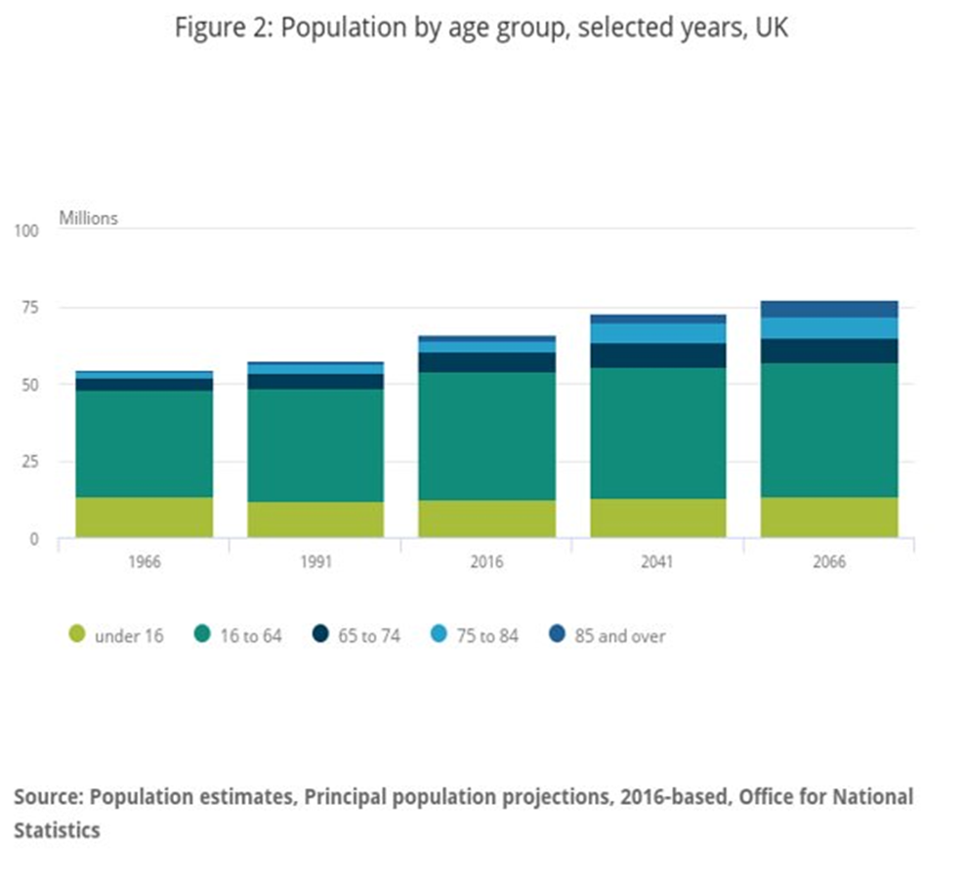Demographic changes are taking place in the UK. The median age of the population in the United Kingdom has been continuously increasing since the middle of the 20th century, and future estimates indicate that this pattern will not change anytime soon. There were 11.8 million people in the UK who were 65 years old or older in 2016, making about 18% of the total population of the country. This figure was 9.1 million twenty-five years ago, which corresponds to 15.8% of the total population. In 2041, the baby boomers of the 1960s, who are presently in their 50s, will have reached older age. By 2066, it is estimated that an additional 8.6 million UK citizens would be 65 or older, bringing the total to 20.4 million and accounting for 26% of the country's population. In 2041, the baby boomers of the 1960s will have reached older age. The current population of London is about equivalent to the growth in numbers presented here. The age bracket that will experience the most rapid expansion is the one that includes persons who are 85 and older. In the middle of 2016, there were 1.6 million people aged 85 and over, which represented 2% of the whole population of the UK. It is estimated that by the middle of 2041, this number will have doubled to 3.2 million, representing 4%; and it is anticipated that by the middle of 2066, it will have tripled to reach 5.1 million, representing 7% of the total population of the UK. On the other hand, it is expected that the population of people aged 16 to 64 will only increase by 2% over the course of the following 25 years and by 5% by the year 2066.
Caused the population to age. According to (Office for National Statistics, 2018) they describe that. Caused the population to age is.
Mortality and pregnancy: Trends in mortality and fertility throughout history and today.
Life expectancy: The average life expectancy in the UK now is 82.9 years for girls, 79.2 years for boy. 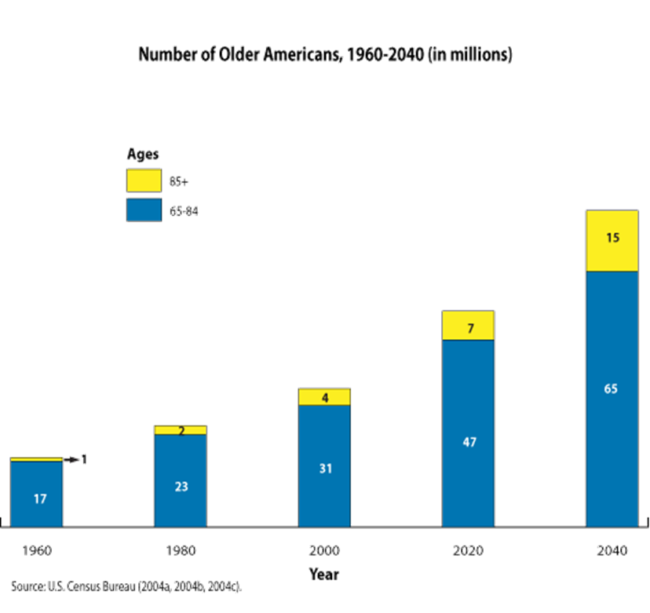
The number of people aged 65 and older in the United States is expected to more than double within the next 40 years, reaching 80 million by the year 2040. Between the years 2000 and 2040, the population of persons aged 85 and older, the age group that requires assistance with basic personal care tasks the most frequently, will nearly treble.
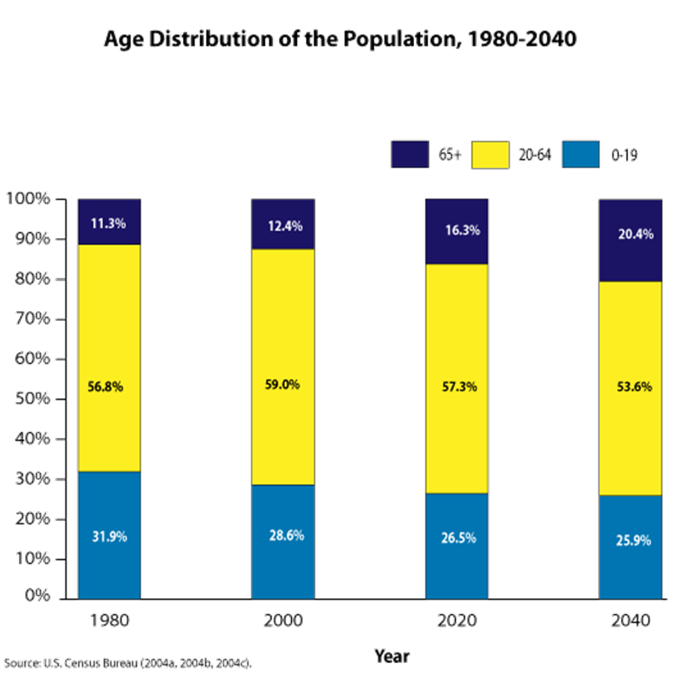
American population is getting older. In the year 2000, around one in eight Americans were 65 or older; this proportion is expected to increase to approximately one in five by the year 2040. Population ageing could put a pressure on government finances due to the fact that younger individuals have a far higher likelihood than older people of working and paying taxes, which are used to finance Social Security, Medicare, and all other operations that are carried out by the public sector. In general, the aging population will be challenging for the future. Both for politicians and for labour health care workforce. And moreover, necessitates the development of an excellent strategic plan.
These five countries have the largest ageing populations.
According to (Tsugane,2020) they describe that, the most recent mortality-related statistics for the group of seven (G7) countries (in alphabetical order: Canada, France, Germany, Italy, Japan, United Kingdom (UK), and United States (US)), which were obtained from a database maintained by the World Health Organisation (WHO).
Increases in life expectancy are another factor that has contributed to the rise in the number of people in their later years. Between the years 1900 and 1960, the average life expectancy of men rose from 51 years to 74 years, while the average life expectancy of women rose from 58 years to 80 years. This was mostly due to a decline in the mortality rates of infants, children, and young adults. Since 1960, improvements in longevity have been slower, especially for women. These improvements have been powered by lowering mortality rates at older ages. The trajectory of life expectancy in the future is not clear, but it might significantly increase. (Vaupel 2000) There are others who believe that half of all girls born today will make it to the age of 100.
c) Discussion of key ideas of loneliness and isolation, as well as analysis of the concepts linked with loneliness.
Evolutionary Theory of Loneliness. (Cacioppo & Cacioppo, 2018) The ETL that was developed by Cacioppo offers a theoretical explanation for the experience of feeling lonely. The theory postulates that emotions of loneliness can develop over time and persist throughout life, as well as that these sentiments can have negative effects on both a person's physical and mental health. According to the ETL, a signalling function that is comparable to that of physical pain has been referred to as social separation, sometimes known as loneliness. According to Cacioppo's Evolution motivation theory (ETL), humans have a natural urge to connect with other people in order to receive and offer protection against a potential threat. If people are unable to satisfy their desire for social connection, they may consequently report feeling lonely. (Cacioppo & Hawkley, 2009).
Both feelings of loneliness and isolation, which are closely connected to one another but are not the same thing at all, can have a substantial negative influence on an individual's physical and mental health.
Experience of being isolated or missing company is what refer to as loneliness. Because it is not always about physical isolation but rather about the perceived quality and depth of social ties, it can be experienced even when one is surrounded by other people. This is because the focus is on the quality of social interactions. Even if are surrounded by a large number of people, it is still possible to have feelings of isolation if do not feel emotionally or socially connected to those around. The impacts of chronic loneliness and extended isolation are key topics of research both in the field of psychology and in the field of public health.
Chronic vs. short-term concerns Situational loneliness is a brief experience caused by specific circumstances, while chronic loneliness is a long-term feeling. Long-term alone can harm mental and physical health.
Social loneliness is the lack of a wider social network or community, whereas emotional loneliness is the absence of a strong emotional relationship or tie, such as with a best friend, lover, or family member. Both sorts of loneliness can harm mental and physical health.
However, isolation is the objective state of being physically alone or isolated from others. One might isolate oneself freely, such as by living alone or for personal reasons, or involuntarily, such as by illness, disability, or society.
The following are basic principles about being alone:
Physical vs. social isolation Physical isolation involves being geographically removed from others, whereas social isolation entails having no social connections, activities, or interactions.
Comparison of Voluntary and Involuntary Isolation Voluntary isolation is a conscious choice to seek alone, whereas involuntary isolation is enforced via quarantine or social exclusion.
Isolation and Health: Long-term social isolation can lead to heart disease, depression, cognitive decline, and early mortality.
Finally, despite their close link, loneliness and isolation are different. Someone might be physically alone without feeling lonely or surrounded by others and still feel lonely. However, social isolation and loneliness can have a particularly negative impact on an individual's well-being. Psychology and public health research have examined the detrimental impacts of persistent loneliness and isolation.
2- Comparison between two countries
d) The effects that feelings of loneliness and isolation can have on older people who live in an assisted living facility or another similar environment
Whether they live in the United Kingdom or the United States, older persons who experience feelings of loneliness and social isolation can have a significant impact on both their physical and mental health. These impacts can be even more prominent among elderly people who live in assisted living facilities or other surroundings with comparable characteristics, such as changes in living arrangements and decreasing levels of freedom, both of which can contribute to a sense of being isolated.
Healthcare Systems: The United Kingdom (UK) has a nationalised healthcare system that is provided by the National Health Service (NHS), which includes services for mental health. In spite of the existence of public insurance options like Medicare for people over 65, medical care in the United States is mostly provided by the private sector. The individual's insurance coverage as well as the resources available in the location in which they reside can have a significant impact on how easy it is for them to get mental health care.
The United Kingdom (UK) and the United States of America (USA) both place a high importance on individualism and independence, which can occasionally lead to elderly people experiencing feelings of isolation if they are unable to continue living alone. The way that society views people who are elderly and ageing can also play a role in the development of emotions of loneliness and isolation.
Care for the Elderly Policies and financing In both nations, the policies and financing that surround the care for the elderly may have a considerable influence on the experience that older persons have in assisted living facilities. Because of this, staffing ratios, the quality of care provided, and the resources available for social activities and mental health assistance may all suffer as a result.
Populations That Are Getting Older Both the United Kingdom, and the United States have populations that are getting older, which implies that an increasing number of people are expected to encounter these difficulties. Nevertheless, the particular demographics and requirements of these communities might differ from case to case.
Isolation and loneliness have a number of negative effects on people as they get older.
Physical Health Loneliness and social isolation, especially when they are chronic, have been related to a variety of physical health concerns, such as an increased risk of cardiovascular disease, high blood pressure, and a weaker immune system.
Isolation and loneliness may have a considerable negative influence on one's mental health, leading to an increased risk of illnesses such as dementia, depression, and anxiety. The mental health of elderly people is a significant issue in both the United Kingdom and the United States, particularly among those who are housed in assisted living communities. (Victor,2012)
Quality of Life: Loneliness and isolation have been shown to have a negative impact on the overall quality of life of older persons. This may be the result of decreased involvement in social activities, a reduction in the amount of time spent engaging in physical exercise, or a general sense of sadness or dissatisfaction.
Mortality: a number of studies have shown a connection between extended periods of social isolation and chronic loneliness, which is associated with an increased risk of death in older persons.
Both the United Kingdom and the United States have put measures into place to lessen the impact of these impacts. These include the provision of mental health services, the encouragement of family participation, and the promotion of social contact inside the institutions. However, the efficacy of these tactics can vary greatly based on a wide range of factors, such as the unique individual's life circumstances as well as the resources that are accessible in various institutions and communities.
e) Legislation and regulations now in effect in the United Kingdom and the United States that deal with, increase awareness of, or attempt to alleviate loneliness and isolation among the senior population
Loneliness and social isolation among the elderly are major concerns, and both the United Kingdom and the United States have developed a variety of laws and efforts to address these issues.
The United Kingdom: The Loneliness approach: In 2018, the UK Government introduced a ground-breaking approach to address loneliness. This strategy, titled "A Connected Society: A Strategy for Tackling Loneliness," provides a broad and long-term approach to creating more socially linked societies. The strategy outlines goals to expand social prescribing, which is the process through which doctors and other healthcare professionals refer patients to a variety of non-clinical services to enhance their health and well-being. (Department for Digital, Culture, Media & Sport, 2018).
Age UK: While not a legislative authority, Age UK is a large organisation that provides companionship, guidance, and assistance to elderly people who are lonely. They have affected public policy to guarantee that the elderly's needs are satisfied.
The Campaign to End Loneliness is a network of national, regional, and local organisations and people working together through community action, good practise, research, and policy to create the right conditions to reduce loneliness in later life in the United Kingdom (“Campaign to End Loneliness” 2019).
The United States: The Older Americans Act (OAA): This federal law provides funding for a variety of home and community-based services for those aged 60 and above, including food programmes, home care services, and carer assistance. These programmes can assist older individuals decrease social isolation by encouraging social engagement and providing necessary care. (Administration for Community Living,2016)
Policies to encourage Ageing in Place: A variety of federal, state, and municipal policies attempt to encourage ageing in place, which is the capacity of older persons to age in their own homes and communities. These policies can assist older persons maintain social ties and avoid the isolation that can sometimes accompany migration by funding home renovations, transportation, and community-based programmes.
The Supporting Grandparents Raising Grandchildren Act and the RAISE Family Carers Act: This legislation, enacted in 2018, aim to provide additional assistance to family carers, who play an important role in preventing loneliness among older individuals. (“Supporting Grandparents Raising Grandchildren | ACL Administration for Community Living”2019).
The Administration for Community Living (ACL) administers a number of programmes aimed at reducing loneliness and social isolation among older individuals. The "No Senior is Alone" project, for example, aims to raise public awareness and link older persons with services. (“About Community Living | ACL Administration for Community Living”2019).
Both the United Kingdom and the United States finance research on loneliness and social isolation in older individuals. For example, the National Institute on Ageing, which is part of the National Institutes of Health in the United States, funds a vigorous programme of study into social isolation and loneliness.
Furthermore, in the United States, state, local, and tribal governments, as well as local authorities and devolved administrations in the United Kingdom, may have their own programmes and projects. These might vary greatly, but they frequently include community-based programmes, social activities for older individuals, and carer assistance.
f) The possible future of care for older people; what changes could be made to schemes that try to help older people who are lonely in the UK and USA?
Elder care is always evolving to meet the needs of an ageing population. In the UK and US, there are several ways to improve elderly isolation:
Enhancing Social Prescribing Social prescribing, in which doctors refer patients to community services, might be improved. This may include suggesting social activities like joining local clubs, exercising together, or attending art or music therapy.
Improving Mental Health Service Funding and Access Mental health help for the elderly is becoming more accepted. Mental health services should be funded and accessible to meet this demand. Increased funding and greater access to these initiatives may reduce loneliness and mental health issues, especially for assisted living residents.
Technology Enables Care and Social Interaction Elder care may benefit from technology. Video chat helps elders stay in touch with family and friends. Telemedicine also allows remote health consultations. Virtual reality and AI companions may potentially help reduce loneliness and promote social interaction. (“Intuition Robotics Tailors ElliQ to Help the Aged Overcome Isolation”2017).
Intergenerational initiatives: These initiatives bring individuals of different ages together and benefit both generations. Schools, community groups, and nursing homes can facilitate intergenerational interactions.
Community-Based Initiatives: Strengthening community links and neighbourhood engagement can help older adults overcome loneliness. Community volunteering, local activities, and neighbourhood support networks are options.
Health Care Carers and Professionals Instruction: persons that engage with elderly persons must know the indicators of loneliness and how to prevent it. This may need particular training or guidelines.
Improving Public Transportation: Seniors, especially rural ones, may feel isolated due to a lack of transportation options. Public transit improvements will assist. Enhancing public transit and providing mobility assistance can help elderly participate more in their communities.
Active Ageing: Encouraging older people to have a healthy lifestyle, including regular exercise, a balanced diet, and enough sleep, helps reduce loneliness. This can be done by encouraging older adult to exercise and obtain proper sleep. (Active Ageing,2002).
Public Policy Changes Ageing in place policies, affordable housing options, and improved funding for senior services help reduce social isolation and loneliness.
The most effective approaches will likely be a mix of many different methods, each tailored to certain groups and individuals. Because there is no silver bullet for elderly isolation, it is crucial to continue researching and implementing a variety of anti-loneliness measures.
3- Recommendation
Recommendation of improve the loneliness and the isolation.
It is a well-known fact that elderly people in the United Kingdom and United States struggle with feelings of isolation, and this issue needs to be addressed as a top priority for public health. Because of the shame that is attached to feeling lonely, it should be taken into consideration that the problem may be underreported and that the true prevalence may be higher. It is imperative that at-risk older persons be recognised because loneliness has been connected to sadness, a reduced quality of life, and poor health practises. The identification of those individuals most likely to suffer from loneliness could pave the way for the creation of strategies to combat the condition. It is not unreasonable to take into consideration screening older persons, particularly those who do not have partners, report that their health is bad, suffer from several comorbidities, are functionally handicapped, or live alone. It would be useful to have more research with longitudinal designs conducted to investigate not just the dangers but also the health outcomes that are associated to feelings of isolation. More information regarding the issue of loneliness in older adults could be gleaned through research that is yet to be conducted that focuses on clinical screening, preventative measures that are sensitive to cultural norms, and therapy approaches.

4- Conclusion

5- Reference list
2022. “Government’s Work on Tackling Loneliness.” GOV.UK, www.gov.uk/guidance/governments-work-on-tackling-loneliness.
“About Community Living | ACL Administration for Community Living.” Acl.gov, 2019, acl.gov/about-community-living. Accessed 1 May 2023.
Active Ageing. 2002.
Administration for Community Living. “Older Americans Act | ACL Administration for Community Living.” Acl.gov, 2016, acl.gov/about-acl/authorizing-statutes/older-americans-act. Accessed 4 May 2023.
Berkman, Lisa F., et al. Social Epidemiology. Google Books, Oxford University Press, 2014, books.google.co.uk/books?hl=en&lr=&id=qHpYCwAAQBAJ&oi=fnd&pg=PP1&ots=8boy8Bf1lp&sig=NrRBGQ9bJWLZEOiQI8mlH6VKMiY&redir_esc=y#v=onepage&q&f=false. Accessed 9 May 2023.
“Campaign to End Loneliness.” Campaign to End Loneliness, 9 Dec. 2019, www.campaigntoendloneliness.org/. Accessed 4 May 2023.
Department for Digital, Culture, Media & Sport. “A Connected Society: A Strategy for Tackling Loneliness.” GOV.UK, 14 Oct. 2018, www.gov.uk/government/publications/a-connected-society-a-strategy-for-tackling-loneliness. Accessed 6 June 2023.
“Intuition Robotics Tailors ElliQ to Help the Aged Overcome Isolation.” Robotics Business Review, 11 Jan. 2017, www.roboticsbusinessreview.com/health-medical/intuition-robotics-tailors-elliq-help-aged-overcome-isolation/. Accessed 4 May 2023.
National Academies of Sciences, Engineering. Social Isolation and Loneliness in Older Adults: Opportunities for the Health Care System. Nap.nationalacademies.org, National Academies Press, 27 Feb. 2020, nap.nationalacademies.org/catalog/25663/social-isolation-and-loneliness-in-older-adults-opportunities-for-the. Accessed 1 May 2023.
NHS England. “Improving Care for Older People.” England.nhs.uk, 2020, www.england.nhs.uk/ourwork/clinical-policy/older-people/improving-care-for-older-people/. Accessed 1 May 2023.
“PhD Student Research Suggests Care Home Residents Want More Time with Staff to Beat Loneliness | ENRICH.” Enrich.nihr.ac.uk, enrich.nihr.ac.uk/news/phd-student-research-suggests-care-home-residents-want-more-time/. Accessed 24 Apr. 2023.
“Reducing Loneliness | Programmes and Innovation.” Age UK, July 2017, www.ageuk.org.uk/our-impact/programmes/reducing-loneliness/. Accessed 16 Apr. 2023.
“Supporting Grandparents Raising Grandchildren | ACL Administration for Community Living.” Acl.gov, 2019, acl.gov/programs/support-caregivers/supporting-grandparents-raising-grandchildren-0. Accessed 1 Apr. 2023.
Urban Institute. “The US Population Is Aging.” Urban Institute, 12 Dec. 2019, www.urban.org/policy-centers/cross-center-initiatives/program-retirement-policy/projects/data-warehouse/what-future-holds/us-population-aging. Accessed 23 Apr. 2023.
US Census Bureau. “International Data Base (IDB).” Census.gov, 5 Dec. 2017, www.census.gov/programs-surveys/international-programs/about/idb.html. Accessed 6 May 2023.
Victor, Christina R. “Loneliness in Care Homes: A Neglected Area of Research?” Aging Health, vol. 8, no. 6, Dec. 2012, pp. 637–646, https://doi.org/10.2217/ahe.12.65.

