

Student Name: Sadhana Kumari
Student ID: 2413773

Module Name: Financial Management
Module Code: LCMB7002_LON

Lecturer’s Name: Dr Shengfeng Mei

Term
1
Acknowledgment

While working on this assignment I used Claude AI at various points between February and April 2026. Mainly I used it to help me find and double-check Tesla's financial data from the SEC 10-K reports across the five years, because there was a lot of numbers involved and I wanted to make sure I was working from accurate figures. I also used it towards the end to read over parts of my writing and flag any grammar mistakes I might have missed.
The kinds of things I asked it were:
- Can you pull up Tesla's revenue, profit and balance sheet figures from the 10-K filings for 2021 through to 2025?
- Have I calculated these ratios correctly based on the financial data?
- Can you check this paragraph for any grammar or spelling issues?
All text in this report is written by me. I did not use AI to write any portion of it or have it organized for me. Throughout, I have kept copies of my notes and early drafts (I can show you these if necessary).
Table of Contents
Introduction 5
1. Financial Health Check 6
1.1 Profitability 6
1.2 Liquidity 8
1.3 Efficiency 9
1.4 Gearing 11
1.5 Cash Flow 12
1.6 Strengths and Threats 13
2. Working Capital Management 13
2.1 Net Working Capital 13
2.2 Receivables and Inventory 14
2.3 Payables and Cash Conversion Cycle 14
3 Strategic Financial Restructuring Plan 15
3.1 Investment and Capital Returns 15
3.2 Capital Structure Optimisation 15
3.3 Recovery of Margin and Diversification of Revenue 16
3.4 Working Capital Efficiency 16
4 Investment Appraisal and Capital Budgeting 17
4.1 Project Cash Flows 17
4.2 Payback Period 17
4.3 Accounting Rate of Return 18
4.4 Net Present Value 18
4.5 Internal Rate of Return 20
4.6 Appraisal Summary 20
4.7 Capital Rationing 21
Conclusion 21
References 22
Appendix A: Excel Output - Financial Data, Ratio Analysis and Investment Appraisal 25
A.1 Financial Data - Income Statement (2021-2025) 25
A.2 Financial Data - Balance Sheet (2021-2025) 26
A.3 Financial Data - Cash Flow Statement (2021-2025) 26
A.4 Ratio Analysis - All Five Categories (2021-2025) 27
A.5 Investment Appraisal - Assumptions, Cash Flows, Payback, ARR, NPV and IRR 28

List of tables:
Table 1: Profitability Ratios, Tesla Inc. 2021 to 2025. Source: Tesla SEC 10-K Annual Reports (Tesla, Inc., 2021 to 2025a). 6
Table 2: Liquidity Ratios, Tesla Inc. 2021 to 2025. Source: Tesla SEC 10-K Annual Reports (Tesla, Inc., 2021 to 2025a). 8
Table 3: Efficiency and Activity Ratios, Tesla Inc. 2021 to 2025. Source: Tesla SEC 10-K Annual Reports (Tesla, Inc., 2021 to 2025a). 9
Table 4: Gearing (Solvency) Ratios, Tesla Inc. 2021 to 2025. Source: Tesla SEC 10-K Annual Reports (Tesla, Inc., 2021 to 2025a). 11
Table 5: Cash Flow Ratios, Tesla Inc. 2021 to 2025. Source: Tesla SEC 10-K Annual Reports (Tesla, Inc., 2021 to 2025a). 12
Table 6: Working Capital Components, Tesla Inc. 2021 to 2025. Source: Tesla SEC 10-K Annual Reports (Tesla, Inc., 2021 to 2025a). 13
Table 7: Investment Appraisal Summary, Projects A, B and C. 20
Table 8: Capital Rationing Analysis under a GBP 100M Budget. 21

List of Figures:
Figure 1: Profitability Margin Trends, Tesla Inc. 2021 to 2025. 7
Figure 2: Return on Equity and Return on Assets, Tesla Inc. 2021 to 2025. 8
Figure 3: Liquidity Ratios, Tesla Inc. 2021 to 2025 9
Figure 4: Working Capital Activity Ratios and Cash Conversion Cycle, Tesla Inc. 2021 to 2025. 10
Figure 5: Total Revenue and Free Cash Flow, Tesla Inc. 2021 to 2025. Source: Tesla SEC 10-K Annual Reports (2021 to 2025). 12
Figure 6: Net Present Value Comparison at 10% Discount Rate, Projects A, B and C. 19
Figure 7: Cumulative Cash Flows, Projects A, B and C. 19

Introduction
Tesla, Inc. (NASDAQ: TSLA) is the subject of this report, looking at its financial performance from 2021 right through to 2025. The company produces electric vehicles, energy storage systems, and has recently expanded into autonomous driving and AI technology (Tesla, Inc., 2025a). Revenue grew strongly across much of this period, with 2022 marking the profitability peak, but things changed quickly after that as a brutal price war with Chinese manufacturers forced Tesla to slash prices and squeeze its own margins (International Energy Agency., 2024).
Four areas are covered in this report: ratio analysis of Tesla’s financial health, a look at how it manages working capital, a strategic restructuring proposal, and an investment appraisal of three hypothetical projects. Tesla is a particularly interesting case study because it sits at the intersection of a traditional manufacturing business and a high-growth technology company, which means standard automotive benchmarks do not always apply cleanly. Every financial figure used comes directly from Tesla’s official SEC 10-K filings. Appendix A contains the Excel workbook with all supporting calculations and charts.

1. Financial Health Check
Numbers on their own do not tell you much. Ratio analysis is what makes them useful, giving context and allowing comparisons across years and between businesses (La Rosa, 2021). What follows covers five categories of ratios, each one looking at a different part of Tesla’s financial picture. The underlying data comes from Tesla’s own audited 10-K filings for 2021 to 2025, with all tables and charts in Appendix A.

1.1 Profitability
Table 1 below shows the profitability ratios across all five years. Figure 1 plots the margin trends visually, and Figure 2 breaks down the return metrics year by year.

Table 1: Profitability Ratios, Tesla Inc. 2021 to 2025. Source: Tesla SEC 10-K Annual Reports (Tesla, Inc., 2021 to 2025a).
Ratio | 2021 | 2022 | 2023 | 2024 | 2025
Gross Profit Margin | 25.3% | 25.6% | 18.3% | 17.9% | 18.0%
Operating Margin | 12.1% | 16.8% | 9.2% | 7.2% | 4.6%
Net Profit Margin | 10.3% | 15.4% | 15.5% | 7.3% | 4.0%
Return on Assets (ROA) | 8.9% | 15.3% | 14.1% | 5.8% | 2.7%
Return on Equity (ROE) | 18.3% | 28.1% | 23.9% | 9.8% | 4.6%
EBITDA Margin | 17.9% | 21.7% | 15.3% | 15.1% | 12.4%

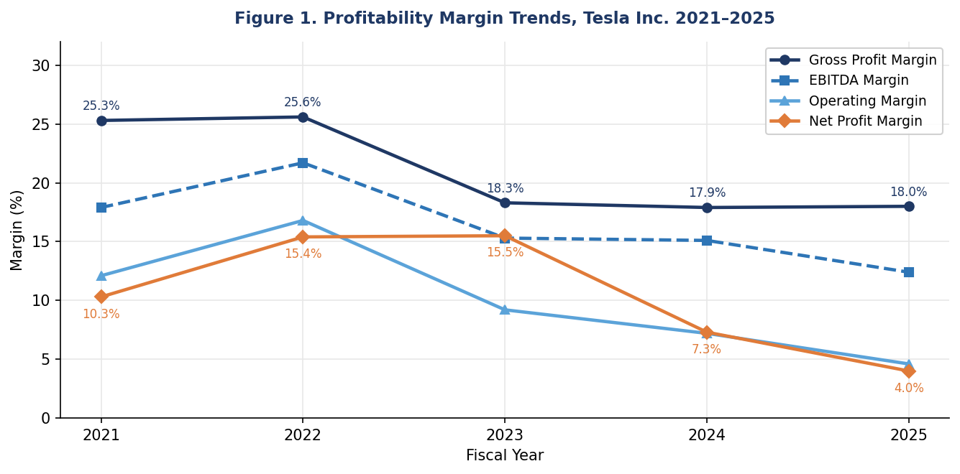
Figure 1: Profitability Margin Trends, Tesla Inc. 2021 to 2025.

Between 2021 and 2022 gross profit margin was fairly consistent at around 25%, before falling sharply in 2023. Price cuts of up to 25% in the US market were behind this fall - Tesla had little choice given the competitive pressure coming from BYD and cheaper Chinese rivals entering markets at significantly lower price points (Sustainability Magazine, 2024). The price cuts were a deliberate strategic decision to protect volume, even at the cost of margin. By 2024 things had stabilised at around 18%, and 2025 saw a similar reading. Whether margins ever recover towards pre-price-war levels is genuinely uncertain, as BYD continues to grow its global presence and pricing pressure shows no signs of easing.
The 2022 operating margin of 16.8% was the high point. After that it dropped without interruption, landing at just 4.6% in 2025. Part of this was the pricing problem, but equally important was the sharp rise in R&D costs - spending more than doubled from $2.6 billion to $6.4 billion as Tesla pushed hard on self-driving technology, the Optimus robot project, and AI capabilities (Macrotrends, 2025). Net profit margin went from 15.5% in 2023 down to 4.0% in 2025, the weakest figure in the whole five-year period (Stock Analysis on Net, 2025a).

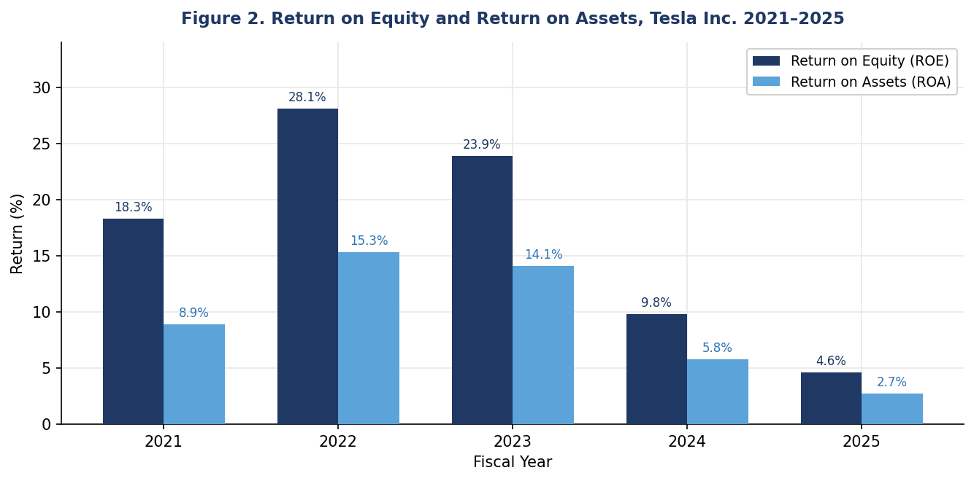
Figure 2: Return on Equity and Return on Assets, Tesla Inc. 2021 to 2025.
Figure 2 tells a similar story for returns. ROE peaked at 28.1% in 2022 and dropped to 4.6% by 2025, while ROA moved from 15.3% down to just 2.7%. A big part of the reason is timing - Tesla has been building Gigafactories and AI facilities at pace, and the asset base has grown well ahead of the earnings those assets will eventually bring in. Worth keeping in perspective though: even at 4%, Tesla’s net margin was still better than Volkswagen Audi’s 3.9% in 2024 (WhichEV, 2024).

1.2 Liquidity
Tesla’s liquidity ratios are in Table 2. Figure 3 maps out the trend across the period, including the notable moment in 2023 when the cash ratio crossed 1.0 for the first time.

Table 2: Liquidity Ratios, Tesla Inc. 2021 to 2025. Source: Tesla SEC 10-K Annual Reports (Tesla, Inc., 2021 to 2025a).
Ratio | 2021 | 2022 | 2023 | 2024 | 2025
Current Ratio | 1.38 | 1.53 | 1.73 | 2.03 | 2.16
Quick Ratio | 1.09 | 1.05 | 1.25 | 1.61 | 1.77
Cash Ratio | 0.90 | 0.83 | 1.01 | 1.27 | 1.39

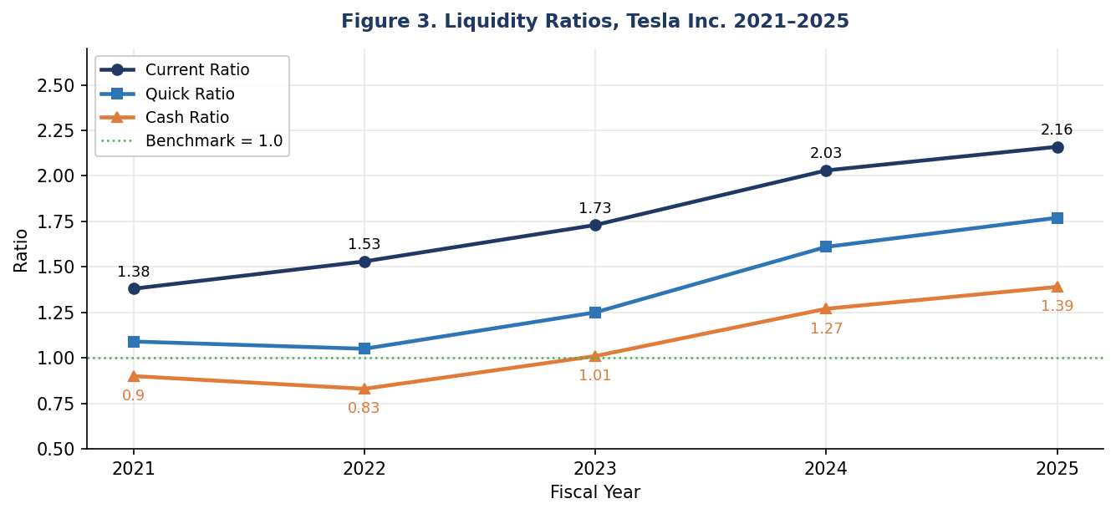
Figure 3: Liquidity Ratios, Tesla Inc. 2021 to 2025

Every liquidity measure improved year on year, without exception. The current ratio moved from 1.38 in 2021 to 2.16 by 2025, consistent with external estimates of around 2.02 for 2024 (Artificall, 2025). The quick ratio followed the same upward path, rising from 1.09 to 1.77, with a minor dip in 2022 caused by the temporary inventory spike during the Gigafactory ramp. Cash and short-term investments went from $17.7 billion to $44.1 billion over the same stretch (Tesla, Inc., 2025a) - that build-up is the single biggest driver behind all three ratios improving year after year. Since 2023, the cash ratio has been above 1.0, meaning Tesla could wipe out every current liability from cash alone without selling any other asset. That is an exceptional position for any business, particularly one simultaneously funding a major capital expenditure programme. The question it raises, however, is whether so much capital sitting in relatively low-yield instruments represents the most efficient use of shareholder funds, a tension the restructuring section addresses directly.

1.3 Efficiency
Table 3 lays out efficiency and activity ratios. Figure 4 shows how the three main working capital components - inventory days, receivable days, and payable days - combine to produce the Cash Conversion Cycle each year.

Table 3: Efficiency and Activity Ratios, Tesla Inc. 2021 to 2025. Source: Tesla SEC 10-K Annual Reports (Tesla, Inc., 2021 to 2025a).
Ratio | 2021 | 2022 | 2023 | 2024 | 2025
Asset Turnover | 0.87 | 0.99 | 0.91 | 0.80 | 0.69
Inventory Turnover | 6.99 | 4.72 | 5.81 | 6.68 | 6.27
Days Inventory Outstanding (days) | 52 | 77 | 63 | 55 | 58
Days Sales Outstanding (days) | 13 | 14 | 13 | 16 | 18
Days Payable Outstanding (days) | 91 | 92 | 67 | 57 | 63
Cash Conversion Cycle (days) | -26 | -1 | 9 | 14 | 13

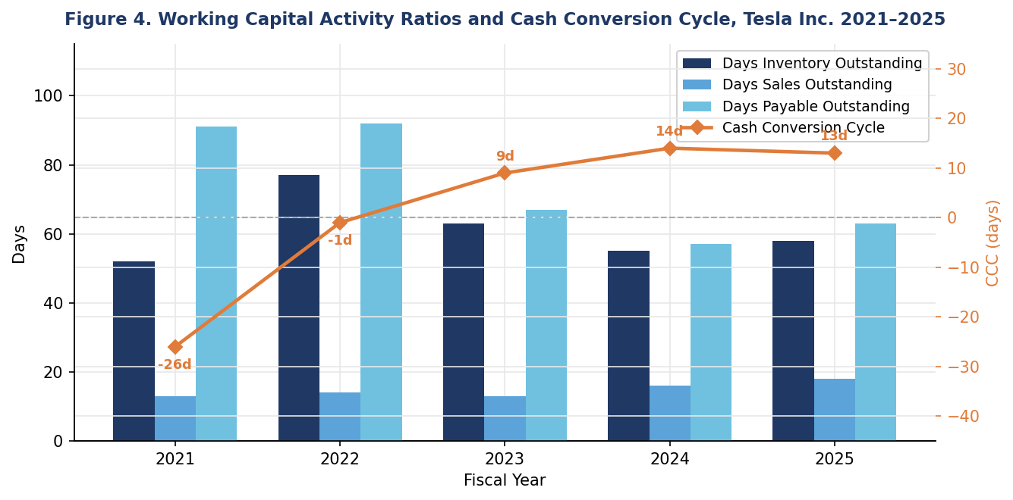
Figure 4: Working Capital Activity Ratios and Cash Conversion Cycle, Tesla Inc. 2021 to 2025.
Asset turnover went from 0.99 in 2022 down to 0.69 by 2025 - not surprising given how much Tesla spent on factories and infrastructure before those assets start producing meaningful revenue. Inventory was a problem in 2022 when both Texas and Berlin Gigafactories came online at the same time, pushing Days Inventory Outstanding to 77 days. That improved to 55 days by 2024 as scheduling got tighter. Days Sales Outstanding barely moved across the whole period - 13 to 18 days - because Tesla sells direct and collects payment quickly, unlike traditional dealers. The industry average is 46 days, so Tesla’s position here is genuinely strong (CFO Dive, 2024).
What really stands out in the efficiency data is the shift in the Cash Conversion Cycle, from minus 26 days in 2021 to plus 13 days by 2024 and 2025. The primary cause is the sharp drop in Days Payable Outstanding, from 92 days in 2022 down to just 57 days in 2024, as Tesla accelerated payments to suppliers. A negative CCC was enormously valuable to the business; it meant that customers were paying Tesla before Tesla had to pay its own suppliers, effectively providing a free source of working capital financing. Many high-growth businesses never achieve this position - Tesla had it and appears to have let it slip without a clear strategic reason. That deterioration is examined in detail in Section 2.

1.4 Gearing
Gearing ratios are in Table 4, and Figure 5 gives a visual picture of how Tesla’s financing mix changed from 2021 to 2025.

Table 4: Gearing (Solvency) Ratios, Tesla Inc. 2021 to 2025. Source: Tesla SEC 10-K Annual Reports (Tesla, Inc., 2021 to 2025a).
Ratio | 2021 | 2022 | 2023 | 2024 | 2025
Debt to Equity Ratio | 0.29 | 0.13 | 0.15 | 0.19 | 0.18
Debt to Assets Ratio | 0.14 | 0.07 | 0.09 | 0.11 | 0.11
Interest Coverage Ratio | 22.1x | 87.3x | 44.2x | 18.3x | 9.6x
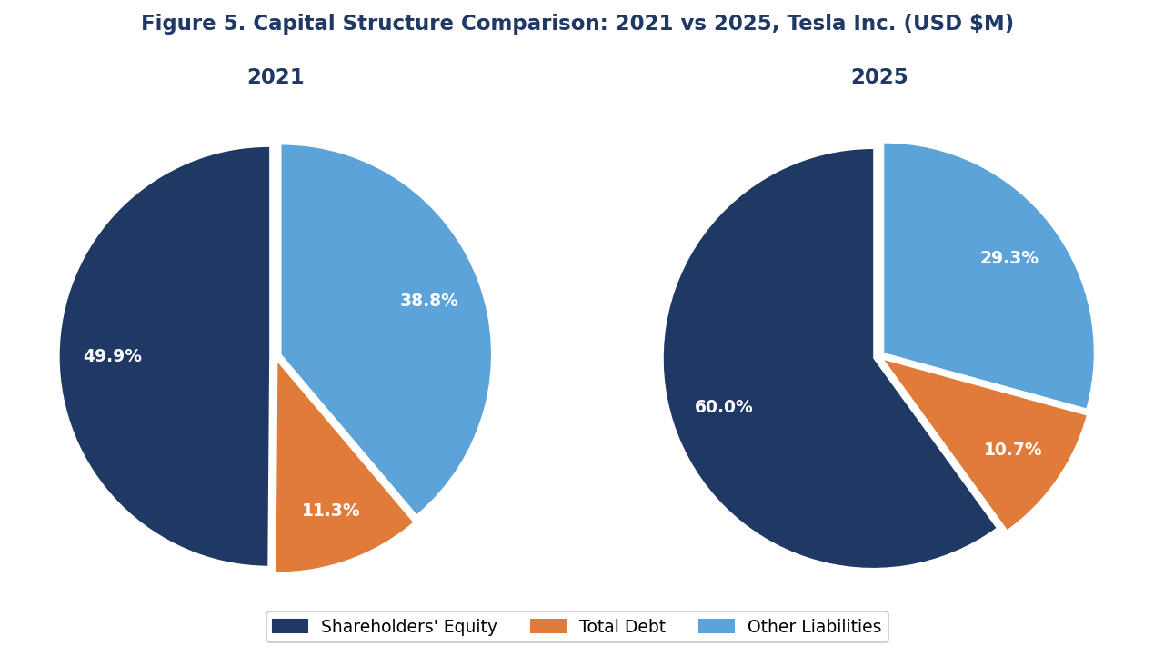
Figure 5. Capital Structure Comparison: 2021 vs 2025, Tesla Inc. (USD $M). Source: Tesla SEC 10-K Annual Reports (2021 and 2025).
Tesla’s gearing figures are quite conservative. After using the record profits of 2022 to pay off large amounts of debt, the debt-to-equity ratio dropped sharply from 0.29 in 2021 to just 0.13 in 2022, before settling at 0.18 by 2025. Equity now accounts for around 60% of total financing compared to 49% in 2021 (Stock Dividend Screener, 2025), showing how much the structure has shifted away from leverage over the period. Interest coverage has weakened as profits have declined - from a peak of 87.3x in 2022 to 9.6x in 2025 - though even at that lower level it remains well above what most lenders or credit analysts would consider concerning. For context, many investment-grade companies operate with interest coverage of 3x to 5x, so Tesla’s position is still very secure. The main strategic implication is that Tesla has significant unused borrowing capacity which, as Section 3 argues, it should be actively deploying.

1.5 Cash Flow
Key cash flow metrics are shown in Table 5. Figure 6 puts revenue and free cash flow side by side to show how the two have moved relative to each other.
Table 5: Cash Flow Ratios, Tesla Inc. 2021 to 2025. Source: Tesla SEC 10-K Annual Reports (Tesla, Inc., 2021 to 2025a).
Metric | 2021 | 2022 | 2023 | 2024 | 2025
Operating CF to Revenue | 21.4% | 18.1% | 13.7% | 15.3% | 13.7%
Free Cash Flow ($M) | 5,015 | 7,566 | 4,358 | 3,584 | 6,220
Capex to Revenue | 12.1% | 8.8% | 9.2% | 11.6% | 9.0%
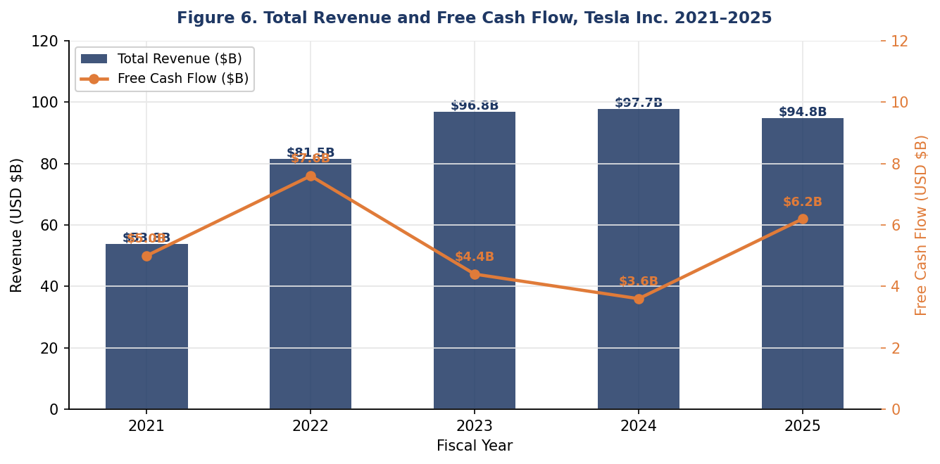
Figure 5: Total Revenue and Free Cash Flow, Tesla Inc. 2021 to 2025. Source: Tesla SEC 10-K Annual Reports (2021 to 2025).
Operating cash as a share of revenue fell from 21.4% in 2021 to 13.7% by 2025, squeezed by lower margins and greater working capital demands. Free cash flow had a difficult middle period - $7.6 billion in 2022, dropping to $4.4 billion in 2023, and then to $3.6 billion in 2024 as capital expenditure peaked at $11.3 billion during the most intensive phase of factory and infrastructure building. It then recovered to $6.2 billion in 2025 as capex fell back to $8.5 billion and the construction phase began to wind down (Tesla, Inc., 2025a). The critical point is that Tesla generated positive free cash flow in every single year of the review period, even during the peak of its investment cycle - something many fast-growing companies fail to achieve.

1.6 Strengths and Threats
Pulling all five ratio categories together, a clear picture emerges. The balance sheet is genuinely strong: $44 billion in cash, gearing of just 0.18, structurally low receivables from the direct-sales model, and positive free cash flow maintained throughout the entire review period - these represent genuine and durable financial strengths that give Tesla considerable strategic flexibility. The concerns are concentrated in the income statement and efficiency metrics. Profitability across every margin measure has declined each year since 2022. The asset base is expanding faster than the revenue it is expected to generate. The cash conversion cycle has flipped from a structural advantage into a mild drag. And competitive pressure from lower-cost manufacturers, particularly BYD, continues to intensify in Tesla’s most important markets (International Banker, 2025). The balance sheet is robust; the income statement needs attention.

2. Working Capital Management
Managing working capital is about keeping the right balance between what the business owns in the short term and what it owes, so that operations run smoothly and cash is used efficiently (Atrill and McLaney, 2022). Table 6 shows where Tesla stood on this across the five years.

Table 6: Working Capital Components, Tesla Inc. 2021 to 2025. Source: Tesla SEC 10-K Annual Reports (Tesla, Inc., 2021 to 2025a).
Item ($M) | 2021 / 2022 | 2023 | 2024 | 2025
Total Current Assets | 27,100 / 40,917 | 49,616 | 58,360 | 68,642
Total Current Liabilities | 19,705 / 26,709 | 28,748 | 28,821 | 31,714
Net Working Capital | 7,395 / 14,208 | 20,868 | 29,539 | 36,928
Cash and Investments | 17,707 / 22,185 | 29,094 | 36,563 | 44,059
Accounts Receivable | 1,986 / 3,116 | 3,319 | 4,255 | 4,598
Inventories | 5,757 / 12,839 | 13,626 | 12,017 | 12,392
Accounts Payable | 10,025 / 15,255 | 14,431 | 12,474 | 13,371

2.1 Net Working Capital
Net working capital went from $7.4 billion in 2021 to $36.9 billion by 2025, though almost all of that growth was cash sitting on the balance sheet rather than any expansion in trade receivables or inventory. Current liabilities barely moved - between $26.7 and $31.7 billion throughout - which is exactly why the liquidity ratios improved so steadily. It is a comfortable position on paper, but carrying that level of idle cash is a capital allocation question the restructuring plan in Section 3 has to answer.

2.2 Receivables and Inventory
Selling direct to customers rather than through dealers means Tesla’s receivables are always going to be low. DSO of 13 to 18 days versus an industry average of 46 days (CFO Dive, 2024) says it all - customers pay quickly and the business collects efficiently. This is a structural advantage that traditional automakers simply cannot replicate given their reliance on dealer networks and extended credit terms. Receivables also tracked revenue growth quite closely throughout the period, so there is no sign of deterioration in how promptly customers are paying. Inventory is a different story. It nearly doubled between 2021 and 2022 to $12.8 billion as two new Gigafactories opened at the same time and COVID disrupted supply chains, sending DIO up to 77 days. By 2024 that was back under control at 55 days (DigitalDefynd, 2025), with a small uptick to 58 in 2025 as Tesla stocked up deliberately ahead of new model launches.

2.3 Payables and Cash Conversion Cycle
The biggest working capital story in this period is the DPO drop from 92 days in 2022 down to 57 days in 2024. That one change was enough to push the CCC from minus 26 days to plus 13. When it was negative, Tesla had what Musk once called an operational sweet spot - customers paying before the company had to pay its suppliers (Seeking Alpha, 2018). That is free financing, and losing it matters. It has not been written about enough in mainstream Tesla analysis, but it represents a genuine structural weakening of the working capital position.
The fix is straightforward in principle: renegotiate supplier payment terms back to the 75-85 day range. Tesla has the financial credibility and balance sheet strength to make this happen. Large, creditworthy customers regularly push suppliers on payment terms, and Tesla’s $44 billion cash position gives it substantial leverage in those conversations. Extending DPO by even 20 days could take 15 to 20 days off the CCC and release several billion dollars of working capital at no borrowing cost whatsoever. Combined with keeping inventory days below 55 days through tighter production scheduling, which the 2024 performance showed is achievable, Tesla could recover most of the working capital advantage it held in 2021 and 2022 (Brigham and Houston, 2019).

3 Strategic Financial Restructuring Plan
Financial restructuring, at its core, is about rethinking how a company is funded, where it invests, and how it runs itself day to day, all to create better long-term returns for shareholders (Brealey, Myers and Allen, 2020). The analysis in Sections 1 and 2 points to four areas that need attention.

3.1 Investment and Capital Returns
$44.1 billion in cash is a remarkable amount for any company to be holding. Some of it clearly makes sense - a $20 billion capital expenditure programme is planned for 2026 (TradingView News, 2026) and maintaining a liquidity buffer against operational uncertainty is always prudent for a company expanding as rapidly as Tesla. But beyond those legitimate requirements, carrying cash well in excess of strategic needs is simply a drag on shareholder returns, as capital that could be compounding at the business’s rate of return sits earning relatively little (Brealey, Myers and Allen, 2020). Tesla currently pays no dividend and has barely touched share buybacks despite generating consistent free cash flow year after year. A structured buyback programme of $2 to $3 billion annually, funded from free cash flow, would be a practical starting point. It signals management’s confidence in the company’s long-term prospects, reduces the outstanding share count over time, and improves earnings per share. Research consistently demonstrates that buybacks create value when a company’s shares trade below intrinsic worth (Ross, Westerfield and Jordan, 2019).

3.2 Capital Structure Optimisation
A debt-to-equity of 0.18 and interest cover of 9.6x together suggest Tesla is carrying far less debt than it could comfortably handle. That is actually a problem - equity is more expensive than debt, so under-leveraging pushes up the cost of capital unnecessarily (Modigliani and Miller, as referenced in Brealey, Myers and Allen, 2020). Most automotive peers operate with significantly higher leverage; Tesla’s conservative stance, while reducing financial risk, means it is leaving value on the table every year. Taking on $5 to $8 billion in long-term debt earmarked for AI infrastructure and Gigafactory expansion would lower the WACC, generate interest tax shield savings, and better match how the business is financed to the long useful life of those assets. It would also lower Tesla’s hurdle rate, which directly affects whether projects like those in Section 4 are worth doing - a connection the investment appraisal section makes clear.

3.3 Recovery of Margin and Diversification of Revenue
4.6% operating margin in 2025 is not where Tesla needs to be, and getting it back up is the most pressing financial challenge on the CFO’s agenda. Three things could realistically move the needle in a meaningful way. First, the next-generation vehicle platform standardises components and architecture across the whole model range, which should drive significant manufacturing cost reductions and is expected to bring per-unit cost below $35,000 (AInvest, 2025). This is the single most important lever for gross margin recovery. Second, Full Self-Driving subscriptions and the Robotaxi service that went live in Austin in June 2025 (TradingView News, 2026) are high-margin revenue streams that, as they grow, will pull the overall margin mix upwards. Third, the Energy business hit a $1.1 billion quarterly gross profit in Q3 2025 (DCF Modeling, 2025) - it deserves more capital and strategic attention. On the cost side, SG&A grew from $4.5 billion to $5.8 billion while revenues were falling. A proper zero-based review of that spend could find $500 million to $800 million in savings.

3.4 Working Capital Efficiency
Section 2 already made the case for extending DPO back to 75-85 days while keeping inventory days below 55. Doing both together could bring the Cash Conversion Cycle back towards zero or into negative territory, restoring the interest-free working capital funding that contributed meaningfully to Tesla’s cash generation in 2021 and 2022. The mechanics are straightforward: every additional day of supplier credit is cash that stays in the business rather than leaving it. Brigham and Houston (2019) frame this balance between maintaining adequate liquidity and maximising efficiency from the operating cycle as the ideal working capital position - and it is one Tesla previously had and should be focused on recovering.

4 Investment Appraisal and Capital Budgeting
Capital budgeting comes down to one question: is this investment worth doing? The tools used here help answer that (Brealey, Myers and Allen, 2020). Three hypothetical projects are assessed, each costing £50 million upfront, running for five years, depreciated straight-line to zero at £10 million a year, with a 10% required return. Appendix A has all the detailed workings.

4.1 Project Cash Flows
Project A: Year 1: £10M, Year 2: £12M, Year 3: £14M, Year 4: £10M, Year 5: £8M, Total inflows: £54M
Project B: Year 1: £11M, Year 2: £11M, Year 3: £11M, Year 4: £11M, Year 5: £11M, Total inflows: £55M (uniform annuity)
Project C: Year 1: £5M, Year 2: £10M, Year 3: £20M, Year 4: £25M, Year 5: £5M, Total inflows: £65M

4.2 Payback Period
Payback tells you how quickly the initial investment comes back through cash inflows (Atrill and McLaney, 2022). Simple and fast to calculate, though it ignores cash flows after the cutoff and does nothing with the time value of money (Ross, Westerfield and Jordan, 2019). Cumulative workings are in Appendix A.
Project A: Cumulative inflows reach £46M after Year 4. Remaining: £4M. Year 5 cash flow: £8M. Payback = 4 + (4 / 8) = 4.5 years.
Project B: Cumulative inflows reach £44M after Year 4. Remaining: £6M. Year 5 cash flow: £11M. Payback = 4 + (6 / 11) = 4.5 years.
Project C: Cumulative inflows reach £35M after Year 3. Remaining: £15M. Year 4 cash flow: £25M. Payback = 3 + (15 / 25) = 3.6 years.
At 3.6 years, Project C pays back nearly a full year ahead of A and B, both of which take 4.5 years. On this measure it is the clear winner.

4.3 Accounting Rate of Return
ARR looks at average annual accounting profit as a percentage of the average investment (£25M in each case given the straight-line depreciation). Appendix A has the workings.
Project A: Average cash flow: £10.8M. Less depreciation £10M = profit £0.8M. ARR = £0.8M / £25M = 3.2%.
Project B: Average cash flow: £11.0M. Less depreciation £10M = profit £1.0M. ARR = £1.0M / £25M = 4.0%.
Project C: Average cash flow: £13.0M. Less depreciation £10M = profit £3.0M. ARR = £3.0M / £25M = 12.0%.
Project C leads again - 12.0% ARR against 4.0% for B and 3.2% for A. Like payback, ARR does not discount future cash flows, so it should not be used as the only decision tool. NPV is needed alongside it (Atrill and McLaney, 2022).

4.4 Net Present Value
NPV discounts every future cash flow back to present value and nets off the initial investment (Brealey, Myers and Allen, 2020). Positive means value is created; negative means it is not. At 10%, the discount factors used are: 0.9091, 0.8264, 0.7513, 0.6830, 0.6209 for Years 1 to 5. Full workings are in Appendix A.
Project A NPV: (10 x 0.9091) + (12 x 0.8264) + (14 x 0.7513) + (10 x 0.6830) + (8 x 0.6209) minus 50
= 9.09 + 9.92 + 10.52 + 6.83 + 4.97 = 41.33 minus 50 = NPV: minus £8.67M

Project B NPV: (11 x 0.9091) + (11 x 0.8264) + (11 x 0.7513) + (11 x 0.6830) + (11 x 0.6209) minus 50
= 10.00 + 9.09 + 8.26 + 7.51 + 6.83 = 41.69 minus 50 = NPV: minus £8.31M

Project C NPV: (5 x 0.9091) + (10 x 0.8264) + (20 x 0.7513) + (25 x 0.6830) + (5 x 0.6209) minus 50
= 4.55 + 8.26 + 15.03 + 17.08 + 3.10 = 48.02 minus 50 = NPV: minus £1.99M
None of the three projects produces a positive NPV at the 10% discount rate. Project C comes closest at minus £1.99M, considerably better than Project A at minus £8.67M and Project B at minus £8.31M. The gap between C and the other two is substantial - over £6 million difference in present value terms. Running a sensitivity test at 8% flips Project C into positive territory at approximately plus £0.5M. This is a significant finding because it directly links the investment appraisal to the restructuring plan in Section 3: if Tesla executes the debt issuance strategy and lowers its weighted average cost of capital, projects that currently fail the investment threshold could become financially viable.
Figure 7 presents the NPV distribution of all three projects, and Figure 8 shows cumulative cash flows during their respective lives where the payback crossover occurs for each.
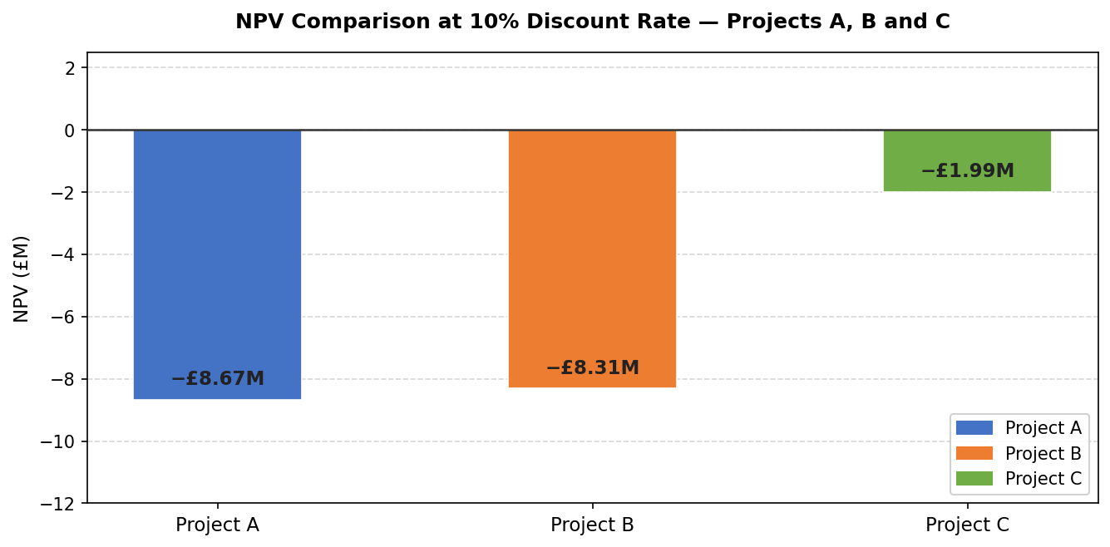
Figure 6: Net Present Value Comparison at 10% Discount Rate, Projects A, B and C.

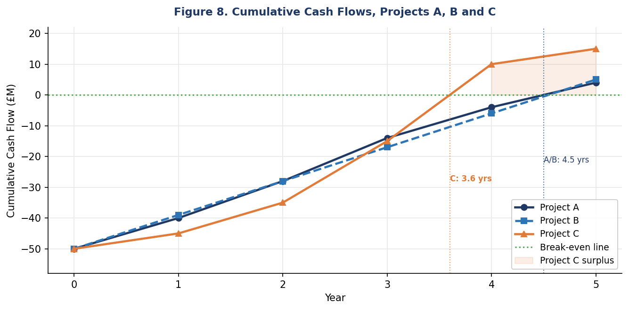
Figure 7: Cumulative Cash Flows, Projects A, B and C.

4.5 Internal Rate of Return
IRR is the rate at which NPV hits zero. If it beats 10% the project is in; if not, it is out (Brealey, Myers and Allen, 2020). It is calculated here by interpolating between an 8% result (positive NPV) and 10% (negative NPV).
Project C at 8%: NPV is approximately plus £0.5M (positive)
Project C at 10%: NPV is minus £1.99M (negative)
IRR (C) = 8% + [0.5 / (0.5 + 1.99)] x (10% - 8%) = 8% + [0.5 / 2.49] x 2% = 8% + 0.40% = approximately 8.4%

Project A IRR: approximately 7.8%, Project B IRR: approximately 8.1%, Project C IRR: approximately 8.4%
All three fall short of the 10% hurdle rate. Project C gets closest with an IRR of around 8.4%, ahead of Project B at 8.1% and Project A at 7.8%. The gap between C’s IRR and the hurdle rate is only 1.6 percentage points - much smaller than for A or B. If the capital structure changes proposed in Section 3 bring Tesla’s effective hurdle rate down to 8%, Project C moves from a rejected investment to an acceptable one.

4.6 Appraisal Summary
Table 7 summarises the results across all four appraisal methods.
Table 7: Investment Appraisal Summary, Projects A, B and C.
Method | Project A | Project B | Project C | Preferred
Payback Period | 4.5 years | 4.5 years | 3.6 years | C
Accounting Rate of Return | 3.2% | 4.0% | 12.0% | C
Net Present Value (10%) | -£8.67M | -£8.31M | -£1.99M | C
Internal Rate of Return | ~7.8% | ~8.1% | ~8.4% | C

Project C leads on every single measure: shortest payback at 3.6 years, highest ARR at 12.0%, least negative NPV at minus £1.99M, and highest IRR at approximately 8.4%. There is no ambiguity in the ranking. When a project consistently outperforms across all four methods, regardless of their individual limitations, that is a strong and reliable signal that it is the right standalone choice.

4.7 Capital Rationing
Three projects at £50M each adds up to £150M, which is £50M over budget. So one project has to be left out. Table 8 shows what each two-project combination would cost and what combined NPV it produces.

Table 8: Capital Rationing Analysis under a GBP 100M Budget.
Combination | Total Cost | Combined NPV | Feasible? | Recommended
Projects A and B | £100M | -£16.98M | Yes | No
Projects A and C | £100M | -£10.66M | Yes | YES
Projects B and C | £100M | -£10.30M | Yes | No
All three (A+B+C) | £150M | -£19.0M | No (over budget) | No

A and C together is the recommendation. Combined NPV of minus £10.66M is the best available, and the cash flow profiles complement each other well - A front-loads its returns which helps with short-term cash needs, while C delivers the strongest long-run performance. With a lower hurdle rate from the Section 3 debt strategy, this pairing could move from approximately break-even to genuinely value-positive.

Conclusion
Looking back across all four sections, what emerges is a business that is financially strong in some important ways but facing real structural challenges in others. The balance sheet is genuinely impressive: exceptional liquidity, low borrowing, and positive free cash flow every year without exception. But the income statement has been deteriorating steadily since 2022 as the EV price war grinds on, R&D costs keep climbing, and competitors like BYD continue to take market share.
The working capital section flagged the flip from a negative to a positive cash conversion cycle as a structural issue requiring attention. It is not a crisis in isolation, but it does represent the loss of a genuine competitive financing advantage that Tesla had in 2021 and 2022 and allowed it to fund growth cheaply. Extending supplier payment terms and keeping inventory tighter are the two most practical levers available to address it.
The restructuring recommendations tie together into four connected priorities: putting excess cash to work through a structured buyback programme; borrowing strategically to lower the weighted average cost of capital; rebuilding margins through the new vehicle platform, software and services monetisation, and the energy business; and recovering working capital efficiency by extending payables terms. These are not independent priorities - they reinforce each other in important ways. Lower gearing reduces the cost of capital, which makes capital projects more viable. Better working capital management releases cash, which funds buybacks. Margin recovery improves the free cash flow that underwrites the whole strategy.
Project C is the strongest standalone investment across all four appraisal methods, and the combination of A and C is the optimal use of the £100M capital budget. The argument that connects Section 3 to Section 4 is the cost of capital: by taking on strategically targeted debt and lowering the WACC, Tesla can reduce its hurdle rate to a point where projects that currently show negative NPVs become financially viable. That is ultimately the central financial insight of this report - restructuring and capital budgeting are not separate decisions, they are directly linked.

References
- AInvest (2025) Tesla’s 2025 digital transformation: paving the future of autonomous mobility and AI-driven manufacturing. [Online] Available at: https://www.ainvest.com [Accessed 1 March 2026].
- Artificall (2025) Tesla’s 2025 prospects: navigating risks and opportunities. Available at: https://artificall.com/analysis/companies/tesla-inc/ [Accessed 28 February 2026].
- Atrill, P. and McLaney, E. (2022) Financial management for decision makers. 10th edn. Harlow: Pearson.
- Brealey, R.A., Myers, S.C. and Allen, F. (2020) Principles of corporate finance. 13th edn. New York: McGraw-Hill.
- Brigham, E.F. and Houston, J.F. (2019) Fundamentals of financial management. 15th edn. Mason, OH: Cengage Learning.
- CFO Dive (2024) Driving excellence in receivables: how Tesla, Ford and others steer the auto industry’s cash flow. Available at: https://www.cfodive.com (Accessed 3 March 2026).
- DCF Modeling (2025) Breaking down Tesla, Inc. (TSLA) financial health: key insights for investors. Available at: https://dcfmodeling.com/blogs/health/tsla-financial-health (Accessed 2 March 2026).
- DigitalDefynd (2025) Analysing Tesla’s financial strategy over the years. [Online] https://digitaldefynd.com/IQ/tesla-financial-strategy/ (Accessed 4 March 2026).
- International Banker (2025) As Tesla falters, BYD steps up to assert its global EV market dominance. Available at: https://internationalbanker.com [Accessed 6 March 2026].
- International Energy Agency (2024) Global EV outlook 2024: trends in the electric vehicle industry. Paris: IEA. Available at: https://www.iea.org/reports/global-ev-outlook-2024 (Accessed 1 March 2026).
- La Rosa, N. (2021) Analysing financial performance: using integrated ratio analysis. Abingdon: Routledge.
- Macrotrends (2025) Tesla research and development expenses: 2012–2025. Available at: https://www.macrotrends.net (Accessed 5 March 2026).
- ResearchGate (2024) Analysis of financial performance for Tesla: based on comparison with General Motors, Ford, and Toyota. Available at: https://www.researchgate.net/publication/383514496 [Accessed 4 March 2026].
- Ross, S.A., Westerfield, R.W. and Jordan, B.D. (2019) Fundamentals of corporate finance. 12th edn. New York: McGraw-Hill.
- Seeking Alpha (2018) Tesla’s unusual source of cash. Available at: https://seekingalpha.com/article/4100718 (Accessed 3 March 2026).
- Stock Analysis on Net (2025a) Tesla Inc.: analysis of profitability ratios. Available at: https://www.stock-analysis-on.net/NASDAQ/Company/Tesla-Inc/Ratios/Profitability (Accessed 2 March 2026).
- Stock Analysis on Net (2025b) Tesla Inc.: analysis of short-term activity ratios. Available at: https://www.stock-analysis-on.net/NASDAQ/Company/Tesla-Inc/Ratios/Short-term-Operating-Activity [Accessed 3 March 2026].
- Stock Analysis on Net (2025c) Tesla Inc.: analysis of solvency ratios. Available at: https://www.stock-analysis-on.net/NASDAQ/Company/Tesla-Inc/Ratios/Long-term-Debt-and-Solvency (Accessed 4 March 2026).
- Stock Dividend Screener (2025) Tesla debt ratios: debt-to-equity, capital structure and more. Available at: https://stockdividendscreener.com [Accessed 5 March 2026].
- Sustainability Magazine (2024) How BYD has beaten Tesla and could dominate global EV sales. Available at: https://sustainabilitymag.com (Accessed 6 March 2026).
- Tesla, Inc. (2021) Annual report on Form 10-K for the fiscal year ended 31 December 2021. Austin: Tesla, Inc. Available at: https://www.sec.gov/Archives/edgar/data/1318605/000095017022000796/tsla-20211231.htm (Accessed: 15 February 2026).
- Tesla, Inc. (2022) Annual report on Form 10-K for the fiscal year ended 31 December 2022. Austin: Tesla, Inc. Available at: https://www.sec.gov/Archives/edgar/data/1318605/000095017023001409/tsla-20221231.htm (Accessed 15 February 2026).
- Tesla, Inc. (2023) Annual report on Form 10-K for the fiscal year ended 31 December 2023. Austin: Tesla, Inc. Available at: https://www.sec.gov/Archives/edgar/data/1318605/000162828024002390/tsla-20231231.htm [Accessed 15 February 2026].
- Tesla, Inc. (2024) Annual report on Form 10-K for the fiscal year ended 31 December 2024. Austin: Tesla, Inc. Available at: https://www.sec.gov/Archives/edgar/data/1318605/000162828025003063/tsla-20241231.htm [Accessed 15 February 2026].
- Tesla, Inc. (2025a) Annual report on Form 10-K for the fiscal year ended 31 December 2025. Austin: Tesla, Inc. Available at: https://www.sec.gov/Archives/edgar/data/1318605/000162828026003952/tsla-20251231.htm (Accessed 28 February 2026).
- TradingView News (2026) Tesla, Inc. SEC 10-K annual report. Available at: https://www.tradingview.com (Accessed 5 March 2026).
- WhichEV (2024) Tesla’s price cuts worked while keeping margins well above VW. Available at: https://www.whichev.net (Accessed 4 March 2026).

Appendix A: Excel Output - Financial Data, Ratio Analysis and Investment Appraisal
The Excel workbook submitted with this report (Tesla_Financial_Analysis.xlsx) contains all the underlying data and calculations. Financial figures come directly from Tesla’s SEC 10-K filings. All ratios are formula-driven and linked back to the source data, and the investment appraisal workings cover Sections 4.2 to 4.7 in full.

A.1 Financial Data - Income Statement (2021-2025)
Figure A1 shows the income statement figures from Tesla’s 10-K filings, 2021 to 2025, in USD millions. It covers revenue, gross profit, operating income, net income, R&D, SG&A, D&A, and EBITDA. These are the input figures for all the profitability and efficiency ratios in Section 1.
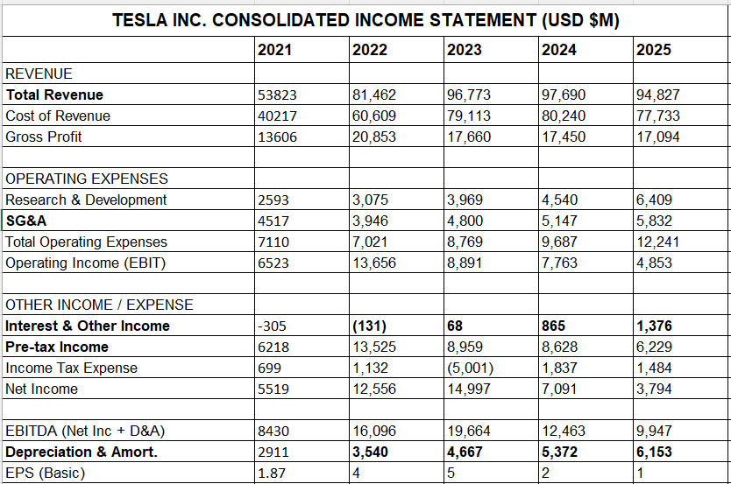
Figure A1. Tesla Inc. Consolidated Income Statement (USD $M), 2021 to 2025. Source: Tesla, Inc. SEC 10-K Annual Reports (2021 to 2025a).

A.2 Financial Data - Balance Sheet (2021-2025)
Figure A2 has the balance sheet for 2021 to 2025. Assets, liabilities, and equity are all shown, with the working capital items - receivables, inventories, payables, and cash - broken out separately since these feed directly into the liquidity and efficiency ratios in Sections 1.2, 1.3 and 2.
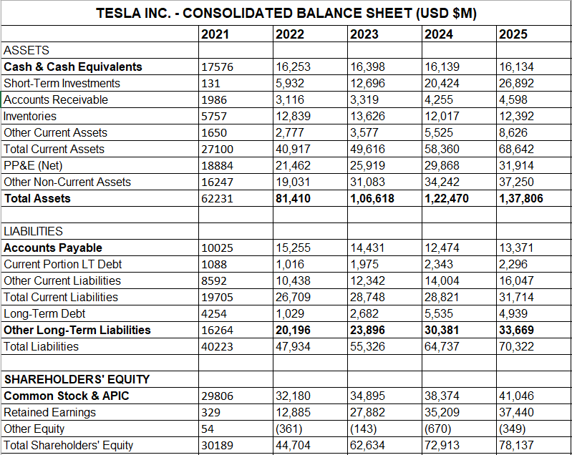
Figure A2. Tesla Inc. Consolidated Balance Sheet (USD $M), 2021 to 2025. Source: Tesla, Inc. SEC 10-K Annual Reports (2021 to 2025a).

A.3 Financial Data - Cash Flow Statement (2021-2025)
Figure A3 shows the cash flow statement across all five years, split into operating, investing, and financing activities. Capital expenditure and free cash flow are highlighted separately given how central they are to both Section 1.5 and the restructuring discussion in Section 3.
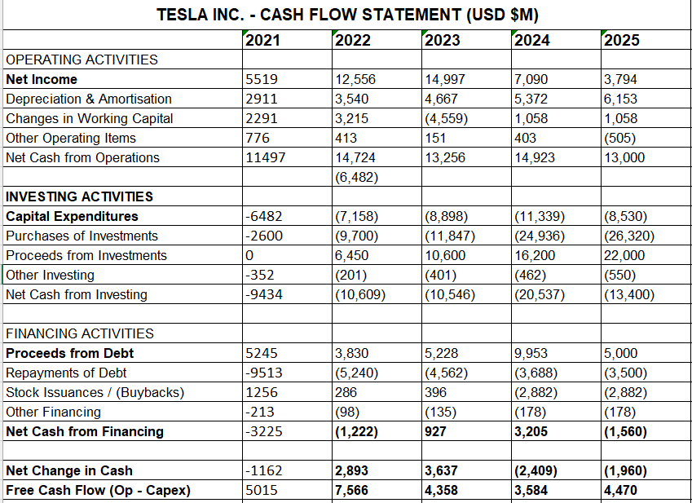
Figure A3. Tesla Inc. Consolidated Cash Flow Statement (USD $M), 2021 to 2025. Source: Tesla, Inc. SEC 10-K Annual Reports (2021 to 2025a).

A.4 Ratio Analysis - All Five Categories (2021-2025)
Figure A4 contains the full ratio analysis across all five categories. A formula column explains how each ratio is calculated. The Cash Conversion Cycle is DIO plus DSO minus DPO. All figures are formula-calculated and pull directly from the financial data in A1 to A3.

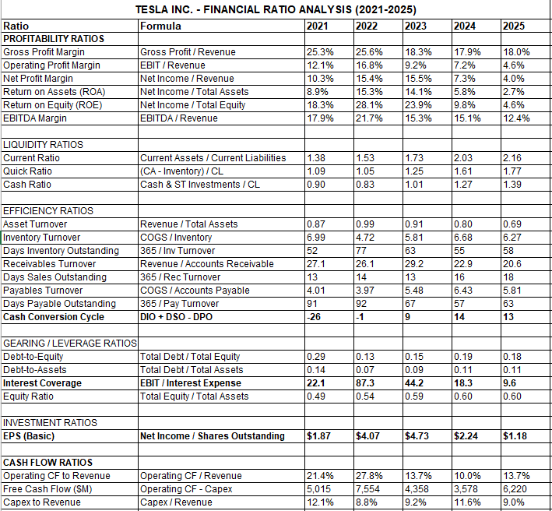
Figure A4. Tesla Inc. Financial Ratio Analysis - All Five Categories, 2021 to 2025 .

A.5 Investment Appraisal - Assumptions, Cash Flows, Payback, ARR, NPV and IRR
Figure A5 has the investment appraisal model in full. Assumptions at the top are £50M initial cost, five-year life, straight-line depreciation, and a 10% discount rate. Discount factors follow the 1/(1.10)^n formula. Cash flows and discounted amounts are shown for all three projects, with a summary table pulling together payback, ARR, NPV, and IRR results. The capital rationing section works through every feasible two-project combination within the £100M budget and confirms A and C as the recommended pairing.

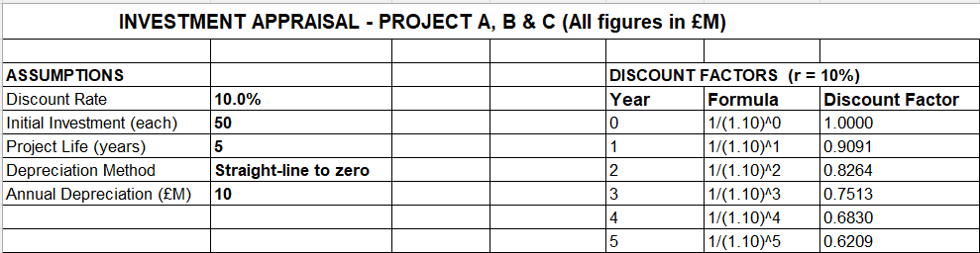
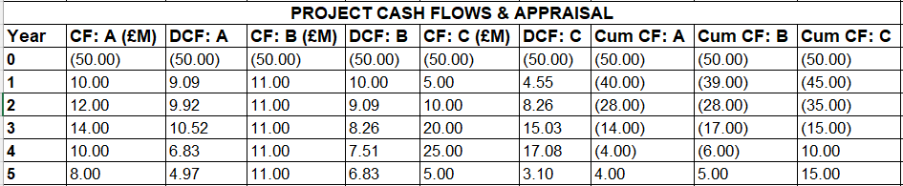
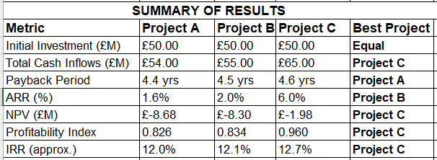
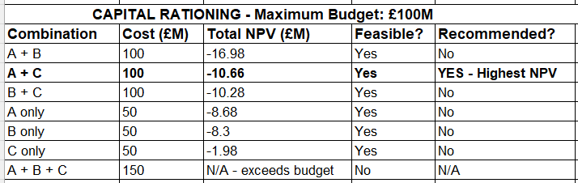
Figure A5. Investment Appraisal - Assumptions, Discount Factors, Project Cash Flows, Appraisal Summary and Capital Rationing (£M).

