Marketing Fundamentals

Individual Blog Post

Student: Rosiyana Domozetska
Student number: 2217516
Lecture: Marketing Fundamentals
LCBB4004
Lecture tutor: Tushara Balendran

In this blog, we will learn more about Asda Stores LTD. We are going to discuss the history of Asda as well as the 4 Ps of marketing – products, price, place and promotion.
Background /history of Asda
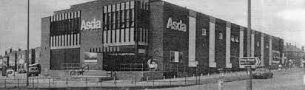
Asda is a supermarket group headquartered in Leeds United Kingdom.
The company was found in 1949 because of a merger of the Asquith Family’s retail business and the Associated Dairies Company of Yorkshire. During the 50s and early 60s Associated Dairies Company had expanded the number of pork butchery shops under the Farm Stores fascia. The son of Arthur Stockdale, Noel became the other co-founder of the future Asda.

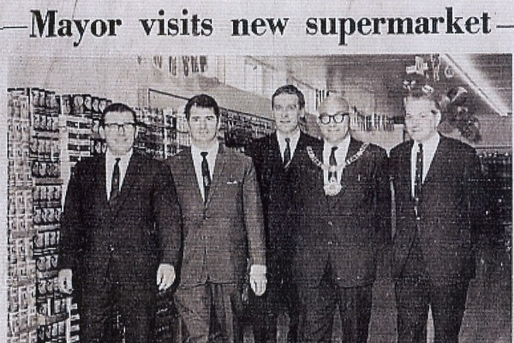

In 1958 Peter and Fred Asquith had opened their first store. Soon they sold it and travelled to the USA and visited Piggy Wiggly. It was the world’s first superstore, and they were so inspired. In 1963 they discovered the concept of food discounting which the customers loved, and they still do. At the same time the two brothers applied late-night shopping on Fridays, which was a first in retail and the customers were impressed.
In 1965 Peter Asquith began a fantastic retail partnership with Noel Stockdale at Associated Dairies.
Asquith+ Dairies=the birth of ASDA
Later in 1968 Peter Asquith introduced the very first discounted petrol filling station. It was a turning point in the history of the Asda shops.
In 1970 Asda had over 30 stores and in the 1977 over 80 stores.
George Davies was asked to produce a range of clothing for Asda in 1989. Clothes with their identity, high quality, and high value are offered in Asda. George brand was created and is very successful.
Another very important moment was in 1996 when the first pharmacy was open in Asda. Today Asda pharmacies offer services including free blood pressure checks, immunisations, and flu jabs .Asda show that the customers are important for them. Then the motto was created. Save money- live better.
In the modern life they started its online retail service: direct.asda.com.
In 2012 the first drive-thru ‘click collect’ was installed in Queensferry.
Asda celebrated its 50th birthday with 600th stores, which was great achievement.
In 2017 the company was named the lowest priced supermarket at the Grocer Gold Awards. Now the company is the 3rd position in the competition with Sainsbury’s.

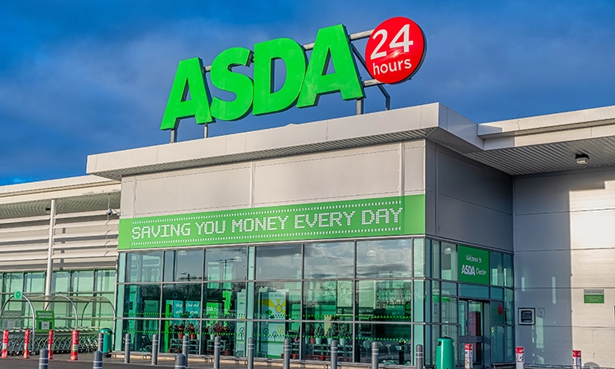
Products:
According to Kotler and Armstrong (2020) a product is anything that can be offered to market for attention use or consumption, that might satisfy a wants or needs. The different style and design, size, colour, and quality attract the customers. Asda offers 35000 different varieties of products. 60 per cent of them are food and beverage items. The company also provides a wide variety of products including fresh food, grocery, frozen and chilling food, health, and beauty products.
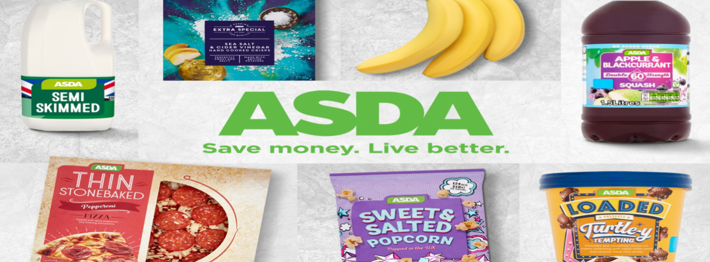
These own-label products give customers value for money as well as choice and variety. The company has over 100 products in vegan area.
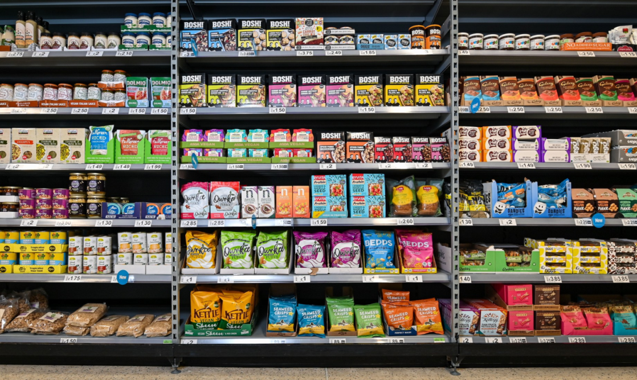
In now days many people rather be vegetarians, so Asda’s desire is to meet their needs.
Milk is a dairy product that everyone needs. The product is available in different package sizes, different oiliness, and different prices. The customers can choose what to buy.

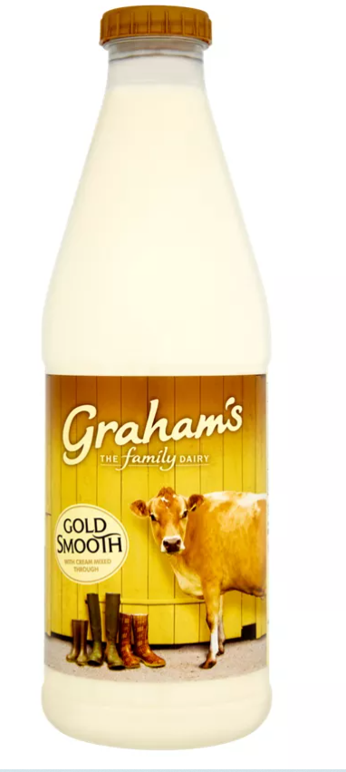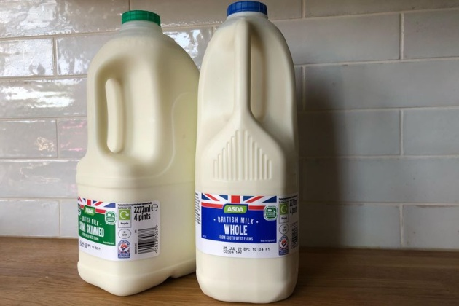
Footwear
Shoes are preferred products that people come to buy from Asda. There are so many
different models, sizes and variety. Sport shoes, boots, sandals for teenagers, man and women. There is something for everyone.
Find your favourite look from Asda’s wide range of stylish shoes. Collection with
Children’s boots school shoes and trainers.
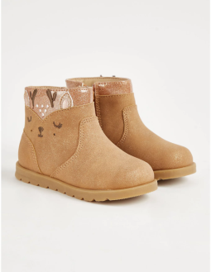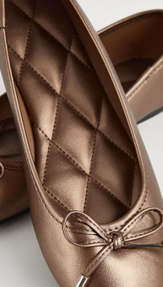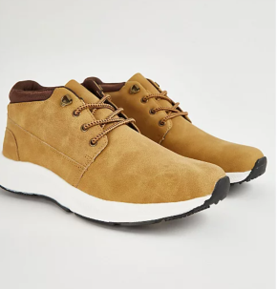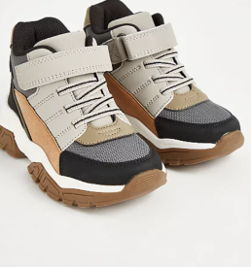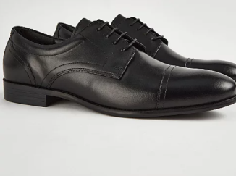
Complete your footwear collection with men’s leather shoes and men’s suede
shoes from George. The ideal option for office wear and special occasions can be found there. You can find many different varieties. Choose from women’s boots, trainers, casual and smart shoes. All our products offer fantastic quality and value.
To find more about our products you can click on the link below.
https://www.asda.com/.
Advantages of George products
- Well-known on the market.
All George products are well-known on the market. Over 85% of consumers buy clothes and shoes by George and make it the top supermarket fashion brand.
2. Good quality and style.
According to marketing literature, George has built up a reputation for Quality, style, and value.
3. Wide-range products. Their range includes boots, sandals, trainers, casual and smart shoes, Clothes like jeans, sweaters, T-shirts jackets and many more.
4. Keep up with fashion. George is kept last fashion trends on the market. In the shops you can discover the latest trends for men, women, and kids.
Price
As noted by Bishop,(2012) price is ‘the amount of money needed to buy products’.
Asda tries to keep good prices on the market. It used Smart Price, which is a range of
simple products, simple packaged at the right size and price to help you buy
everything on your shopping list. Also, you can choose the yellow sticker
bargains. Asda offer decent products at great value for money. You can buy milk
Asda Semi Skimmed Milk 4 pint--£ 1.65
Semi Skimmed Milk 2 pint -£ 1.30
Cravendale Filtered Fresh Semi Skimmed Milk 2l-£ 2.35 or 2 for £4
From George you can buy shoes from 4 to 40 pounds. Spend £25 save 20% gives you the option to buy more things.. The shop tries to keep prices lower.
- These shoes cost £36.

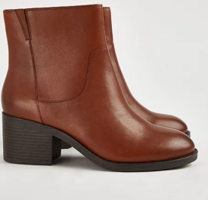

https://direct.asda.com/george/women/shoes/brown-leather-heeled-boots/GEM934566,default,pd.html?cgid=D1M1G20C20
- Man, shoes for £26
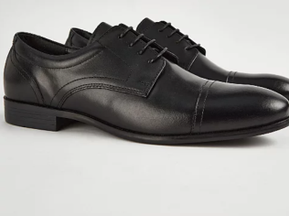

https://direct.asda.com/george/men/shoes/black-lace-up-smart-polished-shoes/GEM943256,default,pd.html?cgid=D2M1G10C13
- Children shoes for £16
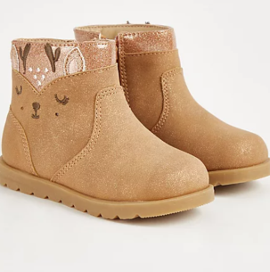
https://direct.asda.com/george/kids/shoes/first-walkers-brown-deer-print-boots/GEM937761,default,pd.html?cgid=D25M2G
Place and distribution:
In his book, Bishop,(2012) postulate that place is ‘the place where the product is located’. Adsa build its stores in very good locations to reach more customers.
Asda use both: direct and indirect channel of distribution. A direct distribution channel is one where a company sells directly to the consumers, through their stores. Indirect channel of distribution: producer- retailer- customers.
Asda has more than 600 stores, so it is easy to find them. It used direct and
indirect selling. The shops are located across the UK. Most of them are big stores and can be found easily.
Some of addresses are show below.
- Unit 4 Prospect Place, Dartford DA11DX London.
https://storelocator.asda.com/south-east/dartford/unit-4-prospect-place
- Asda BugsbyWay, Charlton SE7 7ST London
https://storelocator.asda.com/london/london/bugsby-way-charlton
- Asda Beckton Superstore,Tollgate Road,Beckton E6 5JP London
https://storelocator.asda.com/london/beckton/tollgate-road
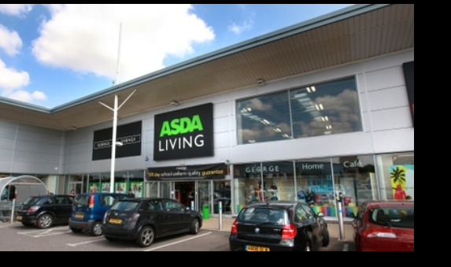

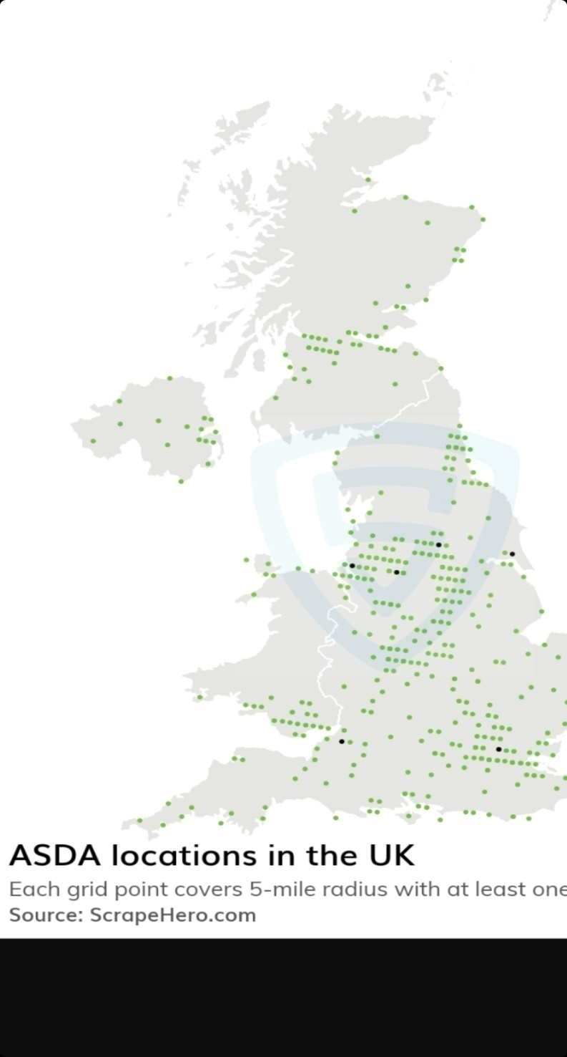
There are 632 ASDA retail stores in the United Kingdom as of November 14, 2022
The card shows the location of each store in the United Kingdom. As shown there
are more than 600 places from where customers can buy their products. Asda use
direct and indirect marketing strategies. Due to the customers changing taste and
busy life Asda offers the mobile app. https://groceries.asda.com/event/mobile-app
Asda mobile app.
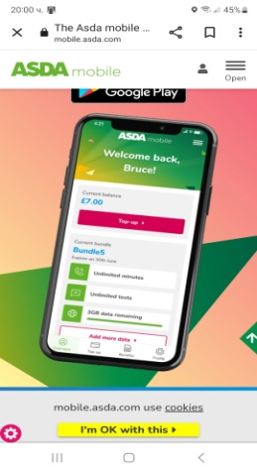
Asda is giving rewards when customers use their app. For example, when you do shopping thorugh their app you can receive X amount of money back. That depends on your spending.

Promotion:
This is one of the most important elements of Asda Marketing Strategy. Promotion or advertising according to Bishop, (2012) is process of making the product known. Our days there are many ways to promote a product or service.
Every business must promote their products and services to increase the sales and
profit in the company. Different companies use different types to promote them.
Asda use television, radio, social media and print advertising to inform
the customers for their products and offers.
Using TV advertising as a promotional strategy is more expensive but it can reach
mass market. During the last few years, the popularity of social media
marketing has raised significantly. Create apps for shopping can keep current and
potential customers.
Asda use her logo to keep the customers that their price is lower than the
competition. The slogan represents Asda’s mission of offering low prices on quality
products to its customers to help them live better lives.

To promote strong brand name and good reputation can bring more customers.
Asda also use Face book and You tube to promote their products.
https://www.facebook.com/Asda/.
The Facebook page you can see many products, news and offers.
You tube also is available on
https://www.youtube.com/user/asda/videos.

Conclusion
Asda mission is to be the best-value retailer covering customer needs. Its purpose is to make products and services more affordable for their customers. Asda is well-structured organisation, offering a wide variety of products and services brings many users. In this reason Asda is the third largest supermarket in the UK. Asda will open its first convenience store this winter. The supermarket has nine per cent more shoppers than this time last year and grows fast.

References:

- Asda Store: https://groceries.asda.com/[ Accessed 20/11/2022].
- Bishop, T. (2012).’ Principles of Marketing Management’. World technologies Publisher
- https://direct.asda.com/george/kids/shoes/first-walkers-butterfly-print-boots/GEM937789,default,pd.html?cgid=D25M2G1C15.[ Access 20/11/2022].
- https://direct.asda.com/george/men/shoes/black-lace-up-smart-polished-shoes/GEM943256,default,pd.html?cgid=D2M1G10C.[ Accessed 20/11/2022].
- https://direct.asda.com/george/women/shoes/brown-leather-heeled-boots/GEM934566,default,pd.html?cgid=D1M1G20C20.[ Accessed 21/11/2022].
- https://groceries.asda.com/. [Accessed 20/11/2022].
- https://storelocator.asda.com/london/beckton/tollgate-road.[ Accessed 21/11/2022].
- https://storelocator.asda.com/london/london/bugsby-way-charlton. [Accessed 21/11/2022].
- https://storelocator.asda.com/south-east/dartford/unit-4-prospect-place.[Accessed 21/11/2022].
- https://www.google.com/search?q=https%2F%2Fwww.facebook.com.asda&rlz=1C1ZKTG_enGB846GB846&oq=https%2F%2Fwww.facebook.com.asda&aqs=chrome..69i57j0i13i512l5j69i58j5i13i44.35808j0j4&sourceid=chrome&ie=UTF-8[Accessed 21/11/2022].
- Kotrel, P. (2020) ‘Principals of marketing’.8th ed. Pearson

