Josh Archer 2011907

Network Operating Systems and Services
ACCA5023

Build, deploy, configure, and manage a
Type 2 Hypervisor platform based Virtualised network

Contents
1 Report Overview 3
1.1 Abstract 3
1.2 Introduction 4
2 Team Evaluation 5
2.1 Team Members 5
2.2 Team Evaluation 5
3 Task 1 Building a virtual LAN using type 2 Hypervisor software. 7
3.1 Set up of Client and Server Machines 7
3.2 Server 2 Start up Screen 8
3.3 Network Connections for Server 1 & 2 9
3.4 IP address, Subnet Mask & Preferred DNS Server 10
3.5 Network Connection PrivateNet1 11
3.6 Firewall Modification 12
3.7 Ping Test Between Client1 & Server1 13
3.8 Ping Between Server2 & Client2 14
4 Task 2 Deploying network directory and creating an Active Directory 15
4.1 Static Defined IP Address 15
4.2 Change of Computer name (DMC1-NT) 16
4.3 Active Directory 17
4.4 Server1 Active Directory 18
18
4.5 DMC1-NT Active Directory Properties 19
4.6 New User Creation 20
4.7 User Log in Times Adjustment 21
4.8 User List 22
4.9 Successful Connection to accatask.msft domain 23
4.10 Successful New User Log In 24
5 Task 3 Observational Tasks 25
5.1 Why Type 2 Hypervisors? 25
5.2 What is a DHCP? 25
5.3 How does a DHCP work? 26
5.3 Active Directory 27
5.4 Terminologies and Purposes 28
6 Reflection 29
References 30

1 Report Overview

1.1 Abstract

The purpose of this assignment was to work within a team of three other students to build, deploy and manage a type 2 Hypervisor platform by creating four virtual machines two for client and two for server. Within this team each student had tasks delegated to them which had to be completed, evaluated, and changed to by each of the other members of the group to make sure each steps of the task work together. Within the first part of this assignment it covers the stages taken to create the type 2 Hypervisor with screen shots of the virtual machines showing certain stages and goals reached with descriptions on what is happening and why it is used.
The second part covers task 3 which is completed individually and shows observations details of why Type 2 Hypervisors are used along with a comparison of Type 1 Hypervisors and an in-depth detailed description of different terminologies such as Ping, Server Management Firewall etc. At the end of this assignment shows a brief reflection on the entirety of the tasks set and how working within a team helped and hindered the tasks.

1.2 Introduction

Hypervisors and virtual machines are 2 ways in which administrators are able to manage, test and execute certain tasks within a Network and IT environment. Depending on the tasks that are needed, a user must then decide which method is best to be able to build the best platform to efficiently complete these tasks. Within this report all methods, terminologies and different Operating Systems will be discussed and evidence will be provided as to why certain methods were chosen to complete the task given to the group.

2 Team Evaluation

2.1 Team Members

Name of the Team: Team Coffee
Team Members
Student Name | Student ID
mARK WILLIAMS | 2022279
ASHLEY REES | 2009258
TIRION WALL | 2023509
JOSH archer | 2011907

2.2 Team Evaluation

 | Mark | Ashley |  | Tirion |  | Josh
Mark | 5 |  | 5 |  | 5 |  | 5
Ashley | 5 |  | 5 |  | 5 |  | 5
Tirion | 5 |  | 5 |  | 5 |  | 5
Josh | 5 |  | 5 |  | 5

Ashely: The team worked well very well together, there was a good mixture of Cyber security and Software development. Each stream contributed differently to the overall creation of the assignment. Josh and Tyrion provided the screenshots needed, while I helped with the technical side when setting up the servers and client systems through the type 2 hypervisor. Mark was then able to compile all the screenshots to create the group section of the assignment.
Mark: Our team work exceptionally well together we each contributed parts to the overall task that helped each other understand the subject further for example Ashley assisted those of us who have less experience within Virtual Machines and guided us when the stages got a bit confusing. Tirion and Josh provided important screen shots that showed parts of the task steps that helped with writing up the assignment.

Josh:
We all worked well as a team and due to us all coming from different disciplines, we were all able to bring unique benefits to the team.
Mark was helpful when it came to trouble shooting a few problems for me. One of these was when I couldn’t figure out that when adjoining the domain and testing user logins, I kept getting an error message instead of being prompted to input an admin account detail. Mark helped me trace the problem back to the incorrect value for the Preferred DNS Server. This then solved the problem.
Ashley was a great help especially in the early stages of setting up the VR Machines and different Server and Client accounts. As I didn’t come from a Network Operating Systems background, Ashley was able to help me understand the layout of what we are trying to do.
Tirion like myself came from a Software Engineering background. Tirion and I both set up the Type 2 Hypervisor platform based Virtualised network. This was to be able to provide us with valuable experiences in network operations and to also provide a back up to each other’s work in case one was lost or corrupted. Tirion and I also both provided the screenshots for the proof.

Tirion: Our team worked well together. Josh and I study Software Engineering, it was therefore really helpful to collaborate with Mark and Ashley who study Cyber Security as they have a good understanding on the topic. Ashley helped us troubleshoot problems we came across, Josh and I provided the screenshots and Mark put the screenshots together, created the layout and wrote the captions. We then all edited it together.

3 Task 1 Building a virtual LAN using type 2 Hypervisor software.

3.1 Set up of Client and Server Machines

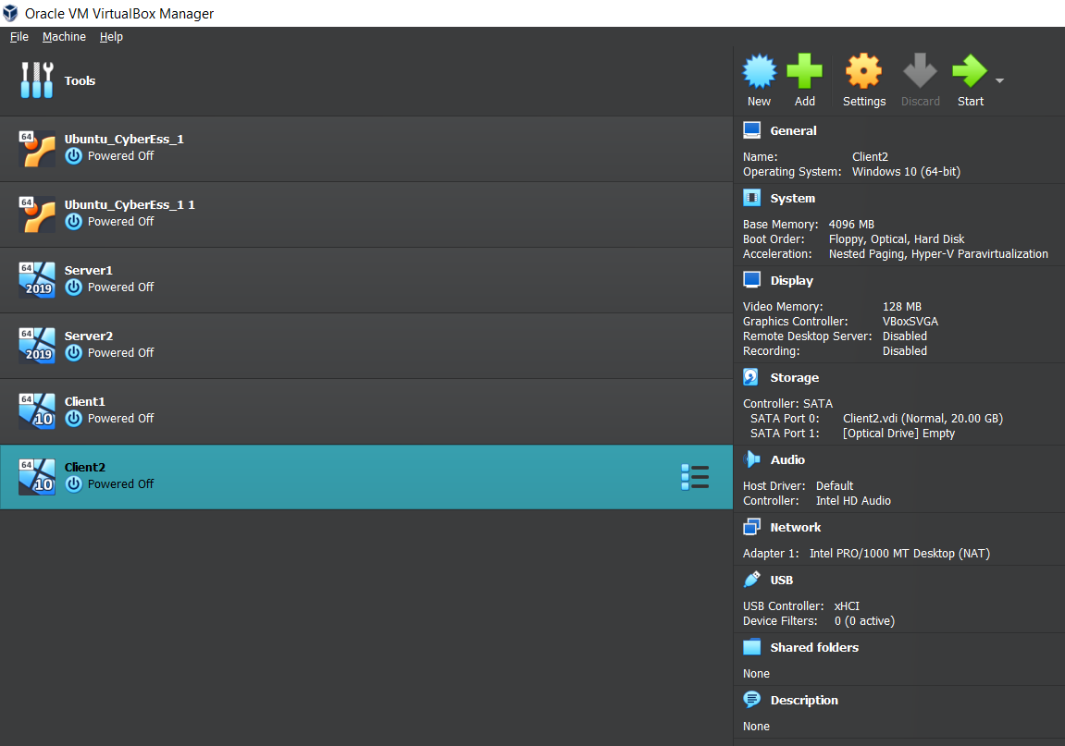

The above image shows Oracle VitualBox Manager with four Virtual Machines, two Client and two Server. The right side of the image shows the configurations for the client Virtual machines showing the systems base memory, operating system, and display settings all of which have been manually set to allow the virtual machine to run smoothly and connect to the server.

3.2 Server 2 Start up Screen

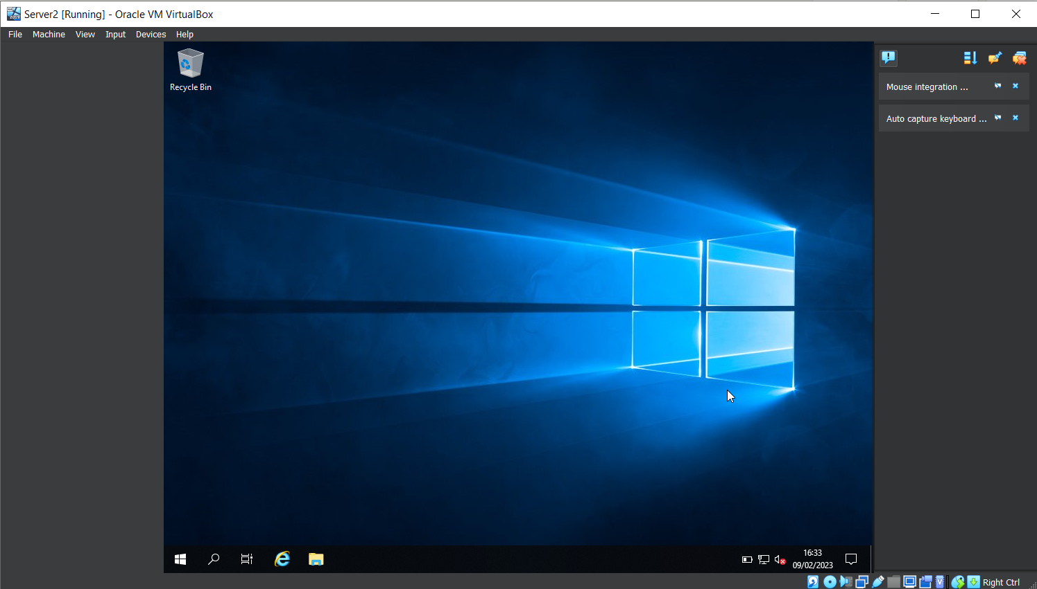
A view of first start up of the Virtual Machine for Server2 which displays like a regular computer would when first starting up, but this Virtual Machine has warnings and errors shown on the right hand side, customisable settings shown in the bottom right of the image and also has the ability to press certain combination of buttons such as alt + control and delete within the “Input” option at the top left.

3.3 Network Connections for Server 1 & 2

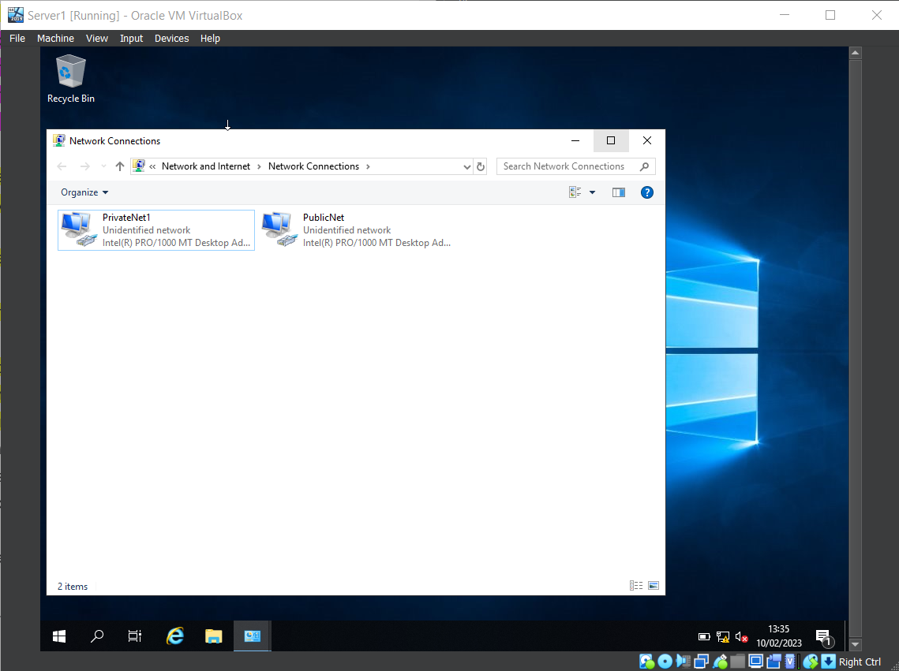
Within this image it shows the Network Connections for both PublicNet and PrivateNet1 this is done on both Server1 and Server2 Virtual machines and allows for the connection between server and client.

3.4 IP address, Subnet Mask & Preferred DNS Server

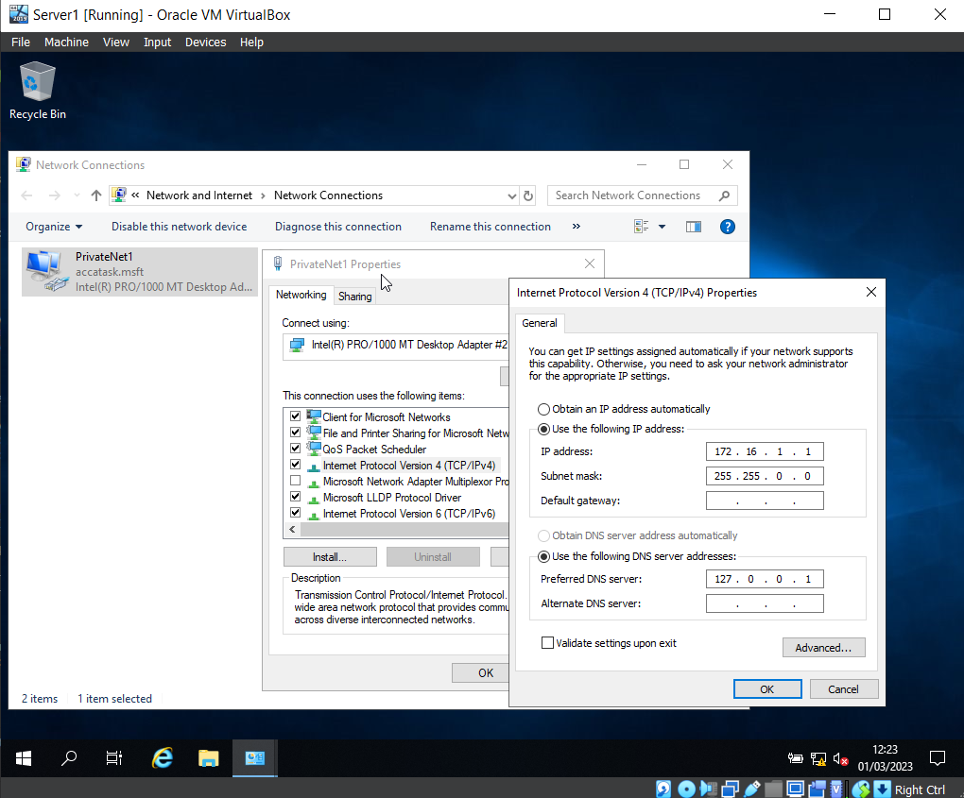
Following from the image above to make the Server and Client Virtual machine communicate there must be an IP address set for the machine. The above image shows the IP address and the Subnet Mask along with the Preferred DNS server which is used for later in the task.

3.5 Network Connection PrivateNet1

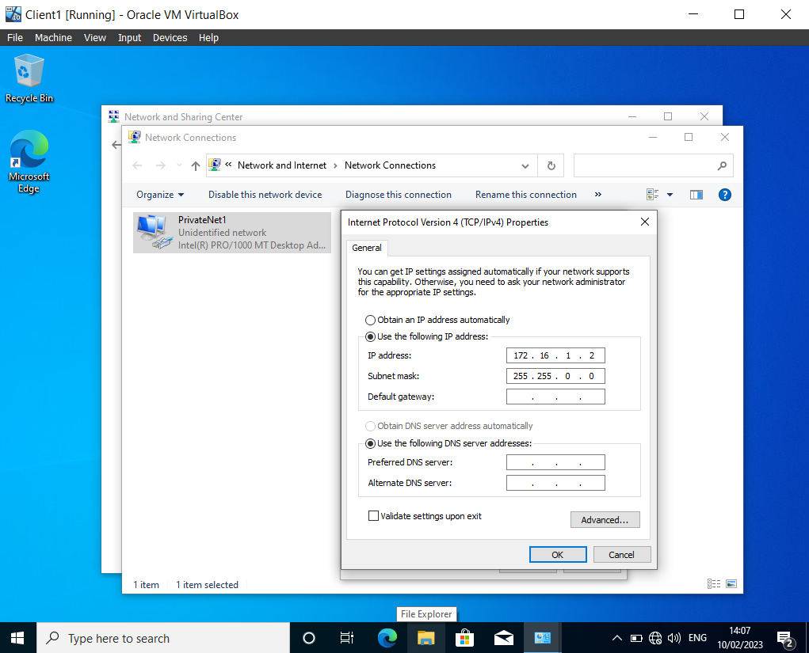
In the image shown above Client1 has been started and as mentioned in the images above to get the Server1 and Client1 virtual machines to communicate the Network Connection PrivateNet1 is created and as shown here the IP address and Subnet mask are inputted.

3.6 Firewall Modification

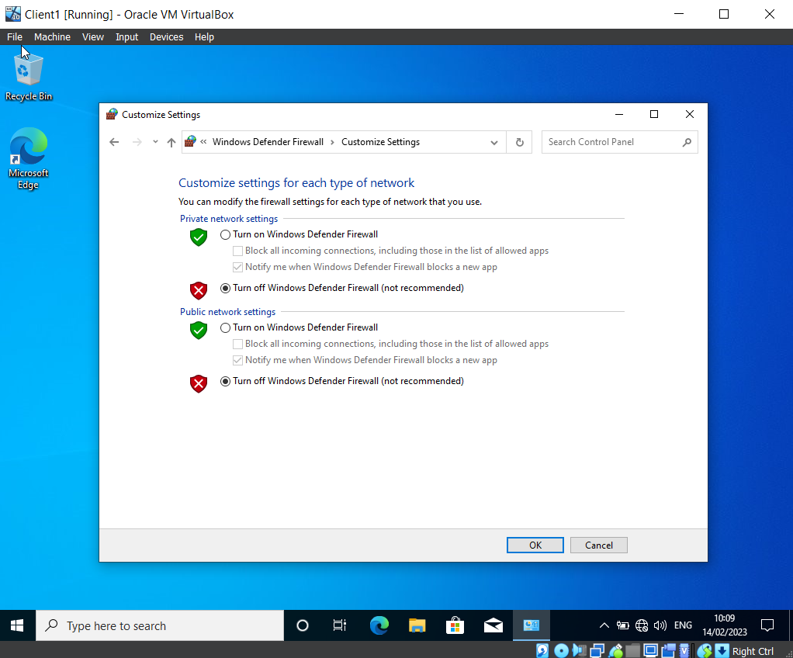
Firewall settings are turned off for the Client and Server Virtual machines to be able to communicate with each other the. The firewall will block incoming ping requests by default from unknown sources as a security measure because pings can be used maliciously.

3.7 Ping Test Between Client1 & Server1

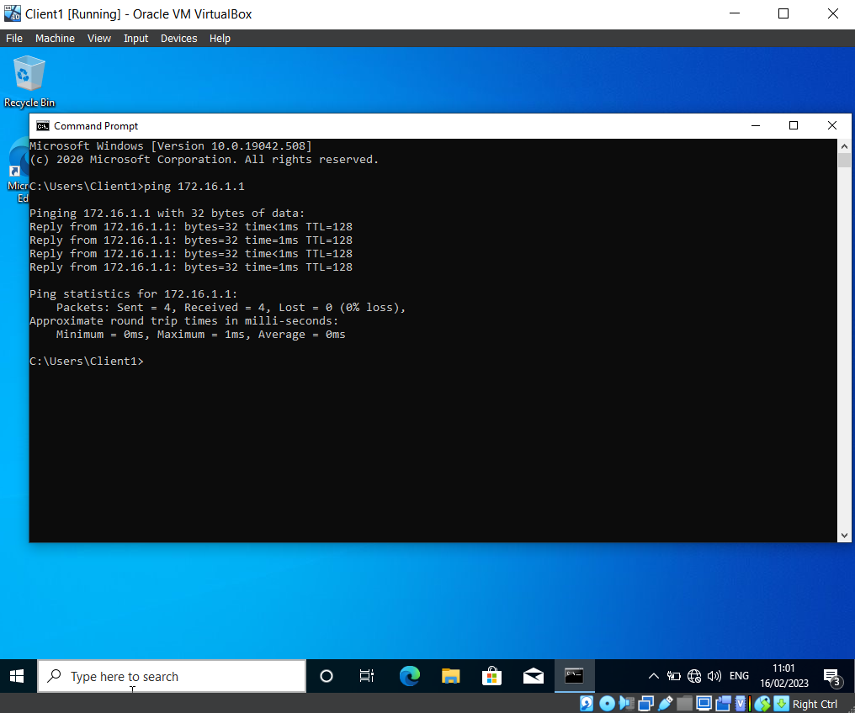Successful ping from Client1 to Server1 virtual machine, the image shows the reply time once the command for the server1 IP address to ping. Which shows that the steps followed within the pictures above have allowed the connection and communication of Server1 and Client1.

3.8 Ping Between Server2 & Client2

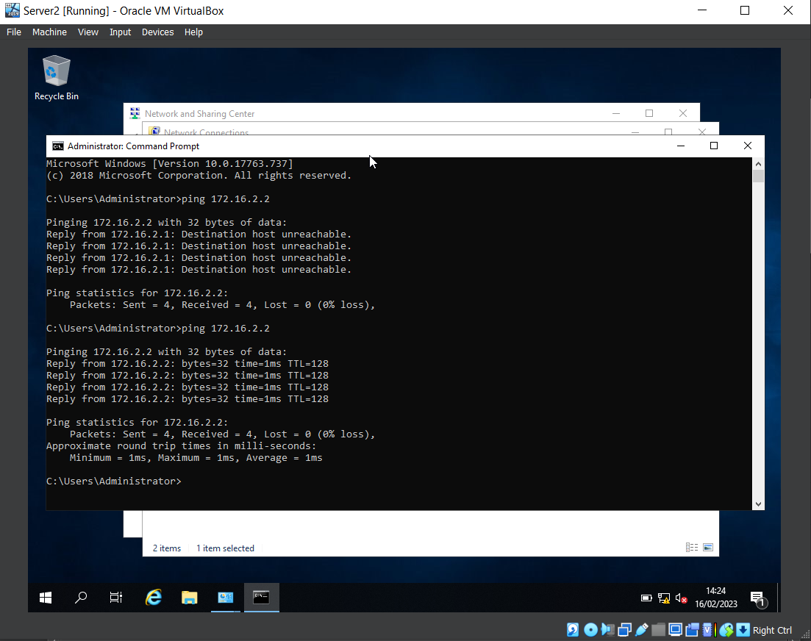Successful ping between Server2 and Client2 virtual machines showing that the setup with network connections was inputted correctly and shows that the IP address set for Client2 are correct.

4 Task 2 Deploying network directory and creating an Active Directory

4.1 Static Defined IP Address

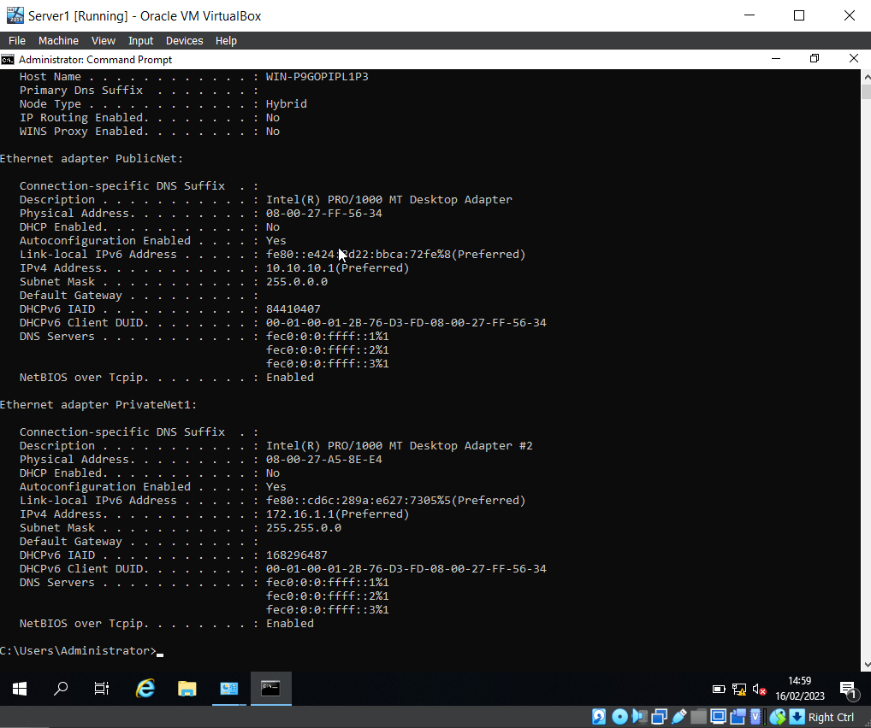
The following image shows that the DNS has not been set up and that the firewall is turned off along with the Server IP being Statically Defined. This confirms all of the steps taken in the task above and shown within the images are correct and confirmed.

4.2 Change of Computer name (DMC1-NT)

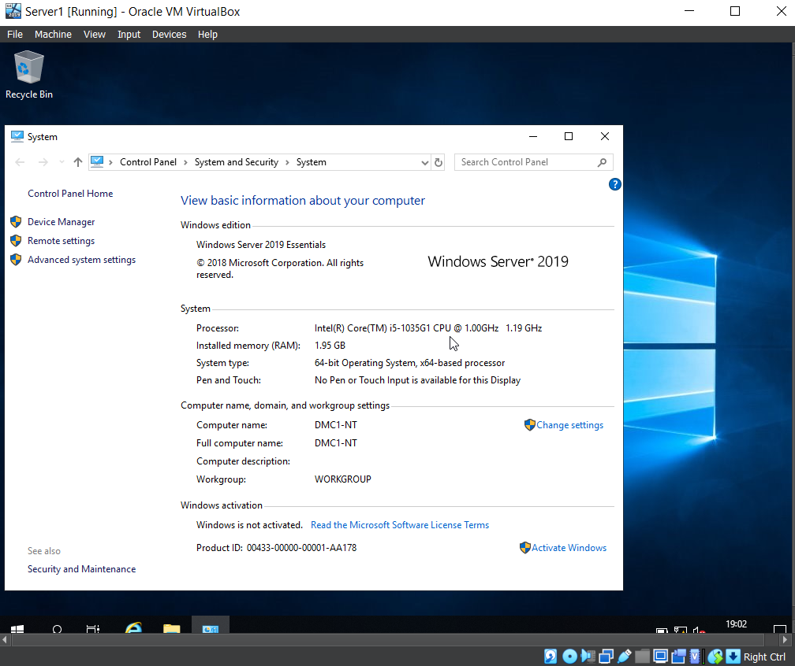 Showing within Server1 the Computer name has been changed to “DMC1-NT” within the control panel system settings.

4.3 Active Directory

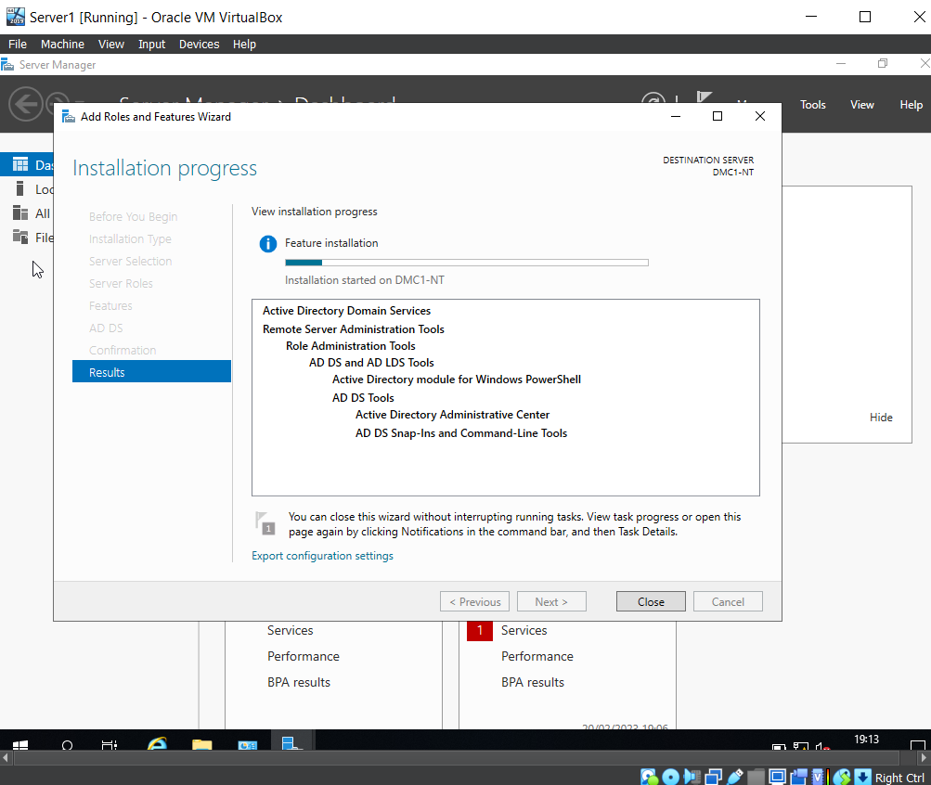Active Directory is a database that manages network resources such as computers and users. It allows for administration to restrict and grant access to all aspects of the network such as groups for specific access, security policies.

4.4 Server1 Active Directory
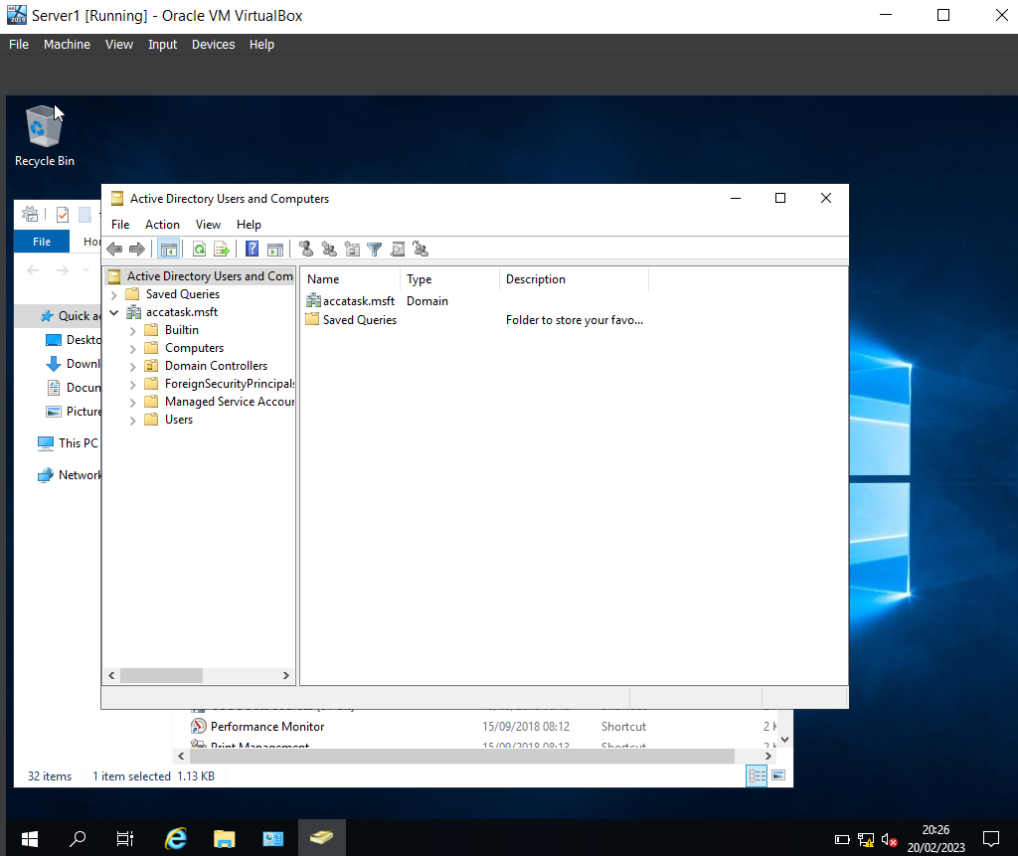
First time opening Active Directory within Server1, on the left hand side of the directory there are the folders for users and computers which allow for creating new users.

4.5 DMC1-NT Active Directory Properties

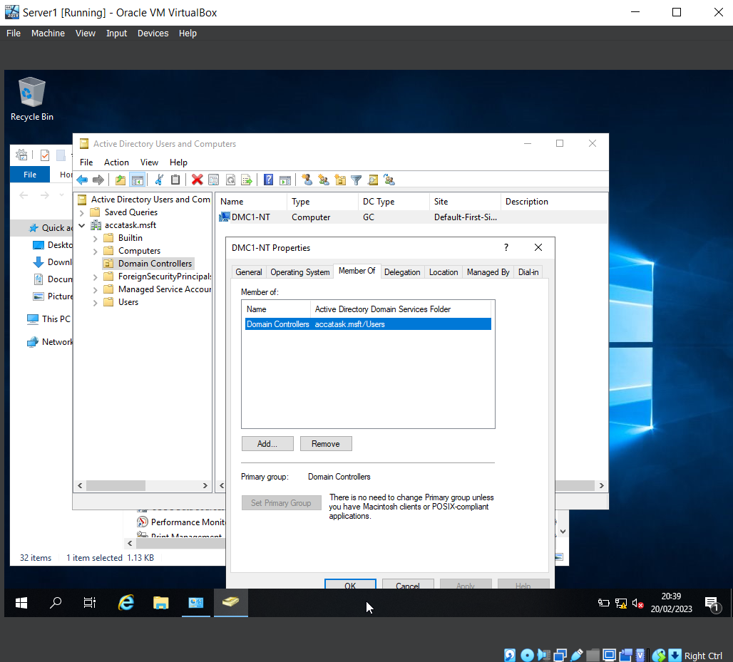The computer name “DMC1-NT” is shown in the image above inside of Active Directory it shows the “member of” group which grants the account access to certain things within the network here the domain controller has been set “accatask.msft”.

4.6 New User Creation

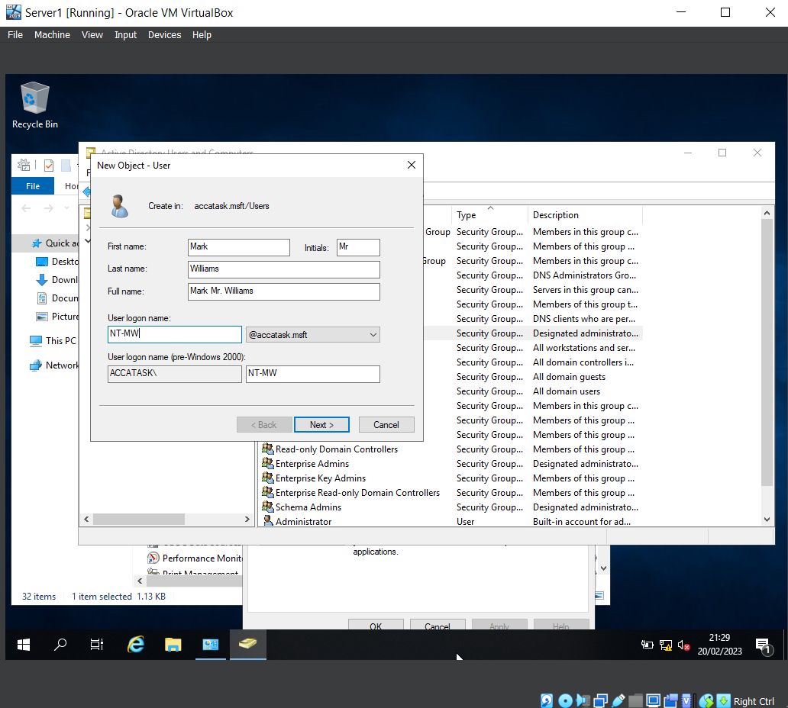Active Directory allows for the creation of users which will than grant access to the network. In this image it shows the users full name and what will be the account details that will be used to login.

4.7 User Log in Times Adjustment

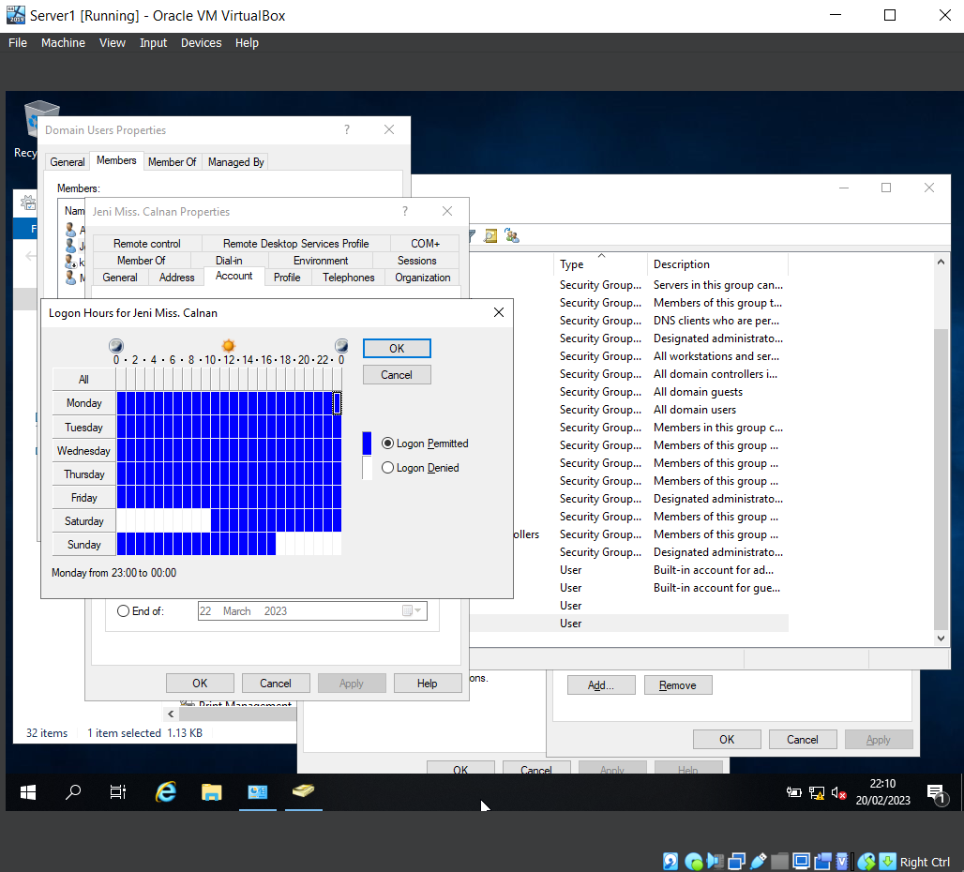A lot can be customized within Active Directory including the times users are able to log in stopping unauthorized access to the network certain times keeping the network safe from possible malicious attempts by users trying to gain access outside of office hours. The customization is simple the white boxes are to deny login at these times and days and the blue allows users to login.

4.8 User List

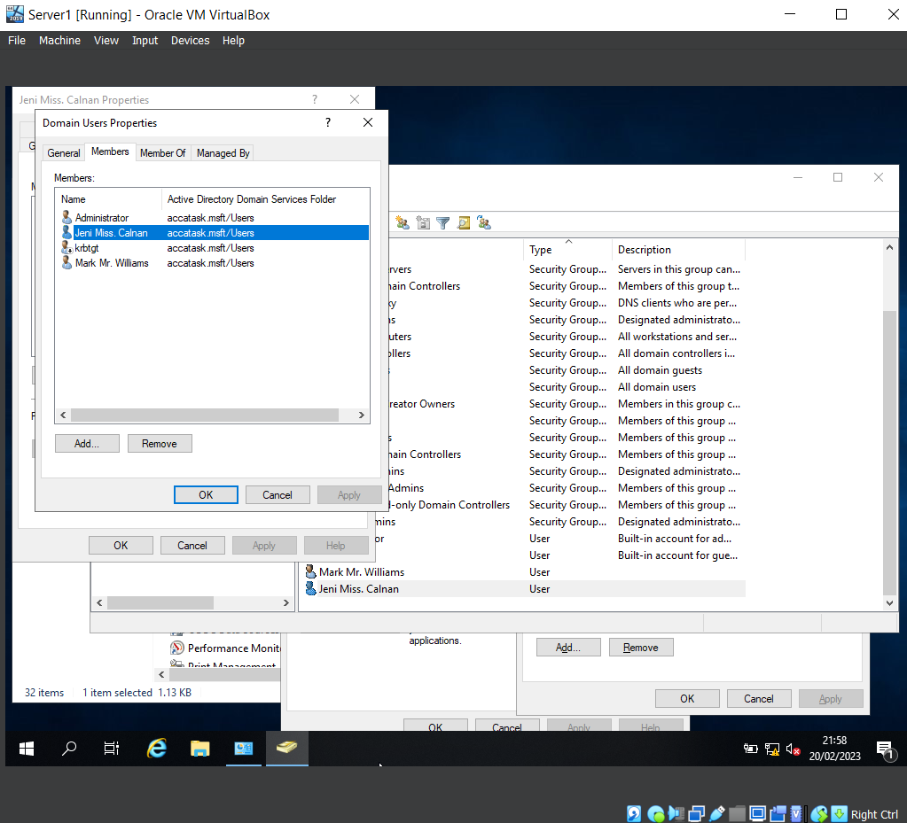The users created within Active Directory and placed within the “Domain Users” group will all appear when accessing the group as shown in the image above where all users that are in that group appear in the list of the “Members” tab inside “Domain Users” properties.

4.9 Successful Connection to accatask.msft domain
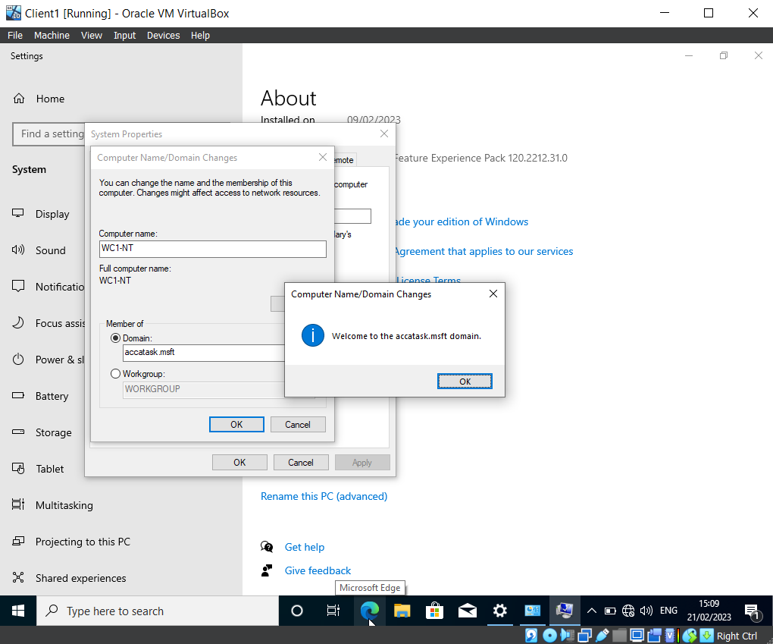Client1 Virtual Machine is connected to “accatask.msft” domain which allows for activate directory users and policies to be used within this computer.

4.10 Successful New User Log In
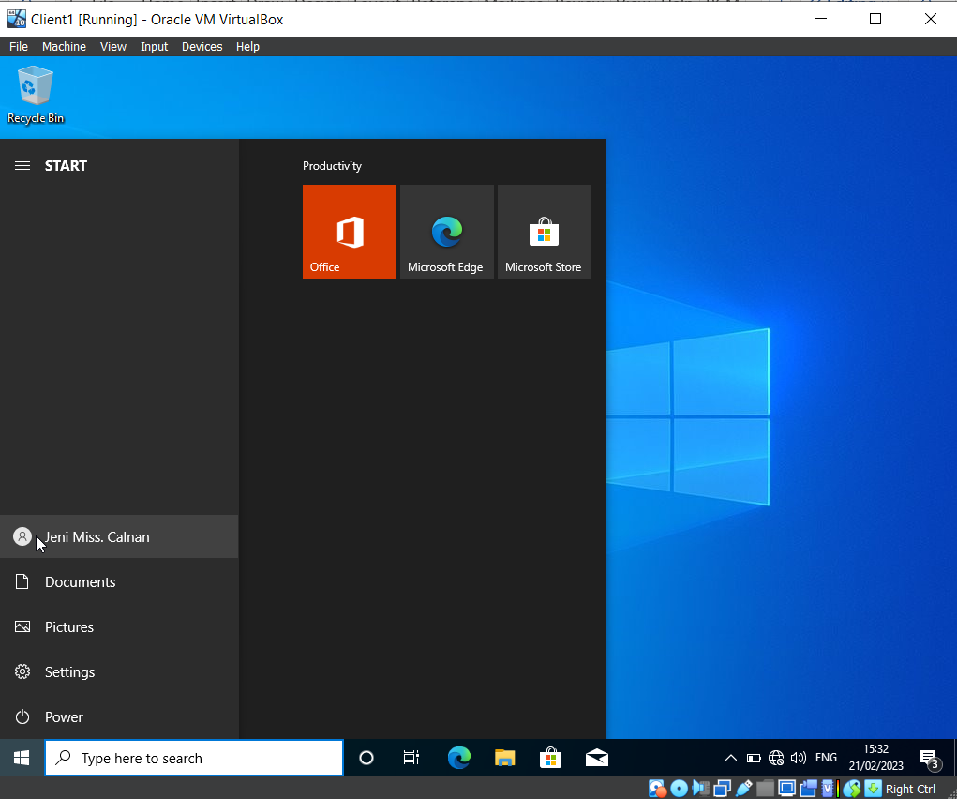Continuing from the above image Client1 is connected to the Active Directory and users are able to login as proven in the image above where a user created “NT-JC” has logged into the Virtual Machine because of the connection to the Active Directory and Network.

5 Task 3 Observational Tasks

5.1 Why Type 2 Hypervisors?

When setting up the task that this report is based on, a Type 2 Hypervisor was chosen over a Type 1. A Type 1 is highly efficient and have better security than a Type 2. The reason for this is they have direct access to the hardware being used. However, the Type 1 does need a separate machine to manage and administer the Virtual Machines (VM) and Hardware. [1] The difference between the Type 1 and 2 is that the Type 2 doesn’t run directly on the hardware. This is run on the OS (Operating System) as an application. One of the reasons why this type was chosen is the fact that the users were acting as a single user needing access to numerous OS. This Type 2 allows for this and is more efficient at granting access to a guest OS to a host OS. This Type also runs at a much lower cost and will are much more easily installed than the Type 1. With what the practical task was asking, testing was also required. A Type 2 is excellent at providing such an environment and allows for software that might not have been able to be run on the native OS to be able to be used. [2] With this being said, Type 2 does carry a significant security risk especially if the host is compromised as an attacker could then Compromise any of the Guest OS [1]. Even though a Type 1 wasn’t suitable for the task in question, there are numerous occasions in which it should be the chosen Hypervisor. One of which would be if the user were to be running a Server Farm or Data centres. The reason being that their performance is a lot better as they run off the hardware being used. This then allows for the Hypervisor to run many different VMs [3].

5.2 What is a DHCP?

A Dynamic Host Configuration Protocol (DHCP), is a protocol in which an Internet Protocol (IP) address is provided to a host. With this comes numerous other configuration information such as the default gateway and the subnet mask. DHCP will provide hosts with Transmission Control Protocol (TCP) and IP information from the server [4]. Some of the more up to date Windows Servers contains DHCP servers. These servers are hosts that return certain parameters for the configuration to DHCP clients. These clients are internet hosts that are looking to obtain said configuration parameters [5]. Every device that is based on a TCP or a IP network must carry a IP address. This address must be unique and is then used to access the network and its resources. In the past IP address would need to be moved from sub nets and be input and configured manually. Any IP addresses that are then needing to removed will need to be done so manually. Having a DHCP will allow for all this to be done automatically which then allows for a much more reliable configuration of the IP addresses [4].

5.3 How does a DHCP work?

A TCP and IP network run of certain stacks of layers that provide certain tasks. The DHCP runs of the administration layer of the stack. This then Dynamically assigns IP addresses to clients as well as configuration information. This includes the information for sub net masks, default gateway IP and Domain Name System (DNS) addresses [6]. It assigns this information to any device or node within a network to allow for communication. The DHCP will centrally manages and stores these IP addresses then leases them out to clients when needed. This is done by clients first sending a request to the DHCP server when they need access the network. This request is usually sent after the device is first booted up. The DHCP will then reply with needed information as well as a time period for the lease. Depending on a type of network will depend on how many DHCP servers are needed. If running of a Local Area Network then only the 1 DHCP will be needed. However working on a larger network such as a Wide Area Network may require more servers.

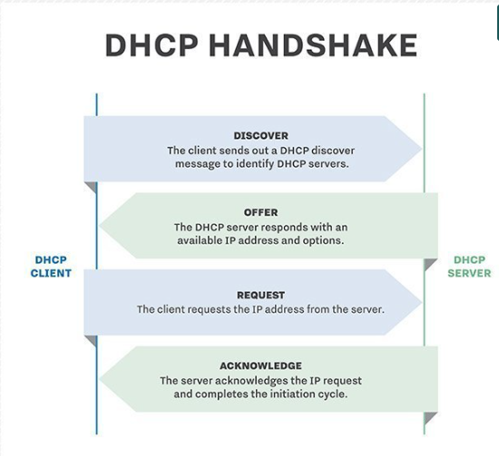
The above image illustrates how a DHCP server and Client will interact to be able to communicate the correct information needed to access the network [6].

5.3 Active Directory

Active Directory simply allows user and rights management to be stored in a centralized area. This makes accessing this information for administrators and end users a lot easier. Centralized control over the user configurations and control over the device are also featured in the Group Policy [7]. The information held in a Active Directory will allow for a single sign in, the user will then be able to access any resource that the active directory authorizes them to be able to access. Active Directories allow for easier collaboration as files are stored in a central area. This then allows for a efficient file back up system to be put in place to allow for business continuity. Overall Active Directory has 3 main functions:

- Centralized files, resources, administration rights and security settings.
- A simple and efficient are for resources to be stored.
- Single log in (Ability to log in once and still have access to resources) [8]
Active Directory Domain Services (AD DS) groups objects into a hierarchy, this then allows for the Domain Services (DS) to then be able to communicate & allow access to management. The domain is made from a group of users, devices or objects that share the same active directory database. All this information is then organized through organizational units. When multiple domains are then grouped together this then forms a tree where the domains are grouped in a logical hierarchy. To go further and group these trees together, would then form a Active Directory forest. At the functional level of an AD tress are then grouped together and the link between said trees, as with the link domains in the tress is known as a Trust. These trusts then allow for configuration specifications to then be shared throughout the Directory [8].
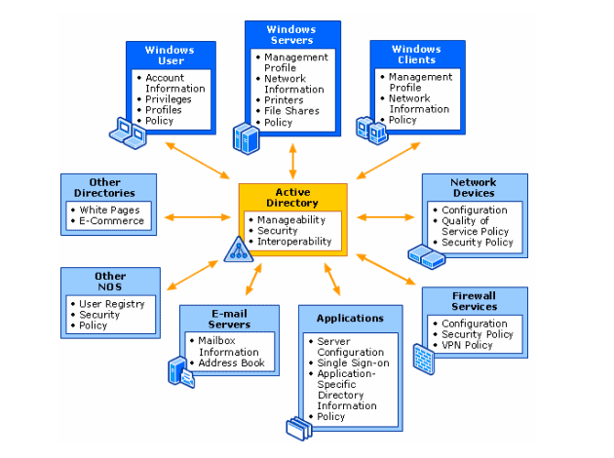

The illustration above shows how an AD works and what can be stored within an AD [9]

5.4 Terminologies and Purposes

During the task, numerous terminologies were come across. Some of these will need to be explained and their purposes proposed, one which was Ping.
The Ping command is used to test whether a host is able to be communicated with across a IP network. The command also measures the time taken for pieces of information known as Packets to be sent from the host to reaching its destination. It will report back the round trip time as well as an loss of information on the journey of the packet [10]. To be able to run a Ping command in Windows, simply access the command prompt and type Ping followed by the IP address you would like to test against in the black box. Pressing enter, will then return the results the user will be looking for. This functionality and operation is the same throughout most OS such as Linux, Windows or Mac [11]
Another terminology would be Windows Firewall. The functionality of this is Windows own security system that is pre built in. This guards against unauthorised access to a users device. The firewall acts as a barrier or Wall between the internet and a users device. It stops the device becoming infected with viruses, Trojan horses or other types of malicious attacks [12].
To be able to modify firewall settings or be able to switch these on or off, simply gain access to the control panel. Once here select System and Security then Windows Defender Firewall. When within this the user can modify or turn the firewall off completely. These instructions are for a windows OS, with a Linux OS it is slightly different.
Within Linux, this is called firewalld. This provides the same functions as Windows Firewall but uses the concept of zones and services. Zones are a set of rules that have been predefined. Interfaces and certain sources can be assigned to these zones. Services use ports or address for communications on a network [13].
An example of how Linux firewalls work is illustrated below.
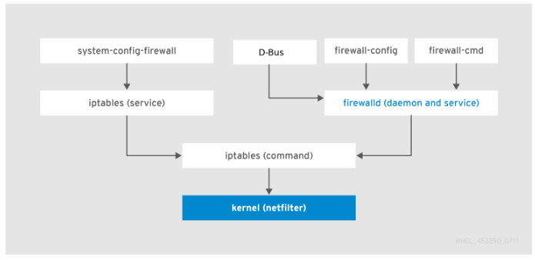
[13]

6 Reflection

On reflection to the tasks completed, it was helpful to be able to work as a team with multiple disciplines and specialists. By doing this, it improved the teams overall knowledge of Network Operations and Systems. It also allowed for certain team members to use there expertise to help with trouble shooting when problems arose.
Being able to successfully use Active Directories and add and modify users properties was exceptionally interesting. Being able to then see how useful and efficient this type of system was will provide the whole team with valuable knowledge and understanding of how this works.

References

[1] | IBM, “Hypervisors,” IBM, 2022. [Online]. Available: https://www.ibm.com/topics/hypervisors. [Accessed 09 03 2023].
[2] | J. Macpherson, “What Is a Hypervisor? – Types, Benefits & How Does It Work?,” 14 02 2022. [Online]. Available: https://www.parkplacetechnologies.com/blog/what-is-hypervisor-types-benefits/. [Accessed 09 03 2023].
[3] | M. Hajdarbegovic, “Hypervisor: A Comprehensive Guide,” Virtasant, 12 10 2020. [Online]. Available: https://www.virtasant.com/blog/hypervisors-a-comprehensive-guide. [Accessed 09 03 2023].
[4] | Microsoft, “Dynamic Host Configuration Protocol (DHCP),” 29 07 2021. [Online]. Available: https://learn.microsoft.com/en-us/windows-server/networking/technologies/dhcp/dhcp-top. [Accessed 09 03 2023].
[5] | S. Alexander, “RFC 2132,” 03 1997. [Online]. Available: https://www.rfc-editor.org/rfc/rfc2132. [Accessed 09 03 2023].
[6] | A. S. Gillis, “DHCP (Dynamic Host Configuration Protocol),” TechTarget, 2022. [Online]. Available: https://www.techtarget.com/searchnetworking/definition/DHCP. [Accessed 09 03 2023].
[7] | Quest, “Benefits of Active Directory,” Quest, 2023. [Online]. Available: https://www.quest.com/solutions/active-directory/what-is-active-directory. [Accessed 09 03 2023].
[8] | Intelecis, “Benefits of Active Directory Domain Services (AD DS),” Intelecis, 12 11 2021. [Online]. Available: https://www.intelecis.com/benefits-of-active-directory-domain-services/. [Accessed 09 03 2023].
[9] | H. Jethva, “What is Active Directory,” Cloud Infastructure Services, 27 04 2022. [Online]. Available: https://cloudinfrastructureservices.co.uk/best-free-active-directory-alternatives/. [Accessed 09 03 2023].
[10] | Domain Tools, “What is the Ping tool? What is it used for?,” Domain Tools, 2021. [Online]. Available: https://www.domaintools.com/support/what-is-the-ping-tool-what-is-it-used-for/. [Accessed 09 03 2023].
[11] | Pager Duty, “How to Ping a Network for Testing Connectivity,” Pager Duty, 2020. [Online]. Available: https://www.pagerduty.com/resources/learn/ping-network-testing-connectivity/. [Accessed 09 03 2023].
[12] | A. Abdullahi, “Windows Firewall,” Microsoft, 05 04 2022. [Online]. Available: https://www.webopedia.com/definitions/windows-firewall/. [Accessed 09 03 2023].
[13] | Red Hat, “Using Firewalls,” Red Hat, 2020. [Online]. Available: https://access.redhat.com/documentation/en-us/red_hat_enterprise_linux/7/html/security_guide/sec-using_firewalls. [Accessed 09 03 2023].

