A Guidance Handbook for Early Years Keyworkers during Childhood Transitions

ECEY4001C Human development Sarah Elizabeth Holborn 2107845
(Source: pngall.com 2021)

CONTENTS

- Introduction to Transitions

- How to use this Handbook

- The needs of the child

- The role of the adult

- Interventions

- Partnerships

- Proposed outcomes

- Reference list

INTRODUCTION TO TRANSITIONS

Transition is a change which all children go through as they grow up. As well as moving up to a new class, changes could be experienced within the family too and can give feelings of worry, upset or stress, according to (Young minds.org).

To help support transitions for children moving up to reception class for example, its vital that Practitioners and parents have a respectful and interactive relationship from the start as it sets the basis for an easy transition. As parents interact with the early year’s workers, children can draw comfort from hearing any conversations being made between them and can give any concerns or questions they may have. By a child witnessing these conversations being done in a friendly manner, it can reassure them which is important to help the process go more smoothly states Anjali Patel (2016), who goes on to say that to help a child feel safe and secure, a homely and secure environment is essential. To provide the child with familiar resources and experiences that they are used to already gives them a sense of belonging and helps them to adapt easier.
Quite often, the parents need more reassurance than the child, which makes communication and respect vital, and part of an early year’s practitioners’ role is to make sure parents understand the importance of ensuring a positive mindset is shown to the child to enable them to enjoy the change, according to NurseryWorld,2019.

Bronfenbrenner was a theorist who developed an ecological systems theory which explains how a child’s surroundings and social environment influence their development. Examples including parent and child interactions and the school environment are what his theory is based on.

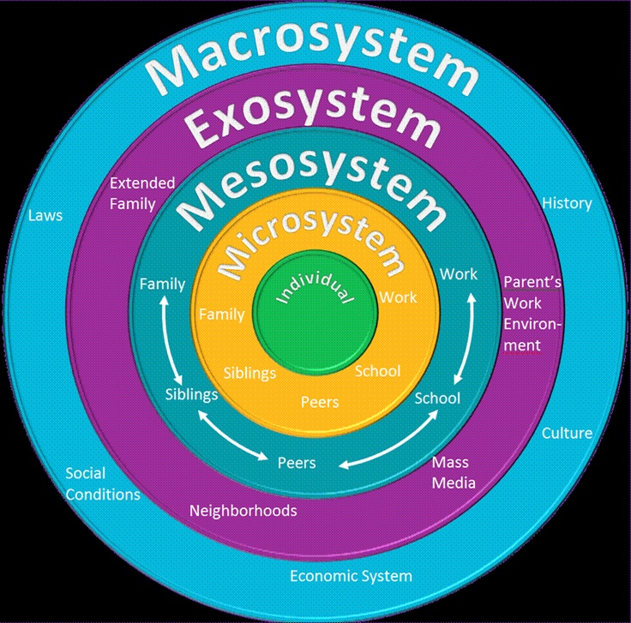
Source: blogspot.com

The image shows his theory as several microsystems. The Microsystem shows what influences the individual in their first surroundings. If a child is nurtured and cared for in the home for example, it will affect the child’s reactions to be positive in return in school, resulting in an easier transition to a school setting unlike being brought up in a negative environment which will most likely have a negative impact in return, possibly making transitions much harder for them to process, suggests Guy-Evans (2020). According to the theory, by parents and teachers working together and having good communication this should shape and benefit the child and their development in a positive way, though teachers need to be understanding if the child’s family is experiencing issues. This theory provides a holistic approach which reflects the influential nature of existing family relationships.
Bronfenbrenner’s work has similarities to Banuras social learning theory and Vygotsky’s sociocultural theory which describes how the environment plays a vital role in a child’s development in the early years.

HOW TO USE THIS HANDBOOK

This handbook is specifically designed for key workers working with children aged 4-5 years of age and has been produced with the aim of informing and supporting early years practitioners through the transition of children leaving the nursery setting and going into reception class, though other ages may be included.
A smooth and positive transition should be attained as the guidance given in sections in this handbook will essentially cover and give direction on the importance of effective communication and by building good relationships between parents, carers and keyworkers, best practice will be achieved.
Looking at the early year’s foundation phase framework, according to Welsh.Gov(2015) “all children in the early years”
- Are and feel safe
- Are cared for, valued and supported
- Are resilient, capable and coping
- Are healthy
- Learn and develop
The importance of a smooth transition is essential as Welsh.Gov (2015) states that for a child to prosper, being in a happy and friendly learning environment will support their wellbeing.
THE NEEDS OF THE CHILD

The key to meeting a child’s need is by firstly recognising their rights. According to UNICEF, article 12 states that every child has the right for their view to be heard and for it to be taken seriously according to the child’s age and maturity.
WelshGoverment (2017) states that the setting must be inclusive and needs to consider any particular and additional needs of all children, including families from different cultural, ethnic and faith groups. Keyworkers need to recognise that there will be some children who find change difficult. For example, a child with Asperger’s fits into this category and will probably need extra support. Allowing the child to have taster sessions in reception class, meeting their new teacher beforehand and showing them around the classroom will make them more familiar with their surroundings and will certainly ease the transition process for them. The foundation phase also encourages children to develop an understanding that other children do have differing needs, beliefs, views and abilities. Welsh Government (2015)

Maslow’s hierarchy of needs
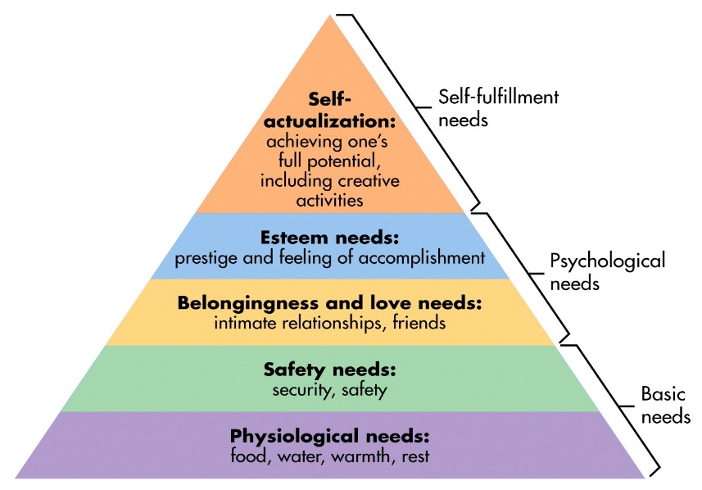
Source: hybridpedagogy.org
Maslow’s hierarchy of needs is a physiological theory that is widely known and referred to in education. Abraham Maslow suggests that before any child can meet their full potential, a series of needs must be met providing teachers a framework to go by. By assessing the framework, it shows how children need their basic needs met for them to reach their full potential according to Changekidslives (2020).
For example, Practitioners can support their physiological needs by ensuring all children have access to water, letting them bring water bottles in. Children can bring in fruit at breaktime, even allowing a child who is sleep deprived due to issues happening at the home for example, a nap if need be. The next step is their safety needs. A child needs to feel safe and secure in the classroom. As keyworkers we can have a sense if things aren’t right in the home environment and if the child is coming from an unstable home for example, they need to be prepared that a child’s transition maybe difficult at the start or end of the school day.
We can support a child having a feeling and sense of belonging in the class by teaching friendship skills and making sure no child feels isolated. To boost a child’s esteem, compliments and praise should be provided. To help them gain confidence in social circles, creating an opportunity for the child’s voice to be heard is essential. For example, having circle time and giving them the opportunity to join the school council. In theory when we support children in all the stages, their fullest potential can be achieved which then takes them to the final self-actualization stage where they are ready to learn and achieve.
Building a secure attachment between the keyworker and child is essential for a smooth transition. Having a secure base where the child feels they can go for support if they are feeling unhappy is going to encourage the child be more helpful and responsive in the setting according to Pacey.org (2014).
Attachment theory emphasises the importance of how a child’s emotional bond with their primary caregiver can affect a child negatively or positively as they go into adulthood states NSPCC (2021). and was developed by Theorist John Bowlby. It is linked to transitions in that as the theory suggests the importance of having the strong relationship with the caregiver, usually the mother as having the ‘secure base’ influences the setting into making sure that procedures are put in place to help produce a positive ongoing relationship between the keyworker and the child too which will essentially help the child grow emotionally and socially (Pacey.org,2021).
The theory is backed up by what CDC,2021 says about children’s brain development, stating that as children are born ready to learn, and whilst depending on parents essentially. It is their first teachers that help them to develop the appropriate skills to be independent and that they grow and learn best whilst being in a safe environment How the brain grows is determined by the child’s experiences with other people and the world.
During transitions, the environment plays a vital role, also it is important for keyworkers to understand some of the theories that influenced child development (Lindon and Brodie,2016).
Theorist Lee Vygotsky pioneered a sociocultural theory. He emphasized the idea of young children learning through social interaction in an environment between other children and adults. He felt that though young children already have skills, they were added through experience through active learning. He realised play was important but didn’t agree to it being the only way that children learned according to Lindon and Brodie (2016). He also believed that language played a vital role of cognitive development. An example of applying Vygotsky in the classroom would be the emphasis on the development of ‘process of learning’ rather than the taking in of facts or information (Aubrey and Riley,2019).

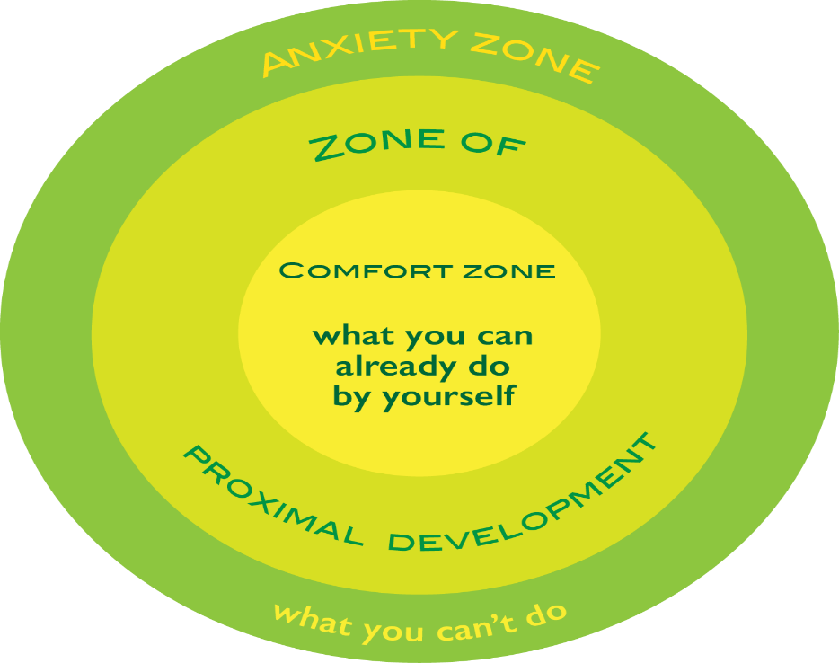
Vygotsky’s zone of proximal
Source: designonline
development

Vygotsky created this concept and named it ‘the zone of proximal development’ to make known how children’s learning could be supported through social and play interactions with each other and what they may be able to achieve with help from more abled individuals. (Lindon and Brodie,2016)
An example would be how a child zips up their coat with someone’s help until they are able to do it themselves.
Jean Piaget was a Cognitive development theorist too and has had a great influence in the UK early year’s philosophy. His approach of describing children as active learners and how they construct their own understanding led him to emphasize that adults should create environments where children could ‘learn through play’ in their own understanding and learning (Lindon and Brodie,2016). He described children’s thinking aged between two and six years of age as egocentric meaning that young children were unable to take different views into account and only make sense of their surroundings with their own perspective. Lindon and Brodie (2016) then go on to state that Vygotsky disagreed with Piaget’s theory of child development. He also viewed language as an essential social tool too and placed more emphasis on the social context of learning, unlike Piaget who viewed the child as a ‘solitary learner’. Piaget’s theories have influenced The Foundation Phase framework in Wales.
Wales.Gov(2015), states that children learn through play in the foundation phase and that the first-hand experiences that children get involved in allows them to develop an understanding of themselves and the world around them, promoting discoveries and independence whilst using the outdoor environment as a basis for children’s learning. The holistic development of children and their abilities lies at the centre of the curriculum.

THE ROLE OF THE ADULT

To ensure a smooth transition for children, keyworkers play a vital role. Being in consultation with parents and other staff enables the keyworker to be aware of the child’s emotional needs and any practical needs that need to be met can be done so as they monitor the transition process states the Welsh Government (2017). According to the Froebel approach, young children are entitled to understanding and well-qualified professionals who are surely informed about and aware of the unique nature of a young child’s learning and development (Tovey,2013).
Looking at Theorist Reggio Emilias approach to early years, communication is key between parents and keyworkers during the transition process. By developing a strong and positive relationship and spending time listening to parents giving an insight into their unique child will help support the child’s learning. For example, for a child or parent who is anxious about moving classes the keyworker can provide encouragement and support by showing physically the class setting, what happens in the setting and how the day is organised. (Thornton and Brunton,2007). Informing parents about the facilities in breakfast club to lunchtime routines are beneficial too especially with children who rely on routines throughout the day.
Children have a native need to attach to at least one caregiver from birth, usually the mother. Theorists John Bowlby and Donald Winnicott both stressed the reliance on the mothers of the child to shape the foundation in their child’s life and enabling them to feel safe through having secure attachments and providing the infants needs throughout all stages of their life, though perhaps being ‘outdated’ in current times as the period which these theories were developed, mothers were the primary caregivers according to Laura Monk (2017). Bowlby’s work includes how babies become attached to their mother and what happens when they are separated. How does the child react? It can result in the child being in a state of distress, despair and detachment, and even theorised that a bondless baby would grow up affectionless (HealthResearchFunding,2017). Highlighting the need that children need a secure base to develop socially and emotionally.
Winnicott’s theory has helped many keyworkers to understand the needs of distressed children at the times of transitions in their lives and the need to support them as they transition from their primary caregiver (Nutbrown and Clough 2014). By observing the child struggling with a transition in the setting, practitioners can see if a child has formed a secure attachment with another adult at the setting, looking to see if they seek them out as a source of comfort (Pacey,2021), as a physical and nurturing environment can have a big impact on the emotional wellbeing of children and a sense of organisation within the setting is essential for a child to be able to feel settled and safe whilst they are there, especially benefitting those children who may be experiencing turmoil at home, as the structured environment provides the child with a sense of wellbeing and safety, according to Cath Hunter (2014). This is backed up by the Welsh Government (2015) which states that for a child to prosper, a warm and caring learning environment will support their wellbeing.


(Source: prignall.com)

Pioneers such as Eric Erikson and Anna Freud also believed in children requiring nurturing care, to pave the way for children to demonstrate empathy, trust and compassion as the supportive interactions with young children help the nervous system to grow more effectively and that effective child development is formed through having a holistic approach within the environment through engaging in these relationships suggests Aaron Bradbury (2017). And goes on to suggest how early years practitioners can enhance nurturing within the environment through:
- Building bonding skills. To help a child become empathetic and be able to communicate by demonstrating a secure and nurturing relationship.
- Developing cognitive skills. A secure attachment enables a child to learn and think. For example, pretend play helps develop cognitive skills.
According to the NOS (2019) to support children’s wellbeing for ages 3 – 7 includes:
- Keyworkers need to use different ways of communicating, including non-verbal, verbal, listening and watching.
- To provide a secure, safe and encouraging environment.
- To use every opportunity to promote children’s communication and language development such as listening, talking, making eye contact, rhymes, singing and stories.
Lindon and Brodie (2013) explain that children also look for a model to imitate. Theorist Albert Bandura evolved his ideas that children learn through the observations of familiar adults and other children. Keyworkers need to show through their own behaviour how they would prefer children to behave. Reggio Emilias approach also suggests that children copy the behaviour of the adults around them and that they learn how to build relationships by doing this. The way the keyworker speaks to fellow colleagues, by being polite and interested in what they have to say contributes to being a good role model. Thornton and Brunton (2007).
INTERVENTIONS

This part of the handbook looks at potential issues for transitions and puts forward activities that can help ease the process.
- Nursery and reception teachers work together to help children familiarise themselves with the classroom by having taster sessions in the class and on the yard, also developing the role of the lunchtime supervisor too by getting them to support children by observation, making sure there is no isolation on the yard or any issues, making sure the children play happily on the yard. (Trodd,2013)
- To support social interaction, ‘buddy’ systems can be introduced on the yard.
- A welcome pack and taster sessions should be provided.
- Communication is key – ask parents or children to write down any concerns.
- Invite parents for settling in sessions. (NurseryWorld,2019)
Welsh Government (2017) stresses that fact that parents of children with ALN, changes can be extremely stressful. Having interactions with their new teacher and to be shown around the new classroom multiple times to have familiarity and even being introduced to Lunchtime Supervisors where they can also see the layout of the canteen for example, will help ease the child in. AutismWales.org (2020) suggests that to help prepare for transition, a countdown planner can be used by the child, as well as suggesting the parents prepare the child for the changes.
Welsh Government (2015), states that PCPs (person centred practices) used in schools helps children reflect their interests and strengths and the information used can help communication between parents, staff and children and help with transitions as the recorded information can be passed from the previous class to the new one giving the teacher.
- One pages profiles is where children and parents write down any character gifts the child may have, talents, worries and what the best way to support them might be.
- A learning log is a record of an individual’s learning that will help the keyworker see what needs to change or stay the same.

PARTNERSHIPS
Pacey (2021) states that working in partnership with parents is essential as a keyworker. Involve parents from the start, from having daily chats to sharing resources making sure your approach is flexible whilst communicating as you may need to adapt to suit different parents needs. For example, those with English as an additional language.
When staff observe a child being withdrawn, quiet or tearful whilst struggling to settle, support strategies will be put in place and by liaising with parents, it will ease the transition process. If need be, the school nurse or Early years local authority advisor will be hand for advice too, in extreme cases a referral to the Ed Psychologist (Trodd,2013). Team around the family is another support network. Where appropriate, settings/schools will need to plan and work with specialist services to establish proper and accessible learning experiences for children with disabilities. Welsh Government (2015) Good practice results in transitions being managed and planned carefully, respecting parents as partners and a commitment from all staff involved in the process of developing effective communication systems and information sharing protocols.
Theorist John Dewy called for a ‘common school’ as stated in (Aubrey and Riley,2019) which embraced differences and similarities found in the community and was a place where children could learn from each other in an environment of understanding and tolerance whether they came from different faiths or social backgrounds.
PROPOSED OUTCOMES

A holistic approach emphasises the importance of recognising children as entire individuals and all their different skills are essential which support their development. (Lindon and Brodie,2016)
Welsh Government (2017) states that the Foundation Phase is a holistic based curriculum and states that practitioners using observations and assessments supports this approach. Te Whariki is a national early childhood curriculum in New Zealand which focusses on empowerment, holistic development, family and community and relationships and can be explained through Bronfenbrenner’s ecological systems model (Te Whariki.org).
Through observations over a 6-week period when a child starts reception class, an assessment is made which allows the keyworker to support their development (Welsh Government,2017) Reggio Emilia’s approach too was that to guide a child’s interests, he promoted nurturing a child’s development by observation (Tovey 2013) as well as Froebel.
There will be reform of the curriculum in Wales following the ‘Donaldson Report’ and the 4 purposes will be:
- Ambitious, capable learners
- Enterprising, creative contributors
- Ethical, informed citizens
- Healthy, confident individuals
Children who are transitioning from nursery to reception should be settled, be able to secure relationships with keyworkers, be confident and curious and to be aware of their value as an individual and feel listened to, according to the Foundation Phrase Framework. (Welsh Government,2015).

REFERENCE LIST

Aubrey, K. and Riley, A. (2019) Understanding and using educational theories (2nd edn) London: Sage Publications.
AutismWales.org (no date) Autism: A guide for early years settings. Available at: https://autismwales.org/wp-content/uploads/2020/08/A-Guide-For-Early-Years-settings (Accessed: 16 November 2021).
Blogspot.com (no date) Bronfenbrenner Bioecological system [image]. Available at: https://4.bp.blogspot.com/ (Accessed: 14 November 2021).
Bradbury, A. (2020) How to nurture children and enhance your early years environment [blog]. 17 Dec. Available at: https://kinderly.co.uk/2020/12/17/how -to-nurture-children-and-enhance-your-early-years-environment/ (Accessed:12 November2021).
CDC.gov (2021) Early brain development and health. Available at: https://www.cdc.gov/ncbddd/childdevelopment/early-brain-development.html (Accessed: 14 November 2021).
Childhood stock image [image]. Available at: https://www.pngall.com/wp-content/uploads/2018/03/Child-Free-Download-PNG.png (Accessed: 7 November 2021).

Guy-Evans, O. (2020) Bronfenbrenner’s ecological systems theory. Available at: https://www.simplypsycology.org/Brofenbrenner.html (Accessed: 20 November 2021).
Happy teachers’ day [image]. Available at: https://www.pngall.com/wp-content/uploads/1/Happy-Teachers-day-Transparent.png (Accessed: 15 November 2021).
Healthresearchfunding.org (2017) John Bowlby’s attachment theory explained. Available at: https://healthresearchfunding.org/john-bowlbys-attachment-theory-explained/ (Accessed: 15 November 2021).
Hunter, C. (2014) Nurturing environment: Emotional development [blog]. September. Available at: https://www.teachearlyyears.com/learning-and-development/view/nurturing-environments (Accessed: 20 November 2021).
Kline, T. (no date) Applying Maslow’s Hierarchy of needs in our classroom. Available at: https://www.changekidslives.org/actions-4 (Accessed: 18 November 2021).
Lindon, J. and Brodie, K. (2016) Understanding Child Development 0-8 years. 4th edn. London: Hodder Education.
Maslow’s Hierarchy of Needs [image]. Available at: https://hybridpedagogy.org/content/images/wordpress/2018/10/image1.png (Accessed: 20 November 2021).
Monk, L. (2017) ‘Winnicott’s good enough mother’, Mothers art project [blog]. Available at: https://mothersartproject.wordpress.com/201708/02/winnicotts-good-enough-mother/ (Accessed: 10 November 2021).

NOS (2009) Support children’s development. Available at: https://www.ukstandard.org.uk/publishedNos-old/TDASTL2.pdf (Accessed: 10 November 2021).
NSPCC (2021) child health development attachment. Available at: https://learningnspcc.org.uk/child-health-development/attachment-early-years (Accessed: 16 November 2021).
Nutbrown, C. and Clough, P. (2014) Early Childhood Education, History, Philosophy and Experience. 2nd edn. London: Sage Publications.
Pacey.org (2021) Transitions and settling in. Available at: https://pacey.org.uk/pacey/media/website-files/school%20ready/PG10-transitions-and-settling-in.pdf (Accessed:10 November 2021).
Pacey.org (2021) Working in childcare. Available at: https://pacey.org.uk/working-in-childcare/ (Accessed: 15 November 2021).
Patel, A, (2016) ‘A unique child’, Supporting transitions in the early years [blog]. 8 February. Available at: https://wwwteachearlyyears.com/a-unique-child/view/supporting-transitions-in-the-early-years (Accessed: 14 November 2021).
Te Whariki online (2017) Underpinning theories and approaches. Available at: https://tewhariki.tki.org.nz/en/key-documents/te-whariki-2017/underpinning-theories-and-approaches/ (Accessed:14 November 2021).
Thornton, L. and Brunton, P. (2007) Bringing the Reggio Approach to your Early Years Practice. Oxon: Routledge.
Tovey, H. (2013) Bringing the Froebel Approach to your Early Years Practice. Oxon: Routledge.
Trodd, L. (2013) Transitions in the early years – working with children and families. London: Sage Publications Ltd.
UNICEF (2019) A summary of the UN convention on the Rights of the Child. Available at: https://www.unicef.org.uk/wp-content/uploads/2019/10/UNCRC_summary-1_1.pdf (Accessed: 12 November 2021).
Welsh Government (2015) A curriculum for Wales-a curriculum for life. Available at: https://dera.ioe.ac.uk/24680/1/151021-a-curriculam-for-wales-a-curriculam-for-life-en_Redacted.pdf (Accessed: 19 November 2021).
Welsh Government (2015) Person centred practice in education: a guide for early years, schools and colleges in Wales. Available at: https://gov.wales/sites/default/files/publications/2019-01/person-centred-practice-in-education-a-guide-for-early-years-schools-and-colleges-in-wales.pdf
(Accessed: 16 November 2021).
Welsh Government (2015) What really works for early years. Available at: https://gov.wales/sites/default/files/publications/2018-11/what-really-works-for-the-early-years.pdf (Accessed: 12 November 2021).
Welsh Government (2017) Foundation phase handbook. (Available at: https://gov.wales/sites/default/files/publications/2018-03/foundation-phase-profile-handbook-revised-september-2017.pdf (Accessed:12 November 2021).
Welsh Government (2018) Foundation phase framework, revised 2015. Available at: https://gov.wales/sites/default/files/publications/2018-02/foundation-phase-framework-revised-2015.pdf (Accessed: 12 November 2021).
Welsh Government (2019) early years outcomes. Available at: https://gov.wales/sites/default/files/publications/2019-07/early-years-outcomes-framework.pdf (Accessed: 14 November 2021).
Welsh Government (2019) flying start transition guidance. Available at: https://gov.wales/sites/default/files/publications/2019-07/flying-start-transition-guidance-for-professionals.pdf (Accessed: 20 November 2021).
Zone of proximal development [image]. Available at: https://designonline.commons.gc.cuny.edu/files/2015/04/comfort-zone-circle-chart.png (Accessed: 19 November 2021).

