  - Health Campaign: Smoking in Wales

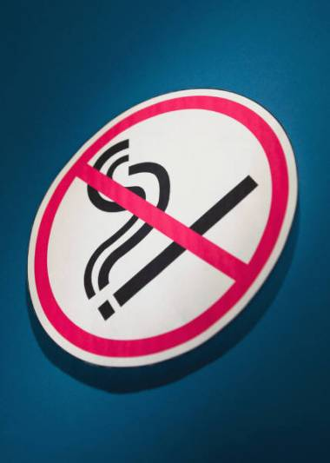
(NHS Direct Wales, 2019).

By Skye Jones

Contents page
Introduction……………………………………………………………………………….p3-4
Problem Statement………………………………………………………………………p5-7
Evaluation……………………………………………………………………………….p8-10
Recommendations………………………………………………………………………..p11
Conclusion………………………………………………………………………………...p12
References…………………………………………………………………………….p13-18
Appendix……………………………………………………………………………….p19-21

Introduction
The purpose of this report is to determine why health campaigns are created by the government and to evaluate their effectiveness, particularly the stop smoking campaign that Wales and the UK have introduced. Health campaigns are projects that are put in place to inform people about the effects that their behaviour has, for example, eating junk food can make you obese and smoking can cause cancer (The George Washington University, 2016). According to the World Health Organisation (WHO) (2012) to initially start a health campaign the government would need to identify their target audience and any partners they could work with, create the key messages of the campaign, prepare the community, prepare materials, for example, reports, adverts or presentations, develop a media strategy and a plan on how to measure and evaluate the effects of the health campaign, such as surveys, reports and questionnaires and for this example the amount of tobacco sales.
Health campaigns are useful and important because they are used to raise awareness in behaviour that can be harmful to people’s health and wellbeing, over time health campaigns have the power to change people’s attitudes and furthermore their behaviour which in turn should create healthier communities (Public Health Agency, 2019).
The government introduce health campaigns because there is usually a benefit for them, for example, health issues related to smoking costs the NHS (National Health Service) over £2 billion pounds a year which puts an enormous strain on the government and NHS, so in theory if people stop smoking, eventually there should be a deduction in health costs for illnesses related to smoking (Gov.uk, 2017). The government will also create health campaigns because they have an obligation to ensure the general public meet their health and wellbeing needs by following social policy laws (LSE, 2020). It is important for the government to follow social policy laws and introduce health campaigns when necessary as the NHS is struggling to keep up with demand and is in over £7 billion pounds in debt and NHS England alone overspent by £4.3 billion in 2017 (The Guardian, 2018). This is why health care campaigns are vital because the NHS has to spend millions treating illnesses that are sometimes self-inflicted by things such as smoking, drinking too much alcohol, overeating and not exercising which can all lead to long term illnesses such as cancer, heart disease and diabetes (NHS, 2018).
The government will use a healthcare campaign in order to shape communities into a healthier society, the government do this by using different behaviour models such as the theory of planned behaviour, the health belief model and CBT examples to ‘manipulate’ people into deciding themselves to adopt positive health choices (encyclopedia.com, 2020). Health campaigns are usually mass media operations where governments will issue indirect methods such as education programmes to change people’s opinions and behaviour which ultimately leaves the decision in the hands of the individual but usually this will go along with direct methods such as banning public smoking which physically makes it more difficult for individuals to smoke (Wakefield, 2010).

Problem statement
The NHS states that smoking tobacco can cause a huge amount of damage to the human body because of the chemicals found in the tobacco, for example, heart disease, lung cancer, the risk of stroke increases, chronic obstructive pulmonary disease, reducing fertility among many more side effects (NHS, 2020). Action on smoking and health wales (2019) goes on to say that during 2018, smoking cost the welsh NHS £302 million pound, they also state that the more deprived areas of Wales have the most smokers (please see diagram one of the appendix).
Britain are not alone in the smoking ‘epidemic’ 28% of adults in Europe smoke, whilst globally, over 8 million people died prematurely due to smoking during 2017 (World Health Organisation, 2020 and University of Oxford, 2019).
Smoking not only affects the individual physically smoking but it also causes harm to others around through second hand smoke, the NHS (2019) reports that second hand smoking can be detrimental to children’s health as they are more susceptible to diseases such as meningitis, cancer, bronchitis and pneumonia, babies exposed to second hand smoke are also more likely to die from cot death. Smoke free families (2019) agree with the NHS and report that 300,000 children’s GP appointments and 9,500 children are admitted to hospital due to second-hand smoke.
There has been a number of health campaigns introduced to Wales and the UK in order to tackle smoking, for example, the public smoking ban in 2007, ‘Quite for Wales’ 2013, the ban on smoking in a car with a person under the age of 18 in 2015, the tobacco control delivery plan 2017-2020, and more recently the banning of smoking outside hospital and schools in 2019 in an effort to ‘denormalise’ smoking (Sky News, 2018). There are also campaigns such as ‘stoptober’ where smokers voluntarily sign up to quit smoking for 28 days, if the individuals who sign up are successful, they are five times more likely to quit smoking for good and help me quit Wales (Public Health England, 2019). In 2016 the UK government introduced standard packaging with graphic health warning for tobacco products as well as packs of ten being banned and a complete ban on menthol cigarettes in 2020 (British Lung Foundation, 2020).
The first large scale study linking smoking with lung cancer was published in 1950, since then governments have focused on reducing illnesses and deaths caused by smoking/ second-hand smoking but it wasn’t until 2006-2007 that the UK actually banned public smoking, this means that people were no longer allowed to smoke in places such as clubs, bars and work places, thus making it more difficult for individuals to smoke and also making healthier environments for non-smokers (institute for government, 2019).
Quite for Wales was launched as a six-month campaign to encourage employers to provide more or better quality support for employees who want to quit smoking and to provide more support for pregnant smokers and smokers with mental health problems. Quite for Wales called for employers to provide flexible support, all midwives and health visitors to be educated on smoking during pregnancy and mental health providers to be trained in quit smoking support (NHS Wales, 2013).
The Tobacco control Delivery Plan (TCDP) was introduced in 2017 and aims to further prevent smoking, prevent young people ever starting to smoke and to improve the health of all communities. The TCDP wanted to reduce the number of smokers in Wales from 23% to 16% by 2020, the TCDP is also working alongside Public Health Wales by introducing registers for tobacco retailers which will make illegal tobacco an offence (Welsh government, 2017).
Europe has also run their own health campaigns, for example, ex-smokers are unstoppable and HELP for a life without tobacco. The main aims of ex-smokers are unstoppable were to reach 28 million smokers by using advertising, social media and word of mouth/ health questionnaires (Europa, 2016). HELP for a life without tobacco was mainly a social media based campaign heavily involving young people (Europa, 2010).
All health campaigns will usually use some from of behaviour model, for example, the health belief model and the theory of planned behaviour. The health belief model was created in the 1950’s by social scientists but has since been researched and improved, it works by looking at an individual’s perceived susceptibility, perceived severity, perceived benefits, perceived barriers, cue to action and self-efficacy. Perceived susceptibility means how a person perceives the risk of developing an illness, perceived severity means how severe a person feels developing an illness is, perceived benefits means how a person perceives how effective actions to reduce likelihood of an illness would be, perceived barriers means how a person feels about obstacles to performing health changes, cue to action means a stimulus or trigger is needed for a person to realise they need to make changes and self-efficacy means how confident a person feels in being able to accomplish health changes (Rosenstock et al, 1988). Cognitive Behavioural Therapy could also be used to help an individual change their thoughts and behaviour. Please see diagram three of the appendix for the health belief model.
The theory of planned behaviour ‘predicts’ an individual’s intention to engage in a behaviour, it looks at a person’s attitude to the subject, behavioural intention, subjective norms, social norms, perceived power and perceived behavioural control. Attitudes refers to an individual’s evaluation of the behaviour, behavioural intention looks at motivational factors that could influence the individual, subjective norms means how people approve or disapprove about a subject, social norms refers to ‘codes’ of behaviour that belong to a group of people, perceived power means how a person feel they can control certain behaviours and perceived behaviour refers to how easy or difficult a person feels a factor to changing behaviour could be (Manstead and Parker, 2011). Please see diagram four of the appendix for the theory of planned behaviour.

Evaluation
The public smoking ban was introduced in Wales in 2006 because a series of reports had proven that second-hand smoke can cause non-smoker’s risks of heart disease, lung cancer and stroke by up to 30%. The British Heart Foundation (2020) report that after the public smoking ban was introduced, more people were successful in quitting smoking because it was easier for individuals to avoid smoking situations, they also argue that the number of children admitted to hospital due to asthma from second-hand smoking reduced by 18%. Please see diagram two of the appendix to see how smoking rates have trended since 1974.
People were worried that the public smoking ban would increase the amount people smoked in their own homes with children present, however, Nanninga et al (2018) found that it actually decreased, and individuals more often chose to smoke outside. Monson and Arsenault (2017) and Vuolo et al (2016) both argue that the smoking ban has actually decreased the number of young smokers which proves that the public smoking ban has contributed to decreasing smoking statistics both in the UK and globally, however, Jones et al (2011) argue that although the smoking ban has helped to reduce smoking, statistics are still high and that smoking bans only reduced smoking numbers in young people as they were less likely to start smoking in the first place but did little to change opinions of 18-24 year olds.
The public smoking ban was a direct approach to the UK’s health and so used both the health belief model and the theory of planned behaviour as the health belief model says people need a ‘cue to action’ which means a physical trigger that will kick start their behaviour change and the theory of planned behaviour uses behavioural intention and social norms, by banning public smoking it motivated many individuals into quitting smoking as they would avoid the situation and it has also played a part in ‘denormalising’ smoking as many people smoked for social aspects and this is why the public smoking ban was so successful.
Quit for Wales is a campaign that provides services such as professional/ self-referral, an information website, training and education about smoking, a contact centre team and group support sessions, however the BBC (2018) reports that the welsh government fell short by 5% of its annual goal and that statistics only show a slight increase in smokers seeking NHS quit smoking help, it is also arguing the point that the more deprived areas of Wales have the highest numbers of smokers, suggesting that more needs to be done to reach these areas of Wales. Twyman et al (2014) argue that people who live in more deprived areas or who are vulnerable due to homelessness or mental health issues have different barriers to quitting smoking than those who don’t live in a deprived area, for example, smoking for stress management, enjoyment, addiction, social norm or lack of support from professionals. Help me quit Wales uses the theory of planned behaviour which heavily relies on education to change people’s awareness and opinions which should motivate them to change their behaviour.
Since the Public smoking ban of 2006, it has been made illegal to smoke in a car with any passengers under the age of 18, in a bid to reduce second-hand smoking. Moore et al (2015) conducted a study that showed since the car smoking ban was introduced the amount of children reporting that smoking was allowed in their family car halved, however, the children who still reported that smoking was allowed in their family car were from poorer families, this shows similarities to the help me quit campaign. Although smoking in cars with children present has decreased, there were no further reductions to asthma issues or other respiratory illnesses, Faber et al (2019) also reported that police were not strict and often didn’t fine people who weren’t adhering to the law. This campaign used the health belief model (cue to action) which enabled people to avoid even more situations involving smoking but it should also implement the theory of planned behaviour so people were educated on why they shouldn’t smoke with children in the car, even with the window open.
Increasing the tax on cigarettes and tobacco products has been proven to have many benefits, such as, reducing demand, higher cessation rates and reduction in relapse rates, it is also the most cost-effective way of encouraging people to quit smoking (WHO, 2020). However, Bader et al (2011) argue that there is no evidence that increasing tax on tobacco products effects long term smokers. The NHS (2018) also argue that the tobacco tax rarely effects the cheaper options, which would explain why people form poorer areas are still able to afford to smoke.
As well as higher tax on tobacco products, the government introduced graphic health warnings on packaging which often show gory pictures of illnesses and side effects caused from smoking, the images are supposed to work by causing fear, educating on the harms of smoking and motivating people to quit. Shadel et al (2019) report that graphic health warnings are being used in over 100 countries, and the effectiveness of the graphic images on tobacco packaging changed by how nicotine dependent the individual was, for example, a person who is less nicotine dependent is more like to quit from the graphic images than someone who is heavily nicotine dependent, they also report that due to this, the graphic images haven’t contributed greatly to global smoking cessation. Woelbert and d’Hombres (2019) agree that although graphic images on packaging of tobacco products have been proven to work to some effect, it is important that images are changed regularly to prevent over-exposure and thus eliminating the shock factor of the graphic health warnings.
For health campaigns to work there needs to be a behaviour model integrated within the health campaign as it is the behaviour models that are used to educate people and change their behaviours. The health belief model works well in health campaigns because the information and education individuals could get from the health belief model could trigger them into making a change in their behaviour, the health belief model could work for individuals, communities and globally if using a media campaign to get the information out to large groups (The King’s Fund, 2008). McDermott et al (2015) argue that there is no evidence to suggest that the theory of planned behaviour can create more positive results within health campaigns, however, it is beneficial to predicting and manipulating behaviours so maybe would be more successful if used in conjunction with the health belief model.

Recommendations
Based on this report there are a number of recommendations that could improve smoking cessation rates. Any future campaigns could focus on using a mixture of health behaviour models, such as, the health belief model and the theory of planned behaviour as both these models will help to educate, change opinions and attitudes and motivate individuals or communities to change their behaviour. Any future campaigns should also put more focus into the more deprived areas of a country because it’s the poorer communities that have higher smoking rates. It would also be beneficial for the government to focus more on long-term and high-dependant nicotine users as those individuals are the ones most likely to not quit even when exposed to health campaigns. Health campaigns would benefit from using behaviour models such as the health belief model and the theory of planned behaviour in order to gain as many positive results as possible.

Conclusion
In conclusion to this report, it is imperative that the UK government continue to research and create healthcare campaigns and continue to improve the health of Britain in order to relieve the NHS of heavy debt much of which is caused by self-inflicted illnesses such as smoking. Smoking has been a major cause to health problems such as stroke, cancer and heart disease whilst also being a danger to people around those smoking, the government in the UK and globally have worked endlessly to reduce the number of smokers and therefor costs on health care, although numbers have significantly decreased, there needs to be more focus on long term smokers and poorer families as they are the more likely to be unaffected by health campaigns and make the majority of smokers.

References
Action on Smoking and Health Wales (2019) Wales smoking statistics. Available at: https://ash.wales/wales-smoking-statistics/ (Accessed 11th January 2020).
Bader, P. et al (2011) ‘Effects of Tobacco Taxation and Pricing on Smoking Behaviour in High Risk Populations: A Knowledge Synthesis’, International Journal of Environ Research and Public Health, 8(11), pp. 4118-4139. DOI: 10.3390/ijerph8114118. Available at: https://www.ncbi.nlm.nih.gov/pmc/articles/PMC3228562/#__ffn_sectitle (Accessed 15th January 2020).
BBC News (2017) Pub smoking ban: 10 charts that show the impact. Available at: https://www.bbc.co.uk/news/health-40444460 (Accessed 12th January 2020).
BBC News (2018) Welsh Government’s stop smoking falls short of 5% goal. Available at: https://www.bbc.co.uk/news/uk-wales-45341925 (Accessed 13th January 2020).
British Heart Foundation (2020) How has the smoking ban changed our health? Available at: https://www.bhf.org.uk/informationsupport/heart-matters-magazine/news/smoking-ban (Accessed 13th January 2020).
British Lung Foundation (2020) Plain Packaging for Cigarettes. Available at: https://www.blf.org.uk/take-action/campaign-with-us/plain-packaging-for-cigarettes?cmp_id=1486843417&adg_id=57808450499&kwd=uk%20cigarette%20packaging&device=c&gclid=EAlalQobChMIHvCZ-YP_sgiveLDtCh2Hdg7xEAAYASAAEgL_v_D_Bwe (Accessed 12th January 2020).
Encyclopedia.com (2020) Public Health Campaigns. Available at: https://www.encyclopedia.com/media/encyclopedias-almanacs-transcripts-and-maps/public-health-campaigns (Accessed 10th January 2020).
Europa (2010) Help for a life without tobacco. Available at: https://ec.europa.eu/health/sites/health/files/tobacco/does/help_legacy.pdf (Accessed 13th January 2020).
Europa (2016) Ex post evaluation, ex-smokers campaign. Available at: https://op.europa.eu/en/publication-detail-/publication/b656dd28-cefa-11e5-a4b5-01aa75ed71a1/language-en (Accessed 13th January 2020).
Faber, T. et al (2019) ‘Investigating the effect of England’s smoke-free private vehicle regulation on changes in tobacco smoke exposure and respiratory disease in children: a quasi-experimental study’, Public Health, 4(12), pp. E607-E617. DOI: 10.1016/S2468-2667(19)30175-6. Available at: https://www.thelancet.com/journals/lanpub/article/PIIS2468-2667(19)30175-6/fulltext#seccestitle10
Gov.uk (2017) Introduction. Available at: https://www.gov.uk/government/publications/cost-of-smoking-to-the-nhs-in-england-2015/cost-of-smoking-to-the-nhs-in-england-2015 (Accessed 10th January 2020).
Institute for government (2019) The Ban on Smoking in Public Places (2007). Available at: https://www.instituteforgovernment.org.uk/sites/default/files/smoking_in_public_places.pdf (Accessed 12th January 2020).
Jones, A. et al (2011) A model of the impact of smoking bans on smoking with evidence from bans in England and Scotland. Available at: https://www.york.ac.uk/media/economics/documents/here/wp/11_05.pdf (Accessed 13th January 2020).
Kan, H, P, M. and Fabrigar, R, L. (2017) ‘Theory of planned behaviour’, Encyclopedia of Personality and Individual Differences. DOI: 10.1007/978-3-319-28099-8. Available at: https://link.springer.com/referenceworkentry/10.1007/978-3-319-28009-8_1338-1 (Accessed 15th January 2020).
Manstead, R, S, A. and Parker, D. (2011) ‘Evaluating and Extending the Theory of Planned Behaviour’, European Review of Social Psychology, 6(1), pp. 69-95. DOI: 10.1080/14792779443000012. Available at: https://www.tandfonline.com/doi/abs/10.1080/14792779443000012 (Accessed 13th January 2020).
McDermott, S, M. et al (2015) ‘The theory of planned behaviour and discrete food choices: a systematic review and meta-analysis’, International Journal of Behavioural Nutrition and Physical Activity, 12(162). DOI: 10.1186/s129966-015-0324-z. Available at: https://ijbnpa.biomedcentral.com/articles/10.1186/s129666-015-0324-2#additional-information (Accessed 15th January 2020).
Monson, E. and Arsenault, N. (2017) ‘Effects of Enactment of Legislative (Public) Smoking Bans on Voluntary Home Smoking Restrictions: A Review’, Nicotine & Tobacco Research, 19(2), pp. 141-148. DOI: 10.1093/ntr/ntw171. Available at: https://academic.oup.com/ntr/article-abstract/19/2/141/2631655 (Accessed 13th January 2020).
Moore, G. et al (2015) ‘Prevalence of smoking restrictions and child exposure to secondhand smoke in cars and homes: a repeated cross-sectional survey of children aged 10-11 years in Wales’, Public health, 5(1). DOI: 10.1136/bmjopen-2014-006914. Available at: https://bmjopen.bmj.com/content/5/1/e006914.info (Accessed 14th January 2020).
Nanninga, S. et al (2018) ‘Impact of public smoking bans on children’s exposure to tobacco smoke at home: a systematic review and meta-analysis’, BMC Public Health, 18(749). DOI: 10.1186/s12889-018-5679-z. Available at: https://bmcpublichealth.biomedcentral.com/articles/10.1186/s12889-018-5679-2#citeas (Accessed 13th January 2020).
National Health Service Direct Wales (2019) Introduction. Available at: https://www.nhsdirect.wales.nhs.uk/encyclopedia/s/article/smoking(quitting)/ (Accessed 10th January 2020).
National Health Service Wales (2013) ‘Quit for Wales’ campaign launched to reduce smoking rates in Wales. Available at: www.wales.nhs.uk/sitesplus/888/news/29617 (Accessed 12th January 2020).
National Health Service (2018) Quit smoking. Available at: https://www.nhs.uk/live-well/quit-smoking/ (Accessed 11th January 2020).
National Health Service (2018) Rapid evidence review: Strengths and limitations of tobacco taxation and price strategies. Available at: www.healthscotland.scot/media/1829/rapid-evidence-review-strengths-and-limitations-of-tobacco-taxation-and-pricing-strategies.pdf (Accessed 15th January 2020).
National Health Service (2019) How smoking affects your body. Available at: https://www.nhs.uk/smokefree/why-quit/smoking-health-problems (Accessed 11th January 2020).
National Health Service (2019) Protect your family from secondhand smoke. Available at: https://www.nhs.uk/smokefree/why-quit/secondhand-smoke (Accessed 12th January 2020).
National Health Service (2019) Smoking. Available at: https://www.wales.nhs.uk/healthtopics/lifestyles/smoking (Accessed 13th January 2020).
Public Health Agency (2019) Public information campaigns. Available at: https://www.publichealth.hscni.net/directorate-operations/communication-and-knowledge-management/public-information-campaigns (Accessed 11th January 2020).
Public Health England (2019) Stoptober. Available at: https://campaignresources.phe.gov.uk/resources/campaigns/6-stoptober/overview (Accessed 12th January 2020).
Rosenstock, M, I. et al (1988). ‘Social Learning Theory and the Health Belief Model’, Health Education Quarterly, 15(2), pp. 175-183. DOI: 10.1177/109019818801500203. Available at: https://journals.sagepub.com/doi/abs/10.1177/109019818801500203 (Accessed 13th January 2020).
Shadel, G, W. et al (2019) ‘Do graphic health warning labels on cigarette packages deter purchases at point-of-sale?’, Health Education Research, 34(3), pp. 321-331. DOI: 10.1093/her/cy2011. Available at: https://academic.oup.com/her/article/3413/321/5424102 (Accessed 15th January 2020).
Sky News (2018) Wales to ban smoking outside hospitals and schools. Available at: https://news.sky.com/story/wales-to-ban-smoking-outside-hospitals-and-schools-11384609 (Accessed 12th January 2020).
Smokefree Families (2019) Facts about secondhand smoke. Available at: www.smokefreefamilies.co.uk/facts (Accessed 12th January 2020).
The King’s Fund (2008) Using Information to Promote Healthy Behaviours. Available at: https://www.kingsfund.org.uk/sites/default/files/KBH_Using_info.pdf (Accessed 15th January 2020).
The London School of Economics and Political Science (2020) What is social policy? Available at: www.ise.ac.uk/social-policy/about-us/What-is-social-policy (Accessed 10th January 2020).
The George Washington University (2016) Public Health Campaigns that Change Minds. Available at: https://publichealthonline.gwv.edu/blog/health-communication-campaigns/ (Accessed 10th January 2020).
The Guardian (2018) NHS £20bn boost risks being used to pay off debts, experts warn. Available at: https://www.theguardian.com/society/2018/oct/21/nhs-20bn-cash-risks-paying-off-debts (Accessed 11th January 2020).
Thweatt, S, T. and Query, L, J. (2005) ‘Health Belief Model’, Encyclopedia of Public Relations, 1, pp. 383-385. DOI: 10.4135/9781412952545.n193. Available at: https://sk.sagepub.com/refernce/publicrelations/n193.xml (Accessed 15th January 2020).
Twyman, L. et al (2014) ‘Perceived barriers to smoking cessation in selected vulnerable groups: a systematic review of the qualitative and quantitative literature’, Smoking and Tobacco Research, 4(12). DOI: 10.1136/bmjopen-2014-006414. Available at: https://bmjopen.bmj.com/content/4/12/e006414.info (Accessed 14th January 2020).
University of Oxford (2019) Smoking. Available at: https://ourworldindata.org/smoking (Accessed 13th January 2020).
Vuolo, M. et al (2016) ‘Independent and Interactive Effects of Smoking Bans and Tobacco Taxes on a Cohort of US Young Adults’, AM J Public Health, 106(2), pp. 374-380. DOI: 10.2105/AJPH.2015.302968. Available at: https://www.ncbi.nlm.nih.gov/pmc/articles/PMC4758814/#__ffn_sectitle (Accessed 13th January 2020).
Wakefield, A. et al (2010) ‘Use of mass media campaigns to change health behaviour’, National Institutes of Health, 376(9748), pp. 1261-1271. DOI: 10.1016/S0140-6736(10)60809-4 Available at: https://www.ncbi.nlm.nih.gov/pmc/articles/PMC4248563/ (Accessed 14th January 2020).
Welsh Government (2017) Tobacco Control Delivery Plan for Wales 2017-2020. Available at: https://gov.wales/sites/default/files/publications/2017-11/tobacco-control-delivery-plan-for-wales-2017-to-2020.pdf (Accessed 12th January 2020).
Woelbert, E. and d’Hombres, B. (2019) ‘Pictoral health warnings and wear-out effects: evidence from a web experiment in 10 European countries’, Tobacco Control, 28(e1), pp. e71-e76. DOI: 10.1136/tobaccocontrol-2018-054402. Available at: https://tobaccocontrol.bmj.com/content/28/e1/e71 (Accessed 15th January 2020).
World Health Organisation (2012) Your World Health Day Campaign- step-by-step Planning. Available at: https://www.who.int/world-health-day.2012/toolkit/campaign_planning/en/ (Accessed 15th January 2020).
World Health Organisation (2020) Data and statistics. Available at: www.euro.who.int/en/health-topics/disease-prevention/tobacco/data-and-statistics (Accessed 13th January 2020).
World Health Organisation (2020) Taxation. Available at: https://www.who.int/tobacco/economics/taxation/en/ (Accessed 15th January 2020).

Appendix
Diagram one
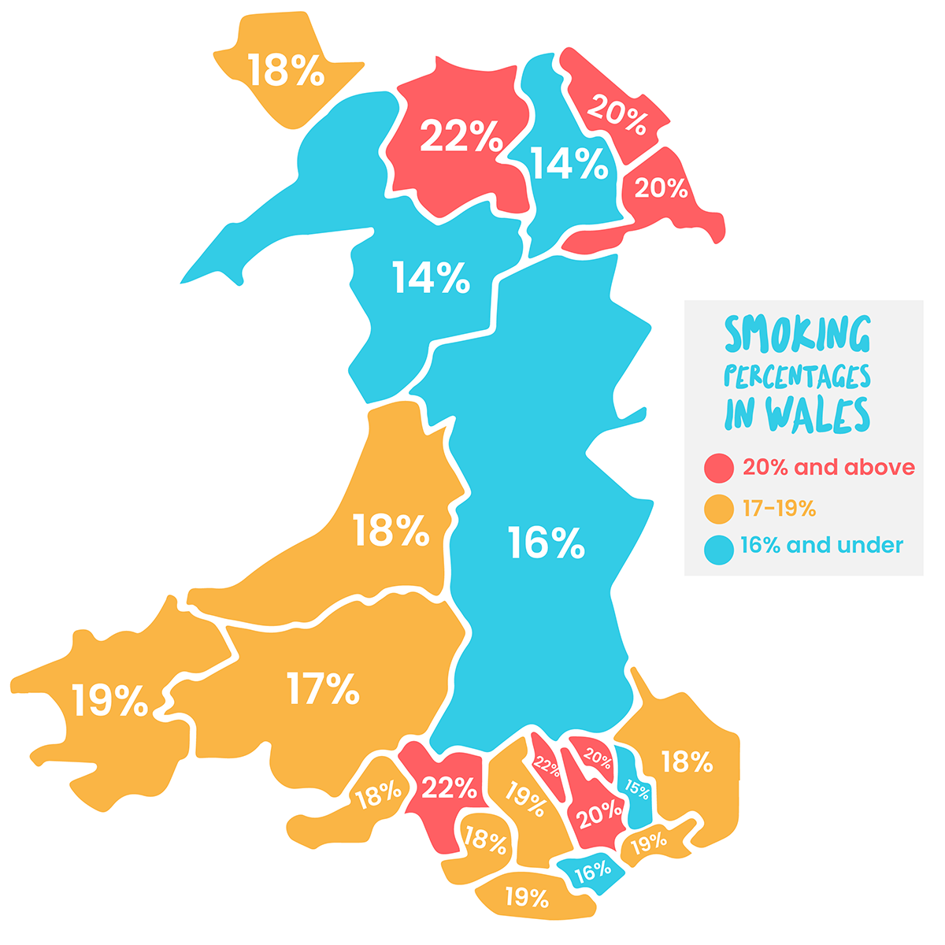
(ASH Wales, 2019).
Diagram two
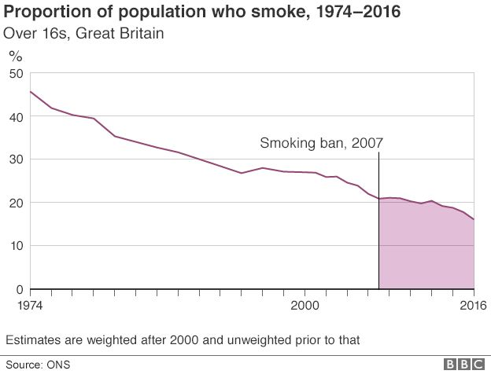
(BBC News, 2017).
Diagram three
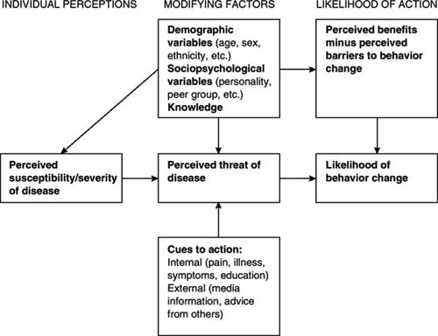
(Thweatt and Query, 2005).
Diagram four
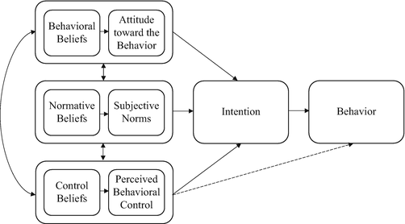
(Kan and Fabrigar, 2017).

