
Individual project: Horizontal centrifugal casting machine
By Sean Storey

2023
Weartech International LTD
University of Wales Trinity Saint David

Table of Contents
Introduction 3
The project 3
My role 3
Project aims and objectives. 4
Timescale / Plan 6
Proposed timescale / Plan 6
Appendix 1 6
Finalised target timescale / plan 6
Recorded timescale / plan 6
Why this project? 7
The Horizontal centrifugal casting machine 11
Initial casting process 13
Tooling 14
Casting features 15
Initial Rough machining process 16
Initial Finish Machining Process 17
Jaws 18
New production process 19
New Tooling moulds 23
New casting features 25
New Rough Machining Process 26
New Finish Machining process 29
Jaws 31
Recorded results 32
The first process 32
The new process 33
Factors that could affect the results. 34
Cost 35
First process – 65 x 20 x 210 35
New process – 65 x 20 x 600 36
First process – 70 x 20 x 220 37
New process – 70 x 20 x 600 38
First process – 80 x 20 x 240 39
New process – 80 x 20 x 600 40
Bibliography 43

Introduction
The company that I work for is Weartech International, I work as a machining operator in the machine shop. Weartech was founded in 1990 and the company is now owned by Lincoln electric who specialize in wear- resistant materials. The company has been built up successfully by helping customers solve their difficulties with their wear resistant problems with the parts and components that the use. The services that the company provides include weld overlay, thermal spray, rapid prototyping, hard facing solutions, and finish machining. The company I now based in Baglan industrial estate in Port Talbot, and this is the site where the project is being implemented.
This report for a project that has been taking place at my company over the past several months, the project that was undertaken was the removal of a vertical centrifugal casting machine and the instalment of a new horizontal centrifugal casting machine. The project is to improve the productivity and efficiency with the casting and machining process. The project will affect the both the machine shop and the casting departments, and this is where the project will be taking place. The report includes the process of the project and all the tasks that were required to complete this company project, it also contains the project aims, the timeline, costs, the recordings, and the results.

The project
The project itself is implementation of a new production process, this is influenced by the installation of a new horizontal centrifugal casting machine which will change the casting size and shape. The project will require the change in process for the casting the raw material, the rough machining of the casting and the finishing machining of the component. During the project I will be overseeing the installation of the new machine and recording the results for both of the processes to compare the difference in times, scrap, cost, resources used and the quality of the finished components and parts. I will also be machining the new castings that have been produced both the roughing out of the casting and the finish machining operations to produce the end product.

My role
The company that I work for have begun company project that I have chosen to be involved with, I will be using the company’s project to use as my own. This report will be about my project that entwines with the company’s project, the role I will be taking in my project is firstly I will be looking into the research on the horizontal casting machine to see if this is a suitable option, I will also be looking at other possible options that the company could consider looking at and decide which would be the better option. I’ll be overseeing process used for the vertical casting machine. I will be recording the results for this process. I will be operating the machinery in the roughing stage of production and the finish machining stage too; these results will also be recorded by myself. i will be overseeing the installation of the new horizontal casting machine and when the machine is introduced into operation, I would be recording those results too. With the new castings produced I will be required to find the best conceivable way to load the casting into the machine and begin the rough machining operations. I am then obligated to write a programme for the CNC lathe that is suitable to finish machine the new casting successfully. I will then have to take all of the recordings of each of the stages ready for comparison to see if the project was a successful investment or not.

Project aims and objectives.
The primary aims and objectives for the project that is at hand is to improve the business that is conducted at Weartech, this is to be done by improving the process of production in the workplace. The application of a new process will provide the company with an incentive to manufacture products more efficiently, effectively, and safely. To achieve this goal, the components would have to be produced faster, using less material, using fewer cutting tips, and creating less waste or scrap/reverted parts.
Reducing production times.
The objective of the production time is to be reduced on each section of the overall production process, this will be in the casting phase, rough machining phase and the finish machining phase. This ambition of the company that is set for the project would hopefully be achieved in the change of the casting process which would have a knock-on effect for the other phases of the production process. Weartech have set this target because the company aims to improve and thrive in production for the components that are being produced in this area, this objective would bring down the cost which include the overhead and operator wages. It would also mean that operators could supply the company with more parts in their working hours, therefore completing orders quicker and encouraging the opportunity to retain more or larger orders for this specific component.
Decrease in reverted and scrap material.
The objective is to minimise the material that is used to produce the castings for the products, the aim is to create a casting that can be effectively machined and finished with as little offcuts and swarf formed possible. This is also to reduce the number of scraped parts that must be reverted either before the rough machining or even if they do not clear up and have defects before the finish machining process. The reason for this objective is to again improve to the cost of production and to get as much use out of the casting as possible with the least amount of reverted material.
Improving quality of the material
The aim of the new process is improving the quality of the material that is produced when using the new casting machine, research that has been done shows that this machine could improve the grain structure within the casting which can avoid the errors such as, folds and porosity. The reason for this would be to avoid downtime and therefore improve cost once again for the company.
Reducing the amount of cutting tips used.
This target is to gain more components successfully with the required use of cutting tips is declined during both of the machining processes. The company have this target in mind because it will bring down the overall cost of the production and hopefully make it easier for the operators when manufacturing these parts.

Health and safety.
The health and safety improvement are also an objective that is involved with this project, the target for the project would be to develop a procedure of casting and machining that is safer with less likelihood of risk of injury to be caused to the operator or any other personnel in the workshop. This goal is important because to company obviously want to keep their employees safe and secure when they come to the workshop, so the reason for this target is to provide the workers with the assurance that the company is always looking to improve the safety and wellbeing of the workforce. This improvement can go a long way because it would provide workers with the confidence to continue to work at the company which also provides and attraction to new potential employees in future.
Cost.
This is the main target and objective for this project, all of the above aims and objectives will influence this target, the company’s ambition for the project is to bring down the overall cost of the production, this then can improve the profits for the produced components and therefore improve the company’s growth.

Provide more opportunity.
The instalment of the new machinery and process is also aiming to open new windows for potential new customers and the process could allow the production of new components. With the production times decreasing it could potentially increase the magnitude of the orders that requested by the current customers. This could also provide the company with the ability to evolve and adopt new orders for different components to be machined on these cells, also that can be cast with this new horizontal casting machine.

Timescale / Plan

Proposed timescale / Plan
The initial timescale plan that was proposed can be seen in Table 1, this was a rough estimate of the time it would take for the horizontal caster to be installed and be introduced into operation. The plan was set as more towards a guideline to be used when the project was taking place, these time limits were not confirmed as final. During the project, the company and I contested to stay within these time limits as much as possible.
Table 1
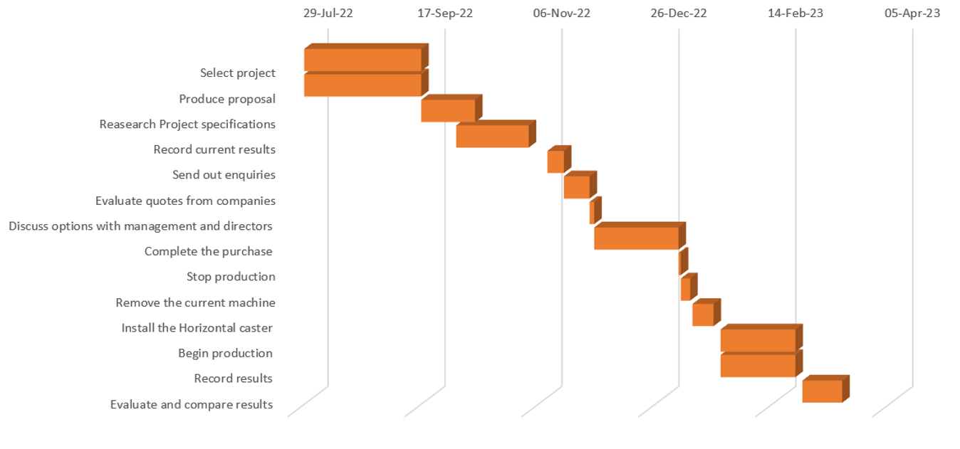

Finalised target timescale / plan
The final target timescale and plan was set when there was more research conducted on the background of the project, this allowed a more realistic and suitable timescale for the project. After the project proposal was reviewed there were more tasks required of myself to have an input in to have a more effective role in this project. This can be viewed in Table 2.
Table 2
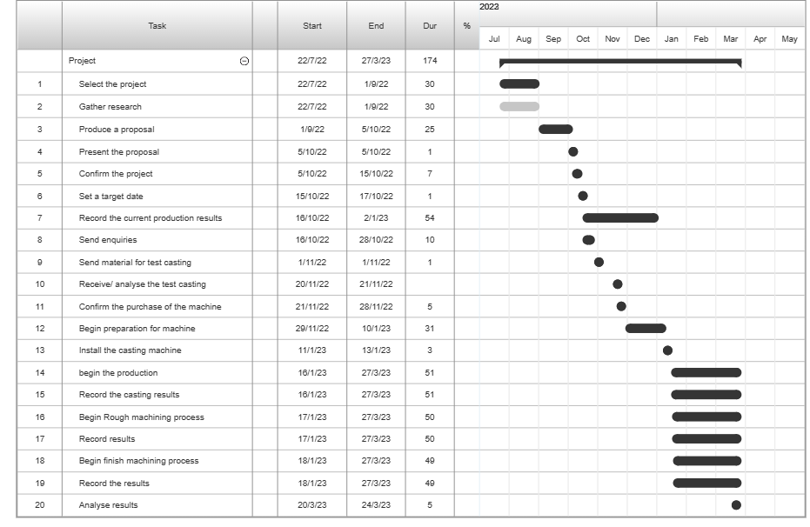

Personal timescale
The timescale for my personal role in the project can be seen in table 3, this is a Gantt chart that shows my personal tasks that I carried out for this project and the correct times that were recorded for this project.
Table 3
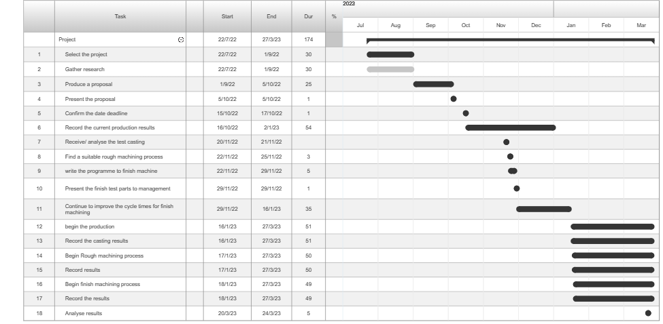

Why this project?
This project was chosen by the company to make further improvements to the manufacturing that takes place at Weartech. There was research required before anything started in motion to see which would be the best route for the improvement in these particular departments. The company believe that the horizontal centrifugal casting machine is the most suitable option for the casting and manufacturing process. There are other processes that could have potential that could improve the manufacturing process and it was important to research all viable options before committing to the instalment of a new process.
There was another option that was researched and that was continuous casting which could be done either horizontal, vertical upward or vertical downward. This process can be used to manufacture semi-finished products of standardized form in a large series, the method can also provide increased control over the casting process through automation. The continuous and equal supply of the molten metal can improve the crystallization, and the removal of the product allows the obtaining of a homogeneous semi-finished metal product during the casting process. (KMM, 2023) This method could have the potential in workplace to improve the overall manufacturing process by avoiding the rough machining stage. This could reduce the time and resources required to complete the product by a significant amount, this would mean that once the material is cast it would advance straight to the finish machining stage. The continuous casting can provide a focused crystallization in the material by choosing the correct speed and the through the intensified cooling with water it could be possible to also increase the speed of crystallization.
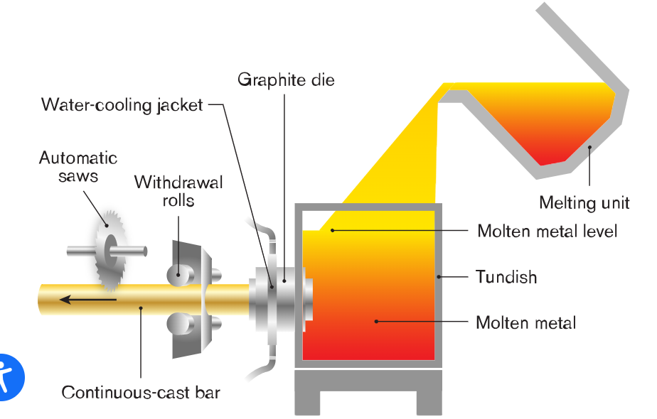
This continuous casting allows the production of a wide range of different profiles which include: tubes, cylindrical bares, slabs of a varied thickness / width, hexagonal profiles and square bares. (Concast, 2023) The diagram shows the process of the casting machine where the material is poured into the tundish, then is pulled through the water-cooling jacket where the molten metal is solidified. The material is then dragged out by the withdrawal rolls in its moulded shape and then cut off with the automatic saws.
There are however many different objections to this process for particular material that is used for castings at Weartech, the material that is used are cobalt and nickel alloys. Cobalt and nickel alloys are used in extremely high temperature conditions and for applied mechanical stresses, they are extremely hard due to the addition of cobalt and have a high resistance to compression (DeanGroup, 2021). Because of the extreme strength of the alloys, it would be difficult to cut the material with the saw that would be used in this process, the cutting would take time and would cause a large amount of wear on the blades which would mean there would be a number of blade changes required, therefore adding to production time and cost. These two elements, nickel and cobalt form a stable and solid solution which can form an extremely hard and conductive coating that can withstand temperatures up to 1,500 degrees Celsius. The kinetics that makes this material impervious to atomic hydrogen ingress and penetration can cause this material to become very brittle and end with cracking and failure. (Larsen, 2020) The brittleness of the material can be exploited in this process with the water-cooling jacket, the temperature of the material will be dropping from highs up to 1,500 degrees rapidly which can invite severe cracking and will cause the material to break.
To go forward with a horizontal centrifugal casting machine the company needed to look at the casting that could potentially be produced, and how it could be effective for the work operations in the overall manufacturing process. To do this the company asked me to research the ideas and products that the casting machine is capable of and how Weartech could benefit from it. The research that investigated was the products that are made by different companies using these specific machines. Trunnion type machines would use a Mold or flask that is supported and rotated by four trunnion wheels, this machine is use for creating casting that are larger in length than they are in the outer diameter. The common components that are manufactured on these machines are bushes, bearings, piston rings, pipe, cylinder liners and steel sleeves and tubes. The dimensions of these machines can be manipulated to the customers’ needs whether that is for the outer diameter which can range from 50 mm to 406 mm, or the length can reach up to 1600 mm. (CCMC, 2023) Federal pipe is another company that was researched for the use of horizontal centrifugal casting machines, they use a roller supporting horizontal hot Mold centrifugal casting machine. This machine is used to produce the long length tubes and pipes including alloy steel pipes, iron pipes, bronze or copper alloy tubes and cylinder liners. The machine use fully automated systems utilizing programmable logic controllers with the functions of automatic pouring, automatic Mold coating, automatic inner Mold wall cleaning and automatic extraction. The machines produce casting that have an outer diameter range from 50 mm to 1000 mm and range of length that can be produces starts from 500 mm and can increase to 8,000 mm. (FederalPipe, 2020)

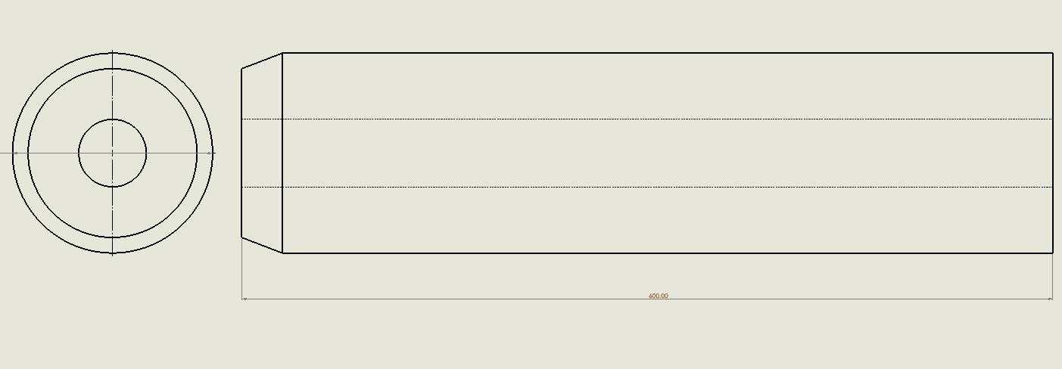
The research that was obtained provided the information that I needed to see what potential design that I could make that could be used for my company. I decided to design a drawing on a Solid works programme of the casting that could be produced if the company wanted to purchase and install a horizontal centrifugal casting machine. The reason for producing this design was to inform the managers at my company that were involved with this project of what the future castings would consist of, this also would give them a visualisation of the dimensions and physical features that are included in this product.

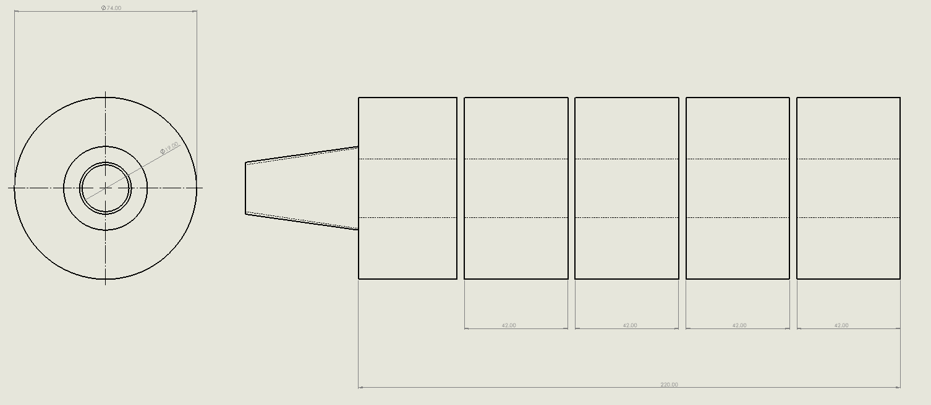
The design shows the casting that could be produced, the design shows a overall length of 600 mm, this would be the ideal size for the casting that we needed. I did not include the outer diameter of the casting because the component do vary because of the customers’ requirements, the research I acquired shows that these machines can be changed using different Molds for larger or smaller diameters. I also created a design of the casting that were produced on the vertical centrifugal casting machine that is used in the initial process, the reason for this design was to show what is being produced and can compared to what could be produced.

The casting that is produced on the vertical casting machine has an overall length of 220 mm, the casting is machined and there is a maximum of 4 components that can be obtained from this casting. The new design is over $2_{2}^{1}$ times the size in length, each component is parted off at 42 mm in length, with this new design there could be 13 components produced from each casting. This shows a huge potential in the increase of production and the decrease in production times and can benefit the company by saving the cost and improving profits.

The Horizontal centrifugal casting machine
The change in the process that the company were willing to go ahead with was the manufacturing using a horizontal casting machine, the company sent out an enquiry to potential supplier of this specific machine that could be suitable for our products.
The enquiry was sent to a supplier that had the most potential to provide Weartech with a new casting machine. Gibson Centri-Tech limited were researched and they showed that they have been supplying these machines to companies for over 40 years and provide a full range of services. They have two distinct styles of the horizontal centrifugal casting machines, which are Alpha range and SHPP.
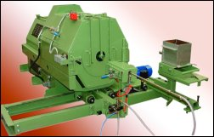
The alpha machines come in five basic sizes and offer an extensive selection of variations that suit requirements of a specific standard. These machines main features are that they are flexible, low noise and vibration levels, simple to maintain, suitable for high production of standard components and they are simple to install and operate. They can produce a number of different products such as bushes, pump sleeves, cylindrical tubes, etc. 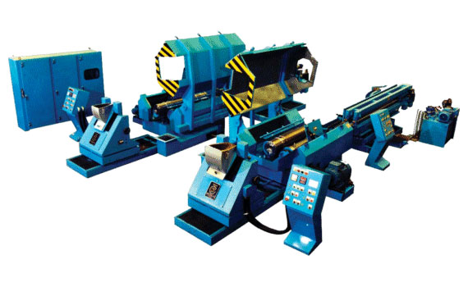
The SHPP machines on the other hand are more specifically designed for pipe production and cylinder liners for use with internal combustion engines. These are heavy duty machines with features including fully automatic modes, special pipe and tube variants and are available for multiple length cylinder production. (Gibson, 2023)

Weartech proceeded with the company Gibson Centri-tech limited with the purchase of the new machine, the next step was to send off the material that was used at Weartech and the casting dimensions and standard that were required for this component. The reason behind this task was to see if these machines were capable enough to produce the product that Weartech were interested in making, this would also prevent the purchase of a machine that would be practically useless in the workplace.
The results were received, and they were acceptable for production, the next step was to proceed with the purchase of the machine that was used for this product. The machine that was purchased was an Alpha Gyra 1 high speed horizontal centrifugal casting machine with anti-vibration mount. The addition equipment that was purchased included:
- A pivoting precision pour unit to work with the Alpha Gyra 1 machine for small bore castings 80 – 65 mm Outer diameter x 20 mm inner diameter x 500 mm length.
- An Automatic spray unit (PLC controlled) with facility to work with the Alpha machine, including a 9-litre mould coating pressure vessel with agitator and airless spray lance.
- Hydraulic rear eject and casting conveyor (manual)

These were all the required items that were necessary to successfully produce the desired quality of castings, therefore the company began the instalment of these items to begin production. Once installed there was a training process that was implemented by Gibson Centri-tech, where all the furnace operators in the workshop were introduced to the new process of production so that they were able and competent to begin production work on this machine.

Initial casting process
The initial process for the production of the castings that were used for this specific job was executed by the use of a vertical centrifugal spin casting machine, this machine can be seen in image 2. The metal would be in the form of ingots and then are placed and melted in a furnace to around 1200 degrees, the molten metal is then poured into the tooling that is locked in place inside the spun caster. The furnace that is used is shown in image 1, as can be seen there are two operators required and they are both obligated to wear the correct PPE. While the molten metal is poured into the tooling, the casting machine will be rotating the tooling at a speed of 180 rpm, the machine will spin continuously until the molten metal has found a solid form. The tooling is then unbolted from the casting machine and then lifted out using and overhead gantry, the casting is then to be knocked out from the tooling and left to cool down.

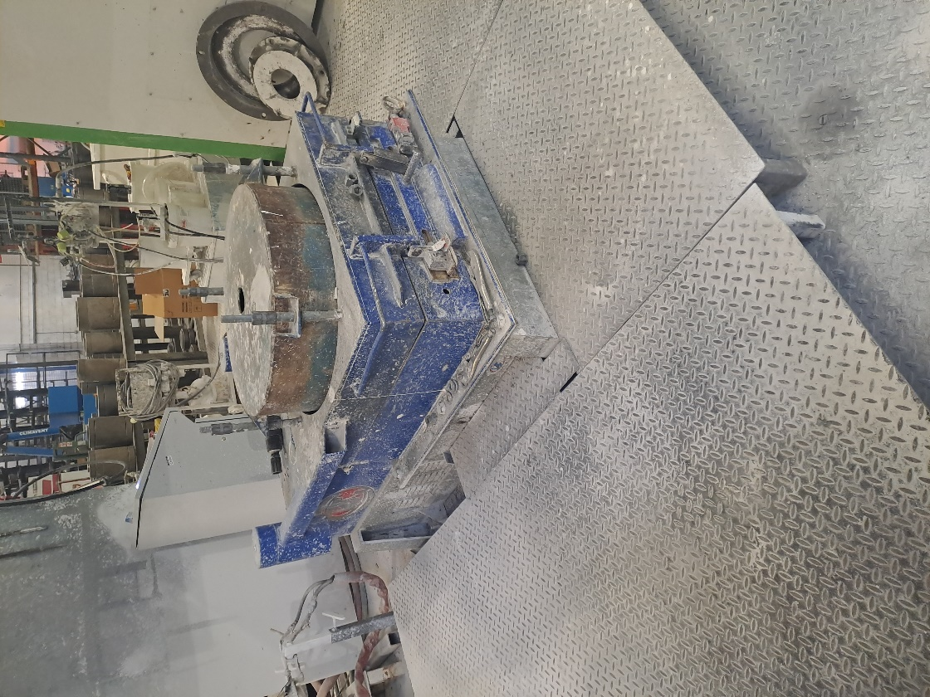

Tooling
The tooling that is used for this machine is manufactured from tool steel, the tooling is made up of three components, the base, the body, and the lid. Tool steel includes additional agents to improve the mechanical strength the elements that are alloyed in the steel that form the carbides include tungsten, chromium, vanadium and molybdenum. (toolbox, 2005) The melting point of this steel is 1450 – 1530 degrees Celsius, this is a suitable material for the casting because the melting point is higher than the melting point of the material that is being cast. The tooling is also sprayed with a ceramic powder coating on the inside of the wall of the body, the base and the lid. Ceramic coatings can offer enhanced properties such as thermal and electrical insulation, these coatings are used for industrial applications such as metal casting troughs and trays, high temperature turbine engines, combustion liners, vanes and blades. The thermal sprayed oxide ceramic coatings require a bond coat for the correct adhesion, with the correct bond coat from alloys and MCrAIY material the coating can improve the thermal conductivity, insulation or wear and corrosion resistance. (Oerlikon, 2023). The use of the powder coating extremely effective when it comes to spun casting, this is done to prevent the molten metal from attaching to the tool when it is spun in and has solidified. Without using the powder coating the casting would stick to the tooling and would be impossible to remove from the tooling without damaging it, the tooling being damaged would then have to be replaced or refurbished by the machine shop and would cause downtime cause increasing costs.
It is compulsory that the tooling size matches the dimensions of the casting that has been desired, the tooling will have to be slightly bigger than the casting because there is the factor of shrinkage to be taken into consideration.
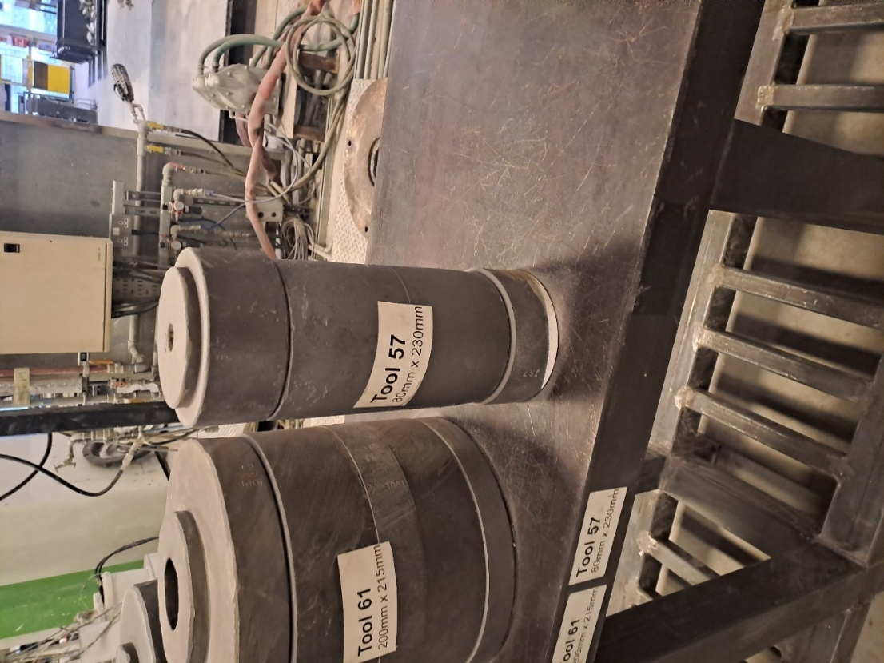

Casting features
The casting that is manufactured from the vertical spun casting machine is made from a cobalt alloy; in this case the grade of the material is grade 1020F. The castings that are produced for the orders are of three assorted sizes, each of the orders require the different tooling to be suitable for the end casting size. The smallest casting that is produced is measured at 65mm outer dimension, 20mm inner dimension and a length of 210mm. The next size up is measured at 70mm outer dimension, 20mm inner dimension and a length of 220mm. The last casting size is measured at 80mm outer dimension, 20mm inner dimension and a length of 240. The casting obviously has a round and rough surface contour which gives a cylindrical shape, there is a tapered hole at the centre of the casting which starts at 20mm and tapers to 0, this is because of the metal that remains at the bottom of the tool when it is spun cast. 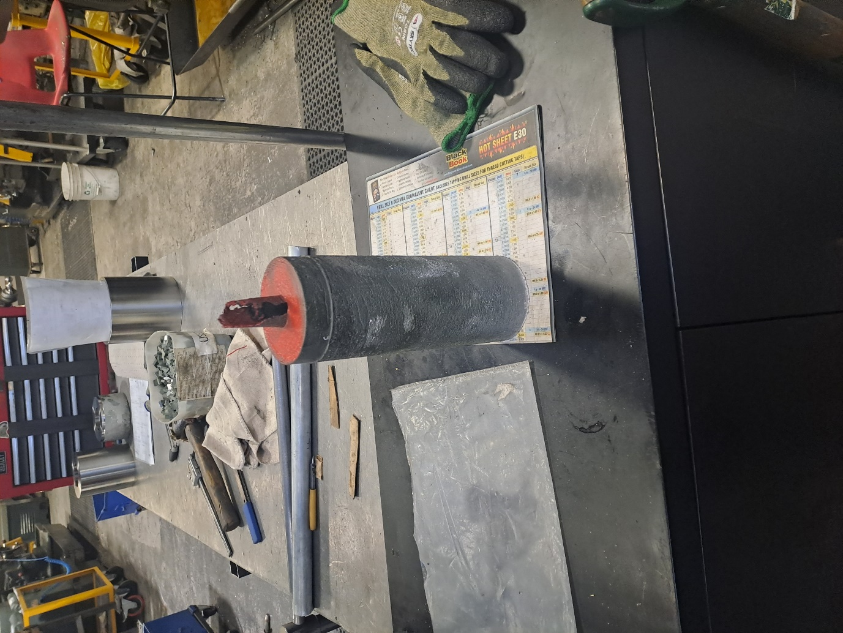

Initial Rough machining process
The rough machining process for this particular casting is to be loaded onto a manual lathe machine ready for turning, the machine that is used for this process is a Herbert 9C-30 manual lathe. The logic for using this specific machine is because this manual lathe is a heavy-duty machine which can operate under heavy forces. The material that the company uses to make these components is incredibly tough and does not cut with ease, hence why the Herbert is ideal for this specific job.
When loading the raw casting into the lathe it will be gripped onto using a four-jaw chuck, the jaws will grip onto the top end of the casting by approximately 10mm to 15mm, this is done so the casting can be finished without having to be taken out and back ended, which would mean doing this would save a large amount of time when machining. The casting needs to be clocked into a central position at both ends of the casting to ensure the material is cleaned on the full outer diameter, if the casting was out of central position this would cause several problems for the process. The turning of the outer diameter would be affected because the casting would not clear up due to the off centred throw, the drilling would also be ineffective because the drill would follow the hole that is currently there causing it to be cutting too much of one side, therefore the component would be scraped for the reason that it would not meet the finish requirements before the finish machining stage in the process began.
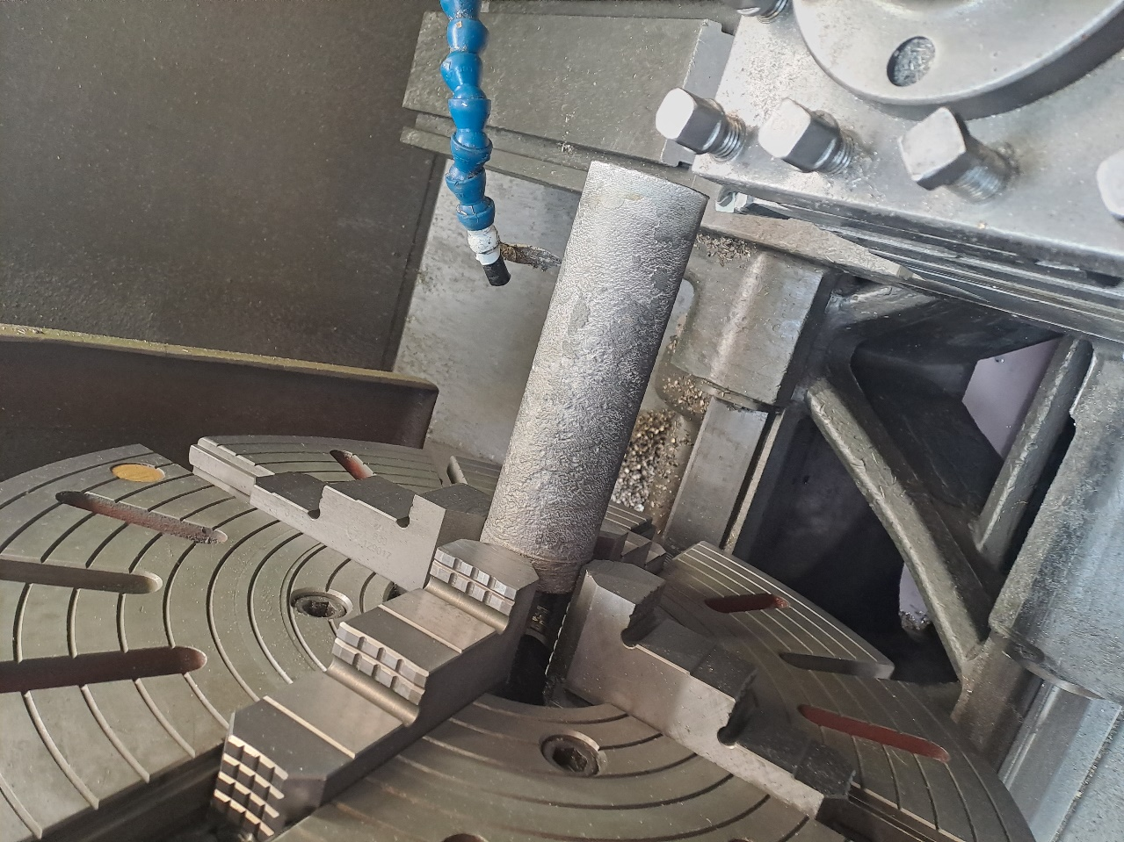
The first operation to be performed on the casting is to face off the raw material to ensure a clean flat surface, this operation is done using a ceramic cutting insert and is machined at a speed of 485 rpm. The following operation is to turn the outer diameter of the casting, this is machined with the same ceramic insert and at the same speed of 485 rpm, the size of the cut is 8mm leaving the casting 2mm above the finish size, the casting is machined directly across the length to leave 1mm between the insert and the jaws. The next action is to centre drill the casting to prepare for the drilling operation, this operation is done with a carbide coated centre drill run at 128 rpm. The follow up action is to drill the casting straight through, this is performed with a 30mm carbide drill insert which is run at 68 rpm. The final operation that is done in this procedure is to part off each component, each one is parted off at 42 mm using a carbide insert and run at 36 rpm.

Initial Finish Machining Process
The finish machining process follows the rough machining in the overall manufacturing development of the component, the finishing of these parts will be done on CNC lathes. The lathes that are in the cell to deliver the final product include one Doosan Puma GT 2100 and two other Doosan Puma GT 1200. This cell that the finish machining is completed in is a three-operation process, the first of op is to face to clean, there is minimal taken off the face which is run at 100 rpm using a ceramic insert. The bore is then machined out to clean the surface finish that has been completed on the roughing section, the cutting of the bore is done using a carbide coated insert with a 0.8 radius at 25 rpm, in the same op the outer diameter is machined down to within again 1mm of the finish sizes using a ceramic insert at 100 rpm. The cycle time on this operation is 10 minutes and 12 seconds, and once the cycle has finished the operator is to remove the part from the hydraulic chuck, then loading the part into the next machine and then repeat process.
The second machine begins the operation will a facing op with a ceramic insert at 100 rpm to clean the surface, then the turning of the outer diameter with the same insert and speed, the outer diameter is machined to the finish sizes with a tolerance of 0.015 mm the bore is then roughed out using a ceramic insert which is done at a speed of 100. The next phase is to finish the bore to the correct size also with a tolerance of 0.015 and is cut using a carbide tip with a 0.4 radius run at 65 rpm, the reason for using this sort of cutting insert is because the smaller radius on the edge provides a cleaner finish on the material. After that operation the inner grooving operation begins, and this is done with a 30-degree angled 3mm carbide grooving insert running at a speed of 20 rpm. The process that follows this is the front and back grooves on the outer diameter, these are completed with a 3 mm carbide grooving insert at a speed of 40 rpm for the front and 30 rpm on the back groove. The final operation is to machine the to cut the dovetailed angles onto the outer diameter front and back grooves, to do this it will cut the inner wall of the grooves to provide an angle within the grooves which is run at the speed of 20 rpm, this is giving an overall cycle time of the operation 10 minutes and 40 seconds.
The third and final operation in this cell is to finish the back end of the component, the component is loaded into the jaws ready to be faced off to the required length on the drawing, this is done again with a ceramic insert at 80 rpm. The outer diameter is then turned to the finished size with the same insert and a speed of 100 rpm. The bore is then machined to the size required using a ceramic insert at 100 rpm ready for the threading and internal grooves. The following stage is the grooves on the inner diameter with a 2 mm carbide insert at a speed of 120 rpm for the first groove and 60 rpm. The undercut and undercut spring cut is next which is run at 80 rpm. The screw cut is the final operation for the component, the thread is a left hand M42 X 1 and this is done with a carbide coated insert running at a speed of 350 rpm. The cycle time for the third op is 7 minutes 39 seconds, this is then added to the other two operation times to give a total time of 28 minutes and 31 seconds to fully complete one part.

Jaws
The jaws that are used for this machine have been machined by an operator, these are seated jaws where the part would sit up against the face of the jaws and then the hydraulic chuck would close with the machined step gripping the external diameter of the part.
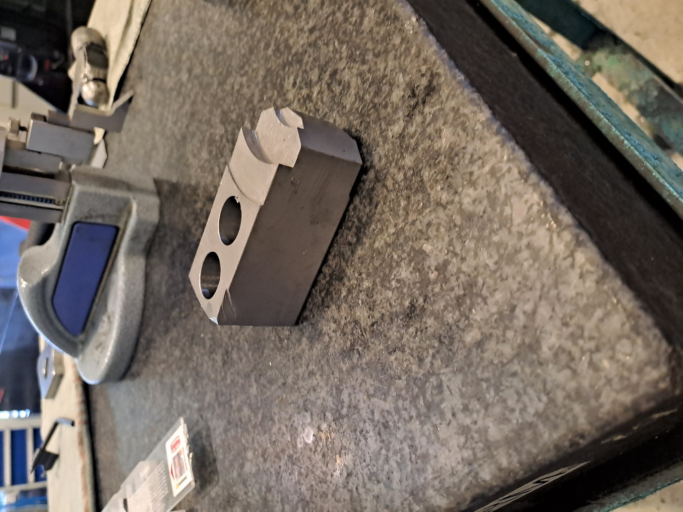
The jaws were machined to a specific depth of 15 mm which is deep enough to hold the part securely, this also mean that each part will be located in the same position every time for machining, so the operator does not have to input the location of the part each time.

New production process
The new manufacturing process that is to implement into the workplace will begin in the casting department, this is where the new horizontal casting machine is to be installed. This will change the procedure for the pouring of the casting, and it will also change the features of the casting that is produced, the features that will be different include the size, shape and potentially the grain structure within the casting.
Horizontal centrifugal casting is best applied to castings that have a greater length than the diameter and they have a bore which is cylindrical, it is common to find a tube-shaped casting between 305 mm to 6000 mm in length. Horizontal casting processes can be done with both ferrous and non-ferrous materials, it is because of the application of different process techniques that affects the material such as the rates of pouring and spinning, or the water-cooling duration can determine a successful quality casting. (Wei, 2012)

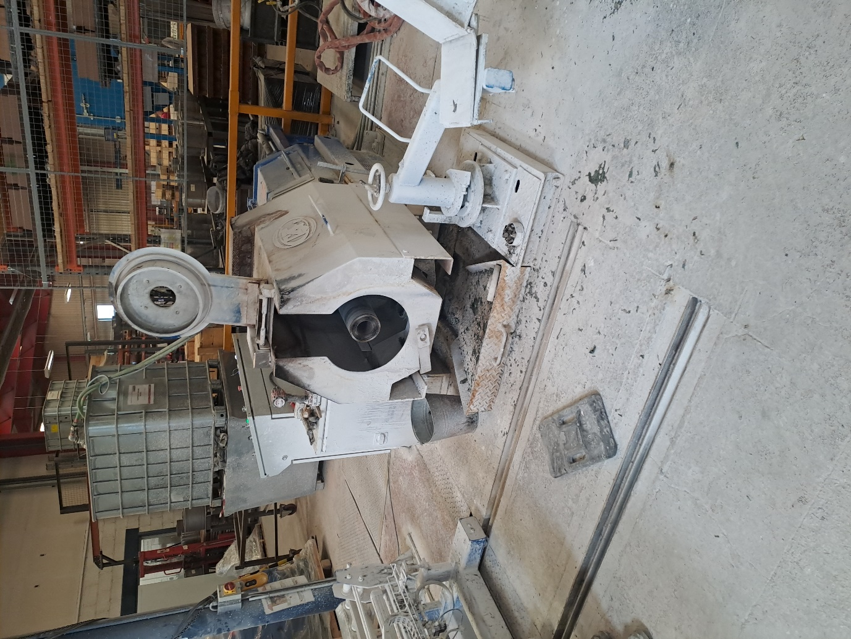

The process of casting will be similar to the previous process where the molten metal will be heated in a furnace, then will be poured into a spun casting machine. The mould that is used in the casting machine will be sprayed with a ceramic powder coated before it is set in place into the machine, this is done to prevent the metal form sticking to the tool once it has reached solidification. The spaying is essential to the procedure of the casting because if the casting were to stick the mould it would be extremely troublesome for the removal of the material from the mould, this could also damage both the casting and the mould. The mould that the metal will be poured into will need to be pre heated for the process to be successful, the mould should reach a temperature of 200 degrees to be suitable for the molten metal.
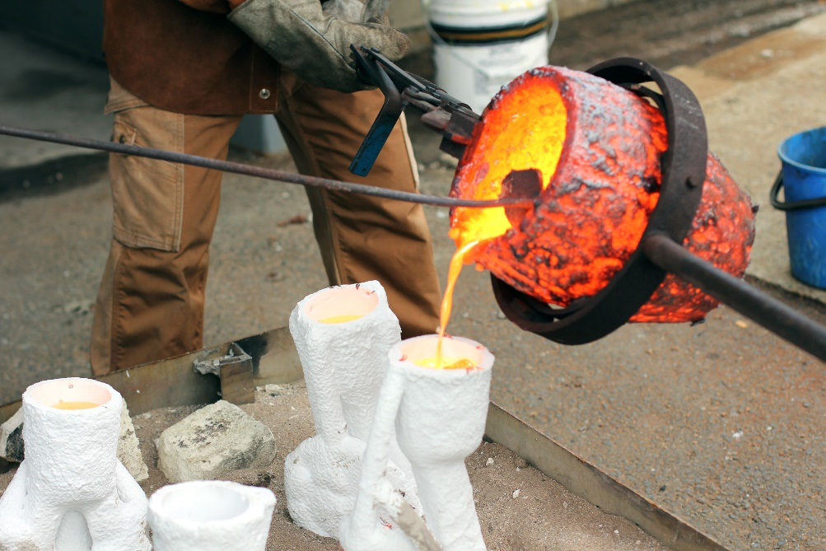 (stonybrook, 2019)
The operators will be instructed to obtain the molten metal using a ladle system which allows the operators to adjust the pouring speed and angle. The process of this is not very simple as the metal needs to be poured at the correct pace, pouring the metal too quickly or too slowly can affect the quality of the material in the end product. The improper pouring techniques can be followed by defect and holes in the material caused by trapped gasses within the moulding. (Swiger, 2022)
The correct temperature for the cobalt and nickel alloys to change state from ingots to the molten state is from 1200 degrees up to 1600 degrees, the temperature for the metal to transfer state will all depend on the grade of material. The grades change due to the percentages of the specific alloys that are included within in the metal as it can affect the melting point of the alloys.

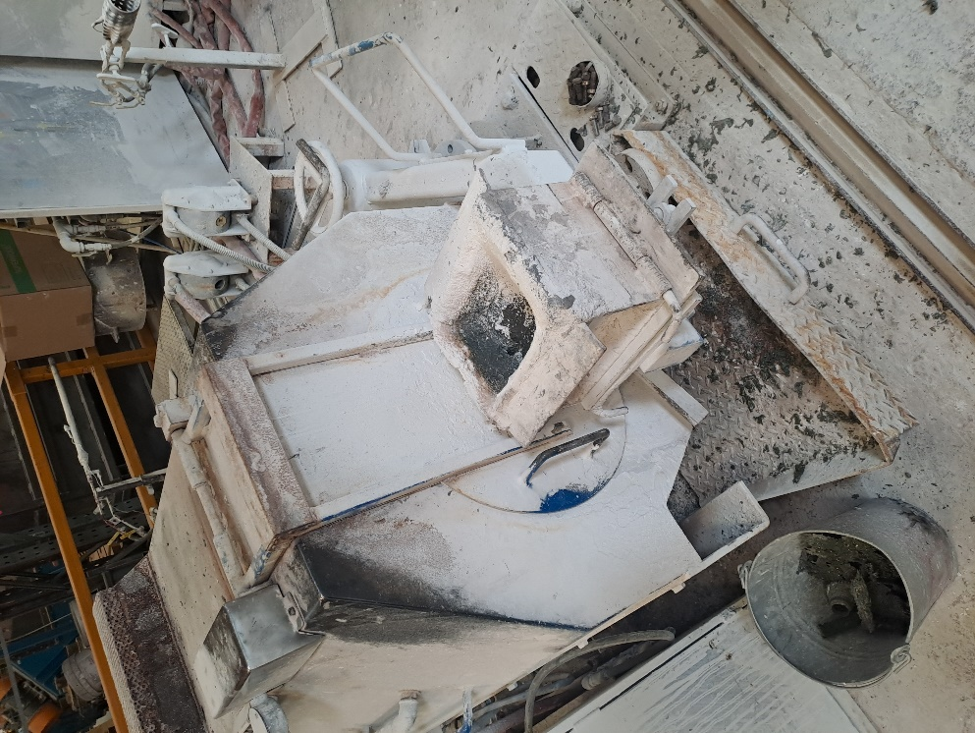
The metal will be poured by the operators into a chamber using the ladle system, the chamber has a hole at the bottom which is where the molten metal will flow through.
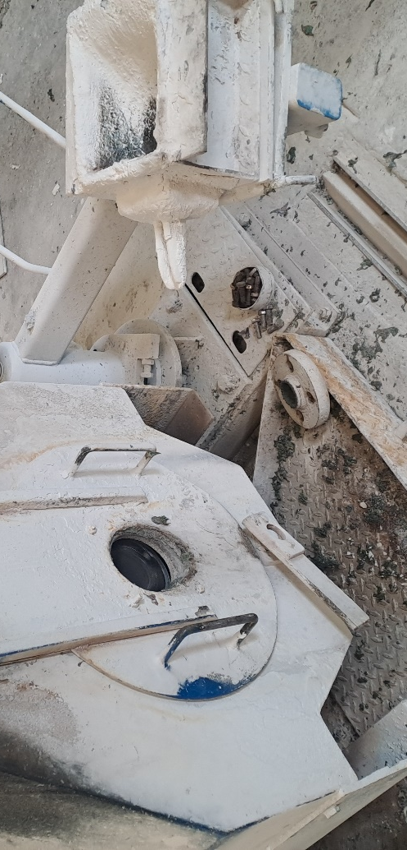
The opposite side of the hole coming from the chamber has a spout attached to it, this is where the metal flows through from the chamber and into the mould. The use of the chamber is to allow the operator to have bigger area to pour the metal into and to avoid spilling any of the metal onto the floor and causing any loss of material. The addition of the spout enables the metal to flow into the mould at a steady and consistent pace and again it is avoiding the spillage of material. The casting machine will spin the metal at a speed of 180 rpm for approximately 16 minutes, once the metal has solidified the lid of the tooling is removed with the hydraulic rear eject which involves the operator to manually extract the casting onto the casting conveyor.

The next step is for the material to be left to cool, once cooled and the order is produced from the casting machine, they are all loaded onto to an oven bed and inserted into an oven for heat treatment. Heat treatment is done to the cobalt and nickel alloys so that mechanical properties can be obtained that are more favourable than those of the prior alloy, the heat treating is to homogenize the lattice of the alloy. The alloys are then quenched rapidly so that the reformations of the deposits in the lattice can be prevented, this solution is preferably done at a temperature minimum of 1000 degrees Celsius. The quenching can be followed by a reheating of the alloyed casting to a temperature between 650 to 800 degrees for approximately 1 hour, the reheating can improve the creep strength and the creep resistance of the casting therefore making the material at an improved quality. (Hirschfeld, 1978)

New Tooling moulds
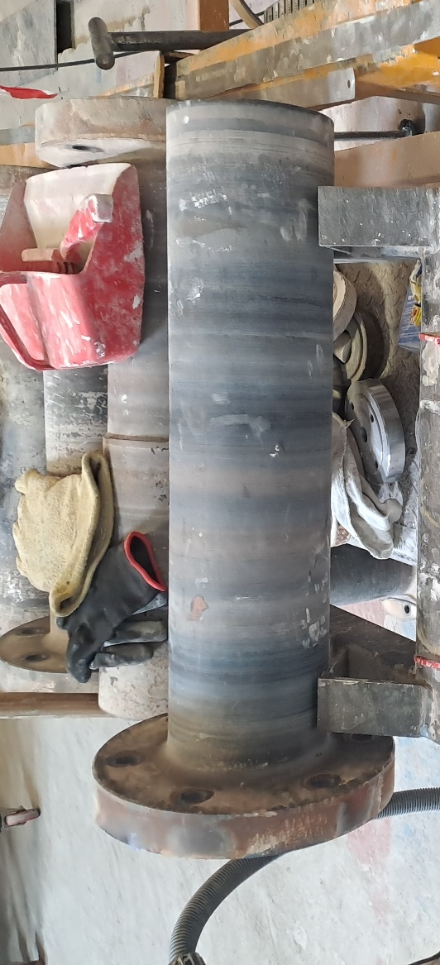
The tooling moulds that will be used on this machine is different to the vertical casting machine, the moulds are made from cold rolled steel. This material is consistent and straight, the desired shape of the material when formed for bars are true and square with well-defined edges and corners, the tubes will have better concentric uniformity and straightness. The melting point of cold rolled steel is between 1425 degrees and 1540 degrees Celsius. The issue with cold rolled steel is that the material is very expensive and the additional treatments can cause internal stress that is within the material, this then can create unpredictable warping if the steel used is not stress relieved before the cutting, welding or grinding (Lina, 2019). The cold rolled steel is a good material to use for the mould on this machine because of the high melting point and the material properties that it has, the concentric uniformity and straightness will be useful for the casting because it will provide a straight casting and the material wont melt when the molten metal becomes in contact with it. The dimensions of the inner diameter of the mould will vary due to the request of the customer which will be between three sizes; 65, 70, and 80 but the length will be consistent of 670 mm and the outer diameter of the shaft will be 150 mm. When the tooling is loaded into the horizontal casting machine the larger diameter is bolted to the back of the machine linked to the rotation spindle, this will cause the mould to spin at the speed the operator desires. The smaller diameter will have a small lid bolted to the front; this is where the metal was pass through when it’s on route to the mould.

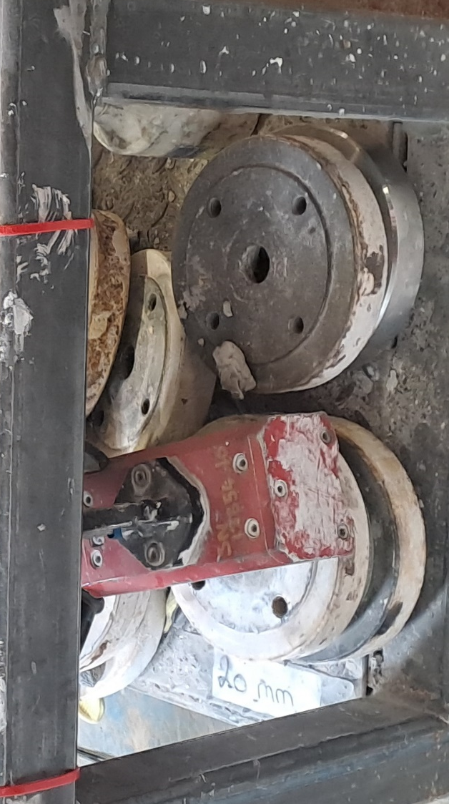
The lids that are attached to moulds have 4 holes which will be aligned with the holes on the front of the mould, the central hole in the lid is hole for the molten metal. The central hole is angled, the front is a larger diameter than the back, the sizes will vary due to the dimension sizes required for the casting. The angle of the tapered hole is at 34.5 degrees, this will match the taper on the spout that is used but the spout will be smaller to avoid collision when lid is spun in operation.

New casting features
The new casting that has been produced from the new machine is as predicted in the design that was produced on solid works, the features of this casting do not consist of complex lineaments and is very basic. The castings produced are at a consistent length of 600 mm with an outer diameter of 80 mm, however the outer diameter can change due to the customers’ requirements for the finished components, the casting has a hole that is straight through the entire length and has a diameter of 20mm. The back end of the casting is tapered and leaves a step down from the outer diameter, this is formed from the process of pouring the molten metal into the tooling, the taper in the tooling is to prevent the metal from flashing and spilling out of the lid. 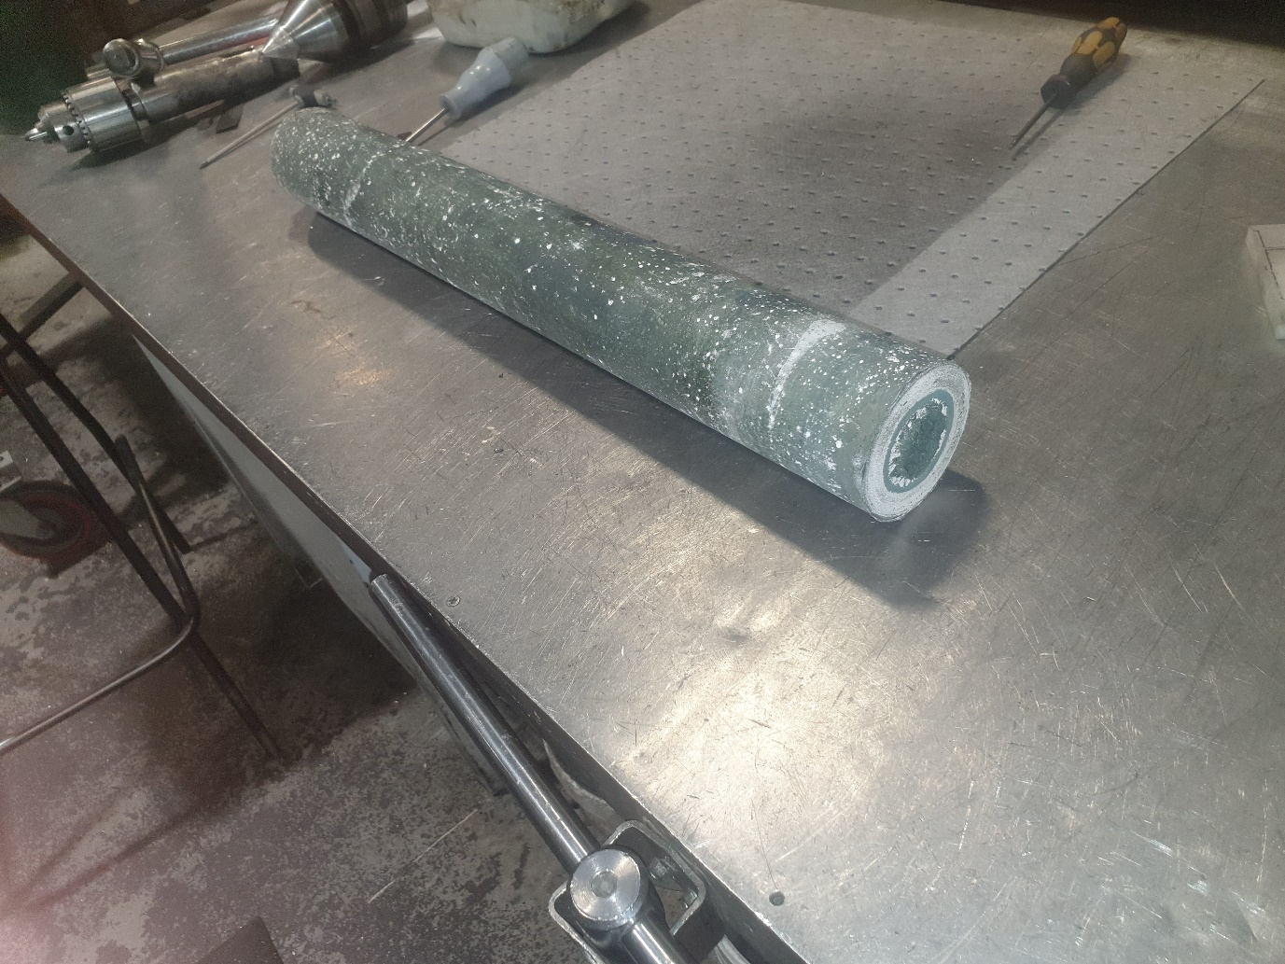

New Rough Machining Process
This stage of the process is similar to the initial production process where to casting will be rough machined ready for finish machining, the machine used will be again a Herbert 9c-30. The difference in this operation will be to do with the loading procedure, the casting will be held by the tapered diameter in a four-jaw chuck.
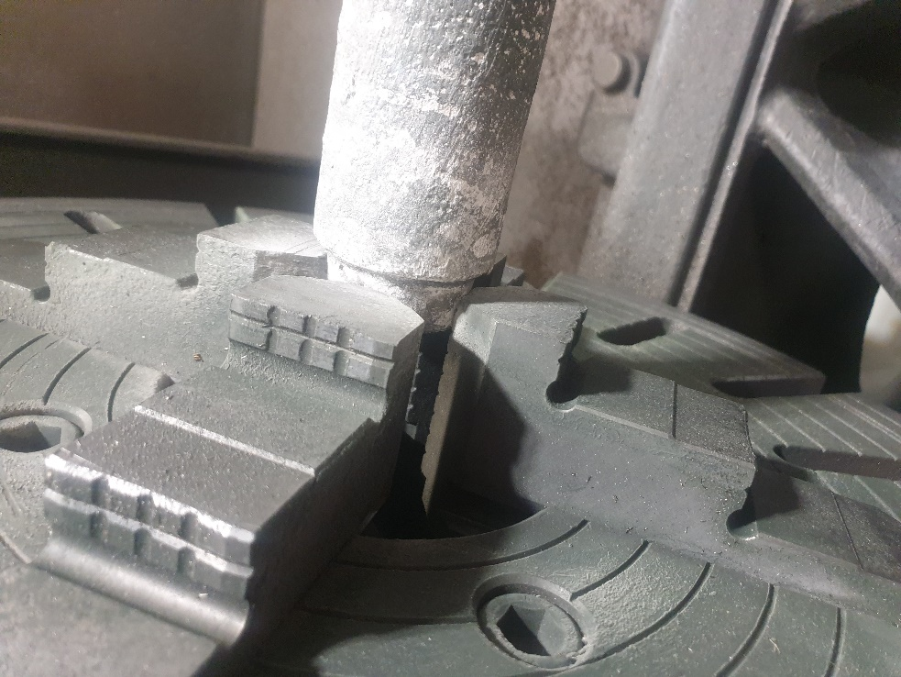
The opposite end of the casting is held in place using a revolving centre which is lodged into the inner diameter hole, the turret is then locked in place so the casting has no possible way of falling out of the chuck.
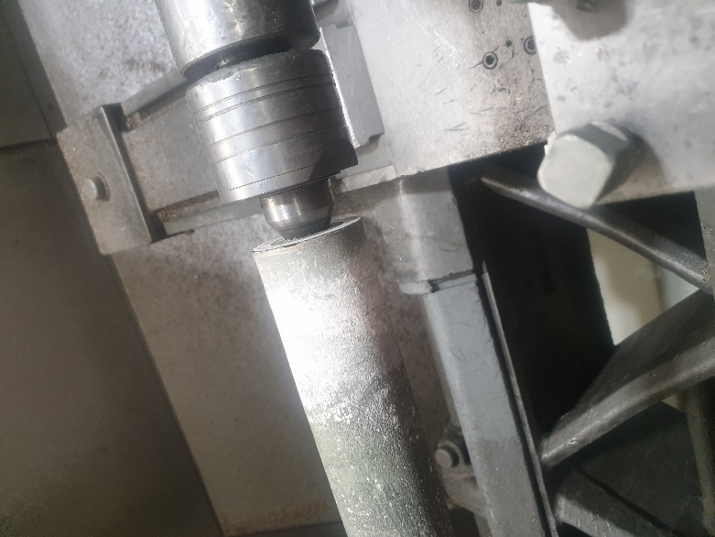
Once the casting is set and secure the operator can then begin the machining process, this will involve a turning operation. The outer diameter of the casting is turned down the required size, assuming the casting is to the correct size the size of the cut that is set is approximately 10mm.
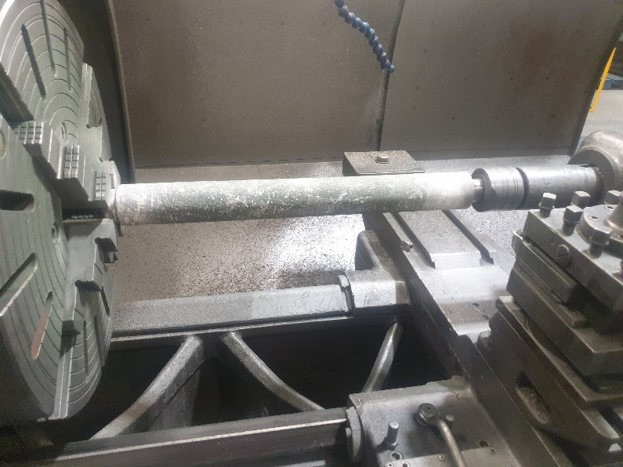

The casting tis turned at 310 RPM and at 0.5 feed speed, this is also cut using a ceramic cutting insert which from results the insert can withstand one full pass across the length of the of casting without chipping or breaking.
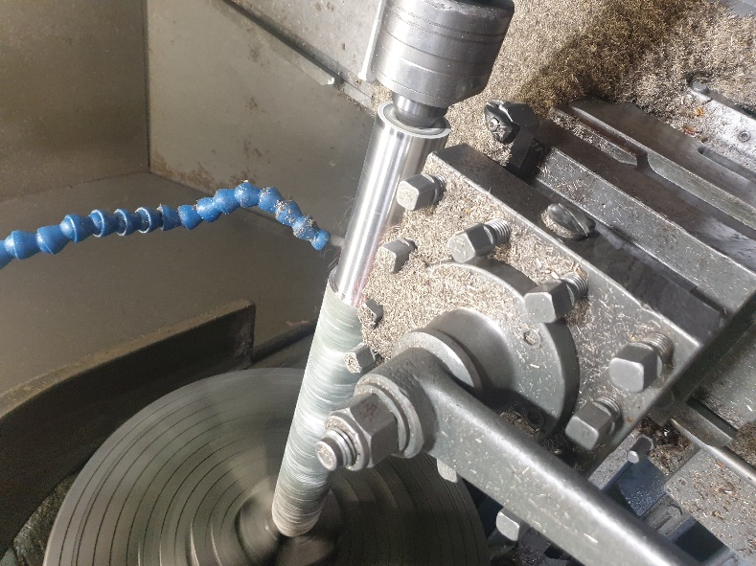
The bar is to be turned without using coolant, this has been discovered to be the most effective way of turning the bar, the other attempts of turning the bar with coolant have only resulted in the cutting insert chipping or breaking away several times when cutting the material. The end result of the turning operation is a fully machined surface right the way across the whole bar, once the operation is done the bar is to be removed by the operator using an overhead gantry, when that is complete the operator will then present the bar to the next stage in the manufacturing and load the next casting and proceed with the process once again.
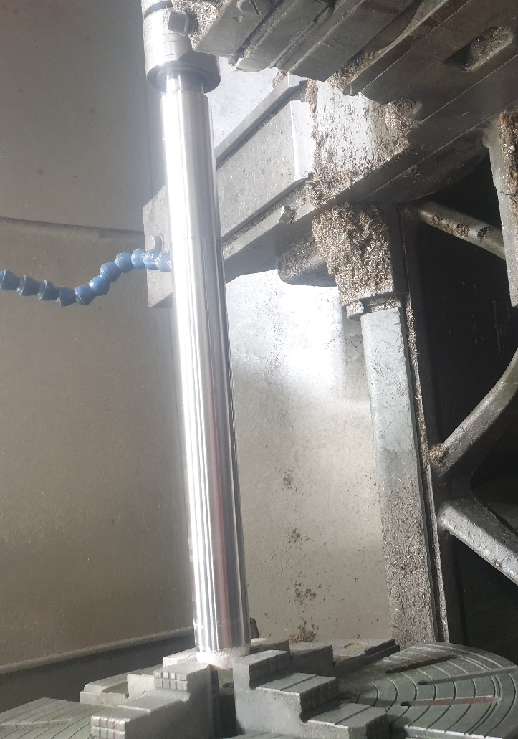

New Finish Machining process
The new process for the finish machining of these components has changed slightly, the initial program that was used for the CNC machine had to be re written. The first and second operations in the Doosan cell were the only programs that needed to be changed, with the programme on the first op, there needed to be an additional operation inserted. The best way to do this was to erase the initial programme and start again, the reason behind this is there is a less likely chance to make human error and forget to change any minor detail that could cause failure, by starting again the operator can write the programme step by step ensuring that everything necessary is included and correct. The work piece offset is needed to be changed because there is a longer required length for the programme to perform all operations, this is done by loading the bar into the chuck, then by hand the operator will touch on the face of the bar with the cutting tool, then the operator will input the location of the tool and that is then set for the programme.
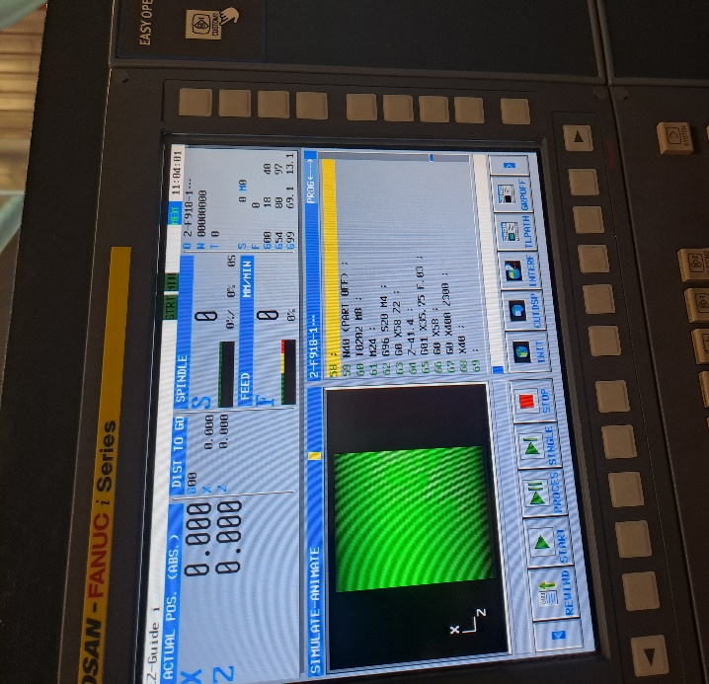
The operations that were added to the programme was the roughing of the inner diameter and the parting off of the component, the parting off is because the castings are now long bars and not individual components. The programme will proceed with all the operations that were included in the initial process; the addition of the roughing of the inner diameter is added to this first machine programme because it has been transferred from the second machine programme. The reason for the transfer between programmes is because the wall width of the part will need to be less for a successful parting off operation. The boring of the material will take the inner diameter to which will be 1.5 mm below the finishing tolerance, this will take place after the turning of the outer diameter, this will also be replacing the original boring operation that was just cleaning the surface finish. The roughing out of the bore will enable the parting off operation to be shorter and it will be taking less material therefore causing less wear on the parting off insert which can then lead to the durability of the insert.

The improvement of the durability on the insert will enable the increase of parts produced with the reduction of carbide parting off inserts used, these inserts do wear easily and are considerably higher in price compared to the ceramic insert that is used for the boring operation. The ceramic insert has 4 edges that can be used on each tip whereas the carbide parting off tip only uses one edge, hence the ceramic insert can machine 2 to 3 parts with each edge and the carbide can machine 5 to 7 parts, if the component that was being machined had a larger wall the carbide insert would be cutting more and would only last 3 machining cycles. This change makes a major difference in downtimes for tip changes and improves the production times therefore it has an effect on the cost and the number of produced parts.
The additional operation of the parting off of the component from the bar will be at the end of the process. The parting off will be done with a 3 mm carbide cutting insert which is run at a speed of 20 rpm. This operation will separate the component from the bar, so it is ready to be loaded into the next machine exactly as it was done before. Once the operation is complete the operator then will open the hydraulic chuck and the pull the bar out to its set length each time. The addition to this programme has evidently added to the overall cycle time on the first machine operation and the complete cell process, the new time of the first operation is 12 minutes and 35 seconds.
The deduction of the roughing of the inner diameter from the second programme means that there will only be a finishing operation on the bore and then brings the cycle time on the second operation to 7 minutes and 44 seconds, which then leads to an overall cycle time of the three machines to 27 minutes and 19 seconds.

Jaws
To change this process the jaws of the hydraulic chuck were also needed to be changed as they are now griping onto a bar of 600mm as opposed to single components. The new jaws were ordered, and they were then machined to the relevant dimensions that were required to hold the bar securely.
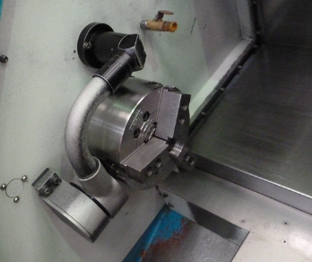
This was done on the CNC lathe manually, the chuck is live and running at 900 RPM, the boring bar is then brought in by hand and machines the jaws with a carbide insert, once the operation is complete the jaws are cleaned up with a hand file and are then ready for production.

Recorded results
During this entire project I myself was to record and analyse the results of the process in both the first and new manufacturing process of all the stages of production including the Casting of the material, the rough machining and the finish machining. Once these results were recorded, I was to compare and analyse the figures and see where the improvements had been made. The reason for the recording was to see if this project had been a success and a beneficial investment for the company.

The first process
Casting results
Recorded and averaged over 100 castings
Size | Time taken each casting (minutes) | Castings produced per shift (8 hrs) | Revert percentage
65 x 20 x 210 | 25 | 15 | 5%
70 x 20 x 220 | 25 | 15 | 6%
80 x 20 x 240 | 26 | 15 | 9%

Rough machining results
Recorded and averaged over 100 parts
Size | Time taken for each casting to be machined (minutes) | Parts produced per shift (8 hrs). (Each casting provided 4 parts) | Revert percentage
65 x 20 x 210 | 110 | 16 | 16%
70 x 20 x 220 | 111 | 16 | 14%
80 x 20 x 240 | 114 | 16 | 10%

Finish machining results
Recorded and averaged over 100 parts
Size | Time taken for each finished part (minutes) | Finish parts produced per shift (8 hrs) | Revert percentage
65 x 47x 210 | 28.3 | 34 | 16%
70 x 20 x 220 | 28.3 | 34 | 17%
80 x 20 x 240 | 28,3 | 34 | 16%

The new process
Casting results
Recorded and averaged over 100 castings
Size | Time taken for each casting (minutes) | Castings produced per shift (8 hrs) | Revert percentage
65 x 20 x 600 | 15 | 28 | 5%
70 x 20 x 600 | 15 | 28 | 3%
80 x 20 x 600 | 16 | 27 | 1%

Rough machining process
Recorded and averaged over 100 parts
Size | Time taken for each casting to be machined (minutes) | Parts produced per shift (8 hrs) | Revert percentage
65 x 20 x 600 | 40 | 10 | 1%
70 x 20 x 600 | 40 | 10 | 0%
80 x 20 x 600 | 40 | 10 | 2%

Finish machining process
Recorded and averaged over 100 parts
Size | Time taken for each finished part (minutes) | Finished parts per shift (8 hrs) | Revert percentage
65 x 20 x 600 | 27.19 | 38 | 17%
70 x 20 x 600 | 27.19 | 38 | 12%
80 x 20 x 600 | 27.19 | 38 | 10%

Analysis of the results
The recordings for the first process show a much higher revert percentage over the 100 parts compared to the new process, there is also less production being done per shift in both the casting and rough machining department. However, the recordings show that in in the finish machining process there are on average 5/6 more parts being produced in the first process that was implemented. Thes results all have contributing factors that need to be considered when they were in the process of manufacturing, these factors can cause disruption in the recordings whether it is with the revert, time taken and the overall number of parts that were successfully produced.

Factors that could affect the results.
The casting process can have many different types of inconveniences when the production is taking place, for instance the furnace could take longer to reach the required temperature in the winter because of the colder environmental temperature. There also could be less operators in the foundry at the time therefore there is more time taken for preparation. The tooling is to be considered when the casting is taken place using the first process as the tools do need to be refurbished, the refurbishment means that the tooling has deformed slightly in the continuous cycles of usage, it then needs to be machined to ensure that the inner diameter is concentric with the outer diameter for is to spin and cast correctly.
The roughing process has many issues with both of the machining process, the castings are not consistent with the shape and the surface quality. The quality of the surface can have a major effect on the cutting process, for instance the casting can have folds or cracks on the outer surface. Therefore, the deformities on the surface can cause the ceramic cutting insert that is used to chip and break, this then creates downtime for the operator as they have to cold down the tool holder and replace the insert to begin the turning operation again. The downtime will affect the time it takes to produce the parts and can also cause reversion of the scraped material. The drilling process can be inconsistent due to the drill becoming blunt and may overheat which can cause creep failure, creep failure is a time dependent and permanent deformation of a material when subjected to a consistent load or stress, this deformation happens when there are extreme elevated temperatures. (CorrosionPedia, 2020) This failure to the drill insert will require the operator to have to remove the broken or blunt insert then either sharpen the insert or replace it with a new one, this will all cause downtime in production.
The parting off of the parts on the roughing process does tend to leave breakage on the internal diameter, this will affect the finish machining process as the CNC machines will not be able to clean the face of the job due to the breakage left on the face. These parts would then have to be returned to the rough machining to face off again to clean, this error can cause major downtime in the process and will affect the results.

Cost
Line No. | Description | Engineering Hours | Eng. Cost @ £60/Hr | Maintenance labour hours @£45/Hr | Maintenance labour hours | Material/ Contractor cost | Total cost per line
1 | Alpha Gyra 1 high speed horizontal Casting machine | 8 | £480 | £720 | 16 | £54,000 | £55,200
2 | Precision Pour unit | 0 | £0 | £0 | 0 | £8,700 | £8,700
3 | Automatic spray unit | 0 | £0 | £0 | 0 | £16,800 | £16,800
4 | Hydraulic rear eject and conveyor | 0 | £0 | £0 | 0 | £12,00 | £12,000
5 | Commissioning | 0 | £0 | £0 | 0 | £2,100 | £2,100
Subtotals |  | 8 | £480 | £720 | 16 | £93,600 | £94,800
5% Contingency |  |  | £24 | £36 |  | £4,680 | £4,740
Totals |  |  | £504 | £756 |  | £98,280 | £99,540
Exchange rate £-$ |  |  |  |  |  |  | 1.31935
Dollar total |  |  |  |  |  |  | $131,328.10

This table shows the total cost of all the equipment that was purchased and all the labouring hour costs for the instalment of this casting machine that was used for this project.

First process – 65 x 20 x 210
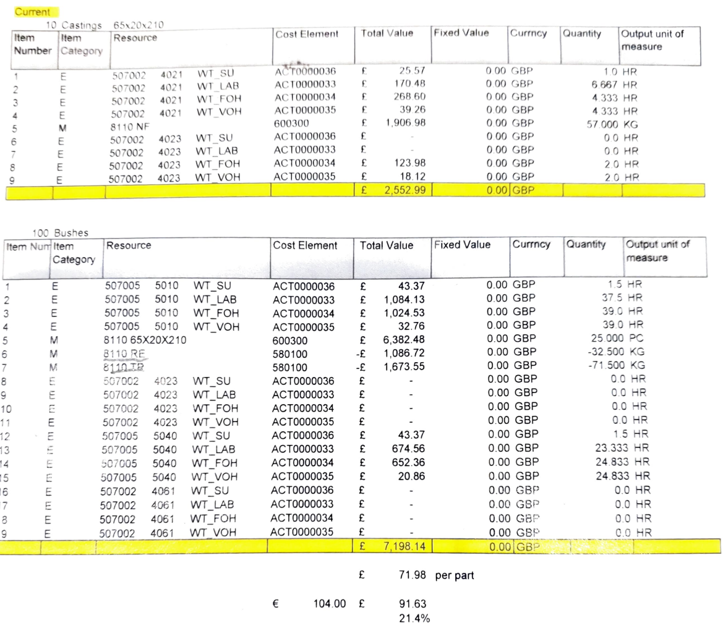

New process – 65 x 20 x 600
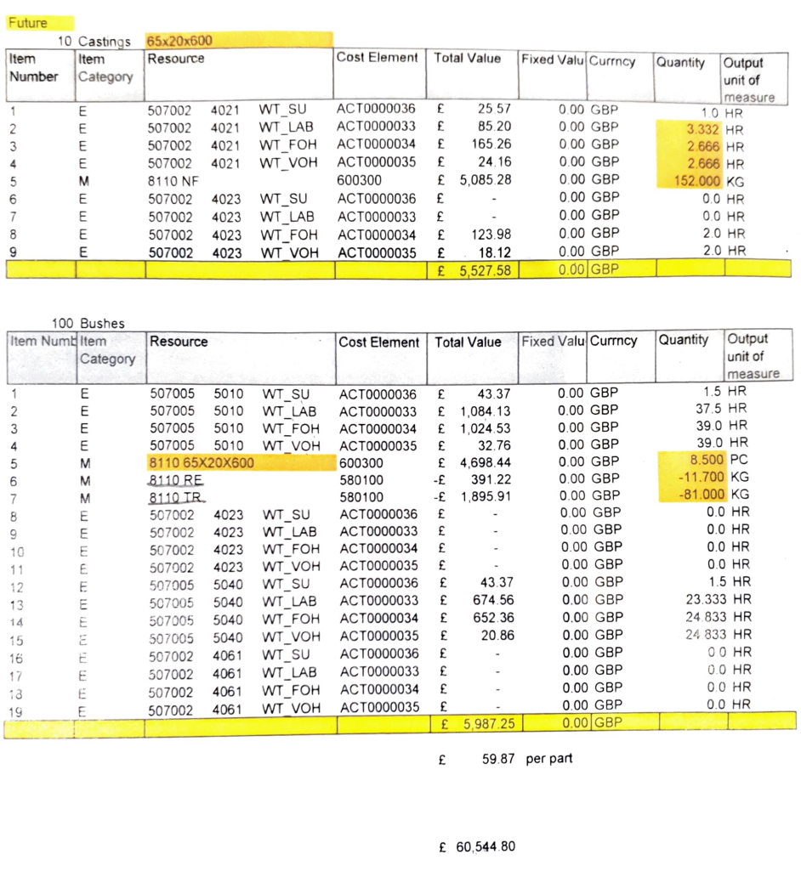

First process – 70 x 20 x 220
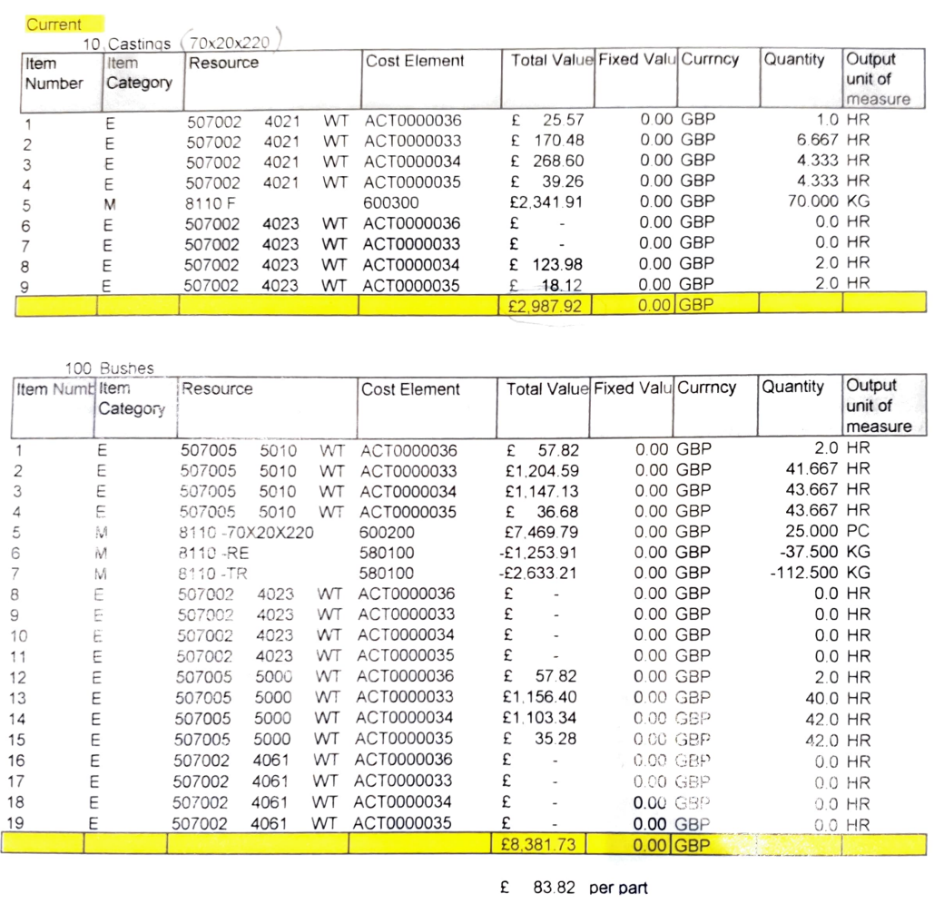

New process – 70 x 20 x 600
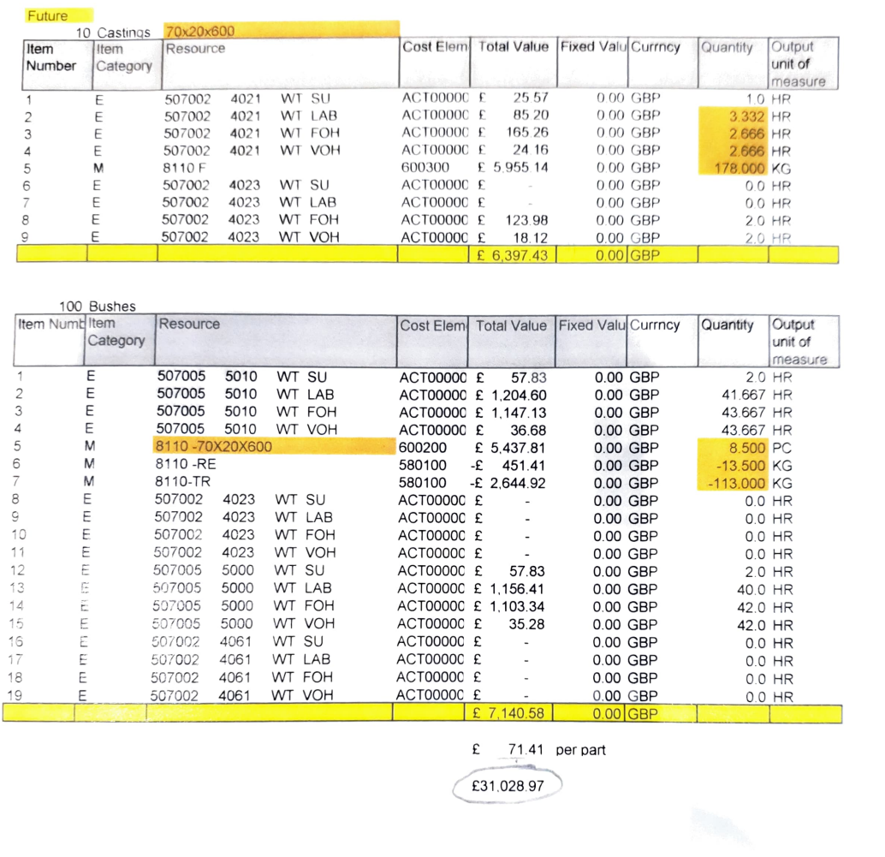

First process – 80 x 20 x 240
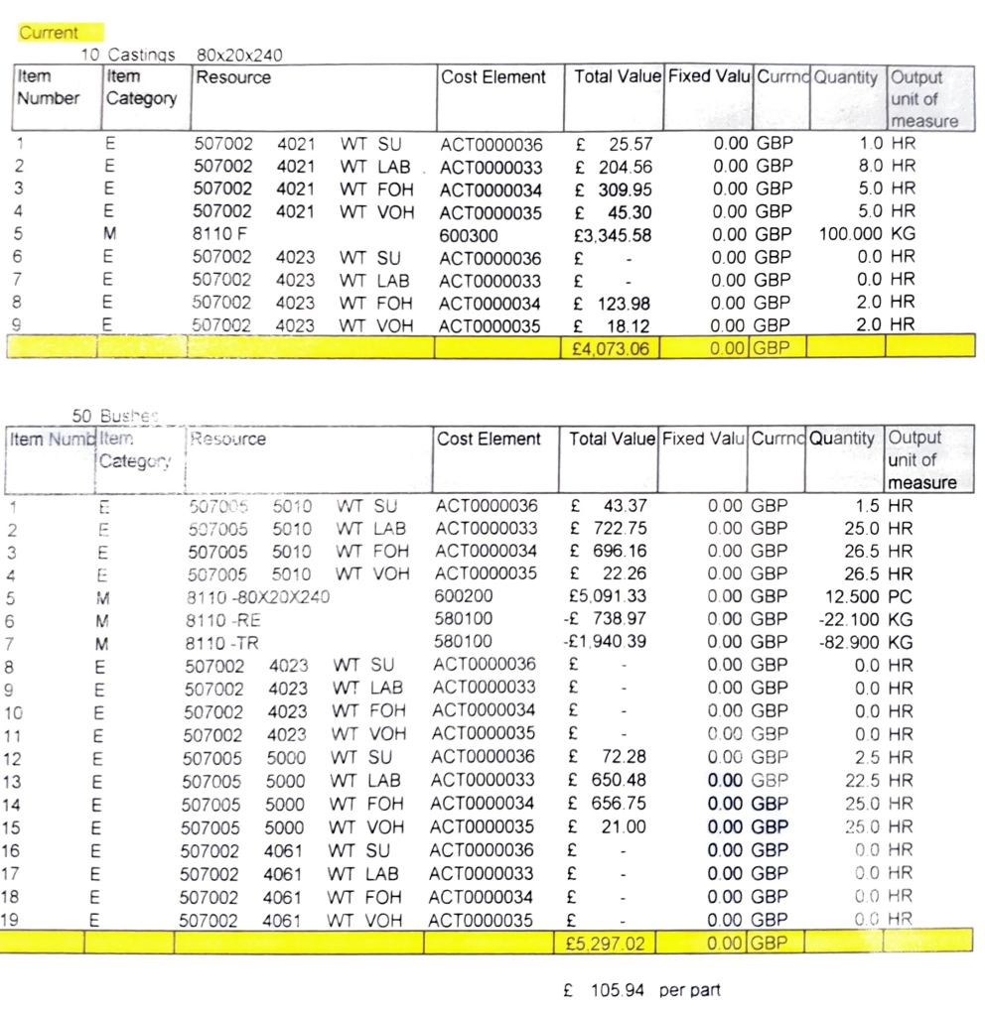

New process – 80 x 20 x 600
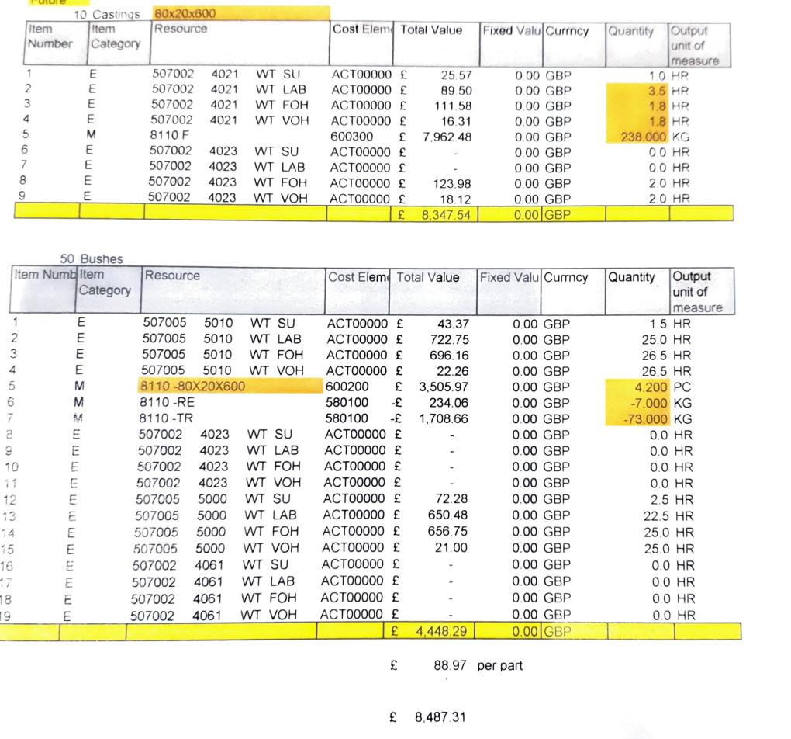
These tables show the overall cost of the production of the older process and the new process that has been installed in place. The cost includes the supplied material, wages of operators, overhead resources such as gas, electric etc and the equipment that is supplied to machine and operate. There is a significant difference in the price per part between the two processes, there are three different sizes of castings used. The results show that the new process is costing much less money to produce parts compared to the initial process, the results were recorded over 10 castings for the casting department and over 100 bushes for the machine shop department. The results were analysed over this amount to get a more accurate value of cost as there can be certain variables that could be affected if it were to be recorded and assessed over a small amount, this marks the results fair and compatible. The results show that the cost of production has been brought down with each of the casting sizes which are per part:
- 65 x 20 = £12.11
- 70 x 20 = £12.41
- 80 x 20 = £16.97
Conclusion
The project was accepted by the company for various aims and potential targets to achieve, the instalment of this new machine has opened up a large amount of opportunity for the company to grow and improve in the casting and machine shop departments. The aims for this project included the reduction of production times, the decrease in reverted material and use of cutting inserts, improving the cost of production, improving the health and safety in the workshop and also providing new opportunity.
The reduction of the total time taken to produce the finalised components include the several stages involved, this is including the casting of material, heat treatment, rough machining, finish machining and inspection. This has come to affect all of these departments, the timing for casting the bars has improved from producing 5 castings an hour that are 220 mm in length to producing 4 casting an hour that are 600mm in length, this then means the operators are casting 52 parts and hour compared to only making 20 parts. The heat treating has a knock-on effect as the number of castings that need to be put in the oven is less, hence this takes time to load and unload the castings on and off the furnace bed which is then saving more time. The rough machining process also has reduced times due to again have the need to machine less casting to reach the required target, this also means that there is less time with tip changes, loading and unloading of castings. There is also less operations that are required as it has changed from 4 different machining operations to just 1 turning operation. The finish machining process has not changed significantly however the overall cycle times have been brought down by 1 minute and 10 seconds, which does make a difference to the number of parts that are completed per shift.
The target of the decrease in reverted material was achieved with the completion of this project, the results show that the percentage of revert was much lower. The target was accomplished in all the areas of the new process again, this was also to do with the less castings made for the required amount that were ordered by the customer. The material was also of a better quality, so the roughing process was improved massively, the better quality of material prevented the folds that were caused by porosity to disrupt the turning operation that was in motion when machining. The prevention of porosity ensured that the full casting bar was used to get as many parts from the bar as possible.
The health and safety that was affected by the project because of the change in the process for casting and rough machining. The casting department did benefit from the instalment of the horizontal casting machine because the operation of pouring molten metal into the mould is slightly different. The pouring into the chamber pot that enters the mould is considerably safer than the previous process where the operators would pour directly into a hole that could be rotating and high speeds. The new process can avoid the spillage of molten metal when pouring and will prevent injury such as severe burns from the metal landing on an operator’s skin or entering their footwear. The rough machining process is much safer with the new process, the job is held between a chuck and centre so it is secure and very unlikely to fall out, the chuck is also holding on to a tapered edge hence the force used to push the casting into the jaws the more secure it will be.
The cost of the overall process was improved drastically with the new installed machine, the production cost has been decreased by approximately £12.11 to £16.97 per casting which will save an incredible amount for the company in the future production orders. The horizontal casting machine did cost the company a total of £99,540 but the reduction of cost for the production of parts shows that in time the machine will pay itself off.
This project has also provided new opportunities for the company, there have already been new component orders that have been accepted from other companies, these orders will be used on this horizontal casting machine to produce castings.
Overall, I believe that this project has been a success for the company and the role that I have participated in has helped the company with the change in the process both rough machining and finish machining, I have been involved with doing the operations on both these steps in the process which included the machining of the rough casting and how it would be best to complete that operation. I also wrote the programmes for both CNC machines that would be completing the component and I had to find the most reliable and fastest way of the product completion. The research that I carried out was presented to my manager and the director of the company to show and influence the decision that they were to make go forward with the project which was the horizontal casting machine.

Bibliography
CCMC. (2023). Trunnion Type Machines. Retrieved from Centrifugal Casting Machine Company, Inc: https://ccmcotulsa.com/machine-type/trunnion-type-machines/
Concast. (2023). MANUFACTURER OF CONTINUOUS CAST COPPER ALLOYS IN BARS, TUBES AND SHAPES. Retrieved from https://www.concast.com/production.php
CorrosionPedia. (2020, 06 12). What is creep failure . Retrieved from https://www.corrosionpedia.com/definition/6175/creep-failure
DeanGroup. (2021, 07 19). SPOTLIGHT ON: NICKEL AND COBALT ALLOYS. Retrieved from https://www.deangroup-int.co.uk/spotlight-on-nickel-and-cobalt-alloys/#:~:text=Other%20properties%20of%20nickel-cobalt%20alloys%20include%20the%20following%3A,because%20of%20the%20nickel%29%206%20Ferromagnetism%207%20Durability
FederalPipe. (2020). Horizontal Centrifugal Casting Machine. Retrieved from https://centrifugalcastmachine.com/Horizontal-Centrifugal-Casting-Machine.html
Gibson. (2023). Horizontal Centrifugal Casting Machines. Retrieved from https://www.gibsoncentritech.com/alpha-horizontal-centrifugal-casting-machines/
Hirschfeld, D. M. (1978). Method of heat treating cobalt-chromium-molybdenum based alloy and product. Retrieved from https://www.freepatentsonline.com/4116724.html
KMM. (2023). Continuous casting: horizontal, vertical downward, vertical upward. Retrieved from BRONZE AND BRASS FOUNDRY: https://kmmbronze.com/technologies-of-continuous-casting-horizontal-vertical-downward-vertical-upward/
Larsen, K. R. (2020, 5 4). Coatings & Linings. Nickel-Cobalt Alloy Coating Protects Steel Fasteners from Hydrogen Embrittlement.
Lina. (2019, 3 26). Hot rolled steel vs cold rolled steel – what’s the difference? Retrieved from https://www.steelo.co.uk/blog/2019/03/26/hot-vs-cold-rolled-steel-whats-difference/
Oerlikon. (2023). Oxide Ceramic Materials for a Wide Range of Uses. Retrieved from https://www.oerlikon.com/metco/en/products-services/materials/oxide-ceramics/
stonybrook. (2019, 7 12). Retrieved from https://www.thebostoncalendar.com/events/mold-making-and-metal-casting-class
Swiger, J. (2022, 12 31). 6 Mold Making & Casting Basics Every Beginner Needs to Know – 2023 Review. Retrieved from https://www.digitalcare.org/mold-making-casting-basics/
toolbox. (2005). ool Steel – Density – Strength – Hardness – Melting Point. Retrieved from https://www.engineeringtoolbox.com/melting-temperature-metals-d_860.html
Wei, D. S. (2012, 10 09). The Differences Between Horizontal and Vertical Centrifugal Casting Machinery. Retrieved from centrifugalcastingmachineco: https://centrifugalcastingmachineco.wordpress.com/2012/10/09/the-differences-between-horizontal-and-vertical-centrifugal-casting-machinery/

