Critically evaluate your creativity and enterprise dispositions in terms of the Entrecomp frame work and how you might develop these to the next level and demonstrate progression.
In Donaldson’s report (2015) he has raised awareness for children to be equipped in the knowledge and skills to think creatively. In employment, skill demands are changing and children need to be able to have opportunities to increase their skillset to be capable. Children should be ‘enterprising, creative contributors ready to play a full part in life and work’. The Welsh Government is prioritising the economic growth of the creative sector. The creative industries Sector Panel Chair states that ‘The Welsh Government’s priority is to provide support and guidance so that no talent is unfulfilled and no marketable creative idea is wasted’. It is therefore of vital importance for teachers to be able to give children the opportunity to be creative.

‘Creativity is the process of having original ideas that have value’ (Robinson, 2015) It is being able to create ideas that are not already present. One is asked to question the norm and learn how to ‘unlearn’ conventions. Another way of seeing creativity is as a behaviour trait. In other words, it is something that one is born with and cannot be learnt or taught. It is often seen as specifically associated in the arts, however creativity should be seen as an integral part across the curriculum. Creativity is also a prerequisite for innovation, by using imagination and creativity to create a new idea. It instils the idea that we are all lifelong learners and that there is always room for improvement. A disposition is the innate qualities a person has for example a person’s temperament or character. The National Council for Accreditation in Teacher Education (NCATE) defines dispositions in education as, ‘The values, commitments, and professional ethics that influence behaviours toward students, families, colleagues, and communities and affect student learning, motivation and development as well as the educator’s own professional growth.’ A teachers’ own dispositions effect their teaching, it is important to encompass all values to be an outstanding teacher. According to Welsh government that overarching values and dispositions of teachers are: The importance of Literacy, Numeracy and digital competence; Keeping the needs and rights of learners central; Emphasises the importance of Welsh language and culture; Professional entitlement; Committed to learners and be a professional learner that commits to continuous engagement in development, collaboration and innovation. (WAG, 2017). They also specify of the importance of teachers to use their innovation to develop new ‘techniques and approaches to improve pedagogic outcomes’.

The combination of innovation and creativity is a way of defining enterprise. It encompasses creative and innovative thinking and problem solving skills. Being enterprising allows a person to see gaps and innovate, creating a new idea. In education, enterprise can promote creativity in a classroom. Children are able to create a new idea and then use problem-solving skills to refine it, then make their initiative. It allows for children to express themselves, communicate their ideas and improve decision making skills.

Anne Bamford, director of projects at the University of the Arts London, says that creativity is a way of thinking. She believes that this form of expression is in every child and it’s the experiences one is exposed to that decides whether it is developed or not. This links to Ken Robinsons TED talk (2006) based on the question ‘Do schools kill creativity?’. He believes that schools are suppressing creativity by fitting children into an ideal. Our education system is supposed to be preparing for children’s futures, however we do not know what that future is going to be like. The school system is creating a standard for children to be, with levels to hit at the end of each phase/key stage. When marking work teachers are fitting individual work into a mark scheme. If a child is painting a picture how is it to marked, is it the amount of detail, how true it is to life or the amount of effort put in. Being creative cannot be put into a mark scheme, in maths 2 + 2 is always 4 so mark schemes are understandable but by fitting creativity into a scheme all work will become the same. In his presentation, Robinson shows that in education some subjects are seen as more important to teach than others. Creativity is not rewarded in the same way as being gifted in maths is, not just in society in general but in schools. To tackle this, schools should support pupils’ individual interests and talents and adopt a constructive way of dealing with mistakes. Instead of children feeling that mistakes are a sign of failure, they should see as a process to learning.

By adopting a creative attitude teachers will become better problem solvers. By thinking ‘outside the box’ when a problem arises solutions will be found quickly. It also promotes risk taking as it helps adopt the attitudes and the willingness to try and fail but then continue to try. Many children lose interest once something they try has failed so as a teacher one needs to have the determination to get that child to see it differently and continue. In a curriculum that has levels and skills children should be achieving it is hard for practitioners to introduce creativity into lessons. Children’s books are scrutinised by head teachers and inspectors to see work is to a certain standard, it is difficult to find time and create evidence of creativity. The amount of creativity in a classroom directly relates to the ability of the teacher to be creative. If one has been teaching in certain way for a long time then it may be difficult to change these ways. As teachers, it is important to not quash children’s imagination and ideas. Instead work with the children to think of new ways to complete tasks. George Land in 1965 created a test to measure creative thinking to help NASA select people who were able to think creatively. He then conducted research on 1,600 children ages 3-5 and found that 98% of them were ‘creative genius’. He then tested the same children when they were 10 and 15 years old. He found that at 10 years old only 30% remained and this dropped again at 15 when only 12% were still ‘creative genius’. The results show that as we get older our creativity levels drop significantly. As Land wrote, ‘what we have concluded, is that non-creative behaviour is learned.’

The componential theory of creativity is a model showing the social and psychological components necessary to produce creative work. Created by Teresa Amabile, 2013 the theory says that the influences on creativity are domain-relevant skills, creativity-relevant processes, and intrinsic task motivation and the surrounding environment. She states, ‘that creativity requires a confluence of all components; creativity should be the highest when an intrinsically motivated person with high domain expertise and high skill in creative thinking works in an environment high in supports for creativity’. Therefore, it is a teacher’s role to create an environment that allows for all these components to work.

The Entrepreneurship Competence Framework, or EntreComp, is a tool to improve the entrepreneurial capacity of European citizens. The development of entrepreneurship is a key objective for the EU as the skills involved can benefit individuals and society. The European Commission states ‘Entrepreneurship is when you act upon opportunities and ideas and transform them into value for others. The value that is created can be financial, cultural, or social’ (FFE-YE, 2012). The model has 3 competence areas and 15 competences that can be a guidance on how to develop one’s own skills. In terms of education this framework can improve a teachers own knowledge of what skills they have and ones that need improving. This would then transfer to pupils as teachers are aware of what they need to be implementing in class in order to improve children’s creativity.

In response to the assignment title the author has studied the Entrecomp framework and will critically analyse their own creativity and dispositions. Those competences will be 1.2 Creativity, 2.2 Motivation and perseverance and 3.5 Learning by doing. These competencies are all vital for teachers to have but the author will look at their own levels and ways they can improve and develop onto the next stage. From this the author will then be able to implement new strategies in the classroom.

It can sometimes be difficult to create new ideas and strategies to teach skills. For example, Twinkl has resources online that are created for teachers that can be downloaded and used in lessons. By paying a subscription teachers have access to differentiated worksheets, PowerPoint presentations and other resource packs. This means that teachers do not need to create their own sheets, they can save time by using pre-made ones. However, there is no creativity used in these work sheets, they are mass made and very similar. They use the same fonts and designs throughout. Teachers have no need to put the extra effort into their lessons if there is a service that will do it for them. From experience, some schools do not allow pre-made schemes of work and worksheets to be used. I have, in past professional teaching experience, used Twinkl for worksheets. However instead of accepting the format that the website gives, I have edited sheets for my own classes. On many occasions this has been because some students would be able to complete sections of a worksheet, but find other areas too difficult. On other occasions, I have searched through Twinkl, found an idea and edited it for myself. As shown in Appendix 2 the column method for addition has been cropped from a Twinkl document and I have added a learning objective appropriately. This does raise the question of whether these ideas are new or just recycled from Twinkl. A descriptor for the creativity competence is to ‘develop several ideas and opportunities to create value’. It could be argued that by editing these pre-made worksheets I am developing an idea to create a new value from the original.

On my time on PTE I had a very mixed experience, some days were difficult and I had the feeling of giving up. I could not see the point of carrying on in an environment that I was not thriving in. However, when I thought about it the idea that if I continued with PTE and finished of my degree I would be a qualified teacher helped me to carry on. On the Entrecomp framework, the motivation and perseverance competence was very important to me at that time. Duckworth’s (2007) research into perseverance concluded that it is ‘grit’ that creates success. In her 2013 TED talk she states, ‘Grit is passion and perseverance for very long-term goals. Grit is having stamina. Grit is sticking with your future, day in, day out, not just for the week, not just for the month, but for years, and working really hard to make that future a reality. Grit is living life like it's a marathon, not a sprint.’ Her research links to Carol Dwecks theory of ‘Growth Mindset’ and that the ability to learn and our intelligence is not fixed. As outlined in diagram 1, working hard and putting in effort in means that higher achievements are met. With this in mind I would say that the fact I never gave up on PTE, underneath I realised that the more I worked towards my goal then I will come to achieve it. From looking in Dwecks research I would say I have ‘grit’, I know that regardless of intelligence if I can imagine reaching my goal it gives me the motivation to achieve it.
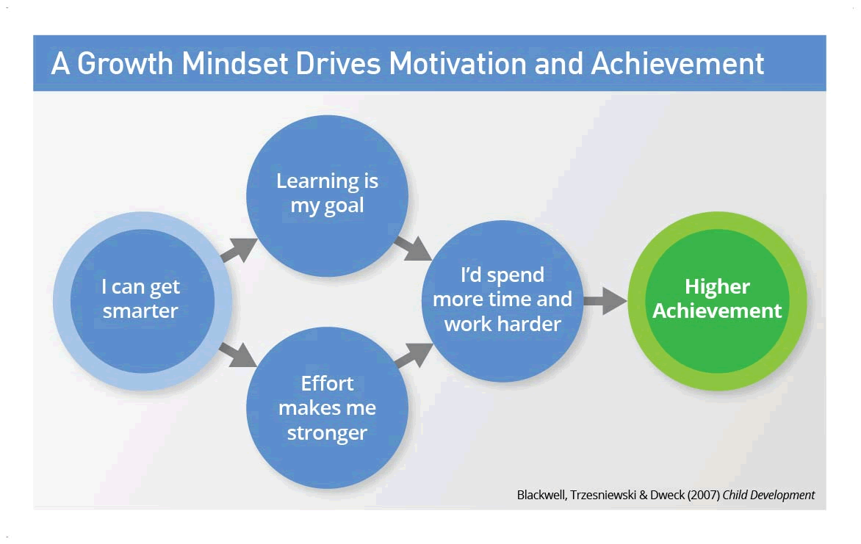
Diagram 1

On PTE end of week reviews are completed by mentors assessing that weeks lessons. In the ‘learning through experience’ competence, one is asked to ‘reflect and learn from both success and failure’. At the beginning of Year 2 PTE I struggled with certain aspects of teaching. As shown in Appendix 1 in week one I was not organised and there was no personality to my lessons. However, after working on these targets by later weeks I had achieved these targets. From the failures to start with I was able to create strategies to stop these things from continuing to happen. By making sure to use my own personality in my lesson planning my lessons began to be more engaging and the children’s’ learning increased. It is through perseverance that I was able to improve my teaching, as I was able to ‘be prepared to be patient and keep trying to achieve long-term aims’.

From the Entrecomp framework one can identify the level they are working at and what their next step is. For creativity, I have given an example from PTE that shows ‘I can develop ideas that create value for others’. According to the framework my proficiency is a foundation, level 2 where I am relying on support from others. To move forward I need to begin to be independent and ‘experiment with different techniques to generate alternative solutions’. From my example of using Twinkl for ideas, to move forward I would not rely on it but begin to think of my own ideas. Instead of nearly always using worksheets as evidence of learning, to improve my own creativity, I would implement other strategies. It is however difficult to say I will never use a Twinkl document as they are so easily accessible and save time that can be focused on other areas.

To best level myself in the ‘motivation and perseverance’ competence I looked at the descriptors that best fit my feelings whilst on PTE. I think ‘I can anticipate the feeling of achieving my goals and this motivates me’ would best describe my mindset. The long term goal is be a qualified teacher and by working at the tasks in-between now and then I will reach it. Therefore, I am a intermediate level 3, my next step being to ‘regulate my own behaviour to stay driven and achieve the benefits of turning idea into action’. I will make sure to constantly remind myself when challenges arise that this is a small step in reaching my goals. Fitting well with motivation is the idea of ‘learning through experience’. From Appendix 1 it shows ‘I can provide examples that show that my abilities and competence have increased with experience’. Many times, on PTE I found that I was often trialling ideas out on the children, with varying levels of success. It is only by trying ideas out that one can learn what works and what does not. I can fit my proficiency into the foundation, level 1 strand. I have learnt from my successes and failures and therefore my next step would be to understand that my ‘abilities and competences will grow with experience’. This links to the idea of having a ‘growth mindset’, my abilities are not set but will increase with more experience and work.

According to George Land, as we get older we are taught out of our creativity. There are two kinds of thinking processes: Convergent thinking devised by Guilford and Divergent thinking. Convergent, is where children have the ability to think of ‘correct’ answers to questions and is the opposite of divergent thinking. This is the way of creating new ideas and is spontaneous. In schools, we are teaching children to do both ways of thinking. We want them to create their own ideas, but we also want them to give us the ‘right’ answer for standardised tests and to prove levels. It is this battle between both ways of thinking and the outcomes as educators we want for children that is damaging their creativity. As Robinson said our education system is leading children to taking their GCSE’s but also trying to equip them for a uncertain future. It is therefore the education systems role to give these children the skills needed in an ever-changing and uncertain future. It is vital that children are able to adapt and think for themselves, which is where the competences on the Entrecomp framework are vital. They need to be able have ‘self awareness’, the ability to ‘cope with uncertainty’ and ‘learn through experience’ and have aspects of the other 15. It is also important that teachers are able to understand these needs and develop their own abilities to be able to provide an education that will equip children for the future.
Word Count - 2725

Appendices
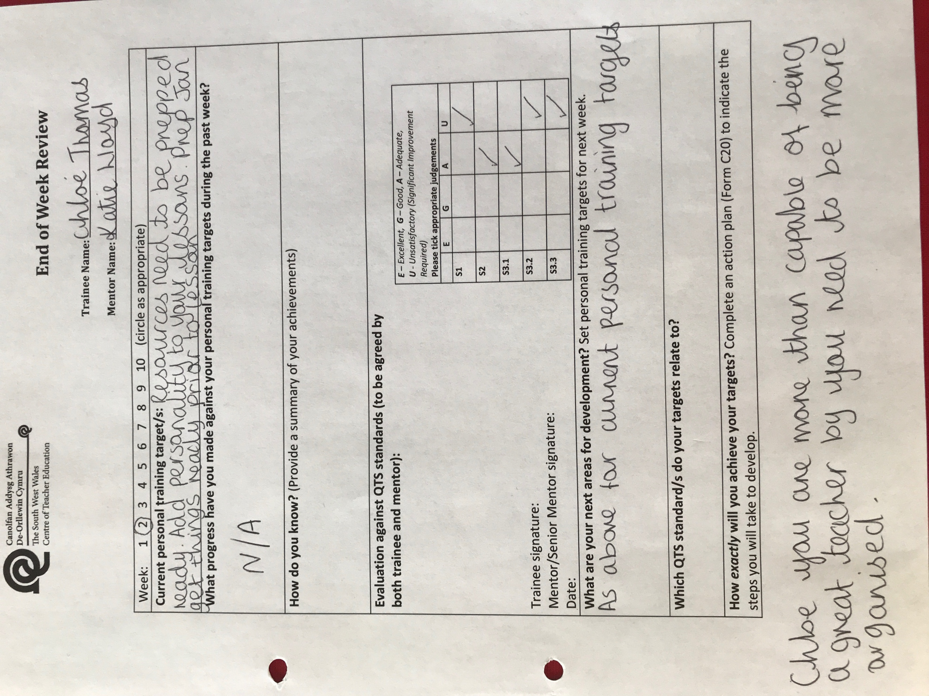
Appendix 1
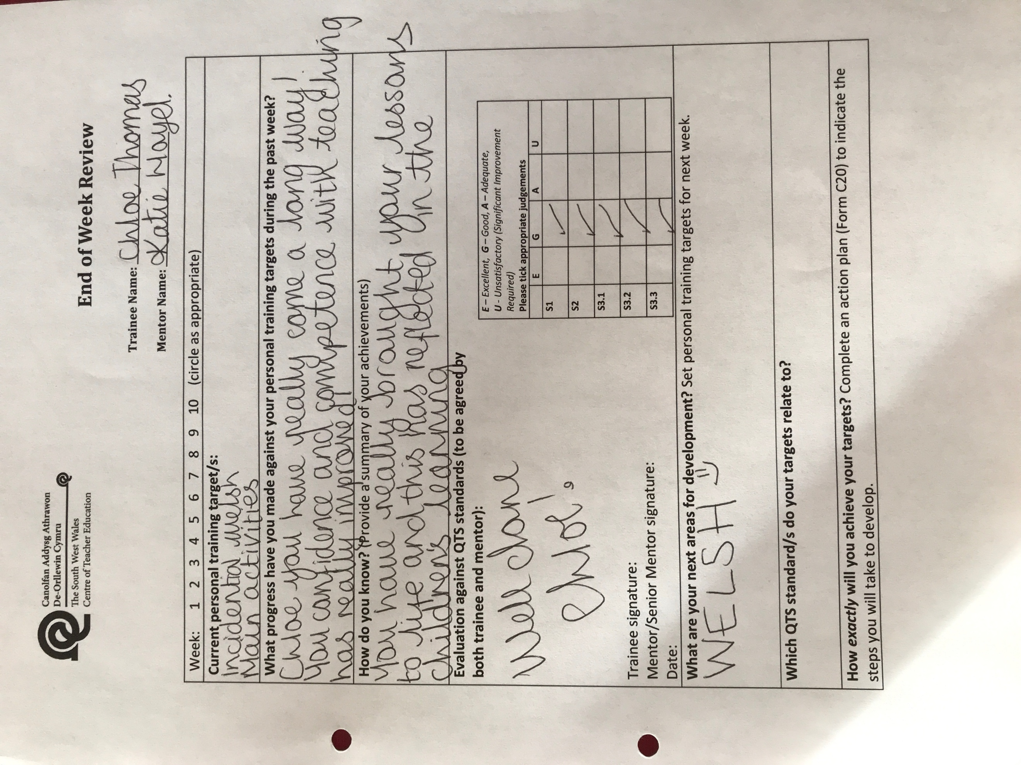
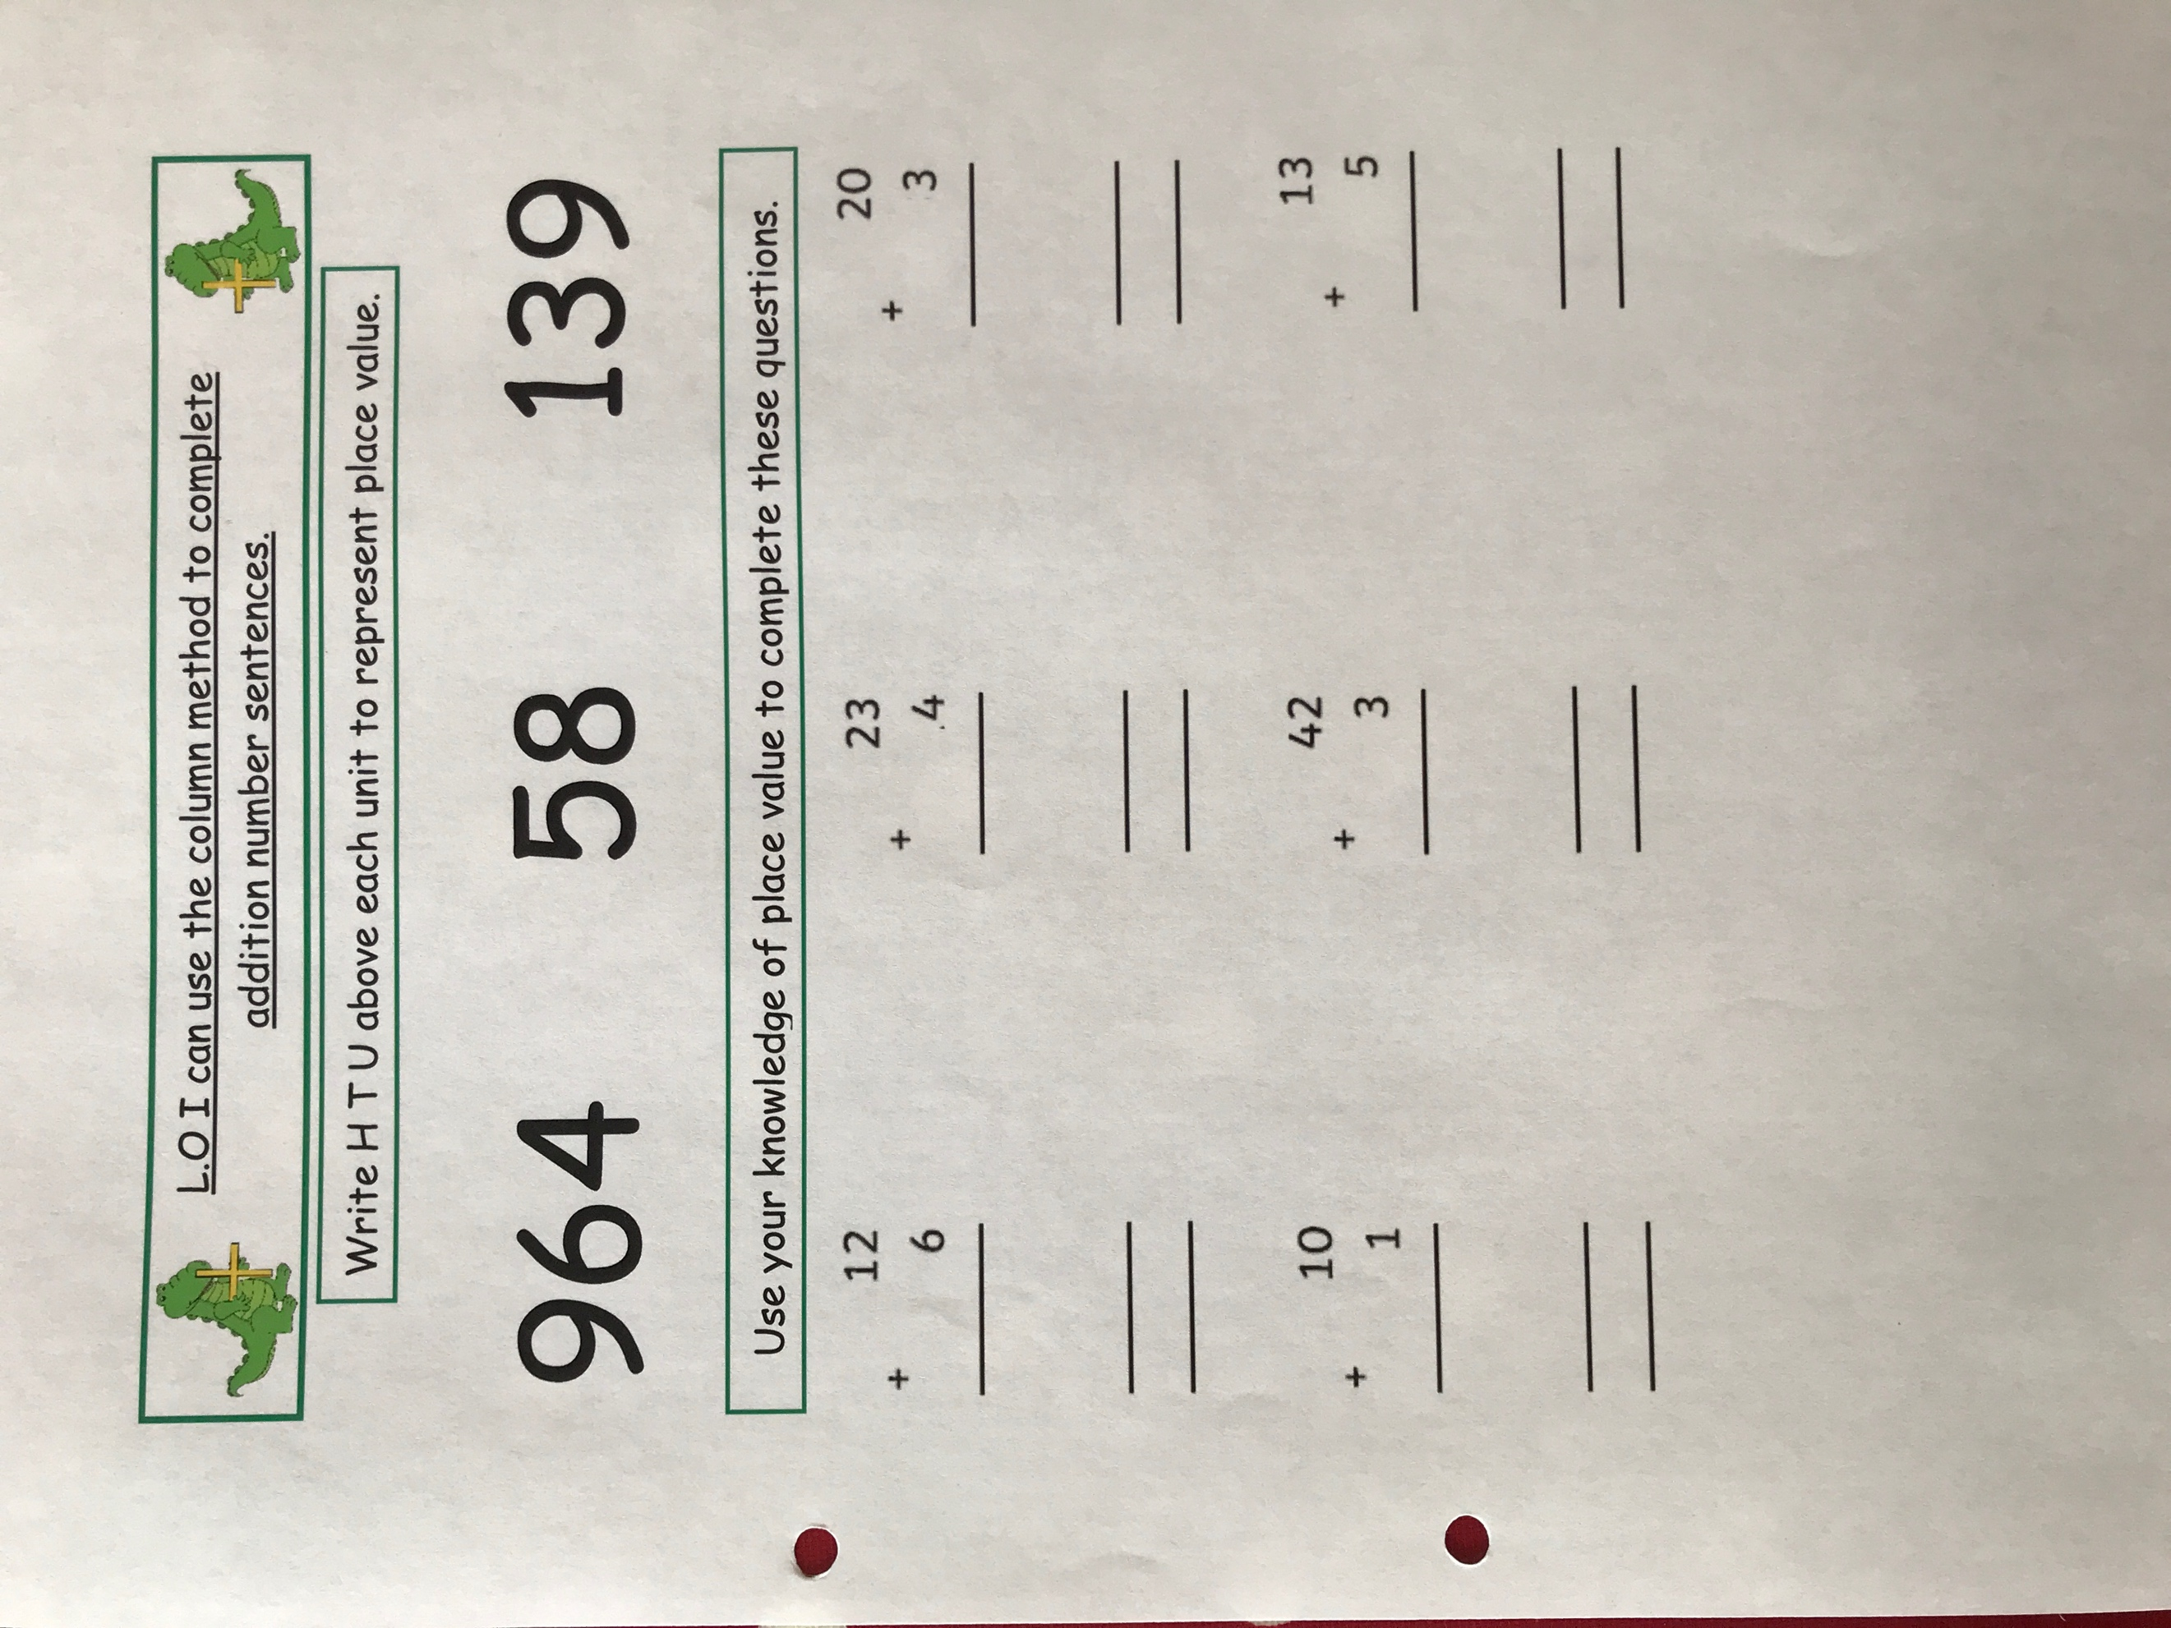
Appendix 2
Reference List
Amabile, T. (2012). Componential Theory of Creativity. Harvard: Sage Publications.

Bacigalupo, M., Kampylis, P., Punie, Y., Van den Brande, G. (2016). EntreComp: The Entrepreneurship Competence Framework. Luxembourg: Publication Office of the European Union; EUR 27939 EN; doi:10.2791/593884

Donaldson, G. (2015). Successful Futures. Cardiff: Welsh Government.

Duckworth, A. (2013) ‘Grit: The power of passion and perseverance’ TED Talks Education. TED Conference. Available at:
https://www.ted.com/talks/angela_lee_duckworth_grit_the_power_of_passion_and_perseverance/transcript [Accessed at: 11th December 2017]

Haddad, G. (2012). The Challenges of Creativity. Paris: UNESCO.
International Baccalaureate (2011) ‘Its not what you know…’ Available at: http://www.ibo.org/ib-world-archive/may-2011-issue-62/its-not-what-you-know/ [Accessed: 12th December 2017]

Land, G. and Jarman, B. (1993). Breaking Point and Beyond. San Francisco: Harper Business.
Mindset Works (2017). Decades of Scientific Research tha Started a Growth Mindset Revloution. [online] Available at: https://www.mindsetworks.com/science/

Robinson, K. and Aronica, L. (2015). Creative Schools. London: Penguin Publishing Group.
Robinson, K. (2006) ‘Do Schools Kill Creativity?’ TED: Ideas Worth Spreading. TED Conference. Available at: www.ted.com/talks/ken_robinson_says_schools_kill_creativity.html. [Accessed: 13th December 2017]

University of Oxford. (2017). Introduction to enterprise and entrepreneurship — Mathematical Physical and Life Sciences Division. [online] Available at: https://www.mpls.ox.ac.uk/enterprise [Accessed 11th December 2017]

Usher, L., Usher, D. and Usher, M. (2003). Nurturing Five Dispositions of Effective Teachers. Available at: http://dartep.org/handouts/Dispositionsproceedingssession_P.pdf

Wales: Department for Children, Education, Lifelong Learning and Skills (2017) Professional Standards for Teaching and Leadership. Cardiff: Welsh Assembly Government. Available at: http://learning.gov.wales/docs/learningwales/publications/170901-professional-standards-for-teaching-and-leadership-en.pdf
Welsh Government (2017). Creative Industries. [online] Available at: http://gov.wales/topics/businessandeconomy/our-priority-sectors/creative-industries/?lang=en [Accessed 10th December 2017]

