

Data Analysis
UWTSD Travel Survey

Thomas Day
P1714429

Tutor: Mr Graham Orr
Module: Research Methods
Word Count excluding title page, contents and references: 2989

Content Page Number
Introduction 3
Theme 3
Analysis 4
Conclusions 11
References 13

- Introduction

“Data Analysis should be seen as detective work with an emphasis being placed on gaining as much information about the data and how they are distributed as possible” (Tukey, 1977). In this analysis paper I have taken raw quantitative data from a Travel Survey collected at the University of Wales Trinity Saint David (UWTSD), and have used it to identify significant patterns, trends and anomalies.

- Theme

With such a vast amount of raw data it is imperative to identify a theme before analysis can happen and recommendations can be made. The theme this data analysis document will take is – What is the opportunity to change the mode of travel for staff and students at UWTSD? I will pose questions, identify hypotheses and then test them using IBM SPSS and Microsoft Excel data analysis software. The IBM SPSS platform offers advanced statistical analysis, a vast library of machine learning algorithms, text analysis, open source extensibility, integration with big data and seamless deployment into applications - as well as being the world’s leading statistical analysis software (IBM, 2018). Microsoft Excel allows users to unlock the potential of their data, by using formulas across a grid of cells (Microsoft, 2018). Data will be presented in the form of Crosstabulation, Chi Square Tests and Independent Sample Tests.

- Analysis

Before analysis can take place, the raw data should be explained. The data was collected in the form of a Travel Survey/Questionnaire. 544 people in total were surveyed, all from UWTSD and across all three campuses. The data was collected from 6th – 20th April 2018. There was a 100% return rate although not all respondents answered all the questions. The demographics of the population surveyed is displayed in Charts 1 -3.
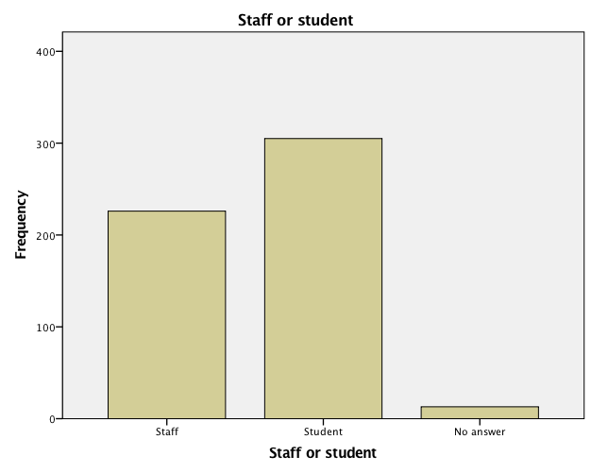
Chart 1 - Of the 544 returned surveys, 226 (41.5%) were from staff, 305 (56.1%) were from students and 13 (2.4%) returned “no answer”. This is to be expected amongst a university where the ratio of students to staff is bound to be higher. For many of the crosstabulation and Chi Square Tests the “no answer” results will have to be made redundant.

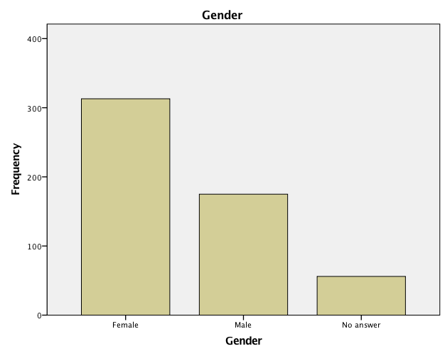
Chart 2 shows 544 returned surveys, 313 (57.5%) of them were from females, 175 (32.2%) were from males and 56 (10.3%) preferred not to disclose their gender. Again, for many of the crosstabulation and Chi Square Tests the “no answer” results will have to be made redundant.

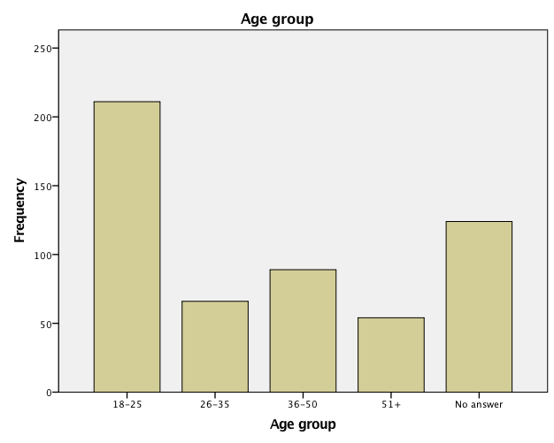
Chart 3 shows 544 returned surveys, 211 people (38.8%) were aged between 18 and 25; 66 people (12.1%) were aged between 26 and 3; 89 people (16.4%) were aged between 36 and 50; 54 people (9.9%) were aged 51 and above; and 124 people (22.8%) preferred not to disclose their age bracket. Again, for many of the crosstabulation and Chi Square Tests the “no answer” results will have to be made redundant.

3.1 Mode of Transport

H₁ – There is no difference in mode of transport used to travel to University between staff and students.
H_{1A} – There is a difference in mode of transport used to travel to University between staff and students.

Using only two variables from a single population (Staff/Student and Mode of Transport) means I can use a Chi Square Test to determine if a difference between the observed data and the expected data is due to chance, or if it is due to a relationship between the variables. If the p value is <0.05 then it indicates there is a relationship and it is statistically significant and therefore not due to chance or coincidence. I will therefore be able to prove a hypothesis correct or not. Table 1 shows the two sets of data presented in the form of crosstabulation.

Staff/Student * Mode of transport Crosstabulation
 |  |  | Mode of transport |  |  |  |  |  | Total
 |  |  | Car | Car share | Bus | Train | Cycle | Walk
 | Staff | Count | 162 | 12 | 14 | 9 | 3 | 26 | 226
 | Staff | Expected Count | 125.2 | 13.7 | 16.7 | 8.1 | 4.3 | 58.1 | 226.0
 | Staff | % within Staff | 71.7% | 5.3% | 6.2% | 4.0% | 1.3% | 11.5% | 100.0%
 | Student | Count | 131 | 20 | 25 | 10 | 7 | 110 | 303
 | Student | Expected Count | 167.8 | 18.3 | 22.3 | 10.9 | 5.7 | 77.9 | 303.0
 | Student | % within student | 43.2% | 6.6% | 8.3% | 3.3% | 2.3% | 36.3% | 100.0%
Total |  | Count | 293 | 32 | 39 | 19 | 10 | 136 | 529
 |  | Expected Count | 293.0 | 32.0 | 39.0 | 19.0 | 10.0 | 136.0 | 529.0
 |  | Total % | 55.4% | 6.0% | 7.4% | 3.6% | 1.9% | 25.7% | 100.0%
Table 1
The result shows χ = 51.807, df = 5, p = 0.00. This result is statistically very highly significant. It shows that there is a relationship between the mode of transport used to get to university and whether they are staff or a student. The data shows that only 529 people have been accounted for, this is because 13 people didn’t specify whether they were staff or student and in order for <20% of the cells to have an expected count less than 5 I had to collapse the park and ride column which accounted for 2 students. Now only 8.3% of the cells have an expected count less than 5 therefore this test is valid. Interestingly, 71.7% of the staff and 43.2% of the students surveyed said they drive themselves to university – it was expected that only 55.4% of both students and staff would use their own car. The other big difference between the observed data and the expected data is the number of staff and students who walk to university. 11.5% of the staff and 36.3% of the students surveyed walk to work. It was expected that 25.71% of both would walk.

In this instance H_{1A} has been proven – there is a difference in mode of transport used to travel to University between staff and students.

3.2 Distance travelled to University

H₂ – There is no difference in the distance travelled to University between staff and students.
H_{2A} – There is a difference in the distance travelled to University between staff and students.

I will use the Chi Square Test to determine if there is a difference. Table 2 shows the two sets of data presented in the form of a crosstabulation.

Staff/Student * Distance Crosstabulation
 |  |  | Distance |  |  |  |  |  | Total
 |  |  | 0-1 miles | 2-5 miles | 5-10 miles | 10-25 miles | 25-50 miles | 50+ miles
 | Staff | Count | 57 | 27 | 28 | 49 | 28 | 11 | 200
 | Staff | Expected Count | 51.8 | 27.5 | 28.9 | 50.9 | 25.2 | 15.6 | 200.0
 | Staff | % within Staff | 28.5% | 13.5% | 14.0% | 24.5% | 14.0% | 5.5% | 100.0%
 | Student | Count | 56 | 33 | 35 | 62 | 27 | 23 | 236
 | Student | Expected Count | 61.2 | 32.5 | 34.1 | 60.1 | 29.8 | 18.4 | 236.0
 | Student | % within student | 23.7% | 14.0% | 14.8% | 26.3% | 11.4% | 9.7% | 100.0%
Total |  | Count | 113 | 60 | 63 | 111 | 55 | 34 | 436
 |  | Expected Count | 113.0 | 60.0 | 63.0 | 111.0 | 55.0 | 34.0 | 436.0
 |  | Total % | 25.9% | 13.8% | 14.4% | 25.5% | 12.6% | 7.8% | 100.0%
Table 2
The result shows χ = 4.219, df = 5, p = .518. This result is not statistically significant. Meaning that there is no relationship between the distance travelled to get to university and whether they are staff or a student. The data shows that only 436 people have been accounted for, this is because 13 people didn’t specify whether they were staff or student and 95 people (26 staff and 69 students) said ‘no answer’ to distance travelled. No cells have an expected count less than 5 therefore this test is valid.

We can now compare the data from H₁ and H₂ test to start identifying patterns. The largest proportion of staff surveyed (71.7%) said they drive in to university, yet the largest proportion of staff surveyed also live less than a mile away (28.5%). Using the IF function in Microsoft Excel (a way of calculating something specific when two or more conditions are true) I was able to calculate that 41 staff members who put down ‘car’ as their mode of transport only travelled 0.5 miles to university – that’s 25.3% of the total staff who use cars. Compared to 21 students who put down ‘car’ as their mode of transport and travelled 0.5 miles to university – that’s 16.03% of the total students who use cars. Clearly the staff are the dominant variable. One would argue it is not necessary to drive to university if you live less than a mile away regardless of student or staff status - unless certain circumstances dictated you have to drive e.g. disability or lots of equipment to transport. Table 3 is a cross tabulation of staff and students compared to where they park- again, you will notice that the 13 personnel who did not disclose whether they were staff or student have been removed.

Staff/Student * Car parking Crosstabulation
 |  |  | Car parking |  |  |  |  | Total
 |  |  | On campus | On the street | Park and Ride | Private | Not applicable
 | Staff | Count | 165 | 4 | 1 | 12 | 44 | 226
 | Staff | % within Staff | 73.0% | 1.8% | 0.4% | 5.3% | 19.5% | 100.0%
 | Student | Count | 76 | 46 | 4 | 27 | 152 | 305
 | Student | % within Student | 24.9% | 15.1% | 1.3% | 8.9% | 49.8% | 100.0%
Total |  | Count | 241 | 50 | 5 | 39 | 196 | 531
 |  | Total % | 45.4% | 9.4% | 0.9% | 7.3% | 36.9% | 100.0%
Table 3
Of the 226 staff surveyed – 165 (73%) of them are parking on campus. However, you cannot park on a campus at UWTSD without a valid car permit. Compare this to the student figures – only 24.9% of students are parking on campus. The majority of students (49.8%) have ticked the “not applicable box” so it can be assumed they have no need to park because they are using another form of transport (table 1 shows this in further detail). In table 1, 56.8% of students surveyed are using any other mode of transport apart from car. Compare that to the 28.3% of staff surveyed who are using any other mode of transport apart from car. Note – any other mode of transport being car share, bus, train, cycle or walk.

In this instance H₂ has been proven. There is no difference in the distance travelled to University between staff and students.

3.3 Number of Passengers

H₃ – There is no difference between staff and students in the number of passengers carried to university.
H_{3A} – There is a difference between staff and students in the number of passengers carried to university.

This data has been collected in the scale form as opposed to the nominal or ordinal form therefore it would be inappropriate to conduct a Chi Squared Test. Instead an Independent Samples test can be conducted, specifically a t test.

Group Statistics
 | Staff or student | N | Mean | Std. Deviation | Std. Error Mean
Passengers | Staff | 226 | .23 | .576 | .038
Passengers | Student | 305 | .39 | .833 | .048

Independent Samples Test
 |  | Levene's Test for Equality of Variances |  | t-test for Equality of Means
 |  | F | Sig. | t | df | Sig. (2-tailed) | Mean Difference | Std. Error Difference | 95% Confidence Interval of the Difference
 |  |  |  |  |  |  |  |  | Lower | Upper
Passengers | Equal variances assumed | 22.462 | .000 | -2.465 | 529 | .014 | -.159 | .064 | -.286 | -.032
Passengers | Equal variances not assumed |  |  | -2.599 | 526.624 | .010 | -.159 | .061 | -.279 | -.039
Table 4
The t-test result in Table 4 shows t (-2.465), df = 529, p = .014. This result is statistically significant. Meaning that there is a relationship between staff and students in the number of passengers carried to university. Further data is presented in table 5.

Staff/Student * Passengers Crosstabulation
 |  |  | Passengers |  |  |  |  | Total
 |  |  | 0 | 1 | 2 | 3 | 4
 | Staff | Count | 186 | 30 | 8 | 1 | 1 | 226
 | Staff | % within Staff | 82.3% | 13.3% | 3.5% | 0.4% | 0.4% | 100.0%
 | Student | Count | 233 | 41 | 18 | 9 | 4 | 305
 | Student | % within Student | 76.4% | 13.4% | 5.9% | 3.0% | 1.3% | 100.0%
Total |  | Count | 419 | 71 | 26 | 10 | 5 | 531
 |  | Total % | 78.9% | 13.4% | 4.9% | 1.9% | 0.9% | 100.0%
Table 5
Table 5 clearly displays a distinct lack of car share culture amongst the university, 78.9% of all surveyed personnel travel with no passengers. Although it appears the students are marginally better at it than the staff.
In this instance H_{3A} has been proven. There is a difference between staff and students in the number of passengers carried to university.

3.4 Mode of transportation between campuses

H₄ – There is no difference between staff and students in the mode of transport used to travel between campuses.
H_{4A} – There is a difference between staff and students in the mode of transport used to travel between campuses.

Before this test can be run, it is important to distinguish if, how often and how many staff and students actually travel between campuses. Table 6 shows this.

Staff/Student * Trips between campuses Crosstabulation
 |  |  | Trips between campuses |  |  |  |  | Total
 |  |  | Weekly | Biweekly | Monthly | Rarely | Never | Total
 | Staff | Count | 38 | 33 | 27 | 33 | 95 | 226
 | Staff | % within Staff | 16.8% | 14.6% | 11.9% | 14.6% | 42.0% | 100.0%
 | Student | Count | 6 | 23 | 2 | 218 | 56 | 305
 | Student | % within Student | 2.0% | 7.5% | 0.7% | 71.5% | 18.4% | 100.0%
Total |  | Count | 44 | 56 | 29 | 251 | 151 | 531
 |  | Total % | 8.3% | 10.5% | 5.5% | 47.3% | 28.4% | 100.0%
Table 6

It is important to note that 42% of staff and 18.4% of students say they never travel between campuses, and only a minority of staff and students (8.3% in total) travel between campuses weekly. This context is important when conducting the next Chi Squared test that looks at Mode of transport between campuses.

Staff/Student * Mode between campuses Crosstabulation
 |  |  | Mode between campuses |  |  | Total
 |  |  | Car | Public Transport | N/A | Total
 | Staff | Count | 166 | 22 | 38 | 226
 | Staff | Expected Count | 94.5 | 22.6 | 109.0 | 226.0
 | Staff | % within Staff | 73.5% | 9.7% | 16.8% | 100.0%
 | Student | Count | 56 | 31 | 218 | 305
 | Student | Expected Count | 127.5 | 30.4 | 147.0 | 305.0
 | Student | % within student | 18.4% | 10.2% | 71.5% | 100.0%
Total |  | Count | 222 | 53 | 256 | 531
 |  | Expected Count | 222.0 | 53.0 | 256.0 | 531.0
 |  | Total % | 41.8% | 10.0% | 48.2% | 100.0%
Table 7
The result shows χ = 174.709, df = 2, p = .000. This result is statistically highly significant. Meaning that there is a relationship between the mode of transport used to travel between campuses and whether they are staff or a student. Again, the data shows that only 531 people have been accounted for, this is because 13 people didn’t specify whether they were staff or student. No cells have an expected count less than 5 therefore this test is valid. For ease of analysis I collapsed the columns ‘own car’, ‘uni car’, ‘rental car’ and ‘car share’ into just ‘car’. A lot more staff and a lot less students used a car between campuses than the test expected. However, when the rest of the data is consulted it isn’t all that surprising. Table 1 articulates that 71.7% of the staff use a car to drive to university while only 43.2% of students use a car so it’s no surprise staff use cars more to travel between campuses – there are simply more staff cars at university. I used the IF function on Microsoft Excel to look into the data in more detail. Of the 38 staff who drive into university from home every day and travel weekly between campuses, 35 of them use a car to do so – that’s 92.11%. The remaining 3 staff members (7.89%) use public transport. Using the same criteria but for students – Of the 6 students who drive into university every day and travel between campuses weekly, only 3 of them use a car (50%), 2 used public transport and one put down N/A. This snapshot of analysis shows that in relation to students, staff are the predominant car users when moving from campus to campus.

In this instance H_{4A} has been proven. There is a difference between staff and students in the mode of transport used to travel between campuses.

4. Conclusion

In conclusion, the available data was analysed to examine mode of transport used, distance travelled, number of passengers carried and travel between campuses. Four hypotheses were tested and it was found that between staff and students - there is a difference in mode of transport used; there is no difference in the distance travelled; there is a difference in the number of passengers carried; and there is a difference in the mode of transport used to travel between campuses.

It is clear that the majority of staff drive to work (71.7% of the surveyed staff) and very few car share, walk, cycle or use public transport. Student figures are not as high as staff but 43.2% of students still drive to university. When this information is combined with the data in table 2 (distance travelled) - a large number travel less than a mile using a car carrying no passengers – Staff are the worst offenders.

The analysed data shows a lack of car sharing culture across the whole of the surveyed personnel. Although both staff and students predominately travel alone, the students have a larger number of car sharers than staff with 10.2% of students carrying 2 or more passengers, compared to 4.3% from staff. This is to be expected as students tend to live together or in the same area while staff tend to live with their families.

When comparing staff to students, staff tend to travel between campuses more than students. Of those staff who do – 73.5% of them are doing so by car compared to 18.4% of students. When staff and students were asked what mode of transport they use to travel between campuses. 71.5% students answered ‘N/A’ compared to 16.8% staff. We can assume that ‘N/A’ means they don’t travel between campuses or they walk.

4.1 Future

Analysis of the data highlighted many opportunities to change the mode of travel for staff and students at UWTSD. For example, restructuring staff timetables to require less travelling between campuses. Secondly, encouraging car sharing across all campuses - especially amongst staff, and thirdly only issuing car parking permits to staff and students who travel more than 5 miles to university, or have a disabled parking requirement.

4.2 Recommendations

For any further study on this topic, a much wider population demographic would have to be surveyed. Also, in the questionnaire, the question concerning travel time should have provided more options than a simple Yes or No response. Indeed, all the questions should have been worded to have elicited more information and therefore facilitate more in-depth analysis. As Hartwig and Dearing (1979) warn us – it is important to bear in mind that measures which summarise data can sometimes conceal or even misrepresent what may be the most informative aspects of the data.

- References
Connolly, P. (2007). Quantitative Data Analysis in Education: A Critical Introduction Using SPSS. London: Routledge.

Hartwig, F. and Dearing, B. (1979) Exploratory Data Analysis, Sage University Paper Series on Quantitative Applications in the Social Sciences, 16th ed, Beverley Hills, CA: Sag
IBM, (2018), IBM SPSS Software, available at: https://www.ibm.com/analytics/data-science/predictive-analytics/spss-statistical-software Date last accessed 18 May 2018.

Microsoft, (2018), 5 Benefits of Microsoft Excel, available at: https://blogs.business.microsoft.com/en-gb/2016/07/08/top-5-benefits-microsoft-excel/ Date last accessed 18 May 2018.

Tukey, J. (1977). Exploratory Data Analysis, London: Addison-Wesley

