

Student name: Mustafa Alsaady
Student number: 2326285
Module course: Academic skills (Feb 2024)
Module course code: LCLM4001
Module lecturer: Tim Hopkins
Reflective Report

Content
Page:

1.) Introduction 3.
2.) Gibbs reflective cycle 4.
2.1) Note taking 5.
2.2) Paraphrasing 6.
2.3) communication and reflection 7.
3.) Conclusion 8.
4.) Refences 9.
5.) Appendix 10.

Introduction
Throughout academia, success is frequently assessed not just by knowledge of the subject matter, but also by the variety of talents used for pursuing it. Note-taking, paraphrase, communication, and reflection are among the skills which act as the foundation for academic activities. As I begin this reflective report, I find myself dealing with the different environments of my academic journey, analysing the significance and impact of these key methods.
Note-taking, a seeming insignificant activity, emerges as a key component of academic success. The ability to summarise lectures, debates, and texts into easily understood, clear notes is both a mechanical and strategic activity. There are a few methods used for note taking in the academic environment, for example the methods that I have used where linear notes, tabular notes and mind maps.
Paraphrasing, the technique of rephrasing knowledge in one's own words. In addition to assisting alongside resource citation and prohibiting plagiarism, paraphrase advocates recognition as well as interaction with the content on an even deeper level.
Within the realm of education, communication and written acts are a medium for the sharing of knowledge and the exchange of ideas. From scholarly publications to classroom discussions, it is essential to be able to communicate ideas in a way that is consistent and persuasive. The foundation of academic growth and development appears to be reflection, a method of reflection and self-evaluation. I take a deep approach in this report, setting out on a journey for self-awareness and progression within myself. I unravel every aspect of my learning process by examining previous experiences, achievements, and failures. This allows me to pinpoint regions that need improvement and areas that need to be improved. To examine the lessons, I've learned about notetaking, paraphrasing, communication, and reflection skill sets in academics, I will use the reflective cycle devised by Gibbs (gibbs,1991) as a framework in my study. I will be able to thoroughly investigate each ability thanks to this coordinated approach, which will cover every aspect from real-world experiences to analysis, evaluation, conclusion, and action plans for future development. I hope to offer a thorough and knowledgeable examination of my academic career and my growth of the crucial abilities necessary for success in academic studies by using these reflective techniques.

Description
What happened?

Feeling
What were you thinking and feeling?
Action plan: what would you do?

Gibbs reflective
Cycle

Conclusion: what else have you done?
Evaluation: what were the good and bad aspects?

Description what sense can you make of the situation?

Gibbs reflective report adapted by author (Alsaady, 2024)

Note taking.
Description: As a university student, I have found note-taking to be an essential practice in my academic endeavours. Utilising various techniques such as diagram, linear, and tabular notes has significantly enhanced my learning experience. Diagram notes, which include visual representations like flowcharts and mind maps, have been particularly helpful in visualising complex concepts. Linear notes provide a structured framework for organising sequential information from lectures and readings. Tabular notes have facilitated comparison and contrast of key points across different topics, aiding in the identification of patterns and themes.
Feelings: Incorporating these note-taking methods has instilled in me a sense of confidence and efficacy in my study approach. I feel more capable of comprehending and synthesising course material, which has alleviated some of the academic pressures often associated with university studies.
Evaluation: Reflecting on my note-taking practices, I recognise their efficacy in enhancing my understanding and retention of course material. Each method offers unique benefits, catering to different learning styles and content structures. Diagram notes, for instance, excel in visualising complex relationships, while tabular notes streamline comparison tasks. However, I acknowledge the need for continuous refinement and adaptation of these techniques to suit evolving academic demands.
Analysis: The adoption of varied note-taking methods has facilitated deeper engagement with course content, enabling me to extract meaning from lectures and readings more effectively. By integrating visual aids, structured frameworks, and comparative analyses, I have developed a multifaceted approach to knowledge acquisition and retention.
Conclusion: In conclusion, the strategic utilisation of diagram, linear, and tabular notes has significantly enriched my learning experience as a university student. These methods have empowered me to navigate complex subject matter with greater confidence and efficiency, ultimately contributing to my academic success.
Action Plan: Moving forward, I intend to further refine my note-taking strategies by exploring additional techniques and incorporating feedback from peers and educators. Continual reflection and adaptation will be key in maximising the effectiveness of my study approach and sustaining academic growth.

Paraphrasing
Description: Paraphrasing involves rephrasing someone else's ideas in one's own words while retaining the original meaning. Throughout my university studies, I've encountered numerous instances where paraphrasing was crucial, especially in assignments, research papers, and discussions.
Feelings: Initially, I felt apprehensive about paraphrasing, fearing that I might unintentionally distort the original meaning or fail to properly attribute the source. However, with practice and guidance from my lecturer, I gained confidence in my paraphrasing abilities.
Evaluation: Paraphrasing has been instrumental in enhancing my understanding of complex concepts. By actively engaging with the material and expressing it in my own words, I've deepened my comprehension and critical thinking skills. Additionally, paraphrasing has helped me develop effective writing techniques, such as summarizing and synthesizing information coherently.
Analysis: Through the process of paraphrasing, I've learned to dissect and interpret information more effectively. This skill has been particularly beneficial in research projects, where accurately conveying ideas while avoiding plagiarism is essential. Moreover, paraphrasing has encouraged me to engage with diverse perspectives and refine my analytical skills.
Conclusion: Mastering the art of paraphrasing has been a transformative experience in my academic journey. It has not only empowered me to navigate the complexities of university-level coursework but has also equipped me with essential skills for lifelong learning and professional development. Moving forward, I am committed to further refining my paraphrasing abilities and applying them in various academic and professional contexts.
Action Plan: To continue improving my paraphrasing skills, I plan to engage in regular practice exercises, seek feedback from peers and lecturers, and explore additional resources and strategies for effective paraphrasing. Additionally, I aim to integrate paraphrasing into my study routine as a tool for enhancing comprehension and retention of course material.

Reflection and communication.
Throughout my university journey, reflection and effective communication have been pivotal in shaping my academic and personal development. This reflective analysis delves into how engaging in reflective communication has influenced my growth and equipped me with essential skills.
Description: Reflective communication involves analysing and evaluating communication experiences to gain insight and improve one's communication skills. It encompasses various forms of interaction, including group projects, presentations, and discussions, which are integral parts of the university experience.
Feelings: Initially, I approached communication tasks with a mix of excitement and apprehension. While I was eager to share my ideas and engage with others, I also felt nervous about articulating myself effectively and navigating potential challenges in group dynamics.
Evaluation: Reflection has been instrumental in enhancing my communication skills. By critically examining my communication experiences, I've identified areas for improvement and implemented strategies to overcome communication barriers. This process has fostered self-awareness and confidence in expressing my thoughts and ideas.
Analysis: Engaging in reflective communication has facilitated continuous learning and growth. Through introspection, I've developed a deeper understanding of my communication style and preferences. Moreover, reflection has helped me recognize the importance of empathy and active listening in fostering meaningful dialogue and collaboration.
Conclusion: Reflective communication has been a transformative journey throughout my university experience. It has not only enhanced my academic performance but also equipped me with essential skills for navigating professional environments. Moving forward, I am committed to further refining my communication skills through ongoing reflection and practice.
Action Plan: To continue developing my communication skills, I plan to integrate reflection into my daily routine. This includes setting aside time to reflect on communication experiences, seeking feedback from peers and instructors, and actively participating in communication-focused activities such as workshops and seminars. Additionally, I aim to apply the insights gained from reflection to future communication tasks, ensuring continual growth and improvement.

Conclusion
In conclusion, my university journey has been greatly enriched by the adoption and refinement of notetaking, paraphrasing, reflection, and communication skills. Through diligent notetaking, I have been able to capture key concepts and ideas, enhancing my understanding and retention of course material. Paraphrasing has not only aided in academic integrity but has also deepened my comprehension of complex topics and sharpened my critical thinking abilities. Reflection has been instrumental in fostering self-awareness, enabling me to identify areas for improvement and adapt my approach to learning and communication. Effective communication, honed through reflection and practice, has empowered me to articulate my thoughts confidently, collaborate effectively with peers, and succeed in both academic and professional endeavours. Collectively, these skills have not only contributed to my academic success but have also laid a strong foundation for lifelong learning and personal growth beyond the university environment.

Reference:
Gibbs, G., (1988.) Learning by doing: A guide to teaching and learning methods. Further Education Unit.
Alsaady.M (2024), Gibbs reflective model adapted by author Alsaady.M from Gibbs (1988).

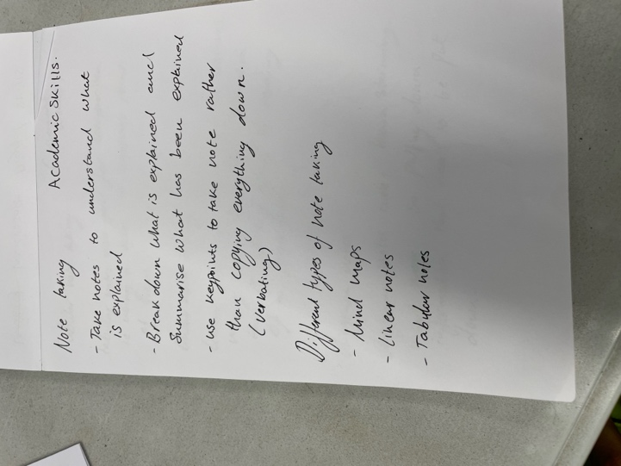
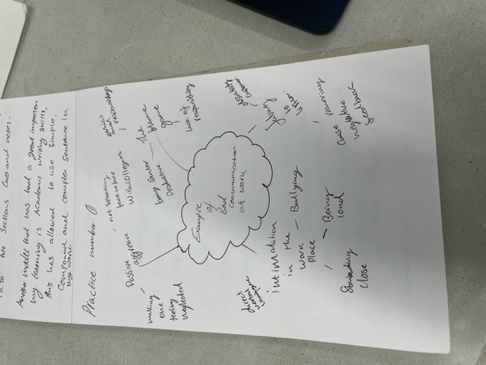
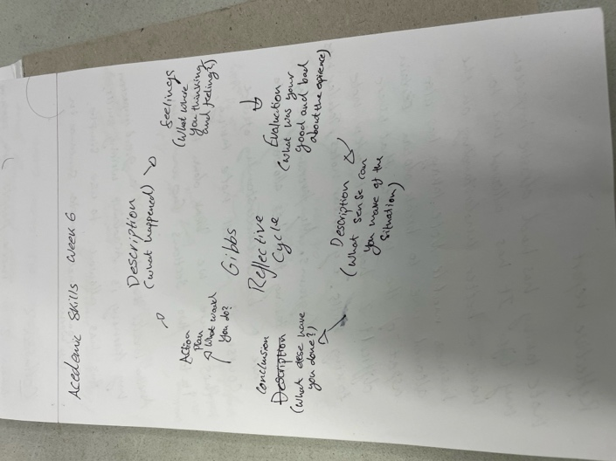
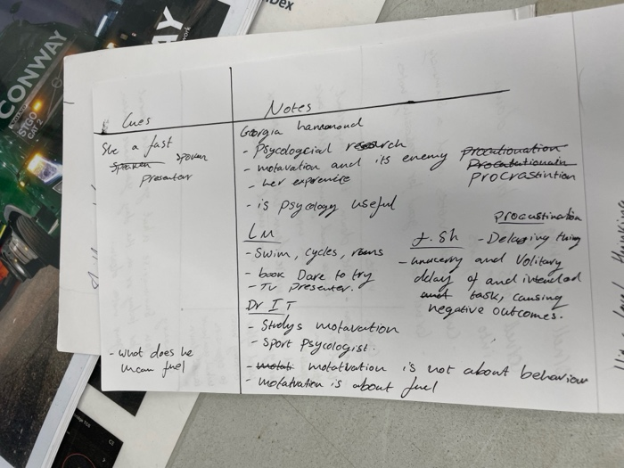
Appendix


