Task 1a
Academic and Employment Skills
It is important to develop a good understanding of academic skills and employability skills for both the workplace and for the degree. This is because the skills you develop whilst studying such as revising, referencing, taking notes and even using feedback can all be used in the workplace in different forms. An example of this is if you were preparing for and interview then revising and taking notes will benefit you to begin on the career ladder while utilising the feedback is important for if you didn’t get the position and you can use the knowledge for next time. Interview will also benefit your employability skills such as CV writing and professional conduct within the workplace. Whilst taking the interview, you will meet people who have years of work experience over you, so they know what they are talking about. The IT sector can become very technical in certain areas which is why communication skills are key to developing the ability to understand and explain to others how a system is working. Another key skill to develop is critical thinking and problem solving. These two skills will support your work for when other members are away or if you are alone working overtime.
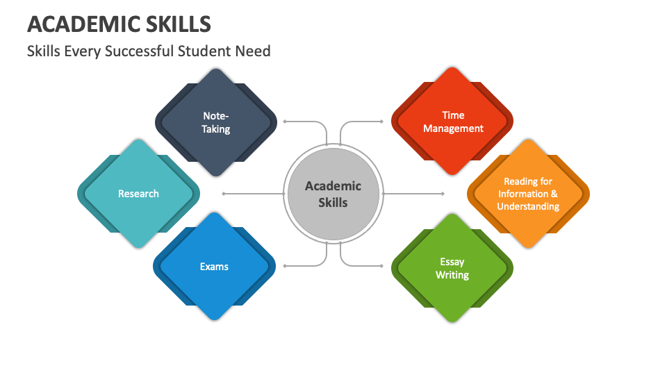
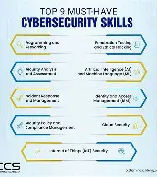
Figure 1: Academic Skills [1] Figure 1: Academic Skills
[2] Figure 2: Employment Skills
Task 1B
Copilot
Copilot is embedded within the Microsoft office suite that we use every day. This AI is great for supporting users with any issues they have regarding Microsoft applications as that is what it was created for. This provides users with better efficiency with tasks such as sending emails in Outlook or writing code in Visual Studio.

ChatGPT [1]
With the release of GPT 6 Astra, ChatGPT is now the leader when it comes to coding support from an AI model hitting a 58.2% on the Terminal-Bench 4.0 test and being compared to the other competing AI models in the market.

Claud [2]
Claud is used by many users daily and is a favourite for users for its ability to hold a context window for up to 1 million tokens. Claud is also known for its extended thinking and is useful for its advanced coding capabilities an for also being the most human-like AI model available.

DeepSeek [3]
DeepSeek is known for being the open-source AI which gives users the ability to make changes to the AI models as they see fit, which most other companies don’t do.

Gemini
Gemini is integrated within google itself, because of this it has a deep integration with the google search engine providing users with detailed search overviews for the topic they are looking for. Gemini is also used in the Google Lens application where you take a picture or scan an object, and it will search the internet for information on the object in the image.

Task 1b – references
[1] Morph Team, “Best AI Coding Agents (September 2026): Scored Leaderboard and Coding Agent Benchmark,” Morph, June 09, 2026. https://www.morphllm.com/best-ai-coding-agents-2026 (accessed Oct. 05, 2026).
[2] M. Benz, ‘What Is Claude AI? Anthropic’s AI Assistant Explained’, Content Force AI. Accessed: Oct. 05, 2026. [Online]. Available: https://blog.contentforce.ai/what-is-claude/
[3] igmguru, ‘What Is DeepSeek?’, Igmguru.com. Accessed: Oct. 05, 2026. [Online]. Available: https://www.igmguru.com/blog/what-is-deepseek
[4] C. Hall, ‘What Is Google Lens and What Can It Do?’, Pocket-lint. Accessed: Oct. 05, 2026. [Online]. Available: https://www.pocket-lint.com/what-is-google-lens-and-how-does-it-work-and-which-devices-have-it/

Copilot is the AI of my choice to support me with my career in my workplace. I work with many colleagues across Europe, Africa, India and Japan and not all of them can speak a language that I can understand. When they are able to speak English it is typically their second language after possibly Japanese, German and Hungarian. With the way copilot is integrated into the Microsoft office suite it can summarise emails and documents whilst also translating them into a language that I can understand for me to be able to understand the text.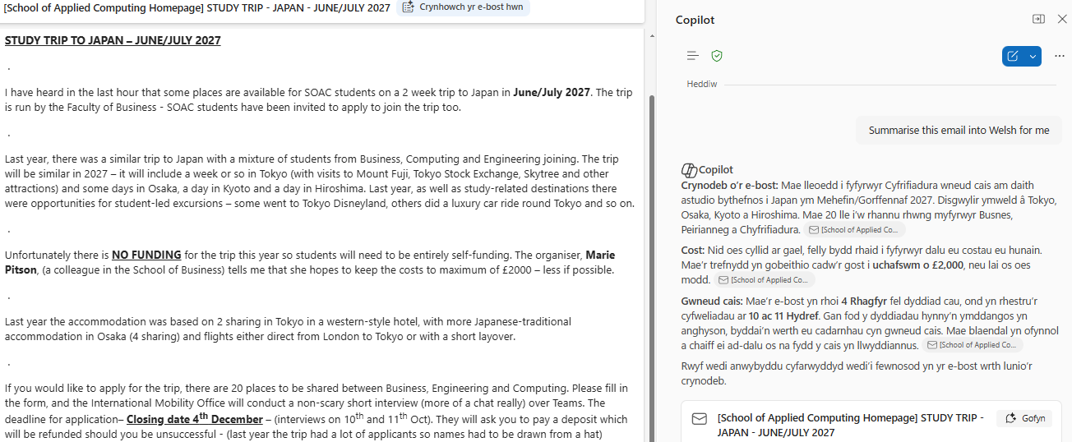
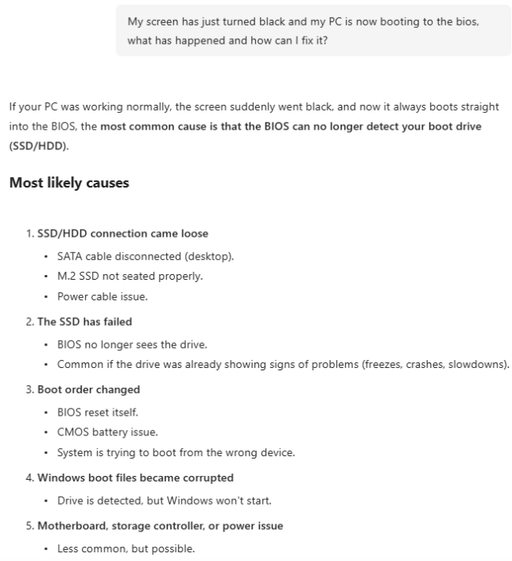
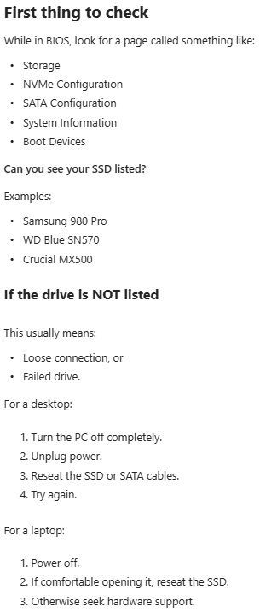 Copilot Is also great for troubleshooting issues relating to windows as it will provide an in-depth response to your queries on why something has happened and how to fix it. It will also help you narrow down complex issues by providing many options and solutions to what the route cause could be.

