

MSC PUBLIC HEALTH AND SOCIAL CARE IN PRACTICE

HEALTH CARE SYSTEM, ORGANISATION AND LEADERSHIP

CASE STUDY ANALYSIS REPORT: COMPARATIVE REPORT ON COVID19 LEADERSHIP RESPONSES

LECTURER NAME: Dr Christopher Mafuva
NAME: Md. Al Zakaria
ID: 2511048
Executive Summary
The system approaches for the healthcare system during the Covid-19 pandemic in Spain, South Korea and Canada has been versatile. Nonetheless, the approaches also incorporate certain challenges such as GDP decline, increased cases of mortality and several others. In this regard, South Korea has been known to incorporate decentralisation along with centralisation in recent times. Advantages and disadvantages of the systems by outlining the system approaches have also been described in a critical and comprehensive manner. The system approaches of the countries regarding the implications during Covid-19 pandemic have been evaluated in a critical manner. Considering the stances of social care paradigm, leadership construct can be considered as an essential element to ensure a high standard of healthcare outcomes. Based on the aforementioned scenario, the report is centred on the stances of assessing key insights related to the healthcare frameworks of Canada, South Korea and Canada. In this regard, subjective insights have been integrated within the present report based on the considerations of Servant Leadership Theory and Social Identity Theory. Following the aforementioned scenario, centralised governance & legal structure and management autonomy have been assessed as two important factors to ensure a robust healthcare setting within the aforementioned nations. The report focussed on critically analysing the leadership styles and theories that contribute towards enhancing the quality of healthcare outcomes in different countries where FMC has established its base. The analysis of different perceptions on enhancing the quality of outcomes provided across patients.

Table of Contents
1. Introduction 4
1.1 Contextual Overview 4
1.2 Outlining key aspects 4
1.3 Outlining concepts of centralisation concerning leadership approaches 4
2. Critical Analysis of each countries Centralised/decentralised approaches to the pandemic 4
2.1 Systems approach for the healthcare system during COVID-19 4
2.2 Discussion on depending on each country, there were some decisions and approaches that were centralised and some which were decentralised 6
2.3 Critical Analysis of advantages and disadvantages of system approaches in each country by outlining its approaches and outcomes 8
2.4 Challenges that results from the above approaches 11
2.5 Critical Literature Review 11
3. Critical Analysis of the Leadership Styles 12
3.1 Leadership theories and styles in Spain 12
3.2 Leadership theories and styles in South Korea 15
3.3 Leadership theories and style in Canada 17
4. Conclusion 20
References 22

1. Introduction

1.1 Contextual Overview
In the context of public and social care, leadership acts as a mediator in terms of improving the existing standards of population health, and reduced inequalities. Considering the aforementioned scenario, the report is centred on the stances of assessing the essentiality of social care setting within the aspects of three nations including Spain South Korea and Canada. As mentioned by Smith and Sinkford (2022, p.1150) leadership plays an important role in terms of fostering the stances of gender equality within the caregiving and operational dynamics. Consequently, the present report is focused to derive both subjective and objective insights based on the aforementioned scenario.

1.2 Outlining key aspects
The differences within leadership dynamics can be considered as one of the most important aspects of the present report. More precisely, the aforementioned scenario is going to be assessed by the report through the considerations of healthcare practices among Canada, South Korea and Spain. Structurally, the entire discussion is going to be focused on four metrics including system type, coverage, governance, leadership focus and prominent barriers.

1.3 Outlining concepts of centralisation concerning leadership approaches
In the context of the leadership aspect, the report will be centralised on the discussion of three major leadership considerations such as autocratic, democratic, laissez-faire. More precisely, the aforementioned discussion will be focused on the healthcare and social care settings of Canada, South Korea and Spain.

2. Critical Analysis of each countries Centralised/decentralised approaches to the pandemic

2.1 Systems approach for the healthcare system during COVID-19
The three countries have significantly employed-varied healthcare system approaches for the management of the COVID-19 pandemic. This has resulted in vastly varied outcomes from each aspect. South Korea has adopted the 3-Ts approach, which is a technology driven framework, which incorporates Trace, Test and Treat (Kim, 2021, p. 34284). The healthcare system has been based on large-scale cooperation between the public and the private sector and online discoveries and isolation of cases without a strict national lockdown. This strategy contributed to a very low number of cases dying during the first case fatality rate of approximately 0.9% by March 12, 2020 (NIH, 2020, p.83). Hundreds of drive-through and walk-in testing facilities were established by the government, which could test enormous volumes of tests within a short period of time. Jeong et al. (2025, p. 81) denoted that as of July 2023, the overall fatality rate in South Korea was still low at 0.11, which is much lower than the world average.
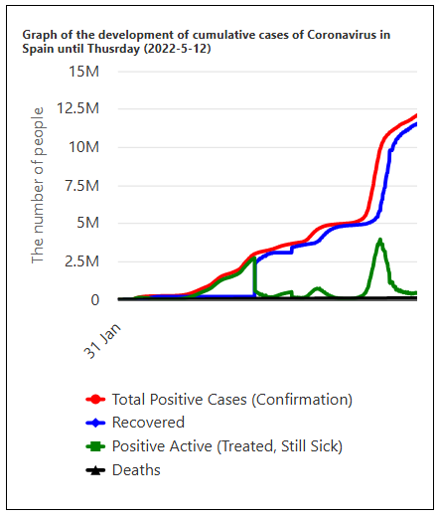
Figure 1: Covid-19 cases in Spain in 2022
(Source: Andra Farm, 2022)
Furthermore, the reaction of Spain was initially slower, which had to be followed by a strict national lockdown because of the high rates of cases, partially because of the delay in the adoption of strong control measures. The system of decentralised public healthcare was under crisis at once, as the lack of free beds and personnel in hospitals became obvious. Talagala et al. (2020, p. 3) denoted that by March 12, 2020, the case fatality rate in Spain was 2.12%, however on March 23, 2020, it had risen to 6.16%. As of May 2022, Spain had a total of more than 12.1 million cases and more than 105,000 deaths with a fatality rate of 0.87% (Andra Farm, 2022). During a lockdown, the virus had reduced its reproductive number to about 0.81% in Spain; nonetheless, it went up swiftly when the measures were eased.
System approach in Canada during covid-19 pandemic has gained a decentralised model that consists of provincial responsibility, significant federal role and creation of task forces. For instance, national guidelines for Canada's healthcare sector have been organised into planning, ethical and legal frameworks to add shared values with the emergency response system (Canada, 2025). Moreover, its structural expansion regarding emergency procedures and modernisation have also extensive strength within the country-based system approach in Canada. Besides these centralised approaches, Canada has also focused on regional decentralisation, tailored to the lockdowns, vaccination rollout-logistics and mandatory use of masks. On the other hand, the trust amidst the population has a major challenge for the “public health system” of Canada while managing Covid-19 pandemic (CBC, 2025). Therefore, the system approach for the healthcare system of Canada during the crisis situation of Covid-19 pandemic has a strategic blend of centralised and decentralised implications.

2.2 Discussion on depending on each country, there were some decisions and approaches that were centralised and some which were decentralised
The balance between centralised and decentralised culture in Spain, South Korea and Canada varies based on historical context and policy aspects. Among the countries Spain’s structure is the most decentralised all across Europe. Erkoreka and Hernando‐Pérez (2022, p. 130) denoted that the 17 Autonomous Communities (ACs) are strong, handling more than 40% of the total number of public spending in harmony with the local governments. In 2016, 32% of the consolidated public sector was ACs, the spending of which was directed at core services, such as health and education (López-Laborda, Martínez-Vázquez and Monasterio-Escudero, 2023, p 341). Nevertheless, the central government still retains substantial power in matters that involve the whole country including international affairs, defense, customs and fundamental economic planning. The COVID-19 pandemic in its first response has provided a demonstration of this conflict, as there has been an intense and temporary, recent centralisation of power, followed by the restoration of the space in decision-making in regions.
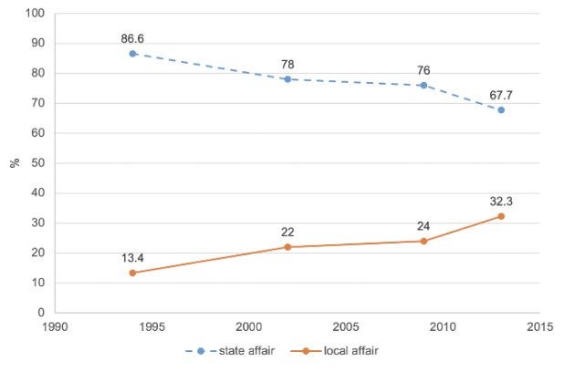
Figure 2: South Korean Trend in government affairs from 1990 to 2015
(Source: Lee and Suh, 2021)
South Korea had a traditionally highly centralised system, through which local affairs were micromanaged, which resulted in the unequal distribution of wealth. Since 1987, democratisation has been a primary contributor to extensive decentralisation. Lee and Suh (2021, p. 70) denoted that the rate of government affairs that are considered to be local also rose by 13% in 1994 to 33% in 2013. Moreover, South Korea designed a successful, centralised e-procurement system, KONEPS, which brings about $8 billion of administrative savings per year with the help of standardised and efficient processes (Public Procurement Service, 2020). Nevertheless, the nation has also been concurrently seeking centralisation and decentralisation legal structure within the country especially on disaster management where a uniform national system operates in concert with the local units.
Canada is a distinctly federal level of decentralisation that has highly centralised municipal governments in the provinces. The Constitution Act, 1867, allocated different powers where the federal state takes the national defense and criminal law, and provinces are in charge of education and health care (Government of Canada, 2022). The framework ensures that policymakers have much provincial freedom, yet it also requires much coordination between governments to deal with complex issues in policy making.

2.3 Critical Analysis of advantages and disadvantages of system approaches in each country by outlining its approaches and outcomes
Spain
The healthcare system in Spain can be considered as highly decentralised in which there are 17 autonomous regions, responsible for managing health services. Coordinated formation of the national government in Spain has been carried out through “Inter-territorial Council of National Health System” or CISNS (Sanidad, 2025). Regarding these governance-based implications to tackle the critical situation of Covid-19 pandemic, the decentralised leadership has enabled dynamic responses to Covid-19 pandemic. However, initially, the early leadership has been reactive with fragmented decision-making aspects between central and regional activities (Rodríguez-Teruel et al. 2024, p. 70). Thus, the national vaccination strategy has been designed centrally, whereas the implementation has been conducted regionally.
Advantages
- Regional flexibility that has enabled the adaptation towards local epidemiological condition
- The inclusion of strong and quite efficient primary care networks has strengthened the overall system with resilience (Who, 2025).
- Collaboration and coherence within the integrated systems towards the shared agenda of Covid-19 crisis also benefit the system to deal with pandemics.
Disadvantages
- Challenges of coordination due to extensive crisis pressure and time management
- Delays during the initial stage with logistical problems due to the centralised purchase procedure of medical equipment have slowed down the management in a scale (Oxcon.ouplaw, 2024).
- Inconsistency in measures has led to the higher mortality during the first wave of the crisis.
These approaches in Spain have yielded positive health outcomes that can be assessed by the achievement of higher vaccination coverage with improved measures in later stages. Spain’s responses have ensured “highest life expectancy” amidst all of the EU states, leading towards the positive implications for crisis situations (Euro health observatory, 2024). Thus, it can be stated that Spain gained a high yield of positive health outcomes during the pandemic stage.
South Korea
Unlike Spain, South Korea has widely adopted a “centralised” system in the form of “whole-of-nation”, in terms of dealing with crisis situations like pandemic. For instance, Hong (2024, p. 2126) has found that the centralised model of South Korea, as a “whole-of-nation” has been formed as a dynamic governance model by combining government, private sectors and civil societies. This particular system has shaped a strong leadership, leading to the quick and strategic decision-making and coordinated implications. For instance, the rollout of Covid-19 vaccination has been commenced with the support of AstraZeneca and more than 5000 care givers (Dw, 2021). Therefore, the advantages of this system have lied upon the governance-based modelling of South Korea, while the disadvantages have lied upon technical aspects.
Advantages
- Key features like rapid testing, tracing, controlled measures and the validation of uncontrolled spread through the strategic isolation prevention
- Consistent policies across the entire nation through centralised coordination within South Korea’s governance management (Park and Fowler, 2021, p. 290)
- Transparency in governmental decisions and activities has strengthened the public trust in a significant manner
Disadvantages
- Excessive dependency on surveillance has raised privacy concerns across South Korea amid the pandemic crisis (Dw, 2021).
- The centralised control amidst the entire country has limited the regional autonomy in a drastic manner.
- Lack of information or data-driven visibility regarding the effectiveness of vaccines for elderly individuals (Dw, 2021)
These aforementioned critical approaches in Spain have also secured positive health outcomes in terms of viable results. For instance, three stage implications of South Korea’s responses towards pandemic such as Detection, Containment and Treatment have validated gradual, as well as strong control over the widespread of virus (Exemplars, 2025). Thus, higher vaccination rate and control systems have showcased the positive determinants in South Korea’s response towards pandemic.
Canada
As compared to both Spain and South Korea, Canada has also adopted a decentralised system approach that has been managed by provinces and federal coordination. Mainly, the Government of Canada has crafted two major task forces related to the vaccination drive such as COVID-19 “Vaccine Task Force” (VTF) and COVID-19 “Immunity Task Force” (CITF) (Cirnetwork, 2021). These approaches have also showcased the collaborative and evidence-based leadership strategies, rather than central directives. VTF has managed the manufacturing and procurement of vaccines (Ised-isde.canada, 2021). On the other hand, CITF focuses on immunity, as well as surveillance for viable credibility in terms of mitigating the spread of virus.
Advantages
- Science-based decisions with credibility implications have shaped expert-driven practices to control the widespread of Covid-19 virus
- CITF has mandated the catalysing support and funding by harmonising knowledge on the “SARS-CoV-2 immunity”, that have protected Canadians from the severe impact of Covid-19 pandemic (Covid-19 immunity task force, 2025).
- Decentralised decision-making with federal, territorial and provincial decision-making have also ensured strong implications of vaccination strategies
Disadvantages
- Outcomes like uneven restrictions and lack of balance in vaccine rollout have been critical outcomes of provincial autonomy
- Slowed vaccine deployment at the initial stage, as compared to the peer countries
- The problem of “moral injury” among the frontline healthcare workers poses long-lasting challenges in Canada’s responses to Covid-19 pandemic (Canada, 2025).
Based on the vaccination coverage by the late 2021, Canada has gained positive and desired outcomes with higher vaccination drive. However, the underlying constraints such as regional disparities along with slowed rollout at the early stage have caused limited effectiveness (Canada, 2025). Despite these, the decentralised governance support of Canada has secured positive health outcomes for people.

2.4 Challenges that results from the above approaches
The two systems of governance, centralised and decentralised, have unique issues of difficulty when faced with crisis situations. Centralised systems have the benefit of being streamlined, uniform in policy implementation, but may lack local responsiveness and the existence of bureaucracy bottlenecks. Decentralised systems increase flexibility and local responses however, this can result in coordination problems, policy inconsistency and inter-jurisdictional problems.
In Spain, which is a highly decentralised nation, the initial reaction to the COVID-19 pandemic illustrated the difficulties in coordinating the work of the central government and autonomous communities (ACs). The dual role of intermediate governments and ambiguity of legislation regarding the functions of the governments caused confusion at the time when the central government asserted its authority. In 2020, the Spanish GDP declined by 10.8% in the 2020 fiscal year, with the amount of the public debt reaching 120% of the GDP (Reuters, 2021). The central government and social security absorbing most of it manifested the concentration of the resulting deficit. Additionally, the comparison demonstrates that the collective measure of fiscal decentralisation in Spain has statistically significantly impacted negatively on the economic growth in terms of expenditure shares.
South Korea, which has been partial to decentralisation, encounters a continuous problem of realising full implementation of local autonomy and prioritisation of relevant agendas (Rowan, 2025). The power distribution in Canada is a federal state and has also caused difficulties in the handling of national matters with the provinces adopting different strategies in dealing with health and economic practices. Hence, it can be stated that the main issue of a decentralised system is the necessity to have a mechanism, which enables mutual learning, and incorporates views of various levels of government to prevent wastage of time.

2.5 Critical Literature Review
In the context of healthcare construct, leadership can be viewed as an important mediator to foster a high standard of accountability and accessibility. Stengård et al. (2021, p.11) have described the essentiality of constructive leadership paradigm in terms of developing structured healthcare outcomes based on different metrics such as control, collaboration and employee participation. Following the aforementioned evidence, a robust foundation of leadership and management, both can be regarded as key pillars to ensure a high standard of healthcare operations based on involvement and accessibility. Another study by Miller et al. (2023) has supported the aforementioned statement by indicating the essentiality of robust foundation of leadership and management to foster diversified dynamics of healthcare operations and operational construct. Following the aforementioned scenario, strong leadership acts as a pivotal element for a nation’s healthcare construct to ensure a high standard of accessibility and transparency within the operational metrics.
The integration of structured health care system can be considered as another important paradigm of social and public healthcare, through the channels constructive leadership style. For example, NHS UK has developed a structured foundation of governance within their healthcare framework through the channels of accessibility information across the nation (NHS, 2025). Based on the aforementioned evidence, structured leadership can be considered as an important ledger for a nation’s healthcare sector to foster increased accessibility within the patient-centric dynamics. Moreover, the study by Ressang-Wildschut et al. (2023, p.107017) has supported the previous statement by describing the significance of leadership to reshape the existing stances of healthcare operations through the considerations of service delivery and Quality of Service (QoS). Henceforth, structured and robust leadership have been conceptualised as major factors for a nation’s social and public care in relation to the amalgamation of increased standard of accessibility and transparency.

3. Critical Analysis of the Leadership Styles

3.1 Leadership theories and styles in Spain
Spanish healthcare can be considered as one of the most stable foundations in the world, concerning the presence of accessibility and accountability. As illustrated in the figure below, in 2023 the at-risk-of-poverty metrics reached the valuation of 26.5% in Spain, concerning the stances of social exclusion. Based on the aforementioned scenario, the existing leadership metrics of the Spanish healthcare can be considered as significant in terms of ensuring a high standard of accessibility based on the existing standards of socio-economic dynamics. According to Avanzas et al. (2017, p.1), the Spanish healthcare foundation is majorly driven by three key channels including equity, participation and quality. The aforementioned insights have clearly indicated the prominence of managerial leadership style within Spain's existing healthcare dynamics.
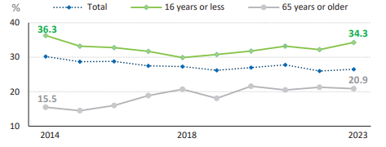
Figure 3: The at-risk-of-poverty in Spanish healthcare
(Source: Sanidad, 2023)
The increasing diversification of the Spain’s socio-economic construct can be regarded as one of the key barriers within the nation’s healthcare dynamics. More precisely, the aforementioned diversification can be viewed as the catalyst in terms of constraining healthcare operations due to disparities within different measures such as life expectancy, disability and deaths. According to the visualisation of the figure below, Spain experienced the life expectancy at birth as 83.2 years during 2022, surpassing the EU average. In this regard, Avanzas et al. (2017) have described the essentiality of governance in terms of ensuring improved healthcare outcomes based on the considerations of management autonomy and structured outcomes. The theory of servant leadership has uniquely embraced the essentiality of combined motivation in terms of ensuring a high standard of strong conviction, concerning the stances of caregiving paradigm (Demeke et al. 2024, p.1). In line with the theorisation of servant leadership, governance and management autonomy can be viewed as two important metrics for the Spanish healthcare construct to foster the initiation of multidirectional goals and diversified operations.
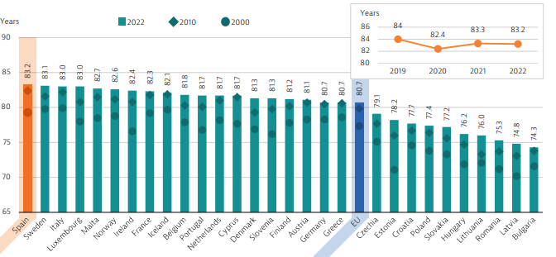
Figure 4: Life expectancy in Spain
(Source: OECD, 2025)
Social identification can be considered as another important metric for Spanish healthcare system in terms of ensuring operational outcomes. Fundamentally, Spain’s healthcare foundation is considered to be driven by decentralised governance, concerning seamless transfer of responsibility (Avanzas et al. 2017). Based on the aforementioned scenario, managerial leadership can be considered as a prominent foundation for the Spanish healthcare in terms of developing a flexible and robust administrative system, concerning existing operations. Social Identity Theory has theorised leadership as a cornerstone of a structured healthcare setting in terms of maximising the stances of intergroup distinctiveness and interdisciplinary collaboration (Leach et al. 2021, p.6). Consequently, the management autonomy can be considered as the most important aspect for the Spanish healthcare to ensure a high standard of operational values through the considerations of involvement and collaboration.
Effective communication can be considered as another important ledger for Spanish healthcare operations. A study by Terkamo‐Moisio et al. (2022, p.596) has conceptualised remote & virtual leadership as a significant paradigm to foster improved healthcare outcomes based on the considerations of technological solutions and organisational behaviours. Considering the aforementioned evidence, effective communication can be considered as a significant parameter for the Spanish healthcare setting to strengthen the stances of management autonomy. Structurally, the entire Spanish healthcare system is focused on the operational standards of primary and ambulatory care (EU, 2019). In this regard, shared responsibility can be considered a significant metric for the Spanish healthcare in terms of ensuring a high standard of management activities. For instance, the Spanish healthcare foundation experienced a spike of 20% within the stances of demand and use of services, concerning overall healthcare spending and expenditure (Avanzas et al. 2017, p.2). The aforementioned insights eventually indicate the effectiveness of effective management in terms of ensuring a feasible and structured consumption of health resources within the operational metrics of Spanish healthcare construct.
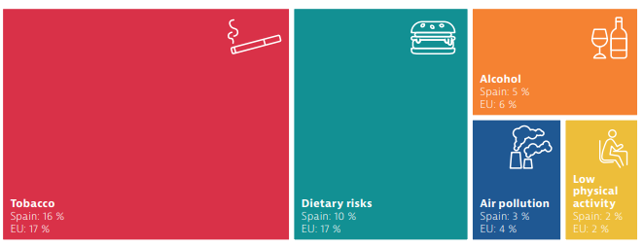
Figure 5: Risk factors within Spanish healthcare system
(Source: Oecd, 2023)
As illustrated in the figure above, tobacco and disparity risks can be viewed as two prominent barriers within the Spanish healthcare system. Furthermore, Avanzas et al. (2017, p.2) have addressed the presence of professional governance within Spain’s healthcare system in relation to the integration of structured operations. The previous evidence can be interpreted in relation to the significance of managerial and virtual leadership styles in terms of developing a high standard of operational values, concerning the entire foundation.

3.2 Leadership theories and styles in South Korea
Laissez-faire leadership style
The laissez-faire form of leadership observed in South Korea is focussed on developing a clear vision related with quality of healthcare standards by FMC. Pizzolitto et al. (2023) stated that Laissez-faire leadership styles are effective for consolidating clear perspectives across the hierarchy for improving business outcomes. South Korea’s excellence in the field of medical care is anticipated from incorporating the Laissez-faire leadership style that influences making pro-active decisions. The leadership style is important for equipping South Korean hospitals with advanced technology that was crucial for enhancing patients' wellbeing as response to the COVID-19 pandemic (Internationalinsurance, 2025). The leadership approach had been responsible for fostering advancement in the medical field such as improvement in people’s health. Laissez-faire leadership
Laissez-faire leadership is significant for leaders in delegating decisions towards enhancing the workabilities of employees through training. Laissez-faire leaders allow the group to self-manage, offering support only when asked (“Leadership- Theories and its importance - Week 4, Slide 13”). The leadership style is significant for enhancing the quality of healthcare facilities across the South Korean healthcare sector. For instance, installation of CT scanners and treatment of skin diseases, leading to higher rates of survival can be correlated with benefits of Laissez-faire leadership as observed in South Korea (Internationalinsurance, 2025). Thus, FMC, having established its branch in South Korea, gains adequate opportunities in enhancing its efficient kidney treatment facilities for overarching patients especially during the COVID-19. The reason is that the leadership style influences collaboration with team members that helps in developing plans to ensure higher chances of scream in treating patients.
Centralised governance can be considered as one of the most important metrics, observed in the South Korean healthcare dynamics. Fundamentally, a strong foundation of governance and management can be considered as two important paradigms of South Korean healthcare sector, ensuring potential outcomes. A 2025 ICI report has indicated a highest suicide rate in the OECD, through the stances of 20% within average healthcare spending (ICI, 2025). Considering aforementioned statement, laissez faire leadership style can be considered as a prominent metric within the South Korean healthcare setting. Fundamentally, in the context of public healthcare sector, centralised governance plays an essential role in terms of amalgamating different measures such as change management, business activity and organisational structure (Deloitte, 2025). Considering the aforementioned scenario, centralised legal structure can be considered legal structure can be considered as one of the most essential metrics, concerning the feasible management activities based on centralisation and standardisation. According to Hundie and Habtewold (2024, p.70), laissez-faire metrics can be considered as a pivotal element within healthcare metrics in terms of ensuring structured healthcare outcomes based on improved employee performance and capital management. Consequently, “Integrated Health Promotion Program” can be viewed as one of the most important segments within the South Korean healthcare system in terms of ensuring centralised governance based on community-setting and local autonomy (OECD, 2020). Thus, centralised autonomy and governance can be considered as two important pillars concerning the entire healthcare settings of South Korea.
Behavioural theory
Laissez-faire leadership is compliant with the behavioural theory that is significant for acting against a lack of agreement across team members that impacts work outcomes. Garavan et al. (2023) stated that behavioural theory focuses on interpreting leadership thinking on workers’ perspectives. The analysis of behavioural patterns of integral team members influences the Laissez-faire leaders in upskilling the team members at FMC, that help in enhancing the delivery of healthcare services. However, Kamal and Kesuma (2024) argued that the laissez-faire leadership hinders clarity due to, in addition, active participation of team leaders in solving queries. The interpretation of qualities across team members in FMC can relate to identifying chances of disagreement while applying this leadership style that could help in improving patients’ healthcare outcomes during the COVID-19.
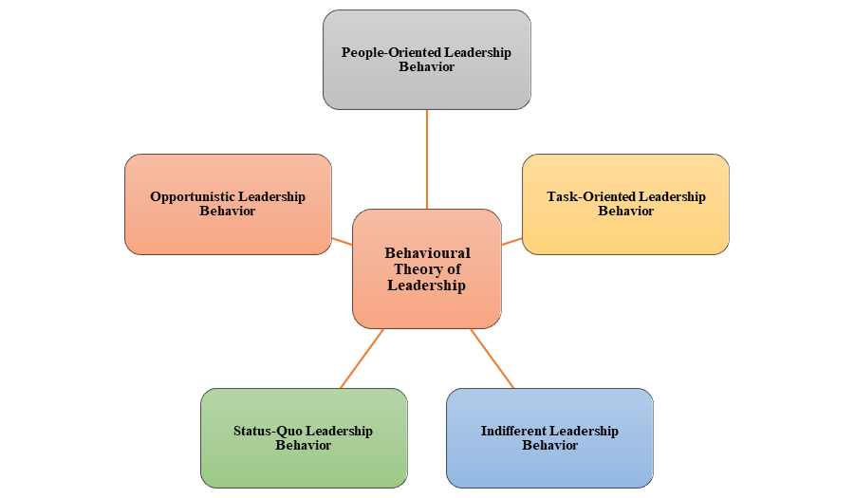
Figure 6: Behavioural Theory
(Source: Self-developed)
The behavioural theory can play an important role in ensuring better coordination across team members and leaders within the South Korean healthcare sector during the COVID-19 pandemic. In addition, dimension on leadership behaviours comprise feasibility of task accomplishment along with concern for the people doing the work (“Leadership- Theories and its importance - Week 5”, Slide 25). The analysis of the team members’ behaviour using the laissez-faire leadership contributed to integrating popular alternative treatments in South Korean hospitals such as acupuncture and cupping (Internationalinsurance, 2025). Laissez-faire leadership in compliance with the behaviour theory can be important for FMC’s team leaders in solving disputes arising from disagreement within perspectives across team members. The statement signifies that this leadership style is significant for enhancing the quality of healthcare practices provided across patients.

3.3 Leadership theories and style in Canada
Transformational leadership style
The transformation leadership style can be anticipated as a significant step in optimising the healthcare services in Canada. Tan et al. (2024) stated that transformational leadership style is essential for committing to improvement in quality standards of business across real-life organisations. In this respect, the leadership style is essential for the Canadian healthcare industry in improving the quality of services across integral healthcare institutions such as FMC. The transformation leadership style in Canada is focused on connecting people through dialogue and engagement across team members that contribute towards advancing health leadership research (Chlnet, 2025). The statement signifies that this form of leadership is effective in addressing skill gaps observed by team leaders that leads to optimization of healthcare services in Canada.
The transformation leadership style also witnessed the impacts of limitation that witnessed a hindrance in improving the quality of healthcare facilities. According to research conducted, regarding the transformation of the healthcare system in Canada, 50% of the respondents claimed that the healthcare institutions (Chlnet, 2025). The leadership gaps are anticipated as lack of supply/demand of raw materials along with capabilities of the healthcare providers in enhancing the quality of healthcare services. The 2020 report infers that applying transformation leadership across Canadian healthcare institutions needs to organise its resources to address the evolving future patients’ demands.
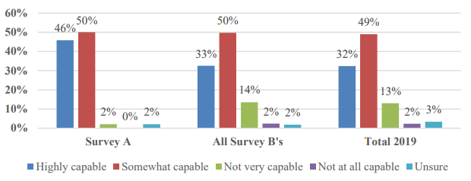
Figure 7: Benchmarking of organizational leadership capacity
(Source: Chlnet, 2025)
Trait Theory
The transformation leadership style is in compliance with the traits theory that can be effective for addressing similar disadvantages as inferred from above. The trait theory is significant for analysing the qualities of leadership towards addressing identified challenges in business (“Leadership- Theories and its importance - Week 5”, Slide 17). The trait theory is compliant with transforming the incumbent leadership arch across organisations such as FMC in optimising existing healthcare facilities for improving patient outcome.
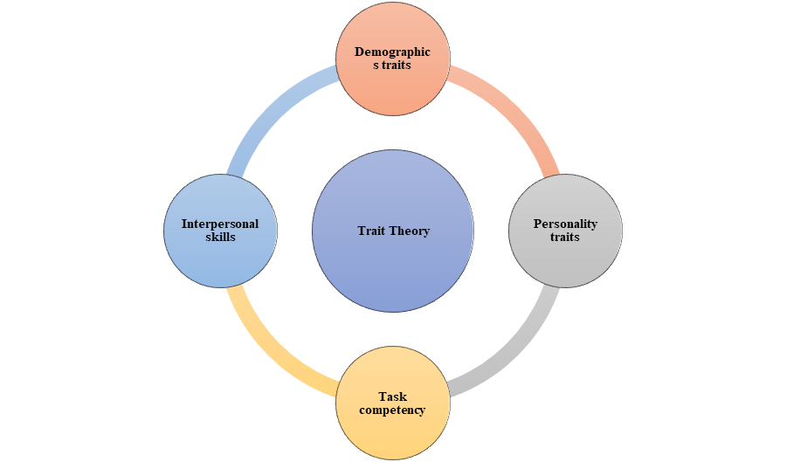
Figure 8: Trait Theory
(Source: Self-developed)
The trait thirty can be applied for optimising the transformational leadership approaches undertaken across Canadian healthcare institutions such as FMC. Nanjundeswaraswamy et al. (2024) commented that trait theory is effective for identifying the gaps in leadership approaches for mitigating future challenges across organisations. The theory is effective for anticipating modification across current work practices such as FMC that contributes towards enhancing quality of renal care. As a result, applying its leadership theory can be beneficial for transformation leaders in gaining loyalty from patients and employees in the long run. The leadership theory supports stability of FMC’s competitive presence in the Canadian healthcare industry.
Relationship Theory
The relationship theory contributed toward enhancing the quality of healthcare services through analysing the relationship across healthcare seekers and providers across Canadian healthcare organisations such as FMC.
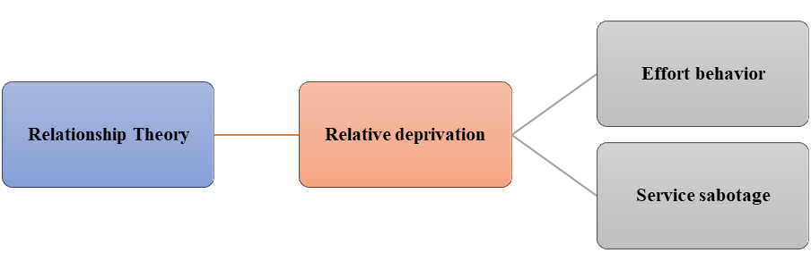
Figure 9: Relationship Theory
(Source: Self-developed)
The 2020 healthcare report on Canada appraised that leadership ropes have been effective for improving the relationship with patients during the COVID-19 pandemic. The impact of positive influence on patients’ morale is altered through transformation in respective healthcare practices across the organizational culture (Chlnet, 2025). However, 75% of nurses reported being disincentivised that declined their motive in improving the quality of healthcare across Canadian organisations (Chlnet, 2025). The critique of the relationship theory correlates with the presence of a negative perception on maintaining one one's roles in contributing towards team effectiveness. Talat et al. (2025) stated that the presence of a non-conducive leadership approach leads to decreased attention to clinical responsibilities. The impact signifies a disadvantage of the transformational theory that lowers the effectiveness of delivering commendable healthcare services across companies such as FMC.
A majority of Canadians believe the health care system witnessed the deterioration of quality of health care in Canada. About 68% of healthcare providers complained of inconsistency in delivering adequate healthcare assistance while retaliating against the COVID-19 pandemic (Angusreid, 2025). The administration of healthcare providers witnesses facing challenges in organising activities for ensuring seamless delivery of quality healthcare services.
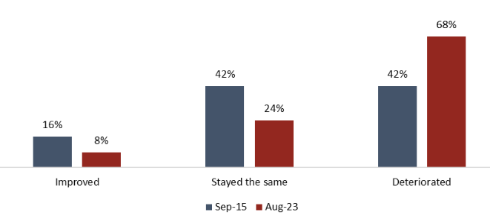
Figure 10: Quality of healthcare in Canada
(Source: Angusreid, 2025)
Applying the relationship theory can be effective for maintaining trust across patients due to leaders' focus on coordinating on undertaking non-verbal communication during the pandemic. Lowe et al. (2023) stated that the Canadian healthcare sector implemented public health responses and restrictions up to 88 %while tackling the COVID-19 pandemic. The relationship theory is in compliance with the transformation leadership style for ensuring the conveyance of safety guidelines and protocols to be maintained by patients in Canada. The statement signifies that the theory and the leadership style is crucial for FMC in contributing towards enhancing patients’ health and wellbeing in Canada.

4. Conclusion
Based on the information provided in the report, it can be concluded that the healthcare system was based on large-scale cooperation between the public and the private sector organisations. The impact optimised online discoveries and isolation of cases without a strict national lockdown during the wake of the COVID-19 pandemic observed across organisations such as FMC. The healthcare system across the three nations followed strict national lockdown due to increasing rates of pandemic cases, which led to the delay in the adoption of strong control measures. The COVID-19 pandemic imposed a conflict between centralisation of power, followed by the restoration of the space in decision-making in regions. However, centralised systems may lack local responsiveness and the existence of bureaucracy bottlenecks. As a result, decentralisation has been significant for increased flexibility and local responses towards acting against the impact of COVID-19 pandemic.
The integration of a structured health care system can be considered an important step towards conveying social and public healthcare awareness across the healthcare sector in Spain, Canada and South Korea. The leadership styles and theories have been effective for consolidating clear perspectives across the hierarchy for improving business outcomes. However, lack of cordoning patient’s outcomes has also been anticipated from the drawbacks of the applied theories. The leadership styles contributed to equipping hospitals with advanced technology and patients-centred coordination for enhancing patients' wellbeing as response to the COVID-19 pandemic. In this respect, the behavioural patterns of integral team members helped in improving patients’ healthcare outcomes during the COVID-19 as inferred from the report’s context.

References
Andra Farm (2022) Info on the development of the Coronavirus in Spain each day until May 12,2022, Andra Farm. Available at: https://m.andrafarm.com/_andra.php?_i=daftar-corona&_en=ENGLISH&noneg=166&negke=844&perhal=50&urut=1&asc=01000000000&coltam=3&no1=451&no2=500&kk=11 (Accessed: 13 December 2025).
Angusreid, (2025). After a ‘decade of decline’ in health care, Canadians not convinced that money is enough to solve the crisis Available at: https://angusreid.org/cma-health-care-access-priorities-(2023)/ (Accessed: 15 December 2025).
Avanzas, P., Pascual, I. and Moris, C. (2017) ‘The great challenge of the public health system in Spain’, Journal of thoracic disease, 9(Suppl 6), p.S430. DOI: http://dx.doi.org/10.21037/jtd.2017.04.59
Canada, (2025). COVID-19 Challenges: Moral Trauma on the Frontline – See, Prevent and Treat. Available at: https://www.canada.ca/en/department-national-defence/programs/defence-ideas/element/innovation-networks/challenge/covid-19-challenges.html (Accessed 16 December 2025)
Canada, (2025). COVID-19 pandemic guidance for the health care sector. Available at: https://www.canada.ca/en/public-health/services/diseases/2019-novel-coronavirus-infection/health-professionals/covid-19-pandemic-guidance-health-care-sector.html (Accessed 16 December 2025)
CBC, (2025). How COVID changed Canadians, their health and the future. Available at: https://www.cbc.ca/news/health/second-opinion-covid-canada-health-1.7484095 (Accessed 16 December 2025)
Chlnet, (2025). Technical Report: Benchmarking the Health Leadership in Canada Available at: https://chlnet.ca/wp-content/uploads/CHLNet-Bench-2-Technical-Report-Final-June-22-2020.pdf (Accessed: 15 December 2025).
Cirnetwork, (2021). Canadian researchers to study best approaches to possible adverse events following COVID-19 vaccination. Available at: https://cirnetwork.ca/news/canadian-researchers-to-study-best-approaches-to-possible-adverse-events-following-covid-19-vaccination/ (Accessed 16 December 2025)
Covid-19 immunity task force, (2025). The COVID-19 Immunity Task Force’s mandate. Available at: https://www.covid19immunitytaskforce.ca/ (Accessed 16 December 2025)
Deloitte (2025) Centralizing governance: An increasingly pertinent consideration. Available at: https://www.deloitte.com/global/en/services/legal/centralizing-governance-an-increasingly-pertinent-consideration.html (Accessed: 16 December 2025).
Demeke, G.W., van Engen, M.L. and Markos, S. (2024) ‘Servant leadership in the healthcare literature: A systematic review’, Journal of healthcare leadership, pp.1-14. Available at: https://www.tandfonline.com/doi/pdf/10.2147/JHL.S440160 (Accessed: 16 December 2025).
Dw, (2021). South Korea kicks off vaccination drive. Available at: https://www.dw.com/en/coronavirus-digest-south-korea-launches-vaccination-drive/a-56710292#:~:text=South%20Korea%20kicks%20off%20vaccination,DW%20%E2%80%93%2002/26/2021 (Accessed 16 December 2025)
Erkoreka, M. and Hernando‐Pérez, J. (2022) ‘Decentralization: A handicap in fighting the COVID‐19 pandemic? The response of the regional governments in Spain’, Public Administration and Development, 43(2), pp. 129–140. DOI: https://doi.org/10.1002/pad.1988.
EU (2019) Spain Health Care & Long-Term Care Systems. Available at: https://economy-finance.ec.europa.eu/document/download/cf06a319-1d6c-417c-bca1-15a997646147_en?filename=joint-report_es_en.pdf&prefLang=hu (Accessed: 16 December 2025).
Euro health observatory, (2024). Spain: health system review 2024. Available at: https://eurohealthobservatory.who.int/publications/i/spain-health-system-review-2024#:~:text=Spain%20has%20the%20highest%20life,non%2Dappropriate%20or%20ineffective%20procedures. (Accessed 16 December 2025)
Exemplars, (2025). Emerging COVID-19 Success Story: South Korea Learned the Lessons of MERS. Available at: https://www.exemplars.health/emerging-topics/epidemic-preparedness-and-response/covid-19/south-korea (Accessed 16 December 2025)
Garavan, T., Ullah, I., O'Brien, F., Darcy, C., Wisetsri, W., Afshan, G. and Mughal, Y.H., (2023). Employee perceptions of individual green HRM practices and voluntary green work behaviour: A signalling theory perspective. Asia Pacific Journal of Human Resources, 61(1), pp.32-56. Available at: http://doi.org/10.1111/1744-7941.12342 (Accessed: 15 December 2025).
Government of Canada (2022) The constitutional distribution of legislative powers, Government of Canada. DOI: https://www.canada.ca/en/intergovernmental-affairs/services/federation/distribution-legislative-powers.html (Accessed: 12 December 2025).
Hong, S.A., (2024). ‘Toward better pandemic governance and preparedness: South Korea’s whole-of-nation approach to COVID-19’. BMC Public Health, 24(1), p.2126. DOI: https://doi.org/10.1186/s12889-024-19655-8
Hundie, Z.A. and Habtewold, E.M. (2024) ‘The Effect of transformational, transactional, and laissez-faire leadership styles on employees’ level of performance: the case of hospital in Oromia Region, Ethiopia’, Journal of healthcare leadership, pp.67-82. Available at: Available at: https://www.tandfonline.com/doi/pdf/10.2147/JHL.S450077 (Accessed: 16 December 2025).
ICI (2025) South Korea’s Healthcare System. Available at: https://www.internationalinsurance.com/countries/south-korea/healthcare/ (Accessed: 16 December 2025).
Internationalinsurance, (2025). An Overview of Healthcare in South Korea Available at: https://www.internationalinsurance.com/countries/south-korea/healthcare/ (Accessed: 15 December 2025).
Ised-isde.canada, (2021). COVID-19 Vaccine Task Force. Available at: https://ised-isde.canada.ca/site/ised/en/programs-and-initiatives/health-emergency-readiness-canada/biomanufacturing/covid-19-vaccine-task-force (Accessed 16 December 2025)
Jeong, S.-J., Park, S.Y., Ryu, B., An, M., Jeon, J.-H., Choi, S.Y. and Kim, S.-S. (2025) ‘Characteristics and trends of severe/critical COVID-19 cases in the Republic of Korea (January 2020 to August 2023)’, Osong Public Health and Research Perspectives, 16(1), pp. 81–88. DOI: https://doi.org/10.24171/j.phrp.2024.0295.
Kamal, F. and Kesuma, T.A.R.P., (2024). Laissez-Faire Leadership: A Comprehensive Systematic Review for Effective Education Practices. Journal of Education and Learning (EduLearn), 18(4), pp.1460-1467. Available at: http://doi.org/10.11591/edulearn.v18i4.21407 (Accessed: 15 December 2025).
Kim, H. (2021) ‘The Korean 3T practice: A New Biosurveillance Model utilizing New IT and Digital Tools (Preprint)’, JMIR Formative Research, 6(5), p. e34284. DOI: https://doi.org/10.2196/34284.
Leach, L., Hastings, B., Schwarz, G., Watson, B., Bouckenooghe, D., Seoane, L. and Hewett, D. (2021) ‘Distributed leadership in healthcare: leadership dyads and the promise of improved hospital outcomes’, Leadership in Health Services, 34(4), pp.353-374. Available at: https://ira.lib.polyu.edu.hk/bitstream/10397/98082/1/Watson_Distributed_Leadership_Healthcare.pdf (Accessed: 16 December 2025).
Lee, J.H. and Suh, J. (2021) ‘Decentralisation and government trust in South Korea: Distinguishing local government trust from national government trust’, Asia & the Pacific Policy Studies, 8(1), pp. 68–93. DOI: https://doi.org/10.1002/app5.317.
López-Laborda, J., Martínez-Vázquez, J. and Monasterio-Escudero, C. (2023) ‘Spain’, Springer eBooks, 1(1), pp. 341–382. DOI: https://doi.org/10.1007/978-3-030-97258-5_9.
Lowe, C., Rafiq, M., MacKay, L.J., Letourneau, N., Ng, C.F., Keown-Gerrard, J., Gilbert, T. and Ross, K.M., (2023). Impact of the COVID-19 pandemic on Canadian social connections: A thematic analysis. Journal of Social and Personal Relationships, 40(1), pp.76-101. Available at: https://doi.org/10.1177/02654075221113365 (Accessed: 15 December 2025).
Miller, R., Ehrenberg, N., Jackson, C., Penwarden, H., Stein, V., van der Vlegel-Brouwer, W. and Wojtak, A. (2023) ‘Builder, expert, disruptor, leader: The many roles of people with lived experience’, International Journal of Integrated Care, 23(3), p.12. Available at: https://pmc.ncbi.nlm.nih.gov/articles/PMC10453958/pdf/ijic-23-3-7696.pdf (Accessed: 16 December 2025).
Nanjundeswaraswamy, T.S., Nagesh, P., Bharath, S. and Vignesh, K.M., (2024). Leadership theories and styles-a systematic literature review and narrative synthesis. Human Resources Management and Services, 6(3), pp.3477-3477. Available at: https://doi.org/10.18282/hrms.v6i3.3477 (Accessed: 15 December 2025).
NHS (2025) Accessibility. Available at: https://digital.nhs.uk/about-nhs-digital/accessibility (Accessed: 16 December 2025).
NIH (2020) ‘Coronavirus Disease-19: The First 7,755 Cases in the Republic of Korea’, Osong Public Health and Research Perspectives, 11(2), pp. 85–90. DOI: https://doi.org/10.24171/j.phrp.2020.11.2.05.
OECD (2020) OECD Reviews of Public Health: Korea. Available at: https://www.oecd.org/content/dam/oecd/en/publications/reports/2020/03/oecd-reviews-of-public-health-korea_335bc8ac/be2b7063-en.pdf (Accessed: 16 December 2025).
OECD (2023) State of Health in the EU Spain Country Health Profile 2023. Available at: https://www.oecd.org/content/dam/oecd/en/publications/reports/2023/12/spain-country-health-profile-2023_727a7995/71d029b2-en.pdf (Accessed: 16 December 2025).
Oxcon.ouplaw, (2024). Spain: Legal response to Covid-19. Available at: https://oxcon.ouplaw.com/display/10.1093/law-occ19/law-occ19-e10#:~:text=9.,regulatory%20competences%20of%20the%20ACs. (Accessed 16 December 2025)
Park, S. and Fowler, L., (2021). ‘Political and administrative decentralization and responses to COVID-19: comparison of the United States and South Korea’. International Journal of Organization Theory &Behavior, 24(4), pp.289-299. DOI: https://doi.org/10.1108/IJOTB-02-2021-0022
Pizzolitto, E., Verna, I. and Venditti, M., (2023). Authoritarian leadership styles and performance: a systematic literature review and research agenda. Management Review Quarterly, 73(2), pp.841-871. Available at: https://doi.org/10.1007/s11301-022-00263-y (Accessed: 15 December 2025).
Public Procurement Service (2020) Public Procurement Service, Pps.go.kr. Available at: https://www.pps.go.kr/eng/content.do?key=00776 (Accessed: 16 December 2025).
Ressang-Wildschut, J., Oldenhof, L. and Leistikow, I. (2023) ‘Can leadership make the difference? A scoping review of leadership and its effects in child and youth care’, Children and Youth Services Review, 150, p.107017. Available at: https://www.sciencedirect.com/science/article/pii/S0190740923002128 (Accessed: 16 December 2025).
Reuters (2021) ‘Spain’s debt-to-GDP ratio rose to 120% in fourth quarter 2020’, Reuters, 31 March. Available at: https://www.reuters.com/article/markets/us/spains-debt-to-gdp-ratio-rose-to-120-in-fourth-quarter-2020-idUSL8N2LT2MP/ (Accessed: 14 December 2025).
Rodríguez-Teruel, J., Del Pino, E. and Real-Dato, J., (2024). ‘The Limits of Power Concentration and Expert Knowledge in Emergency Management: Spain's Government Response during the First Phase of the Covid-19 Pandemic’. In Southern Europe in The Covid-19 Pandemic (pp. 56-88). Routledge. DOI: https://doi.org/10.1080/13608746.2022.2091861
Rowan, B. (2025) Korean local autonomy, Koreatimes.co.kr. The Korea Times. Available at: https://www.koreatimes.co.kr/opinion/20251012/korean-local-autonomy (Accessed: 14 December 2025).
Sanidad (2023) Annual report on the National Health System of Spain 2023. Available at: https://www.sanidad.gob.es/estadEstudios/estadisticas/sisInfSanSNS/tablasEstadisticas/InfAnualSNS2023/Resumen_Ejecutivo_2023_Ingles.pdf (Accessed: 16 December 2025).
Sanidad, (2024). COVID-19 VACCINATION STRATEGY IN SPAIN: KEY POINTS. Available at: https://www.sanidad.gob.es/gabinetePrensa/notaPrensa/pdf/24.11241120144436287.pdf (Accessed 16 December 2025)
Smith, S.G. and Sinkford, J.C. (2022) ‘Gender equality in the 21st century: Overcoming barriers to women's leadership in global health’, Journal of Dental Education, 86(9), pp.1144-1173. Available at: https://onlinelibrary.wiley.com/doi/pdf/10.1002/jdd.13059 (Accessed: 16 December 2025).
Stengård, J., Peristera, P., Johansson, G. and Nyberg, A. (2021) ‘The role of managerial leadership in sickness absence in health and social care: antecedent or moderator in the association between psychosocial working conditions and register-based sickness absence? A longitudinal study based on a swedish cohort’, BMC public health, 21(1), p.2215. Available at: https://link.springer.com/content/pdf/10.1186/s12889-021-12236-z.pdf (Accessed: 16 December 2025).
Talagala, I.A., Karunarathna, B., Gunatilake, I., Rodrigo, C., Kantharuban, D., Seneviwickrama, M., Jayawardana, P. and Goonewardena, S. (2020) ‘CFR of COVID-19: a comparison among different countries’, Journal of the College of Community Physicians of Sri Lanka, 26(5), pp. 1–6. DOI: https://doi.org/10.4038/jccpsl.v26i5.8352.
Talat, H., Iqbal, M.Z. and Aslam, K., (2025). “It’s Too Painful to Explain My Role”: Factors Affecting Professional Identity Formation among Health Professions Educationists. Education in Medicine Journal, 17(3), pp.105-16. Available at: http://doi.org/10.21315/eimj(2025).17.3.8 (Accessed: 15 December 2025).
Tan, A.B., Van Dun, D.H. and Wilderom, C.P., (2024). Lean innovation training and transformational leadership for employee creative role identity and innovative work behavior in a public service organization. International Journal of Lean Six Sigma, 15(8), pp.1-31. Available at: http://dx.doi.org/10.1108/IJLSS-06-(2022)-0126 (Accessed: 15 December 2025).
Terkamo‐Moisio, A., Karki, S., Kangasniemi, M., Lammintakanen, J. and Häggman‐Laitila, A. (2022) ‘Towards remote leadership in health care: Lessons learned from an integrative review’, Journal of advanced nursing, 78(3), pp.595-608. Available at: https://onlinelibrary.wiley.com/doi/pdfdirect/10.1111/jan.15028 (Accessed: 16 December 2025).
Who, (2025). ACCELERATING MULTIDISCIPLINARY TEAMWORK TO ADDRESS EMERGING PRIMARY CARE NEEDS IN THREE SPANISH REGIONS. Available at: https://www.who.int/docs/librariesprovider2/default-document-library/primary-health-care-spain-eng.pdf (Accessed 16 December 2025)

