A Simulation of a Potential Real-Life Scenario

Ethan Ridd - P144898 – School of applied Computing – UWTSD
Abstract – Threats to network security has been on the rise for many years and numerous companies tend to hire penetration testers to test the security. The author had been asked to test the security of tevelcyber.com, a site owned by a cyber security firm. The author has been given many rules and restrictions on what he can and cannot do. The author used numerous tools from the Kali Linux operating system and a few web-based tools to gather information. Numerous vulnerabilities were detected within the site from outdated operating systems to security features that were disabled and even point of weakness that leave the site open to malicious intrusion from common attack such as cross site scripting and SQL injection. To conclude the report the author made numerous suggestions on areas on improvement and associated costs.
- Introduction
Over the last 20 years the internet has experienced a massive amount of growth with roughly 55.1% of the human population in 2018 being active users[1]. In recent years the number of attacks on computer networks have increased and, in some cases, have captured the public eye in terms of the severity of the attack and the information stolen. As an example, there was plenty of media attention around the HBO cyber-attack and extortion that took place in July 2017 which threatened to cost the company millions in revenue when an Iranian hacker stole, vital information relating to popular TV shows such as Game of Thrones and Westworld then attempted to extort from the company 6 million dollars[2].
For reasons that seem more than obvious many companies have begun implementing strict security measures on their computer networks to prevent such things from happening. One very popular method of securing a network is to hire outside help in the form of penetration testers also known as “White Hats”. Penetration testers actively attempt to infiltrate the network of a company and find any flaw in the security from the outside, this allows them to see the network from the perspective of the attacker and make suggestions from the information they have gathered from their attempts to access the network. The methods used vary from the use of programs, scripts and known vulnerabilities to social engineering which uses the employees of a company and attempts to get them to violate security policies through social interactions.
In this paper the author details his attempt at penetration testing on a cyber security firm called tevelcyber.com. he will outline his methodology, the framework and the penetrations tools he used in his attempts whilst also giving a justification for said methods and tools. He will also layout the information he has gathered from his attempts and go on to set some recommendations for the company for the improvement of their network such as policy updates, software or hardware recommendations and a possible defence strategy for the network in case of a future attack.
- Testing Restrictions and Scope
The website that the author is performing the penetration testing on is a live website. Thus, due to the nature of the company and the sensitive attributes of the data stored the author must be restricted in what he can and cannot do as to not disrupt the everyday function of the company and its employees.
The guidelines for the penetration testing are as follows:
- No modifications to any contents on or within the website
- Provide the details of the vulnerability and the methodology used this include any information needed for replication.
- Attempt to avoid privacy violations, data corruption/ destruction and interruption of the services provided by the website.
- Do not use or pivot a vulnerability to discover more vulnerabilities.
Some methods have been excluded from the testing process to ensure security and stability of the functioning website. They are as follows:
- The author cannot access, download or modify any data in any account.
- Use of Denial of service attacks is strictly prohibited.
- Uploading, sending or storing malicious software on the website.
- No transmission of unsolicited email or spam.
These rules have restricted the authors ability to perform a comprehensive penetration test and only allows him to do recon and discover vulnerabilities. The author isn’t allowed to test whether these vulnerabilities can be successfully utilized and exploited. In this report the author will give examples of attacks that can be used to gain access or harm the Tevel cyber corps website. The author will provide explanations and diagrams to illustrate discovered attacks and give some suggestions on how to prevent them, this includes software or hardware updates, policy improvements and mitigation techniques to prevent exploitation of the vulnerabilities discovered.
- Framework
For a penetration test to be successful a good framework that will act as a solid bedrock for further testing must be established. The author has been provided an example and has done his own research into a potential framework. At the centre of the authors framework is a Linux based operating system designed specifically for penetration testing called Kali[3]. Kali offers numerous penetration testing programs that have been natively installed within the operating system. There are also numerous web-based tools that can gather information about a site and scan for vulnerabilities. The author will detail these tools further on in this report.
The author has devised a comprehensive plan for how he plans to test the security of the site and the steps needed to achieve this, they are as follows:
- Step 1- Recon
  - Gather information on the website using “whois” tools on both Kali and web-based applications.
- Step 2 – Information Gathering
  - Gather information on the network including, port usage, operating systems used on the network, possible topology, software and plugins used in the operation of web services.
- Step 3 – vulnerability analysis
  - Gather information on common vulnerabilities found in certain services on the server.
- Step 4 – Web Application analysis
  - Scan numerous potential web applications that are being used on the server to gather possible vulnerabilities within said web applications.
- Step 5 – Improvements
  - Look for possible improvements to the network through change of configurations or updating of software and hardware.

- Penetration Testing Tools
As previously mentioned, Kali Linux provides numerous penetration testing tools within the OS, some of these tools violate the rules set by Tevel cyber corps and thus will not be used by the author. The first groups of tools the author has chosen to use are reconnaissance and information gathering tools, that gather information about the target. The first tool within the group is “Nmap” which is used for network exploration and checking the security of the target network, most importantly it is open source which allows for the use of addons to make the program more useful[4]. Nmap is more reliable than other port and networking scanning programs[5].
The second tool within the group that the author used to gather information is called “Dmitry” this is a whois lookup program that gathers information about numerous aspects of the site including port scanning, subdomains, email addresses and even system and server uptime[6].
The second group of tools the author plans to use in his testing of the network’s security is focused primarily on vulnerability analysis the author plans on using 2 tools from kali as the rest are too intrusive and might break the rules of the test. The first being “Nitko” this is again an open source program that scans web servers for vulnerabilities and any common files that might be susceptible to an attack[7]. The second tool the author plans to use is “Recon-NG” this is a framework which analyses a network for vulnerabilities quickly and thoroughly[8].
The third group is focused on the web application analysis. Due to the restrictions of the test the author cannot use many of these applications from Kali, but he is able to use one called WPscan this scans for vulnerabilities in a common content management system called WordPress. WordPress allows for easier content publishing[9]. WPscan analyses any WordPress plugins and themes that are installed on the network and finds any related vulnerabilities[10].
Beside Kali there are a few websites that perform some basic scans that the author plans on using. One such scan is the WhoIs provided by Robtex, this displays all registration information for the website and more such as IP addresses, domain names, the hosting site and the mail servers used [11]. The author plans to use a site called “Pentest-Tools” that scans for numerous vulnerabilities such as cross site scripting (XSS), SQL Injections and an overall website scan[12].
Most of these online tools are free and open source, it also allows the author to reinforce his findings by scanning the same areas with different tools making his results more reliable and precise.
- Scan Results and Vulnerabilities found
The author has performed all the scans and the investigation into the site has been completed. In this section the author will detail the scans performed, the methodology and the results of the scans along with any discovered vulnerabilities.
  - Information gathering
The author has performed all the scans and the investigation into the site has been completed. The first thing the author attempted was to find a login page to find a way to access the site with a login and password. The author did this by visiting the site and editing the URL to add the /Login Prefix to the end, and as the author suspected he was taken to a Word Press login page. This can be seen below if figure 1
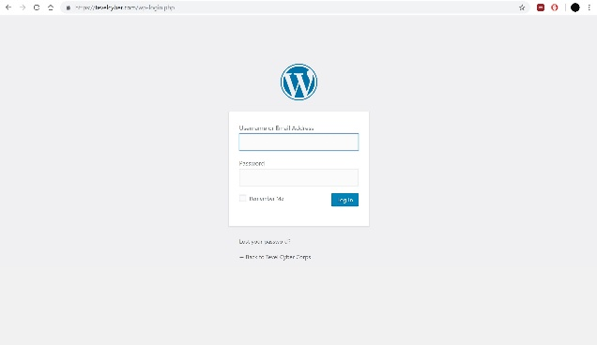

Figure 1 – tevelcyber.com Word Press Login page (Larger Version in the Appendices)
The login Page is a point of possible attack as with the correct username and a brute force attack an unauthorized user might be able to gain access to the Word Press admin control panel.
After discovery of the Word Press login the author decided to do several WhoIs scans to discover more information about the website. The first scan was with the previously mentioned Dmitry, below in figure 2 is a screenshot of the scan
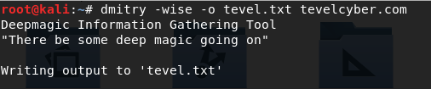
Figure 2 – Dmitry Scan output
This scan was performed from the root directory of the Kali Linux terminal. The command wise is a set of 4 commands that have 4 different functions concatenated to one command. The commands are as follows:
- -w – Performs WhoIs on the target.
- -i – Performs and internet number WhoIs scan on the target.
- -s – Performs Subdomain scan of the target.
- -e – Performs email address search on the target.
- -o – This allows the author to set a file in which the data will be saved.
The output file can be seen below in figure 3.
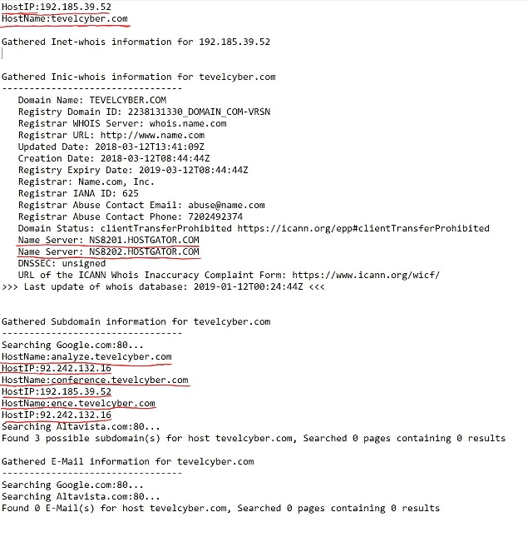
Figure 3 – Screenshot of Dmitry scan output file
In the Figure the author has highlighted the information he thought was important. At the top, the IP address can be seen of the site, this is useful for further scans later. It can also be seen that tevelcyber.com doesn’t host its own site on private, company servers this is a common practice as it removes the expensive cost of the infrastructure development and maintenance from the company. We can also see numerous other IP addresses at the bottom, these are the IP addresses of the 3 subdomains within the site.
Unfortunately, Dmitry was unable to find any mail servers within the domain, so the author decided to perform another test from his list, this time using the Robtex whois scan. The output of this scan can be seen below in figure 4.
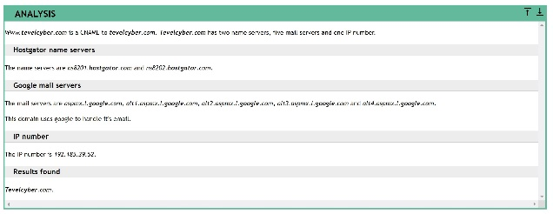
Figure 4 – output of Robtex WhoIs scan

This second scan was able to find 5 google mail servers that a frequently used by the site. The second scan also shows plenty of information that the author has already discovered with the previous scan.
After all the WhoIs scans had been completed and all information about the network that is publicly available had been discovered the author then moved on to the Nmap Scan which as previously mentioned allows for much deeper scanning of the ports, services and the operating systems used.
Nmap was very useful as it displayed the ports in use and whether it was secured with appropriate security protocols or not. It also displayed the operating systems and some of the devices used with version numbers.
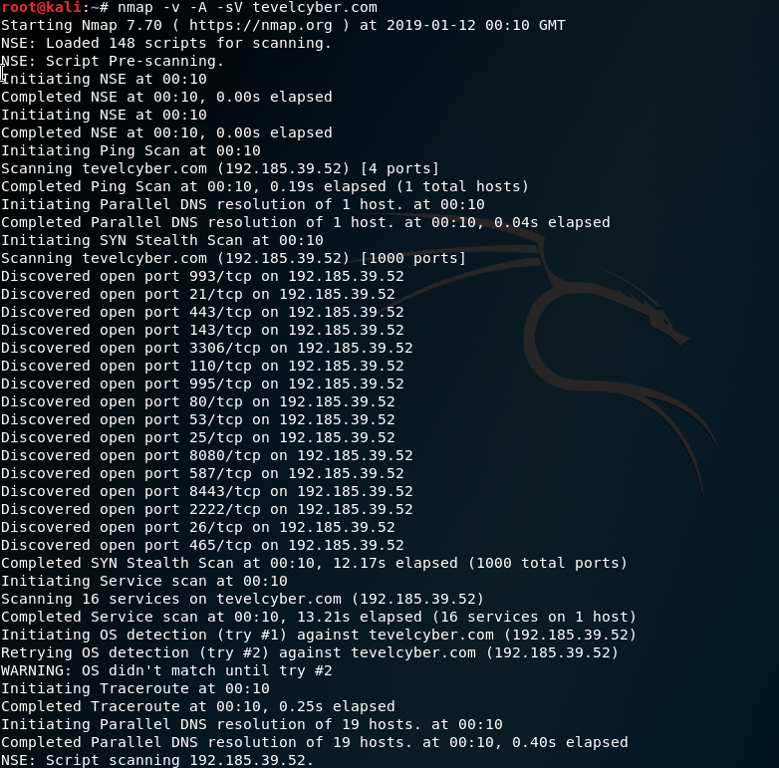
Figure 5 – The command used to initiate the scan

Figure 5 displays the command used in the root directory to begin the Nmap scan, there are 3 extra commands placed into the scan which defines the scope of the scan. -v sets the verbosity of the scan this means this allows the scan to print more information in real time during the scan[13]. -A enables for the scanning of operating systems found within the network[14]. The final command -sV probes the open ports to determine the services and security used[14].
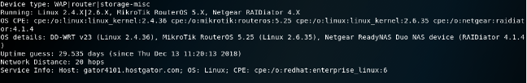
Figure 6 – Output of the Nmap Scan OS section

As can be seen in figure 6 the author has learnt numerous things about the target. The first being that it has discovered that the network is using a wireless access point running an unknown version of Linux at either 2.4.36, further research into the current Linux kernel release shows that 4.20 is the most current and most stable version[15], this means that the version running on the wireless access point is missing potential security updates to the kernel. After some research the author has found that numerous vulnerabilities exist that can result in many denial of service attacks, the total number of vulnerabilities within the version of the Linux kernel is roughly 50[16]. A denial of service attack works by disrupting the services and operation of a website or a network, this is most commonly done by constant requests for access to the site usually millions of times per day and thus reducing network bandwidth[17]. A good way to mitigate this attack is the implementation of a firewall with DOS protection services installed and enabled.
The scan also uncovered that the router the target is using is developed and sold by Mikrotik which is running a router OS developed by Mikrotik which is currently at 5.25 which is based on the Linux kernel version 2.6.35. Mikrotiks router OS version 5.25 was released in 2013 which is very out of date as the current version released in early 2019 is 6.42.11[18]. Research shows that this OS Version is susceptible to buffer overflow attacks[19]. The way a buffer overflow attacks work is by the attacker using malicious code to insert bytes of data or instructions into the program to gain access and control this is done by placing bytes of data into a variable that exceeds the storage limit of said variable and thus causing the data to overflow into the next field disrupting the pointer space[20]. Most commonly through the root shell which give admin privileges to the attacker[21].
The Nmap scan has also discovered that the target is using a Netgear ReadyNAS Duo running Netgear’s RAIDiator OS version 4.1.4 which is also out of date as the current version being rolled out by Netgear is 5.3. the author is unable to find any solid evidence of possible vulnerabilities with this out of date OS but some threads on online forums have reported a few.
The final OS that the Nmap scan discovered was the OS used on the HostGator servers. From the scan it can be seen that the OS running on the server is RedHat Enterprise Linux OS version 6 which was supported from 2010 to mid-2018 as the scan cannot give a more specific version number it can be hard to pin point any vulnerabilities so for this report we are going to assume that they are running the latest version of RedHat 6, but even with this hypothetical version number it is still out of date as current distros of RedHat Enterprise is version 7. Research into possible vulnerabilities show that there are numerous overflow, DOS and info vulnerabilities which have been fixed in the latest released distro of RedHat Enterprise 7[22]. Since the server with the RedHat vulnerability belongs to the hosting site, it is not the responsibility of Tevel cyber, though the author would recommend moving to a hosting site with more secure operating systems running on their servers.
Nmap was also able to scan the ports of the server the website is hosted on and discovered a total of 17 portz in use or active. Some ports had specific security assigned to them. Due to the large amount of data the author has developed a chart to simplify the information as seen in figure 7, full screenshots of the scan can be seen in the appendices
Port No. | Services | Active | Security
21 | FTP | Open | RSA-2048  SHA256
22 | SSH | Filtered | N/A
25 | SMTP | Open | Base 64
26 | SMTP | Open  No connection | N/A
53 | Domain | Open | N/A
80 | HTTP | Open | N/A
110 | POP3 | Open | RSA-2048  SHA256
143 | IMAP | Open | RSA-2048  SHA256
443 | SSL/HTTP | Open | RSA-2048  SHA256
465 | SSL/SMTP | Open | RSA-2048  SHA256
587 | SMTP | Open  No connection | N/A
993 | SSL/IMAP | Open | RSA-2048  SHA256
995 | SSL/POP3 | Open | RSA-2048  SHA256
2222 | SSH | Open | RSA
3306 | MYSQL | Open | N/A
8080 | HTTP | Open | MD5
8443 | SSL/HTTP | Open | RSA-2048  SHA256
Figure 7 – Simplified Graph detailing open ports and security measures (full scan output in the appendices)
In figure 7 the author has highlighted 2 specific ports that he believes would most likely be possible attack vectors by hackers. The first port the author has highlighted is port 25 which is used for the Simple Mail Transfer Protocol, this protocol is responsible for Mail Transfer Agents which deliver, receive and route email messages[23], so to a company this is very important. There are numerous vulnerabilities found with SMTP such as the debug command which allows hackers to issue commands in root or certain versions of SMTP having weakness to DOS or buffer overflow attacks. More common vulnerabilities with this port can be seen in a report by SANS Penetration testing[24]. The scan did detect that the port uses base64 encryption which make it hard for potential attackers to read any data that they might intercept[25].
The Second port the author has highlighted is port 53 this is used in domain name services or DNS, this service maps domain names to IP address and is almost always open on devices connected to the internet[26]. A possible attack that may occur on this port is called DNS spoofing, this attack is implemented by an attacker imitating the DNS server and sending false data to the network, this is effectively a man in the middle attack and can affect the overall function of the network’s capabilities[27]. The author recommends an audit of all ports to ensure that they are secure with stringent passwords and the appropriate protection protocols just in case.
  - Vulnerability Scanning
So far, the author has learned a lot about the network and numerous attack vectors possible for hackers to approach from. Now the author is going to focus on looking for 2 common attacks within the network that can occur and find out if the target is susceptible to said attacks. The first attack the author search for is Cross Site Scripting or XSS, this attack works by injecting malicious code into a webpage that uses HTML and effect the way it works, it can be used to steal private information such as login details and passwords from unsuspecting users. Most common XSS attacks involves the corruption or implementation of malicious links that the user clicks on and uses it to sign into a website[28]. To scan for this the author used Recon-NG which has a module to scan for this specific vulnerability as can be seen in figure 8
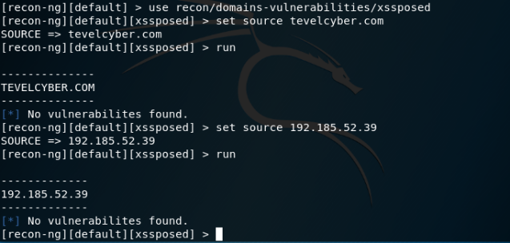
Figure 8 – Screenshot of Recon-NG scan
As can be seen in figure 8 the author activates the module within the scanner with the “use” command followed by the module name. He then set the destination, the author did this scan twice with both the URL and the IP address as destinations to make sure that there were no inconsistencies. With the final command being “run” this executed the scan and it returned that no XSS vulnerabilities were discovered on the site. This scan is contradicted by a scan done after this by the program called “Nitko”, from the results of the scan the author highlighted 3 main areas for concern.
The first being the use of Iloha Mail version 0.8.10 which has and XSS vulnerability as seen in figure 9. Iloha mail is a multilingual webmail service that runs off PHP[29], the vulnerability lays in the sending of email, which doesn’t prevent users from being sent emails or bookmarks that contains XSS scripts in links[30]. The scan also detected that the cookies are used without the HTTPONLY flags this prevents a client from accessing the scrip side of the cookies, this is often used in cross site scripting attacks. An attacker would uses the hole in security to steal the cookies information that it store on the users[31]. The author recommends enabling this feature.
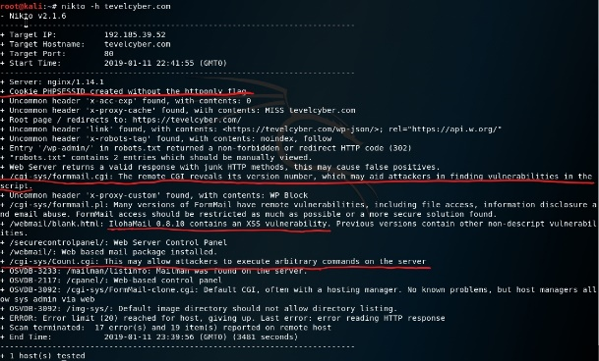
Figure 9 – Results of the Nitko scan
The scan also found 2 more possible vulnerabilities, but it doesn’t detail them enough for a comprehensive explanation., The first being the FormMail Script which possible allows attackers to see the version numbers of the script and an issue with another script that might allow attackers to execute possible commands into the web control panel. Due to how vague the scan was on these two vulnerabilities further testing and scanning must be conducted, and the author suggest a future investigation into these issues.
The second common attack that the author had scanned for is a SQL injection attack, this works by users inputting malicious entries into the web application and the information is then stored into an SQL server, dynamically creating a query that could make the data viewable by the attacker[32]. unfortunately, the SQL scanner found on Kali violates the rules of the test and thus cannot be use luckily the author found a web-based scanner which he had run on the site. The results of the scan can be seen below in figure 10.
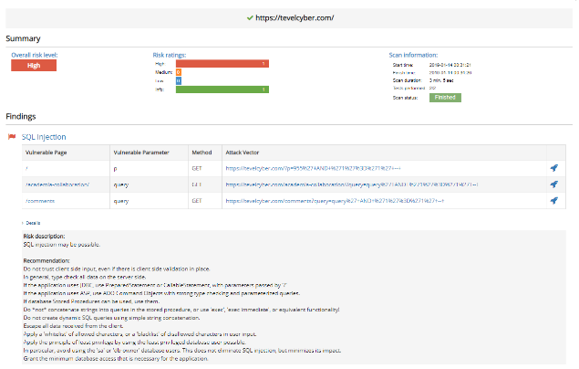
Figure 10 – Results of the SQL Injection Scan
As can be seen in figure 10 the author has discovered 3 vulnerable pages that can be targeted by an attacker using the GET method which uses the GET request to receive certain information. To prevent the possibility of the attack from taking place, the author suggests that Tevel cyber keeps an eye on any errors generated in user input. This would highlight any attempts by attackers to enter faulty data into their system. The author also suggests that the company go over the code that is used in the SQL server to make sure that dynamic inputs are properly protected[33].
  - Web Application scanning
The author also performed a scan on the WordPress plugins and themes as there are many known vulnerabilities, the scan was performed using WPScan a common tool found in Kali. To run the scan the author entered the URL of the target and the variable -e vp and – e vt these enumerate the vulnerable plugins and the vulnerable themes of the site as seen in figure 11.
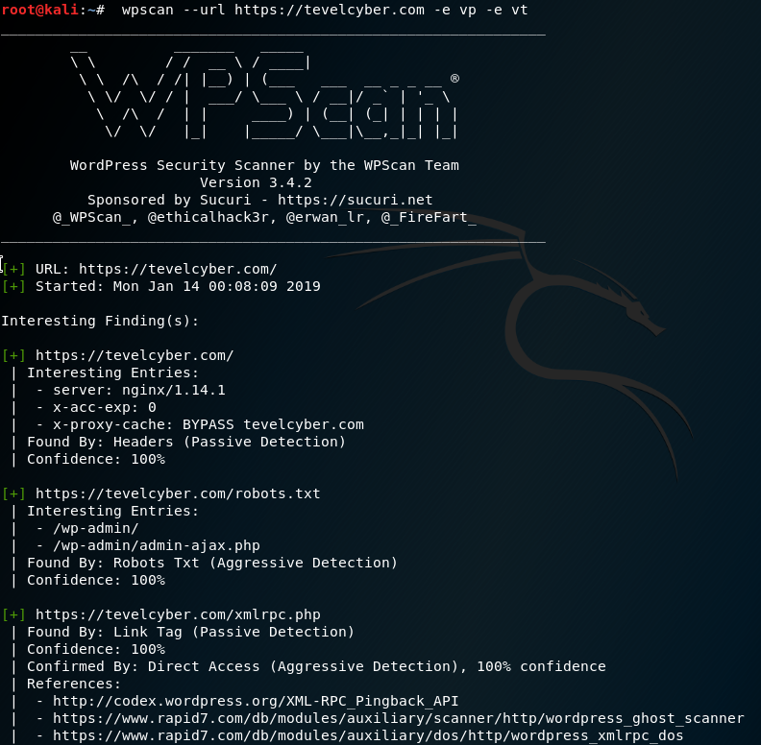
Figure 11 – screenshot of WPScan command
The Scan returned no vulnerabilities found within the themes, but it did find one possible vulnerability within a plugin called wordpress-seo. As can be seen in figure 12 it is out of date and thus could be used to attack the site. The output shows that the plugins is currently running 7.8 and the latest version is 9.4. it also shows that a security issue was fixed in 9.2 which is why the author recommends an update to this latest version.
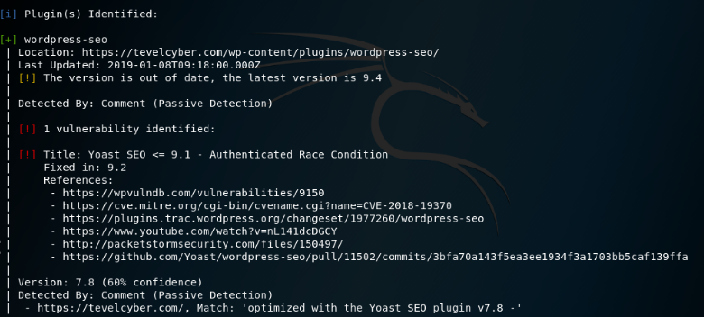
Figure 12 – Wordpress-seo vulnerability
The author performed plenty of scans and gained a lot of information about the security of the site. Of course, the outputs of all the scans cannot be displayed in the main text but are available in the appendices.
- Recommendations
Throughout the report the author has noticed that there is some room for improvement within the network, these recommendations would be beneficial and very cost efficient for the company and most are update or patches. The recommendations are as follows:
- Audit ports to ensure appropriate security is enabled.
- Update the following software:
  - WordPress -seo plugin from 7.8 to 9.4.
  - Update WAP Linux from 2.4.36 to 4.20.
  - Update Mikrotik router from 5.25 to 6.42.11.
  - Update ReadyNAS Duo RAIDiator OS from 4.1.4 to 5.3.
  - Move to a different hosting site or request that HostGator updates RedHat Enterprise from 6 to 7.
  - Use a different mail service than Iloha mail as it is insecure.
  - Update form Mail.
- Install a firewall that has DOS controls and prevention systems.
- The author also recommends that Tevel cyber move the site to a server within the company instead of a hosting site.
- Change the SQL server making it harder to allows SQL Injection using the GET method.
- Enable HTTPONLY to prevent cookie theft and possible XSS exploitation.
These recommendations should be fairly cost effective as the hardware seems decent and most of these updates are free.
WordPress should be updated in line with the plan in which the company pays to WordPress. To update RedHat the cost should be 349USD but that is the responsibility of HostGator. As the author could not gain information on a firewall it would be pointless for him to suggest an upgrade, but if they do not have one in place then the author recommends cisco based ASAs as they are reliable and are the industry standard, even though the price might be considered excessive as they are in the range of £300-£400. Overall the improvements should cost no more than roughly £1000, most of the updates can be done in house by the security professionals in the company along with the SQL code to prevent injection attacks

- Conclusion
Throughout this report the author has outlined the need for security and penetration testing, he also developed a plan and strategy of attack that follows the guidelines set by Tevel cyber. The author conducted numerous scans from basic recon scan to more advanced and specialised scans that focus on areas such as WordPress scanning. The author highlighted numerous vulnerabilities found within the network with possible attack vectors and the attacks that could take place, the site in the authors opinion is relatively secure and only requires updates to software and plugins that the site is using. The author also made a recommendation to move the website host from HostGator to a private server with in the company this allows for more control over the security of the site. The overall cost of the improvements should cost no more than £1000 which is relatively cheap. Due to the restrictions of the test, the author might have missed a few vulnerabilities that other testers might have picked up, so the results and recommendations can be improved upon with more research and more testing on the site. The author would have liked to test the reliability of the scan by attacking the site but the restrictions made this unlikely and improbable that he could attack without violating the rules and regulations set by Tevel cyber corps.

[1] “World Internet Users Statistics and 2018 World Population Stats.” [Online]. Available: https://www.internetworldstats.com/stats.htm. [Accessed: 10-Nov-2018].
[2] “Iranian military hacker fingered for ‘Game of p0wns’ HBO leak • The Register.” [Online]. Available: https://www.theregister.co.uk/2017/11/22/department_of_justice_names_behzad_mesri_as_hbo_hacker/. [Accessed: 24-Jan-2019].
[3] R. Gaddam, “An Analysis of Various Snort Based Techniques to Detect and Prevent Intrusions in Networks,” no. Icicct, pp. 10–15, 2017.
[4] “Chapter 15. Nmap Reference Guide | Nmap Network Scanning.” [Online]. Available: https://nmap.org/book/man.html#man-description. [Accessed: 21-Jan-2019].
[5] R. R. Rohrmann, “Large Scale Anonymous Port Scanning.”
[6] “DMitry | Penetration Testing Tools.” [Online]. Available: https://tools.kali.org/information-gathering/dmitry. [Accessed: 21-Jan-2019].
[7] “Nikto | Penetration Testing Tools.” [Online]. Available: https://tools.kali.org/information-gathering/nikto. [Accessed: 21-Jan-2019].
[8] “Recon-ng | Penetration Testing Tools.” [Online]. Available: https://tools.kali.org/information-gathering/recon-ng. [Accessed: 21-Jan-2019].
[9] J. Cabot, “Word press: A content management system to democratize publishing,” IEEE Softw., vol. 35, no. 3, pp. 89–92, 2018.
[10] “Web Application File Upload Vulnerabilities.”
[11] “www.tevelcyber.com - Robtex.” [Online]. Available: https://www.robtex.com/dns-lookup/www.tevelcyber.com. [Accessed: 23-Jan-2019].
[12] “Online Penetration Testing and Ethical Hacking Tools.” [Online]. Available: https://pentest-tools.com/home. [Accessed: 23-Jan-2019].
[13] “Output Options | Nmap Network Scanning.” [Online]. Available: https://nmap.org/book/nping-man-output-options.html. [Accessed: 23-Jan-2019].
[14] “Options Summary | Nmap Network Scanning.” [Online]. Available: https://nmap.org/book/man-briefoptions.html. [Accessed: 23-Jan-2019].
[15] “The Linux Kernel Archives.” [Online]. Available: https://www.kernel.org/. [Accessed: 23-Jan-2019].
[16] “Linux Linux Kernel version 2.4.36 : Security vulnerabilities.” [Online]. Available: https://www.cvedetails.com/vulnerability-list/vendor_id-33/product_id-47/version_id-123091/Linux-Linux-Kernel-2.4.36.html. [Accessed: 23-Jan-2019].
[17] UK National Computer Emergency Response Team, “Denial of service attacks : what you need to know,” CERT-UK Website, 2015.
[18] Mikrotik, “Mikrotik RouterOS version Archives.”
[19] “MikroTik RouterOS CVE-2018-7445 Buffer Overflow Vulnerability.” [Online]. Available: https://www.securityfocus.com/bid/103427. [Accessed: 23-Jan-2019].
[20] S. K. Pandey, K. Mustafa, and S. I. Ahson, “A checklist based approach for the mitigation of buffer overflow attacks,” 2007 3rd Int. Conf. Wirel. Commun. Sens. Networks, WCSN, pp. 115–117, 2007.
[21] T. Tsai and N. Singh, “Libsafe: Transparent system-wide protection against buffer overflow attacks,” Proc. 2002 Int. Conf. Dependable Syst. Networks, p. 541, 2002.
[22] “Redhat Enterprise Linux version 6 : Security vulnerabilities.” [Online]. Available: https://www.cvedetails.com/vulnerability-list/vendor_id-25/product_id-78/version_id-87783/Redhat-Enterprise-Linux-6.html. [Accessed: 24-Jan-2019].
[23] S. Alarcon, “Global Information Assurance Certification Paper GCIH Practical Assignment-Version 2.1a Option 2-Support for the Cyber Defense Initiative GIAC Certified 4277 Port 25 (SMTP)-Remote Sendmail Header Processing Vulnerability: Exploiting the Internet’s Second Most Popular Pasttime,” 2003.
[24] “SMTP – Always a victim of a good time,” 2003.
[25] “Base64 Can Get You Pwned.”
[26] “GRC | Port Authority, for Internet Port 53.” [Online]. Available: https://www.grc.com/port_53.htm. [Accessed: 23-Jan-2019].
[27] F. Carli, “SANS GSEC Practical Assignment Version 1.4b Option 1-Research on Topics in Information Security,” 2003.
[28] A. Shrivastava, S. Choudhary, and A. Kumar, “XSS vulnerability assessment and prevention in web application,” Proc. 2016 2nd Int. Conf. Next Gener. Comput. Technol. NGCT 2016, no. October, pp. 850–853, 2017.
[29] “IlohaMail.” [Online]. Available: https://ilohamail.org/. [Accessed: 24-Jan-2019].
[30] “IlohaMail Webmail - Persistent Cross-Site Scripting.” [Online]. Available: https://www.exploit-db.com/exploits/20627. [Accessed: 24-Jan-2019].
[31] “HttpOnly - OWASP.” [Online]. Available: https://www.owasp.org/index.php/HttpOnly. [Accessed: 24-Jan-2019].
[32] “SQL Injection.”
[33] Y. Fouad and K. Elshazly, “Detection and Prevention of SQL Injection Attacks on Web Applications,” 2013.

Appendices
WordPress Login Page
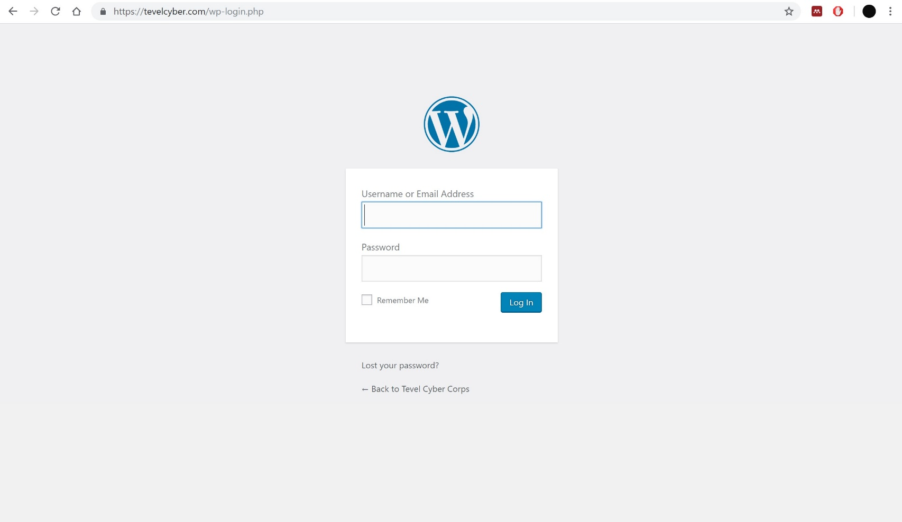

Dmitry Scan

Dmitry Output
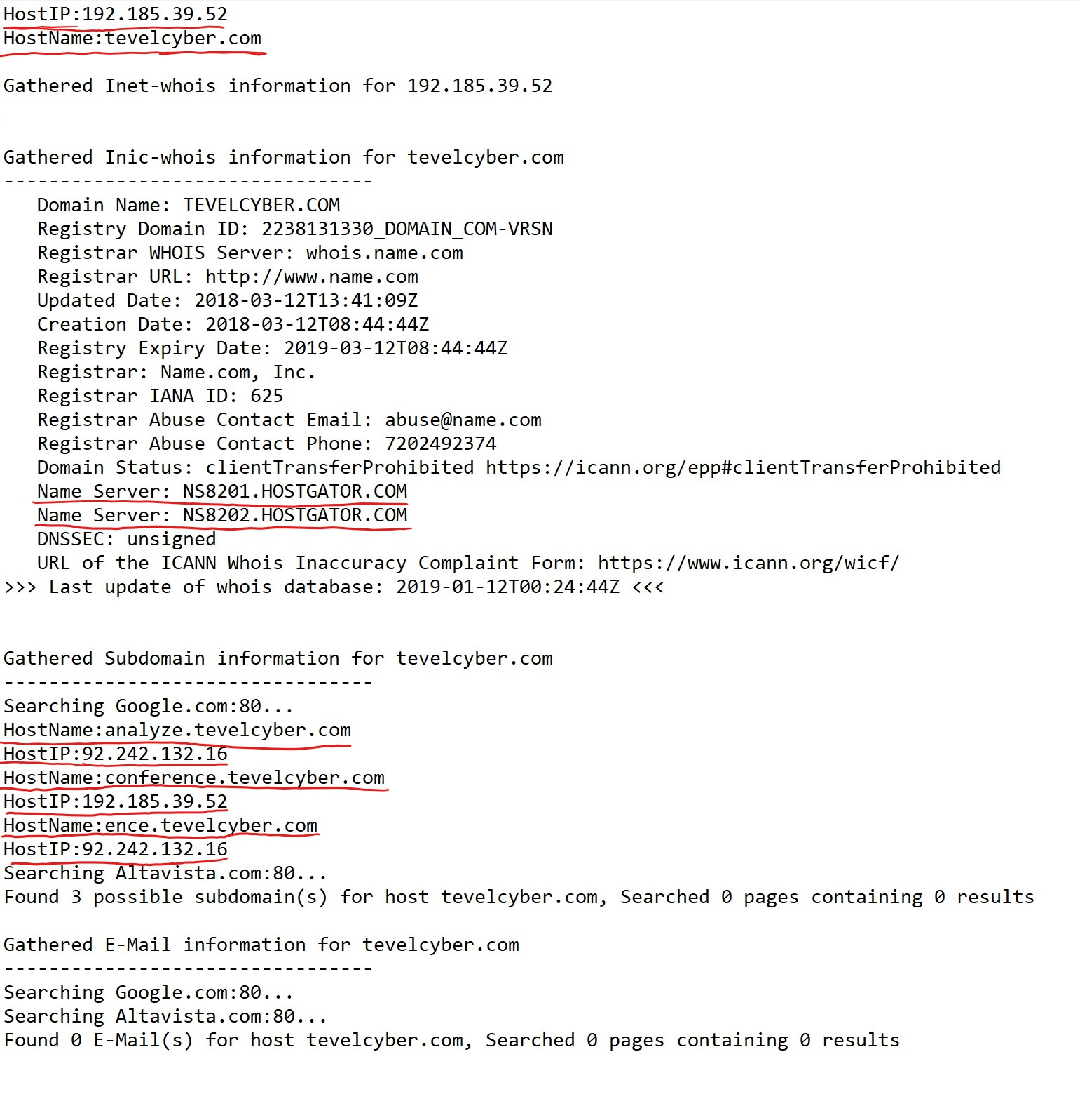

Robtex Scans
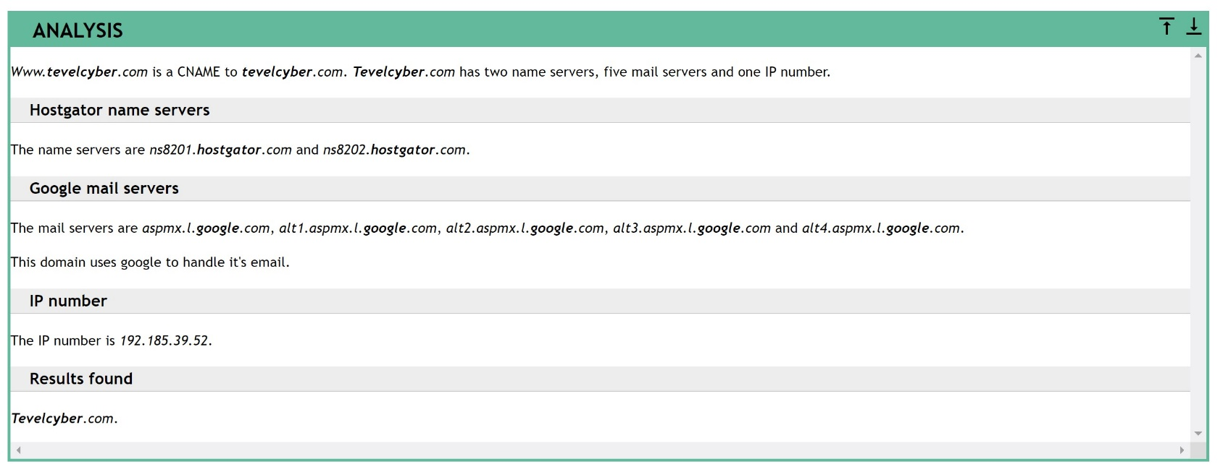

Nmap scans
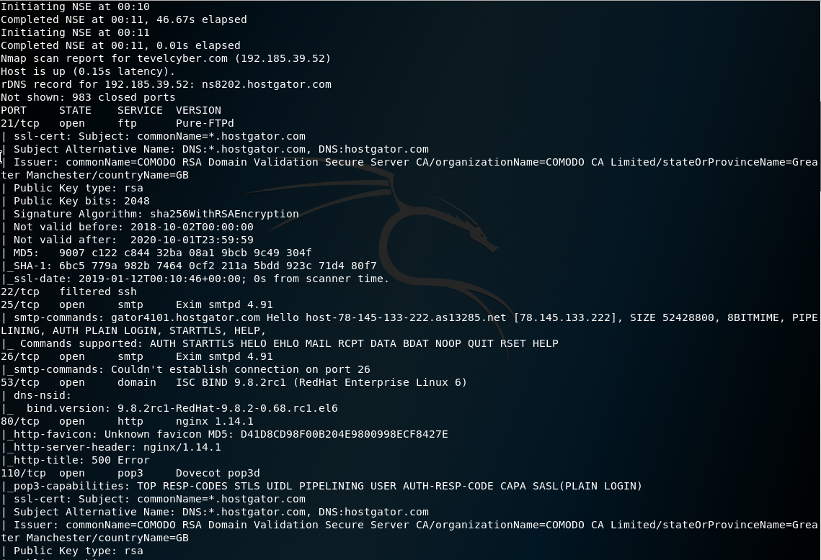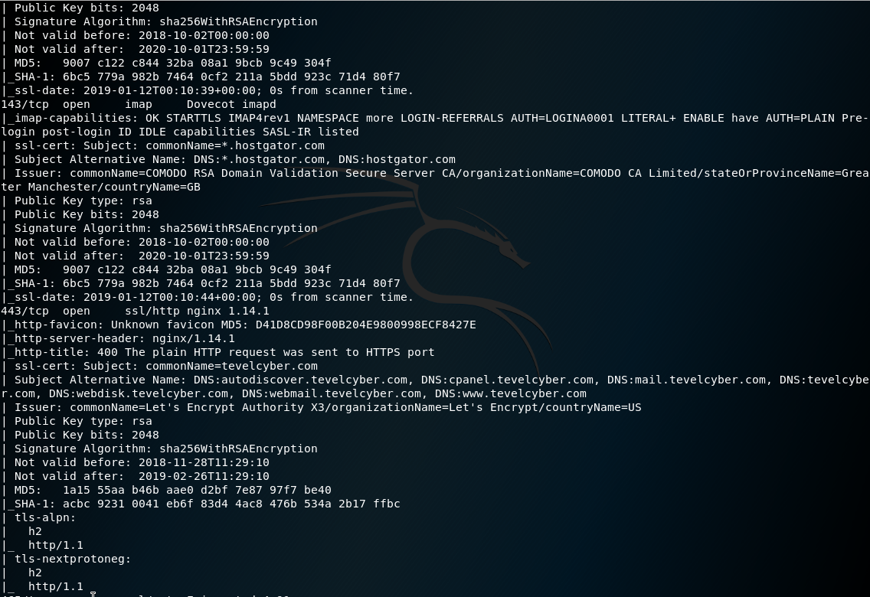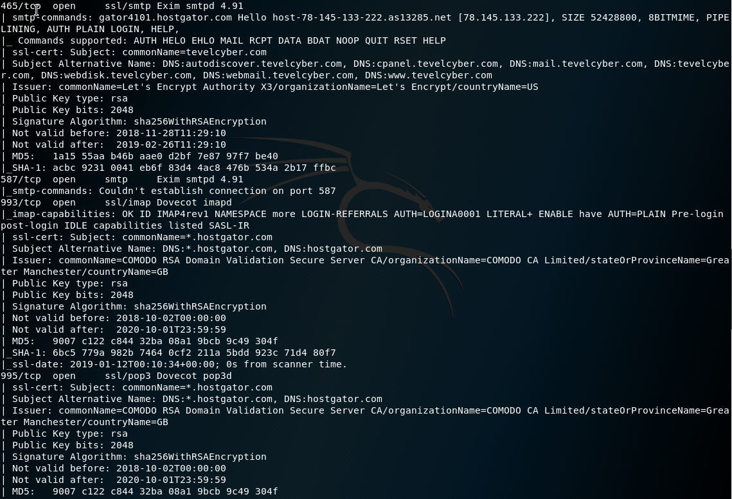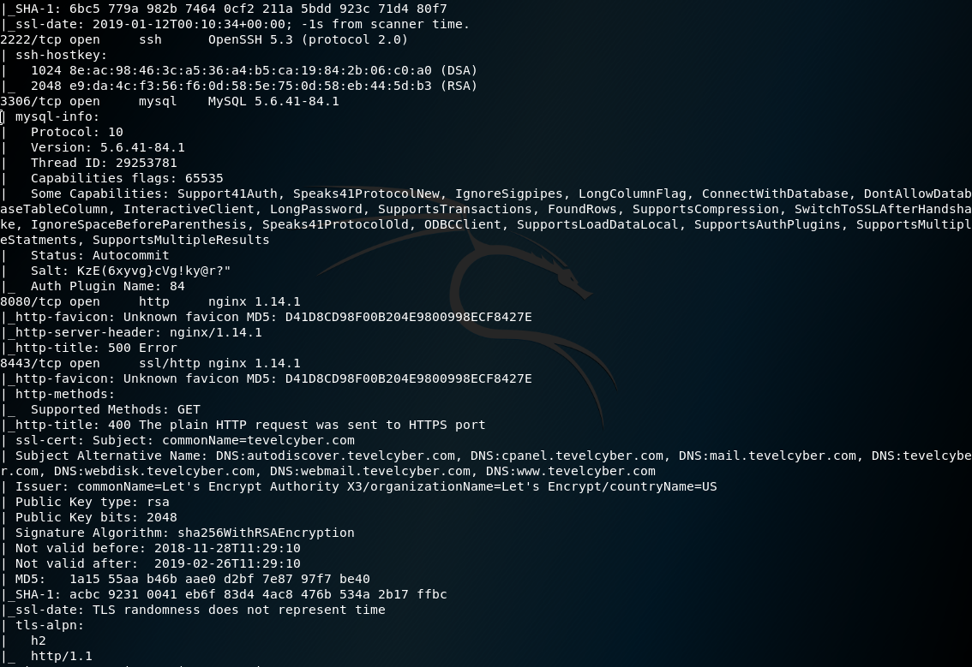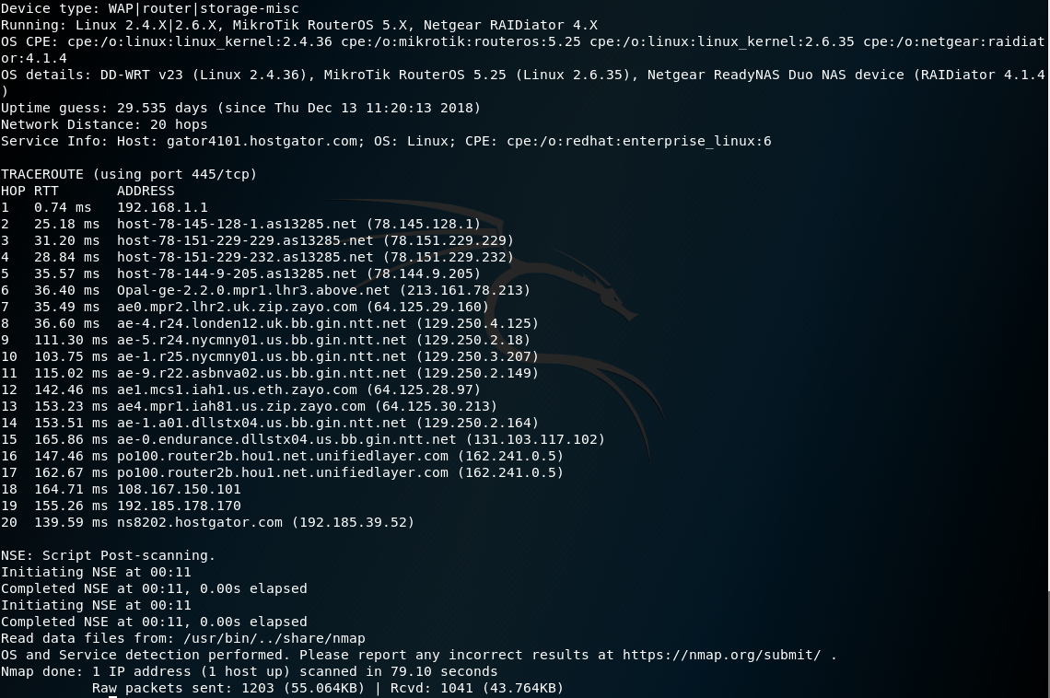

Recon-NG scans
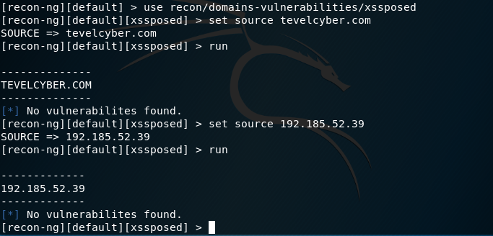

Nitko Scans
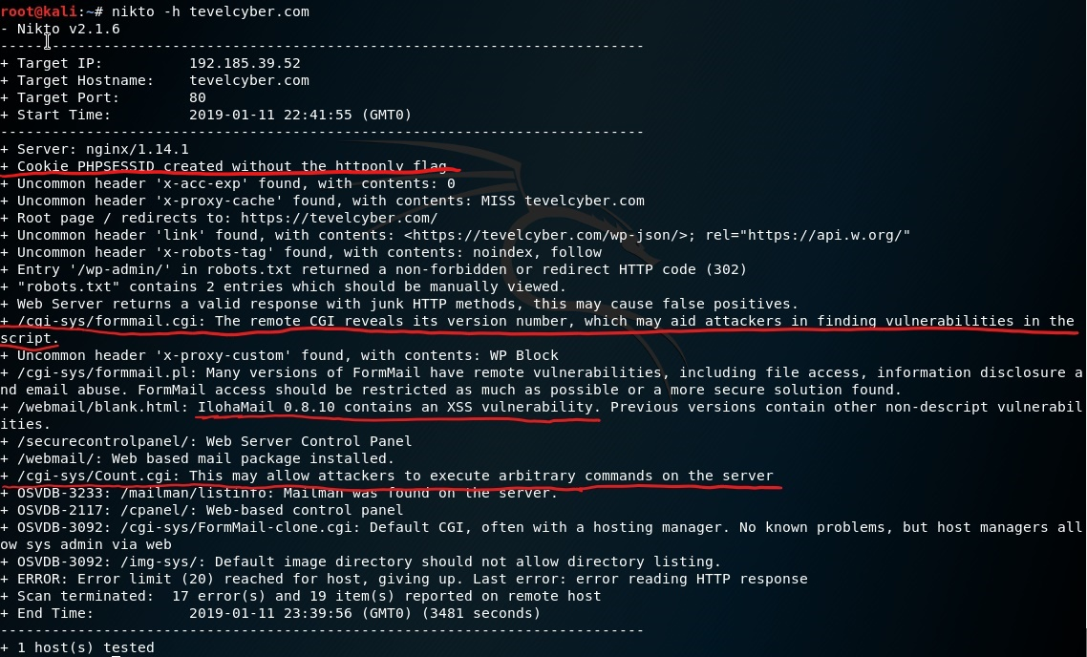

XSS Scan
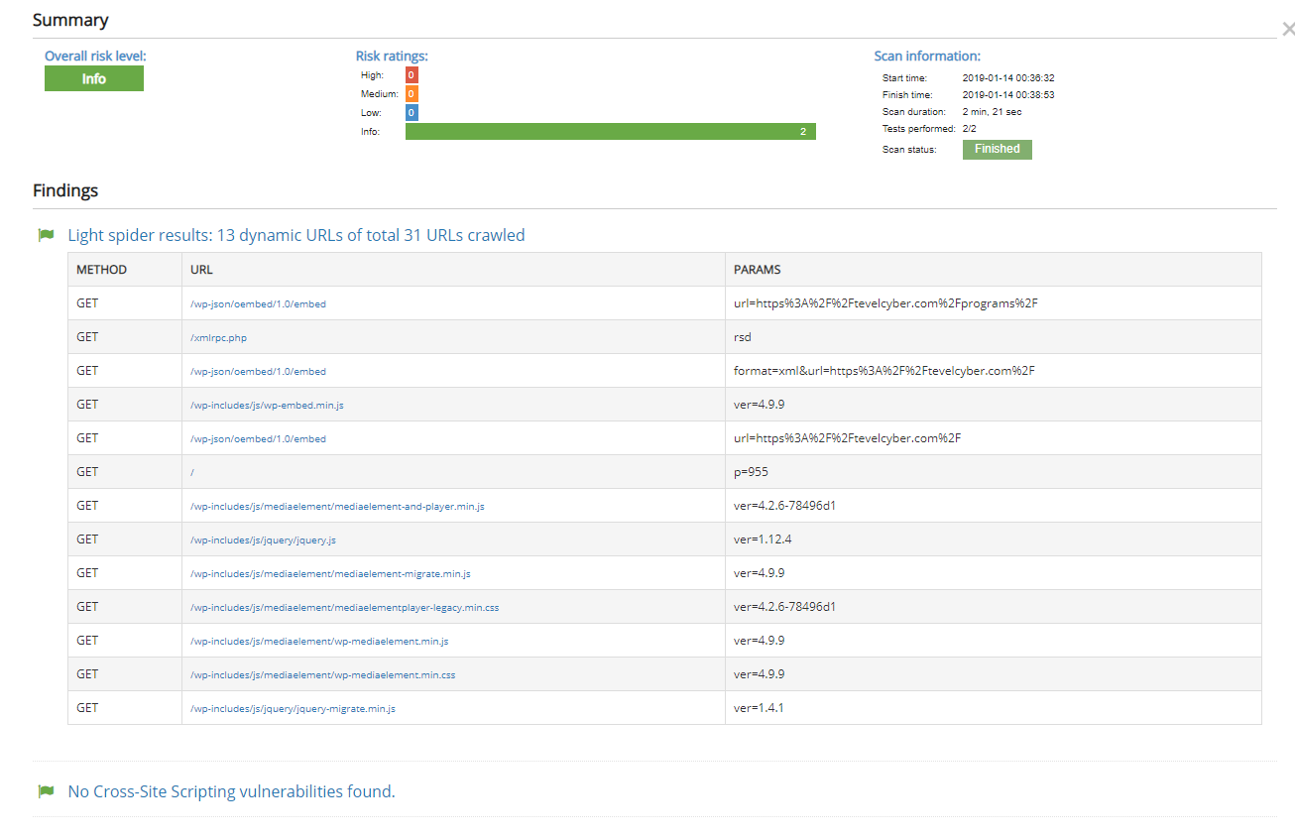

WPScan


