

NETWORK OPERATING

AND SECURITY
REPORT SNOWDENIAPOLICY .

DATA SECURITY AND PROTECTION

Modou Pene 1810381

University of Wales Trinity Saint David

Indice

Introduction 1
Security 2
CIA Model… 3
Data confidentiality 3.1
Data integrity 3.2
Data availability 3.3
Man in the middle (MITM) 4
Prevent man-in-the-middle attacks 4.1
Security policies 5
Governance, Risk and Compliance 5.1
Conclusion 6
References 7

1.Introduction
Cybersecurity is a very serious problem in the technical-computer field due to the increasing computerization of society, public and private services in terms of computer systems and equipment and systems and the parallel dissemination and specialization of attackers or hackers. Interest in the security of computer systems has therefore grown in recent years, in proportion to their spread and their role in the community. Achieving availability depends on several factors that interfere between the user and the system, such as: robustness of basic and application software, reliability of the equipment and the environments in which they are located.
The computer system must be able to prevent direct or indirect alteration of information, either by unauthorized users or by accidental events; It must also prevent abusive access to data. In general, it is not a good idea to assume that countermeasures in a system are sufficient to prevent any attack. Protection from cyber- attacks is achieved by acting on several levels: firstly at the physical and material level, placing the servers in places as secure as possible, equipped with surveillance and access control.
Although this is part of normal security and not of cybersecurity, it is always appropriate to point out that often adopting the most sophisticated techniques generates a false sense of security that can lead to neglect of the simple ones. The second layer is normally the logical level that involves authenticating and authorizing an entity that represents the user in the system. After the authentication process, the user's operations are tracked in log files.

2.Security
Cybersecurity refers to that branch of computing that deals with the analysis of vulnerabilities, risk, threats or attacks, and therefore the protection of the physical availability and confidentiality integrity (hardware) and logical-functional (software) of a computer system and the data contained or exchanged in it in a communication with a user. This protection is achieved through technical-organizational and functional measures to ensure:

- data correctness (integrity);
- confidentiality of data(encryption).

- physical and/or logical access only to authorized users(authentication).
- all and only the services provided for that user in the time and manner provided by the system(availability).
- protect your system from malicious software attacks to ensure previous requirements.

Confidentiality, Integrity and Availability for the Council's information

When it comes to the protection and security of cyber data, there are three fundamental principles to focus on, in the name of proper management: confidentiality, integrity and availability. These principles must be sought in any security solution, taking into account the implications of vulnerabilities and risks.
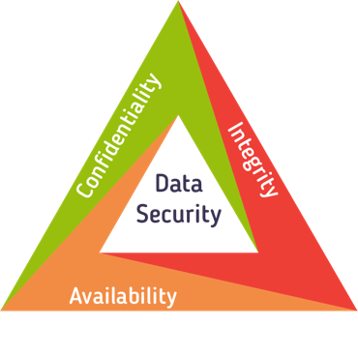

Data Confidentiality
A cyber privacy strategy must first offer confidentiality, which is to ensure that data and resources are preserved from possible use or access by unauthorized individuals. Confidentiality must be ensured throughout all stages of the data's life, starting with its storage, during its use or its transit along a connection network.
The causes of breach of confidentiality can be attributable to a malicious attack or human error. Attack modes can be multiple, such as switching from password embezzlement, data interception on a network, or social engineering actions to name a few. Errors of people who compromise the confidentiality of information include mis-using authentication tools and rules and free access to unauthorized third-party devices.
Protecting the confidentiality of a computer system
There are a number of tools that can be used to ensure the confidentiality of information: the encryption of communications, authentication procedures, the creation of well-defined data governance models and user awareness actions.

Data integrity
Another element behind the concept of cybersecurity concerns integrity, or rather the ability to maintain the veracity of data and resources and ensure that they are not in any way modified or deleted, except by authorized entities. Talking about integrity means taking into account different scenarios: preventing unauthorized changes to information by users, but also ensuring that the information itself is uniquely identifiable and verifiable in all contexts in which it is used.
Authentication policies and health threats
To ensure integrity, you need to put in place clear authentication policies and constantly monitor the actual access and usage of resources, with tools that can create audit logs. Access control (e.g. through Identity & Access Management systems), authentication procedures, Intrusion Detection systems, access restrictions, and, once again, user training are useful solutions to comply with this principle.
Data integrity breaches can occur at different levels, from the user to the administrators, and may be related to a non-compliant use of defined policies or an improperly designed security system; there are also vulnerabilities inherent in the code itself that expose applications and resources to potential fraudulent uses, putting the integrity of the information at risk.

Data availability
Finally, availability refers to the possibility, for authorized parties, of being able to access the resources they need for a set time and uninterrupted. Making a service available essentially means two things: preventing outages during the defined time frame and ensuring that infrastructure resources are ready for the proper delivery of what is required. Mechanisms must therefore be put in place to maintain defined service levels, using Disaster Recovery, Back Up and Business Continuity tools, which can limit the effects of possible service unavailability or data loss.
Data protection and security techniques and technologies Threats that jeopardize the availability of a service can include software failures, device breakdowns, environmental factors, and catastrophic events that put infrastructure offside, such as power outages, floods, earthquakes. There are also malicious actions specifically aimed at making services unattainable: denial of

service/DDos (DoS/DDos) attacks or communication interruptions. In addition to the reasons for arson, there are other reasons for an availability violation, such as overuse of hardware and software or accidental data removal.
The countermeasures that can be put in place in this case relate, for example, to the design of network infrastructures that guarantee the redundancy of the systems and to offer the services required even in the event of a failure or accident, firewall systems that can protect internal networks and continuous monitoring systems of traffic. Business Continuity policies also provide solutions that limit possible attack points.

The concepts of confidentiality, integrity, and availability are closely related to each other, and the design of a data security management system requires them to be taken into account in a unified manner.

Man in the middle (MITM)

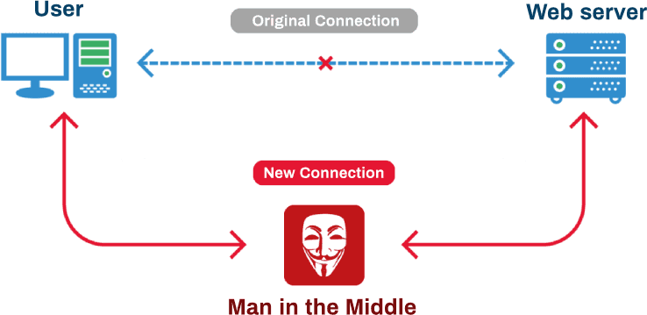
Man-in-the-middle is a cyber threat that allows the malicious cyber to intercept and manipulate internet traffic that the user believes is private. More specifically, in the case of a man-in-the-middle attack, the attacker literally gets in the middle between two entities that are trying to communicate with each other: a client the victim and the server or router. This not only intercepts sent and received messages. But, if you want, you can also modify them or pretend to be either party. In the offline world, we can imagine him as someone who puts fake invoices in our mailbox and then tries to collect their payment.

Man in the middle attackmodel:
- ARP poisoning/ARP spoofing– Is a network protocol that is used to provide a mapping between the internal IP address of the LAN and the hardware address (MAC address). In order

for a computer to send data packets within a network, it must know the MAC address of the recipient's system, which is why an ARP request is sent as a MAC message to all systems in the LAN that contains the MAC address and IP of the requesting computer as well as the IP of the system being searched. This combination of local MAC and IP addresses is saved as a table in the so-called ARP cache of the computer that requires it. This is where ARP poisoning takes place. The purpose of this type of attack is to manipulate the ARP tables of different computers in the network through false ARP responses, for example to pass a computer that is under the control of the criminal as a Wi-Fi access point or a gateway to the Internet.

- Password Cracking: A brute force attack tries to guess the password of an online or remote account by trying as many character combinations as possible. Crackers typically use brute force software such as John the Ripper, Hydra, and Hashcat, which try different username and password combinations until they can access the system.

- Wifi hacking: Spying on Wi-Fi networks is a huge problem. To conduct a man-in-the-middle attack via Wi-Fi, hackers typically exploit a fake network, or a technique called The Evil Twin, it's when a public Wi-Fi network is configured by hackers to simulate a legitimate network previously used by the unfortunate victim. If you have such a network, devices can be induced to connect automatically, as they are often designed to make our lives easier, so we don't have to enter our password every time we sign in.

Prevent man-in-the-middle attacks

MITM attacks are very difficult to detect, so you need to focus on prevention. Here are some of our tips for reducing risk and defending against man-in-the-middle attacks:
    - Intrusion Prevention (IPS), all the power of deep-packet inspection to ensure you control and prevail over internal and external threats.

    - Hotspot offers an integrated, customizable and secure Internet access service for employees, guests and customers.
    - Quality of Service (QoS), control and manage available bandwidth usage by prioritizing critical services such as VoIP, web, email, and more.

    - VPN and IPsec give your employees secure remote access to resources by connecting branch offices and tele-workers through the easiest and most secure VPN technology on the market.
•
    - Multi-WAN, increase network reliability and make bandwidth efficient by using multiple options for connecting to the Internet, including support for 3G/4G modems.

Security policies

A number of regulations and regulations have been defined in the context of information security that require organizations and information system security managers to adopt policies, procedures and controls to ensure that they have prepared appropriate countermeasures to protect the confidentiality, integrity and availability of information. Compliance with regulations and regulations is a very important aspect of cybersecurity.
Some information security regulations:
ISO/IEC 27001: Defines the requirements for an INFORMATION Security Management System (ISMS), includes logical, physical, and organizational security aspects.
GDPR- General Data Protection Regulation, EU Regulation 2016/679 in personal data processing and private data handling.

Like all ISO standards, it defines guidelines for building a system.

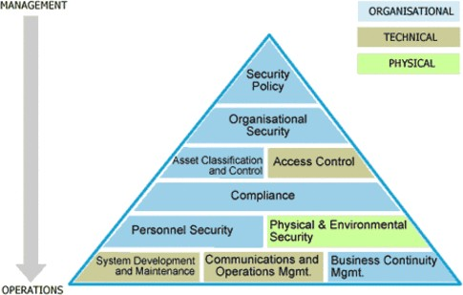
SGSI: Information Security Management System consists of policies, procedures, documents, registrations and also support tools and computer type systems.

GRC – Governance, Risk and Compliance
The security of the information system must be governed through processes, regulations, policies, external regulations and checks carried out continuously on the entire perimeter of the company's information system. In particular, since an absolute level of security can never be achieved (cybersecurity is in fact a process of continuous improvement), it is essential to measure the risk indices to which The Corporate Snowdenia County Council is subjected, compared to the vulnerabilities and threats that insist on the information system. These risks must be identified and measured and then defined risk mitigation plans, which lead to them being cancelled, transferred to others or reduced below acceptable thresholds.
The information system consists of assets (computers, data stores, services, etc.)
Assets have vulnerabilities that, if exploited, can cause harm to the business
Threats are a subject's ability to exploit (knowingly or not) vulnerabilities
Risks are a measure of the impact of a threat on a given asset Internal regulations and regulations suggest guidelines to reduce vulnerabilities or mitigate risks; a compliance management process, through a set of controls, verifies the compliance of the configuration of systems or business processes to current regulations (e.g. GDPR) and company regulations. GRC systems support business organization in security governance, risk analysis and risk management and compliance management

Conclusion

We can then think of the domain of Information Security, Data Protection and Privacy as three concentric circles, with the broader perspective that Information Security incorporates data protection and privacy. The latter two, while sharing the data, have different perspectives: the first is concerned with the protection of individuals, while the second is more focused on the protection of information of individuals. It is therefore clear why the indifferent use of the terms Information Security, Data Protection and Privacy is incorrect and approximate.

7.References

1-Chou-Chen Yang, Kuan-Hao Chu and Ya-Wen Yang, " Interworking Security: Current Status and Key Issues", International Journal of Network System Security, vol. 2, no. 1, pp. 1-13, Jan. 2006.
2-G. Adomavicius and Y. Kwon, "Multi-Criteria Recommender Systems," Recommender Systems Handbook: A Complete Guide for Research Scientists and Practitioners, Springer, 2010

3-G.-J. Ahn, M. Ko, and M. Shehab, "Privacy- Enhanced User-Centric Identity Management," Proc. IEEE Int'l Conf. Comm. (ICC), pp. 1-5, 2009
4-Zhe Chen, Shize Guo, Kangfeng Zheng and Yixian Yang., Modeling of Man-in-the-Middle Attack , The 3rd International Conference on Wireless Communications, Networking and Mobile Computing (WiCOM 2007), Proceedings-Vol.1, pp.2255-2258, IEEE, Sep. 2007.

5-E. Bertino, "Data security and privacy: Concepts approaches and research directions", COMPSAC 2016 Proceedings.

