Aaron Bowditch
2012801

BEng Electrical and Electronic Engineering

Applied Programmable Logic Controllers

ACDA6000

17/12/2022

Abstract
For this assignment the goal was to design and program a PLC operated factory simulation using factory IO and the TIA portal to program a virtual Siemens S7-1200 to sort a range of four packages by size and weight. There were are number of limitations set for the factory, such as safety guidelines for start-up and a suitable alarm system. These controls and parameters were all then transferred to a virtual HMI.
Introduction

PLC stands for programmable logic controller, a PLC has the ability to control a number of outputs dependant on the state of the inputs. PLCs were implemented to increase productivity in the manufacturing industry as they have the ability to carry out jobs at a much quicker rate then a human operator, they can also be used to control more complex processes and production lines which may involve multiple operators. A PLC system typically consists of a range of sensors connected to either analogue or digital inputs, then a variety of output components, such as pistons, fans & conveyors connected to output. The program within the PLC is used operate these output components depending on the input, acting at much quicker speed and accuracy, with a small margin of error than a human operator could.

Research
There are four main types of PLCs;

Unitary PLC -
A unitary PLC is a simple type of programmable logic controller, and contains all of the basic system components within a single housing, or box. The components typically include the processor, which runs the software program, in addition to ports for input and output connections. Unitary PLCs are commonly attached directly to the device or application that is being controlled.
The Unitary PLC is typically the smallest and least expensive. It would be used in a small machine or fixed application such as overhead door controls or a stand-alone parts inspection system. The unitary PLC is not expandable so the application is limited to the on-board inputs and outputs available when purchased.
Brick type -
A brick type PLC consists of a block shaped case with the strips of terminal on it. They can be DIN rail mounted or panel but come in a set of I/O capabilities.
Brick type PLCs are mostly used in harsh environments and have a limited input ouput capability. These extremes can include;
- Dusty
- Humid
- Extreme heat
- Extreme cold
The brick type PLCs ability to operate efficiently in these environments make them very useful for areas such as steel works or factories which manufacture chemical products.
Modular PLC -
A modular PLC can contain several different modules that can be connected together to build a customized controller. a typical base module contains core functions such as electrical power regulation, the computer processor, and input / output connections. Additional modules can be added to a modular PLC if needed, these include analogue to digital signal converters or additional outputs. This modular design allows for the PLC to be modified and changed easily to suit different applications.
The Modular PLCs start with a processor which has a limited number of inputs and outputs. They are typically mount on a DIN rail and sometimes require a separate power supply, additional inputs and outputs as well as specialty modules, such as convertors, also mount onto the DIN rail and plug into the processor. Modular PLCs are used in applications where a large number of inputs or outputs are needed, or when using specialty modules such as quadrature encoders. Modular PLCs are also useful in small applications that have options or upgrades available to the end user.
Rack mounted PLC -
A rack mounted type PLC is very similar to a modular PLC but it is implemented differently, whereas each module in a modular PLC connects to the base unit directly, a rack mounting PLC keeps each module separate. All extra modules in a rack mounted PLC are connected through a network, and modules are held in organized racks, this allows for larger control systems to be built without causing the original PLC to become overcomplicated. The commercial unit SLC 500 is an industry-standard example of the rack mounting PLC type. There are no limits on the number of modules that can be added to this system, which allows this setup to produce large, automation solutions to be built and is most commonly used in factory settings. Rack style PLCs are more expensive, expandable, and powerful than unitary or modular PLCs. The rack provides a power and communication backplane which allows for the communication rate between the processor and the modules to be much quicker than that of another type of PLC, as well as allowing some specialty modules to communicate with each other without the processor.

Practical applications
When selecting a PLC practical application and also future application needs to be taken into account before purchasing as there are different PLCs which are designed for different needs.
Brick type PLCs are most suited for harsh environments where the processes involved aren’t too complex, an example of an application of a brick type PLC would be in the steel works, the PLC could be used on a production line to move materials from one process to another.
Modular type PLCs are most suited for neutral environments, such as a food processing company, one modular type PLC can be used from start to finish to control every process within a factory, with multiple processes involved they require a large amount of memory to store the complex programmes.
Examples;

Siemens -
Siemens is the most commonly known manufacturer of PLCs and has a wide range used in industry, the two chosen to compare are the S7-300 & S7-1200.

The S7-300 is one of the most commonly used on the market as it is space saving and has a wide range of expansion modules making it fit for most purposes, advantages and disadvantages can be seen in table.1

The S7-1200 is more suited for operations which require extended communication options and is the most suited choice for large automation, this is the one selected and used for the factory simulation. The advantages and disadvantages of the
S7-1200 Can be seen in table.2

Allan Bradley –
Allen Bradley PLCs are also one of the most common used in industry. Then SLC 500 is a family of PLCs, and peripheral devices which has a wide range of communication configurations. Unlike the Siemens PLCs the SLC 500 used the RSLogix 500 package to program. The SC 500 will the discontinued at the end on 2022. Advantages and disadvantages of this PLC can be seen in table.3

MicroLogix 1400 controller is a cheaper, smaller PLC more suited for smaller processes such as printing and small material handling. Advantages and disadvantages of this controller can be seen in table.4

S7-300
Advantages | Disadvantages
User friendly | expensive
Easy expansion | Limited to eight expansion modules
Range of integrated functions
Table.1 - S7-300

S7-1200
Advantages | Disadvantages
Cheaper than other PLCs | Limited to eight modules
Multiple communication methods – profinet or profibus or analogue/digital | Previous programs for older models cannot be used in most cases
Multiple hardware options | Slow processing speed
Table.2 – S7-1200

SLC 500

Advantages | Disadvantages
Expandable | Larger than most PLCs
Utilizes different communication protocols | Doesn’t support structured text programming
Easy to install expansion modules | Must be offline to rewrite the EEPROM
Table.3 – SLC 500

MicroLogix 1400
Advantages | Disadvantages
Built in LCD display | Smaller memory
Up to 256 discrete I/O | Limited to 7 expansion modules
Webserver capability through Ethernet port | Only 6 analogue inputs when without expansion modules
Table.4 – MicroLogix 1400

Programming –

The main programming language used in PLC programming is ladder diagram (LD), Ladder logic is the main programming method used for PLC's, ladder logic is designed to mirror relay logic. The advantages of ladder is that it is easy use and follow through, also you can use a simulation and monitor package built into the software to test the programmes functionality and fault find. The disadvantages of Ladder are that the bigger the programme, the more time it will take for the PLC to operate as it follows each rung through as if reading a book, left to right, top to bottom, this can cause the programme to be in-efficient.

Some advantages of ladder are;
- simple to use
- easy to learn from scratch
- Rungs are well organised for simple programmes

Some of the disadvantages of Ladder are;
- In complicated systems the rung system can become difficult to link to
Achieve certain functions
- Not ideal for large programmes as it can become excessively long
- Fault finding can become challenging due to rungs being connected

Sequential function charts (SFC), this programming language was developed to accommodating the programming of more advanced systems, SFC are similar to flow charts, but much more powerful as it doesn’t have to follow a single path through the flowchart. The main advantage of SFC is that it’s flexible and unlike ladder it does not have to follow a specific order, it is also capable of producing more complex programmes than ladder.

Function block diagram (FBD), is a graphical programming language, data flow starts at inputs and passes through the blocks to generate an output signal.
Some advantages of FB;
- Can be easy to use for complex programmes
- Can be easy to fault find to due gate representation
- Gives users knowledge on hard wired circuits
Some disadvantages of FB are;
- Can be messy due to unorganised structure
- Users will find it difficult to grasp with little to no prior knowledge of the system
- Large programmes can be difficult to read

Structured text (ST), is a more modern programming language, it is very similar to other programming languages used outside of PLC programming such as BASIC and Pascal. ST is very flexible and intuitive for writing control algorithms
Advantages of ST;
- Allows for highly complicated systems to be coded
- Can be easy to fault find
Disadvantages of ST;
- complex to use for new users
- integration will be hard

PLC scan cycles-

Most PLCs operate in ‘scan cycles’, and usually consist of three steps which are;
Input scan – this is when the PLC looks at each input card to determine if it is ON or OFF and saves this information for use in the next step. This makes the process faster and avoids cases where an input changes from the start to the end of the program.
Executing programmes - the PLC executes a program one instruction at a time using only the memory copy of the inputs in the programme. The PLC will then follow the instructions as stated in the programme, the path it takes depends on whether or not the inputs are on or off.
Output scan - is when the ladder scan completes, the outputs are updated using the temporary values in memory. The PLC updates the status of the outputs based on which inputs were ON during the first step and the results of executing a program during the second step. The PLC then restarts its process by starting a self-check for faults.

Plc selection criteria

- Safety – safety is the most important factor to consider when selecting a PLC, integrated safety factors within the PLC need to be considered as well as the affect it will have on plant safety once installed.
- Functionality – whether the PLC will function with the systems and machines already in place will need to be considered, as well as if the PLC can perform all the required functions.
- Communication - the PLC communication system needs to be considered, can it communicate via wifi or will it require to be hardwired?
- Compatibility – are the machines already installed compatible with the PLC being considered
- Environment – what effects will the PLC have on its surrounding environment
- Reliability – dependant on what the PLC will be controlling reliability needs to be taken into account.
- Cost – cost must always be considered, whether or not installing a PLC will be cost effective is vital when deciding to install a system or not.

Advantages and Disadvantages of a PLC

Advantages;
- Replacing operators in tasks that involve hard physical or monotonous work.
- Replacing operators in tasks performed in dangerous environments such as those with temperature extremes or radioactive and toxic atmospheres.
- Production time is decreased which increases productivity.
- Eliminates the potential of human error.
- The system can be controlled from a central point making it easier to change and control processes without having to travel through the factory.
- PLC integrated control can allow for smoother process control.
- Once implemented the PLC can reduce labour costs.
- Fault finding is made easier, especially in large circuits, as it can be done directly through the programme instead of following a circuit with testing tools.
- Wire complexity – adding a PLC to a system reduces the need for large amounts of cable.
- It also reduces the need for hard wired systems as everything can be controlled by I/O.
- A PLC system is a lot easier to maintain than a hard wired one as there are less cables and can also be less components, such as diodes to control an ‘inching’ process of a motor.
- PLC programmes are a lot easier to make than constructing a complex circuit with electrical components.
- Maintaining a PLC system is a lot easier than maintaining a hard wired circuit as there are less components.
Disadvantages;
- A failure to the CPU has the potential to cause a complete shutdown.
- Can be extremely expensive to set up.
- Expertise is needed to operate, this problem can be solved by giving a technician the specific training to deal with all the issues which could occur
- If an error occurs such as the programme is corrupted it can cause a complete shutdown.
- Power loss to the specific area where the PLC is controlled can also cause a shutdown.
- Maintenance can be easier but if the PLC fails or breaks a new one will be required, this can be costly and time consuming.

Factory I/O & PLC Programming

The main aim of the assignment was to use the stock components within Factory I/O to design a system which has the capabilities of sorting a range of four package sizes, two of which needed to be sorted by weight, as well as the ability to notify an operator if any faults are present.
For this the following components were used;
- 9 diffuse sensors
- 3 pushers
- 8 conveyors varying in length
- 2 curved conveyors
- 2 stack lights
- Pop up wheel sorted
- Scale conveyor
- Siren
- Warning light
- Control unit including;
  - Start button
  - Stop button
  - Start light
  - Stop light
- Package emitter
- Package removers

The factory layout was done with one main line feeding three pushers, the pushers are activated by sensors which sort the packages and move them to the next stage, this can be seen in appendix.B figure.3, the packages are then sorted by height seen in appendix.B figure.4 the middle line is then sorts the small/medium packages by weight and a pop up conveyor directs them to the specified side to be removed, seen in appendix.B figure.5. A full view of the factory can be seen in appendix.B figure.1 & figure.6.
The main consumer unit seen in appendix.B figure.2 would contain the PLC and HMI in a real life scenario. On the outside are the start and stop buttons and indicators, aswell as an alarm light, siren and stack light. A replication of the main board stack light was placed at the opposite end of the factory seen in appendix.B figure.7.
Each component was assigned an input or output pin on the simulation chip, this was then related to the PLC tags, the chip pin out can be seen in appendix.B figure.8.

A ladder logic programme was written to upload to the Factory IO simulation using the TIA Portal software, the simulation PLC used was the Siemens S71200. The programme contained 20 nets to complete all operations and the warning/alarm system and each nets operation, a copy of this can be seen in appendix.A, and the operation of each net is as follows;

- Network 1 is the PLC communications block, this is used to communicate with the PLC within factory IO, and each type of PLC would require its own function block.
- Network 2 activates starting process of the system, for the system to start the alarms must be cleared, when pressing the start button this activates an operate output which is then used to hold itself on.
- Network 3 resets for scale conveyor by pressing the general reset button on the HMI.
- Network 4 starts the conveyors in intervals to limit current draw – the first 5 conveyors are started in 1s intervals, then 0.5s after that.
- Network 5 operates the start and stop lights.
- Network 6, 7 & 8 operates the sensors and pushers. When each sensor is sensed the corresponding pusher is then activated, the first time is used to hold the sensor off long enough to register, the second delay then holds the signal, and finally the time pulse is used to activate the pusher.
- Network 9 & 10 uses the pushers to count up how many of each type of box is in the system, sensors positioned at the end of line then count down. The counts are then outputted to the HMI screen.
- Network 11 is the master warning function, when the warning parameters are met the warning is flagged, when the alarm parameters are met the master alarm sounds.
- Network 12 /13 / 14 – controls scale and conveyor, if weight is higher/lower than set figure, conveyor shifts to right direction
- Network 16, 17, 18, 19 & 20 – operates the warning functions and lights, limits for these are set on engineer’s screen, and the alarm strategy will be discussed in further detail later on in the report.

An operational flow chart of the system and how the networks operate the factory can be seen in Figure.1

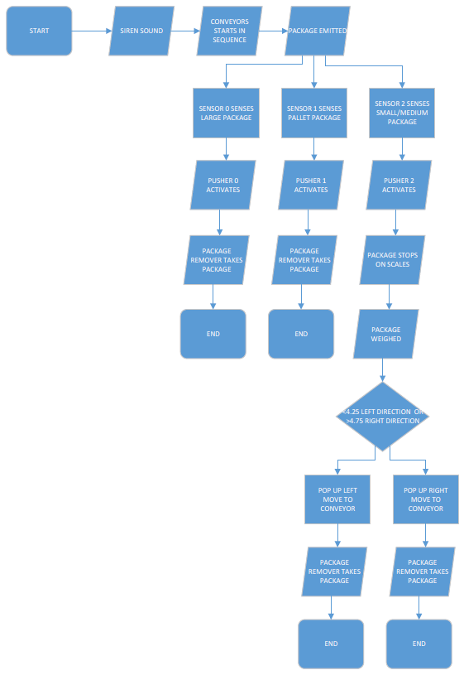
Operational flow chart Figure.1
A HMI was required for the factory, this incorporated 3 separate screens, the root screen, alarm screen and engineers screen;
Root screen –
The root screen is the master control screen for the factory and contains the buttons for start/stop, E-stop, screen selection and a general reset, the indication lights for the sensors and pushers, as well as a successful package count and error indicators. The root screen can be seen in Appendix B Figure.9

Alarm screen –
The alarm screen is used to alert the operator to any errors in the system, this screen works as part of the alarm system and indicated to the operator to which package the errors are occurring with. The alarm screen can be seen in Appendix B Figure.10.

Engineers screen –
The engineers screen contains more detailed information about the errors, on here the parameters was set for the alarm system. The master reset was also controlled on this screen. The engineers screen can be seen in Appendix B Figure.11

Alarm strategy-
The alarm strategy for the system utilizes counters to ensure all packages are successfully reaching the end of line. Diffuse sensors are positioned where each box is first sorted by the pushers, these sensors are used to count up, another set of sensors are then positioned by the end of each sorting line, these are used to count down. These counting functions are done within the ladder logic program and have set parameters on the engineers screen, tests were done to see the maximum number of each type of package which could be in on the line at once, this was set as the warning count parameter, if this number is met then the warning light on the alarm screen will light dependant on where the count is exceeded, the yellow stack light will then turn on to alert the operator. If the count then exceeds seven, which means multiple packages have been lost on the line, an alarm will sound and the system will stop.

RESULTS

The final result of this assignment was a fully working factory IO system complete with all the required components, the system had a successful warning strategy which would work repeatedly when tested. The counter system worked as intended and gave the operator a clear understanding of whether or not the system was functioning as intended or if errors where occurring. By completing the work a good understanding of the TIA software has been achieved as well as an understanding of how internal PLC functions, such as counters and timers, can be used together in series to allow a set of required functions to work.
After reviewing the work many improvements were found, the main improvements are as follows;
- Utilized the pusher limits as sensors for counting, removing the need of tome extras.
- The counter system could have done with some improvements as the first run of conveyor belts makes the count inaccurate, accuracy is only achieved when the pushers move the packages to the next stage of sorting.
- Spreading the factory out over more space and using more conveyors may have made the system more accurate when it came to counting, and easier to manage, as it is all removers are spread out, an improvement would be to group them all together and then use signage to distinguish between the four removal bays.
- Safety features such as guard rails and fences could have been used more efficiently and effectively to close off certain parts of the factory and only have the main consumer unit and removal points accessible to operators.

Appendix A – ladder logic programme
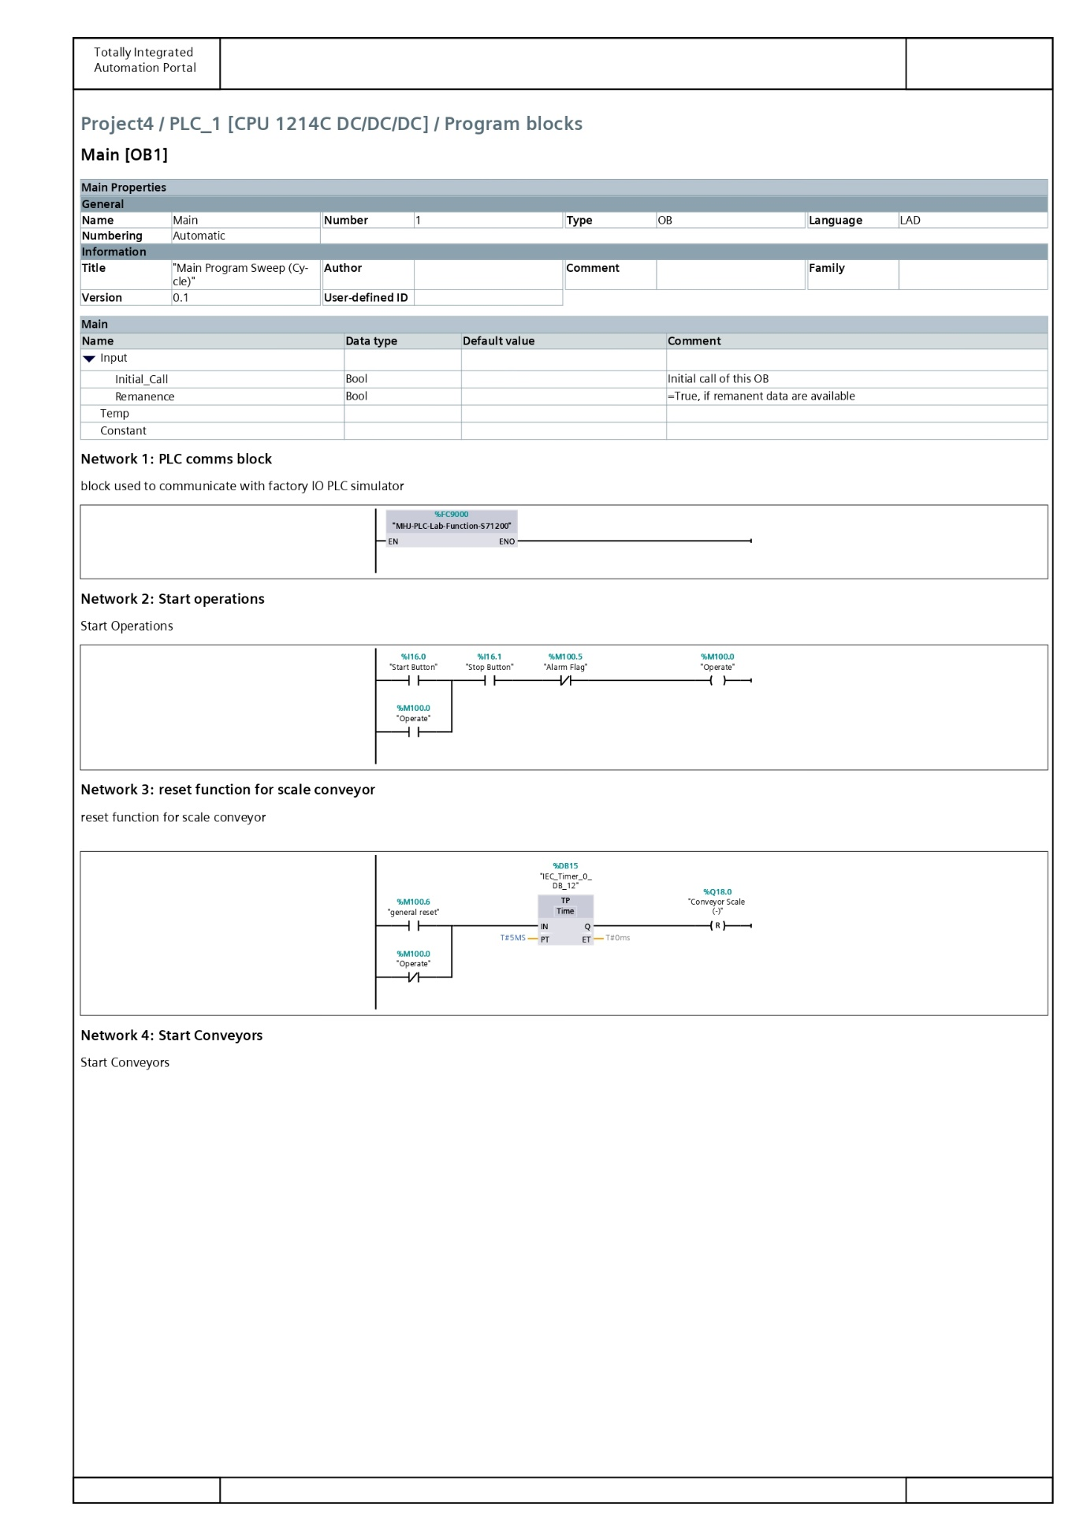
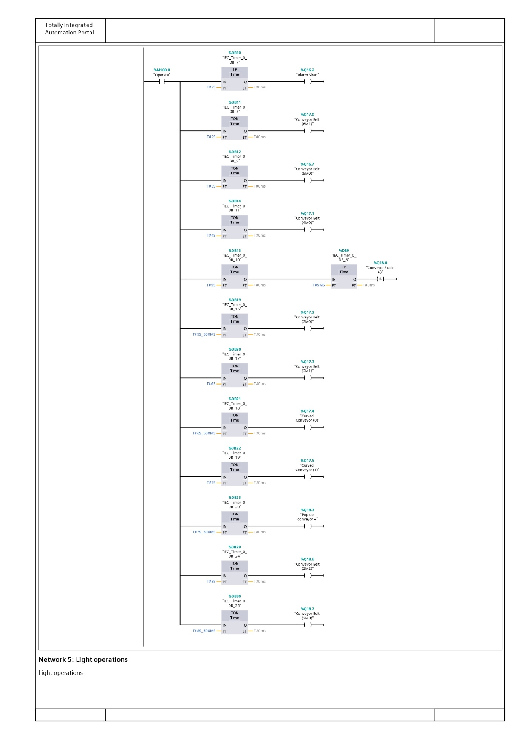
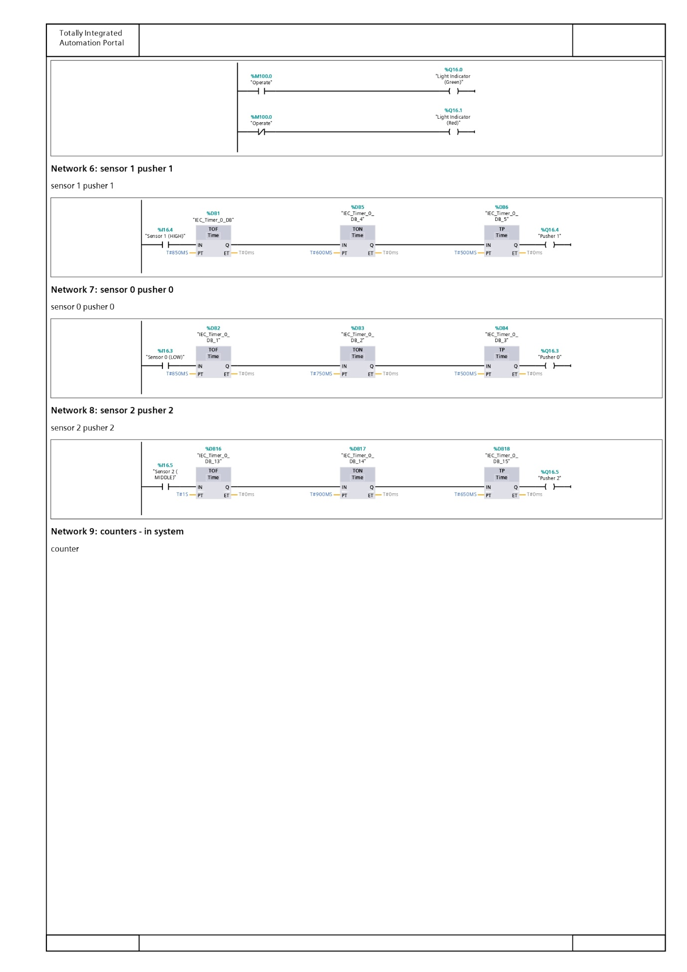
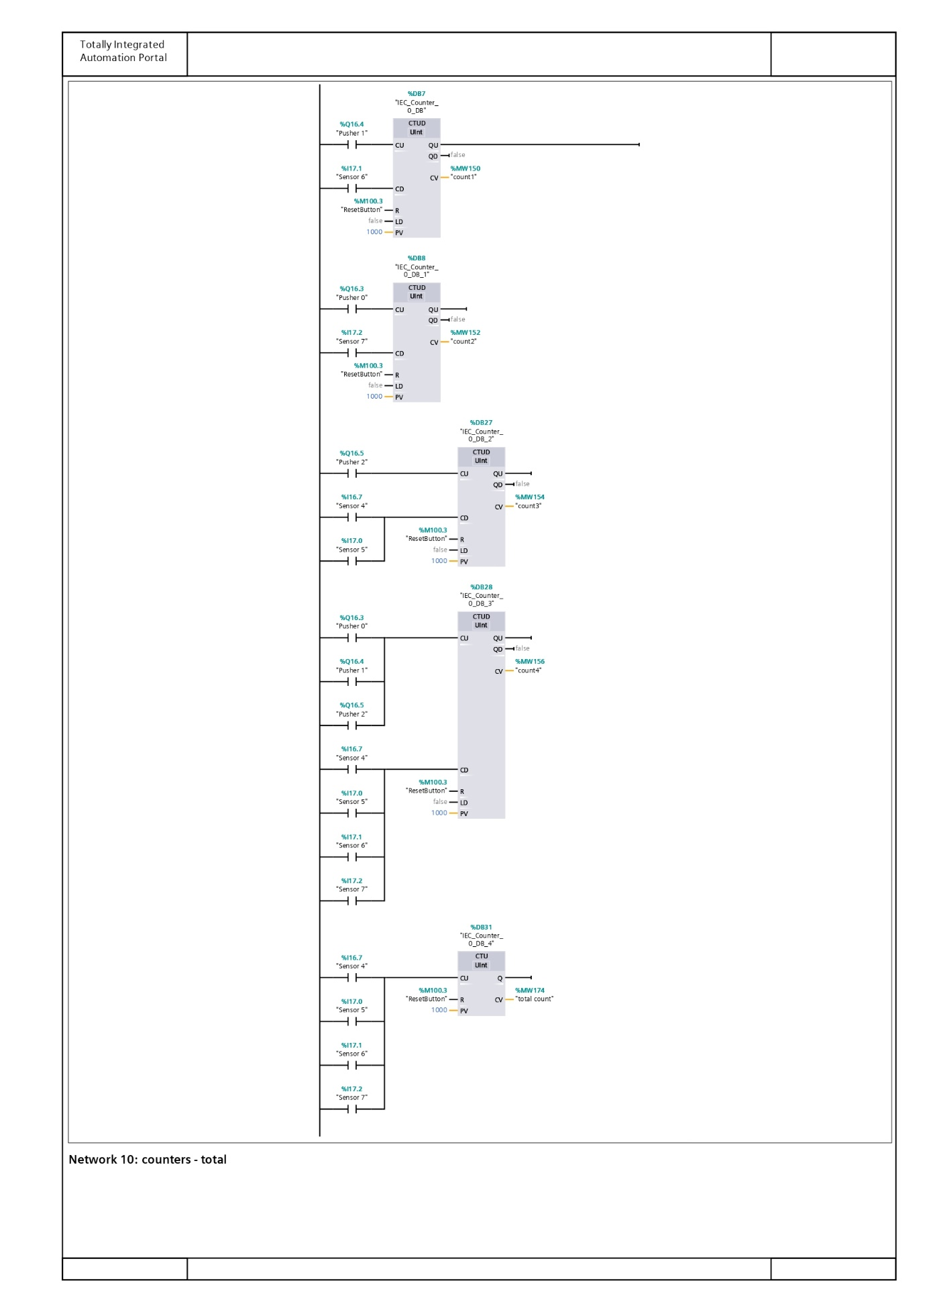
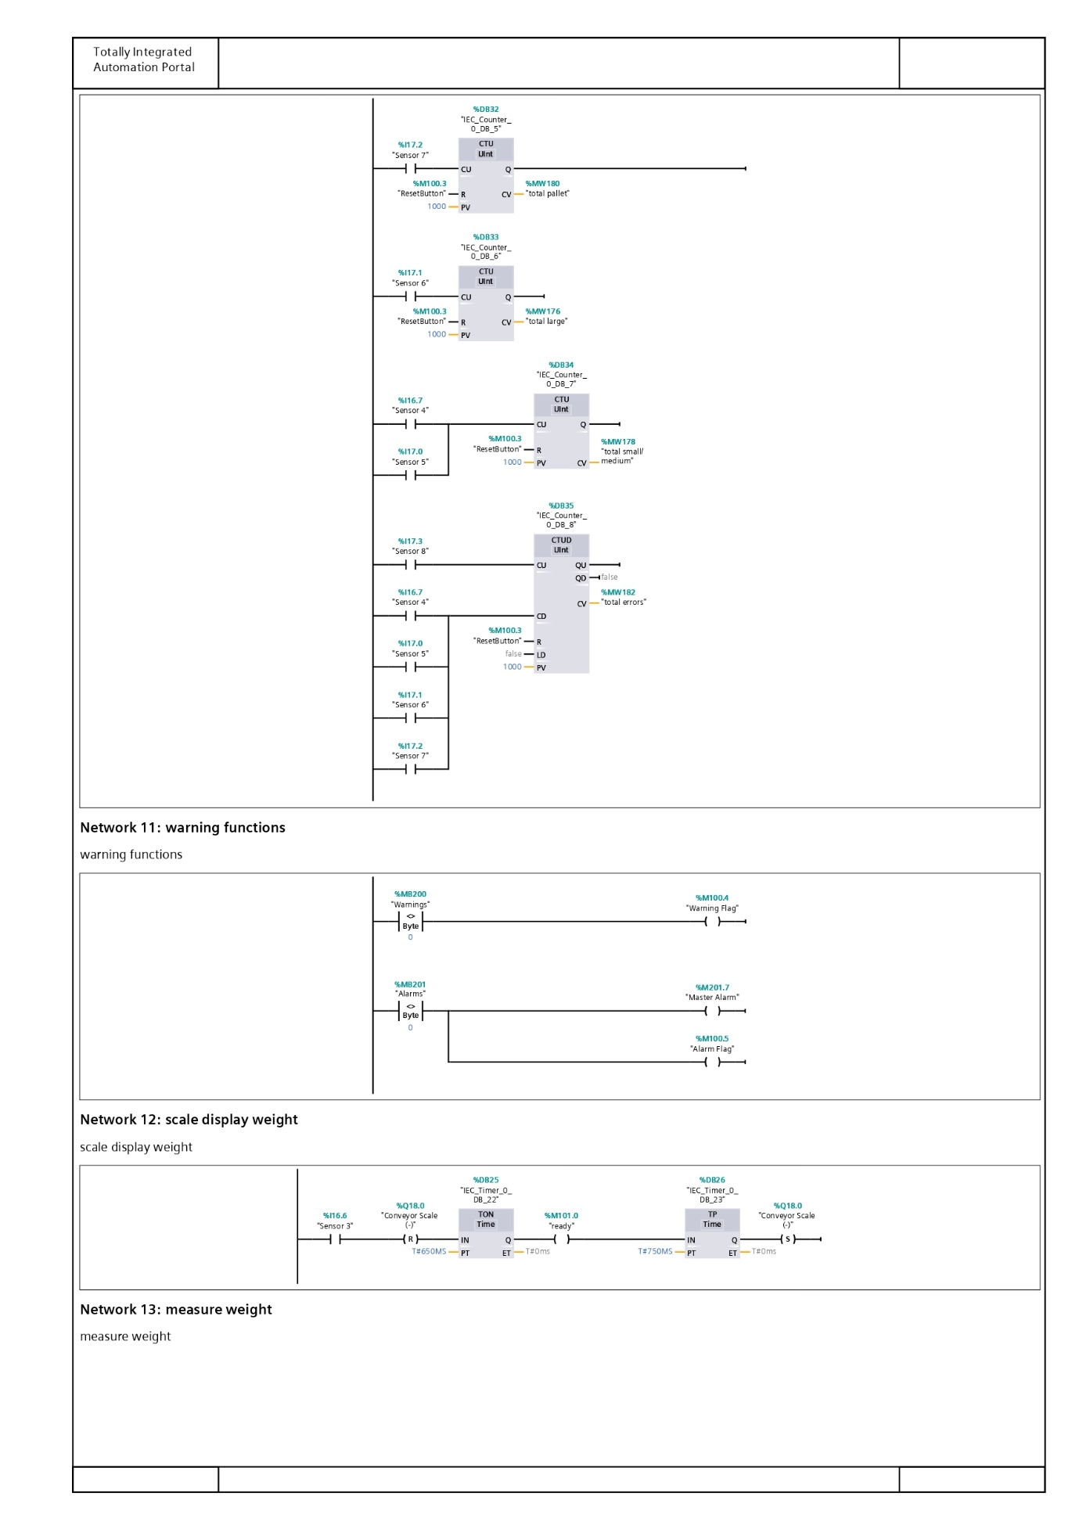
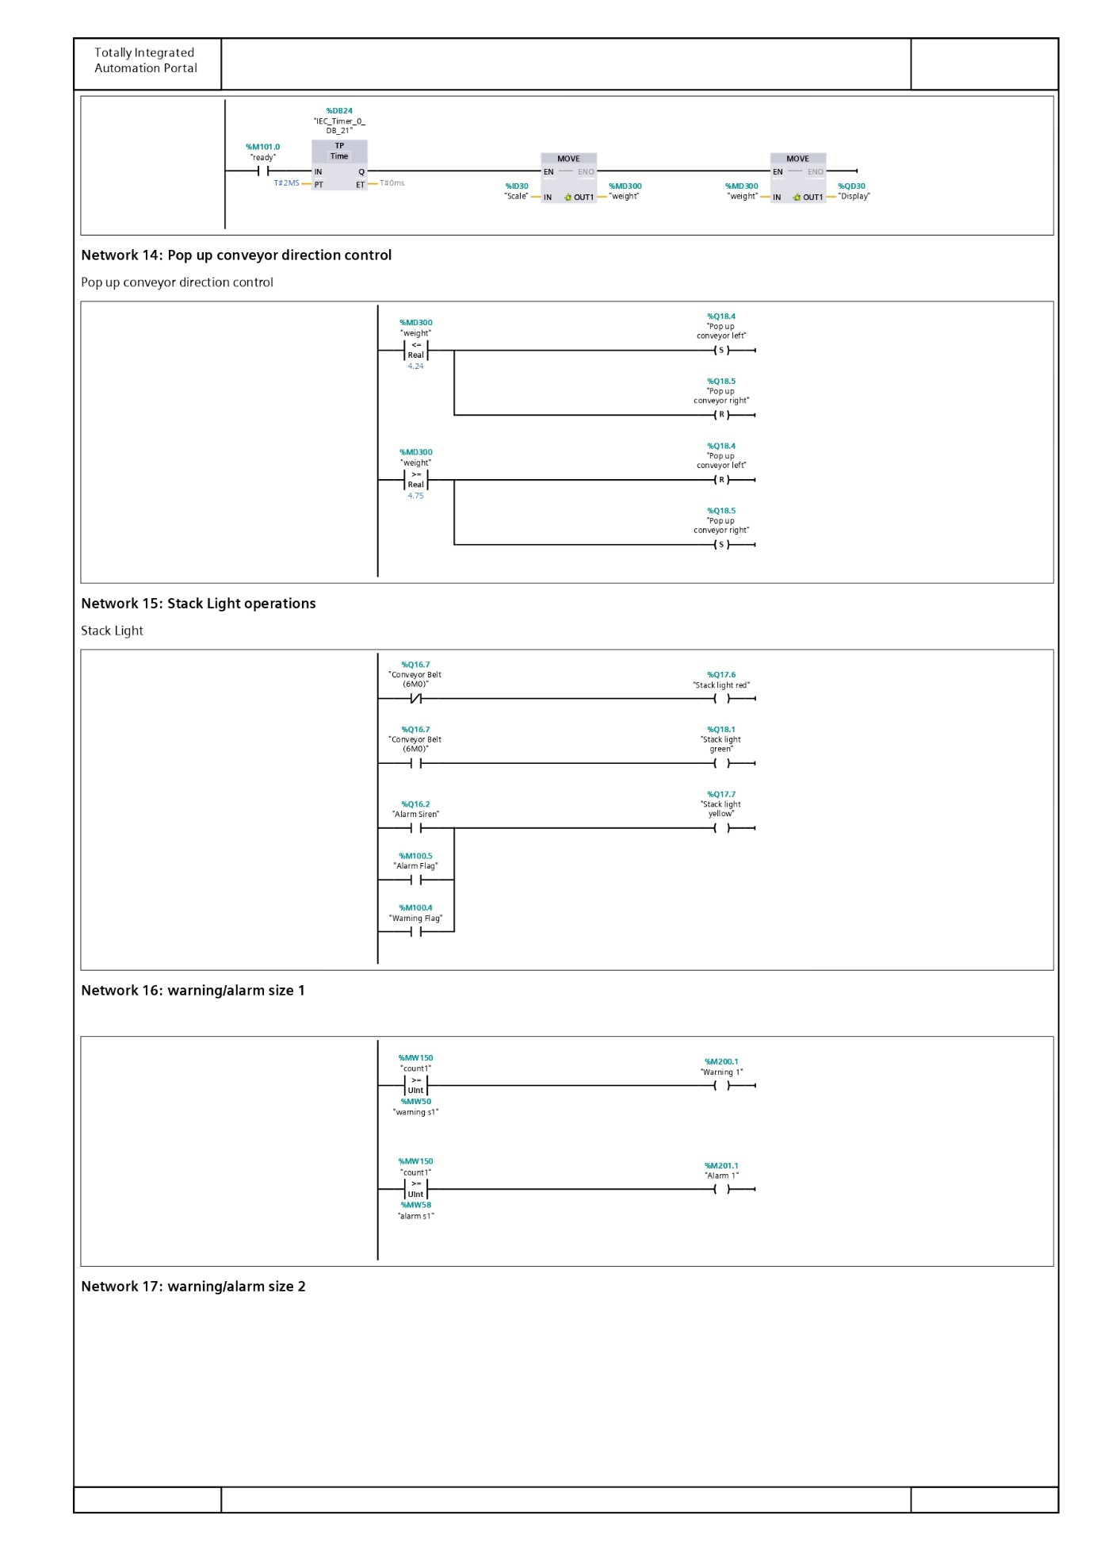
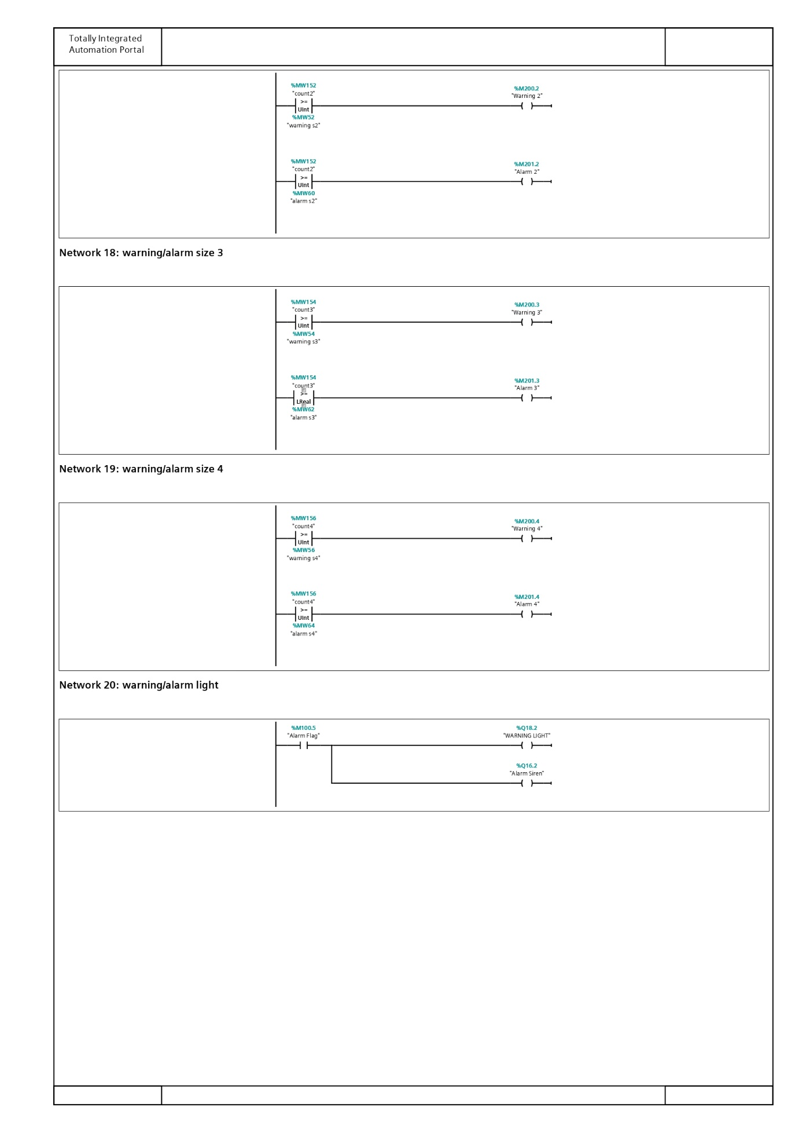

Appendix B
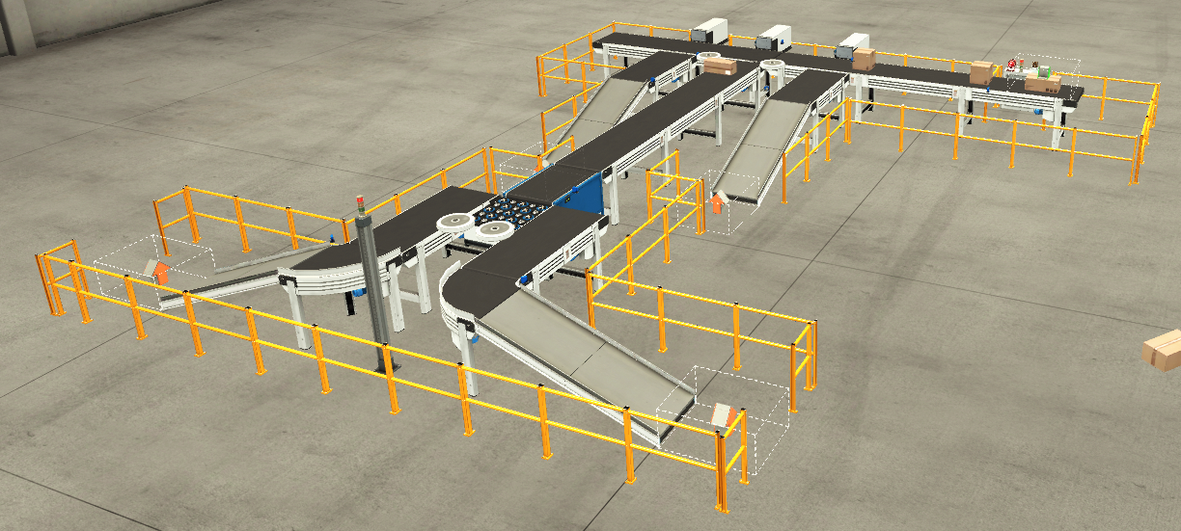
Figure.1 - Full factory view
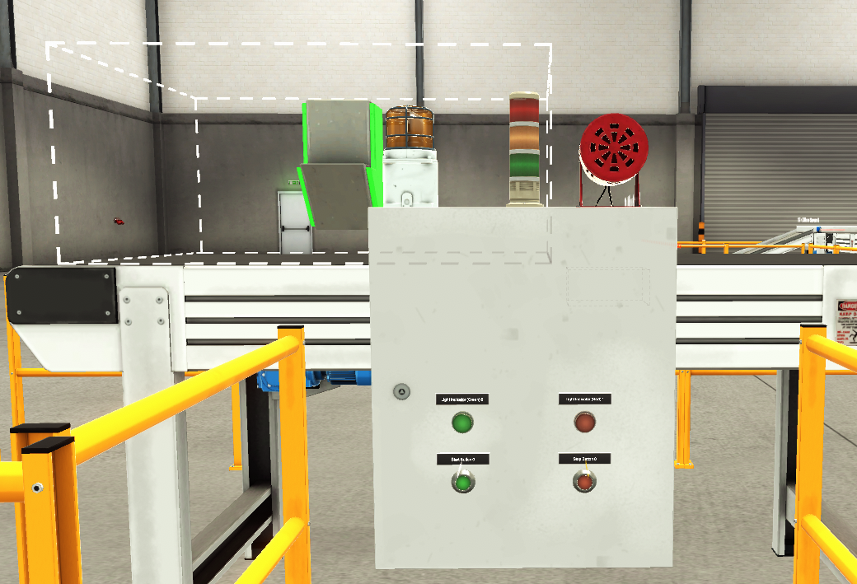
Figure.2 - Switch Board - Alarm - Warning Light - Stack Lights - Box Emitter

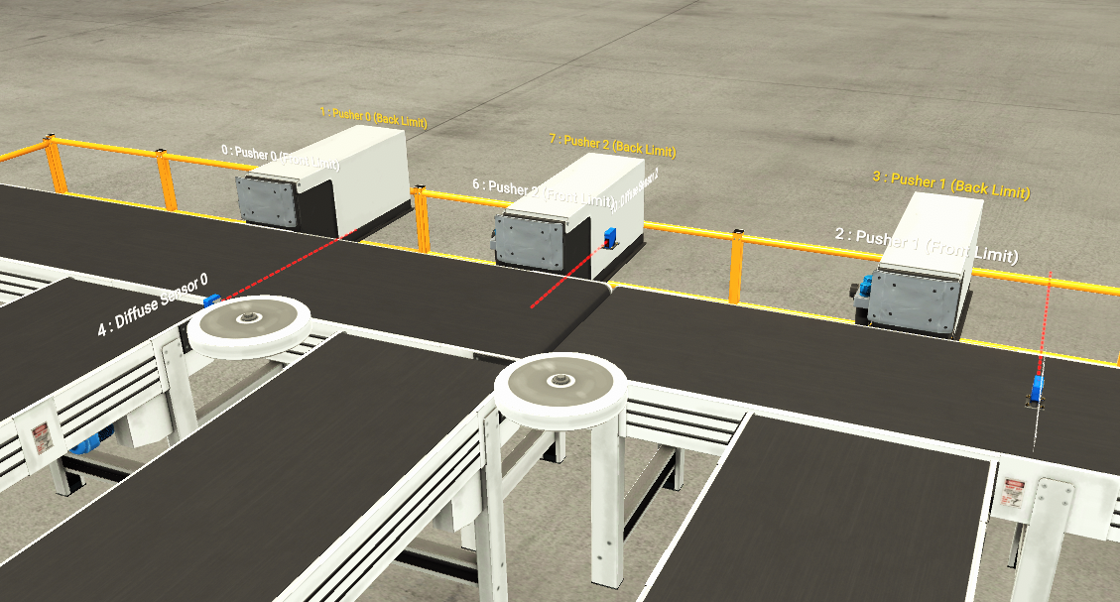
Figure.3 - Pusher and sensor configuration
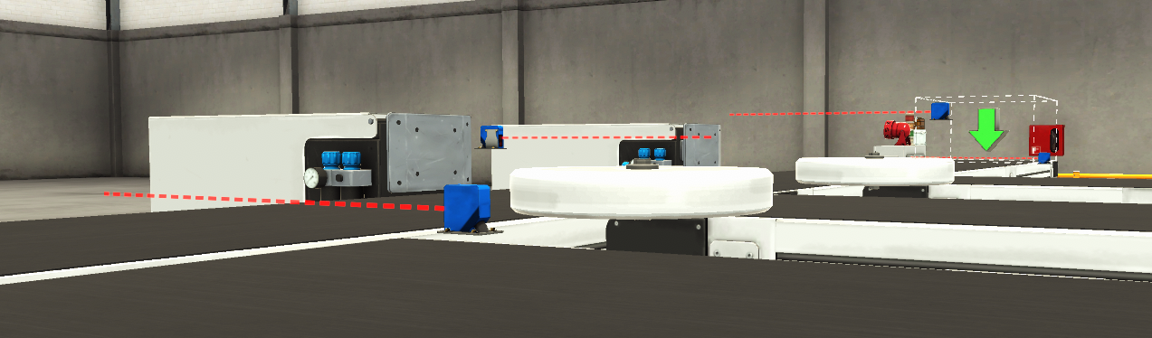
Figure.4 – Sensor height
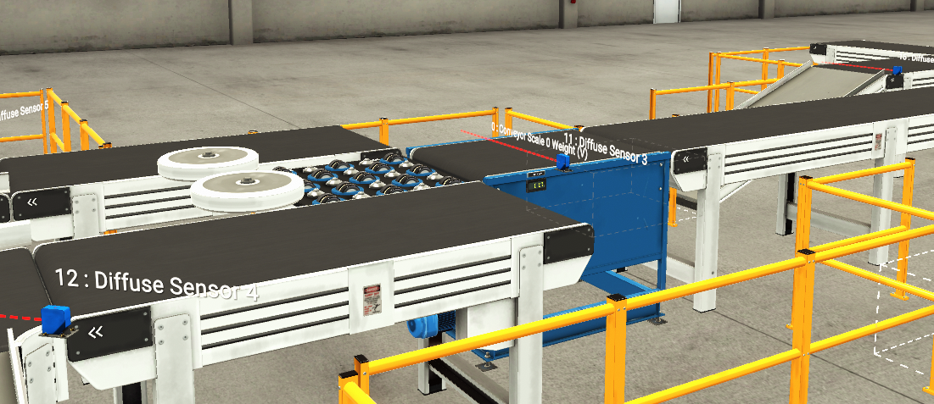
Figure.5 – Weighing operations and pop up sorter
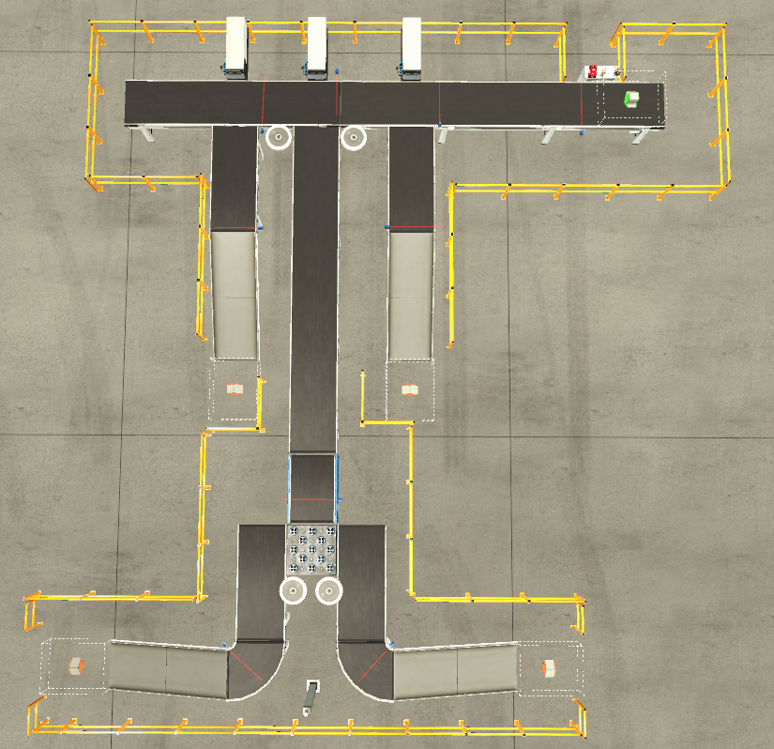
Figure.6 – Top down view of factory
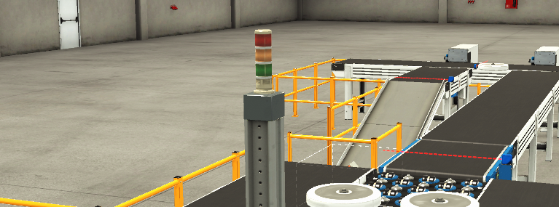
Figure.7 – Replication of stack light at opposite end of line
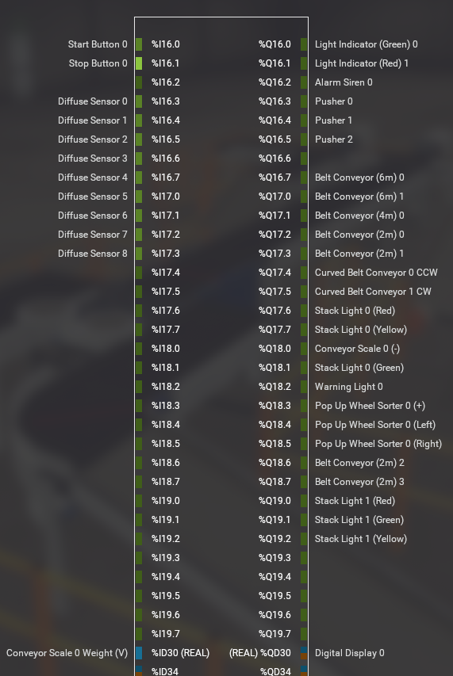
Figure.8 – Chip drivers and I/O assignments
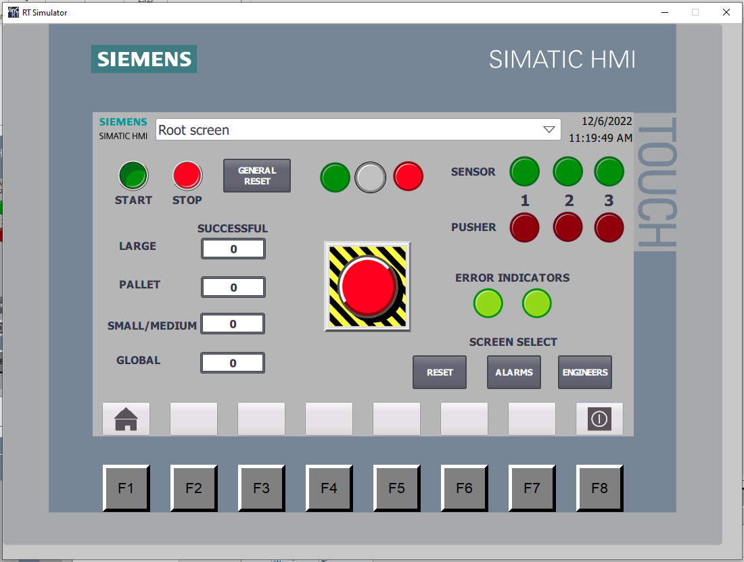
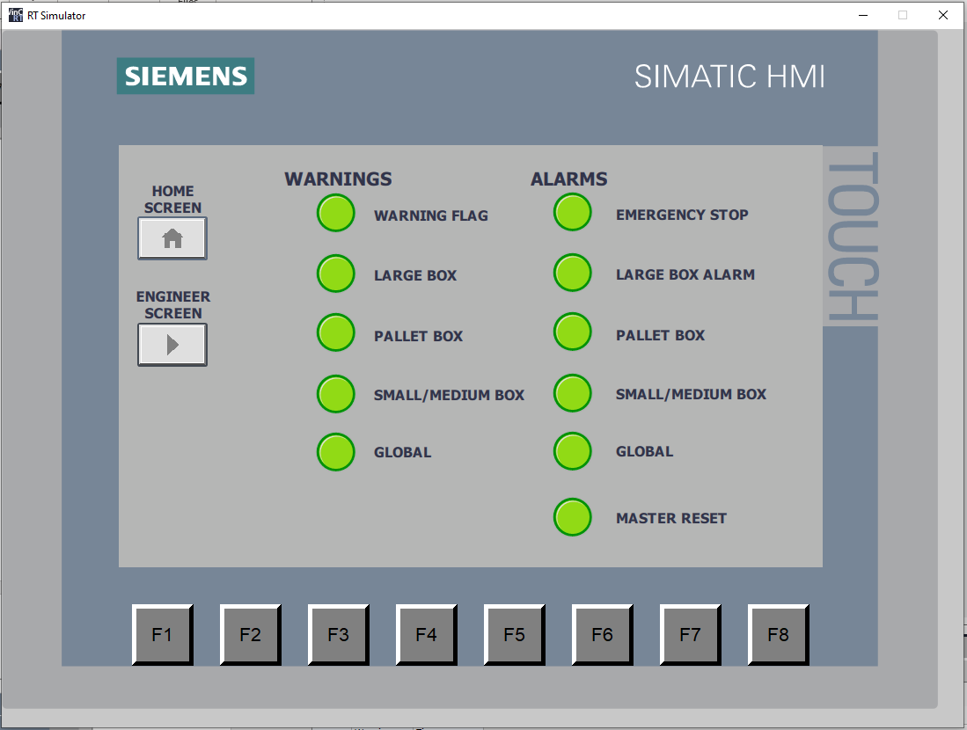
Figure.9 – HMI Root Screen

Figure.10 – HMI Warning/Alarm Screen
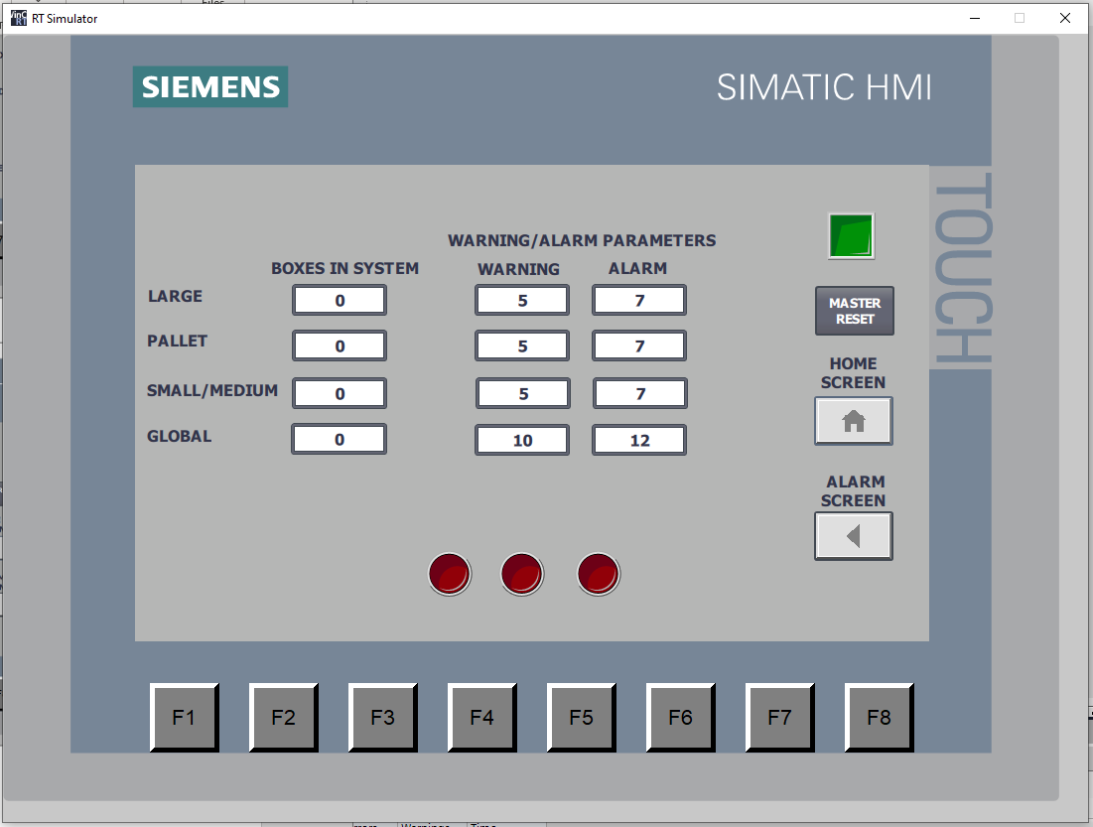

Figure.11 – HMI Engineers Screen

