

Assessment 1
Supporting Paper

Student name:
Student ID:

Module name: Living with care: The older person
Module code: BMHP6009
Lecturer name: Dr Laila
Date:

Introduction
This report will focus on reflecting on the debate as a group made in class and discuss the pros and cons of using technology for the elderly population also provide statistics related to the topic and analyse the government support in the UK. This report also involves collecting data from different sources: articles, newspaper, internet, books, encyclopaedia, etc.

1.Standpoint in the debate group
From my point of view, technology has the potential to open new opportunities in the healthcare sector, it is accessible to everyone and allows medical professionals to provide quality service to users. As a result, maintain the independence and helping to reduce expenses in different sectors. However, this was a group presentation, and we talk about the disadvantages of technology for elderly people and the outcomes.
2.Reflect the information providing as group
Elderly population often struggle to use electronic devices due to the limitations of their body as people get older, their vision often deteriorates. Seniors may struggle to perceive small details, confusion with the colours, and distinguish low-contrast items, which can lead to complaints that looking at screens hurts their eyes or causes headaches. Also, their health and mobility tend to decline. People with chronic illnesses are susceptible to revealing personal information for safety. They are more vulnerable to the monitoring and information collection standards of care services, sharing personal information more regularly increases the danger of identity theft (Zaid et al;2023).
In addition, 25% of people aged 65 and over in the UK do not use internet. Elderly people who are lack digital skills, have a risk losing access to essential services such as banking, shopping, and health care, as well as communication networks that keep people in touch. According to the researchers indicates in England there the three primary explanation for the adult’s population are not use internet: Insufficient confidence in internet, lack of abilities and absence of equipment and broadband connectivity (Age UK,2024)
Other group perspective:

3.statistics of people related to my topic
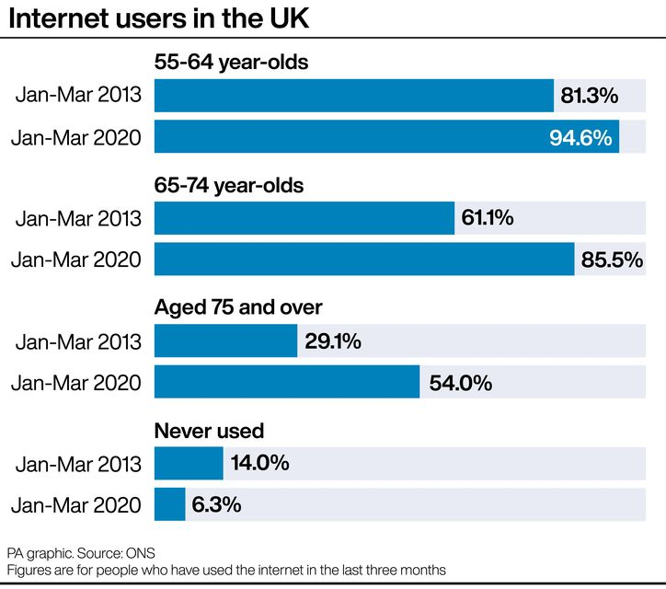
This table shows:
According to new data from the Office for National Statistics (ONS), 92% of all UK people had recently been online, an increase from 91% in 2019.
The findings indicate that practically all adults in the age range of 16 to 44 (99%) utilize the internet. Additionally, more than half of people aged 75 and above (54%) have recently accessed the internet, which marks a noteworthy surge since 2013.
The data indicates that the percentage of adults in the UK who have never utilised the internet has decreased from 7.5% in 2019 to 6.3%. Conversely, the proportion of disabled persons who have accessed the internet has increased from 78% in 2019 to 81% in 2020.

https://www.belfasttelegraph.co.uk/news/northern-ireland/internet-use-up-among-older-people-figures-show/40280054.html

4.Current government support of services in place to support Uk elderly population

5.Conclusion

References
Age Uk (2024) Helping Older people get Online Available at:https://www.ageuk.org.uk/our-impact/programmes/digital-skills/#:~:text=Older%20people%20who%20are%20without,platforms%20that%20keep%20people%20connected.
Zaid N et al 2023: Elderly and their barriers to accepting and learning to use technology :A scoping review Available at :https://www.researchgate.net/publication/368659002_Elderly_and_their_barriers_to_accepting_and_learning_to_use_technology_A_scoping_review

Additional information have a look:https://www.researchgate.net/publication/358765897_Effect_of_digital_technology_on_our_brain_health

