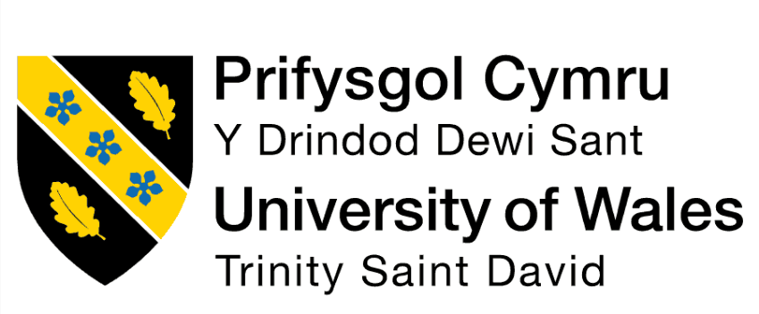
Programme : Master of Business Administration
Module Code: LCMB7023
Module Title: Human Capital Management
Title: Assessment component 1: Individual report
Lecturer Name: Ejike Udeogu
Student Name: MD Abdul Kadir Chowdhury
Student ID: 2435894
Submission Date: 17th October 2025

Table of Contents
QS NO 1. Technological Advancements and HRM/IHRM 4
Impact on Recruitment 4
Automation in HRM 4
Digital Platforms for Collaboration 4
Organizational Adaptability 5
Challenges of Technology 5
(Team pH, 2025) 6
Conclusion 6
QS NO 2. 6
Demographic and Geopolitical Influences on Employment Markets 6
Demographic Factors 6
Geopolitical Factors 7
Conclusion 8
QS NO 3. 9
Addressing Skills Gaps and Talent Shortages 9
The Challenge of Skills Gaps and Talent Shortages 9
HRM Strategies to Address Skills Gaps 9
Strategic Recruitment Practices 10
Talent Acquisition Partnerships 10
Conclusion 10
QS NO 4. 11
Personal Reflection on International Work Readiness 11
1. Technology: Leveraging Digital Tools in a Global Context 11
2. Communication: Cross-Cultural and Digital Communication Skills 11
3. Teamwork: Collaborating Across Borders 12
4. Leadership: Inspiring and Leading International Teams 12
5. Self-Directed Learning: Continual Growth and Adaptability 13
Conclusion: Moving Forward 13
References 14

QS NO 1. Technological Advancements and HRM/IHRM
Global labour market is changing with technological has infiltrations, Artificial Intelligence (AI), automation, and digital platforms, which pose both a challenge and an opportunity to Human Resource Management (HRM) and International Human Resource Management (IHRM). With the introduction of new technologies in organisations, HRM and IHRM policies should respond to such shifts in recruitment, employee management, and flexibility in order to adjust to the introduced changes.

Impact on Recruitment
Applicant tracking systems (ATS) are AI-driven tools that have transformed the recruitment process by automating the screening of the candidates. These systems compare resumes to determine suitability of the candidate by experience, skill and qualification. The Society for Human Resource Management (SHRM, 2023) argues that more than 60% of companies rely on AI to philtre the applicants to increase their hiring speed and minimise human bias. This comes in handy especially in the case of IHRM where AI facilitates the realisation of global talent in various markets. Nevertheless, the HR professionals should make sure that algorithms are optimised to eliminate biassing and foster diversity during hiring.

Automation in HRM
Automation is transforming the HR by performing repetitive processes which include, payroll processing, benefits, and employee data management. This will enable HR professionals to devote more time to such strategic tasks as talent development. As an example, chatbots currently handle employee questions on the company policies, which promotes efficiency. In IHRM, automation simplifies the global HR activities, as it becomes easy to deal with international employees, compensation, and benefits at the various regions(Conroy and Malik, 2025). Electronic Work Groups.

Digital Platforms for Collaboration
Digital communication and collaboration Digital communication and collaboration has redesigned the communication and collaboration of a hybrid or remote workplace with the aid of digital media like Slack, Zoom, and Microsoft Teams. They are the tools applied in management of the projects and real-time virtual teamwork. Not only do they increase the engagement and productivity of the employees but also increase global collaboration of IHRM wherein teams are frequently spread over the borders. Such systems help human resource managers to implement homogenous policies, screen performance and the maintenance of the company culture in each of its international places(Stallkamp and Schotter, 2020).

Organizational Adaptability
Technological advances bring out the need of organisational adaptability. The rapid innovation rate suggests that organisations will have to reskill their staff to be able to survive. The HRM strategies must be capable of availing a digital atmosphere that can enable expansion of digital skills. Employee development programmes, such as e-learning solutions, are essential in employee growth because they assist the employees to keep abreast with the ever-changing work environment.

Challenges of Technology
Just as much as there exist more positive qualities about technology, there are issues. Employment of automation and AI may have the effect of job displacement especially in these sectors that rely on routine work. These transitions should be handled by the HR professionals in a responsible way through the reskilling and potentially redundancy. The change of technology in IHRM is also one of the key elements that must be in respect with the local labour laws and the cultural needs in different countries.
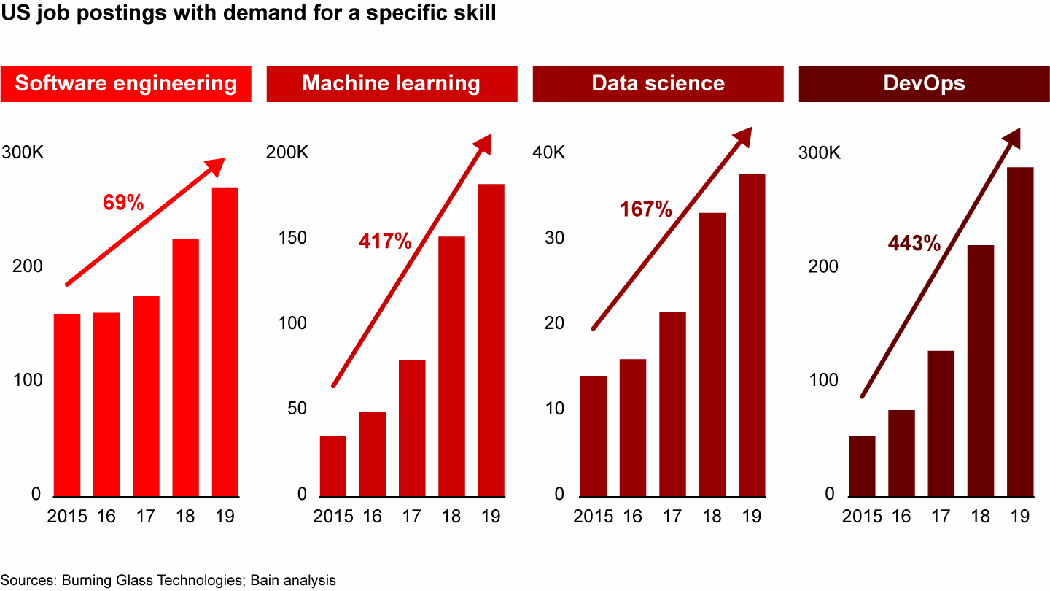

(Team pH, 2025)

Conclusion
The innovations that are taking place within the technological facet of HRM and IHRM world are altering it through automation, maximisation of collaboration and demand unceasing flexibility. HR experts must apply technology to create efficient, inclusive, and flexible organisations and erase the barriers to prejudice, job substitution and lifelong learning. Use of power of technology to produce much effective and stronger organisations is the future of HRM and IHRM.

QS NO 2.

Demographic and Geopolitical Influences on Employment Markets
Demographic and geopolitical factors are very strong in the employment market. These aspects are challenging Human Resource Management (HRM) and International Human Resource Management (IHRM) as the world trends keep changing. These trends are inherent and knowledge about them is pertinent in ensuring the organisations remain competitive and resilient to any changes in the labour market.

Demographic Factors
Another demographic trend that has been of great influence on the employment markets is the trend in population which is the ageing population and mainly in the developed countries. According to the United Nations (2022), the worldwide population reaching 60 years and older will almost be doubled in 2050. This ageing trend is putting a strain on healthcare, senior care, and other age friendly workplaces. Another issue of the ageing workforce is the challenge of rates of retirements and the necessity of succession plans. The human resource managers need to implement solutions to retain the older employees, which includes options of a flexible work environment, personal growth, and customised health insurance(Mansour and Tremblay, 2019).

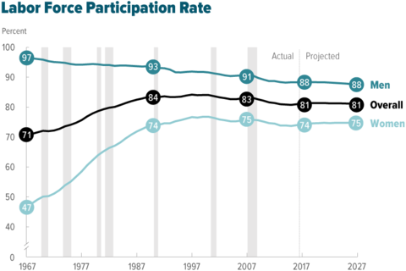

(Congressional Budget Office, 2018)
Moreover, more labour markets is the growing participation of women in the labour market, and the increased migration. The workforce has become more diverse with the contribution of the rising number of women achieved in most sectors due to their higher education and professional level. The gender parity issues such as the disparity in remuneration and work-life balance are the issues that should be addressed by HRM and IHRM to ensure that they harvest the talent pool in this diversity. Other than that, the migration patterns are bringing people of diversified work force and with various legal rights, cultural and language abilities. These differences must be accommodated within the HR strategies, and this should be accompanied with fair and equitable practise in recruitment, training as well as the employee relationship practises.

Geopolitical Factors
The geopolitical events, which may involve political conflicts, trade conflicts, and changes in government policies have immense implications on the labour markets in terms of their actions that are associated with the transfer of talent across the borders. The Brexit (the departure of the United Kingdom out of the European Union) is one instance of how the labour mobility has been disrupted, particularly in the sectors of the economy that employed EU workers, e.g. the healthcare sector and the hospitality industry(Bickerton, 2019). IHRM must undergo the alternatives of changing the immigration, visa regulations, and international labour laws to maintain a skilled and diverse labour in the various jurisdictions.
The workforce disruptions and transformations of international supply chains are also caused by the trade tensions, as well as by the international trade policy of the states, i.e., use of tariffs and sanctions. As an example, the U.S.-China trade war resulted into the companies shifting their manufacturing to other nations in Asia and Latin America. The HR in these areas should make sure that they have the correct talent and capabilities to satisfy the demands of the industry.
Also, the increased technological factor, such as automation and artificial intelligence, are altering the geopolitics of the world, and has a consequence of influencing employment creation. To adapt to these changes HRM strategies must be dynamic to anticipate the skills demanded in different regions and invest into training and development so as to remain comparable with the emerging technologies.

Conclusion
The aspects of demographics and geopolitics are very influential on the employment markets. These factors jeopardise HRM and IHRM practitioners bearing in mind that they are instigated by an ageing population to accelerate migration and political tensions. The talents and workforce diversity, talents management across the national borders, investing in retraining and skilled and many other are only a few of the measures that organisations are bound to use to beat those odds. This can also focus on the demographic and geopolitical changes, which help the HR practitioners to attract, retain and develop the skills that would help them survive in a more globalised environment.

QS NO 3.

Addressing Skills Gaps and Talent Shortages
Some of the areas where skills gaps and shortage of talents are so rampant are the industries of technology, healthcare and hospitality in the modern dynamic international economy. The growing requirement to specialised skills, in presence of unqualified applicants present opportunities in as much as it provides challenges to organisations. To address these lapses, Human Resource Management (HRM) and International Human Resource Management (IHRM) ought to put in place strategic practises that address such lapses in order to make sure that the current and future needs of the talent requirements of organisations are met.

The Challenge of Skills Gaps and Talent Shortages
In other industries such as technology, the distance between the high rate of digital transformation and talent is increasing. Rise in artificial intelligence (AI), cybersecurity, and the Internet of Things (IoT) necessitate the proficiency in data science, machine learning, and software development but the demand is often higher than the supply. The health care sector is not an exception as the growing aged population creates a greater demand pressure on the medical personnel and nurses, physicians and allied medical workers are short in supply. Also, hotel management is facing a problem of short age of skilled labour, which was increased by the pandemic as most employees dropped out during lockdowns.
To HR professionals, such shortages must be resolved through new approaches to be able to attract, train and keep talents in highly competitive sectors. The burden of IHRM lies in dealing with these shortages in as many as different countries which have different labour markets, different educational systems, and different immigration policies. HRM Strategies to eliminate Skills Gaps.

HRM Strategies to Address Skills Gaps
Talent development and workforce planning should be given priority so that skills gaps could be bridged by HRM. One of the strategies is to ensure that the existing employees are upskilled through training and development programmes. Life-long learning opportunities will make the workforce flexible to the changes in the industry. McKinsey (2022) discovered how the organisations investing in employee development are 40% more likely to retain top talent. Collaboration with academic institutions to create an educational process that meets the industry requirements would also be a helpful solution to this in ensuring that graduates are qualified with the skills required.

Strategic Recruitment Practices
HR specialists, also, need to embrace strategic recruitment strategies. One of the methods that could be used is to widen the talent pool that means recruiting beyond conventional sources e.g. underrepresented groups or international recruits. As an example, tech companies experiencing talent shortages can consider the market of countries that offer efficient STEM education programmes, such as India and Eastern Europe, as a source of skilled labour. An inclusive process in hiring may also bring in a rich source of talents to fill skill gap in an organisation and inject innovativeness into the organisation.

Talent Acquisition Partnerships
The other viable approach is the establishment of talent acquisition alliances with third parties such as recruiting agencies, and talent marketplaces. These alliances offer greater access to talent pool and less time-to-hire. Global recruitment firms, such as those, are experts in talent identification in certain areas and it is therefore easy to get qualified workers in different countries through IHRM teams.

Conclusion
The only way to resolve the current skills gaps and shortage of talent is through an integrated strategy that engages in upskilling of the workforce, improving the recruitment methods and establishing strategic alliances(S. Gomathi, A. Rajeswari and Seifedine Kadry, 2023). The HRM and IHRM is required to take initiative and bridge these gaps through investment in training programmes, partnering with educational institutions and also through global pool of talent. This way, organisations are able to develop a strong workforce that is able to resist the pressure of the competitive environment presented by their rapidly changing global marketplace.

QS NO 4.

Personal Reflection on International Work Readiness
Posing in the modern globalised economy, a skill to operate efficiently in a global environment is a very essential skill. Due to the increasing cross-border expansion of various industries, the international work preparedness improves the professional growth and employability. This reflection evaluates my readiness to be employed in international environment with references to five areas: technology, communication, teamwork, leadership, and self-directed learning. Based on my scholarly and professional level of experience, I assess my strong and weak points in these areas and lay my plans on how to use upon the strength side, and I do on areas that need to be improved.

1. Technology: Leveraging Digital Tools in a Global Context
The international work requires the capability to utilise technology, especially in remote and hybrid work. The pandemic increased the pace of digitization, which requires a high level of expertise at the platforms, Microsoft Teams, Zoom, and project management tools, including Asana and Trello. I am also familiar with these tools, and I was using them during my internship period to secure communication and collaboration without spending much time across cultural borders.
Nevertheless, I understand that such technological achievements as artificial intelligence (AI) and data analytics have started gaining more significance. Although I possess a general knowledge of the technologies, I must further advance my knowledge in order to remain competitive in a multi-national working environment. To deal with it, I will undertake online AI, data and cloud computing courses. This will improve my technical skills and make me up to date in the dynamic digital workplace.

2. Communication: Cross-Cultural and Digital Communication Skills
In a global workplace, proper communication plays a central role. I have studied in a diverse academic setting and therefore have acquired good communication skills both through writing and oral communication. Nonetheless, cross-cultural communication is a difficult one, and various cultures may exhibit different expectations of communication, starting with hierarchies up to the use of varied approaches to conflict resolutions.
I have not been able to experience working in a really multicultural team yet, thus I realise the necessity to become better informed about intercultural communication. To shed more light on my skills I will undertake the cross-cultural training in form of workshops, after that I will pursue international internships or volunteer activity. Moreover, an international workplace involves digital communication that involves aspects like active listening and interpretation of non-verbal communication that is found in online conferences. I will enhance these competencies in order to overcome misunderstandings more easily and foster a stronger relationship even when remote.

3. Teamwork: Collaborating Across Borders
In the international arena, teamwork is nowadays multinational and intercultural. The experience in the academic field has introduced to me interacting with international peers where I have learned to appreciate other views, and I have gotten used to working with teams virtually. Time management and time zone management was another central issue, which made me understand that I need to be flexible and manage my time properly.
Even with such experiences, I feel that I have to reinforce my skills of creating team cohesion particularly in virtual world. Establishing proper relationships remotely involves the aggressiveness of interaction. I will also work on my emotional intelligence, specifically, empathy and self-management, as the most vital element to regulate conflicts and comprehend team relationships at international levels.

4. Leadership: Inspiring and Leading International Teams
One of the most appropriate skills to ensure success in work related to international environment is leadership especially leading multidimensional teams. I have also been able to manage small groups in academic institutions where I have mastered the art of making decisions, conflict resolution, and influencing others. Nevertheless, the management of cultural diversities and differences in work styles entails other challenges in working with the leading international teams.
To enhance this, I intend to find leadership training courses specifically in the international team management and volunteer in international projects or internships in which I can assume a leadership position. This will enable me to have a practical experience in cross-cultural leadership and improve my skills in motivating and leading teams across the borders. Self-Directed Learning: Permanent Development and Flexibility.

5. Self-Directed Learning: Continual Growth and Adaptability
It is essential to self-educate to succeed in the global world, where constant change is an order of the day. During my studies, I have tried to find an opportunity to work on myself, by taking some extra classes and obtaining feedback on my work provided by professors. This self-directed learning capability has been my strength.
Nevertheless, I am aware that lifelong learning is necessary in order to remain competitive especially when the industries are highly technological orientated. I am going to utilise online courses to pursue and accomplish my plans online because the industry is evolving, and new technologies must be adapted to. Through constant learning attitude, I will always be flexible and strong in a dynamic global working environment.

Conclusion: Moving Forward
To sum up, the self-assessment and continuous improvement are the two processes in my life that help me be prepared to work internationally. Although I gained strengths in technology, communication, teamwork, leadership, and self-directed learning, I can admit that there are still areas of improvement, such as cross-cultural communication, leading teams on the international level, and technical expertise. Having been proactive in addressing them, I will be in a better position to overcome the challenges and opportunities that come with working internationally.

References
Bickerton, C.J. (2019) ‘The limits of differentiation: capitalist diversity and labour mobility as drivers of Brexit’, Comparative European Politics, 17(2), pp. 231–245. doi: 10.1057/s41295-019-00160-x.
Conroy, K.M. and Malik, A. (2025) ‘International Human Resource Management’, Human Resource Management, pp. 351–370. doi: 10.4324/9781032625560-18.
Congressional Budget Office (2018) Factors affecting the labor force participation of people ages 25 to 54. Available at: https://www.cbo.gov/system/files/115th-congress-2017-2018/reports/53452-lfpr.pdf (Accessed: 16 October 2025)
Mansour, S. and Tremblay, D.-G. (2019) ‘What strategy of human resource management to retain older workers?’, International Journal of Manpower, 40(1), pp. 135–153. doi: 10.1108/ijm-07-2017-0170.
McKinsey & Company (2022) The future of work: How companies can close the skills gap. McKinsey & Company. Available at: www.mckinsey.com (Accessed: 16 October 2025).
Gomathi, S., Rajeswari, A. and Kadry, S. (2023) ‘Emerging HR practices—digital upskilling: A strategic way of talent management and engagement’, River Publishers eBooks, pp. 51–63. doi: 10.1201/9781032622743-4.

SHRM (2023) Artificial intelligence in human resource management. Society for Human Resource Management. Available at: www.shrm.org (Accessed: 16 October 2025).
Stallkamp, M. and Schotter, A.P.J. (2020) ‘Platforms without borders? The international strategies of digital platform firms’, Global Strategy Journal, 11(1), pp. 58–80. doi: 10.1002/gsj.1336
Team pH (2025). 6 biggest HR challenges in the tech industry. peopleHum. Available at: https://www.peoplehum.com/blog/biggest-hr-challenges-tech-industry [Accessed 16 October 2025].

United Nations (2022) World population ageing 2022 highlights. United Nations. Available at: www.un.org (Accessed: 16 October 2025).

