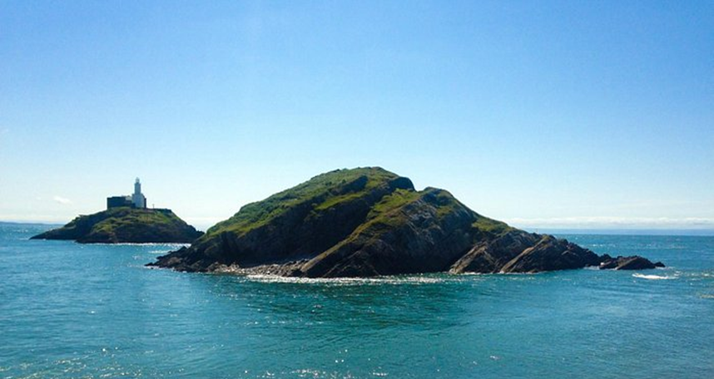

Mumbles Islands
  - Physical Landscapes and the Geosphere
Robyn | ESCC | 20-05-2022

Table of Contents

- Introduction
- Geological Composition
- Geological Structure
- Glaciation
- Pedogenesis
- Coastal Influences
- Topographical
- Management and Conservation
- References

Introduction

This report aims to look at the two islands that are off the coast of Mumbles and the surrounding coastline. Researching the different geological/physical processes which make these islands what we see today.
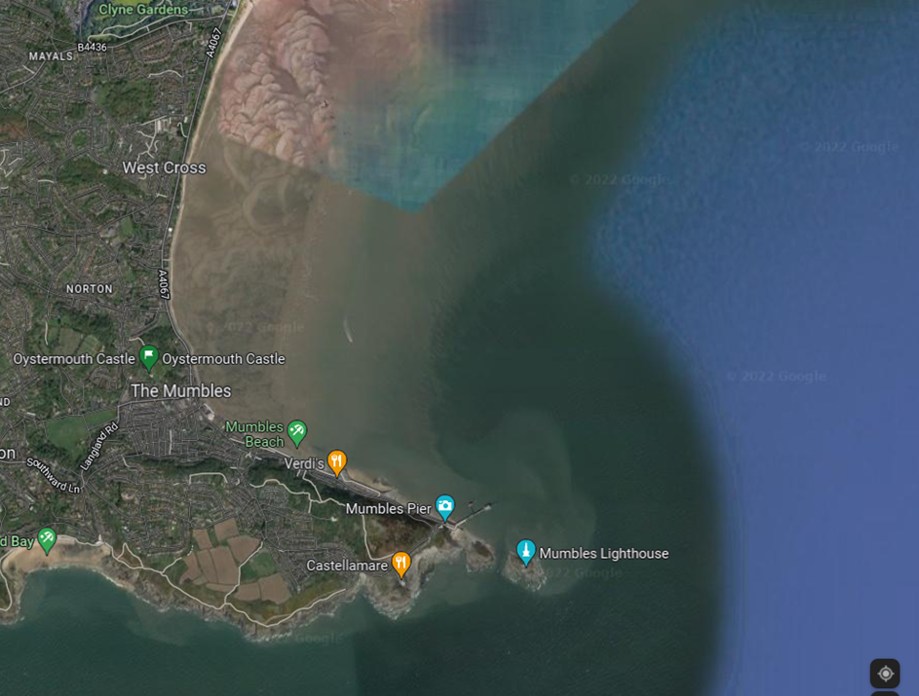

Basic Description
Mumbles head which is the furthest island out south from the main coastline is a natural rocky island about 300m south of the mainland. Middle head is a rocky tidal island with grass that is 100m south of Mumbles Pierhead. Both islands are separated from the mainland by an outer and inner sound tidal canal at high tide but at low tied it is possible to cross to both islands.
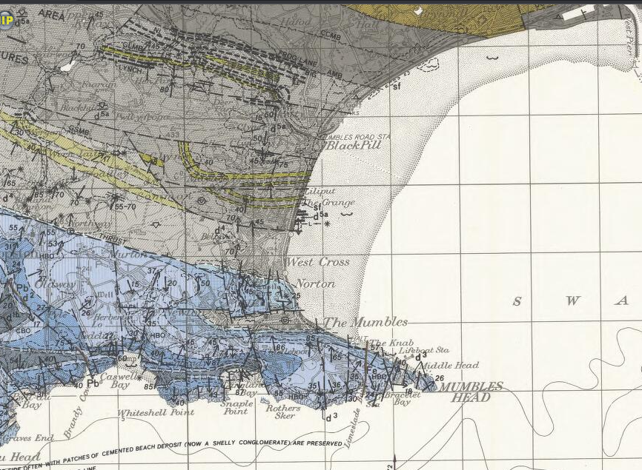
Geological composition
(British Geological Survey Map,2022)

The two islands off the coast of mumbles are mostly comprised of dolomitic Carboniferous Limestone. There are two types of processes involved with this geological composition.
Firstly, Carboniferous Limestone, so named because of its link to the Carboniferous period. This is the fifth period of the Paleozoic era. The Carboniferous period was roughly “360 million to 300 million years ago.” (Carboniferous Period and Prehistoric Facts, 2022)
During this time Wales supported a much warmer climate and thus a rich and vibrant amount of sea creatures and corals. The shells from their dead bodies mixed with Micah rich clay and lime this then created limestone. As time moved on the limestone was pushed and pressed under layers and layers eventually creating coal, which is what Swansea was famous for in 1717 all the way until 1960 (The Past - Hafod Morfa Copperworks, 2022).
The second process is the dolomization. Before lithification, the majority of dolomite developed as a magnesium substitute for limestone or lime mud. Dolomitization refers to the geological process of converting calcite to dolomite, and dolomitic limestone refers to the intermediate result. “In this instance when limestone is exposed to magnesium-rich water, the mineral dolomite, calcium, and magnesium carbonate, CaMg (CO3)2, replaces the calcite (calcium carbonate, CaCO3) in the rock, volume for volume.”
(dolomitization | mineralogy, 2022)

Geological structure
Structural geology is used to show the forces of stress within rock formations, caused by slow movements and rapid shifts of tectonic plates increasing the force and putting stress on the surrounding area. This can be used in conjunction with understanding the evolution of a locations structure and give us an indication of the geological history of an area. Through the observation and mapping of these deformations.
The Mumbles islands limestones are graded D1/D2. This area has a thin rock strata, but multiple layers can be seen, this is due to the process of the layering which created the limestone formations. Mumbles also has an anticline formation, caused by natural movement leading to the shape of the landscape arching from an originally horizontal layout, in the rock strata as the rock layers descend into the sea. The model below shows the way erosion will affect the sloping gradient of the islands.
There is also evidence in the rock strata of lots of fault lines, fault likes are caused by stress on rocks, caused by earthquakes or a slow build up of pressure, they look like fractures between rocks and can range from being millimeters to kilometers in length, the slipping of these plates can lead to major earthquakes resulting in injury, damage to buildings and loss of life.
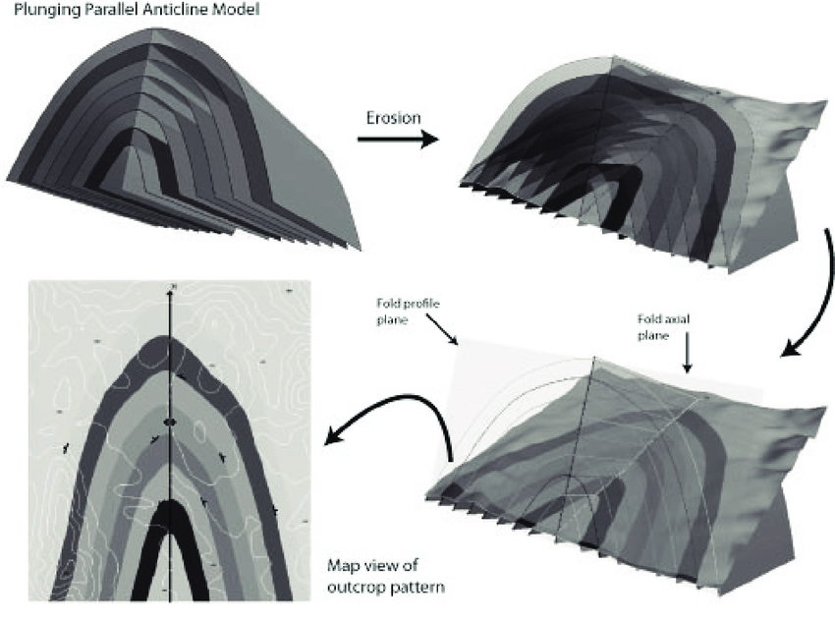

(Bond and Wightman, 2012)
Glaciation
Through observations we can see how level the horizon becomes as you approach Mumbles as you follow the beach around the western arm of the bay.
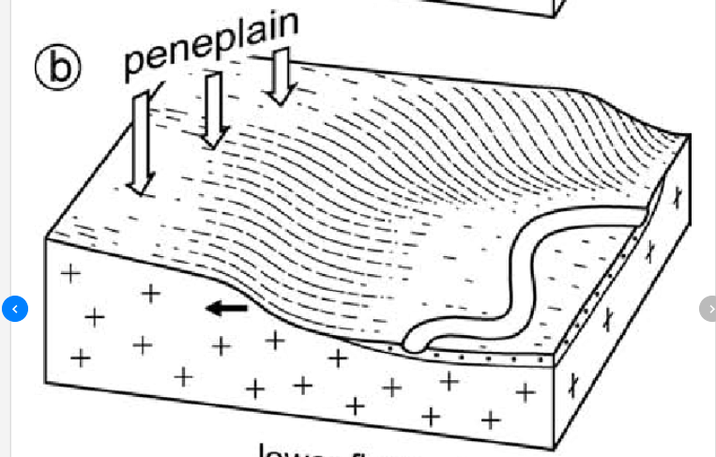
A peneplain as shown in the diagram (left) depicts the shape of sea erosion this is a similar process to what has happened to the coast of mumbles. Also making a cape out to the two islands. Peneplain as a process comes from when sea level was a lot higher in comparison the land than it is now. Before the ice age.
The Ice Age was a series of advances and retreats of the polar ice caps, punctuated by thousands of years of interglacial periods during which the climate was significantly milder - in many cases much warmer than it is today. About 18,000 years ago, the last ice left this region.
(Model diagram of Peneplain, 2022)
The retreat of the ice culminated in the deposition of a variety of glacial sediments throughout the region. Swansea Bay's real bedrock, for example, “lies 600 feet below the current seabed” (The Geological Society of London, 2022). The most prevalent deposit in the town's vicinity, however, is boulder clay (also known as glacial till), which is a combination of clay and huge boulders thrown by melting glaciers. Singleton Park, which is located behind the University and is well worth a visit, exhibits the erosional topography distinctive of this type of glacial deposit.

Pedogenesis
Pedogenesis is the formation of soil and how the process takes place leading to the natural production of soil and the soils maturing process, what leads to different soils forming and how layers of soil develop, the formation of soil taking place is dependent on variables such as the location, the climate and the environment surrounding the area, these variables can determined whether soil is formed or not and how the soil will evolve over a sustained period of time reliant on the health of the soil and being able to reproduce. (Corti et al., 2005)
Soil can be formed by the aging and natural erosion of rocks, stones, and metal. Chemical interference, animals, weather, and time are factors that contribute to the natural erosion of the materials and alter the formation and evolution of the soil, for example, soil on land that is sloping can impact drainage and the types of plants that will end up growing in that soil and other impacts dependent or the weather and most importantly the rainfall in that location, generally soil on sloping hills will have a faster rate of erosion and improves the water flow aiding the ability to carry the soil elsewhere.
Soil begins its formation as natural debris in the surrounding area comes together and goes through the process of weathering, after the parent materials have been weathered, bacteria and fungus start feeding off of the nutrients produced by the soil during the weathering process releasing oils that contribute to the development and maturing of the soil. The decomposition of plants and creatures in the soil will lead to the production of humus in the soil, produced when animal and plants start to decay, the production of humus is key to the evolution of the soil as it allows the soil organisms to feed of it and reproduce. Humus will also feed other organisms improving the health of the soil.

Coastal Influences
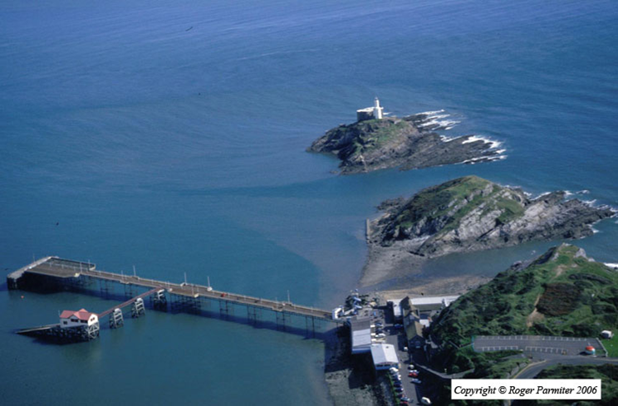
The Mumbles islands are subject to a lot of different coastal influences such as wind and tides. Thus, in turn eroding the islands into what we see today. This is important to understand as using models we can predict the future of coastal erosion through the information we have on these influences by using current statistics to make projections on the rate at which erosion will increase and what impacts that will have on the coastal region.
Looking at the diagram (right). We can see that the end coast of Mumbles forms a cape shape. Like the islands of Cape Horn. The islands are separated by a strait which when low tide occurs, people can walk to the furthest island which houses the light house.
“Swansea has the second highest tidal range in the world” (Swansea Bay - Swansea, 2022). It is also subject to forces of two tides a day this has shaped the island to create a declining slope. But also means that the tide comes in fast in between the islands.
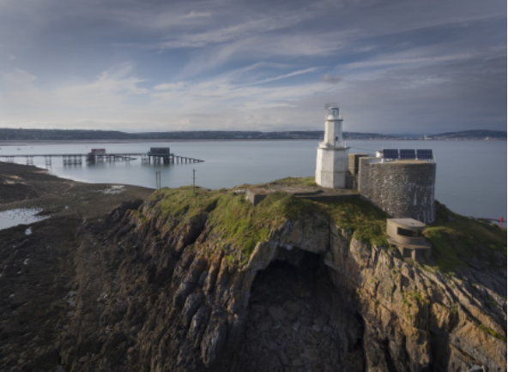
Another process of coastal influences that affect the island it the creation of ‘Bob’s Cave.’ Excessive erosion and weathering to coastal landforms can change the physical features. The waves create a hydraulic action that pushes water into the cracks and crevices. Over time sediments and sand in the sea, become abrasive until eventually the cracks become a cave.
Eventually caves form to become stacks, however due to the shape of the island it could lead to collapse of the side without the light house. The lighthouse and the gunners post have concrete bases which may help stabilize the other half of the island from collapsing.
(Collins, 2022)
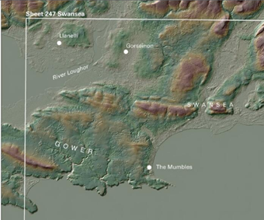
Topographical
The term "topography" refers to the detailed description of a landmass. In addition, it is the practice of depicting a surface in maps or charts.
It can be used to show both natural and man-made features, as well as their relative locations and heights. The area is depicted through a two-dimensional map which is an effective way of understanding the surface features of the land.
This map from the (British Geological Survey, 2022 depicts the elevation levels of the Mumbles and Swansea Area. The darker shaded areas in yellow and brown are mostly from old sandstone formations. The blue and grey which is mostly the area of the Mumbles is the low-lying lands of “quaternary superficial deposits.” (British Geological Survey, 2022)
Topography is a particularly important part of understanding the landscape. Through mapping topography over the years scientists can theorize how the landscape has changed over the years, and the processes involved. They can also use it to module the impact of climate change in the area.

Management and conservation
Current Management
Swansea as a county has one of the most diverse ranges of natural habitats in the UK. This abundance of natural areas supports many diverse types of plant and animal species. This beautiful coastal city “is home to about 70% of the UK's ecosystems and at least 20% of the species designated as important for biodiversity conservation.” (Partnership, 2022).
Mumbles currently has a sea wall which was originally built in the 19th Century. Over the years because of lack of maintenance and with natural erosion processes from being on the coast, the walls have fallen into disrepair. The threat of rising sea levels predicted in the future has urged the council to rethink their current assessments and in 2015 they created the “Coastal Risk Management Programme.” This was a way for the issues relating to the risk of flooding be addressed and to secure the finances for the projects to ensure the future of Mumbles. Works are to be started as of this year to update the sea wall defense. (Mumbles coastal protection project - Swansea, 2022)
Unfortunately, the Mumbles islands will continue to erode over time, until the islands disappear. This is a natural process of all coastal landforms. The main considerations to look at is recording the gradual decline of Mumbles and use this information to help monitor similar occurrences so that we may understand better how the land is affected over time and how to manage the decline of such landforms.
Another key factor is in using this information to help us understand how rising sea levels due to climate change will affect these landforms erosion processes. Evidence will be key in making informed decisions to solutions and climate change policies in future.

References

2022. [online] Available at: <https://www.researchgate.net/figure/Model-illustrating-the-envisaged-landscape-evolution-of-the-Bangoin-peneplain-northwest_fig6_233677060> [Accessed 9 January 2022].

2022. [online] Available at: <https://largeimages.bgs.ac.uk/iip/mapsportal.html?id=1004285> [Accessed 3 March 2022].
Bond, C. and Wightman, R., 2012. Beyond map view: teaching the conceptualisation and visualisation of geology through 3D and 4D geological models. Planet, 25(1), pp.7-15.
Collins, L., 2022. Mumbles Lighthouse pier and Bobs cave - Leighton Collins Print. [online] Pictorem. Available at: <https://www.pictorem.com/209392/Mumbles%20Lighthouse%20pier%20and%20Bobs%20cave.html> [Accessed 23 February 2022].
Corti, G., Agnelli, A., Cuniglio, R., Sanjurjo, M. and Cocco, S., 2005. Characteristics of rhizosphere soil from natural and agricultural environments. Biogeochemistry of Trace Elements in the Rhizosphere, pp.57-128.

Encyclopedia Britannica. 2022. dolomitization | mineralogy. [online] Available at: <https://www.britannica.com/science/dolomitization> [Accessed 20 February 2022].

Geolsoc.org.uk. 2022. The Geological Society of London. [online] Available at: <https://www.geolsoc.org.uk/GowerTour> [Accessed 7 February 2022].

Hafod Morfa Copperworks. 2022. The Past - Hafod Morfa Copperworks. [online] Available at: <https://hafodmorfacopperworks.com/the-past/#:~:text=The%20copper%20industry%20of%20the%20Lower%20Swansea%20Valley&text=Such%20was%20the%20importance%20of,produced%20by%20the%20smelting%20works.> [Accessed 20 February 2022].

Partnership, W., 2022. Wales Biodiversity Partnership - Swansea. [online] Biodiversitywales.org.uk. Available at: <https://www.biodiversitywales.org.uk/Swansea#:~:text=Nearly%2070%25%20of%20the%20habitats,(SSSI%2C%20NNR)%20level.> [Accessed 29 March 2022]

Science. 2022. Carboniferous Period and Prehistoric Facts. [online] Available at: <https://www.nationalgeographic.com/science/article/carboniferous> [Accessed 20 February 2022].
Onajite, E., 2014. Sedimentation and Oil/Gas Formation. Seismic Data Analysis Techniques in Hydrocarbon Exploration, pp.3-16.
Swansea. 2022. Mumbles coastal protection project - Swansea. [online] Available at: <https://www.swansea.gov.uk/mumblescoastalprotection#Location%20and%20proposed%20improvements> [Accessed 30 January 2022].

Swansea. 2022. Swansea Bay - Swansea. [online] Available at: <https://www.swansea.gov.uk/article/6987/Swansea-Bay#:~:text=At%2010.4m%20Swansea%20Bay,Swansea%20Beach%20is%20the%20longest.> [Accessed 28 January 2022].

