LCBB5001
Entrepreneurship
Assessment 2

Student Name: Andreea Gina Tabacaru
Student ID: 1914595

Table of Contents
Introduction 1
Business description and market opportunities 2
Evaluating industry attractiveness by Porter’s Five forces model 3
Operations and management team for Sully’s E-Mart 5
Marketing plan for Sully’s E-Mart 6
Financial plans for Sully’s E-Mart 8
Market research 9
Conclusion 10
References 11

Introduction
A business plan is essential for the transformation of a business through the proper alignment of innovative ideas, entrepreneurial actions and business objectives (McKenzie, 2017). This paper is to formulate an effective business plan by identifying and creating business scopes and opportunities in the post-Covid-19 landscape. It includes an industry analysis by utilizing Porter’s five forces model, highlighting the scopes and opportunities based on organizational capacity and the external environment. Besides, it outlines the operational functions of the business, production procedures, supplier and distribution chains and management framework of the business plan. The paper also evaluates the marketing plan by adopting the marketing mix functions. A financial plan is also evaluated in the paper for securing the financial sources and a cash budget forecast for defining the financial objectives.

Business description and market opportunities
The business plan adopts an appropriate strategic choice based on the market analysis data, market opportunity, external and internal analysis and management procedures for an effective business operation (McKenzie, 2017). The Covid-19 all over the world has brought a dramatic boost to the e-commerce sales all over the world creating many business opportunities. The retail companies often provide the fundamental needs including foods, groceries, fashion and footwear, home appliance furniture and so on. The Covid-19 pandemic has severely affected the frequent mobility of the people making them online dependent. In this stance, an opportunity has been created for retail e-commerce (Ritch and McColl, 2021). Considering this opportunity, an e-commerce marketplace called Sully’s E-Mart will be introduced in the UK. The company is going to start a large entrepreneurial venture with online marketing of daily retail products. The company is to introduce grocery items, fashions and clothing, footwear, home appliance, toys, jewellery items and organic and processed food products. Sully’s E-Mart is going to operate in around 40 different physical locations for operational eases. The online market is to collaborate with renowned and potential brands with higher values. The products from different brands will be displayed, specified, sold and delivered by Sully’s E-Mart. The business plan is to include the development of a mobile app, websites, campaigns, financial plan, placement of a proper marketing mix and operational plans.

Evaluating industry attractiveness by Porter’s Five forces model
The analysis focuses on the five forces within the retail industry to assess the level of competition and identifies the adequate strategic priorities that will be effective to address in the business plan. The business plan is evaluated for establishing Sully’s E-Mart as a leading retail company across the UK.
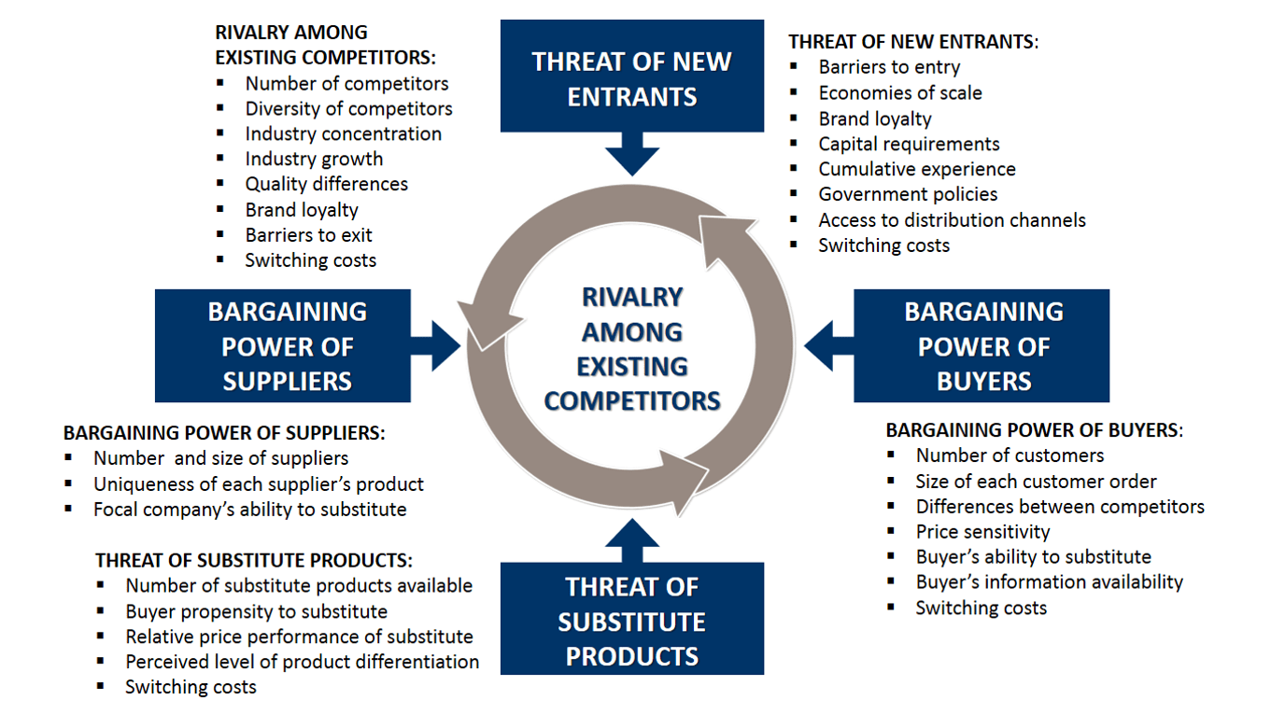
Figure 1: Porter’s five forces model, Source: (Berbegal et al., 2016)
Bargaining power of the supplier: Lack of suppliers and alternative options to Sully’s E-Mart will lead to the higher bargaining power of the suppliers. Besides, the quantity of the product items and their rarity also defines the bargaining power of the suppliers. The higher bargaining power of the suppliers will affect the profitability and net operating income. The company should develop alternative producers and partner businesses. Alternative organizations with substitute products will be effective in controlling the bargaining power of the suppliers.
Bargaining power of the buyer: The bargaining power of the buyer depends on the number of marketers within the same industry. Plenty of choices will cause higher bargaining power to the buyer which may lead to higher demands for low-price products or a decrease in sales (Berbegal et al., 2016). This potential threat to Sully’s E-Marts’ business operation can be contrasted by enhancing the value proposition. Competitive forces are planned to be developed by addressing the market preferences, and supplies of the rare products, developing potential customers and assessing higher brand equity.
Threats of new entrants: Porter’s five forces analysis emphasizes the threat of new entrants in the specific industry and their impacts on the business operation. New retail marketers are threats to the market shares held by the company. Sully’s E-Mart will develop an affiliated and social media marketing chain to expand the business in the European regions. The globalized conception of marketing is undertaken by the company to dominate the field of e-commerce. Higher expertise will be required by Sully’s E-Mart to comprehend the new threats in the retail and e-commerce industry.
Threats of substitute products: The alternative products or services decrease the appeal of a unique product that is provided by Sully’s E-Mart. For example, the £5-£20 voucher coupon for more than £100 shopping encourages many customers. But a substitute coupon discount of £10-£30 voucher by Laura Ashley would fade the offers provided by Sully’s E-Mart (Bolland, 2017). As the competition in the e-commerce and retail industry in the UK has been intensive, Sully’s E-Mart should be focused on its uniqueness and exclusive offerings.
Rivalry among the existing competitors: Rivalry among existing marketers within the retail industry is intensive across the globe. Higher expertise in product selection, exceptional service provision and attractive discounts and promotions will help Sully’s E-Mart to comprehend the market competitors. Tesco Plc has been the most popular retailer, besides, Laura Ashley, Debenhams, Asda, Topshop Topman, John Lewis Partnership and Zalando have been prominent rival marketers to Sully’s E-Mart (Bolland, 2017). The company will enhance its service, reduce in-app bugs and malfunctions, develop additional features within its apps, and place appropriate marketing mixes to create a positive portfolio.
Name of competitor | Differentiation
Laura Ashley | Leading business in fashion, clothing and furniture retail.
Debenhams | The company retails clothing, fashion, e-commerce electronics, health and beauty and consumer goods.
Asda | Prominent e-commerce, consumer goods, clothing, health and beauty and subsidiary.
Table 1: Competitor analysis of Sully’s E-Mart.
The shifts toward online sales and promotion should be up to the mark and capable of attracting customers. There have been several reasons behind the drawbacks in the performance of innovative ideas. Proper alignment was overlooked during the Covid-19 situation and that resulted in a decrease in its operating income (Mitchelmore and Rowley, 2016). The critical analysis of the industry and recommended actions will be supportive to enhance business operations and functional progress in Sully’s E-Mart.

Operations and management team for Sully’s E-Mart
Sully’s E-Mart will operate in the retail chain industry in the UK. The company will be operating in around 40 different locations across the UK. The company will require around 12,000 employees based on direct employment and concessions. The company will be linked with around 7,600 brands and companies that are related to their sales and distributive initiatives (Hokkanen et al., 2020).
Sully’s E-Mart has planned an effective operational and managerial structure to operate the business within a complex market situation. The online business plan has emphasised the post-Covid-19 situation and the tendency to overcome the impacts of global crises on business operations (e.g.: Covid-19 and the Ukraine crisis). The company is planning to add several items like clothing and fashion for males, females and kids, consumer goods, electronics, jewellery, toys, footwear, home appliances and furniture. Different brands and companies will collaborate with the distributive chain managed the Sully’s E-Mart. The company will be operating in 40 physical locations across the UK and the e-commerce platform is planned to cover the EU zones as part of expansion programs. New executives and management teams will operate in different units of the company.
Name | Role | Specialization
Nick Witney | Chief Executive | Nick Witney will cover the executive roles of management and operations in the regional markets in the European Union.
Pierre Hougardy | Development Director | Pierre will imply the research data and tends to carry out development goals in suitable places.
Bertrand de Cordoue | R&T Director | Research and technology support will be carried out by Cordoue and his team.
Ulf Hammarstrom | Marketing Director | The marketing ad campaigns, promotional actions and occasional discounts will be planned and executed by Hammarstrom.
Table 2: Operation and management framework of Sully’s E-Mart.
Physical shops will be available to the customers for in-person visits and purchases. Besides, the e-commerce platform is planned to make optimized with several payment methods and gateways for an easy procedure for online purchases.
The company will develop its iOS and android app, official website and relating different payment gateways for easier transactions and purchasing process. A customer-friendly interface will be developed as this is effective in attracting a wide range of audiences in the EU and UK (Hokkanen et al., 2020). The online purchases will be delivered to the customers within 3-7 working days by Sully’s E-Mart. An easy return policy is added to the purchasing process which will cherish the enthusiasm amongst the potential buyers of Sully’s E-Mart.

Marketing plan for Sully’s E-Mart
The marketing plan evaluates a set of actions for proper utilization of the marketing mixes to assess an optimum sale of the products and services. The four Ps of the marketing mix directs the development process of products and services for a specific market scenario, adequate pricing of the products and services, effective means of promotional actions and public communications and placement to the most appropriate locations (Cao, 2018).
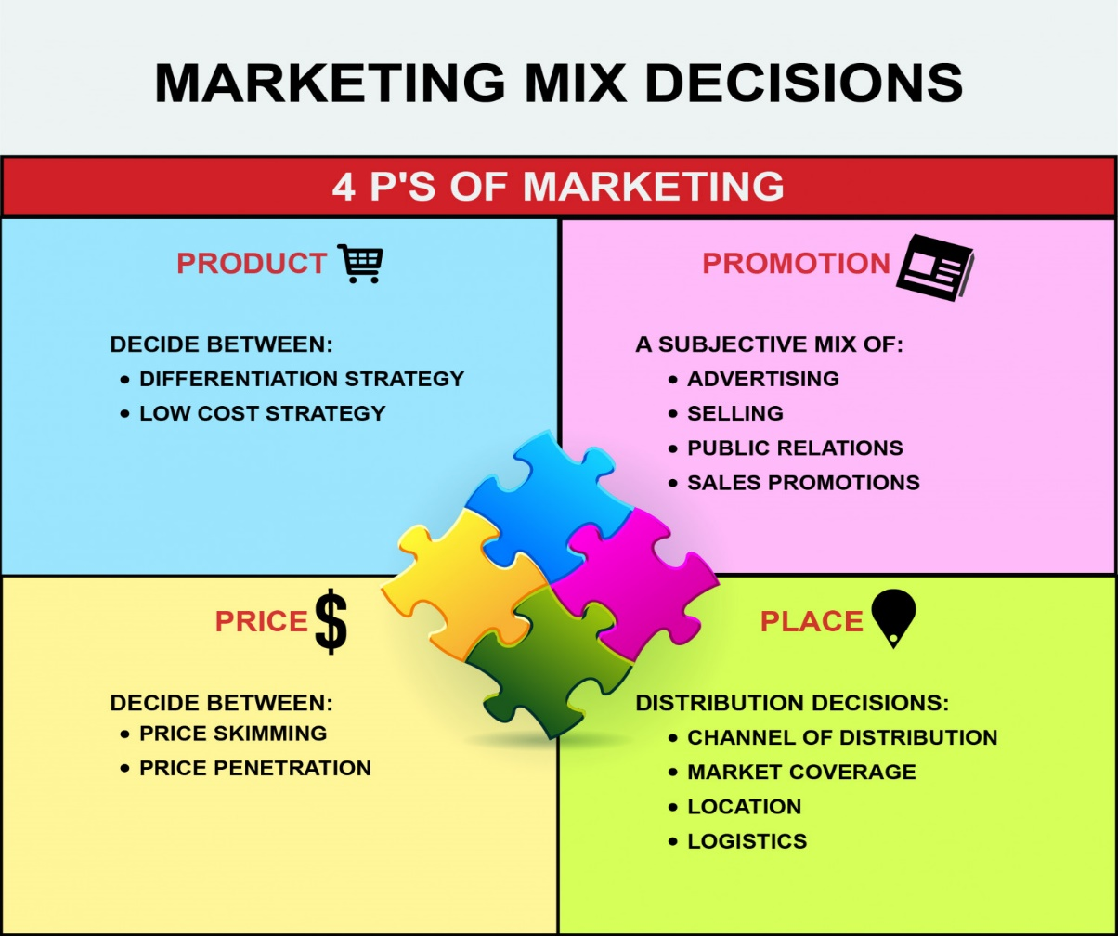
Figure 2: Marketing Mix decisions of Sully’s E-Mart, Source: (Cao, 2018)
Product and services: Sully’s E-Mart will collaborate with different fashion brands, footwear, toys and several grocery companies. Sully’s E-Mart will tend to focus on the cultural aspects, demographic situations and social trends for marketing an appropriate product. Different occasions are to be covered while planning for the product and service deliveries.
Pricing: Demographic data, economic status and lifestyle are essential parts of deciding the pricing of products and services provided by Sully’s E-Mart. The company should be concerned with demographic portraits, income status and social trends to place an adequate price.
Promotional campaigns: Promotion is an effective medium of approaching the projected audience. The marketing team of Sully’s E-Marts should imply the local occasions, festivals, trends and demographic to approach with the right promotional offers. Discounts, price reductions, cashback offers and incentives should be highlighted through the promotional campaigns.
Placement: The product and services in the physical locations should be proposed according to the external factors. Sully’s E-Mart will assess the potential customers’ data in different locations and inform them about any updates. The e-commerce platforms should be utilized to highlight the new products and any promotional actions in remote areas across the globe (Cao, 2018).

Financial plans for Sully’s E-Mart
A financial plan refers to the documentation and strategic choices of adequate utilization of the money and proposing future monetary goals through a business initiative. An adequate financial plan suggests the company assess resources from different investors from different financial sources including business incubators, angel investors, stockholders and venture capitals (Wheadon et al., 2014). The inclusion of varied investors and stakeholders reduces the risk exposure by dividing into the investors and financial sources.
 | Month 1 | Month 2 | Month 3 | Month 4 | Month 5 | Month 6
Group Revenues | 23.6 million | 27.3 million | 24.9 million | 26.5 million | 22.8 million | 24.9 million
Fixed Costs  (Rents, Labour cost, Production and Delivery cost) | 13.3 million | 15.4 million | 11.2 million | 15.1 million | 11. 4 million | 13.7 million
Variable Costs  (Underlying EBITDA, Maintenance and utility, Others) | 4.6 million | 6.9 million | 5.2 million | 11.2 million | 7.7 million | 7.1 million
Profit | 5.7 million | 5 million | 8.5 million | 0.2 million | 3.7 million | 4.1 million
Table 3: Projected Cash budget forecast of Sully’s E-Mart.
Sully’s E-Mart is to utilize the financial resource to attract potential fashion, leisure and subsidiary brands. These potential brands will attract customers to purchase the products and services provided by the retail company. The revenues attained by Sully’s E-Mart are planned to utilize properly and to extract expected profitability. The net operating incomes from the first 3 months will be invested in the potential brands with higher sales. This will enhance the profitability rate of Sully’s E-Mart. The company should avoid investing the operating income in brands with lower potential and minimal sales. The external sources of finance will be deployed in these sources to avoid risk exposure (Horgan, 2021).

Market research
The e-commerce platform has become popular among the audience since Covid-19. The total sales of Sully’s E-Mart will be increased by 6.9% during the second phase of the business plan. Sully’s E-Mart is planned to assess around £80 million in operating income in 2022 and it will gross around £140 million in revenues. According to Lauretta Roberts’ industry report, total sales of different retailers have increased by 7% during the 2020 pandemic situation (Horgan, 2021). Especially the online purchase will be reached an optimum after the last phase of the pandemic period in 2020 (Yang et al., 2021). The utility of Sully’s E-Mart app and its easy return policies will be appraised by many users. Sully’s E-Mart will introduce its online marketing procedures by integrating additional features, minimalistic purchasing process, payment methods, security and promotional campaigns. Highlighting the e-commerce media of business operation will enable Sully’s E-Mart with low-cost service provision and access to a wider audience.

Conclusion
An entrepreneurial venture requires an adequate business plan for properly managing the entrepreneurial objectives. The innovative ideas and radical changes are dependable on the evaluation and implementation of adequate strategic priorities. An appropriate analysis of the external environment is essential to assess the opportunities and scopes of entrepreneurship. Besides, Porter’s five forces model gives an overview of the market threats and impediments that would make trouble to the business operation and profitability. Marketing mixes and financial plans should be executed properly as well.

References
Berbegal, J., Gil Doménech, M.D. and Alegre, I., 2016. Improving business plan development and entrepreneurial skills through a project-based activity. Journal of entrepreneurship education, 19(2), pp.89-97.
Bolland, E.J., 2017. Internal and External Analysis. In Comprehensive Strategic Management. Emerald Publishing Limited.
Cao, H., 2018. The growth of e-commerce and its impact on fast-fashion retailers.
Hokkanen, H., Walker, C. and Donnelly, A., 2020. Business model opportunities in brick and mortar retailing through digitalization. Journal of Business Models, 8(3), pp.33-61.
Horgan, D.C., 2021. Modelling UK Department Store Market Share Using the Nonautonomous Lotka-Volterra Equations.
McKenzie, D., 2017. Identifying and spurring high-growth entrepreneurship: Experimental evidence from a business plan competition. American Economic Review, 107(8), pp.2278-2307.
Mitchelmore, S. and Rowley, J., 2016. Entrepreneurial competencies: a literature review and development agenda. International journal of entrepreneurial Behavior & Research.
Ritch, E.L. and McColl, J., 2021. The ‘Race to the Bottom’: Moving Closer to Home? In New Perspectives on Critical Marketing and Consumer Society. Emerald Publishing Limited.
Sinha, J.I., 2021. Positioning a brand as an internet meme: The case study of Supreme. Journal of Brand Strategy, 10(2), pp.148-157.
Wheadon, J.D. and Duval-Couetil, N., 2014. Business plan development activities as a pedagogical tool in entrepreneurship education. The Journal of Engineering Entrepreneurship, 5(1), pp.31-48.
Yang, M.X., Zeng, K.J., Chan, H. and Irina, Y.Y., 2021. Managing loyalty program communications in the digital era: Does culture matter? Journal of Retailing and Consumer Services, 60, p.102476.

