Danielle Tooze (1812486)
3RD JULY 2020
understanding and engaging in the customer experience

TESCO LTD. 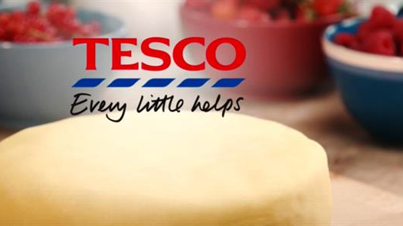

EXECUTIVE SUMMARY

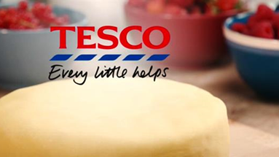

(Haymarket Media Group LTD,2020)

This report has been requested to analyse, ethical practice and sustainability within the Tesco organisation.
The report will be investigating, how engaged Tesco is regarding ethics and sustainability, to conclude if Tesco practice what their policy states. While conducting research, there has been a lot of controversy by articles agreeing and objecting when it comes to Tesco’s ethical practice.
Examples of competitor supermarkets will be given.
Research will show whether Tesco’s customer service improved due to their policies.
The researcher Danielle Tooze will demonstrate her knowledge and understanding of how ethical and sustainable the organisation Tesco is.
The customer relationship management (CRM), will be explained in detail with examples and how this can be used by organisations, how the technology system works and how it stores data, in relation to customers and Tesco.
Within the findings will be an outline improvement of how the Tesco organisation.
Models will be included in this report.
The researcher will incorporate better solutions to become more ethical and sustainable in the fourth-coming future.

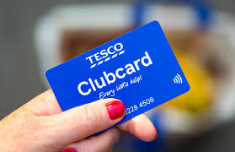

(The Sun,2020)

CONTENTS PAGE

- Page number
- 2 – Executive summary
- 3 – Contents page
- 4 – Introduction
- 5 to 11– Findings
- 12 – Conclusion
- 13 – Recommendations
- 14 to 16 – Reference List

Introduction

This report is requested by Maria Heffernan on the June 2020. The purpose of this report is to analyse ethical standards and sustainability of the organisation Tesco. The report will be compiled by the student Danielle Tooze.

This focus of this report will cross examine Tesco, to discover if the organisation complies by the standards they portray to customers or dishonestly preach. Furthermore, how Tesco has improved its customer service by adopting these policies that are currently in place. Research will be conducted from a variety of credible sources including articles, books, and websites.

Research shows that Tesco presents itself as a customer focused business, selling only products from quality supply chains who abide by regulations.

Tesco states that “All potential new suppliers are evaluated to ensure that they understand the standards we require and have the ability to meet them. In practice this means that all new suppliers are risk-assessed before supply begins, with appropriate action being taken to resolve any serious issues prior to commencing supply. We will not work with a supplier if we identify critical problems at this initial screening stage and cannot resolve them.” (Tesco,2020).

Included in this report will be an example of a competitor supermarket, regarding ethical and sustainability policies, also models and theories will be shown with regards to the Tesco company and how the organisation can improve its practice for the future.

2.1 Findings

Background information on the organisation Tesco

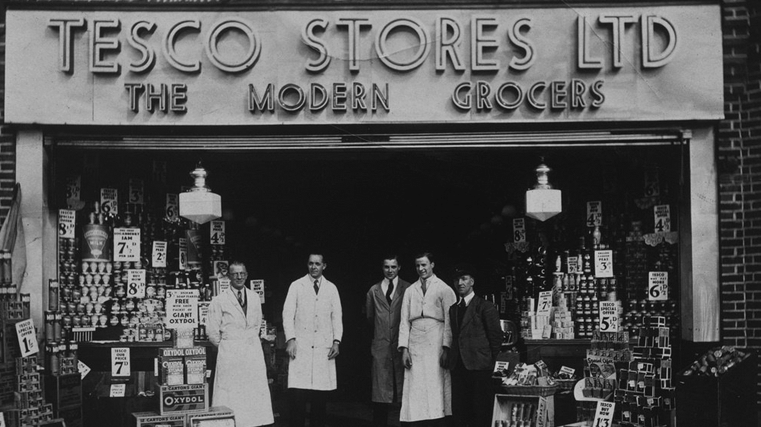 (Solutions for Retail Brands Ltd,2020)

The Tesco company was first created by an entrepreneur called Jack Cohen in 1919, Cohen opened a market stall in Hackney, East End of London, selling surplus groceries, on his first day he made just £4 and only £1 of that was profit. In 1929 Cohen opened his first store in Middlesex, north London called Tesco Stores Limited - The Modern Grocers, the store sold dry items such as coffee beans and tea. There he started to create stability for his business and customers.
In 1963 Cohen went on to offering green shield stamps to attract more customers, Tesco believed it injected momentum into their business and inspired loyalty amongst their customers.

In 2014, Tesco made a ground breaking step in battling food waste, Tesco pledge “so long as that food is fit for human consumption, I’d much prefer it to go to people than animal or fuel.”(BBC,2020).

In 2020, Tesco is currently being affected by the Covid19 Pandemic, which has restricted the organisations opening times, customer service and revenue. With the organisation having to pay 50,000 employees full statutory sick pay due to the current lockdown of stores across the globe, Tesco still must pay distributors and other employees who have worked through the pandemic plus giving each a bonus of 10% on top of their standard wage. Tesco has been granted a £635m tax break, to ensure the organisation can adapt to health and safety measures, to safeguard employees and customers.

2.2 Tesco ethics and sustainability

Tesco has made huge developments over the last 100 years, starting from a market stall to one of the biggest supermarkets in the world, Tesco currently have 7,000 stores around the world, employing over 50,000 employees. Tesco not only sell food, they sell products such as clothing, loans, pet insurance, toiletries, tobacco products and alcohol.
The organisation has evolved drastically with modern day life, they offer delivery service to your door, click, and collect and even mobile phones.
Tesco stores have engaged in work standards, all stores are bright, attractive and a clean environment for employees and customers. This organisation only source suppliers who have been inspected, care about employees and abide by the laws of ethics and sustainability as Tesco stand by.
“We always had a reputation for being tough because we wanted to drive the best deal for our customers, but we were always seen as fair”. (William Reed Business Media,2020)
The organisation only source suppliers who share the same values on ethics and sustainability. When sourcing suppliers, they must examine how ethical this supply chain is. The chosen suppliers will endure a full investigation into the ethical practice they stand by and if it aligned with the ethical values Tesco have.

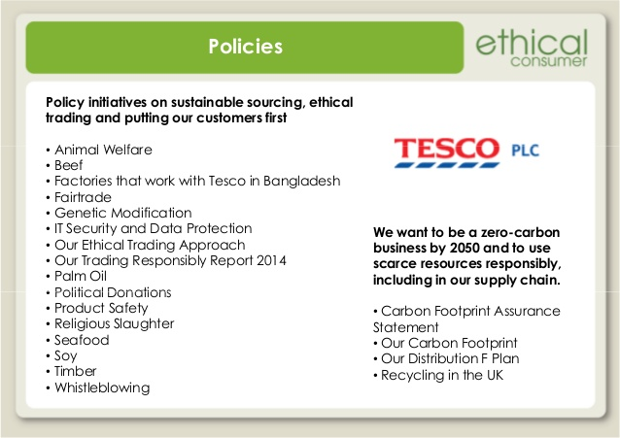 (Linkedin corporation,2020)

Tesco are committed to creating a zero-carbon business by 2050, the organisation is taking positive steps in the right direction, including night time energy saving, turning off unnecessary lighting during the night time hours to reduce energy costs and lower its carbon footprint.
Tesco distributors have adopted the F plan, where delivery drivers use fuller pallets or cages to maximise the amount of food delivered, furthermore deliveries are grouped together to reduce the distance they travel and subsequently lower fuel consumption.
The organisation already has adopted using only recyclable packaging on products and grocery bags are also made from recycled plastic and organic fabric.

According to an article dated 2015 in the Guardian, Tesco suppliers state that In fact, Tesco is the worst at following the grocery code of practice, due to 30% of Tesco’s suppliers don’t comply with industry code, 1,000 out of 3,000 manufacturers had been contacted, 6% of them said they do comply the other 35% stated they rarely comply with the code. Only 4 out of 100 suppliers responded by questionnaire to state, that Tesco rarely complies with government back industry laws to protect manufactures. This means that Tesco is unionist in what they stand by. Tesco replied to this acquisition by stating

“Suppliers are at the heart of our business and we’ve been working collaboratively with them to change the way in which we work. Since 2013, we have taken action to strengthen our compliance processes and have established a dedicated supplier helpline in the UK.” (Guardian News & Media Limited, (2020)

According to the Guardian newspaper article in 2019, the Tesco supermarket chain pledge to band all excessive use of packaging, firstly, the organisation stopped, the plastic used when buying multiple tins in store, has saved 490 tonnes of plastic in one year. This is a great step in the right direction. Secondly black plastic microwave meal trays have been eliminated and replaced with recyclable cardboard trays to help landfill. Tesco is working with suppliers to do the same.

Competitor supermarket – Morrisons

Competitors such as Morrisons are one step ahead of Tesco, when it comes to being more sustainable, Morrisons has already introduced, no packaging fruit and veg, customers have a choice to use recycled paper bags for loose products, the organisation has also refill stations, for food products such as nuts, pasta and cereal. In just one-year Morrisons has seen an increase of 40% in purchases and saved 156 tonnes of plastic going into landfill sites. This has made a huge impact on their carbon footprint and revenue. The organisation has also removed polystyrene from food and drink packages and is now using only recyclable packing which includes grocery bags being recycled paper only, this saves 1,300 tonnes of plastic going to landfill every year. This organisation wants to make positive steps in the right direction in terms of the environment.
“Morrisons plastic reduction initiatives are detailed in it’s 2018-19 Corporate Responsibility Review. The review also details that the group has reduced carbon emissions by 45% since 2005.” (Morrisons LTD,2020)

Research shows that Tesco are taking positive steps in the right direction when it comes to ethics and sustainability, the organisation has replaced plastic packaging with recycled paper bags.

Tesco’s strategy for customer-based focus

The Tesco organisation are customer based; this organisation uses a technology-built software called

Customer relationship management also known as the acronym CRM. This software programme is used to manage interactions between the customer and organisation. CRM system helps organisations such as Tesco build customer relationships ad streamline processes so they can increase sales, improve customer service, and increase profitability.
The CRM system also provides Tesco with customer purchase history, this is easier to track the customer buying habits and allows the organisation to know what the customer will purchase again, when using the CRM system, for example, Tesco rewards loyal customers giving money off vouchers off next purchase and sends promotional offers via email and post. This will build better relationships with the customer and make the customer feel appreciated.
Tesco use CRM for a range of purposes, firstly for the technology side of things, for example record/report keeping and analysing interactions between company and customer. secondly the business strategy, for example for the business philosophy of absent how relationships between customer and organisation can be managed. Thirdly for the process, for example the system that the organisation uses to nurture and manage those relationships.
If your business is going to last, CRM is the framework for that strategy.

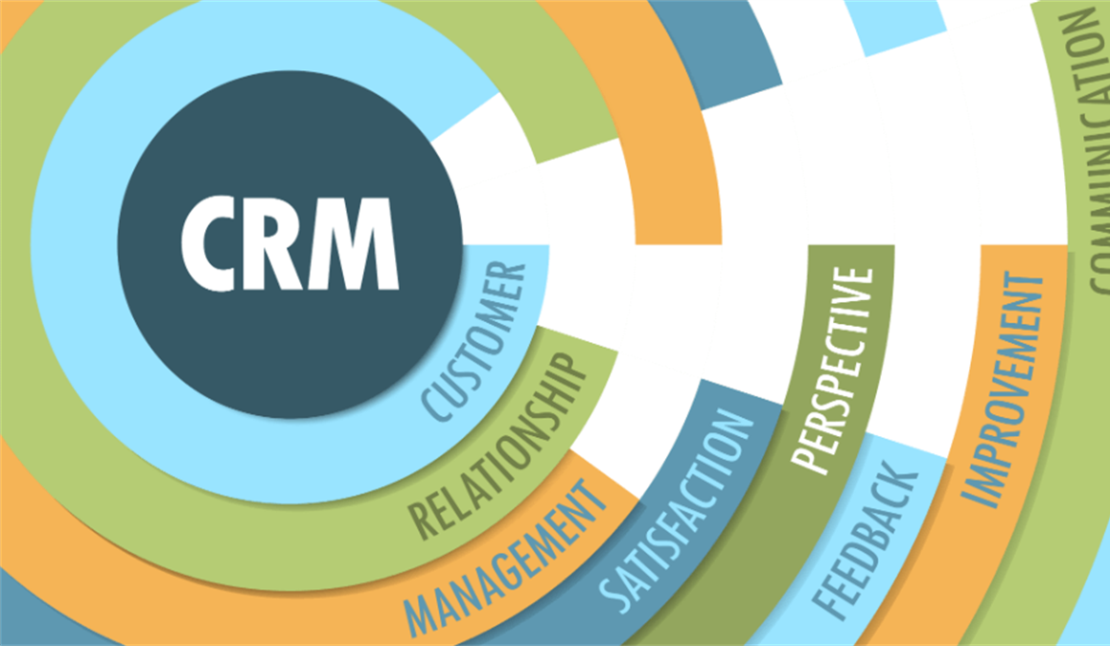(Tech.Co,2020)

“A more popular approach with the recent application of information technology is to focus on individual or one-to-one relationships with customers that integrate database knowledge with a long-term customer retention and growth strategy.”(Parvatiyar, A. and Sheth, 2001)

- Disadvantages to the customer:
“Some Customer Relationship Software utilizes remote Internet Connections to keep customers’ data. The downside of this kind of CRM is that the organization has no control of customers’ details.” (Andysowards,2020)
- Disadvantages to the employee:
“A lack of commitment or resistance to cultural change from people within the company can cause major difficulties with the CRM implementation.” (NiDirect,2020)

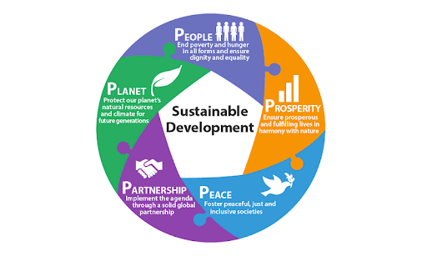
(International Young Nature Friends,2020)

To create long lasting customer relationships, Tesco must create a customer service plan, with short-term goals that are defined and obtainable over a reasonable period. So, to build sustainability, make short term changes that can be clearly obtained. If issues arise in short term goals then plans can be altered, but if this happens in the long-term goals this can cause time consuming problems.

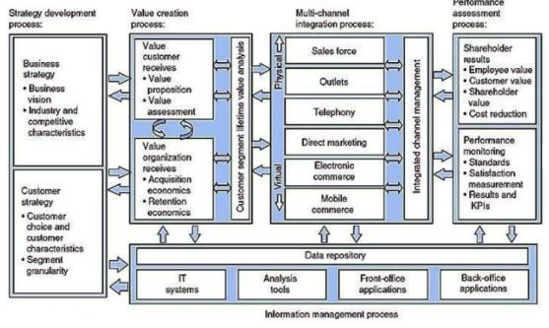

(Project Guru,2020)

Developing Tesco’s ethical and sustainability

Research shows that the organisation Tesco, could be more sustainable in a variety of areas, for example Tesco could create a no package area, selling fruit, veg, nuts and cereal. This area would be bringing your own bag or recycled paper bags would be available to use, this idea could save tonnes of plastic waste, less plastic in landfill sites and lower Tesco’s carbon footprint on the environment. This area would be appealing to customers that care for the environment, want to save money on packaging costs which are usually added to products and fresher produce. Supermarkets plastic free pledge need to connect more with customers to gather traction, which has not yet happened. Questionnaire’s should be completed by customers, to ask what they want to see in stores and how the store can change its sustainable resources to better the environment.

Secondly supermarkets use 3% of the worlds energy, with big stores all over the world, Energy efficiency is really only a small part of a much bigger supermarket sustainability picture – and point of sale is just a small part of the food supply chain from field to fork. There are energy demand reduction and other opportunities for greener practises to be found throughout, from agriculture to processing, transport and waste disposal.
There’s no doubt, however, that supermarkets are making moves to improve their contribution to reducing emissions and waste. From bold plastic reduction and recycling targets to moves to reduce food waste and the introduction of electric vehicles to delivery fleets, action is evident. For a couple of specific recent examples, Aldi has been hailed for its greener refrigeration technologies and practices, while Sainsbury’s has become the first to remove plastic bags for loose fruit, veg and bakery products.

But are the grocery giants going far enough? Not yet, it seems. Ethical Consumers such as Tesco, which considers everything from environmental reporting and waste to bee health, only featured one major supermarket (Marks and Spencer) in its top ten, with Waitrose, Co-op, Iceland and Aldi following. Alternative food retailers showed the big guys how it is done, dominating the lead positions.

The organisation could benefit from using less energy at stores, for example Tesco already reduces lighting at night time hours, this could go on further to reduce wasted energy such as big signs in store, by reducing the use of lighting which isn’t necessary, Tesco could reduce their carbon footprint by tonnes per year.

Developing the customer relationship management system, the thing to remember is the easy part is using CRM system to store information, but its hard part is analysing it. With technology advances making CRM more powerful. To use the CRM system effectively the organisation must use the data system in everything they do, to create customer purchase history and the one on one customer relationship strong.
When the CRM technology was created, initially it wasn’t created for the use of supermarkets, it was created for businesses such as banks and telephone companies, but over the years supermarkets have been using it to create customer relations and more revenue in their organisation. Supermarkets have thrived using this system, they now know what the customer wants through purchase history.

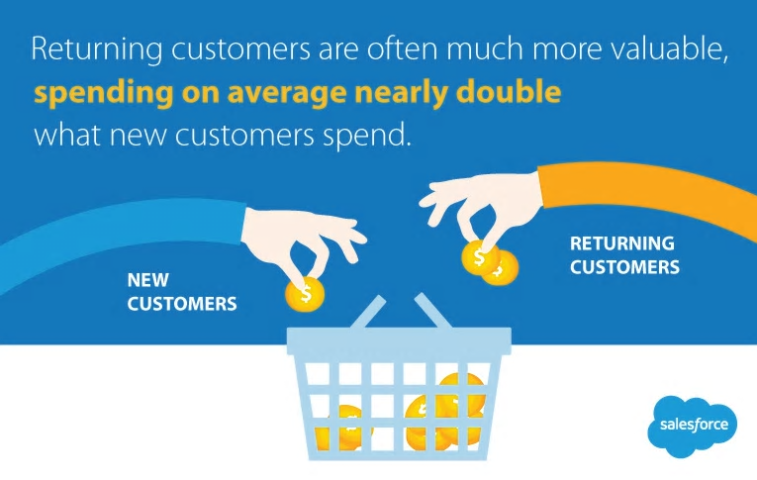(Salesforce.com,2020)

Conclusion

When research was conducted on the organisation Tesco, its clear to see that from the start the Entrepreneur knew what type of grocery store, he wanted to create and how he wanted entice customer and business relationships, when Jack Cohen opened his first store in 1929, he created a store that would attract loyal customers, using the green shield stamps insured customers would return for future purchases. Cohen created a store that was customer focused and employee driven. This resulted in Tesco becoming one of the world’s biggest supermarkets as we see it today. Over the years the laws and regulations has changed, more focus on the carbon footprint and reducing waste to landfills, for example for many years’ plastic was used to hold products such as fruit and veg. Now organisations are realising that plastic take 1,000’s of years to disintegrate and landfills are completely full of it. Now is the time to create less of an impact on the environment. Tesco is taking major steps to create a less carbon footprint regarding the environment, this organisation has banished all plastic carrier bags (which created 7,000 tonnes of plastic waste per year). Replacing the plastic carrier bags with recycled paper bags and reusable straw bags that customers can use for years. This has impacted positively on the environment and customers now bring their own bags to stores, which reduce Tesco’s waste.
Tesco portrays itself as a customer-based organisation,

Tesco must engage in the The Uk Plastic’s Pact to make a big change, regarding no packaging produce and biodegradable packaging to reduce the organisations carbon footprint. Tesco must adapt change to see positive results including higher revenue and less dividends outlay.

Recommendations

The researcher strongly advises, The Tesco company to join forces with The UK Plastic’s Pact. This was created for the competitor supermarket Morrisons, the organisation wants to create a low carbon footprint by implementing these steps.

What Morrisons have already done:
- “We'll still serve you from the Morrisons Market Street Butcher and Fishmonger counter using our store containers - but you can now bring your own container if you'd prefer us to serve your meat and fish in this.
- Morrisons no longer buys plastic drinking straws
- Morrisons now only buys cotton buds with paper stems rather than plastic ones
- Morrisons no longer sells 5p single-use carrier bags” (Morrisons LTD,2020)
In the Morrisons store over 82% of packaging is recyclable, their aim is to hit the 100% recyclable mark to save the environment.
Tesco should follow in suit, the researcher recommends the Tesco company to join forces with The UK Plastic Pact in order to produce only recycled packaging moving forward, stop selling plastic straws and bring your on container should be welcomed at all Tesco stores.
This will have a huge positive impact on the environment and no packaging will spend 1,000’s of years in landfill sites disintegrating.

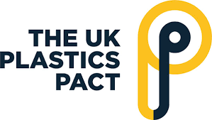(Morrisons LTD,2020)

Reference List

Tesco, (2020) Ethical Trading.

https://www.ourtesco.ie/working-at-tesco/people-policies/legal-policies/code-of-business-conduct/trading-fairly/ethical-trading/ (accessed on 26/06/20)

BBC, (2020) Tesco: No edible food will go to waste by February 2018.
https://www.bbc.co.uk/news/uk-42464912 (accessed on 26/06/20)

William Reed Business Media, (2020) How Tesco Works With Suppliers.
https://www.thegrocer.co.uk/promotional-features/how-tesco-works-with-suppliers/596398.article (accessed on 24/06/20)

The Guardian News & Media Limited, (2020) Tesco suppliers say retailer worst at following grocery code of conduct.
https://www.theguardian.com/business/2015/jun/22/tesco-suppliers-say-retailer-worst-at-following-grocery-code-of-practice (accessed on 24/06/20)

Linkedin corporation, (2020) Supermarkets and Ethics.
https://www.slideshare.net/Ethical_Consumer/supermarkets-and-ethics (accessed on 21/06/20)

Morrisons LTD, (2020) Morrisons to introduce plastic-free fruit and veg areas to help customers to buy bagless.
https://www.morrisons-corporate.com/media-centre/corporate-news/morrisons-to-introduce-plastic-free-fruit-and-veg-areas-to-help-customers-buy-bagless/ (accessed on 27/06/20)

Andysowards, (2020) 8 Advantages and Disadvantages of Using Customer Relationship Management Software
https://infinigeek.com/8-advantages-disadvantages-using-customer-relationship-management-software/ (accessed on 28/06/20)

Gradient consulting limited, (2020) A Less-than-Dynamic Guide to What CRM is and Why You Need It
https://www.gradientconsulting.co.uk/crm-a-less-than-dynamic-guide-to-why-you-need-one/ (accessed on 28/06/20)

Haymarket Media Group Ltd,(2020) How Tesco and BBH used 'The Great British Bake Off' to champion 'Every little helps’.
https://www.campaignlive.co.uk/article/tesco-bbh-used-the-great-british-bake-off-champion-every-little-helps/1406642 (accessed on 28/06/20)

InfoWorld, (2020) The Most Dangerous Breach Ever known.
https://www.infoworld.com/article/2941333/the-most-dangerous-data-heist-ever-known.html (accessed on 29/06/20)

NiDirect, (2020) Customer Relationship Management.
https://www.nibusinessinfo.co.uk/content/potential-drawbacks-crm-systems (accessed on 30/06/20)

Parvatiyar, A. and Sheth, J.N., 2001. Customer relationship management: Emerging practice, process, and discipline. Journal of Economic & Social Research, 3(2). (accessed on 30/06/20)

Solutions for Retail Brands Ltd, (2020) The history of Tesco - 98 years of every little helpS.
https://blog.s4rb.com/the-history-of-tesco-98-years-of-every-little-helps
(accessed on 29/06/20)

Tech.co, (2020) Top 8 Benefits of CRM Software.
https://tech.co/crm-software/top-8-benefits-of-crm-software
(accessed on 30/06/20)

Project Guru, (2020) How Payne’s Five Process Model Can Help to Improve CRM?
https://www.projectguru.in/paynes-five-process-model-crm-strategy/ (accessed on 29/06/20)

Salesforce.com, (2020) Developing a CRM strategy that best fits your business.
https://www.salesforce.com/crm/strategy/ (accessed on 26/06/20)

Internationals Young Nature Friends, (2020) Sustainable development and its challenges in developing countries.
http://www.iynf.org/2018/08/a-guide-to-sustainable-development-and-its-challenges-in-developing-countries/ (accessed on 24/06/20)

Morrisons LTD, (2020) The UK Plastic’s Pact.
https://my.morrisons.com/uk-plastics-pact/ (accessed on 28/06/20)

The Sun, (2020) loyalty Boost – How to reclaim lost Tesco Clubcard points as millions set to expire this month.
https://www.thesun.co.uk/money/10932595/reclaim-lost-tesco-clubcard-points-millions-expire/ (accessed on 28/06/20)

