

University of Wales Trinity Saint David’s
School of Engineering
Social Networking
Social Trends and Consumerism (M5X01285)
Chris Ashmead
1902167
BSc (Hons) Logistics and Supply Chain Management

Abstract: In society today, the emergence and continuous expansion of social networking has been influential in providing businesses with strategic ways of using social platforms to connect with core investors, affiliates and the international marketplace instantaneously, via the click of a button.

Table of Contents
1.0. Introduction 4
2.0. Social media platforms 4
2.1.1. Facebook 5
2.1.2. LinkedIn 5
2.1.3. Trustpilot 5
2.1.4. Lyft 6
3.0. The impacts of the internet on the marketing mix 6
3.1. eBay's marketing mix strategy 6
3.2. Price 6
3.3. Product 6
3.4. Place 7
3.4.1. eBays official webpage and mobile app - is the main places where customers can obtain full access to the full range of services that the company offers. 7
3.4.2. An Application programming interface (API) 7
3.5. Promotion 7
4.0. Advantages of using social media in logistics 7
4.1. Breaking down communication barriers 7
4.2. Providing vital real time information 8
5.0. UP’s Effective use of social networking 8
6.0. Disadvantages of social media in logistics 8
7.0. Conclusion 8

1.0. Introduction
The brief is to critically evaluate the opportunities and challenges being presented to the Logistics and Transport industry by the growth of social networking.
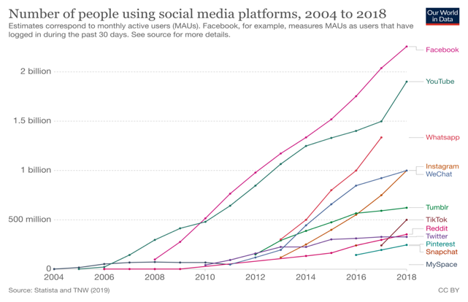
There have been considerable developments in digital media and marketing technology since the inauguration of the world wide web, which was founded by Sir Tim Berners some thirty years ago (Chaffey, D et al 2019). One such digital platform that has gathered a considerable amount of momentum through increased popularity over the years has been social networking, as highlighted by fig 1. Assaad and Gómez, (2011) define social networking as "the convergence of technologies that make it possible for individuals to communicate, share information and form new communities online easily”. The significant growth in social media has been startling and has enabled 3.8 billion people, over forty-five per cent of the world's population to stay connected digitally (Atherton, J. 2019). It is through these social media platforms that businesses have been able to capitalise, as it has presented them with the opportunity to advertise their products and services. Through the implementation of digital ads, businesses can engage with customers and obtain feedback instantaneously. This, in turn, allows companies to obtain a clear understanding of how consumers think and what their interests are. For businesses, this has provided them with vitally important information to enable necessary changes to improve their products and services. Recently addressed in a survey conducted by Social Media Today, it states that "71% of social media users are more likely to buy products from brands that are digitally connected through a social media platform (Express, 2019).

Figure 1- Total number of global social media users (Ortiz-Ospina, 2019)

2.0. Social media platforms

Social networking sites are a series of web-based service instruments for the creation of digital communities, whereby individuals of similar interests and lifestyles can express themselves through photos, videos and ideas (Kietzmann et al., 2011). From the information gathered from an individual's online profile and their recent activities, businesses can extract vital information to facilitate them in producing advertisements that directly target the wants, needs and interests of the individual (Thomas, 2018). Moreover, this interaction between B2C allows a company to build relationships with their consumer, which can be an extremely effective way to build their brands image, create greater visibility and improve its reputation. However, this engagement between both a business and its target audience should not just be to promote and achieve sales but be used as platform to install a level of brand loyalty. This is further reinforced by (Express, 2019) who stipulates that a business can significantly increase it profits by between 25% - 85% simply by improving its customer retention rate by 5%.

2.1.1. Facebook

As it is currently, Facebook is the largest social networking platform, which has amassed a colossal following of more than 2 billion monthly users worldwide (Appel et al., 2019). The company prides itself in its ability to "give people the power to share and make the world more open and connected “However, Facebook is not only considered as a means of social interaction; it has presented numerous opportunities for businesses to use digitised advertisements and promotions to reach a much greater target audience which helps to facilitate in the purchasing of their products and services (Sehl, 2020).

2.1.2. LinkedIn

LinkedIn is a professional social networking platform that is used by some 30 million companies and 690 million individual members as a means to communicate, build relationships and obtain more effective insider skills and knowledge from other major players within their industry. These corporations utilise the site as a way to promote potential job opportunities whilst allowing individuals to create a polished and professional profile and upload a CV, s as a way of "putting their name on the professional map" (Kohler, 2020).

2.1.3. Trustpilot

Trust pilot is a robust platform that gives businesses a compelling way of showing how they appreciate their customers and how their customers appreciate them through feedback reviews. At present, Trustpilot is accountable for more than 100 million reviews spanning across four hundred thousand companies (Trustpilot, 2020).Addressed recently in a study conducted by to Dimensional Research, it concluded that some 90% of individuals are enticed into purchasing products that have received positive reviews and a further 72% of people consider online reviews just as important.(Kaemingk, 2020) Additionally, A survey conducted by Survey Monkey Audience revealed that A survey conducted by Survey Monkey Audience revealed that eight seven per cent of consumers find that those adds that include a Trustpilot star rating, to be significantly more reputable than those adds that do not.

2.1.4. Lyft

Lyft is an American based, multi-vehicle rental service that makes the use of mobile technology in the form of an app to fulfil customer travel requirements. The company's primary focus of app integration is to make the process of making and coordinating bookings as hassle-free as possible for both the rider and driver. Due to its slick and simplistic design layout, the app itself can be utilised to enable swift and effortless payment transactions. When Lyft was first launched, they were seen as a wishful rival to Uber. From the stiff competition they received, Lyft conducted an innovative and noticeable marketing strategy where the company started a pink moustache campaign, where pink moustache emblems were placed on every one of their vehicles, this was a significant branding move that can significantly accelerate consumer awareness (Erica, 2018).

3.0. The impacts of the internet on the marketing mix
Although there has been a sudden shift to new marketing strategies used within eCommerce from a steep rise in technology, many of the conventional marketing concepts can still be applied such as the four Ps (product, price, place and promotion) as they are as pertinent to online businesses as they are with offline ones (Nezamabad, 2011).Many E-businesses utilize many forms of technology innovations from artificial intelligence, apps and widgets within their marketing strategy, these useful tools provide an effective way of reaching greater target audiences and obtain a level of competitive advantage (Stephenson, D. 2018).

3.1. eBay's marketing mix strategy
eBay’s marketing mix strategy can be considered as a prime exemplification of how an ecommerce business can successfully maximize its online assets. The main focus of eBay’s marketing mix strategy is on the services that it provides to its global market of buyers and sellers. eBays marketing mix is described by (Mitchell, 2017) as :

3.2. Price
The organisations price strategy is directly focused on competitive pricing to ensure that the company can effectively compete by ensuring the lowest price of a product against their other main rivals such as Amazon. eBay implements a dynamic pricing strategy which is used to allow them to remain versatile in setting out the product price. Which helps them to handle customer expectations.

3.3. Product
Products are considered as either a physical item or service that is inputted into the market to satisfy the desire of a consumer. In the case of eBay, the products are their online/retail auction services. eBays services can be categorized in three main elements, Marketplace services - which allows consumer to bid for, “buy now” or sell either used or new products. Ticket exchange services where customers have an option to resell or purchase event tickets services and finally a classified service which enables customer to post localised advertisements.

3.4. Place
eBay’s place strategy comprises of places where the company can disperse its products to a target market. The relevant places are categorized as :

3.4.1. eBays official webpage and mobile app - is the main places where customers can obtain full access to the full range of services that the company offers.

3.4.2. An Application programming interface (API)
The company makes use of API which has been an effective way for eBay to distribute its goods whilst simultaneously allowing other company websites and apps to obtain access to eBay’s many products and services. By having a series of alternative places to sell their many products, it has helped eBay to not only increase their efforts to be able to reach a wider target market but has supported the company’s overall strategy to maintain a level of competitive advantage over other eCommerce-based businesses.

3.5. Promotion
eBay’s promotes its products through a series of different strategies. Firstly, through effective sales promotion eBay is able to fulfil customer expectations and entice them with discount coupons. Secondly, the use of advertisements is a persuasive way to allure in bigger audiences to make use of their online platform and finally by incorporating public relations it can elevate the company’s business and brand awareness.

4.0. Advantages of using social media in logistics

4.1. Breaking down communication barriers
Figure 2 - Amazons use of twitter (Twitter,2020)

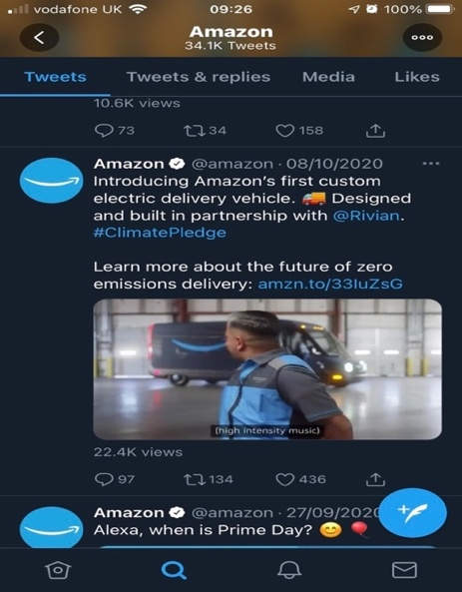
Individual logistics companies often feel it is challenging to exhibit a more human side of their business, as they are aware of the changes in consumer behaviour, where buyers are consistently after a more personal connection to brands. This has caused many B2B logistics companies to become more innovative in their approach, and this where social media can play a crucial role in achieving just this (Agnihotri et al., 2016). Social media can help an organisation to communicate with their clientele through the use of images, videos and sound which provides an insider look, which allows them to keep actively engaged with their followers, build relationships and construct a lively community. Fig 2 shows how the global online retailer giant Amazon, has been able to effectively make use of twitter as a way promoting their services whilst also using it as means to show what the company is doing to lessen their global impacts regarding environmental sustainability issues (Twitter,2020).

4.2. Providing vital real time information
Real-time tracking between a business and a third-party logistics company can be improved through social media integration. As it can help with both parties in amending their shipping and delivery schedules much more quickly, which helps to improve the transparency of the supply chain drastically. Moreover, companies can make use of the information on accidents, sudden changes in weather conditions and shipping transportation issues from social media to make necessary changes to re-route a delivery, alter a delivery schedule and notify a customer about the change in the situation (Jordan, 2018).

5.0. UP’s Effective use of social networking
The Universal Parcel Service (UPS) is one such organisation that demonstrates how social media can be effectively integrated to ensure that its supply chain is running smoothly. The company makes use of social media in the form of blog posts to help to increase the company's transparency and visibility. These blogs can appear in the forms of case studies and stories from different employees throughout the whole of the supply chain. Subsequently, the sharing of usually obscured information on these blogs allows the company to increase the awareness of their supply chain undertakings for not just their customers but more crucially for their employees across the supply chain (Baker, 2018).

6.0. Disadvantages of social media in logistics
Figure 3 - Associated disadvantages of social media (Gonzalez, 2015)

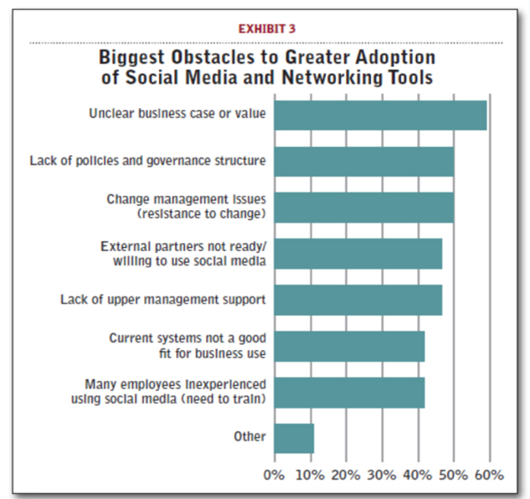
From a negative sense, many logistics companies feel that social media networking is not a vital asset to have included in the day to day running of their business. (Gonzalez, 2015) states that,many companies see these public social media sites such as the likes of Facebook and Twitter lack any supply chain and logistics context. Moreover, logistic companies also see the biggest problem of all is their inability to evaluate the business value of using social networking. This, in turn, presents them with a series of questions like how much money could the company realistically save, and will it improve the productivity of the company? Further drawbacks within logistics are highlighted by fig 3.

7.0. Conclusion
To summarize, this report has in detail, highlighted the many advantages and disadvantages that are being presented to the logistics industry due to the growth of social networking. It is and will continue to remain vitally important for the logistics sector and associated businesses to be fully in tuned within social media to not only continue to remain relevant with their customer base, but also as a means to mitigate against the chances of their competitors in gaining the upper hand.
References
Agnihotri, R., Dingus, R., Hu, M.Y. and Krush, M.T., 2016. Social media: Influencing customer satisfaction in B2B sales. Industrial Marketing Management, 53, pp.172–180.
Appel, G., Grewal, L., Hadi, R. and Stephen, A.T., 2019. The future of social media in marketing. Journal of the Academy of Marketing Science, 48(1), pp.79–95.
Baker, D., 2018. UPS Delivers with Social Media Supply Chain Management Strategy – Social Media for Business Performance. [online] Available at: <https://smbp.uwaterloo.ca/2018/06/ups-delivers-with-social-media-supply-chain-management-strategy/> [Accessed 17 Nov. 2020].
Erica, 2018. Lyft and Snickers: Their Perfectly Timed Marketing Strategies. [online] Available at: <https://www.webcontentdevelopment.com/lyft-and-snickers-their-perfectly-timed-marketing-strategies/> [Accessed 15 Nov. 2020].
Express, E., 2019. Eagle Express Service | Blog | How to Use Social Media to Grow Your Logistics Company. [online] Eagle Express Service. Available at: <https://www.eagexpress.com/blog/how-to-grow-your-logistics-company-using-social-media> [Accessed 8 Oct. 2020].
F.Reichheld, F. and Sasser, W.E., 2020. Zero Defections_-Quality comes to services.pdf. [online] Available at: <http://matlesiouxx.free.fr/Cours/HKU/Courses/CSIS0404/Lecture%201/Module1_3_Zero_Defections_-Quality_Comes_to_Services.pdf> [Accessed 19 Nov. 2020].
Gonzalez, A., 2015. The Social Side of Supply Chain Management - Supply Chain 24/7. [online] Available at: <https://www.supplychain247.com/article/the_social_side_of_supply_chain_management_all_pages> [Accessed 8 Oct. 2020].
Jordan, R., 2018. Advantages of Using Social Media in Logistics Industry. SociableBlog. Available at: <https://www.sociableblog.com/2018/05/21/advantages-of-using-social-media-in-logistics-industry/> [Accessed 12 Nov. 2020].
Kaemingk, D., 2020. 20 Online Review Stats to Know in 2019. [online] Qualtrics. Available at: <https://www.qualtrics.com/blog/online-review-stats/> [Accessed 20 Nov. 2020].
Kietzmann, J.H., Hermkens, K., McCarthy, I.P. and Silvestre, B.S., 2011. Social media? Get serious! Understanding the functional building blocks of social media. Business Horizons, 54(3), pp.241–251.
Kohler, C., 2020. Here are the 7 Reasons Why LinkedIn is Important. [online] TopResume. Available at: <https://www.topresume.com/career-advice/why-linkedin-is-important> [Accessed 20 Nov. 2020].
Mitchell, C., 2017. eBay Inc.’s Marketing Mix or 4Ps (Analysis) - Panmore Institute. [online] Available at: <http://panmore.com/ebay-inc-marketing-mix-4ps-analysis> [Accessed 22 Nov. 2020].
Nezamabad, M.N., 2011. The Impact and Benefits of Internet on Marketing Mix. p.6.
Ortiz-Ospina, E., 2019. The rise of social media. [online] Our World in Data. Available at: <https://ourworldindata.org/rise-of-social-media> [Accessed 23 Nov. 2020].
Sehl, K., 2020. How to Use LinkedIn for Business: A Step-by-Step Guide for Marketers. Social Media Marketing & Management Dashboard. Available at: <https://blog.hootsuite.com/linkedin-for-business/> [Accessed 20 Nov. 2020].
Thomas, M., 2018. Social media strategy - Boost your business,manage risk and develop your personal brand. 1st ed. Pearson.
Trustpilot, 2020. Why Trustpilot | Trustpilot Business. [online] Trustpilot. Available at: <https://uk.business.trustpilot.com/why-trustpilot> [Accessed 21 Nov. 2020].

