

Assignment 1 E-Portfolio

Name: Farzana Khan
Student No: 2508956
Course Title: Certhe computing Skills for the Workplace
Module name Learning in the Digital Era(ACCA4025-BIR)
Lecturer: Dr. Martin Svejda
Date: 2nd April 2026
Time 12.45am

Contents
Introduction 2
e-Portfolio 2
Task 1: Summary: 2
Task 2: Mind Map and Academic Poster 3
Essential Skills for Academic and Workplace 4
Time Management: 4
Critical Thinking: 6
Communication: 6
Digital Skills 7
Problem solving: 8
Reflection 8
Illustrative Review 9
Key features of Google are 9
Similarity Words: 9
References…………………………………………………………………………………………….………10

Introduction
Now a days highly competitive world, developing effective skills and using tools are essential academic and professional success. This assignment explores key points such as e-portfolio, essential skill for workplace and academic career. Essential skills for workplace such as time management, communication teamwork, problem-solving and adaptability are important for success in any career. Auto referencing tools support for academic work helping users accurately cite sources. These concepts are playing important role in personal growth, academic achievement and career development.

e-Portfolio
Hi, Dear Sir/madam
Here is my e-Portfolio (Farzana Khan, 2508956). To watch my portfolio link is below:
Thanks
Google Sites/farzanakhan

Task 1: Summary:
Google Sites is a free website creation and publishing platform. It's completely online and very easy to use. You don’t need to have any experience in creating websites, E-Portfolios, school projects, Team or Club sites, company internet pages, Blogs, or bio sites. Everything is sorted in Google Drive and easily shareable.
other Google Apps for Workspace using Google Apps Scripts.
Google sites like all under one roof, your websites, email, and documents all managed in the same ecosystem. Google Sites is another application in the Google Apps environment, so you have the same intuitive controls and settings, and it’s easy to manage straight from the browser. Google Workspace administrators can manage site creation and editing, custom URL, and template galleries
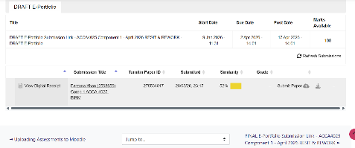

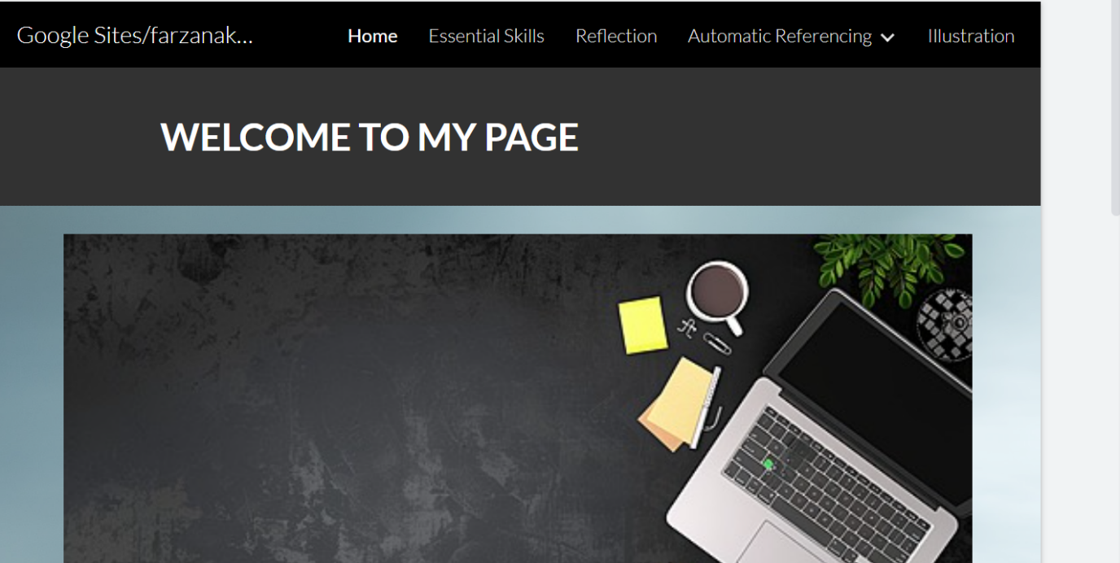

Task 2: Mind Map and Academic Poster
1: Screenshot of Mind Map
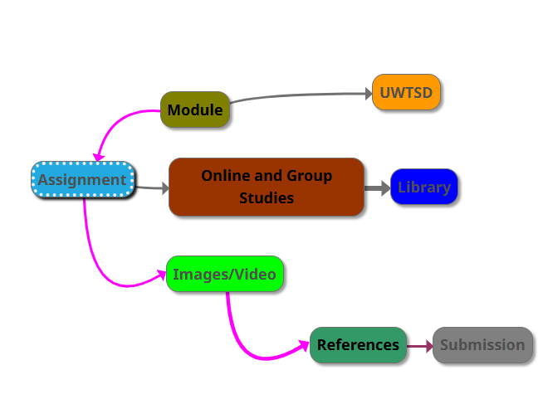
Dear Sir/Madam, please view the link of mind map
mind map 3.png
2: Screenshot of the Poste
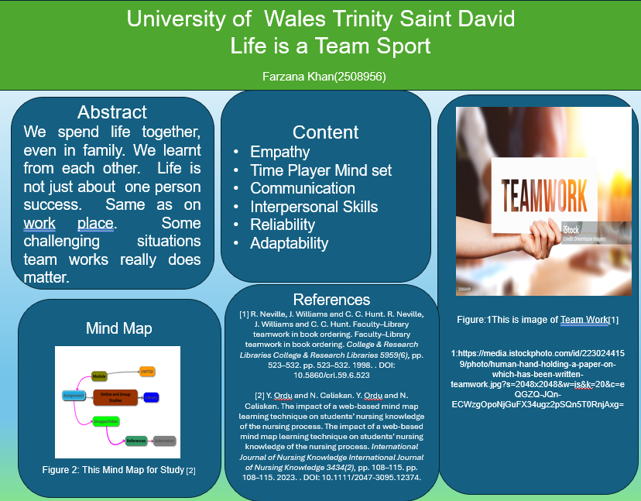
Final poster.pptx

Task 3- Automatic Referencing tools.
Referencing tools are online tools designed to help easily create references. First need to check that the references generated in this way are consistent with the referencing style. As inconsistencies are frequent [1].
Save and manage records in the library and export to other reference tools. We can use the citation feature to generate a reference. We will find this under the menu when viewing the complete information about any book or journal article.
Copy and paste references from the ‘cite’ tab on google Scholar or add items to Google Scholar Library where we can export them to other referencing tools.
Import reference into Microsoft word using Researcher feature under the reference tab.
Library databases have ‘cite’ feature like Library Search and google Scholar.
RefWorks is web-based subscription required (paid by Uni) Plugins for MS Word and Google Docs [2].

Essential Skills for Academic and Workplace
I want to be IT Engineer/Software Engineer
Time Management:
These skills help people to decide, stay focused, and avoid all unnecessary tasks if -there is no agenda. There is a 4D Strategy: identify the things that are not important, Defer Putting things off until the assignment has been completed. Do things rather than a perfect standard. Delegate: Ask others for help with household chores [3].
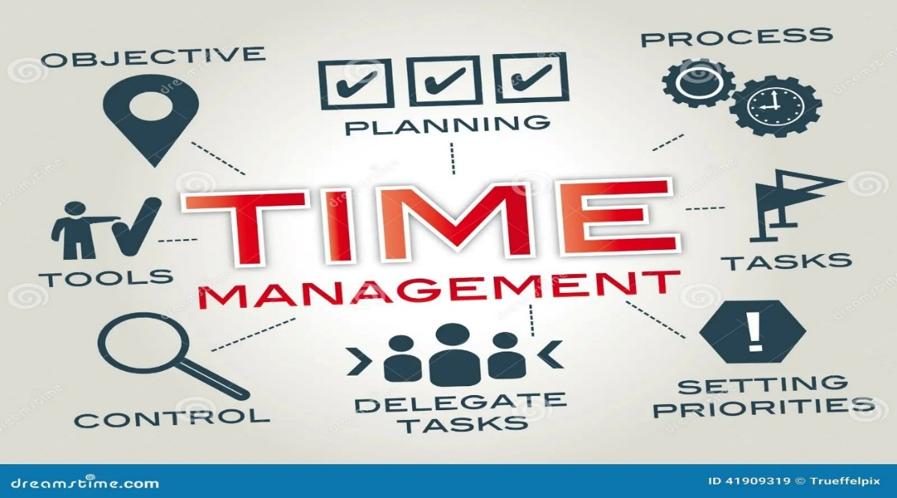
Figure 1: This image shows time Management. https://www.dreamstime.com/stock-illustration-time-management-chart-keywords-icons-image41909319[1
Researching:

Research is a process of systematic inquiry that entails the collection of data, the documentation of critical information, and the analysis and interpretation of that data/information in accordance with suitable methodologies set by specific professional fields and academic disciplines [4].



Figure 2: This image shows Research Work. Scientist Analyze Biochemical Samples In Advanced Scientific Laboratory Medical Professional Use Microscope Look Microbiological Developmental Of Viral Biotechnology Research In Science Lab Stock Photo - Download Image Now - iStock

Critical Thinking:
Critical thinking is the analysis of facts to form a judgment. It is the way of deciding if a claim is true, false or sometimes true and sometimes false, or partly true and partly false. It can be split into two important areas: Logical Fallacies and Cognitive Bias [4].


Figure 3: This image shows the way of thinking.
https://media.istockphoto.com/id/1409086749/photo/thoughtful-girl-studying-in-library-seated-at-table-with-textbooks.jpg?s=1024x1024&w=is&k=20&c=ODX325n7ne202-0FpOYY7I8vLMBMLE-me1Oy2_x0r6M

Communication:
Communication skills allow one to understand and be understood by others. Communication skills are important whether you are speaking face to face, on video/voice call or through letters and emails [ 5].

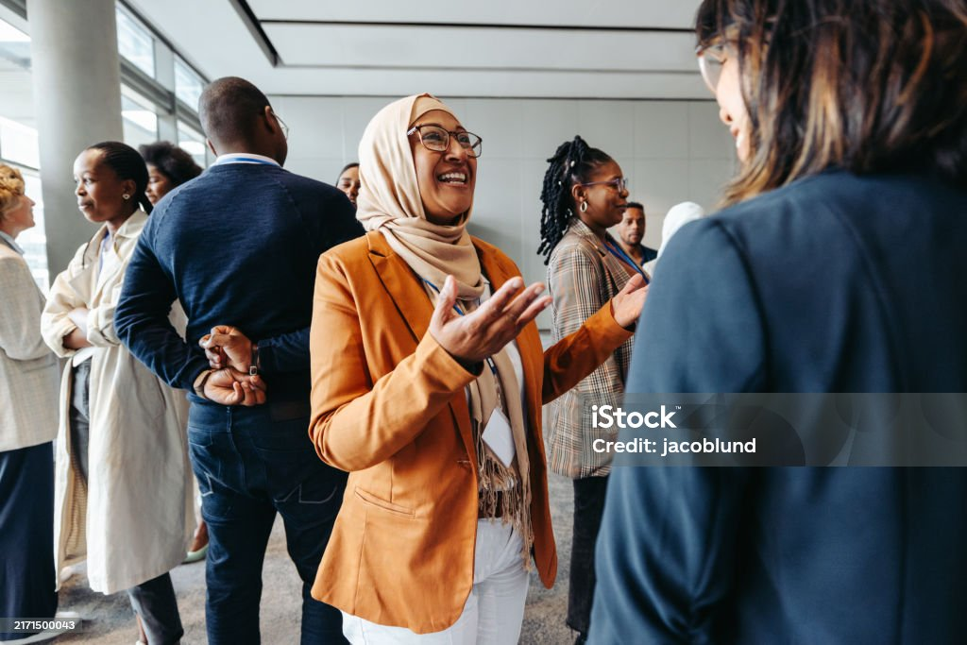
Figure 4: This image shows communication with each other’s. https://media.istockphoto.com/id/2171500043/photo/smiling-muslim-businesswoman-sharing-and-talking-during-a-networking-event.jpg?s=1024x1024&w=is&k=20&c=BXAE_kiGjtlIF6sdqWuoHAbif9xD3xORwUImfOqxEQE=

Digital Skills

Digital skill is much more than just knowing how to use smartphone devices; they are also about being able to select the right tools and technologies and to continually develop new skills, as technologies change and advance [6].
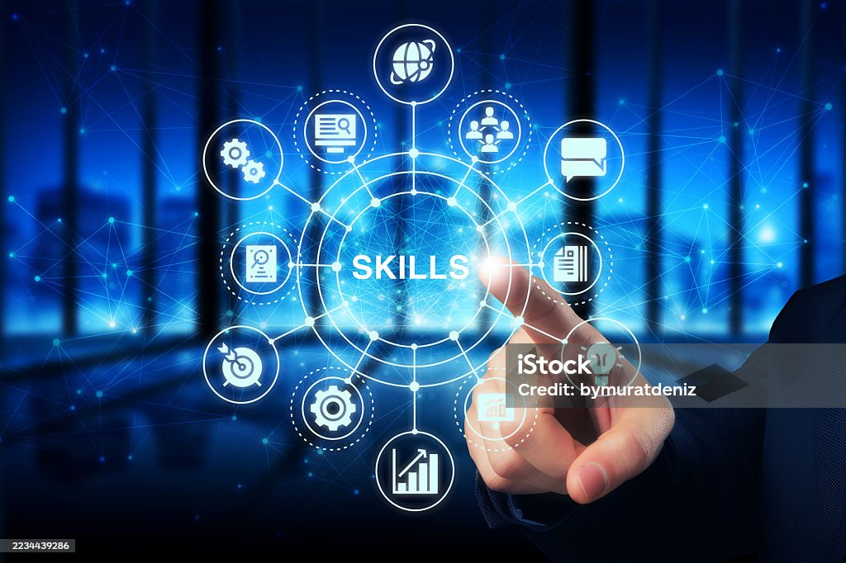
Figure 5: This image shows Digital skills. https://media.istockphoto.com/id/2234439286/photo/business-skills-development-concept.jpg?s=1024x1024&w=is&k=20&c=dmGJj_7Uq9sbX-sPhWYXcHy8EpIYsYbew4owSd4ztmM=

Problem solving:
Problem-solving is both an ability and a process. As an ability, problem-solving can help resolve issues in different environments, such as home, school, abroad and social situations. As a process, problem-solving involves a series of steps for finding solutions to questions or concerns that arise throughout life.

Reflection
Through this assignment, I learned a better understanding of the importance of e-portfolio, essential skills for workplace and academic career. Also, this assignment helped me reflection my time management skills, I have realised the importance of planning, prioritising tasks, and meeting deadlines. Improving my time management will allow me to work more efficiently and reduce stress in my studies and future work. Learning about auto referencing tools has made me aware of how important it is to correctly cite source.
Overall, this assignment has helped me reflect on my current abilities and identify areas for improvement, preparing me for both academic success and future career development.

Illustrative Review
Google Sites is a free website creation and publishing service. It’s completely online and very easy to use, you don’t need to have any experience in creating websites, e-Portfolio, school project, Team or Club sites and company internet pages, Blogs, and Bio Sites. Everything is sorted in Google Drive and is easily shareable [8].
Google sites like all under one roof, your websites, email, and documents all managed in the same ecosystem. Google Sites is another application in the Google Apps environment, so you have the same intuitive controls and settings, and it’s easy to manage straight from the browser. Google Workspace administrators can manage site creation and editing, custom URL, and template galleries.
Key features of Google are: [9]
The Effortless Drag-and-Drop Editor
Seamless Google workspace Integration
Fully Responsive Design
Easy Collaboration & Publish
Secure and Private
Free to Use
Automatic Saving
Mobile Friendly

Similarity Words:

I checked my assignment through similarity; the result is 36%. I tried my best, but I don’t know where I need to improve my work. I put references as required in the work. Also, I tried my best to create a portfolio in the best way by adding the pages. Maybe I need to make an academic poster and Mind map in best way. And complete the 350 words in the Automatic tools reference. Illustrative review also needs to do in a better way. Same needs to do reflection in better way. I think these are my weak points. I will try to do my best in future to overcome on my weakness.

References
[1] Oh"The use of spelling and reference tools in second language writing: Their impact on students’ writing performance and process," vol. 57, pp.100916, 2022, doi: 10.1016/j.jslw.2022.100916.
[2] Hautbergue, Hung, "UIF, a New mRNA Export Adaptor that Works Together with REF/ALY, Requires FACT for Recruitment to mRNA," vol. 19, no. 22, pp.1918–1924, 2009, doi: 10.1016/j.cub.2009.09.041.
[3] Stoilov and Stoilov,Time Management, Croatia: IntechOpen, 2012.
[4] "International critical thought," Int.critical thought (Online). 2011,
[5] Pan, Liu, "Human–AI communication in initial encounters: How AI agency affects trust, liking, and chat quality evaluation," vol. 27, no. 10, pp.5822–5847, 2025, doi: 10.1177/14614448241259149.
[6] LockwoodGolden Ages : Hasidic Singers and Cantorial Revival in the Digital Era, 1st Ed. Berkeley, CA: University of California Press, 2024. doi: 10.1525/9780520396449
[7] Kikuchi"Reflection," J.Biochem., Tokyo. vol. 172, no. 3, pp.139, 2022, doi: 10.1093/jb/mvac038.
[8] Osei, Darko, "Management of pediatric quadrigeminal arachnoid cysts: a systematic review and illustrative case report," Childs Nerv.Syst. vol. 41, no. 1, pp.137, 2025, doi: 10.1007/s00381-025-06796-3.
[9] Abi Adams-PrasslPerceived Returns to Job Search, IZA - Institute of Labor Economics, 2022.

