XIN WU 1905033
Resilience, Talent and Technology
BMDB7004

Content
1. 3
2. 9
3. 12
4. 14
5. 19
6. 37
7. 41

1.
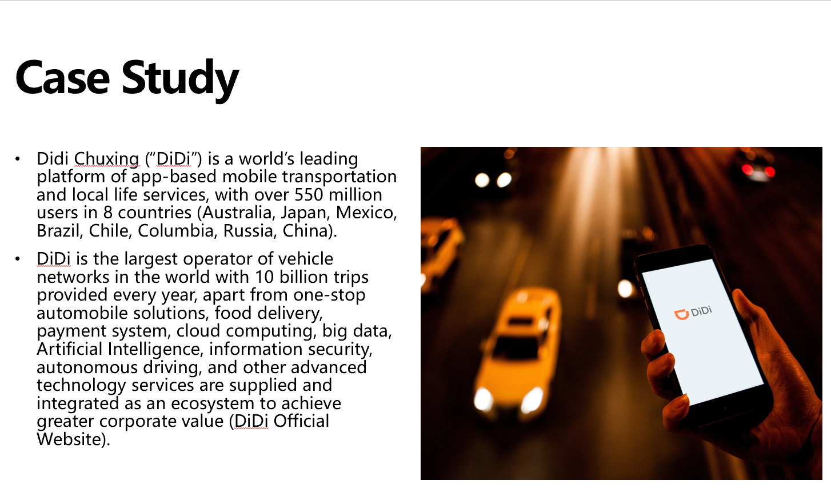
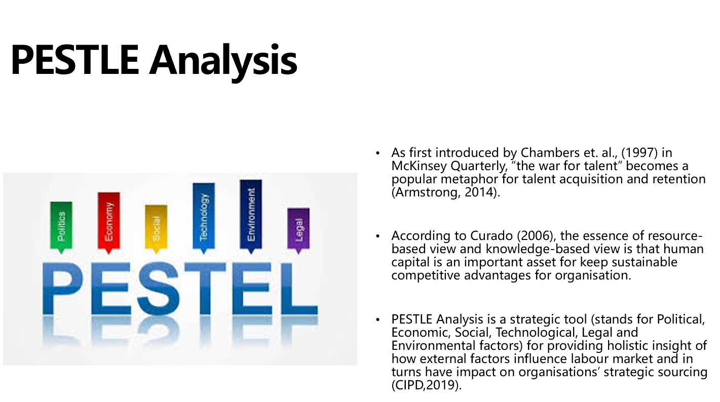
Political
On one hand, the Sino-US trade war has worsened the tension between two countries (BBC,2020), and Donald Trump has issued tightened policies to restrict academic exchanges between China and US. As DiDi has launched business in 8 countries, the intensified international relationship could have detrimental influences to some businesses, such as Autonomous Driving, which were collaborated with US (California), in turns, in might hamper the ability to attract overseas talents as well as local talents for host subsidiary in other country. On the other hand, China's domestic political situation is stable, and Chinese government has release tightened rules for outward talent mobility together with attractive policies to attract returning talents (University World News, 2020). And according to China Daily, (2017), China has issued some sophisticated guidelines and regulations to promote sharing economy. These are positive indicators for talent acquisition in mainland China.
Economic
Due to the economic downturn caused by the Sino-US trade war together with the global pandemic, according to The Economist (2020), it is predicted that China will have 10% unemployment rate by 2021/2022. Meanwhile, there are still huge unfilled shortage in the segments such as IT, AI, semiconductor (China Briefing, 2019). Moreover, as indicated by one of the world's largest human resource management consulting agency—Mercer (2019), the cost of living in China has increased a lot, with some big cities appeared in the top ten list in the world, such as Shanghai (Rank 6), Beijing (Rank 8), Shenzhen (Rank 10). And compared with Vietnam (2.99 USD) and Mexico (4.82 USD), the manufacturing labor cost per hour in China is 6.5 USD (Statista, 2019), and average salary for IT talents in Shanghai is ¥243,302 / year (36,240 USD) compared to 52941.48 USD in UK, and 18333.50 USD in Mexico (Glassdoor). The rising cost of living and labor cost in China imposes threat for DiDi attracting talents.
Social
Nowadays, individuals heavily rely on online communities, where they can share, connect and build networks (Deloitte, 2013). Two corporate scandals happened in May and Aug 2018 reveals of safety problem of DiDi registration verification and face recognition system, which caused great concern in public (BBC,2018). Individual customers launch a nationwide backlash #DeleteDidi in social media, which cased DiDi faced pressure from all fronts, and reportedly lost ($1.6 billion) and lay off 15 percent of its staff or about 2,000 people in 2018 (Reuters, 2018). Unethical business decisions could generate profound negative impact on corporate reputation, which will generate harmful consequences in talent management.
Technological
Technological progress has allowed DiDi to seek global talents to commit to its smart and advanced transportation services. Telecommuting enables the open talent economy to be implemented on a global scale, reduces the barriers to knowledge transfer from home headquarter, and makes more reasonable and economical use of various talent resources (Edwards & Rees,2011; Deloitte, 2013).
Legal
The laws and regulations of the global car-hailing market are vague, and potential safety hazards have become people’s main consideration, affecting corporate reputation (Cetin a, 2019; Chaudhrya, et,al. ,2018; Li, et, al. , 2018; Ma et, al. , 2018; Phil, 2017). High-level talents pay more attention to corporate CSR, it is not easy for DiDi to win the War (Bhattacharya, Sen & Korschun, 2018).
Environmental
As indicated by The 2020 Global Millennial Survey of Deloitte, Millennials show great concerns toward how business impact on society. Environmental CSR of a firm could help attract talent. DiDi put great effort in building electronic vehicle networks all over the world (China Daily, 2019; Qasim Khan, 2020), the sustainable value can support its talents sourcing strategies.

References

Armstrong, M. (2014). Armstrong’s Handbook of Human Resource Management Practice 14th Ed. London: Kogan Page.

BBC, (2018). Didi Chuxing suspends carpool service after woman killed. (Online). Available at: https://www.bbc.com/news/world-asia-china-45313074 (Accessed: 25/10/ 2020).

BBC, (2020). A quick guide to the US-China trade war. (Online). Available at: https://www.bbc.com/news/business-45899310 (Accessed: 25/10/ 2020).

Benish Chaudhrya, Ansar-Ul-Haque Yasarb, Samar El-Aminec, Elhadi Shakshukid, (2018). Passenger Safety in Ride-Sharing Services. Procedia Computer Science 130 (2018) 1044–1050.

Bhattacharya, Sen & Korschun, (2018). Using Corporate Social Responsibility to Win the War for Talent. MIT Sloan Management Review, Winter 2008, Vol. 49 No. 2.

China Daily, (2017). China issues guidelines to promote sharing economy. (Online). Available at: https://www.chinadaily.com.cn/business/2017-07/04/content_29986732.htm (Accessed: 26/10/ 2020).

China Daily, (2019). Didi Chuxing, BP announce new venture to build EV charging network. (Online). Available at: http://www.chinadaily.com.cn/a/201908/01/WS5d429ea3a310cf3e355635f6.html(Accessed: 26/10/ 2020).

CIPD, (2019). Understanding the economy and labour market. (Online). Available at:
https://www.cipd.co.uk/knowledge/work/trends/economy-labour-market-factsheet(Accessed: 26/10/ 2020).

Curado, (2006). The knowledge-based view of the firm and its theoretical precursor. Int. J. Learning and Intellectual Capital, 3(4).

Deloitte, (2013). The open talent economy: People and work in a borderless workplace. (Online). Available at: https://www2.deloitte.com/content/dam/Deloitte/global/Documents/HumanCapital/dttl-hc-english-opentalenteconomy.pdf(Accessed: 26/10/ 2020).

Deloitte, (2020). The 2020 Global Millennial Survey. (Online). Available at: https://www2.deloitte.com/global/en/pages/about-deloitte/articles/millennialsurvey.html(Accessed: 26/10/ 2020).

DiDi Official Website (Online). Available at: https://www.didiglobal.com/about-didi/about-us
(Accessed: 26/10/ 2020).
Edwards, T. and Rees, C. (2011). International Human Resource Management: globalisation, national systems and multinational companies. 2nd ed. Essex: Palgrave

Glassdoor (Online). Available at: https://www.glassdoor.com.hk/Salaries(Accessed: 25/10/ 2020).

Khan.Q, (2020). Didi Launches South Americas First EV Sharing Service. (Online). Available at: https://equalocean.com/news/2020012313453(Accessed: 25/10/ 2020).

Liang Ma, Xin Zhang, Xiaoyan Ding, Gaoshan Wang, (2019). Risk perception and intention to discontinue use of ride-hailing services in China: Taking the example of DiDi Chuxing. Transportation Research Part F 66 (2019) 459–470.

Mercer, (2019). 2019 cost of living ranking: China. (Online). Available at: https://mobilityexchange.mercer.com/insights/article/2019-cost-of-living-ranking-china(Accessed: 25/10/ 2020).

Mushnick, Phil, (2017). Didi shows concern. New York Post ; New York, N.Y. [New York, N.Y]24 Sep 2017: 67.

Reuters, (2018). China ride-hailing giant Didi to lay off 15 percent staff this year. (Online). Available at: https://uk.reuters.com/article/us-didi-chuxing-layoffs/china-ride-hailing-giant-didi-to-lay-off-15-percent-staff-this-year-source-idUKKCN1Q40CZ(Accessed: 25/10/ 2020).

Statista, (2019). Manufacturing labor costs per hour: China, Vietnam, Mexico 2016-2020. (Online). Available at:https://www.statista.com/statistics/744071/manufacturing-labor-costs-per-hour-china-vietnam-mexico/(Accessed: 25/10/ 2020).

Tamer Cetin a, *, Elizabeth Deakin, (2019). Regulation of taxis and the rise of ridesharing. Transport Policy 76 (2019) 149–158.

University World News, (2020). The coming ‘China crisis’ in global higher education. (Online). Available at: https://www.universityworldnews.com/post.php?story=20190403104242366 (Accessed: 25/10/ 2020).

University World News, (2020). Trump has just made it harder to attract academic talent. (Online). Available at: https://www.universityworldnews.com/post.php?story=20200703145123105(Accessed: 25/10/ 2020).

Yanwei Li, Araz Taeihagh and Martin de Jong (2018). The Governance of Risks in Ridesharing: A Revelatory Case from Singapore. (Online). Available at:https://arxiv.org/ftp/arxiv/papers/1805/1805.07885.pdf(Accessed: 25/10/ 2020).

2.
PESTLE analysis is a tool for identifying influential factors in macro environment that could generate challenge or opportunities for predicting the labor market trends and helping in management operation of an organisation (CIPD, 2020). FJJX University is a public university in Fujian Province in China, which currently has 14838 enrolled students and 756 teachers (except for administrative staffs) and has been actively promote international cooperation and exchanges and was approved to recruit foreign teachers international students in 2019. PESTLE analysis and some other influential labor market trends will be discussed for FJJX University.
The economic downturn caused by the Sino-US trade war has worsened due to the global pandemic (BBC,2020). The United States has issued a large number of policies to restrict academic exchanges between China and the United States, according to Altbach, who is the director and research professor at Boston College, 1/5 of Chinese international higher education partner were closed. As the international situation has become more tense, Chinese government put some restrictions for outward talent mobility and implemented some attractive policies to attract returning graduates. With the continuous improvement of China's economic and technological global status and international influence, 84.46% overseas students choose to return to China, with increasingly number of high-level talents (University World News, 2020). Furthermore, as indicated by China Briefing (2019), comparing to the restrict policies in overpopulated Tier 1 cities, Tier 2 and 3 cities are trying to push employee policies to attract younger talents. According to the 2018 graduate employability market survey released by Zhaopin Recruitment shows that Tier 2 cities account for 25.94% of expected employment location, increased 4.74%. FJJX University is based in Fuzhou (Tier-2 city), with the help of local government, universities are making effort to offering incentives to attract overseas talents.
On one hand, the unemployment rate in China is 5.3% in Jan (National Bureau of Statistics of china, 2020) and it is predicted that China will have 10% unemployment rate by 2021/2022 (The Economist,2020), 34% of employers have been suspended from campus recruitment (Chinese recruiting website 51job.com). On the other hand, there are still huge unfilled shortage in the segments such as IT, AI, semiconductor (China Briefing, 2019). Therefore, under the economic downturn, students have difficulty finding jobs, and their skills do not meet the requirements of employers, which puts more pressure on schools. although it is a loose market for recruiting ordinary lecturers and administrators but for high-level talents, such as professors, experts, and technical talents, universities should fight hard in tight market.
According to Forbes, (2019), there are about 61 million youngsters (Gen Z) born after 1996 are about to enter the labor market with their unique properties and values. 90% of them seek the interwoven of digital convenience and human interaction; 83% of them put work-life balance as their first priority; 60% of them do not bother but welcome technological check-ins weekly (even daily) to provide tangible feedback for their improvement. Also, as indicated by China Briefing (2019), the Chinese young generation prefer jobs in internet, media, education industries. Although FJJX University cannot afford same level salaries as Internet and media companies offer, but compared to the working time and pressure in these sectors (most of them have ‘996’ work schedule, from 9am to 9pm and work 6 days per week), flexible time in university provides the opportunities to satisfied their priority of work-life balance.
Technological development with the improved accessibility has increased flexibility. Online courses enable both teachers and students break down distance barriers to have instant communication. The changing teaching and learning process bring us both opportunities and challenges. Working and studying at home could allow the university to satisfied different needs, such as providing comfortable and convenient learning environments for impairment or disable students and flexible working time and space for a caregiver (Vista College, 2019). With the help of technology, universities could access to the overseas talents. Adopting information system allows greater management efficiency.

References

CIPD, (2020). PESTLE analysis. (Online). Available at: https://www.cipd.co.uk/knowledge/strategy/organisational-development/pestle-analysis-factsheet (Accessed: 25/10/ 2020).

BBC, (2020). A quick guide to the US-China trade war. (Online). Available at: https://www.bbc.com/news/business-45899310 (Accessed: 25/10/ 2020).

University World News, (2020). The coming ‘China crisis’ in global higher education. (Online). Available at: https://www.universityworldnews.com/post.php?story=20190403104242366 (Accessed: 25/10/ 2020).

University World News, (2020). Trump has just made it harder to attract academic talent. (Online). Available at: https://www.universityworldnews.com/post.php?story=20200703145123105(Accessed: 25/10/ 2020).

China Briefing, (2019). China Labor Market: Hiring Costs, Job Preferences, Talent Acquisition. (Online). Available at: https://www.china-briefing.com/news/china-labor-market-hiring-costs-job-preferences-talent-acquisition/(Accessed: 25/10/ 2020).

The Economist, (2020). China's unemployment rate may hit 10%. (Online). Available at: http://country.eiu.com/article.aspx?articleid=359423819&Country=China&topic=Economy&subtopic=Forecast&subsubtopic=Economic+growth (Accessed:25/10/2020).

Forbes, (2019). Dire Predictions For The Job Market In 2020. (Online). Available at: https://www.forbes.com/sites/jackkelly/2019/12/16/dire-predictions-for-the-job-market-in-2020/#368c822d3270(Accessed:25/10/2020).

Vista College (2019). How Technology Has Changed Education. (Online). Available at: https://www.vistacollege.edu/blog/resources/how-technology-has-changed-education/(Accessed:25/10/2020).

3.
One-Drive Link:
https://uowtsd-my.sharepoint.com/:u:/g/personal/1905033_student_uwtsd_ac_uk/EajHyPnWmDlNncHSBXgy_L8B9gDyqgrA-t9c-ts2LKzVHA?e=l0cvAR

References

Armstrong M. (2014). Armstrong’s Handbook of Human Resource Management Practice 14th Ed. London: Kogan Page, pp. 211.

CIPD (2010a). Workforce Planning: Right people, right time, right skills, London, CIPD, pp. 4.

CIPD (2019) “People and machines: from hype to reality” [Pdf] Available at: https://www.cipd.co.uk/Images/people-and-machines-exec summary_tcm1856971.pdf (Accessed: 14th September 2020).

CIPD (2020) “Artificial intelligence and automation in the workplace” [Pdf] Available at: file:///C:/Users/%E5%90%B4%E6%98%95/Downloads/emerging-future-work-factsheet_20200915T040457.pdf (Accessed: 14th September 2020).

Edwards, T. and Rees, C. (2011) International Human Resource Management: globalisation, national systems and multinational companies. 2nd ed. Essex: Palgrave.

Gaur, A. (2019). A Paradigm Shift from Human Resource Management (HRM) to Electronic Human Resource Management (E-HRM) - A Review. Journal of Gujarat Research Society.

Houghton, E.(2020) “Coronavirus and the workforce: working from home in the 'new normal'” CIPD [Online] Available at: https://www.cipd.co.uk/news-views/changing-work-views/future-work/thought-pieces/coronavirus-working-home(Accessed: 14th September 2020).

Insight Report, (2018) “The Future of Jobs Report 2018.” World Economic Forum [Pdf] Available at: http://www3.weforum.org/docs/WEF_Future_of_Jobs_2018.pdf (Accessed: 14th September 2020).

Jacobs, K.(2020) “Don’t leave technology in the hands of technologists'” CIPD [Online] Available at: https://www.cipd.co.uk/news-views/changing-work-views/future-work/thought-pieces/technology (Accessed: 14th September 2020).

Lina (2019). Human Resource Information System (HRIS): An Important Element of Modern Organization. Global Disclosure of Economics and Business, Volume 8, No 2.

Pwc, (2018). Will robots really steal our jobs? An international analysis of the potential long term impact of automation. [Pdf] Available at: https://www.pwc.co.uk/economic-services/assets/international-impact-of-automation-feb-2018.pdf (Accessed: 14th September 2020).

Rajasankar & Nagarajan (2019). Study on Effects of Human Resource Information System in Human Resource Planning towards Organizational Performance. Journal of Gujarat Research Society.

Yousifi & Khayyat (2019). How Information and Communications Technology Affects the Performance of Human Resources Management in the Higher Education? Research Article.

4.
If HR Strategy points out the direction of HR activities, then HR policies serves the important role in providing the guidance to effectively implemented the strategy (Armstrong, 2014; CIPD, 2019). There are plenty of practical and theoretical evidences to address the fact that HRM policy should be formulated according to different market economy, political and legal systems, cultural and social factors etc. in different countries (Armstrong, 2014; Edwards and Rees, 2014; Huo, Huang & Napier, 2002; Wilkins, S & Neri, 2018, etc.). As asserts by Dr Michael Dickmann, the critical ability of global HRM is to see the “bigger picture” of different business environments in complexity environment but also understand the local context (Armstrong, 2014), as the laws, regulations and conventions in different context are supposed to affect employment practices. Also, HRM literature and capitalism literature indicates that organisations are grounded in divergent capitalisms (Batt, Nohara and Kwon, 2010; Hall & Soskice, 2001). Liberal market economies (LMEs) such as US, UK, Australia, etc. and coordinated market economies (CMEs) i.e. Germany, Japan, China. etc. are identified as two idea types of market economy (Hall & Soskice, 2001). LMEs have some distinct characteristics such as predominate by shareholder ownership, emphasis on short-term profit, in favor of minimal interference of government control, loosely labor market regulation and fierce market competition, and in line with the external market economic context, the internal relationships between employees and employers is relatively low-trust and low- commitment. In contrast, CMEs have a wide-ranging choices of stakeholder approach, focus on long-term profit, more strict regulation of the labor market, with a higher level of interdependence, trust and commitment (ibid).
If FJJX University wants to start the operation in UK, a liberal economy, university need to adopt its policy in different aspects of human resource, related to employee relationship. As indicated by Hofstede (2011), the values are different for in the 6 dimensions (UK in Figure 1 and China in Figure 2), they have big divergent in power distance, individualism, long term orientation and indulgence, which align with Pendleton et al. (2009), HRM of LMEs rely heavily on markets and prices, and decentralized power unions give the employer autonomy to design and implement HR practices, such as wages, contracts, performance appraisal approach, etc. When tailor HR policy in UK, it is necessary to pay attention to some legal issues brought about by different economic, political, cultural, and customs in advance while formulating employee contracts, to avoid labor disputes. Unlike CMEs, a high trust and commitment is taken for granted, the employment relationships in UK has the features of low trust, low commitment and low engagement (Edwards & Rees, 2014). To improve the employee engagement, extra efforts should be taken. According to self-determination theory, human-beings have three kinds of basic needs, and HR policy should follow the instruction to make them feel they are competence, autonomy and related. And Macleod & Clarke (2009) gave some strategy for HR practice. To be specific, we should recruit and retain talents with a visionary leadership style with clear organisational values to facilitate the integrity, trust, commitment and build strong psychological contract with employees. Not only the top senior management teams but also the managers cross different level and functions, such as the deans or heads of different departments could serve as important brokers and boundary spanners to adopted flexibility measures break the cultural barrier. Robinson et al. (2004) point out that employee voice should be valued during decision making process as the more decentralized and democratic system under LME context compared with CMEs.Extra attention should be given on empathic skills. Qualitative and quantitative methods are welcomed to investigate the different needs, motivations, bias of stakeholders, such as the employees, customers, partners, as well as ourselves.

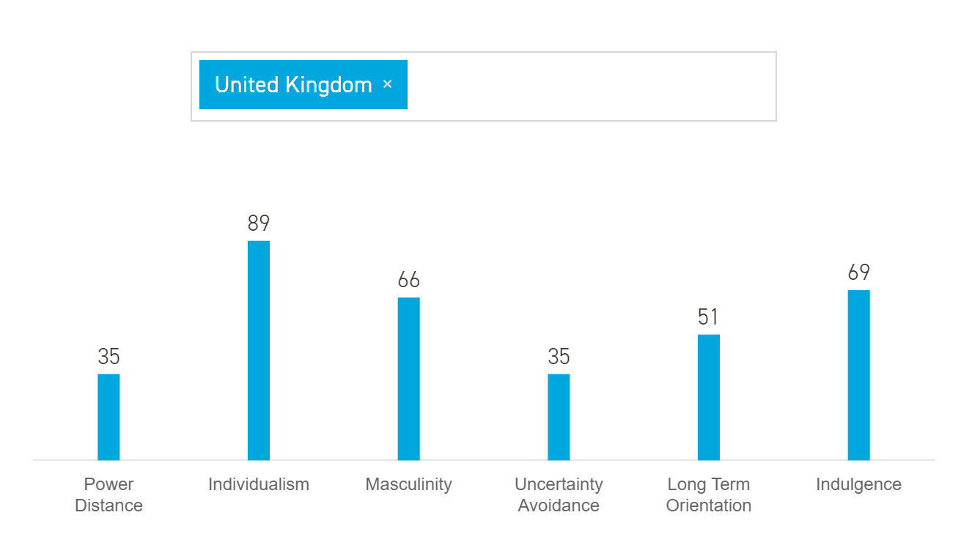
Figure 1: 6-dimension values of the U.K. (Source from Hofstede Insights,2019)
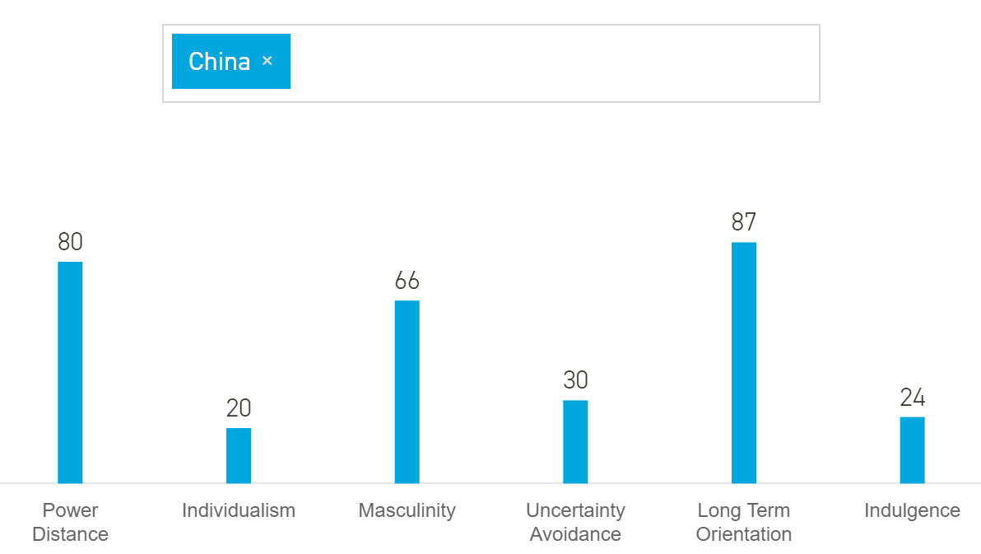
Figure 2: 6-dimension values of China (Source from Hofstede Insights,2019).

References

Armstrong, M. (2014). Armstrong’s Handbook of Human Resource Management Practice 14th Ed. London: Kogan Page.

Batt, Nohara and Kwon (2010). Employer Strategies and Wages in New Service Activities: A Comparison of Coordinated and Liberal Market Economies. ILR Collection.

CIPD (2019). HR Policy. (Online). Available at: https://www.cipd.co.uk/knowledge/fundamentals/people/hr/policies-factsheet (Accessed: 24th Oct. 2020)

Edwards & Rees (2014). International Human Resource Management: Globalization, National Systems and Multinational Companies? Human Resource Management Journal 16(4):432-433.

Hall, A.& Soskice, D. (2001). Varieties of capitalism: The institutional foundations of comparative advantage. Oxford, UK: Oxford University Press.

Hofstede, G. (2011). Dimensionalizing Cultures: The Hofstede Model in Context. Online Readings in Psychology and Culture, 2(1). https://doi.org/10.9707/2307-0919.1014(Accessed: 25th Oct. 2020)
Hofstede Insights (2019). (Online). Available at: https://www.hofstede-insights.com/(Accessed: 25th Oct. 2020)

Huo, Y. P., Huang, H. J., & Napier, N. K. (2002). Divergence or convergence: A cross-national comparison of personnel selection practices. Human Resource Management, 41(1): 31-44.

MacLeod, D. and Clarke, N. (2009) Engaging for Success: Enhancing Performance through Employee Engagement. Office of Public Sector Information, London.

Pendleton, A., Whitfield, K. & Bryson, A. (2009). ‘The changing use of contingent pay at the modern British workplace’. In W. Brown, A. Bryson, J. Forth and K. Whitfield (eds.), The Evolution of the Modern Workplace. Cambridge: Cambridge University Press, pp. 256–84.

Robinson et al. (2004) The drivers of employee engagement, Brighton: institute of employment studies. IES.
Wilkins, S & Neri, (2018). Managing Faculty in Transnational Higher Education: Expatriate Academics at International Branch Campuses. Journal of Studies in International Education.

5. (Had been assessed in the class)
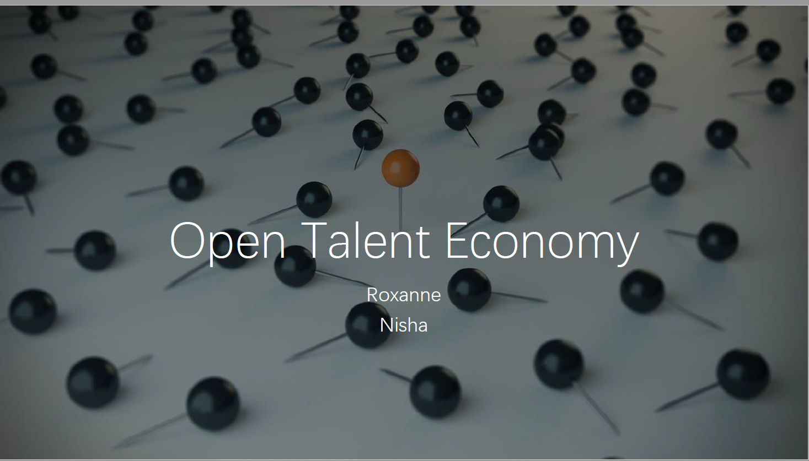
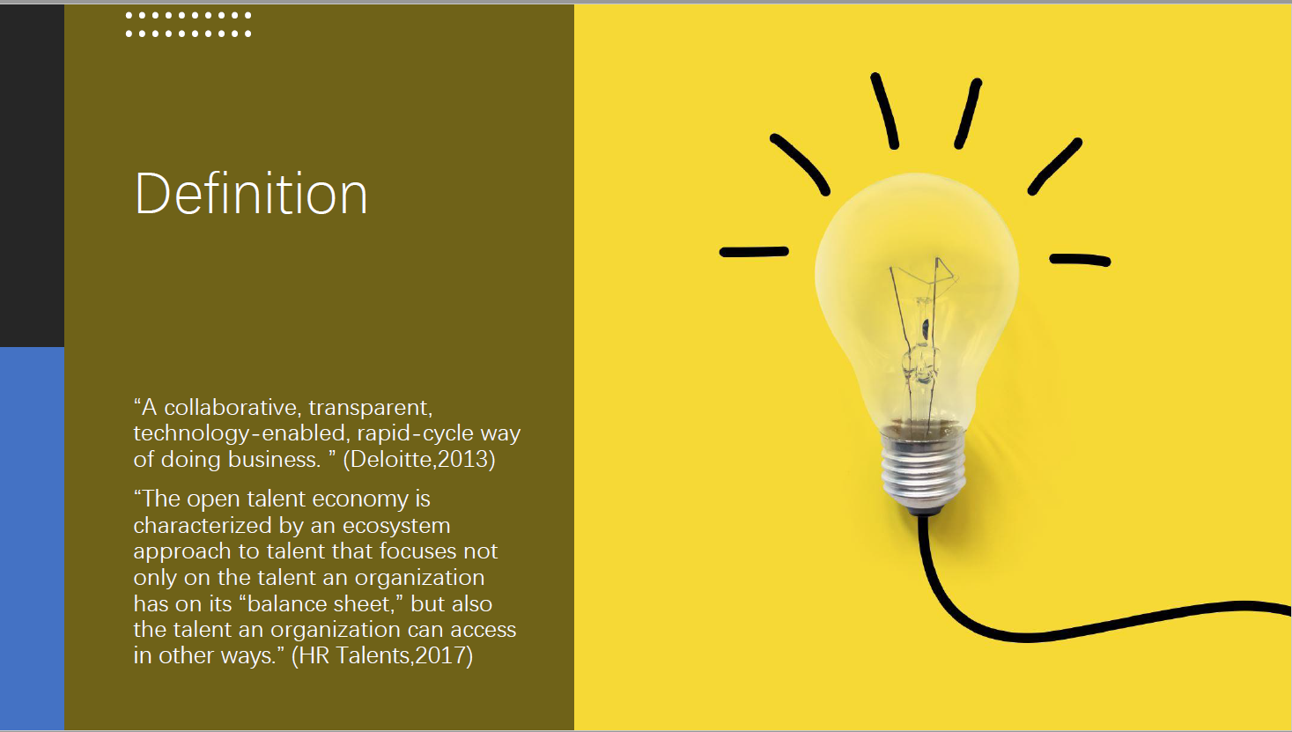
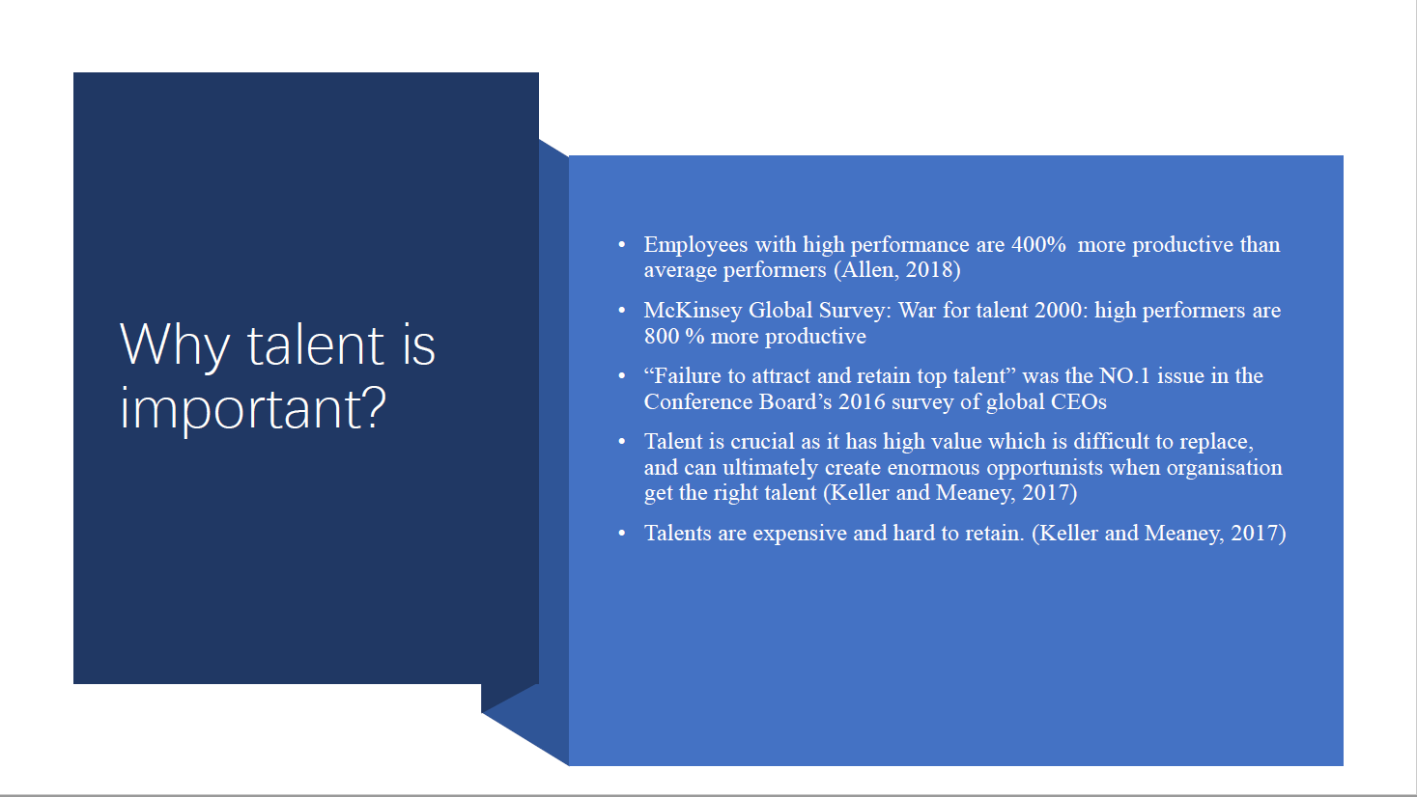
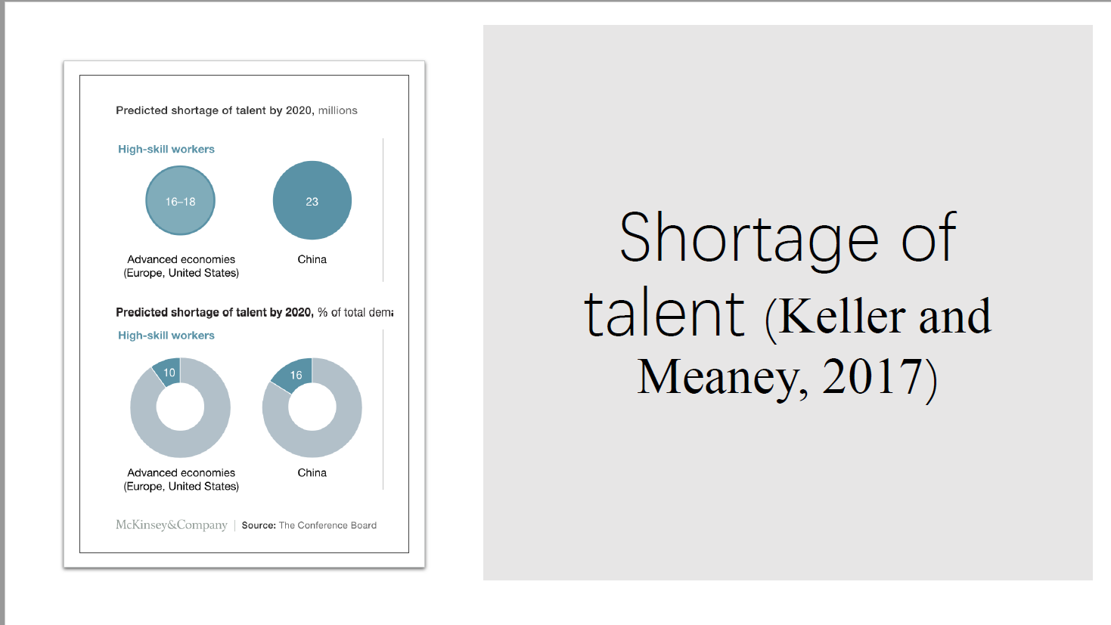
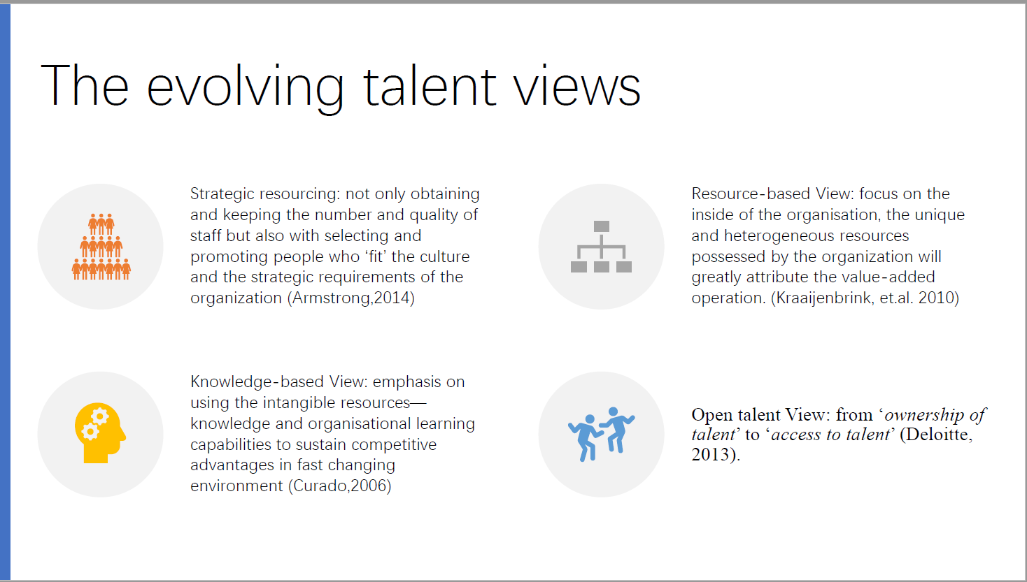
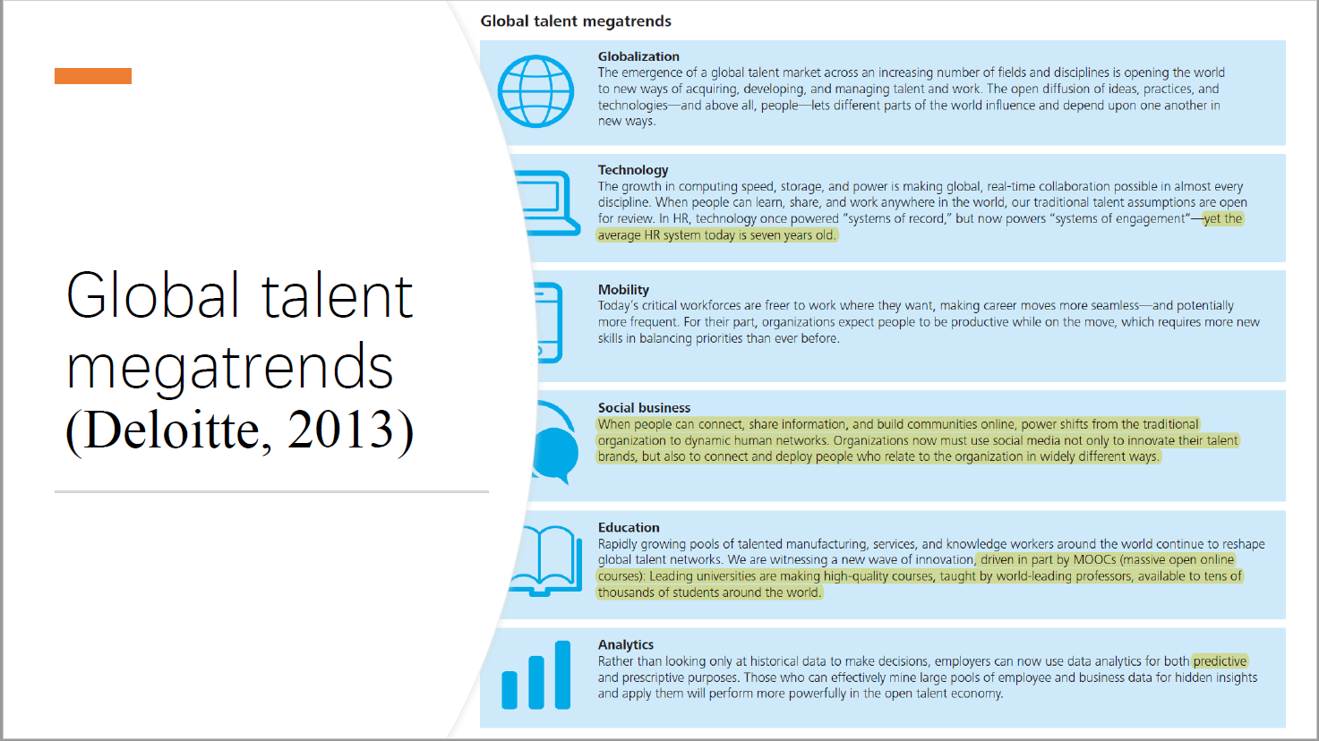
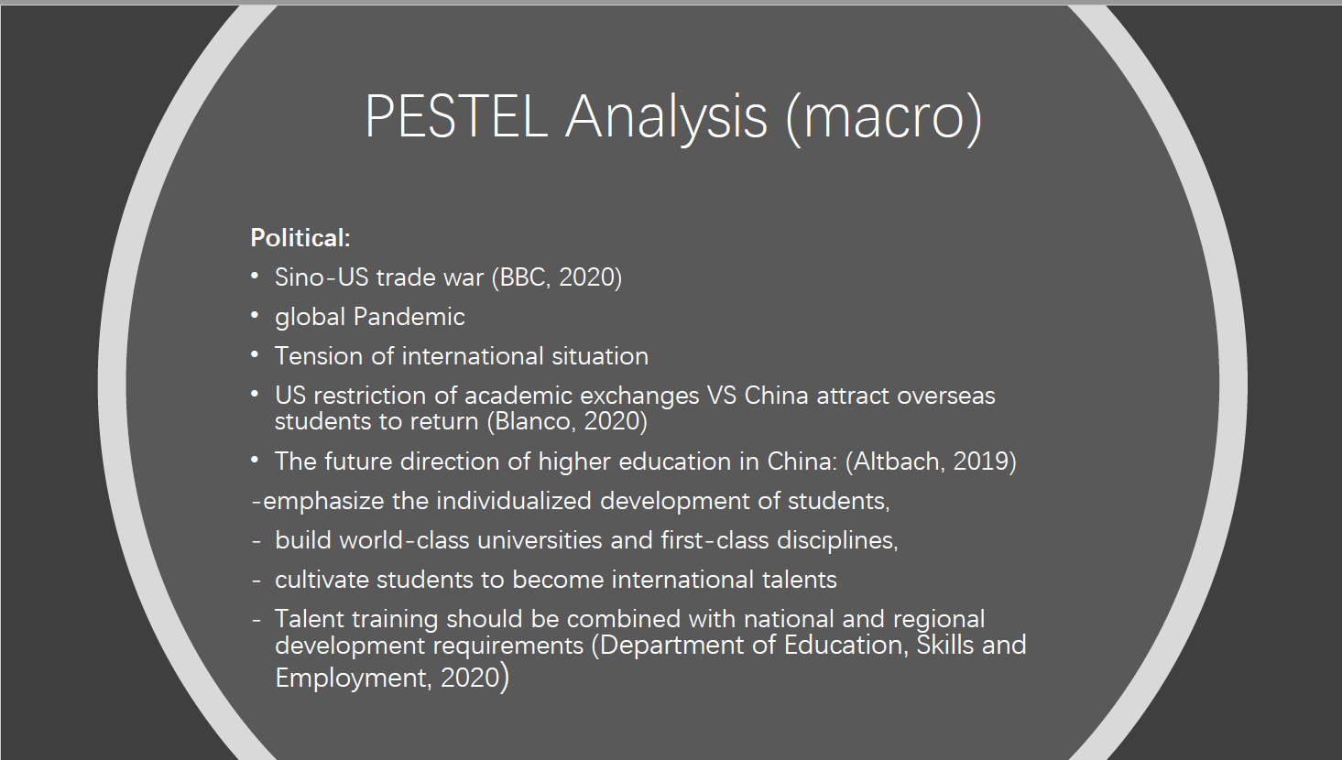
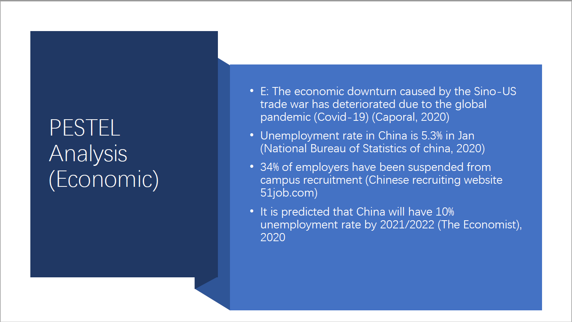
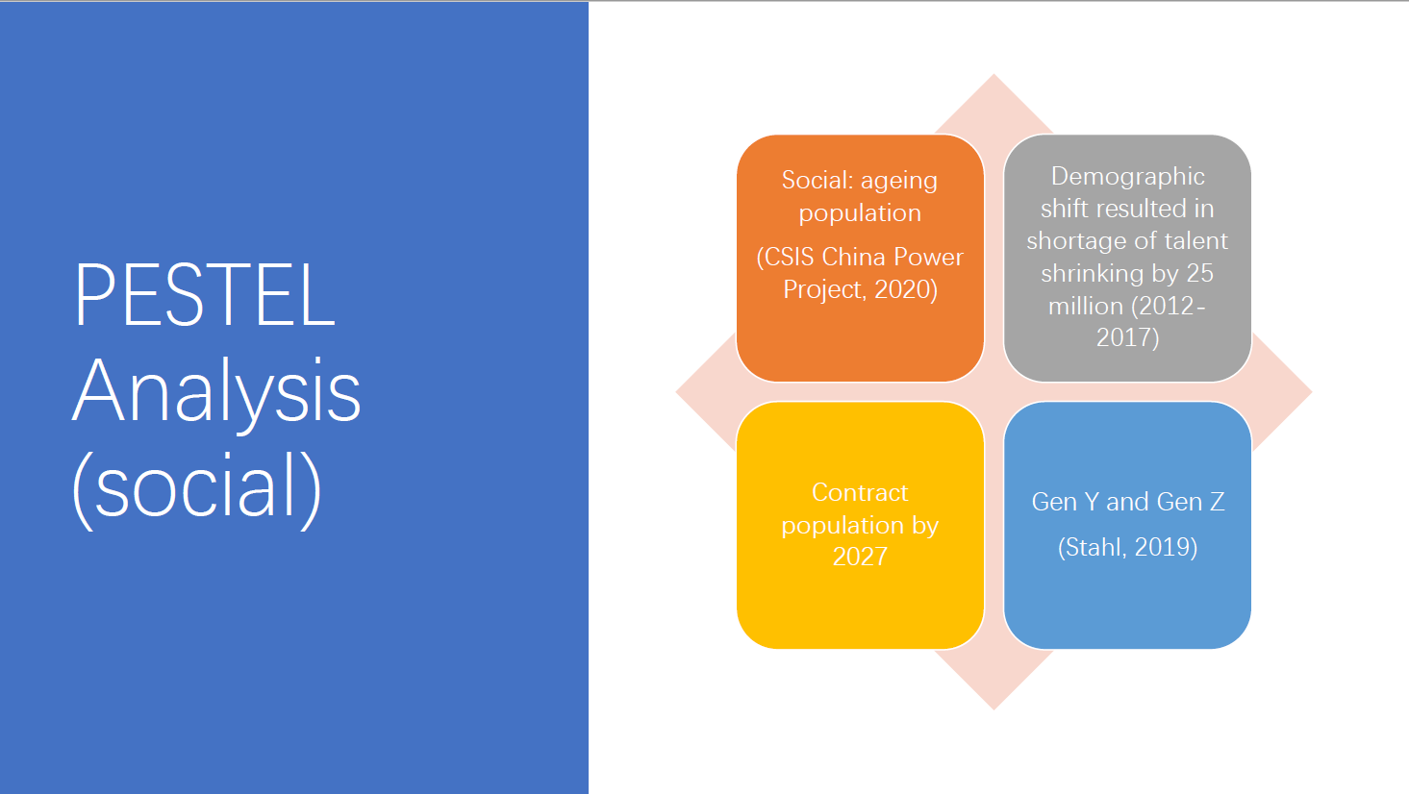
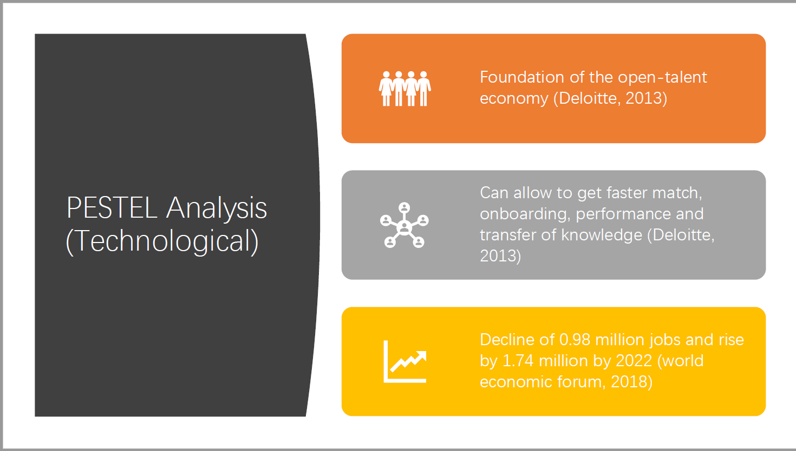
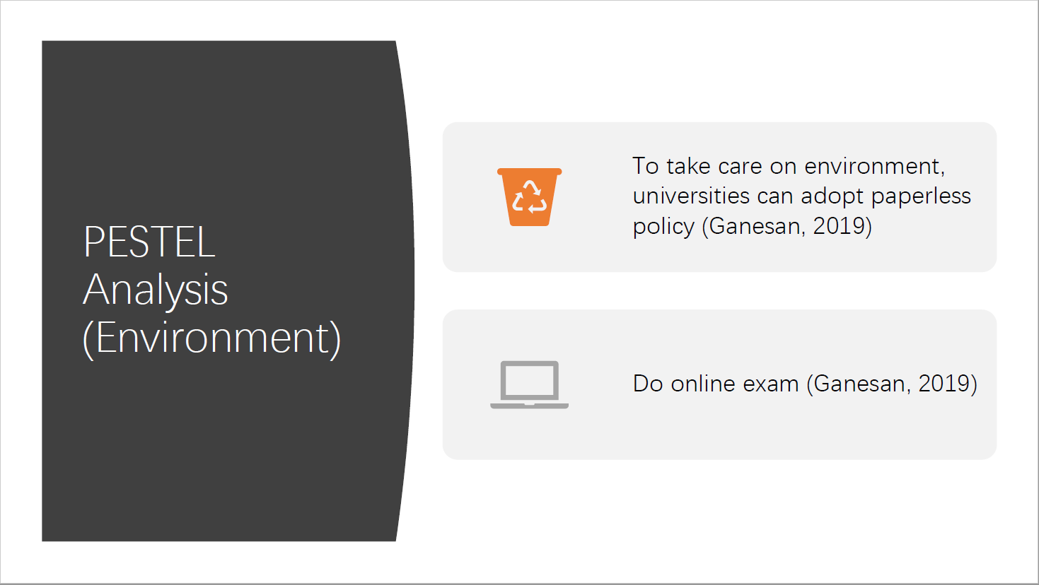
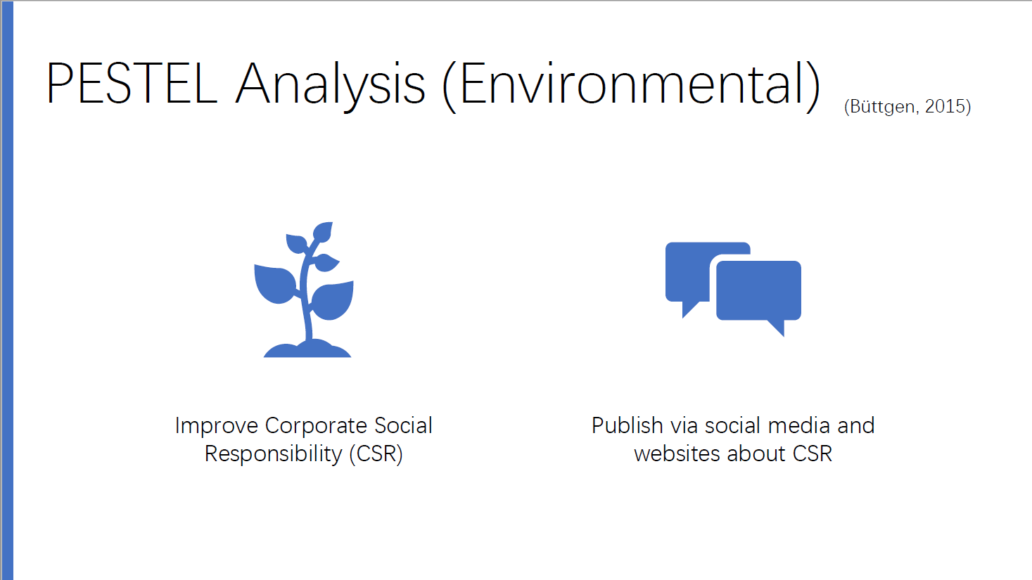
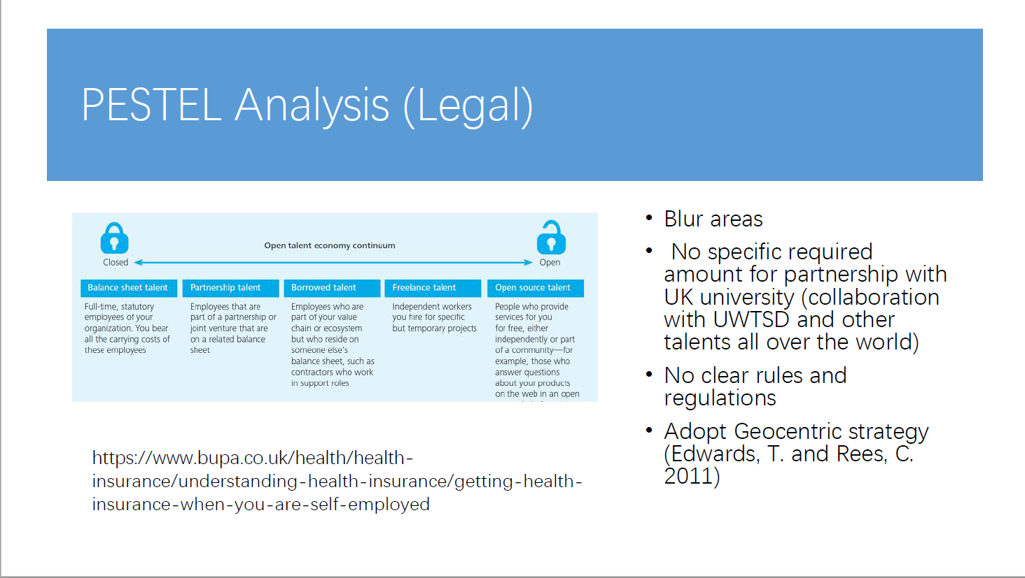
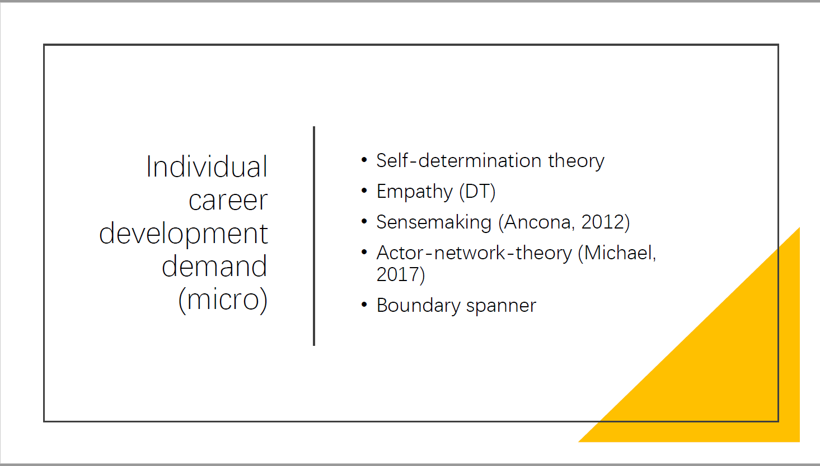
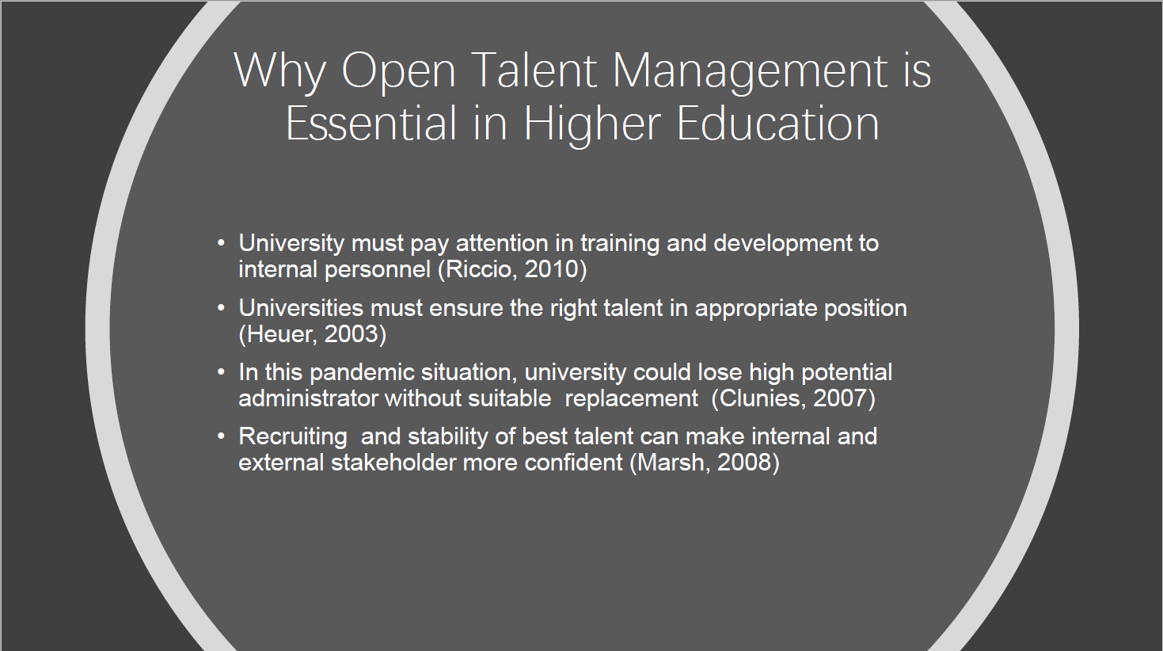
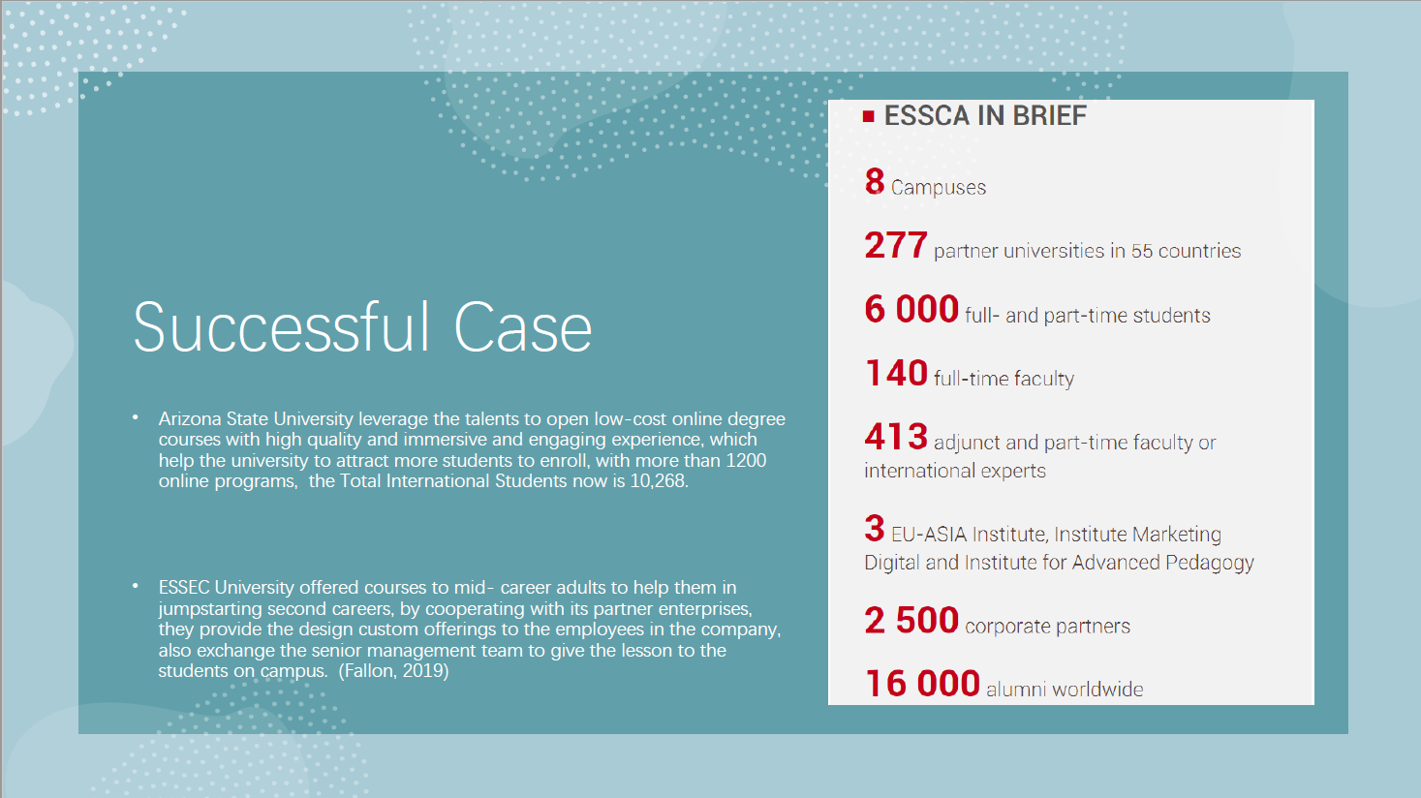
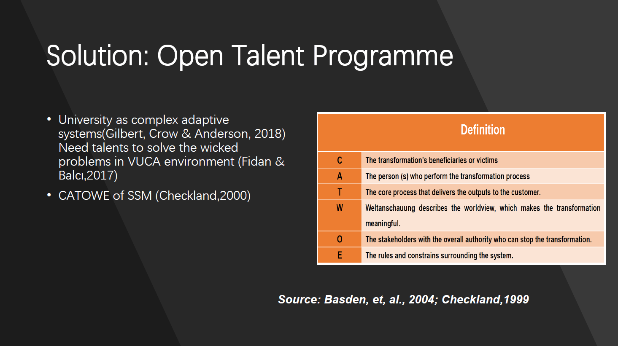
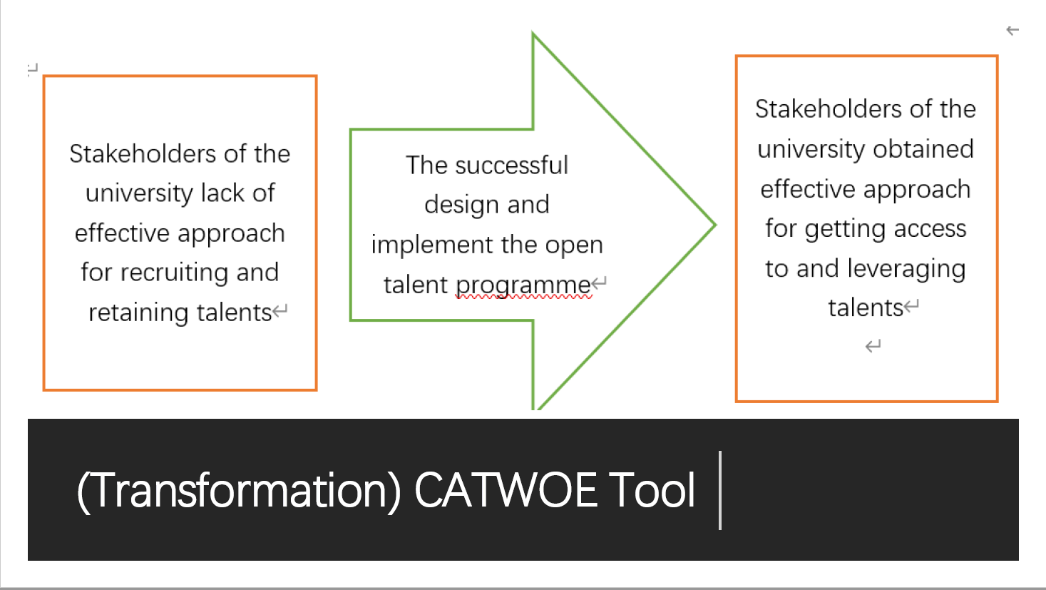
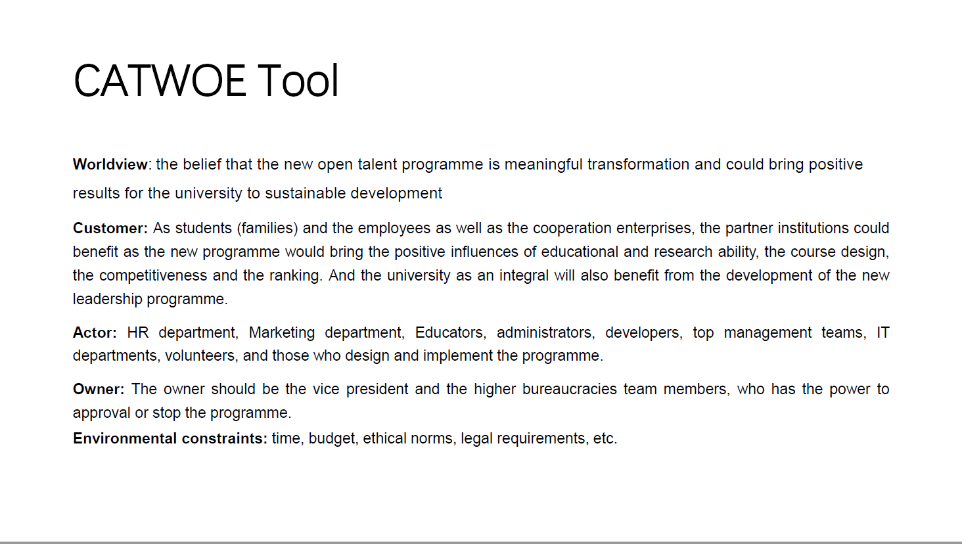
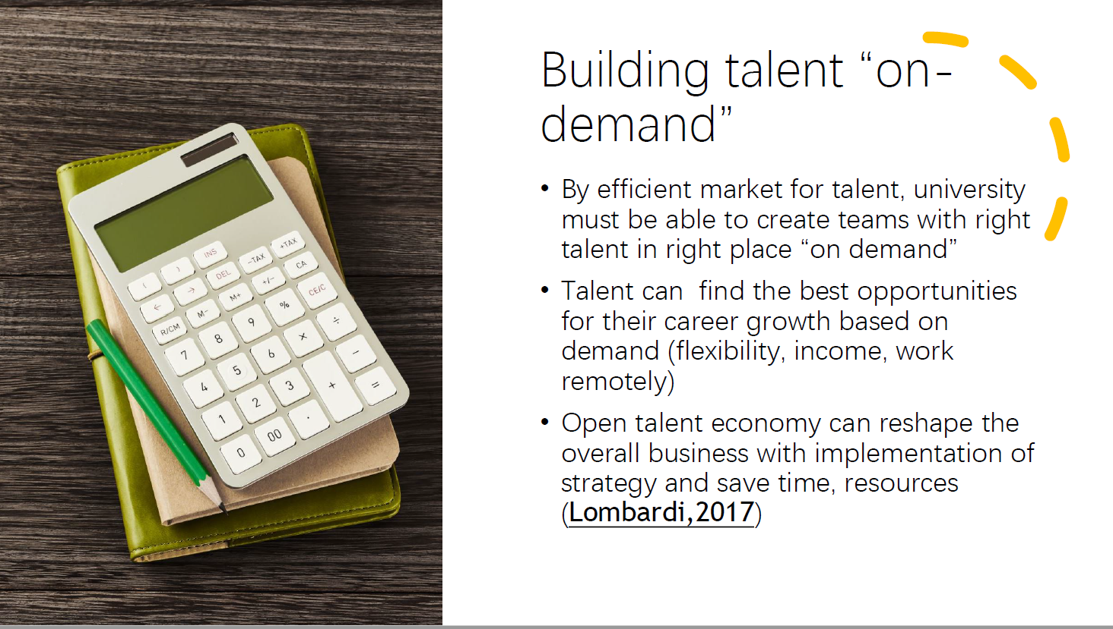
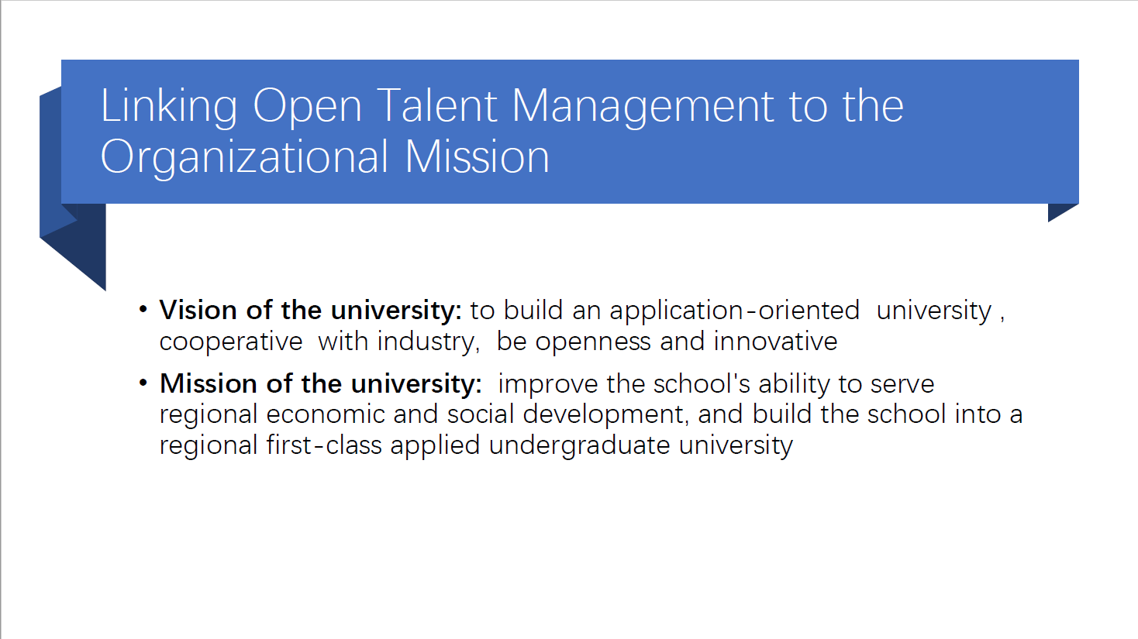
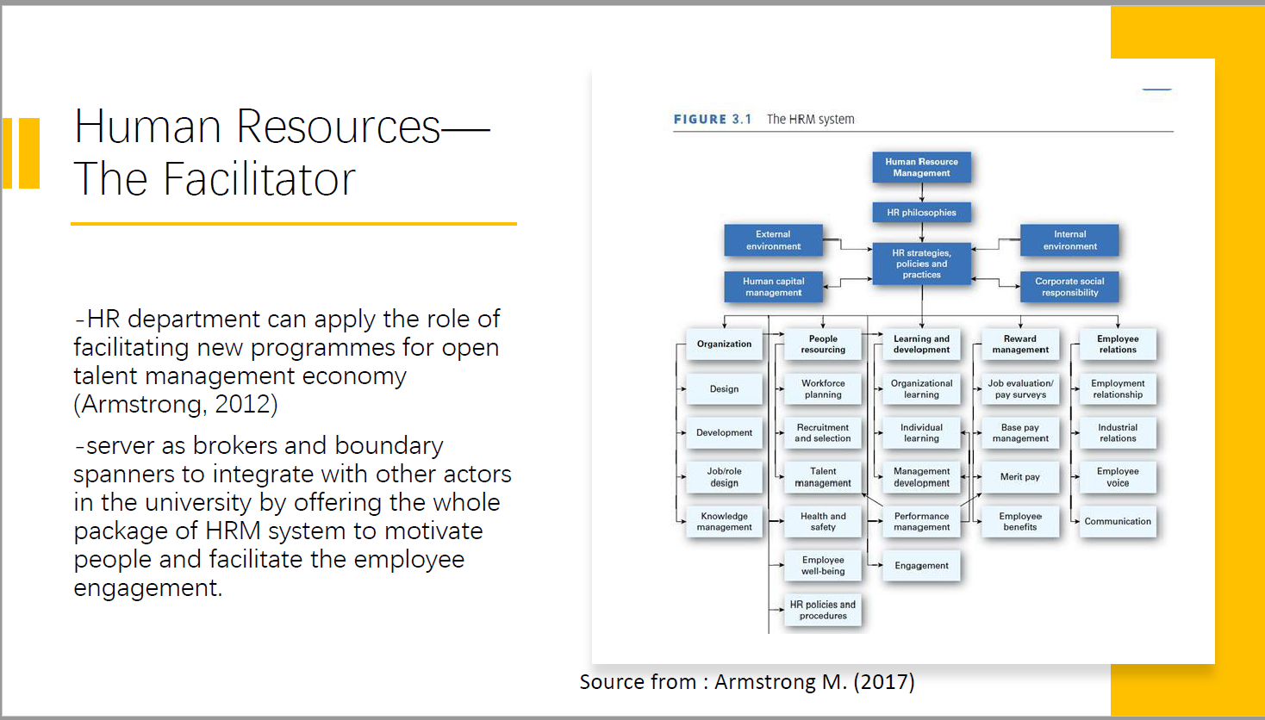
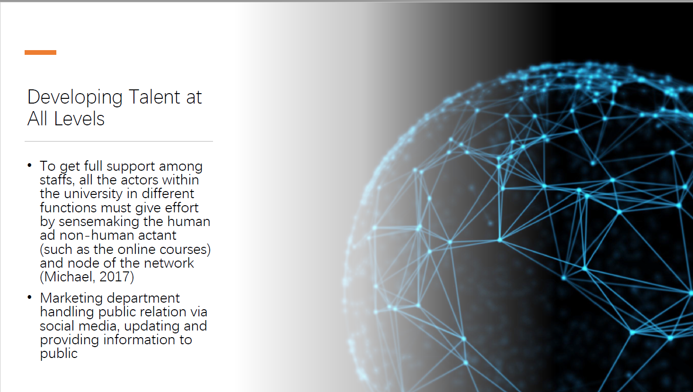
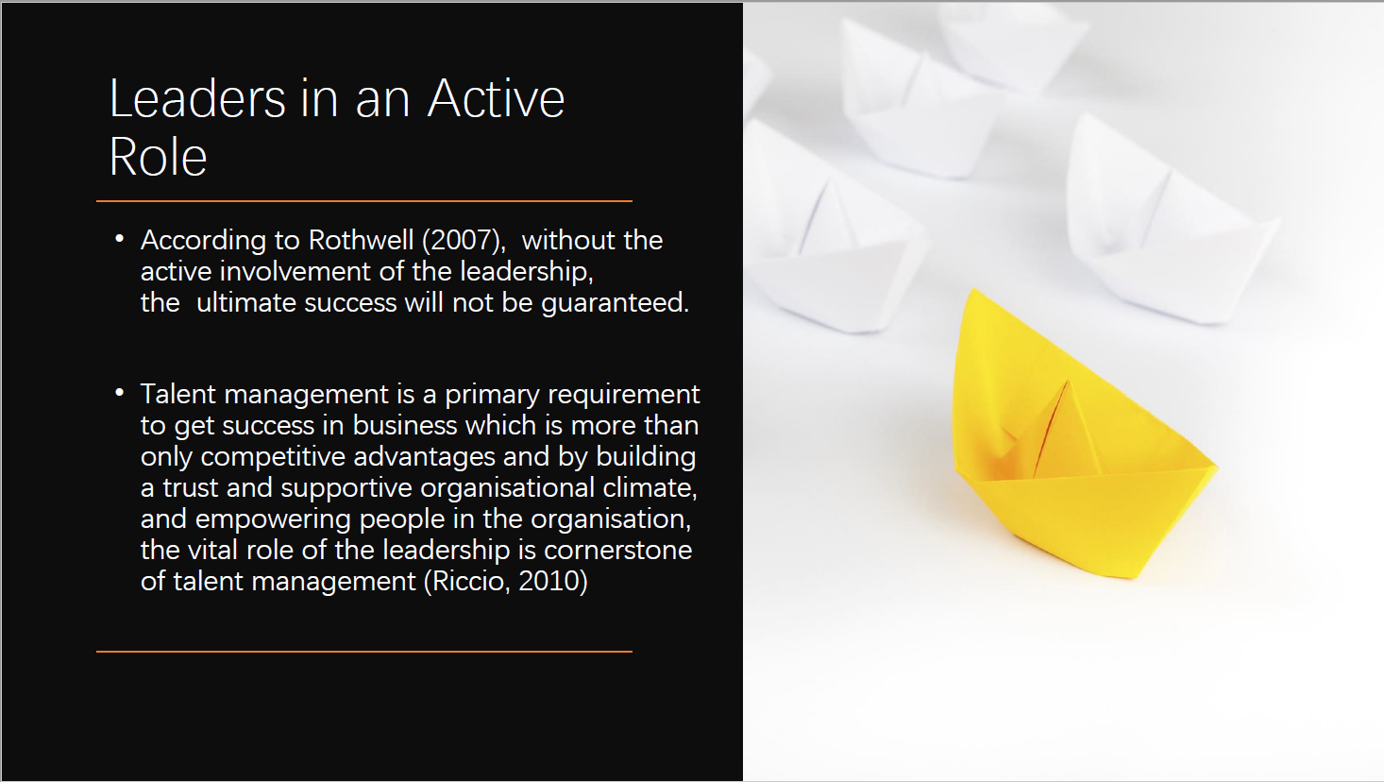

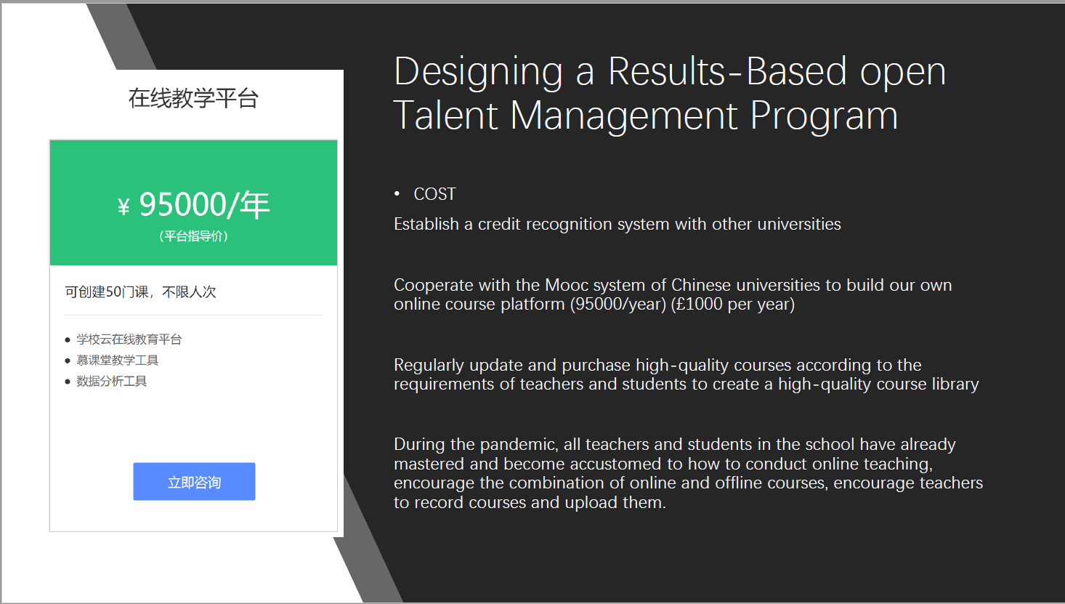
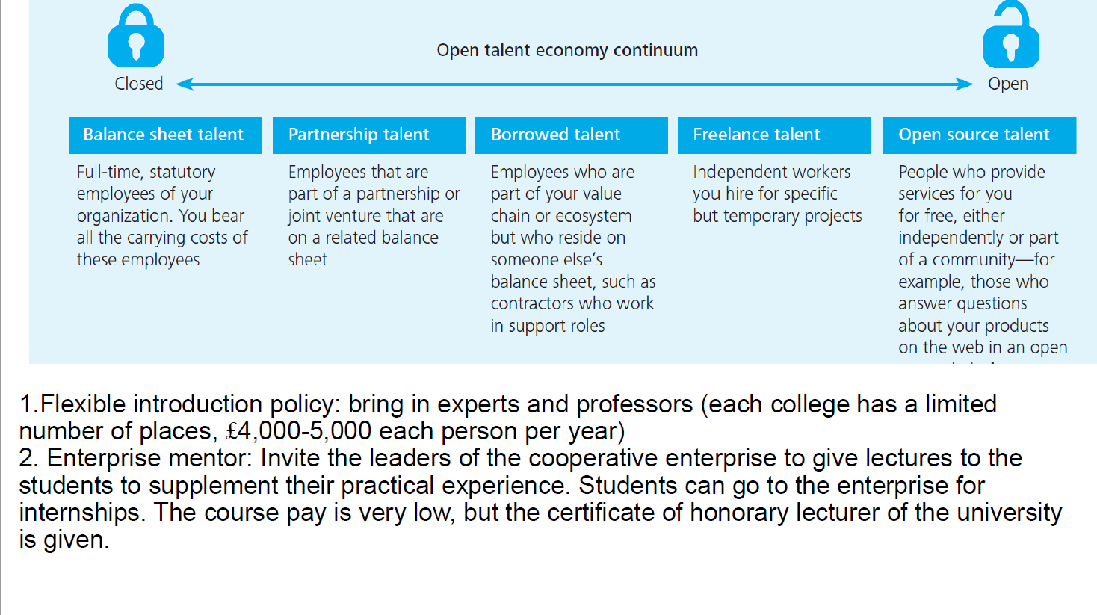
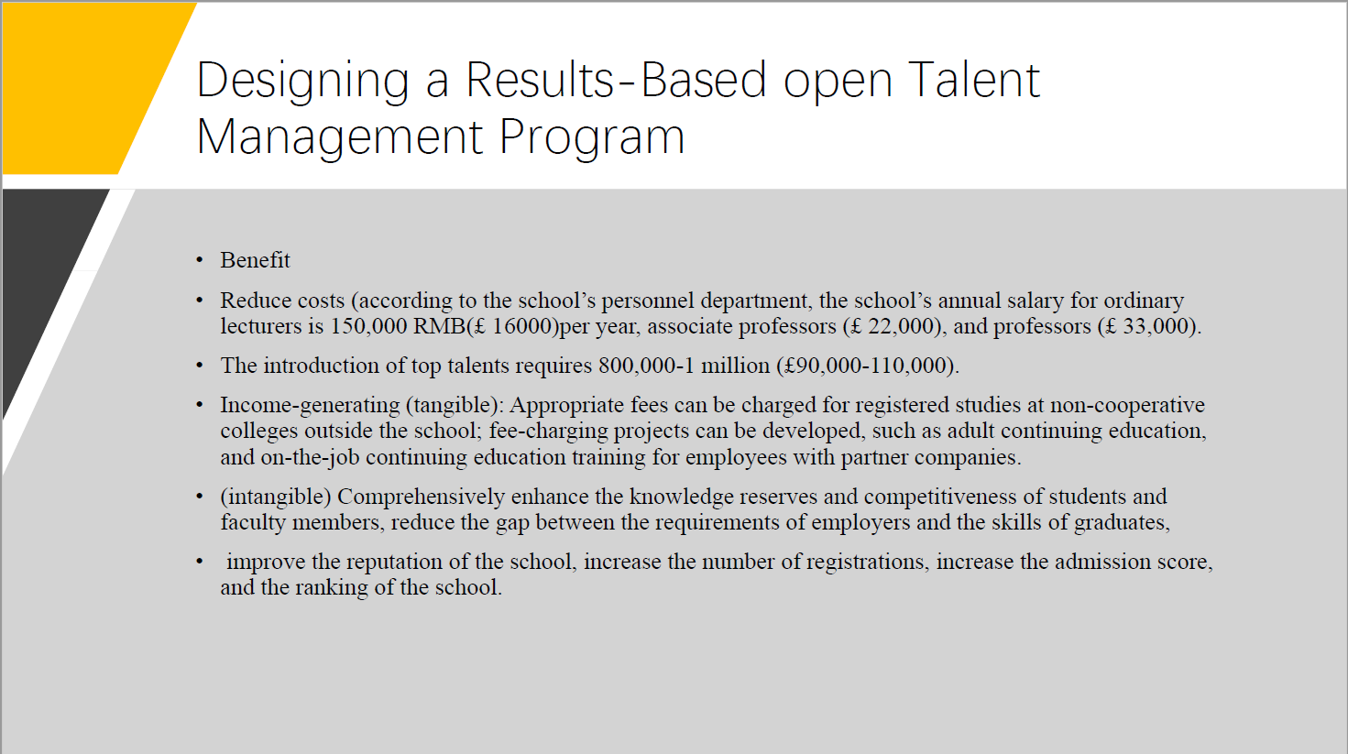
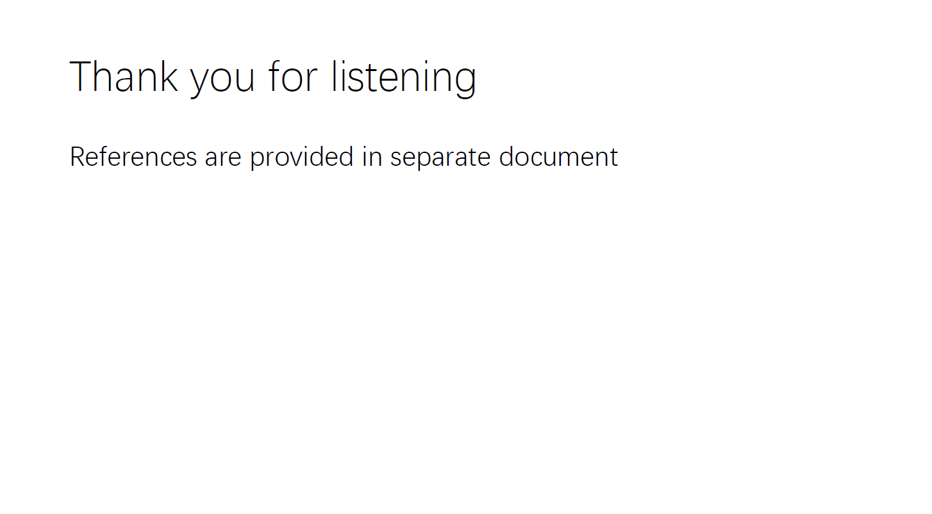
References

A Connect, (2020). 7 Trends Driving the Open Talent Economy: Fuelling the exciting future of work across the globe. (Online).
Available at: https://www.a-connect.com/knowledge/7-trends-driving-the-open-talent-economy/?/acknowledge/7-trends-driving-the-open-talent-economy/
(Accessed 6 9 2020).

Ackerman, C. E., (2020). Self-Determination Theory of Motivation: Why Intrinsic Motivation Matters. (Online)
Available at: https://positivepsychology.com/self-determination-theory/
(Accessed 7 9 2020).

Aguinis, H., and O’Boyle Jr, E., (2012). “The best and the rest: Revisiting the norm of normality in individual performance,” Personal Psychology, Volume 65, Issue 1, pp. 79–119, onlinelibrary.wiley.com.

Allen, T., (2018). 7 Behaviors High Performers Demonstrate To Get Out Of Their Own Way. (Online)
Available at: https://www.forbes.com/sites/terinaallen/2018/10/03/7-behaviors-high-performers-demonstrate-to-get-out-of-their-own-way/#342bff6c4963
(Accessed 8 9 2020).

Altbach, P. G., (2019). The coming ‘China crisis’ in global higher education. (Online)
Available at: https://www.universityworldnews.com/post.php?story=20190403104242366
(Accessed 8 9 2020).

Ancona, D., (2012). Sensemaking : framing and acting in the unknown. In: The handbook for teaching leadership : knowing, doing, and being. Los Angeles: Sage.

Armstrong, M., (2017). Armstrong’s Handbook of Human Resource Management Practice. 14 ed. London: Kogan Page.

Barkhuizen, N., Cooke, G. W., Schutte, N., and Stanz, K., (2014). Talent Management and Leadership Reciprocity: The case of the South African Aviation Industry. Mediterranean Journal of Social Sciences , 5(9), pp. 11-17.

BBC, (2020). A quick guide to the US-China trade war. (Online)
Available at: https://www.bbc.co.uk/news/business-45899310
(Accessed 7 9 2020).

Blanco, G., (2020). Trump has just made it harder to attract academic talent. (Online)
Available at: https://www.universityworldnews.com/post.php?story=20200703145123105
(Accessed 7 9 2020).

Boxall, P. and Purcell, J. (2008) Strategy and Human Resource Management, 2nd edition. Basingstoke and New York: Palgrave Macmillan

Bupa, (2020). Getting health insurance when you're self-employed. (Online)
Available at: https://www.bupa.co.uk/health/health-insurance/understanding-health-insurance/getting-health-insurance-when-you-are-self-employed
(Accessed 5 9 2020).

Burgess, S., and Sievertsen, H. H., (2020). Schools, skills, and learning: The impact of COVID-19 on education. (Online)
Available at: https://voxeu.org/article/impact-covid-19-education
(Accessed 6 9 2020).

Büttgen, P. K. a. M., (2015). Using social media to communicate employer brand identity: The impact on corporate image and employer attractiveness. Journal of Brand Management, 22(9), pp. 755-777.

Caporal, J., (2020). COVID-19 Risks Reigniting US-China Trade War. (Online)
Available at: https://www.brinknews.com/covid-risks-reigniting-us-china-trade-war-economic-recovery-recession/
(Accessed 8 9 2020).

Checkland, P., (2000). Soft Systems Methodology: A Thirty YearRetrospective. Systems Research and Behavioral Science, Volume 17, pp. S11-S58.

CIPD, (2020). CIPD Good Work Index. (Online)
Available at: https://www.cipd.co.uk/knowledge/work/trends/goodwork
(Accessed 7 9 2020).

CSIS China Power Project, (2020). Does China have an aging problem?. (Online)
Available at: https://chinapower.csis.org/aging-problem/
(Accessed 8 9 2020).

Curado, (2006). The knowledge-based view of the firm and its theoretical precursor. Int. J. Learning and Intellectual Capital, 3(4).

Department of Education, Skills and Employment, (2020). China's education modernisation plan towards 2035. (Online)
Available at: https://internationaleducation.gov.au/International-network/china/PolicyUpdates-China/Pages/China%27s-education-modernisation-plan-towards-2035-.aspx
(Accessed 8 9 2020).

Deloitte, (2020). COVID-19 and impacts on the higher education sector. (Online)
Available at: https://www2.deloitte.com/uk/en/pages/public-sector/articles/covid-19-and-impacts-on-the-higher-education-sector.html
(Accessed 7 9 2020).

Deloitte, (2013). The open talent economy: People and work in a borderless workplace. (Online) Available at: https://www2.deloitte.com/content/dam/Deloitte/global/Documents/HumanCapital/dttl-hc-english-opentalenteconomy.pdf (Accessed 7 9 2020)

Edwards, T. and Rees, C. (2011) International Human Resource Management: globalisation, national systems and multinational companies. 2nd ed. Essex: Palgrave

Eurodice, (2019). Higher Education Funding. (Online)
Available at: https://eacea.ec.europa.eu/national-policies/eurydice/content/higher-education-funding-93_en
(Accessed 5 9 2020).

European Federation of Journalists, (2020). COVID-19: It is time to guarantee social security for all. (Online)
Available at: https://europeanjournalists.org/blog/2020/03/23/covid-19-it-is-time-to-guarantee-social-security-for-all/
(Accessed 7 8 2020).

Fallon, J., (2019). How Higher Education Can Support the New 'Talent Economy'. (Online)
Available at: https://www.linkedin.com/pulse/how-higher-education-can-support-new-talent-economy-john-fallon
(Accessed 8 9 2020).

Flexing, I., (2017). Start shifting gears — It’s time for an open talent economy. (Online)
Available at: https://medium.com/@Flexingit1/start-shifting-gears-its-time-for-an-open-talent-economy-bf2539b3dfe1
(Accessed 6 9 2020).

Fidan &Balcı (2017). Managing schools as complex adaptive systems: A strategic perspective. International Electronic Journal of Elementary Education. Volume 10, Issue 1.

Ganesan, S., (2019). Educational institutions are taking up green initiatives. (Online)
Available at: https://www.sundayguardianlive.com/lifestyle/educational-institutions-taking-green-initiatives
(Accessed 8 9 2020).

Gilbert, Crow & Anderson (2018). Design Thinking for Higher Education. Stanford Social Innovation Review. (Online). Available at: https://ssir.org/articles/entry/design_thinking_for_higher_education# (Accessed 5 9 2020).

HRTalents, (2017). Connect with Content - Welcome to the open talent economy. (Online)
Available at: https://www.hrbuilders.eu/en/blog/welcome-to-the-open-talent-economy
(Accessed 5 9 2020).

Kraaijenbrink, J., Spender, J-C., and Groen, J. A., (2009). The Resource-Based View: A Review and Assessment of Its Critiques. Journal of Management.

Lombardi, G., (2017). HARNESSING THE POWER OF THE OPEN TALENT ECONOMY. (Online)
Available at: https://futureofearth.online/harnessing-the-power-of-the-open-talent-economy/
(Accessed 6 9 2020).

Keller, S., and Meaney, M., (2017). Attracting and retaining the right talent. (Online)
Available at: https://www.mckinsey.com/business-functions/organization/our-insights/attracting-and-retaining-the-right-talent
(Accessed 5 9 2020).

Michael, M., (2017). Actor-Network Theory: Trials, Trails and Translations. Los Angeles: SAGE Publications Ltd.

O'Donnell, Z., (2016). Why in practice employers often appear to fail to achieve the objectives expected of their HR policies and initiatives. (Online)
Available at: https://www.lmplusconsulting.com/wp-content/uploads/2016/11/HR-Management.pdf
(Accessed 6 9 2020).

Office for National Statistics (2020). Labour market overview, UK: August 2020

Riccio, S., (2010). Talent Management in Higher E alent Management in Higher Education: De ducation: Developing Emer eloping Emerging Leaders Within the Administration at Private Colleges and Universities. Lincoln : University of Nebraska.

Stahl, A., (2019). How Generation-Z Will Revolutionize The Workplace. (Online)
Available at: https://www.forbes.com/sites/ashleystahl/2019/09/10/how-generation-z-will-revolutionize-the-workplace/#981ba6e4f537
(Accessed 8 9 2020).

The Economist, (2020). China's unemployment rate may hit 10%. (Online)
Available at: http://country.eiu.com/article.aspx?articleid=359423819&Country=China&topic=Economy&subtopic=Forecast&subsubtopic=Economic+growth
(Accessed 7 9 2020).

Vistage, (2020). Talent management: The comprehensive guide for leadership teams. (Online)
Available at: https://blog.vistage.co.uk/talent-management-the-comprehensive-guide-for-leadership-teams
(Accessed 7 9 2020).

Wedrychowicz, S., (2019). The Open Talent Economy. [Online]
Available at: https://www.linkedin.com/pulse/open-talent-economy-sonia-wedrychowicz
(Accessed 7 9 2020).

Winsor, J., (2020). Why ‘Gig Economy’ Is Out And ‘Open Talent’ Is In. (Online)
Available at: https://www.forbes.com/sites/johnwinsor/2020/03/16/why-gig-economy-is-out-and-open-talent-is-in/#6b95d2af663c
(Accessed 6 9 2020).

6.
Atkinson’s Flexible Firm Model was proposed by Atkinson and his fellows in mid-1980s (Procter, et.al., 1994), which aimed to offer management aspiration of reforming different employment policies. As indicated in this model, through flexible deploy core, first and second peripheral and other layers of labor force, the organisations could efficiently allocate its human resources with numerical, functional and financial flexibility (Atkinson,1984). Since the model was initiatively put forward, some critiques are surged. I am in line with Hyman (1991)’s criticizes about the detrimental to workforce and dishonored its importance by not recognizing it as a strategy but just an ad hoc planning. As this model clearly defines various manpower in terms of different peripheral. The more external peripheral employees are, the less work security, less learning and training opportunities (Ahmad, 2015). Although Tatara (2005) and Snell (2012) endorsed its merits of flextime, but the flexibility of this model seems to provide convenience and low cost only unilaterally for the organization. Furthermore, it is more like an organization-level policy or even manpower practices rather than a strategy as it rigidly stipulates the status of employees at various levels, giving the organization little discretion to implement it.

However, I would like to defense its crucial position as its overarching philosophy to foster the flexible reaction for organisations could be considered as the bud of open talent economy and resilience in the era of globalization and technological evolving along with fourth industrial revolution. The external influences provide the initiatives to adopt flexible talent strategy. First, the development and widespread use of telecommunication make teleworking even tele-networking possible, gives the opportunity to deploy different kinds of workforce despite the geographic limitations and doing it in a more flexible and cost-effective way (CIPD,2020). Second, gen Y and gen Z’s need for new working patterns (Wadee.2013) which means more flexible work choices, to balance their lives, reduce psychological stress (Ahmad, 2015). Besides, the global pandemic also gave working flexibility a good operating opportunity, implying that working flexibility is an imperative trend for the organisation in a complex environment.

Open talent economy is defined as “a collaborative, transparent, technology-enabled, rapid-cycle way of doing business.” (Deloitte,2013) different groups of workers such as full-time employees, temporary workers, outsourcing manpower and self-employment workforce etc. in Atkinson’s model are align with the employee ecosystem in open talent economy. When formulating the talent strategy in your organisation, questions like “how do these different peripheral manpower effectively co-exist?” “How ‘closed’ and ‘open’ should it be?” need thoughtful consideration. Take my organisation (FJJX University) as an example, which has the aspiration to become a first-class application-oriented university with open and innovative view and be qualified to recruit master students within two years. To align the strategy of university, Atkinson’s module is helpful to leverage human resources. Professor and experts with rich academic and industrial experiences as well as the new and scarce talent such as data analysts and scientists, training and development specialists, digital marketing and strategy specialists, people and culture specialists (Future of jobs survey 2018, world economic forum) are “organisational-specific” talents cater to FJJX university. These talents are the source of core competitiveness for the organisation. Therefore, when acquiring and retaining these talents, long-term and holistic view is needed. It is not recommended to use a very open form (i.e. borrowed, freelance, open source, etc.) (Deloitte,2013) to replace core talents. At this time, financial flexibility is the last consideration. On the contrary, some redundant roles such as lectures, administrative staff (Heery and Noon, 2008), can use contract labor, crowdsourcing, temporary labor, etc. (second peripheral group) to maximize financial and numerical flexibility.

References
Ahmad. H (2015). A critical examination of the advantages and disadvantages of adopting flexible working practices in relation to the employer and employee. (Online). Available at: https://www.researchgate.net/publication/304038081_A_critical_examination_of_the_advantages_and_disadvantages_of_adopting_flexible_working_practices_in_relation_to_the_employer_and_employee (Accessed: 23 Oct 2020)

Atkinson, J. (1984) Manpower Strategies for Flexible Organizations. Personnel Management. Vol.16, pp 28-31.

CIPD (2020). Labor Market Outlook. Views From Employers. (Online). Available at: https://www.cipd.co.uk/Images/labour-market-outlook-spring-2020_tcm18-76992.pdf
(Assessed 24/10/2020).

Deloitte (2013). The open talent economy People and work in a borderless workplace. (Online).
Available at:https://www2.deloitte.com/content/dam/Deloitte/global/Documents/HumanCapital/dttl-hc-english-opentalenteconomy.pdf (Assessed 24/10/2020).

Heery, E. and Noon, M. (2008) A dictionary of human resource management. 2nd edn. New York: Oxford University Press.

Hyman, R. (1991). Plus ca change? The Theory of Production and the Production of Theory. In A. Pollert (ed.) Farewell to Flexibility? Oxford: Blackwell, 259-83.

Insight Report. The Future of Jobs Report 2018. (Online). Available at : http://www3.weforum.org/docs/WEF_Future_of_Jobs_2018.pdf (Assessed 24/10/2020)

Procter, et.al., (1994). Flexibility, Politics & Strategy: In Defence of The Model of The Flexible Firm. Work, Employment & Society, Vol.8, No.2, pp 221-242.

Snell, S.A. (2012) Managing human resources / edition 16. 16th edn. United States: South-Western College Publishing.

Tatara, I.E. (2005) HR how-to: Work life benefits. Illinois: Wolters Kluwer.

Wadee, Z. (2013). Generation Y choose greater flexibility over financial reward, PwC study reveals. (Online). Available at:
http://www.hrmagazine.co.uk/article-details/generation-y-choose-greater-flexibility-over-financial-reward-pwc-study-reveals (Accessed: 23/10/2020).

7.

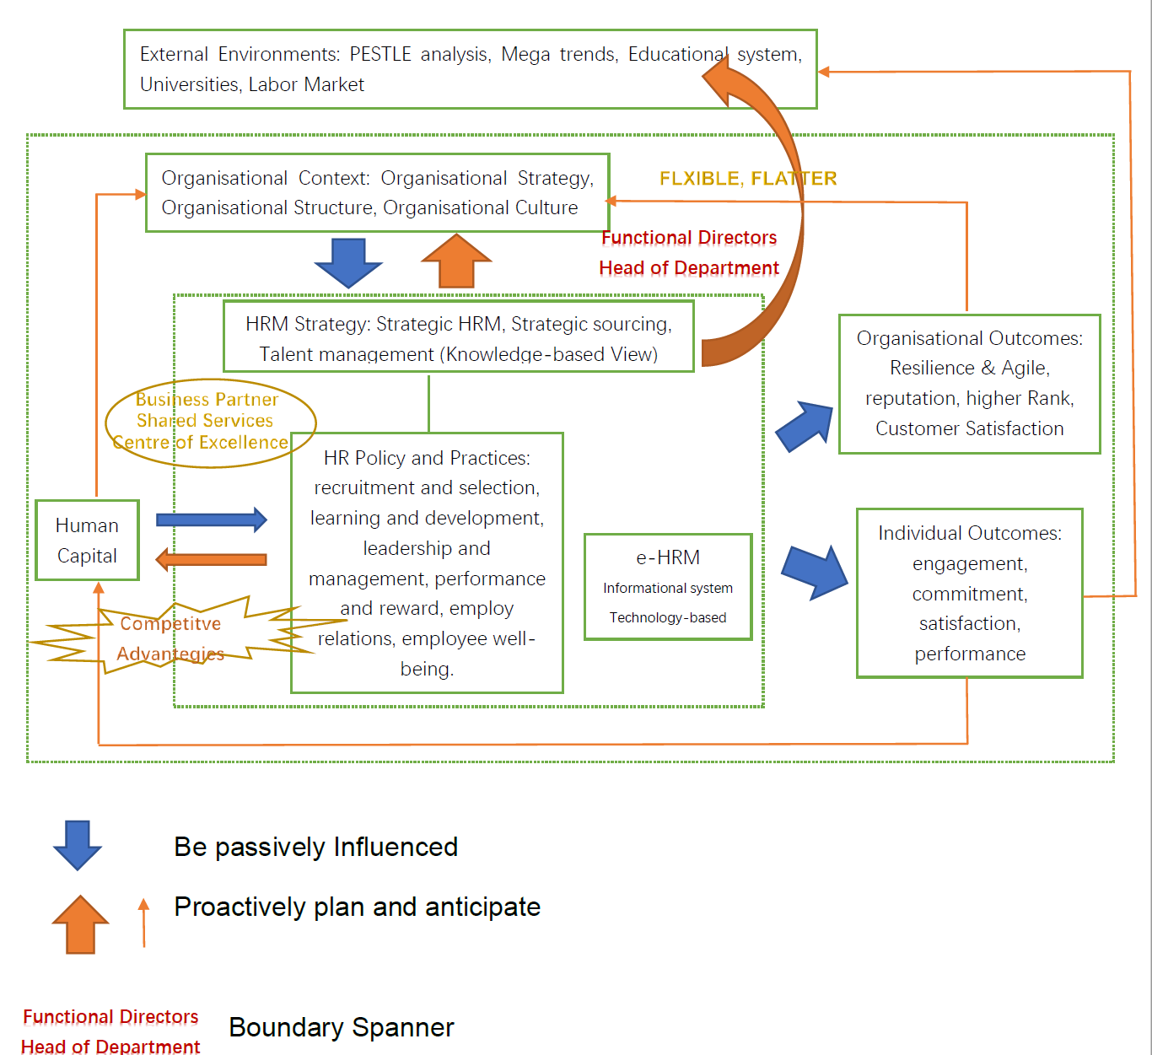
Figure 3: Resilience Model for FJJX University
According to Gary & Välikangas (2003), organisational resilience is the proactive anticipation and adjustment capacity to change before change. The ability of reacting and rebounding from crisis require the organisation to have the holistic view of an organisational-wide-strategy, which reflect to soft systematic methodology (Checkland ,2000).
To understand the relationship between human resource management and organizational resilience at FJJX University, five models are borrowed and introduced, they are the MIT 90s Framework (Morton, 1991) the HR system (Amstrong, 2017:37), Ulrich Model (Ulrich, 1998), the Harvard Model (Beer et al., 1984) and the integrative Model of HRM (Martín-Alcázar,et, al.,2005). By critically absorb ideas from four models and analyzing the HRM process at FJJX University, and describing important factors and indicators outside and inside the organisation that could influence HRM strategies, policies, practices and outcomes, my model intended to improve the HRM process and help my university become a resilience and agile organisation.
According to the MIT 90s Framework (Morton, 1991), five major elements of organisational strategies, organisational structures, management process, individual & roles and technology are indispensable factors when creating HRM model. And HR system (Amstrong, 2017:37) provided an overview of the meaningful, integrated and jointly HR activities. Ulrich Model (Ulrich, 1998) showed the three-leg triangulation of HR role as business partners, shared service center and centre of excellence and imply the role shift from administrative to strategic function. And the Harvard Model (Beer et al., 1984) outlined the importance of stakeholder and line managers, which are functional directors and head of departments in university. Also, the integrative Model of HRM (Martín-Alcázar,et, al.,2005) gave example to what is a coherent and mutually reinforcing HR management strategies, policies and practices.
The framework has two major compositions (PESTLE, Mega trends, Educational system, Universities, Labor Market), the external environment and internal context (Organisational Strategy, Organisational Structure, Organisational Culture, HRM strategies, policies, practices, etc.). Strategic HRM, especially the talent management strategy aims to influence the human capital in the organisation and generate positive outcomes and finally have proactive impact on the interdependency between external and internal context. Based on knowledge-based view, knowledge is considered as the most important resource, talents’ acquisition, retaining and development is to strengthen the capability of its knowledge human capita and acquire sustainable competitive advantages (Curado, 2006). All the HRM strategies, HR policies and practices connected with each other for achieving the goals of organisation. Strategy points out the direction, policies offers guiding principles, and practices (six major activities) implemented to answer the questions of individual needs and roles. According to Weller & Anderson (2013), digital resilience in university is the ability to reaction to the technological changes, a technology-based e-HRM is essential tool to achieve the goals in a better and quicker way. The active interaction between organisational strategies, HR Strategies, policies and practices require the support from a more flexible and flatter structure and all line managers (functional directors and head of department in university). As a whole package, the synergic set serviced as business partner, shared services centre and the centre of excellence to develop the stock of human capital of university (Ulrich, 1998). Finally, the outcomes of the model are supposed to be results of the HRM decisions and practices on organisational and individual level. As for employee effects, by deploying appropriate policies and practices such as situational leadership management style, who guide the employees and facilitate two-way communication; line managers who motivate and give enough autonomy to their subordinates make them feel they are competence, autonomy and relatedness (Deci & Ryan, 2014); and an foster a recognition organisational culture to encourage the employee voice and apply psychological contract to promote mutual commitments between employer and employee. All the right HRM decisions enable the individual outcomes such as better and higher level of employee engagement, commitment, satisfaction and performance. As for organisational outcome, apart from what we expect for the reliance and agile organisation, other positive effects such as better reputation, higher rank and customer satisfaction.

References
Armstrong M. (2017) Armstrong’s Handbook of Human Resource Management Practice 14th Ed. London: Kogan Page

Beer, M., Spector, B., Lawrence, P., Mills, D. Q., & Walton, R. (1984). Human resource management: A general manager’s perspective. New York, NY: Free Press.

Checkland (2000). Soft systems methodology: a thirty year retrospective. Systems Research and Behavioral Science Syst. Res. 17, S11–S58.

Curado, (2006). The knowledge-based view of the firm and its theoretical precursor. Int. J. Learning and Intellectual Capital, 3(4).

Deci, E. L., & Ryan, R. M. (2014). Autonomy and need satisfaction in close relationships: Relationships motivation theory. In N. Weinstein (Ed.), Human motivation and interpersonal relationships: Theory, research, and applications pp. 53–73.

Gary & Välikangas (2003). The Quest for Resilience. Harvard Business Review.

Ulrich, D. (1998). A new mandate for human resources. Harvard business review 76, 124-135.

Martín-Alcázar, F., Romero-Fernandez, P. M. & Sanchez-Gardey, G. (2005). Strategic human resource management: integrating the universalistic, contingent, configurational and contextual perspectives. International Journal of Human Resource Managament, Vol. 16, No. 5, Pp 633-659. Retrieved March 7, 2010. (Online). Available at: http://molar.crb.ucp.pt/cursos/2%C2%BA%20Ciclo%20-%20Mestrados/Gest%C3%A3o/200709/DGRH/Papers/Alcaz%C3%A1r_revis%C3%A3o%20de%20literatura%20sobre%20GERH.pdf (Accessed: 23 Oct 2020)

Scott Morton, M.S. (1991). The Corporation of the 1990s – Information technology and organizational transformation. Oxford University Press.

Weller & Anderson (2013). Digital resilience in higher education. European Journal of Open, Distance and E-Learning.

