

Portfolio and reflective piece linked to a voluntary or work-based experiences that utilises basic counselling skills

Table of Contents

Reflective Commentary………………………………………………………………………………..………………………3
References……………………………………………………………………………………………………………………..6
Portfolio of Evidence…………………………………………………………………………………………………………….7
Evidence 1: Background Information………………………………………………………………………………7
Mission Statement…………………………………………………………………………………………………..7
Correspondence………………………………………………………………………………………………………8
Evidence 2: Reflective Logs…………………………………………………………………………………………….9
Evidence 3: Pictures on Site………………………………………………………………………………………….14
Appendix…………………………………………………………………………………………………………………………….20

Reflective Commentary
In order to reflect upon the time, I spent taking part in my chosen placement, I will be using the Gibbs’ Reflective Cycle (1988). I will also be reflecting on the ways the placement has allowed me to be able to develop my core counselling skills that I have learnt whilst studying Psychology and Counselling (Midwinter, 2015).
After finding out that I would need to take part in a placement for my course, I felt quite nervous and became stressed over the worry of not being able to find an appropriate setting. After speaking to my lecturer and discovering the setting had to be one that provides care and wellbeing to individuals I decided to try and find a placement in a school as I knew this would be suitable. I decided on Ogmore Vale Primary School, as this is where I attended, and I had previously completed my work experience there while still in secondary school.
While completing my placement at the primary school, I had the perfect opportunity to practice some skills that are beneficial to counselling. As I was working with children it was very important for me to ensure I remained patient with them throughout the day. While providing help with the work they were completing I had to take time to explain to them how to complete the tasks, this required a great deal of patience which I believe I have further developed through my time spent there. I also had the opportunity to develop my confidence and assertiveness, which is something I struggle with a lot. Early on in my placement I came to the realisation that the only way I would be able to get the children to listen to me would be to be assertive with them, which in turn built my confidence as I was able to get them to listen to me when needed to while also maintaining a good rapport with them which allowed them to speak to me about anything they wanted to. Within the class I was placed in, they were some children who were more difficult than others, where they wouldn’t complete their work, these children allowed me to develop my negotiation skills, which I used to get them to refocus on the task they were completing.
One thing that surprised me while completing my placement was how the teachers dealt with some situations. There were multiple instances where some children would have huge outbursts and I was shocked when the teachers would just simply pretend it wasn’t happening, instead deciding to ignore the child until they had calmed down. This really affected me as it was not something I thought I would have to go through while completing my placement and I knew there was nothing I could do in the situation for the child
Something that I learnt while completing my placement is that sometimes it is better to leave people to deal with their emotions themselves than attempting to involve yourself and trying to solve their problems for them. As stated before, there were some children who were more difficult than others, and these children tended to have more outbursts than others. In one instance, as stated above, a child was having an outburst and was left to go through their emotions, and after calming themselves down they were very apologetic about what they had done and what they had said. In another instance, a different child was having an outburst, but instead of just leaving them, I was tasked with walking around the school with them as it allowed them to calm down and regulate their emotions away from the situation that caused the outburst. After speaking to the teacher about these situations I learnt that these children don’t react well to anyone trying to calm them down and just need to express these emotions in order to get over them.
These situations were what I found most challenging during my time at the primary school as I found myself wanting to do something to help but knowing there was nothing I could do. All I was able to do was stand there and watch, I couldn’t interfere as I knew I would most likely make the situation worse, but the only thing I wanted to be able to do was give the children help and comfort them.
Although there were many situations I found difficult to face, there were also many things throughout the placement that were satisfying. For one, I was very pleased over the fact I was able to work on my core counselling skills. As I want to go into counselling in the future, this was very beneficial to me as I need to be able to use these skills with all kinds of people and know how to approach people appropriately. I also found my ability to build a rapport with the children very satisfying as they would come to speak to me about a range of things, which let me know that they were comfortable with me and somewhat trusted me to help them with some issues they were facing.
I experienced a huge variety of different emotions while at Ogmore Vale Primary School. These emotions were greatly influenced by what I had to deal with each day. At the start of my placement, I was very nervous and anxious as I tend to struggle when it comes having to do something that is not a frequent in my life. I was also very scared that I would mess up in some way, which could have affected any of the people was working with an also this assignment. I also experienced all of these emotions, as well as being worried and stresses, while dealing with the situations where children had outbursts due to not being able to do anything. However, I also experienced a lot of positive emotions. These become more frequent further on in my placement as I had developed somewhat of a relationship with some of the children so I would feel excited and happy to see what new things they had to tell me about. I also felt content as I was in a routine of going to the primary school and helping, making myself as useful as I could to the teacher I was placed with.

References
Gibbs, G. (1988). Learning by Doing: A guide to teaching and learning methods. Oxford Polytechnic.
Midwinter, R. (2015) Embedding Counselling and Communication Skills: A relational skills model.

Portfolio of Evidence
Evidence 1: Background Information
Mission Statement
Below is some of the information provided about the Primary School found on their website. https://www.ogmorevaleprimary.co.uk/about-our-school.html
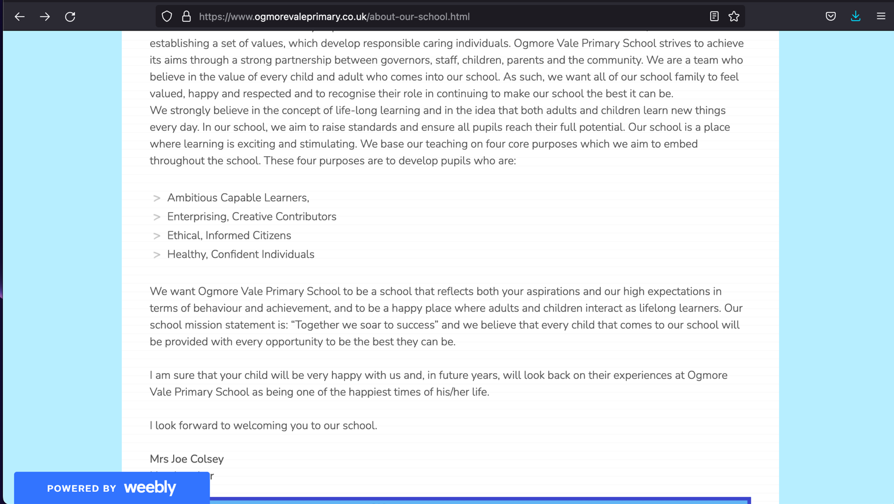
Ogmore Vale Primary’s mission statement shows that they aim to provide every child with equal opportunity to help them succeed in life.

Correspondence
Below shows the emails between myself and the primary school about conducting my placement with them
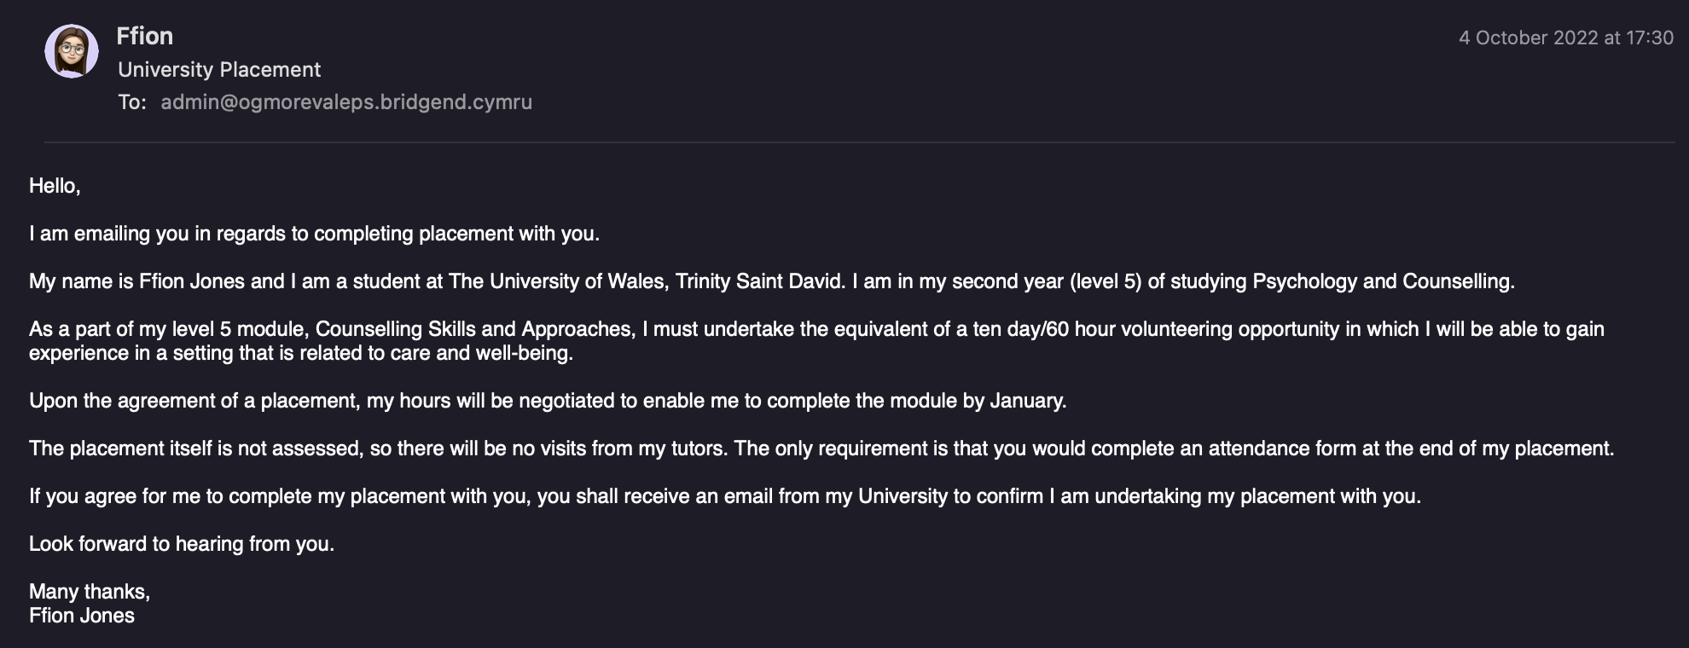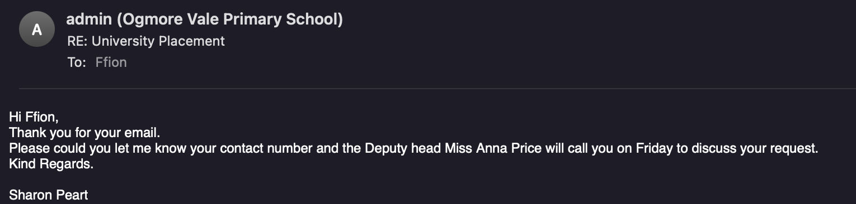

Evidence 2: Reflective Logs
Below are the logs I created while reflecting after each visit to the primary school during my placement
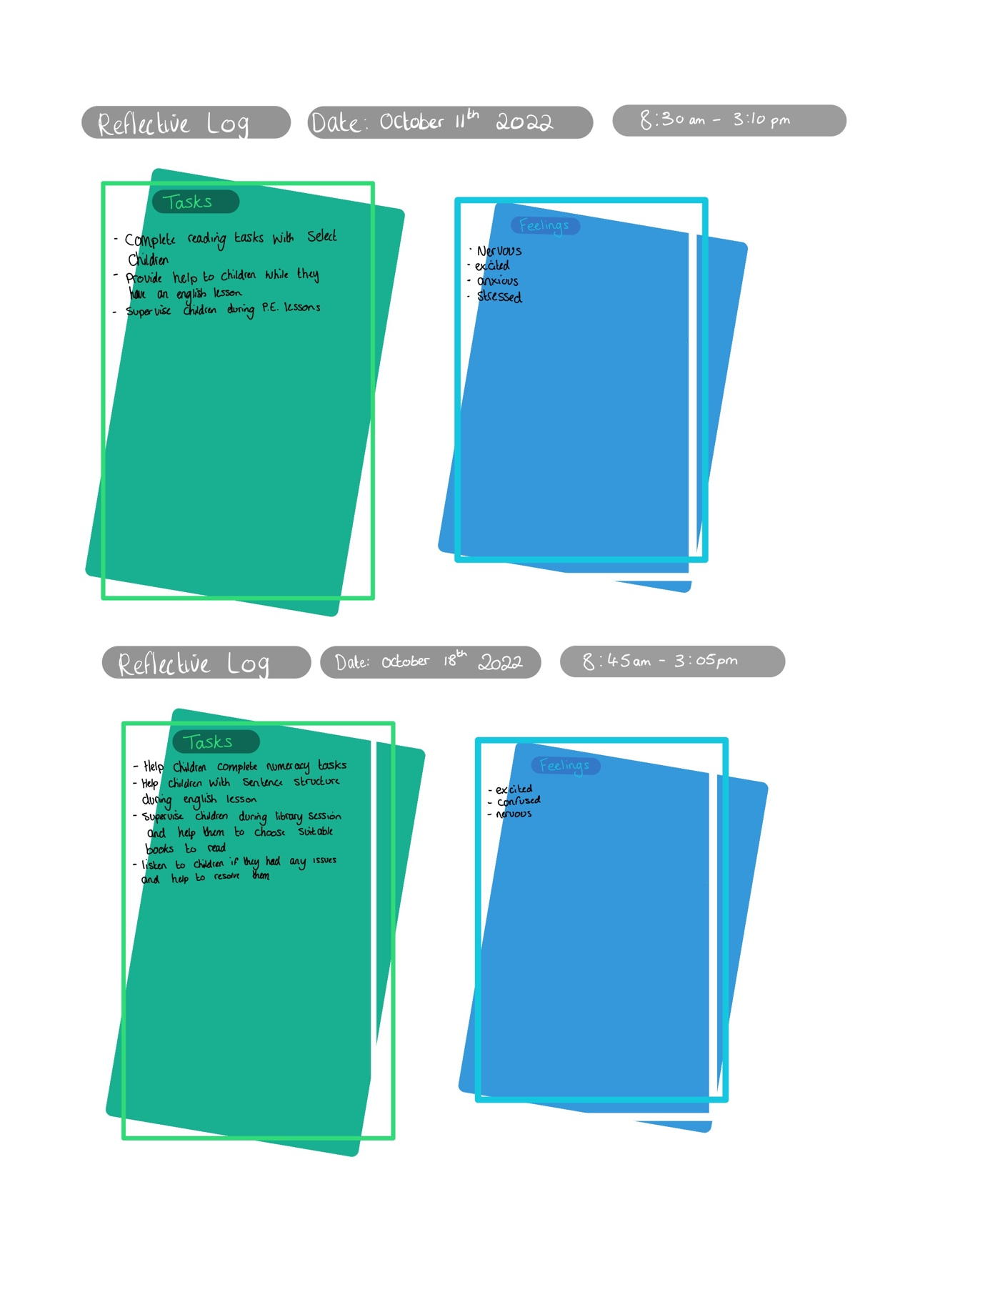
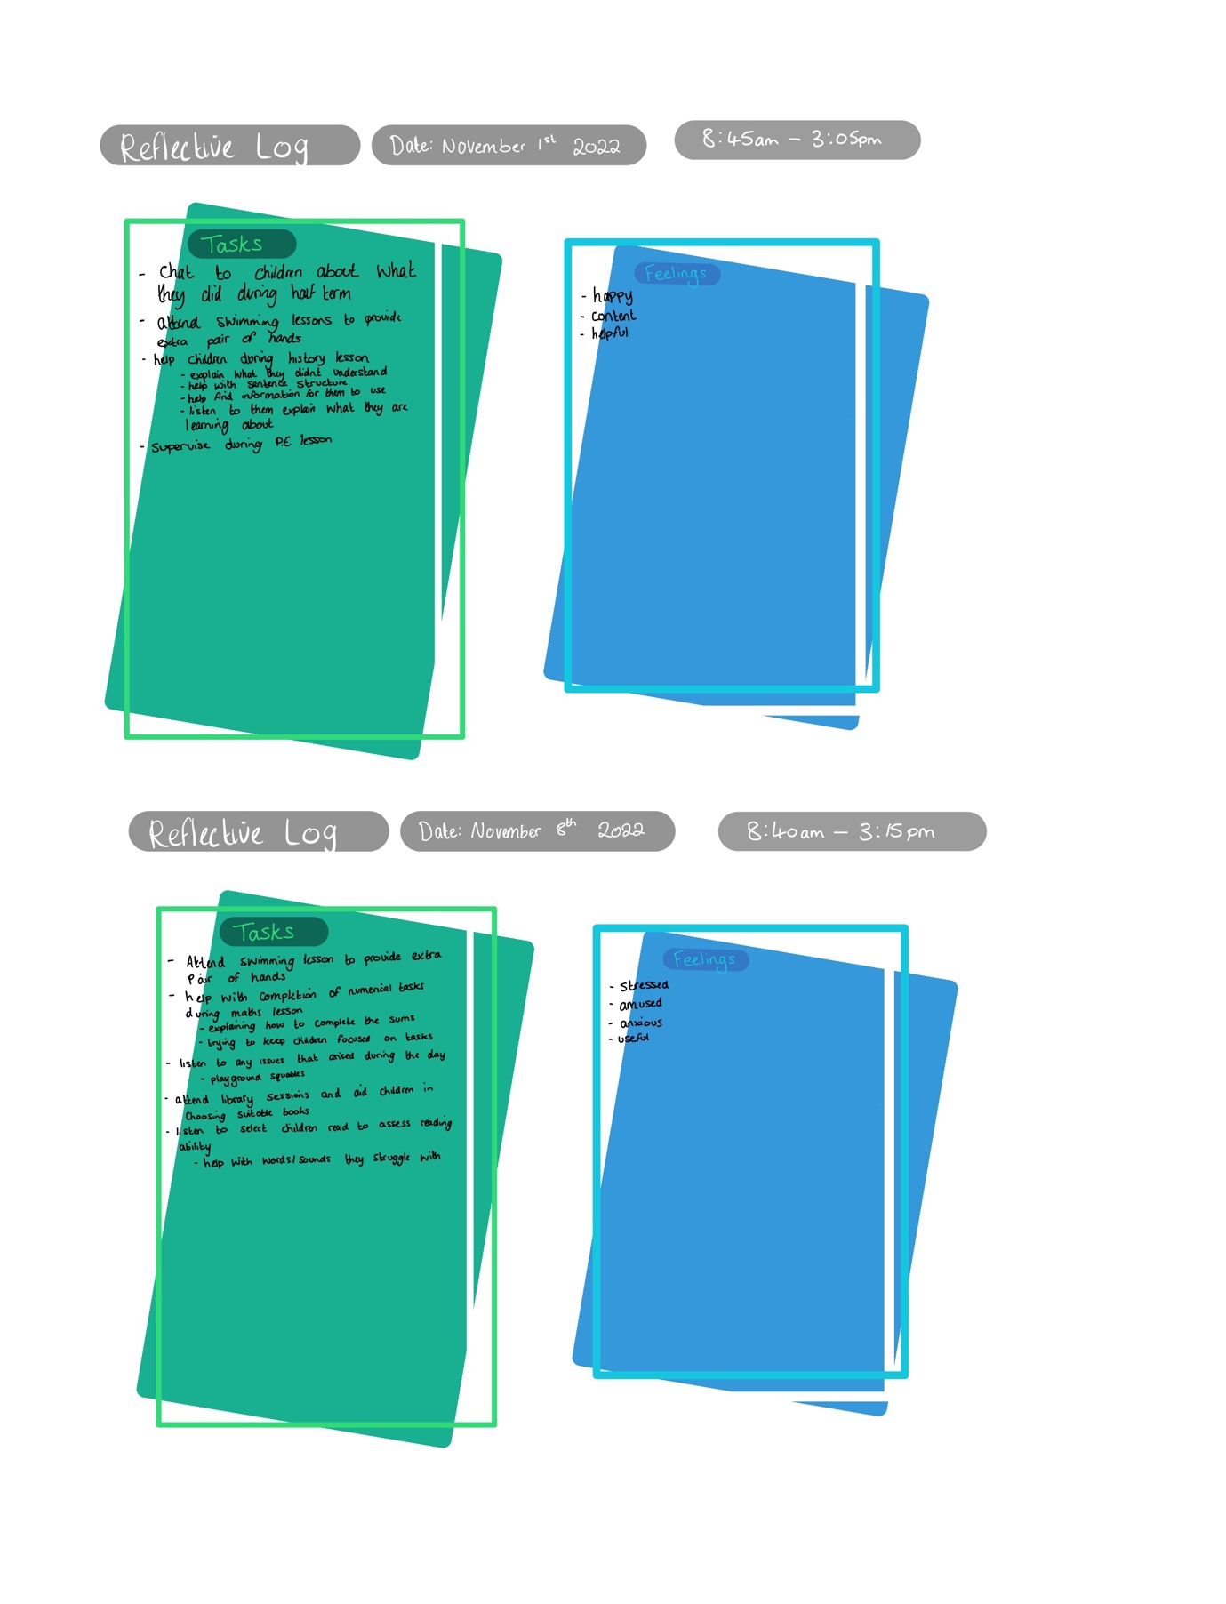

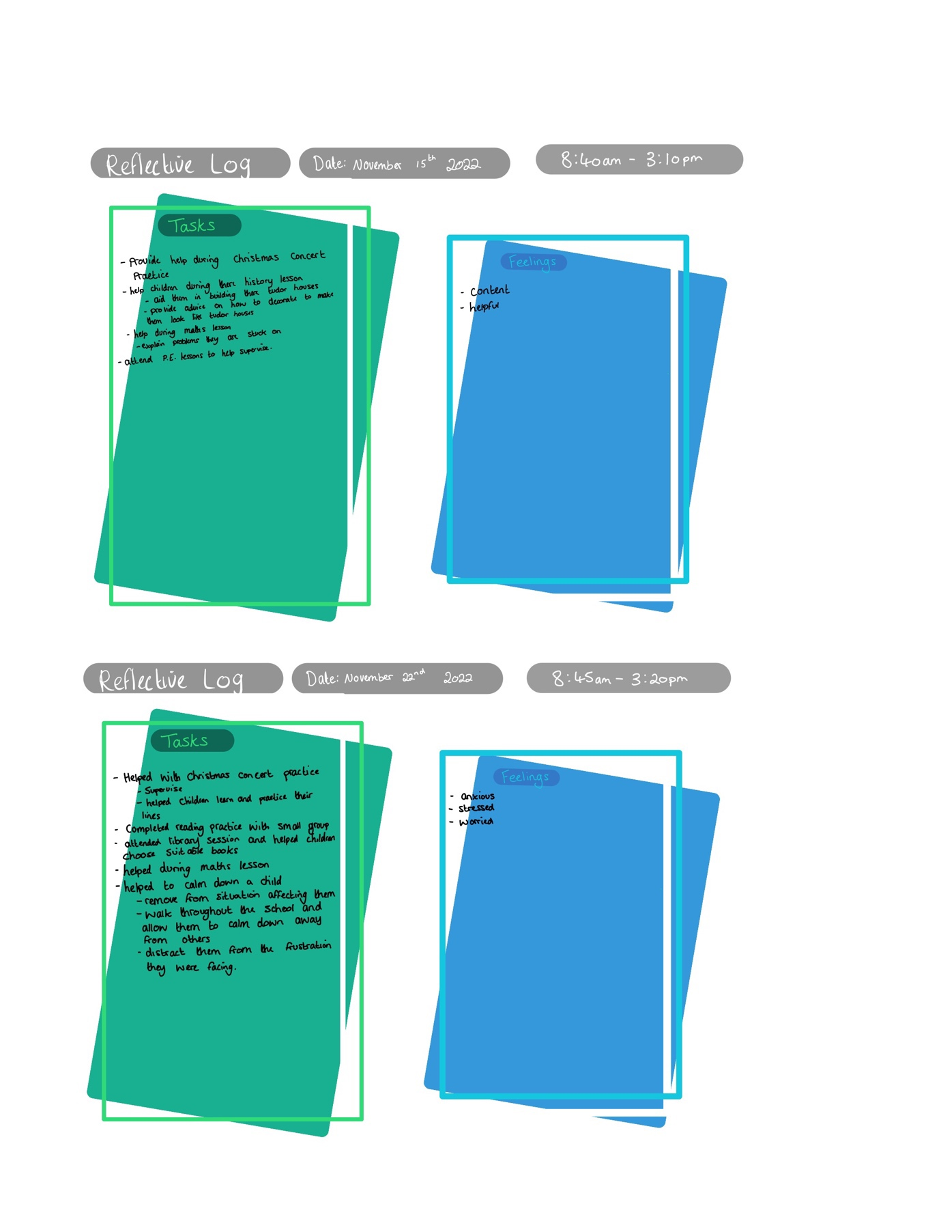

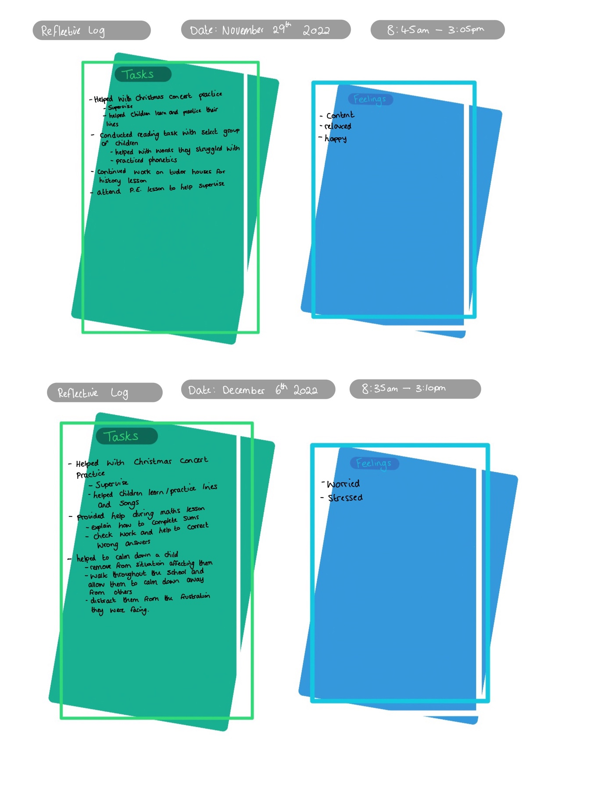

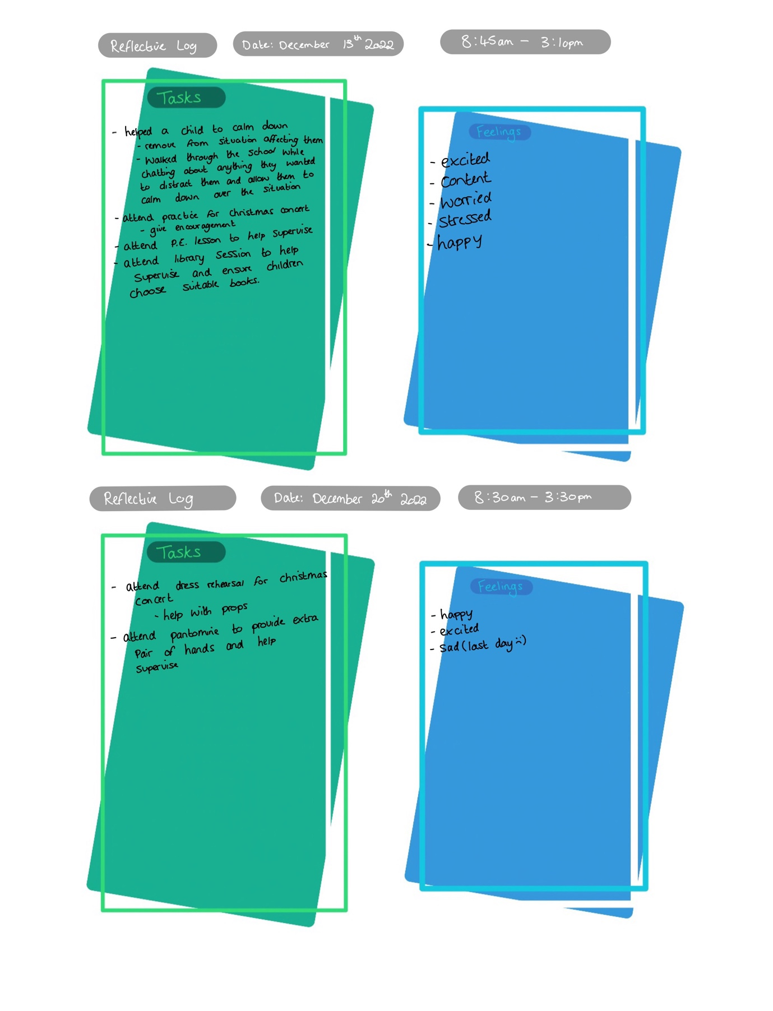

Evidence 3: Pictures on site
These are pictures that I took while at the primary school taking part in different activities.
I made sure not to include pictures of the children faces due to some parents not being comfortable with it. 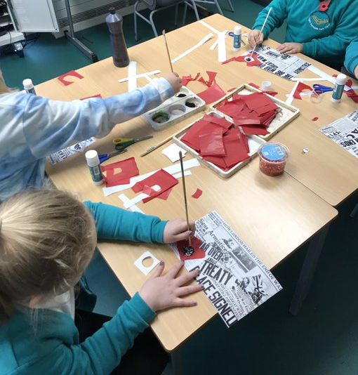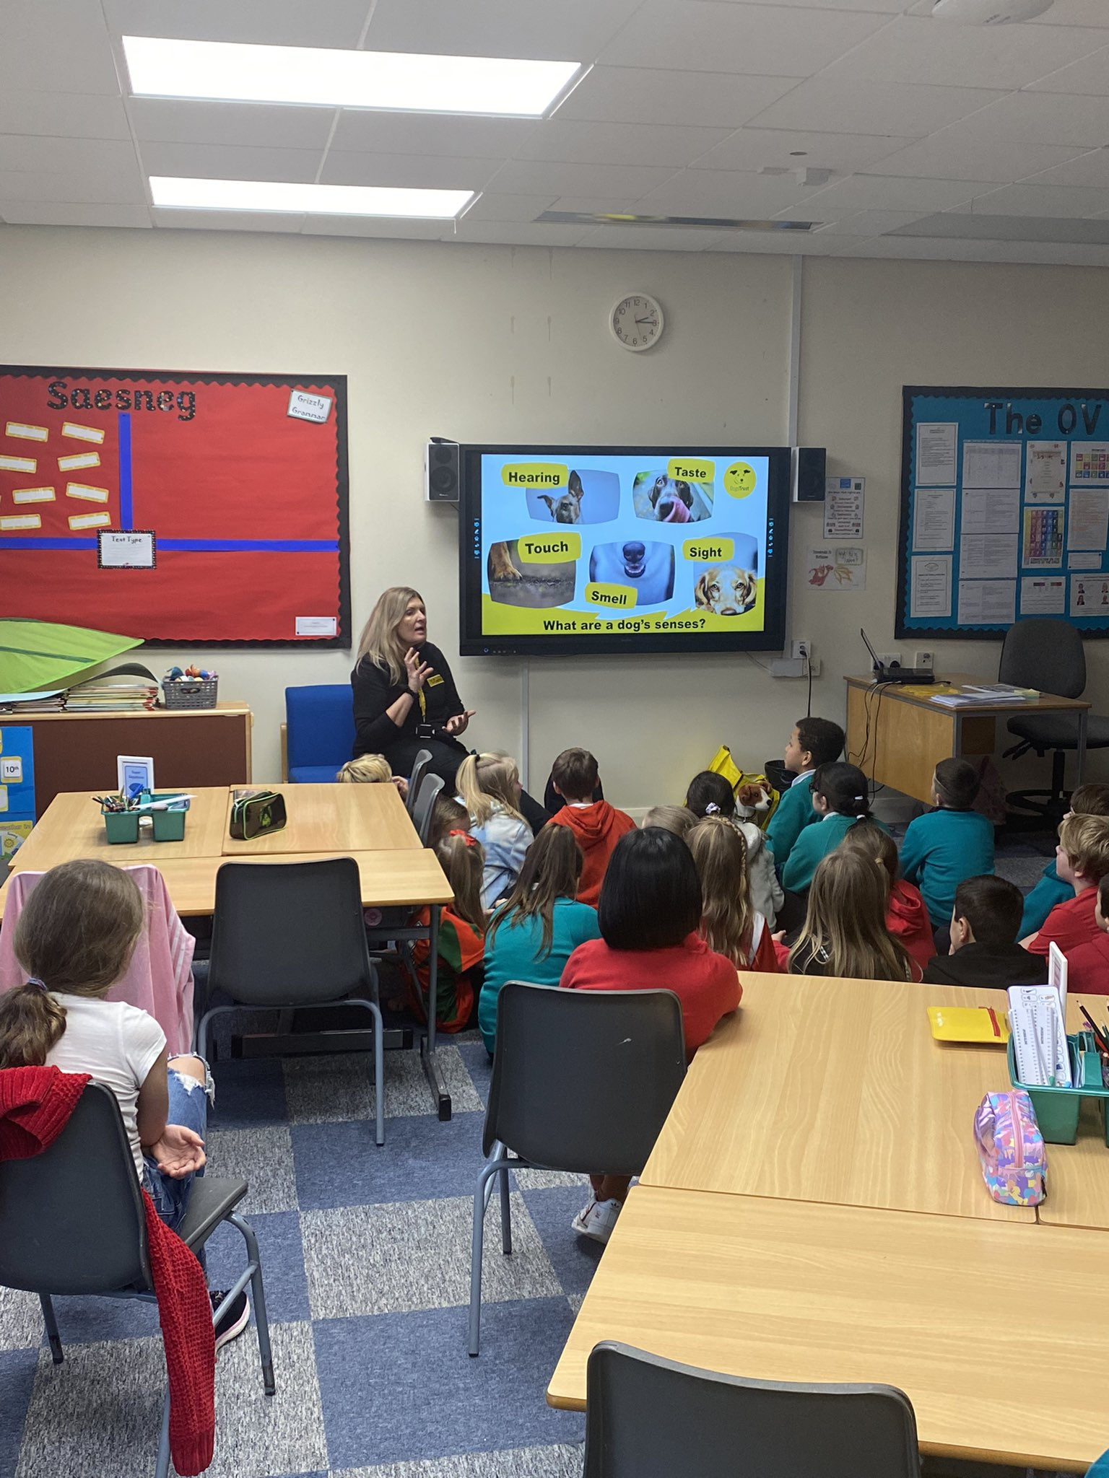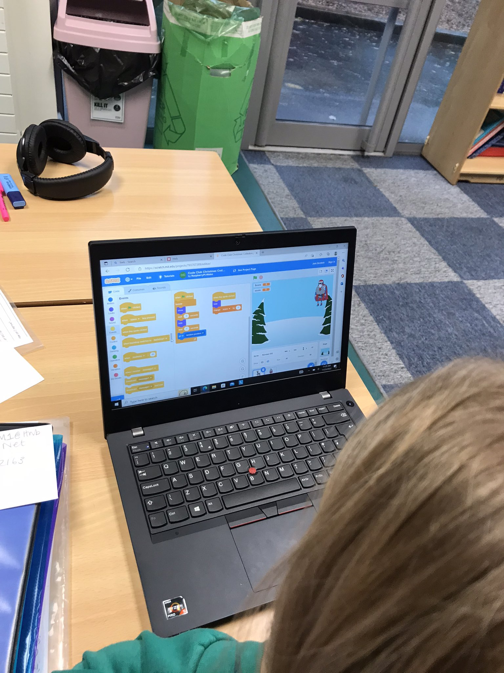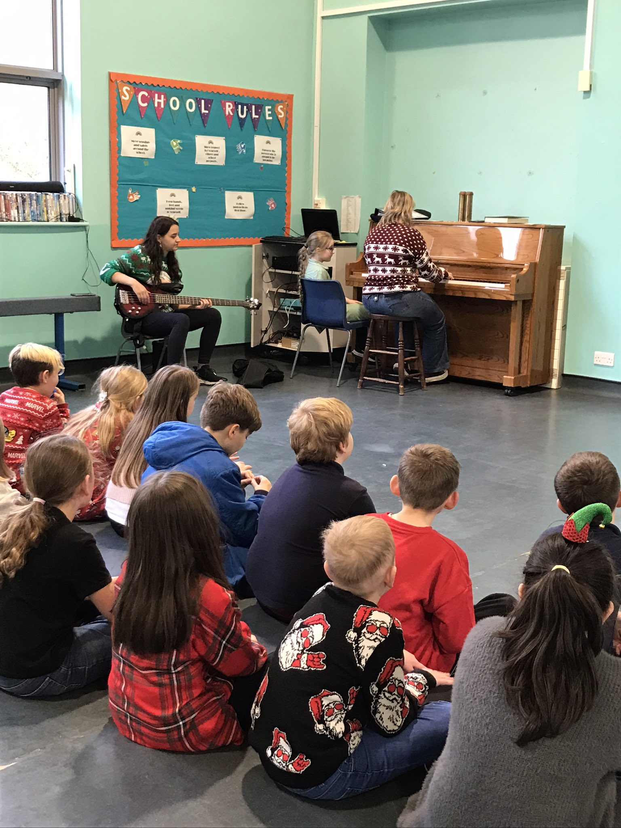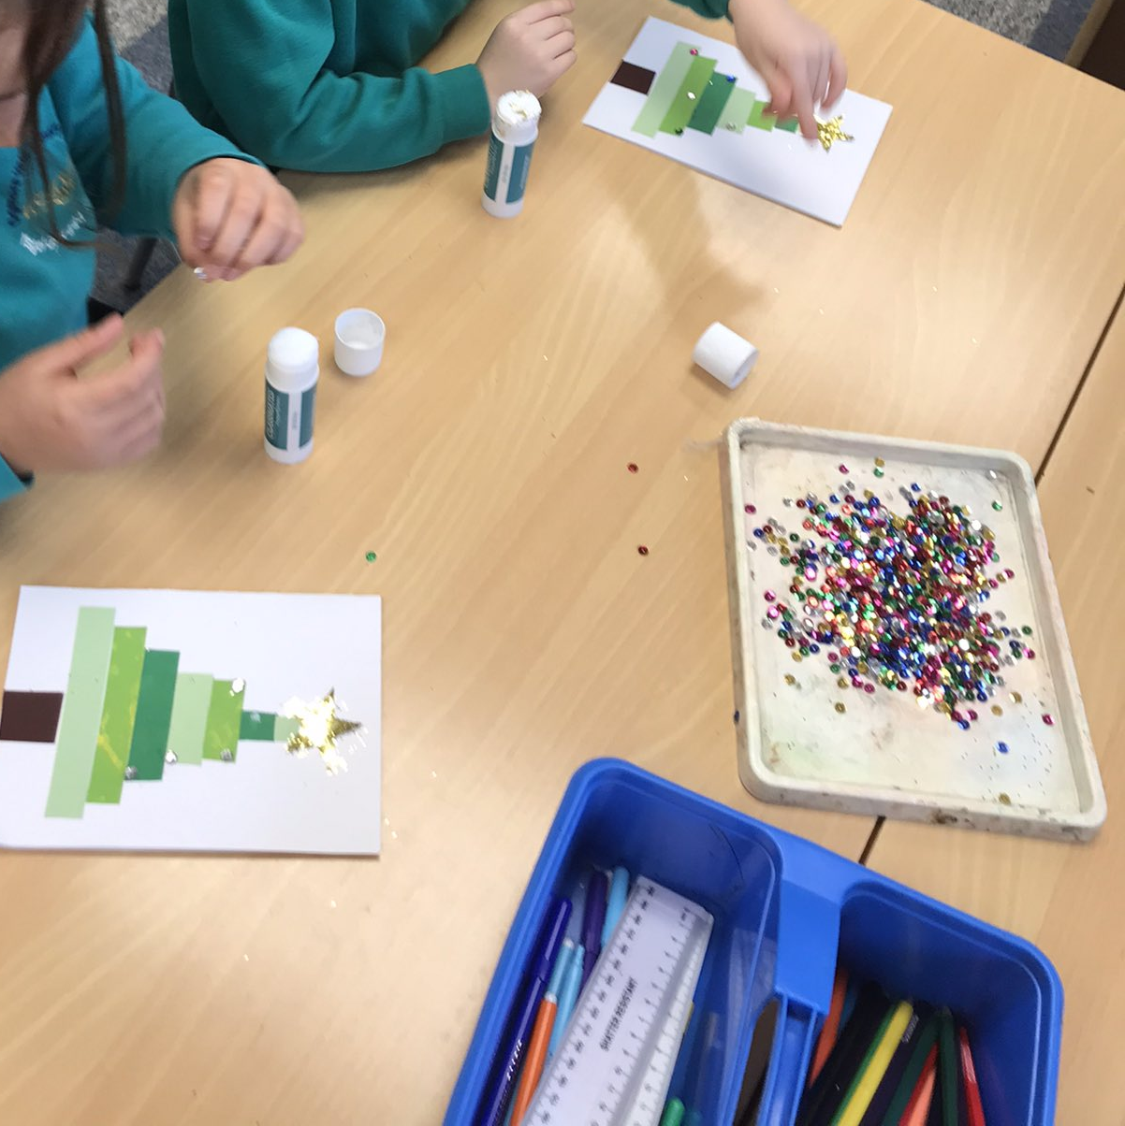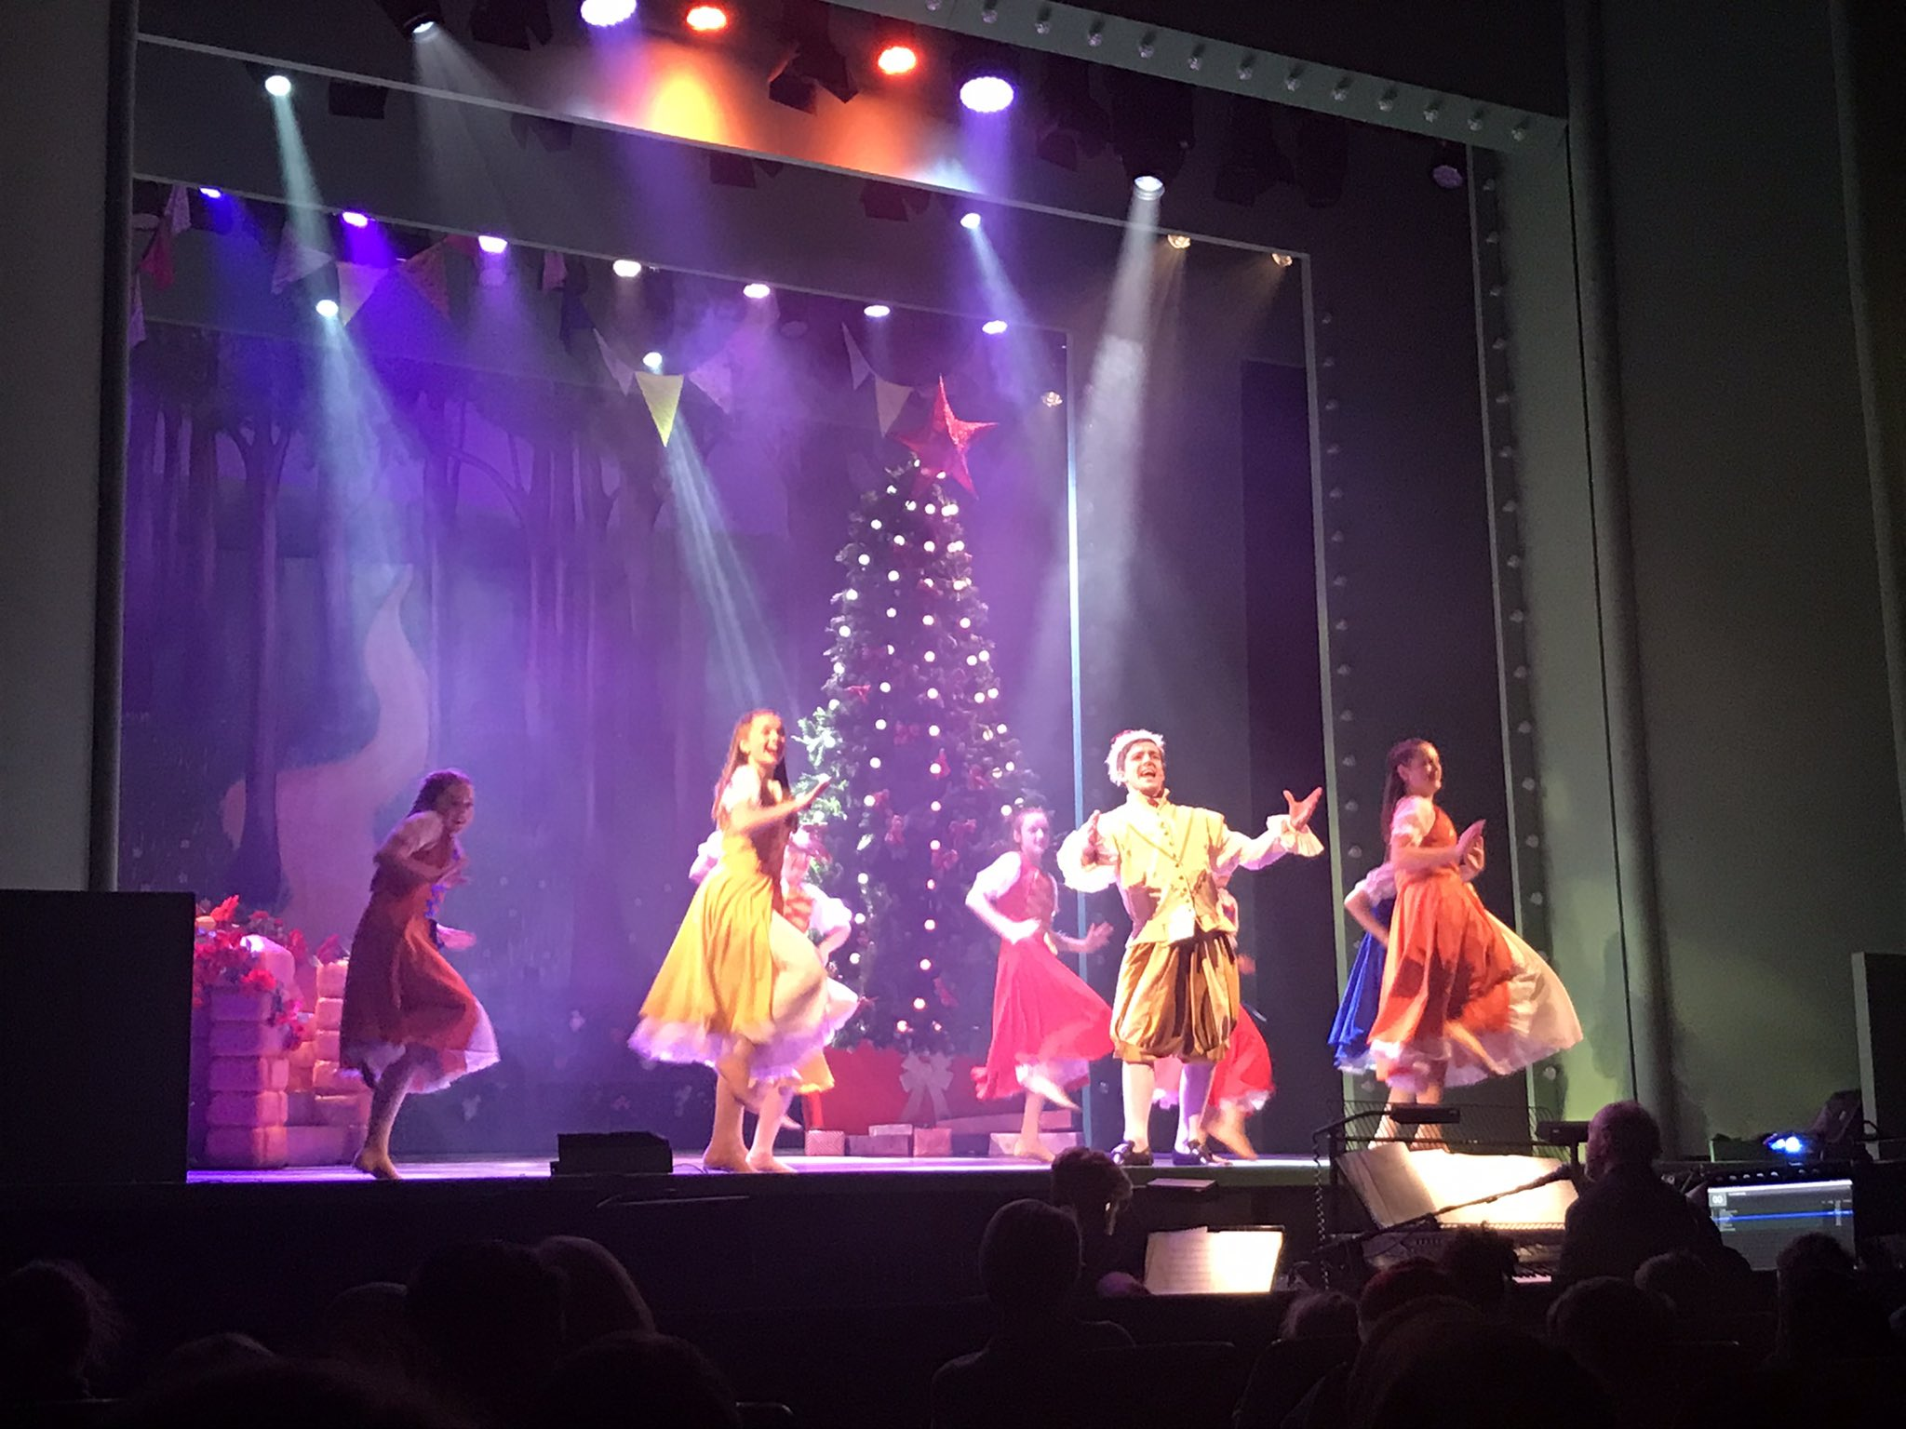

Appendices
Appendix A
Completed Information Sheet
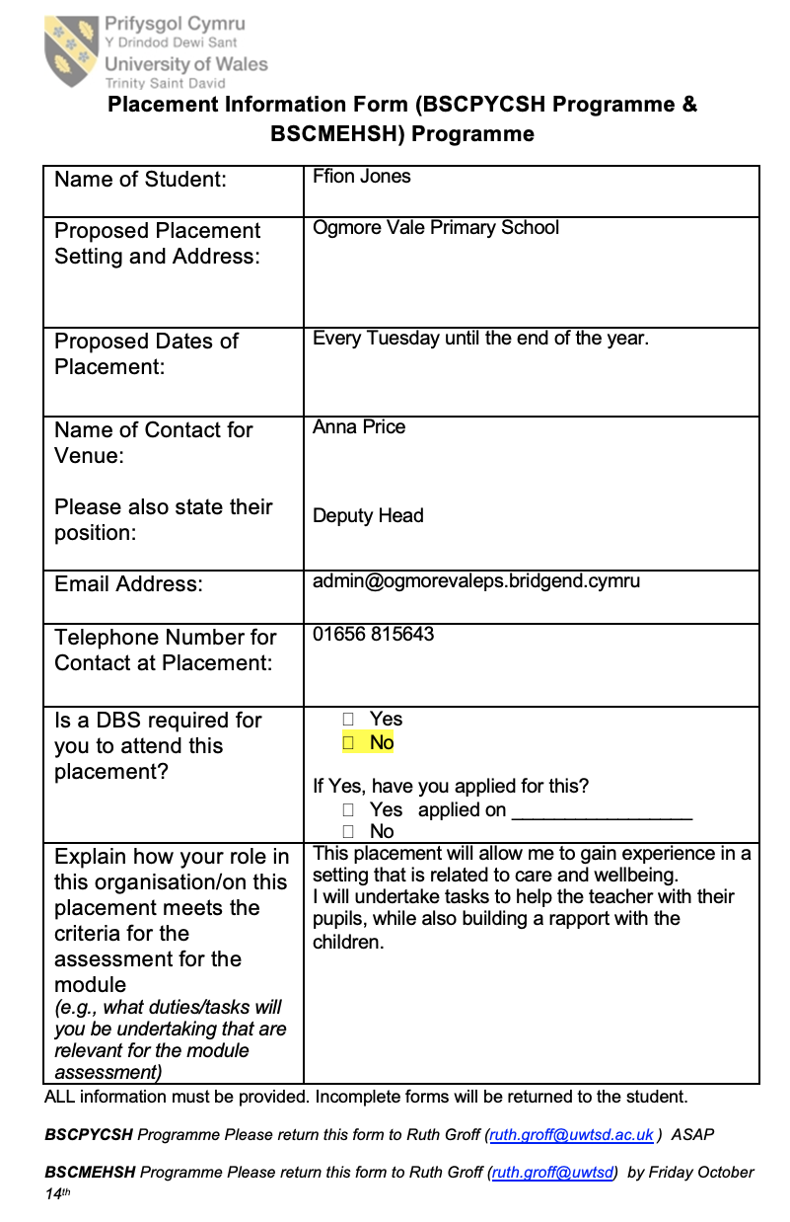
Appendix B
Correspondence

Appendix C
Attendance confirmation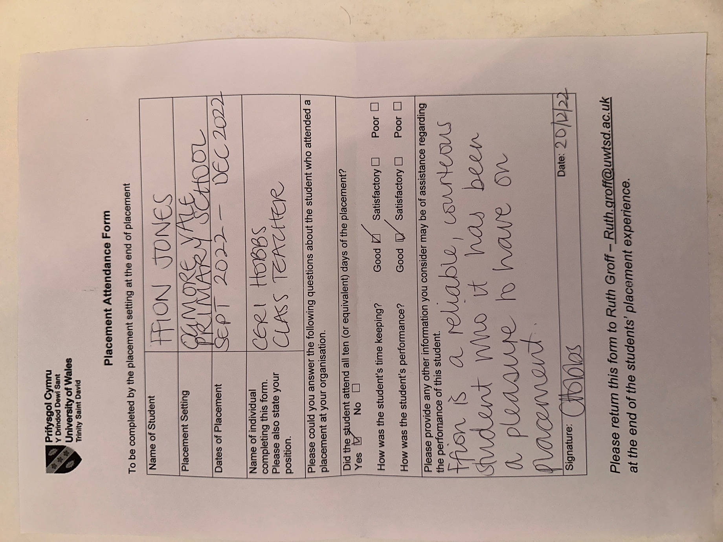

Appendix D
Record of time

