
problem solving and decision making


December 7, 2021
Malika Ali - 2026355
University Of Wales Trinity Saint David
BMSW4004 – Task 2
Lecturer – Jonathan Wyatt
Stress is a leading problem that is undermining the entire workplace system in United Kingdom. The main goal of this report is to analyze the underlying cause of the problem and provide detailed explanations for its reasons. The use of PESTLE analysis and diagram is done to further highlight the externalities associated with stress. I believe that there are some steps that we should take to eradicate this problem and help those who are suffering from this rough patch.
Contents
What Is Stress 2
Scope and Impact 2
Types of Stress 4
Physiological Stress and Its Effects 4
Stress and Organization 5
Pestle Analysis 5
Solutions: 6
Workplace Design 9

What Is Stress
In this ever-growing world where people are facing serious physical illnesses, stress is growing rapidly in people of all ages. Work-related stress affects 80% of the employed population in the United Kingdom. These are some alarming numbers that are affecting working people from all age’s groups and mental illness has become a common problem for the country (Mustard, 2004). Stress affects a person to work efficiently. According to data, mental disorder is a developing disease that affects people of all ages. It can have a significant impact on the body's healthy functioning and may be a cause of brain diseases and heart issues (Taris, 2016).

Scope and Impact

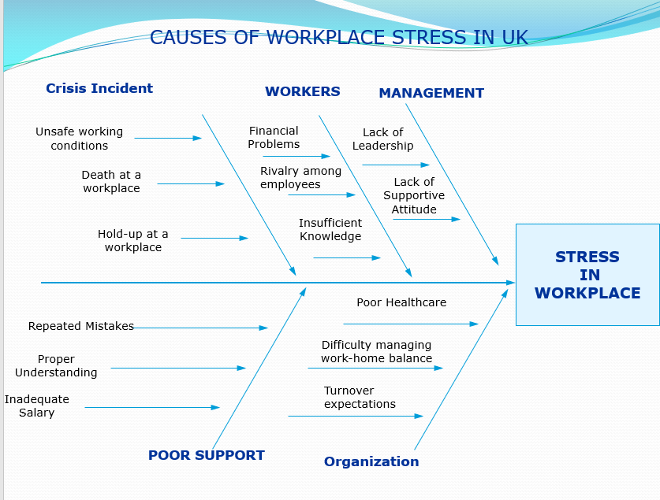
Fishbone model was used to highlight the main causes of stress in the workplace and then highlight their causes and sub-causes. There are 5 different main causes identified which are responsible for a stressful work environment within the workplace.
In every work environment, statistical data shows that people are not happy about what they do and there are quite a few reasons like they don't like their job and it's been seen that they are always striving hard to get to a better place (Drabek and Merecz, 2013). These problems are the real backbone of the stress people are facing in the work environment. The policies and certain practices in the work environment demotivate people to work efficiently.
Ravalier, (2018) has noted that employees become stressed as a result of poor working circumstances, and the problem becomes even more complicated when an organization's controls are inadequate, the management staff keeps failing to reimburse its staff, and the support structure within the hierarchy is inadequate. The blame culture and extended work hours due to poor management skills of the chain are tiring for employees and are building blocks for other kinds of stress that they face outside the office. If the policies and system of any organization fail to compensate their employees, then their efficiency starts to decrease gradually up to a point where they became a danger to the company and their blunders become too hefty to resolve. Surveying several organizations, we've observed that individuals don't accept their mistakes and pass the blame down the chain (Luk’ianchuk and Kryvoshapka, 2021).
Bhui et al., (2016) states that an organization is only as good as the people that work for it. Certain practices like unreasonable expectations, insufficient support, teamwork, issues of transparency, and ineffective communication influence the working capabilities of its workers which in turn affect the health of the organization.

Types of Stress
According to data collected in 2020 it has been noted that stress related to work is at the top of the chart but other kinds like monetary constraints, medical problems, and personal relations also affect a large group of individuals (Kato, 2014). If an employee is having trouble in the workplace and he's continuously facing difficulties coping up with his work then it can put one in a financial bind like losing their job, family stress, and health problems. Thus, if we correct the root cause of stress then we can easily eliminate the further conditions of stress (Kelloway, 2015). An organization should keep a proper check and assist their employees in such a way that they create a friendly environment where they can share their problems otherwise it can lead to unwanted outcomes (Shakoor, 2020).

Physiological Stress and Its Effects
Not every employee can work within the given policies and its human nature that a few terms and conditions might not be ideal for everyone, and they may have some reservations that are affecting their work efficiency (Kurt, 2017). Few organizations gather information from different surveys taken within their company to seek answers for low performance and they devise certain measures that assist to improve the efficiency of work and decrease stress in the workplace.
The last task is to build individual and collective relations of the workers and modify these relations in such a way that people with the same characteristics work collectively and these approaches might reduce the stress from workers and they strive to become a valuable member of the company.

Stress and Organization
Indian Journals, (2021) depicted that some things are unavoidable due to certain reasons and stress is one of them. It has been termed as "invisible" because it can affect that employee, the people related to him, and his organization and softens the pillars of an organization and such issues shouldn’t be ignored. Ignoring them is the worst thing you can do (Kurt, 2017). People experience stress in their day to day lives like a student experience it in coping up with their academic demands, people on job and business may suffer from the stress of managing their work and having to work diligently keeping their minds off the possibility of being superseded or lose their job or promotions. Breaching a certain line can affect the capabilities of employees and could lead to physiological and social disorders from which one may find difficult to recover and unusually affects the organization (Luk’ianchuk and Kryvoshapka, 2021).

Pestle Analysis

In our scenario, stress has some adverse effects from a political point of view. Like if employees of an organization aren't performing to their full potential due to stress and that organization is facing difficulty in achieving its goals then it would generate less revenue for the government in the form of taxation and from a wider perspective, lesser industries will invest in future. From a financial standpoint, stress leads to performance flaws of employees which in turn hurdles the growth of an organization and restricts new opportunities it might have scored. Due to inflation the company will soon fail to pay off its debts and could face financial problems.
Yin, Ou, Davison and Wu, (2018) highlighted that Technological advancement can take a business to the next level. It has been seen in quite a few businesses that employees fail to change along with technology because of poor management policies as they fail to corporate and assist their overloaded employees and satisfy their work problems.
Thach et al., (2020) A well-established business realizes that how important it is to have a comfortable environment for the effectiveness of employees' work. If the given environment is not suitable or has problems like noise, office timings, location of the office, indoor facilities, etc. Then these can lead to both physical and psychological stress between employees.
It has been observed in many firms that staff fails to adapt with technology due to inadequate management practices that fail to corporate and support their overburdened employees and satisfy their work concerns. Every business is required by law to follow a legal code and ethics. Such policies and their implementation may be difficult for staff to adapt to, and if sufficient advice is not provided, the stress of not complying with these regulations may pose an issue for a business.

Employees can perform better when provided with an attractive, comfortable, and satisfactory working environment (Troup and Dewe, 2002). If the given environment is unsuitable or has issues such as noise, workplace schedules, office location, indoor facilities, and so on, this can contribute to both physical and psychological stress among employees.

Solutions:

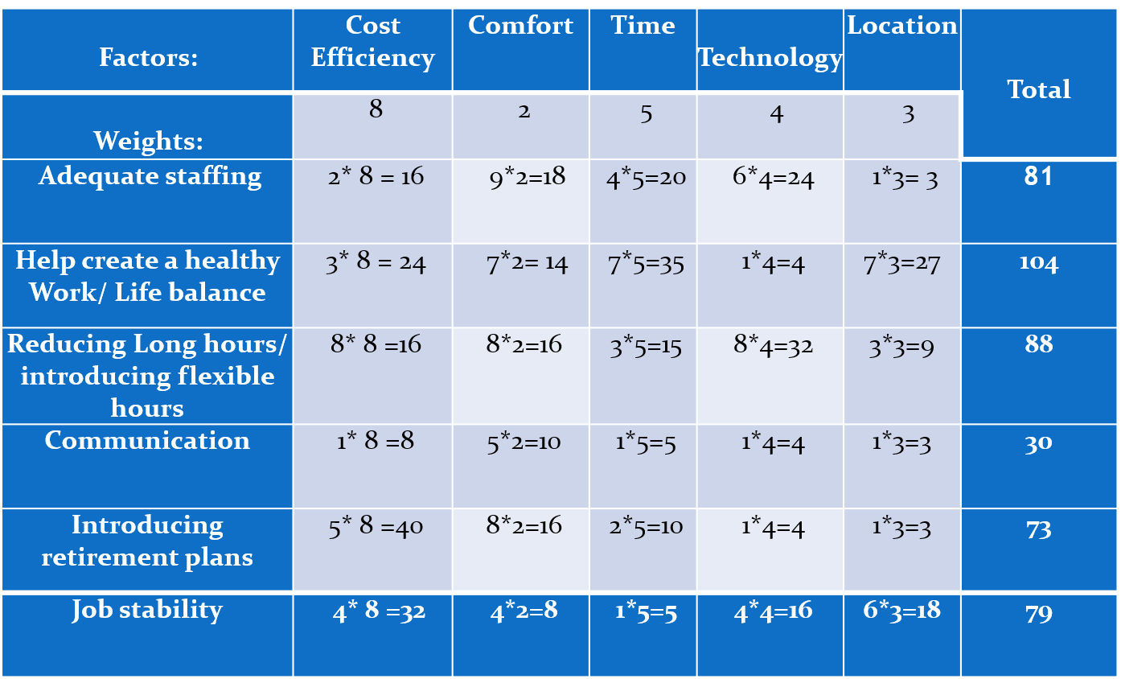

The grid analysis present evaluates the effectiveness of the solutions presented to decrease stress in the workplace. From the score, it is easy to see that helping employees create a healthy work and personal life balance will help manage stress more effectively. This grid analysis takes into all the factors that help reduce stress in the workplace and emphasizes the value placed on these factors. Communication ranked poorly which shows from this analysis that it plays less importance in reducing stress.

As we've mentioned the detailed reasons behind the growth of stress in a workplace, it would be incomplete to devise some solution to eradicate these issues. Panigrahi, (2016) observed that managing stress is the goal for everyone and they need to find ways by themselves by engaging in certain activities like dancing, music, sports, etc.

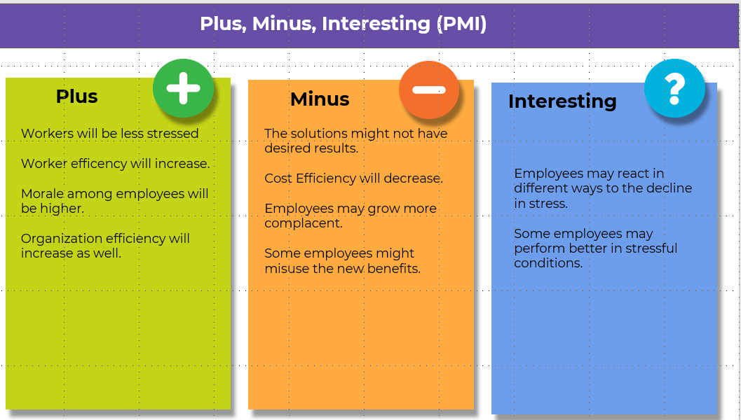
There are a lot of measures that can be taken by the organization itself to combat stress within their employees. Firstly, by managing the workload efficiently for the employees, the organization can enable its employees to maintain a good work-life balance and get home earlier and enable them to get proper sleep which will help them combat the effects of stress (Albrecht, 1982). The organization can also partake in health and wellness retreats for their employees, which would give the employees a space to rejuvenize with their peers (Cox and Griffiths, 1995). Organizations can reduce long working hours, which has proven to be a great technique in helping reduce stress within employees and teach them proper time management, so they are not overwhelmed with their workload.

Organizations should provide seminars and training for employees to master the technology and work towards advancement (Arora, 2016). Having an open communication channel between management and employees is very important, which is why a special network should be set up where employees can come forward with their grievances and be heard. This will allow management to take proper action and reduce any causes of stress within the organization (Cheng, Kogan and Chio, 2012).

The economic crisis to play a country is a very sensitive matter which keeps employees in fear of losing their jobs or their company being downsized. While there is nothing internal management can do to avoid this issue, management can ease their fears by being transparent about the workings of the organization and helping their employees find new job if the time ever comes (Carlson, 2007).

Workplace Design
Stress is unavoidable but certain measures can be taken; few policies could be implemented to reduce the issue up to an extent where it is no longer a danger to the company.
Hui & Aye, (2018) proposed simple yet effective solution to this problem is by having a solution-focused approach in an organization. What this means is that if an organization is facing some problems, then that specific department brainstorm together, discuss a different solution and give everyone a chance to express their ideas.

Reference list
Albrecht, T.L. (1982). What job stress means for the staff nurse. Nursing Administration Quarterly, 7(1), pp.1–11.
Arora, R. (2016). Managing the Complaint Factors or Workplace Stress: A study on Effects of Stress among employees in ITES-BPO Organizations of NCR. Effulgence-A Management Journal, 14(1), p.1.
Bhui, K., Dinos, S., Galant-Miecznikowska, M., de Jongh, B. and Stansfeld, S. (2016). Perceptions of work stress causes and effective interventions in employees working in public, private and non-governmental organisations: A qualitative study. BJPsych Bulletin, online] 40(6), pp.318–325. Available at: https://www.ncbi.nlm.nih.gov/pmc/articles/PMC5353523/.
Carlson, J.G. (2007). The management of Stress Management: A decade of the journal. International Journal of Stress Management, 14(4), pp.329–332.
Cheng, C., Kogan, A. and Chio, J.H. (2012). The effectiveness of a new, coping flexibility intervention as compared with a cognitive-behavioural intervention in managing work stress. Work & Stress, 26(3), pp.272–288.
Cox, T. and Griffiths, A. (1995). Guidance for UK employers on managing work-related stress. Work & Stress, 9(1), pp.1–3.
Drabek, M. and Merecz, D. (2013). JOB STRESS, OCCUPATIONAL POSITION AND GENDER AS FACTORS DIFFERENTIATING WORKPLACE BULLYING EXPERIENCE. Medycyna Pracy.
Hui, F. and Aye, L. (2018). Occupational Stress and Workplace Design. Buildings, 8(10), p.133.
Kato, T. (2014). Coping with Workplace Interpersonal Stress among Japanese Employees. Stress and Health, 31(5), pp.411–418.
Kelloway, E.K. (2015). The Psychologically Healthy Workplace. Stress and Health, 31(4), pp.263–263.
Kurt, S. (2017). Causes of stress experienced by nurses and its effects on nurses. New Trends and Issues Proceedings on Humanities and Social Sciences, 4(2), pp.01-10.
Luk’ianchuk, N.V. and Kryvoshapka, N.Yu. (2021). USE OF ANTI-STRESS MEASURES TO INCREASE WORK EFFICIENCY. Habitus, (28), pp.127–130.
Mustard, C. (2004). Work-related stress in the UK: a new, “Management Standards” approach. Work & Stress, 18(2), pp.140–141.
Panigrahi, C. (2016). Managing Stress at Workplace.
Ravalier, J.M. (2018). Psycho-Social Working Conditions and Stress in UK Social Workers. The British Journal of Social Work, 49(2), pp.371–390.
Rose, J., Jones, F. and Fletcher, B.C. (1998). The impact of a stress management programme on staff well-being and performance at work. Work & Stress, 12(2), pp.112–124.
Shakoor, R. (2020). Workplace Conflicts and its Effect on Employee Productivity: A Mediating Role of Workplace Politics. International Journal of Psychosocial Rehabilitation, 24(3), pp.2774–2783.
Taris, T.W. (2016). Work & Stress: Thirty years of impact. Work & Stress, 30(1), pp.1–6.
Thach, T., Mahirah, D., Sauter, C., Roberts, A.C., Dunleavy, G., Nazeha, N., Rykov, Y., Zhang, Y., Christopoulos, G.I., Soh, C. and Car, J. (2020). Associations of perceived indoor environmental quality with stress in the workplace. Indoor Air, 30(6), pp.1166–1177.
Troup, C. and Dewe, P. (2002). Exploring the nature of control and its role in the appraisal of workplace stress. Work & Stress, 16(4), pp.335–355.
www.indianjournals.com. (n.d.). Indian Journals. online] Available at: https://www.indianjournals.com/ijor.aspx?target=ijor%3Asajmmr&volume=9&issue=10and11&article=002. Accessed 30 Nov. 2021].
Yin, P., Ou, C.X.J., Davison, R.M. and Wu, J. (2018). Coping with mobile technology overload in the workplace. Internet Research, 28(5), pp.1189–1212.

