Proposal
Title: All It Takes.
I got this idea with my own personal experience, I constantly doubted myself that it would never get better, and I’ve recently understood that All it takes is love, understanding, support, stages, love and family.

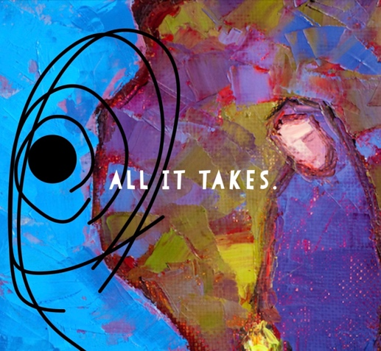
I found this photo online and added my own style to it, I added the black hole, with the title of my show. When I look at this photo, I see the colours as memories and the love and support that helps with the healing process pushing the sadness away. https://tinybuddha.com/blog/navigating-loss-dealing-with-the-pain/

Subject: The exploration and truthful experience of the stages, struggles and benefits of grief through the medium of live theatre.

Overview of Aims: I believe that everyone in life will come across a loss, we really need to prepare ourselves. Grief has no rules and many different journeys that lead to different things. I wish to educate myself and the audiences with a true story of struggles, 7 stages and the suffering an individual can have during grief, but also the positivity that grows around the black hole, leaving it so small you can’t even see it anymore. But some days you’ll feel it. But that’s okay. All l it takes is smile, love, Memories and then you’ll soon deal and feel normal again.

My goal is to create a dramatic/positive show that shows flashback of what happened to me, showing the impact of the 7 stages, and how grief comes in many forms. I would like the audience to come out prepared, with a realisation to be there for people, and to notice that loosing someone isn’t just a loss, it changes who you are interlay, makes you view things differently, makes you stronger in ways you can’t even imagine. It also takes over you in a way, a way you can’t control. I need everyone to understand.

Research:
- Websites
I will be using websites as a source of research to investigate in people’s experiences with grief to get a better understanding of how different people are.

https://www.recover-from-grief.com/7-stages-of-grief.html I will use this to explore further what the stages are. I will be able to use this information to gain knowledge and show the true stages to the audience.

https://www.youngminds.org.uk/young-person/my-feelings/grief-and-loss/ I will collect information from this to help me understand the support that’s needed, to understand that grief can come in many ways not just through loss.

https://mygriefandloss.org/how-grief-changes-us This website is very beneficial for me as it notes down how losing someone can change you completely, my struggle is missing the person I used to be. I can use this information to professionally show that it does change a person but gains a lot of positivity that everyone needs in life.

- Questionnaire
How – I will send out a questionnaire to people I know to find out how they grief and to see the differences.

- Interviews/clips
- https://www.google.com/search?q=grief+encounter+alex&client=safari&rls=en&source=lnms&tbm=vid&sa=X&ved=2ahUKEwjY-JnR5O38AhWEglwKHdrVAQUQ_AUoA3oECAEQBQ&biw=1199&bih=848&dpr=2&safari_group=9#fpstate=ive&vld=cid:54d932e5,vid:AJIn1_1yFPA I feel that this is helpful for me personally, knowing that they feel The same way allows me to know that it’s normal to not be okay. I could portray Grief from the point of view of others who feel the same way.

Podcast Grief cast- https://shows.acast.com/griefcast These Interviews that are with Cariad Lloyd are very useful because it’s different people around the world speaking about death and grief in a positive way, which can lead me to the positive journey.

- Books
I will be using real life books as another source of research. I want to research into how it gets better and how to deal with grief in your own way.

http://clickserve.dartsearch.net You are Not alone Written by Cariad Lloyd. Cariad reflects on her own grief, the Greif of others , the psychology and science of how our society deals with death and loss.

- Articles/Newspaper
These articles I'll be researching will help me show the audience not just my experience and feelings but others in the whole world and how similar but also different grief is for any age.
https://www.theguardian.com/society/2022/jun/16/prolonged-grief-disorder-diagnosis-us

Quotes

By Grace McGettigan:
“Everyone’s personal experience of grief is unique and each of us will face it most likely many times in our lifetime”
“while it can be a difficult thing to go through alone, sometimes talking about it is the hardest thing to do”

