Professional Career Development
Shelby Elise Phillips 1813382
University of Wales Trinity Saint David
27th November 2020
Report requested by Mark

Contents Page

- Content
- 1.0 Terms of procedure
- 1.1 Procedure
- 2.0 Self Awareness
- 3.0 Learning Styles
- 3.1 VARK Learning Styles Questionnaires
- 3.2 Myers Briggs Personality Test
- 4.0 Personal Development
- 4.2 SMART Analysis
- 5.0 Conclusion
- 6.0 References

Introduction
The reporter will be giving there reflective review on their own learning journey. During this report the reporter will be conducting a number of theories. This report will show different learning styles. The report will include an S.W.O.T analysis which stands for strengths, weaknesses, opportunities and threats. It will also include the reporter identifying their SMART goal. They will also be applying two different learning styles to themselves which apply to them. The report will conclude by doing a PDP (personal development plan) to be able to achieve two learning objectives while thinking of employability skills and linking it to the learning styles they have chosen. The main focus of this report is to be able to identify on how to develop yourself and apply these learning styles and personal development plan to be able to achieve their end goal.

- Terms of reference
This report was requested by Mark, this report needs to be completed and handed in by the 27th November 2020 by 3.oopm on turn it in.

1.1 Procedure
To prepare for this report the researcher will use information from a range of sources including, books, online websites and journals. At the end of this report the researcher will conduct a conclusion of their findings they will then reference their findings at the end of this report. The researcher will include references to show where they had their information from.

2.0 Self-Awareness
Self-awareness initials an individual being aware of their own aspects of themselves. It is a psychological state when one becomes the focus of attention. Self-awareness is the first component of self-concept to emerge. Psychologists often break self-awareness down into two different types, either public or private.self-awareness is something we don’t do naturally every day we usually just get on with things but sometimes taking time out to think of our self-awareness will improve and make us more aware of what we need to do to become more efficient in either our personal life or work or university.
  - S.W.O.T analysis (Humphreys, 2005)

The S.W.O.T analysis was developed by a gentleman called Albert Humphreys. The S.W.O.T analysis consists of strengths, weaknesses, opportunities and threats. By doing an S.W.O.T analysis can help focusing on your strengths, minimizing your weaknesses and taking advantage of opportunities available to you.

Strengths
- Good communication skills
By having good communication skills you are able to speak clearly and put across any point your making, even though I have low confidence I feel like communication is a strength as communication isn’t always face to face sometimes it can be telephone, emails etc.
- Good at engaging with other people

- Good at listening to other people
Having good listening skills will help you whether you are in a learning setting e.g. university or in work setting e.g. employment. It will help you understand what your lecture or employee wants from you whether it be an assignment or a work task.
- Empathy
Having a good understanding of empathy will give you a skill of compassion not everything goes the way you like in life and even in a university or work you will need to have compassion. For example if you were dong a presentation in university and a member of your team was unable to attend for personal reasons you need compassion to help this person situation rather than being annoyed they couldn’t make the presentation.

Weaknesses
- Lack of confidence
Being an individual with low confidence could affect the performance in a presentation. The individual may struggle with the ability to speak clearly and efficient due to the lack of confidence. This could also affect how you would present yourself in an interview as your employee will see this as your weakness and prefer someone with good strong confidence.
- Low self esteem
Having low self-esteem will affect your ability to engage with others confidently having low confidence will often relate to the low self – esteem. Having low self-esteem would affect you in a work place as if you don’t feel good about yourself how can you make others feel good about themselves (example) if you worked in a clothes shop and someone asked “do I look ok in this” if you have low self-esteem and don’t feel good in clothes your emotional conscience without your realising would put a negative effect on that person and make them not feel good.

Opportunities
- Finishing and Passing this course (Certificate of higher education skills for the workplace) to enable gaining a new qualification to be able to succeed on to a Level 5 & 6 Course.
- By doing things to gain more confidence will improve performance on presentations, class discussions, group work. Which will improve self-esteem.
- By finishing this course with a good mark I will have learnt good employability skills to prepare me for the employment sector
Threats
- Being nervous while delivering presentations
- Not passing Level 4 of this course to move on to level 5&6
- By not passing the course I will have not have learnt the skills I need to prepare me for the employment sector.

- Learning Styles
The learning style VARK (Fleming and Mills, 1987) stands for Visual, Aural, reading/writing and Kinaesthetic learning. The results on this VARK questionnaire shows more there learning style is a reading /writing.
3.1 VARK learning style questionnaire

You’re VARK Results
Your scores were:
- Visual 2
- Aural 4
- Read/Write 9
- Kinesthetic 6
Your learning preference: Mild Read/Write
Share
People with your preference like:
notes, handouts, print, text, ...
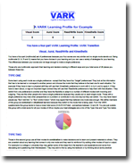https://vark-learn.com/vark-questionnaire-results/

3.2 Myers Biggs Personality Test
On this link is my results from my Myer Biggs Personality Test https://www.16personalities.com/profiles/8cc4183fe404a

The test shows that this person is more of an extraverted person by 53%. Also is shows that the person that the persons energy is 37% intuitive and 63% observant. The nature of this person shows 19% thinking and 81% feeling. The tactic thinking on this person is 47% judging and 53% prospecting. And finally the personality test shows identity is 28% assertive and 72% turbulent.
This test shows the personality this person has and maybe look at ways they can think differently in different aspects of the personality test.

- personal Development plan

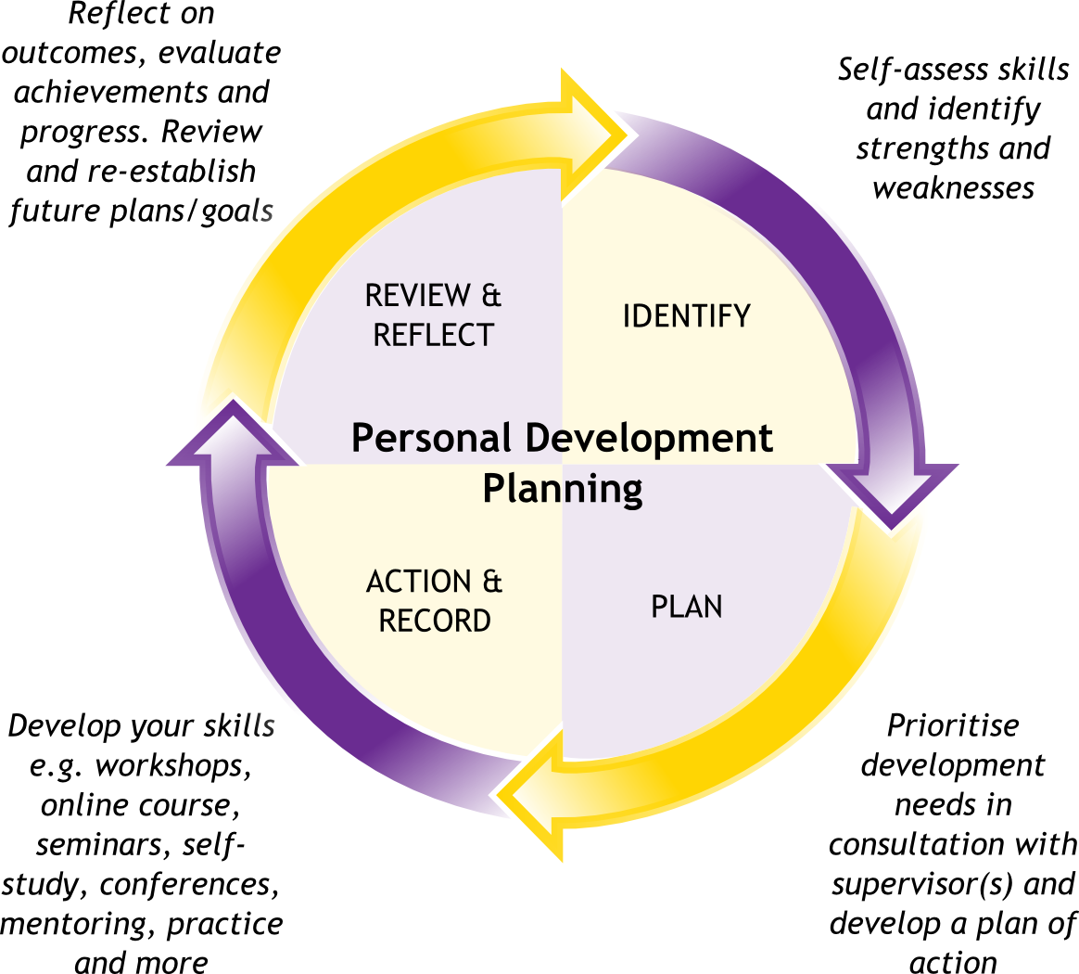

Development  Objective | Specific  Actions | Support required | How will I know when I achieve the objective?
Gaining Confidence | To practice speaking in front of people | From my tutors | When able to stand up and present a presentation confidently
Self-esteem | Not worrying about how others see me, to trust others more | Tutors to remind me I’m doing ok | When I start believing in myself a bit more
Working hard to pass level 4 | Make sure all my work Is handed in on time | Family/tutors | When I pass the course next September
In my personal development plan I have included my development objective which need specific actions to be able to achieve my end goal.

4.2 SMART Analysis
SMART stands for specific, measurable, achievable, reliable and time bound. By producing a SMART analysis will help you manage your goals.
SPECIFIC- by being specific you will set a goal that will relate to your personality, by adapting the goal to what you need to do then it will be more valuable to you. My specific goal is to become more confident in things I do so I will be able to show my full potential and achieve the goals I have set out.by being more confident will help me in a employability setting as an employer will look for a confident person for a job role.

MEASUREABLE- is my goal measurable? By making my goal measurable it will allow me to identify when the goal has been reached and what I want the end result to be. By setting myself a goal to become more confident by the end of this course as it will prepare me for the employment sector in the employment I choose.
ACHIEVABLE- by making the goal achievable will give you more motivation to achieve it, the whole point of making a goal is to challenge and motivate yourself to complete the goal in hand. If you made the goal is too comfortable it would not make you push yourself. Having low confidence and self-esteem is a major setback as if I had an interview I would less likely want to attend as I wouldn’t believe in myself.
REALISTIC – “ I’m going to buy my own house at the end of the month “ might be a bit too ambitious, having ambition is not a bad thing at all but always make a goal that is realistic, the individual wouldn’t become more confident overnight but overtime it can happen. By doing this course and attending all my lectures and having the support off my tutors and family will help me gain the confidence to make my goal realistic.
TIMEBOUNDS- even though not everyone likes deadlines having a deadline or a date in mind you want to achieve your goal will help motivate you. So you could say “I have a presentation on the 11th of December I must be focused by then “ even though this doesn’t mean that your low confidence will be high by then but you have set yourself s goal to try and improve your confidence by then. Having an end date to a goal will always motivate you to stay on task. When you apply for a job you will always have a set date for an interview this will give you time to prepare for the employee giving you the interview.

SMART is used in a lot of businesses or personal life’s sometimes we don’t even realise we applying smart to ourselves but having a SMART goal will keep you on task and motivated to achieve your end goal. Also by having a SMART goal in place it will help you think how you apply yourself in either an academic role or employment role.

5.0 Conclusion
In this report I learnt about SWOT which stands for Strengths, weaknesses, opportunities and threats, created my own development plan and did some learning styles to show what type of learner I am. I learnt from the VARK personality questionnaire that I am more of a reading/writing type of person. I also did the Myer Briggs learning personality test which shows different percentages of the personality you have, I was quite surprised at the results on some of them as I didn’t think my personality came across like this I think in some arears I need to change the way I think and how people see me as it would help with my employability skills. I have also learnt that everything I have done in this report e.g. SWOT and personal development plan I always relate back to my confidence and self-esteem these are the main factors that I need to work on. To achieve my goal of completing this course of level 4 and progressing to Level 5&6 I will need to learn to be confident in presentations by practicing more. During this report I found it challenging to speak about myself some areas e.g. my SWOT I had to say what I thought my strengths were I found this hard as one of my weaknesses was low confidence so find it hard to think positively about myself. Going forward I will have to start believing in myself to start gaining the confidence I need to have a successful career after I pass this course. I will apply this personal learning journey to my future assignments and in my lectures as this assignment I feel has helped me develop skills in creating a report. Overall I have found that my weaknesses can be turned into strengths that will develop into opportunities which will help me achieve my Personal development plan which will enable me to progress and achieve my goals. This assignment will also help me develop my skills in employability as having good strong employability skills will help you secure a good job in the employability sector that you chose to follow.

References
16personalities.com. 2020. Welcome! | 16Personalities. [Online] Available at: <https://www.16personalities.com/profile> [Accessed 24th November 2020].

VARK - A Guide to Learning Styles. 2020. [Online] Available at: <https://vark-learn.com/vark-questionnaire-results/> [Accessed 20th November 2020].

Academy, P., 2020. What Are SMART Objectives And How Do I Apply Them? [Online] Professionalacademy.com. Available at: <https://www.professionalacademy.com/blogs-and-advice/what-are-smart-objectives-and-how-do-i-apply-them> [Accessed 18th November 2020].

Bing.com. 2020. Personal Development Plan - Bing. [Online] Available at: <https://www.bing.com/images/search?view=detailV2&ccid=_highres_captions.png&exph=1050&expw=1164&q=personal+development+plan&simid=608022285579061722&ck=C31042B912ED608773407B5D5AC036A8&selectedIndex=0&FORM=IRPRST&ajaxhist=0> [Accessed 25th November 2020].
Verywell Mind. 2020. Self-Awareness: How It Develops And Why It Matters. [Online] Available at: <https://www.verywellmind.com/what-is-self-awareness-2795023> [Accessed 26 November 2020].

