

Undergraduate assignment feedback form
(to be completed by marker)

Student Name:
Emily Sykes
Module Code:  CLCS4011  Module title:  Classical Mythology and Art | Student number:  1700547
For completion by marker:
Comments:

Marker’s signature: |  | Date:
Provisional mark:
NB. All marks are provisional until confirmed by the final examination board.

The statue (Fig. 1) contains the gods Aphrodite and Pan, as well as, in some myths, Aphrodite’s love-child, Eros. It can be found in the National Archaeological Museum in Athens, in Exhibition Room 30. It’s dated from about 100 BC, and is from Delos, measuring to a height of 1.55 metres including the base. This statue appeared in front of many tradesmen and ship owners in the Hall of the Guild of the Poseidoniasts, Beirut. The Romans declared the port free in 166 BC, allowing it to become an area for ‘Greco-Roman transactions and a cosmopolitan centre’.

Pan can be identified easily, as when looking at any ancient art of the God of the Wild he is always depicted with horns and legs of a goat. This can be seen in other statues including Pan and Daphnis (Fig. 2), and Pan and a Goat (Fig. 3). Similarly, Aphrodite can be identified easily, as she is in the nude; this also helps with approximating dating the statue, as Aphrodite was never depicted in the nude until the 4th century. Aphrodite is also commonly seen in this position, with her hand covering her pubic area, such as in the famous Aphrodite of Knidos (Fig. 4); this is her protecting her modesty, especially in Fig. 1 with Pan. By looking at the statue, it seems that Pan is attempting to pry Aphrodite’s hand away in an attempt to seduce her. Aphrodite isn’t keen on this, and has one of her sandals in her hand; this is raised, possibly in the middle of Aphrodite using it to defend herself from Pan’s sexual advances. Between the two gods is Eros, who can be identified as he is with Aphrodite. He has one hand on Pan’s horns, which could possibly be an attempt to help his mother. Only in some myths is Eros Aphrodite’s son, with his father being either Ares or Hermes; in other myths, he is seen as a primordial god, being born from Chaos.

Pan doesn’t seem to appear in many myths alongside Aphrodite, this statue being a first. The only myth with an obvious link between the two is when Pan was to judge in a beauty contest between Aphrodite and a mortal names Akhilleus. When he awarded Akhilleus, Aphrodite cursed the god to fall in love with the nymph Ekho. Aphrodite is seen separately in the story of Paris and Helen of Troy competing in another beauty competition against Athena and Hera; in this one she wins and starts the Trojan War by allowing Helen of Troy to fall in love and run away with Paris, despite already being married to King Menelaus of Sparta.

All gods can easily be identified when compared to other statues and ancient art depicting them, and the scene clearly shows one of distress between the gods, but also the bond between mother and son.

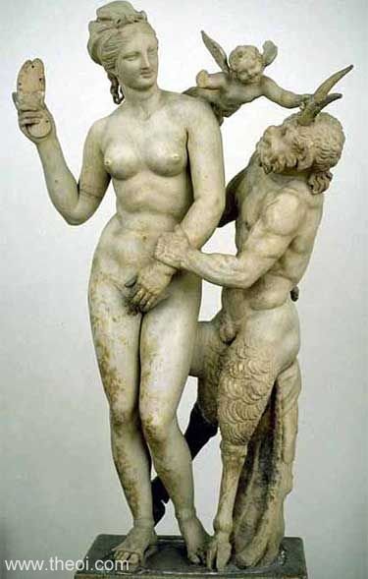
Fig. 1: Aphrodite, Pan and Eros

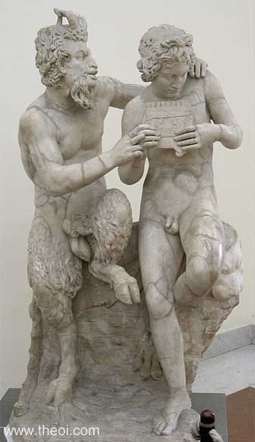
Fig. 2: Pan and Daphnis

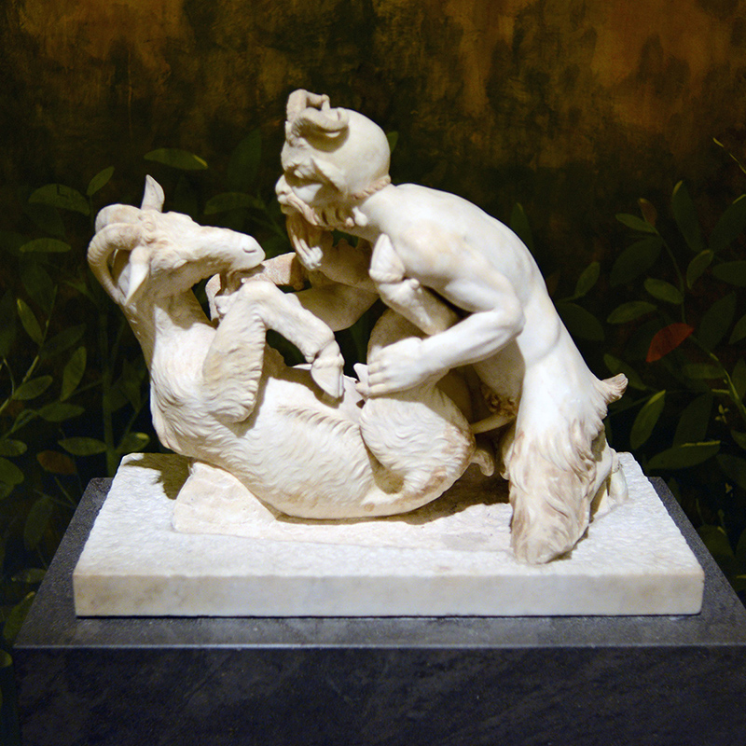
Fig. 3: Pan with a Goat

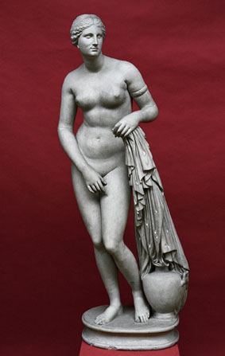
Fig. 4: Aphrodite of Knidos

Bibliography

‘Aphrodite of Knidos’. University of Cambridge. ‘Museum of Classical Archaeology Databases: Aphrodite of Knidos’. museum.classics.cam.ac.uk. http://museum.classics.cam.ac.uk/collections/casts/aphrodite-knidos. [Accessed on: 18th December 2017]

‘Aphrodite, Pan and Eros’. National Archaeological Museum. ‘Aphrodite & Pan’ 2010. namuseum.gr. http://www.theoi.com/Gallery/S10.4.html. [Accessed on: 15th December 2017]

Cartwright. ‘Aphrodite’ 24 June 2012. ancient.eu. https://www.ancient.eu/Aphrodite/ [Accessed on: 19th December 2017]

Encyclopedia Brittanica. ‘Helen of Troy’ 28th December 2017. britannica.com. https://www.britannica.com/topic/Helen-Greek-mythology. [Accessed on: 1st January 2018]

Morford, M.P.O., Lenardon, R.J., Sham, M. 2015. Classical Mythology. New York: Oxford University Press

‘Pan and Daphnis’. Theoi Project. ‘Pan and Daphnis’. theoi.com. http://www.theoi.com/Gallery/S22.2.html. [Accessed on: 15th December 2017]

‘Pan with a Goat’. Snackish. ‘The Secret Cabinet of Pompeii’. snackish.com. http://www.snackish.com/2016/02/15/the-secret-cabinet-of-pompeii/ [Accessed on: 18th December 2017]

Theoi Project. ‘Aphrodite Wrath 2’. theoi.com. http://www.theoi.com/Olympios/AphroditeWrath2.html. [Accessed on: 1st January 2018]

http://www.theoi.com/Gallery/S10.4.html
National Archaeological Museum, 2010
http://www.theoi.com/Gallery/S22.2.html
http://www.snackish.com/2016/02/15/the-secret-cabinet-of-pompeii/
Cartwright, 2012
http://museum.classics.cam.ac.uk/collections/casts/aphrodite-knidos
Morford, Lenardon, Sham 2015: inside front cover
Theoi Project
Encyclopedia Britannica, 2017

