How does the designer’s state of mind affect their creativity?

Adele Murphy
(P150554)
Surface Pattern Design

Julia Lockheart
M6X01791

Word count: 5,548

Contents

Introduction Page 3

Chapter 1 Page 4

Chapter 2 Page 8

Conclusion Page 13

Bibliography Page 16

List of Illustrations Page 17

Introduction
Within this essay I am going to explore what makes designers’ and other creative people enjoy certain tasks more than others. It fascinates me how a selection of people who specialise in various fields have so much passion for what they do, is there a reason behind this? Does their state of mind affect the way they see things?
Unlocking the most effective way of working is key, as designers hold the ability to change our future because of the way they see the world. They have a unique way of seeing, that involves foreseeing the future and therefore adapting the way they work to minimise any complications that could possibly occur. Even though some designers and creative people may be able to look to the future for inspiration, no one can really know what it may hold because “the unpredictability is extraordinary” (Robinson, 2007). The future genuinely is unpredictable, but that is what makes it so exciting.
One of the key theorists that look into the effects the mind has on creativity is Csikszentmihalyi, who has researched into what causes a designer to enter a state of mind he calls flow. He outlines nine elements that contribute to overall enjoyment and satisfaction, of which the most relevant will be discussed in detail below (Csikszentmihalyi, 1996). Other people who have explored into what goes into achieving a creative state of mind include David Bohm. Bohm explores the affects that achieving a creative state of mind can have on the health of an individual and on their social surroundings, such as the pressure to always be perfect in today’s society (Bohm, 1998). Although, through achieving this state of mind he explains how it can give way for more harmony, though this will only happen if the designer is open to new discoveries (Bohm, 1998). Their work will be used in chapter one to explain how entering a certain state of mind can alter the way a designer can focus, whilst also explaining how it may allow them to receive a pure level of enjoyment.
Within chapter two I will discuss how the way the human race is behaving is affecting creativity in the world and what can be done to improve these scenarios. The education system is vital for creating a future where everyone’s creativity can thrive, whilst containing a natural balance within our environment. It is “education that’s meant to take us into this future that we can’t grasp” (Robinson, 2007), therefore it needs to be ensured that it is the best it can be. This will happen when we stop treating children all the same, some may take to learning the standardised academic subjects such as languages and mathematics, but others may struggle and need to be taught using different methods (Hayes, 2017). The fact that schools are still teaching all children the same in order to meet the industrial needs, means that their creativity begins to be pushed out of them (Robinson, 2007). The reasons behind this will be discussed further in chapter two.
Additionally, the natural world is also struggling as a result of carelessness and oblivion from the human race, specifically looking at climate change. Humans are a massive cause of climate change, this is because of actions such as; burning fossil fuels thus emitting harmful chemicals, deforestation and the amount of waste we produce (BBC 2018). I will continue to explore how creativity could have been used to cause destruction, whether it was intentional or not. Also, what steps we can take to mend those mistakes made. Moreover, how designers specifically can use their mistakes whilst working with nature to evolve and learn, therefore allowing them to create more enhanced designs while at the same time aiding the harmony between humans and nature.

Chapter one
During the design process the designer’s state of mind affects the way they work and inevitably, the work they produce. Without the correct state of mind, they will most likely be open to distractions. This means they will not be working as efficiently as if they were in an environment with minimum distractions, where they also had full enjoyment of the process. Designers who are fully immersed in their designs and the processes of making are more likely to enter a creative state of mind and be able to experience pure enjoyment.
Csikszentmihalyi looks into what makes certain tasks so enjoyable to various people in different professions (1996). He does this by discussing how there is a specific state of mind called flow, which once entered will allow for pure enjoyment to be attained, one of the nine elements of flow that he outlines is the fact that while we are in the state of flow, “there is no worry of failure” (Csikszentmihalyi, 1996, p.112). The reason for this, is because our mind is solely focused on the job at hand that nothing seems to matter, therefore we may even lose track of time, “hours may pass by in what seems like a few minutes” (Csikszentmihalyi, 1996, p.113) and sometimes we even forego the feeling of hunger. Working in this way will allow the designer to speedily achieve their goals while enjoying the process, as opposed to working with a state of mind that is open to distractions. For example, a designer who is working for a client towards a deadline cannot afford to be constantly distracted, therefore, working within a flow state of mind will allow them to focus on the task at hand. Also, a designer who likes what they do and who enjoys making and creating designs, will be more likely to produce a larger amount of work potentially of a higher standard. This would suggest enjoyment is a key element of achieving flow. To be in flow you need to be fully immersed in a task and therefore needs to be enjoyable, otherwise you would be easily distracted. Pure enjoyment comes when we are being challenged, not when we are “relaxing, when [we are] taking drugs or alcohol, or when [we are] consuming the expensive privileges of wealth.” (Bohm, 1998, p.110). Therefore, it is important to remember that no one will have the same experience of flow. This is because different people have different interests, so will therefore carry out separate tasks to suit them, whilst equally challenging their personal abilities in order for them to achieve flow.
Similarly, another element of flow is that our “actions and awareness are merged” (Csikszentmihalyi, 1996, p.111). This means a designer may be so engrossed in drawing that they forget to eat, or whilst in school “a student may appear to be paying attention to what the teacher is saying, but in truth they are thinking about lunch” (Csikszentmihalyi, 1996, p.111). Within fashion it is a very sought-after asset, due to the fact that the fashion industry is so fast paced with very high demand. Each season has different trends and styles, so therefore the designers have to be able to create lots of designs in only short amounts of time. By being able to put their mind in a state of flow, allows the designer to shut off from all distractions and just get the work done. To be fully immersed in what you are doing is incredible, because it means you are truly happy in that moment. Therefore, you may even prefer the process of carrying out an activity over the actual outcome, just as novelist Naguib Mahfouz stated, “I love my work more than I love what it produces” (Csikszentmihalyi, 1996, p.107). Just like, how an embroiderer may enjoy the feeling of a needle and thread in their hands to form beautiful stitched marks, over the feeling of looking at their final design at the end of the process.
Just like an embroiderer with a needle and thread, many artisan designers and makers receive their pure enjoyment whilst using their hands. It is something about going back to basics that gives a great sense of satisfaction, making something completely by hand can give a product meaning and personality. The hands are linked to our sight in a way that our “hand motions [become] part of the act of seeing ahead” (Sennett, 2008, p.176). This means that sometimes we can be creating something with our hands without thinking about the actual motions too much, instead, let our minds focus on what our eyes are perceiving (Sennett, 2008). By working in this way, a designer can create work without over thinking, for the reason that over thinking may cause an unhealthy level of doubt.
Having a creative state of mind can be crucial to our health because, “just as the health of the body demands that we breathe properly… the health of the mind requires that we be creative.” (Bohm, 1998, p.24). Creativity allows our minds to be open and free, so when we are in that state of mind where nothing around us matters it means we can just be in that moment. However, achieving this state is very challenging, “it is one of the most difficult things that could possibly be attempted.” (Bohm, 1998, p.24). It is not as simple as just wanting to change your state of mind, the designer must be equally challenged to their capabilities within their specific skill set. If the task a designer is performing is of a higher skill level to their capability then it will cause them to develop anxiety and result in their stress levels rising (Baron, 2012). This is due to the fact that the task no longer becomes enjoyable as their level of skills aren’t high enough to be able to carry out the task without a great amount of pressure. On the other hand, a designer will most likely become very bored if they are met with a task that is way below their capabilities (Baron, 2012). On account of the task being so easy that it takes little to no effort for them to complete, therefore will not be stimulating their mind and bring them satisfaction. It is for these reasons that in order for a designer to achieve their desired flow state of mind they must find a task or process that equally matches their interests and available skill set. It is when this peak is found that they can truly let their creativity be free without stress or anxiety, allowing them to become more creative and let their talents shine through their work.
The key to unlocking someone’s mind to a creative state is by being “original and creative about reactions that are making him mediocre and mechanical” (Bohm, 1998, p.23). We are not machines, “the mind is not the sort of thing that can properly act mechanically… this is why we always fail whenever we try to be mechanical” (Bohm, 1998, p.24). Therefore, whenever we do attempt to be mechanically perfect it just results in us falling into “a painful and unpleasant state of dissatisfaction and conflict” (Bohm, 1998, p.24). This then causes designers to hold back and may prevent them from taking any further risks, resulting in the quality of their work to slowly decline. It needs to be taught early on within the education system that it is okay to make mistakes, as it is a way of learning and also supports the development of new and existing skills. Many of us struggle to achieve a creative state of mind, because we are constantly being pressured to be perfect, when our minds were not built for that. By focusing on our reactions to certain situations will allow our minds to adjust and therefore be more likely to enter flow, where the fear of failure is not a big source of stress (Csikszentmihalyi, 1996). It is important to not let social restrictions affect the creative process, if a designer stops worrying about whether they are going to fail or succeed and just perform the job at hand, they will start to enjoy just being in the moment and forget what is happening around them. If those who are striving to achieve a creative mind-set start training their mind in this way they will be one step closer to achieving a creative state of mind and entering flow.
Creativity for a designer is very important as it is necessary for them to be unique and original. Most designers have been well trained and are able to see the world differently to people in other professions. Just as some may view the word technique as “soulless” (Sennett, 2008, p.149), a designer who has adapted and is trained to work with their hands will not view it in that way, they are much more likely to think of technique as being “intimately linked to expression” (Sennett, 2008, p.149). As designers, we use an array of different techniques to portray our creative image, therefore it has a very important part to play and shouldn’t be overlooked. Designers who are very passionate about their work often create their work for the pure enjoyment of doing so, or even the opportunity to discover “something new that had previously been unknown” (Bohm, 1998, p.2). As discussed before, being in flow eliminates the fear of failure and the “one thing that prevents us from thus giving primary emphasis to the perception of what is new and different is that we are afraid to make mistakes” (Bohm, 1998, p.4). By training the mind to be open to new experiences it is possible to receive more enjoyment out of day to day tasks. Also, by having a more open mind it could give way for a new mind-set, it may turn mundane looking situations or tasks into something that is packed full of opportunities and potential.

Chapter two
To enable a designer to successfully receive their desired state of mind it depends on how much creativity they have been able to express. By restricting creativity, it restricts the designer’s openness to new experiences as they may be afraid to take risks for fear of failure. This feeling of needing to be perfect stems from childhood, where children are indirectly taught that mistakes mean failure and in order to become successful, you have to work in a way that could be described as being mechanically perfect (Bohm, 1998).
Children are the key to having a successful, creative future; however, according to Ken Robinson, “we squander them, pretty ruthlessly” (2007). Within schools, children are restricted from expressing their creative talents, as subjects such as languages and mathematics take priority, but in our current climate of environmental change, “Creativity now is as important in education as literacy, and we should treat it with the same status” (Robinson, 2007). Robinson discusses in his TED talk how schools may be killing creativity, he believes that “we are educating people out of their creative capacities” (Robinson, 2007) by forcing them to suppress their creativity and not allowing them to give the subjects they find enjoyable more priority. If the system continues to do this then eventually we will have fewer creative people in the world and this would have catastrophic consequences. Without creative people, the world wouldn’t be a very appealing place to live, in fact “when there’s no creativity, there would be no innovation” (Chhabria, 2015) which means there would be very little improvement within day to day life. In essence, there may be a time where we hit a standstill and everything stops progressing, creating quite a boring environment to live in. Without even realising it, we are constantly surrounded by the work of creatives, from buildings that require an architect to design them, to the music we listen to and to the clothes we wear every day. These people are so underappreciated because a lot of people are not able to see the world without them, therefore cannot see the issues within the education system.
By leading children into more academic subjects “to meet the needs of industrialism” (Robinson, 2007) we may be depriving them of what makes them happy, in turn this will mean that they may find it even more difficult to achieve a creative state of mind and receive that level of pure enjoyment. When I was a child in school I received similar treatment. I loved art from primary school but I remember only having one art lesson every two weeks, if that. Whereas, we would have regular maths and English lessons. I felt like I came alive while I was making art and it gave me great confidence, although as soon I was put back into an academic environment I went back into my shell. This refers to another one of the nine elements of flow set out by Csikszentmihalyi, he stated that whilst in flow the designers “self-consciousness disappears” (Csikszentmihalyi, 1996, p.112). This links back to my experience as a child because I didn’t care what was going on around me, I was just enjoying the moment of working with my hands and letting myself be free. Designers can have stages where they feel very self-conscious about the way they work and in many cases the work its self. This can be for various reasons such as self-doubt, or the fact that someone may not like their style of work. As a result of being subconsciously taught that mistakes are something to be ashamed of it could make us more sensitive to criticism.
From a very early age “One is taught to maintain the image of ‘self’ or ‘ego’ as essentially perfect” (Bohm, 1998, p.4). This is why we are afraid to make mistakes because it would be seen as weak or not good enough. However, some children have not yet been taught out of this perfect image so therefore you may find that “kids will take a chance, if they don’t know, they’ll have a go… they’re not frightened of being wrong” (Robinson, 2007). This is so pure and is an essential attribute to a designer if they want to be successful and create original, unique work. “If you’re not prepared to be wrong, you will never come up with anything original” (Robinson, 2007). Mistakes are important as they allow you to learn, mistakes also let you realise what works and what doesn’t. For example, a textile printer whose working with fabric dyes and various fabrics, needs room for mistakes due to the different fibres of fabrics, along with the different strengths and combinations of the various dyes. This is especially true while working with natural dyes through eco-printing, such as using fruits and botanicals as the results are so unpredictable. A certain result would be hard to repeat as the natural materials such as leaves will most likely only have one strong print before the colour begins to get exhausted. Also, the various shapes and sizes of the certain materials will affect each result, therefore making it hard to predict the outcomes of natural dying (see fig 1). Depending on how much time you leave the fabric in the solution will determine the strength of the colour, also, the ratio of fabric to dye will also affect the colour that is formed (see fig 2). It is a very long process so therefore, if you are not willing to put in the time and be prepared to make mistakes you will not get the results you desire. Tasks that take a lot of work such as this are what stretches a designer’s “capacity and [involves] an element of novelty and discovery” (Csikszentmihalyi, 1996, p.110). Therefore, the key is to stop worrying about being perfect and stop the misconception that “each mistake seems to reveal that one is an inferior sort of being, who will therefore, in some way, not be fully accepted by others” (Bohm, 1998, p.4). This is because we are not machines so we are inevitably going to make mistakes, so use it to explore the creative process further and open the mind to new possibilities.
Fig. 1: Eco-printing
Fig. 2: Eco-dying
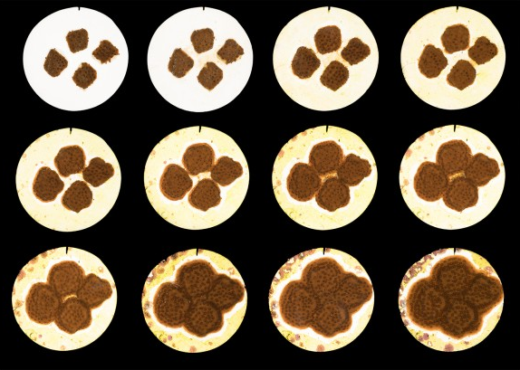
The natural world is beautiful and full of creative possibilities to help it flourish. However, there is some ways creativity has been misused to help with the destruction of the natural world. The Industrial Revolution was a prime example of how design can be taken too far in such a short amount of time, it resulted in putting “billions of toxic materials into the air, water and soil” (McDonough and Braungart, 2009, p.18). This has also resulted in large quantities of waste being produced, therefore is partly the reason of today’s environment being so heavily contaminated that future generations will have to be extremely vigilant (McDonough and Braungart, 2009). Likewise, affecting the lives of various other species, ranging from animals to plants. One big issue in today’s society is fluctuating temperatures, it has resulted in many species becoming endangered including the coral reefs, which over the years have been severely bleached due to raising water temperatures (Watts, 2018). Over the last five decades, our climate has changed so drastically that future generations may never be able to see these beautiful reef systems, these systems that have managed to survive on their own for up to 50 million years, (Watts, 2018). Designers, engineers, architects and other creative minded people all have the capabilities to prevent further destruction. This can be done by working with nature rather than against it. There is currently a project being carried out that involves the restoration of corals. Mote Marine Laboratory have found a way to allow the growth of coral to be up to 40% quicker than they would normally take in the wild, this was discovered by scientist, Dr David Vaughan through an accident, a piece of coral had snapped while he was attempting to move it (BBC Earth, 2018). This resulted in tiny pieces breaking off which then grew back to their original size within just a few weeks, whilst normally it would have taken 3 years for a coral to grow to that size (BBC Earth, 2018). This process is called micro-fragmentation (see fig 3). Since then they have done more research and experiments and are aiming to plant “100,000 corals into the ocean by 2019” (BBC Earth, 2018). This is another great example of how something that happens unexpectedly can result in massive change for the good, it also shows how important having an open, creative mind is for being able to see the possible changes and actually make those changes happen. The human race as a whole has made mistakes but as previously stated, mistakes can lead to something beautiful that may not have even been intended. We must not let these mistakes take control, instead we need to use them as learning curves to improve the way we work.
Fig. 3: micro-fragmentation of coral (Dan Mele)
We can use our creativity to take back control and work with nature for the benefit of the environment. For example, a company was told their fabric trimmings were deemed as hazardous waste so could not be burned or buried, however the material that was used for their products were able to be sold as safe to their customers, which would then be installed into their homes (McDonough and Braungart, 2009). It is quite a scary thought to know that the waste products of the material that is going into people’s homes were too hazardous to naturally dispose of, yet the material its self was deemed as ‘safe’. So, the fabric trimmings were to be sent off to be disposed of correctly which was disappointing as the company didn’t want them to go to waste. They had planned to give back to the community by using the trimmings to “make mulch for the local garden club” (McDonough and Braungart, 2009, p.107). This would help benefit the local people and plant life, aiding the growth of a more sustainable eco-system. Due to the fact that this couldn’t happen, they decided to adapt the materials they were using so that instead of using fabrics that were just harmless, they used fabrics that were actually nutritious (McDonough and Braungart, 2009). During this process, they managed to eliminate almost “eight thousand chemicals that are commonly used in the textile industry” (McDonough and Braungart, 2009, p.108). This portrays that if you put in the time and effort to actively improve the affect you have on the environment around you, then change can happen and especially by using nature to help structure the way we work will result in a healthier eco-system.
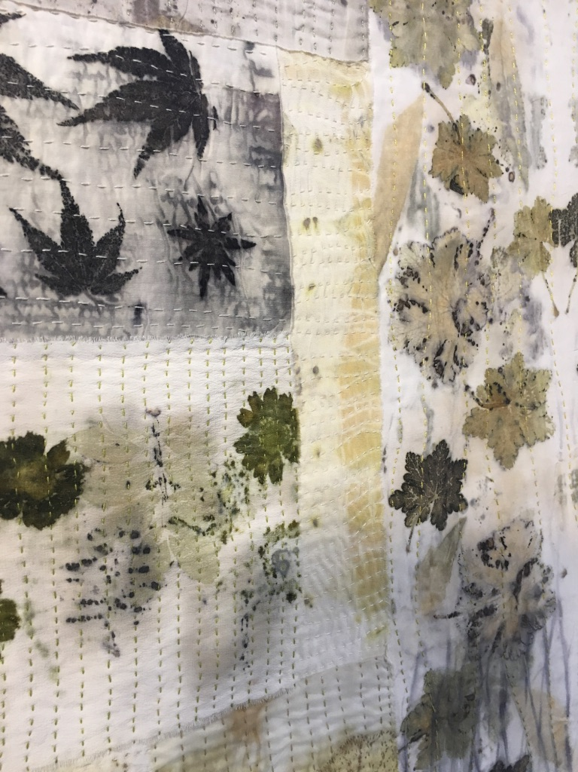
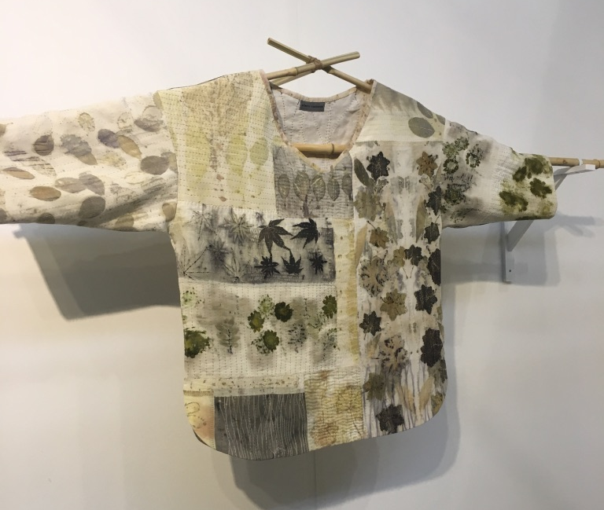
Working with nature will have its challenges but the outcomes can be beautiful and have a great softness about them. There is a purity about the results as they contain a very unique, natural strength that is hard to achieve using artificial dying. However, in comparison, when working with chemical dyes it is easier to anticipate the various shades and tones of colour that will be produced. This is because the dye powder and chemicals used can be measured and recorded through testing, therefore a result can be easily repeated. However, with natural dye materials, the strength and quantity may vary from object to object. For example, if a designer is dying cloth with leaves, no two leaves will produce the same strength of colour (see fig 4 and 5). However, this is what allows this method of dying to create such beautiful, unique pieces.
Fig 4: alchemilla by Edwina Mackinnon
There are no escaping mistakes when it comes to working with nature as you cannot control it, therefore you must follow where it wants to lead you. Csikszentmihalyi discusses how, when in flow “we always know what needs to be done” (Csikszentmihalyi, 1996, p.111). However, that is hard to do with eco-printing, due to the fact that each step you do can have unpredictable occurrences that you may not have a set solution to. There are a lot of factors that could cause the outcome to not come out as planned. However, there are a lot of cases in my own work where I have made mistakes but they ended up giving me results that I preferred, compared to what I originally wanted. So, what I am trying to convey is that mistakes are essential, people who are scared to make mistakes never take risks, so may never realise their full potential.
Fig 5: Detail of alchemilla by Edwina Mackinnon
Children who are stripped of their creativity at a young age will grow up fearing mistakes and therefore be too scared to make a difference with the risk of looking foolish. This is because “we are now running national education systems where mistakes are the worst thing you can make” (Robinson, 2007) thus putting fear into their minds and depriving them of creative exploration. Over time this may result in less discoveries being made and consequently less progression within society.

Conclusion
Through my research I have discovered that a designer’s state of mind does affect their creativity and how it is ever growingly hard to achieve a peak level of pure enjoyment, as a result of our social environments and the way we are taught to view ourselves from such a young age. The key to receiving pure enjoyment is by accessing the state of mind called flow, this allows a designer to be free from distractions and therefore; become more productive, have clear goals of where they want to be, and also to be able to remove the element of fear from their minds which will allow them to be free to take risks and learn from their mistakes, without being made to feel inferior (Csikszentmihalyi, 1996). Flow also allows the designer to begin enjoying the process of actually making rather than focusing on just the final product and whether or not it will be successful. Csikszentmihalyi uses the term autotelic to explain this process, autotelic is used to describe “something that is an end in itself” (Csikszentmihalyi, 1996, p.113). So, instead of carrying out a task that is not enjoyable in order to receive a later goal (which would be exotelic), a task would be carried out for the pure reason of personal enjoyment and to experience the process. This method explains how certain people in different professions do their job not for monetary gain but for the joy of the experience. Csikszentmihalyi stated that a designer should not “start with the idea, ‘What will make money?’” (Csikszentmihalyi, 1996, p.107). If that is the mind set you have then you will never reach the top level of enjoyment. Although, money has been proven to affect the overall happiness and quality of life, that is of course only to a certain level (Guild, 2012). After a certain point, how much money a person has will have no effect on their overall happiness, for example, once a nation’s Gross Domestic Product “rises above $10,000.00 per capita there is no relationship between GDP and happiness” (Guild, 2012). Therefore, if we continue to live in a society where industrialism takes over and our only purpose for working is to make money, humanity as a whole will be no closer to achieving a better quality of life. However, my research has proven that creativity can increase happiness and therefore by providing more opportunities for creative minds to expand we are in a more likely position to increase the overall quality of life.
Furthermore, my research has also brought to my attention the problems within the school systems and how they are affecting future designers, they are doing this by focusing teaching around industrialism (Robinson, 2007). Therefore, creating a structure that is heavily favoured towards academic ability, resulting in subjects such as dance, music and art to suffer. It is the sort of information you never really pay attention to until something happens that opens your eyes to the issues, for me it has been through writing this essay. As a child, I would think in my head that I was not enjoying certain subjects and that I would rather be doing something else, however, these personal concerns tend to be overlooked and perceived as normal. Children shouldn’t hate school, they should wake up in the mornings excited to learn and make new discoveries. Through further research, I have learned that in order to have a future where creative people are able to express themselves, the way children are taught needs to be adapted to suit the individual, rather than just the select few (Hayes, 2017). By adapting in this way may allow more and more people to discover their creative talents and find something that allows them to enter flow and receive happiness. However, if nothing changes then some children may never find what could bring them genuine enjoyment and satisfaction.
Consequently, from inspiring children to be more creative we are giving way for a better future. It is people with creative minds who are able to think of solutions to problems that are occurring worldwide, this is because people with a creative state of mind have a different way of seeing. Flusser believed that “this way of seeing involved foreseeing the future” (Flusser, 1999, p.39), which explains how some people are able to detect a problem before it actually becomes a problem. This way of seeing is incredibly important as it means that many issues that may arise could be prevented by certain creative minds picking up on signals that may indicate these future issues. Although, being able to foresee the future and prevent issues occurring may have many benefits, it is also extremely important that we make mistakes and allow for events to occur that we may not have seen coming. It is because of these mistakes that designers are able to become more in tune within their specific fields. For example, a designer who specialises in fabric dying didn’t just try it once and suddenly become an expert, it would have taken years to master and involved many trial and errors. Every mistake that is made expands their knowledge, by knowing what could possibly go wrong means that they can learn to ensure the right steps are carried out so that it does not become a reoccurring issue. In comparison, if the professional dyer had never made a mistake and every task they carried out went exactly to plan, then when an error was to occur which would be inevitable, they wouldn’t know how to deal with the situation.
How does the designer’s state of mind affect their creativity? I have discovered that there are so many factors that are involved in a designer receiving a state of mind that optimises their creativity. It is an eye opener to learn that the reasons behind whether or not a person is more likely to achieve a creative state of mind originates from the way children are taught in school. However, it also depends on the designer’s determination and ambition as to whether they can achieve pure enjoyment or not. It is the responsibility of “each individual to realise the creative potentialities of the human mind” (Bohm, 1998, p.24). Therefore, each individual has the power to take control of their own mind and be open to exploring new possibilities, it is within that exploration of the self that one may unlock their creative state of mind.

Bibliography

Books

Bohm, D. (1998). Nichol, L. On Creativity. London: Routledge
Csikszentmihalyi, M. (1996). Creativity. HarperCollins Publishers
Flusser, V. (1999). The shape of things. London: Reaktion Books Ltd
McDonough, W. Braungart, M. (2009). Cradle to Cradle. London: Vintage
Sennett, R. (2008) The Craftsman. London: Allen Lane, Penguin Books ltd

Video’s

BBC Earth (2018) Our Blue Planet: Accidental discovery could save coral reefs [Facebook video] Available at: https://www.facebook.com/bbcearth/videos/468088793700621/ (Accessed on: 3rd December 2018)
Robinson, K (2007) Do schools kill creativity? [video] Available at: https://www.youtube.com/watch?v=iG9CE55wbtY (Accessed on: 28th November 2018)
Robinson, K (2013) How to escape education’s death valley [video] Available at: https://www.youtube.com/watch?v=wX78iKhInsc (Accessed on: 28th November 2018)
YouTube. (2015). FLOW BY MIHALY CSIKSZENTMIHALYI | ANIMATED BOOK REVIEW. [video] Available at: https://www.youtube.com/watch?v=8h6IMYRoCZw [Accessed on 9th May 2018].

Websites

Baron, s. (2012) ‘Cognitive Flow: The Psychology of Great Game Design’, Gamasutra.com [online] Available at: http://www.gamasutra.com/view/feature/166972/cognitive_flow_the_psychology_of_.php (Accessed on: 9th May 2018).
BBC (2018) ‘Climate change: What is it and why is everyone talking about?’, Newsround [article] Available at: https://www.bbc.co.uk/newsround/45880633 (Accessed on: 8th December)
Chhabria, A (2015) ‘Life without ART’, Live your life [blog]. 29th May. Available at: https://liveyourlifetheblog.wordpress.com/tag/life-without-creativity/ (Accessed on: 30th November)
Cormier, Z (2017) Saving Coral. [article] Available at: https://www.bbcearth.com/blog/?article=saving-coral (Accessed on: 6th December)
Guild, G. (2012) ‘Happiness as Measured by GDP: Really?’, How Do You Think? [online]. Available at: http://geraldguild.com/blog/2012/05/23/happiness-as-measured-by-gdp-really/comment-page-1/ (Accessed on 9th May 2018).
Hayes, D (2017) ‘Seven ways education needs to change in 2017’, The Conversation [article] Available at: http://theconversation.com/seven-ways-education-needs-to-change-in-2017-70821 (Accessed on: 6th December 2018)
Ullen, F., Manzano, Ö., Almeida, R., Magnusson, P., Pedersen, N., Nakamura, J., Csikszentmihalyi, M., Madison, G. (2012) Proneness for psychological flow in everyday life: Associations with personality and intelligence in Science Direct.52:2. Pp 167-172. [online] Available at: https://www.sciencedirect.com/science/article/pii/S0191886911004491?via%3Dihub (Accessed on 1st May, 2018).
Watts, J (2018) ‘Next generation ‘may never see the glory of coral reefs’ ’, The guardian [article] Available at: https://www.theguardian.com/environment/2018/nov/11/next-generation-may-never-see-coral-reefs (Accessed on: 3rd December 2018)

List of Images

Figure 1: Notjustnat (2013) Eco star or two [blog] Available at: https://notjustnat.blogspot.com/2013/12/eco-star-or-two.html (Accessed on: 2nd December 2018)
Figure 2: andreablum () Creating Lichen Dyes [online] Available at: https://www.instructables.com/id/Creating-Lichen-Dyes-Letharia-vulpina-or-Wolf-Lich/ (Accessed on: 2nd December 2018)
Figure 3: Mele, D (2017) Saving Coral [article] Available at: https://www.bbcearth.com/blog/?article=saving-coral (Accessed on: 6th December)
Figure 4: Mackinnon, E (2018) alchemilla. [Exhibition] The Festival of Quilts at the National Exhibition Centre (NEC), Birmingham (Photograph taken by author) August 10th 2018.
Figure 5: Mackinnon, E (2018) detail of alchemilla. [Exhibition] The Festival of Quilts at the National Exhibition Centre (NEC), Birmingham (Photograph taken by author) August 10th 2018.

