Combustion and emission simulation of methane-gasoline dual fuel SI engine
Zihao Wen 2300258
Abstract
Under the background of increasingly tight oil resources and increasingly serious environmental pollution, the search for efficient and environmentally friendly engine fuel has become an important research direction in the field of internal combustion engine. Based on ANSYS Forte and Ricardo WAVE software, combustion and emission characteristics of a methane-gasoline dual-fuel SI engine are constructed and simulated. Through the simulation of single cylinder and four cylinder engine models, the effects of methane addition on engine performance were studied and the emission products were compared. The results show that the addition of methane has NO negative impact on engine performance in terms of torque and pressure performance, while effectively reducing CO, NO and NO2 emissions. The results indicate that methane-gasoline hybrid fuel has a significant contribution to reducing greenhouse gas emissions and improving combustion cleanliness. This study provides some data and theoretical support for the development of alternative fuels and emission control of internal combustion engine, which is of great significance for promoting the green transformation of internal combustion engine technology.
Introduction
One of the greatest inventions of the 20th century was the automobile, the advantages of which became clear due to the long driving range of gasoline cars and later improvements in thermal efficiency, starting power, and noise emissions. Subsequently, oil has been recognized as the main fuel of motor vehicles in the world, thus determining the dominant position of gasoline vehicles, making the internal combustion engine has been rapidly developed. However, with the development of society and economy, the number of motor vehicles is increasing year by year at a high speed. As a non-renewable fossil fuel, oil resources are already stretched, so energy conservation and emission reduction is an imminent problem.
At present, an important measure for gasoline engines to deal with energy saving and emission reduction is small strengthening, that is, gasoline engines are developing in the direction of miniaturization and lightweight, but still to ensure high power, torque and other output, which requires the use of supercharging technology, especially at low speed to maintain the maximum output torque as much as possible. However, the turbocharging technology of gasoline engine will bring the problem of knocking under the condition of large load, especially at low speed, and even early ignition phenomenon. In order to solve this problem, the engine usually adopts measures such as delaying ignition, enriching fuel, or adding additives to gasoline to improve the octane number of gasoline to solve the knock problem.
On the other hand, the engine is now mainly fueled by oil, and the scarcity of oil and environmental problems caused by internal combustion engine emissions have become a huge challenge for the internal combustion engine industry, so efficient and clean alternative fuels and their utilization efficiency have attracted more and more attention[1]. Methane (CH4) is a renewable biomass energy source and a major component of natural gas, combustible ice and shale gas, which are currently abundant, cheap and widely used around the world. With the development of combustible ice mining technology, combustible ice will play a huge role in human society. The chemical and physical parameters of methane in gasoline are shown in Table 1. The hydrogen carbon of methane is 40% higher than that of gasoline. Under the same thermal efficiency condition, the theoretical CO2 emission of methane can be reduced by 23% compared with gasoline[2]. At the same time, methane has a higher octane number (RON=125), and has better knock resistance than gasoline, which is conducive to solving the knock problem that limits the further improvement of the thermal efficiency of modern high-supercharged SI engines. At the same time, methane is difficult to produce carbon smoke because of its small molecules, so there is almost no particulate matter emissions. However, the gas fuel also has some shortcomings, for example, because the gas fuel does not have the cooling and lubrication effect of the liquid fuel, the intake valve is exposed to high temperature, so the wear between the intake valve and the valve seat of the CNG engine is more serious. In addition, poor ignitability and slow flame propagation are also important challenges for the use of methane in internal combustion engines.
Table 1 the physical and chemical parameters of gasoline and methane
Fuel type | gasoline | methane
Chemical formula | C4-C12 | CH4
C/H (%) | 0.56 | 0.25
Molar mass (kg/mole) | 98 | 16
Density at standard conditions (kg/m3) | 720 | 0.67
Autoignition temperature (°C) | 350 | 540
Theoretical air-fuel ratio | 14.6 | 17.24
Laminar flame velocity in air (m/s) | 0.45 | 0.43
Therefore, the engine burns methane-gasoline binary fuel, which can take advantage of the advantages of both fuels, and the advantages of high methane octane number and less particulate matter to solve the knocking problem of small reinforced gasoline engines, so that the engine works at a higher compression ratio and intake pressure to improve fuel economy and reduce the emissions of nitrogen oxides and carbon oxides. At the same time, combining gasoline can improve the problem of insufficient methane power and slow flame propagation speed.
Literature review
Because methane has a special tetrahedral molecular structure and a large C-H bond energy, it requires a higher ignition energy than gasoline, and the flame propagation speed is lower than gasoline. The above characteristics of methane are not conducive to the improvement of engine thin burn limit, and will lead to the increase of engine combustion cycle variation at low load[3]. Gasoline has a higher activity (shorter ignition delay period and faster laminar flame velocity) than methane under the condition of chemical equivalent ratio[4], and it is generally believed that the activity of methane-gasoline binary fuel will be between the two, and its combustion rate should be between that of pure methane or gasoline as fuel. However, based on the optical engine, Di Iorio[5] carried out optical test research on the combustion process of methane-gasoline binary fuel by using the methods of gasoline injection at the inlet and direct injection of methane in the cylinder, and found that this method can improve the stratified quality of combustible mixture and the stability of lean combustion. Meanwhile, compared with single fuel, dual fuel can extend the thin burn limit. The CH and OH groups were measured by chemical fluorescence method, and it was found that the flame propagation rate of the binary fuel with 50% and 80% methane mass fraction was higher than that of methane or gasoline as fuel, and the reason may be better in-cylinder stratification for the dual fuel/air mixture charge. The above findings well explain the reason why the fuel economy and power performance of the methane-gasoline binary fuel engine can be improved, but the mechanism of the flame propagation characteristics of the methane-gasoline binary fuel is only a simple qualitative explanation. In order to further explore the combustion characteristics of methane-gasoline, Mahdi Baloo et al.[6] studied the laminar flame velocity of methane-isoctane under different initial pressure, temperature, excess air coefficient and methane mass fraction on the capacitance. The laminar flame propagation velocity of methane-isoctane binary fuel is closely related to the excess air coefficient and the initial pressure. When the initial pressure is 0.25 MPa and the temperature is 368 K, the laminar flame velocity is higher than that of the isoctane mixture in the thin burn region with equivalent ratio less than 1. In the oil-rich region with equivalent ratio greater than 1, the flame propagation speed decreases. However, when the initial pressure is 0.5MPa and the temperature is 368 K, the laminar flame intensity of methane-gasoline dual fuel is lower than that of gasoline, and the higher the methane ratio, the slower the laminar flame propagation speed. Even when the initial pressure is 0.25MPa and the initial temperature is 468 K, the laminar flame speed of methane gasoline dual fuel with 70% methane mixture ratio is higher than that of gasoline and methane at the same time under the condition of chemical equivalent ratio. By analyzing the influencing factors, it can be concluded that the possible cause is the interaction between methane and isooctane during oxidation reaction under different initial conditions. It can be seen that the flame propagation speed of methane-gasoline binary fuel is not always higher than that of pure gasoline, but may be close to or lower than that of pure gasoline under certain conditions. Pipitone et al.[7] first proposed the simultaneous injection of CNG and gasoline on SI engines, using the characteristics of high octane number of CNG to solve the problems of fuel enrichment and ignition delay in gasoline engines to avoid knock, so that the engine can work under the chemical equivalent ratio and better combustion phase, and improve the effective thermal efficiency of gasoline engines. Based on the problem that natural Gas engine can reduce CO2 emission but has low volumetric efficiency, Delpech V et al.[8] proposed the concept of Concomitant Injection of Gas and Liquid fuels (CIGAL). That is, the simultaneous injection of natural gas and gasoline in the inlet can increase the volumetric efficiency compared with the pure natural gas engine, and can maintain the high anti-knock characteristics of natural gas, so that the engine can work under the stoichiometric ratio and the best ignition advance Angle under the condition of large load. The results show that the binary fuel combustion mode mean effective pressure (BMEP) exceeds 26.5bar when λ=1, throttle is fully open and methane mass fraction is 55%. Compared to pure gasoline mode, BMEP is improved by 14.2%, thermal efficiency is improved by 36% and BSFC is reduced by 25%. In the study on emission characteristics of methane-gasoline, Jerome Obiols et al.[9] studied the influence of dual injection of CNG-gasoline on HC emission under the condition of large load on a turbocharged engine, and the results showed that the simultaneous injection of CNG and gasoline could significantly reduce THC emission. Di Iorio et al. [10] studied the emission characteristics of methane-gasoline dual fuel on an optical single-cylinder SI gasoline engine, and the results showed that both gas emission and particulate matter emission were lower than those of pure gasoline mode. Abbas [11] adopted the variable compression ratio (VCR) strategy to study the changes of engine performance and emissions when gasoline and hydrogen-rich natural gas were used under different compression ratios. They found that when using hydrogen-rich natural gas, increasing the engine's actual compression ratio from 11.05 to 11.80 could significantly increase power by up to 13%; At the same time, carbon monoxide emissions decreased by 7% after the compression ratio was increased from 11.05 to 11.80. When the compression ratio is increased, the turbulent kinetic energy (TKE) of the unburned gas mixture increases during combustion, which promotes the increase of combustion rate. However, the increase of turbulent kinetic energy will increase the heat transfer loss, resulting in the decrease of engine thermal efficiency. Cylinder pressure increased from 6.95MPa to 7.25MPa, an increase of 4%. Greater in-cylinder pressure will shorten the durability and life of the engine, so the actual compression ratio of the engine needs to be limited. With the increase of the compression ratio, the pressure and temperature in the cylinder will further rise, and the NOx emissions will also increase slightly, but the high temperature will further promote the oxidation of CO, making the CO emissions decrease. Because natural gas has a higher cetane number and good knock resistance, a higher compression ratio can be used to promote in-cylinder combustion, resulting in better combustion and emissions.
Model building
In the part of model building, this paper mainly uses two Simulation software, ANSYS Forte Simulation Suite and Ricardo WAVE. They are used to create and analyze different internal combustion engine models. Firstly, a single cylinder engine model is built on the Forte simulation platform, which is specially used to study the combustion dynamics and emission characteristics of a single combustion chamber. This model can simulate the combustion of the fuel and the resulting pollutants in detail, helping us to understand and optimize the behavior of synthetic fuels during actual combustion. Then, using Wave software, this paper builds a more complex four-cylinder engine model. The model is designed to comprehensively evaluate the performance of a complete engine system, including fuel efficiency, cylinder pressure and torque output. With this four-cylinder model, we can simulate the response of the engine under different working conditions and analyze the influence of various operating parameters on the engine performance. Through these two models, we are able to evaluate and optimize internal combustion engine technologies at micro and macro levels, explore the combustion and emission performance of various fuel blends, meet the requirements of the 2035 emissions regulations, and adapt to future energy and environmental challenges.
First, Forte was used to build a single cylinder engine model. According to the provided tutorial data, this paper chooses the model of Chapter 2 of ANSYS Forte Tutorials as the basis to build. The engine's geometrical specification is 70 mm in bore, 76.2 mm in stroke, The engine's geometrical specification is 70 mm in bore, 76.2 mm in stroke, 152.4mm in connecting rod length. Further details about the cylinder parameters are presented in Table 2. The correctness of these parameters is checked by the built-in verification tool. The Mesh Topology is then selected according to the specific shape of the combustion chamber, with the aim of ensuring that the mesh can effectively capture the key characteristics of fluid flow and heat transfer, while taking into account the rational use of computational resources. The Mesh Sizing is then precisely defined in mesh sizing Settings, including the selection of mesh densities and hierarchies for different regions, especially in areas where thermodynamic and hydrodynamic behavior is more complex, such as near the combustion chamber. After the grid is generated, its quality is checked to ensure that the grid is not overly distorted or too small, and the accuracy of the simulation results will not be affected because of the grid quality. If a problem is found, the parameters generated by the grid need to be returned and adjusted until the grid quality meets the predetermined criteria. Next, initial and boundary conditions such as fuel type, intake conditions, and exhaust Settings are defined in the project setup, appropriate physical models are selected, and these models are configured according to the actual engineering requirements.
Table 2 The cylinder parameters.
Parameter | Values
Engine type | Single cylinder, 4-stroke
Bore × stroke | 70 × 76.2 mm
Sweep volume | 0.3L
Compression ratio | 11
Combustion form | Spark Ignition
Using WaveBuild software to build a petrol engine model, you start by building a complete flow network on the canvas, ensuring that all key components such as the air box, throttle, intake manifold and engine core are properly positioned and connected. Next, the environmental conditions are set in detail and the characteristics of the individual flow channels, such as size and shape, are defined to ensure the accuracy of the fluid dynamics simulation. Then, define the parameters of the engine. The specific parameters of the engine are shown in Table 3. In addition, select and set the appropriate combustion model, this paper adopts the Wiebe combustion model, and reasonably adjust its parameters to match the characteristics of the actual combustion process. Finally, the cooling system is configured, including the flow path of the coolant and the characteristics of the radiator, to ensure effective cooling of the engine during operation.
Table 3 The engine parameters
Parameter | Values
Engine type | Four cylinders ,4-stroke
Bore × stroke | 70 × 76.2 mm
Sweep volume | 1.2L
Combustion form | Spark Ignition
Ignition sequence | 1-3-4-2
Results and discussion
Firstly, the Spray Model was disabled in Forte, Spark ignition module was activated, Spark plug was created, and its position in the combustion chamber, ignition advance Angle, Spark Energy and other parameters were reasonably adjusted. Then set the Composition in the Initial Conditions to the species and fraction in Table 4. Run the model and save the simulation results.
Table 4 The proportion of mixed gas components with only gasoline as fuel
Species | Fraction
o2 | 0.1967
h2o | 0.0089
co2 | 0.0192
n2 | 0.7189
ic8h18 | 0.0562
Then, as long as other setting conditions remain unchanged, the fuel is modified into a mixture of methane and gasoline with a mass fraction of 1:1, and the Composition setting is shown in Table 5. Run the model, and the simulation results are shown in Figure1-10.
Table 5 Mixed gas composition ratio of methane-gasoline as fuel
Species | Fraction
o2 | 0.1967
h2o | 0.0089
co2 | 0.0192
n2 | 0.7189
ic8h18 | 0.02281
ch4 | 0.02281
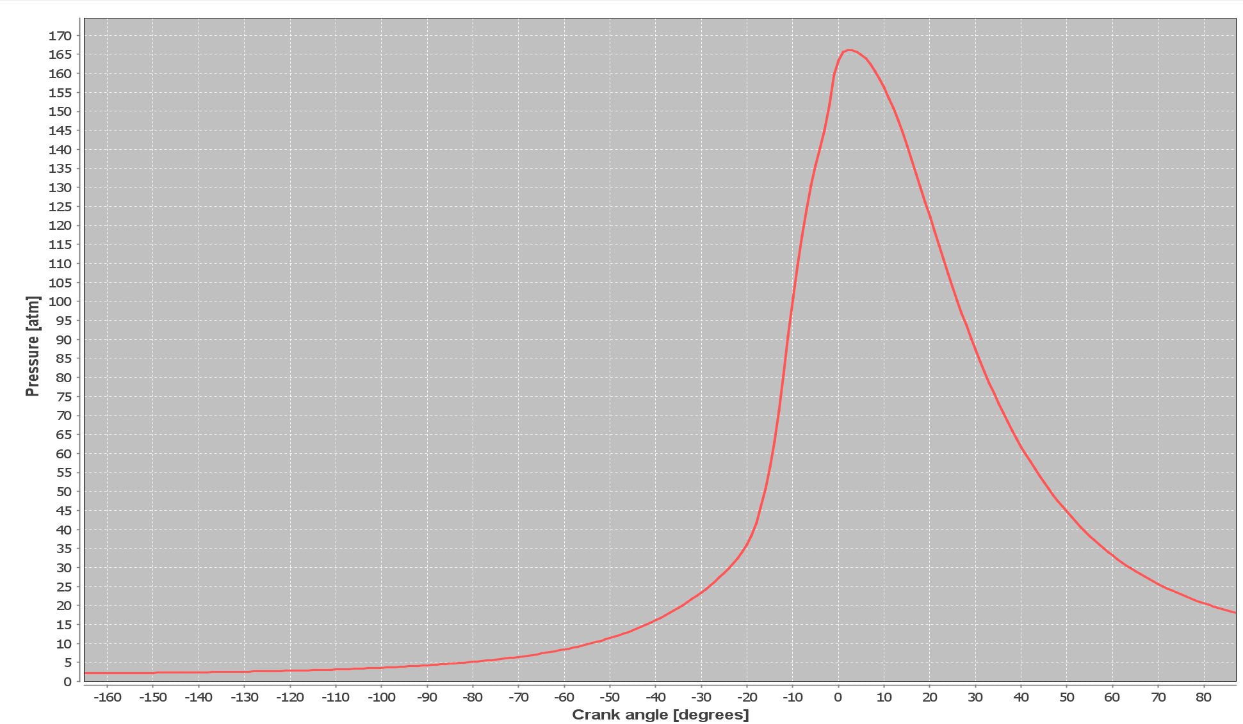
Figure 1 Gasoline fuel in-cylinder pressure
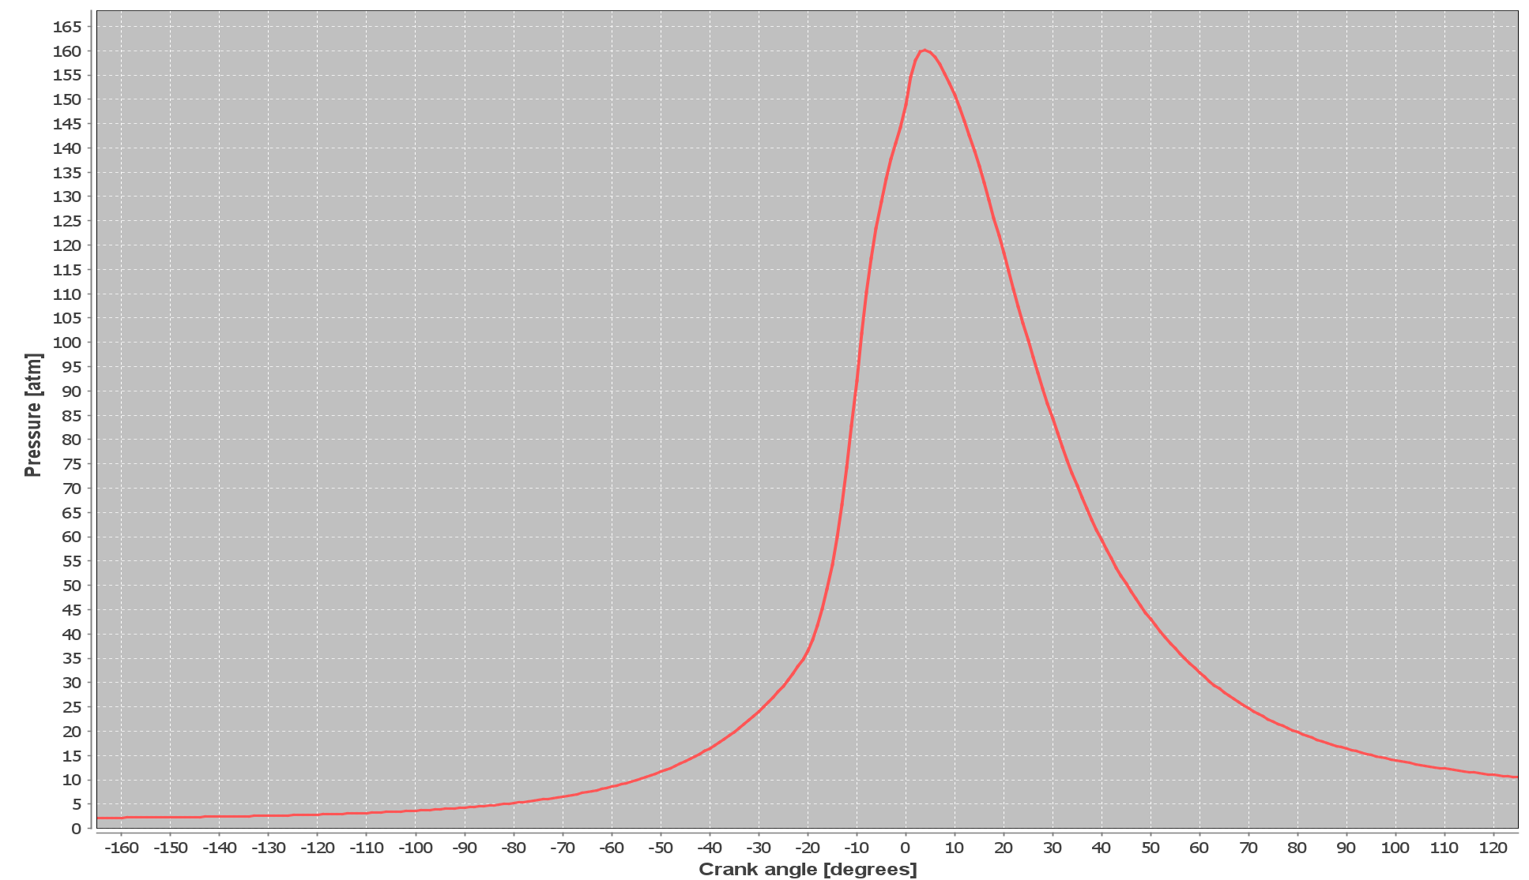
Figure 2 Methane-gasoline fuel in-cylinder pressure
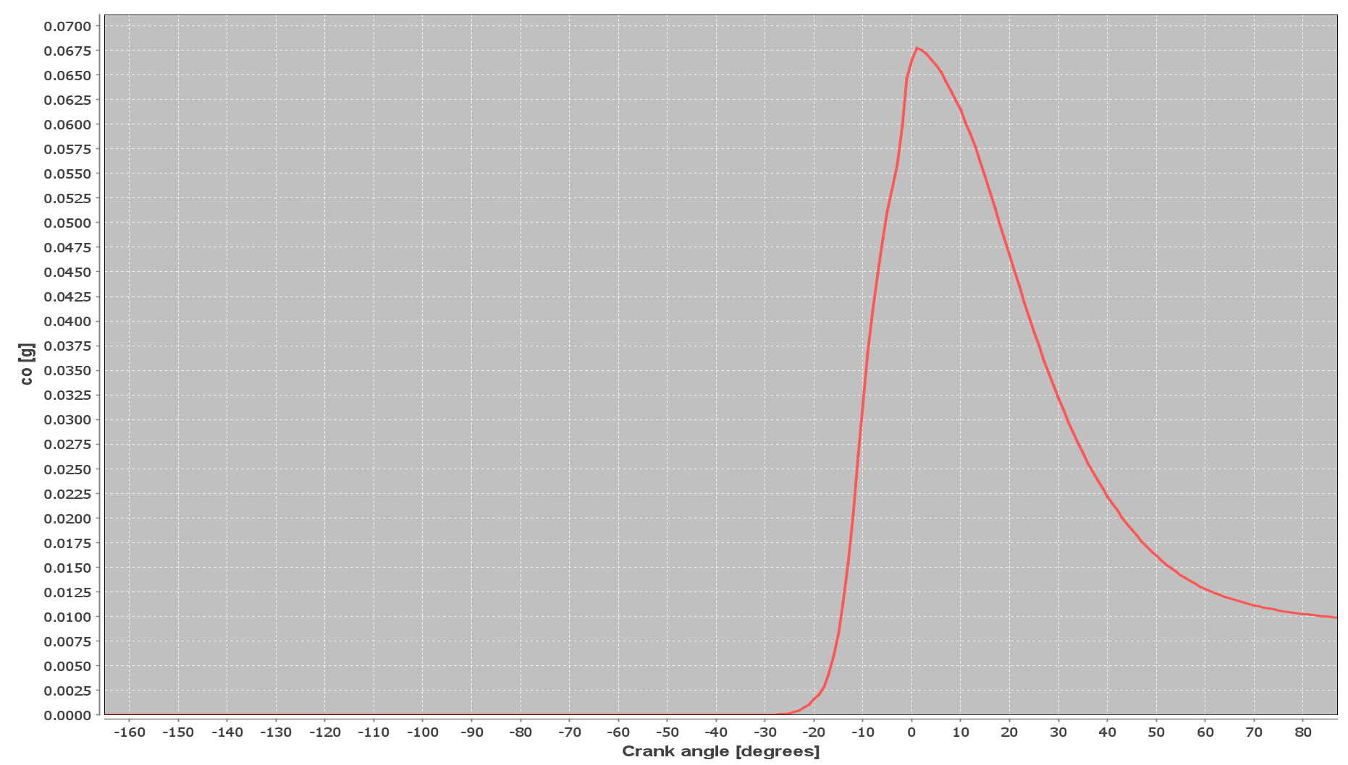
Figure 3 CO emissions from gasoline fuel
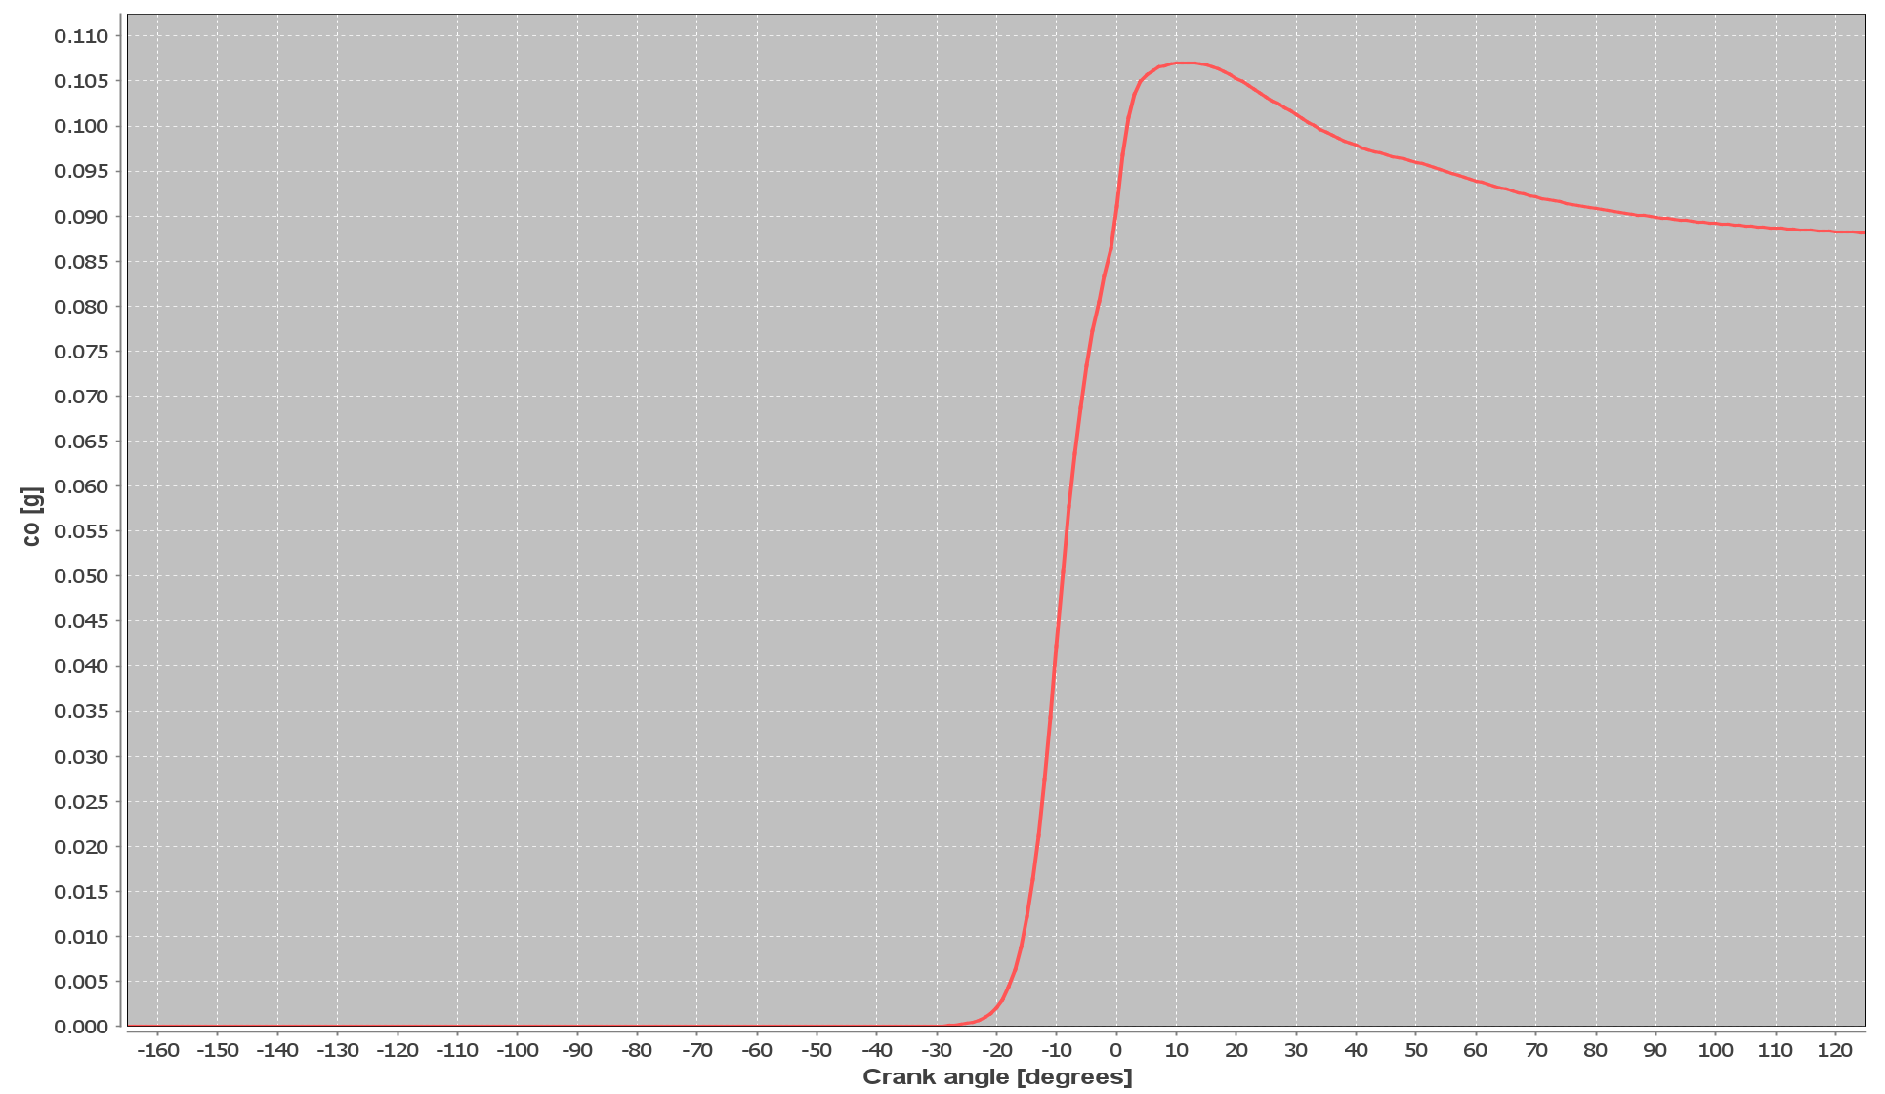
Figure 4 CO emissions from methane-gasoline fuel
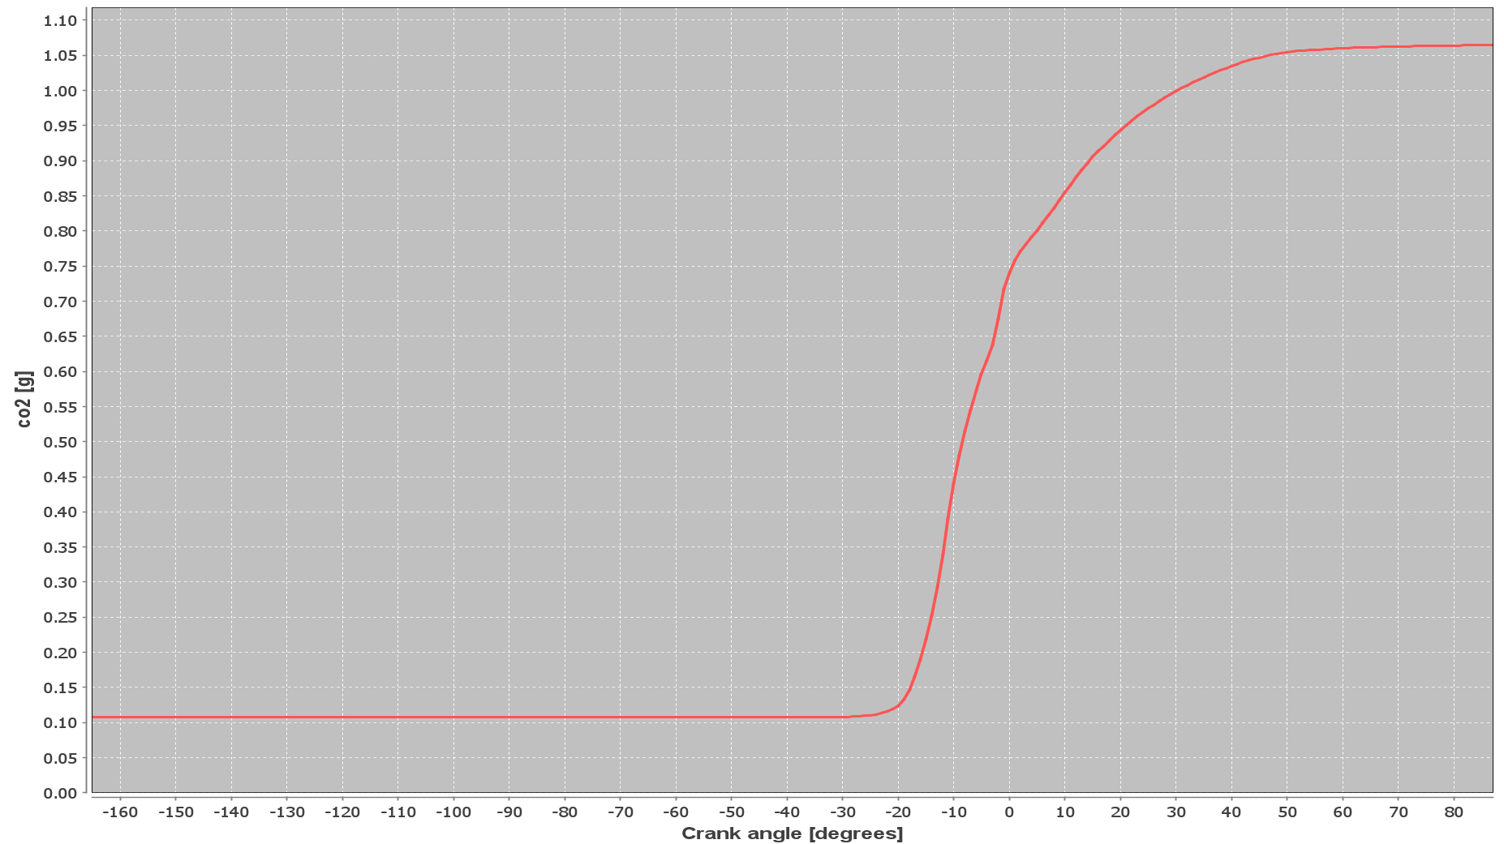
Figure 5 CO₂ emissions from gasoline fuel
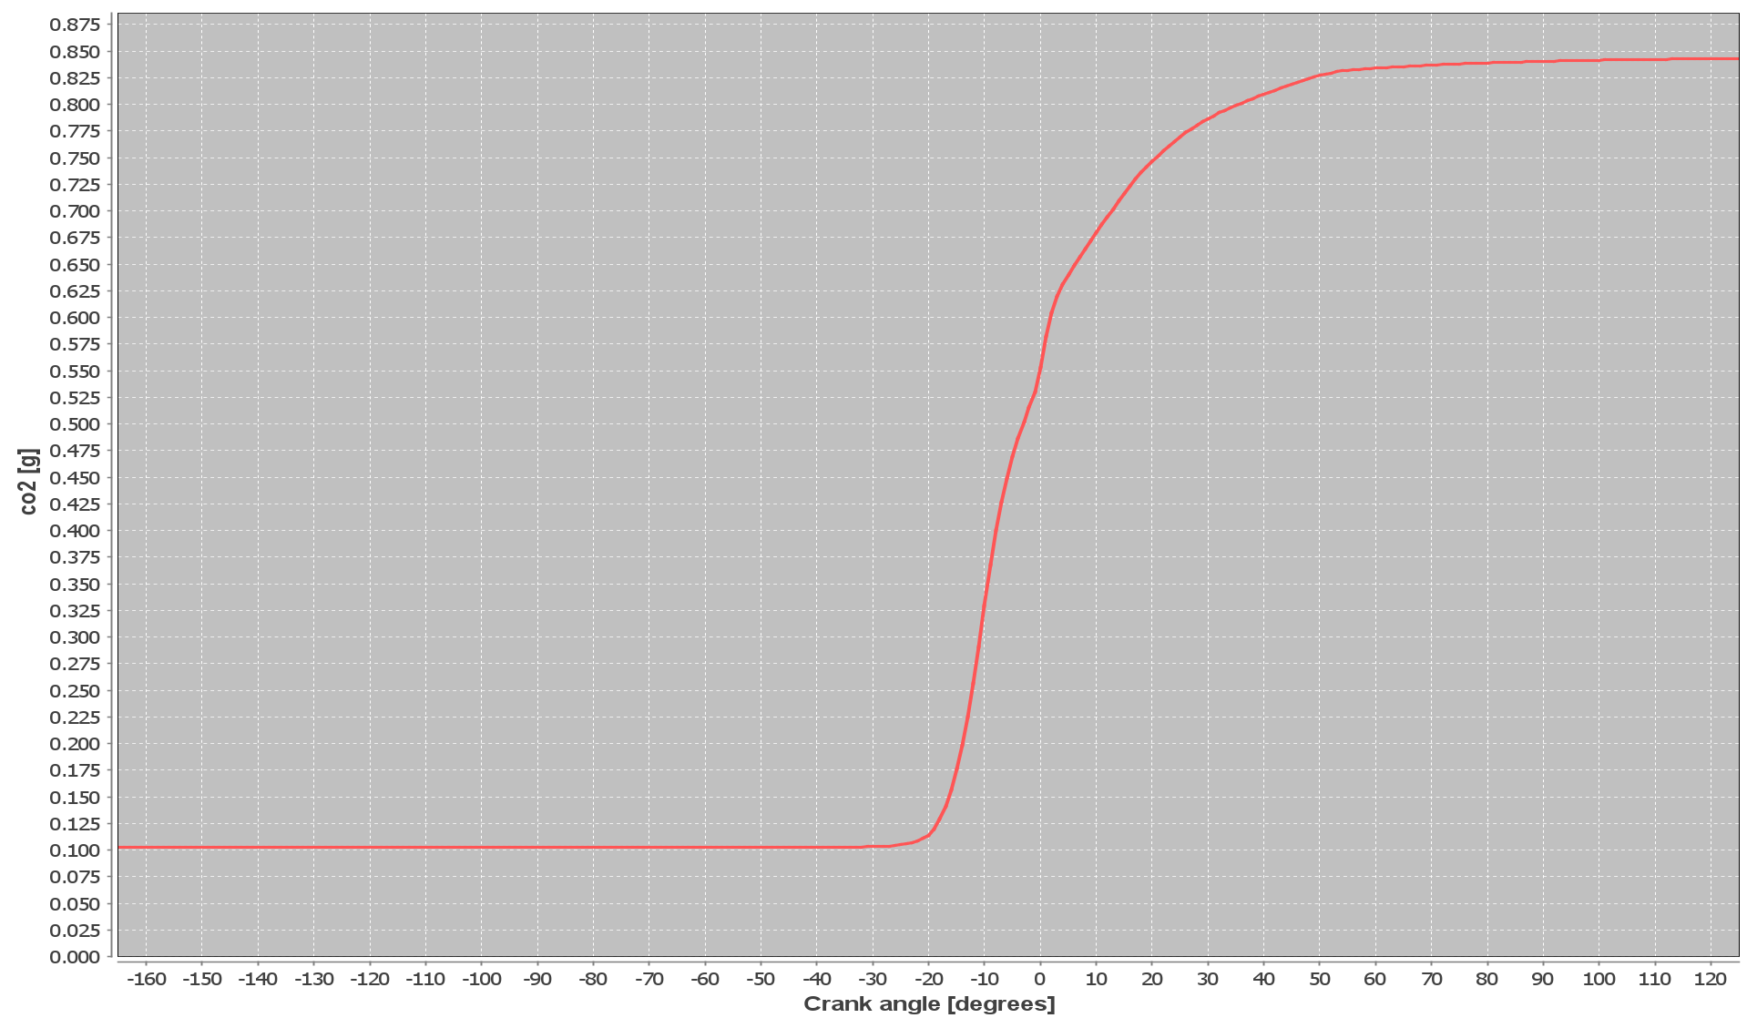
Figure 6 CO₂ emissions from methane-gasoline fuel
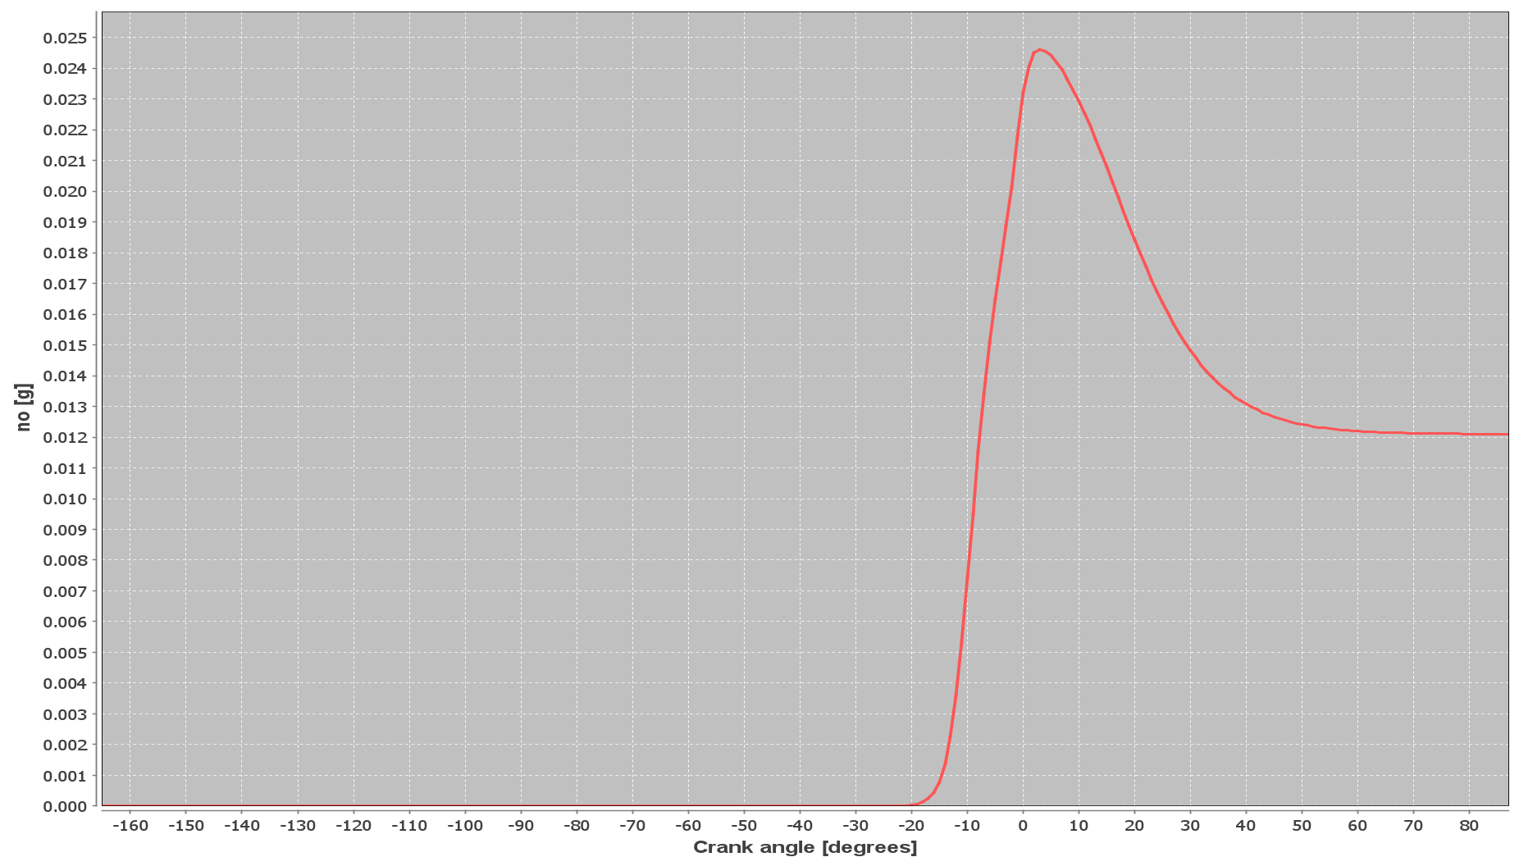
Figure 7 NO emissions from gasoline fuel
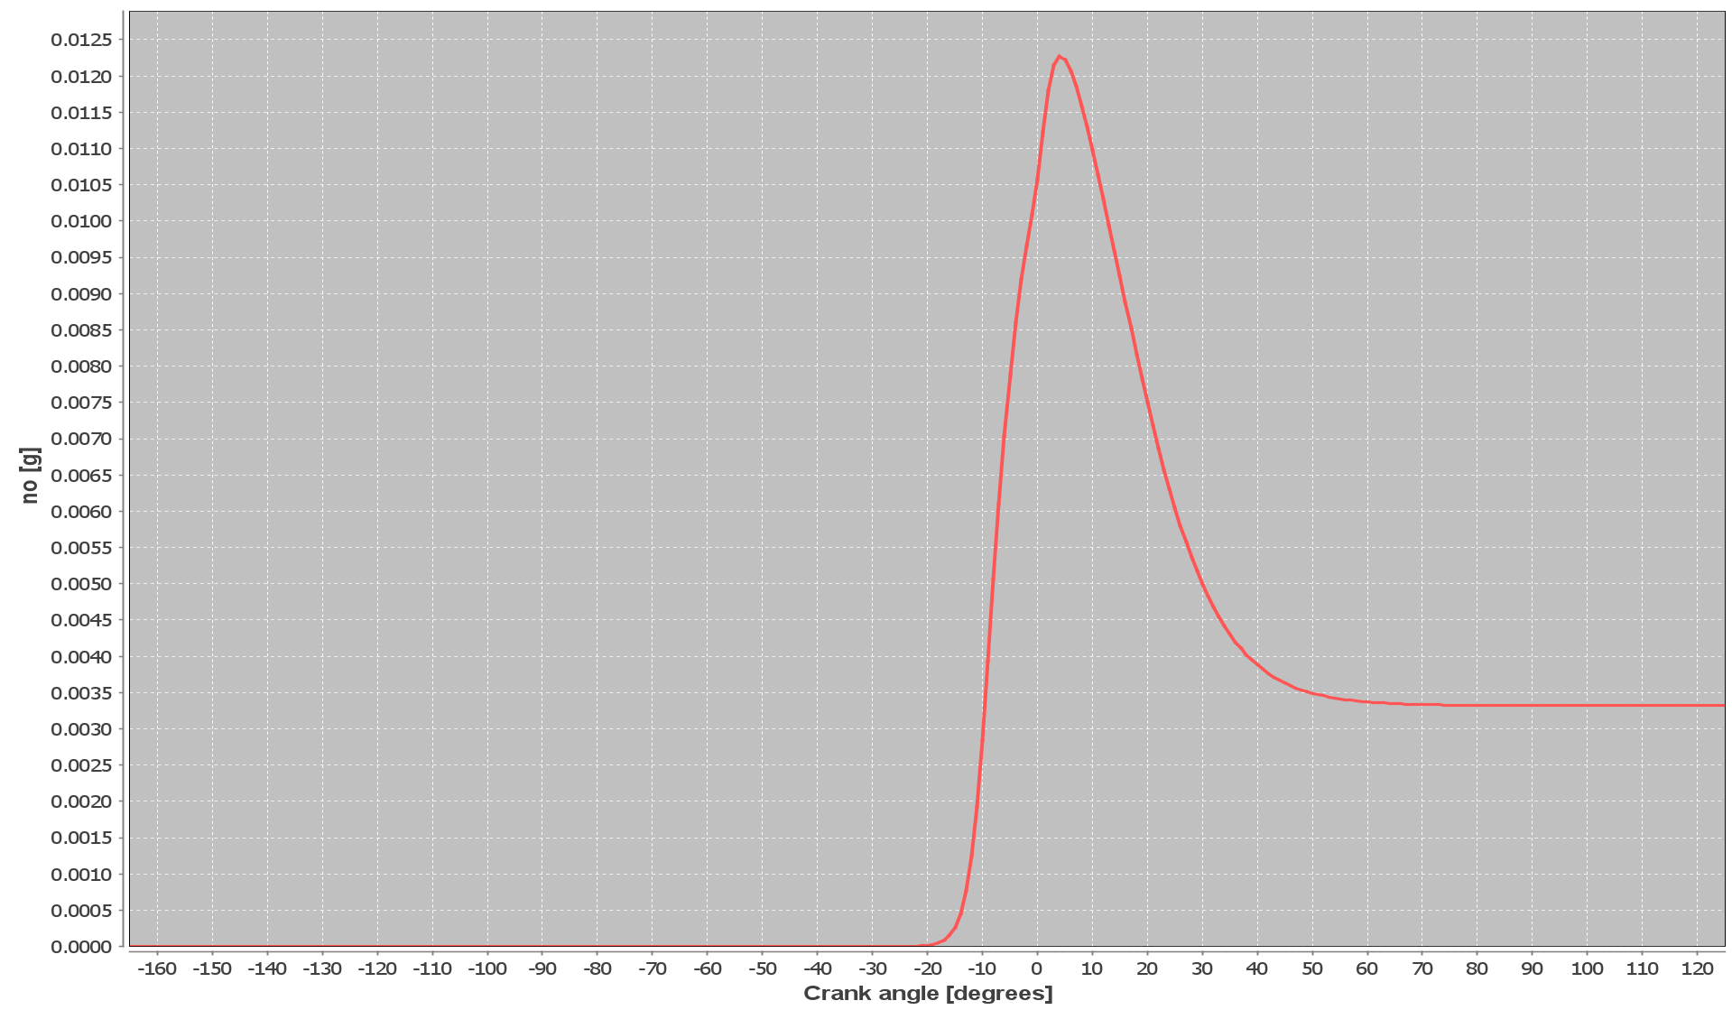
Figure 8 NO emissions from methane-gasoline fuel
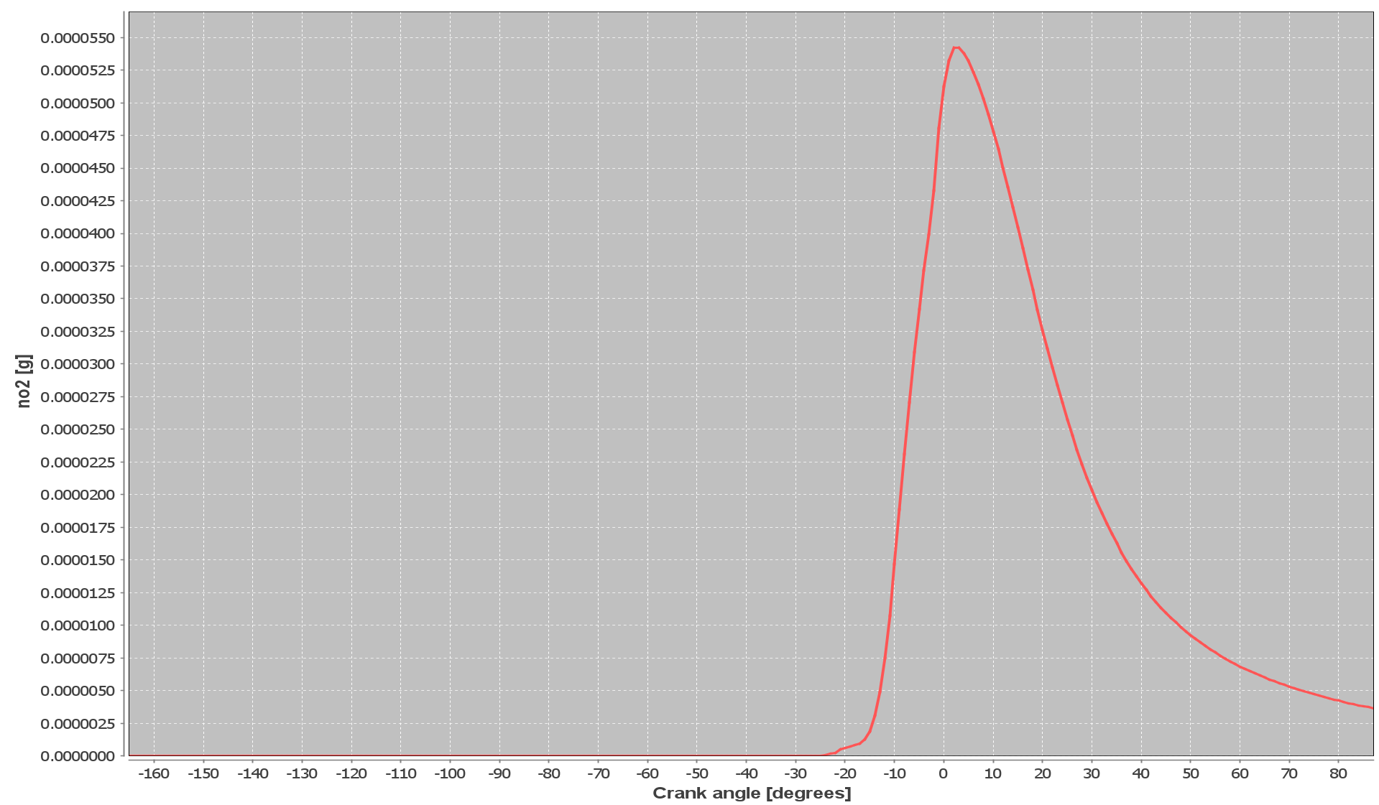
Figure 9 NO₂ emissions from gasoline fuel
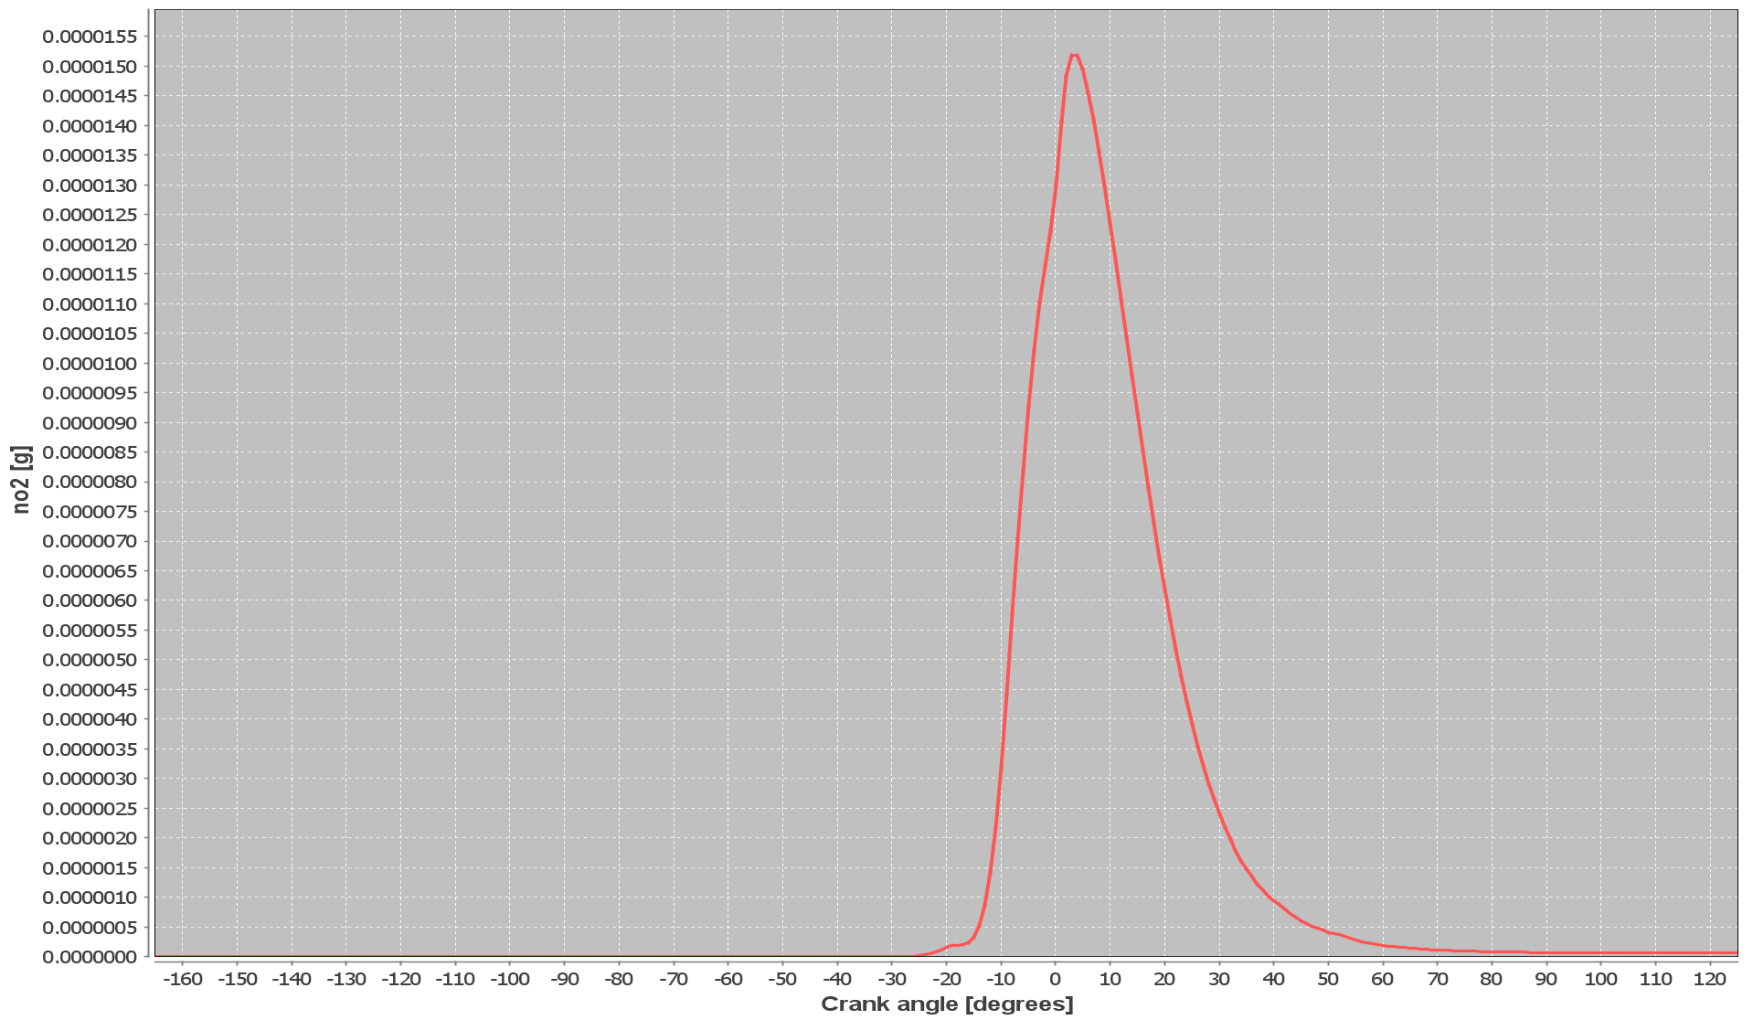
Figure 10 NO₂ emissions from methane-gasoline fuel
By comparing the simulation results with the existing academic literature, it is found that these results show high reliability[12]. By comparing the pressure curves of the two, it can be seen that the peak pressure of pure gasoline is higher, indicating that more energy is released in the combustion process, which means that pure gasoline as a fuel has higher combustion efficiency and better engine performance. The lower peak pressure curve of the methane-gasoline hybrid fuel may be due to the lower octane number and energy density of methane, which affects its combustion performance. It can be seen from the co emission curves of the two fuels that the peak CO emission of pure gasoline combustion is lower than that of gasoline-methane mixed fuel, which indicates that the combustion process of pure gasoline is more complete, less CO is produced, and the addition of methane makes the combustion incomplete, resulting in higher CO emission. By comparing the co2 emission curves of the two, it can be seen that the peak CO2 emission after adding methane is lower than that of pure gasoline combustion, which may be because the proportion of water and CO2 generated by methane during combustion is different from that of gasoline. The results indicate that CO2 emissions can be reduced to a certain extent by using methane mixed with gasoline, which has a positive effect on reducing greenhouse gas emissions. By comparing the NOX emission curves of the two, it can be seen that the peak NOX generated by pure gasoline combustion is higher. Since the formation of NOX is more favorable under high temperature conditions, this phenomenon may be related to the higher combustion temperature of gasoline. The results show that methane-gasoline combustion is more beneficial to reducing NOX emissions than pure gasoline combustion, which is more conducive to protecting the environment.
After testing the combustion and emission characteristics of gasoline and methane-gasoline fuel in the cylinder, the four-cylinder four-stroke engine is opened in WAVE, and the parameters in the engine cylinder are matched to those in Forte. The Location of 50% burn point and Combustion duration in cylinder characteristics are consistent with the simulation results in Forte. Run the model and save the experiment results. Then, change the Specified by the Model Properties to the Fuel file, and create and use methane and gasoline with a mass fraction of 1: 1. Mixed fuel model. Change the fuel composition in Injector to 0.5 liquid fuel and 0.5 gas fuel. Run the model.
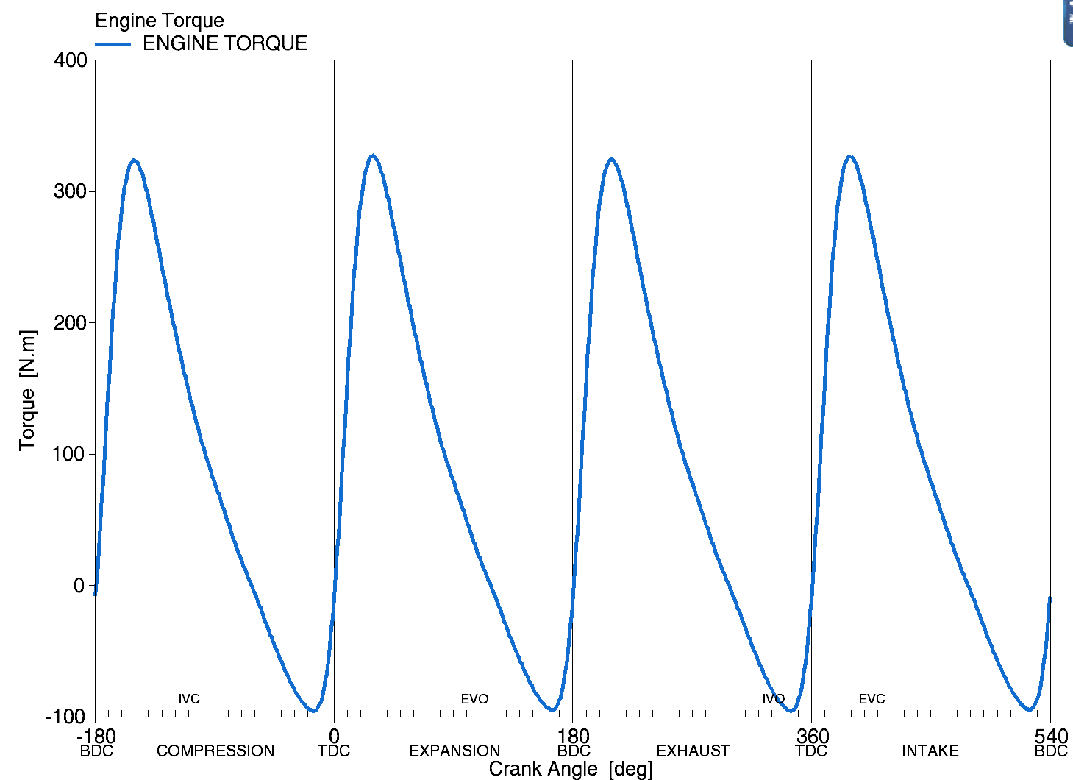  Figure 11 Gasoline Engine Torque | 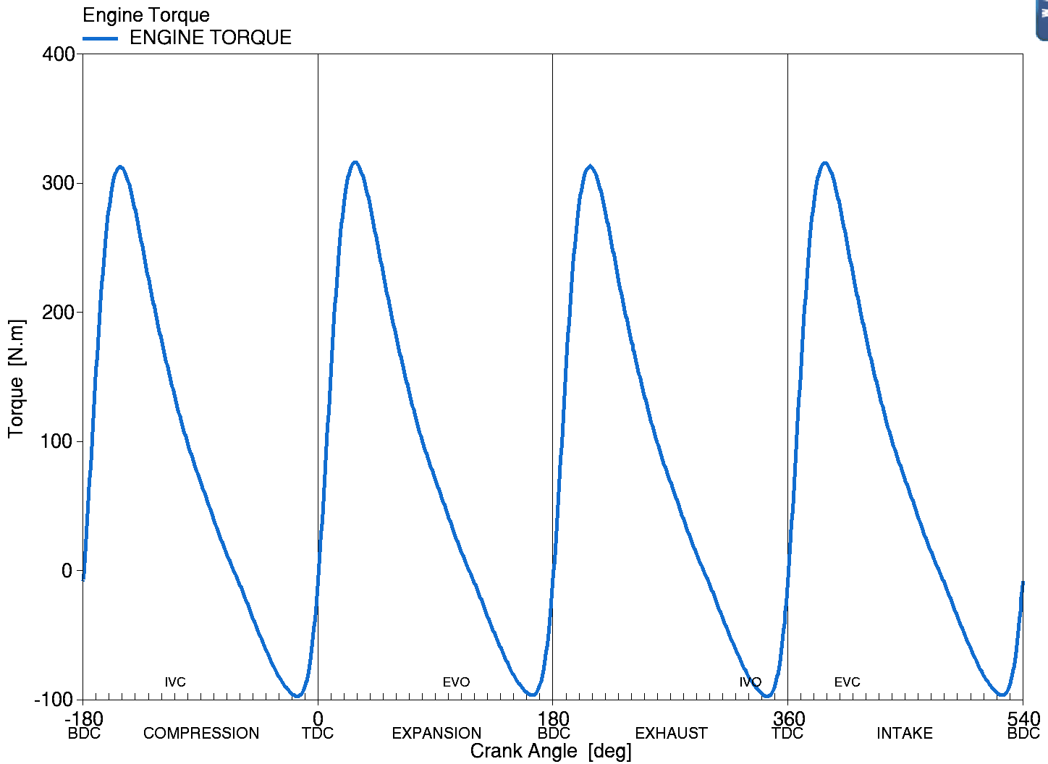  Figure 12 Methane-gasoline engine torque
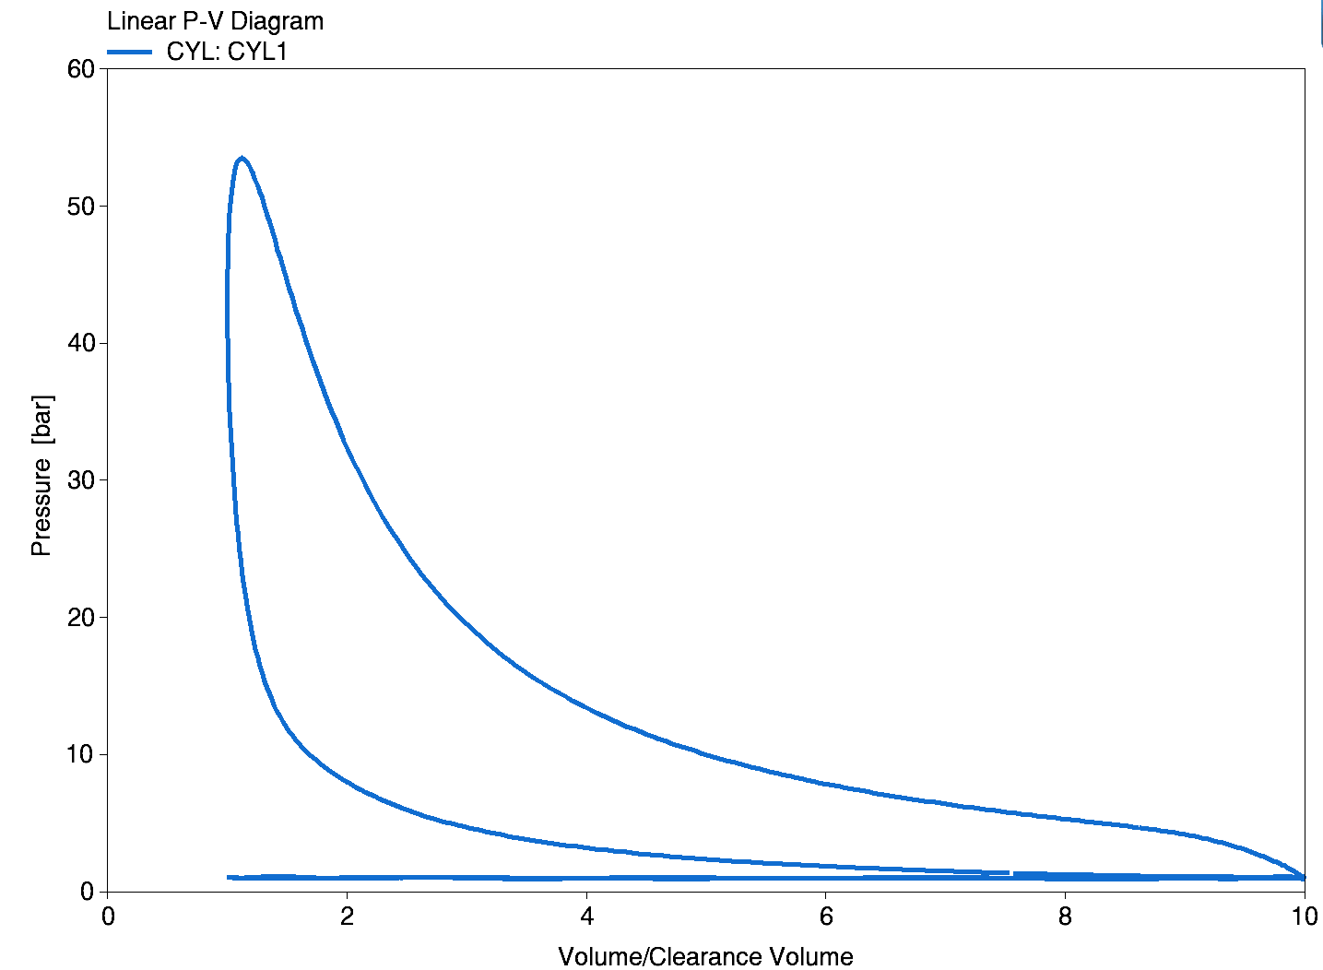  Figure 13 gasoline linear P-V diagram | 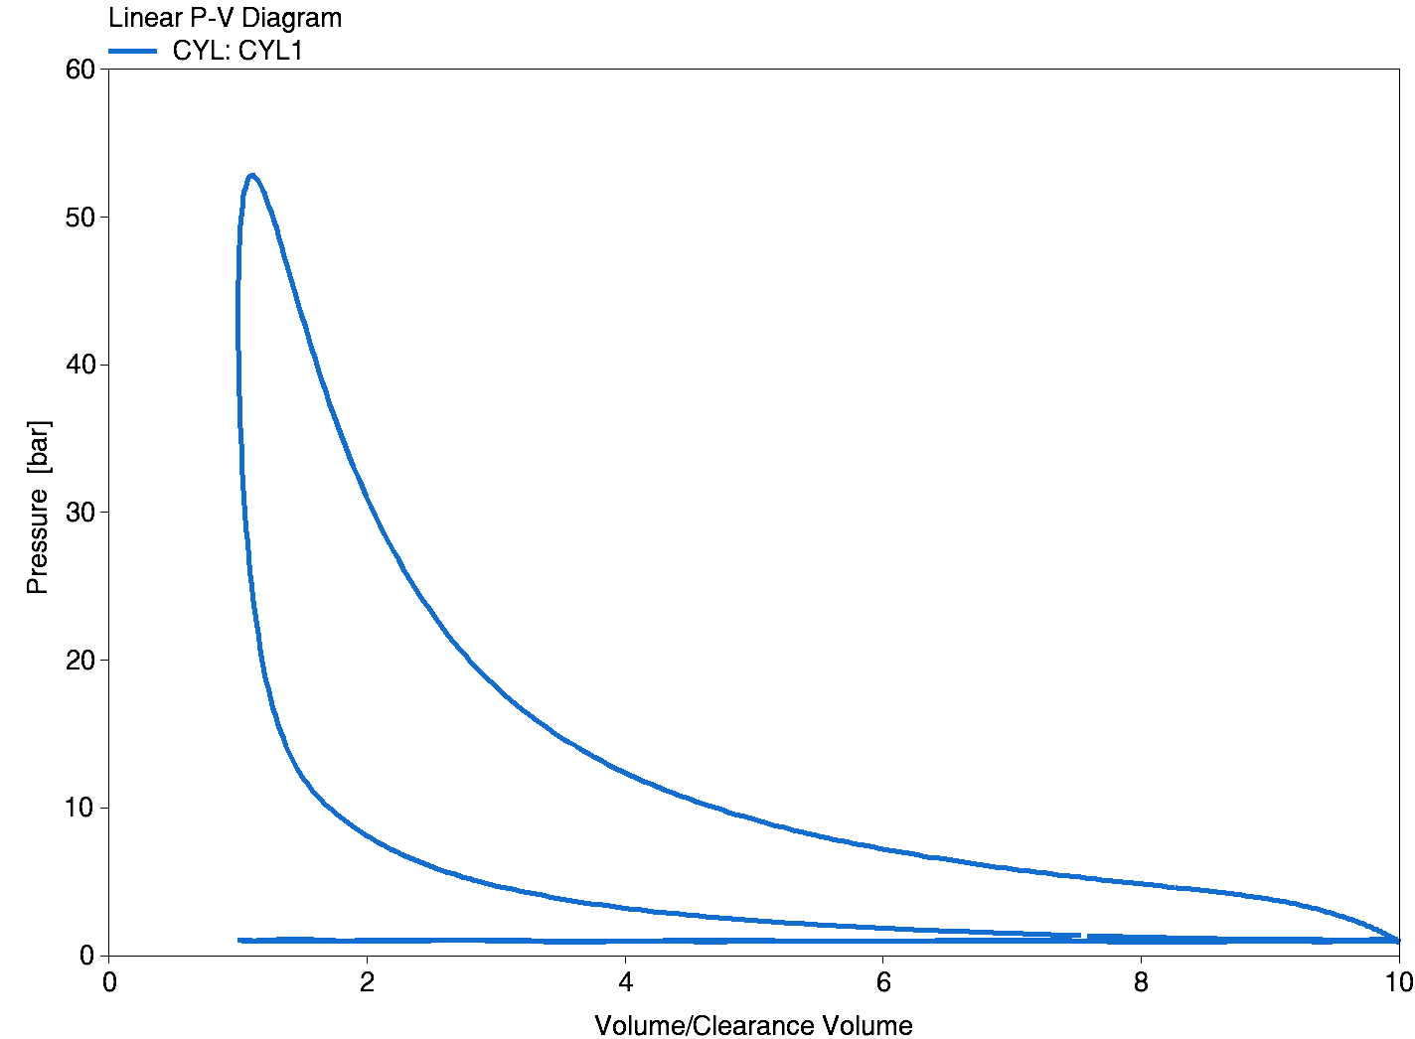  Figure 14 Methane-gasoline P-V diagram
Comparing the engine torque curves for both pure gasoline and gasoline-methane hybrid fuels shows that the torque curves are very similar at each cycle stage (compression, expansion, exhaust, intake), indicating that the addition of methane does not significantly change the engine's torque output. Comparing the P-V diagrams of the two, it can be seen that the relationship between pressure and volume change in the two diagrams is very close, indicating that there is almost no difference in the power generated by pure gasoline and gasoline-methane mixed fuel in different working cycles of the engine.
In summary, the addition of methane to gasoline not only has no negative impact on engine performance, but also reduces harmful gases such as NOX and greenhouse gases such as CO2.
Conclusion
The simulation results show that the addition of methane does not affect the output of engine torque and pressure, while maintaining the power performance, significantly reduce NOx emissions, and to a certain extent reduce CO2 emissions, reflecting its advantages in energy saving and emission reduction. As a supplement to gasoline, methane increases the octane number of the fuel, helps to suppress knocking, and because of its chemical properties, reduces engine emissions, which is an effective way to achieve cleaner combustion. This has provided a certain contribution to the automotive industry in terms of energy conservation, emission reduction and combustion efficiency.
Reference
[1] S. K. Thangavelu, A. S. Ahmed, and F. N. Ani, ‘Review on bioethanol as alternative fuel for spark ignition engines’, Renew. Sustain. Energy Rev., vol. 56, pp. 820–835, Apr. 2016, doi: 10.1016/j.rser.2015.11.089.
[2] T. Korakianitis, A. M. Namasivayam, and R. J. Crookes, ‘Natural-gas fueled spark-ignition (SI) and compression-ignition (CI) engine performance and emissions’, Prog. Energy Combust. Sci., vol. 37, no. 1, pp. 89–112, Feb. 2011, doi: 10.1016/j.pecs.2010.04.002.
[3] J. Wang, H. Chen, B. Liu, and Z. Huang, ‘Study of cycle-by-cycle variations of a spark ignition engine fueled with natural gas–hydrogen blends’, Int. J. Hydrog. Energy, vol. 33, no. 18, pp. 4876–4883, Sep. 2008, doi: 10.1016/j.ijhydene.2008.06.062.
[4] H. R. Zhang, E. G. Eddings, and A. F. Sarofim, ‘Criteria for selection of components for surrogates of natural gas and transportation fuels’, Proc. Combust. Inst., vol. 31, no. 1, pp. 401–409, Jan. 2007, doi: 10.1016/j.proci.2006.08.001.
[5] S. Di Iorio, P. Sementa, and B. M. Vaglieco, ‘Experimental Investigation of a Methane-Gasoline Dual-Fuel Combustion in a Small Displacement Optical Engine’, presented at the 11th International Conference on Engines & Vehicles, Sep. 2013, pp. 2013-24–0046. doi: 10.4271/2013-24-0046.
[6] M. Baloo, B. M. Dariani, M. Akhlaghi, and M. AghaMirsalim, ‘Effects of pressure and temperature on laminar burning velocity and flame instability of iso-octane/methane fuel blend’, Fuel, vol. 170, pp. 235–244, Apr. 2016, doi: 10.1016/j.fuel.2015.12.039.
[7] E. Pipitone and S. Beccari, ‘PERFORMANCES IMPROVEMENT OF A S. I. CNG BI-FUEL ENGINE BY MEANS OF DOUBLE-FUEL INJECTION’, presented at the 9th International Conference on Engines and Vehicles, Sep. 2009, pp. 2009-24–0058. doi: 10.4271/2009-24-0058.
[8] V. Delpech, J. Obiols, D. Soleri, L. Mispreuve, E. Magere, and S. Kermarrec, ‘Towards an Innovative Combination of Natural Gas and Liquid Fuel Injection in Spark Ignition Engines’, SAE Int. J. Fuels Lubr., vol. 3, no. 2, pp. 196–209, May 2010, doi: 10.4271/2010-01-1513.
[9] J. Obiols, D. Soleri, N. Dioc, and M. Moreau, ‘Potential of Concomitant Injection of CNG and Gasoline on a 1.6L Gasoline Direct Injection Turbocharged Engine’, presented at the SAE International Powertrains, Fuels and Lubricants Meeting, Aug. 2011, pp. 2011-01–1995. doi: 10.4271/2011-01-1995.
[10] S. Di Iorio, P. Sementa, B. M. Vaglieco, and F. Catapano, ‘An experimental investigation on combustion and engine performance and emissions of a methane-gasoline dual-fuel optical engine’, presented at the SAE 2014 World Congress & Exhibition, Apr. 2014, pp. 2014-01–1329. doi: 10.4271/2014-01-1329.
[11] A. Zarenezhad Ashkezari, ‘Numerical analysis of performance and emissions behavior of a bi-fuel engine with compressed natural gas enriched with hydrogen using variable compression ratio strategy’, Int. J. Hydrog. Energy, vol. 47, no. 19, pp. 10762–10776, Mar. 2022, doi: 10.1016/j.ijhydene.2022.01.129.
[12] J. Pan, N. Li, H. Wei, J. Hua, and G. Shu, ‘Experimental investigations on combustion acceleration behavior of methane/gasoline under partial load conditions of SI engines’, Appl. Therm. Eng., vol. 139, pp. 432–444, Jul. 2018, doi: 10.1016/j.applthermaleng.2018.04.123.

