
Student Name: | Marva Walters Cadogan
Student Number: | 1711042
Module No: | BMSK4005
Module Title: | Managing Enterprise in 21st Century
Assessment: | 2
Skills for the Workplace
Module Assignment Submission
Date of Submission: 04/09/2018

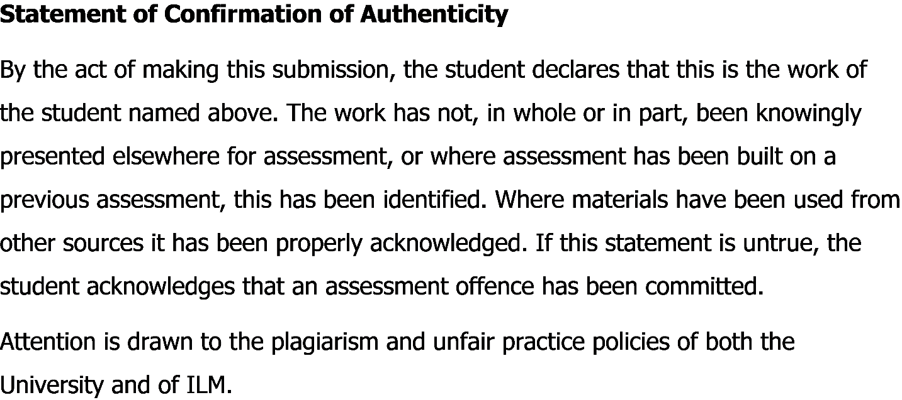

Table of Contents
Introduction: 2
Main body: 2
Description: 3
Feeling: 3
Evaluation: 4
Analysis: 5
Conclusion: 5
Action plan: 6
Conclusion 6
References 7

Introduction:
Reflection of someone means a way the person sees a particular person. Reflective papers mean a reflection on a particular topic or event or plan. In this reflection paper, I tried to reflect on a business plan that I had written in the past semester and tried to come up with the best ideas that I could from the plans. My business was about a cup cake business from home called Azziscupcakes. At the start of writing the business plan, I had no idea of how to cope with a business plan. I had worked with numerous case studies where I learned different business models, business strategical efficiency and value achievement procedures and coping with different business problems as a whole but writing and working with a business plan was something new and exciting for me as I had no prior knowledge about the procedures.I will use the Gibbs cycle, to present my reflection on what I learned in the previous semester, to help me be more precise with my elaboration so that the report can be more significant for understanding better. In the Gibbs report (Anon, n.d.) I cycle where I start off with a description of my work then I explain my feeling and experiences following with an evaluation and analysis of my learning. Finally, I conclude my experiences and finish with an action plan to make my learnings a reality.

Main body:
The reflection study means the experience I got from doing something. That event can be anything from an assignment to a research project or even a work description. Reflection helps the people to know about the job he or she has done was anything valuable to him or her. My reflection paper is about a care agency and I have used the Gibbs method to make the paper. I have tried to reflect mostly about my experience after (Anon, n.d.) I had written the paper.I have literally very little idea about how a business plan works but after working for this business plan I can honestly say I have learned a lot. The Gibbs cycle consists of 6 parts they (ACAS, 2018) are: description phase, feeling phase, the evaluation phase, and a conclusion. I will provide (Mancuso, 1974) a graph that shows the Gibbs cycle procedure.


Figure: Gibbs cycle. (Google.com, 2018)
The experience that I gathered from the business plan is given below.

Description:
Our task for the previous semester was (ACAS, 2018) about making a business plan where we had to come up with a business idea and make an implementation plan to go with those ideas. At first, we had to see the components of a business plan .Then (Mancuso, 1974) we found out the business plan needed to be strategically sound and we had to select a proper target (Anon, n.d.)Market to sell our product. After we had selected our product which was cup cake and selected a target market we needed to find ways of selling those products and ultimately brand our products to the final customers and make sales in the process. On the way of branding our products, we needed to find places we are going to sell off our products and create strategic importance for our products. Then we had to develop and create action plans for our distribution channels to make the most cost-effective decisions.Then we had to find out the basics of management procedure and think how our business is going to be run by the management and finally understand the risk and its mitigation techniques to go ahead with the business and cope with any unexpected bumps on the way. I really enjoyed doing the tasks and for this reflection study, I used the Gibbs cycle to share my experience of writing this business plan. Prior to this business plan work, I had worked with some business cases but this is for the first time I worked with a business plan. This has given me loads of experience of how a startup or business works

Feeling:
A new experience always brings hurdles as well as self-fulfilling stories along the way. The experience of me conducting and implementing a business plan for me was all of those feelings.From doing sleepless nights to hanging out with the teammates to have a coffee, this was one of the most amazing experiences (Anon, n.d.) of my life. As doing a business plan requires on to have a business idea we shared ideas of different prospects then we were checking the feasibility of our project. So when we were in the idea phase I learned how an idea comes when doing the silliest thing to the most important things and when we were doing the feasibility tests the (Mancuso, 1974) I learned how the smallest detail can change the whole idea. After we had come to a conclusion about the idea we had to set a strategy to implement our business and this is where (ACAS, 2018) I learned how the business world works and how a small business idea like minimizing the supply (Anon, n.d.)Chain can easily lower costs a lot. I learned about different prospects of distribution and supply chain management of products. These are some of the business skills I had learned from the project now I want to talk about the soft skills I got from working on this project. Time management has always been a problem for me but while working in a team I got to understand the value of time and if you miss a (Mancuso, 1974) timeline the whole team is going to get in trouble for you. The next skill I got from the process was team management skill. Working in a team you tend to meet new people who are maybe skilled at something and you are also skilled at another. So diversification in the team’s people made a business plan much more efficient and more comprehensive. I learned how to manage teams and how to get the best out of the teams by acting as a leader. Then I got to learn how to write an academic business plan this enriched my writing as well as presentation skills. After we had written down the report we had to present our ideas this taught us how to get your message to the stakeholders and that is my overall view of the experiences I had writing a business plan.

Evaluation:
The business has its strengths as well as its weaknesses. The plan we made for the past semester business plan has both its strengths and the risk (Mancuso, 1974) factors that might severely affect the operations of the business (ACAS, 2018).While we got praised for the strengths of the business especially as our business was which promoted healthy eating, and we got questioned for our weaknesses. We had few strategies to tackle our weaknesses. We created cards for the possible weaknesses we might have while operating the business. Then we created risk mitigation strategies and tried to take care of our weaknesses.For finding our weaknesses we (Anon, n.d.)Had to evaluate two sides of the industry, the internal and the external sites. This gave us valuable insights from the industry and gave us proper ways to understand the risk and opportunities we can use to capitalize our business. After evaluation, we got to the original business plan and we analyzed different things and created an action plan for the future which will help us to be more precise in making our business a reality. Finally again we evaluated the business plan to find out the problems we might face to make our business a reality these are called the risk factors and finally we created strategies to cope with them.

Analysis:
In this part, I will explain some of the things I learned from the whole business project. To start off I must explain the team management things I learned from the project. The team management skill had been developed for me by working with some talented and diversified people.They were quite collaborative and I understood how different people see a problem and idea differently. This actually helped me to come up with new ideas challenge myself to be better so I can contribute more to the team. The next thing I want to talk about is the time management skill. This was really one of my biggest weakness but with working for and with some wonderful people who tend to be very time specific I was able to solve this problem to a greater extent, the third thing I learned from this project was evaluating a business.I learned a whole lot of new concepts like cost minimization frontier, the new brand policies, creative ideas about branding and marketing, supply chain management, operational management etc. The fourth thing I learned from this project was handling stakeholders. I had to (Anon, n.d.) manage (ACAS, 2018) each of the stakeholders while planning for the project. I had to see the best use of selling to the customers and also keeping a good profit along the way. I also had to take care of the social site of the company that it does not hurt our society in any way. (Mancuso, 1974) The fifth and the last thing I learned from the whole project was about the academic writing I faced while we wrote this whole project. The project made my writing skills a whole lot better. All in all, it was a great educative approach for me to get to know the business world (Anon, n.d.) better and this was an experience I don’t intend to forget in the recent years.

Conclusion:
As this project went by I got to meet new people, gathered new experiences and got to work in a different environment. This was a very fulfilling task for me as I got to learn many new jobs with specific knowledge. My business acumen got a lot sharper by working with this project.This project helped me and challenged me to an extent where everything I knew about the business world seemed to crumble as I had a huge gap for building models towards the future but now I can make models for businesses which is much more feasible and does not crumble before implementing them. I got to learn about new ways business operations can work.These new learnings have given me new objectives and with the newly found objectives, I am hoping I can work a lot better and find new horizons of knowledge. I even might start a startup with the (Mancuso, 1974) people if I get the proper resources. This will give me more out of this business plan. This business plan gave me believe that I can start and create something new if I have the resources. All in all the project was helpful for me to go forward.

Action plan:
The Action plan for a reflective report means what I should do to go forward with the key learnings I had gathered from the report. For the key learning, which I have (ACAS, 2018) explained widely in my previous paragraphs, I have understood how a real-life startup business (Anon, n.d.) works. I know the path has its hurdles but with the new found knowledge I know I will be able to at least start off with a plan. I can honestly say this project has made more calculative to implement a business plan and the main part of this learning was that I would not make non-feasible decisions when I want to start a business. I have also gotten some soft skills which will give me a boost in the future like, time management skills, writing skills, presentation skills, stakeholders management skills etc. These skills will make me (ACAS, 2018) more able to cope with my future problems. The third thing and maybe the most important thing I learned from the experience was facing criticism. This brings me to an experience, I was criticized for (Mancuso, 1974) a promotional plan I thought will definitely work. My teammates told me on the ethical ground it would not work. So I generated new plans to get a better promotional offering (Mancuso, 1974) and being ethical along the way.

Conclusion
To finish off the business plan project was quite fulfilling for me as it had given us lots of new things to learn and made me more equipped for the future. I have always dreamt to be an entrepreneur when I had started in my business school.By making this business plan now I know I can do business and make a good plan by (Anon, n.d.) which I can earn profits and be a successful business owner.

References
ACAS. (2018). ACAS Toronto - Asian Community AIDS Service. [online] Available at: http://www.acas.org/ [Accessed 21 Aug. 2018].
Anon, (n.d.). How to Write a Reflection Paper - wikiHow. [online] Available at: https://www.wikihow.com/Write-a-Reflection-Paper [Accessed 2018].
Anon, (n.d.). Individual Reflective Report. - University Education and .... [online] Available at: http://www.markedbyteachers.com/university-degree/education-and-teaching/individual-reflective-report.html [Accessed 2018].
Anon, (n.d.). Reflective Reports – how to write 1st class reflective reports. [online] Available at: https://www.ivoryresearch.com/library/other-articles/reflective-reports-how-to-write-1st-class-reflective-reports/ [Accessed 2018].
Anon, (n.d.). Reflective Reports - SlideShare. [online] Available at: https://www.slideshare.net/lcslidepresentations/reflective-reports [Accessed 2018].
Anon, (n.d.). Transition to Post-Secondary/Workforce. [online] Available at: http://atlasabe.org/professional/transitions [Accessed 2018].
Anon, (n.d.). Writing a reflection - YouTube. [online] Available at: https://www.youtube.com/watch?v=WjLa2sJjla0 [Accessed 2018].
Mancuso, J. (1974). How a business plan is read. Business Horizons, 17(4), pp.33-42.
Miller, L., Biggart, A., and Newton, B. (2013). Basic and employability skills. International Journal of Training and Development, 17(3), pp.173-175.
SAGE India. (2018). Maund, Andrew. [online] Available at: https://in.sagepub.com/en-in/sas/author/andrew-maund [Accessed 17 Aug. 2018].
Google.com. (2018). gibbs cycle - Google Search. [online] Available at: https://www.google.com/search?q=gibbs+cycle&source=lnms&tbm=isch&sa=X&ved=0ahUKEwj-xdWJov7cAhXDNo8KHfM2D-QQ_AUICigB&biw=1366&bih=619#imgrc=vs-mTidbd_NJKM: [Accessed 21 Aug. 2018].

