Iestyn Thomas – 2404285 Contemporary Management Approaches (BMSP4013) Assessment 1

Figure 1 (Amazon, n.d.)

1,500-word report
Lecturer: Glenn Behenna
Introduction
This Report aims to analyse the organisational function of Amazon. This will cover several different areas in relation to organisational function i.e. including organisational context, approaches to organisation and management, work motivation and satisfaction and finally perception and communication.
Amazon are a multinational technology company founded in 1994 by Jeff Bezos who offer a wide range of products through their worldwide famous subscription and retail services which include Prime, Prime Video, AWS, amazon.com and many others (Yasar, 2022). Amazon are active with localized sites and retail operations in 23 countries including the US, UK and Japan. They also ship products to over 100 countries worldwide (Scott, 2024). Today Amazon are an e-commerce giant considered to be one of the world’s biggest companies.
Organisational Context
The Importance of Understanding Organisational Behaviour
Organisational behaviour involves the understanding, prediction and control of the behaviour of people within an organisational setting. Organisational behaviour is commonly defined as along the lines of; “the study and understanding of individual and group behaviour and patterns of structure and management in order to help improve organisational performance and effectiveness” (Mullins, 2019). For businesses, understanding organizational behaviour can be used to streamline efficiency, improve the workplace environment and enhance productivity to give firms a competitive advantage (Kopp, 2024).
Sigsworth’s (2024) article suggests that organisational behaviour includes 4 elements that all play a crucial role in shaping how an organization function and succeed, these are people, structure, technology and the environment.
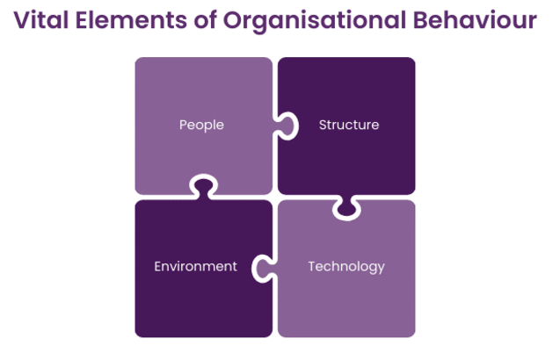
The people element refers to the unique contribution that each individual brings to the workplace i.e. personality, skills and behaviours. The way in which employees interact with work and each other is a vital element in a work environment. By understanding how employees interact and what motivates them, managers can create an environment where people are more engaged and productive.
Figure 2 (Roberts, 2024)
Structure refers to how tasks and responsibilities are distributed within an organization. It defines the roles of individuals and groups and helps employees understand how they fit into the larger organization. When the structure is effective, communication is improved and employees know who to report to, who they work with, and what their specific duties are.
The tools and resources provided to employees to perform tasks and achieve goals describes the technology element. When technology is integrated well into the workplace, it can enhance productivity.
The environment includes both internal and external factors that influence an organization. Internal factors include the company’s culture, policies, and resources, while external factors cover economic conditions and social trends (Sigsworth, 2024; Sujan, 2024).
Studying these specific areas within organisational behaviour allows an organization to enhance their understanding of their employees. Using this research and results, organizations can implement changes that enhance performance and efficiency. Implementing changes based on the information gathered from studying their organisational behaviour can provide benefits for businesses like Amazon such as increased employee satisfaction, improved communication which can lead to creating a more effective work environment, improved alignment on values which can enhance teamwork, minimize employee burnout and overall create a more positive work environment (Crail, 2024; Sigsworth, 2024).
How The Organisational Environment is Organised
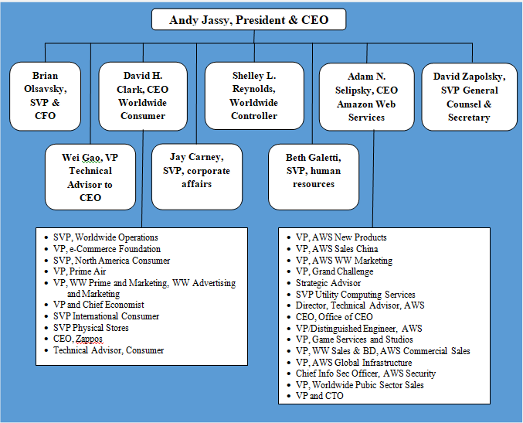
As of October 2024, Amazon have around 1.53 million employees globally illustrating the enormity of the e-commerce giant (Kumar, 2024). To control and organise all these employees as well as ensure a functional workplace, Amazon use a vertical hierarchical structure. This allows all Amazon employees from current CEO Andy Jessy to workers at the bottom of the tree to understand their respective roles and who each employee is accountable for and to. Employing this organizational idea allows top-down control over its operations which makes for clear and efficient decision-making processes and communication chains (Lino, 2024).
Amazon’s hierarchical organisational structure provides several benefits such as evident career and promotion paths for workers and an efficient communication chain meaning all employees know who to communicate with when shearing new ideas, who to ask when needing support as well as knowing who their responsible for. However, there are also disadvantages to this organisational approach such as slower decision-making and a risk of poor communication or miscommunication between different levels of the chain (Indeed Editorial Team, 2023; Lino, 2024).
Figure 3 (Dudovskiy, 2022)
At the top of Amazon’s chain is a senior management team known as the S-Team, a small group of senior executives who work closely with CEO Jessy. The S-Team oversee several function-based groups, including Worldwide Operations, Finance, AWS and Human Resources (Cuofano, 2024). The S-Team's structure allows for clear communication and fast decision-making at the company’s summit. However, Amazon also emphasizes the importance of pushing decision-making down the chain where appropriate, enabling faster responses to market changes and customer needs (Lino, 2024).
Approaches to Organisation Management
Approaches to management refers to different theories and methodologies used to direct and control organizations. Amazon’s management style incorporates elements of a variety of management theories, including classical, human relations, systems approach, and the contingency method (Dahlgaard-Park, Reyes, & Chen, 2018). Amazon mainly employs the classical management approach, which aims to increase efficiency and productivity. The classical approach supports a hierarchical chain of command which allows for order as well as clear responsibility for workers over other employees, but this approach can neglect lower-level employee input.
Amazon also implements elements of the human relations principles. The human relations theory was a psychology and social experiment conducted by Elton Mayo and his team, where they evaluated the impact on the productivity of workers in a variety of workplace conditions at the Hawthorne Works factory. Conclusions developed for this theory showed that group dynamics affect job performance, communication between employees and employers must go in both directions, workers prefer to be included in the decision-making process and integration between different departments positively impacts an organization (“An Overview of Management Theories”, 2022).
In summary, Amazon doesn’t restrict itself to one management approach instead in incorporates a variety of theories to create an adaptable management system.
Amazon’s Work Motivation and Job Satisfaction
Similarly to many major organisations, employee motivation at the workplace is a key focus for Amazon. Motivation is described as the “forces acting either on or within a person to initiate behaviour” (Cofer & Petri, 2024). Money plays a key role in motivating employees at Amazon. However, Amazon have managed to understand that it’s not money itself that motivates employees, it’s ‘the hope for money’ that’s an enormous motivator to keep workers going (Outlook, 2017). Amazon also use performance rewards to motivate their employees. Increased responsibilities and an opportunity to buy into stocks are prizes for good performance. In 2022 Amazon gave employees a record amount of stock awards, in an attempt to motivate workers as well as retain corporate workers amid high inflation and a competitive labour market (Kim, 2022).
Amazon’s approach for motivation coincides with Maslow’s hierarchy of needs theory. Maslow motivational theory suggests there is a hierarchy of human needs, consisting of 5 tiers with each step containing different needs. The five tiers are physiological needs, safety needs, love and belonging, esteem needs and self-actualization. Lower-level basic needs must be fulfilled before being able to fulfil higher tier needs. Some basic needs include food, water and shelter. To fulfil these and pay for essential weekly home bills, money is vital. Therefore, this is a theory behind how and why Amazon manages to keep workers engaged and motivated (McLeod, 2024).
Another key element for a functional workplace is employee job satisfaction. “Job satisfaction is defined as the level of contentment employees feel with their job” (BasuMallick, 2021). It is vital for employees to feel satisfied with their job to ensure a healthy workplace atmosphere. For a business like Amazon this could lead to better productivity levels and therefore higher sales and revenue. This will also increase the chance of employee retention, therefore lowering recruitment costs which is essential in a competitive labour market. Amazon recognises the importance of job satisfaction and aims to keep it high by offering employee benefits such as a safe and sustainable workplace, medical insurance, competitive wages, career opportunities and so on (Amazon Staff, 2022).

Perception and Communication in the Workplace
Perception at the workplace refers to how employees interpret information, experiences and the environment in the workplace. Perception is subjective, meaning that each employee may have a different interpretation of the same work situation (Parker, 2023). Amazon managers, place great importance on perception through the lens of their leadership principles. These principles help guide the companies decision-making processes. Amazon higher-ups prioritize customer perceptions and feedback to drive inner improvement (Amazon Staff, 2023).
Communication in the workplace is the process of sharing information between employees in the work environment by using verbal, non-verbal, written and visual communication techniques (Coursera Staff, 2024). Amazon employees are able to communicate effectively in the workplace due to their classical hierarchical structural approach. Amazon’s hierarchical structure is conceived of several tiers including CEO, Senior Executives, Directors, Managers, Employees and so on. The hierarchy approach allows for clear lines of communication and accountability throughout the organization, which helps ensure everyone is working together towards the same goals (Springer, 2024).
When communicating internally to higher level management, certain departments or even the whole workplace, Amazon often use memos. 20 years ago, Bezos banned the use of PowerPoint when presenting to higher management. Instead, Amazon executives would have to write a six-page memo when presenting on an important managerial decision, for example when launching a new product. Using memos instead of a PowerPoint presentation can provide benefits such as more effort from workers and better detail due to being forced to write in full sentences rather than bullet points (“Amazon Memo”, 2024).
To improve communication and decision-making in upper management meetings, Amazon use the “Two Pizza Rule”, which typically limits teams to around 6-8 members, small enough that two pizzas can feed the entire group. This boosts efficiency, lower costs and can reduce the time and frequency of meetings. The theory is that teams of lower numbers waste less time and are better for effective communication as well as decision-making (Cuofano, 2024).
This report sought to study the organisational function of Amazon and how the management team at Amazon approaches these aspects.

Reference List
Amazon Memo: What Lessons Does It Hold?. (2024). Management Consulted. Available at: https://managementconsulted.com/amazon-memo/#:~:text=The%20Amazon%20memo%20is%20often%20mentioned%20as%20one,one%20of%20the%20company%E2%80%99s%20most%20important%20managerial%20tactics.
Amazon Staff. (2022). 10 reasons why Amazon is a great place to work. Amazon. Available at: https://www.aboutamazon.co.uk/news/working-at-amazon/10-reasons-why-amazon-is-a-great-place-to-work
Amazon Staff. (2023). An Amazon interviewer dives deep into how she uses the Leadership Principles. Amazon. Available at: https://www.aboutamazon.com/news/workplace/what-do-each-of-amazons-leadership-principles-really-mean
Amazon. (n.d.). Logopedia. Available at: https://logos.fandom.com/wiki/Amazon?file=Amazon2024.svg
An Overview of Management Theories: Classical, Behavioral, and Modern Approaches. (2022). Villanova University. Available at: https://www.villanovau.com/articles/leadership/an-overview-of-management-theories/
BasuMallick, C. (2021). What Is Job Satisfaction? Definition, Factors, Importance, Statistics, and Examples. Spiceworks. Available at: https://www.spiceworks.com/hr/engagement-retention/articles/what-is-job-satisfaction/
Cofer, C. N & Petri, H. L. (2024). Motivation. Encyclopedia Britannica. Available at: https://www.britannica.com/topic/motivation
Coursera Staff. (2024). Workplace Communication: What Is It & Why Is It Important?. Coursera. Available at: https://www.coursera.org/articles/workplace-communication?msockid=38838867965e632638b59b9597be6262
Crail, C. (2024). What Is Organizational Behavior?. Forbes. Available at: https://www.forbes.com/advisor/business/what-is-organizational-behavior/
Cuofano, G. (2024). Amazon Organizational Structure In A Nutshell. FourWeekMBA. Available at: https://fourweekmba.com/amazon-organizational-structure/
Dahlgaard-Park, S. M., Reyes, L., & Chen, C. K. (2018). The evolution and convergence of total quality management and management theories. Total Quality Management & Business Excellence, 29(9–10), 1108–1128. Available at: https://doi-org.ezproxy.uwtsd.ac.uk/10.1080/14783363.2018.1486556
Dudovskiy, J. (2022). Amazon Organizational Structure: a brief overview. Business Research Methodology. Available at: https://research-methodology.net/amazon-organizational-structure-2-2/#_ftn1
Indeed Editorial Team. (2023). Hierarchical Structure: Advantages and Disadvantages. Indeed. Available at: https://www.indeed.com/career-advice/career-development/hierarchical-structure-definition-and-examples
Kim, E. (2022). Amazon is handing out a record $6 billion in employee stock awards this quarter as it battles a competitive labor market and complaints of low pay. Business Insider. Available at: https://www.businessinsider.com/amazon-employee-stock-award-rsu-competition-tech-labor-market-2022-4#:~:text=Amazon%20is%20expected%20to%20spend%20%246%20billion%20on,CFO%20Brian%20Olsavsky%20said%20during%20Thursday%27s%20earnings%20call.
Kopp, C. M. (2024). Organizational Behavior (OB): What It Is and Why It Matters. Investopedia. Available at: https://www.investopedia.com/terms/o/organizational-behavior.asp#toc-organizational-behavior-and-hr
Kumar, N. (2024). How Many Employees Does Amazon Have (2024 Data). DemandSage. Available at: https://www.demandsage.com/amazon-employees/
Lino, G. (2024). Amazon's Organizational Structure: A Comprehensive Guide. Giro’s Newsletter. Available at: https://www.girolino.com/amazons-organizational-structure-a-comprehensive-guide/
McLeod, S. (2024). Maslow’s Hierarchy of Needs. Simply Psychology. Available at: https://www.simplypsychology.org/maslow.html
Mullins, L. (2019). Mullins: Organisational behaviour in the workplace. Pearson Education, Limited.
Outlook, O. (2017). How Amazon uses money to motivate employees. Medium. Available at: https://medium.com/@objoutlook/how-amazon-uses-money-to-motivate-employees-8e059f5a9698
Parker, A. (2023). What is Employee Perception and Why Does it Matter?. Drive Research. Available at: https://www.driveresearch.com/market-research-company-blog/what-is-employee-perception-and-why-does-it-matter/
Roberts, S. (2024). Key Elements of Organisational Behavior (OB): An Overview. The Knowledge Academy. https://www.theknowledgeacademy.com/blog/key-elements-of-organisational-behaviour/
Scott, C. (2024). How Many Countries Does Amazon Operate In During 2023? The Full List. Expert Beacon. Available at: https://expertbeacon.com/how-many-countries-does-amazon-operate-in/
Sigsworth, W. (2024). How to boost company performance with organizational behavior. Pipedrive. Available at: https://www.pipedrive.com/en/blog/organizational-behavior
Springer, A. (2024). Amazon’s Corporate Structure: Exploring Hierarchy and Management Style. Functionly. Available at: https://www.functionly.com/orginometry/amazon-corprate-structure#:~:text=Here%20are%20some%20reasons%20why%20Amazon%27s%20structure%20matters%3A,focus%20on%20specific%20target%20markets.%20. . .%20More%20items
Sujan. (2024). The 4 Fundamental Elements of Organizational Behavior. TheMBAins. Available at: https://thembains.com/elements-of-organizational-behavior/
Yasar, K. (2022). Amazon. TechTarget. Available at: https://www.techtarget.com/whatis/definition/Amazon

