Cold Cube Production
Project Proposal
Reasons and Relevance of Project
Enersys Newport machines known as Nugget Casters are used to produce 20mm cylindrical nuggets for the oxide mill using molten lead generated from 40kg ingots that are fed automatically into a lead pot. Having to need molten lead means that gas burners are used to keep the pot at roughly 440⁰C, therefore a continuous call and need for gas is costing Enersys massive amounts in energy bills. Collecting the data from energy provider and EHS within Enersys, it is roughly costing Enersys £230,202 per year based off cost of gas per KWH being 0.075. Considering Enersys has three of these machines something needed to be considered in making a change.
As well as the cost in gas energy bills, the nugget casters produce around £119,384 worth of waste called dross, which is formed from the molten lead’s reaction with air through oxidation. Again, this is formed on each of the three pots within the factory.
As with any machine within production manufacturing the nugget casters and relevant machinery with it has break downs and downtime. Using the internal maintenance system within Enersys, it was found that 248 work orders were raised for breakdowns on the machines collectively, with each machine roughly being down for near 21 days a year.

Using the data collected it can be found that in maintenance labour costs, roughly £8000 was spent and this does not include contractors or system and process engineers. Along with this nearing £24,000 was spent in maintenance spares which in total is £32,000 spent on them machines alone during 2022.
Aims of Project
The project proposal is to remove the three nugget caster tables and replace them with cold cube processing machines which Sovema have been using for their plants. Cold cube machines use 50kg Ingots which are fed into the machine via a robot arm or suitable alternative, the ingots are then transferred along an automated conveyor to be processed into small 20mm cubes for the oxide mill process. They are processed by a blade cutting up the original ingot into small chunks, these are then formed using two rollers into 20mm cubes.
The objective of using this machinery instead of the nugget casters is to utilise 2 of the cold cube machines for all 4 of the oxide mills on site. Reduce the energy bills and gas consumption, reduce the health and safety risks which came with the molten lead, and finally to reduce the downtime and maintenance requirements.
The cold cube machine completely removes the requirement of gas due to no molten lead being involved, as well as this it removes the biggest health and safety risk along with the waste dross which can be formed. The new process relies entirely on pneumatic and electric drives with the aim of achieving 2 tonnes of nuggets to feed mills 3 & 4 and even 1 & 2 when required.
Timescales and Provisional Plan
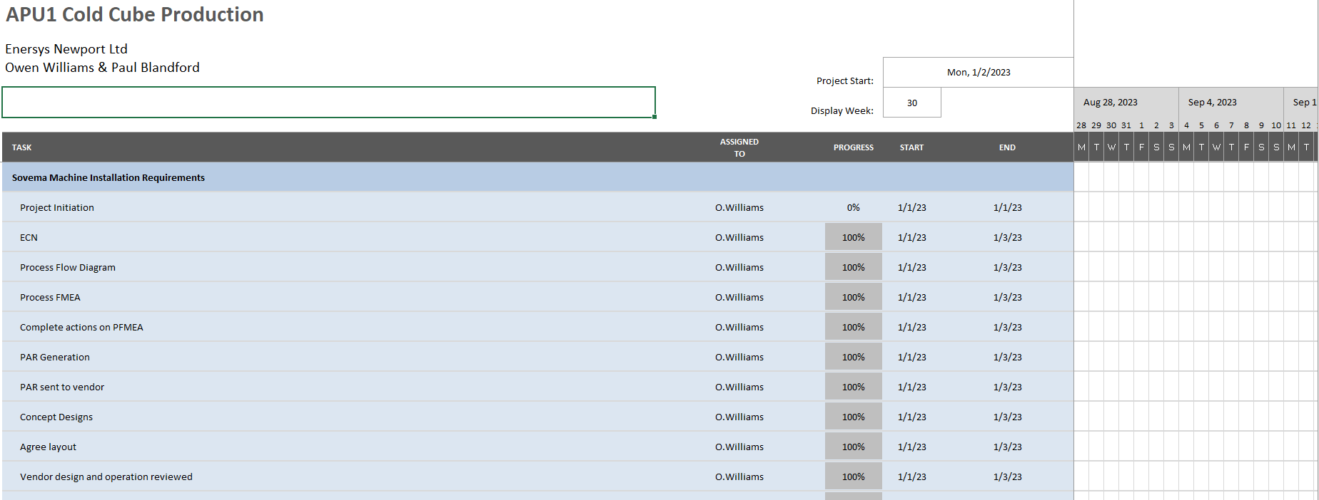
A timescale has been made in order to get an understanding of when things need to be done as well as to set targets and aims for individual tasks to be carried out and completed. Before any major work can be completed, relevant paperwork and documents need to be done, such as initial research, data collection, feasibility studies etc. Setting dates for these allows for a consistency to be achieved and sets up for a better outcome when the project is ready to be implemented.

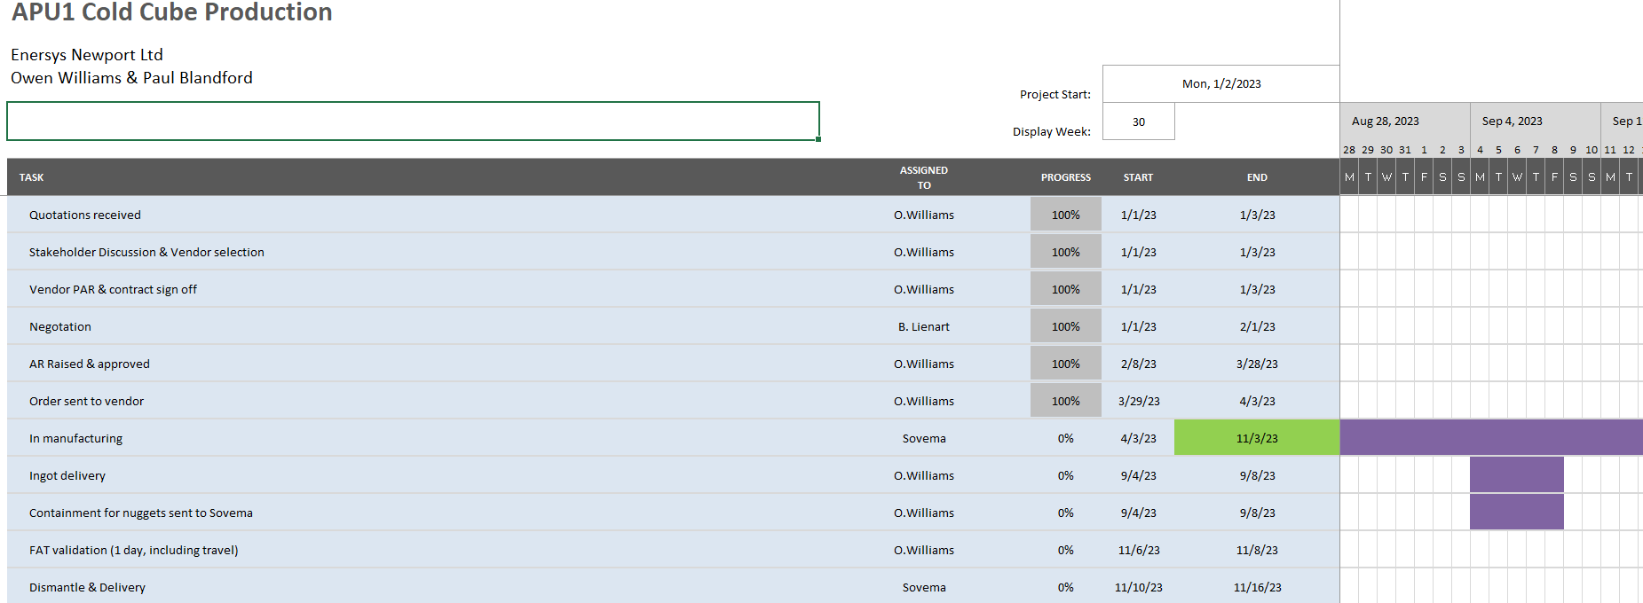
As seen from above these are the relevant documents which must be completed before any decommissioning or installation can begin. Setting realistic and achievable completion dates allows for the project to stay on track and not fall behind. It also means the documents can be carried out at a high standard and therefore reduce the chances of mistakes or delays.
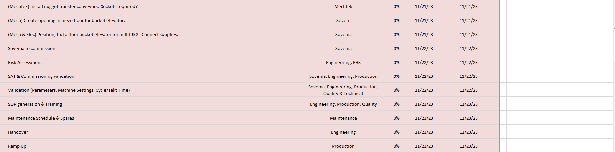
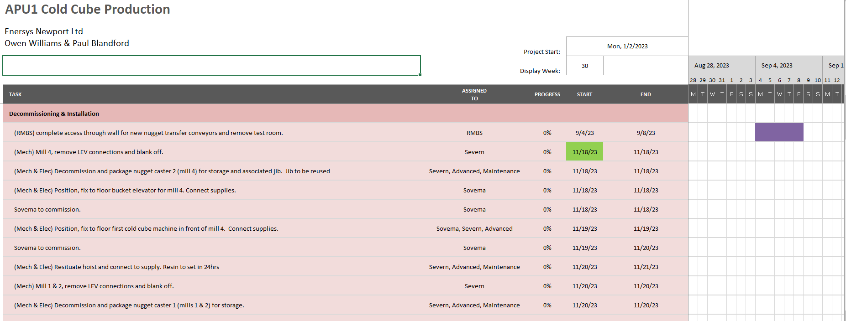
From this a provisional workplan can be drafted for the implementation of the cold cube machines.

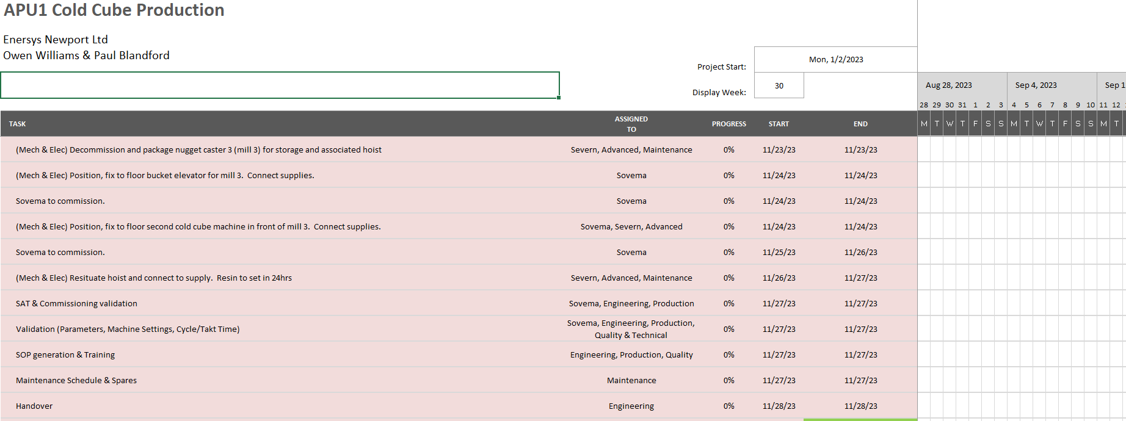
These dates are provisional and once the cold cube has been manufactured and much clearer date will be set. This will allow production to produce enough nuggets to allow for a week turnaround of machines and not have production stop further down the line.
Background Research
Basic background research was conducted at the beginning of this. Firstly, it needed to be found how much production the machines can produce per hour. The information was gathered from manufacturers Arras and Sovema who state that the nugget capacity if using 2 machines would be 4800 an hour with a daily production capability of around 47000 with a production time of 9.8 hours. Energy saving and cost on bill alongside comparison of production out put is key with research.
Further information gathered from the product specification determines that between 5 – 6 bar of pressure will be needed for the machine to operate. Information such as the control equipment needed such as breakers, contactors, PLCs, drives etc is supplied in the specification which allows for an understanding of what infeed power is needed.
Finally, a clear understanding of the health and safety requirements and legislations that must be followed. The research shows these to be:
- European Directive on Machine safety 2006/42/EC
- The European Work Equipment Directive 2009/104/EC and 89/391/EEC.
- European Directive 2006/95/CE – Low Voltage Directive
- European Directive Electromagnetic Compatibility Directive 2004/108/CE
https://www.sovemagroup.com/it/products/cold-lead-cubing-machine/
PROCUREMENT ASSET REQUEST APU1 COLD CUBE PRODUCTION AT ENERSYS NEWPORT
Ref: PE20021-06 v2

Facilities Required
PLC programming software
Maintenance log software to collect data
Quality support to test if nuggets are correct size for mill

Industrial Partners/Stakeholders
Site Manager: Timothy Gibbons
Engineering Manager: Samuel Annan
Maintenance Manager: Paul Herbert
Health & Safety Manager: Jeff Bull
Quality Manager: Andre Barni De Azevedo
Supply Chain Manager: Jayne Gibbon
Technical Manager: Des Williams
APU1 Production Manager: Glen Murdoch

